Apical Endpoint Benchmark Dose Modeling Results; Toxicology Benchmark Dose Results
  - BMD Results for: SD4
BMDS version: BMDS v2.7.0
    - Input dataset
Dose | 0 | 55 | 110 | 220 | 441 | 881
N | 5 | 5 | 5 | 5 | 5 | 5
Mean ± SD | 276.3 ± 10.286 | 271.3 ± 11.404 | 271.9 ± 8.273 | 278.8 ± 10.51 | 262.4 ± 18.112 | 232.5 ± 21.019

    - Summary table
Modelª | Goodness of fit |  | BMD | BMDL | Comments
 | p-value | AIC
Linear | 0.261 | 193.134 | 283.489 | 209.164 | Polynomial-2 recommended as best-fitting model on the basis of the lowest AIC.
Polynomial 2°^{b} | 0.735 | 189.873 | 486.413 | 278.1
Polynomial 3° (equivalent models include Polynomial 4°, 5°) | 0.571 | 191.873 | 489.883 | 274.988
Power | 0.574 | 191.861 | 500.092 | 285.353
Hill | 0.753 | 191.069 | 442.808 | 322.87
Exponential M2 (equivalent models include Exponential M4) | 0.22 | 193.606 | 274.199 | 197.845
Exponential M3 | 0.58 | 191.83 | 497.585 | 289.961
Exponential M5 | 0.548 | 193.069 | 442.523 | 321.919
ª Constant variance case presented (BMDS Test 2 p-value = 0.233, BMDS Test 3 p-value = 0.233).
^{b} Recommended model

    - Model recommendation details
Model | Bin | Notes
Linear | Valid | -
Polynomial 2°ª | Valid | -
Polynomial 3° (equivalent models include Polynomial 4°, 5°) | Valid | -
Power | Valid | -
Hill | Valid | -
Exponential M2 (equivalent models include Exponential M4) | Valid | -
Exponential M3 | Valid | -
Exponential M5 | Valid | -
ª Recommended model

    - Recommended model
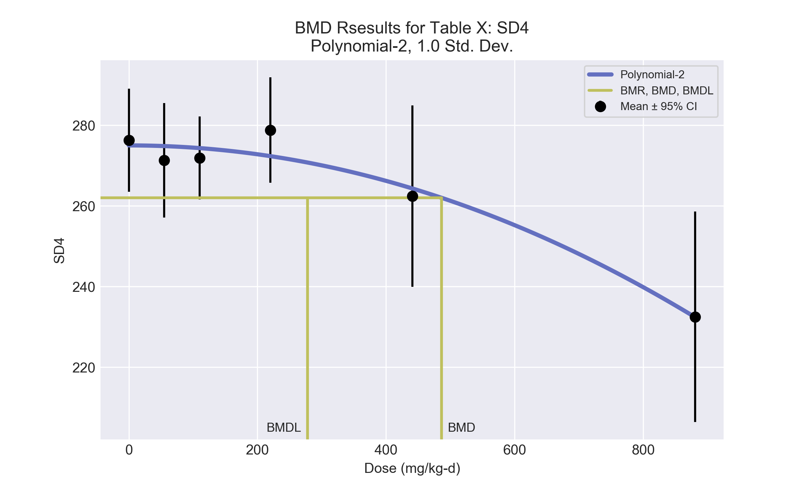
====================================================================
Polynomial Model. (Version: 2.21; Date: 03/14/2017)
Input Data File: C:\Users\USERNAME\AppData\Local\Temp\2\bmds-ghxikak_.(d)
Gnuplot Plotting File: C:\Users\USERNAME\AppData\Local\Temp\2\bmds-ghxikak_.plt
Mon Dec 18 12:02:51 2017
====================================================================
BMDS_Model_Run
~~~~~~~~~~~~~~~~~~~~~~~~~~~~~~~~~~~~~~~~~~~~~~~~~~~~~~~~~~~~~~~~~~~~~
The form of the response function is:
Y[dose] = beta_0 + beta_1*dose + beta_2*dose^2 + ...
Dependent variable = Response
Independent variable = Dose
rho is set to 0
The polynomial coefficients are restricted to be negative
A constant variance model is fit
Total number of dose groups = 6
Total number of records with missing values = 0
Maximum number of iterations = 500
Relative Function Convergence has been set to: 1e-008
Parameter Convergence has been set to: 1e-008
Default Initial Parameter Values
alpha = 197.433
rho = 0 Specified
beta_0 = 274.363
beta_1 = 0
beta_2 = -6.13731e-005
Asymptotic Correlation Matrix of Parameter Estimates
( *** The model parameter(s) -rho -beta_1
have been estimated at a boundary point, or have been specified by the user,
and do not appear in the correlation matrix )
alpha beta_0 beta_2
alpha 1 1.4e-007 -1.4e-008
beta_0 1.4e-007 1 -0.53
beta_2 -1.4e-008 -0.53 1
Parameter Estimates
95.0% Wald Confidence Interval
Variable Estimate Std. Err. Lower Conf. Limit Upper Conf. Limit
alpha 168.866 43.601 83.4096 254.322
beta_0 275 2.79087 269.53 280.47
beta_1 -0 NA
beta_2 -5.49239e-005 8.52697e-006 -7.16365e-005 -3.82114e-005
NA - Indicates that this parameter has hit a bound
implied by some inequality constraint and thus
has no standard error.
Table of Data and Estimated Values of Interest
Dose N Obs Mean Est Mean Obs Std Dev Est Std Dev Scaled Res.
------ --- -------- -------- ----------- ----------- ----------
0 5 276 275 10.3 13 0.224
55 5 271 275 11.4 13 -0.608
110 5 272 274 8.27 13 -0.419
220 5 279 272 10.5 13 1.11
441 5 262 264 18.1 13 -0.33
881 5 233 232 21 13 0.0223
Model Descriptions for likelihoods calculated
Model A1: Yij = Mu(i) + e(ij)
Var{e(ij)} = Sigma^2
Model A2: Yij = Mu(i) + e(ij)
Var{e(ij)} = Sigma(i)^2
Model A3: Yij = Mu(i) + e(ij)
Var{e(ij)} = Sigma^2
Model A3 uses any fixed variance parameters that
were specified by the user
Model R: Yi = Mu + e(i)
Var{e(i)} = Sigma^2
Likelihoods of Interest
Model Log(likelihood) # Param's AIC
A1 -90.933862 7 195.867723
A2 -87.513245 12 199.026491
A3 -90.933862 7 195.867723
fitted -91.936585 3 189.873170
R -104.961782 2 213.923564
Explanation of Tests
Test 1: Do responses and/or variances differ among Dose levels?
(A2 vs. R)
Test 2: Are Variances Homogeneous? (A1 vs A2)
Test 3: Are variances adequately modeled? (A2 vs. A3)
Test 4: Does the Model for the Mean Fit? (A3 vs. fitted)
(Note: When rho=0 the results of Test 3 and Test 2 will be the same.)
Tests of Interest
Test -2*log(Likelihood Ratio) Test df p-value
Test 1 34.8971 10 0.00013
Test 2 6.84123 5 0.2327
Test 3 6.84123 5 0.2327
Test 4 2.00545 4 0.7348
The p-value for Test 1 is less than .05. There appears to be a
difference between response and/or variances among the dose levels
It seems appropriate to model the data
The p-value for Test 2 is greater than .1. A homogeneous variance
model appears to be appropriate here
The p-value for Test 3 is greater than .1. The modeled variance appears
to be appropriate here
The p-value for Test 4 is greater than .1. The model chosen seems
to adequately describe the data
Benchmark Dose Computation
Specified effect = 1
Risk Type = Estimated standard deviations from the control mean
Confidence level = 0.95
BMD = 486.413
BMDL = 278.1
BMDU = 593.803

  - BMD Results for: Globulin (g/dL)
BMDS version: BMDS v2.7.0
    - Input dataset
Dose | 0 | 55 | 110 | 220 | 441 | 881
N | 5 | 5 | 5 | 5 | 5 | 5
Mean ± SD | 2.5 ± 0.157 | 2.56 ± 0.157 | 2.52 ± 0.112 | 2.66 ± 0.112 | 2.76 ± 0.134 | 2.72 ± 0.335

    - Summary table
Modelª | Goodness of fit |  | BMD | BMDL | Comments
 | p-value | AIC
Linear^{b} (equivalent models include Power, Polynomial 2°, 3°, 4°, 5°) | 0.801 | -73.456 | 328.341 | 174.01 | Linear recommended as best-fitting model on the basis of the lowest AIC.
Hill | 0.544 | -69.882 | 295.513 | -999
Exponential M2 (equivalent models include Exponential M3) | 0.79 | -73.393 | 341.287 | 184.628
Exponential M4 | 0.692 | -71.642 | 264.571 | 89.233
Exponential M5 | 0.532 | -69.839 | 298.123 | 92.828
ª Modeled variance case presented (BMDS Test 2 p-value = 0.061, BMDS Test 3 p-value = 0.238).
^{b} Recommended model

    - Model recommendation details
Model | Bin | Notes
Linearª (equivalent models include Power, Polynomial 2°, 3°, 4°, 5°) | Valid | -
Hill | Failure | Failures  • BMDL does not exist  Cautions  • Warning(s): BMDL computation failed.
Exponential M2 (equivalent models include Exponential M3) | Valid | -
Exponential M4 | Valid | -
Exponential M5 | Valid | -
ª Recommended model

    - Recommended model
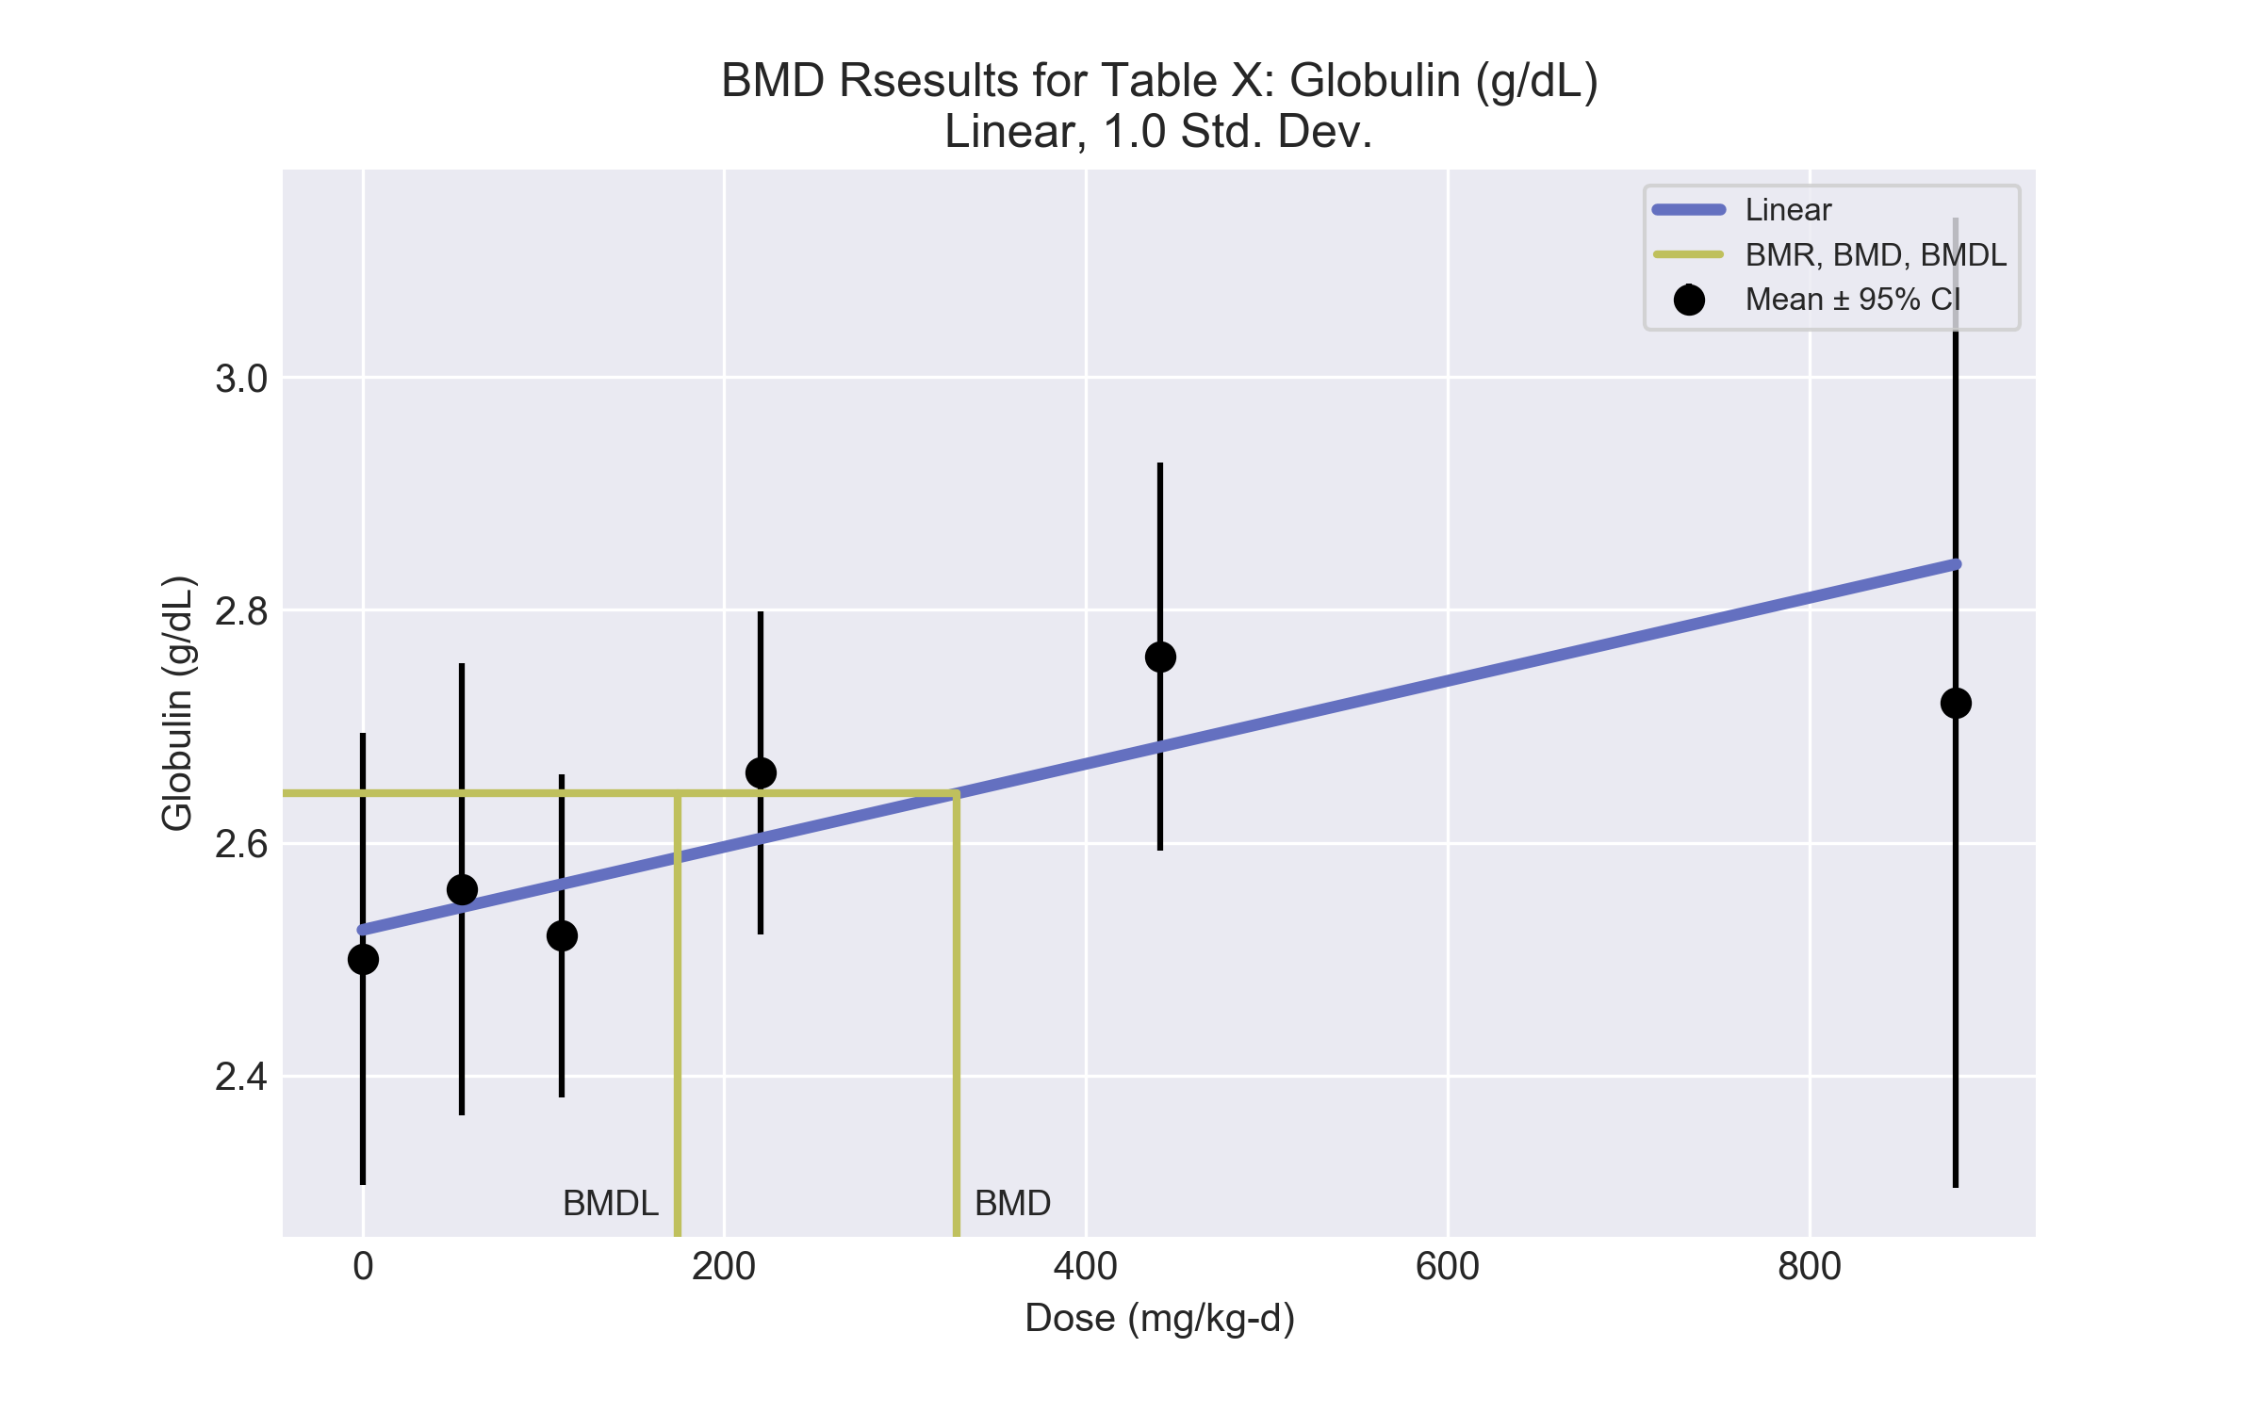
====================================================================
Polynomial Model. (Version: 2.21; Date: 03/14/2017)
Input Data File: C:\Users\USERNAME\AppData\Local\Temp\2\bmds-o1vuem1o.(d)
Gnuplot Plotting File: C:\Users\USERNAME\AppData\Local\Temp\2\bmds-o1vuem1o.plt
Mon Dec 18 12:02:51 2017
====================================================================
BMDS_Model_Run
~~~~~~~~~~~~~~~~~~~~~~~~~~~~~~~~~~~~~~~~~~~~~~~~~~~~~~~~~~~~~~~~~~~~~
The form of the response function is:
Y[dose] = beta_0 + beta_1*dose + beta_2*dose^2 + ...
Dependent variable = Response
Independent variable = Dose
The polynomial coefficients are restricted to be positive
The variance is to be modeled as Var(i) = exp(lalpha + log(mean(i)) * rho)
Total number of dose groups = 6
Total number of records with missing values = 0
Maximum number of iterations = 500
Relative Function Convergence has been set to: 1e-008
Parameter Convergence has been set to: 1e-008
Default Initial Parameter Values
lalpha = -3.37895
rho = 0
beta_0 = 2.54514
beta_1 = 0
Asymptotic Correlation Matrix of Parameter Estimates
lalpha rho beta_0 beta_1
lalpha 1 -1 0.4 -0.55
rho -1 1 -0.4 0.55
beta_0 0.4 -0.4 1 -0.71
beta_1 -0.55 0.55 -0.71 1
Parameter Estimates
95.0% Wald Confidence Interval
Variable Estimate Std. Err. Lower Conf. Limit Upper Conf. Limit
lalpha -18.0817 6.56888 -30.9565 -5.20694
rho 14.89 6.80127 1.55975 28.2202
beta_0 2.52507 0.0378055 2.45097 2.59917
beta_1 0.000356622 0.000169673 2.40692e-005 0.000689175
Table of Data and Estimated Values of Interest
Dose N Obs Mean Est Mean Obs Std Dev Est Std Dev Scaled Res.
------ --- -------- -------- ----------- ----------- ----------
0 5 2.5 2.53 0.157 0.117 -0.479
55 5 2.56 2.54 0.157 0.124 0.276
110 5 2.52 2.56 0.112 0.131 -0.754
220 5 2.66 2.6 0.112 0.147 0.859
441 5 2.76 2.68 0.134 0.184 0.946
881 5 2.72 2.84 0.335 0.28 -0.951
Model Descriptions for likelihoods calculated
Model A1: Yij = Mu(i) + e(ij)
Var{e(ij)} = Sigma^2
Model A2: Yij = Mu(i) + e(ij)
Var{e(ij)} = Sigma(i)^2
Model A3: Yij = Mu(i) + e(ij)
Var{e(ij)} = exp(lalpha + rho*ln(Mu(i)))
Model A3 uses any fixed variance parameters that
were specified by the user
Model R: Yi = Mu + e(i)
Var{e(i)} = Sigma^2
Likelihoods of Interest
Model Log(likelihood) # Param's AIC
A1 39.031368 7 -64.062736
A2 44.308187 12 -64.616375
A3 41.549606 8 -67.099212
fitted 40.727847 4 -73.455694
R 34.398613 2 -64.797227
Explanation of Tests
Test 1: Do responses and/or variances differ among Dose levels?
(A2 vs. R)
Test 2: Are Variances Homogeneous? (A1 vs A2)
Test 3: Are variances adequately modeled? (A2 vs. A3)
Test 4: Does the Model for the Mean Fit? (A3 vs. fitted)
(Note: When rho=0 the results of Test 3 and Test 2 will be the same.)
Tests of Interest
Test -2*log(Likelihood Ratio) Test df p-value
Test 1 19.8191 10 0.03101
Test 2 10.5536 5 0.06098
Test 3 5.51716 4 0.2382
Test 4 1.64352 4 0.801
The p-value for Test 1 is less than .05. There appears to be a
difference between response and/or variances among the dose levels
It seems appropriate to model the data
The p-value for Test 2 is less than .1. A non-homogeneous variance
model appears to be appropriate
The p-value for Test 3 is greater than .1. The modeled variance appears
to be appropriate here
The p-value for Test 4 is greater than .1. The model chosen seems
to adequately describe the data
Benchmark Dose Computation
Specified effect = 1
Risk Type = Estimated standard deviations from the control mean
Confidence level = 0.95
BMD = 328.341
BMDL = 174.01
BMDU = 836.468

  - BMD Results for: A/G Ratio
BMDS version: BMDS v2.7.0
    - Input dataset
Dose | 0 | 55 | 110 | 220 | 441 | 881
N | 5 | 5 | 5 | 5 | 5 | 5
Mean ± SD | 1.38 ± 0.067 | 1.31 ± 0.022 | 1.34 ± 0.045 | 1.28 ± 0.045 | 1.22 ± 0.067 | 1.16 ± 0.157

    - Summary table
Modelª | Goodness of fit |  | BMD | BMDL | Comments
 | p-value | AIC
Linear (equivalent models include Power, Polynomial 2°, 3°, 4°, 5°) | 0.579 | -128.729 | 162.514 | 104.092 | No model was recommended as a best-fitting model.
Hill | 0.464 | -127.042 | 128.658 | 55.684
Exponential M2 (equivalent models include Exponential M3) | 0.606 | -128.888 | 151.177 | 95.514
Exponential M4 (equivalent models include Exponential M5) | 0.463 | -127.036 | 130.281 | 61.506
ª Modeled variance case presented (BMDS Test 2 p-value = 8.6E-04, BMDS Test 3 p-value = 0.044).

    - Model recommendation details
Model | Bin | Notes
Linear (equivalent models include Power, Polynomial 2°, 3°, 4°, 5°) | Warning | Warnings  • Variance model fit p-value is less than threshold (0.0435 < 0.1)  • Ratio of modeled to actual stdev. at control is greater than threshold (1.51 > 1.5)
Hill | Warning | Warnings  • Variance model fit p-value is less than threshold (0.0435 < 0.1)  • Ratio of modeled to actual stdev. at control is greater than threshold (1.54 > 1.5)
Exponential M2 (equivalent models include Exponential M3) | Warning | Warnings  • Variance model fit p-value is less than threshold (0.0435 < 0.1)
Exponential M4 (equivalent models include Exponential M5) | Warning | Warnings  • Variance model fit p-value is less than threshold (0.0435 < 0.1)

    - Recommended model
No model was recommended as a best-fitting model.

  - BMD Results for: Albumin (g/dL)
BMDS version: BMDS v2.7.0
    - Input dataset
Dose | 0 | 55 | 110 | 220 | 441 | 881
N | 5 | 5 | 5 | 5 | 5 | 5
Mean ± SD | 3.44 ± 0.157 | 3.36 ± 0.157 | 3.38 ± 0.089 | 3.4 ± 0.089 | 3.36 ± 0.134 | 3.12 ± 0.134

    - Summary table
Modelª | Goodness of fit |  | BMD | BMDL | Comments
 | p-value | AIC
Linear | 0.458 | -89.592 | 393.215 | 271.887 | Polynomial-2 recommended as best-fitting model on the basis of the lowest AIC.
Polynomial 2°^{b} | 0.811 | -91.639 | 575.928 | 322.39
Polynomial 3° | 0.739 | -89.967 | 644.104 | 337.35
Polynomial 4° | 0.752 | -90.021 | 666.397 | 338.843
Polynomial 5° | 0.755 | -90.033 | 686.724 | 338.672
Power | 0.733 | -89.941 | 663.984 | 338.51
Hill | 0.529 | -87.954 | 484.721 | -999
Exponential M2 (equivalent models include Exponential M4) | 0.438 | -89.453 | 388.098 | 263.966
Exponential M3 | 0.733 | -89.941 | 662.072 | 342.222
Exponential M5 | 0.529 | -87.954 | 481.377 | 343.203
ª Constant variance case presented (BMDS Test 2 p-value = 0.698, BMDS Test 3 p-value = 0.698).
^{b} Recommended model

    - Model recommendation details
Model | Bin | Notes
Linear | Valid | -
Polynomial 2°ª | Valid | -
Polynomial 3° | Valid | -
Polynomial 4° | Valid | -
Polynomial 5° | Valid | -
Power | Valid | -
Hill | Failure | Failures  • BMDL does not exist  Cautions  • Warning(s): BMDL computation failed.
Exponential M2 (equivalent models include Exponential M4) | Valid | -
Exponential M3 | Valid | -
Exponential M5 | Valid | -
ª Recommended model

    - Recommended model
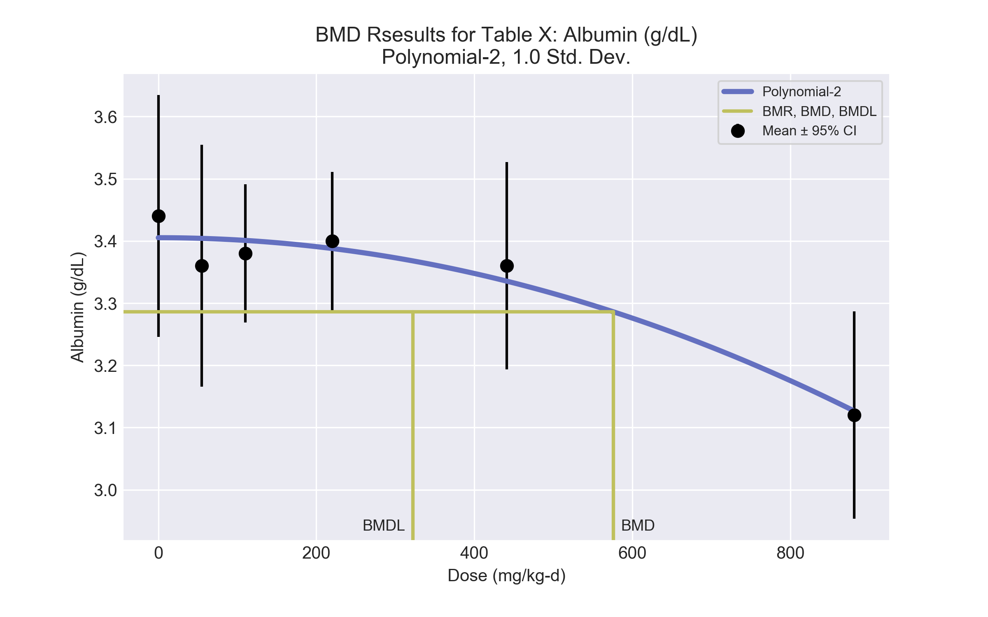
====================================================================
Polynomial Model. (Version: 2.21; Date: 03/14/2017)
Input Data File: C:\Users\USERNAME\AppData\Local\Temp\2\bmds-5aoqc6m7.(d)
Gnuplot Plotting File: C:\Users\USERNAME\AppData\Local\Temp\2\bmds-5aoqc6m7.plt
Mon Dec 18 12:02:54 2017
====================================================================
BMDS_Model_Run
~~~~~~~~~~~~~~~~~~~~~~~~~~~~~~~~~~~~~~~~~~~~~~~~~~~~~~~~~~~~~~~~~~~~~
The form of the response function is:
Y[dose] = beta_0 + beta_1*dose + beta_2*dose^2 + ...
Dependent variable = Response
Independent variable = Dose
rho is set to 0
The polynomial coefficients are restricted to be negative
A constant variance model is fit
Total number of dose groups = 6
Total number of records with missing values = 0
Maximum number of iterations = 500
Relative Function Convergence has been set to: 1e-008
Parameter Convergence has been set to: 1e-008
Default Initial Parameter Values
alpha = 0.0168334
rho = 0 Specified
beta_0 = 3.39645
beta_1 = 0
beta_2 = -4.48363e-007
Asymptotic Correlation Matrix of Parameter Estimates
( *** The model parameter(s) -rho -beta_1
have been estimated at a boundary point, or have been specified by the user,
and do not appear in the correlation matrix )
alpha beta_0 beta_2
alpha 1 -2.3e-013 9.5e-014
beta_0 -2.3e-013 1 -0.53
beta_2 9.5e-014 -0.53 1
Parameter Estimates
95.0% Wald Confidence Interval
Variable Estimate Std. Err. Lower Conf. Limit Upper Conf. Limit
alpha 0.0141983 0.00366597 0.00701308 0.0213834
beta_0 3.40525 0.0255909 3.35509 3.45541
beta_1 -0 NA
beta_2 -3.59237e-007 7.81882e-008 -5.12483e-007 -2.05991e-007
NA - Indicates that this parameter has hit a bound
implied by some inequality constraint and thus
has no standard error.
Table of Data and Estimated Values of Interest
Dose N Obs Mean Est Mean Obs Std Dev Est Std Dev Scaled Res.
------ --- -------- -------- ----------- ----------- ----------
0 5 3.44 3.41 0.157 0.119 0.652
55 5 3.36 3.4 0.157 0.119 -0.829
110 5 3.38 3.4 0.0894 0.119 -0.392
220 5 3.4 3.39 0.0894 0.119 0.228
441 5 3.36 3.34 0.134 0.119 0.462
881 5 3.12 3.13 0.134 0.119 -0.121
Model Descriptions for likelihoods calculated
Model A1: Yij = Mu(i) + e(ij)
Var{e(ij)} = Sigma^2
Model A2: Yij = Mu(i) + e(ij)
Var{e(ij)} = Sigma(i)^2
Model A3: Yij = Mu(i) + e(ij)
Var{e(ij)} = Sigma^2
Model A3 uses any fixed variance parameters that
were specified by the user
Model R: Yi = Mu + e(i)
Var{e(i)} = Sigma^2
Likelihoods of Interest
Model Log(likelihood) # Param's AIC
A1 49.613036 7 -85.226071
A2 51.121009 12 -78.242019
A3 49.613036 7 -85.226071
fitted 48.819541 3 -91.639083
R 40.827911 2 -77.655822
Explanation of Tests
Test 1: Do responses and/or variances differ among Dose levels?
(A2 vs. R)
Test 2: Are Variances Homogeneous? (A1 vs A2)
Test 3: Are variances adequately modeled? (A2 vs. A3)
Test 4: Does the Model for the Mean Fit? (A3 vs. fitted)
(Note: When rho=0 the results of Test 3 and Test 2 will be the same.)
Tests of Interest
Test -2*log(Likelihood Ratio) Test df p-value
Test 1 20.5862 10 0.02417
Test 2 3.01595 5 0.6975
Test 3 3.01595 5 0.6975
Test 4 1.58699 4 0.8111
The p-value for Test 1 is less than .05. There appears to be a
difference between response and/or variances among the dose levels
It seems appropriate to model the data
The p-value for Test 2 is greater than .1. A homogeneous variance
model appears to be appropriate here
The p-value for Test 3 is greater than .1. The modeled variance appears
to be appropriate here
The p-value for Test 4 is greater than .1. The model chosen seems
to adequately describe the data
Benchmark Dose Computation
Specified effect = 1
Risk Type = Estimated standard deviations from the control mean
Confidence level = 0.95
BMD = 575.928
BMDL = 322.39
BMDU = 752.524

  - BMD Results for: Cholesterol (mg/dL)
BMDS version: BMDS v2.7.0
    - Input dataset
Dose | 0 | 55 | 110 | 220 | 441 | 881
N | 5 | 5 | 5 | 5 | 5 | 5
Mean ± SD | 101 ± 12.969 | 115 ± 14.534 | 122.4 ± 13.864 | 127.8 ± 14.087 | 145.4 ± 16.323 | 170 ± 43.38

    - Summary table
Modelª | Goodness of fit |  | BMD | BMDL | Comments
 | p-value | AIC
Linear^{b} (equivalent models include Power, Polynomial 2°, 3°, 4°, 5°) | 0.621 | 207.282 | 141.641 | 90.374 | Linear recommended as best-fitting model on the basis of the lowest AIC.
Hill | 0.604 | 208.5 | 86.758 | -999
Exponential M2 (equivalent models include Exponential M3) | 0.474 | 208.175 | 181.264 | 121.434
Exponential M4 (equivalent models include Exponential M5) | 0.583 | 208.599 | 94.577 | 41.241
ª Modeled variance case presented (BMDS Test 2 p-value = 0.011, BMDS Test 3 p-value = 0.63).
^{b} Recommended model

    - Model recommendation details
Model | Bin | Notes
Linearª (equivalent models include Power, Polynomial 2°, 3°, 4°, 5°) | Valid | -
Hill | Failure | Failures  • BMDL does not exist  Cautions  • Warning(s): BMDL computation failed.
Exponential M2 (equivalent models include Exponential M3) | Valid | -
Exponential M4 (equivalent models include Exponential M5) | Valid | -
ª Recommended model

    - Recommended model
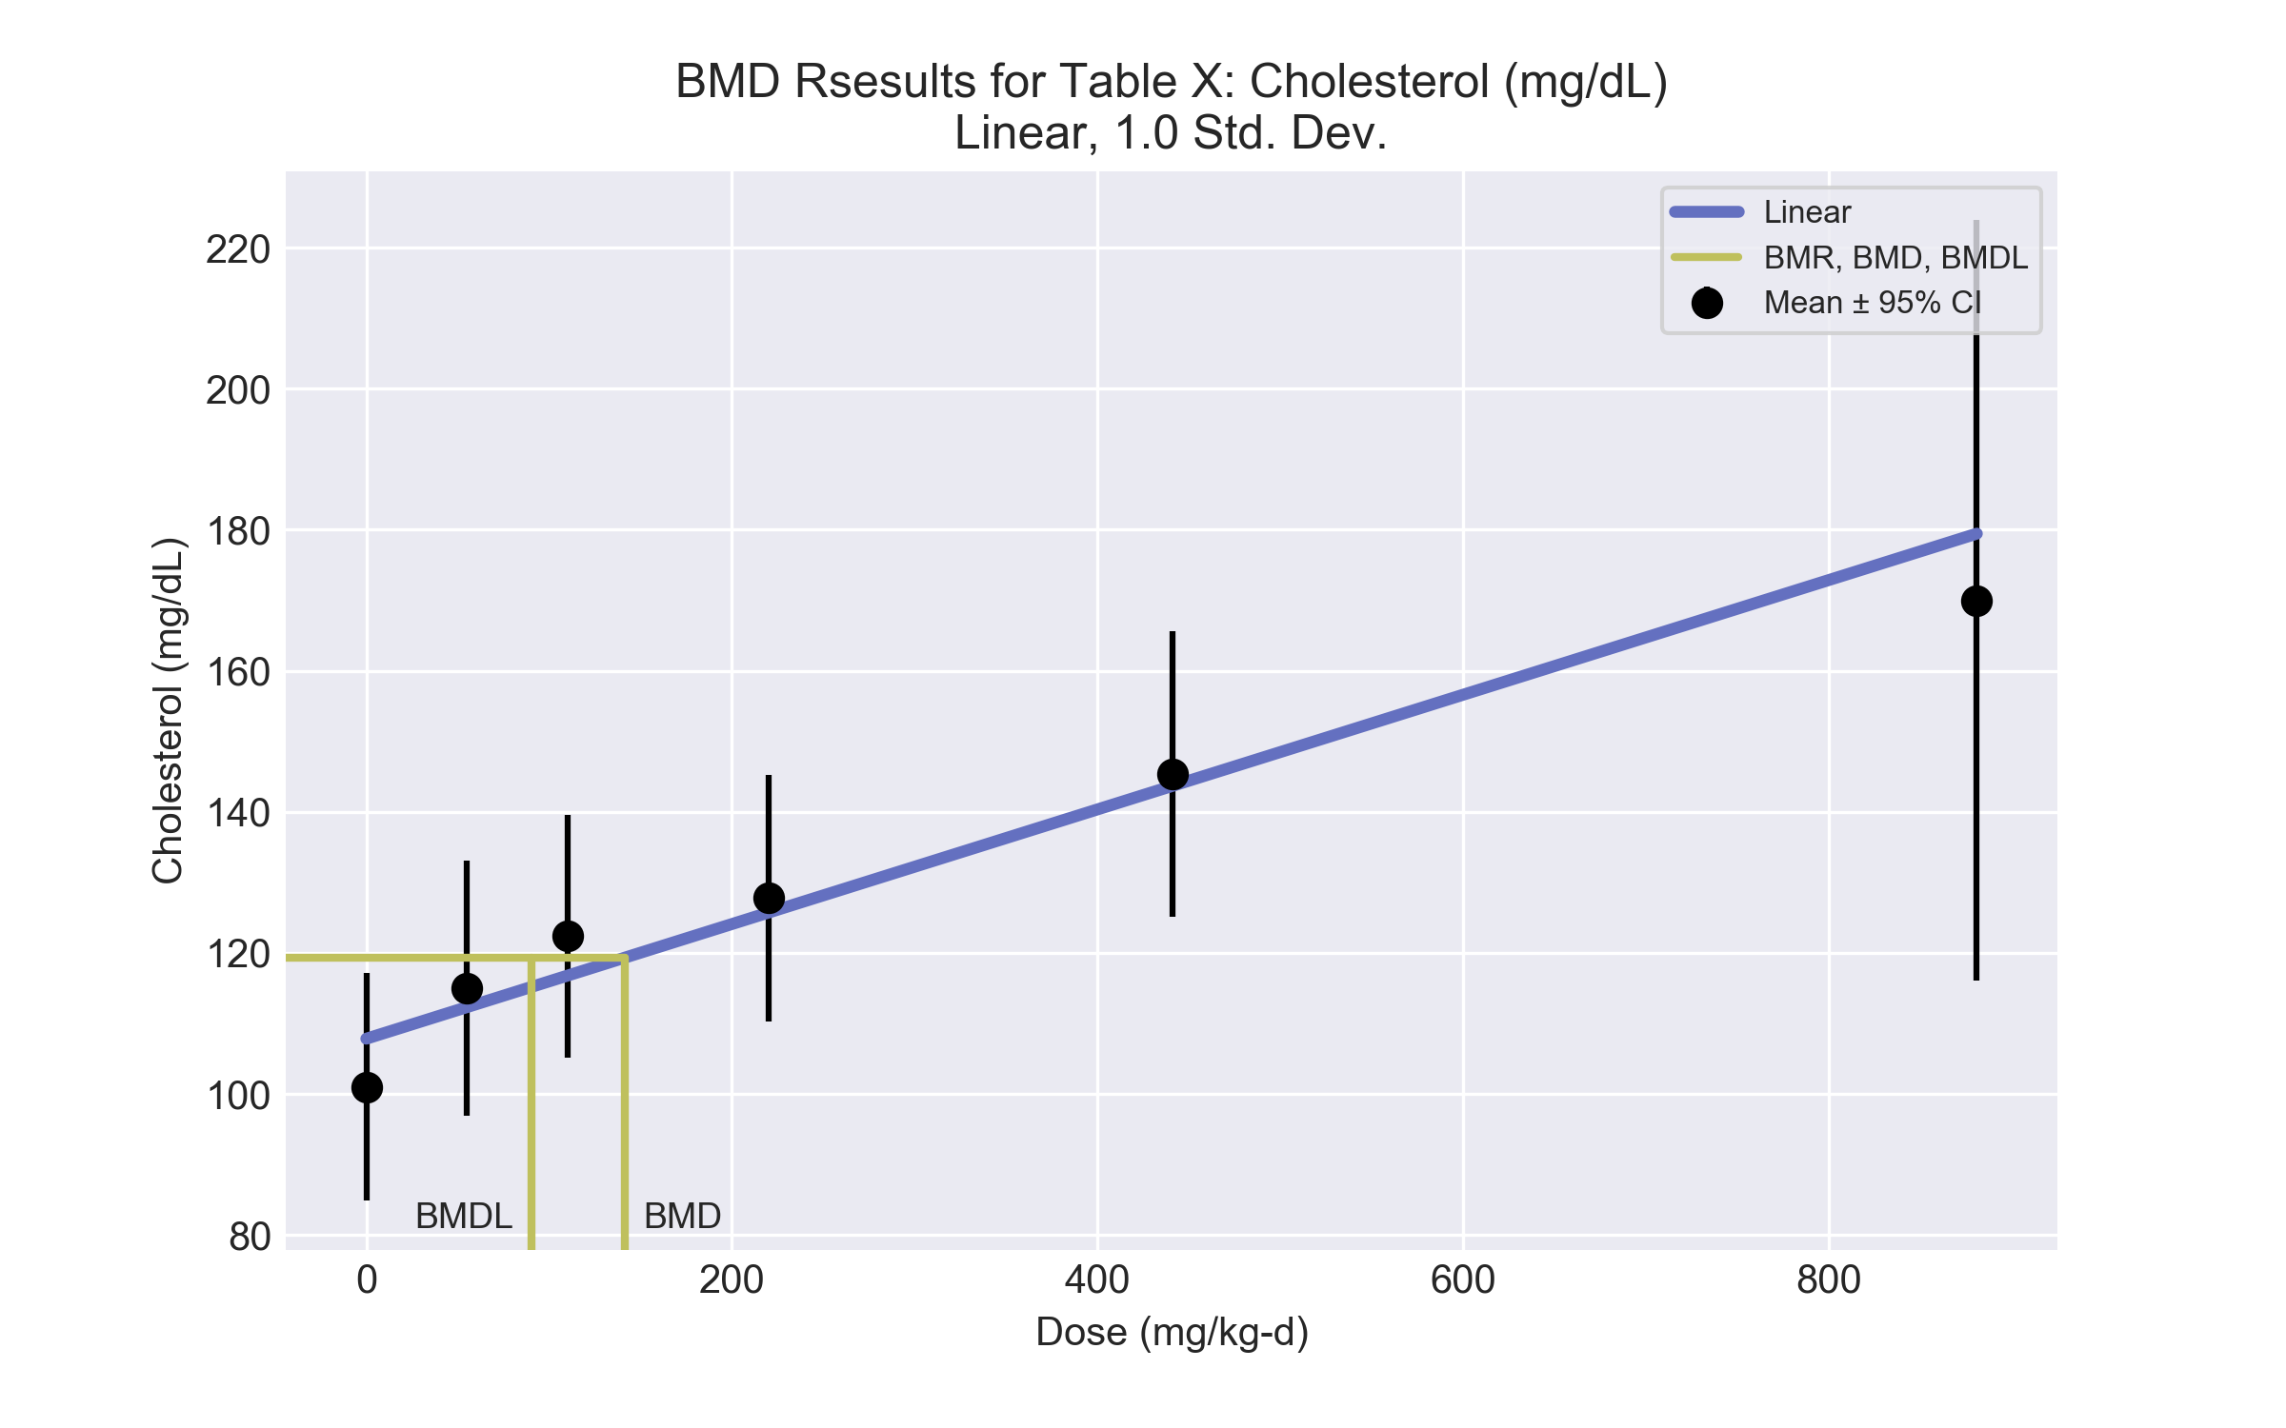
====================================================================
Polynomial Model. (Version: 2.21; Date: 03/14/2017)
Input Data File: C:\Users\USERNAME\AppData\Local\Temp\2\bmds-pveozi1h.(d)
Gnuplot Plotting File: C:\Users\USERNAME\AppData\Local\Temp\2\bmds-pveozi1h.plt
Mon Dec 18 12:02:56 2017
====================================================================
BMDS_Model_Run
~~~~~~~~~~~~~~~~~~~~~~~~~~~~~~~~~~~~~~~~~~~~~~~~~~~~~~~~~~~~~~~~~~~~~
The form of the response function is:
Y[dose] = beta_0 + beta_1*dose + beta_2*dose^2 + ...
Dependent variable = Response
Independent variable = Dose
The polynomial coefficients are restricted to be positive
The variance is to be modeled as Var(i) = exp(lalpha + log(mean(i)) * rho)
Total number of dose groups = 6
Total number of records with missing values = 0
Maximum number of iterations = 500
Relative Function Convergence has been set to: 1e-008
Parameter Convergence has been set to: 1e-008
Default Initial Parameter Values
lalpha = 6.18701
rho = 0
beta_0 = 109.815
beta_1 = 0.0718858
Asymptotic Correlation Matrix of Parameter Estimates
lalpha rho beta_0 beta_1
lalpha 1 -1 0.27 -0.38
rho -1 1 -0.27 0.38
beta_0 0.27 -0.27 1 -0.64
beta_1 -0.38 0.38 -0.64 1
Parameter Estimates
95.0% Wald Confidence Interval
Variable Estimate Std. Err. Lower Conf. Limit Upper Conf. Limit
lalpha -14.9482 6.91119 -28.4939 -1.40256
rho 4.23775 1.42088 1.45289 7.02262
beta_0 107.835 3.58466 100.81 114.861
beta_1 0.0812855 0.0164193 0.0491043 0.113467
Table of Data and Estimated Values of Interest
Dose N Obs Mean Est Mean Obs Std Dev Est Std Dev Scaled Res.
------ --- -------- -------- ----------- ----------- ----------
0 5 101 108 13 11.5 -1.33
55 5 115 112 14.5 12.5 0.48
110 5 122 117 13.9 13.6 0.923
220 5 128 126 14.1 15.9 0.292
441 5 145 144 16.3 21.1 0.182
881 5 170 179 43.4 33.9 -0.624
Model Descriptions for likelihoods calculated
Model A1: Yij = Mu(i) + e(ij)
Var{e(ij)} = Sigma^2
Model A2: Yij = Mu(i) + e(ij)
Var{e(ij)} = Sigma(i)^2
Model A3: Yij = Mu(i) + e(ij)
Var{e(ij)} = exp(lalpha + rho*ln(Mu(i)))
Model A3 uses any fixed variance parameters that
were specified by the user
Model R: Yi = Mu + e(i)
Var{e(i)} = Sigma^2
Likelihoods of Interest
Model Log(likelihood) # Param's AIC
A1 -104.458060 7 222.916119
A2 -97.033947 12 218.067894
A3 -98.324126 8 212.648251
fitted -99.641128 4 207.282256
R -116.755577 2 237.511154
Explanation of Tests
Test 1: Do responses and/or variances differ among Dose levels?
(A2 vs. R)
Test 2: Are Variances Homogeneous? (A1 vs A2)
Test 3: Are variances adequately modeled? (A2 vs. A3)
Test 4: Does the Model for the Mean Fit? (A3 vs. fitted)
(Note: When rho=0 the results of Test 3 and Test 2 will be the same.)
Tests of Interest
Test -2*log(Likelihood Ratio) Test df p-value
Test 1 39.4433 10 <.0001
Test 2 14.8482 5 0.01103
Test 3 2.58036 4 0.6303
Test 4 2.634 4 0.6208
The p-value for Test 1 is less than .05. There appears to be a
difference between response and/or variances among the dose levels
It seems appropriate to model the data
The p-value for Test 2 is less than .1. A non-homogeneous variance
model appears to be appropriate
The p-value for Test 3 is greater than .1. The modeled variance appears
to be appropriate here
The p-value for Test 4 is greater than .1. The model chosen seems
to adequately describe the data
Benchmark Dose Computation
Specified effect = 1
Risk Type = Estimated standard deviations from the control mean
Confidence level = 0.95
BMD = 141.641
BMDL = 90.3744
BMDU = 238.643

  - BMD Results for: Triglyceride (mg/dL)
BMDS version: BMDS v2.7.0
    - Input dataset
Dose | 0 | 55 | 110 | 220 | 441 | 881
N | 5 | 5 | 5 | 5 | 5 | 5
Mean ± SD | 54 ± 13.416 | 53.8 ± 3.13 | 61.6 ± 15.205 | 74 ± 13.64 | 53 ± 11.851 | 140.6 ± 132.152

    - Summary table
Modelª | Goodness of fit |  | BMD | BMDL | Comments
 | p-value | AIC
Linear | 0.005 | 219.404 | 187.888 | 86.465 | No model was recommended as a best-fitting model.
Polynomial 2° | 0.004 | 219.699 | 288.455 | 107.505
Polynomial 3° | 0.005 | 219.061 | 329.975 | 113.749
Polynomial 4° | 0.007 | 218.469 | 373.155 | 119.889
Polynomial 5° | 0.009 | 218.03 | 414.794 | 125.005
Power | 0.02 | 216.027 | 797.502 | 161.184
Hill | 0.009 | 218.027 | 795.352 | -999
Exponential M2 | 0.008 | 218.079 | 199.274 | 116.768
Exponential M3 | 0.004 | 219.593 | 284.268 | 121.676
Exponential M4 | 0.002 | 221.404 | 187.89 | 86.464
Exponential M5 | 0.001 | 221.98 | 276.407 | 105.057
ª Modeled variance case presented (BMDS Test 2 p-value = <0.0001, BMDS Test 3 p-value = 0.067).

    - Model recommendation details
Model | Bin | Notes
Linear | Warning | Warnings  • Variance model fit p-value is less than threshold (0.0672 < 0.1)  • Goodness of fit p-value is less than threshold (0.00461 < 0.1)  • Ratio of modeled to actual stdev. at control is greater than threshold (1.59 > 1.5)  Cautions  • Warning(s): THE MODEL HAS PROBABLY NOT CONVERGED!!!; THIS USUALLY MEANS THE MODEL HAS NOT CONVERGED!
Polynomial 2° | Warning | Warnings  • Variance model fit p-value is less than threshold (0.0672 < 0.1)  • Goodness of fit p-value is less than threshold (0.00396 < 0.1)  Cautions  • Warning(s): THE MODEL HAS PROBABLY NOT CONVERGED!!!; THIS USUALLY MEANS THE MODEL HAS NOT CONVERGED!
Polynomial 3° | Warning | Warnings  • Variance model fit p-value is less than threshold (0.0672 < 0.1)  • Goodness of fit p-value is less than threshold (0.00533 < 0.1)  Cautions  • Warning(s): THE MODEL HAS PROBABLY NOT CONVERGED!!!; THIS USUALLY MEANS THE MODEL HAS NOT CONVERGED!
Polynomial 4° | Warning | Warnings  • Variance model fit p-value is less than threshold (0.0672 < 0.1)  • Goodness of fit p-value is less than threshold (0.00702 < 0.1)
Polynomial 5° | Warning | Warnings  • Variance model fit p-value is less than threshold (0.0672 < 0.1)  • Goodness of fit p-value is less than threshold (0.0086 < 0.1)
Power | Warning | Warnings  • Variance model fit p-value is less than threshold (0.0672 < 0.1)  • Goodness of fit p-value is less than threshold (0.02 < 0.1)
Hill | Failure | Failures  • BMDL does not exist  Warnings  • Variance model fit p-value is less than threshold (0.0672 < 0.1)  • Goodness of fit p-value is less than threshold (0.00861 < 0.1)  Cautions  • Warning(s): BMDL computation failed.
Exponential M2 | Warning | Warnings  • Variance model fit p-value is less than threshold (0.0672 < 0.1)  • Goodness of fit p-value is less than threshold (0.00825 < 0.1)
Exponential M3 | Warning | Warnings  • Variance model fit p-value is less than threshold (0.0672 < 0.1)  • Goodness of fit p-value is less than threshold (0.00416 < 0.1)
Exponential M4 | Warning | Warnings  • Variance model fit p-value is less than threshold (0.0672 < 0.1)  • Goodness of fit p-value is less than threshold (0.00178 < 0.1)
Exponential M5 | Warning | Warnings  • Variance model fit p-value is less than threshold (0.0672 < 0.1)  • Goodness of fit p-value is less than threshold (0.0011 < 0.1)

    - Recommended model
No model was recommended as a best-fitting model.

  - BMD Results for: LDL Cholesterol (mg/dL)
BMDS version: BMDS v2.7.0
    - Input dataset
Dose | 0 | 55 | 110 | 220 | 441 | 881
N | 5 | 5 | 5 | 5 | 5 | 5
Mean ± SD | 21.8 ± 1.565 | 21.8 ± 2.46 | 23.2 ± 2.012 | 23.8 ± 3.354 | 23.4 ± 2.46 | 32.8 ± 14.311

    - Summary table
Modelª | Goodness of fit |  | BMD | BMDL | Comments
 | p-value | AIC
Linear | 0.273 | 106.015 | 197.86 | 104.536 | Exponential-M2 recommended as best-fitting model on the basis of the lowest AIC.
Polynomial 2° | 0.218 | 107.306 | 299.379 | 112.801
Polynomial 3° | 0.287 | 106.648 | 346.581 | 123.133
Polynomial 4° | 0.35 | 106.156 | 375.742 | 132.71
Polynomial 5° | 0.393 | 105.863 | 390.392 | 137.804
Power | 0.186 | 107.689 | 582.268 | 108.07
Hill | 0.09 | 109.69 | 582.718 | -999
Exponential M2^{b} | 0.308 | 105.68 | 212.502 | 123.028
Exponential M3 | 0.198 | 107.544 | 288.549 | 124.467
Exponential M4 | 0.162 | 108.017 | 197.799 | 92.074
Exponential M5 | 0.086 | 109.777 | 290.279 | 95.73
ª Modeled variance case presented (BMDS Test 2 p-value = <0.0001, BMDS Test 3 p-value = 0.848).
^{b} Recommended model

    - Model recommendation details
Model | Bin | Notes
Linear | Valid | -
Polynomial 2° | Valid | Cautions  • Warning(s): THE MODEL HAS PROBABLY NOT CONVERGED!!!; THIS USUALLY MEANS THE MODEL HAS NOT CONVERGED!
Polynomial 3° | Valid | -
Polynomial 4° | Valid | -
Polynomial 5° | Valid | -
Power | Valid | Cautions  • BMD/BMDL ratio is greater than threshold (5.39 > 5.0)
Hill | Failure | Failures  • BMDL does not exist  Warnings  • Goodness of fit p-value is less than threshold (0.0899 < 0.1)  Cautions  • Warning(s): BMDL computation failed.
Exponential M2ª | Valid | -
Exponential M3 | Valid | -
Exponential M4 | Valid | -
Exponential M5 | Warning | Warnings  • Goodness of fit p-value is less than threshold (0.0861 < 0.1)
ª Recommended model

    - Recommended model
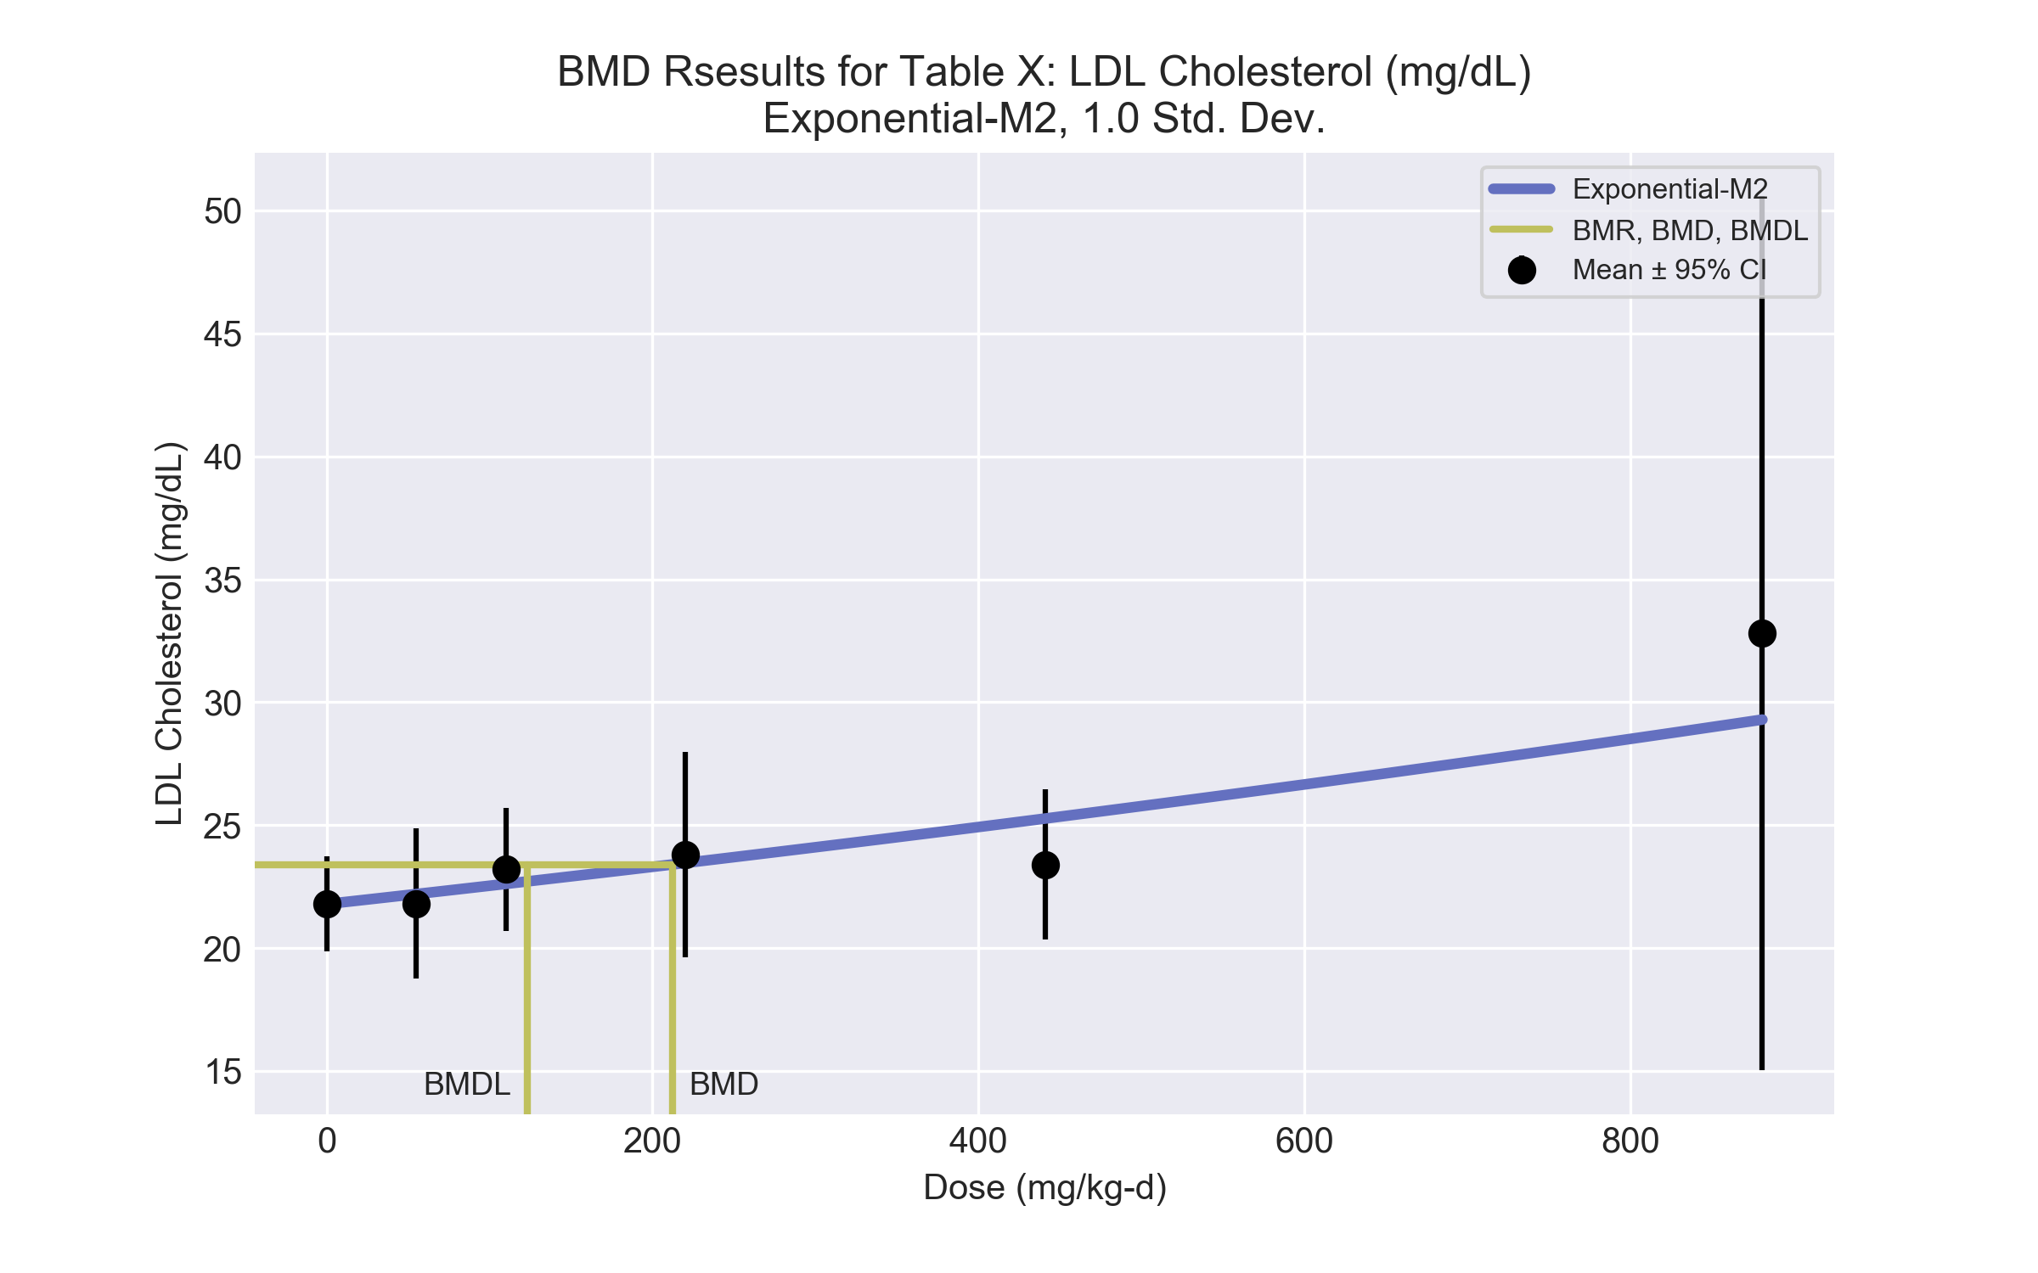
====================================================================
Exponential Model. (Version: 1.11; Date: 03/14/2017)
Input Data File: C:\Users\USERNAME\AppData\Local\Temp\2\bmds-fv1sx_c7.(d)
Gnuplot Plotting File:
Mon Dec 18 12:03:02 2017
====================================================================
BMDS_Model_Run
~~~~~~~~~~~~~~~~~~~~~~~~~~~~~~~~~~~~~~~~~~~~~~~~~~~~~~~~~~~~~~~~~~~~~
The form of the response function by Model:
Model 2: Y[dose] = a * exp{sign * b * dose}
Model 3: Y[dose] = a * exp{sign * (b * dose)^d}
Model 4: Y[dose] = a * [c-(c-1) * exp{-b * dose}]
Model 5: Y[dose] = a * [c-(c-1) * exp{-(b * dose)^d}]
Note: Y[dose] is the median response for exposure = dose;
sign = +1 for increasing trend in data;
sign = -1 for decreasing trend.
Model 2 is nested within Models 3 and 4.
Model 3 is nested within Model 5.
Model 4 is nested within Model 5.
Dependent variable = Response
Independent variable = Dose
Data are assumed to be distributed: normally
Variance Model: exp(lnalpha +rho *ln(Y[dose]))
The variance is to be modeled as Var(i) = exp(lalpha + log(mean(i)) * rho)
Total number of dose groups = 6
Total number of records with missing values = 0
Maximum number of iterations = 500
Relative Function Convergence has been set to: 1e-008
Parameter Convergence has been set to: 1e-008
MLE solution provided: Exact
Initial Parameter Values
Variable Model 2
-------- --------
lnalpha -29.4871
rho 9.96609
a 21.3967
b 0.000434333
c 0 Specified
d 1 Specified
Parameter Estimates
Variable Model 2 Std. Err.
-------- ------- ---------
lnalpha -40.9993 19.7613
rho 13.6154 6.31919
a 21.7884 0.51354
b 0.000335881 0.000138741
NC = No Convergence
Table of Stats From Input Data
Dose N Obs Mean Obs Std Dev
----- --- ---------- -------------
0 5 21.8 1.565
55 5 21.8 2.46
110 5 23.2 2.012
220 5 23.8 3.354
441 5 23.4 2.46
881 5 32.8 14.31
Estimated Values of Interest
Dose Est Mean Est Std Scaled Residual
------ ---------- --------- ----------------
0 21.79 1.612 0.01608
55 22.19 1.828 -0.4827
110 22.61 2.073 0.6381
220 23.46 2.666 0.2857
441 25.27 4.419 -0.9448
881 29.29 12.08 0.6492
Other models for which likelihoods are calculated:
Model A1: Yij = Mu(i) + e(ij)
Var{e(ij)} = Sigma^2
Model A2: Yij = Mu(i) + e(ij)
Var{e(ij)} = Sigma(i)^2
Model A3: Yij = Mu(i) + e(ij)
Var{e(ij)} = exp(lalpha + log(mean(i)) * rho)
Model R: Yij = Mu + e(i)
Var{e(ij)} = Sigma^2
Likelihoods of Interest
Model Log(likelihood) DF AIC
------- ----------------- ---- ------------
A1 -66.64788 7 147.2958
A2 -45.74616 12 115.4923
A3 -46.43633 8 108.8727
R -72.35188 2 148.7038
2 -48.84015 4 105.6803
Additive constant for all log-likelihoods = -27.57. This constant added to the
above values gives the log-likelihood including the term that does not
depend on the model parameters.
Explanation of Tests
Test 1: Does response and/or variances differ among Dose levels? (A2 vs. R)
Test 2: Are Variances Homogeneous? (A2 vs. A1)
Test 3: Are variances adequately modeled? (A2 vs. A3)
Test 4: Does Model 2 fit the data? (A3 vs. 2)
Tests of Interest
Test -2*log(Likelihood Ratio) D. F. p-value
-------- ------------------------ ------ --------------
Test 1 53.21 10 < 0.0001
Test 2 41.8 5 < 0.0001
Test 3 1.38 4 0.8476
Test 4 4.808 4 0.3076
The p-value for Test 1 is less than .05. There appears to be a
difference between response and/or variances among the dose
levels, it seems appropriate to model the data.
The p-value for Test 2 is less than .1. A non-homogeneous
variance model appears to be appropriate.
The p-value for Test 3 is greater than .1. The modeled
variance appears to be appropriate here.
The p-value for Test 4 is greater than .1. Model 2 seems
to adequately describe the data.
Benchmark Dose Computations:
Specified Effect = 1.000000
Risk Type = Estimated standard deviations from control
Confidence Level = 0.950000
BMD = 212.502
BMDL = 123.028
BMDU = 426.784

  - BMD Results for: HDL Cholesterol (mg/dL)
BMDS version: BMDS v2.7.0
    - Input dataset
Dose | 0 | 55 | 110 | 220 | 441 | 881
N | 5 | 5 | 5 | 5 | 5 | 5
Mean ± SD | 46 ± 6.485 | 54.6 ± 6.037 | 56.8 ± 6.261 | 60.6 ± 6.485 | 70.6 ± 7.155 | 78.2 ± 11.404

    - Summary table
Modelª | Goodness of fit |  | BMD | BMDL | Comments
 | p-value | AIC
Linear (equivalent models include Power, Polynomial 2°, 3°, 4°, 5°) | 0.176 | 156.83 | 225.091 | 171.588 | Hill recommended as best-fitting model on the basis of the lowest BMDL.
Hill^{b} | 0.762 | 153.671 | 79.236 | 38.558
Exponential M2 (equivalent models include Exponential M3) | 0.085 | 158.696 | 281.293 | 221.34
Exponential M4 (equivalent models include Exponential M5) | 0.722 | 153.84 | 90.238 | 51.481
ª Constant variance case presented (BMDS Test 2 p-value = 0.627, BMDS Test 3 p-value = 0.627).
^{b} Recommended model

    - Model recommendation details
Model | Bin | Notes
Linear (equivalent models include Power, Polynomial 2°, 3°, 4°, 5°) | Valid | -
Hillª | Valid | -
Exponential M2 (equivalent models include Exponential M3) | Warning | Warnings  • Goodness of fit p-value is less than threshold (0.085 < 0.1)
Exponential M4 (equivalent models include Exponential M5) | Valid | -
ª Recommended model

    - Recommended model
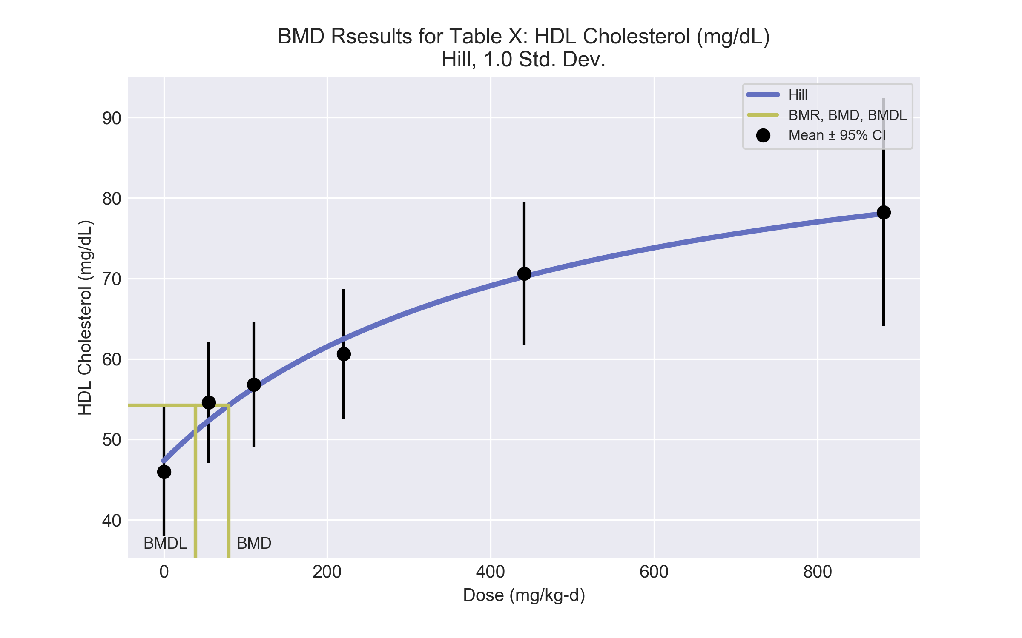
====================================================================
Hill Model. (Version: 2.18; Date: 03/14/2017)
Input Data File: C:\Users\USERNAME\AppData\Local\Temp\2\bmds-rsm6s3g8.(d)
Gnuplot Plotting File: C:\Users\USERNAME\AppData\Local\Temp\2\bmds-rsm6s3g8.plt
Mon Dec 18 12:03:04 2017
====================================================================
BMDS_Model_Run
~~~~~~~~~~~~~~~~~~~~~~~~~~~~~~~~~~~~~~~~~~~~~~~~~~~~~~~~~~~~~~~~~~~~~
The form of the response function is:
Y[dose] = intercept + v*dose^n/(k^n + dose^n)
Dependent variable = Response
Independent variable = Dose
rho is set to 0
Power parameter restricted to be greater than 1
A constant variance model is fit
Total number of dose groups = 6
Total number of records with missing values = 0
Maximum number of iterations = 500
Relative Function Convergence has been set to: 1e-008
Parameter Convergence has been set to: 1e-008
Default Initial Parameter Values
alpha = 56.8333
rho = 0 Specified
intercept = 46
v = 32.2
n = 0.246121
k = 628.85
Asymptotic Correlation Matrix of Parameter Estimates
( *** The model parameter(s) -rho -n
have been estimated at a boundary point, or have been specified by the user,
and do not appear in the correlation matrix )
alpha intercept v k
alpha 1 -1.2e-006 -2.4e-006 -2.9e-006
intercept -1.2e-006 1 0.3 0.66
v -2.4e-006 0.3 1 0.89
k -2.9e-006 0.66 0.89 1
Parameter Estimates
95.0% Wald Confidence Interval
Variable Estimate Std. Err. Lower Conf. Limit Upper Conf. Limit
alpha 47.2616 12.2029 23.3444 71.1788
intercept 47.3418 2.75195 41.9481 52.7356
v 46.7113 12.0284 23.1362 70.2865
n 1 NA
k 459.144 309.077 -146.636 1064.92
NA - Indicates that this parameter has hit a bound
implied by some inequality constraint and thus
has no standard error.
Table of Data and Estimated Values of Interest
Dose N Obs Mean Est Mean Obs Std Dev Est Std Dev Scaled Res.
------ --- -------- -------- ----------- ----------- ----------
0 5 46 47.3 6.48 6.87 -0.436
55 5 54.6 52.3 6.04 6.87 0.735
110 5 56.8 56.4 6.26 6.87 0.14
220 5 60.6 62.5 6.48 6.87 -0.609
441 5 70.6 70.2 7.16 6.87 0.121
881 5 78.2 78 11.4 6.87 0.049
Model Descriptions for likelihoods calculated
Model A1: Yij = Mu(i) + e(ij)
Var{e(ij)} = Sigma^2
Model A2: Yij = Mu(i) + e(ij)
Var{e(ij)} = Sigma(i)^2
Model A3: Yij = Mu(i) + e(ij)
Var{e(ij)} = Sigma^2
Model A3 uses any fixed variance parameters that
were specified by the user
Model R: Yi = Mu + e(i)
Var{e(i)} = Sigma^2
Likelihoods of Interest
Model Log(likelihood) # Param's AIC
A1 -72.254692 7 158.509385
A2 -70.517836 12 165.035672
A3 -72.254692 7 158.509385
fitted -72.835514 4 153.671029
R -90.882702 2 185.765405
Explanation of Tests
Test 1: Do responses and/or variances differ among Dose levels?
(A2 vs. R)
Test 2: Are Variances Homogeneous? (A1 vs A2)
Test 3: Are variances adequately modeled? (A2 vs. A3)
Test 4: Does the Model for the Mean Fit? (A3 vs. fitted)
(Note: When rho=0 the results of Test 3 and Test 2 will be the same.)
Tests of Interest
Test -2*log(Likelihood Ratio) Test df p-value
Test 1 40.7297 10 <.0001
Test 2 3.47371 5 0.6274
Test 3 3.47371 5 0.6274
Test 4 1.16164 3 0.7622
The p-value for Test 1 is less than .05. There appears to be a
difference between response and/or variances among the dose levels
It seems appropriate to model the data
The p-value for Test 2 is greater than .1. A homogeneous variance
model appears to be appropriate here
The p-value for Test 3 is greater than .1. The modeled variance appears
to be appropriate here
The p-value for Test 4 is greater than .1. The model chosen seems
to adequately describe the data
Benchmark Dose Computation
Specified effect = 1
Risk Type = Estimated standard deviations from the control mean
Confidence level = 0.95
BMD = 79.2356
BMDL = 38.5579
BMDU = 186.702

  - BMD Results for: Manual Hematocrit (%)
BMDS version: BMDS v2.7.0
    - Input dataset
Dose | 0 | 55 | 110 | 220 | 441 | 881
N | 5 | 5 | 5 | 5 | 5 | 5
Mean ± SD | 40 ± 2.236 | 42 ± 0 | 41 ± 2.236 | 41 ± 2.236 | 42 ± 2.236 | 44 ± 2.236

    - Summary table
Modelª | Goodness of fit |  | BMD | BMDL | Comments
 | p-value | AIC
Linear^{b} | <0.0001 | 76.939 | 509.521 | 298.479 | Linear recommended as best-fitting model on the basis of the lowest AIC.
Polynomial 2° | <0.0001 | 78.814 | 593.958 | 301.95
Polynomial 3° | <0.0001 | 78.779 | 610.688 | 302.927
Polynomial 4° (equivalent models include Polynomial 5°) | <0.0001 | 78.775 | 620.644 | 303.051
Power | <0.0001 | 78.904 | 593.051 | 299.438
Hill | <0.0001 | 80.904 | 593.405 | -999
Exponential M2 | <0.0001 | 85.609 | 1 | -999
Exponential M3 | <0.0001 | 69128 | 1 | -999
Exponential M4 | <0.0001 | 87.609 | -999 | 0
Exponential M5 | <0.0001 | 89.609 | 93622 | 308.133
ª Modeled variance case presented (BMDS Test 2 p-value = <0.0001, BMDS Test 3 p-value = <0.0001).
^{b} Recommended model

    - Model recommendation details
Model | Bin | Notes
Linearª | Valid | Cautions  • Warning(s): Warning: Likelihood for fitted model larger than the Likelihood for model A3.
Polynomial 2° | Valid | Cautions  • Warning(s): Warning: Likelihood for fitted model larger than the Likelihood for model A3.
Polynomial 3° | Valid | Cautions  • Warning(s): Warning: Likelihood for fitted model larger than the Likelihood for model A3.
Polynomial 4° (equivalent models include Polynomial 5°) | Valid | Cautions  • Warning(s): Warning: Likelihood for fitted model larger than the Likelihood for model A3.
Power | Valid | Cautions  • Warning(s): Warning: Likelihood for fitted model larger than the Likelihood for model A3.
Hill | Failure | Failures  • BMDL does not exist  Cautions  • Warning(s): BMDL computation failed.
Exponential M2 | Failure | Failures  • BMDL does not exist  Warnings  • BMD/minimum dose ratio is greater than threshold (55.0 > 10.0)  Cautions  • BMD/minimum dose ratio is greater than threshold (55.0 > 3.0)
Exponential M3 | Failure | Failures  • BMDL does not exist  Warnings  • BMD/minimum dose ratio is greater than threshold (55.0 > 10.0)  Cautions  • BMD/minimum dose ratio is greater than threshold (55.0 > 3.0)
Exponential M4 | Failure | Failures  • BMD does not exist  Warnings  • Residual of Interest does not exist
Exponential M5 | Warning | Warnings  • BMD/BMDL ratio is greater than threshold (3.04e+02 > 20.0)  Cautions  • BMD/BMDL ratio is greater than threshold (3.04e+02 > 5.0)  • Residual of interest is greater than threshold (2.36 > 2.0)  • BMD/high dose ratio is greater than threshold (1.06e+02 > 1.0)
ª Recommended model

    - Recommended model
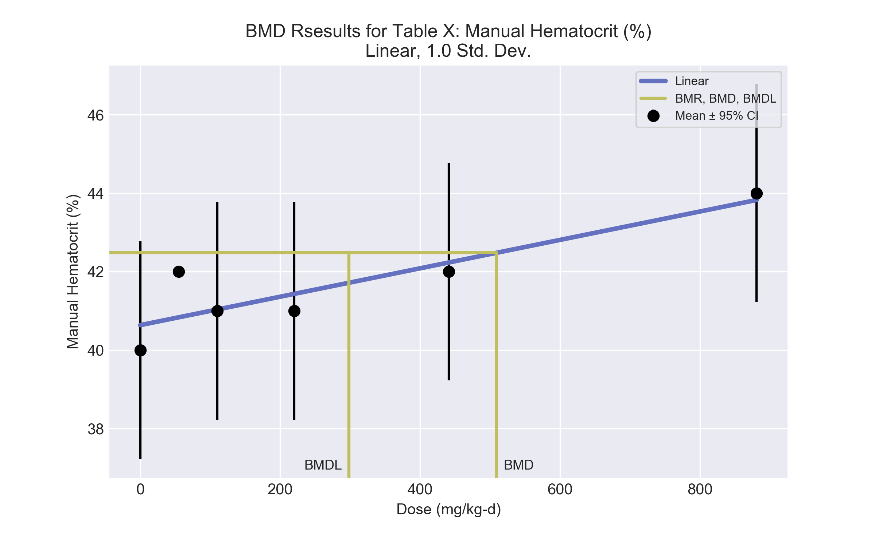
====================================================================
Polynomial Model. (Version: 2.21; Date: 03/14/2017)
Input Data File: C:\Users\USERNAME\AppData\Local\Temp\2\bmds-6lmxm28l.(d)
Gnuplot Plotting File: C:\Users\USERNAME\AppData\Local\Temp\2\bmds-6lmxm28l.plt
Mon Dec 18 12:03:04 2017
====================================================================
BMDS_Model_Run
~~~~~~~~~~~~~~~~~~~~~~~~~~~~~~~~~~~~~~~~~~~~~~~~~~~~~~~~~~~~~~~~~~~~~
The form of the response function is:
Y[dose] = beta_0 + beta_1*dose + beta_2*dose^2 + ...
Dependent variable = Response
Independent variable = Dose
The polynomial coefficients are restricted to be positive
The variance is to be modeled as Var(i) = exp(lalpha + log(mean(i)) * rho)
Total number of dose groups = 6
Total number of records with missing values = 0
Maximum number of iterations = 500
Relative Function Convergence has been set to: 1e-008
Parameter Convergence has been set to: 1e-008
Default Initial Parameter Values
lalpha = 1.42712
rho = 0
beta_0 = 40.6288
beta_1 = 0
Asymptotic Correlation Matrix of Parameter Estimates
lalpha rho beta_0 beta_1
lalpha 1 -1 -0.054 0.08
rho -1 1 0.054 -0.08
beta_0 -0.054 0.054 1 -0.67
beta_1 0.08 -0.08 -0.67 1
Parameter Estimates
95.0% Wald Confidence Interval
Variable Estimate Std. Err. Lower Conf. Limit Upper Conf. Limit
lalpha -9.68576 37.9496 -84.0656 64.6941
rho 2.9452 10.1757 -16.9987 22.8892
beta_0 40.6362 0.47116 39.7127 41.5596
beta_1 0.0036215 0.00120702 0.00125578 0.00598722
Table of Data and Estimated Values of Interest
Dose N Obs Mean Est Mean Obs Std Dev Est Std Dev Scaled Res.
------ --- -------- -------- ----------- ----------- ----------
0 5 40 40.6 2.24 1.85 -0.771
55 5 42 40.8 0 1.86 1.4
110 5 41 41 2.24 1.87 -0.0412
220 5 41 41.4 2.24 1.9 -0.51
441 5 42 42.2 2.24 1.95 -0.267
881 5 44 43.8 2.24 2.06 0.188
Warning: Likelihood for fitted model larger than the Likelihood for model A3.
Model Descriptions for likelihoods calculated
Model A1: Yij = Mu(i) + e(ij)
Var{e(ij)} = Sigma^2
Model A2: Yij = Mu(i) + e(ij)
Var{e(ij)} = Sigma(i)^2
Model A3: Yij = Mu(i) + e(ij)
Var{e(ij)} = exp(lalpha + rho*ln(Mu(i)))
Model A3 uses any fixed variance parameters that
were specified by the user
Model R: Yi = Mu + e(i)
Var{e(i)} = Sigma^2
Likelihoods of Interest
Model Log(likelihood) # Param's AIC
A1 -33.059592 7 80.119185
A2 1.#INF00 12 -1.#INF00
A3 -368262177617.213380 8 736524355250.426760
fitted -34.469285 4 76.938570
R -38.804476 2 81.608952
Explanation of Tests
Test 1: Do responses and/or variances differ among Dose levels?
(A2 vs. R)
Test 2: Are Variances Homogeneous? (A1 vs A2)
Test 3: Are variances adequately modeled? (A2 vs. A3)
Test 4: Does the Model for the Mean Fit? (A3 vs. fitted)
(Note: When rho=0 the results of Test 3 and Test 2 will be the same.)
Tests of Interest
Test -2*log(Likelihood Ratio) Test df p-value
Test 1 1.#INF 10 <.0001
Test 2 1.#INF 5 <.0001
Test 3 1.#INF 4 <.0001
Test 4 -7.36524e+011 4 <.0001
The p-value for Test 1 is greater than .05. There may not be a
diffence between responses and/or variances among the dose levels
Modelling the data with a dose/response curve may not be appropriate
The p-value for Test 2 is greater than .1. Consider running a
homogeneous model
The p-value for Test 3 is greater than .1. The modeled variance appears
to be appropriate here
The p-value for Test 4 is less than .1. You may want to try a different
model
Benchmark Dose Computation
Specified effect = 1
Risk Type = Estimated standard deviations from the control mean
Confidence level = 0.95
BMD = 509.521
BMDL = 298.479
BMDU = 1248.27

  - BMD Results for: Reticulocytes (10^3/uL)
BMDS version: BMDS v2.7.0
    - Input dataset
Dose | 0 | 55 | 110 | 220 | 441 | 881
N | 5 | 5 | 5 | 5 | 5 | 5
Mean ± SD | 0.3 ± 0 | 0.3 ± 0 | 0.3 ± 0 | 0.2 ± 0 | 0.2 ± 0 | 0.1 ± 0

    - Summary table
Modelª | Goodness of fit |  | BMD | BMDL | Comments
 | p-value | AIC
Linear | <0.0001 | 1614634 | -9999 | 0.225 | No model was recommended as a best-fitting model.
Polynomial 2° | <0.0001 | 1614634 | -9999 | -999
Polynomial 3° | <0.0001 | 1614634 | -9999 | 0.152
Polynomial 4° | <0.0001 | 1614634 | -9999 | 0.646
Polynomial 5° | <0.0001 | 1614634 | -9999 | 82031
Power | <0.0001 | -266.442 | 375.386 | -999
Hill | <0.0001 | -235.572 | 0 | 0
Exponential M2 | <0.0001 | -196.901 | 95.042 | 59.866
Exponential M3 | <0.0001 | -266.869 | 354.669 | -999
Exponential M4 | <0.0001 | -260.24 | 1.0E-04 | 1.0E-04
Exponential M5 | <0.0001 | -285.266 | 403.68 | -999
ª Modeled variance case presented (BMDS Test 2 p-value = <0.0001, BMDS Test 3 p-value = <0.0001).

    - Model recommendation details
Model | Bin | Notes
Linear | Warning | Warnings  • Residual of Interest does not exist  • BMDL/minimum dose ratio is greater than threshold (2.44e+02 > 10.0)  • Residual at lowest dose is greater than threshold (nan > 2.0)  • Ratio of modeled to actual stdev. at control is greater than threshold (nan > 1.5)  Cautions  • Warning(s): THE MODEL HAS PROBABLY NOT CONVERGED!!!; THIS USUALLY MEANS THE MODEL HAS NOT CONVERGED!; BMD = 100*(maximum dose)  • BMDL/minimum dose ratio is greater than threshold (2.44e+02 > 3.0)
Polynomial 2° | Failure | Failures  • BMDL does not exist  Warnings  • Residual of Interest does not exist  • Residual at lowest dose is greater than threshold (nan > 2.0)  • Ratio of modeled to actual stdev. at control is greater than threshold (nan > 1.5)  Cautions  • Warning(s): THE MODEL HAS PROBABLY NOT CONVERGED!!!; THIS USUALLY MEANS THE MODEL HAS NOT CONVERGED!; BMD = 100*(maximum dose); BMDL computation failed.
Polynomial 3° | Warning | Warnings  • Residual of Interest does not exist  • BMDL/minimum dose ratio is greater than threshold (3.61e+02 > 10.0)  • Residual at lowest dose is greater than threshold (nan > 2.0)  • Ratio of modeled to actual stdev. at control is greater than threshold (nan > 1.5)  Cautions  • Warning(s): THE MODEL HAS PROBABLY NOT CONVERGED!!!; THIS USUALLY MEANS THE MODEL HAS NOT CONVERGED!; BMD = 100*(maximum dose)  • BMDL/minimum dose ratio is greater than threshold (3.61e+02 > 3.0)
Polynomial 4° | Warning | Warnings  • Residual of Interest does not exist  • BMDL/minimum dose ratio is greater than threshold (85.2 > 10.0)  • Residual at lowest dose is greater than threshold (nan > 2.0)  • Ratio of modeled to actual stdev. at control is greater than threshold (nan > 1.5)  Cautions  • Warning(s): THE MODEL HAS PROBABLY NOT CONVERGED!!!; THIS USUALLY MEANS THE MODEL HAS NOT CONVERGED!; BMD = 100*(maximum dose)  • BMDL/minimum dose ratio is greater than threshold (85.2 > 3.0)
Polynomial 5° | Warning | Warnings  • Residual of Interest does not exist  • BMDL/high dose ratio is greater than threshold (93.1 > 1.0)  • Residual at lowest dose is greater than threshold (nan > 2.0)  • Ratio of modeled to actual stdev. at control is greater than threshold (nan > 1.5)  Cautions  • Warning(s): THE MODEL HAS PROBABLY NOT CONVERGED!!!; THIS USUALLY MEANS THE MODEL HAS NOT CONVERGED!; BMD = 100*(maximum dose)
Power | Failure | Failures  • BMDL does not exist  Cautions  • Warning(s): BMDL computation failed.
Hill | Warning | Warnings  • BMD/minimum dose ratio is greater than threshold (1.45e+14 > 10.0)  • BMDL/minimum dose ratio is greater than threshold (1.45e+14 > 10.0)  Cautions  • Warning(s): THE MODEL HAS PROBABLY NOT CONVERGED!!!; THIS USUALLY MEANS THE MODEL HAS NOT CONVERGED!  • BMD/minimum dose ratio is greater than threshold (1.45e+14 > 3.0)  • BMDL/minimum dose ratio is greater than threshold (1.45e+14 > 3.0)
Exponential M2 | Warning | Warnings  • Correct variance model cannot be determined (p-value 2 = -999)
Exponential M3 | Failure | Failures  • BMDL does not exist  Warnings  • Correct variance model cannot be determined (p-value 2 = -999)
Exponential M4 | Warning | Warnings  • Correct variance model cannot be determined (p-value 2 = -999)  • BMD/minimum dose ratio is greater than threshold (5.52e+05 > 10.0)  • BMDL/minimum dose ratio is greater than threshold (5.52e+05 > 10.0)  Cautions  • BMD/minimum dose ratio is greater than threshold (5.52e+05 > 3.0)  • BMDL/minimum dose ratio is greater than threshold (5.52e+05 > 3.0)
Exponential M5 | Failure | Failures  • BMDL does not exist  Warnings  • Correct variance model cannot be determined (p-value 2 = -999)

    - Recommended model
No model was recommended as a best-fitting model.

  - BMD Results for: Reticulocyte Percentage
BMDS version: BMDS v2.7.0
    - Input dataset
Dose | 0 | 55 | 110 | 220 | 441 | 881
N | 5 | 5 | 5 | 5 | 5 | 5
Mean ± SD | 3.9 ± 0.671 | 3.5 ± 0.447 | 3.6 ± 0.447 | 3.1 ± 0.447 | 3.2 ± 0.894 | 0.9 ± 0.447

    - Summary table
Modelª | Goodness of fit |  | BMD | BMDL | Comments
 | p-value | AIC
Linear | 0.058 | 6.229 | 196.072 | 151.749 | Polynomial-5 recommended as best-fitting model on the basis of the lowest AIC.
Polynomial 2° | 0.198 | 3.755 | 377.077 | 210.906
Polynomial 3° | 0.3 | 2.756 | 385.68 | 213.713
Polynomial 4° | 0.363 | 2.279 | 386.374 | 211.462
Polynomial 5°^{b} | 0.398 | 2.047 | 384.409 | 209.417
Power | 0.202 | 3.706 | 445.629 | 240.526
Hill | 0.099 | 5.711 | 445.994 | 241.152
Exponential M2 (equivalent models include Exponential M4) | 0.006 | 11.45 | 165.095 | 115.404
Exponential M3 | 0.169 | 4.128 | 476.424 | 307.449
Exponential M5 | 0.08 | 6.128 | 476.424 | 307.449
ª Constant variance case presented (BMDS Test 2 p-value = 0.406, BMDS Test 3 p-value = 0.406).
^{b} Recommended model

    - Model recommendation details
Model | Bin | Notes
Linear | Warning | Warnings  • Goodness of fit p-value is less than threshold (0.0577 < 0.1)
Polynomial 2° | Valid | -
Polynomial 3° | Valid | -
Polynomial 4° | Valid | -
Polynomial 5°ª | Valid | -
Power | Valid | -
Hill | Warning | Warnings  • Goodness of fit p-value is less than threshold (0.0991 < 0.1)
Exponential M2 (equivalent models include Exponential M4) | Warning | Warnings  • Goodness of fit p-value is less than threshold (0.00622 < 0.1)
Exponential M3 | Valid | -
Exponential M5 | Warning | Warnings  • Goodness of fit p-value is less than threshold (0.0805 < 0.1)
ª Recommended model

    - Recommended model
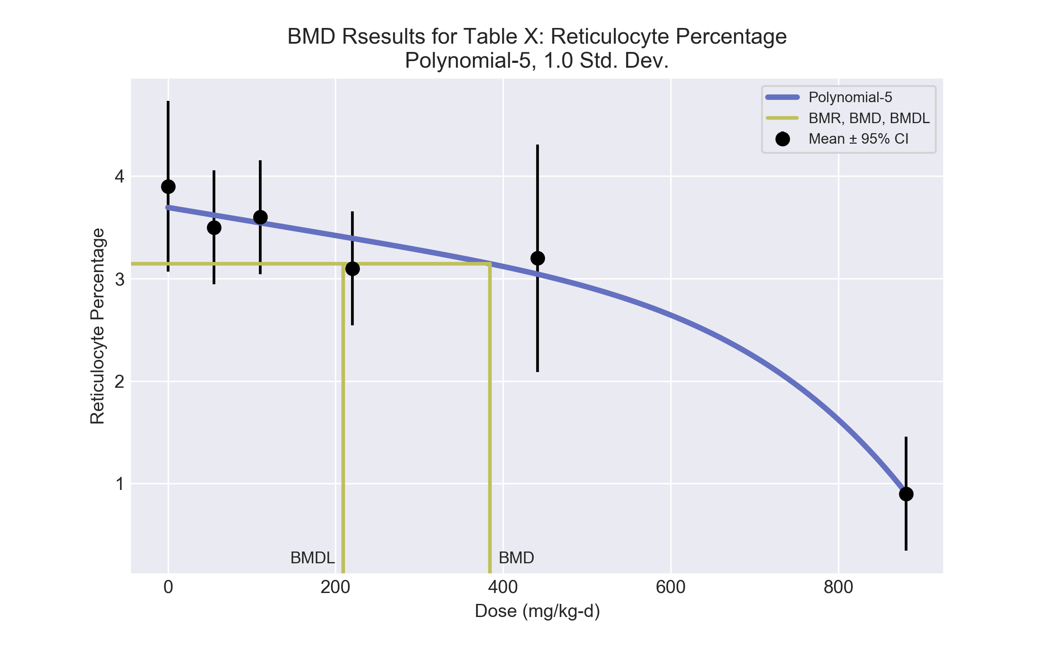
====================================================================
Polynomial Model. (Version: 2.21; Date: 03/14/2017)
Input Data File: C:\Users\USERNAME\AppData\Local\Temp\2\bmds-i9xvenm6.(d)
Gnuplot Plotting File: C:\Users\USERNAME\AppData\Local\Temp\2\bmds-i9xvenm6.plt
Mon Dec 18 12:03:11 2017
====================================================================
BMDS_Model_Run
~~~~~~~~~~~~~~~~~~~~~~~~~~~~~~~~~~~~~~~~~~~~~~~~~~~~~~~~~~~~~~~~~~~~~
The form of the response function is:
Y[dose] = beta_0 + beta_1*dose + beta_2*dose^2 + ...
Dependent variable = Response
Independent variable = Dose
rho is set to 0
The polynomial coefficients are restricted to be negative
A constant variance model is fit
Total number of dose groups = 6
Total number of records with missing values = 0
Maximum number of iterations = 500
Relative Function Convergence has been set to: 1e-008
Parameter Convergence has been set to: 1e-008
Default Initial Parameter Values
alpha = 0.341667
rho = 0 Specified
beta_0 = 3.9
beta_1 = -0.0184134
beta_2 = 0
beta_3 = -1.57957e-006
beta_4 = 0
beta_5 = -2.00925e-012
Asymptotic Correlation Matrix of Parameter Estimates
( *** The model parameter(s) -rho -beta_2 -beta_3 -beta_4
have been estimated at a boundary point, or have been specified by the user,
and do not appear in the correlation matrix )
alpha beta_0 beta_1 beta_5
alpha 1 -3.3e-008 5.4e-008 -7.3e-008
beta_0 -2.9e-008 1 -0.73 0.52
beta_1 5.3e-008 -0.73 1 -0.89
beta_5 -6.6e-008 0.52 -0.89 1
Parameter Estimates
95.0% Wald Confidence Interval
Variable Estimate Std. Err. Lower Conf. Limit Upper Conf. Limit
alpha 0.301671 0.077891 0.149007 0.454334
beta_0 3.69462 0.161704 3.37768 4.01155
beta_1 -0.00136344 0.000742936 -0.00281957 9.26894e-005
beta_2 -1.58452e-028 NA
beta_3 0 NA
beta_4 -3.78114e-034 NA
beta_5 -2.99355e-015 1.14257e-015 -5.23294e-015 -7.54163e-016
NA - Indicates that this parameter has hit a bound
implied by some inequality constraint and thus
has no standard error.
Table of Data and Estimated Values of Interest
Dose N Obs Mean Est Mean Obs Std Dev Est Std Dev Scaled Res.
------ --- -------- -------- ----------- ----------- ----------
0 5 3.9 3.69 0.671 0.549 0.836
55 5 3.5 3.62 0.447 0.549 -0.487
110 5 3.6 3.54 0.447 0.549 0.226
220 5 3.1 3.39 0.447 0.549 -1.19
441 5 3.2 3.04 0.894 0.549 0.638
881 5 0.9 0.905 0.447 0.549 -0.0189
Model Descriptions for likelihoods calculated
Model A1: Yij = Mu(i) + e(ij)
Var{e(ij)} = Sigma^2
Model A2: Yij = Mu(i) + e(ij)
Var{e(ij)} = Sigma(i)^2
Model A3: Yij = Mu(i) + e(ij)
Var{e(ij)} = Sigma^2
Model A3 uses any fixed variance parameters that
were specified by the user
Model R: Yi = Mu + e(i)
Var{e(i)} = Sigma^2
Likelihoods of Interest
Model Log(likelihood) # Param's AIC
A1 4.455944 7 5.088112
A2 6.995646 12 10.008707
A3 4.455944 7 5.088112
fitted 2.976293 4 2.047415
R -18.373797 2 40.747594
Explanation of Tests
Test 1: Do responses and/or variances differ among Dose levels?
(A2 vs. R)
Test 2: Are Variances Homogeneous? (A1 vs A2)
Test 3: Are variances adequately modeled? (A2 vs. A3)
Test 4: Does the Model for the Mean Fit? (A3 vs. fitted)
(Note: When rho=0 the results of Test 3 and Test 2 will be the same.)
Tests of Interest
Test -2*log(Likelihood Ratio) Test df p-value
Test 1 50.7389 10 <.0001
Test 2 5.0794 5 0.4063
Test 3 5.0794 5 0.4063
Test 4 2.9593 3 0.3979
The p-value for Test 1 is less than .05. There appears to be a
difference between response and/or variances among the dose levels
It seems appropriate to model the data
The p-value for Test 2 is greater than .1. A homogeneous variance
model appears to be appropriate here
The p-value for Test 3 is greater than .1. The modeled variance appears
to be appropriate here
The p-value for Test 4 is greater than .1. The model chosen seems
to adequately describe the data
Benchmark Dose Computation
Specified effect = 1
Risk Type = Estimated standard deviations from the control mean
Confidence level = 0.95
BMD = 384.409
BMDL = 209.417
BMDU = 643.489

  - BMD Results for: Mean Cell Hemoglobin (pg)
BMDS version: BMDS v2.7.0
    - Input dataset
Dose | 0 | 55 | 110 | 220 | 441 | 881
N | 2 | 5 | 5 | 5 | 5 | 5
Mean ± SD | 20.2 ± 0 | 19.9 ± 0.671 | 20.1 ± 0.671 | 19.5 ± 0.224 | 19.4 ± 0.671 | 19.5 ± 0.224

    - Summary table
Modelª | Goodness of fit |  | BMD | BMDL | Comments
 | p-value | AIC
Linear^{b} (equivalent models include Power, Polynomial 2°, 3°, 4°, 5°) | <0.0001 | -4.36 | 847.462 | 465.287 | Linear recommended as best-fitting model on the basis of the lowest AIC.
Hill | <0.0001 | -7.308 | 181.062 | -999
Exponential M2 | <0.0001 | 2.628 | 1 | -999
Exponential M3 | <0.0001 | 4.628 | 321205 | 1952.36
Exponential M4 (equivalent models include Exponential M5) | 1.#QO | 1.#QNAN | 1 | -999
ª Modeled variance case presented (BMDS Test 2 p-value = <0.0001, BMDS Test 3 p-value = <0.0001).
^{b} Recommended model

    - Model recommendation details
Model | Bin | Notes
Linearª (equivalent models include Power, Polynomial 2°, 3°, 4°, 5°) | Valid | -
Hill | Failure | Failures  • BMDL does not exist  Cautions  • Warning(s): BMDL computation failed.
Exponential M2 | Failure | Failures  • BMDL does not exist  Warnings  • BMD/minimum dose ratio is greater than threshold (55.0 > 10.0)  Cautions  • BMD/minimum dose ratio is greater than threshold (55.0 > 3.0)
Exponential M3 | Warning | Warnings  • BMD/BMDL ratio is greater than threshold (1.65e+02 > 20.0)  • BMDL/high dose ratio is greater than threshold (2.22 > 1.0)  Cautions  • BMD/BMDL ratio is greater than threshold (1.65e+02 > 5.0)  • BMD/high dose ratio is greater than threshold (3.65e+02 > 1.0)
Exponential M4 (equivalent models include Exponential M5) | Failure | Failures  • BMDL does not exist  • AIC does not exist  Warnings  • BMD/minimum dose ratio is greater than threshold (55.0 > 10.0)  • Residual at lowest dose is greater than threshold (3.89e+22 > 2.0)  Cautions  • Residual of interest is greater than threshold (3.89e+22 > 2.0)  • BMD/minimum dose ratio is greater than threshold (55.0 > 3.0)
ª Recommended model

    - Recommended model
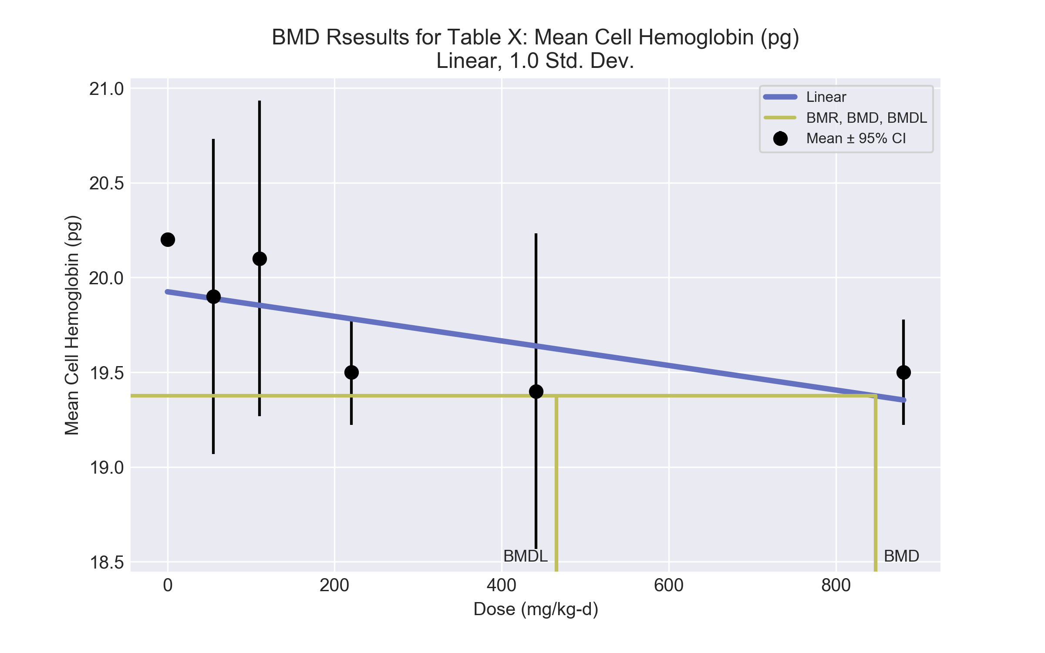
====================================================================
Polynomial Model. (Version: 2.21; Date: 03/14/2017)
Input Data File: C:\Users\USERNAME\AppData\Local\Temp\2\bmds-334zlfwx.(d)
Gnuplot Plotting File: C:\Users\USERNAME\AppData\Local\Temp\2\bmds-334zlfwx.plt
Mon Dec 18 12:03:11 2017
====================================================================
BMDS_Model_Run
~~~~~~~~~~~~~~~~~~~~~~~~~~~~~~~~~~~~~~~~~~~~~~~~~~~~~~~~~~~~~~~~~~~~~
The form of the response function is:
Y[dose] = beta_0 + beta_1*dose + beta_2*dose^2 + ...
Dependent variable = Response
Independent variable = Dose
The polynomial coefficients are restricted to be negative
The variance is to be modeled as Var(i) = exp(lalpha + log(mean(i)) * rho)
Total number of dose groups = 6
Total number of records with missing values = 0
Maximum number of iterations = 500
Relative Function Convergence has been set to: 1e-008
Parameter Convergence has been set to: 1e-008
Default Initial Parameter Values
lalpha = -1.28667
rho = 0
beta_0 = 19.98
beta_1 = -0.000749828
Asymptotic Correlation Matrix of Parameter Estimates
( *** The model parameter(s) -rho
have been estimated at a boundary point, or have been specified by the user,
and do not appear in the correlation matrix )
lalpha beta_0 beta_1
lalpha 1 0.078 -0.1
beta_0 0.078 1 -0.76
beta_1 -0.1 -0.76 1
Parameter Estimates
95.0% Wald Confidence Interval
Variable Estimate Std. Err. Lower Conf. Limit Upper Conf. Limit
lalpha -55.0519 0.273663 -55.5883 -54.5156
rho 18 NA
beta_0 19.9248 0.146173 19.6383 20.2113
beta_1 -0.000648704 0.000290918 -0.00121889 -7.85156e-005
NA - Indicates that this parameter has hit a bound
implied by some inequality constraint and thus
has no standard error.
Table of Data and Estimated Values of Interest
Dose N Obs Mean Est Mean Obs Std Dev Est Std Dev Scaled Res.
------ --- -------- -------- ----------- ----------- ----------
0 2 20.2 19.9 0 0.55 0.708
55 5 19.9 19.9 0.671 0.541 0.045
110 5 20.1 19.9 0.671 0.532 1.04
220 5 19.5 19.8 0.224 0.515 -1.22
441 5 19.4 19.6 0.671 0.483 -1.11
881 5 19.5 19.4 0.224 0.423 0.775
Model Descriptions for likelihoods calculated
Model A1: Yij = Mu(i) + e(ij)
Var{e(ij)} = Sigma^2
Model A2: Yij = Mu(i) + e(ij)
Var{e(ij)} = Sigma(i)^2
Model A3: Yij = Mu(i) + e(ij)
Var{e(ij)} = exp(lalpha + rho*ln(Mu(i)))
Model A3 uses any fixed variance parameters that
were specified by the user
Model R: Yi = Mu + e(i)
Var{e(i)} = Sigma^2
Likelihoods of Interest
Model Log(likelihood) # Param's AIC
A1 7.262729 7 -0.525458
A2 1.#INF00 12 -1.#INF00
A3 29.555549 8 -43.111098
fitted 5.179767 3 -4.359535
R 2.685911 2 -1.371822
Explanation of Tests
Test 1: Do responses and/or variances differ among Dose levels?
(A2 vs. R)
Test 2: Are Variances Homogeneous? (A1 vs A2)
Test 3: Are variances adequately modeled? (A2 vs. A3)
Test 4: Does the Model for the Mean Fit? (A3 vs. fitted)
(Note: When rho=0 the results of Test 3 and Test 2 will be the same.)
Tests of Interest
Test -2*log(Likelihood Ratio) Test df p-value
Test 1 1.#INF 10 <.0001
Test 2 1.#INF 5 <.0001
Test 3 1.#INF 4 <.0001
Test 4 48.7516 5 <.0001
The p-value for Test 1 is greater than .05. There may not be a
diffence between responses and/or variances among the dose levels
Modelling the data with a dose/response curve may not be appropriate
The p-value for Test 2 is greater than .1. Consider running a
homogeneous model
The p-value for Test 3 is greater than .1. The modeled variance appears
to be appropriate here
The p-value for Test 4 is less than .1. You may want to try a different
model
Benchmark Dose Computation
Specified effect = 1
Risk Type = Estimated standard deviations from the control mean
Confidence level = 0.95
BMD = 847.462
BMDL = 465.287
BMDU = 2856.88

  - BMD Results for: Mean Cell Hemoglobin Concentration (g/dL)
BMDS version: BMDS v2.7.0
    - Input dataset
Dose | 0 | 55 | 110 | 220 | 441 | 881
N | 2 | 5 | 5 | 5 | 5 | 5
Mean ± SD | 35.4 ± 0.141 | 34.5 ± 0.447 | 34.3 ± 0.447 | 34 ± 0.447 | 33.8 ± 0.671 | 34.3 ± 1.565

    - Summary table
Modelª | Goodness of fit |  | BMD | BMDL | Comments
 | p-value | AIC
Linear (equivalent models include Power, Polynomial 2°, 4°, 5°) | 0.009 | 13.729 | 276.247 | 110.652 | No model was recommended as a best-fitting model.
Polynomial 3° | 0.009 | 13.729 | 276.248 | 110.652
Hill | 0.331 | 5.616 | 3.275 | -999
Exponential M2 (equivalent models include Exponential M3) | 0.009 | 13.69 | 268.705 | 105.9
Exponential M4 (equivalent models include Exponential M5) | 0.091 | 8.647 | 5.135 | 2.007
ª Modeled variance case presented (BMDS Test 2 p-value = 9.0E-04, BMDS Test 3 p-value = 0.458).

    - Model recommendation details
Model | Bin | Notes
Linear (equivalent models include Power, Polynomial 2°, 4°, 5°) | Warning | Warnings  • Goodness of fit p-value is less than threshold (0.00893 < 0.1)  • Residual at lowest dose is greater than threshold (2.48 > 2.0)  • Ratio of modeled to actual stdev. at control is greater than threshold (3.05 > 1.5)  Cautions  • Warning(s): THE MODEL HAS PROBABLY NOT CONVERGED!!!; THIS USUALLY MEANS THE MODEL HAS NOT CONVERGED!
Polynomial 3° | Warning | Warnings  • Goodness of fit p-value is less than threshold (0.00893 < 0.1)  • Residual at lowest dose is greater than threshold (2.48 > 2.0)  • Ratio of modeled to actual stdev. at control is greater than threshold (3.05 > 1.5)  Cautions  • Warning(s): THE MODEL HAS PROBABLY NOT CONVERGED!!!; THIS USUALLY MEANS THE MODEL HAS NOT CONVERGED!
Hill | Failure | Failures  • BMDL does not exist  Warnings  • BMD/minimum dose ratio is greater than threshold (16.8 > 10.0)  Cautions  • Warning(s): BMDL computation failed.  • BMD/minimum dose ratio is greater than threshold (16.8 > 3.0)
Exponential M2 (equivalent models include Exponential M3) | Warning | Warnings  • Goodness of fit p-value is less than threshold (0.00908 < 0.1)  • Residual at lowest dose is greater than threshold (2.48 > 2.0)
Exponential M4 (equivalent models include Exponential M5) | Warning | Warnings  • Goodness of fit p-value is less than threshold (0.0914 < 0.1)  • BMD/minimum dose ratio is greater than threshold (10.7 > 10.0)  • BMDL/minimum dose ratio is greater than threshold (27.4 > 10.0)  Cautions  • BMD/minimum dose ratio is greater than threshold (10.7 > 3.0)  • BMDL/minimum dose ratio is greater than threshold (27.4 > 3.0)

    - Recommended model
No model was recommended as a best-fitting model.

  - BMD Results for: White Blood Cells (10^3/uL)
BMDS version: BMDS v2.7.0
    - Input dataset
Dose | 0 | 55 | 110 | 220 | 441 | 881
N | 5 | 5 | 5 | 5 | 5 | 5
Mean ± SD | 11.5 ± 0.894 | 14.25 ± 1.364 | 12.07 ± 1.789 | 13.4 ± 0.984 | 14.37 ± 2.437 | 16.25 ± 2.236

    - Summary table
Modelª | Goodness of fit |  | BMD | BMDL | Comments
 | p-value | AIC
Linear (equivalent models include Power, Polynomial 2°, 4°, 5°) | 0.11 | 69.413 | 394.049 | 272.328 | Exponential-M2 recommended as best-fitting model on the basis of the lowest AIC.
Polynomial 3° | 0.11 | 69.413 | 394.048 | 272.328
Hill | 0.057 | 71.389 | 362.716 | 97.985
Exponential M2^{b} (equivalent models include Exponential M3) | 0.107 | 69.479 | 426.561 | 308.468
Exponential M4 (equivalent models include Exponential M5) | 0.057 | 71.39 | 364.08 | 131.164
ª Constant variance case presented (BMDS Test 2 p-value = 0.158, BMDS Test 3 p-value = 0.158).
^{b} Recommended model

    - Model recommendation details
Model | Bin | Notes
Linear (equivalent models include Power, Polynomial 2°, 4°, 5°) | Warning | Warnings  • Ratio of modeled to actual stdev. at control is greater than threshold (1.96 > 1.5)
Polynomial 3° | Warning | Warnings  • Ratio of modeled to actual stdev. at control is greater than threshold (1.96 > 1.5)
Hill | Warning | Warnings  • Goodness of fit p-value is less than threshold (0.0572 < 0.1)  • Ratio of modeled to actual stdev. at control is greater than threshold (1.95 > 1.5)
Exponential M2ª (equivalent models include Exponential M3) | Valid | -
Exponential M4 (equivalent models include Exponential M5) | Warning | Warnings  • Goodness of fit p-value is less than threshold (0.0572 < 0.1)
ª Recommended model

    - Recommended model
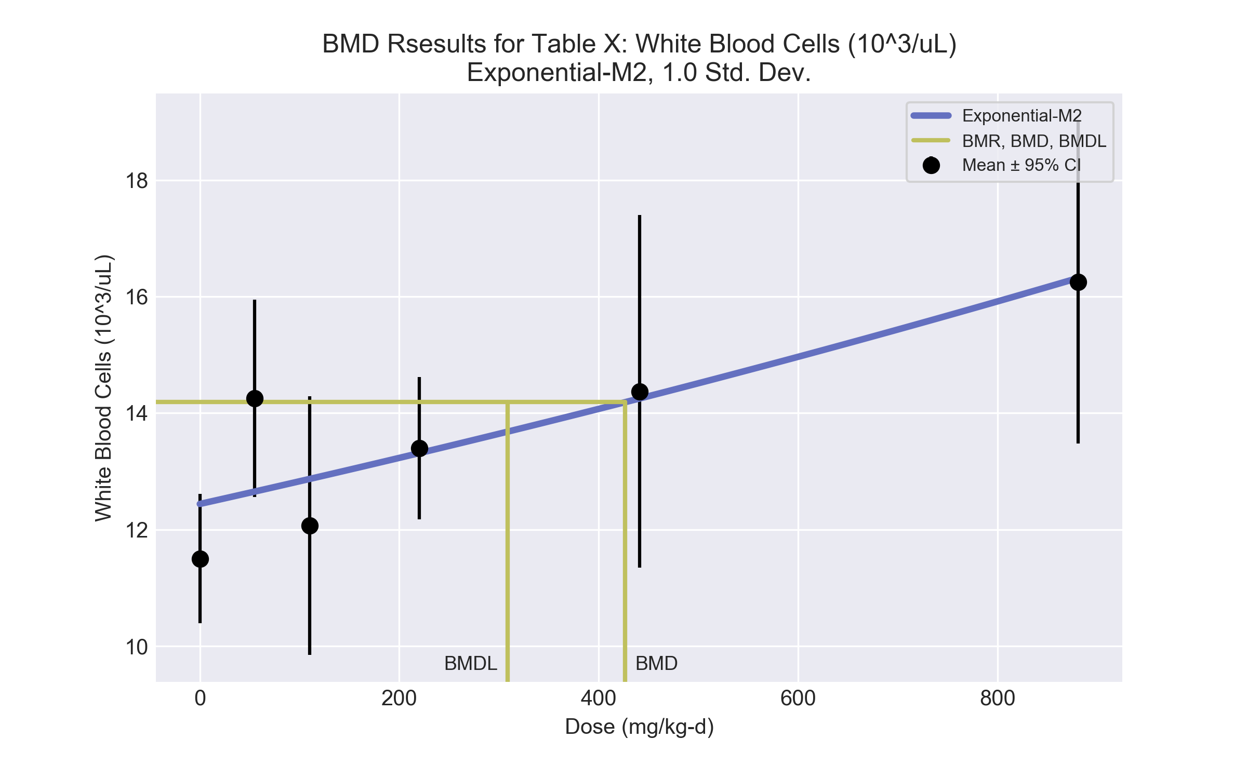
====================================================================
Exponential Model. (Version: 1.11; Date: 03/14/2017)
Input Data File: C:\Users\USERNAME\AppData\Local\Temp\2\bmds-801nvws5.(d)
Gnuplot Plotting File:
Mon Dec 18 12:03:15 2017
====================================================================
BMDS_Model_Run
~~~~~~~~~~~~~~~~~~~~~~~~~~~~~~~~~~~~~~~~~~~~~~~~~~~~~~~~~~~~~~~~~~~~~
The form of the response function by Model:
Model 2: Y[dose] = a * exp{sign * b * dose}
Model 3: Y[dose] = a * exp{sign * (b * dose)^d}
Model 4: Y[dose] = a * [c-(c-1) * exp{-b * dose}]
Model 5: Y[dose] = a * [c-(c-1) * exp{-(b * dose)^d}]
Note: Y[dose] is the median response for exposure = dose;
sign = +1 for increasing trend in data;
sign = -1 for decreasing trend.
Model 2 is nested within Models 3 and 4.
Model 3 is nested within Model 5.
Model 4 is nested within Model 5.
Dependent variable = Response
Independent variable = Dose
Data are assumed to be distributed: normally
Variance Model: exp(lnalpha +rho *ln(Y[dose]))
rho is set to 0.
A constant variance model is fit.
Total number of dose groups = 6
Total number of records with missing values = 0
Maximum number of iterations = 500
Relative Function Convergence has been set to: 1e-008
Parameter Convergence has been set to: 1e-008
MLE solution provided: Exact
Initial Parameter Values
Variable Model 2
-------- --------
lnalpha 0.862552
rho 0 Specified
a 12.3833
b 0.000316473
c 0 Specified
d 1 Specified
Parameter Estimates
Variable Model 2 Std. Err.
-------- ------- ---------
lnalpha 1.11598 0.788169
a 12.4397 0.419638
b 0.000308099 7.05315e-005
NC = No Convergence
Table of Stats From Input Data
Dose N Obs Mean Obs Std Dev
----- --- ---------- -------------
0 5 11.5 0.8944
55 5 14.25 1.364
110 5 12.07 1.789
220 5 13.4 0.9839
441 5 14.37 2.437
881 5 16.25 2.236
Estimated Values of Interest
Dose Est Mean Est Std Scaled Residual
------ ---------- --------- ----------------
0 12.44 1.747 -1.203
55 12.65 1.747 2.045
110 12.87 1.747 -1.022
220 13.31 1.747 0.1124
441 14.25 1.747 0.1534
881 16.32 1.747 -0.0883
Other models for which likelihoods are calculated:
Model A1: Yij = Mu(i) + e(ij)
Var{e(ij)} = Sigma^2
Model A2: Yij = Mu(i) + e(ij)
Var{e(ij)} = Sigma(i)^2
Model A3: Yij = Mu(i) + e(ij)
Var{e(ij)} = exp(lalpha + log(mean(i)) * rho)
Model R: Yij = Mu + e(i)
Var{e(ij)} = Sigma^2
Likelihoods of Interest
Model Log(likelihood) DF AIC
------- ----------------- ---- ------------
A1 -27.93828 7 69.87657
A2 -23.95174 12 71.90349
A3 -27.93828 7 69.87657
R -38.65083 2 81.30165
2 -31.73973 3 69.47946
Additive constant for all log-likelihoods = -27.57. This constant added to the
above values gives the log-likelihood including the term that does not
depend on the model parameters.
Explanation of Tests
Test 1: Does response and/or variances differ among Dose levels? (A2 vs. R)
Test 2: Are Variances Homogeneous? (A2 vs. A1)
Test 3: Are variances adequately modeled? (A2 vs. A3)
Test 4: Does Model 2 fit the data? (A3 vs. 2)
Tests of Interest
Test -2*log(Likelihood Ratio) D. F. p-value
-------- ------------------------ ------ --------------
Test 1 29.4 10 0.001074
Test 2 7.973 5 0.1577
Test 3 7.973 5 0.1577
Test 4 7.603 4 0.1073
The p-value for Test 1 is less than .05. There appears to be a
difference between response and/or variances among the dose
levels, it seems appropriate to model the data.
The p-value for Test 2 is greater than .1. A homogeneous
variance model appears to be appropriate here.
The p-value for Test 3 is greater than .1. The modeled
variance appears to be appropriate here.
The p-value for Test 4 is greater than .1. Model 2 seems
to adequately describe the data.
Benchmark Dose Computations:
Specified Effect = 1.000000
Risk Type = Estimated standard deviations from control
Confidence Level = 0.950000
BMD = 426.561
BMDL = 308.468
BMDU = 724.926

  - BMD Results for: Monocytes (10^3/uL)
BMDS version: BMDS v2.7.0
    - Input dataset
Dose | 0 | 55 | 110 | 220 | 441 | 881
N | 5 | 5 | 5 | 5 | 5 | 5
Mean ± SD | 0.2 ± 0.134 | 0.39 ± 0.134 | 0.35 ± 0.179 | 0.32 ± 0.134 | 0.31 ± 0.134 | 0.65 ± 0.089

    - Summary table
Modelª | Goodness of fit |  | BMD | BMDL | Comments
 | p-value | AIC
Linear | 0.041 | -80.176 | 380.169 | 264.927 | Power recommended as best-fitting model on the basis of the lowest AIC.
Polynomial 2° | 0.112 | -82.628 | 562.8 | 474.887
Polynomial 3° | 0.164 | -83.608 | 649.251 | 489.349
Polynomial 4° | 0.102 | -81.931 | 685.395 | 382.128
Polynomial 5° | 0.109 | -82.064 | 708.898 | 385.61
Power^{b} | 0.193 | -84.048 | 837.561 | 454
Hill | 0.048 | -80.048 | 837.508 | 454.223
Exponential M2 | 0.074 | -81.583 | 442.793 | 350.29
Exponential M3 | 0.108 | -82.048 | 846.977 | -999
Exponential M4 | 0.019 | -78.175 | 380.143 | 240.496
Exponential M5 | 0.048 | -80.048 | 837.556 | 454.007
ª Constant variance case presented (BMDS Test 2 p-value = 0.811, BMDS Test 3 p-value = 0.811).
^{b} Recommended model

    - Model recommendation details
Model | Bin | Notes
Linear | Warning | Warnings  • Goodness of fit p-value is less than threshold (0.0413 < 0.1)
Polynomial 2° | Valid | -
Polynomial 3° | Valid | -
Polynomial 4° | Valid | -
Polynomial 5° | Valid | -
Powerª | Valid | -
Hill | Warning | Warnings  • Goodness of fit p-value is less than threshold (0.0479 < 0.1)  Cautions  • Warning(s): THE MODEL HAS PROBABLY NOT CONVERGED!!!; THIS USUALLY MEANS THE MODEL HAS NOT CONVERGED!
Exponential M2 | Warning | Warnings  • Goodness of fit p-value is less than threshold (0.0736 < 0.1)
Exponential M3 | Failure | Failures  • BMDL does not exist
Exponential M4 | Warning | Warnings  • Goodness of fit p-value is less than threshold (0.019 < 0.1)
Exponential M5 | Warning | Warnings  • Goodness of fit p-value is less than threshold (0.0479 < 0.1)
ª Recommended model

    - Recommended model
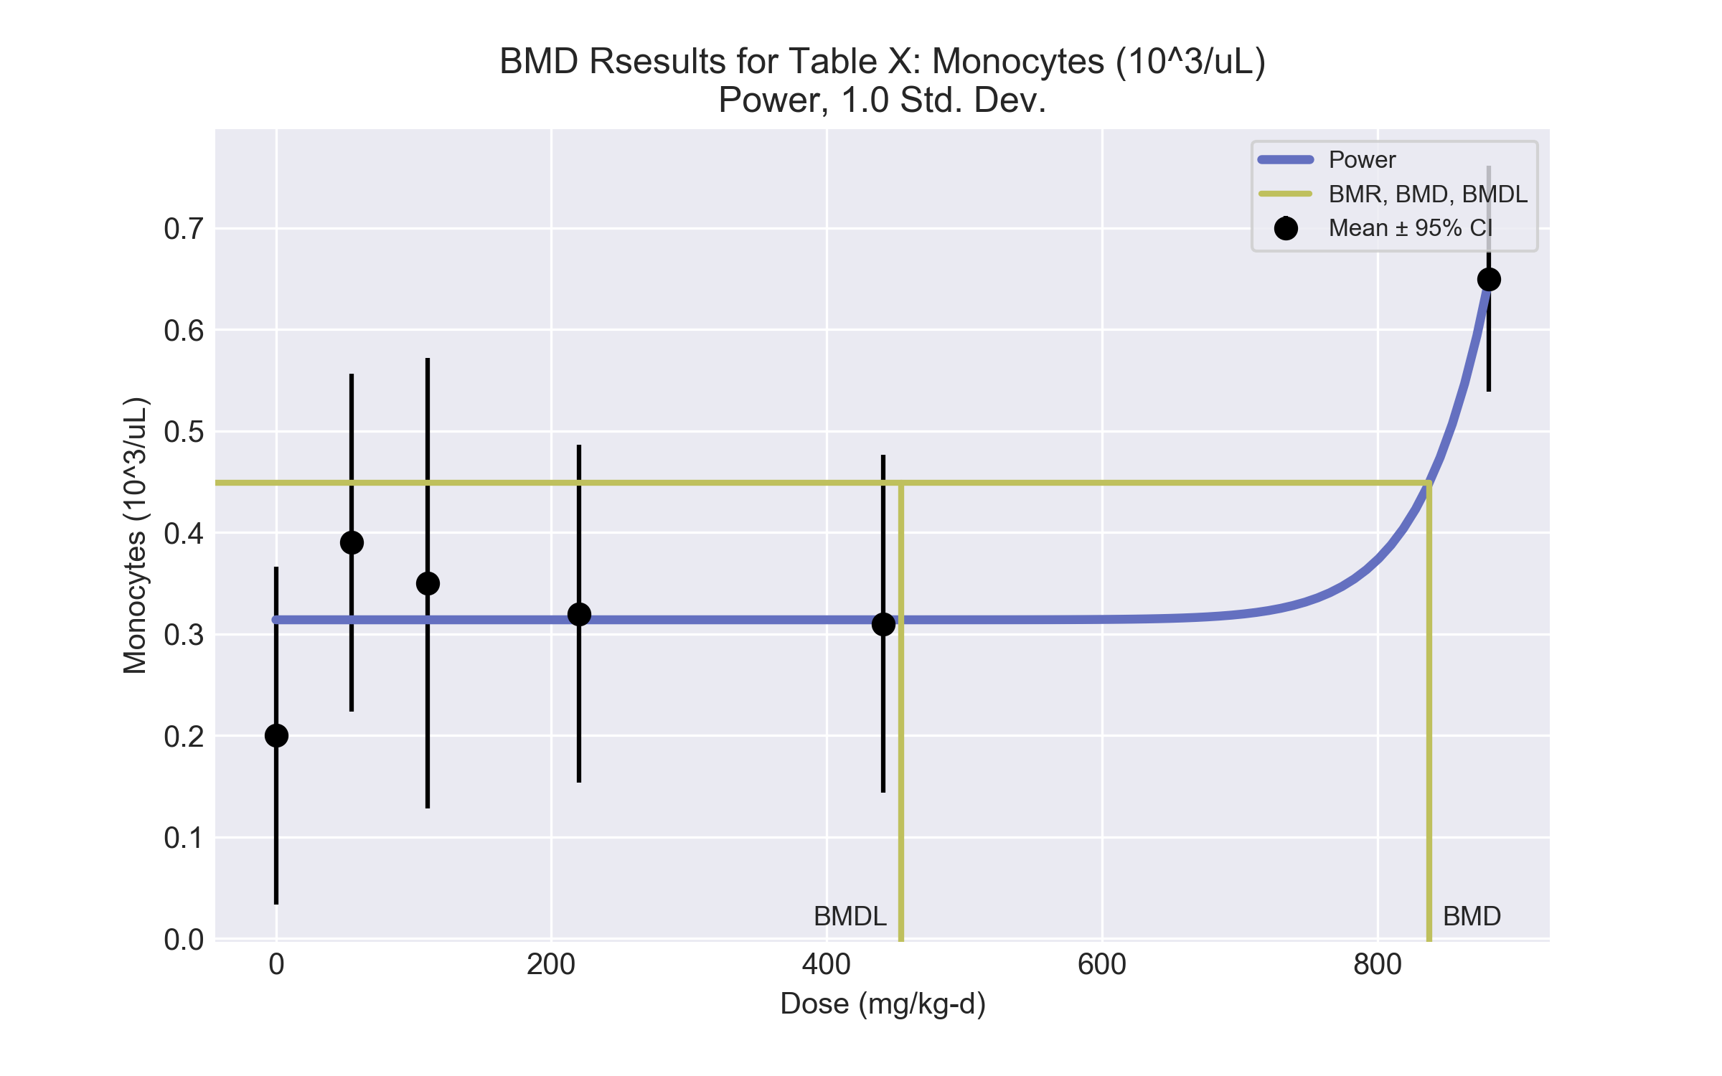
====================================================================
Power Model. (Version: 2.19; Date: 03/14/2017)
Input Data File: C:\Users\USERNAME\AppData\Local\Temp\2\bmds-qfdv4o34.(d)
Gnuplot Plotting File: C:\Users\USERNAME\AppData\Local\Temp\2\bmds-qfdv4o34.plt
Mon Dec 18 12:03:15 2017
====================================================================
BMDS_Model_Run
~~~~~~~~~~~~~~~~~~~~~~~~~~~~~~~~~~~~~~~~~~~~~~~~~~~~~~~~~~~~~~~~~~~~~
The form of the response function is:
Y[dose] = control + slope * dose^power
Dependent variable = Response
Independent variable = Dose
rho is set to 0
The power is restricted to be greater than or equal to 1
A constant variance model is fit
Total number of dose groups = 6
Total number of records with missing values = 0
Maximum number of iterations = 500
Relative Function Convergence has been set to: 1e-008
Parameter Convergence has been set to: 1e-008
Default Initial Parameter Values
alpha = 0.0186666
rho = 0 Specified
control = 0.2
slope = 0.0586607
power = -9999
Asymptotic Correlation Matrix of Parameter Estimates
( *** The model parameter(s) -rho -power
have been estimated at a boundary point, or have been specified by the user,
and do not appear in the correlation matrix )
alpha control slope
alpha 1 -8e-009 2.9e-008
control -7.4e-009 1 -0.41
slope 2.4e-008 -0.41 1
Parameter Estimates
95.0% Wald Confidence Interval
Variable Estimate Std. Err. Lower Conf. Limit Upper Conf. Limit
alpha 0.0182866 0.00472159 0.00903249 0.0275408
control 0.314 0.0270456 0.260991 0.367008
slope 3.2868e-054 6.48047e-055 2.01665e-054 4.55695e-054
power 18 NA
NA - Indicates that this parameter has hit a bound
implied by some inequality constraint and thus
has no standard error.
Table of Data and Estimated Values of Interest
Dose N Obs Mean Est Mean Obs Std Dev Est Std Dev Scaled Res.
------ --- -------- -------- ----------- ----------- ----------
0 5 0.2 0.314 0.134 0.135 -1.89
55 5 0.39 0.314 0.134 0.135 1.26
110 5 0.35 0.314 0.179 0.135 0.595
220 5 0.32 0.314 0.134 0.135 0.0992
441 5 0.31 0.314 0.134 0.135 -0.0662
881 5 0.65 0.65 0.0894 0.135 1.67e-007
Model Descriptions for likelihoods calculated
Model A1: Yij = Mu(i) + e(ij)
Var{e(ij)} = Sigma^2
Model A2: Yij = Mu(i) + e(ij)
Var{e(ij)} = Sigma(i)^2
Model A3: Yij = Mu(i) + e(ij)
Var{e(ij)} = Sigma^2
Model A3 uses any fixed variance parameters that
were specified by the user
Model R: Yi = Mu + e(i)
Var{e(i)} = Sigma^2
Likelihoods of Interest
Model Log(likelihood) # Param's AIC
A1 48.062417 7 -82.124834
A2 49.196830 12 -74.393659
A3 48.062417 7 -82.124834
fitted 45.023766 3 -84.047531
R 35.735646 2 -67.471291
Explanation of Tests
Test 1: Do responses and/or variances differ among Dose levels?
(A2 vs. R)
Test 2: Are Variances Homogeneous? (A1 vs A2)
Test 3: Are variances adequately modeled? (A2 vs. A3)
Test 4: Does the Model for the Mean Fit? (A3 vs. fitted)
(Note: When rho=0 the results of Test 3 and Test 2 will be the same.)
Tests of Interest
Test -2*log(Likelihood Ratio) Test df p-value
Test 1 26.9224 10 0.002679
Test 2 2.26883 5 0.8108
Test 3 2.26883 5 0.8108
Test 4 6.0773 4 0.1934
The p-value for Test 1 is less than .05. There appears to be a
difference between response and/or variances among the dose levels
It seems appropriate to model the data
The p-value for Test 2 is greater than .1. A homogeneous variance
model appears to be appropriate here
The p-value for Test 3 is greater than .1. The modeled variance appears
to be appropriate here
The p-value for Test 4 is greater than .1. The model chosen seems
to adequately describe the data
Benchmark Dose Computation
Specified effect = 1
Risk Type = Estimated standard deviations from the control mean
Confidence level = 0.95
BMD = 837.561
BMDL = 454.003
BMDU = 860.518

  - BMD Results for: Monocyte percentage
BMDS version: BMDS v2.7.0
    - Input dataset
Dose | 0 | 55 | 110 | 220 | 441 | 881
N | 5 | 5 | 5 | 5 | 5 | 5
Mean ± SD | 1.8 ± 1.297 | 2.8 ± 1.096 | 2.8 ± 1.297 | 2.4 ± 0.894 | 2.2 ± 0.827 | 4 ± 0

    - Summary table
Modelª | Goodness of fit |  | BMD | BMDL | Comments
 | p-value | AIC
Linear^{b} | <0.0001 | 31.455 | 702.71 | 483.824 | Linear recommended as best-fitting model on the basis of the lowest AIC.
Polynomial 2° | <0.0001 | 6.707 | 892.816 | 733.587
Polynomial 3° | <0.0001 | -58.631 | 1120.5 | -999
Polynomial 4° | <0.0001 | -88.09 | 816.356 | -999
Polynomial 5° | <0.0001 | -93.305 | 802.06 | -999
Power | <0.0001 | -100.093 | 805.999 | -999
Hill | <0.0001 | 104.052 | 1 | -999
Exponential M2 | -999 | 45.455 | 1 | -999
Exponential M3 | -999 | 47.455 | 499116 | 9652.65
Exponential M4 | -999 | 47.455 | -999 | 0
Exponential M5 | -999 | 49.455 | -999 | 0
ª Modeled variance case presented (BMDS Test 2 p-value = <0.0001, BMDS Test 3 p-value = <0.0001).
^{b} Recommended model

    - Model recommendation details
Model | Bin | Notes
Linearª | Valid | Cautions  • Warning(s): Warning: Likelihood for fitted model larger than the Likelihood for model A3.
Polynomial 2° | Warning | Warnings  • Ratio of modeled to actual stdev. at control is greater than threshold (1.6 > 1.5)  Cautions  • Warning(s): THE MODEL HAS PROBABLY NOT CONVERGED!!!; THIS USUALLY MEANS THE MODEL HAS NOT CONVERGED!; Warning: Likelihood for fitted model larger than the Likelihood for model A3.  • BMD/high dose ratio is greater than threshold (1.01 > 1.0)
Polynomial 3° | Failure | Failures  • BMDL does not exist  Warnings  • Ratio of modeled to actual stdev. at control is greater than threshold (3.12 > 1.5)  Cautions  • Warning(s): THE MODEL HAS PROBABLY NOT CONVERGED!!!; THIS USUALLY MEANS THE MODEL HAS NOT CONVERGED!; BMDL computation failed.; Warning: Likelihood for fitted model larger than the Likelihood for model A3.  • BMD/high dose ratio is greater than threshold (1.27 > 1.0)
Polynomial 4° | Failure | Failures  • BMDL does not exist  Cautions  • Warning(s): THE MODEL HAS PROBABLY NOT CONVERGED!!!; THIS USUALLY MEANS THE MODEL HAS NOT CONVERGED!; BMDL computation failed.; Warning: Likelihood for fitted model larger than the Likelihood for model A3.
Polynomial 5° | Failure | Failures  • BMDL does not exist  Cautions  • Warning(s): BMDL computation failed.; Warning: Likelihood for fitted model larger than the Likelihood for model A3.
Power | Failure | Failures  • BMDL does not exist  Cautions  • Warning(s): THE MODEL HAS PROBABLY NOT CONVERGED!!!; THIS USUALLY MEANS THE MODEL HAS NOT CONVERGED!; BMDL computation failed.; Warning: Likelihood for fitted model larger than the Likelihood for model A3.
Hill | Failure | Failures  • BMDL does not exist  Warnings  • BMD/minimum dose ratio is greater than threshold (55.0 > 10.0)  • Ratio of modeled to actual stdev. at control is greater than threshold (2.02 > 1.5)  Cautions  • Warning(s): THIS USUALLY MEANS THE MODEL HAS NOT CONVERGED!; BMDL computation failed.  • BMD/minimum dose ratio is greater than threshold (55.0 > 3.0)
Exponential M2 | Failure | Failures  • BMDL does not exist  Warnings  • BMD/minimum dose ratio is greater than threshold (55.0 > 10.0)  Cautions  • BMD/minimum dose ratio is greater than threshold (55.0 > 3.0)
Exponential M3 | Warning | Warnings  • BMD/BMDL ratio is greater than threshold (51.7 > 20.0)  • BMDL/high dose ratio is greater than threshold (11.0 > 1.0)  Cautions  • BMD/BMDL ratio is greater than threshold (51.7 > 5.0)  • Residual of interest is greater than threshold (2.63 > 2.0)  • BMD/high dose ratio is greater than threshold (5.67e+02 > 1.0)
Exponential M4 | Failure | Failures  • BMD does not exist  Warnings  • Residual of Interest does not exist
Exponential M5 | Failure | Failures  • BMD does not exist  Warnings  • Residual of Interest does not exist
ª Recommended model

    - Recommended model
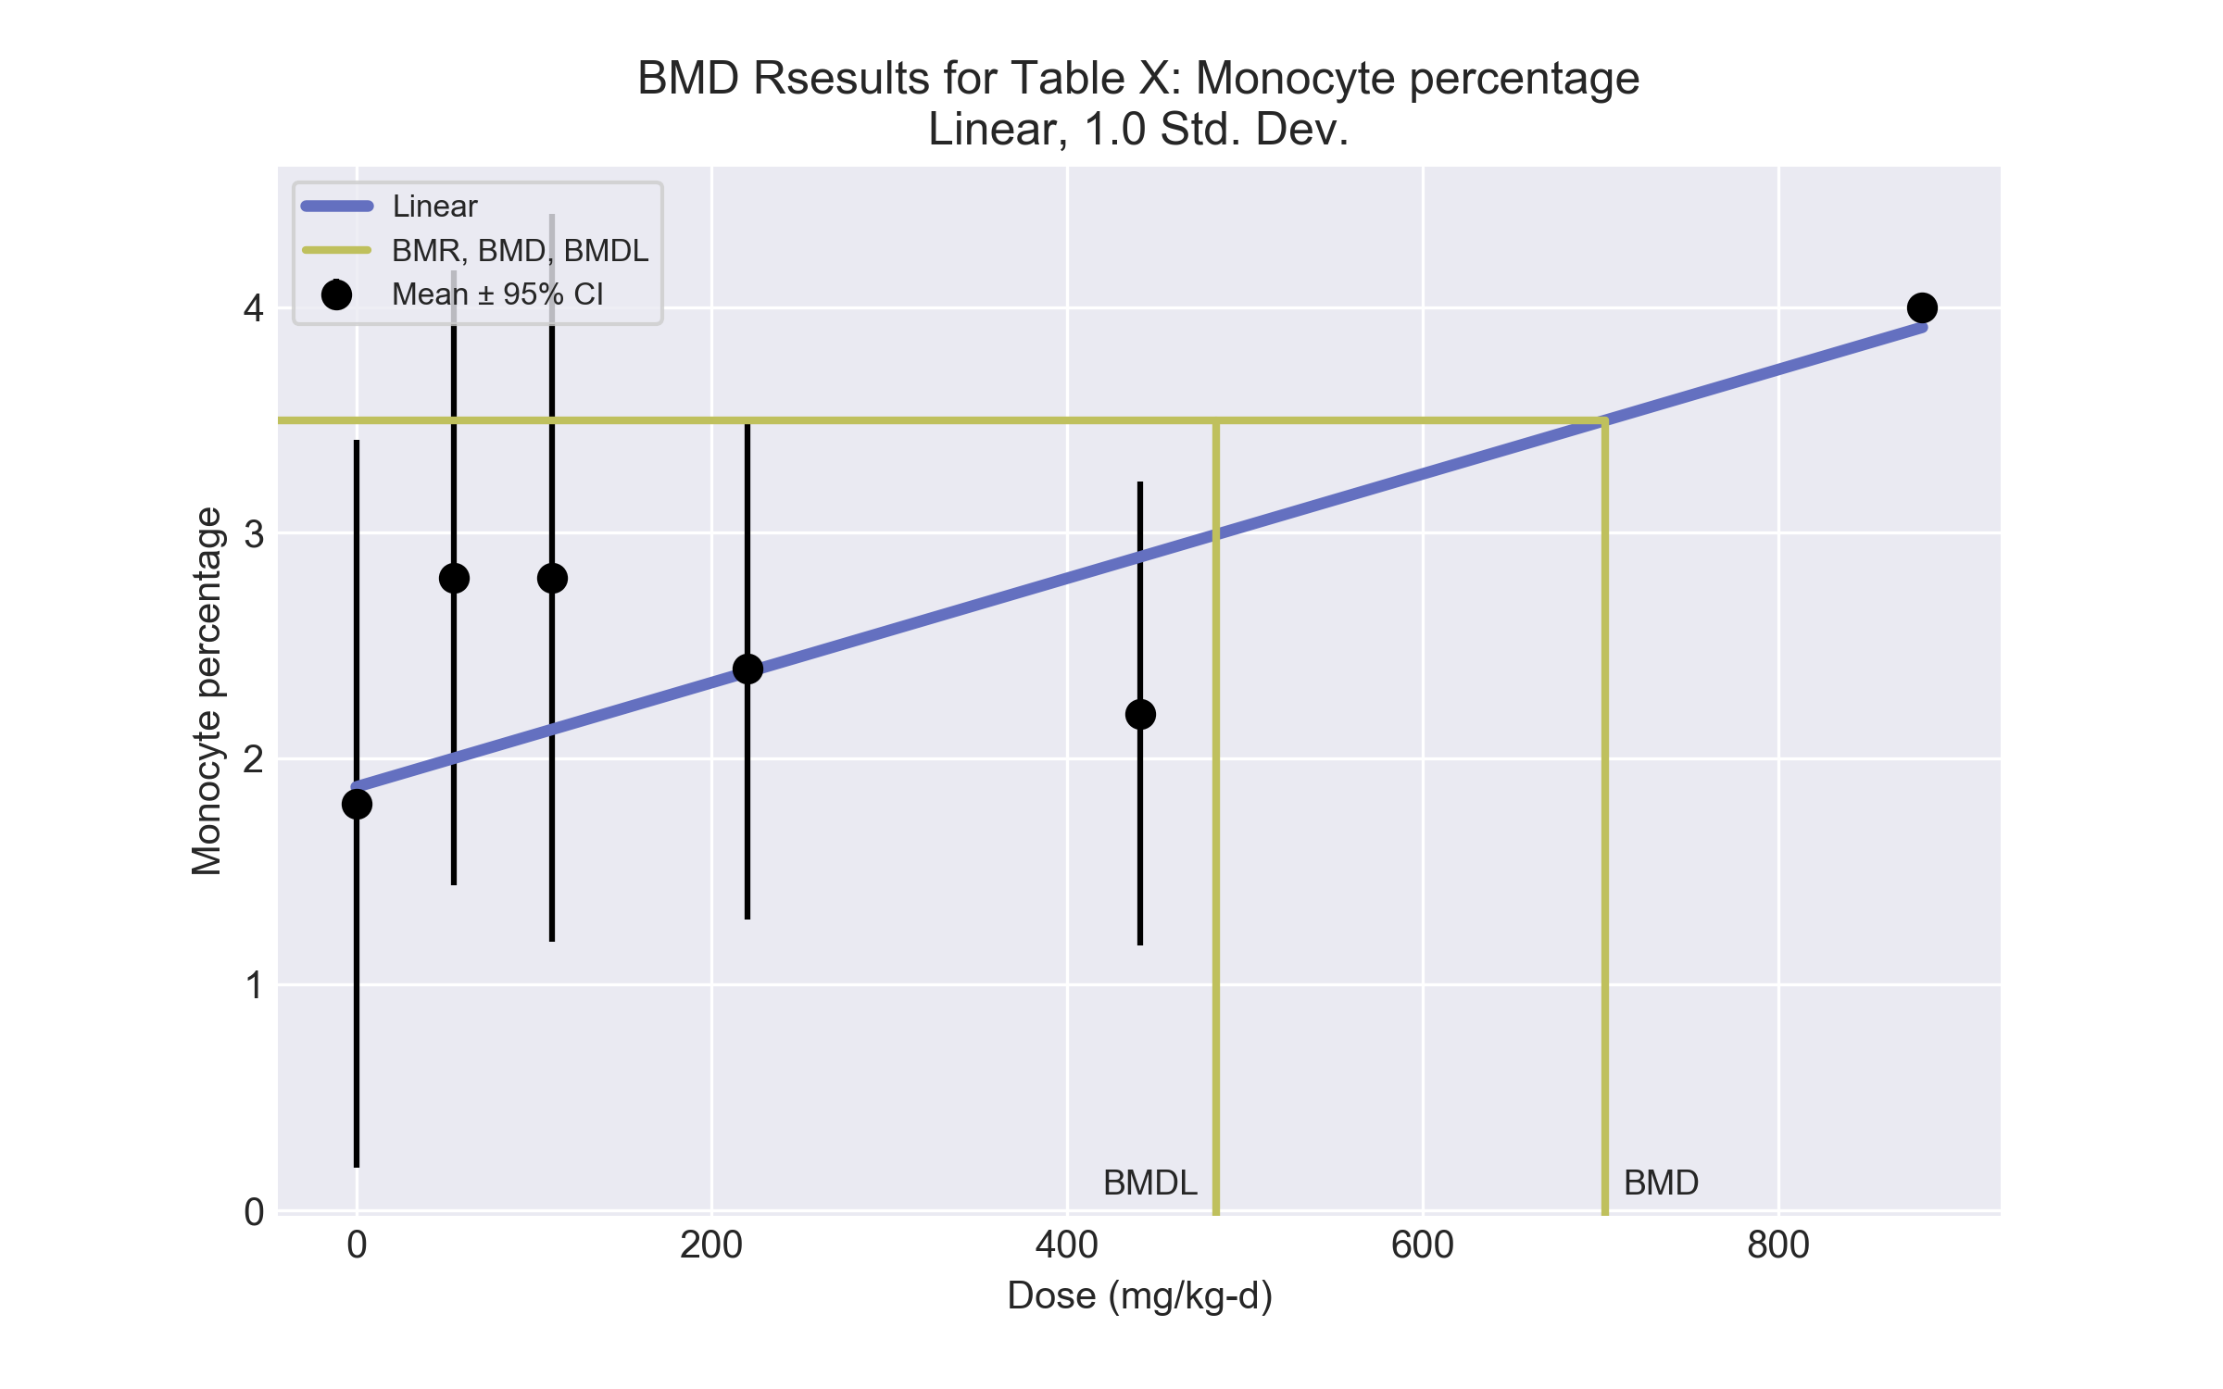
====================================================================
Polynomial Model. (Version: 2.21; Date: 03/14/2017)
Input Data File: C:\Users\USERNAME\AppData\Local\Temp\2\bmds-hpklbqy1.(d)
Gnuplot Plotting File: C:\Users\USERNAME\AppData\Local\Temp\2\bmds-hpklbqy1.plt
Mon Dec 18 12:03:15 2017
====================================================================
BMDS_Model_Run
~~~~~~~~~~~~~~~~~~~~~~~~~~~~~~~~~~~~~~~~~~~~~~~~~~~~~~~~~~~~~~~~~~~~~
The form of the response function is:
Y[dose] = beta_0 + beta_1*dose + beta_2*dose^2 + ...
Dependent variable = Response
Independent variable = Dose
The polynomial coefficients are restricted to be positive
The variance is to be modeled as Var(i) = exp(lalpha + log(mean(i)) * rho)
Total number of dose groups = 6
Total number of records with missing values = 0
Maximum number of iterations = 500
Relative Function Convergence has been set to: 1e-008
Parameter Convergence has been set to: 1e-008
Default Initial Parameter Values
lalpha = 0.00813292
rho = 0
beta_0 = 2.18317
beta_1 = 0
Asymptotic Correlation Matrix of Parameter Estimates
lalpha rho beta_0 beta_1
lalpha 1 -0.98 0.075 -0.016
rho -0.98 1 -0.059 -0.00099
beta_0 0.075 -0.059 1 -0.86
beta_1 -0.016 -0.00099 -0.86 1
Parameter Estimates
95.0% Wald Confidence Interval
Variable Estimate Std. Err. Lower Conf. Limit Upper Conf. Limit
lalpha 3.76568 1.34871 1.12225 6.40911
rho -4.44799 1.47702 -7.3429 -1.55309
beta_0 1.87538 0.221881 1.44051 2.31026
beta_1 0.00230982 0.000303993 0.00171401 0.00290564
Table of Data and Estimated Values of Interest
Dose N Obs Mean Est Mean Obs Std Dev Est Std Dev Scaled Res.
------ --- -------- -------- ----------- ----------- ----------
0 5 1.8 1.88 1.3 1.62 -0.104
55 5 2.8 2 1.1 1.4 1.27
110 5 2.8 2.13 1.3 1.22 1.23
220 5 2.4 2.38 0.894 0.952 0.0386
441 5 2.2 2.89 0.827 0.618 -2.51
881 5 4 3.91 0 0.317 0.633
Warning: Likelihood for fitted model larger than the Likelihood for model A3.
Model Descriptions for likelihoods calculated
Model A1: Yij = Mu(i) + e(ij)
Var{e(ij)} = Sigma^2
Model A2: Yij = Mu(i) + e(ij)
Var{e(ij)} = Sigma(i)^2
Model A3: Yij = Mu(i) + e(ij)
Var{e(ij)} = exp(lalpha + rho*ln(Mu(i)))
Model A3 uses any fixed variance parameters that
were specified by the user
Model R: Yi = Mu + e(i)
Var{e(i)} = Sigma^2
Likelihoods of Interest
Model Log(likelihood) # Param's AIC
A1 -11.774841 7 37.549681
A2 1.#INF00 12 -1.#INF00
A3 -4766885752703518.000000 8 9533771505407052.000000
fitted -11.727505 4 31.455009
R -18.727355 2 41.454710
Explanation of Tests
Test 1: Do responses and/or variances differ among Dose levels?
(A2 vs. R)
Test 2: Are Variances Homogeneous? (A1 vs A2)
Test 3: Are variances adequately modeled? (A2 vs. A3)
Test 4: Does the Model for the Mean Fit? (A3 vs. fitted)
(Note: When rho=0 the results of Test 3 and Test 2 will be the same.)
Tests of Interest
Test -2*log(Likelihood Ratio) Test df p-value
Test 1 1.#INF 10 <.0001
Test 2 1.#INF 5 <.0001
Test 3 1.#INF 4 <.0001
Test 4 -9.53377e+015 4 <.0001
The p-value for Test 1 is greater than .05. There may not be a
diffence between responses and/or variances among the dose levels
Modelling the data with a dose/response curve may not be appropriate
The p-value for Test 2 is greater than .1. Consider running a
homogeneous model
The p-value for Test 3 is greater than .1. The modeled variance appears
to be appropriate here
The p-value for Test 4 is less than .1. You may want to try a different
model
Benchmark Dose Computation
Specified effect = 1
Risk Type = Estimated standard deviations from the control mean
Confidence level = 0.95
BMD = 702.71
BMDL = 483.824
BMDU = 1084.56

  - BMD Results for: Free Thyroxine (ng/dL)
BMDS version: BMDS v2.7.0
    - Input dataset
Dose | 0 | 55 | 110 | 220 | 441 | 881
N | 5 | 5 | 5 | 5 | 5 | 5
Mean ± SD | 5.122 ± 0.508 | 5.114 ± 0.438 | 4.678 ± 0.68 | 4.274 ± 0.588 | 4.066 ± 0.74 | 1.87 ± 0.959

    - Summary table
Modelª | Goodness of fit |  | BMD | BMDL | Comments
 | p-value | AIC
Linear^{b} | 0.455 | 9.289 | 178.3 | 139.212 | Linear recommended as best-fitting model on the basis of the lowest AIC.
Polynomial 2° | 0.506 | 9.97 | 257.756 | 148.564
Polynomial 3° | 0.578 | 9.609 | 253.687 | 152.149
Polynomial 4° | 0.619 | 9.418 | 248.575 | 154.114
Polynomial 5° | 0.64 | 9.322 | 245.081 | 154.784
Power | 0.438 | 10.351 | 267.976 | 145.398
Hill | 0.257 | 12.353 | 268.082 | 145.266
Exponential M2 (equivalent models include Exponential M4) | 0.14 | 12.554 | 143.395 | 104.632
Exponential M3 | 0.315 | 11.18 | 302.746 | 148.225
Exponential M5 | 0.17 | 13.18 | 302.746 | 148.225
ª Constant variance case presented (BMDS Test 2 p-value = 0.556, BMDS Test 3 p-value = 0.556).
^{b} Recommended model

    - Model recommendation details
Model | Bin | Notes
Linearª | Valid | -
Polynomial 2° | Valid | -
Polynomial 3° | Valid | -
Polynomial 4° | Valid | -
Polynomial 5° | Valid | -
Power | Valid | -
Hill | Valid | -
Exponential M2 (equivalent models include Exponential M4) | Valid | -
Exponential M3 | Valid | -
Exponential M5 | Valid | -
ª Recommended model

    - Recommended model
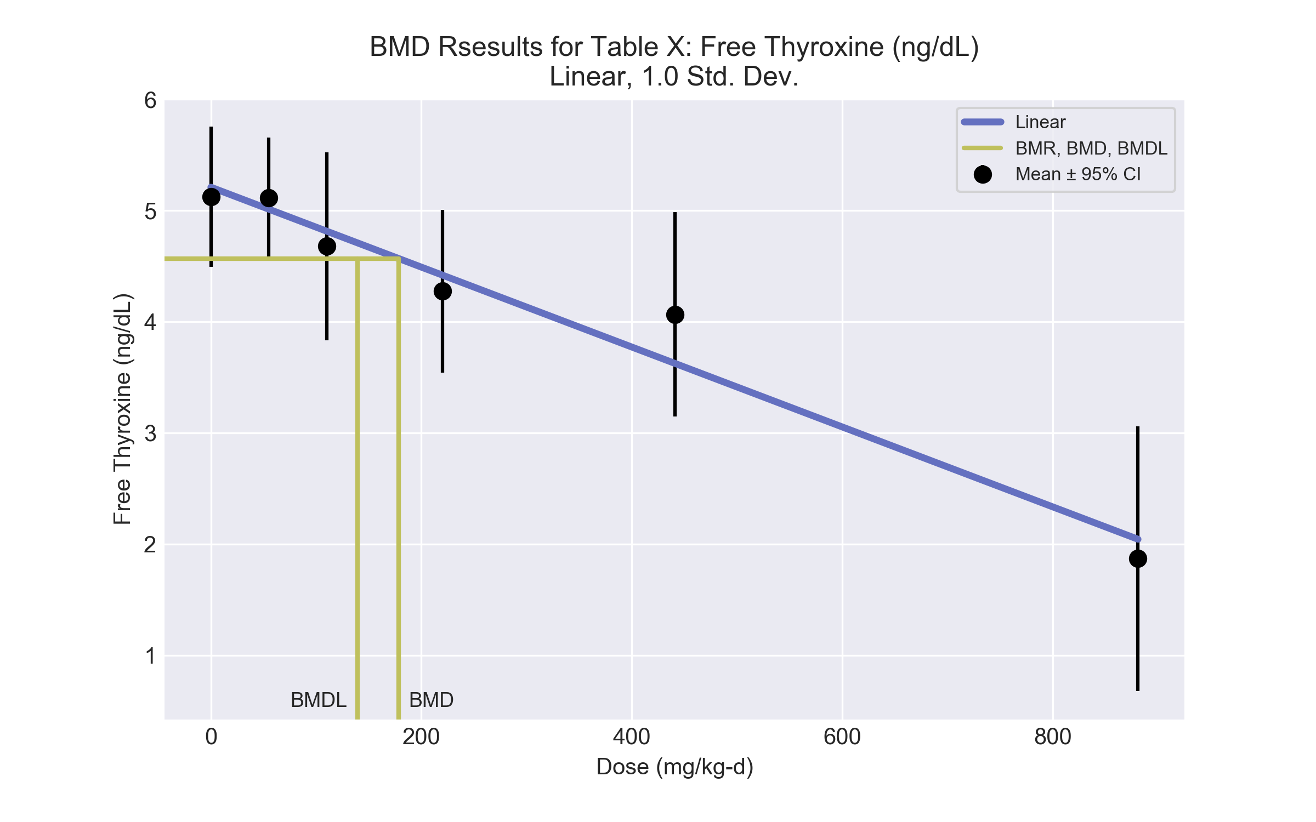
====================================================================
Polynomial Model. (Version: 2.21; Date: 03/14/2017)
Input Data File: C:\Users\USERNAME\AppData\Local\Temp\2\bmds-lc88i5yf.(d)
Gnuplot Plotting File: C:\Users\USERNAME\AppData\Local\Temp\2\bmds-lc88i5yf.plt
Mon Dec 18 12:03:18 2017
====================================================================
BMDS_Model_Run
~~~~~~~~~~~~~~~~~~~~~~~~~~~~~~~~~~~~~~~~~~~~~~~~~~~~~~~~~~~~~~~~~~~~~
The form of the response function is:
Y[dose] = beta_0 + beta_1*dose + beta_2*dose^2 + ...
Dependent variable = Response
Independent variable = Dose
rho is set to 0
The polynomial coefficients are restricted to be negative
A constant variance model is fit
Total number of dose groups = 6
Total number of records with missing values = 0
Maximum number of iterations = 500
Relative Function Convergence has been set to: 1e-008
Parameter Convergence has been set to: 1e-008
Default Initial Parameter Values
alpha = 0.454277
rho = 0 Specified
beta_0 = 5.20966
beta_1 = -0.0035934
Asymptotic Correlation Matrix of Parameter Estimates
( *** The model parameter(s) -rho
have been estimated at a boundary point, or have been specified by the user,
and do not appear in the correlation matrix )
alpha beta_0 beta_1
alpha 1 7.9e-008 -1.1e-007
beta_0 7.9e-008 1 -0.69
beta_1 -1.1e-007 -0.69 1
Parameter Estimates
95.0% Wald Confidence Interval
Variable Estimate Std. Err. Lower Conf. Limit Upper Conf. Limit
alpha 0.410502 0.105991 0.202763 0.61824
beta_0 5.20966 0.160618 4.89485 5.52446
beta_1 -0.0035934 0.000386878 -0.00435167 -0.00283513
Table of Data and Estimated Values of Interest
Dose N Obs Mean Est Mean Obs Std Dev Est Std Dev Scaled Res.
------ --- -------- -------- ----------- ----------- ----------
0 5 5.12 5.21 0.508 0.641 -0.306
55 5 5.11 5.01 0.438 0.641 0.356
110 5 4.68 4.81 0.68 0.641 -0.476
220 5 4.27 4.42 0.588 0.641 -0.506
441 5 4.07 3.62 0.74 0.641 1.54
881 5 1.87 2.04 0.959 0.641 -0.607
Model Descriptions for likelihoods calculated
Model A1: Yij = Mu(i) + e(ij)
Var{e(ij)} = Sigma^2
Model A2: Yij = Mu(i) + e(ij)
Var{e(ij)} = Sigma(i)^2
Model A3: Yij = Mu(i) + e(ij)
Var{e(ij)} = Sigma^2
Model A3 uses any fixed variance parameters that
were specified by the user
Model R: Yi = Mu + e(i)
Var{e(i)} = Sigma^2
Likelihoods of Interest
Model Log(likelihood) # Param's AIC
A1 0.182885 7 13.634231
A2 2.159136 12 19.681727
A3 0.182885 7 13.634231
fitted -1.644369 3 9.288738
R -21.965224 2 47.930447
Explanation of Tests
Test 1: Do responses and/or variances differ among Dose levels?
(A2 vs. R)
Test 2: Are Variances Homogeneous? (A1 vs A2)
Test 3: Are variances adequately modeled? (A2 vs. A3)
Test 4: Does the Model for the Mean Fit? (A3 vs. fitted)
(Note: When rho=0 the results of Test 3 and Test 2 will be the same.)
Tests of Interest
Test -2*log(Likelihood Ratio) Test df p-value
Test 1 48.2487 10 <.0001
Test 2 3.9525 5 0.5563
Test 3 3.9525 5 0.5563
Test 4 3.65451 4 0.4548
The p-value for Test 1 is less than .05. There appears to be a
difference between response and/or variances among the dose levels
It seems appropriate to model the data
The p-value for Test 2 is greater than .1. A homogeneous variance
model appears to be appropriate here
The p-value for Test 3 is greater than .1. The modeled variance appears
to be appropriate here
The p-value for Test 4 is greater than .1. The model chosen seems
to adequately describe the data
Benchmark Dose Computation
Specified effect = 1
Risk Type = Estimated standard deviations from the control mean
Confidence level = 0.95
BMD = 178.3
BMDL = 139.212
BMDU = 244.897

  - BMD Results for: Cholinesterase (IU/L)
BMDS version: BMDS v2.7.0
    - Input dataset
Dose | 0 | 55 | 110 | 220 | 441 | 881
N | 5 | 5 | 5 | 5 | 5 | 5
Mean ± SD | 277.4 ± 37.119 | 178.4 ± 17.889 | 162.6 ± 16.994 | 116.6 ± 12.969 | 108.8 ± 18.559 | 82.8 ± 4.696

    - Summary table
Modelª | Goodness of fit |  | BMD | BMDL | Comments
 | p-value | AIC
Linear (equivalent models include Power, Polynomial 2°) | <0.0001 | 242.029 | 742.57 | 499.78 | No model was recommended as a best-fitting model.
Polynomial 3° | <0.0001 | 289.538 | 3560.28 | -999
Polynomial 4° | <0.0001 | 242.029 | 742.571 | 499.78
Polynomial 5° | <0.0001 | 344.267 | -9999 | -999
Hill | 0.035 | 211 | 13.778 | -999
Exponential M2 | <0.0001 | 289.708 | 1 | -999
Exponential M3 | <0.0001 | 237.016 | 585.701 | 340.5
Exponential M4 (equivalent models include Exponential M5) | 0.001 | 218.657 | 20.872 | 12.054
ª Modeled variance case presented (BMDS Test 2 p-value = 0.003, BMDS Test 3 p-value = 0.24).

    - Model recommendation details
Model | Bin | Notes
Linear (equivalent models include Power, Polynomial 2°) | Warning | Warnings  • Residual at lowest dose is greater than threshold (3.65 > 2.0)  • Ratio of modeled to actual stdev. at control is greater than threshold (1.87 > 1.5)
Polynomial 3° | Failure | Failures  • BMDL does not exist  Warnings  • Residual at lowest dose is greater than threshold (4.14 > 2.0)  • Ratio of modeled to actual stdev. at control is greater than threshold (1.73 > 1.5)  Cautions  • Warning(s): THE MODEL HAS PROBABLY NOT CONVERGED!!!; THIS USUALLY MEANS THE MODEL HAS NOT CONVERGED!; BMDL computation failed.  • BMD/high dose ratio is greater than threshold (4.04 > 1.0)
Polynomial 4° | Warning | Warnings  • Residual at lowest dose is greater than threshold (3.65 > 2.0)  • Ratio of modeled to actual stdev. at control is greater than threshold (1.87 > 1.5)
Polynomial 5° | Failure | Failures  • BMDL does not exist  Warnings  • Residual of Interest does not exist  • Ratio of modeled to actual stdev. at control is greater than threshold (9.25 > 1.5)  Cautions  • Warning(s): BMD = 100*(maximum dose); BMDL computation failed.
Hill | Failure | Failures  • BMDL does not exist  Warnings  • Goodness of fit p-value is less than threshold (0.0353 < 0.1)  Cautions  • Warning(s): BMDL computation failed.  • BMD/minimum dose ratio is greater than threshold (3.99 > 3.0)
Exponential M2 | Failure | Failures  • BMDL does not exist  Warnings  • BMD/minimum dose ratio is greater than threshold (55.0 > 10.0)  • Residual at lowest dose is greater than threshold (4.14 > 2.0)  Cautions  • Residual of interest is greater than threshold (4.14 > 2.0)  • BMD/minimum dose ratio is greater than threshold (55.0 > 3.0)
Exponential M3 | Warning | Warnings  • Residual at lowest dose is greater than threshold (3.42 > 2.0)
Exponential M4 (equivalent models include Exponential M5) | Warning | Warnings  • Goodness of fit p-value is less than threshold (0.00101 < 0.1)  Cautions  • BMDL/minimum dose ratio is greater than threshold (4.56 > 3.0)

    - Recommended model
No model was recommended as a best-fitting model.

  - BMD Results for: Terminal Body Weight (g)
BMDS version: BMDS v2.7.0
    - Input dataset
Dose | 0 | 55 | 110 | 220 | 441 | 881
N | 5 | 5 | 5 | 5 | 5 | 5
Mean ± SD | 276.3 ± 10.286 | 271.3 ± 11.404 | 271.9 ± 8.273 | 278.8 ± 10.51 | 262.4 ± 18.112 | 232.5 ± 21.019

    - Summary table
Modelª | Goodness of fit |  | BMD | BMDL | Comments
 | p-value | AIC
Linear | 0.261 | 193.134 | 283.489 | 209.164 | Polynomial-2 recommended as best-fitting model on the basis of the lowest AIC.
Polynomial 2°^{b} | 0.735 | 189.873 | 486.413 | 278.1
Polynomial 3° (equivalent models include Polynomial 4°, 5°) | 0.571 | 191.873 | 489.883 | 274.988
Power | 0.574 | 191.861 | 500.092 | 285.353
Hill | 0.753 | 191.069 | 442.808 | 322.87
Exponential M2 (equivalent models include Exponential M4) | 0.22 | 193.606 | 274.199 | 197.845
Exponential M3 | 0.58 | 191.83 | 497.585 | 289.961
Exponential M5 | 0.548 | 193.069 | 442.523 | 321.919
ª Constant variance case presented (BMDS Test 2 p-value = 0.233, BMDS Test 3 p-value = 0.233).
^{b} Recommended model

    - Model recommendation details
Model | Bin | Notes
Linear | Valid | -
Polynomial 2°ª | Valid | -
Polynomial 3° (equivalent models include Polynomial 4°, 5°) | Valid | -
Power | Valid | -
Hill | Valid | -
Exponential M2 (equivalent models include Exponential M4) | Valid | -
Exponential M3 | Valid | -
Exponential M5 | Valid | -
ª Recommended model

    - Recommended model
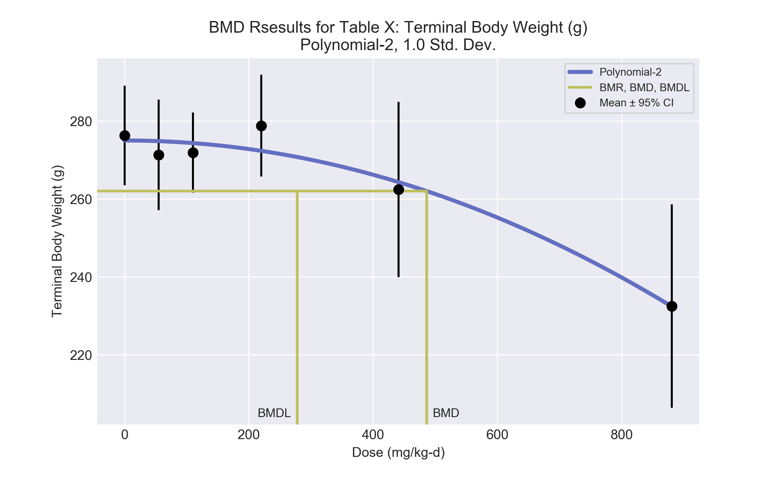
====================================================================
Polynomial Model. (Version: 2.21; Date: 03/14/2017)
Input Data File: C:\Users\USERNAME\AppData\Local\Temp\2\bmds-g238jbg9.(d)
Gnuplot Plotting File: C:\Users\USERNAME\AppData\Local\Temp\2\bmds-g238jbg9.plt
Mon Dec 18 12:03:18 2017
====================================================================
BMDS_Model_Run
~~~~~~~~~~~~~~~~~~~~~~~~~~~~~~~~~~~~~~~~~~~~~~~~~~~~~~~~~~~~~~~~~~~~~
The form of the response function is:
Y[dose] = beta_0 + beta_1*dose + beta_2*dose^2 + ...
Dependent variable = Response
Independent variable = Dose
rho is set to 0
The polynomial coefficients are restricted to be negative
A constant variance model is fit
Total number of dose groups = 6
Total number of records with missing values = 0
Maximum number of iterations = 500
Relative Function Convergence has been set to: 1e-008
Parameter Convergence has been set to: 1e-008
Default Initial Parameter Values
alpha = 197.433
rho = 0 Specified
beta_0 = 274.363
beta_1 = 0
beta_2 = -6.13731e-005
Asymptotic Correlation Matrix of Parameter Estimates
( *** The model parameter(s) -rho -beta_1
have been estimated at a boundary point, or have been specified by the user,
and do not appear in the correlation matrix )
alpha beta_0 beta_2
alpha 1 1.4e-007 -1.4e-008
beta_0 1.4e-007 1 -0.53
beta_2 -1.4e-008 -0.53 1
Parameter Estimates
95.0% Wald Confidence Interval
Variable Estimate Std. Err. Lower Conf. Limit Upper Conf. Limit
alpha 168.866 43.601 83.4096 254.322
beta_0 275 2.79087 269.53 280.47
beta_1 -0 NA
beta_2 -5.49239e-005 8.52697e-006 -7.16365e-005 -3.82114e-005
NA - Indicates that this parameter has hit a bound
implied by some inequality constraint and thus
has no standard error.
Table of Data and Estimated Values of Interest
Dose N Obs Mean Est Mean Obs Std Dev Est Std Dev Scaled Res.
------ --- -------- -------- ----------- ----------- ----------
0 5 276 275 10.3 13 0.224
55 5 271 275 11.4 13 -0.608
110 5 272 274 8.27 13 -0.419
220 5 279 272 10.5 13 1.11
441 5 262 264 18.1 13 -0.33
881 5 233 232 21 13 0.0223
Model Descriptions for likelihoods calculated
Model A1: Yij = Mu(i) + e(ij)
Var{e(ij)} = Sigma^2
Model A2: Yij = Mu(i) + e(ij)
Var{e(ij)} = Sigma(i)^2
Model A3: Yij = Mu(i) + e(ij)
Var{e(ij)} = Sigma^2
Model A3 uses any fixed variance parameters that
were specified by the user
Model R: Yi = Mu + e(i)
Var{e(i)} = Sigma^2
Likelihoods of Interest
Model Log(likelihood) # Param's AIC
A1 -90.933862 7 195.867723
A2 -87.513245 12 199.026491
A3 -90.933862 7 195.867723
fitted -91.936585 3 189.873170
R -104.961782 2 213.923564
Explanation of Tests
Test 1: Do responses and/or variances differ among Dose levels?
(A2 vs. R)
Test 2: Are Variances Homogeneous? (A1 vs A2)
Test 3: Are variances adequately modeled? (A2 vs. A3)
Test 4: Does the Model for the Mean Fit? (A3 vs. fitted)
(Note: When rho=0 the results of Test 3 and Test 2 will be the same.)
Tests of Interest
Test -2*log(Likelihood Ratio) Test df p-value
Test 1 34.8971 10 0.00013
Test 2 6.84123 5 0.2327
Test 3 6.84123 5 0.2327
Test 4 2.00545 4 0.7348
The p-value for Test 1 is less than .05. There appears to be a
difference between response and/or variances among the dose levels
It seems appropriate to model the data
The p-value for Test 2 is greater than .1. A homogeneous variance
model appears to be appropriate here
The p-value for Test 3 is greater than .1. The modeled variance appears
to be appropriate here
The p-value for Test 4 is greater than .1. The model chosen seems
to adequately describe the data
Benchmark Dose Computation
Specified effect = 1
Risk Type = Estimated standard deviations from the control mean
Confidence level = 0.95
BMD = 486.413
BMDL = 278.1
BMDU = 593.803

  - BMD Results for: Brain Weight Relative (mg/g)
BMDS version: BMDS v2.7.0
    - Input dataset
Dose | 0 | 55 | 110 | 220 | 441 | 881
N | 5 | 5 | 5 | 5 | 4 | 5
Mean ± SD | 6.28 ± 0.514 | 6.43 ± 0.134 | 6.52 ± 0.291 | 6.48 ± 0.067 | 7.03 ± 0.28 | 7.73 ± 0.827

    - Summary table
Modelª | Goodness of fit |  | BMD | BMDL | Comments
 | p-value | AIC
Linear | 0.544 | -23.015 | 176.18 | 122.545 | No model was recommended as a best-fitting model.
Polynomial 2° (equivalent models include Polynomial 3°, 4°, 5°) | 0.657 | -22.489 | 288.96 | 137.018
Power | 0.682 | -22.6 | 298.105 | 138.523
Hill | 0.884 | -23.446 | 418.997 | -999
Exponential M2 | 0.611 | -23.407 | 186.914 | 132.369
Exponential M3 | 0.671 | -22.552 | 294.221 | 143.142
Exponential M4 | 0.378 | -21.01 | 176.068 | 113.837
Exponential M5 | 0.721 | -21.446 | 422.297 | 156.103
ª Modeled variance case presented (BMDS Test 2 p-value = <0.0001, BMDS Test 3 p-value = 2.2E-04).

    - Model recommendation details
Model | Bin | Notes
Linear | Warning | Warnings  • Variance model fit p-value is less than threshold (0.000218 < 0.1)  • Ratio of modeled to actual stdev. at control is greater than threshold (1.86 > 1.5)
Polynomial 2° (equivalent models include Polynomial 3°, 4°, 5°) | Warning | Warnings  • Variance model fit p-value is less than threshold (0.000218 < 0.1)  • Ratio of modeled to actual stdev. at control is greater than threshold (1.87 > 1.5)
Power | Warning | Warnings  • Variance model fit p-value is less than threshold (0.000218 < 0.1)  • Ratio of modeled to actual stdev. at control is greater than threshold (1.86 > 1.5)
Hill | Failure | Failures  • BMDL does not exist  Warnings  • Variance model fit p-value is less than threshold (0.000218 < 0.1)  • Ratio of modeled to actual stdev. at control is greater than threshold (1.85 > 1.5)  Cautions  • Warning(s): BMDL computation failed.
Exponential M2 | Warning | Warnings  • Variance model fit p-value is less than threshold (0.000218 < 0.1)
Exponential M3 | Warning | Warnings  • Variance model fit p-value is less than threshold (0.000218 < 0.1)
Exponential M4 | Warning | Warnings  • Variance model fit p-value is less than threshold (0.000218 < 0.1)
Exponential M5 | Warning | Warnings  • Variance model fit p-value is less than threshold (0.000218 < 0.1)

    - Recommended model
No model was recommended as a best-fitting model.

  - BMD Results for: Liver Weight Absolute (g)
BMDS version: BMDS v2.7.0
    - Input dataset
Dose | 0 | 55 | 110 | 220 | 441 | 881
N | 5 | 5 | 5 | 5 | 5 | 5
Mean ± SD | 11.46 ± 0.425 | 11.83 ± 1.252 | 11.84 ± 0.648 | 12.95 ± 1.073 | 12.92 ± 1.431 | 13.09 ± 0.85

    - Summary table
Modelª | Goodness of fit |  | BMD | BMDL | Comments
 | p-value | AIC
Linear (equivalent models include Power, Polynomial 3°, 4°, 5°) | 0.28 | 34.83 | 564.197 | 352.58 | Exponential-M4 recommended as best-fitting model on the basis of the lowest BMDL.
Polynomial 2° | 0.28 | 34.83 | 564.196 | 352.58
Hill | 0.778 | 34.259 | 157.258 | 52.497
Exponential M2 (equivalent models include Exponential M3) | 0.263 | 35.001 | 589.208 | 378.316
Exponential M4^{b} | 0.698 | 33.192 | 135.736 | 47.984
Exponential M5 | 0.788 | 34.233 | 169.784 | 57.903
ª Constant variance case presented (BMDS Test 2 p-value = 0.134, BMDS Test 3 p-value = 0.134).
^{b} Recommended model

    - Model recommendation details
Model | Bin | Notes
Linear (equivalent models include Power, Polynomial 3°, 4°, 5°) | Warning | Warnings  • Ratio of modeled to actual stdev. at control is greater than threshold (2.31 > 1.5)
Polynomial 2° | Warning | Warnings  • Ratio of modeled to actual stdev. at control is greater than threshold (2.31 > 1.5)
Hill | Warning | Warnings  • Ratio of modeled to actual stdev. at control is greater than threshold (2.14 > 1.5)
Exponential M2 (equivalent models include Exponential M3) | Valid | -
Exponential M4ª | Valid | -
Exponential M5 | Valid | -
ª Recommended model

    - Recommended model
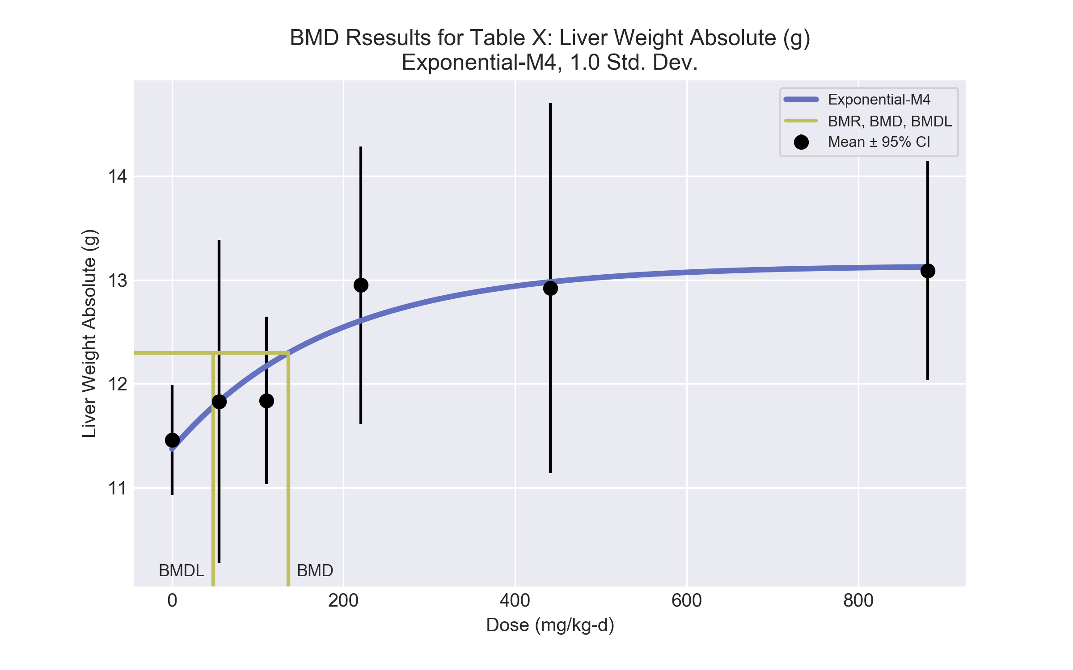
====================================================================
Exponential Model. (Version: 1.11; Date: 03/14/2017)
Input Data File: C:\Users\USERNAME\AppData\Local\Temp\2\bmds-3dnbbsd_.(d)
Gnuplot Plotting File:
Mon Dec 18 12:03:21 2017
====================================================================
BMDS_Model_Run
~~~~~~~~~~~~~~~~~~~~~~~~~~~~~~~~~~~~~~~~~~~~~~~~~~~~~~~~~~~~~~~~~~~~~
The form of the response function by Model:
Model 2: Y[dose] = a * exp{sign * b * dose}
Model 3: Y[dose] = a * exp{sign * (b * dose)^d}
Model 4: Y[dose] = a * [c-(c-1) * exp{-b * dose}]
Model 5: Y[dose] = a * [c-(c-1) * exp{-(b * dose)^d}]
Note: Y[dose] is the median response for exposure = dose;
sign = +1 for increasing trend in data;
sign = -1 for decreasing trend.
Model 2 is nested within Models 3 and 4.
Model 3 is nested within Model 5.
Model 4 is nested within Model 5.
Dependent variable = Response
Independent variable = Dose
Data are assumed to be distributed: normally
Variance Model: exp(lnalpha +rho *ln(Y[dose]))
rho is set to 0.
A constant variance model is fit.
Total number of dose groups = 6
Total number of records with missing values = 0
Maximum number of iterations = 500
Relative Function Convergence has been set to: 1e-008
Parameter Convergence has been set to: 1e-008
MLE solution provided: Exact
Initial Parameter Values
Variable Model 4
-------- --------
lnalpha -0.20809
rho 0 Specified
a 10.887
b 0.00212232
c 1.26247
d 1 Specified
Parameter Estimates
Variable Model 4 Std. Err.
-------- ------- ---------
lnalpha -0.160272 0.219963
a 11.3745 0.361185
b 0.00545253 0.00351911
c 1.15517 0.0459453
NC = No Convergence
Table of Stats From Input Data
Dose N Obs Mean Obs Std Dev
----- --- ---------- -------------
0 5 11.46 0.4249
55 5 11.83 1.252
110 5 11.84 0.6485
220 5 12.95 1.073
441 5 12.92 1.431
881 5 13.09 0.8497
Estimated Values of Interest
Dose Est Mean Est Std Scaled Residual
------ ---------- --------- ----------------
0 11.37 0.923 0.2071
55 11.83 0.923 -0.004481
110 12.17 0.923 -0.8011
220 12.61 0.923 0.8293
441 12.98 0.923 -0.1457
881 13.13 0.923 -0.08498
Other models for which likelihoods are calculated:
Model A1: Yij = Mu(i) + e(ij)
Var{e(ij)} = Sigma^2
Model A2: Yij = Mu(i) + e(ij)
Var{e(ij)} = Sigma(i)^2
Model A3: Yij = Mu(i) + e(ij)
Var{e(ij)} = exp(lalpha + log(mean(i)) * rho)
Model R: Yij = Mu + e(i)
Var{e(ij)} = Sigma^2
Likelihoods of Interest
Model Log(likelihood) DF AIC
------- ----------------- ---- ------------
A1 -11.87865 7 37.75729
A2 -7.663101 12 39.3262
A3 -11.87865 7 37.75729
R -18.20223 2 40.40445
4 -12.59592 4 33.19185
Additive constant for all log-likelihoods = -27.57. This constant added to the
above values gives the log-likelihood including the term that does not
depend on the model parameters.
Explanation of Tests
Test 1: Does response and/or variances differ among Dose levels? (A2 vs. R)
Test 2: Are Variances Homogeneous? (A2 vs. A1)
Test 3: Are variances adequately modeled? (A2 vs. A3)
Test 6a: Does Model 4 fit the data? (A3 vs 4)
Tests of Interest
Test -2*log(Likelihood Ratio) D. F. p-value
-------- ------------------------ ------ --------------
Test 1 21.08 10 0.02055
Test 2 8.431 5 0.134
Test 3 8.431 5 0.134
Test 6a 1.435 3 0.6975
The p-value for Test 1 is less than .05. There appears to be a
difference between response and/or variances among the dose
levels, it seems appropriate to model the data.
The p-value for Test 2 is greater than .1. A homogeneous
variance model appears to be appropriate here.
The p-value for Test 3 is greater than .1. The modeled
variance appears to be appropriate here.
The p-value for Test 6a is greater than .1. Model 4 seems
to adequately describe the data.
Benchmark Dose Computations:
Specified Effect = 1.000000
Risk Type = Estimated standard deviations from control
Confidence Level = 0.950000
BMD = 135.736
BMDL = 47.9838
BMDU = 8.81e+006

  - BMD Results for: Liver Weight Relative (mg/g)
BMDS version: BMDS v2.7.0
    - Input dataset
Dose | 0 | 55 | 110 | 220 | 441 | 881
N | 5 | 5 | 5 | 5 | 5 | 5
Mean ± SD | 41.5 ± 1.297 | 43.52 ± 3.153 | 43.51 ± 1.409 | 46.42 ± 2.862 | 49.14 ± 2.236 | 56.74 ± 7.2

    - Summary table
Modelª | Goodness of fit |  | BMD | BMDL | Comments
 | p-value | AIC
Linear^{b} (equivalent models include Power, Polynomial 2°) | 0.49 | 95.805 | 102.779 | 71.319 | Linear recommended as best-fitting model on the basis of the lowest AIC.
Polynomial 3° | 0.332 | 97.805 | 102.982 | 71.319
Polynomial 4° | 0.332 | 97.798 | 104.625 | 71.351
Polynomial 5° | 0.334 | 97.79 | 105.275 | 71.388
Hill | 0.335 | 97.779 | 96.959 | -999
Exponential M2 (equivalent models include Exponential M3) | 0.452 | 96.061 | 118.202 | 83.366
Exponential M4 | 0.335 | 97.781 | 97.354 | 50.208
Exponential M5 | 0.335 | 97.781 | 97.354 | 50.208
ª Modeled variance case presented (BMDS Test 2 p-value = 6.9E-04, BMDS Test 3 p-value = 0.261).
^{b} Recommended model

    - Model recommendation details
Model | Bin | Notes
Linearª (equivalent models include Power, Polynomial 2°) | Valid | -
Polynomial 3° | Valid | -
Polynomial 4° | Valid | -
Polynomial 5° | Valid | -
Hill | Failure | Failures  • BMDL does not exist  Cautions  • Warning(s): BMDL computation failed.
Exponential M2 (equivalent models include Exponential M3) | Valid | -
Exponential M4 | Valid | -
Exponential M5 | Valid | -
ª Recommended model

    - Recommended model
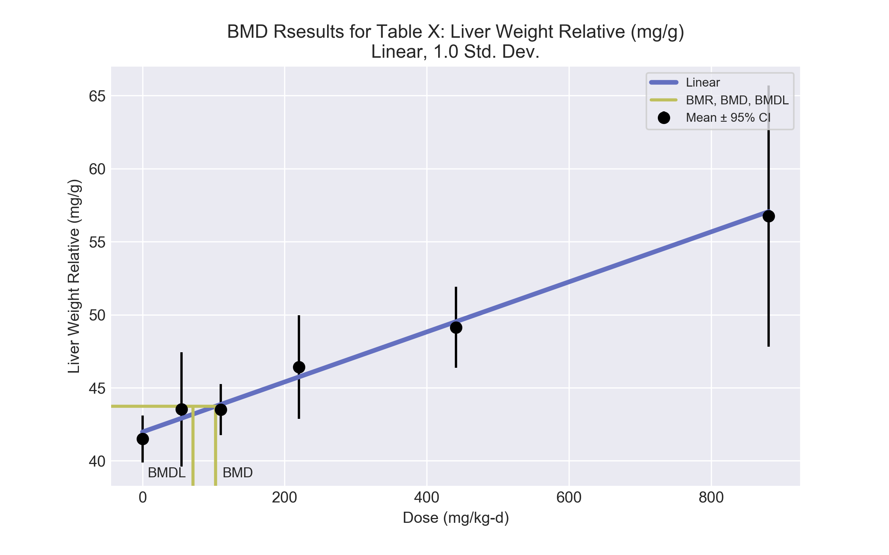
====================================================================
Polynomial Model. (Version: 2.21; Date: 03/14/2017)
Input Data File: C:\Users\USERNAME\AppData\Local\Temp\2\bmds-sn84zvo5.(d)
Gnuplot Plotting File: C:\Users\USERNAME\AppData\Local\Temp\2\bmds-sn84zvo5.plt
Mon Dec 18 12:03:22 2017
====================================================================
BMDS_Model_Run
~~~~~~~~~~~~~~~~~~~~~~~~~~~~~~~~~~~~~~~~~~~~~~~~~~~~~~~~~~~~~~~~~~~~~
The form of the response function is:
Y[dose] = beta_0 + beta_1*dose + beta_2*dose^2 + ...
Dependent variable = Response
Independent variable = Dose
The polynomial coefficients are restricted to be positive
The variance is to be modeled as Var(i) = exp(lalpha + log(mean(i)) * rho)
Total number of dose groups = 6
Total number of records with missing values = 0
Maximum number of iterations = 500
Relative Function Convergence has been set to: 1e-008
Parameter Convergence has been set to: 1e-008
Default Initial Parameter Values
lalpha = 2.57313
rho = 0
beta_0 = 42.0568
beta_1 = 0
Asymptotic Correlation Matrix of Parameter Estimates
lalpha rho beta_0 beta_1
lalpha 1 -1 0.096 -0.15
rho -1 1 -0.096 0.15
beta_0 0.096 -0.096 1 -0.6
beta_1 -0.15 0.15 -0.6 1
Parameter Estimates
95.0% Wald Confidence Interval
Variable Estimate Std. Err. Lower Conf. Limit Upper Conf. Limit
lalpha -27.4524 8.87189 -44.8409 -10.0638
rho 7.64854 2.30865 3.12366 12.1734
beta_0 41.9742 0.53027 40.9349 43.0135
beta_1 0.0171245 0.0024516 0.0123194 0.0219295
Table of Data and Estimated Values of Interest
Dose N Obs Mean Est Mean Obs Std Dev Est Std Dev Scaled Res.
------ --- -------- -------- ----------- ----------- ----------
0 5 41.5 42 1.3 1.76 -0.602
55 5 43.5 42.9 3.15 1.92 0.705
110 5 43.5 43.9 1.41 2.08 -0.374
220 5 46.4 45.7 2.86 2.44 0.62
441 5 49.1 49.5 2.24 3.31 -0.261
881 5 56.7 57.1 7.2 5.7 -0.126
Model Descriptions for likelihoods calculated
Model A1: Yij = Mu(i) + e(ij)
Var{e(ij)} = Sigma^2
Model A2: Yij = Mu(i) + e(ij)
Var{e(ij)} = Sigma(i)^2
Model A3: Yij = Mu(i) + e(ij)
Var{e(ij)} = exp(lalpha + rho*ln(Mu(i)))
Model A3 uses any fixed variance parameters that
were specified by the user
Model R: Yi = Mu + e(i)
Var{e(i)} = Sigma^2
Likelihoods of Interest
Model Log(likelihood) # Param's AIC
A1 -50.249853 7 114.499706
A2 -39.559757 12 103.119515
A3 -42.192973 8 100.385946
fitted -43.902300 4 95.804601
R -68.822673 2 141.645346
Explanation of Tests
Test 1: Do responses and/or variances differ among Dose levels?
(A2 vs. R)
Test 2: Are Variances Homogeneous? (A1 vs A2)
Test 3: Are variances adequately modeled? (A2 vs. A3)
Test 4: Does the Model for the Mean Fit? (A3 vs. fitted)
(Note: When rho=0 the results of Test 3 and Test 2 will be the same.)
Tests of Interest
Test -2*log(Likelihood Ratio) Test df p-value
Test 1 58.5258 10 <.0001
Test 2 21.3802 5 0.0006864
Test 3 5.26643 4 0.261
Test 4 3.41865 4 0.4904
The p-value for Test 1 is less than .05. There appears to be a
difference between response and/or variances among the dose levels
It seems appropriate to model the data
The p-value for Test 2 is less than .1. A non-homogeneous variance
model appears to be appropriate
The p-value for Test 3 is greater than .1. The modeled variance appears
to be appropriate here
The p-value for Test 4 is greater than .1. The model chosen seems
to adequately describe the data
Benchmark Dose Computation
Specified effect = 1
Risk Type = Estimated standard deviations from the control mean
Confidence level = 0.95
BMD = 102.779
BMDL = 71.319
BMDU = 156.112

