Figure S1. LC-MS of BPS glucuronide in urine collected 0 to 24 h following gavage administration of 500 mg/kg BPS to male rats. Top panel represents the extracted ion chromatogram at m/z 425.1 for parent, middle panel the exact mass of BPS glucuronide. and the bottom panel, MS/MS of the parent ion at m/z 425.1

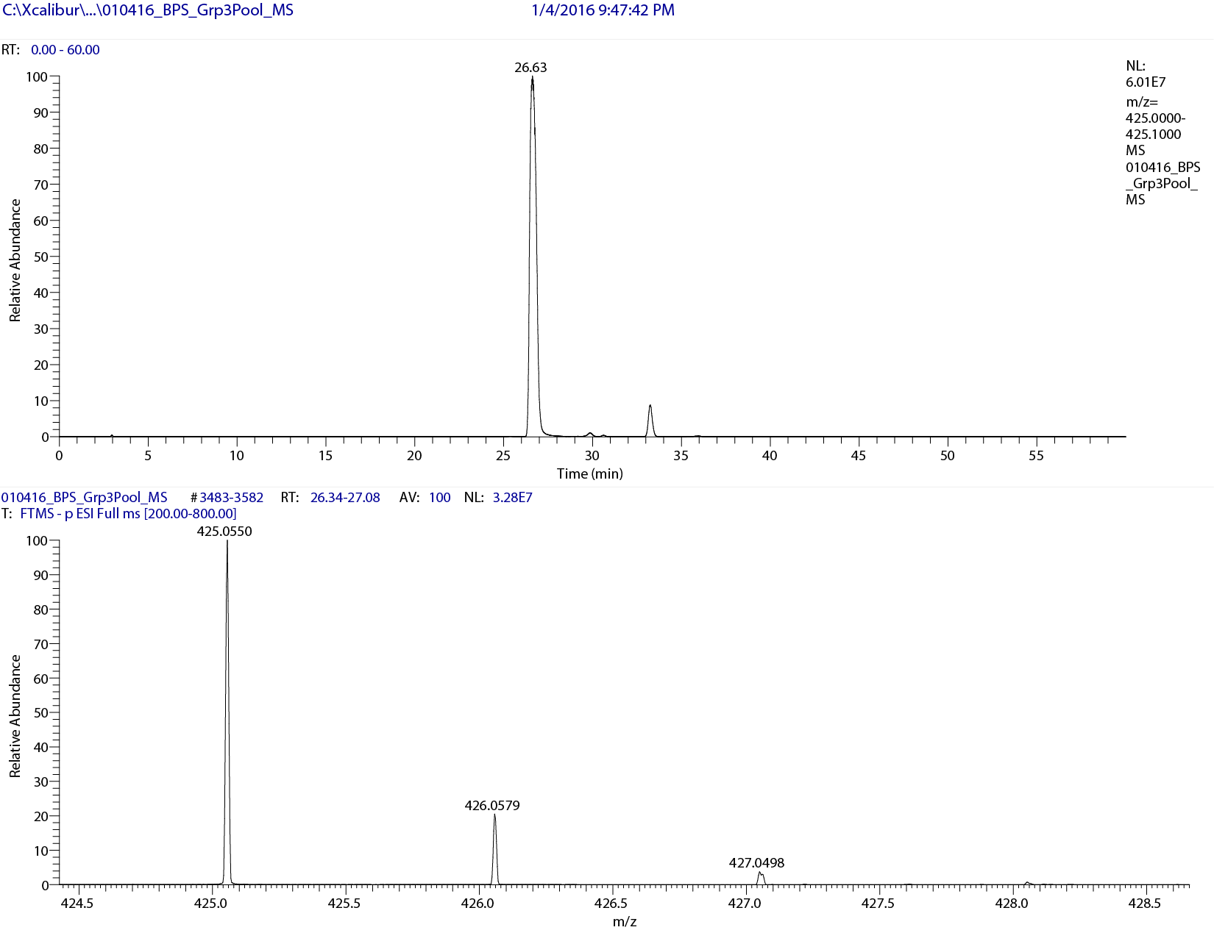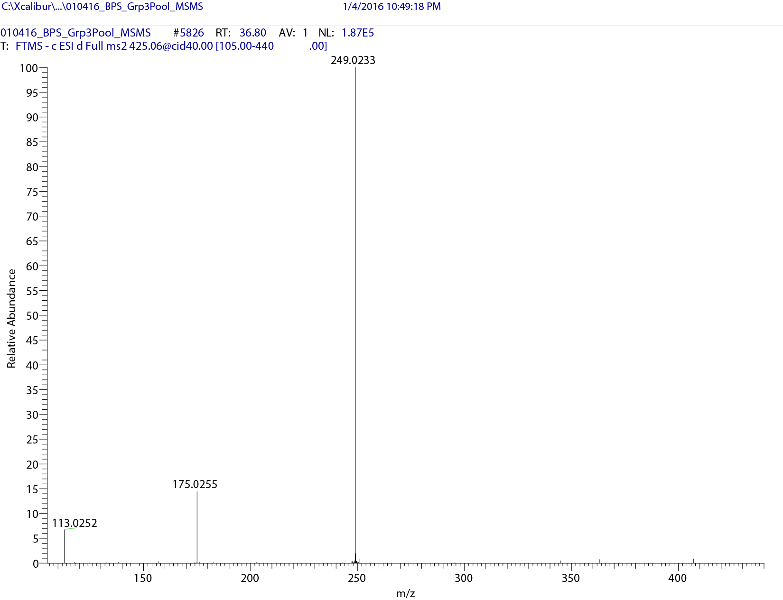
Figure S2 LC-MS of BPS sulfate in urine collected 0 to 24 h following gavage administration of 500 mg/kg BPS to male rats. Top panel represents the extracted ion chromatogram at m/z 329, and the bottom panel exact mass of BPS sulfate at m/z 328.9798

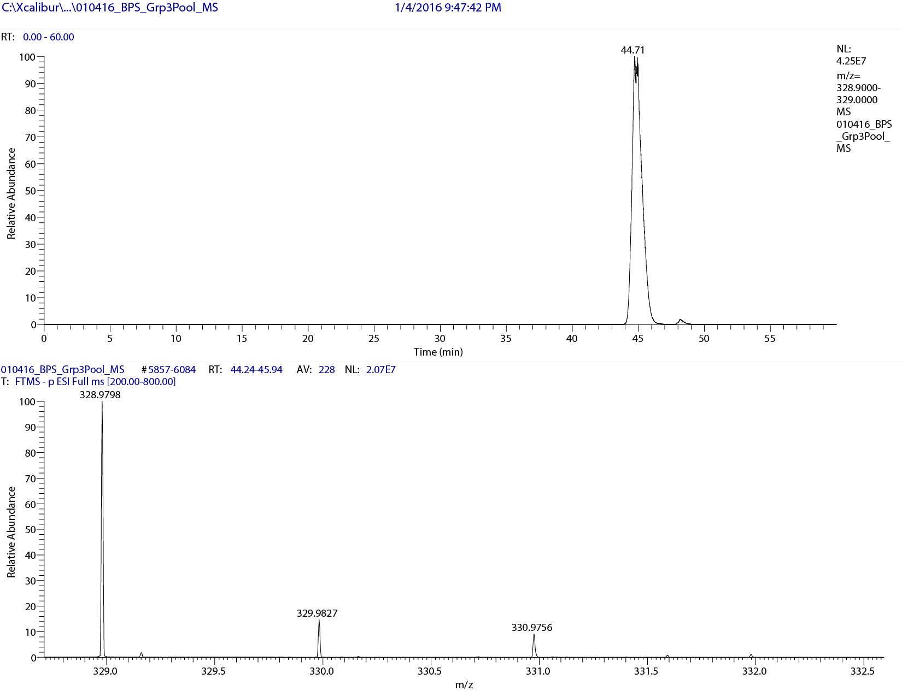

Figure S3. LC-MS of hydroxylated BPS metabolites in urine collected 0 to 24 h following gavage administration of 500 mg/kg BPS to male rats. Top panel represents the extracted ion chromatogram at m/z 265.1, middle panel the mass spectrum of monohydroxylated BPS, and the bottom panel, MS/MS of the parent ion at m/z 265.02.

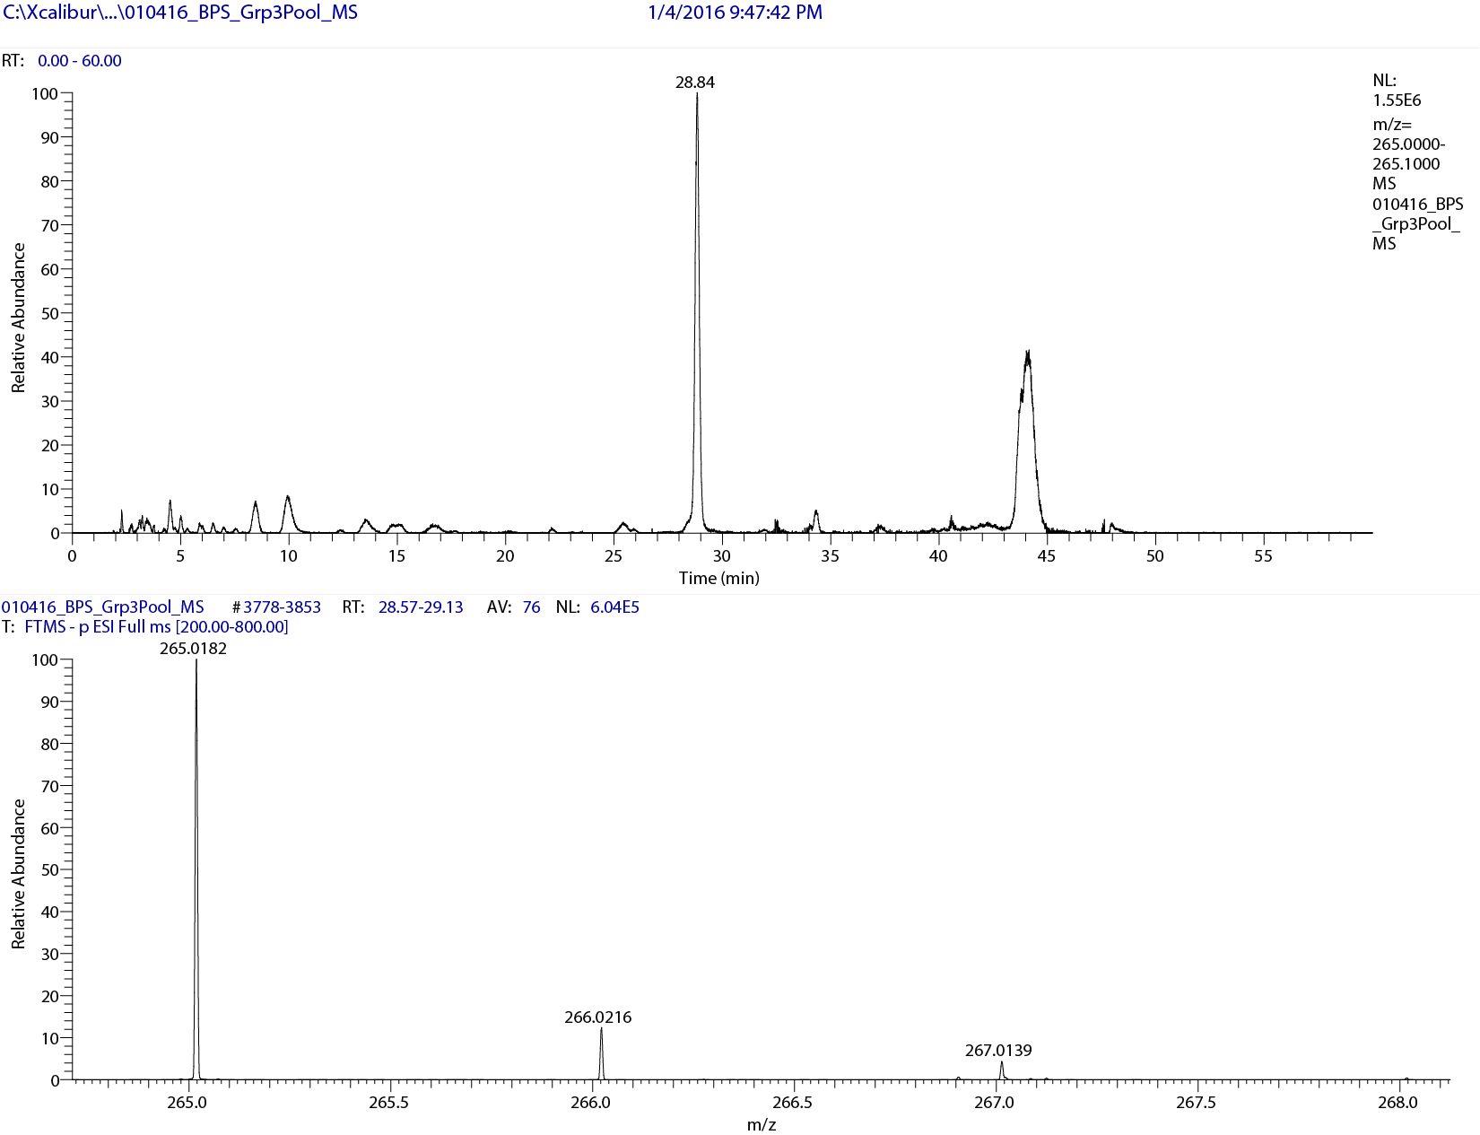
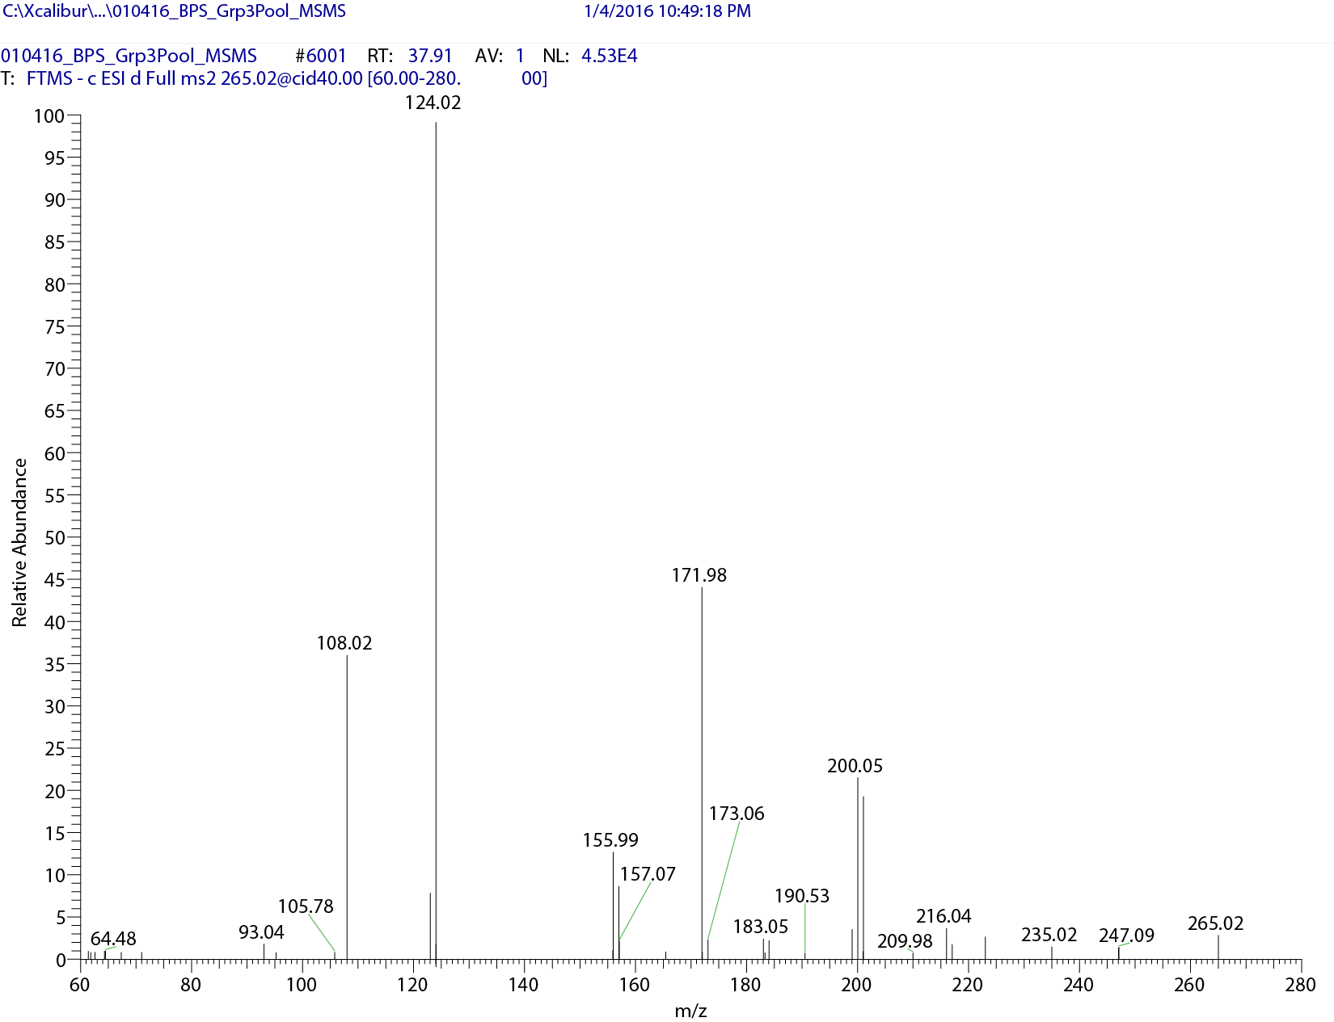

Figure S4. LC-MS extracted ion chromatograms of BPS metabolites in Male Rat Hepatocytes. A: BPS, 249 m/z. B: BPS-OH, 265 m/z. C: BPS-Glucuronide, 425 m/z. D: BPS-Sulfate, 329 m/z. E: BPS-Sulfate-OH, 345 m/z.
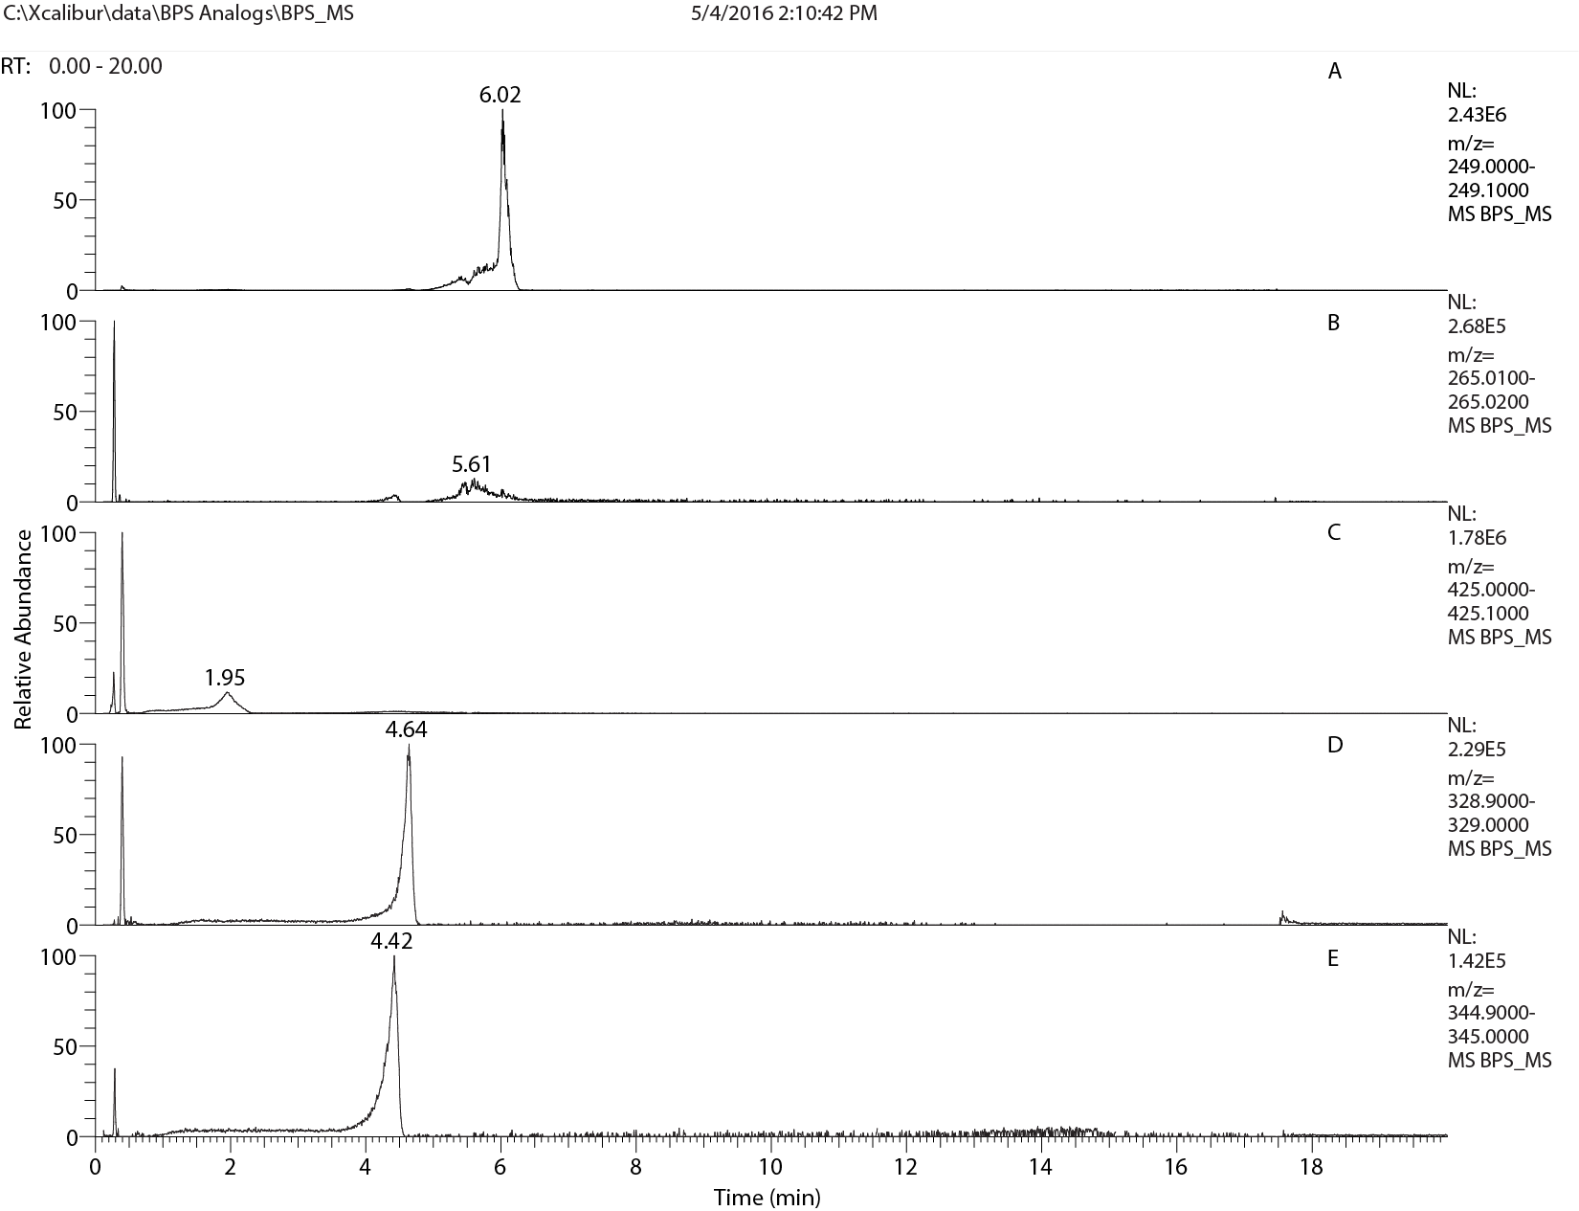

Table S1. Clearance and half-life of BPS and derivatives in rat, mouse, and human hepatocytes in vitroª
Chemical Abbreviation^{b} | Species | Sex | t_{1/2}  (h) | Clearance mL/(min*kg)
BPS | Rat | Male | 1.002 (0.040) | 115.7 (4.6)
 |  | Female | 0.486 (0.020) | 155.3 (6.4)
 | Mouse | Male | 0.488 (0.070) | 139.9 (21.4)
 |  | Female | 0.581 (0.027) | 131.0 (6.0)
 | Human | Male | 1.617 (0.069) | 34.3 (1.5)
 |  | Female | 1.414 (0.057) | 35.6 (1.4)
2,4-BPS | Rat | Male | 0.401 (0.030) | 289.5 (21.3)
 |  | Female | 0.306 (0.006) | 246.8 (4.5)
 | Mouse | Male | 0.181 (0.013) | 373.6 (28.4)
 |  | Female | 0.212 (0.025) | 362.6 (46.5)
 | Human | Male | 0.458 (0.037) | 121.3 (10.1)
 |  | Female | 0.311 (0.010) | 162.0 (5.1)
BPS-MAE | Rat | Male | 0.246 (0.034) | 476.5 (65.0)
 |  | Female | 0.114 (0.010) | 664.0 (62.9)
 | Mouse | Male | 0.275 (0.044) | 249.1 (36.6)
 |  | Female | 0.264 (0.017) | 288.2 (19.0)
 | Human | Male | 0.750 (0.040) | 73.9 (4.0)
 |  | Female | 0.639 (0.163) | 82.7 (23.4)
D8 | Rat | Male | 0.598 (0.070) | 195.7 (24.4)
 |  | Female | 0.305 (0.017) | 247.7 (13.8)
 | Mouse | Male | 0.486 (0.048) | 139.3 (13.6)
 |  | Female | 0.425 (0.031) | 179.5 (13.1)
 | Human | Male | 1.308 (0.052) | 42.3 (1.7)
 |  | Female | 0.667 (0.046) | 75.6 (5.1)
TGSA | Rat | Male | 0.490 (0.193) | 263.7 (107.0)
 |  | Female | 0.278 (0.006) | 271.8 (6.2)
 | Mouse | Male | 0.189 (0.037) | 365.2 (73.8)
 |  | Female | 0.285 (0.028) | 268.2 (27.4)
 | Human | Male | 0.847 (0.014) | 65.3 (1.1)
 |  | Female | 0.503 (0.026) | 100.2 (5.4)
BPS-MPE | Rat | Male | 0.209 (0.028) | 560.9 (70.8)
 |  | Female | 0.152 (0.005) | 497.5 (16.0)
 | Mouse | Male | 0.278 (0.017) | 242.8 (15.2)
 |  | Female | 0.265 (0.024) | 288.1 (25.3)
 | Human | Male | 0.442 (0.054) | 126.6 (16.7)
 |  | Female | 0.420 (0.037) | 120.5 (11.1)
D90 | Rat | Male | 4.407 (0.858) | 26.9 (4.7)
 |  | Female | 6.598 (2.220) | 12.2 (3.4)
 | Mouse | Male | 4.028 (0.815) | 17.2 (3.9)
 |  | Female | 3.078 (0.306) | 24.9 (2.4)
 | Human | Male | 10.051 (7.272) | 7.4 (3.9)
 |  | Female | 9.272 (2.690) | 5.7 (1.5)

ª Average and (SD) for n=3 replicates are shown. ^{b}BPS, bisphenol S; 2,4-BPS, 2,4-bisphenol S; BPS-MAE, Bis(4-hydroxyphenyl)sulfonylphenyl;D8, 4-Hydroxy-4’isopropoxydiphenylsulfone;TGSA, 4,4’Sulfonylbis[2-(2-propenyl)]phenol; BPS-MPE, 4-Benzyloxyphenyl-4-hydroxyphenyl sulfone; D90, Bis(2-chloroethyl)ether-4,4”-dihydroxydiphenyl sulfone copolymer. Cell concentrations for all chemicals were as follows (x 10⁶ cells/mL): Male rat: 0.407, Female rat: 0.625, Male mouse: 0.700, Female mouse: 0.620, Male human: 0.644, Female human: 0.708.

