BMD Results for Table: Brain Weight Absolute
BMDS version: BMDS v2.7.0

Input dataset
Dose | 0 | 65 | 129 | 258 | 516 | 1033
N | 4 | 3 | 5 | 5 | 5 | 4
Mean ± SD | 1.672 ± 0.144 | 1.797 ± 0.074 | 1.818 ± 0.029 | 1.784 ± 0.041 | 1.774 ± 0.072 | 1.772 ± 0.086

Summary table
Modelª | Goodness of fit |  | BMD | BMDL | Comments
 | p-value | AIC
Linear | 8.5E-04 | -97.079 | 8372.11 | 1037.59 | No model was recommended as a best-fitting model. Doses were dropped until there were only 3 remaining dose-groups.
Polynomial 2° | 8.5E-04 | -97.079 | 8372.35 | 1037.59
Polynomial 3° | 8.5E-04 | -97.079 | 8369.54 | 1037.59
Polynomial 4° | 8.5E-04 | -97.079 | 8386.37 | 1037.59
Polynomial 5° | 8.5E-04 | -97.079 | 8368.36 | -999
Power | 8.5E-04 | -97.079 | 8374.94 | 1061.68
Hill | 0.145 | -109.063 | -999 | -999
Exponential M2 | 8.5E-04 | -97.074 | 8454.15 | 1043.78
Exponential M3 | 8.5E-04 | -97.074 | 8454.31 | 1043.78
Exponential M4 | 0.077 | -107.063 | -999 | 0
Exponential M5 | 0.033 | -105.063 | -999 | 0
ª Modeled variance case presented (BMDS Test 2 p-value = 0.025, BMDS Test 3 p-value = 0.812).

Model recommendation details
Model | Bin | Notes
Linear | Warning | Warnings  • Goodness of fit p-value is less than threshold (0.000851 < 0.1)  • BMD/high dose ratio is greater than threshold (8.1 > 1.0)  • Residual at lowest dose is greater than threshold (2.07 > 2.0)  Cautions  • BMD/BMDL ratio is greater than threshold (8.07 > 5.0)  • Warning(s): THE MODEL HAS PROBABLY NOT CONVERGED!!!; THIS USUALLY MEANS THE MODEL HAS NOT CONVERGED!  • BMDL/high dose ratio is greater than threshold (1.0 > 1.0)
Polynomial 2° | Warning | Warnings  • Goodness of fit p-value is less than threshold (0.000851 < 0.1)  • BMD/high dose ratio is greater than threshold (8.1 > 1.0)  • Residual at lowest dose is greater than threshold (2.07 > 2.0)  Cautions  • BMD/BMDL ratio is greater than threshold (8.07 > 5.0)  • Warning(s): THE MODEL HAS PROBABLY NOT CONVERGED!!!; THIS USUALLY MEANS THE MODEL HAS NOT CONVERGED!  • BMDL/high dose ratio is greater than threshold (1.0 > 1.0)
Polynomial 3° | Warning | Warnings  • Goodness of fit p-value is less than threshold (0.000851 < 0.1)  • BMD/high dose ratio is greater than threshold (8.1 > 1.0)  • Residual at lowest dose is greater than threshold (2.07 > 2.0)  Cautions  • BMD/BMDL ratio is greater than threshold (8.07 > 5.0)  • Warning(s): THE MODEL HAS PROBABLY NOT CONVERGED!!!; THIS USUALLY MEANS THE MODEL HAS NOT CONVERGED!  • BMDL/high dose ratio is greater than threshold (1.0 > 1.0)
Polynomial 4° | Warning | Warnings  • Goodness of fit p-value is less than threshold (0.000851 < 0.1)  • BMD/high dose ratio is greater than threshold (8.12 > 1.0)  • Residual at lowest dose is greater than threshold (2.07 > 2.0)  Cautions  • BMD/BMDL ratio is greater than threshold (8.08 > 5.0)  • Warning(s): THE MODEL HAS PROBABLY NOT CONVERGED!!!; THIS USUALLY MEANS THE MODEL HAS NOT CONVERGED!  • BMDL/high dose ratio is greater than threshold (1.0 > 1.0)
Polynomial 5° | Failure | Failures  • BMDL does not exist  Warnings  • Goodness of fit p-value is less than threshold (0.000851 < 0.1)  • BMD/high dose ratio is greater than threshold (8.1 > 1.0)  • Residual at lowest dose is greater than threshold (2.07 > 2.0)  Cautions  • Warning(s): THE MODEL HAS PROBABLY NOT CONVERGED!!!; THIS USUALLY MEANS THE MODEL HAS NOT CONVERGED!; BMDL computation failed.
Power | Warning | Warnings  • Goodness of fit p-value is less than threshold (0.000851 < 0.1)  • BMD/high dose ratio is greater than threshold (8.11 > 1.0)  • Residual at lowest dose is greater than threshold (2.07 > 2.0)  Cautions  • BMD/BMDL ratio is greater than threshold (7.89 > 5.0)  • BMDL/high dose ratio is greater than threshold (1.03 > 1.0)
Hill | Failure | Failures  • BMD does not exist  • BMDL does not exist  Warnings  • Residual of Interest does not exist  Cautions  • Warning(s): BMR value is not in the range of the mean function
Exponential M2 | Warning | Warnings  • Goodness of fit p-value is less than threshold (0.00085 < 0.1)  • BMD/high dose ratio is greater than threshold (8.18 > 1.0)  • Residual at lowest dose is greater than threshold (2.07 > 2.0)  Cautions  • BMD/BMDL ratio is greater than threshold (8.1 > 5.0)  • BMDL/high dose ratio is greater than threshold (1.01 > 1.0)
Exponential M3 | Warning | Warnings  • Goodness of fit p-value is less than threshold (0.00085 < 0.1)  • BMD/high dose ratio is greater than threshold (8.18 > 1.0)  • Residual at lowest dose is greater than threshold (2.07 > 2.0)  Cautions  • BMD/BMDL ratio is greater than threshold (8.1 > 5.0)  • BMDL/high dose ratio is greater than threshold (1.01 > 1.0)
Exponential M4 | Failure | Failures  • BMD does not exist  Warnings  • Residual of Interest does not exist  • Goodness of fit p-value is less than threshold (0.0772 < 0.1)
Exponential M5 | Failure | Failures  • BMD does not exist  Warnings  • Residual of Interest does not exist  • Goodness of fit p-value is less than threshold (0.0327 < 0.1)

Recommended model
No model was recommended as a best-fitting model.

BMD Results for Table: Brain Weight Relative
BMDS version: BMDS v2.7.0

Input dataset
Dose | 0 | 65 | 129 | 258 | 516 | 1033
N | 4 | 3 | 5 | 5 | 5 | 4
Mean ± SD | 6.144 ± 0.525 | 6.986 ± 0.508 | 6.393 ± 0.18 | 6.497 ± 0.32 | 6.486 ± 0.315 | 6.765 ± 0.313

Summary table
Modelª | Goodness of fit |  | BMD | BMDL | Comments
 | p-value | AIC
Linear (equivalent models include Power) | 0.034 | -17.747 | 1260.07 | 569.056 | Hill recommended as best-fitting model on the basis of the lowest AIC.
Polynomial 2° | 0.016 | -15.792 | 1176.03 | 571.681
Polynomial 3° | 0.016 | -15.859 | 1124.86 | 575.622
Polynomial 4° | 0.016 | -15.888 | 1102.12 | 577.403
Polynomial 5° | 0.017 | -15.901 | 1088.95 | 578.205
Hill^{b} | 0.104 | -20.476 | 4.8E-12 | 4.8E-12
Exponential M2 (equivalent models include Exponential M3) | 0.034 | -17.751 | 1251.18 | 581.251
Exponential M4 | 0.015 | -15.747 | 1260.7 | 3.546
Exponential M5 | 0.015 | -15.747 | 1260.69 | 5.1E-04
ª Constant variance case presented (BMDS Test 2 p-value = 0.378, BMDS Test 3 p-value = 0.378).
^{b} Recommended model

Model recommendation details
Model | Bin | Notes
Linear (equivalent models include Power) | Warning | Warnings  • Goodness of fit p-value is less than threshold (0.0341 < 0.1)  • BMD/high dose ratio is greater than threshold (1.22 > 1.0)
Polynomial 2° | Warning | Warnings  • Goodness of fit p-value is less than threshold (0.0157 < 0.1)  • BMD/high dose ratio is greater than threshold (1.14 > 1.0)
Polynomial 3° | Warning | Warnings  • Goodness of fit p-value is less than threshold (0.0162 < 0.1)  • BMD/high dose ratio is greater than threshold (1.09 > 1.0)
Polynomial 4° | Warning | Warnings  • Goodness of fit p-value is less than threshold (0.0164 < 0.1)  • BMD/high dose ratio is greater than threshold (1.07 > 1.0)
Polynomial 5° | Warning | Warnings  • Goodness of fit p-value is less than threshold (0.0165 < 0.1)  • BMD/high dose ratio is greater than threshold (1.05 > 1.0)
Hillª | Valid | Cautions  • Minimum dose/BMD ratio is greater than threshold (1.35e+13 > 3.0)
Exponential M2 (equivalent models include Exponential M3) | Warning | Warnings  • Goodness of fit p-value is less than threshold (0.0341 < 0.1)  • BMD/high dose ratio is greater than threshold (1.21 > 1.0)
Exponential M4 | Warning | Warnings  • Goodness of fit p-value is less than threshold (0.0154 < 0.1)  • BMD/BMDL ratio is greater than threshold (3.56e+02 > 20.0)  • BMD/high dose ratio is greater than threshold (1.22 > 1.0)  Cautions  • BMD/BMDL ratio is greater than threshold (3.56e+02 > 5.0)
Exponential M5 | Warning | Warnings  • Goodness of fit p-value is less than threshold (0.0154 < 0.1)  • BMD/BMDL ratio is greater than threshold (2.47e+06 > 20.0)  • BMD/high dose ratio is greater than threshold (1.22 > 1.0)  Cautions  • BMD/BMDL ratio is greater than threshold (2.47e+06 > 5.0)
ª Recommended model

Recommended model
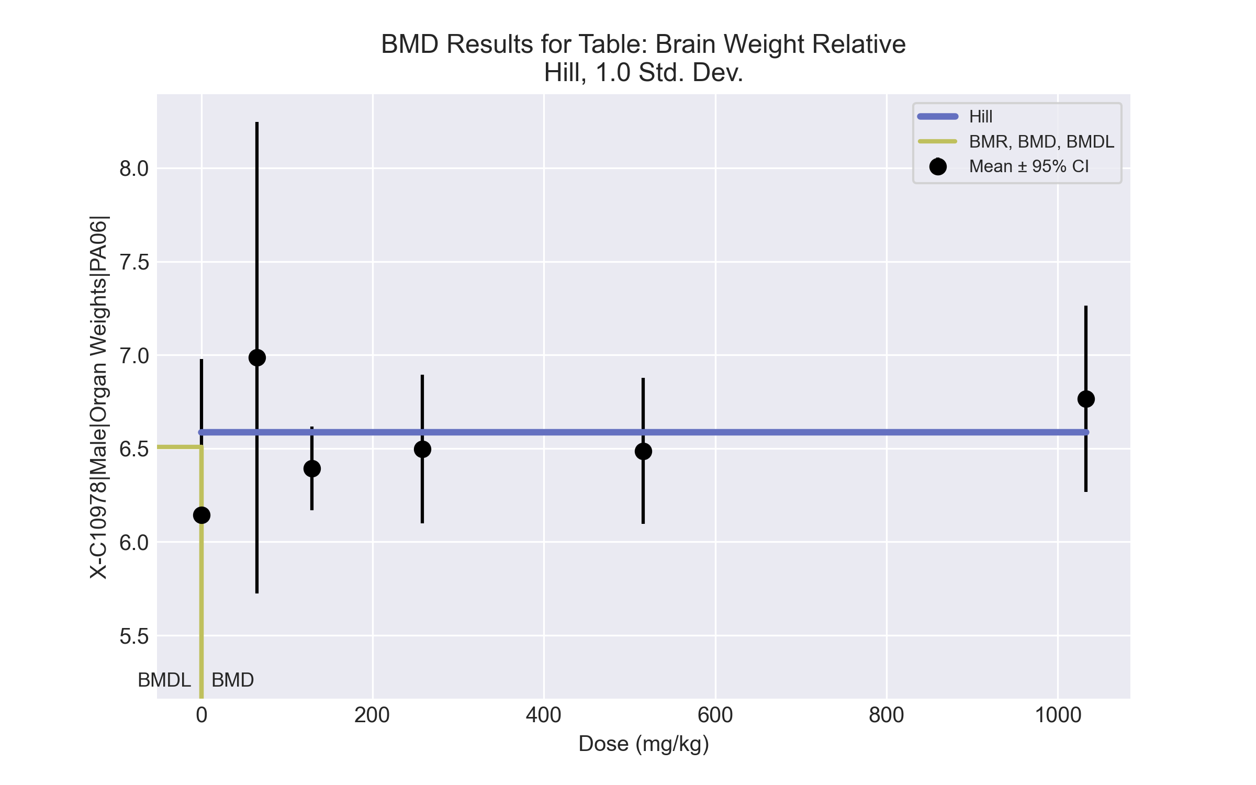
====================================================================
Hill Model. (Version: 2.18; Date: 03/14/2017)
Input Data File: C:\Windows\TEMP\bmds-q2sal2ee.(d)
Gnuplot Plotting File: C:\Windows\TEMP\bmds-q2sal2ee.plt
Fri Jul 16 07:29:25 2021
====================================================================
BMDS_Model_Run
~~~~~~~~~~~~~~~~~~~~~~~~~~~~~~~~~~~~~~~~~~~~~~~~~~~~~~~~~~~~~~~~~~~~~
The form of the response function is:
Y[dose] = intercept + v*dose^n/(k^n + dose^n)
Dependent variable = Response
Independent variable = Dose
rho is set to 0
Power parameter restricted to be greater than 1
A constant variance model is fit
Total number of dose groups = 6
Total number of records with missing values = 0
Maximum number of iterations = 500
Relative Function Convergence has been set to: 1e-008
Parameter Convergence has been set to: 1e-008
Default Initial Parameter Values
alpha = 0.128561
rho = 0 Specified
intercept = 6.14369
v = 0.841979
n = 0.109847
k = 97.5
Asymptotic Correlation Matrix of Parameter Estimates
( *** The model parameter(s) -rho -n -k
have been estimated at a boundary point, or have been specified by the user,
and do not appear in the correlation matrix )
alpha intercept v
alpha 1 2.8e-008 7.4e-009
intercept 2.8e-008 1 -0.92
v 7.4e-009 -0.92 1
Parameter Estimates
95.0% Wald Confidence Interval
Variable Estimate Std. Err. Lower Conf. Limit Upper Conf. Limit
alpha 0.132881 0.0368545 0.0606472 0.205114
intercept 6.14369 0.182264 5.78646 6.50092
v 0.44263 0.198142 0.0542791 0.830981
n 1 NA
k 1.033e-012 NA
NA - Indicates that this parameter has hit a bound
implied by some inequality constraint and thus
has no standard error.
Table of Data and Estimated Values of Interest
Dose N Obs Mean Est Mean Obs Std Dev Est Std Dev Scaled Res.
------ --- -------- -------- ----------- ----------- ----------
0 4 6.14 6.14 0.525 0.365 -1.01e-007
65 3 6.99 6.59 0.508 0.365 1.9
129 5 6.39 6.59 0.18 0.365 -1.19
258 5 6.5 6.59 0.32 0.365 -0.546
516 5 6.49 6.59 0.315 0.365 -0.615
1033 4 6.77 6.59 0.313 0.365 0.982
Model Descriptions for likelihoods calculated
Model A1: Yij = Mu(i) + e(ij)
Var{e(ij)} = Sigma^2
Model A2: Yij = Mu(i) + e(ij)
Var{e(ij)} = Sigma(i)^2
Model A3: Yij = Mu(i) + e(ij)
Var{e(ij)} = Sigma^2
Model A3 uses any fixed variance parameters that
were specified by the user
Model R: Yi = Mu + e(i)
Var{e(i)} = Sigma^2
Likelihoods of Interest
Model Log(likelihood) # Param's AIC
A1 17.078275 7 -20.156551
A2 19.739535 12 -15.479070
A3 17.078275 7 -20.156551
fitted 13.237954 3 -20.475908
R 10.955431 2 -17.910862
Explanation of Tests
Test 1: Do responses and/or variances differ among Dose levels?
(A2 vs. R)
Test 2: Are Variances Homogeneous? (A1 vs A2)
Test 3: Are variances adequately modeled? (A2 vs. A3)
Test 4: Does the Model for the Mean Fit? (A3 vs. fitted)
(Note: When rho=0 the results of Test 3 and Test 2 will be the same.)
Tests of Interest
Test -2*log(Likelihood Ratio) Test df p-value
Test 1 17.5682 10 0.0627
Test 2 5.32252 5 0.3778
Test 3 5.32252 5 0.3778
Test 4 7.68064 4 0.104
The p-value for Test 1 is greater than .05. There may not be a
diffence between responses and/or variances among the dose levels
Modelling the data with a dose/response curve may not be appropriate
The p-value for Test 2 is greater than .1. A homogeneous variance
model appears to be appropriate here
The p-value for Test 3 is greater than .1. The modeled variance appears
to be appropriate here
The p-value for Test 4 is greater than .1. The model chosen seems
to adequately describe the data
Benchmark Dose Computation
Specified effect = 1
Risk Type = Estimated standard deviations from the control mean
Confidence level = 0.95
BMD = 4.82135e-012
BMDL = 4.82135e-012
BMDU = 4.82137e-012

BMD Results for Table: Liver Weight Absolute
BMDS version: BMDS v2.7.0

Input dataset
Dose | 0 | 65 | 129 | 258 | 516 | 1033
N | 4 | 3 | 5 | 5 | 5 | 4
Mean ± SD | 10.4 ± 0.613 | 9.7 ± 0.165 | 12.626 ± 0.985 | 12.958 ± 0.556 | 15.002 ± 1.094 | 14.623 ± 0.944

Summary table
Modelª | Goodness of fit |  | BMD | BMDL | Comments
 | p-value | AIC
Linear (equivalent models include Power, Polynomial 2°, 3°, 4°, 5°) | <0.0001 | 49.268 | 189.459 | 82.086 | Exponential-M2 recommended as best-fitting model on the basis of the lowest AIC.
Hill | 1.3E-04 | 34.557 | 78.435 | 49.169
Exponential M2^{b} (equivalent models include Exponential M3) | <0.0001 | 51.612 | 313.013 | 121.543
Exponential M4 | 1.3E-04 | 35.106 | 52.484 | 30.357
Exponential M5 | 1.0E-04 | 34.974 | 81.742 | 39.523
ª Modeled variance case presented (BMDS Test 2 p-value = 0.059, BMDS Test 3 p-value = 0.216).
^{b} Recommended model

Model recommendation details
Model | Bin | Notes
Linear (equivalent models include Power, Polynomial 2°, 3°, 4°, 5°) | Warning | Warnings  • Ratio of modeled to actual stdev. at control is greater than threshold (1.71 > 1.5)
Hill | Warning | Warnings  • Goodness of fit p-value is less than threshold (0.000128 < 0.1)
Exponential M2ª (equivalent models include Exponential M3) | Valid | -
Exponential M4 | Warning | Warnings  • Goodness of fit p-value is less than threshold (0.000135 < 0.1)
Exponential M5 | Warning | Warnings  • Goodness of fit p-value is less than threshold (0.000104 < 0.1)
ª Recommended model

Recommended model
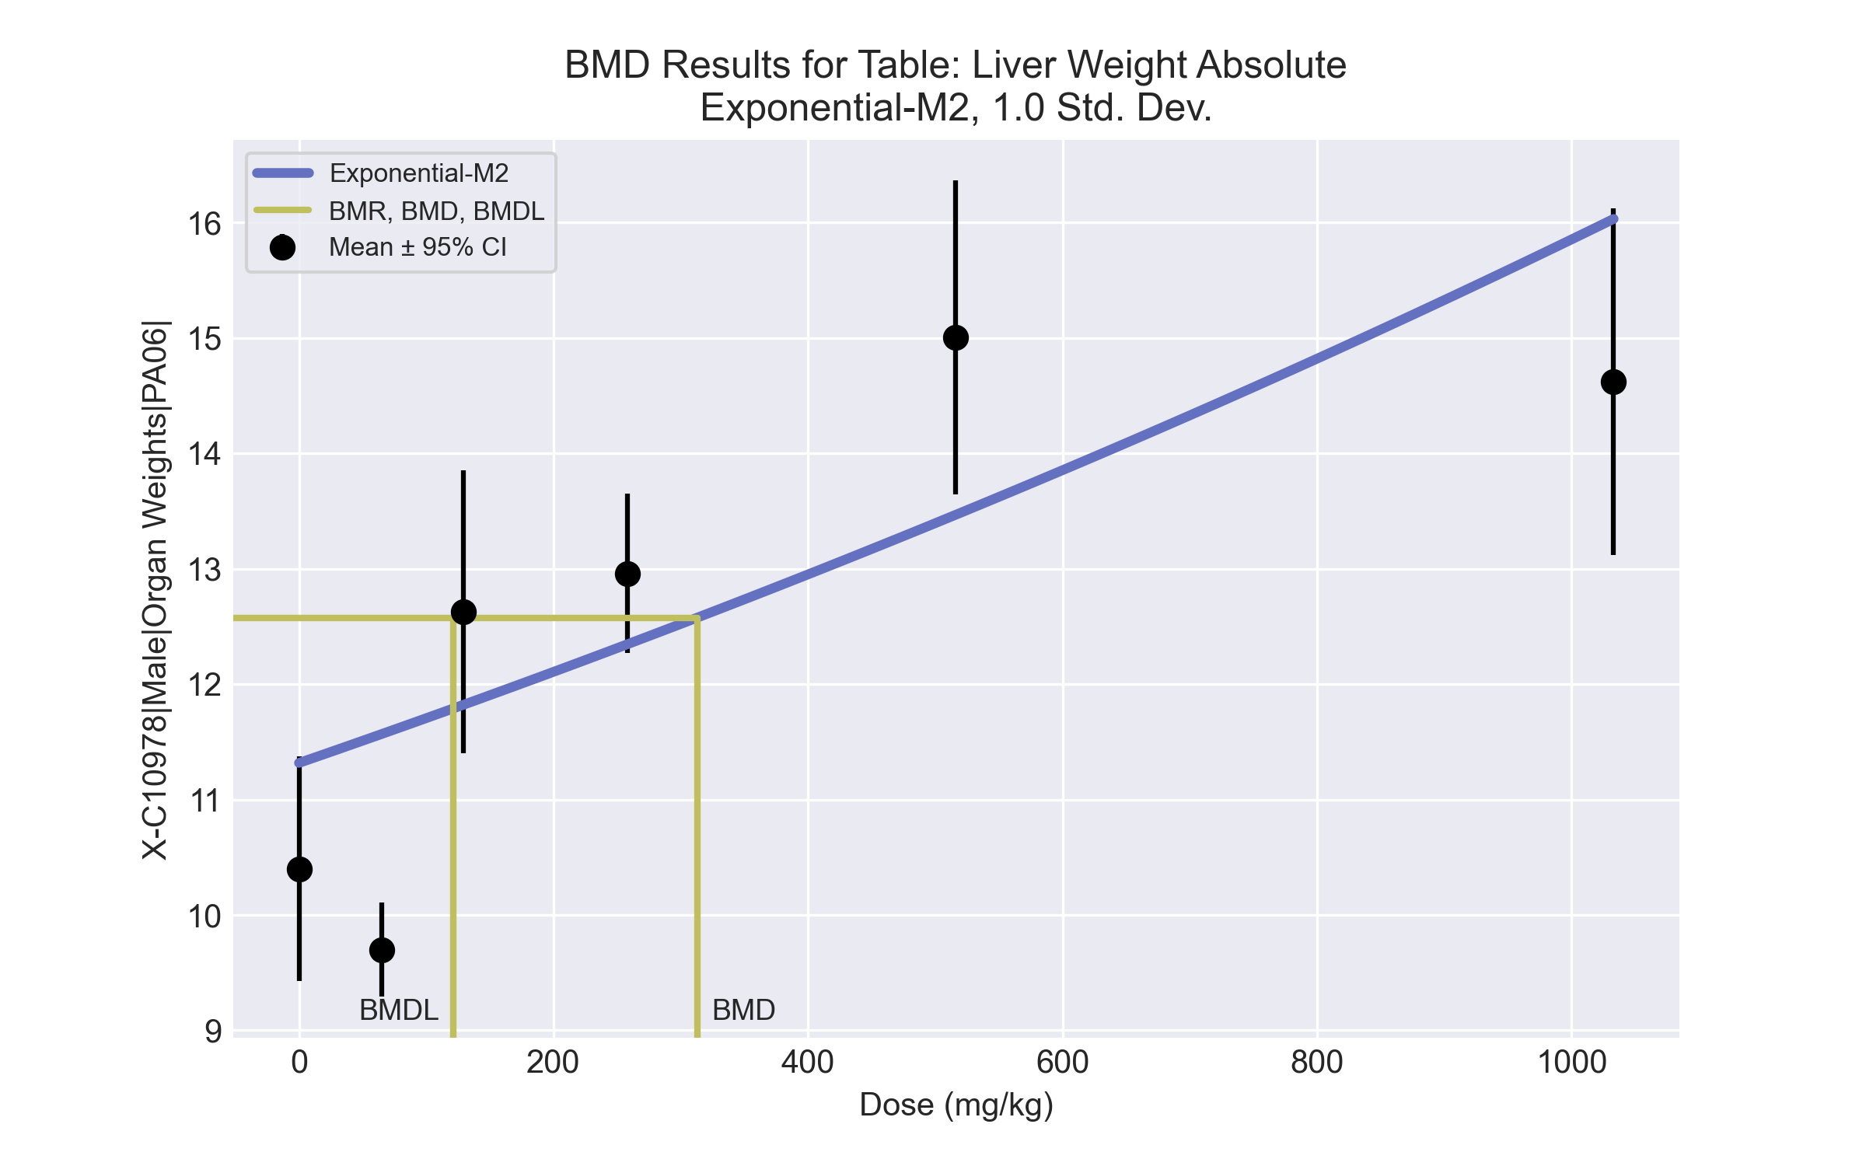
====================================================================
Exponential Model. (Version: 1.11; Date: 03/14/2017)
Input Data File: C:\Windows\TEMP\bmds-y6lec25b.(d)
Gnuplot Plotting File:
Fri Jul 16 07:29:33 2021
====================================================================
BMDS_Model_Run
~~~~~~~~~~~~~~~~~~~~~~~~~~~~~~~~~~~~~~~~~~~~~~~~~~~~~~~~~~~~~~~~~~~~~
The form of the response function by Model:
Model 2: Y[dose] = a * exp{sign * b * dose}
Model 3: Y[dose] = a * exp{sign * (b * dose)^d}
Model 4: Y[dose] = a * [c-(c-1) * exp{-b * dose}]
Model 5: Y[dose] = a * [c-(c-1) * exp{-(b * dose)^d}]
Note: Y[dose] is the median response for exposure = dose;
sign = +1 for increasing trend in data;
sign = -1 for decreasing trend.
Model 2 is nested within Models 3 and 4.
Model 3 is nested within Model 5.
Model 4 is nested within Model 5.
Dependent variable = Response
Independent variable = Dose
Data are assumed to be distributed: normally
Variance Model: exp(lnalpha +rho *ln(Y[dose]))
The variance is to be modeled as Var(i) = exp(lalpha + log(mean(i)) * rho)
Total number of dose groups = 6
Total number of records with missing values = 0
Maximum number of iterations = 500
Relative Function Convergence has been set to: 1e-008
Parameter Convergence has been set to: 1e-008
MLE solution provided: Exact
Initial Parameter Values
Variable Model 2
-------- --------
lnalpha -17.2392
rho 6.47041
a 11.2501
b 0.000340673
c 0 Specified
d 1 Specified
Parameter Estimates
Variable Model 2 Std. Err.
-------- ------- ---------
lnalpha -4.11921 11.5744
rho 1.88775 4.55422
a 11.3168 0.55717
b 0.000337064 0.000128309
NC = No Convergence
Table of Stats From Input Data
Dose N Obs Mean Obs Std Dev
----- --- ---------- -------------
0 4 10.4 0.6131
65 3 9.7 0.1652
129 5 12.63 0.9853
258 5 12.96 0.5559
516 5 15 1.094
1033 4 14.62 0.944
Estimated Values of Interest
Dose Est Mean Est Std Scaled Residual
------ ---------- --------- ----------------
0 11.32 1.259 -1.456
65 11.57 1.286 -2.516
129 11.82 1.312 1.374
258 12.34 1.367 1.003
516 13.47 1.484 2.314
1033 16.03 1.749 -1.61
Other models for which likelihoods are calculated:
Model A1: Yij = Mu(i) + e(ij)
Var{e(ij)} = Sigma^2
Model A2: Yij = Mu(i) + e(ij)
Var{e(ij)} = Sigma(i)^2
Model A3: Yij = Mu(i) + e(ij)
Var{e(ij)} = exp(lalpha + log(mean(i)) * rho)
Model R: Yij = Mu + e(i)
Var{e(ij)} = Sigma^2
Likelihoods of Interest
Model Log(likelihood) DF AIC
------- ----------------- ---- ------------
A1 -4.733709 7 23.46742
A2 0.5794294 12 22.84114
A3 -2.311328 8 20.62266
R -30.94973 2 65.89946
2 -21.80625 4 51.61249
Additive constant for all log-likelihoods = -23.89. This constant added to the
above values gives the log-likelihood including the term that does not
depend on the model parameters.
Explanation of Tests
Test 1: Does response and/or variances differ among Dose levels? (A2 vs. R)
Test 2: Are Variances Homogeneous? (A2 vs. A1)
Test 3: Are variances adequately modeled? (A2 vs. A3)
Test 4: Does Model 2 fit the data? (A3 vs. 2)
Tests of Interest
Test -2*log(Likelihood Ratio) D. F. p-value
-------- ------------------------ ------ --------------
Test 1 63.06 10 < 0.0001
Test 2 10.63 5 0.05931
Test 3 5.782 4 0.2161
Test 4 38.99 4 < 0.0001
The p-value for Test 1 is less than .05. There appears to be a
difference between response and/or variances among the dose
levels, it seems appropriate to model the data.
The p-value for Test 2 is less than .1. A non-homogeneous
variance model appears to be appropriate.
The p-value for Test 3 is greater than .1. The modeled
variance appears to be appropriate here.
The p-value for Test 4 is less than .1. Model 2 may not adequately
describe the data; you may want to consider another model.
Benchmark Dose Computations:
Specified Effect = 1.000000
Risk Type = Estimated standard deviations from control
Confidence Level = 0.950000
BMD = 313.013
BMDL = 121.543
BMDU = 806.275

BMD Results for Table: Liver Weight Relative
BMDS version: BMDS v2.7.0

Input dataset
Dose | 0 | 65 | 129 | 258 | 516 | 1033
N | 4 | 3 | 5 | 5 | 5 | 4
Mean ± SD | 38.206 ± 2.298 | 37.703 ± 2.047 | 44.374 ± 3.292 | 47.134 ± 1.166 | 54.821 ± 3.716 | 55.79 ± 3.017

Summary table
Modelª | Goodness of fit |  | BMD | BMDL | Comments
 | p-value | AIC
Linear (equivalent models include Power, Polynomial 2°, 3°, 4°, 5°) | <0.0001 | 104.514 | 227.357 | 172.501 | Exponential-M2 recommended as best-fitting model on the basis of the lowest AIC.
Hill | 0.051 | 88.466 | 85.856 | 46.173
Exponential M2^{b} (equivalent models include Exponential M3) | <0.0001 | 107.353 | 288.723 | 223.524
Exponential M4 | 0.048 | 88.42 | 48.938 | 33.791
Exponential M5 | 0.067 | 87.918 | 82.675 | 42.905
ª Constant variance case presented (BMDS Test 2 p-value = 0.22, BMDS Test 3 p-value = 0.22).
^{b} Recommended model

Model recommendation details
Model | Bin | Notes
Linear (equivalent models include Power, Polynomial 2°, 3°, 4°, 5°) | Warning | Warnings  • Ratio of modeled to actual stdev. at control is greater than threshold (1.75 > 1.5)
Hill | Warning | Warnings  • Goodness of fit p-value is less than threshold (0.0508 < 0.1)
Exponential M2ª (equivalent models include Exponential M3) | Valid | -
Exponential M4 | Warning | Warnings  • Goodness of fit p-value is less than threshold (0.0478 < 0.1)
Exponential M5 | Warning | Warnings  • Goodness of fit p-value is less than threshold (0.0668 < 0.1)
ª Recommended model

Recommended model
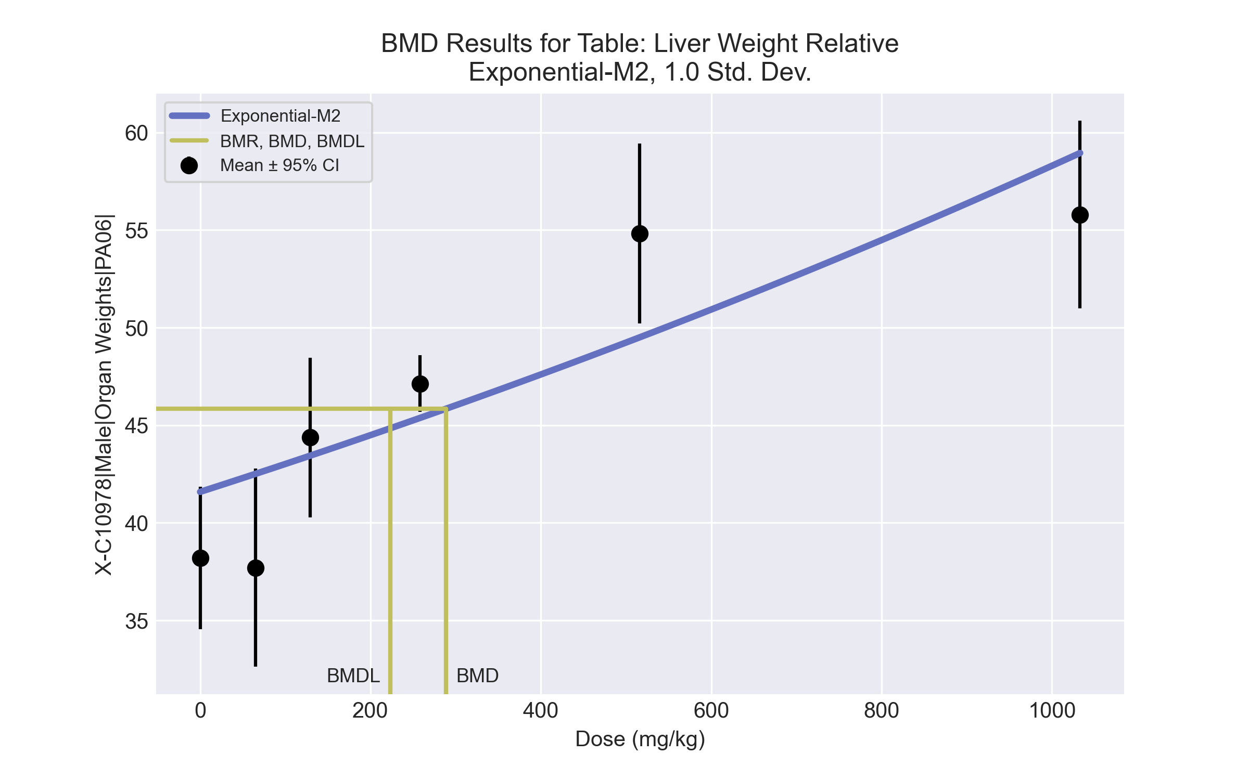
====================================================================
Exponential Model. (Version: 1.11; Date: 03/14/2017)
Input Data File: C:\Windows\TEMP\bmds-pf31rf1n.(d)
Gnuplot Plotting File:
Fri Jul 16 07:29:36 2021
====================================================================
BMDS_Model_Run
~~~~~~~~~~~~~~~~~~~~~~~~~~~~~~~~~~~~~~~~~~~~~~~~~~~~~~~~~~~~~~~~~~~~~
The form of the response function by Model:
Model 2: Y[dose] = a * exp{sign * b * dose}
Model 3: Y[dose] = a * exp{sign * (b * dose)^d}
Model 4: Y[dose] = a * [c-(c-1) * exp{-b * dose}]
Model 5: Y[dose] = a * [c-(c-1) * exp{-(b * dose)^d}]
Note: Y[dose] is the median response for exposure = dose;
sign = +1 for increasing trend in data;
sign = -1 for decreasing trend.
Model 2 is nested within Models 3 and 4.
Model 3 is nested within Model 5.
Model 4 is nested within Model 5.
Dependent variable = Response
Independent variable = Dose
Data are assumed to be distributed: normally
Variance Model: exp(lnalpha +rho *ln(Y[dose]))
rho is set to 0.
A constant variance model is fit.
Total number of dose groups = 6
Total number of records with missing values = 0
Maximum number of iterations = 500
Relative Function Convergence has been set to: 1e-008
Parameter Convergence has been set to: 1e-008
MLE solution provided: Exact
Initial Parameter Values
Variable Model 2
-------- --------
lnalpha 1.78873
rho 0 Specified
a 40.8823
b 0.00037526
c 0 Specified
d 1 Specified
Parameter Estimates
Variable Model 2 Std. Err.
-------- ------- ---------
lnalpha 2.89818 5.03141
a 41.586 1.09419
b 0.00033772 4.56093e-005
NC = No Convergence
Table of Stats From Input Data
Dose N Obs Mean Obs Std Dev
----- --- ---------- -------------
0 4 38.21 2.298
65 3 37.7 2.047
129 5 44.37 3.292
258 5 47.13 1.166
516 5 54.82 3.716
1033 4 55.79 3.017
Estimated Values of Interest
Dose Est Mean Est Std Scaled Residual
------ ---------- --------- ----------------
0 41.59 4.259 -1.587
65 42.51 4.259 -1.954
129 43.44 4.259 0.4915
258 45.37 4.259 0.9249
516 49.5 4.259 2.792
1033 58.95 4.259 -1.482
Other models for which likelihoods are calculated:
Model A1: Yij = Mu(i) + e(ij)
Var{e(ij)} = Sigma^2
Model A2: Yij = Mu(i) + e(ij)
Var{e(ij)} = Sigma(i)^2
Model A3: Yij = Mu(i) + e(ij)
Var{e(ij)} = exp(lalpha + log(mean(i)) * rho)
Model R: Yij = Mu + e(i)
Var{e(ij)} = Sigma^2
Likelihoods of Interest
Model Log(likelihood) DF AIC
------- ----------------- ---- ------------
A1 -36.25348 7 86.50696
A2 -32.7496 12 89.49919
A3 -36.25348 7 86.50696
R -64.57197 2 133.1439
2 -50.67629 3 107.3526
Additive constant for all log-likelihoods = -23.89. This constant added to the
above values gives the log-likelihood including the term that does not
depend on the model parameters.
Explanation of Tests
Test 1: Does response and/or variances differ among Dose levels? (A2 vs. R)
Test 2: Are Variances Homogeneous? (A2 vs. A1)
Test 3: Are variances adequately modeled? (A2 vs. A3)
Test 4: Does Model 2 fit the data? (A3 vs. 2)
Tests of Interest
Test -2*log(Likelihood Ratio) D. F. p-value
-------- ------------------------ ------ --------------
Test 1 63.64 10 < 0.0001
Test 2 7.008 5 0.2201
Test 3 7.008 5 0.2201
Test 4 28.85 4 < 0.0001
The p-value for Test 1 is less than .05. There appears to be a
difference between response and/or variances among the dose
levels, it seems appropriate to model the data.
The p-value for Test 2 is greater than .1. A homogeneous
variance model appears to be appropriate here.
The p-value for Test 3 is greater than .1. The modeled
variance appears to be appropriate here.
The p-value for Test 4 is less than .1. Model 2 may not adequately
describe the data; you may want to consider another model.
Benchmark Dose Computations:
Specified Effect = 1.000000
Risk Type = Estimated standard deviations from control
Confidence Level = 0.950000
BMD = 288.723
BMDL = 223.524
BMDU = 408.117

BMD Results for Table: Bile salts/acids
BMDS version: BMDS v2.7.0

Input dataset
Dose | 0 | 65 | 129 | 258 | 516 | 1033
N | 4 | 3 | 5 | 5 | 5 | 4
Mean ± SD | 52.15 ± 10.314 | 35.067 ± 3.953 | 41.86 ± 14.387 | 30.92 ± 20.234 | 41.46 ± 14.431 | 23.4 ± 11.558

Summary table
Modelª | Goodness of fit |  | BMD | BMDL | Comments
 | p-value | AIC
Linear^{b} (equivalent models include Power, Polynomial 2°) | 0.202 | 169.222 | 763.124 | 434.064 | Linear recommended as best-fitting model on the basis of the lowest AIC.
Polynomial 3° | 0.116 | 171.164 | 832.321 | 436.088
Polynomial 4° | 0.12 | 171.092 | 867.436 | 438.656
Polynomial 5° | 0.122 | 171.046 | 889.801 | 440.331
Hill | 0.149 | 170.586 | 127.806 | 0.003
Exponential M2 | 0.201 | 169.227 | 704.783 | 320.489
Exponential M3 (equivalent models include Exponential M4) | 0.201 | 169.227 | 704.782 | 320.489
Exponential M5 | 0.113 | 171.227 | 704.783 | 6.061
ª Constant variance case presented (BMDS Test 2 p-value = 0.146, BMDS Test 3 p-value = 0.146).
^{b} Recommended model

Model recommendation details
Model | Bin | Notes
Linearª (equivalent models include Power, Polynomial 2°) | Valid | -
Polynomial 3° | Valid | -
Polynomial 4° | Valid | -
Polynomial 5° | Valid | -
Hill | Warning | Warnings  • BMD/BMDL ratio is greater than threshold (4.23e+04 > 20.0)  Cautions  • BMD/BMDL ratio is greater than threshold (4.23e+04 > 5.0)
Exponential M2 | Valid | -
Exponential M3 (equivalent models include Exponential M4) | Valid | -
Exponential M5 | Warning | Warnings  • BMD/BMDL ratio is greater than threshold (1.16e+02 > 20.0)  Cautions  • BMD/BMDL ratio is greater than threshold (1.16e+02 > 5.0)
ª Recommended model

Recommended model
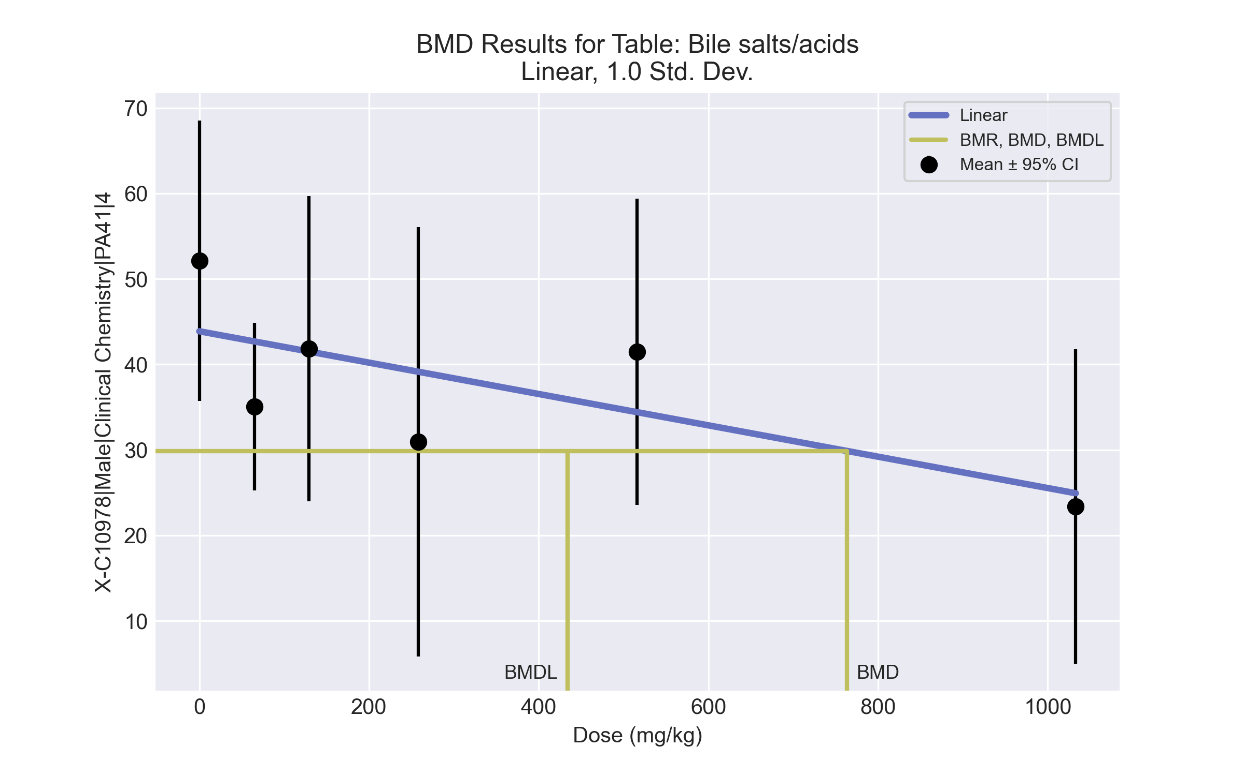
====================================================================
Polynomial Model. (Version: 2.21; Date: 03/14/2017)
Input Data File: C:\Windows\TEMP\bmds-ysvu_yka.(d)
Gnuplot Plotting File: C:\Windows\TEMP\bmds-ysvu_yka.plt
Fri Jul 16 07:36:04 2021
====================================================================
BMDS_Model_Run
~~~~~~~~~~~~~~~~~~~~~~~~~~~~~~~~~~~~~~~~~~~~~~~~~~~~~~~~~~~~~~~~~~~~~
The form of the response function is:
Y[dose] = beta_0 + beta_1*dose + beta_2*dose^2 + ...
Dependent variable = Response
Independent variable = Dose
rho is set to 0
The polynomial coefficients are restricted to be negative
A constant variance model is fit
Total number of dose groups = 6
Total number of records with missing values = 0
Maximum number of iterations = 500
Relative Function Convergence has been set to: 1e-008
Parameter Convergence has been set to: 1e-008
Default Initial Parameter Values
alpha = 202.488
rho = 0 Specified
beta_0 = 43.5701
beta_1 = -0.0182728
Asymptotic Correlation Matrix of Parameter Estimates
( *** The model parameter(s) -rho
have been estimated at a boundary point, or have been specified by the user,
and do not appear in the correlation matrix )
alpha beta_0 beta_1
alpha 1 4.1e-008 7.2e-011
beta_0 4.1e-008 1 -0.71
beta_1 7.2e-011 -0.71 1
Parameter Estimates
95.0% Wald Confidence Interval
Variable Estimate Std. Err. Lower Conf. Limit Upper Conf. Limit
alpha 195.93 54.3412 89.4232 302.437
beta_0 43.8763 3.87758 36.2764 51.4762
beta_1 -0.0183424 0.00805282 -0.0341256 -0.00255912
Table of Data and Estimated Values of Interest
Dose N Obs Mean Est Mean Obs Std Dev Est Std Dev Scaled Res.
------ --- -------- -------- ----------- ----------- ----------
0 4 52.1 43.9 10.3 14 1.18
65 3 35.1 42.7 3.95 14 -0.943
129 5 41.9 41.5 14.4 14 0.0559
258 5 30.9 39.1 20.2 14 -1.31
516 5 41.5 34.4 14.4 14 1.13
1033 4 23.4 24.9 11.6 14 -0.218
Model Descriptions for likelihoods calculated
Model A1: Yij = Mu(i) + e(ij)
Var{e(ij)} = Sigma^2
Model A2: Yij = Mu(i) + e(ij)
Var{e(ij)} = Sigma(i)^2
Model A3: Yij = Mu(i) + e(ij)
Var{e(ij)} = Sigma^2
Model A3 uses any fixed variance parameters that
were specified by the user
Model R: Yi = Mu + e(i)
Var{e(i)} = Sigma^2
Likelihoods of Interest
Model Log(likelihood) # Param's AIC
A1 -78.628141 7 171.256281
A2 -74.529605 12 173.059211
A3 -78.628141 7 171.256281
fitted -81.610854 3 169.221708
R -83.976104 2 171.952209
Explanation of Tests
Test 1: Do responses and/or variances differ among Dose levels?
(A2 vs. R)
Test 2: Are Variances Homogeneous? (A1 vs A2)
Test 3: Are variances adequately modeled? (A2 vs. A3)
Test 4: Does the Model for the Mean Fit? (A3 vs. fitted)
(Note: When rho=0 the results of Test 3 and Test 2 will be the same.)
Tests of Interest
Test -2*log(Likelihood Ratio) Test df p-value
Test 1 18.893 10 0.04164
Test 2 8.19707 5 0.1457
Test 3 8.19707 5 0.1457
Test 4 5.96543 4 0.2017
The p-value for Test 1 is less than .05. There appears to be a
difference between response and/or variances among the dose levels
It seems appropriate to model the data
The p-value for Test 2 is greater than .1. A homogeneous variance
model appears to be appropriate here
The p-value for Test 3 is greater than .1. The modeled variance appears
to be appropriate here
The p-value for Test 4 is greater than .1. The model chosen seems
to adequately describe the data
Benchmark Dose Computation
Specified effect = 1
Risk Type = Estimated standard deviations from the control mean
Confidence level = 0.95
BMD = 763.124
BMDL = 434.064
BMDU = 3134.22

BMD Results for Table: Creatinine
BMDS version: BMDS v2.7.0

Input dataset
Dose | 0 | 65 | 129 | 258 | 516 | 1033
N | 4 | 3 | 5 | 5 | 5 | 4
Mean ± SD | 0.35 ± 0.058 | 0.33 ± 0 | 0.332 ± 0.033 | 0.31 ± 0.039 | 0.302 ± 0.04 | 0.275 ± 0.04

Summary table
Modelª | Goodness of fit |  | BMD | BMDL | Comments
 | p-value | AIC
Linear (equivalent models include Polynomial 2°, 3°, 4°, 5°) | <0.0001 | -139.397 | 558.244 | 313.597 | No model was recommended as a best-fitting model. Doses were dropped until there were only 3 remaining dose-groups.
Power | <0.0001 | -139.397 | 558.245 | 313.597
Hill | <0.0001 | -138.12 | 298.435 | -999
Exponential M2 (equivalent models include Exponential M3) | -999 | -139.542 | 520.134 | 276.409
Exponential M4 | -999 | -129.145 | 170163 | 149.024
Exponential M5 | -999 | -138.056 | 322.362 | 82.438
ª Modeled variance case presented (BMDS Test 2 p-value = <0.0001, BMDS Test 3 p-value = <0.0001).

Model recommendation details
Model | Bin | Notes
Linear (equivalent models include Polynomial 2°, 3°, 4°, 5°) | Warning | Warnings  • Variance model poorly fits dataset (p-value 3 = 0.0001)  Cautions  • Warning(s): Warning: Likelihood for fitted model larger than the Likelihood for model A3.
Power | Warning | Warnings  • Variance model poorly fits dataset (p-value 3 = 0.0001)  Cautions  • Warning(s): Warning: Likelihood for fitted model larger than the Likelihood for model A3.
Hill | Failure | Failures  • BMDL does not exist  Warnings  • Variance model poorly fits dataset (p-value 3 = 0.0001)  Cautions  • Warning(s): BMDL computation failed.
Exponential M2 (equivalent models include Exponential M3) | Warning | Warnings  • Variance model poorly fits dataset (p-value 3 = 0.0001)
Exponential M4 | Warning | Warnings  • Variance model poorly fits dataset (p-value 3 = 0.0001)  • BMD/BMDL ratio is greater than threshold (1.14e+03 > 20.0)  • BMD/high dose ratio is greater than threshold (1.65e+02 > 1.0)  Cautions  • BMD/BMDL ratio is greater than threshold (1.14e+03 > 5.0)
Exponential M5 | Warning | Warnings  • Variance model poorly fits dataset (p-value 3 = 0.0001)

Recommended model
No model was recommended as a best-fitting model.

BMD Results for Table: Cholinesterase
BMDS version: BMDS v2.7.0

Input dataset
Dose | 0 | 65 | 129 | 258 | 516 | 1033
N | 4 | 3 | 5 | 5 | 5 | 4
Mean ± SD | 291.25 ± 18.768 | 209 ± 24 | 236 ± 15.017 | 183.4 ± 19.578 | 152.4 ± 44.797 | 129 ± 29.698

Summary table
Modelª | Goodness of fit |  | BMD | BMDL | Comments
 | p-value | AIC
Linear (equivalent models include Power, Polynomial 2°, 3°, 4°, 5°) | 2.7E-04 | 219.218 | 275.574 | 204.11 | No model was recommended as a best-fitting model. Doses were dropped until there were only 3 remaining dose-groups.
Hill | 0.046 | 207.846 | 41.286 | 21.42
Exponential M2 (equivalent models include Exponential M3) | 0.002 | 214.524 | 160.655 | 111.684
Exponential M4 (equivalent models include Exponential M5) | 0.036 | 208.39 | 54.864 | 32.977
ª Constant variance case presented (BMDS Test 2 p-value = 0.146, BMDS Test 3 p-value = 0.146).

Model recommendation details
Model | Bin | Notes
Linear (equivalent models include Power, Polynomial 2°, 3°, 4°, 5°) | Warning | Warnings  • Goodness of fit p-value is less than threshold (0.000267 < 0.1)  • Residual at lowest dose is greater than threshold (2.59 > 2.0)  • Ratio of modeled to actual stdev. at control is greater than threshold (1.95 > 1.5)
Hill | Warning | Warnings  • Goodness of fit p-value is less than threshold (0.046 < 0.1)  • Ratio of modeled to actual stdev. at control is greater than threshold (1.51 > 1.5)
Exponential M2 (equivalent models include Exponential M3) | Warning | Warnings  • Goodness of fit p-value is less than threshold (0.00223 < 0.1)  • Residual at lowest dose is greater than threshold (2.1 > 2.0)
Exponential M4 (equivalent models include Exponential M5) | Warning | Warnings  • Goodness of fit p-value is less than threshold (0.036 < 0.1)

Recommended model
No model was recommended as a best-fitting model.

BMD Results for Table: Total Thyroxine
BMDS version: BMDS v2.7.0

Input dataset
Dose | 0 | 65 | 129 | 258 | 516 | 1033
N | 4 | 3 | 5 | 5 | 5 | 4
Mean ± SD | 3.973 ± 0.469 | 4.157 ± 0.938 | 4.692 ± 0.494 | 4.108 ± 0.632 | 3.31 ± 0.523 | 2.768 ± 0.508

Summary table
Modelª | Goodness of fit |  | BMD | BMDL | Comments
 | p-value | AIC
Linear | 0.093 | 5.291 | 369.717 | 260.327 | Hill recommended as best-fitting model on the basis of the lowest AIC.
Polynomial 2° (equivalent models include Polynomial 3°, 4°, 5°) | 0.048 | 7.247 | 408.337 | 260.962
Power | 0.056 | 6.907 | 452.938 | 266.176
Hill^{b} | 0.104 | 5.879 | 391.168 | 256.902
Exponential M2 (equivalent models include Exponential M4) | 0.084 | 5.564 | 324.719 | 211.965
Exponential M3 | 0.066 | 6.532 | 437.613 | 229.709
Exponential M5 | 0.101 | 5.929 | 411.175 | 264.783
ª Constant variance case presented (BMDS Test 2 p-value = 0.819, BMDS Test 3 p-value = 0.819).
^{b} Recommended model

Model recommendation details
Model | Bin | Notes
Linear | Warning | Warnings  • Goodness of fit p-value is less than threshold (0.0935 < 0.1)
Polynomial 2° (equivalent models include Polynomial 3°, 4°, 5°) | Warning | Warnings  • Goodness of fit p-value is less than threshold (0.048 < 0.1)
Power | Warning | Warnings  • Goodness of fit p-value is less than threshold (0.056 < 0.1)
Hillª | Valid | -
Exponential M2 (equivalent models include Exponential M4) | Warning | Warnings  • Goodness of fit p-value is less than threshold (0.0838 < 0.1)
Exponential M3 | Warning | Warnings  • Goodness of fit p-value is less than threshold (0.0661 < 0.1)
Exponential M5 | Valid | -
ª Recommended model

Recommended model
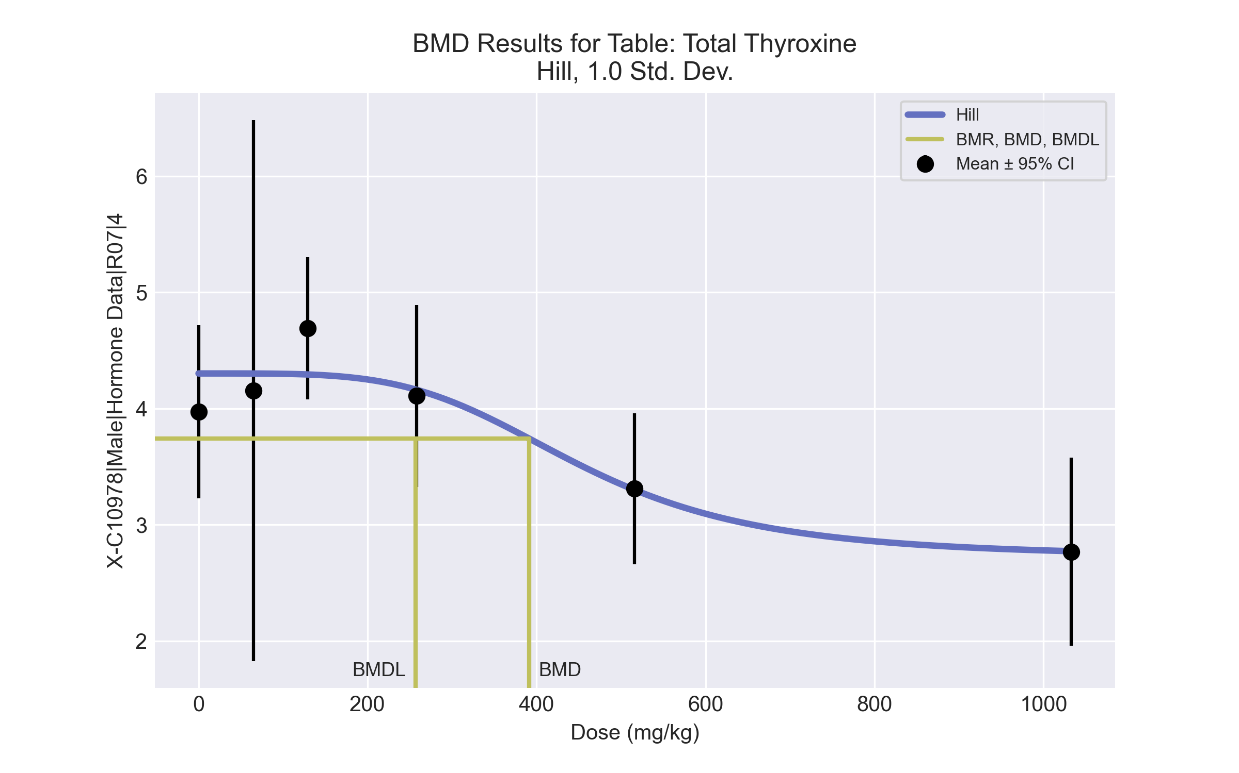
====================================================================
Hill Model. (Version: 2.18; Date: 03/14/2017)
Input Data File: C:\Windows\TEMP\bmds-ugof5124.(d)
Gnuplot Plotting File: C:\Windows\TEMP\bmds-ugof5124.plt
Fri Jul 16 07:37:03 2021
====================================================================
BMDS_Model_Run
~~~~~~~~~~~~~~~~~~~~~~~~~~~~~~~~~~~~~~~~~~~~~~~~~~~~~~~~~~~~~~~~~~~~~
The form of the response function is:
Y[dose] = intercept + v*dose^n/(k^n + dose^n)
Dependent variable = Response
Independent variable = Dose
rho is set to 0
Power parameter restricted to be greater than 1
A constant variance model is fit
Total number of dose groups = 6
Total number of records with missing values = 0
Maximum number of iterations = 500
Relative Function Convergence has been set to: 1e-008
Parameter Convergence has been set to: 1e-008
Default Initial Parameter Values
alpha = 0.342809
rho = 0 Specified
intercept = 3.9725
v = -1.205
n = 5.21499
k = 496.602
Asymptotic Correlation Matrix of Parameter Estimates
( *** The model parameter(s) -rho
have been estimated at a boundary point, or have been specified by the user,
and do not appear in the correlation matrix )
alpha intercept v n k
alpha 1 -4.9e-009 3.2e-008 -2.7e-008 -3.5e-008
intercept -4.9e-009 1 -0.48 -0.39 -0.31
v 3.2e-008 -0.48 1 0.54 -0.41
n -2.7e-008 -0.39 0.54 1 -0.0068
k -3.5e-008 -0.31 -0.41 -0.0068 1
Parameter Estimates
95.0% Wald Confidence Interval
Variable Estimate Std. Err. Lower Conf. Limit Upper Conf. Limit
alpha 0.313954 0.0870751 0.14329 0.484618
intercept 4.30223 0.161014 3.98665 4.61781
v -1.57912 0.398407 -2.35998 -0.798254
n 4.15383 2.79474 -1.32376 9.63141
k 451.724 101.843 252.116 651.333
Table of Data and Estimated Values of Interest
Dose N Obs Mean Est Mean Obs Std Dev Est Std Dev Scaled Res.
------ --- -------- -------- ----------- ----------- ----------
0 4 3.97 4.3 0.469 0.56 -1.18
65 3 4.16 4.3 0.938 0.56 -0.448
129 5 4.69 4.29 0.494 0.56 1.59
258 5 4.11 4.16 0.632 0.56 -0.215
516 5 3.31 3.3 0.523 0.56 0.0403
1033 4 2.77 2.77 0.508 0.56 -0.0174
Model Descriptions for likelihoods calculated
Model A1: Yij = Mu(i) + e(ij)
Var{e(ij)} = Sigma^2
Model A2: Yij = Mu(i) + e(ij)
Var{e(ij)} = Sigma(i)^2
Model A3: Yij = Mu(i) + e(ij)
Var{e(ij)} = Sigma^2
Model A3 uses any fixed variance parameters that
were specified by the user
Model R: Yi = Mu + e(i)
Var{e(i)} = Sigma^2
Likelihoods of Interest
Model Log(likelihood) # Param's AIC
A1 4.328317 7 5.343366
A2 5.434700 12 13.130601
A3 4.328317 7 5.343366
fitted 2.060623 5 5.878754
R -7.644158 2 19.288316
Explanation of Tests
Test 1: Do responses and/or variances differ among Dose levels?
(A2 vs. R)
Test 2: Are Variances Homogeneous? (A1 vs A2)
Test 3: Are variances adequately modeled? (A2 vs. A3)
Test 4: Does the Model for the Mean Fit? (A3 vs. fitted)
(Note: When rho=0 the results of Test 3 and Test 2 will be the same.)
Tests of Interest
Test -2*log(Likelihood Ratio) Test df p-value
Test 1 26.1577 10 0.003534
Test 2 2.21277 5 0.819
Test 3 2.21277 5 0.819
Test 4 4.53539 2 0.1036
The p-value for Test 1 is less than .05. There appears to be a
difference between response and/or variances among the dose levels
It seems appropriate to model the data
The p-value for Test 2 is greater than .1. A homogeneous variance
model appears to be appropriate here
The p-value for Test 3 is greater than .1. The modeled variance appears
to be appropriate here
The p-value for Test 4 is greater than .1. The model chosen seems
to adequately describe the data
Benchmark Dose Computation
Specified effect = 1
Risk Type = Estimated standard deviations from the control mean
Confidence level = 0.95
BMD = 391.168
BMDL = 256.902
BMDU = 561.507

