BMD Results for Table: Body Weight SD4
BMDS version: BMDS v2.7.0

Input dataset
Dose | 0 | 77 | 153 | 306 | 611
N | 5 | 5 | 5 | 5 | 5
Mean ± SD | 247.16 ± 8.483 | 251.16 ± 7.732 | 245.78 ± 11.885 | 239.42 ± 9.316 | 230.58 ± 10.15

Summary table
Modelª | Goodness of fit |  | BMD | BMDL | Comments
 | p-value | AIC
Linear^{b} | 0.693 | 140.072 | 278.244 | 187.298 | Linear recommended as best-fitting model on the basis of the lowest AIC.
Polynomial 2° (equivalent models include Polynomial 3°, 4°) | 0.502 | 141.995 | 319.027 | 188.177
Power | 0.536 | 141.864 | 329.161 | 189.734
Hill | 0.399 | 143.329 | 285.94 | 141.473
Exponential M2 (equivalent models include Exponential M4) | 0.687 | 140.098 | 272.458 | 180.45
Exponential M3 | 0.542 | 141.844 | 327.538 | 183.472
Exponential M5 | 0.392 | 143.35 | 289.255 | 142.229
ª Constant variance case presented (BMDS Test 2 p-value = 0.891, BMDS Test 3 p-value = 0.891).
^{b} Recommended model

Model recommendation details
Model | Bin | Notes
Linearª | Valid | -
Polynomial 2° (equivalent models include Polynomial 3°, 4°) | Valid | -
Power | Valid | -
Hill | Valid | -
Exponential M2 (equivalent models include Exponential M4) | Valid | -
Exponential M3 | Valid | -
Exponential M5 | Valid | -
ª Recommended model

Recommended model
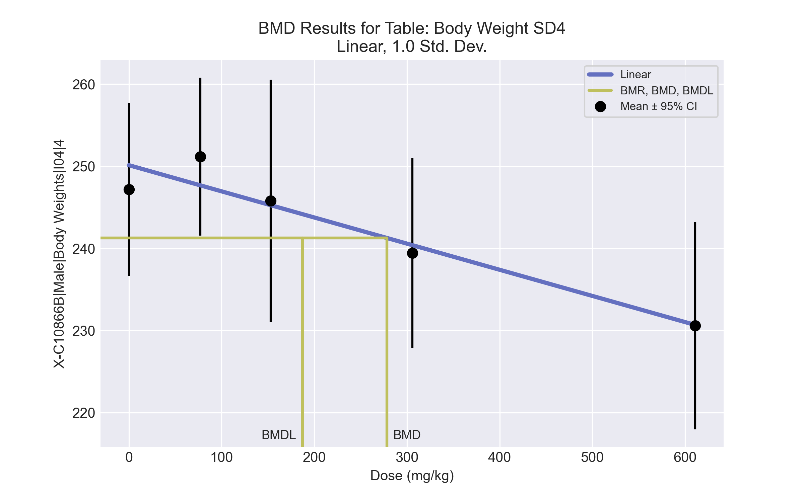
====================================================================
Polynomial Model. (Version: 2.21; Date: 03/14/2017)
Input Data File: C:\Windows\TEMP\bmds-h8cp7464.(d)
Gnuplot Plotting File: C:\Windows\TEMP\bmds-h8cp7464.plt
Tue Jul 06 12:34:52 2021
====================================================================
BMDS_Model_Run
~~~~~~~~~~~~~~~~~~~~~~~~~~~~~~~~~~~~~~~~~~~~~~~~~~~~~~~~~~~~~~~~~~~~~
The form of the response function is:
Y[dose] = beta_0 + beta_1*dose + beta_2*dose^2 + ...
Dependent variable = Response
Independent variable = Dose
rho is set to 0
The polynomial coefficients are restricted to be negative
A constant variance model is fit
Total number of dose groups = 5
Total number of records with missing values = 0
Maximum number of iterations = 500
Relative Function Convergence has been set to: 1e-008
Parameter Convergence has been set to: 1e-008
Default Initial Parameter Values
alpha = 92.5624
rho = 0 Specified
beta_0 = 250.124
beta_1 = -0.0318389
Asymptotic Correlation Matrix of Parameter Estimates
( *** The model parameter(s) -rho
have been estimated at a boundary point, or have been specified by the user,
and do not appear in the correlation matrix )
alpha beta_0 beta_1
alpha 1 -5.6e-011 -3e-010
beta_0 -5.6e-011 1 -0.73
beta_1 -3e-010 -0.73 1
Parameter Estimates
95.0% Wald Confidence Interval
Variable Estimate Std. Err. Lower Conf. Limit Upper Conf. Limit
alpha 78.4817 22.198 34.9745 121.989
beta_0 250.124 2.58491 245.058 255.19
beta_1 -0.0318389 0.00820465 -0.0479197 -0.0157581
Table of Data and Estimated Values of Interest
Dose N Obs Mean Est Mean Obs Std Dev Est Std Dev Scaled Res.
------ --- -------- -------- ----------- ----------- ----------
0 5 247 250 8.48 8.86 -0.748
77 5 251 248 7.73 8.86 0.88
153 5 246 245 11.9 8.86 0.133
306 5 239 240 9.32 8.86 -0.243
611 5 231 231 10.1 8.86 -0.0228
Model Descriptions for likelihoods calculated
Model A1: Yij = Mu(i) + e(ij)
Var{e(ij)} = Sigma^2
Model A2: Yij = Mu(i) + e(ij)
Var{e(ij)} = Sigma(i)^2
Model A3: Yij = Mu(i) + e(ij)
Var{e(ij)} = Sigma^2
Model A3 uses any fixed variance parameters that
were specified by the user
Model R: Yi = Mu + e(i)
Var{e(i)} = Sigma^2
Likelihoods of Interest
Model Log(likelihood) # Param's AIC
A1 -66.309243 6 144.618487
A2 -65.750363 10 151.500726
A3 -66.309243 6 144.618487
fitted -67.035821 3 140.071643
R -72.929294 2 149.858588
Explanation of Tests
Test 1: Do responses and/or variances differ among Dose levels?
(A2 vs. R)
Test 2: Are Variances Homogeneous? (A1 vs A2)
Test 3: Are variances adequately modeled? (A2 vs. A3)
Test 4: Does the Model for the Mean Fit? (A3 vs. fitted)
(Note: When rho=0 the results of Test 3 and Test 2 will be the same.)
Tests of Interest
Test -2*log(Likelihood Ratio) Test df p-value
Test 1 14.3579 8 0.0729
Test 2 1.11776 4 0.8914
Test 3 1.11776 4 0.8914
Test 4 1.45316 3 0.6931
The p-value for Test 1 is greater than .05. There may not be a
diffence between responses and/or variances among the dose levels
Modelling the data with a dose/response curve may not be appropriate
The p-value for Test 2 is greater than .1. A homogeneous variance
model appears to be appropriate here
The p-value for Test 3 is greater than .1. The modeled variance appears
to be appropriate here
The p-value for Test 4 is greater than .1. The model chosen seems
to adequately describe the data
Benchmark Dose Computation
Specified effect = 1
Risk Type = Estimated standard deviations from the control mean
Confidence level = 0.95
BMD = 278.244
BMDL = 187.298
BMDU = 536.529

BMD Results for Table: Brain Weight Relative
BMDS version: BMDS v2.7.0

Input dataset
Dose | 0 | 77 | 153 | 306 | 611ª
N | 5 | 5 | 5 | 5 | 5
Mean ± SD | 6.824 ± 0.502 | 6.914 ± 0.157 | 6.959 ± 0.292 | 7.191 ± 0.264 | 6.947 ± 1.37
ª Dose group removed in BMD modeling session

Summary table
Modelª | Goodness of fit |  | BMD | BMDL | Comments
 | p-value | AIC
Linear^{b} (equivalent models include Power, Polynomial 2°, 3°, 4°) | 0.625 | -22.645 | 287.243 | 153.671 | Linear recommended as best-fitting model on the basis of the lowest AIC.
Hill | 0.381 | -20.819 | 283.317 | -999
Exponential M2 (equivalent models include Exponential M3) | 0.621 | -22.631 | 288.092 | 156.917
Exponential M4 (equivalent models include Exponential M5) | 0.372 | -20.789 | 281.606 | 2.417
ª Modeled variance case presented (BMDS Test 2 p-value = 0.089, BMDS Test 3 p-value = 0.139).
^{b} Recommended model

Model recommendation details
Model | Bin | Notes
Linearª (equivalent models include Power, Polynomial 2°, 3°, 4°) | Valid | -
Hill | Failure | Failures  • BMDL does not exist  Cautions  • Warning(s): BMDL computation failed.
Exponential M2 (equivalent models include Exponential M3) | Valid | -
Exponential M4 (equivalent models include Exponential M5) | Warning | Warnings  • BMD/BMDL ratio is greater than threshold (1.17e+02 > 20.0)  Cautions  • BMD/BMDL ratio is greater than threshold (1.17e+02 > 5.0)
ª Recommended model

Recommended model
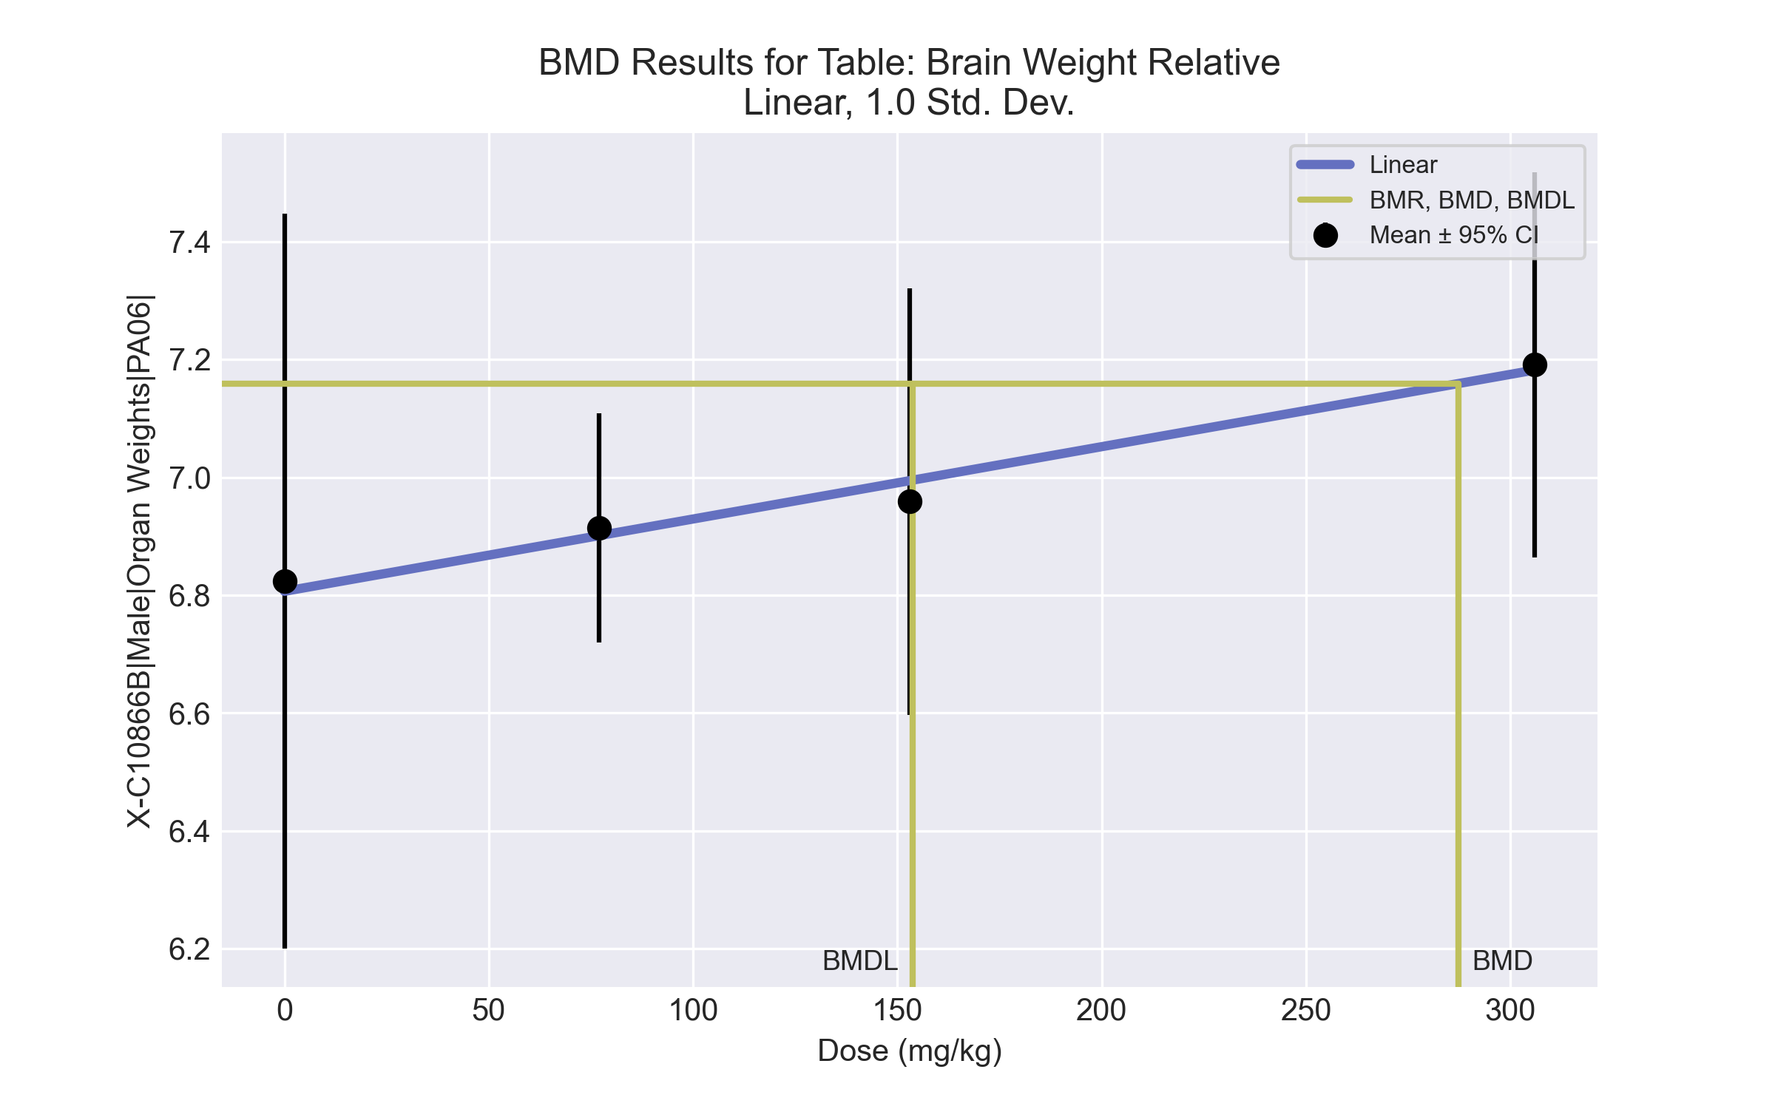
====================================================================
Polynomial Model. (Version: 2.21; Date: 03/14/2017)
Input Data File: C:\Windows\TEMP\bmds-snoahh3x.(d)
Gnuplot Plotting File: C:\Windows\TEMP\bmds-snoahh3x.plt
Tue Jul 06 12:38:42 2021
====================================================================
BMDS_Model_Run
~~~~~~~~~~~~~~~~~~~~~~~~~~~~~~~~~~~~~~~~~~~~~~~~~~~~~~~~~~~~~~~~~~~~~
The form of the response function is:
Y[dose] = beta_0 + beta_1*dose + beta_2*dose^2 + ...
Dependent variable = Response
Independent variable = Dose
The polynomial coefficients are restricted to be positive
The variance is to be modeled as Var(i) = exp(lalpha + log(mean(i)) * rho)
Total number of dose groups = 4
Total number of records with missing values = 0
Maximum number of iterations = 500
Relative Function Convergence has been set to: 1e-008
Parameter Convergence has been set to: 1e-008
Default Initial Parameter Values
lalpha = -2.22742
rho = 0
beta_0 = 6.81332
beta_1 = 0.00118416
Asymptotic Correlation Matrix of Parameter Estimates
lalpha rho beta_0 beta_1
lalpha 1 -1 -0.18 0.21
rho -1 1 0.18 -0.21
beta_0 -0.18 0.18 1 -0.85
beta_1 0.21 -0.21 -0.85 1
Parameter Estimates
95.0% Wald Confidence Interval
Variable Estimate Std. Err. Lower Conf. Limit Upper Conf. Limit
lalpha 34.1988 27.6451 -19.9847 88.3823
rho -18.9184 14.2376 -46.8237 8.98687
beta_0 6.80638 0.116818 6.57742 7.03534
beta_1 0.00122803 0.000557847 0.000134668 0.00232139
Table of Data and Estimated Values of Interest
Dose N Obs Mean Est Mean Obs Std Dev Est Std Dev Scaled Res.
------ --- -------- -------- ----------- ----------- ----------
0 5 6.82 6.81 0.502 0.353 0.111
77 5 6.91 6.9 0.157 0.31 0.0961
153 5 6.96 6.99 0.292 0.273 -0.29
306 5 7.19 7.18 0.264 0.212 0.0934
Model Descriptions for likelihoods calculated
Model A1: Yij = Mu(i) + e(ij)
Var{e(ij)} = Sigma^2
Model A2: Yij = Mu(i) + e(ij)
Var{e(ij)} = Sigma(i)^2
Model A3: Yij = Mu(i) + e(ij)
Var{e(ij)} = exp(lalpha + rho*ln(Mu(i)))
Model A3 uses any fixed variance parameters that
were specified by the user
Model R: Yi = Mu + e(i)
Var{e(i)} = Sigma^2
Likelihoods of Interest
Model Log(likelihood) # Param's AIC
A1 14.505680 5 -19.011359
A2 17.768339 8 -19.536679
A3 15.792373 6 -19.584746
fitted 15.322421 4 -22.644841
R 12.575874 2 -21.151749
Explanation of Tests
Test 1: Do responses and/or variances differ among Dose levels?
(A2 vs. R)
Test 2: Are Variances Homogeneous? (A1 vs A2)
Test 3: Are variances adequately modeled? (A2 vs. A3)
Test 4: Does the Model for the Mean Fit? (A3 vs. fitted)
(Note: When rho=0 the results of Test 3 and Test 2 will be the same.)
Tests of Interest
Test -2*log(Likelihood Ratio) Test df p-value
Test 1 10.3849 6 0.1093
Test 2 6.52532 3 0.08867
Test 3 3.95193 2 0.1386
Test 4 0.939905 2 0.625
The p-value for Test 1 is greater than .05. There may not be a
diffence between responses and/or variances among the dose levels
Modelling the data with a dose/response curve may not be appropriate
The p-value for Test 2 is less than .1. A non-homogeneous variance
model appears to be appropriate
The p-value for Test 3 is greater than .1. The modeled variance appears
to be appropriate here
The p-value for Test 4 is greater than .1. The model chosen seems
to adequately describe the data
Benchmark Dose Computation
Specified effect = 1
Risk Type = Estimated standard deviations from the control mean
Confidence level = 0.95
BMD = 287.243
BMDL = 153.671
BMDU = 1122.71

BMD Results for Table: Liver Weight Absolute
BMDS version: BMDS v2.7.0

Input dataset
Dose | 0 | 77 | 153 | 306 | 611
N | 5 | 5 | 5 | 5 | 4
Mean ± SD | 10.354 ± 0.504 | 11.23 ± 0.61 | 11.288 ± 0.831 | 11.95 ± 0.95 | 11.75 ± 0.926

Summary table
Modelª | Goodness of fit |  | BMD | BMDL | Comments
 | p-value | AIC
Linear (equivalent models include Power, Polynomial 2°, 3°, 4°) | 0.119 | 18.11 | 381.08 | 228.554 | Exponential-M2 recommended as best-fitting model on the basis of the lowest AIC.
Hill | 0.302 | 17.319 | 63.079 | 1.2E-04
Exponential M2^{b} (equivalent models include Exponential M3) | 0.11 | 18.286 | 399.984 | 246.025
Exponential M4 | 0.615 | 15.224 | 70.786 | 0.343
Exponential M5 | 0.615 | 15.224 | 70.786 | 0.294
ª Constant variance case presented (BMDS Test 2 p-value = 0.622, BMDS Test 3 p-value = 0.622).
^{b} Recommended model

Model recommendation details
Model | Bin | Notes
Linear (equivalent models include Power, Polynomial 2°, 3°, 4°) | Warning | Warnings  • Ratio of modeled to actual stdev. at control is greater than threshold (1.55 > 1.5)
Hill | Warning | Warnings  • BMD/BMDL ratio is greater than threshold (5.31e+05 > 20.0)  Cautions  • BMD/BMDL ratio is greater than threshold (5.31e+05 > 5.0)
Exponential M2ª (equivalent models include Exponential M3) | Valid | -
Exponential M4 | Warning | Warnings  • BMD/BMDL ratio is greater than threshold (2.07e+02 > 20.0)  Cautions  • BMD/BMDL ratio is greater than threshold (2.07e+02 > 5.0)
Exponential M5 | Warning | Warnings  • BMD/BMDL ratio is greater than threshold (2.41e+02 > 20.0)  Cautions  • BMD/BMDL ratio is greater than threshold (2.41e+02 > 5.0)
ª Recommended model

Recommended model
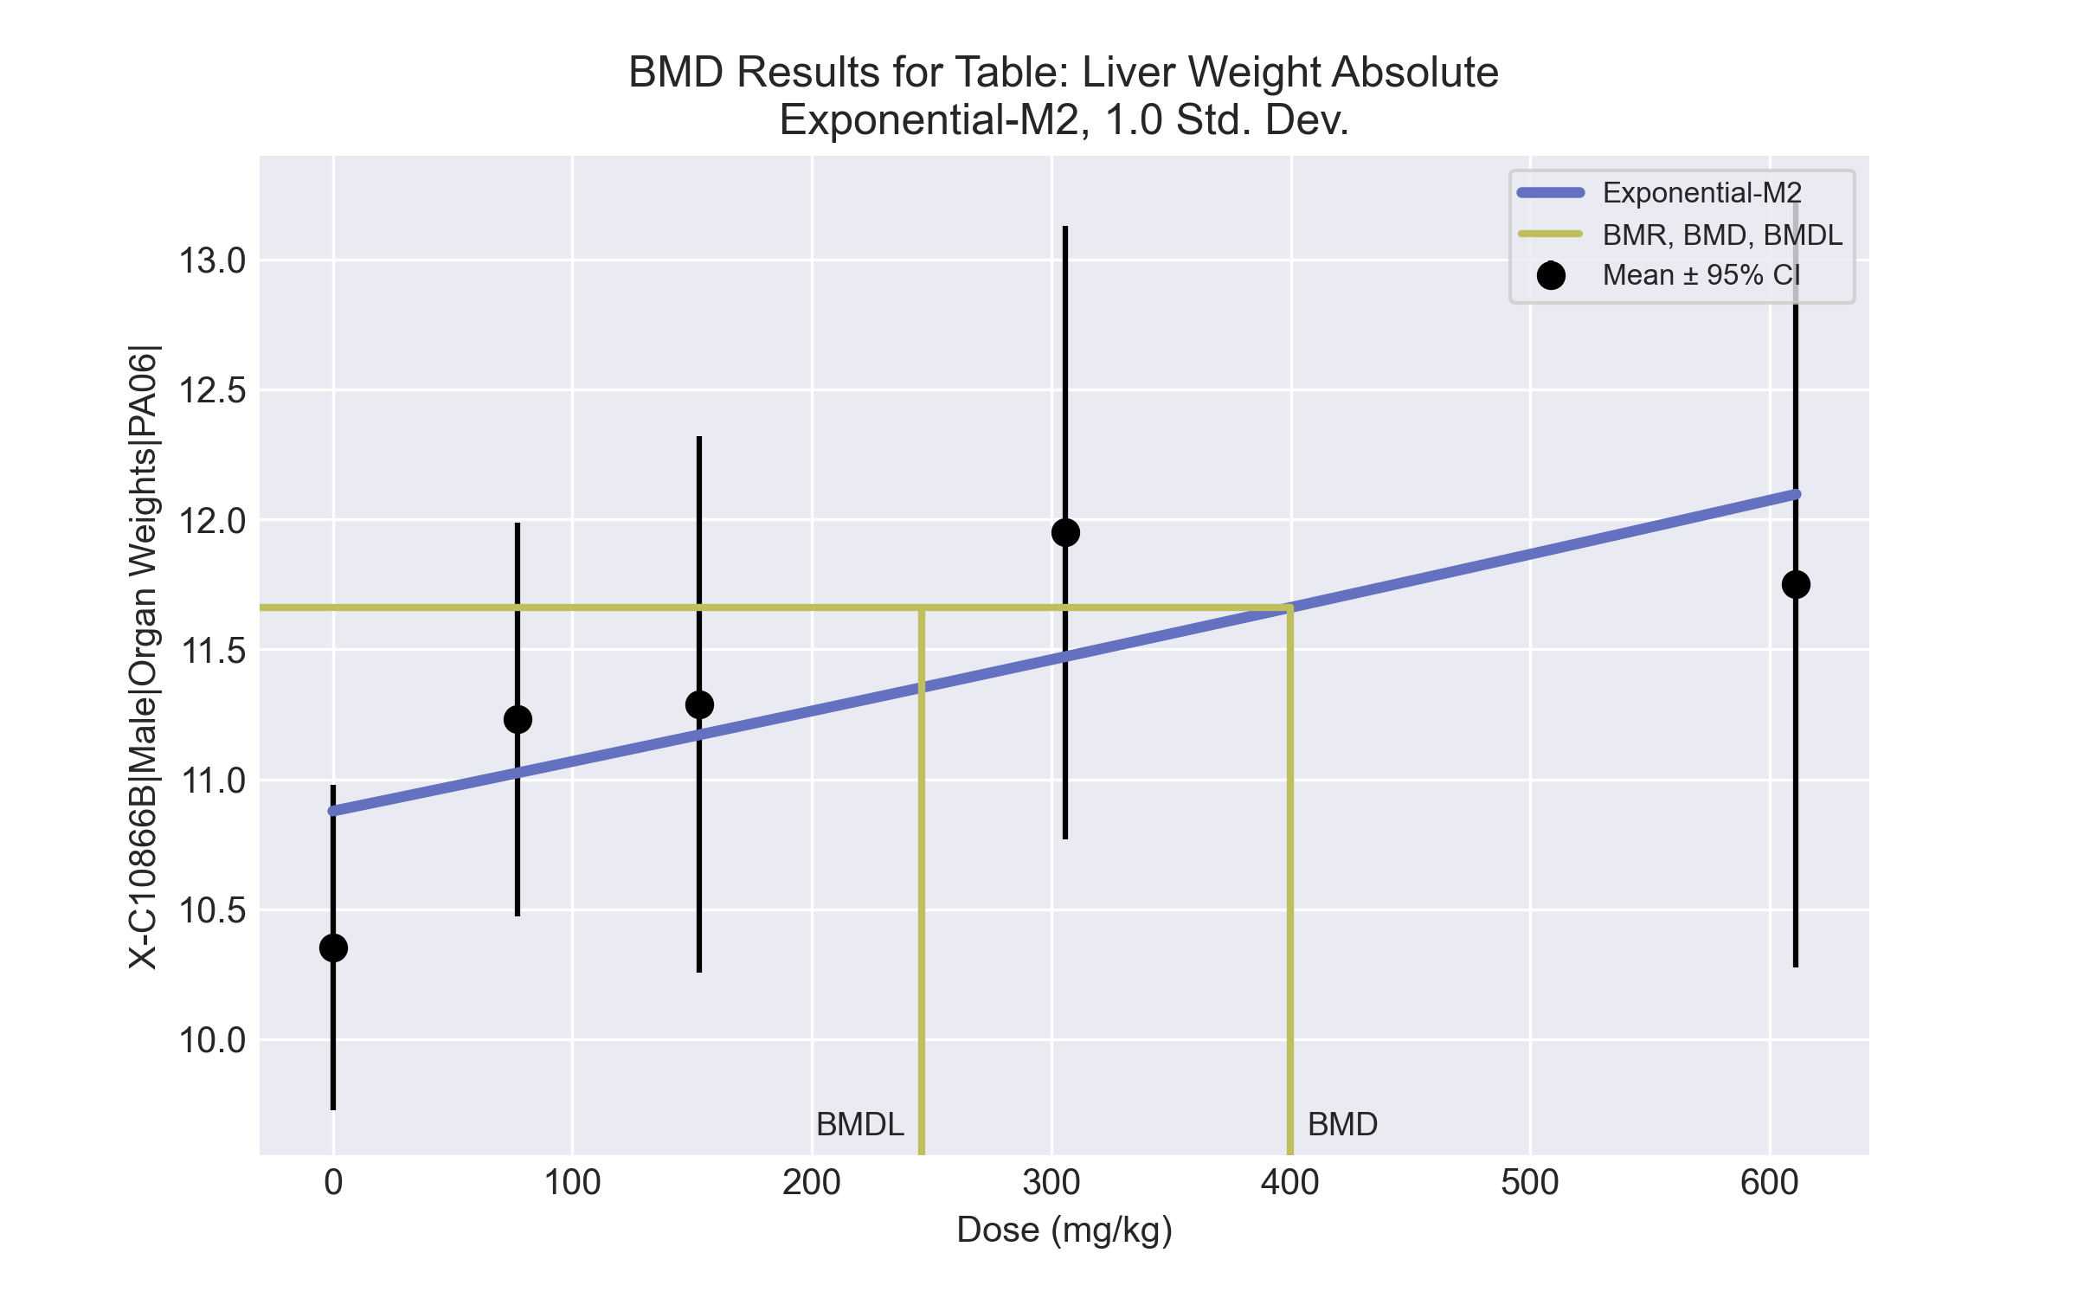
====================================================================
Exponential Model. (Version: 1.11; Date: 03/14/2017)
Input Data File: C:\Windows\TEMP\bmds-sy3yg_g3.(d)
Gnuplot Plotting File:
Tue Jul 06 12:38:47 2021
====================================================================
BMDS_Model_Run
~~~~~~~~~~~~~~~~~~~~~~~~~~~~~~~~~~~~~~~~~~~~~~~~~~~~~~~~~~~~~~~~~~~~~
The form of the response function by Model:
Model 2: Y[dose] = a * exp{sign * b * dose}
Model 3: Y[dose] = a * exp{sign * (b * dose)^d}
Model 4: Y[dose] = a * [c-(c-1) * exp{-b * dose}]
Model 5: Y[dose] = a * [c-(c-1) * exp{-(b * dose)^d}]
Note: Y[dose] is the median response for exposure = dose;
sign = +1 for increasing trend in data;
sign = -1 for decreasing trend.
Model 2 is nested within Models 3 and 4.
Model 3 is nested within Model 5.
Model 4 is nested within Model 5.
Dependent variable = Response
Independent variable = Dose
Data are assumed to be distributed: normally
Variance Model: exp(lnalpha +rho *ln(Y[dose]))
rho is set to 0.
A constant variance model is fit.
Total number of dose groups = 5
Total number of records with missing values = 0
Maximum number of iterations = 500
Relative Function Convergence has been set to: 1e-008
Parameter Convergence has been set to: 1e-008
MLE solution provided: Exact
Initial Parameter Values
Variable Model 2
-------- --------
lnalpha -0.739488
rho 0 Specified
a 10.8494
b 0.000183253
c 0 Specified
d 1 Specified
Parameter Estimates
Variable Model 2 Std. Err.
-------- ------- ---------
lnalpha -0.488086 0.177189
a 10.8777 0.224787
b 0.000173877 6.58692e-005
NC = No Convergence
Table of Stats From Input Data
Dose N Obs Mean Obs Std Dev
----- --- ---------- -------------
0 5 10.35 0.5038
77 5 11.23 0.6105
153 5 11.29 0.8314
306 5 11.95 0.9502
611 4 11.75 0.9263
Estimated Values of Interest
Dose Est Mean Est Std Scaled Residual
------ ---------- --------- ----------------
0 10.88 0.7835 -1.495
77 11.02 0.7835 0.5869
153 11.17 0.7835 0.3339
306 11.47 0.7835 1.364
611 12.1 0.7835 -0.8858
Other models for which likelihoods are calculated:
Model A1: Yij = Mu(i) + e(ij)
Var{e(ij)} = Sigma^2
Model A2: Yij = Mu(i) + e(ij)
Var{e(ij)} = Sigma(i)^2
Model A3: Yij = Mu(i) + e(ij)
Var{e(ij)} = exp(lalpha + log(mean(i)) * rho)
Model R: Yij = Mu + e(i)
Var{e(ij)} = Sigma^2
Likelihoods of Interest
Model Log(likelihood) DF AIC
------- ----------------- ---- ------------
A1 -3.12615 6 18.2523
A2 -1.81263 10 23.62526
A3 -3.12615 6 18.2523
R -9.119681 2 22.23936
2 -6.142969 3 18.28594
Additive constant for all log-likelihoods = -22.05. This constant added to the
above values gives the log-likelihood including the term that does not
depend on the model parameters.
Explanation of Tests
Test 1: Does response and/or variances differ among Dose levels? (A2 vs. R)
Test 2: Are Variances Homogeneous? (A2 vs. A1)
Test 3: Are variances adequately modeled? (A2 vs. A3)
Test 4: Does Model 2 fit the data? (A3 vs. 2)
Tests of Interest
Test -2*log(Likelihood Ratio) D. F. p-value
-------- ------------------------ ------ --------------
Test 1 14.61 8 0.0671
Test 2 2.627 4 0.622
Test 3 2.627 4 0.622
Test 4 6.034 3 0.11
The p-value for Test 1 is greater than .05. There may not be a
diffence between responses and/or variances among the dose levels
Modelling the data with a dose/response curve may not be appropriate.
The p-value for Test 2 is greater than .1. A homogeneous
variance model appears to be appropriate here.
The p-value for Test 3 is greater than .1. The modeled
variance appears to be appropriate here.
The p-value for Test 4 is greater than .1. Model 2 seems
to adequately describe the data.
Benchmark Dose Computations:
Specified Effect = 1.000000
Risk Type = Estimated standard deviations from control
Confidence Level = 0.950000
BMD = 399.984
BMDL = 246.025
BMDU = 1184.99

BMD Results for Table: Liver Weight Relative
BMDS version: BMDS v2.7.0

Input dataset
Dose | 0 | 77 | 153 | 306 | 611
N | 5 | 5 | 5 | 5 | 4
Mean ± SD | 41.901 ± 1.714 | 44.7 ± 1.604 | 45.914 ± 2.128 | 49.87 ± 2.614 | 51.3 ± 3.188

Summary table
Modelª | Goodness of fit |  | BMD | BMDL | Comments
 | p-value | AIC
Linear (equivalent models include Power, Polynomial 2°, 3°, 4°) | 0.06 | 71.18 | 154.242 | 114.214 | Exponential-M4 recommended as best-fitting model on the basis of the lowest AIC.
Hill | 0.295 | 68.853 | 70.585 | 29.566
Exponential M2 (equivalent models include Exponential M3) | 0.04 | 72.086 | 172.486 | 129.612
Exponential M4^{b} | 0.577 | 66.857 | 55.84 | 33.684
Exponential M5 | 0.359 | 68.6 | 72.032 | 34.438
ª Constant variance case presented (BMDS Test 2 p-value = 0.588, BMDS Test 3 p-value = 0.588).
^{b} Recommended model

Model recommendation details
Model | Bin | Notes
Linear (equivalent models include Power, Polynomial 2°, 3°, 4°) | Warning | Warnings  • Goodness of fit p-value is less than threshold (0.0596 < 0.1)
Hill | Valid | -
Exponential M2 (equivalent models include Exponential M3) | Warning | Warnings  • Goodness of fit p-value is less than threshold (0.0397 < 0.1)
Exponential M4ª | Valid | -
Exponential M5 | Valid | -
ª Recommended model

Recommended model
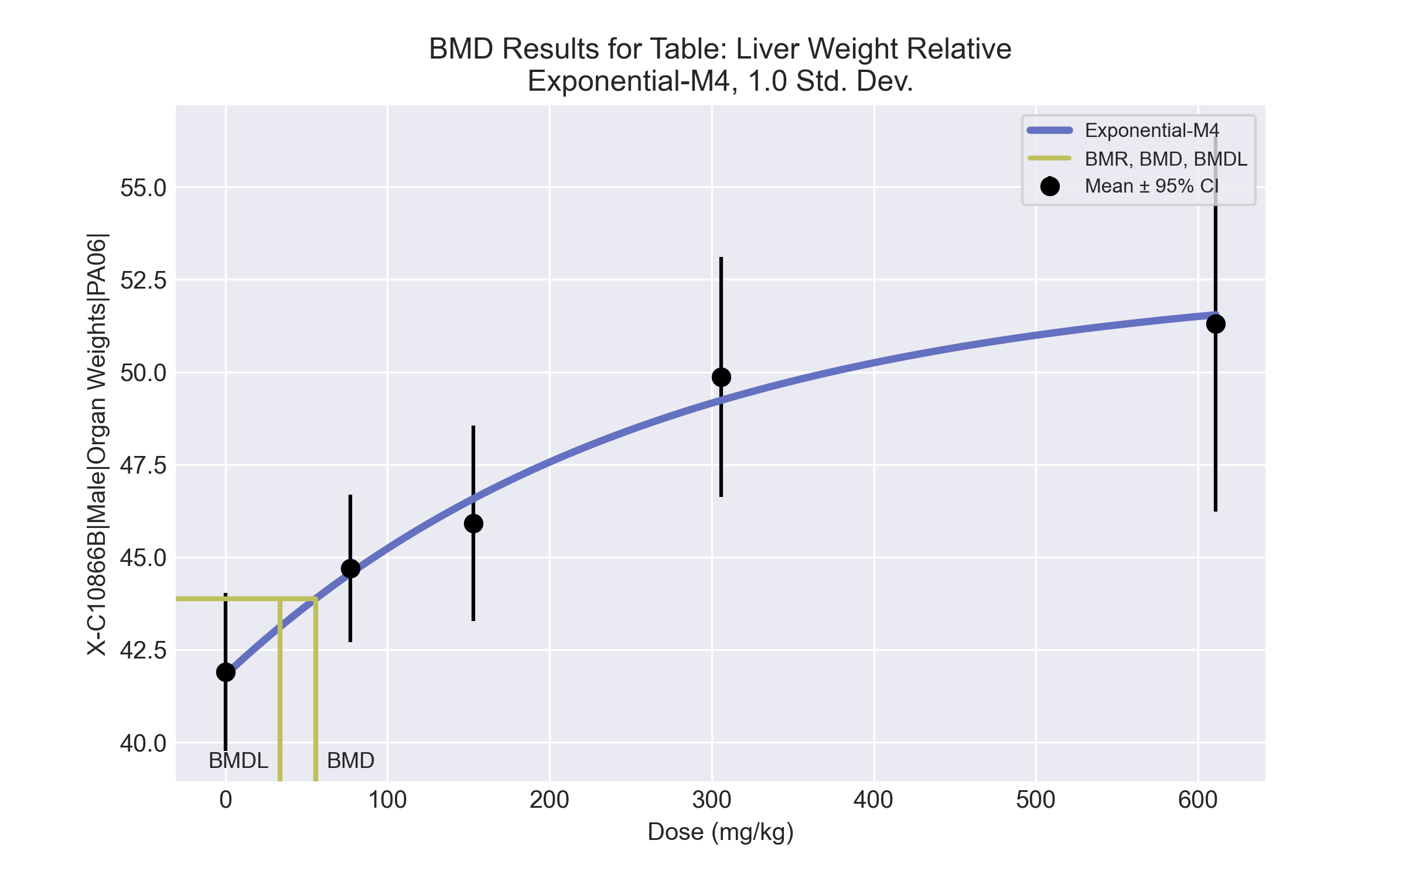
====================================================================
Exponential Model. (Version: 1.11; Date: 03/14/2017)
Input Data File: C:\Windows\TEMP\bmds-hcmdpqtz.(d)
Gnuplot Plotting File:
Tue Jul 06 12:38:50 2021
====================================================================
BMDS_Model_Run
~~~~~~~~~~~~~~~~~~~~~~~~~~~~~~~~~~~~~~~~~~~~~~~~~~~~~~~~~~~~~~~~~~~~~
The form of the response function by Model:
Model 2: Y[dose] = a * exp{sign * b * dose}
Model 3: Y[dose] = a * exp{sign * (b * dose)^d}
Model 4: Y[dose] = a * [c-(c-1) * exp{-b * dose}]
Model 5: Y[dose] = a * [c-(c-1) * exp{-(b * dose)^d}]
Note: Y[dose] is the median response for exposure = dose;
sign = +1 for increasing trend in data;
sign = -1 for decreasing trend.
Model 2 is nested within Models 3 and 4.
Model 3 is nested within Model 5.
Model 4 is nested within Model 5.
Dependent variable = Response
Independent variable = Dose
Data are assumed to be distributed: normally
Variance Model: exp(lnalpha +rho *ln(Y[dose]))
rho is set to 0.
A constant variance model is fit.
Total number of dose groups = 5
Total number of records with missing values = 0
Maximum number of iterations = 500
Relative Function Convergence has been set to: 1e-008
Parameter Convergence has been set to: 1e-008
MLE solution provided: Exact
Initial Parameter Values
Variable Model 4
-------- --------
lnalpha 1.40659
rho 0 Specified
a 39.8056
b 0.00311249
c 1.3532
d 1 Specified
Parameter Estimates
Variable Model 4 Std. Err.
-------- ------- ---------
lnalpha 1.45236 1.23356
a 41.8144 0.848432
b 0.00381167 0.00155013
c 1.25786 0.0459667
NC = No Convergence
Table of Stats From Input Data
Dose N Obs Mean Obs Std Dev
----- --- ---------- -------------
0 5 41.9 1.714
77 5 44.7 1.604
153 5 45.91 2.128
306 5 49.87 2.614
611 4 51.3 3.188
Estimated Values of Interest
Dose Est Mean Est Std Scaled Residual
------ ---------- --------- ----------------
0 41.81 2.067 0.09325
77 44.56 2.067 0.1553
153 46.58 2.067 -0.7188
306 49.24 2.067 0.6836
611 51.55 2.067 -0.2385
Other models for which likelihoods are calculated:
Model A1: Yij = Mu(i) + e(ij)
Var{e(ij)} = Sigma^2
Model A2: Yij = Mu(i) + e(ij)
Var{e(ij)} = Sigma(i)^2
Model A3: Yij = Mu(i) + e(ij)
Var{e(ij)} = exp(lalpha + log(mean(i)) * rho)
Model R: Yij = Mu + e(i)
Var{e(ij)} = Sigma^2
Likelihoods of Interest
Model Log(likelihood) DF AIC
------- ----------------- ---- ------------
A1 -28.87906 6 69.75811
A2 -27.46692 10 74.93384
A3 -28.87906 6 69.75811
R -44.84305 2 93.6861
4 -29.42827 4 66.85654
Additive constant for all log-likelihoods = -22.05. This constant added to the
above values gives the log-likelihood including the term that does not
depend on the model parameters.
Explanation of Tests
Test 1: Does response and/or variances differ among Dose levels? (A2 vs. R)
Test 2: Are Variances Homogeneous? (A2 vs. A1)
Test 3: Are variances adequately modeled? (A2 vs. A3)
Test 6a: Does Model 4 fit the data? (A3 vs 4)
Tests of Interest
Test -2*log(Likelihood Ratio) D. F. p-value
-------- ------------------------ ------ --------------
Test 1 34.75 8 < 0.0001
Test 2 2.824 4 0.5877
Test 3 2.824 4 0.5877
Test 6a 1.098 2 0.5774
The p-value for Test 1 is less than .05. There appears to be a
difference between response and/or variances among the dose
levels, it seems appropriate to model the data.
The p-value for Test 2 is greater than .1. A homogeneous
variance model appears to be appropriate here.
The p-value for Test 3 is greater than .1. The modeled
variance appears to be appropriate here.
The p-value for Test 6a is greater than .1. Model 4 seems
to adequately describe the data.
Benchmark Dose Computations:
Specified Effect = 1.000000
Risk Type = Estimated standard deviations from control
Confidence Level = 0.950000
BMD = 55.8399
BMDL = 33.6836
BMDU = 109.52

BMD Results for Table: Terminal Body Weight
BMDS version: BMDS v2.7.0

Input dataset
Dose | 0 | 77 | 153 | 306 | 611
N | 5 | 5 | 5 | 5 | 5
Mean ± SD | 247.16 ± 8.483 | 251.16 ± 7.732 | 245.78 ± 11.885 | 239.42 ± 9.316 | 230.58 ± 10.15

Summary table
Modelª | Goodness of fit |  | BMD | BMDL | Comments
 | p-value | AIC
Linear^{b} | 0.693 | 140.072 | 278.244 | 187.298 | Linear recommended as best-fitting model on the basis of the lowest AIC.
Polynomial 2° (equivalent models include Polynomial 3°, 4°) | 0.502 | 141.995 | 319.027 | 188.177
Power | 0.536 | 141.864 | 329.161 | 189.734
Hill | 0.399 | 143.329 | 285.94 | 141.473
Exponential M2 (equivalent models include Exponential M4) | 0.687 | 140.098 | 272.458 | 180.45
Exponential M3 | 0.542 | 141.844 | 327.538 | 183.472
Exponential M5 | 0.392 | 143.35 | 289.255 | 142.229
ª Constant variance case presented (BMDS Test 2 p-value = 0.891, BMDS Test 3 p-value = 0.891).
^{b} Recommended model

Model recommendation details
Model | Bin | Notes
Linearª | Valid | -
Polynomial 2° (equivalent models include Polynomial 3°, 4°) | Valid | -
Power | Valid | -
Hill | Valid | -
Exponential M2 (equivalent models include Exponential M4) | Valid | -
Exponential M3 | Valid | -
Exponential M5 | Valid | -
ª Recommended model

Recommended model
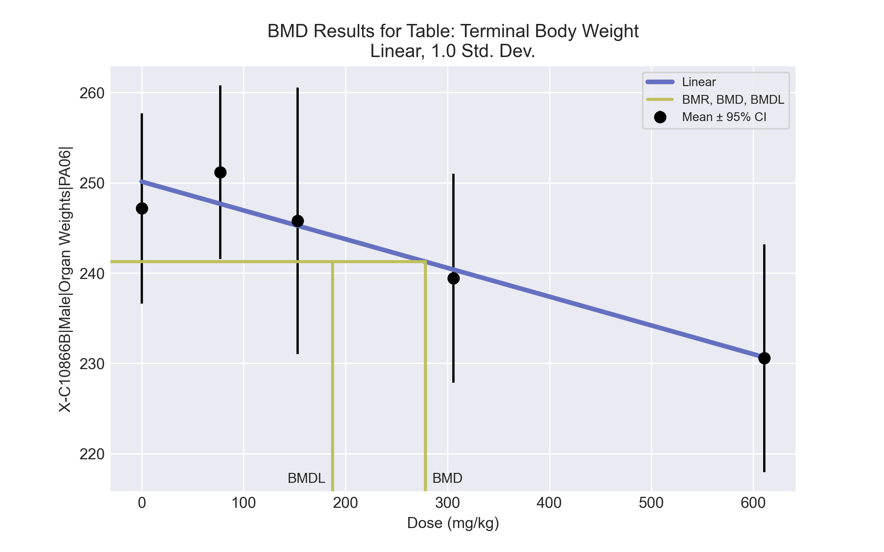
====================================================================
Polynomial Model. (Version: 2.21; Date: 03/14/2017)
Input Data File: C:\Windows\TEMP\bmds-7ln_0m_u.(d)
Gnuplot Plotting File: C:\Windows\TEMP\bmds-7ln_0m_u.plt
Tue Jul 06 12:38:52 2021
====================================================================
BMDS_Model_Run
~~~~~~~~~~~~~~~~~~~~~~~~~~~~~~~~~~~~~~~~~~~~~~~~~~~~~~~~~~~~~~~~~~~~~
The form of the response function is:
Y[dose] = beta_0 + beta_1*dose + beta_2*dose^2 + ...
Dependent variable = Response
Independent variable = Dose
rho is set to 0
The polynomial coefficients are restricted to be negative
A constant variance model is fit
Total number of dose groups = 5
Total number of records with missing values = 0
Maximum number of iterations = 500
Relative Function Convergence has been set to: 1e-008
Parameter Convergence has been set to: 1e-008
Default Initial Parameter Values
alpha = 92.5624
rho = 0 Specified
beta_0 = 250.124
beta_1 = -0.0318389
Asymptotic Correlation Matrix of Parameter Estimates
( *** The model parameter(s) -rho
have been estimated at a boundary point, or have been specified by the user,
and do not appear in the correlation matrix )
alpha beta_0 beta_1
alpha 1 -5.6e-011 -3e-010
beta_0 -5.6e-011 1 -0.73
beta_1 -3e-010 -0.73 1
Parameter Estimates
95.0% Wald Confidence Interval
Variable Estimate Std. Err. Lower Conf. Limit Upper Conf. Limit
alpha 78.4817 22.198 34.9745 121.989
beta_0 250.124 2.58491 245.058 255.19
beta_1 -0.0318389 0.00820465 -0.0479197 -0.0157581
Table of Data and Estimated Values of Interest
Dose N Obs Mean Est Mean Obs Std Dev Est Std Dev Scaled Res.
------ --- -------- -------- ----------- ----------- ----------
0 5 247 250 8.48 8.86 -0.748
77 5 251 248 7.73 8.86 0.88
153 5 246 245 11.9 8.86 0.133
306 5 239 240 9.32 8.86 -0.243
611 5 231 231 10.1 8.86 -0.0228
Model Descriptions for likelihoods calculated
Model A1: Yij = Mu(i) + e(ij)
Var{e(ij)} = Sigma^2
Model A2: Yij = Mu(i) + e(ij)
Var{e(ij)} = Sigma(i)^2
Model A3: Yij = Mu(i) + e(ij)
Var{e(ij)} = Sigma^2
Model A3 uses any fixed variance parameters that
were specified by the user
Model R: Yi = Mu + e(i)
Var{e(i)} = Sigma^2
Likelihoods of Interest
Model Log(likelihood) # Param's AIC
A1 -66.309243 6 144.618487
A2 -65.750363 10 151.500726
A3 -66.309243 6 144.618487
fitted -67.035821 3 140.071643
R -72.929294 2 149.858588
Explanation of Tests
Test 1: Do responses and/or variances differ among Dose levels?
(A2 vs. R)
Test 2: Are Variances Homogeneous? (A1 vs A2)
Test 3: Are variances adequately modeled? (A2 vs. A3)
Test 4: Does the Model for the Mean Fit? (A3 vs. fitted)
(Note: When rho=0 the results of Test 3 and Test 2 will be the same.)
Tests of Interest
Test -2*log(Likelihood Ratio) Test df p-value
Test 1 14.3579 8 0.0729
Test 2 1.11776 4 0.8914
Test 3 1.11776 4 0.8914
Test 4 1.45316 3 0.6931
The p-value for Test 1 is greater than .05. There may not be a
diffence between responses and/or variances among the dose levels
Modelling the data with a dose/response curve may not be appropriate
The p-value for Test 2 is greater than .1. A homogeneous variance
model appears to be appropriate here
The p-value for Test 3 is greater than .1. The modeled variance appears
to be appropriate here
The p-value for Test 4 is greater than .1. The model chosen seems
to adequately describe the data
Benchmark Dose Computation
Specified effect = 1
Risk Type = Estimated standard deviations from the control mean
Confidence level = 0.95
BMD = 278.244
BMDL = 187.298
BMDU = 536.529

BMD Results for Table: A/G Ratio
BMDS version: BMDS v2.7.0

Input dataset
Dose | 0 | 77 | 153 | 306 | 611
N | 5 | 5 | 5 | 5 | 5
Mean ± SD | 1.348 ± 0.034 | 1.278 ± 0.073 | 1.232 ± 0.046 | 1.176 ± 0.066 | 1.171 ± 0.076

Summary table
Modelª | Goodness of fit |  | BMD | BMDL | Comments
 | p-value | AIC
Linear (equivalent models include Power, Polynomial 2°, 3°, 4°) | 0.038 | -105.806 | 247.441 | 171.193 | Exponential-M4 recommended as best-fitting model on the basis of the lowest AIC.
Hill | 0.609 | -109.954 | 65.806 | 20.656
Exponential M2 (equivalent models include Exponential M3) | 0.047 | -106.242 | 229.65 | 156.035
Exponential M4^{b} | 0.865 | -111.925 | 51.337 | 26.983
Exponential M5 | 0.74 | -110.106 | 64.049 | 27.542
ª Constant variance case presented (BMDS Test 2 p-value = 0.384, BMDS Test 3 p-value = 0.384).
^{b} Recommended model

Model recommendation details
Model | Bin | Notes
Linear (equivalent models include Power, Polynomial 2°, 3°, 4°) | Warning | Warnings  • Goodness of fit p-value is less than threshold (0.0382 < 0.1)  • Ratio of modeled to actual stdev. at control is greater than threshold (1.93 > 1.5)
Hill | Warning | Warnings  • Ratio of modeled to actual stdev. at control is greater than threshold (1.64 > 1.5)
Exponential M2 (equivalent models include Exponential M3) | Warning | Warnings  • Goodness of fit p-value is less than threshold (0.0466 < 0.1)
Exponential M4ª | Valid | -
Exponential M5 | Valid | -
ª Recommended model

Recommended model
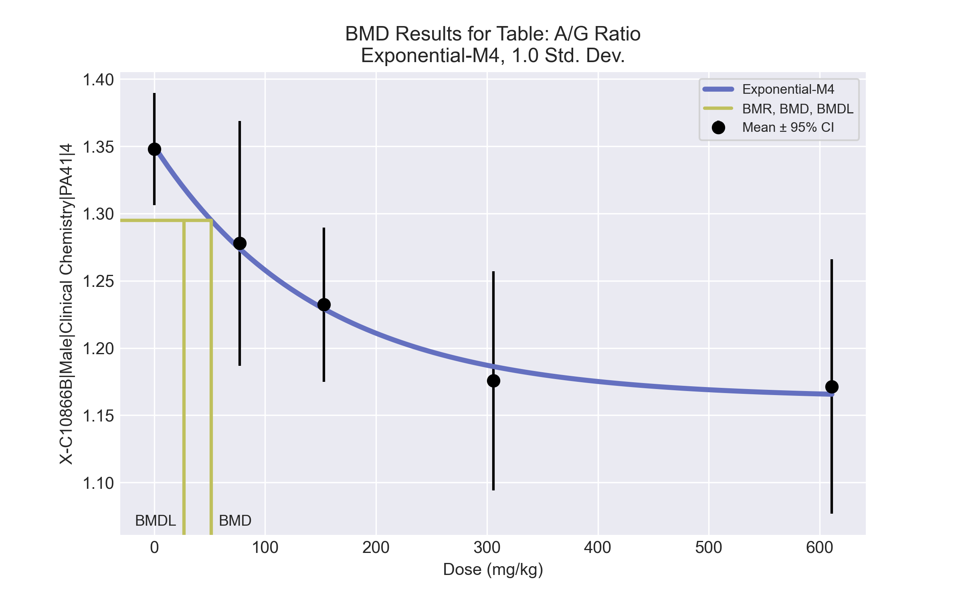
====================================================================
Exponential Model. (Version: 1.11; Date: 03/14/2017)
Input Data File: C:\Windows\TEMP\bmds-v6s_7qot.(d)
Gnuplot Plotting File:
Tue Jul 06 12:39:15 2021
====================================================================
BMDS_Model_Run
~~~~~~~~~~~~~~~~~~~~~~~~~~~~~~~~~~~~~~~~~~~~~~~~~~~~~~~~~~~~~~~~~~~~~
The form of the response function by Model:
Model 2: Y[dose] = a * exp{sign * b * dose}
Model 3: Y[dose] = a * exp{sign * (b * dose)^d}
Model 4: Y[dose] = a * [c-(c-1) * exp{-b * dose}]
Model 5: Y[dose] = a * [c-(c-1) * exp{-(b * dose)^d}]
Note: Y[dose] is the median response for exposure = dose;
sign = +1 for increasing trend in data;
sign = -1 for decreasing trend.
Model 2 is nested within Models 3 and 4.
Model 3 is nested within Model 5.
Model 4 is nested within Model 5.
Dependent variable = Response
Independent variable = Dose
Data are assumed to be distributed: normally
Variance Model: exp(lnalpha +rho *ln(Y[dose]))
rho is set to 0.
A constant variance model is fit.
Total number of dose groups = 5
Total number of records with missing values = 0
Maximum number of iterations = 500
Relative Function Convergence has been set to: 1e-008
Parameter Convergence has been set to: 1e-008
MLE solution provided: Exact
Initial Parameter Values
Variable Model 4
-------- --------
lnalpha -5.80866
rho 0 Specified
a 1.41532
b 0.00344767
c 0.788188
d 1 Specified
Parameter Estimates
Variable Model 4 Std. Err.
-------- ------- ---------
lnalpha -5.79702 0.00085888
a 1.35016 0.0235655
b 0.00677691 0.00273569
c 0.861099 0.0226097
NC = No Convergence
Table of Stats From Input Data
Dose N Obs Mean Obs Std Dev
----- --- ---------- -------------
0 5 1.348 0.03351
77 5 1.278 0.07334
153 5 1.232 0.04624
306 5 1.176 0.06561
611 5 1.171 0.07625
Estimated Values of Interest
Dose Est Mean Est Std Scaled Residual
------ ---------- --------- ----------------
0 1.35 0.05511 -0.09056
77 1.274 0.05511 0.1612
153 1.229 0.05511 0.1278
306 1.186 0.05511 -0.4303
611 1.166 0.05511 0.2319
Other models for which likelihoods are calculated:
Model A1: Yij = Mu(i) + e(ij)
Var{e(ij)} = Sigma^2
Model A2: Yij = Mu(i) + e(ij)
Var{e(ij)} = Sigma(i)^2
Model A3: Yij = Mu(i) + e(ij)
Var{e(ij)} = exp(lalpha + log(mean(i)) * rho)
Model R: Yij = Mu + e(i)
Var{e(ij)} = Sigma^2
Likelihoods of Interest
Model Log(likelihood) DF AIC
------- ----------------- ---- ------------
A1 60.10826 6 -108.2165
A2 62.1906 10 -104.3812
A3 60.10826 6 -108.2165
R 48.82469 2 -93.64939
4 59.96271 4 -111.9254
Additive constant for all log-likelihoods = -22.97. This constant added to the
above values gives the log-likelihood including the term that does not
depend on the model parameters.
Explanation of Tests
Test 1: Does response and/or variances differ among Dose levels? (A2 vs. R)
Test 2: Are Variances Homogeneous? (A2 vs. A1)
Test 3: Are variances adequately modeled? (A2 vs. A3)
Test 6a: Does Model 4 fit the data? (A3 vs 4)
Tests of Interest
Test -2*log(Likelihood Ratio) D. F. p-value
-------- ------------------------ ------ --------------
Test 1 26.73 8 0.0007864
Test 2 4.165 4 0.3842
Test 3 4.165 4 0.3842
Test 6a 0.2911 2 0.8645
The p-value for Test 1 is less than .05. There appears to be a
difference between response and/or variances among the dose
levels, it seems appropriate to model the data.
The p-value for Test 2 is greater than .1. A homogeneous
variance model appears to be appropriate here.
The p-value for Test 3 is greater than .1. The modeled
variance appears to be appropriate here.
The p-value for Test 6a is greater than .1. Model 4 seems
to adequately describe the data.
Benchmark Dose Computations:
Specified Effect = 1.000000
Risk Type = Estimated standard deviations from control
Confidence Level = 0.950000
BMD = 51.3369
BMDL = 26.9832
BMDU = 121.485

BMD Results for Table: Albumin
BMDS version: BMDS v2.7.0

Input dataset
Dose | 0 | 77 | 153 | 306 | 611
N | 5 | 5 | 5 | 5 | 5
Mean ± SD | 3.42 ± 0.13 | 3.42 ± 0.13 | 3.3 ± 0.141 | 3.24 ± 0.114 | 3.18 ± 0.164

Summary table
Modelª | Goodness of fit |  | BMD | BMDL | Comments
 | p-value | AIC
Linear (equivalent models include Power, Polynomial 2°, 3°, 4°) | 0.565 | -71.888 | 309.608 | 202.671 | Exponential-M4 recommended as best-fitting model on the basis of the lowest BMDL.
Hill | 0.531 | -69.533 | 161.757 | 66.186
Exponential M2 (equivalent models include Exponential M3) | 0.581 | -71.966 | 300.878 | 193.856
Exponential M4^{b} | 0.6 | -70.906 | 167.591 | 63.215
Exponential M5 | 0.438 | -69.323 | 175.482 | 67.894
ª Constant variance case presented (BMDS Test 2 p-value = 0.947, BMDS Test 3 p-value = 0.947).
^{b} Recommended model

Model recommendation details
Model | Bin | Notes
Linear (equivalent models include Power, Polynomial 2°, 3°, 4°) | Valid | -
Hill | Valid | -
Exponential M2 (equivalent models include Exponential M3) | Valid | -
Exponential M4ª | Valid | -
Exponential M5 | Valid | -
ª Recommended model

Recommended model
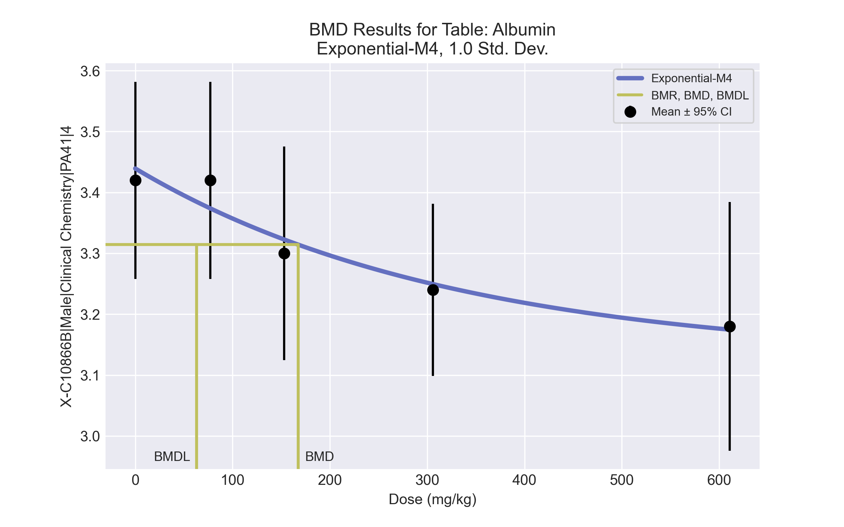
====================================================================
Exponential Model. (Version: 1.11; Date: 03/14/2017)
Input Data File: C:\Windows\TEMP\bmds-3l_twgvj.(d)
Gnuplot Plotting File:
Tue Jul 06 12:39:19 2021
====================================================================
BMDS_Model_Run
~~~~~~~~~~~~~~~~~~~~~~~~~~~~~~~~~~~~~~~~~~~~~~~~~~~~~~~~~~~~~~~~~~~~~
The form of the response function by Model:
Model 2: Y[dose] = a * exp{sign * b * dose}
Model 3: Y[dose] = a * exp{sign * (b * dose)^d}
Model 4: Y[dose] = a * [c-(c-1) * exp{-b * dose}]
Model 5: Y[dose] = a * [c-(c-1) * exp{-(b * dose)^d}]
Note: Y[dose] is the median response for exposure = dose;
sign = +1 for increasing trend in data;
sign = -1 for decreasing trend.
Model 2 is nested within Models 3 and 4.
Model 3 is nested within Model 5.
Model 4 is nested within Model 5.
Dependent variable = Response
Independent variable = Dose
Data are assumed to be distributed: normally
Variance Model: exp(lnalpha +rho *ln(Y[dose]))
rho is set to 0.
A constant variance model is fit.
Total number of dose groups = 5
Total number of records with missing values = 0
Maximum number of iterations = 500
Relative Function Convergence has been set to: 1e-008
Parameter Convergence has been set to: 1e-008
MLE solution provided: Exact
Initial Parameter Values
Variable Model 4
-------- --------
lnalpha -4.19704
rho 0 Specified
a 3.591
b 0.0024995
c 0.843378
d 1 Specified
Parameter Estimates
Variable Model 4 Std. Err.
-------- ------- ---------
lnalpha -4.15623 0.00443117
a 3.43933 0.0501098
b 0.00303733 0.00305791
c 0.908772 0.0407013
NC = No Convergence
Table of Stats From Input Data
Dose N Obs Mean Obs Std Dev
----- --- ---------- -------------
0 5 3.42 0.1304
77 5 3.42 0.1304
153 5 3.3 0.1414
306 5 3.24 0.114
611 5 3.18 0.1643
Estimated Values of Interest
Dose Est Mean Est Std Scaled Residual
------ ---------- --------- ----------------
0 3.439 0.1252 -0.3454
77 3.374 0.1252 0.8236
153 3.323 0.1252 -0.4057
306 3.249 0.1252 -0.1686
611 3.175 0.1252 0.09613
Other models for which likelihoods are calculated:
Model A1: Yij = Mu(i) + e(ij)
Var{e(ij)} = Sigma^2
Model A2: Yij = Mu(i) + e(ij)
Var{e(ij)} = Sigma(i)^2
Model A3: Yij = Mu(i) + e(ij)
Var{e(ij)} = exp(lalpha + log(mean(i)) * rho)
Model R: Yij = Mu + e(i)
Var{e(ij)} = Sigma^2
Likelihoods of Interest
Model Log(likelihood) DF AIC
------- ----------------- ---- ------------
A1 39.96302 6 -67.92603
A2 40.32886 10 -60.65772
A3 39.96302 6 -67.92603
R 33.98864 2 -63.97727
4 39.45284 4 -70.90568
Additive constant for all log-likelihoods = -22.97. This constant added to the
above values gives the log-likelihood including the term that does not
depend on the model parameters.
Explanation of Tests
Test 1: Does response and/or variances differ among Dose levels? (A2 vs. R)
Test 2: Are Variances Homogeneous? (A2 vs. A1)
Test 3: Are variances adequately modeled? (A2 vs. A3)
Test 6a: Does Model 4 fit the data? (A3 vs 4)
Tests of Interest
Test -2*log(Likelihood Ratio) D. F. p-value
-------- ------------------------ ------ --------------
Test 1 12.68 8 0.1233
Test 2 0.7317 4 0.9474
Test 3 0.7317 4 0.9474
Test 6a 1.02 2 0.6004
The p-value for Test 1 is greater than .05. There may not be a
diffence between responses and/or variances among the dose levels
Modelling the data with a dose/response curve may not be appropriate.
The p-value for Test 2 is greater than .1. A homogeneous
variance model appears to be appropriate here.
The p-value for Test 3 is greater than .1. The modeled
variance appears to be appropriate here.
The p-value for Test 6a is greater than .1. Model 4 seems
to adequately describe the data.
Benchmark Dose Computations:
Specified Effect = 1.000000
Risk Type = Estimated standard deviations from control
Confidence Level = 0.950000
BMD = 167.591
BMDL = 63.2153
BMDU = 538.632

BMD Results for Table: Bile salts/acids
BMDS version: BMDS v2.7.0

Input dataset
Dose | 0 | 77 | 153 | 306 | 611
N | 5 | 5 | 5 | 5 | 5
Mean ± SD | 34.94 ± 9.852 | 33.46 ± 24.831 | 23.16 ± 4.993 | 26.36 ± 13.155 | 18.88 ± 9.13

Summary table
Modelª | Goodness of fit |  | BMD | BMDL | Comments
 | p-value | AIC
Linear | 0.056 | 159.007 | 684.223 | 352.992 | No model was recommended as a best-fitting model. Doses were dropped until there were only 3 remaining dose-groups.
Polynomial 2° (equivalent models include Power, Polynomial 3°) | 0.056 | 159.007 | 684.224 | 352.992
Polynomial 4° | 0.056 | 159.007 | 684.226 | 352.992
Hill | 0.097 | 158.113 | -999 | -999
Exponential M2 | 0.058 | 158.931 | 685.433 | 262.33
Exponential M3 | 0.024 | 160.929 | 687.829 | 262.422
Exponential M4 | 0.024 | 160.922 | 691.565 | 111.413
Exponential M5 | 0.007 | 162.861 | 828.948 | 78.334
ª Modeled variance case presented (BMDS Test 2 p-value = 0.01, BMDS Test 3 p-value = 0.167).

Model recommendation details
Model | Bin | Notes
Linear | Warning | Warnings  • Goodness of fit p-value is less than threshold (0.0563 < 0.1)  • BMD/high dose ratio is greater than threshold (1.12 > 1.0)  • Ratio of modeled to actual stdev. at control is greater than threshold (1.58 > 1.5)
Polynomial 2° (equivalent models include Power, Polynomial 3°) | Warning | Warnings  • Goodness of fit p-value is less than threshold (0.0563 < 0.1)  • BMD/high dose ratio is greater than threshold (1.12 > 1.0)  • Ratio of modeled to actual stdev. at control is greater than threshold (1.58 > 1.5)
Polynomial 4° | Warning | Warnings  • Goodness of fit p-value is less than threshold (0.0563 < 0.1)  • BMD/high dose ratio is greater than threshold (1.12 > 1.0)  • Ratio of modeled to actual stdev. at control is greater than threshold (1.58 > 1.5)
Hill | Failure | Failures  • BMD does not exist  • BMDL does not exist  Warnings  • Residual of Interest does not exist  • Goodness of fit p-value is less than threshold (0.0974 < 0.1)  • Ratio of modeled to actual stdev. at control is greater than threshold (1.72 > 1.5)  Cautions  • Warning(s): BMR value is not in the range of the mean function
Exponential M2 | Warning | Warnings  • Goodness of fit p-value is less than threshold (0.0582 < 0.1)  • BMD/high dose ratio is greater than threshold (1.12 > 1.0)
Exponential M3 | Warning | Warnings  • Goodness of fit p-value is less than threshold (0.0238 < 0.1)  • BMD/high dose ratio is greater than threshold (1.13 > 1.0)
Exponential M4 | Warning | Warnings  • Goodness of fit p-value is less than threshold (0.0239 < 0.1)  • BMD/high dose ratio is greater than threshold (1.13 > 1.0)  Cautions  • BMD/BMDL ratio is greater than threshold (6.21 > 5.0)
Exponential M5 | Warning | Warnings  • Goodness of fit p-value is less than threshold (0.0065 < 0.1)  • BMD/high dose ratio is greater than threshold (1.36 > 1.0)  Cautions  • BMD/BMDL ratio is greater than threshold (10.6 > 5.0)

Recommended model
No model was recommended as a best-fitting model.

BMD Results for Table: Cholesterol
BMDS version: BMDS v2.7.0

Input dataset
Dose | 0 | 77 | 153 | 306 | 611ª
N | 5 | 5 | 5 | 5 | 5
Mean ± SD | 113.2 ± 11.345 | 140.6 ± 16.979 | 131.6 ± 11.546 | 134 ± 11.314 | 149 ± 8.66
ª Dose group removed in BMD modeling session

Summary table
Modelª | Goodness of fit |  | BMD | BMDL | Comments
 | p-value | AIC
Linear (equivalent models include Polynomial 2°, 3°, 4°) | 0.012 | 133.092 | 314.543 | 152.967 | Hill recommended as best-fitting model on the basis of the lowest AIC.
Power | 0.012 | 133.092 | 314.542 | 152.967
Hill^{b} | 0.215 | 127.743 | 3.7E-13 | 3.7E-13
Exponential M2 (equivalent models include Exponential M3) | 0.011 | 133.187 | 326.716 | 165.772
Exponential M4 | 0.215 | 127.743 | 3.881 | 0.006
Exponential M5 | -999 | 129.743 | 20.175 | 0.037
ª Constant variance case presented (BMDS Test 2 p-value = 0.721, BMDS Test 3 p-value = 0.721).
^{b} Recommended model

Model recommendation details
Model | Bin | Notes
Linear (equivalent models include Polynomial 2°, 3°, 4°) | Warning | Warnings  • Goodness of fit p-value is less than threshold (0.0117 < 0.1)  • BMD/high dose ratio is greater than threshold (1.03 > 1.0)
Power | Warning | Warnings  • Goodness of fit p-value is less than threshold (0.0117 < 0.1)  • BMD/high dose ratio is greater than threshold (1.03 > 1.0)
Hillª | Valid | Cautions  • Minimum dose/BMD ratio is greater than threshold (2.1e+14 > 3.0)
Exponential M2 (equivalent models include Exponential M3) | Warning | Warnings  • Goodness of fit p-value is less than threshold (0.0112 < 0.1)  • BMD/high dose ratio is greater than threshold (1.07 > 1.0)
Exponential M4 | Warning | Warnings  • BMD/BMDL ratio is greater than threshold (6.57e+02 > 20.0)  Cautions  • BMD/BMDL ratio is greater than threshold (6.57e+02 > 5.0)  • Minimum dose/BMD ratio is greater than threshold (19.8 > 3.0)
Exponential M5 | Warning | Warnings  • BMD/BMDL ratio is greater than threshold (5.48e+02 > 20.0)  • Zero degrees of freedom; saturated model  Cautions  • BMD/BMDL ratio is greater than threshold (5.48e+02 > 5.0)  • Minimum dose/BMD ratio is greater than threshold (3.82 > 3.0)
ª Recommended model

Recommended model
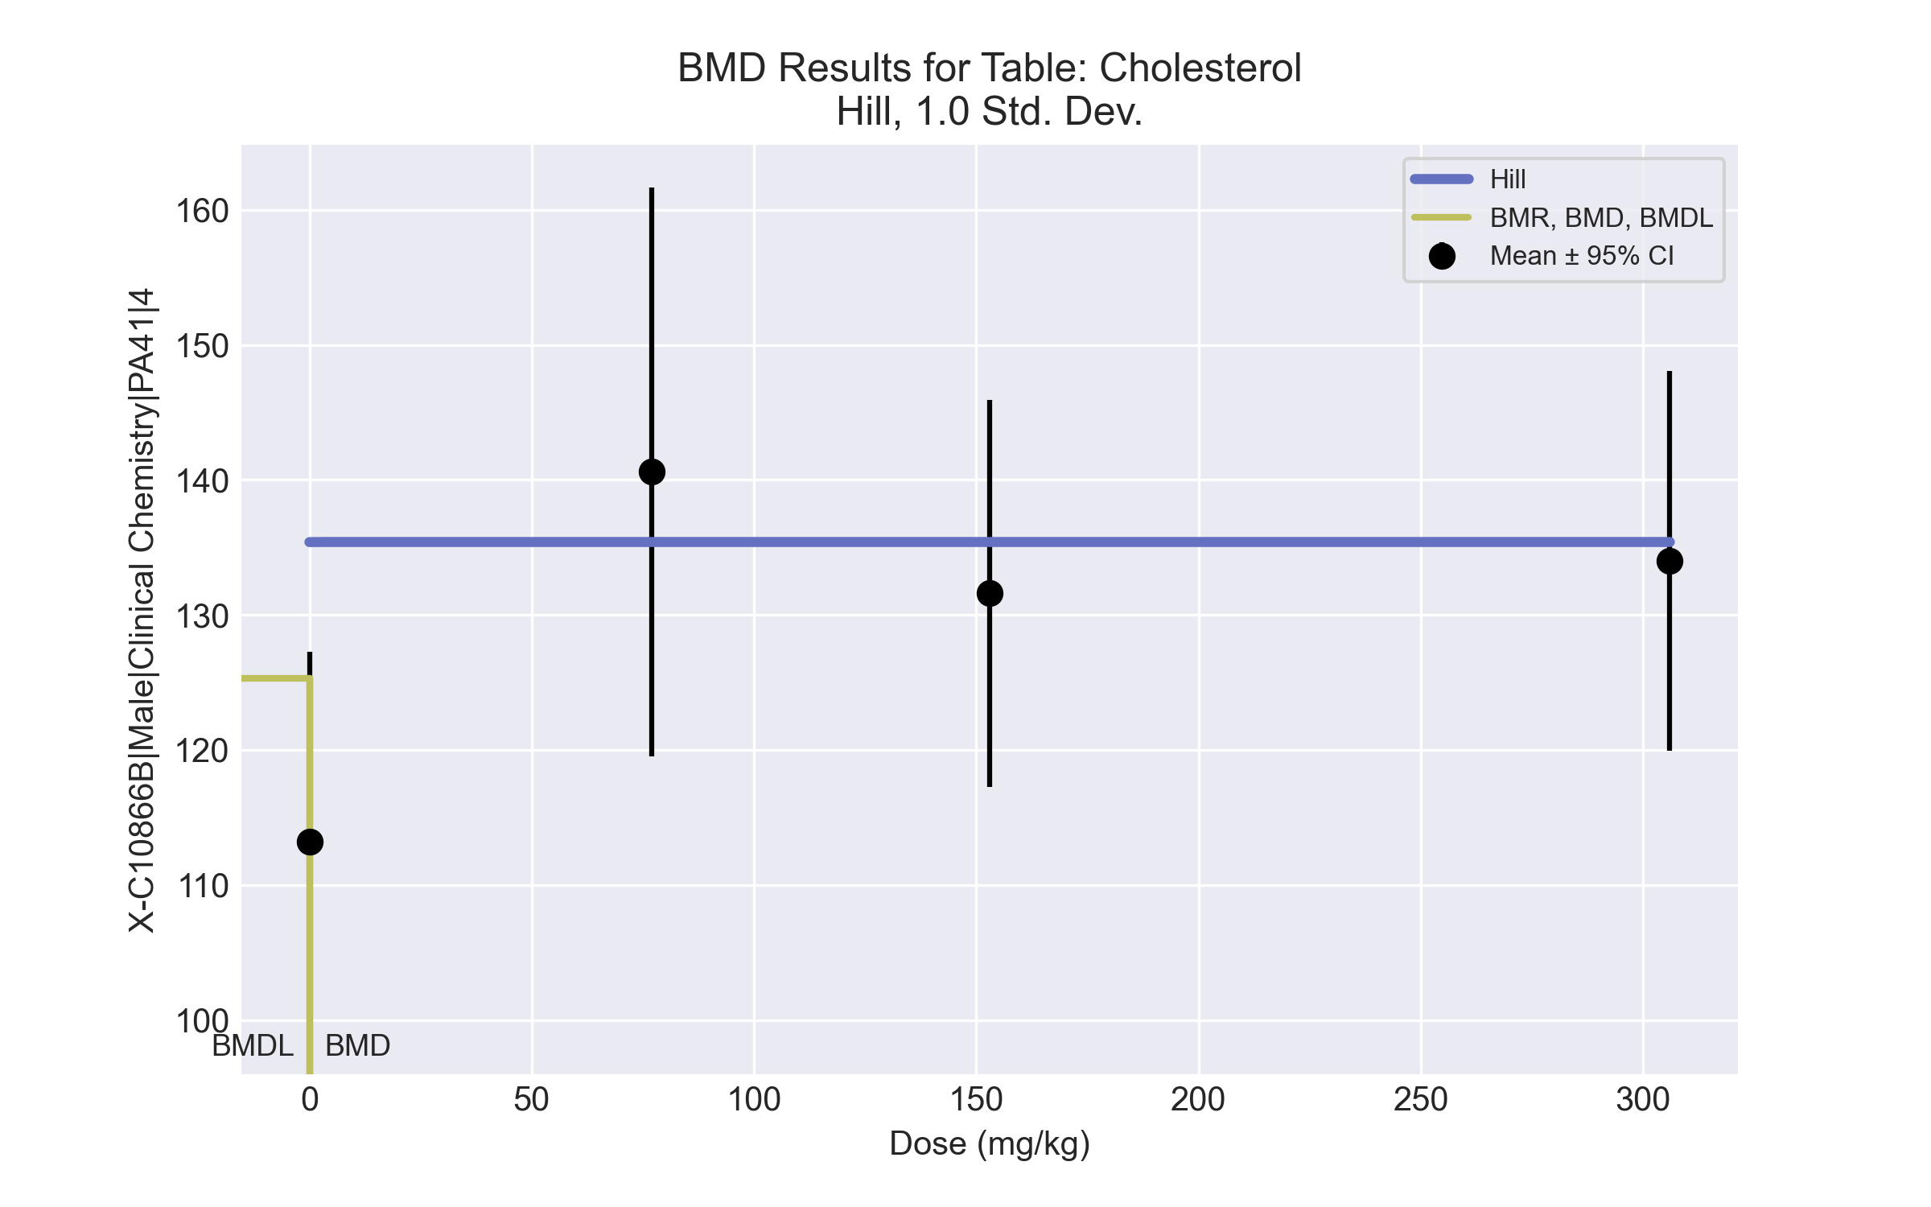
====================================================================
Hill Model. (Version: 2.18; Date: 03/14/2017)
Input Data File: C:\Windows\TEMP\bmds-012wqt80.(d)
Gnuplot Plotting File: C:\Windows\TEMP\bmds-012wqt80.plt
Tue Jul 06 12:39:37 2021
====================================================================
BMDS_Model_Run
~~~~~~~~~~~~~~~~~~~~~~~~~~~~~~~~~~~~~~~~~~~~~~~~~~~~~~~~~~~~~~~~~~~~~
The form of the response function is:
Y[dose] = intercept + v*dose^n/(k^n + dose^n)
Dependent variable = Response
Independent variable = Dose
rho is set to 0
Power parameter restricted to be greater than 1
A constant variance model is fit
Total number of dose groups = 4
Total number of records with missing values = 0
Maximum number of iterations = 500
Relative Function Convergence has been set to: 1e-008
Parameter Convergence has been set to: 1e-008
Default Initial Parameter Values
alpha = 169.575
rho = 0 Specified
intercept = 113.2
v = 27.4
n = 1.86078
k = 115.5
Asymptotic Correlation Matrix of Parameter Estimates
( *** The model parameter(s) -rho -k
have been estimated at a boundary point, or have been specified by the user,
and do not appear in the correlation matrix )
alpha intercept v n
alpha 1 5e-009 -2e-008 -5.4e-006
intercept 5e-009 1 -0.87 -4.1e-006
v -2e-008 -0.87 1 -1.2e-005
n -5.4e-006 -4.1e-006 -1.2e-005 1
Parameter Estimates
95.0% Wald Confidence Interval
Variable Estimate Std. Err. Lower Conf. Limit Upper Conf. Limit
alpha 146.52 46.3338 55.7076 237.333
intercept 113.2 5.41332 102.59 123.81
v 22.2 6.25076 9.94873 34.4513
n 1.00006 2660.6 -5213.69 5215.69
k 3.06e-013 NA
NA - Indicates that this parameter has hit a bound
implied by some inequality constraint and thus
has no standard error.
Table of Data and Estimated Values of Interest
Dose N Obs Mean Est Mean Obs Std Dev Est Std Dev Scaled Res.
------ --- -------- -------- ----------- ----------- ----------
0 5 113 113 11.3 12.1 -1.59e-008
77 5 141 135 17 12.1 0.961
153 5 132 135 11.5 12.1 -0.702
306 5 134 135 11.3 12.1 -0.259
Model Descriptions for likelihoods calculated
Model A1: Yij = Mu(i) + e(ij)
Var{e(ij)} = Sigma^2
Model A2: Yij = Mu(i) + e(ij)
Var{e(ij)} = Sigma(i)^2
Model A3: Yij = Mu(i) + e(ij)
Var{e(ij)} = Sigma^2
Model A3 uses any fixed variance parameters that
were specified by the user
Model R: Yi = Mu + e(i)
Var{e(i)} = Sigma^2
Likelihoods of Interest
Model Log(likelihood) # Param's AIC
A1 -59.101517 5 128.203034
A2 -58.433860 8 132.867719
A3 -59.101517 5 128.203034
fitted -59.871619 4 127.743238
R -64.761601 2 133.523203
Explanation of Tests
Test 1: Do responses and/or variances differ among Dose levels?
(A2 vs. R)
Test 2: Are Variances Homogeneous? (A1 vs A2)
Test 3: Are variances adequately modeled? (A2 vs. A3)
Test 4: Does the Model for the Mean Fit? (A3 vs. fitted)
(Note: When rho=0 the results of Test 3 and Test 2 will be the same.)
Tests of Interest
Test -2*log(Likelihood Ratio) Test df p-value
Test 1 12.6555 6 0.04885
Test 2 1.33532 3 0.7208
Test 3 1.33532 3 0.7208
Test 4 1.5402 1 0.2146
The p-value for Test 1 is less than .05. There appears to be a
difference between response and/or variances among the dose levels
It seems appropriate to model the data
The p-value for Test 2 is greater than .1. A homogeneous variance
model appears to be appropriate here
The p-value for Test 3 is greater than .1. The modeled variance appears
to be appropriate here
The p-value for Test 4 is greater than .1. The model chosen seems
to adequately describe the data
Benchmark Dose Computation
Specified effect = 1
Risk Type = Estimated standard deviations from the control mean
Confidence level = 0.95
BMD = 3.66893e-013
BMDL = 3.66893e-013
BMDU = 3.66895e-013

BMD Results for Table: Creatinine
BMDS version: BMDS v2.7.0

Input dataset
Dose | 0 | 77 | 153 | 306 | 611
N | 5 | 5 | 5 | 5 | 5
Mean ± SD | 0.274 ± 0.017 | 0.278 ± 0.008 | 0.28 ± 0.023 | 0.25 ± 0.016 | 0.252 ± 0.008

Summary table
Modelª | Goodness of fit |  | BMD | BMDL | Comments
 | p-value | AIC
Linear (equivalent models include Power, Polynomial 2°, 3°, 4°) | 0.079 | -175.738 | 330.241 | 212.26 | Hill recommended as best-fitting model on the basis of the lowest AIC.
Hill^{b} | 0.766 | -180.005 | 223.913 | 158.866
Exponential M2 | 0.081 | -175.804 | 318.629 | 199.539
Exponential M3 | 0.035 | -173.804 | 318.939 | 199.539
Exponential M4 | 0.038 | -174.019 | 255.658 | 101.254
Exponential M5 | 0.469 | -178.013 | 263.293 | 157.626
ª Constant variance case presented (BMDS Test 2 p-value = 0.107, BMDS Test 3 p-value = 0.107).
^{b} Recommended model

Model recommendation details
Model | Bin | Notes
Linear (equivalent models include Power, Polynomial 2°, 3°, 4°) | Warning | Warnings  • Goodness of fit p-value is less than threshold (0.0786 < 0.1)
Hillª | Valid | -
Exponential M2 | Warning | Warnings  • Goodness of fit p-value is less than threshold (0.0809 < 0.1)
Exponential M3 | Warning | Warnings  • Goodness of fit p-value is less than threshold (0.0345 < 0.1)
Exponential M4 | Warning | Warnings  • Goodness of fit p-value is less than threshold (0.0384 < 0.1)
Exponential M5 | Valid | -
ª Recommended model

Recommended model
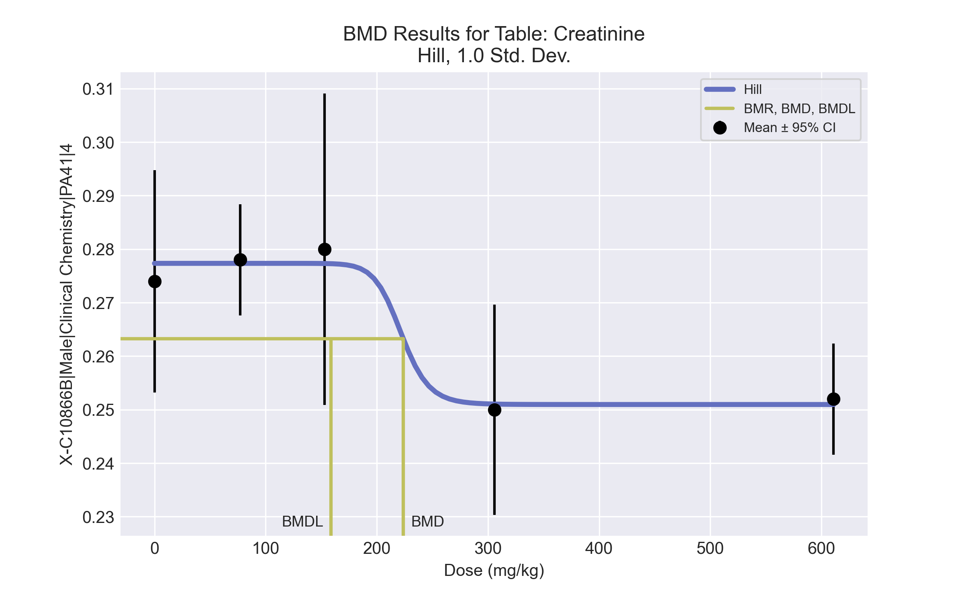
====================================================================
Hill Model. (Version: 2.18; Date: 03/14/2017)
Input Data File: C:\Windows\TEMP\bmds-0asi5ygi.(d)
Gnuplot Plotting File: C:\Windows\TEMP\bmds-0asi5ygi.plt
Tue Jul 06 12:39:42 2021
====================================================================
BMDS_Model_Run
~~~~~~~~~~~~~~~~~~~~~~~~~~~~~~~~~~~~~~~~~~~~~~~~~~~~~~~~~~~~~~~~~~~~~
The form of the response function is:
Y[dose] = intercept + v*dose^n/(k^n + dose^n)
Dependent variable = Response
Independent variable = Dose
rho is set to 0
Power parameter restricted to be greater than 1
A constant variance model is fit
Total number of dose groups = 5
Total number of records with missing values = 0
Maximum number of iterations = 500
Relative Function Convergence has been set to: 1e-008
Parameter Convergence has been set to: 1e-008
Default Initial Parameter Values
alpha = 0.000243998
rho = 0 Specified
intercept = 0.274
v = -0.024
n = 2.62164
k = 244.8
Asymptotic Correlation Matrix of Parameter Estimates
( *** The model parameter(s) -rho -n
have been estimated at a boundary point, or have been specified by the user,
and do not appear in the correlation matrix )
alpha intercept v k
alpha 1 -1e-006 4.1e-007 1.8e-006
intercept -1e-006 1 -0.63 -0.044
v 4.1e-007 -0.63 1 -0.079
k 1.8e-006 -0.044 -0.079 1
Parameter Estimates
95.0% Wald Confidence Interval
Variable Estimate Std. Err. Lower Conf. Limit Upper Conf. Limit
alpha 0.0001994 5.63988e-005 8.88602e-005 0.00030994
intercept 0.277342 0.00365103 0.270186 0.284498
v -0.0263798 0.00579447 -0.0377368 -0.0150229
n 18 NA
k 222.161 186.148 -142.683 587.005
NA - Indicates that this parameter has hit a bound
implied by some inequality constraint and thus
has no standard error.
Table of Data and Estimated Values of Interest
Dose N Obs Mean Est Mean Obs Std Dev Est Std Dev Scaled Res.
------ --- -------- -------- ----------- ----------- ----------
0 5 0.274 0.277 0.0167 0.0141 -0.529
77 5 0.278 0.277 0.00837 0.0141 0.104
153 5 0.28 0.277 0.0235 0.0141 0.426
306 5 0.25 0.251 0.0158 0.0141 -0.165
611 5 0.252 0.251 0.00837 0.0141 0.164
Model Descriptions for likelihoods calculated
Model A1: Yij = Mu(i) + e(ij)
Var{e(ij)} = Sigma^2
Model A2: Yij = Mu(i) + e(ij)
Var{e(ij)} = Sigma(i)^2
Model A3: Yij = Mu(i) + e(ij)
Var{e(ij)} = Sigma^2
Model A3 uses any fixed variance parameters that
were specified by the user
Model R: Yi = Mu + e(i)
Var{e(i)} = Sigma^2
Likelihoods of Interest
Model Log(likelihood) # Param's AIC
A1 94.268669 6 -176.537338
A2 98.075000 10 -176.150000
A3 94.268669 6 -176.537338
fitted 94.002481 4 -180.004962
R 86.419216 2 -168.838431
Explanation of Tests
Test 1: Do responses and/or variances differ among Dose levels?
(A2 vs. R)
Test 2: Are Variances Homogeneous? (A1 vs A2)
Test 3: Are variances adequately modeled? (A2 vs. A3)
Test 4: Does the Model for the Mean Fit? (A3 vs. fitted)
(Note: When rho=0 the results of Test 3 and Test 2 will be the same.)
Tests of Interest
Test -2*log(Likelihood Ratio) Test df p-value
Test 1 23.3116 8 0.002986
Test 2 7.61266 4 0.1068
Test 3 7.61266 4 0.1068
Test 4 0.532375 2 0.7663
The p-value for Test 1 is less than .05. There appears to be a
difference between response and/or variances among the dose levels
It seems appropriate to model the data
The p-value for Test 2 is greater than .1. A homogeneous variance
model appears to be appropriate here
The p-value for Test 3 is greater than .1. The modeled variance appears
to be appropriate here
The p-value for Test 4 is greater than .1. The model chosen seems
to adequately describe the data
Benchmark Dose Computation
Specified effect = 1
Risk Type = Estimated standard deviations from the control mean
Confidence level = 0.95
BMD = 223.913
BMDL = 158.866
BMDU = 308.084

BMD Results for Table: Globulin
BMDS version: BMDS v2.7.0

Input dataset
Dose | 0 | 77 | 153 | 306 | 611
N | 5 | 5 | 5 | 5 | 5
Mean ± SD | 2.54 ± 0.152 | 2.68 ± 0.11 | 2.68 ± 0.13 | 2.76 ± 0.114 | 2.72 ± 0.148

Summary table
Modelª | Goodness of fit |  | BMD | BMDL | Comments
 | p-value | AIC
Linear^{b} (equivalent models include Power, Polynomial 2°, 3°, 4°) | 0.175 | -70.91 | 567.648 | 299.379 | Linear recommended as best-fitting model on the basis of the lowest AIC.
Hill | 0.385 | -71.104 | 61.456 | 5.0E-05
Exponential M2 (equivalent models include Exponential M3) | 0.172 | -70.857 | 577.927 | 310.406
Exponential M4 (equivalent models include Exponential M5) | 0.688 | -73.112 | 74.039 | 0.209
ª Constant variance case presented (BMDS Test 2 p-value = 0.93, BMDS Test 3 p-value = 0.93).
^{b} Recommended model

Model recommendation details
Model | Bin | Notes
Linearª (equivalent models include Power, Polynomial 2°, 3°, 4°) | Valid | -
Hill | Warning | Warnings  • BMD/BMDL ratio is greater than threshold (1.23e+06 > 20.0)  Cautions  • BMD/BMDL ratio is greater than threshold (1.23e+06 > 5.0)
Exponential M2 (equivalent models include Exponential M3) | Valid | -
Exponential M4 (equivalent models include Exponential M5) | Warning | Warnings  • BMD/BMDL ratio is greater than threshold (3.55e+02 > 20.0)  Cautions  • BMD/BMDL ratio is greater than threshold (3.55e+02 > 5.0)
ª Recommended model

Recommended model
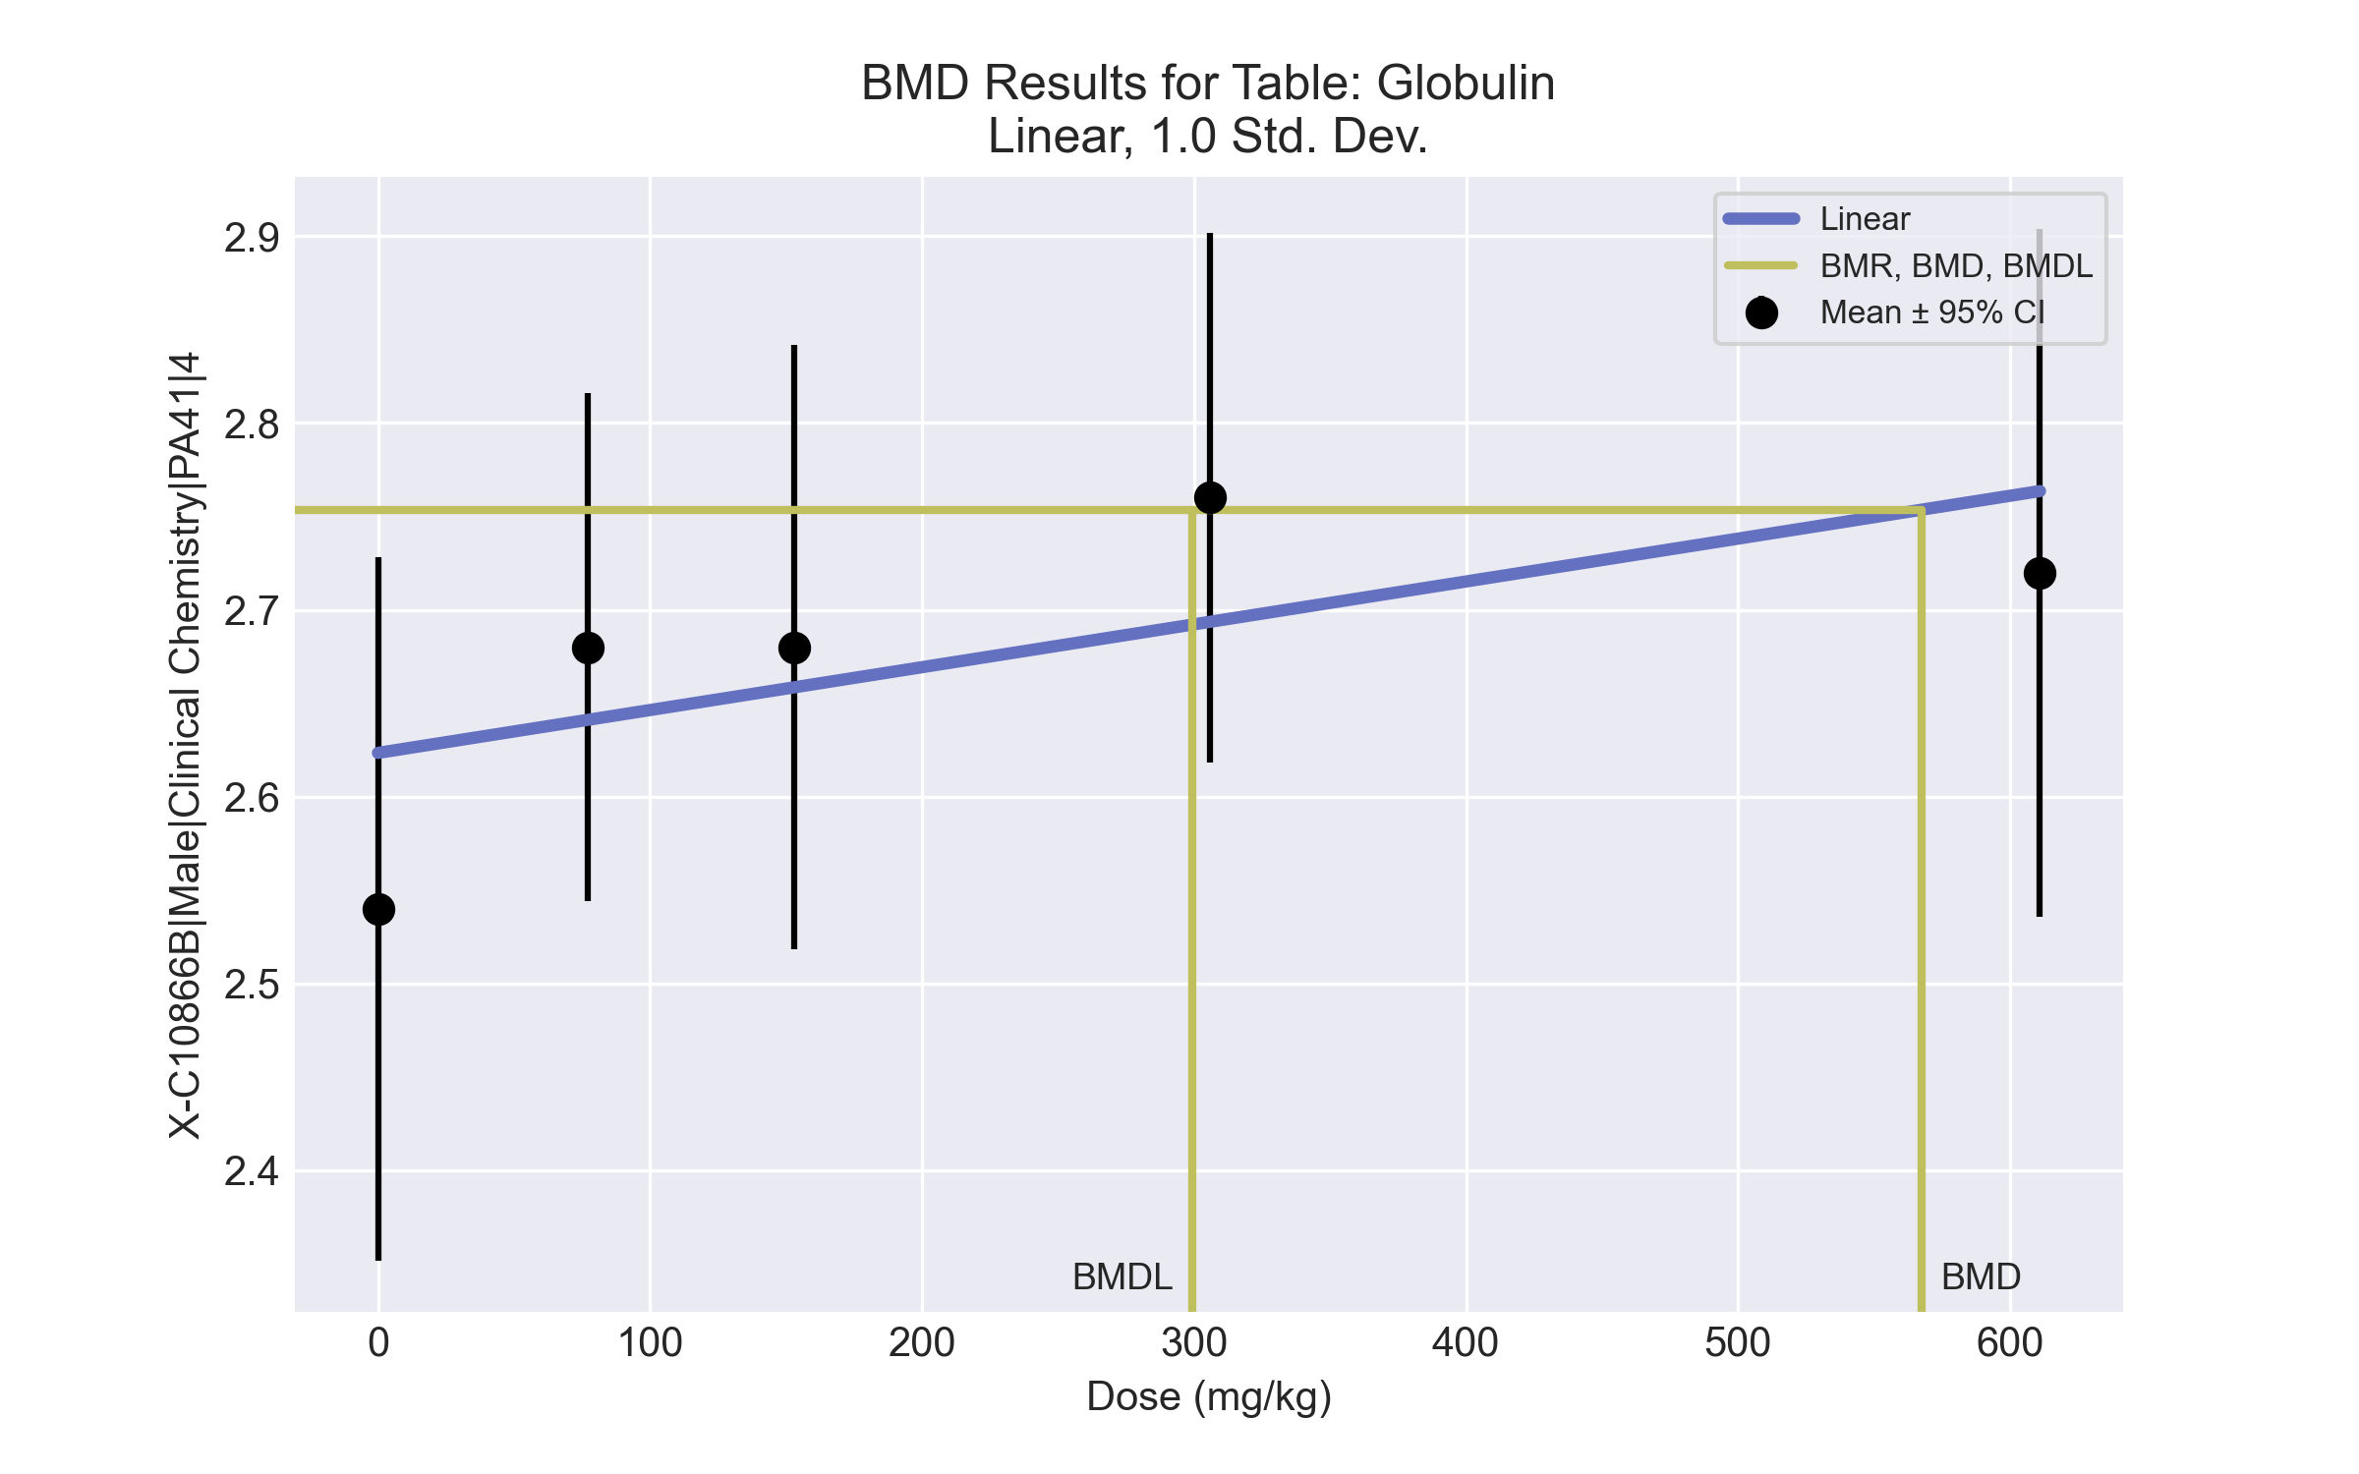
====================================================================
Polynomial Model. (Version: 2.21; Date: 03/14/2017)
Input Data File: C:\Windows\TEMP\bmds-trty3tz9.(d)
Gnuplot Plotting File: C:\Windows\TEMP\bmds-trty3tz9.plt
Tue Jul 06 12:39:45 2021
====================================================================
BMDS_Model_Run
~~~~~~~~~~~~~~~~~~~~~~~~~~~~~~~~~~~~~~~~~~~~~~~~~~~~~~~~~~~~~~~~~~~~~
The form of the response function is:
Y[dose] = beta_0 + beta_1*dose + beta_2*dose^2 + ...
Dependent variable = Response
Independent variable = Dose
rho is set to 0
The polynomial coefficients are restricted to be positive
A constant variance model is fit
Total number of dose groups = 5
Total number of records with missing values = 0
Maximum number of iterations = 500
Relative Function Convergence has been set to: 1e-008
Parameter Convergence has been set to: 1e-008
Default Initial Parameter Values
alpha = 0.0174001
rho = 0 Specified
beta_0 = 2.62336
beta_1 = 0
Asymptotic Correlation Matrix of Parameter Estimates
( *** The model parameter(s) -rho
have been estimated at a boundary point, or have been specified by the user,
and do not appear in the correlation matrix )
alpha beta_0 beta_1
alpha 1 -9.1e-008 1e-007
beta_0 -9.1e-008 1 -0.73
beta_1 1e-007 -0.73 1
Parameter Estimates
95.0% Wald Confidence Interval
Variable Estimate Std. Err. Lower Conf. Limit Upper Conf. Limit
alpha 0.0169683 0.00479935 0.00756172 0.0263748
beta_0 2.62336 0.0380084 2.54886 2.69785
beta_1 0.000229478 0.000120641 -6.97431e-006 0.000465929
Table of Data and Estimated Values of Interest
Dose N Obs Mean Est Mean Obs Std Dev Est Std Dev Scaled Res.
------ --- -------- -------- ----------- ----------- ----------
0 5 2.54 2.62 0.152 0.13 -1.43
77 5 2.68 2.64 0.11 0.13 0.669
153 5 2.68 2.66 0.13 0.13 0.37
306 5 2.76 2.69 0.114 0.13 1.14
611 5 2.72 2.76 0.148 0.13 -0.748
Model Descriptions for likelihoods calculated
Model A1: Yij = Mu(i) + e(ij)
Var{e(ij)} = Sigma^2
Model A2: Yij = Mu(i) + e(ij)
Var{e(ij)} = Sigma(i)^2
Model A3: Yij = Mu(i) + e(ij)
Var{e(ij)} = Sigma^2
Model A3 uses any fixed variance parameters that
were specified by the user
Model R: Yi = Mu + e(i)
Var{e(i)} = Sigma^2
Likelihoods of Interest
Model Log(likelihood) # Param's AIC
A1 40.930307 6 -69.860613
A2 41.362163 10 -62.724325
A3 40.930307 6 -69.860613
fitted 38.455119 3 -70.910238
R 36.765537 2 -69.531073
Explanation of Tests
Test 1: Do responses and/or variances differ among Dose levels?
(A2 vs. R)
Test 2: Are Variances Homogeneous? (A1 vs A2)
Test 3: Are variances adequately modeled? (A2 vs. A3)
Test 4: Does the Model for the Mean Fit? (A3 vs. fitted)
(Note: When rho=0 the results of Test 3 and Test 2 will be the same.)
Tests of Interest
Test -2*log(Likelihood Ratio) Test df p-value
Test 1 9.19325 8 0.3263
Test 2 0.863712 4 0.9297
Test 3 0.863712 4 0.9297
Test 4 4.95038 3 0.1755
The p-value for Test 1 is greater than .05. There may not be a
diffence between responses and/or variances among the dose levels
Modelling the data with a dose/response curve may not be appropriate
The p-value for Test 2 is greater than .1. A homogeneous variance
model appears to be appropriate here
The p-value for Test 3 is greater than .1. The modeled variance appears
to be appropriate here
The p-value for Test 4 is greater than .1. The model chosen seems
to adequately describe the data
Benchmark Dose Computation
Specified effect = 1
Risk Type = Estimated standard deviations from the control mean
Confidence level = 0.95
BMD = 567.648
BMDL = 299.379
BMDU computation failed.

BMD Results for Table: HDL Cholesterol
BMDS version: BMDS v2.7.0

Input dataset
Dose | 0 | 77 | 153 | 306 | 611
N | 5 | 5 | 5 | 5 | 5
Mean ± SD | 52 ± 5 | 66.8 ± 7.563 | 59 ± 4.848 | 66 ± 3 | 71.2 ± 5.675

Summary table
Modelª | Goodness of fit |  | BMD | BMDL | Comments
 | p-value | AIC
Linear (equivalent models include Power, Polynomial 2°, 3°, 4°) | 0.002 | 124.476 | 269.605 | 182.885 | No model was recommended as a best-fitting model. Doses were dropped until there were only 3 remaining dose-groups.
Hill | 0.004 | 123.06 | 31.39 | 8.0E-05
Exponential M2 (equivalent models include Exponential M3) | 0.002 | 124.757 | 293.929 | 206.963
Exponential M4 (equivalent models include Exponential M5) | 0.002 | 124.552 | 89.056 | 0.403
ª Constant variance case presented (BMDS Test 2 p-value = 0.399, BMDS Test 3 p-value = 0.399).

Model recommendation details
Model | Bin | Notes
Linear (equivalent models include Power, Polynomial 2°, 3°, 4°) | Warning | Warnings  • Goodness of fit p-value is less than threshold (0.00225 < 0.1)
Hill | Warning | Warnings  • Goodness of fit p-value is less than threshold (0.00383 < 0.1)  • BMD/BMDL ratio is greater than threshold (3.93e+05 > 20.0)  Cautions  • BMD/BMDL ratio is greater than threshold (3.93e+05 > 5.0)
Exponential M2 (equivalent models include Exponential M3) | Warning | Warnings  • Goodness of fit p-value is less than threshold (0.00197 < 0.1)
Exponential M4 (equivalent models include Exponential M5) | Warning | Warnings  • Goodness of fit p-value is less than threshold (0.00182 < 0.1)  • Residual of interest is greater than threshold (2.47 > 2.0)  • BMD/BMDL ratio is greater than threshold (2.21e+02 > 20.0)  Cautions  • BMD/BMDL ratio is greater than threshold (2.21e+02 > 5.0)

Recommended model
No model was recommended as a best-fitting model.

BMD Results for Table: Sorbitol dehydrogenase
BMDS version: BMDS v2.7.0

Input dataset
Dose | 0 | 77 | 153 | 306 | 611
N | 5 | 5 | 5 | 5 | 5
Mean ± SD | 14.96 ± 3.365 | 10.04 ± 1.26 | 13.44 ± 4.45 | 11.34 ± 1.815 | 10.04 ± 2.763

Summary table
Modelª | Goodness of fit |  | BMD | BMDL | Comments
 | p-value | AIC
Linear | 0.011 | 87.75 | 665.59 | 330.332 | No model was recommended as a best-fitting model. Doses were dropped until there were only 3 remaining dose-groups.
Polynomial 2° (equivalent models include Polynomial 3°) | 0.011 | 87.75 | 665.588 | 330.332
Polynomial 4° | 0.001 | 92.423 | 3700.2 | 223.577
Power | 0.011 | 87.75 | 665.589 | 330.332
Hill | 0.007 | 88.572 | 2.0E-12 | 2.0E-12
Exponential M2 (equivalent models include Exponential M3) | 0.012 | 87.655 | 658.989 | 284.634
Exponential M4 | 0.005 | 89.43 | 691.914 | 1.235
Exponential M5 | 0.005 | 89.43 | 691.915 | 1.923
ª Modeled variance case presented (BMDS Test 2 p-value = 0.07, BMDS Test 3 p-value = 0.289).

Model recommendation details
Model | Bin | Notes
Linear | Warning | Warnings  • Goodness of fit p-value is less than threshold (0.0113 < 0.1)  • BMD/high dose ratio is greater than threshold (1.09 > 1.0)
Polynomial 2° (equivalent models include Polynomial 3°) | Warning | Warnings  • Goodness of fit p-value is less than threshold (0.0113 < 0.1)  • BMD/high dose ratio is greater than threshold (1.09 > 1.0)
Polynomial 4° | Warning | Warnings  • Goodness of fit p-value is less than threshold (0.00128 < 0.1)  • BMD/high dose ratio is greater than threshold (6.06 > 1.0)  • Residual at lowest dose is greater than threshold (2.04 > 2.0)  Cautions  • BMD/BMDL ratio is greater than threshold (16.6 > 5.0)  • Warning(s): THE MODEL HAS PROBABLY NOT CONVERGED!!!; THIS USUALLY MEANS THE MODEL HAS NOT CONVERGED!
Power | Warning | Warnings  • Goodness of fit p-value is less than threshold (0.0113 < 0.1)  • BMD/high dose ratio is greater than threshold (1.09 > 1.0)
Hill | Warning | Warnings  • Goodness of fit p-value is less than threshold (0.00709 < 0.1)  Cautions  • Minimum dose/BMD ratio is greater than threshold (3.9e+13 > 3.0)
Exponential M2 (equivalent models include Exponential M3) | Warning | Warnings  • Goodness of fit p-value is less than threshold (0.0118 < 0.1)  • BMD/high dose ratio is greater than threshold (1.08 > 1.0)
Exponential M4 | Warning | Warnings  • Goodness of fit p-value is less than threshold (0.00462 < 0.1)  • BMD/BMDL ratio is greater than threshold (5.6e+02 > 20.0)  • BMD/high dose ratio is greater than threshold (1.13 > 1.0)  Cautions  • BMD/BMDL ratio is greater than threshold (5.6e+02 > 5.0)
Exponential M5 | Warning | Warnings  • Goodness of fit p-value is less than threshold (0.00462 < 0.1)  • BMD/BMDL ratio is greater than threshold (3.6e+02 > 20.0)  • BMD/high dose ratio is greater than threshold (1.13 > 1.0)  Cautions  • BMD/BMDL ratio is greater than threshold (3.6e+02 > 5.0)

Recommended model
No model was recommended as a best-fitting model.

BMD Results for Table: Urea Nitrogen
BMDS version: BMDS v2.7.0

Input dataset
Dose | 0 | 77 | 153 | 306ª | 611ª
N | 5 | 5 | 5 | 5 | 5
Mean ± SD | 9.6 ± 0.548 | 10.8 ± 2.775 | 11.8 ± 4.764 | 12.6 ± 1.517 | 11.2 ± 1.643
ª Dose group removed in BMD modeling session

Summary table
Modelª | Goodness of fit |  | BMD | BMDL | Comments
 | p-value | AIC
Linear^{b} (equivalent models include Power, Polynomial 2°, 3°, 4°) | <0.0001 | 39.068 | 35.114 | 14.754 | Linear recommended as best-fitting model on the basis of the lowest AIC.
Hill | 0.292 | 53.637 | 66.123 | -999
Exponential M2 (equivalent models include Exponential M3) | -999 | 41.525 | 41.226 | 18.291
Exponential M4 | -999 | 41.789 | 17.006 | 0.092
Exponential M5 | -999 | 57.637 | 46.156 | 0.043
ª Modeled variance case presented (BMDS Test 2 p-value = 5.3E-04, BMDS Test 3 p-value = 0.136).
^{b} Recommended model

Model recommendation details
Model | Bin | Notes
Linearª (equivalent models include Power, Polynomial 2°, 3°, 4°) | Valid | Cautions  • Warning(s): Warning: Likelihood for fitted model larger than the Likelihood for model A3.
Hill | Failure | Failures  • BMDL does not exist  Cautions  • Warning(s): BMDL computation failed.
Exponential M2 (equivalent models include Exponential M3) | Valid | -
Exponential M4 | Warning | Warnings  • BMD/BMDL ratio is greater than threshold (1.85e+02 > 20.0)  • Zero degrees of freedom; saturated model  Cautions  • BMD/BMDL ratio is greater than threshold (1.85e+02 > 5.0)  • Minimum dose/BMD ratio is greater than threshold (4.53 > 3.0)
Exponential M5 | Warning | Warnings  • BMD/BMDL ratio is greater than threshold (1.08e+03 > 20.0)  • Zero degrees of freedom; saturated model  Cautions  • BMD/BMDL ratio is greater than threshold (1.08e+03 > 5.0)
ª Recommended model

Recommended model
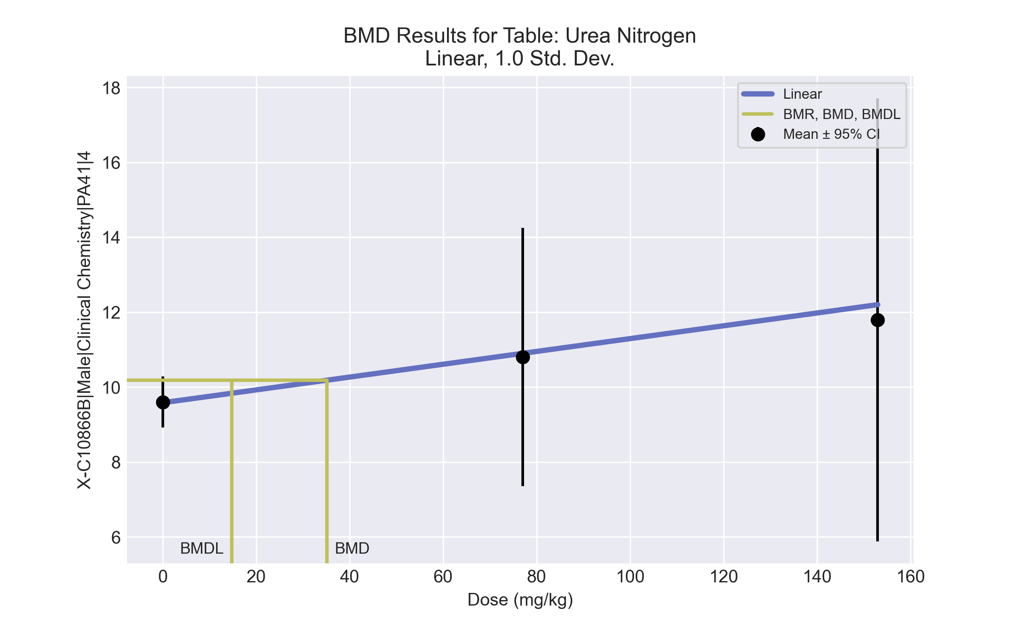
====================================================================
Polynomial Model. (Version: 2.21; Date: 03/14/2017)
Input Data File: C:\Windows\TEMP\bmds-i0rxus4c.(d)
Gnuplot Plotting File: C:\Windows\TEMP\bmds-i0rxus4c.plt
Tue Jul 06 12:40:24 2021
====================================================================
BMDS_Model_Run
~~~~~~~~~~~~~~~~~~~~~~~~~~~~~~~~~~~~~~~~~~~~~~~~~~~~~~~~~~~~~~~~~~~~~
The form of the response function is:
Y[dose] = beta_0 + beta_1*dose + beta_2*dose^2 + ...
Dependent variable = Response
Independent variable = Dose
The polynomial coefficients are restricted to be positive
The variance is to be modeled as Var(i) = exp(lalpha + log(mean(i)) * rho)
Total number of dose groups = 3
Total number of records with missing values = 0
Maximum number of iterations = 500
Relative Function Convergence has been set to: 1e-008
Parameter Convergence has been set to: 1e-008
Default Initial Parameter Values
lalpha = 2.32565
rho = 0
beta_0 = 9.63073
beta_1 = 0.0143817
Asymptotic Correlation Matrix of Parameter Estimates
( *** The model parameter(s) -rho
have been estimated at a boundary point, or have been specified by the user,
and do not appear in the correlation matrix )
lalpha beta_0 beta_1
lalpha 1 -0.017 0.095
beta_0 -0.017 1 -0.1
beta_1 0.095 -0.1 1
Parameter Estimates
95.0% Wald Confidence Interval
Variable Estimate Std. Err. Lower Conf. Limit Upper Conf. Limit
lalpha -41.6966 0.366826 -42.4156 -40.9777
rho 18 NA
beta_0 9.5822 0.254781 9.08284 10.0816
beta_1 0.017116 0.00605784 0.00524287 0.0289892
NA - Indicates that this parameter has hit a bound
implied by some inequality constraint and thus
has no standard error.
Table of Data and Estimated Values of Interest
Dose N Obs Mean Est Mean Obs Std Dev Est Std Dev Scaled Res.
------ --- -------- -------- ----------- ----------- ----------
0 5 9.6 9.58 0.548 0.601 0.0662
77 5 10.8 10.9 2.77 1.92 -0.117
153 5 11.8 12.2 4.76 5.29 -0.17
Warning: Likelihood for fitted model larger than the Likelihood for model A3.
Model Descriptions for likelihoods calculated
Model A1: Yij = Mu(i) + e(ij)
Var{e(ij)} = Sigma^2
Model A2: Yij = Mu(i) + e(ij)
Var{e(ij)} = Sigma(i)^2
Model A3: Yij = Mu(i) + e(ij)
Var{e(ij)} = exp(lalpha + rho*ln(Mu(i)))
Model A3 uses any fixed variance parameters that
were specified by the user
Model R: Yi = Mu + e(i)
Var{e(i)} = Sigma^2
Likelihoods of Interest
Model Log(likelihood) # Param's AIC
A1 -23.268801 4 54.537603
A2 -15.725458 6 43.450916
A3 -16.836426 5 43.672851
fitted -16.534036 3 39.068072
R -23.975480 2 51.950960
Explanation of Tests
Test 1: Do responses and/or variances differ among Dose levels?
(A2 vs. R)
Test 2: Are Variances Homogeneous? (A1 vs A2)
Test 3: Are variances adequately modeled? (A2 vs. A3)
Test 4: Does the Model for the Mean Fit? (A3 vs. fitted)
(Note: When rho=0 the results of Test 3 and Test 2 will be the same.)
Tests of Interest
Test -2*log(Likelihood Ratio) Test df p-value
Test 1 16.5 4 0.002417
Test 2 15.0867 2 0.0005296
Test 3 2.22194 1 0.1361
Test 4 -0.604779 2 <.0001
The p-value for Test 1 is less than .05. There appears to be a
difference between response and/or variances among the dose levels
It seems appropriate to model the data
The p-value for Test 2 is less than .1. A non-homogeneous variance
model appears to be appropriate
The p-value for Test 3 is greater than .1. The modeled variance appears
to be appropriate here
The p-value for Test 4 is less than .1. You may want to try a different
model
Benchmark Dose Computation
Specified effect = 1
Risk Type = Estimated standard deviations from the control mean
Confidence level = 0.95
BMD = 35.1135
BMDL = 14.7537
BMDU = 104.848

BMD Results for Table: Cholinesterase
BMDS version: BMDS v2.7.0

Input dataset
Dose | 0 | 77 | 153 | 306 | 611ª
N | 5 | 5 | 5 | 5 | 5
Mean ± SD | 285.4 ± 35.956 | 166.4 ± 17.785 | 146.4 ± 30.884 | 116.4 ± 13.813 | 104 ± 8.631
ª Dose group removed in BMD modeling session

Summary table
Modelª | Goodness of fit |  | BMD | BMDL | Comments
 | p-value | AIC
Linear | <0.0001 | 173.917 | 82.83 | 60.034 | Hill recommended as best-fitting model on the basis of the lowest AIC.
Polynomial 2° (equivalent models include Power, Polynomial 3°, 4°) | <0.0001 | 173.917 | 82.83 | 60.034
Hill^{b} | 0.487 | 154.708 | 7.276 | 3.429
Exponential M2 | 5.8E-04 | 167.125 | 39.616 | 27.343
Exponential M3 | 5.8E-04 | 167.125 | 39.616 | 27.343
Exponential M4 (equivalent models include Exponential M5) | 0.244 | 155.581 | 10.689 | 6.726
ª Constant variance case presented (BMDS Test 2 p-value = 0.137, BMDS Test 3 p-value = 0.137).
^{b} Recommended model

Model recommendation details
Model | Bin | Notes
Linear | Warning | Warnings  • Residual at lowest dose is greater than threshold (2.3 > 2.0)
Polynomial 2° (equivalent models include Power, Polynomial 3°, 4°) | Warning | Warnings  • Residual at lowest dose is greater than threshold (2.3 > 2.0)
Hillª | Valid | Cautions  • Minimum dose/BMD ratio is greater than threshold (10.6 > 3.0)
Exponential M2 | Warning | Warnings  • Goodness of fit p-value is less than threshold (0.000582 < 0.1)
Exponential M3 | Warning | Warnings  • Goodness of fit p-value is less than threshold (0.000582 < 0.1)
Exponential M4 (equivalent models include Exponential M5) | Valid | Cautions  • Minimum dose/BMD ratio is greater than threshold (7.2 > 3.0)
ª Recommended model

Recommended model
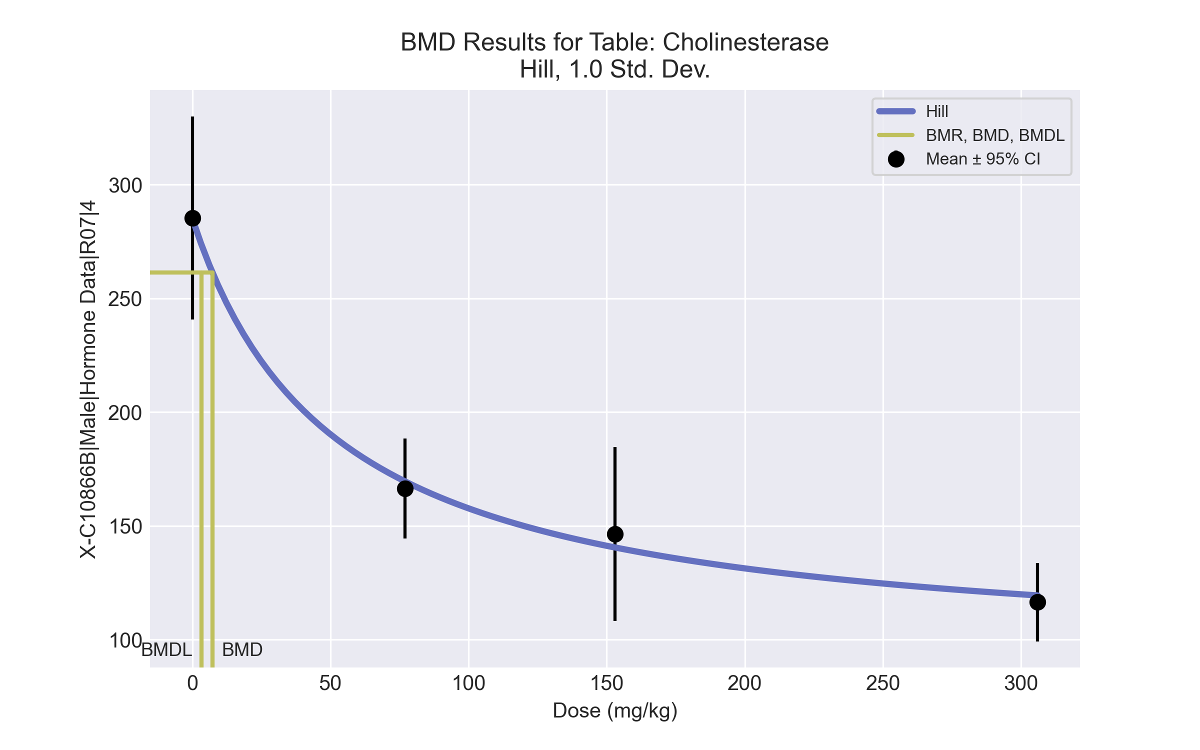
====================================================================
Hill Model. (Version: 2.18; Date: 03/14/2017)
Input Data File: C:\Windows\TEMP\bmds-2x4x97oc.(d)
Gnuplot Plotting File: C:\Windows\TEMP\bmds-2x4x97oc.plt
Tue Jul 06 12:41:45 2021
====================================================================
BMDS_Model_Run
~~~~~~~~~~~~~~~~~~~~~~~~~~~~~~~~~~~~~~~~~~~~~~~~~~~~~~~~~~~~~~~~~~~~~
The form of the response function is:
Y[dose] = intercept + v*dose^n/(k^n + dose^n)
Dependent variable = Response
Independent variable = Dose
rho is set to 0
Power parameter restricted to be greater than 1
A constant variance model is fit
Total number of dose groups = 4
Total number of records with missing values = 0
Maximum number of iterations = 500
Relative Function Convergence has been set to: 1e-008
Parameter Convergence has been set to: 1e-008
Default Initial Parameter Values
alpha = 688.425
rho = 0 Specified
intercept = 285.4
v = -169
n = 2.01134
k = 54.6765
Asymptotic Correlation Matrix of Parameter Estimates
( *** The model parameter(s) -rho -n
have been estimated at a boundary point, or have been specified by the user,
and do not appear in the correlation matrix )
alpha intercept v k
alpha 1 -8.6e-007 8.8e-007 -3.6e-007
intercept -8.6e-007 1 -0.38 -0.24
v 8.8e-007 -0.38 1 -0.74
k -3.6e-007 -0.24 -0.74 1
Parameter Estimates
95.0% Wald Confidence Interval
Variable Estimate Std. Err. Lower Conf. Limit Upper Conf. Limit
alpha 564.187 178.412 214.507 913.867
intercept 285.211 10.6345 264.368 306.054
v -194.089 23.8154 -240.766 -147.411
n 1 NA
k 52.1748 23.7256 5.67351 98.6761
NA - Indicates that this parameter has hit a bound
implied by some inequality constraint and thus
has no standard error.
Table of Data and Estimated Values of Interest
Dose N Obs Mean Est Mean Obs Std Dev Est Std Dev Scaled Res.
------ --- -------- -------- ----------- ----------- ----------
0 5 285 285 36 23.8 0.0178
77 5 166 170 17.8 23.8 -0.293
153 5 146 140 30.9 23.8 0.558
306 5 116 119 13.8 23.8 -0.282
Model Descriptions for likelihoods calculated
Model A1: Yij = Mu(i) + e(ij)
Var{e(ij)} = Sigma^2
Model A2: Yij = Mu(i) + e(ij)
Var{e(ij)} = Sigma(i)^2
Model A3: Yij = Mu(i) + e(ij)
Var{e(ij)} = Sigma^2
Model A3 uses any fixed variance parameters that
were specified by the user
Model R: Yi = Mu + e(i)
Var{e(i)} = Sigma^2
Likelihoods of Interest
Model Log(likelihood) # Param's AIC
A1 -73.112628 5 156.225257
A2 -70.350906 8 156.701812
A3 -73.112628 5 156.225257
fitted -73.353855 4 154.707710
R -94.480419 2 192.960838
Explanation of Tests
Test 1: Do responses and/or variances differ among Dose levels?
(A2 vs. R)
Test 2: Are Variances Homogeneous? (A1 vs A2)
Test 3: Are variances adequately modeled? (A2 vs. A3)
Test 4: Does the Model for the Mean Fit? (A3 vs. fitted)
(Note: When rho=0 the results of Test 3 and Test 2 will be the same.)
Tests of Interest
Test -2*log(Likelihood Ratio) Test df p-value
Test 1 48.259 6 <.0001
Test 2 5.52344 3 0.1372
Test 3 5.52344 3 0.1372
Test 4 0.482454 1 0.4873
The p-value for Test 1 is less than .05. There appears to be a
difference between response and/or variances among the dose levels
It seems appropriate to model the data
The p-value for Test 2 is greater than .1. A homogeneous variance
model appears to be appropriate here
The p-value for Test 3 is greater than .1. The modeled variance appears
to be appropriate here
The p-value for Test 4 is greater than .1. The model chosen seems
to adequately describe the data
Benchmark Dose Computation
Specified effect = 1
Risk Type = Estimated standard deviations from the control mean
Confidence level = 0.95
BMD = 7.27554
BMDL = 3.42945
BMDU = 40.7938

