BMD Results for Table: Body Weight SD4
BMDS version: BMDS v2.7.0

Input dataset
Dose | 0 | 62 | 125 | 249 | 497 | 995
N | 5 | 6 | 5 | 5 | 5 | 5
Mean ± SD | 247.16 ± 8.483 | 244.95 ± 3.814 | 239.46 ± 8.697 | 245.74 ± 10.843 | 240.42 ± 9.175 | 232.18 ± 14.339

Summary table
Modelª | Goodness of fit |  | BMD | BMDL | Comments
 | p-value | AIC
Linear^{b} | 0.675 | 172.738 | 687.041 | 420.179 | Linear recommended as best-fitting model on the basis of the lowest AIC.
Polynomial 2° | 0.532 | 174.608 | 771.942 | 424.188
Polynomial 3° | 0.539 | 174.57 | 791.06 | 425.405
Polynomial 4° | 0.541 | 174.563 | 804.821 | 425.634
Polynomial 5° | 0.34 | 176.563 | 813.967 | 425.635
Power | 0.518 | 174.676 | 778.372 | 422.071
Hill | 0.526 | 174.635 | 547.553 | 309.205
Exponential M2 (equivalent models include Exponential M4) | 0.672 | 172.753 | 682.716 | 410.835
Exponential M3 | 0.518 | 174.68 | 780.511 | 413.101
Exponential M5 | 0.321 | 176.68 | 780.511 | 413.101
ª Constant variance case presented (BMDS Test 2 p-value = 0.137, BMDS Test 3 p-value = 0.137).
^{b} Recommended model

Model recommendation details
Model | Bin | Notes
Linearª | Valid | -
Polynomial 2° | Valid | -
Polynomial 3° | Valid | -
Polynomial 4° | Valid | -
Polynomial 5° | Valid | -
Power | Valid | -
Hill | Valid | -
Exponential M2 (equivalent models include Exponential M4) | Valid | -
Exponential M3 | Valid | -
Exponential M5 | Valid | -
ª Recommended model

Recommended model
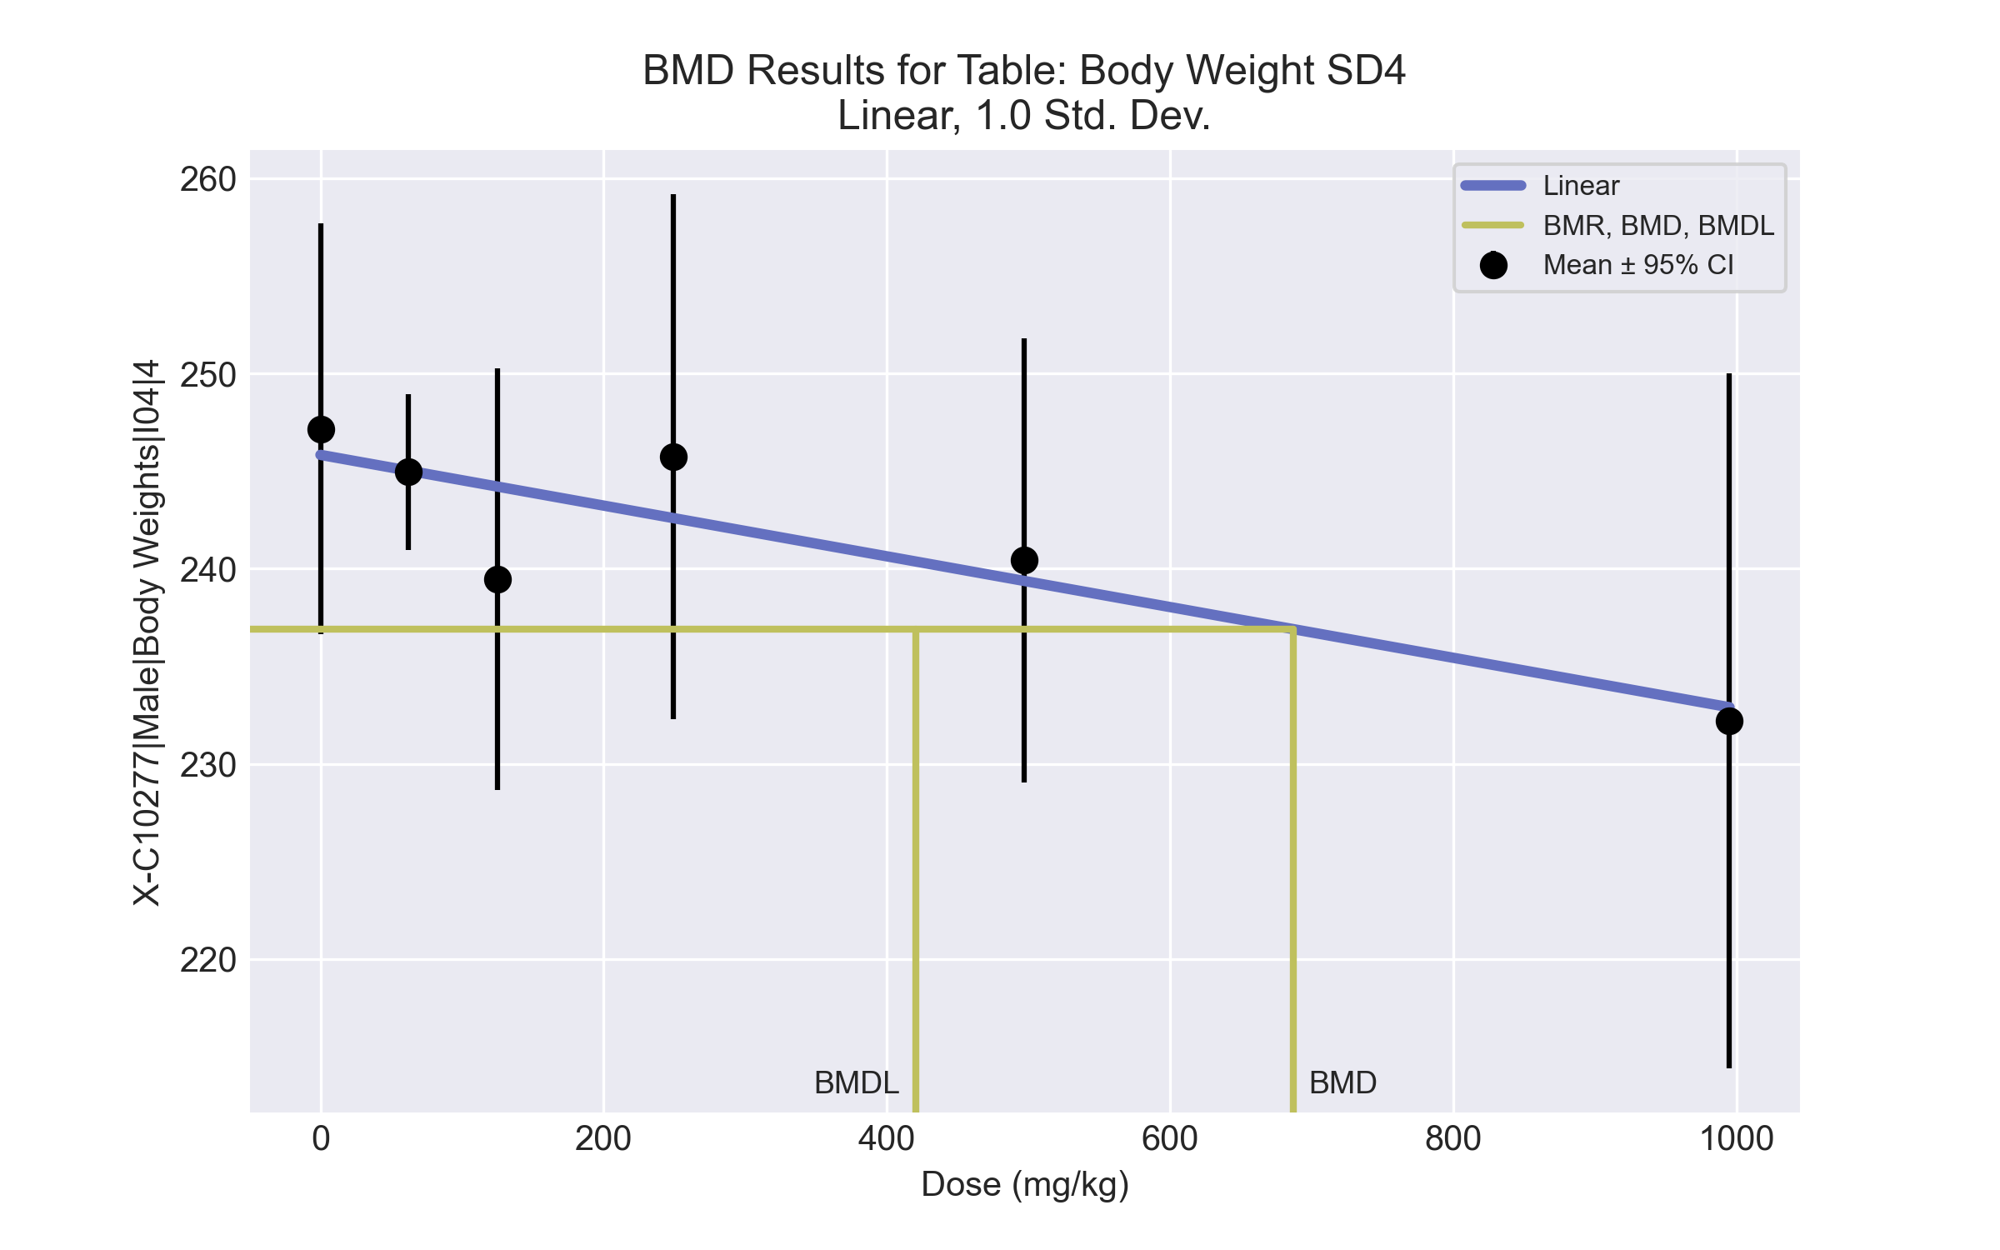
====================================================================
Polynomial Model. (Version: 2.21; Date: 03/14/2017)
Input Data File: C:\Windows\TEMP\bmds-5q1kh7lv.(d)
Gnuplot Plotting File: C:\Windows\TEMP\bmds-5q1kh7lv.plt
Wed May 19 09:24:59 2021
====================================================================
BMDS_Model_Run
~~~~~~~~~~~~~~~~~~~~~~~~~~~~~~~~~~~~~~~~~~~~~~~~~~~~~~~~~~~~~~~~~~~~~
The form of the response function is:
Y[dose] = beta_0 + beta_1*dose + beta_2*dose^2 + ...
Dependent variable = Response
Independent variable = Dose
rho is set to 0
The polynomial coefficients are restricted to be negative
A constant variance model is fit
Total number of dose groups = 6
Total number of records with missing values = 0
Maximum number of iterations = 500
Relative Function Convergence has been set to: 1e-008
Parameter Convergence has been set to: 1e-008
Default Initial Parameter Values
alpha = 91.7043
rho = 0 Specified
beta_0 = 245.83
beta_1 = -0.0130018
Asymptotic Correlation Matrix of Parameter Estimates
( *** The model parameter(s) -rho
have been estimated at a boundary point, or have been specified by the user,
and do not appear in the correlation matrix )
alpha beta_0 beta_1
alpha 1 -1.3e-006 4.3e-007
beta_0 -1.3e-006 1 -0.68
beta_1 4.3e-007 -0.68 1
Parameter Estimates
95.0% Wald Confidence Interval
Variable Estimate Std. Err. Lower Conf. Limit Upper Conf. Limit
alpha 79.7308 20.2516 40.0383 119.423
beta_0 245.826 2.18304 241.547 250.104
beta_1 -0.0129966 0.00473251 -0.0222722 -0.00372107
Table of Data and Estimated Values of Interest
Dose N Obs Mean Est Mean Obs Std Dev Est Std Dev Scaled Res.
------ --- -------- -------- ----------- ----------- ----------
0 5 247 246 8.48 8.93 0.334
62 6 245 245 3.81 8.93 -0.0191
125 5 239 244 8.7 8.93 -1.19
249 5 246 243 10.8 8.93 0.789
497 5 240 239 9.17 8.93 0.264
995 5 232 233 14.3 8.93 -0.179
Model Descriptions for likelihoods calculated
Model A1: Yij = Mu(i) + e(ij)
Var{e(ij)} = Sigma^2
Model A2: Yij = Mu(i) + e(ij)
Var{e(ij)} = Sigma(i)^2
Model A3: Yij = Mu(i) + e(ij)
Var{e(ij)} = Sigma^2
Model A3 uses any fixed variance parameters that
were specified by the user
Model R: Yi = Mu + e(i)
Var{e(i)} = Sigma^2
Likelihoods of Interest
Model Log(likelihood) # Param's AIC
A1 -82.203594 7 178.407187
A2 -78.016121 12 180.032243
A3 -82.203594 7 178.407187
fitted -83.369176 3 172.738353
R -86.744423 2 177.488845
Explanation of Tests
Test 1: Do responses and/or variances differ among Dose levels?
(A2 vs. R)
Test 2: Are Variances Homogeneous? (A1 vs A2)
Test 3: Are variances adequately modeled? (A2 vs. A3)
Test 4: Does the Model for the Mean Fit? (A3 vs. fitted)
(Note: When rho=0 the results of Test 3 and Test 2 will be the same.)
Tests of Interest
Test -2*log(Likelihood Ratio) Test df p-value
Test 1 17.4566 10 0.06485
Test 2 8.37494 5 0.1367
Test 3 8.37494 5 0.1367
Test 4 2.33117 4 0.6751
The p-value for Test 1 is greater than .05. There may not be a
diffence between responses and/or variances among the dose levels
Modelling the data with a dose/response curve may not be appropriate
The p-value for Test 2 is greater than .1. A homogeneous variance
model appears to be appropriate here
The p-value for Test 3 is greater than .1. The modeled variance appears
to be appropriate here
The p-value for Test 4 is greater than .1. The model chosen seems
to adequately describe the data
Benchmark Dose Computation
Specified effect = 1
Risk Type = Estimated standard deviations from the control mean
Confidence level = 0.95
BMD = 687.041
BMDL = 420.179
BMDU = 1874.8

BMD Results for Table: Liver Weight Absolute
BMDS version: BMDS v2.7.0

Input dataset
Dose | 0 | 62 | 125 | 249 | 497 | 995
N | 5 | 4 | 5 | 5 | 5 | 4
Mean ± SD | 10.354 ± 0.504 | 10.512 ± 0.709 | 10.02 ± 0.676 | 11.104 ± 0.482 | 11.426 ± 0.659 | 11.57 ± 0.883

Summary table
Modelª | Goodness of fit |  | BMD | BMDL | Comments
 | p-value | AIC
Linear (equivalent models include Polynomial 2°, 3°, 4°, 5°) | 0.107 | 10.896 | 456.635 | 306.488 | Exponential-M4 recommended as best-fitting model on the basis of the lowest BMDL.
Power | 0.107 | 10.896 | 456.634 | 306.488
Hill | 0.611 | 7.113 | 238.378 | 139.073
Exponential M2 (equivalent models include Exponential M3) | 0.099 | 11.105 | 480.897 | 329.91
Exponential M4^{b} | 0.122 | 11.094 | 223.801 | 97.057
Exponential M5 | 0.403 | 9.113 | 241.925 | 136.502
ª Constant variance case presented (BMDS Test 2 p-value = 0.841, BMDS Test 3 p-value = 0.841).
^{b} Recommended model

Model recommendation details
Model | Bin | Notes
Linear (equivalent models include Polynomial 2°, 3°, 4°, 5°) | Valid | -
Power | Valid | -
Hill | Valid | -
Exponential M2 (equivalent models include Exponential M3) | Warning | Warnings  • Goodness of fit p-value is less than threshold (0.0988 < 0.1)
Exponential M4ª | Valid | -
Exponential M5 | Valid | -
ª Recommended model

Recommended model
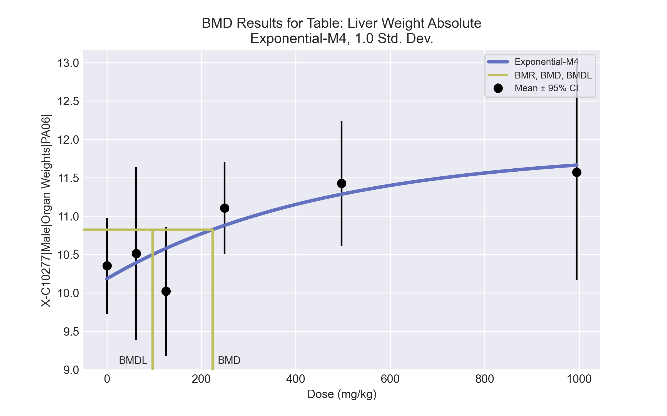
====================================================================
Exponential Model. (Version: 1.11; Date: 03/14/2017)
Input Data File: C:\Windows\TEMP\bmds-yhfby1wz.(d)
Gnuplot Plotting File:
Wed May 19 08:49:47 2021
====================================================================
BMDS_Model_Run
~~~~~~~~~~~~~~~~~~~~~~~~~~~~~~~~~~~~~~~~~~~~~~~~~~~~~~~~~~~~~~~~~~~~~
The form of the response function by Model:
Model 2: Y[dose] = a * exp{sign * b * dose}
Model 3: Y[dose] = a * exp{sign * (b * dose)^d}
Model 4: Y[dose] = a * [c-(c-1) * exp{-b * dose}]
Model 5: Y[dose] = a * [c-(c-1) * exp{-(b * dose)^d}]
Note: Y[dose] is the median response for exposure = dose;
sign = +1 for increasing trend in data;
sign = -1 for decreasing trend.
Model 2 is nested within Models 3 and 4.
Model 3 is nested within Model 5.
Model 4 is nested within Model 5.
Dependent variable = Response
Independent variable = Dose
Data are assumed to be distributed: normally
Variance Model: exp(lnalpha +rho *ln(Y[dose]))
rho is set to 0.
A constant variance model is fit.
Total number of dose groups = 6
Total number of records with missing values = 0
Maximum number of iterations = 500
Relative Function Convergence has been set to: 1e-008
Parameter Convergence has been set to: 1e-008
MLE solution provided: Exact
Initial Parameter Values
Variable Model 4
-------- --------
lnalpha -1.09663
rho 0 Specified
a 9.519
b 0.00184627
c 1.27624
d 1 Specified
Parameter Estimates
Variable Model 4 Std. Err.
-------- ------- ---------
lnalpha -0.889512 0.109806
a 10.1829 0.226073
b 0.00214804 0.00167576
c 1.16492 0.0587037
NC = No Convergence
Table of Stats From Input Data
Dose N Obs Mean Obs Std Dev
----- --- ---------- -------------
0 5 10.35 0.5038
62 4 10.51 0.7088
125 5 10.02 0.6756
249 5 11.1 0.482
497 5 11.43 0.6588
995 4 11.57 0.8828
Estimated Values of Interest
Dose Est Mean Est Std Scaled Residual
------ ---------- --------- ----------------
0 10.18 0.641 0.5968
62 10.39 0.641 0.375
125 10.58 0.641 -1.948
249 10.88 0.641 0.7863
497 11.28 0.641 0.4923
995 11.66 0.641 -0.2939
Other models for which likelihoods are calculated:
Model A1: Yij = Mu(i) + e(ij)
Var{e(ij)} = Sigma^2
Model A2: Yij = Mu(i) + e(ij)
Var{e(ij)} = Sigma(i)^2
Model A3: Yij = Mu(i) + e(ij)
Var{e(ij)} = exp(lalpha + log(mean(i)) * rho)
Model R: Yij = Mu + e(i)
Var{e(ij)} = Sigma^2
Likelihoods of Interest
Model Log(likelihood) DF AIC
------- ----------------- ---- ------------
A1 1.352842 7 11.29432
A2 2.381641 12 19.23672
A3 1.352842 7 11.29432
R -8.201613 2 20.40323
4 -1.546837 4 11.09367
Additive constant for all log-likelihoods = -25.73. This constant added to the
above values gives the log-likelihood including the term that does not
depend on the model parameters.
Explanation of Tests
Test 1: Does response and/or variances differ among Dose levels? (A2 vs. R)
Test 2: Are Variances Homogeneous? (A2 vs. A1)
Test 3: Are variances adequately modeled? (A2 vs. A3)
Test 6a: Does Model 4 fit the data? (A3 vs 4)
Tests of Interest
Test -2*log(Likelihood Ratio) D. F. p-value
-------- ------------------------ ------ --------------
Test 1 21.17 10 0.01996
Test 2 2.058 5 0.8411
Test 3 2.058 5 0.8411
Test 6a 5.799 3 0.1218
The p-value for Test 1 is less than .05. There appears to be a
difference between response and/or variances among the dose
levels, it seems appropriate to model the data.
The p-value for Test 2 is greater than .1. A homogeneous
variance model appears to be appropriate here.
The p-value for Test 3 is greater than .1. The modeled
variance appears to be appropriate here.
The p-value for Test 6a is greater than .1. Model 4 seems
to adequately describe the data.
Benchmark Dose Computations:
Specified Effect = 1.000000
Risk Type = Estimated standard deviations from control
Confidence Level = 0.950000
BMD = 223.801
BMDL = 97.0572
BMDU = 642.486

BMD Results for Table: Liver Weight Relative
BMDS version: BMDS v2.7.0

Input dataset
Dose | 0 | 62 | 125 | 249 | 497 | 995
N | 5 | 4 | 5 | 5 | 5 | 4
Mean ± SD | 41.901 ± 1.714 | 42.955 ± 2.467 | 41.832 ± 2.142 | 45.192 ± 0.792 | 47.534 ± 2.349 | 50.112 ± 1.502

Summary table
Modelª | Goodness of fit |  | BMD | BMDL | Comments
 | p-value | AIC
Linear (equivalent models include Power, Polynomial 2°, 3°, 4°, 5°) | 0.148 | 70.071 | 216.842 | 166.022 | Exponential-M4 recommended as best-fitting model on the basis of the lowest AIC.
Hill | 0.229 | 70.244 | 195.314 | 91.397
Exponential M2 (equivalent models include Exponential M3) | 0.113 | 70.767 | 238.53 | 184.843
Exponential M4^{b} | 0.212 | 69.797 | 129.542 | 78.353
Exponential M5 | 0.199 | 70.523 | 188.235 | 88.942
ª Constant variance case presented (BMDS Test 2 p-value = 0.272, BMDS Test 3 p-value = 0.272).
^{b} Recommended model

Model recommendation details
Model | Bin | Notes
Linear (equivalent models include Power, Polynomial 2°, 3°, 4°, 5°) | Valid | -
Hill | Valid | -
Exponential M2 (equivalent models include Exponential M3) | Valid | -
Exponential M4ª | Valid | -
Exponential M5 | Valid | -
ª Recommended model

Recommended model
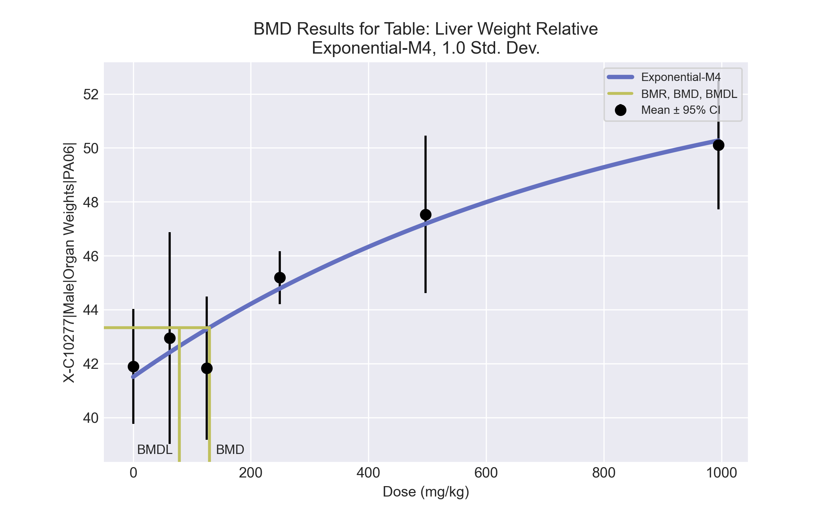
====================================================================
Exponential Model. (Version: 1.11; Date: 03/14/2017)
Input Data File: C:\Windows\TEMP\bmds-62tugs36.(d)
Gnuplot Plotting File:
Wed May 19 08:49:50 2021
====================================================================
BMDS_Model_Run
~~~~~~~~~~~~~~~~~~~~~~~~~~~~~~~~~~~~~~~~~~~~~~~~~~~~~~~~~~~~~~~~~~~~~
The form of the response function by Model:
Model 2: Y[dose] = a * exp{sign * b * dose}
Model 3: Y[dose] = a * exp{sign * (b * dose)^d}
Model 4: Y[dose] = a * [c-(c-1) * exp{-b * dose}]
Model 5: Y[dose] = a * [c-(c-1) * exp{-(b * dose)^d}]
Note: Y[dose] is the median response for exposure = dose;
sign = +1 for increasing trend in data;
sign = -1 for decreasing trend.
Model 2 is nested within Models 3 and 4.
Model 3 is nested within Model 5.
Model 4 is nested within Model 5.
Dependent variable = Response
Independent variable = Dose
Data are assumed to be distributed: normally
Variance Model: exp(lnalpha +rho *ln(Y[dose]))
rho is set to 0.
A constant variance model is fit.
Total number of dose groups = 6
Total number of records with missing values = 0
Maximum number of iterations = 500
Relative Function Convergence has been set to: 1e-008
Parameter Convergence has been set to: 1e-008
MLE solution provided: Exact
Initial Parameter Values
Variable Model 4
-------- --------
lnalpha 1.04621
rho 0 Specified
a 39.7402
b 0.00171991
c 1.32405
d 1 Specified
Parameter Estimates
Variable Model 4 Std. Err.
-------- ------- ---------
lnalpha 1.20702 0.89359
a 41.5083 0.634254
b 0.00122901 0.000815868
c 1.2993 0.109835
NC = No Convergence
Table of Stats From Input Data
Dose N Obs Mean Obs Std Dev
----- --- ---------- -------------
0 5 41.9 1.714
62 4 42.96 2.467
125 5 41.83 2.142
249 5 45.19 0.7915
497 5 47.53 2.349
995 4 50.11 1.502
Estimated Values of Interest
Dose Est Mean Est Std Scaled Residual
------ ---------- --------- ----------------
0 41.51 1.829 0.4797
62 42.42 1.829 0.5854
125 43.28 1.829 -1.768
249 44.78 1.829 0.4998
497 47.19 1.829 0.4237
995 50.27 1.829 -0.1776
Other models for which likelihoods are calculated:
Model A1: Yij = Mu(i) + e(ij)
Var{e(ij)} = Sigma^2
Model A2: Yij = Mu(i) + e(ij)
Var{e(ij)} = Sigma(i)^2
Model A3: Yij = Mu(i) + e(ij)
Var{e(ij)} = exp(lalpha + log(mean(i)) * rho)
Model R: Yij = Mu + e(i)
Var{e(ij)} = Sigma^2
Likelihoods of Interest
Model Log(likelihood) DF AIC
------- ----------------- ---- ------------
A1 -28.64692 7 71.29385
A2 -25.461 12 74.92199
A3 -28.64692 7 71.29385
R -48.55427 2 101.1085
4 -30.89829 4 69.79658
Additive constant for all log-likelihoods = -25.73. This constant added to the
above values gives the log-likelihood including the term that does not
depend on the model parameters.
Explanation of Tests
Test 1: Does response and/or variances differ among Dose levels? (A2 vs. R)
Test 2: Are Variances Homogeneous? (A2 vs. A1)
Test 3: Are variances adequately modeled? (A2 vs. A3)
Test 6a: Does Model 4 fit the data? (A3 vs 4)
Tests of Interest
Test -2*log(Likelihood Ratio) D. F. p-value
-------- ------------------------ ------ --------------
Test 1 46.19 10 < 0.0001
Test 2 6.372 5 0.2717
Test 3 6.372 5 0.2717
Test 6a 4.503 3 0.212
The p-value for Test 1 is less than .05. There appears to be a
difference between response and/or variances among the dose
levels, it seems appropriate to model the data.
The p-value for Test 2 is greater than .1. A homogeneous
variance model appears to be appropriate here.
The p-value for Test 3 is greater than .1. The modeled
variance appears to be appropriate here.
The p-value for Test 6a is greater than .1. Model 4 seems
to adequately describe the data.
Benchmark Dose Computations:
Specified Effect = 1.000000
Risk Type = Estimated standard deviations from control
Confidence Level = 0.950000
BMD = 129.542
BMDL = 78.3535
BMDU = 246.865

BMD Results for Table: Terminal Body Weight
BMDS version: BMDS v2.7.0

Input dataset
Dose | 0 | 62 | 125 | 249 | 497 | 995
N | 5 | 6 | 5 | 5 | 5 | 5
Mean ± SD | 247.16 ± 8.483 | 244.95 ± 3.814 | 239.46 ± 8.697 | 245.74 ± 10.843 | 240.42 ± 9.175 | 232.18 ± 14.339

Summary table
Modelª | Goodness of fit |  | BMD | BMDL | Comments
 | p-value | AIC
Linear^{b} | 0.675 | 172.738 | 687.041 | 420.179 | Linear recommended as best-fitting model on the basis of the lowest AIC.
Polynomial 2° | 0.532 | 174.608 | 771.942 | 424.188
Polynomial 3° | 0.539 | 174.57 | 791.06 | 425.405
Polynomial 4° | 0.541 | 174.563 | 804.821 | 425.634
Polynomial 5° | 0.34 | 176.563 | 813.967 | 425.635
Power | 0.518 | 174.676 | 778.372 | 422.071
Hill | 0.526 | 174.635 | 547.553 | 309.205
Exponential M2 (equivalent models include Exponential M4) | 0.672 | 172.753 | 682.716 | 410.835
Exponential M3 | 0.518 | 174.68 | 780.511 | 413.101
Exponential M5 | 0.321 | 176.68 | 780.511 | 413.101
ª Constant variance case presented (BMDS Test 2 p-value = 0.137, BMDS Test 3 p-value = 0.137).
^{b} Recommended model

Model recommendation details
Model | Bin | Notes
Linearª | Valid | -
Polynomial 2° | Valid | -
Polynomial 3° | Valid | -
Polynomial 4° | Valid | -
Polynomial 5° | Valid | -
Power | Valid | -
Hill | Valid | -
Exponential M2 (equivalent models include Exponential M4) | Valid | -
Exponential M3 | Valid | -
Exponential M5 | Valid | -
ª Recommended model

Recommended model
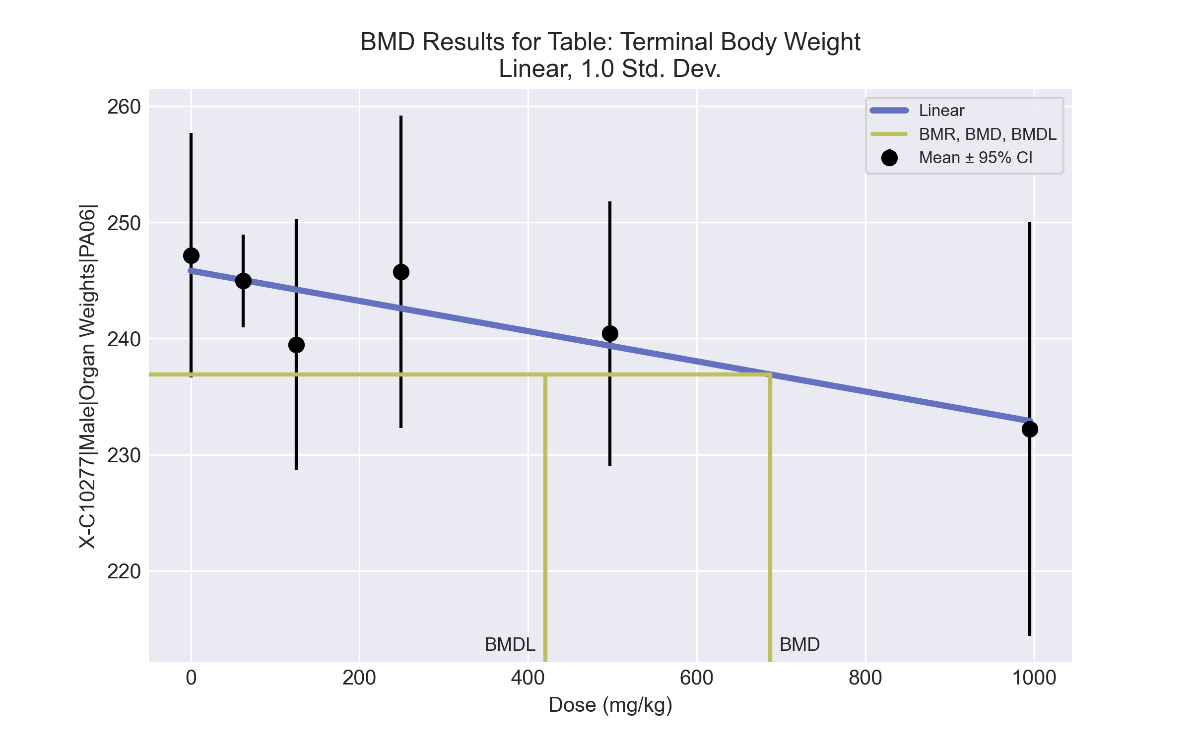
====================================================================
Polynomial Model. (Version: 2.21; Date: 03/14/2017)
Input Data File: C:\Windows\TEMP\bmds-g04dmez1.(d)
Gnuplot Plotting File: C:\Windows\TEMP\bmds-g04dmez1.plt
Wed May 19 08:49:53 2021
====================================================================
BMDS_Model_Run
~~~~~~~~~~~~~~~~~~~~~~~~~~~~~~~~~~~~~~~~~~~~~~~~~~~~~~~~~~~~~~~~~~~~~
The form of the response function is:
Y[dose] = beta_0 + beta_1*dose + beta_2*dose^2 + ...
Dependent variable = Response
Independent variable = Dose
rho is set to 0
The polynomial coefficients are restricted to be negative
A constant variance model is fit
Total number of dose groups = 6
Total number of records with missing values = 0
Maximum number of iterations = 500
Relative Function Convergence has been set to: 1e-008
Parameter Convergence has been set to: 1e-008
Default Initial Parameter Values
alpha = 91.7043
rho = 0 Specified
beta_0 = 245.83
beta_1 = -0.0130018
Asymptotic Correlation Matrix of Parameter Estimates
( *** The model parameter(s) -rho
have been estimated at a boundary point, or have been specified by the user,
and do not appear in the correlation matrix )
alpha beta_0 beta_1
alpha 1 -1.3e-006 4.3e-007
beta_0 -1.3e-006 1 -0.68
beta_1 4.3e-007 -0.68 1
Parameter Estimates
95.0% Wald Confidence Interval
Variable Estimate Std. Err. Lower Conf. Limit Upper Conf. Limit
alpha 79.7308 20.2516 40.0383 119.423
beta_0 245.826 2.18304 241.547 250.104
beta_1 -0.0129966 0.00473251 -0.0222722 -0.00372107
Table of Data and Estimated Values of Interest
Dose N Obs Mean Est Mean Obs Std Dev Est Std Dev Scaled Res.
------ --- -------- -------- ----------- ----------- ----------
0 5 247 246 8.48 8.93 0.334
62 6 245 245 3.81 8.93 -0.0191
125 5 239 244 8.7 8.93 -1.19
249 5 246 243 10.8 8.93 0.789
497 5 240 239 9.17 8.93 0.264
995 5 232 233 14.3 8.93 -0.179
Model Descriptions for likelihoods calculated
Model A1: Yij = Mu(i) + e(ij)
Var{e(ij)} = Sigma^2
Model A2: Yij = Mu(i) + e(ij)
Var{e(ij)} = Sigma(i)^2
Model A3: Yij = Mu(i) + e(ij)
Var{e(ij)} = Sigma^2
Model A3 uses any fixed variance parameters that
were specified by the user
Model R: Yi = Mu + e(i)
Var{e(i)} = Sigma^2
Likelihoods of Interest
Model Log(likelihood) # Param's AIC
A1 -82.203594 7 178.407187
A2 -78.016121 12 180.032243
A3 -82.203594 7 178.407187
fitted -83.369176 3 172.738353
R -86.744423 2 177.488845
Explanation of Tests
Test 1: Do responses and/or variances differ among Dose levels?
(A2 vs. R)
Test 2: Are Variances Homogeneous? (A1 vs A2)
Test 3: Are variances adequately modeled? (A2 vs. A3)
Test 4: Does the Model for the Mean Fit? (A3 vs. fitted)
(Note: When rho=0 the results of Test 3 and Test 2 will be the same.)
Tests of Interest
Test -2*log(Likelihood Ratio) Test df p-value
Test 1 17.4566 10 0.06485
Test 2 8.37494 5 0.1367
Test 3 8.37494 5 0.1367
Test 4 2.33117 4 0.6751
The p-value for Test 1 is greater than .05. There may not be a
diffence between responses and/or variances among the dose levels
Modelling the data with a dose/response curve may not be appropriate
The p-value for Test 2 is greater than .1. A homogeneous variance
model appears to be appropriate here
The p-value for Test 3 is greater than .1. The modeled variance appears
to be appropriate here
The p-value for Test 4 is greater than .1. The model chosen seems
to adequately describe the data
Benchmark Dose Computation
Specified effect = 1
Risk Type = Estimated standard deviations from the control mean
Confidence level = 0.95
BMD = 687.041
BMDL = 420.179
BMDU = 1874.8

BMD Results for Table: A/G Ratio
BMDS version: BMDS v2.7.0

Input dataset
Dose | 0 | 62 | 125 | 249 | 497 | 995
N | 5 | 5 | 5 | 5 | 5 | 5
Mean ± SD | 1.348 ± 0.034 | 1.303 ± 0.035 | 1.294 ± 0.03 | 1.241 ± 0.055 | 1.238 ± 0.05 | 1.114 ± 0.019

Summary table
Modelª | Goodness of fit |  | BMD | BMDL | Comments
 | p-value | AIC
Linear (equivalent models include Power, Polynomial 2°, 3°, 4°) | 0.133 | -158.387 | 186.27 | 146.35 | Exponential-M2 recommended as best-fitting model on the basis of the lowest AIC.
Polynomial 5° | 0.07 | -156.387 | 186.95 | 146.352
Hill | 0.081 | -156.733 | 148.906 | 76.973
Exponential M2^{b} (equivalent models include Exponential M3) | 0.142 | -158.572 | 172.758 | 134.476
Exponential M4 (equivalent models include Exponential M5) | 0.08 | -156.685 | 154.388 | 89.483
ª Constant variance case presented (BMDS Test 2 p-value = 0.288, BMDS Test 3 p-value = 0.288).
^{b} Recommended model

Model recommendation details
Model | Bin | Notes
Linear (equivalent models include Power, Polynomial 2°, 3°, 4°) | Valid | -
Polynomial 5° | Warning | Warnings  • Goodness of fit p-value is less than threshold (0.0699 < 0.1)
Hill | Warning | Warnings  • Goodness of fit p-value is less than threshold (0.0814 < 0.1)
Exponential M2ª (equivalent models include Exponential M3) | Valid | -
Exponential M4 (equivalent models include Exponential M5) | Warning | Warnings  • Goodness of fit p-value is less than threshold (0.0797 < 0.1)
ª Recommended model

Recommended model
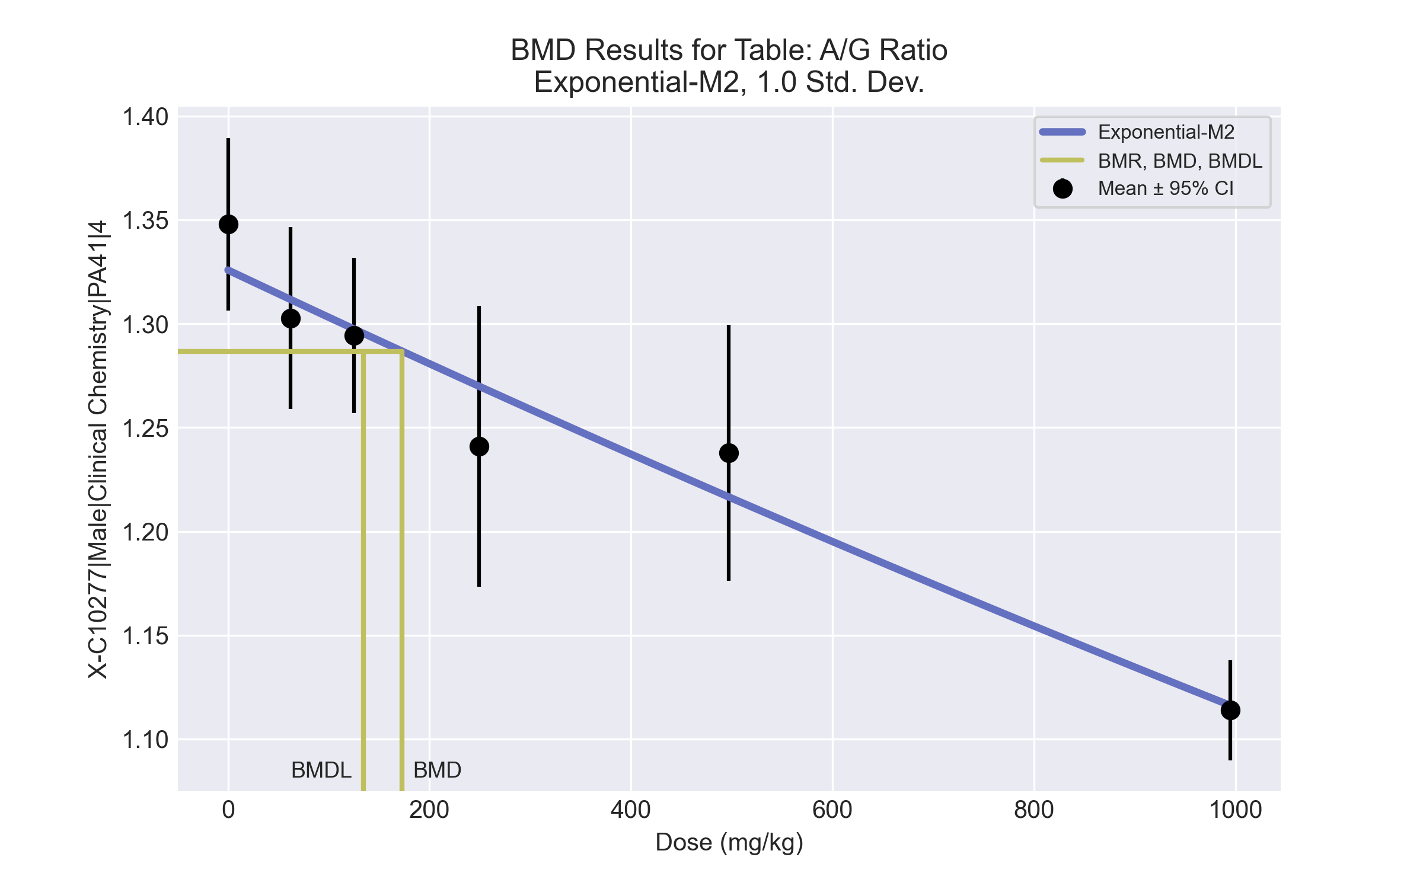
====================================================================
Exponential Model. (Version: 1.11; Date: 03/14/2017)
Input Data File: C:\Windows\TEMP\bmds-kz2554nk.(d)
Gnuplot Plotting File:
Wed May 19 08:52:32 2021
====================================================================
BMDS_Model_Run
~~~~~~~~~~~~~~~~~~~~~~~~~~~~~~~~~~~~~~~~~~~~~~~~~~~~~~~~~~~~~~~~~~~~~
The form of the response function by Model:
Model 2: Y[dose] = a * exp{sign * b * dose}
Model 3: Y[dose] = a * exp{sign * (b * dose)^d}
Model 4: Y[dose] = a * [c-(c-1) * exp{-b * dose}]
Model 5: Y[dose] = a * [c-(c-1) * exp{-(b * dose)^d}]
Note: Y[dose] is the median response for exposure = dose;
sign = +1 for increasing trend in data;
sign = -1 for decreasing trend.
Model 2 is nested within Models 3 and 4.
Model 3 is nested within Model 5.
Model 4 is nested within Model 5.
Dependent variable = Response
Independent variable = Dose
Data are assumed to be distributed: normally
Variance Model: exp(lnalpha +rho *ln(Y[dose]))
rho is set to 0.
A constant variance model is fit.
Total number of dose groups = 6
Total number of records with missing values = 0
Maximum number of iterations = 500
Relative Function Convergence has been set to: 1e-008
Parameter Convergence has been set to: 1e-008
MLE solution provided: Exact
Initial Parameter Values
Variable Model 2
-------- --------
lnalpha -6.71507
rho 0 Specified
a 1.18635
b 0.000172577
c 0 Specified
d 1 Specified
Parameter Estimates
Variable Model 2 Std. Err.
-------- ------- ---------
lnalpha -6.48574 0.000393762
a 1.32583 0.0100446
b 0.000173057 1.77366e-005
NC = No Convergence
Table of Stats From Input Data
Dose N Obs Mean Obs Std Dev
----- --- ---------- -------------
0 5 1.348 0.03351
62 5 1.303 0.0353
125 5 1.294 0.03019
249 5 1.241 0.05451
497 5 1.238 0.04967
995 5 1.114 0.01938
Estimated Values of Interest
Dose Est Mean Est Std Scaled Residual
------ ---------- --------- ----------------
0 1.326 0.03905 1.265
62 1.312 0.03905 -0.5173
125 1.297 0.03905 -0.1773
249 1.27 0.03905 -1.66
497 1.217 0.03905 1.216
995 1.116 0.03905 -0.1254
Other models for which likelihoods are calculated:
Model A1: Yij = Mu(i) + e(ij)
Var{e(ij)} = Sigma^2
Model A2: Yij = Mu(i) + e(ij)
Var{e(ij)} = Sigma(i)^2
Model A3: Yij = Mu(i) + e(ij)
Var{e(ij)} = exp(lalpha + log(mean(i)) * rho)
Model R: Yij = Mu + e(i)
Var{e(ij)} = Sigma^2
Likelihoods of Interest
Model Log(likelihood) DF AIC
------- ----------------- ---- ------------
A1 85.72609 7 -157.4522
A2 88.82356 12 -153.6471
A3 85.72609 7 -157.4522
R 60.11491 2 -116.2298
2 82.28609 3 -158.5722
Additive constant for all log-likelihoods = -27.57. This constant added to the
above values gives the log-likelihood including the term that does not
depend on the model parameters.
Explanation of Tests
Test 1: Does response and/or variances differ among Dose levels? (A2 vs. R)
Test 2: Are Variances Homogeneous? (A2 vs. A1)
Test 3: Are variances adequately modeled? (A2 vs. A3)
Test 4: Does Model 2 fit the data? (A3 vs. 2)
Tests of Interest
Test -2*log(Likelihood Ratio) D. F. p-value
-------- ------------------------ ------ --------------
Test 1 57.42 10 < 0.0001
Test 2 6.195 5 0.2877
Test 3 6.195 5 0.2877
Test 4 6.88 4 0.1424
The p-value for Test 1 is less than .05. There appears to be a
difference between response and/or variances among the dose
levels, it seems appropriate to model the data.
The p-value for Test 2 is greater than .1. A homogeneous
variance model appears to be appropriate here.
The p-value for Test 3 is greater than .1. The modeled
variance appears to be appropriate here.
The p-value for Test 4 is greater than .1. Model 2 seems
to adequately describe the data.
Benchmark Dose Computations:
Specified Effect = 1.000000
Risk Type = Estimated standard deviations from control
Confidence Level = 0.950000
BMD = 172.758
BMDL = 134.476
BMDU = 237.635

BMD Results for Table: Alanine aminotransferase
BMDS version: BMDS v2.7.0

Input dataset
Dose | 0 | 62 | 125 | 249ª | 497ª | 995ª
N | 5 | 5 | 5 | 5 | 5 | 5
Mean ± SD | 59.6 ± 8.933 | 89.8 ± 63.978 | 78 ± 16.956 | 83.8 ± 21.464 | 98 ± 26.524 | 104.6 ± 31.809
ª Dose group removed in BMD modeling session

Summary table
Modelª | Goodness of fit |  | BMD | BMDL | Comments
 | p-value | AIC
Linear^{b} (equivalent models include Power, Polynomial 3°, 4°) | <0.0001 | 128.6 | 31.122 | 10.11 | Linear recommended as best-fitting model on the basis of the lowest AIC.
Polynomial 2° | <0.0001 | 128.252 | 1041.82 | -999
Polynomial 5° | 1.9E-04 | 125.975 | 411.763 | -999
Hill | 0.002 | 158.497 | 3.3E-10 | 3.3E-10
Exponential M2 (equivalent models include Exponential M3) | <0.0001 | 130.305 | 119.381 | 21.291
Exponential M4 | -999 | 120.665 | 1.233 | 0.002
Exponential M5 | -999 | 160.497 | 26.849 | 0.03
ª Modeled variance case presented (BMDS Test 2 p-value = 1.4E-04, BMDS Test 3 p-value = 0.431).
^{b} Recommended model

Model recommendation details
Model | Bin | Notes
Linearª (equivalent models include Power, Polynomial 3°, 4°) | Valid | Cautions  • Warning(s): THE MODEL HAS PROBABLY NOT CONVERGED!!!; THIS USUALLY MEANS THE MODEL HAS NOT CONVERGED!
Polynomial 2° | Failure | Failures  • BMDL does not exist  Warnings  • BMD/high dose ratio is greater than threshold (8.33 > 1.0)  • Ratio of modeled to actual stdev. at control is greater than threshold (5.82 > 1.5)  Cautions  • Warning(s): BMDL computation failed.
Polynomial 5° | Failure | Failures  • BMDL does not exist  Warnings  • Goodness of fit p-value is less than threshold (0.000191 < 0.1)  • BMD/high dose ratio is greater than threshold (3.29 > 1.0)  • Ratio of modeled to actual stdev. at control is greater than threshold (4.99 > 1.5)  Cautions  • Warning(s): BMDL computation failed.
Hill | Warning | Warnings  • Goodness of fit p-value is less than threshold (0.00194 < 0.1)  Cautions  • Minimum dose/BMD ratio is greater than threshold (1.88e+11 > 3.0)
Exponential M2 (equivalent models include Exponential M3) | Valid | Cautions  • BMD/BMDL ratio is greater than threshold (5.61 > 5.0)
Exponential M4 | Warning | Warnings  • BMD/BMDL ratio is greater than threshold (6.55e+02 > 20.0)  • Zero degrees of freedom; saturated model  Cautions  • BMD/BMDL ratio is greater than threshold (6.55e+02 > 5.0)  • Minimum dose/BMD ratio is greater than threshold (50.3 > 3.0)
Exponential M5 | Warning | Warnings  • BMD/BMDL ratio is greater than threshold (9.09e+02 > 20.0)  • Zero degrees of freedom; saturated model  Cautions  • BMD/BMDL ratio is greater than threshold (9.09e+02 > 5.0)
ª Recommended model

Recommended model
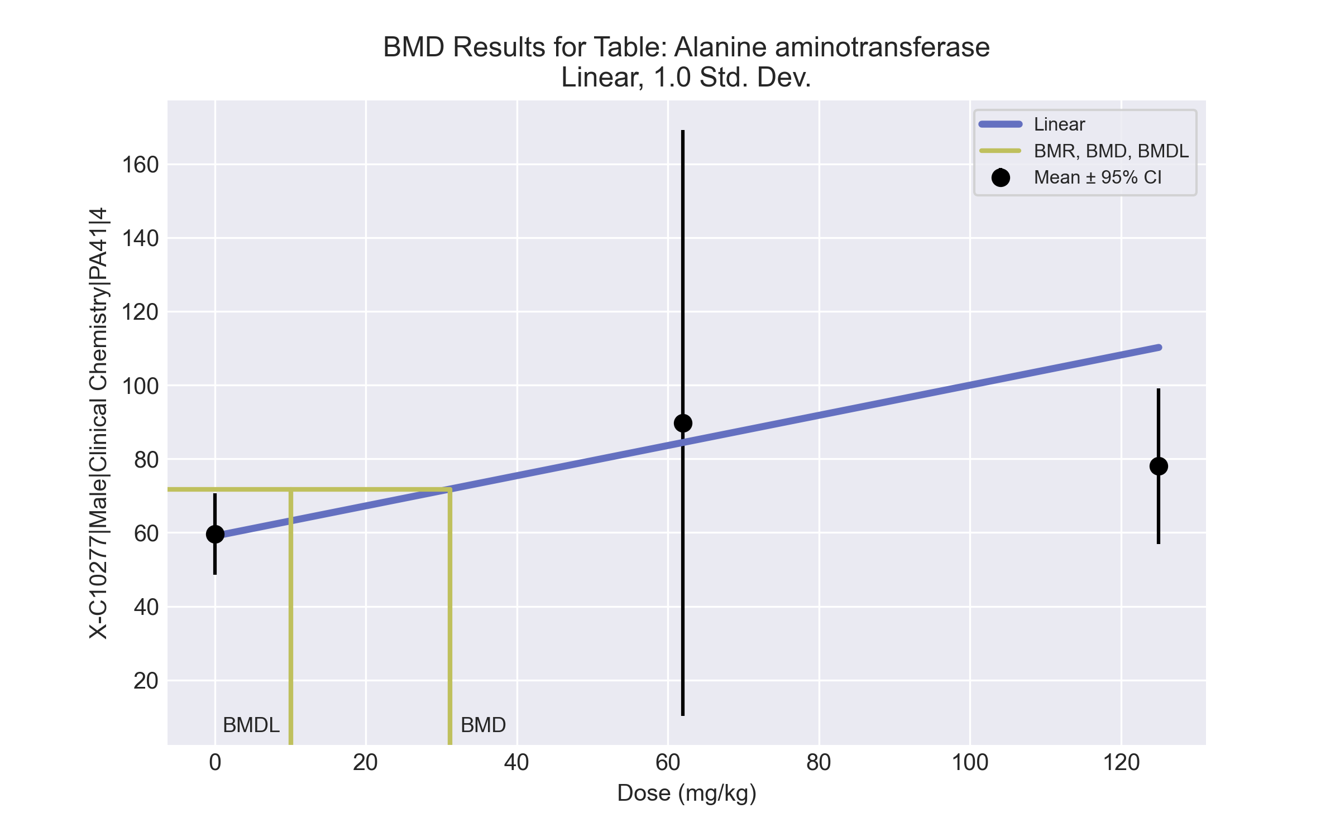
====================================================================
Polynomial Model. (Version: 2.21; Date: 03/14/2017)
Input Data File: C:\Windows\TEMP\bmds-6py4gmcr.(d)
Gnuplot Plotting File: C:\Windows\TEMP\bmds-6py4gmcr.plt
Tue Jul 27 18:01:56 2021
====================================================================
BMDS_Model_Run
~~~~~~~~~~~~~~~~~~~~~~~~~~~~~~~~~~~~~~~~~~~~~~~~~~~~~~~~~~~~~~~~~~~~~
The form of the response function is:
Y[dose] = beta_0 + beta_1*dose + beta_2*dose^2 + ...
Dependent variable = Response
Independent variable = Dose
The polynomial coefficients are restricted to be positive
The variance is to be modeled as Var(i) = exp(lalpha + log(mean(i)) * rho)
Total number of dose groups = 3
Total number of records with missing values = 0
Maximum number of iterations = 500
Relative Function Convergence has been set to: 1e-008
Parameter Convergence has been set to: 1e-008
Default Initial Parameter Values
lalpha = 7.3044
rho = 0
beta_0 = 66.6806
beta_1 = 0
Asymptotic Correlation Matrix of Parameter Estimates
lalpha rho beta_0 beta_1
lalpha NA NA NA NA
rho NA NA NA NA
beta_0 NA NA NA NA
beta_1 NA NA NA NA
NA - This parameter's variance has been estimated as zero or less.
THE MODEL HAS PROBABLY NOT CONVERGED!!!
Parameter Estimates
95.0% Wald Confidence Interval
Variable Estimate Std. Err. Lower Conf. Limit Upper Conf. Limit
lalpha -19.2388 NA NA NA
rho 5.96486 NA NA NA
beta_0 59.0562 NA NA NA
beta_1 0.409232 NA NA NA
At least some variance estimates are negative.
THIS USUALLY MEANS THE MODEL HAS NOT CONVERGED!
Try again from another starting point.
Table of Data and Estimated Values of Interest
Dose N Obs Mean Est Mean Obs Std Dev Est Std Dev Scaled Res.
------ --- -------- -------- ----------- ----------- ----------
0 5 59.6 59.1 8.93 12.7 0.0955
62 5 89.8 84.4 64 37 0.325
125 5 78 110 17 81.9 -0.88
Model Descriptions for likelihoods calculated
Model A1: Yij = Mu(i) + e(ij)
Var{e(ij)} = Sigma^2
Model A2: Yij = Mu(i) + e(ij)
Var{e(ij)} = Sigma(i)^2
Model A3: Yij = Mu(i) + e(ij)
Var{e(ij)} = exp(lalpha + rho*ln(Mu(i)))
Model A3 uses any fixed variance parameters that
were specified by the user
Model R: Yi = Mu + e(i)
Var{e(i)} = Sigma^2
Likelihoods of Interest
Model Log(likelihood) # Param's AIC
A1 -60.609452 4 129.218905
A2 -51.720995 6 115.441991
A3 -52.031591 5 114.063182
fitted -60.299993 4 128.599986
R -61.524946 2 127.049892
Explanation of Tests
Test 1: Do responses and/or variances differ among Dose levels?
(A2 vs. R)
Test 2: Are Variances Homogeneous? (A1 vs A2)
Test 3: Are variances adequately modeled? (A2 vs. A3)
Test 4: Does the Model for the Mean Fit? (A3 vs. fitted)
(Note: When rho=0 the results of Test 3 and Test 2 will be the same.)
Tests of Interest
Test -2*log(Likelihood Ratio) Test df p-value
Test 1 19.6079 4 0.0005967
Test 2 17.7769 2 0.000138
Test 3 0.621192 1 0.4306
Test 4 16.5368 1 <.0001
The p-value for Test 1 is less than .05. There appears to be a
difference between response and/or variances among the dose levels
It seems appropriate to model the data
The p-value for Test 2 is less than .1. A non-homogeneous variance
model appears to be appropriate
The p-value for Test 3 is greater than .1. The modeled variance appears
to be appropriate here
The p-value for Test 4 is less than .1. You may want to try a different
model
Benchmark Dose Computation
Specified effect = 1
Risk Type = Estimated standard deviations from the control mean
Confidence level = 0.95
BMD = 31.1217
BMDL = 10.1097
BMDU = 1.5625e+008

BMD Results for Table: Albumin
BMDS version: BMDS v2.7.0

Input dataset
Dose | 0 | 62 | 125 | 249 | 497 | 995
N | 5 | 5 | 5 | 5 | 5 | 5
Mean ± SD | 3.42 ± 0.13 | 3.36 ± 0.114 | 3.26 ± 0.055 | 3.2 ± 0.1 | 3.24 ± 0.055 | 3.14 ± 0.089

Summary table
Modelª | Goodness of fit |  | BMD | BMDL | Comments
 | p-value | AIC
Linear (equivalent models include Power, Polynomial 2°, 3°, 4°, 5°) | 0.034 | -101.574 | 448.51 | 309.36 | Exponential-M4 recommended as best-fitting model on the basis of the lowest AIC.
Hill | 0.212 | -104.907 | 74.436 | 23.215
Exponential M2 (equivalent models include Exponential M3) | 0.036 | -101.711 | 435.265 | 296.908
Exponential M4^{b} | 0.287 | -106.235 | 62.522 | 28.385
Exponential M5 | 0.191 | -104.701 | 79.027 | 30.243
ª Constant variance case presented (BMDS Test 2 p-value = 0.303, BMDS Test 3 p-value = 0.303).
^{b} Recommended model

Model recommendation details
Model | Bin | Notes
Linear (equivalent models include Power, Polynomial 2°, 3°, 4°, 5°) | Warning | Warnings  • Goodness of fit p-value is less than threshold (0.0337 < 0.1)
Hill | Valid | -
Exponential M2 (equivalent models include Exponential M3) | Warning | Warnings  • Goodness of fit p-value is less than threshold (0.0357 < 0.1)
Exponential M4ª | Valid | -
Exponential M5 | Valid | -
ª Recommended model

Recommended model
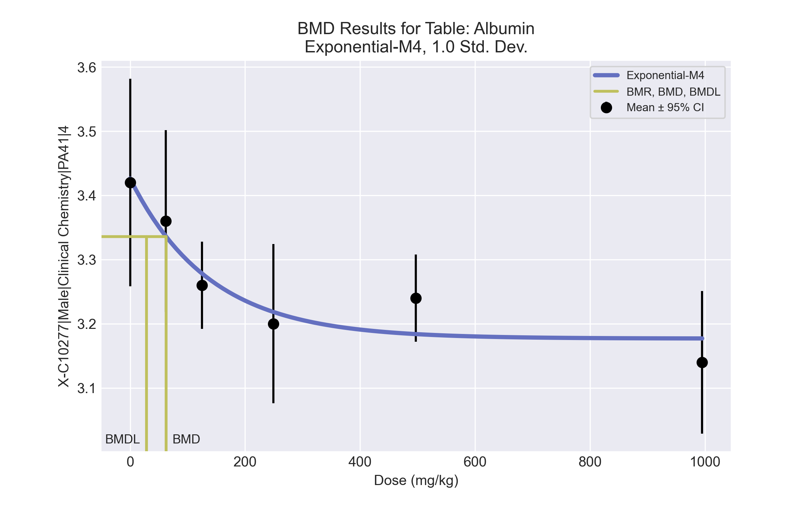
====================================================================
Exponential Model. (Version: 1.11; Date: 03/14/2017)
Input Data File: C:\Windows\TEMP\bmds-7g3yjtqh.(d)
Gnuplot Plotting File:
Wed May 19 08:52:57 2021
====================================================================
BMDS_Model_Run
~~~~~~~~~~~~~~~~~~~~~~~~~~~~~~~~~~~~~~~~~~~~~~~~~~~~~~~~~~~~~~~~~~~~~
The form of the response function by Model:
Model 2: Y[dose] = a * exp{sign * b * dose}
Model 3: Y[dose] = a * exp{sign * (b * dose)^d}
Model 4: Y[dose] = a * [c-(c-1) * exp{-b * dose}]
Model 5: Y[dose] = a * [c-(c-1) * exp{-(b * dose)^d}]
Note: Y[dose] is the median response for exposure = dose;
sign = +1 for increasing trend in data;
sign = -1 for decreasing trend.
Model 2 is nested within Models 3 and 4.
Model 3 is nested within Model 5.
Model 4 is nested within Model 5.
Dependent variable = Response
Independent variable = Dose
Data are assumed to be distributed: normally
Variance Model: exp(lnalpha +rho *ln(Y[dose]))
rho is set to 0.
A constant variance model is fit.
Total number of dose groups = 6
Total number of records with missing values = 0
Maximum number of iterations = 500
Relative Function Convergence has been set to: 1e-008
Parameter Convergence has been set to: 1e-008
MLE solution provided: Exact
Initial Parameter Values
Variable Model 4
-------- --------
lnalpha -4.93367
rho 0 Specified
a 3.591
b 0.0016779
c 0.83277
d 1 Specified
Parameter Estimates
Variable Model 4 Std. Err.
-------- ------- ---------
lnalpha -4.80783 0.00210835
a 3.42617 0.0392838
b 0.00719866 0.00359235
c 0.927227 0.0129028
NC = No Convergence
Table of Stats From Input Data
Dose N Obs Mean Obs Std Dev
----- --- ---------- -------------
0 5 3.42 0.1304
62 5 3.36 0.114
125 5 3.26 0.05477
249 5 3.2 0.1
497 5 3.24 0.05477
995 5 3.14 0.08944
Estimated Values of Interest
Dose Est Mean Est Std Scaled Residual
------ ---------- --------- ----------------
0 3.426 0.09036 -0.1527
62 3.336 0.09036 0.5838
125 3.278 0.09036 -0.451
249 3.218 0.09036 -0.4544
497 3.184 0.09036 1.391
995 3.177 0.09036 -0.9163
Other models for which likelihoods are calculated:
Model A1: Yij = Mu(i) + e(ij)
Var{e(ij)} = Sigma^2
Model A2: Yij = Mu(i) + e(ij)
Var{e(ij)} = Sigma(i)^2
Model A3: Yij = Mu(i) + e(ij)
Var{e(ij)} = exp(lalpha + log(mean(i)) * rho)
Model R: Yij = Mu + e(i)
Var{e(ij)} = Sigma^2
Likelihoods of Interest
Model Log(likelihood) DF AIC
------- ----------------- ---- ------------
A1 59.00509 7 -104.0102
A2 62.01996 12 -100.0399
A3 59.00509 7 -104.0102
R 46.93403 2 -89.86806
4 57.1174 4 -106.2348
Additive constant for all log-likelihoods = -27.57. This constant added to the
above values gives the log-likelihood including the term that does not
depend on the model parameters.
Explanation of Tests
Test 1: Does response and/or variances differ among Dose levels? (A2 vs. R)
Test 2: Are Variances Homogeneous? (A2 vs. A1)
Test 3: Are variances adequately modeled? (A2 vs. A3)
Test 6a: Does Model 4 fit the data? (A3 vs 4)
Tests of Interest
Test -2*log(Likelihood Ratio) D. F. p-value
-------- ------------------------ ------ --------------
Test 1 30.17 10 0.0008029
Test 2 6.03 5 0.3033
Test 3 6.03 5 0.3033
Test 6a 3.775 3 0.2868
The p-value for Test 1 is less than .05. There appears to be a
difference between response and/or variances among the dose
levels, it seems appropriate to model the data.
The p-value for Test 2 is greater than .1. A homogeneous
variance model appears to be appropriate here.
The p-value for Test 3 is greater than .1. The modeled
variance appears to be appropriate here.
The p-value for Test 6a is greater than .1. Model 4 seems
to adequately describe the data.
Benchmark Dose Computations:
Specified Effect = 1.000000
Risk Type = Estimated standard deviations from control
Confidence Level = 0.950000
BMD = 62.5221
BMDL = 28.3846
BMDU = 207.059

BMD Results for Table: Cholesterol
BMDS version: BMDS v2.7.0

Input dataset
Dose | 0 | 62 | 125 | 249 | 497ª | 995ª
N | 5 | 5 | 5 | 5 | 5 | 5
Mean ± SD | 113.2 ± 11.345 | 125.6 ± 12.759 | 114 ± 12.629 | 135.6 ± 3.507 | 140.6 ± 11.059 | 152.8 ± 7.328
ª Dose group removed in BMD modeling session

Summary table
Modelª | Goodness of fit |  | BMD | BMDL | Comments
 | p-value | AIC
Linear | 0.013 | 122.862 | 192.184 | 110.72 | Power recommended as best-fitting model on the basis of the lowest AIC.
Polynomial 2° | 0.223 | 117.151 | 213.586 | 174.562
Polynomial 3° | 0.489 | 115.576 | 221.577 | 186.417
Polynomial 4° | 0.617 | 115.11 | 227.254 | 191.513
Polynomial 5° | 0.67 | 114.947 | 231.156 | 192.569
Power^{b} | 0.711 | 114.827 | 243.836 | 193.058
Hill | -999 | 118.827 | 243.569 | -999
Exponential M2 | 0.018 | 122.174 | 196.222 | 120.105
Exponential M3 | 0.409 | 116.827 | 244.131 | 194.002
Exponential M4 | 0.003 | 124.862 | 192.183 | 110.719
Exponential M5 | -999 | 118.827 | 243.836 | 134.389
ª Modeled variance case presented (BMDS Test 2 p-value = 0.061, BMDS Test 3 p-value = 0.229).
^{b} Recommended model

Model recommendation details
Model | Bin | Notes
Linear | Warning | Warnings  • Goodness of fit p-value is less than threshold (0.0128 < 0.1)  • Ratio of modeled to actual stdev. at control is greater than threshold (1.6 > 1.5)
Polynomial 2° | Valid | -
Polynomial 3° | Valid | -
Polynomial 4° | Valid | -
Polynomial 5° | Valid | -
Powerª | Valid | -
Hill | Failure | Failures  • BMDL does not exist  Warnings  • Zero degrees of freedom; saturated model  Cautions  • Warning(s): BMDL computation failed.
Exponential M2 | Warning | Warnings  • Goodness of fit p-value is less than threshold (0.0181 < 0.1)
Exponential M3 | Valid | -
Exponential M4 | Warning | Warnings  • Goodness of fit p-value is less than threshold (0.00315 < 0.1)
Exponential M5 | Warning | Warnings  • Zero degrees of freedom; saturated model
ª Recommended model

Recommended model
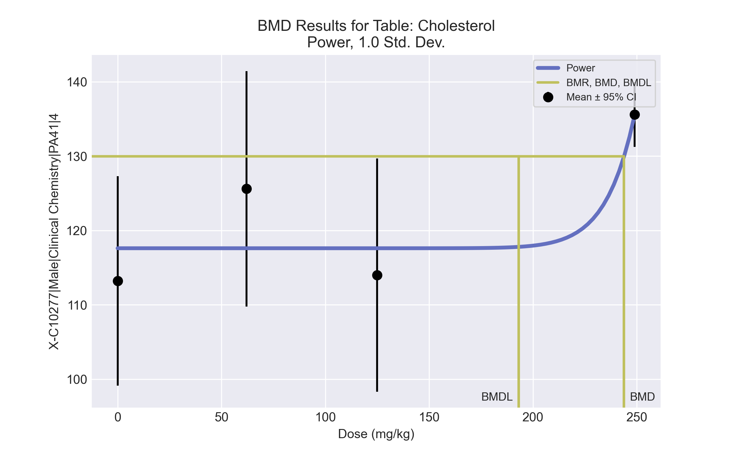
====================================================================
Power Model. (Version: 2.19; Date: 03/14/2017)
Input Data File: C:\Windows\TEMP\bmds-vvgaraed.(d)
Gnuplot Plotting File: C:\Windows\TEMP\bmds-vvgaraed.plt
Wed May 19 08:53:07 2021
====================================================================
BMDS_Model_Run
~~~~~~~~~~~~~~~~~~~~~~~~~~~~~~~~~~~~~~~~~~~~~~~~~~~~~~~~~~~~~~~~~~~~~
The form of the response function is:
Y[dose] = control + slope * dose^power
Dependent variable = Response
Independent variable = Dose
The power is restricted to be greater than or equal to 1
The variance is to be modeled as Var(i) = exp(lalpha + log(mean(i)) * rho)
Total number of dose groups = 4
Total number of records with missing values = 0
Maximum number of iterations = 500
Relative Function Convergence has been set to: 1e-008
Parameter Convergence has been set to: 1e-008
Default Initial Parameter Values
lalpha = 4.75208
rho = 0
control = 113.2
slope = 0.827038
power = -9999
Asymptotic Correlation Matrix of Parameter Estimates
( *** The model parameter(s) -power
have been estimated at a boundary point, or have been specified by the user,
and do not appear in the correlation matrix )
lalpha rho control slope
lalpha 1 -1 0.58 -0.61
rho -1 1 -0.57 0.61
control 0.58 -0.57 1 -0.92
slope -0.61 0.61 -0.92 1
Parameter Estimates
95.0% Wald Confidence Interval
Variable Estimate Std. Err. Lower Conf. Limit Upper Conf. Limit
lalpha 96.7393 31.2104 35.5681 157.91
rho -19.238 6.4536 -31.8868 -6.58915
control 117.6 3.1872 111.353 123.847
slope 1.32949e-042 2.57203e-043 8.25382e-043 1.8336e-042
power 18 NA
NA - Indicates that this parameter has hit a bound
implied by some inequality constraint and thus
has no standard error.
Table of Data and Estimated Values of Interest
Dose N Obs Mean Est Mean Obs Std Dev Est Std Dev Scaled Res.
------ --- -------- -------- ----------- ----------- ----------
0 5 113 118 11.3 12.3 -0.797
62 5 126 118 12.8 12.3 1.45
125 5 114 118 12.6 12.3 -0.652
249 5 136 136 3.51 3.14 6.67e-007
Model Descriptions for likelihoods calculated
Model A1: Yij = Mu(i) + e(ij)
Var{e(ij)} = Sigma^2
Model A2: Yij = Mu(i) + e(ij)
Var{e(ij)} = Sigma(i)^2
Model A3: Yij = Mu(i) + e(ij)
Var{e(ij)} = exp(lalpha + rho*ln(Mu(i)))
Model A3 uses any fixed variance parameters that
were specified by the user
Model R: Yi = Mu + e(i)
Var{e(i)} = Sigma^2
Likelihoods of Interest
Model Log(likelihood) # Param's AIC
A1 -55.289369 5 120.578737
A2 -51.597689 8 119.195379
A3 -53.072649 6 118.145298
fitted -53.413648 4 114.827297
R -61.789143 2 127.578285
Explanation of Tests
Test 1: Do responses and/or variances differ among Dose levels?
(A2 vs. R)
Test 2: Are Variances Homogeneous? (A1 vs A2)
Test 3: Are variances adequately modeled? (A2 vs. A3)
Test 4: Does the Model for the Mean Fit? (A3 vs. fitted)
(Note: When rho=0 the results of Test 3 and Test 2 will be the same.)
Tests of Interest
Test -2*log(Likelihood Ratio) Test df p-value
Test 1 20.3829 6 0.002366
Test 2 7.38336 3 0.06063
Test 3 2.94992 2 0.2288
Test 4 0.681999 2 0.7111
The p-value for Test 1 is less than .05. There appears to be a
difference between response and/or variances among the dose levels
It seems appropriate to model the data
The p-value for Test 2 is less than .1. A non-homogeneous variance
model appears to be appropriate
The p-value for Test 3 is greater than .1. The modeled variance appears
to be appropriate here
The p-value for Test 4 is greater than .1. The model chosen seems
to adequately describe the data
Benchmark Dose Computation
Specified effect = 1
Risk Type = Estimated standard deviations from the control mean
Confidence level = 0.95
BMD = 243.836
BMDL = 193.058
BMDU = 258.682

BMD Results for Table: Globulin
BMDS version: BMDS v2.7.0

Input dataset
Dose | 0 | 62 | 125 | 249 | 497 | 995
N | 5 | 5 | 5 | 5 | 5 | 5
Mean ± SD | 2.54 ± 0.152 | 2.58 ± 0.084 | 2.52 ± 0.084 | 2.58 ± 0.045 | 2.62 ± 0.084 | 2.82 ± 0.11

Summary table
Modelª | Goodness of fit |  | BMD | BMDL | Comments
 | p-value | AIC
Linear | 0.497 | -106.494 | 336.307 | 246.067 | Exponential-M2 recommended as best-fitting model on the basis of the lowest AIC.
Polynomial 2° (equivalent models include Polynomial 3°, 4°, 5°) | 0.699 | -106.437 | 553.583 | 281.647
Power | 0.699 | -106.438 | 552.805 | 281.687
Hill | 0.49 | -104.438 | 551.931 | 280.301
Exponential M2^{b} | 0.531 | -106.703 | 344.789 | 255.822
Exponential M3 | 0.699 | -106.437 | 553.689 | 285.34
Exponential M4 | 0.337 | -104.489 | 336.145 | 223.772
Exponential M5 | 0.49 | -104.438 | 552.036 | 280.339
ª Constant variance case presented (BMDS Test 2 p-value = 0.199, BMDS Test 3 p-value = 0.199).
^{b} Recommended model

Model recommendation details
Model | Bin | Notes
Linear | Valid | -
Polynomial 2° (equivalent models include Polynomial 3°, 4°, 5°) | Valid | -
Power | Valid | -
Hill | Valid | -
Exponential M2ª | Valid | -
Exponential M3 | Valid | -
Exponential M4 | Valid | -
Exponential M5 | Valid | -
ª Recommended model

Recommended model
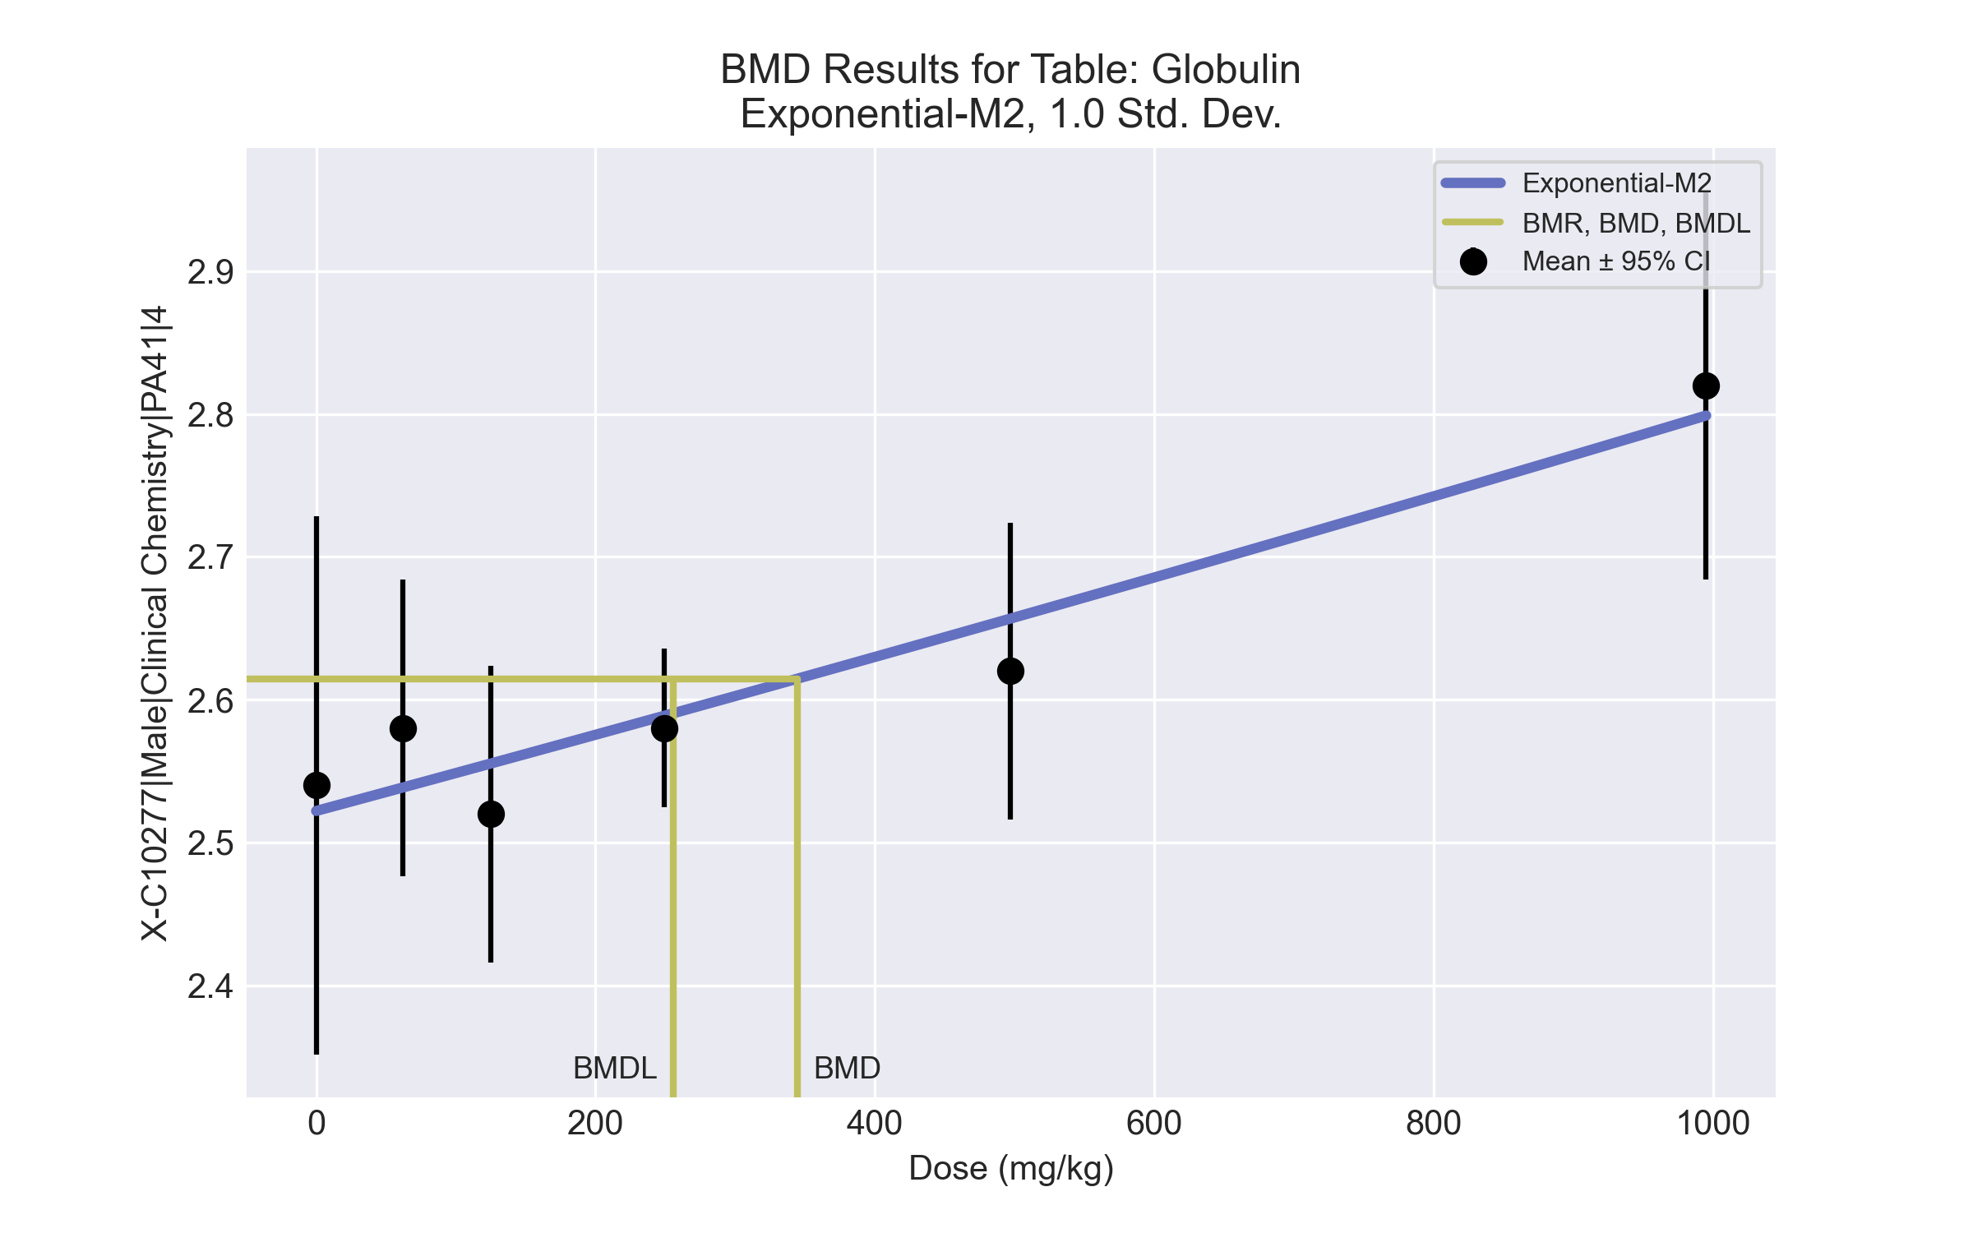
====================================================================
Exponential Model. (Version: 1.11; Date: 03/14/2017)
Input Data File: C:\Windows\TEMP\bmds-g5e3w4jj.(d)
Gnuplot Plotting File:
Wed May 19 08:53:11 2021
====================================================================
BMDS_Model_Run
~~~~~~~~~~~~~~~~~~~~~~~~~~~~~~~~~~~~~~~~~~~~~~~~~~~~~~~~~~~~~~~~~~~~~
The form of the response function by Model:
Model 2: Y[dose] = a * exp{sign * b * dose}
Model 3: Y[dose] = a * exp{sign * (b * dose)^d}
Model 4: Y[dose] = a * [c-(c-1) * exp{-b * dose}]
Model 5: Y[dose] = a * [c-(c-1) * exp{-(b * dose)^d}]
Note: Y[dose] is the median response for exposure = dose;
sign = +1 for increasing trend in data;
sign = -1 for decreasing trend.
Model 2 is nested within Models 3 and 4.
Model 3 is nested within Model 5.
Model 4 is nested within Model 5.
Dependent variable = Response
Independent variable = Dose
Data are assumed to be distributed: normally
Variance Model: exp(lnalpha +rho *ln(Y[dose]))
rho is set to 0.
A constant variance model is fit.
Total number of dose groups = 6
Total number of records with missing values = 0
Maximum number of iterations = 500
Relative Function Convergence has been set to: 1e-008
Parameter Convergence has been set to: 1e-008
MLE solution provided: Exact
Initial Parameter Values
Variable Model 2
-------- --------
lnalpha -4.86221
rho 0 Specified
a 2.52295
b 0.000103386
c 0 Specified
d 1 Specified
Parameter Estimates
Variable Model 2 Std. Err.
-------- ------- ---------
lnalpha -4.75677 0.00221879
a 2.52201 0.0229148
b 0.000104693 1.83724e-005
NC = No Convergence
Table of Stats From Input Data
Dose N Obs Mean Obs Std Dev
----- --- ---------- -------------
0 5 2.54 0.1517
62 5 2.58 0.08367
125 5 2.52 0.08367
249 5 2.58 0.04472
497 5 2.62 0.08367
995 5 2.82 0.1095
Estimated Values of Interest
Dose Est Mean Est Std Scaled Residual
------ ---------- --------- ----------------
0 2.522 0.0927 0.4338
62 2.538 0.0927 1.003
125 2.555 0.0927 -0.85
249 2.589 0.0927 -0.208
497 2.657 0.0927 -0.8856
995 2.799 0.0927 0.5089
Other models for which likelihoods are calculated:
Model A1: Yij = Mu(i) + e(ij)
Var{e(ij)} = Sigma^2
Model A2: Yij = Mu(i) + e(ij)
Var{e(ij)} = Sigma(i)^2
Model A3: Yij = Mu(i) + e(ij)
Var{e(ij)} = exp(lalpha + log(mean(i)) * rho)
Model R: Yij = Mu + e(i)
Var{e(ij)} = Sigma^2
Likelihoods of Interest
Model Log(likelihood) DF AIC
------- ----------------- ---- ------------
A1 57.93317 7 -101.8663
A2 61.58529 12 -99.17058
A3 57.93317 7 -101.8663
R 45.62626 2 -87.25251
2 56.3515 3 -106.703
Additive constant for all log-likelihoods = -27.57. This constant added to the
above values gives the log-likelihood including the term that does not
depend on the model parameters.
Explanation of Tests
Test 1: Does response and/or variances differ among Dose levels? (A2 vs. R)
Test 2: Are Variances Homogeneous? (A2 vs. A1)
Test 3: Are variances adequately modeled? (A2 vs. A3)
Test 4: Does Model 2 fit the data? (A3 vs. 2)
Tests of Interest
Test -2*log(Likelihood Ratio) D. F. p-value
-------- ------------------------ ------ --------------
Test 1 31.92 10 0.0004132
Test 2 7.304 5 0.199
Test 3 7.304 5 0.199
Test 4 3.163 4 0.5309
The p-value for Test 1 is less than .05. There appears to be a
difference between response and/or variances among the dose
levels, it seems appropriate to model the data.
The p-value for Test 2 is greater than .1. A homogeneous
variance model appears to be appropriate here.
The p-value for Test 3 is greater than .1. The modeled
variance appears to be appropriate here.
The p-value for Test 4 is greater than .1. Model 2 seems
to adequately describe the data.
Benchmark Dose Computations:
Specified Effect = 1.000000
Risk Type = Estimated standard deviations from control
Confidence Level = 0.950000
BMD = 344.789
BMDL = 255.822
BMDU = 529.789

BMD Results for Table: HDL Cholesterol
BMDS version: BMDS v2.7.0

Input dataset
Dose | 0 | 62 | 125 | 249 | 497ª | 995ª
N | 5 | 5 | 5 | 5 | 5 | 5
Mean ± SD | 52 ± 5 | 58.4 ± 5.771 | 54.2 ± 6.611 | 64.8 ± 1.924 | 63.6 ± 3.912 | 65.6 ± 5.857
ª Dose group removed in BMD modeling session

Summary table
Modelª | Goodness of fit |  | BMD | BMDL | Comments
 | p-value | AIC
Linear | 0.017 | 93.011 | 150.265 | 85.899 | Power recommended as best-fitting model on the basis of the lowest AIC.
Polynomial 2° | 0.177 | 88.318 | 196.451 | 151.061
Polynomial 3° | 0.339 | 87.023 | 210.395 | 167.5
Polynomial 4° | 0.408 | 86.651 | 218.738 | 172.466
Polynomial 5° | 0.198 | 88.52 | 223.706 | 176.19
Power^{b} | 0.456 | 86.431 | 241.788 | 175.102
Hill | 0.21 | 88.431 | 241.716 | -999
Exponential M2 | 0.023 | 92.378 | 158.615 | 96.076
Exponential M3 | 0.21 | 88.431 | 242.234 | 175.627
Exponential M4 | 0.004 | 95.012 | 150.264 | 85.898
Exponential M5 | -999 | 90.431 | 241.786 | 175.102
ª Modeled variance case presented (BMDS Test 2 p-value = 0.092, BMDS Test 3 p-value = 0.321).
^{b} Recommended model

Model recommendation details
Model | Bin | Notes
Linear | Warning | Warnings  • Goodness of fit p-value is less than threshold (0.017 < 0.1)  • Ratio of modeled to actual stdev. at control is greater than threshold (1.51 > 1.5)
Polynomial 2° | Valid | -
Polynomial 3° | Valid | -
Polynomial 4° | Valid | -
Polynomial 5° | Valid | -
Powerª | Valid | -
Hill | Failure | Failures  • BMDL does not exist  Cautions  • Warning(s): BMDL computation failed.
Exponential M2 | Warning | Warnings  • Goodness of fit p-value is less than threshold (0.0233 < 0.1)
Exponential M3 | Valid | -
Exponential M4 | Warning | Warnings  • Goodness of fit p-value is less than threshold (0.0043 < 0.1)
Exponential M5 | Warning | Warnings  • Zero degrees of freedom; saturated model
ª Recommended model

Recommended model
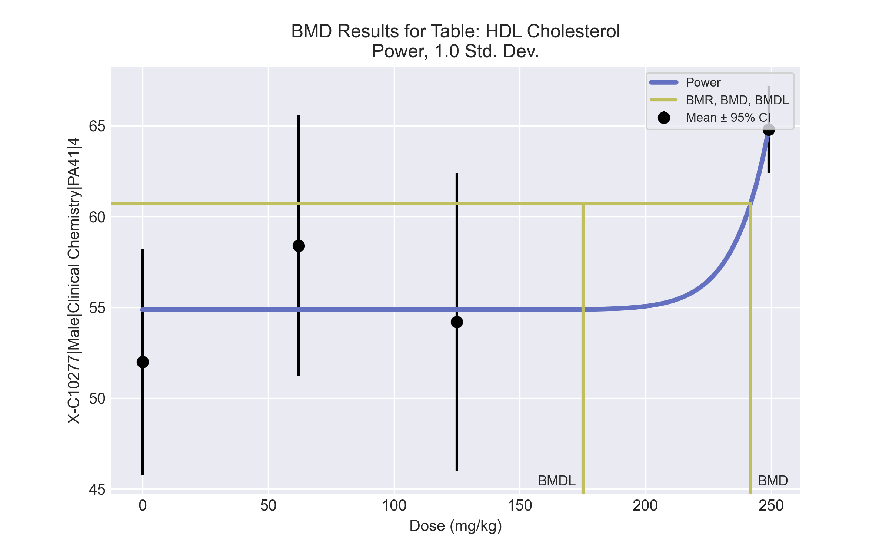
====================================================================
Power Model. (Version: 2.19; Date: 03/14/2017)
Input Data File: C:\Windows\TEMP\bmds-99f8bx_s.(d)
Gnuplot Plotting File: C:\Windows\TEMP\bmds-99f8bx_s.plt
Wed May 19 08:53:21 2021
====================================================================
BMDS_Model_Run
~~~~~~~~~~~~~~~~~~~~~~~~~~~~~~~~~~~~~~~~~~~~~~~~~~~~~~~~~~~~~~~~~~~~~
The form of the response function is:
Y[dose] = control + slope * dose^power
Dependent variable = Response
Independent variable = Dose
The power is restricted to be greater than or equal to 1
The variance is to be modeled as Var(i) = exp(lalpha + log(mean(i)) * rho)
Total number of dose groups = 4
Total number of records with missing values = 0
Maximum number of iterations = 500
Relative Function Convergence has been set to: 1e-008
Parameter Convergence has been set to: 1e-008
Default Initial Parameter Values
lalpha = 3.27431
rho = 0
control = 52
slope = 0.524466
power = -9999
Asymptotic Correlation Matrix of Parameter Estimates
( *** The model parameter(s) -power
have been estimated at a boundary point, or have been specified by the user,
and do not appear in the correlation matrix )
lalpha rho control slope
lalpha 1 -1 0.49 -0.52
rho -1 1 -0.47 0.52
control 0.49 -0.47 1 -0.89
slope -0.52 0.52 -0.89 1
Parameter Estimates
95.0% Wald Confidence Interval
Variable Estimate Std. Err. Lower Conf. Limit Upper Conf. Limit
lalpha 62.4633 20.8895 21.5206 103.406
rho -14.7144 5.12786 -24.7648 -4.66395
control 54.8667 1.51105 51.9051 57.8283
slope 7.33681e-043 1.25242e-043 4.88211e-043 9.79152e-043
power 18 NA
NA - Indicates that this parameter has hit a bound
implied by some inequality constraint and thus
has no standard error.
Table of Data and Estimated Values of Interest
Dose N Obs Mean Est Mean Obs Std Dev Est Std Dev Scaled Res.
------ --- -------- -------- ----------- ----------- ----------
0 5 52 54.9 5 5.85 -1.1
62 5 58.4 54.9 5.77 5.85 1.35
125 5 54.2 54.9 6.61 5.85 -0.255
249 5 64.8 64.8 1.92 1.72 4.67e-007
Model Descriptions for likelihoods calculated
Model A1: Yij = Mu(i) + e(ij)
Var{e(ij)} = Sigma^2
Model A2: Yij = Mu(i) + e(ij)
Var{e(ij)} = Sigma(i)^2
Model A3: Yij = Mu(i) + e(ij)
Var{e(ij)} = exp(lalpha + rho*ln(Mu(i)))
Model A3 uses any fixed variance parameters that
were specified by the user
Model R: Yi = Mu + e(i)
Var{e(i)} = Sigma^2
Likelihoods of Interest
Model Log(likelihood) # Param's AIC
A1 -40.511670 5 91.023340
A2 -37.293849 8 90.587698
A3 -38.430002 6 88.860004
fitted -39.215383 4 86.430766
R -48.050501 2 100.101002
Explanation of Tests
Test 1: Do responses and/or variances differ among Dose levels?
(A2 vs. R)
Test 2: Are Variances Homogeneous? (A1 vs A2)
Test 3: Are variances adequately modeled? (A2 vs. A3)
Test 4: Does the Model for the Mean Fit? (A3 vs. fitted)
(Note: When rho=0 the results of Test 3 and Test 2 will be the same.)
Tests of Interest
Test -2*log(Likelihood Ratio) Test df p-value
Test 1 21.5133 6 0.001483
Test 2 6.43564 3 0.09224
Test 3 2.27231 2 0.3211
Test 4 1.57076 2 0.4559
The p-value for Test 1 is less than .05. There appears to be a
difference between response and/or variances among the dose levels
It seems appropriate to model the data
The p-value for Test 2 is less than .1. A non-homogeneous variance
model appears to be appropriate
The p-value for Test 3 is greater than .1. The modeled variance appears
to be appropriate here
The p-value for Test 4 is greater than .1. The model chosen seems
to adequately describe the data
Benchmark Dose Computation
Specified effect = 1
Risk Type = Estimated standard deviations from the control mean
Confidence level = 0.95
BMD = 241.788
BMDL = 175.102
BMDU = 248.644

BMD Results for Table: LDL Cholesterol
BMDS version: BMDS v2.7.0

Input dataset
Dose | 0 | 62 | 125 | 249 | 497 | 995
N | 5 | 5 | 5 | 5 | 5 | 5
Mean ± SD | 23.2 ± 2.95 | 22 ± 2.739 | 22.2 ± 2.28 | 23.8 ± 1.924 | 26.8 ± 2.168 | 28.6 ± 2.074

Summary table
Modelª | Goodness of fit |  | BMD | BMDL | Comments
 | p-value | AIC
Linear^{b} (equivalent models include Power, Polynomial 2°, 3°, 4°, 5°) | 0.428 | 85.273 | 335.623 | 245.654 | Linear recommended as best-fitting model on the basis of the lowest AIC.
Hill | 0.593 | 86.477 | 317.739 | 190.706
Exponential M2 (equivalent models include Exponential M3) | 0.392 | 85.537 | 370.665 | 279.671
Exponential M4 | 0.308 | 87.03 | 274.016 | 136.991
Exponential M5 | 0.568 | 86.562 | 332.266 | 190.387
ª Constant variance case presented (BMDS Test 2 p-value = 0.922, BMDS Test 3 p-value = 0.922).
^{b} Recommended model

Model recommendation details
Model | Bin | Notes
Linearª (equivalent models include Power, Polynomial 2°, 3°, 4°, 5°) | Valid | -
Hill | Valid | -
Exponential M2 (equivalent models include Exponential M3) | Valid | -
Exponential M4 | Valid | -
Exponential M5 | Valid | -
ª Recommended model

Recommended model
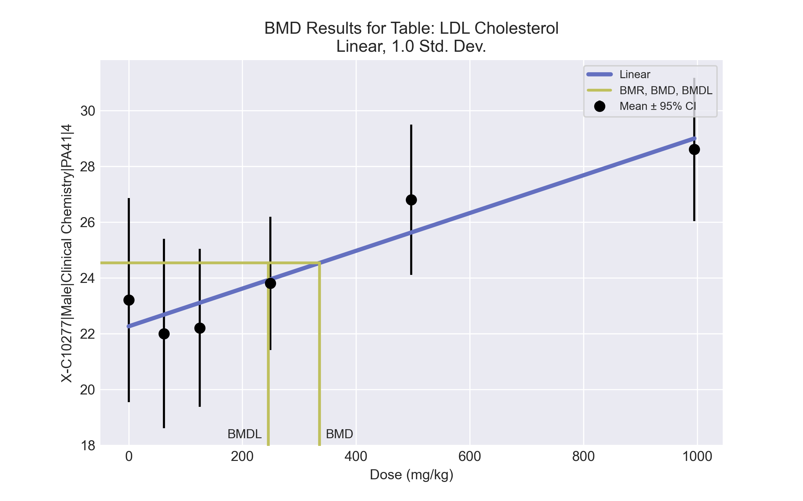
====================================================================
Polynomial Model. (Version: 2.21; Date: 03/14/2017)
Input Data File: C:\Windows\TEMP\bmds-yiqt1gz6.(d)
Gnuplot Plotting File: C:\Windows\TEMP\bmds-yiqt1gz6.plt
Wed May 19 08:53:24 2021
====================================================================
BMDS_Model_Run
~~~~~~~~~~~~~~~~~~~~~~~~~~~~~~~~~~~~~~~~~~~~~~~~~~~~~~~~~~~~~~~~~~~~~
The form of the response function is:
Y[dose] = beta_0 + beta_1*dose + beta_2*dose^2 + ...
Dependent variable = Response
Independent variable = Dose
rho is set to 0
The polynomial coefficients are restricted to be positive
A constant variance model is fit
Total number of dose groups = 6
Total number of records with missing values = 0
Maximum number of iterations = 500
Relative Function Convergence has been set to: 1e-008
Parameter Convergence has been set to: 1e-008
Default Initial Parameter Values
alpha = 5.68333
rho = 0 Specified
beta_0 = 22.2569
beta_1 = 0
Asymptotic Correlation Matrix of Parameter Estimates
( *** The model parameter(s) -rho
have been estimated at a boundary point, or have been specified by the user,
and do not appear in the correlation matrix )
alpha beta_0 beta_1
alpha 1 -4.4e-009 5.1e-009
beta_0 -4.4e-009 1 -0.69
beta_1 5.1e-009 -0.69 1
Parameter Estimates
95.0% Wald Confidence Interval
Variable Estimate Std. Err. Lower Conf. Limit Upper Conf. Limit
alpha 5.16774 1.3343 2.55255 7.78293
beta_0 22.2569 0.570033 21.1396 23.3741
beta_1 0.00677327 0.001216 0.00438994 0.00915659
Table of Data and Estimated Values of Interest
Dose N Obs Mean Est Mean Obs Std Dev Est Std Dev Scaled Res.
------ --- -------- -------- ----------- ----------- ----------
0 5 23.2 22.3 2.95 2.27 0.928
62 5 22 22.7 2.74 2.27 -0.666
125 5 22.2 23.1 2.28 2.27 -0.889
249 5 23.8 23.9 1.92 2.27 -0.141
497 5 26.8 25.6 2.17 2.27 1.16
995 5 28.6 29 2.07 2.27 -0.39
Model Descriptions for likelihoods calculated
Model A1: Yij = Mu(i) + e(ij)
Var{e(ij)} = Sigma^2
Model A2: Yij = Mu(i) + e(ij)
Var{e(ij)} = Sigma(i)^2
Model A3: Yij = Mu(i) + e(ij)
Var{e(ij)} = Sigma^2
Model A3 uses any fixed variance parameters that
were specified by the user
Model R: Yi = Mu + e(i)
Var{e(i)} = Sigma^2
Likelihoods of Interest
Model Log(likelihood) # Param's AIC
A1 -37.715914 7 89.431828
A2 -37.006332 12 98.012665
A3 -37.715914 7 89.431828
fitted -39.636525 3 85.273049
R -50.288078 2 104.576157
Explanation of Tests
Test 1: Do responses and/or variances differ among Dose levels?
(A2 vs. R)
Test 2: Are Variances Homogeneous? (A1 vs A2)
Test 3: Are variances adequately modeled? (A2 vs. A3)
Test 4: Does the Model for the Mean Fit? (A3 vs. fitted)
(Note: When rho=0 the results of Test 3 and Test 2 will be the same.)
Tests of Interest
Test -2*log(Likelihood Ratio) Test df p-value
Test 1 26.5635 10 0.003052
Test 2 1.41916 5 0.9222
Test 3 1.41916 5 0.9222
Test 4 3.84122 4 0.4279
The p-value for Test 1 is less than .05. There appears to be a
difference between response and/or variances among the dose levels
It seems appropriate to model the data
The p-value for Test 2 is greater than .1. A homogeneous variance
model appears to be appropriate here
The p-value for Test 3 is greater than .1. The modeled variance appears
to be appropriate here
The p-value for Test 4 is greater than .1. The model chosen seems
to adequately describe the data
Benchmark Dose Computation
Specified effect = 1
Risk Type = Estimated standard deviations from the control mean
Confidence level = 0.95
BMD = 335.623
BMDL = 245.654
BMDU = 525.34

BMD Results for Table: Cholinesterase
BMDS version: BMDS v2.7.0

Input dataset
Dose | 0 | 62 | 125 | 249 | 497 | 995
N | 5 | 5 | 5 | 5 | 5 | 5
Mean ± SD | 285.4 ± 35.956 | 164 ± 24.042 | 138.6 ± 15.192 | 111 ± 12.826 | 80.4 ± 18.284 | 63.4 ± 17.615

Summary table
Modelª | Goodness of fit |  | BMD | BMDL | Comments
 | p-value | AIC
Linear (equivalent models include Power, Polynomial 2°, 3°, 4°, 5°) | <0.0001 | 272.943 | 321.957 | 237.311 | Hill recommended as best-fitting model on the basis of the lowest AIC.
Hill^{b} | 0.473 | 219.352 | 6.447 | 4.494
Exponential M2 | <0.0001 | 257.341 | 66.899 | 41.221
Exponential M3 | <0.0001 | 257.341 | 66.899 | 41.221
Exponential M4 (equivalent models include Exponential M5) | 0.014 | 227.421 | 11.585 | 8.254
ª Constant variance case presented (BMDS Test 2 p-value = 0.19, BMDS Test 3 p-value = 0.19).
^{b} Recommended model

Model recommendation details
Model | Bin | Notes
Linear (equivalent models include Power, Polynomial 2°, 3°, 4°, 5°) | Warning | Warnings  • Residual at lowest dose is greater than threshold (4.01 > 2.0)
Hillª | Valid | Cautions  • Minimum dose/BMD ratio is greater than threshold (9.62 > 3.0)
Exponential M2 | Warning | Warnings  • Residual at lowest dose is greater than threshold (2.67 > 2.0)
Exponential M3 | Warning | Warnings  • Residual at lowest dose is greater than threshold (2.67 > 2.0)
Exponential M4 (equivalent models include Exponential M5) | Warning | Warnings  • Goodness of fit p-value is less than threshold (0.0142 < 0.1)  Cautions  • Minimum dose/BMD ratio is greater than threshold (5.35 > 3.0)
ª Recommended model

Recommended model
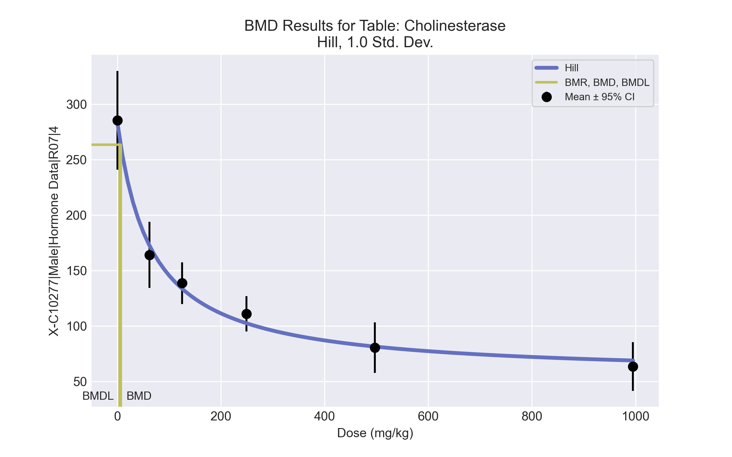
====================================================================
Hill Model. (Version: 2.18; Date: 03/14/2017)
Input Data File: C:\Windows\TEMP\bmds-8l6vmcwh.(d)
Gnuplot Plotting File: C:\Windows\TEMP\bmds-8l6vmcwh.plt
Wed May 19 08:54:06 2021
====================================================================
BMDS_Model_Run
~~~~~~~~~~~~~~~~~~~~~~~~~~~~~~~~~~~~~~~~~~~~~~~~~~~~~~~~~~~~~~~~~~~~~
The form of the response function is:
Y[dose] = intercept + v*dose^n/(k^n + dose^n)
Dependent variable = Response
Independent variable = Dose
rho is set to 0
Power parameter restricted to be greater than 1
A constant variance model is fit
Total number of dose groups = 6
Total number of records with missing values = 0
Maximum number of iterations = 500
Relative Function Convergence has been set to: 1e-008
Parameter Convergence has been set to: 1e-008
Default Initial Parameter Values
alpha = 485.117
rho = 0 Specified
intercept = 285.4
v = -222
n = 1.24217
k = 56.6886
Asymptotic Correlation Matrix of Parameter Estimates
( *** The model parameter(s) -rho -n
have been estimated at a boundary point, or have been specified by the user,
and do not appear in the correlation matrix )
alpha intercept v k
alpha 1 1.3e-007 8.8e-007 -1.9e-006
intercept 1.3e-007 1 -0.65 -0.44
v 8.8e-007 -0.65 1 -0.27
k -1.9e-006 -0.44 -0.27 1
Parameter Estimates
95.0% Wald Confidence Interval
Variable Estimate Std. Err. Lower Conf. Limit Upper Conf. Limit
alpha 422.025 108.966 208.455 635.595
intercept 284.076 9.2229 265.999 302.152
v -229.454 12.2828 -253.528 -205.38
n 1 NA
k 65.5594 13.0561 39.97 91.1487
NA - Indicates that this parameter has hit a bound
implied by some inequality constraint and thus
has no standard error.
Table of Data and Estimated Values of Interest
Dose N Obs Mean Est Mean Obs Std Dev Est Std Dev Scaled Res.
------ --- -------- -------- ----------- ----------- ----------
0 5 285 284 36 20.5 0.144
62 5 164 173 24 20.5 -0.931
125 5 139 134 15.2 20.5 0.548
249 5 111 102 12.8 20.5 0.931
497 5 80.4 81.4 18.3 20.5 -0.105
995 5 63.4 68.8 17.6 20.5 -0.588
Model Descriptions for likelihoods calculated
Model A1: Yij = Mu(i) + e(ij)
Var{e(ij)} = Sigma^2
Model A2: Yij = Mu(i) + e(ij)
Var{e(ij)} = Sigma(i)^2
Model A3: Yij = Mu(i) + e(ij)
Var{e(ij)} = Sigma^2
Model A3 uses any fixed variance parameters that
were specified by the user
Model R: Yi = Mu + e(i)
Var{e(i)} = Sigma^2
Likelihoods of Interest
Model Log(likelihood) # Param's AIC
A1 -104.418688 7 222.837376
A2 -100.698297 12 225.396593
A3 -104.418688 7 222.837376
fitted -105.675972 4 219.351944
R -144.770219 2 293.540438
Explanation of Tests
Test 1: Do responses and/or variances differ among Dose levels?
(A2 vs. R)
Test 2: Are Variances Homogeneous? (A1 vs A2)
Test 3: Are variances adequately modeled? (A2 vs. A3)
Test 4: Does the Model for the Mean Fit? (A3 vs. fitted)
(Note: When rho=0 the results of Test 3 and Test 2 will be the same.)
Tests of Interest
Test -2*log(Likelihood Ratio) Test df p-value
Test 1 88.1438 10 <.0001
Test 2 7.44078 5 0.1899
Test 3 7.44078 5 0.1899
Test 4 2.51457 3 0.4727
The p-value for Test 1 is less than .05. There appears to be a
difference between response and/or variances among the dose levels
It seems appropriate to model the data
The p-value for Test 2 is greater than .1. A homogeneous variance
model appears to be appropriate here
The p-value for Test 3 is greater than .1. The modeled variance appears
to be appropriate here
The p-value for Test 4 is greater than .1. The model chosen seems
to adequately describe the data
Benchmark Dose Computation
Specified effect = 1
Risk Type = Estimated standard deviations from the control mean
Confidence level = 0.95
BMD = 6.44679
BMDL = 4.49367
BMDU = 11.7492

