BMD Results for Table: Liver Weight Absolute
BMDS version: BMDS v2.7.0

Input dataset
Dose | 0 | 66 | 132 | 264 | 527 | 1054
N | 5 | 5 | 5 | 5 | 5 | 5
Mean ± SD | 11.46 ± 0.434 | 12.02 ± 0.976 | 12.854 ± 0.671 | 12.942 ± 1.012 | 13.54 ± 1.347 | 13.21 ± 0.802

Summary table
Modelª | Goodness of fit |  | BMD | BMDL | Comments
 | p-value | AIC
Linear (equivalent models include Power, Polynomial 4°, 5°) | 0.045 | 34.026 | 703.636 | 433.635 | Exponential-M4 recommended as best-fitting model on the basis of the lowest AIC.
Polynomial 2° (equivalent models include Polynomial 3°) | 0.045 | 34.026 | 703.637 | 433.635
Hill | 0.609 | 29.264 | 82.94 | 22.859
Exponential M2 (equivalent models include Exponential M3) | 0.041 | 34.244 | 738.689 | 466.39
Exponential M4^{b} | 0.755 | 27.463 | 74.612 | 30.211
Exponential M5 | 0.567 | 29.407 | 81.387 | 30.483
ª Constant variance case presented (BMDS Test 2 p-value = 0.248, BMDS Test 3 p-value = 0.248).
^{b} Recommended model

Model recommendation details
Model | Bin | Notes
Linear (equivalent models include Power, Polynomial 4°, 5°) | Warning | Warnings  • Goodness of fit p-value is less than threshold (0.0448 < 0.1)  • Ratio of modeled to actual stdev. at control is greater than threshold (2.23 > 1.5)
Polynomial 2° (equivalent models include Polynomial 3°) | Warning | Warnings  • Goodness of fit p-value is less than threshold (0.0448 < 0.1)  • Ratio of modeled to actual stdev. at control is greater than threshold (2.23 > 1.5)
Hill | Warning | Warnings  • Ratio of modeled to actual stdev. at control is greater than threshold (1.93 > 1.5)
Exponential M2 (equivalent models include Exponential M3) | Warning | Warnings  • Goodness of fit p-value is less than threshold (0.0409 < 0.1)
Exponential M4ª | Valid | -
Exponential M5 | Valid | -
ª Recommended model

Recommended model
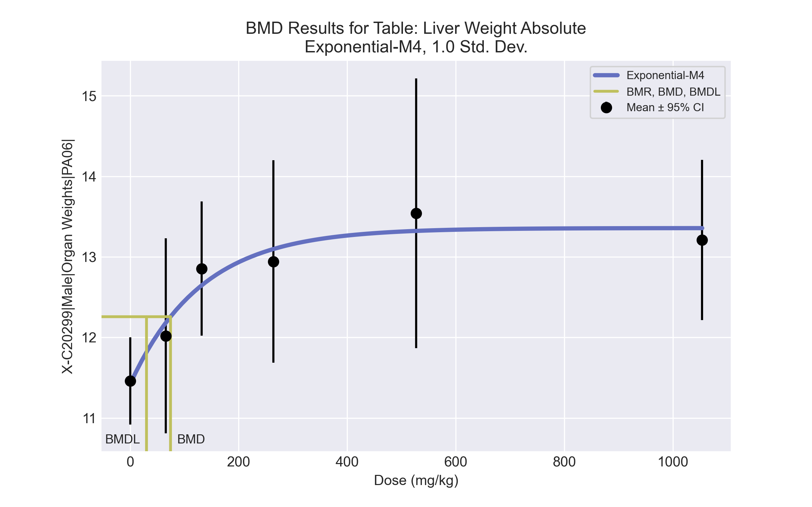
====================================================================
Exponential Model. (Version: 1.11; Date: 03/14/2017)
Input Data File: C:\Windows\TEMP\bmds-46rjeyg4.(d)
Gnuplot Plotting File:
Tue May 18 15:25:49 2021
====================================================================
BMDS_Model_Run
~~~~~~~~~~~~~~~~~~~~~~~~~~~~~~~~~~~~~~~~~~~~~~~~~~~~~~~~~~~~~~~~~~~~~
The form of the response function by Model:
Model 2: Y[dose] = a * exp{sign * b * dose}
Model 3: Y[dose] = a * exp{sign * (b * dose)^d}
Model 4: Y[dose] = a * [c-(c-1) * exp{-b * dose}]
Model 5: Y[dose] = a * [c-(c-1) * exp{-(b * dose)^d}]
Note: Y[dose] is the median response for exposure = dose;
sign = +1 for increasing trend in data;
sign = -1 for decreasing trend.
Model 2 is nested within Models 3 and 4.
Model 3 is nested within Model 5.
Model 4 is nested within Model 5.
Dependent variable = Response
Independent variable = Dose
Data are assumed to be distributed: normally
Variance Model: exp(lnalpha +rho *ln(Y[dose]))
rho is set to 0.
A constant variance model is fit.
Total number of dose groups = 6
Total number of records with missing values = 0
Maximum number of iterations = 500
Relative Function Convergence has been set to: 1e-008
Parameter Convergence has been set to: 1e-008
MLE solution provided: Exact
Initial Parameter Values
Variable Model 4
-------- --------
lnalpha -0.390961
rho 0 Specified
a 10.887
b 0.00168833
c 1.30587
d 1 Specified
Parameter Estimates
Variable Model 4 Std. Err.
-------- ------- ---------
lnalpha -0.351244 0.181724
a 11.4196 0.355487
b 0.00760452 0.00382981
c 1.16967 0.0417406
NC = No Convergence
Table of Stats From Input Data
Dose N Obs Mean Obs Std Dev
----- --- ---------- -------------
0 5 11.46 0.4343
66 5 12.02 0.9764
132 5 12.85 0.6709
264 5 12.94 1.012
527 5 13.54 1.347
1054 5 13.21 0.8018
Estimated Values of Interest
Dose Est Mean Est Std Scaled Residual
------ ---------- --------- ----------------
0 11.42 0.8389 0.1077
66 12.18 0.8389 -0.4376
132 12.65 0.8389 0.5516
264 13.1 0.8389 -0.4128
527 13.32 0.8389 0.5814
1054 13.36 0.8389 -0.3904
Other models for which likelihoods are calculated:
Model A1: Yij = Mu(i) + e(ij)
Var{e(ij)} = Sigma^2
Model A2: Yij = Mu(i) + e(ij)
Var{e(ij)} = Sigma(i)^2
Model A3: Yij = Mu(i) + e(ij)
Var{e(ij)} = exp(lalpha + log(mean(i)) * rho)
Model R: Yij = Mu + e(i)
Var{e(ij)} = Sigma^2
Likelihoods of Interest
Model Log(likelihood) DF AIC
------- ----------------- ---- ------------
A1 -9.135592 7 32.27118
A2 -5.811431 12 35.62286
A3 -9.135592 7 32.27118
R -17.52793 2 39.05587
4 -9.731343 4 27.46269
Additive constant for all log-likelihoods = -27.57. This constant added to the
above values gives the log-likelihood including the term that does not
depend on the model parameters.
Explanation of Tests
Test 1: Does response and/or variances differ among Dose levels? (A2 vs. R)
Test 2: Are Variances Homogeneous? (A2 vs. A1)
Test 3: Are variances adequately modeled? (A2 vs. A3)
Test 6a: Does Model 4 fit the data? (A3 vs 4)
Tests of Interest
Test -2*log(Likelihood Ratio) D. F. p-value
-------- ------------------------ ------ --------------
Test 1 23.43 10 0.009256
Test 2 6.648 5 0.2481
Test 3 6.648 5 0.2481
Test 6a 1.192 3 0.755
The p-value for Test 1 is less than .05. There appears to be a
difference between response and/or variances among the dose
levels, it seems appropriate to model the data.
The p-value for Test 2 is greater than .1. A homogeneous
variance model appears to be appropriate here.
The p-value for Test 3 is greater than .1. The modeled
variance appears to be appropriate here.
The p-value for Test 6a is greater than .1. Model 4 seems
to adequately describe the data.
Benchmark Dose Computations:
Specified Effect = 1.000000
Risk Type = Estimated standard deviations from control
Confidence Level = 0.950000
BMD = 74.6117
BMDL = 30.2109
BMDU = 258.766

BMD Results for Table: Liver Weight Relative
BMDS version: BMDS v2.7.0

Input dataset
Dose | 0 | 66 | 132 | 264 | 527 | 1054
N | 5 | 5 | 5 | 5 | 5 | 5
Mean ± SD | 41.498 ± 1.3 | 43.952 ± 3.128 | 46.822 ± 2.587 | 47.715 ± 1.597 | 48.752 ± 2.43 | 49.087 ± 1.597

Summary table
Modelª | Goodness of fit |  | BMD | BMDL | Comments
 | p-value | AIC
Linear (equivalent models include Power, Polynomial 3°, 4°, 5°) | 0.001 | 94.416 | 460.681 | 320.065 | Exponential-M4 recommended as best-fitting model on the basis of the lowest AIC.
Polynomial 2° | 0.001 | 94.416 | 460.682 | 320.065
Hill | 0.819 | 81.149 | 53.114 | 17.614
Exponential M2 (equivalent models include Exponential M3) | 0.001 | 94.864 | 492.294 | 347.858
Exponential M4^{b} | 0.839 | 79.593 | 39.811 | 22.359
Exponential M5 | 0.671 | 81.546 | 44.93 | 22.463
ª Constant variance case presented (BMDS Test 2 p-value = 0.34, BMDS Test 3 p-value = 0.34).
^{b} Recommended model

Model recommendation details
Model | Bin | Notes
Linear (equivalent models include Power, Polynomial 3°, 4°, 5°) | Warning | Warnings  • Goodness of fit p-value is less than threshold (0.00143 < 0.1)  • Residual at lowest dose is greater than threshold (2.41 > 2.0)  • Ratio of modeled to actual stdev. at control is greater than threshold (2.04 > 1.5)
Polynomial 2° | Warning | Warnings  • Goodness of fit p-value is less than threshold (0.00143 < 0.1)  • Residual at lowest dose is greater than threshold (2.41 > 2.0)  • Ratio of modeled to actual stdev. at control is greater than threshold (2.04 > 1.5)
Hill | Warning | Warnings  • Ratio of modeled to actual stdev. at control is greater than threshold (1.53 > 1.5)
Exponential M2 (equivalent models include Exponential M3) | Warning | Warnings  • Goodness of fit p-value is less than threshold (0.00117 < 0.1)  • Residual at lowest dose is greater than threshold (2.46 > 2.0)
Exponential M4ª | Valid | -
Exponential M5 | Valid | -
ª Recommended model

Recommended model
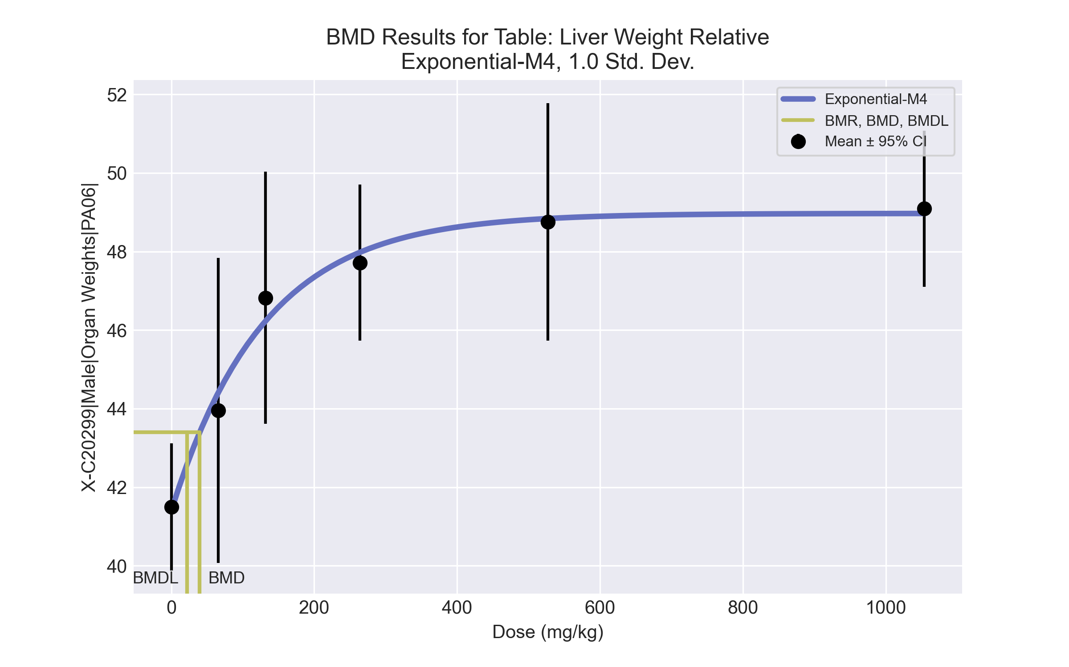
====================================================================
Exponential Model. (Version: 1.11; Date: 03/14/2017)
Input Data File: C:\Windows\TEMP\bmds-z8g8ms42.(d)
Gnuplot Plotting File:
Tue May 18 15:25:52 2021
====================================================================
BMDS_Model_Run
~~~~~~~~~~~~~~~~~~~~~~~~~~~~~~~~~~~~~~~~~~~~~~~~~~~~~~~~~~~~~~~~~~~~~
The form of the response function by Model:
Model 2: Y[dose] = a * exp{sign * b * dose}
Model 3: Y[dose] = a * exp{sign * (b * dose)^d}
Model 4: Y[dose] = a * [c-(c-1) * exp{-b * dose}]
Model 5: Y[dose] = a * [c-(c-1) * exp{-(b * dose)^d}]
Note: Y[dose] is the median response for exposure = dose;
sign = +1 for increasing trend in data;
sign = -1 for decreasing trend.
Model 2 is nested within Models 3 and 4.
Model 3 is nested within Model 5.
Model 4 is nested within Model 5.
Dependent variable = Response
Independent variable = Dose
Data are assumed to be distributed: normally
Variance Model: exp(lnalpha +rho *ln(Y[dose]))
rho is set to 0.
A constant variance model is fit.
Total number of dose groups = 6
Total number of records with missing values = 0
Maximum number of iterations = 500
Relative Function Convergence has been set to: 1e-008
Parameter Convergence has been set to: 1e-008
MLE solution provided: Exact
Initial Parameter Values
Variable Model 4
-------- --------
lnalpha 1.3583
rho 0 Specified
a 39.4234
b 0.0019707
c 1.30738
d 1 Specified
Parameter Estimates
Variable Model 4 Std. Err.
-------- ------- ---------
lnalpha 1.38643 1.03294
a 41.3975 0.859599
b 0.00770556 0.00250819
c 1.18289 0.0276895
NC = No Convergence
Table of Stats From Input Data
Dose N Obs Mean Obs Std Dev
----- --- ---------- -------------
0 5 41.5 1.3
66 5 43.95 3.128
132 5 46.82 2.587
264 5 47.72 1.597
527 5 48.75 2.43
1054 5 49.09 1.597
Estimated Values of Interest
Dose Est Mean Est Std Scaled Residual
------ ---------- --------- ----------------
0 41.4 2 0.1126
66 44.42 2 -0.5181
132 46.23 2 0.661
264 47.98 2 -0.2942
527 48.84 2 -0.09631
1054 48.97 2 0.135
Other models for which likelihoods are calculated:
Model A1: Yij = Mu(i) + e(ij)
Var{e(ij)} = Sigma^2
Model A2: Yij = Mu(i) + e(ij)
Var{e(ij)} = Sigma(i)^2
Model A3: Yij = Mu(i) + e(ij)
Var{e(ij)} = exp(lalpha + log(mean(i)) * rho)
Model R: Yij = Mu + e(i)
Var{e(ij)} = Sigma^2
Likelihoods of Interest
Model Log(likelihood) DF AIC
------- ----------------- ---- ------------
A1 -35.37453 7 84.74906
A2 -32.54082 12 89.08164
A3 -35.37453 7 84.74906
R -51.40794 2 106.8159
4 -35.79647 4 79.59294
Additive constant for all log-likelihoods = -27.57. This constant added to the
above values gives the log-likelihood including the term that does not
depend on the model parameters.
Explanation of Tests
Test 1: Does response and/or variances differ among Dose levels? (A2 vs. R)
Test 2: Are Variances Homogeneous? (A2 vs. A1)
Test 3: Are variances adequately modeled? (A2 vs. A3)
Test 6a: Does Model 4 fit the data? (A3 vs 4)
Tests of Interest
Test -2*log(Likelihood Ratio) D. F. p-value
-------- ------------------------ ------ --------------
Test 1 37.73 10 < 0.0001
Test 2 5.667 5 0.3399
Test 3 5.667 5 0.3399
Test 6a 0.8439 3 0.8389
The p-value for Test 1 is less than .05. There appears to be a
difference between response and/or variances among the dose
levels, it seems appropriate to model the data.
The p-value for Test 2 is greater than .1. A homogeneous
variance model appears to be appropriate here.
The p-value for Test 3 is greater than .1. The modeled
variance appears to be appropriate here.
The p-value for Test 6a is greater than .1. Model 4 seems
to adequately describe the data.
Benchmark Dose Computations:
Specified Effect = 1.000000
Risk Type = Estimated standard deviations from control
Confidence Level = 0.950000
BMD = 39.8113
BMDL = 22.359
BMDU = 84.6062

BMD Results for Table: A/G Ratio
BMDS version: BMDS v2.7.0

Input dataset
Dose | 0 | 66 | 132 | 264 | 527 | 1054
N | 5 | 5 | 5 | 5 | 5 | 5
Mean ± SD | 1.379 ± 0.076 | 1.413 ± 0.075 | 1.334 ± 0.052 | 1.306 ± 0.039 | 1.243 ± 0.032 | 1.282 ± 0.068

Summary table
Modelª | Goodness of fit |  | BMD | BMDL | Comments
 | p-value | AIC
Linear (equivalent models include Power, Polynomial 2°, 4°) | 0.009 | -126.531 | 588.666 | 383.693 | Hill recommended as best-fitting model on the basis of the lowest AIC.
Polynomial 3° | 0.009 | -126.531 | 588.664 | 383.693
Polynomial 5° | 0.009 | -126.531 | 588.667 | 383.693
Hill^{b} | 0.137 | -132.062 | 146.207 | 85.833
Exponential M2 (equivalent models include Exponential M3) | 0.01 | -126.774 | 561.456 | 359.676
Exponential M4 | 0.086 | -131.452 | 124.448 | 60.084
Exponential M5 | 0.128 | -131.925 | 170.603 | 85.166
ª Constant variance case presented (BMDS Test 2 p-value = 0.348, BMDS Test 3 p-value = 0.348).
^{b} Recommended model

Model recommendation details
Model | Bin | Notes
Linear (equivalent models include Power, Polynomial 2°, 4°) | Warning | Warnings  • Goodness of fit p-value is less than threshold (0.00906 < 0.1)
Polynomial 3° | Warning | Warnings  • Goodness of fit p-value is less than threshold (0.00906 < 0.1)
Polynomial 5° | Warning | Warnings  • Goodness of fit p-value is less than threshold (0.00906 < 0.1)
Hillª | Valid | -
Exponential M2 (equivalent models include Exponential M3) | Warning | Warnings  • Goodness of fit p-value is less than threshold (0.0101 < 0.1)
Exponential M4 | Warning | Warnings  • Goodness of fit p-value is less than threshold (0.0865 < 0.1)
Exponential M5 | Valid | -
ª Recommended model

Recommended model
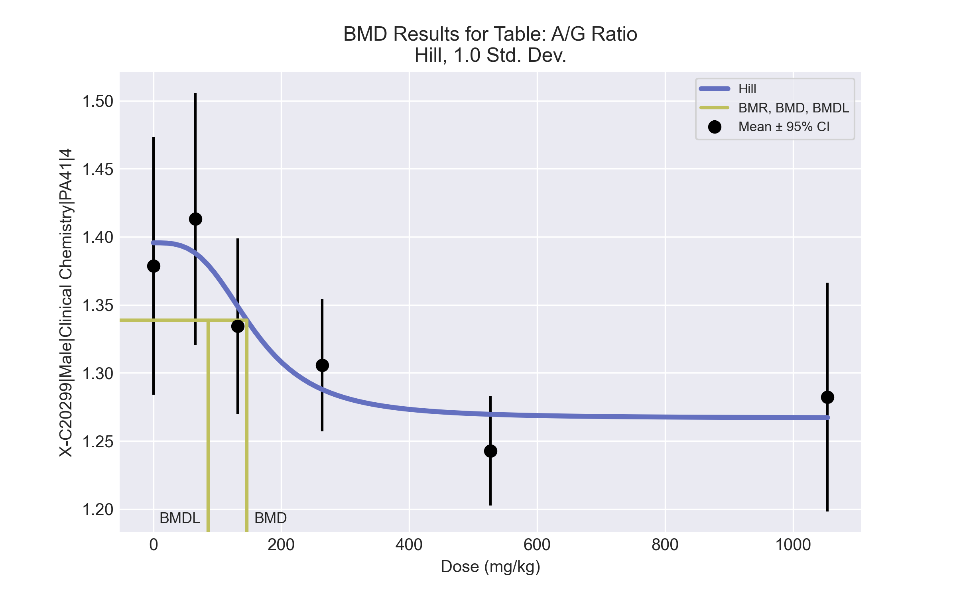
====================================================================
Hill Model. (Version: 2.18; Date: 03/14/2017)
Input Data File: C:\Windows\TEMP\bmds-e92k0nhl.(d)
Gnuplot Plotting File: C:\Windows\TEMP\bmds-e92k0nhl.plt
Tue May 18 15:27:32 2021
====================================================================
BMDS_Model_Run
~~~~~~~~~~~~~~~~~~~~~~~~~~~~~~~~~~~~~~~~~~~~~~~~~~~~~~~~~~~~~~~~~~~~~
The form of the response function is:
Y[dose] = intercept + v*dose^n/(k^n + dose^n)
Dependent variable = Response
Independent variable = Dose
rho is set to 0
Power parameter restricted to be greater than 1
A constant variance model is fit
Total number of dose groups = 6
Total number of records with missing values = 0
Maximum number of iterations = 500
Relative Function Convergence has been set to: 1e-008
Parameter Convergence has been set to: 1e-008
Default Initial Parameter Values
alpha = 0.00353629
rho = 0 Specified
intercept = 1.37858
v = -0.13584
n = 1.14358
k = 240.992
Asymptotic Correlation Matrix of Parameter Estimates
( *** The model parameter(s) -rho
have been estimated at a boundary point, or have been specified by the user,
and do not appear in the correlation matrix )
alpha intercept v n k
alpha 1 1.8e-006 -4.4e-007 -6.3e-007 5.3e-007
intercept 1.8e-006 1 -0.65 -0.072 -0.44
v -4.4e-007 -0.65 1 0.48 -0.17
n -6.3e-007 -0.072 0.48 1 -0.49
k 5.3e-007 -0.44 -0.17 -0.49 1
Parameter Estimates
95.0% Wald Confidence Interval
Variable Estimate Std. Err. Lower Conf. Limit Upper Conf. Limit
alpha 0.00322957 0.000833871 0.00159521 0.00486393
intercept 1.39557 0.0203584 1.35567 1.43547
v -0.128748 0.0285522 -0.18471 -0.0727872
n 3.16678 1.87971 -0.517385 6.85095
k 157.494 59.261 41.345 273.644
Table of Data and Estimated Values of Interest
Dose N Obs Mean Est Mean Obs Std Dev Est Std Dev Scaled Res.
------ --- -------- -------- ----------- ----------- ----------
0 5 1.38 1.4 0.0761 0.0568 -0.669
66 5 1.41 1.39 0.0747 0.0568 0.996
132 5 1.33 1.35 0.052 0.0568 -0.567
264 5 1.31 1.29 0.0391 0.0568 0.702
527 5 1.24 1.27 0.0324 0.0568 -1.06
1054 5 1.28 1.27 0.0676 0.0568 0.594
Model Descriptions for likelihoods calculated
Model A1: Yij = Mu(i) + e(ij)
Var{e(ij)} = Sigma^2
Model A2: Yij = Mu(i) + e(ij)
Var{e(ij)} = Sigma(i)^2
Model A3: Yij = Mu(i) + e(ij)
Var{e(ij)} = Sigma^2
Model A3 uses any fixed variance parameters that
were specified by the user
Model R: Yi = Mu + e(i)
Var{e(i)} = Sigma^2
Likelihoods of Interest
Model Log(likelihood) # Param's AIC
A1 73.017307 7 -132.034614
A2 75.815103 12 -127.630206
A3 73.017307 7 -132.034614
fitted 71.031094 5 -132.062188
R 61.463529 2 -118.927058
Explanation of Tests
Test 1: Do responses and/or variances differ among Dose levels?
(A2 vs. R)
Test 2: Are Variances Homogeneous? (A1 vs A2)
Test 3: Are variances adequately modeled? (A2 vs. A3)
Test 4: Does the Model for the Mean Fit? (A3 vs. fitted)
(Note: When rho=0 the results of Test 3 and Test 2 will be the same.)
Tests of Interest
Test -2*log(Likelihood Ratio) Test df p-value
Test 1 28.7031 10 0.001392
Test 2 5.59559 5 0.3476
Test 3 5.59559 5 0.3476
Test 4 3.97243 2 0.1372
The p-value for Test 1 is less than .05. There appears to be a
difference between response and/or variances among the dose levels
It seems appropriate to model the data
The p-value for Test 2 is greater than .1. A homogeneous variance
model appears to be appropriate here
The p-value for Test 3 is greater than .1. The modeled variance appears
to be appropriate here
The p-value for Test 4 is greater than .1. The model chosen seems
to adequately describe the data
Benchmark Dose Computation
Specified effect = 1
Risk Type = Estimated standard deviations from the control mean
Confidence level = 0.95
BMD = 146.207
BMDL = 85.8333
BMDU = 296.661

BMD Results for Table: Bile salts/acids
BMDS version: BMDS v2.7.0

Input dataset
Dose | 0 | 66 | 132 | 264 | 527 | 1054
N | 5 | 5 | 5 | 5 | 5 | 5
Mean ± SD | 57.42 ± 19.77 | 53.86 ± 9.082 | 34.46 ± 9.546 | 40.76 ± 13.985 | 32.34 ± 12.625 | 32.14 ± 9.553

Summary table
Modelª | Goodness of fit |  | BMD | BMDL | Comments
 | p-value | AIC
Linear (equivalent models include Polynomial 2°, 4°) | 0.043 | 192.947 | 684.501 | 425.744 | Hill recommended as best-fitting model on the basis of the lowest AIC.
Power (equivalent models include Polynomial 3°, 5°) | 0.043 | 192.947 | 684.5 | 425.744
Hill^{b} | 0.625 | 186.86 | 72.929 | 49.692
Exponential M2 (equivalent models include Exponential M3) | 0.065 | 191.968 | 517.109 | 272.333
Exponential M4 | 0.269 | 189.036 | 86.639 | 31.433
Exponential M5 | 0.416 | 188.86 | 81.985 | 52.948
ª Constant variance case presented (BMDS Test 2 p-value = 0.413, BMDS Test 3 p-value = 0.413).
^{b} Recommended model

Model recommendation details
Model | Bin | Notes
Linear (equivalent models include Polynomial 2°, 4°) | Warning | Warnings  • Goodness of fit p-value is less than threshold (0.0432 < 0.1)
Power (equivalent models include Polynomial 3°, 5°) | Warning | Warnings  • Goodness of fit p-value is less than threshold (0.0432 < 0.1)
Hillª | Valid | -
Exponential M2 (equivalent models include Exponential M3) | Warning | Warnings  • Goodness of fit p-value is less than threshold (0.0646 < 0.1)
Exponential M4 | Valid | -
Exponential M5 | Valid | -
ª Recommended model

Recommended model
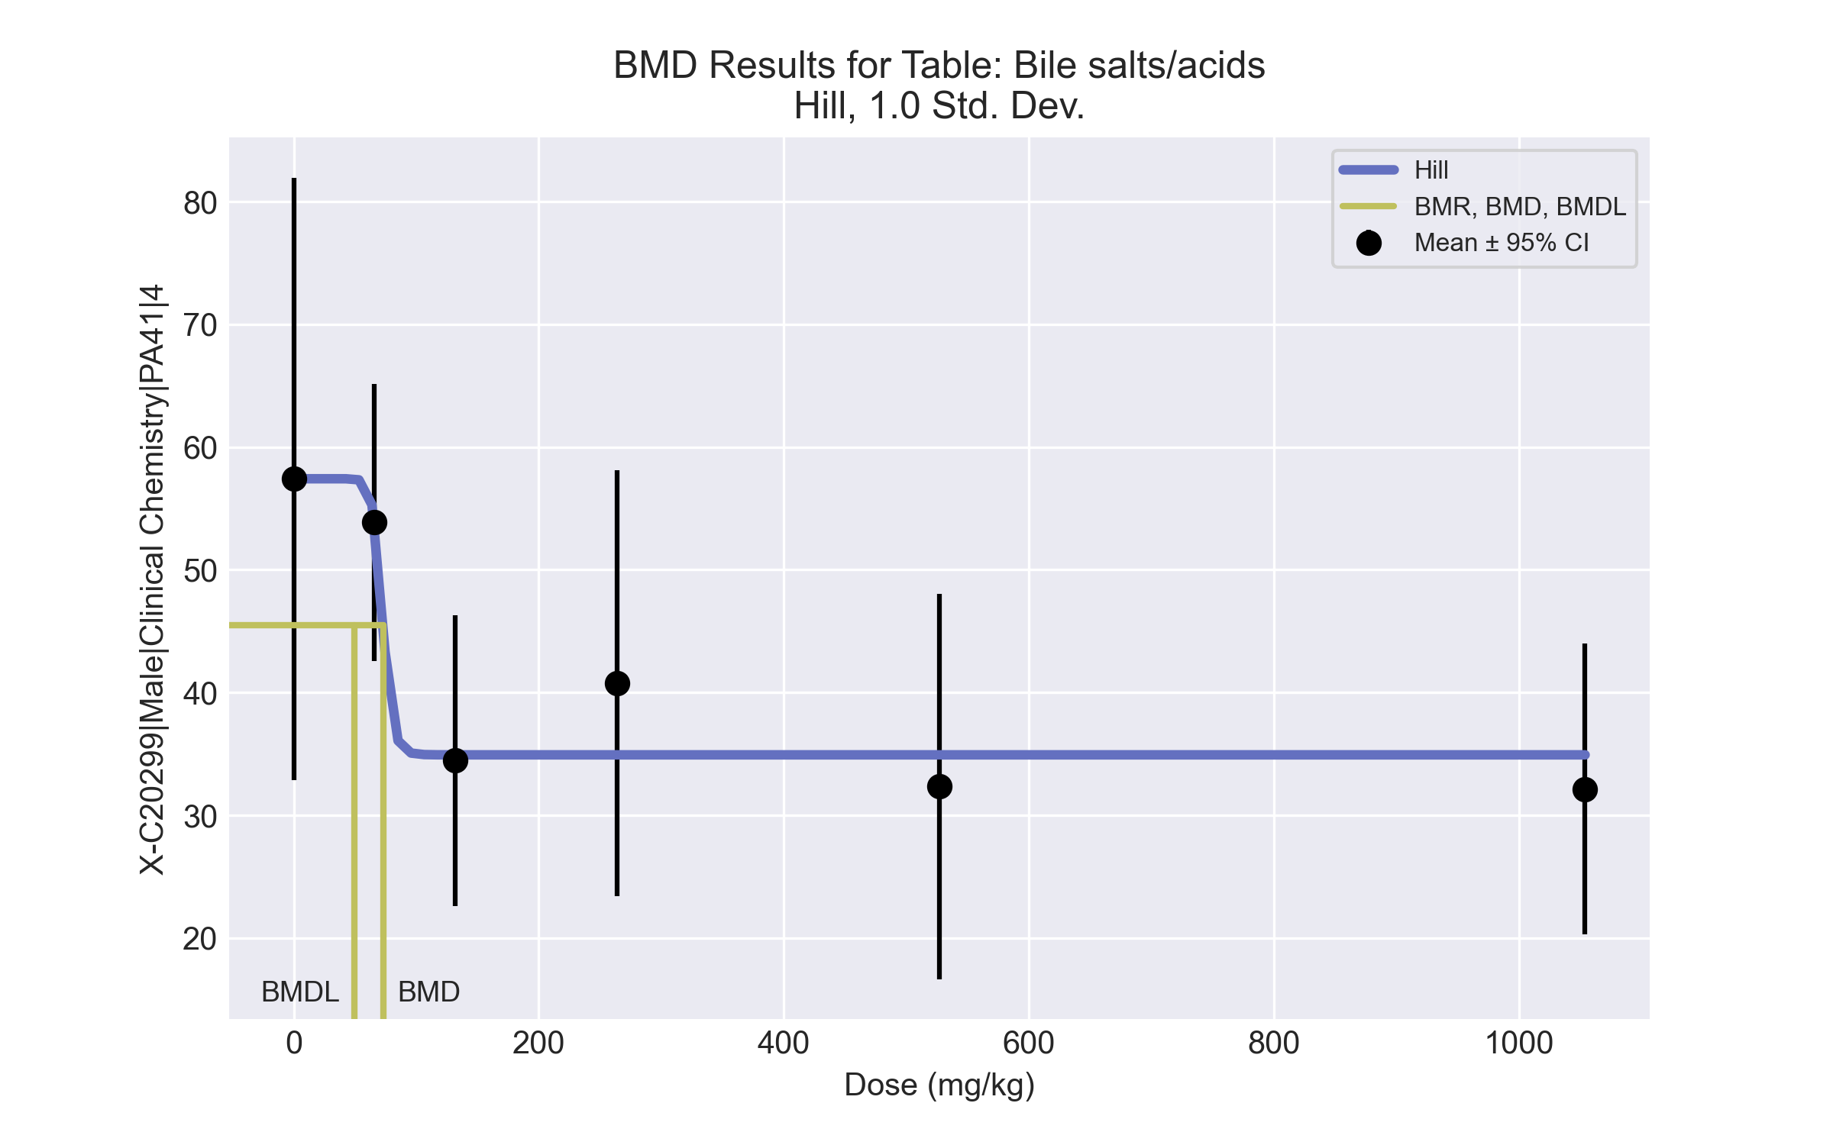
====================================================================
Hill Model. (Version: 2.18; Date: 03/14/2017)
Input Data File: C:\Windows\TEMP\bmds-eehn2o5v.(d)
Gnuplot Plotting File: C:\Windows\TEMP\bmds-eehn2o5v.plt
Tue May 18 15:27:36 2021
====================================================================
BMDS_Model_Run
~~~~~~~~~~~~~~~~~~~~~~~~~~~~~~~~~~~~~~~~~~~~~~~~~~~~~~~~~~~~~~~~~~~~~
The form of the response function is:
Y[dose] = intercept + v*dose^n/(k^n + dose^n)
Dependent variable = Response
Independent variable = Dose
rho is set to 0
Power parameter restricted to be greater than 1
A constant variance model is fit
Total number of dose groups = 6
Total number of records with missing values = 0
Maximum number of iterations = 500
Relative Function Convergence has been set to: 1e-008
Parameter Convergence has been set to: 1e-008
Default Initial Parameter Values
alpha = 168.454
rho = 0 Specified
intercept = 57.42
v = -25.28
n = 3.90836
k = 96.8907
Asymptotic Correlation Matrix of Parameter Estimates
( *** The model parameter(s) -rho -n
have been estimated at a boundary point, or have been specified by the user,
and do not appear in the correlation matrix )
alpha intercept v k
alpha 1 -2e-006 1.7e-006 1.4e-006
intercept -2e-006 1 -0.89 -0.64
v 1.7e-006 -0.89 1 0.55
k 1.4e-006 -0.64 0.55 1
Parameter Estimates
95.0% Wald Confidence Interval
Variable Estimate Std. Err. Lower Conf. Limit Upper Conf. Limit
alpha 142.881 36.8917 70.5744 215.187
intercept 57.42 5.34559 46.9428 67.8972
v -22.4951 5.97646 -34.2088 -10.7815
n 18 NA
k 72.4213 9.39835 54.0009 90.8418
NA - Indicates that this parameter has hit a bound
implied by some inequality constraint and thus
has no standard error.
Table of Data and Estimated Values of Interest
Dose N Obs Mean Est Mean Obs Std Dev Est Std Dev Scaled Res.
------ --- -------- -------- ----------- ----------- ----------
0 5 57.4 57.4 19.8 12 -1.74e-006
66 5 53.9 53.9 9.08 12 1.25e-005
132 5 34.5 34.9 9.55 12 -0.0871
264 5 40.8 34.9 14 12 1.09
527 5 32.3 34.9 12.6 12 -0.484
1054 5 32.1 34.9 9.55 12 -0.521
Model Descriptions for likelihoods calculated
Model A1: Yij = Mu(i) + e(ij)
Var{e(ij)} = Sigma^2
Model A2: Yij = Mu(i) + e(ij)
Var{e(ij)} = Sigma(i)^2
Model A3: Yij = Mu(i) + e(ij)
Var{e(ij)} = Sigma^2
Model A3 uses any fixed variance parameters that
were specified by the user
Model R: Yi = Mu + e(i)
Var{e(i)} = Sigma^2
Likelihoods of Interest
Model Log(likelihood) # Param's AIC
A1 -88.552832 7 191.105664
A2 -86.039153 12 196.078306
A3 -88.552832 7 191.105664
fitted -89.430145 4 186.860290
R -97.165442 2 198.330884
Explanation of Tests
Test 1: Do responses and/or variances differ among Dose levels?
(A2 vs. R)
Test 2: Are Variances Homogeneous? (A1 vs A2)
Test 3: Are variances adequately modeled? (A2 vs. A3)
Test 4: Does the Model for the Mean Fit? (A3 vs. fitted)
(Note: When rho=0 the results of Test 3 and Test 2 will be the same.)
Tests of Interest
Test -2*log(Likelihood Ratio) Test df p-value
Test 1 22.2526 10 0.01387
Test 2 5.02736 5 0.4126
Test 3 5.02736 5 0.4126
Test 4 1.75463 3 0.6249
The p-value for Test 1 is less than .05. There appears to be a
difference between response and/or variances among the dose levels
It seems appropriate to model the data
The p-value for Test 2 is greater than .1. A homogeneous variance
model appears to be appropriate here
The p-value for Test 3 is greater than .1. The modeled variance appears
to be appropriate here
The p-value for Test 4 is greater than .1. The model chosen seems
to adequately describe the data
Benchmark Dose Computation
Specified effect = 1
Risk Type = Estimated standard deviations from the control mean
Confidence level = 0.95
BMD = 72.9287
BMDL = 49.692
BMDU computation failed.

BMD Results for Table: Cholesterol
BMDS version: BMDS v2.7.0

Input dataset
Dose | 0 | 66 | 132 | 264 | 527 | 1054
N | 5 | 5 | 5 | 5 | 5 | 5
Mean ± SD | 101 ± 12.865 | 105.6 ± 10.237 | 111.2 ± 13.918 | 122.2 ± 8.044 | 142.2 ± 5.675 | 146.4 ± 14.588

Summary table
Modelª | Goodness of fit |  | BMD | BMDL | Comments
 | p-value | AIC
Linear (equivalent models include Power, Polynomial 2°, 3°, 4°, 5°) | 0.032 | 185.634 | 270.887 | 206.34 | Exponential-M4 recommended as best-fitting model on the basis of the lowest AIC.
Hill | 0.703 | 179.794 | 156.037 | 63.905
Exponential M2 (equivalent models include Exponential M3) | 0.013 | 187.683 | 331.261 | 258.661
Exponential M4^{b} | 0.59 | 179.006 | 89.302 | 55.89
Exponential M5 | 0.881 | 179.343 | 150.58 | 66.028
ª Constant variance case presented (BMDS Test 2 p-value = 0.343, BMDS Test 3 p-value = 0.343).
^{b} Recommended model

Model recommendation details
Model | Bin | Notes
Linear (equivalent models include Power, Polynomial 2°, 3°, 4°, 5°) | Warning | Warnings  • Goodness of fit p-value is less than threshold (0.0322 < 0.1)
Hill | Valid | -
Exponential M2 (equivalent models include Exponential M3) | Warning | Warnings  • Goodness of fit p-value is less than threshold (0.0134 < 0.1)
Exponential M4ª | Valid | -
Exponential M5 | Valid | -
ª Recommended model

Recommended model
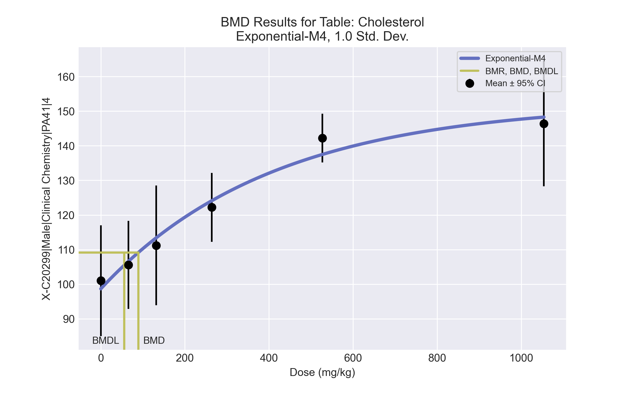
====================================================================
Exponential Model. (Version: 1.11; Date: 03/14/2017)
Input Data File: C:\Windows\TEMP\bmds-23av62sc.(d)
Gnuplot Plotting File:
Tue May 18 15:27:39 2021
====================================================================
BMDS_Model_Run
~~~~~~~~~~~~~~~~~~~~~~~~~~~~~~~~~~~~~~~~~~~~~~~~~~~~~~~~~~~~~~~~~~~~~
The form of the response function by Model:
Model 2: Y[dose] = a * exp{sign * b * dose}
Model 3: Y[dose] = a * exp{sign * (b * dose)^d}
Model 4: Y[dose] = a * [c-(c-1) * exp{-b * dose}]
Model 5: Y[dose] = a * [c-(c-1) * exp{-(b * dose)^d}]
Note: Y[dose] is the median response for exposure = dose;
sign = +1 for increasing trend in data;
sign = -1 for decreasing trend.
Model 2 is nested within Models 3 and 4.
Model 3 is nested within Model 5.
Model 4 is nested within Model 5.
Dependent variable = Response
Independent variable = Dose
Data are assumed to be distributed: normally
Variance Model: exp(lnalpha +rho *ln(Y[dose]))
rho is set to 0.
A constant variance model is fit.
Total number of dose groups = 6
Total number of records with missing values = 0
Maximum number of iterations = 500
Relative Function Convergence has been set to: 1e-008
Parameter Convergence has been set to: 1e-008
MLE solution provided: Exact
Initial Parameter Values
Variable Model 4
-------- --------
lnalpha 4.63628
rho 0 Specified
a 95.95
b 0.00218874
c 1.60208
d 1 Specified
Parameter Estimates
Variable Model 4 Std. Err.
-------- ------- ---------
lnalpha 4.70019 28.3935
a 98.6658 3.75754
b 0.00242966 0.000847307
c 1.54491 0.0828219
NC = No Convergence
Table of Stats From Input Data
Dose N Obs Mean Obs Std Dev
----- --- ---------- -------------
0 5 101 12.86
66 5 105.6 10.24
132 5 111.2 13.92
264 5 122.2 8.044
527 5 142.2 5.675
1054 5 146.4 14.59
Estimated Values of Interest
Dose Est Mean Est Std Scaled Residual
------ ---------- --------- ----------------
0 98.67 10.49 0.4977
66 106.6 10.49 -0.22
132 113.4 10.49 -0.4727
264 124.1 10.49 -0.4096
527 137.5 10.49 1.005
1054 148.3 10.49 -0.4002
Other models for which likelihoods are calculated:
Model A1: Yij = Mu(i) + e(ij)
Var{e(ij)} = Sigma^2
Model A2: Yij = Mu(i) + e(ij)
Var{e(ij)} = Sigma(i)^2
Model A3: Yij = Mu(i) + e(ij)
Var{e(ij)} = exp(lalpha + log(mean(i)) * rho)
Model R: Yij = Mu + e(i)
Var{e(ij)} = Sigma^2
Likelihoods of Interest
Model Log(likelihood) DF AIC
------- ----------------- ---- ------------
A1 -84.54422 7 183.0884
A2 -81.72639 12 187.4528
A3 -84.54422 7 183.0884
R -105.1633 2 214.3267
4 -85.5028 4 179.0056
Additive constant for all log-likelihoods = -27.57. This constant added to the
above values gives the log-likelihood including the term that does not
depend on the model parameters.
Explanation of Tests
Test 1: Does response and/or variances differ among Dose levels? (A2 vs. R)
Test 2: Are Variances Homogeneous? (A2 vs. A1)
Test 3: Are variances adequately modeled? (A2 vs. A3)
Test 6a: Does Model 4 fit the data? (A3 vs 4)
Tests of Interest
Test -2*log(Likelihood Ratio) D. F. p-value
-------- ------------------------ ------ --------------
Test 1 46.87 10 < 0.0001
Test 2 5.636 5 0.3433
Test 3 5.636 5 0.3433
Test 6a 1.917 3 0.5898
The p-value for Test 1 is less than .05. There appears to be a
difference between response and/or variances among the dose
levels, it seems appropriate to model the data.
The p-value for Test 2 is greater than .1. A homogeneous
variance model appears to be appropriate here.
The p-value for Test 3 is greater than .1. The modeled
variance appears to be appropriate here.
The p-value for Test 6a is greater than .1. Model 4 seems
to adequately describe the data.
Benchmark Dose Computations:
Specified Effect = 1.000000
Risk Type = Estimated standard deviations from control
Confidence Level = 0.950000
BMD = 89.3018
BMDL = 55.89
BMDU = 163.285

BMD Results for Table: Globulin
BMDS version: BMDS v2.7.0

Input dataset
Dose | 0 | 66 | 132 | 264 | 527 | 1054
N | 5 | 5 | 5 | 5 | 5 | 5
Mean ± SD | 2.5 ± 0.158 | 2.44 ± 0.167 | 2.58 ± 0.084 | 2.56 ± 0.152 | 2.72 ± 0.084 | 2.66 ± 0.207

Summary table
Modelª | Goodness of fit |  | BMD | BMDL | Comments
 | p-value | AIC
Linear (equivalent models include Power, Polynomial 2°, 3°, 4°, 5°) | 0.2 | -78.982 | 767.531 | 458.874 | Exponential-M4 recommended as best-fitting model on the basis of the lowest BMDL.
Hill | 0.216 | -77.904 | 293.529 | -999
Exponential M2 (equivalent models include Exponential M3) | 0.193 | -78.888 | 787.682 | 480.461
Exponential M4^{b} | 0.301 | -79.309 | 278.025 | 89.601
Exponential M5 | 0.248 | -78.179 | 324.082 | 107.695
ª Constant variance case presented (BMDS Test 2 p-value = 0.282, BMDS Test 3 p-value = 0.282).
^{b} Recommended model

Model recommendation details
Model | Bin | Notes
Linear (equivalent models include Power, Polynomial 2°, 3°, 4°, 5°) | Valid | -
Hill | Failure | Failures  • BMDL does not exist  Cautions  • Warning(s): BMDL computation failed.
Exponential M2 (equivalent models include Exponential M3) | Valid | -
Exponential M4ª | Valid | -
Exponential M5 | Valid | -
ª Recommended model

Recommended model
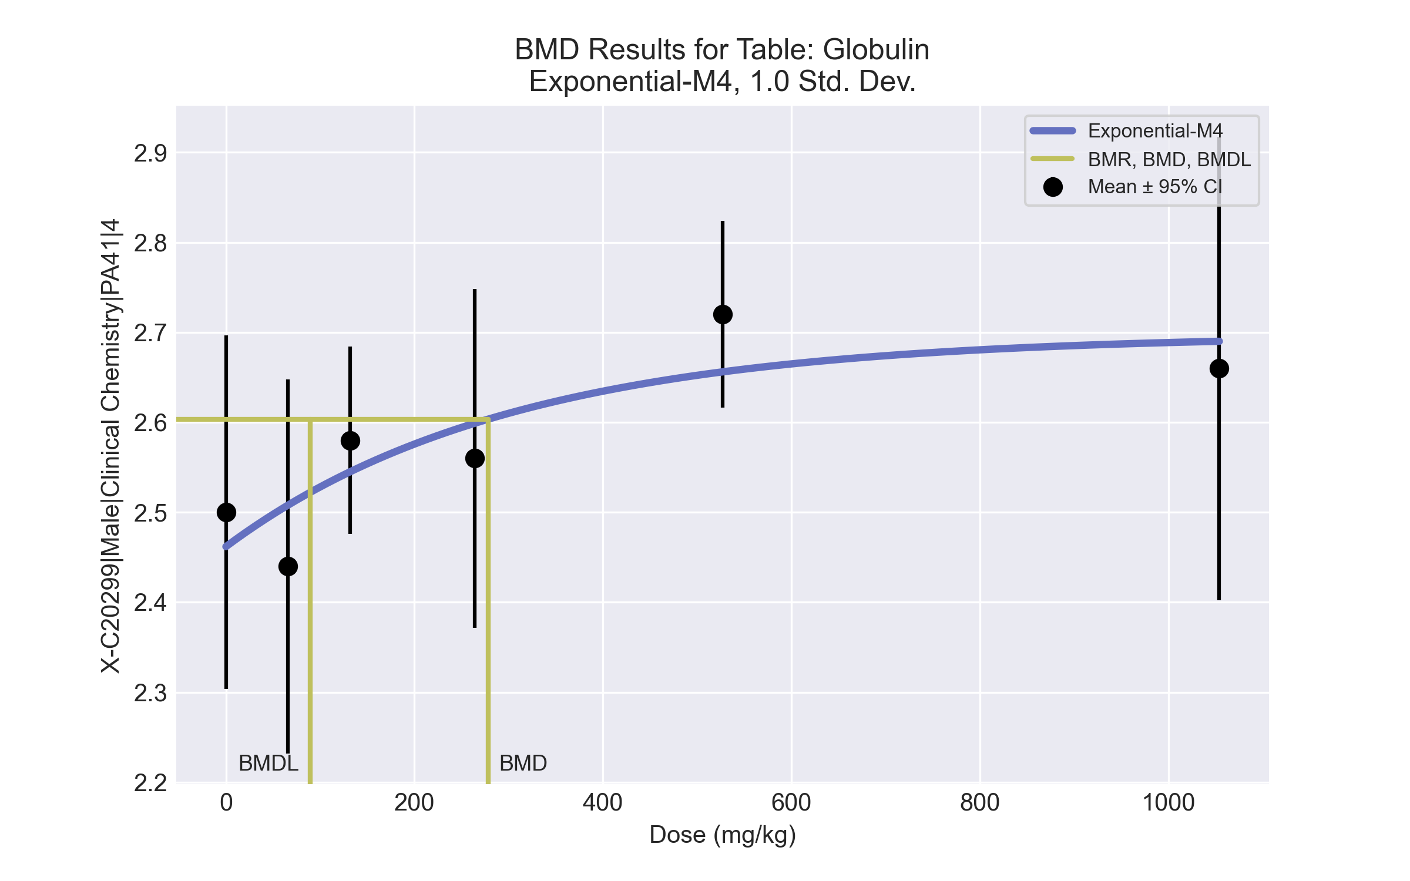
====================================================================
Exponential Model. (Version: 1.11; Date: 03/14/2017)
Input Data File: C:\Windows\TEMP\bmds-rkqlzbvy.(d)
Gnuplot Plotting File:
Tue May 18 15:27:41 2021
====================================================================
BMDS_Model_Run
~~~~~~~~~~~~~~~~~~~~~~~~~~~~~~~~~~~~~~~~~~~~~~~~~~~~~~~~~~~~~~~~~~~~~
The form of the response function by Model:
Model 2: Y[dose] = a * exp{sign * b * dose}
Model 3: Y[dose] = a * exp{sign * (b * dose)^d}
Model 4: Y[dose] = a * [c-(c-1) * exp{-b * dose}]
Model 5: Y[dose] = a * [c-(c-1) * exp{-(b * dose)^d}]
Note: Y[dose] is the median response for exposure = dose;
sign = +1 for increasing trend in data;
sign = -1 for decreasing trend.
Model 2 is nested within Models 3 and 4.
Model 3 is nested within Model 5.
Model 4 is nested within Model 5.
Dependent variable = Response
Independent variable = Dose
Data are assumed to be distributed: normally
Variance Model: exp(lnalpha +rho *ln(Y[dose]))
rho is set to 0.
A constant variance model is fit.
Total number of dose groups = 6
Total number of records with missing values = 0
Maximum number of iterations = 500
Relative Function Convergence has been set to: 1e-008
Parameter Convergence has been set to: 1e-008
MLE solution provided: Exact
Initial Parameter Values
Variable Model 4
-------- --------
lnalpha -4.03231
rho 0 Specified
a 2.318
b 0.00138625
c 1.2321
d 1 Specified
Parameter Estimates
Variable Model 4 Std. Err.
-------- ------- ---------
lnalpha -3.91031 0.00517281
a 2.46186 0.051
b 0.00330866 0.00245628
c 1.09559 0.0335809
NC = No Convergence
Table of Stats From Input Data
Dose N Obs Mean Obs Std Dev
----- --- ---------- -------------
0 5 2.5 0.1581
66 5 2.44 0.1673
132 5 2.58 0.08367
264 5 2.56 0.1517
527 5 2.72 0.08367
1054 5 2.66 0.2074
Estimated Values of Interest
Dose Est Mean Est Std Scaled Residual
------ ---------- --------- ----------------
0 2.462 0.1415 0.6026
66 2.508 0.1415 -1.075
132 2.545 0.1415 0.5508
264 2.599 0.1415 -0.6152
527 2.656 0.1415 1.01
1054 2.69 0.1415 -0.4739
Other models for which likelihoods are calculated:
Model A1: Yij = Mu(i) + e(ij)
Var{e(ij)} = Sigma^2
Model A2: Yij = Mu(i) + e(ij)
Var{e(ij)} = Sigma(i)^2
Model A3: Yij = Mu(i) + e(ij)
Var{e(ij)} = exp(lalpha + log(mean(i)) * rho)
Model R: Yij = Mu + e(i)
Var{e(ij)} = Sigma^2
Likelihoods of Interest
Model Log(likelihood) DF AIC
------- ----------------- ---- ------------
A1 45.48464 7 -76.96927
A2 48.61449 12 -73.22897
A3 45.48464 7 -76.96927
R 39.48434 2 -74.96867
4 43.65472 4 -79.30945
Additive constant for all log-likelihoods = -27.57. This constant added to the
above values gives the log-likelihood including the term that does not
depend on the model parameters.
Explanation of Tests
Test 1: Does response and/or variances differ among Dose levels? (A2 vs. R)
Test 2: Are Variances Homogeneous? (A2 vs. A1)
Test 3: Are variances adequately modeled? (A2 vs. A3)
Test 6a: Does Model 4 fit the data? (A3 vs 4)
Tests of Interest
Test -2*log(Likelihood Ratio) D. F. p-value
-------- ------------------------ ------ --------------
Test 1 18.26 10 0.05073
Test 2 6.26 5 0.2818
Test 3 6.26 5 0.2818
Test 6a 3.66 3 0.3006
The p-value for Test 1 is greater than .05. There may not be a
diffence between responses and/or variances among the dose levels
Modelling the data with a dose/response curve may not be appropriate.
The p-value for Test 2 is greater than .1. A homogeneous
variance model appears to be appropriate here.
The p-value for Test 3 is greater than .1. The modeled
variance appears to be appropriate here.
The p-value for Test 6a is greater than .1. Model 4 seems
to adequately describe the data.
Benchmark Dose Computations:
Specified Effect = 1.000000
Risk Type = Estimated standard deviations from control
Confidence Level = 0.950000
BMD = 278.025
BMDL = 89.6012
BMDU = 1.054e+007

BMD Results for Table: HDL Cholesterol
BMDS version: BMDS v2.7.0

Input dataset
Dose | 0 | 66 | 132 | 264 | 527 | 1054
N | 5 | 5 | 5 | 5 | 5 | 5
Mean ± SD | 46 ± 6.442 | 50 ± 5.148 | 51.8 ± 5.675 | 54 ± 4.359 | 64.8 ± 3.701 | 69.8 ± 9.365

Summary table
Modelª | Goodness of fit |  | BMD | BMDL | Comments
 | p-value | AIC
Linear (equivalent models include Power, Polynomial 2°, 3°, 4°, 5°) | 0.286 | 142.451 | 263.252 | 201.211 | Hill recommended as best-fitting model on the basis of the lowest BMDL.
Hill^{b} | 0.442 | 143.076 | 161.652 | 68.114
Exponential M2 (equivalent models include Exponential M3) | 0.161 | 144.007 | 320.194 | 251.617
Exponential M4 | 0.658 | 141.051 | 131.165 | 76.77
Exponential M5 | 0.497 | 142.84 | 177.765 | 78.288
ª Constant variance case presented (BMDS Test 2 p-value = 0.349, BMDS Test 3 p-value = 0.349).
^{b} Recommended model

Model recommendation details
Model | Bin | Notes
Linear (equivalent models include Power, Polynomial 2°, 3°, 4°, 5°) | Valid | -
Hillª | Valid | -
Exponential M2 (equivalent models include Exponential M3) | Valid | -
Exponential M4 | Valid | -
Exponential M5 | Valid | -
ª Recommended model

Recommended model
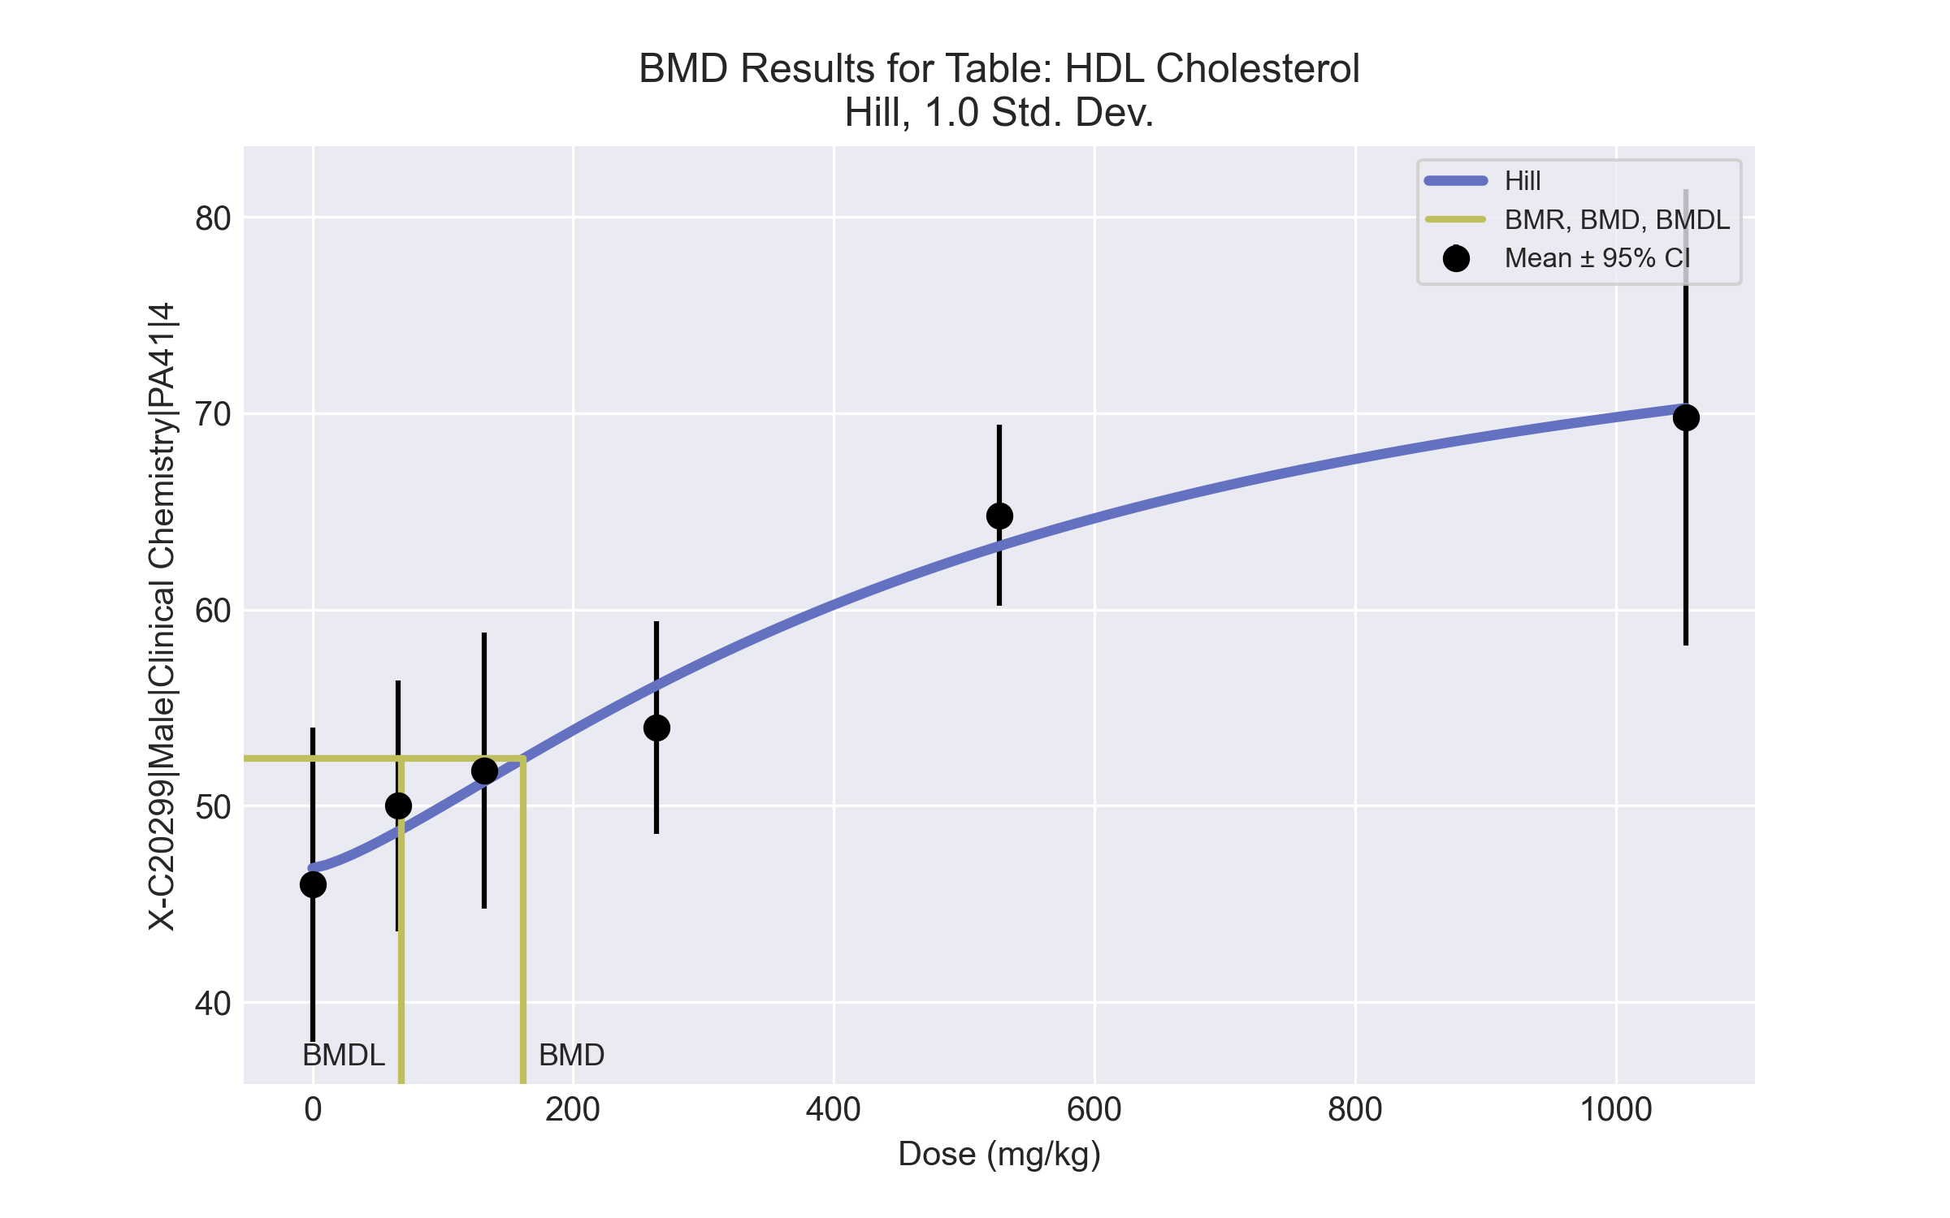
====================================================================
Hill Model. (Version: 2.18; Date: 03/14/2017)
Input Data File: C:\Windows\TEMP\bmds-n9d6krck.(d)
Gnuplot Plotting File: C:\Windows\TEMP\bmds-n9d6krck.plt
Tue May 18 15:27:46 2021
====================================================================
BMDS_Model_Run
~~~~~~~~~~~~~~~~~~~~~~~~~~~~~~~~~~~~~~~~~~~~~~~~~~~~~~~~~~~~~~~~~~~~~
The form of the response function is:
Y[dose] = intercept + v*dose^n/(k^n + dose^n)
Dependent variable = Response
Independent variable = Dose
rho is set to 0
Power parameter restricted to be greater than 1
A constant variance model is fit
Total number of dose groups = 6
Total number of records with missing values = 0
Maximum number of iterations = 500
Relative Function Convergence has been set to: 1e-008
Parameter Convergence has been set to: 1e-008
Default Initial Parameter Values
alpha = 36.7667
rho = 0 Specified
intercept = 46
v = 23.8
n = 0.516044
k = 695.028
Asymptotic Correlation Matrix of Parameter Estimates
( *** The model parameter(s) -rho
have been estimated at a boundary point, or have been specified by the user,
and do not appear in the correlation matrix )
alpha intercept v n k
alpha 1 -1.1e-006 1.8e-006 -1.5e-006 2e-006
intercept -1.1e-006 1 -0.72 0.78 -0.55
v 1.8e-006 -0.72 1 -0.96 0.97
n -1.5e-006 0.78 -0.96 1 -0.91
k 2e-006 -0.55 0.97 -0.91 1
Parameter Estimates
95.0% Wald Confidence Interval
Variable Estimate Std. Err. Lower Conf. Limit Upper Conf. Limit
alpha 31.0585 8.01926 15.341 46.7759
intercept 46.8229 2.98722 40.9681 52.6778
v 32.3741 24.1669 -14.9921 79.7402
n 1.35197 1.17244 -0.945976 3.64991
k 516.506 560.725 -582.495 1615.51
Table of Data and Estimated Values of Interest
Dose N Obs Mean Est Mean Obs Std Dev Est Std Dev Scaled Res.
------ --- -------- -------- ----------- ----------- ----------
0 5 46 46.8 6.44 5.57 -0.33
66 5 50 48.7 5.15 5.57 0.517
132 5 51.8 51.2 5.67 5.57 0.224
264 5 54 56.1 4.36 5.57 -0.855
527 5 64.8 63.2 3.7 5.57 0.63
1054 5 69.8 70.3 9.36 5.57 -0.185
Model Descriptions for likelihoods calculated
Model A1: Yij = Mu(i) + e(ij)
Var{e(ij)} = Sigma^2
Model A2: Yij = Mu(i) + e(ij)
Var{e(ij)} = Sigma(i)^2
Model A3: Yij = Mu(i) + e(ij)
Var{e(ij)} = Sigma^2
Model A3 uses any fixed variance parameters that
were specified by the user
Model R: Yi = Mu + e(i)
Var{e(i)} = Sigma^2
Likelihoods of Interest
Model Log(likelihood) # Param's AIC
A1 -65.721721 7 145.443442
A2 -62.929249 12 149.858499
A3 -65.721721 7 145.443442
fitted -66.538066 5 143.076133
R -84.126805 2 172.253610
Explanation of Tests
Test 1: Do responses and/or variances differ among Dose levels?
(A2 vs. R)
Test 2: Are Variances Homogeneous? (A1 vs A2)
Test 3: Are variances adequately modeled? (A2 vs. A3)
Test 4: Does the Model for the Mean Fit? (A3 vs. fitted)
(Note: When rho=0 the results of Test 3 and Test 2 will be the same.)
Tests of Interest
Test -2*log(Likelihood Ratio) Test df p-value
Test 1 42.3951 10 <.0001
Test 2 5.58494 5 0.3487
Test 3 5.58494 5 0.3487
Test 4 1.63269 2 0.442
The p-value for Test 1 is less than .05. There appears to be a
difference between response and/or variances among the dose levels
It seems appropriate to model the data
The p-value for Test 2 is greater than .1. A homogeneous variance
model appears to be appropriate here
The p-value for Test 3 is greater than .1. The modeled variance appears
to be appropriate here
The p-value for Test 4 is greater than .1. The model chosen seems
to adequately describe the data
Benchmark Dose Computation
Specified effect = 1
Risk Type = Estimated standard deviations from the control mean
Confidence level = 0.95
BMD = 161.652
BMDL = 68.1144
BMDU = 380.332

BMD Results for Table: Cholinesterase
BMDS version: BMDS v2.7.0

Input dataset
Dose | 0 | 66 | 132 | 264 | 527 | 1054ª
N | 5 | 5 | 5 | 5 | 5 | 5
Mean ± SD | 277.4 ± 37.092 | 201 ± 13.285 | 172.4 ± 17.799 | 148.4 ± 19.36 | 141.2 ± 9.365 | 110.2 ± 21.822
ª Dose group removed in BMD modeling session

Summary table
Modelª | Goodness of fit |  | BMD | BMDL | Comments
 | p-value | AIC
Linear (equivalent models include Power, Polynomial 3°) | <0.0001 | 200.701 | 497.837 | 280.799 | Exponential-M4 recommended as best-fitting model on the basis of the lowest AIC.
Polynomial 2° (equivalent models include Polynomial 4°, 5°) | <0.0001 | 200.701 | 497.838 | 280.799
Hill | 0.738 | 178.239 | 20.125 | -999
Exponential M2 (equivalent models include Exponential M3) | <0.0001 | 198.952 | 427.482 | 200.187
Exponential M4^{b} (equivalent models include Exponential M5) | 0.761 | 176.673 | 21.291 | 12.337
ª Modeled variance case presented (BMDS Test 2 p-value = 0.029, BMDS Test 3 p-value = 0.271).
^{b} Recommended model

Model recommendation details
Model | Bin | Notes
Linear (equivalent models include Power, Polynomial 3°) | Warning | Warnings  • Residual at lowest dose is greater than threshold (3.01 > 2.0)  • Ratio of modeled to actual stdev. at control is greater than threshold (1.54 > 1.5)
Polynomial 2° (equivalent models include Polynomial 4°, 5°) | Warning | Warnings  • Residual at lowest dose is greater than threshold (3.01 > 2.0)  • Ratio of modeled to actual stdev. at control is greater than threshold (1.54 > 1.5)
Hill | Failure | Failures  • BMDL does not exist  Cautions  • Warning(s): BMDL computation failed.  • Minimum dose/BMD ratio is greater than threshold (3.28 > 3.0)
Exponential M2 (equivalent models include Exponential M3) | Warning | Warnings  • Residual at lowest dose is greater than threshold (2.88 > 2.0)
Exponential M4ª (equivalent models include Exponential M5) | Valid | Cautions  • Minimum dose/BMD ratio is greater than threshold (3.1 > 3.0)
ª Recommended model

Recommended model
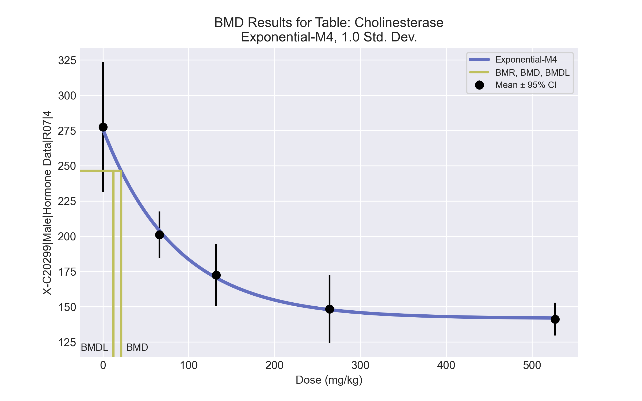
====================================================================
Exponential Model. (Version: 1.11; Date: 03/14/2017)
Input Data File: C:\Windows\TEMP\bmds-2m6nsg_1.(d)
Gnuplot Plotting File:
Tue May 18 15:28:33 2021
====================================================================
BMDS_Model_Run
~~~~~~~~~~~~~~~~~~~~~~~~~~~~~~~~~~~~~~~~~~~~~~~~~~~~~~~~~~~~~~~~~~~~~
The form of the response function by Model:
Model 2: Y[dose] = a * exp{sign * b * dose}
Model 3: Y[dose] = a * exp{sign * (b * dose)^d}
Model 4: Y[dose] = a * [c-(c-1) * exp{-b * dose}]
Model 5: Y[dose] = a * [c-(c-1) * exp{-(b * dose)^d}]
Note: Y[dose] is the median response for exposure = dose;
sign = +1 for increasing trend in data;
sign = -1 for decreasing trend.
Model 2 is nested within Models 3 and 4.
Model 3 is nested within Model 5.
Model 4 is nested within Model 5.
Dependent variable = Response
Independent variable = Dose
Data are assumed to be distributed: normally
Variance Model: exp(lnalpha +rho *ln(Y[dose]))
The variance is to be modeled as Var(i) = exp(lalpha + log(mean(i)) * rho)
Total number of dose groups = 5
Total number of records with missing values = 0
Maximum number of iterations = 500
Relative Function Convergence has been set to: 1e-008
Parameter Convergence has been set to: 1e-008
MLE solution provided: Exact
Initial Parameter Values
Variable Model 4
-------- --------
lnalpha -9.26382
rho 2.87674
a 291.27
b 0.00688734
c 0.461689
d 1 Specified
Parameter Estimates
Variable Model 4 Std. Err.
-------- ------- ---------
lnalpha -8.16635 5.86558
rho 2.65733 1.12578
a 275.873 12.7729
b 0.0116554 0.00213413
c 0.513672 0.027418
NC = No Convergence
Table of Stats From Input Data
Dose N Obs Mean Obs Std Dev
----- --- ---------- -------------
0 5 277.4 37.09
66 5 201 13.29
132 5 172.4 17.8
264 5 148.4 19.36
527 5 141.2 9.365
Estimated Values of Interest
Dose Est Mean Est Std Scaled Residual
------ ---------- --------- ----------------
0 275.9 29.48 0.1158
66 203.9 19.73 -0.3258
132 170.5 15.56 0.2711
264 147.9 12.88 0.08808
527 142 12.2 -0.146
Other models for which likelihoods are calculated:
Model A1: Yij = Mu(i) + e(ij)
Var{e(ij)} = Sigma^2
Model A2: Yij = Mu(i) + e(ij)
Var{e(ij)} = Sigma(i)^2
Model A3: Yij = Mu(i) + e(ij)
Var{e(ij)} = exp(lalpha + log(mean(i)) * rho)
Model R: Yij = Mu + e(i)
Var{e(ij)} = Sigma^2
Likelihoods of Interest
Model Log(likelihood) DF AIC
------- ----------------- ---- ------------
A1 -86.52161 6 185.0432
A2 -81.10745 10 182.2149
A3 -83.06319 7 180.1264
R -111.7425 2 227.485
4 -83.33651 5 176.673
Additive constant for all log-likelihoods = -22.97. This constant added to the
above values gives the log-likelihood including the term that does not
depend on the model parameters.
Explanation of Tests
Test 1: Does response and/or variances differ among Dose levels? (A2 vs. R)
Test 2: Are Variances Homogeneous? (A2 vs. A1)
Test 3: Are variances adequately modeled? (A2 vs. A3)
Test 6a: Does Model 4 fit the data? (A3 vs 4)
Tests of Interest
Test -2*log(Likelihood Ratio) D. F. p-value
-------- ------------------------ ------ --------------
Test 1 61.27 8 < 0.0001
Test 2 10.83 4 0.02856
Test 3 3.911 3 0.2712
Test 6a 0.5466 2 0.7608
The p-value for Test 1 is less than .05. There appears to be a
difference between response and/or variances among the dose
levels, it seems appropriate to model the data.
The p-value for Test 2 is less than .1. A non-homogeneous
variance model appears to be appropriate.
The p-value for Test 3 is greater than .1. The modeled
variance appears to be appropriate here.
The p-value for Test 6a is greater than .1. Model 4 seems
to adequately describe the data.
Benchmark Dose Computations:
Specified Effect = 1.000000
Risk Type = Estimated standard deviations from control
Confidence Level = 0.950000
BMD = 21.2905
BMDL = 12.3373
BMDU = 46.9321

BMD Results for Table: Total Thyroxine
BMDS version: BMDS v2.7.0

Input dataset
Dose | 0 | 66 | 132 | 264 | 527 | 1054
N | 5 | 5 | 5 | 5 | 5 | 5
Mean ± SD | 5.122 ± 0.507 | 4.45 ± 0.465 | 4.228 ± 0.504 | 3.638 ± 0.978 | 4.21 ± 0.612 | 3.312 ± 0.801

Summary table
Modelª | Goodness of fit |  | BMD | BMDL | Comments
 | p-value | AIC
Linear (equivalent models include Power, Polynomial 2°, 3°, 4°, 5°) | 0.053 | 14.715 | 563.072 | 371.695 | Hill recommended as best-fitting model on the basis of the lowest AIC.
Hill^{b} | 0.165 | 12.449 | 67.016 | 15.613
Exponential M2 (equivalent models include Exponential M3) | 0.06 | 14.402 | 500.175 | 306.505
Exponential M4 | 0.131 | 12.982 | 70.584 | 25.208
Exponential M5 | 0.131 | 12.982 | 70.584 | 25.208
ª Constant variance case presented (BMDS Test 2 p-value = 0.453, BMDS Test 3 p-value = 0.453).
^{b} Recommended model

Model recommendation details
Model | Bin | Notes
Linear (equivalent models include Power, Polynomial 2°, 3°, 4°, 5°) | Warning | Warnings  • Goodness of fit p-value is less than threshold (0.0527 < 0.1)
Hillª | Valid | -
Exponential M2 (equivalent models include Exponential M3) | Warning | Warnings  • Goodness of fit p-value is less than threshold (0.0599 < 0.1)
Exponential M4 | Valid | -
Exponential M5 | Valid | -
ª Recommended model

Recommended model
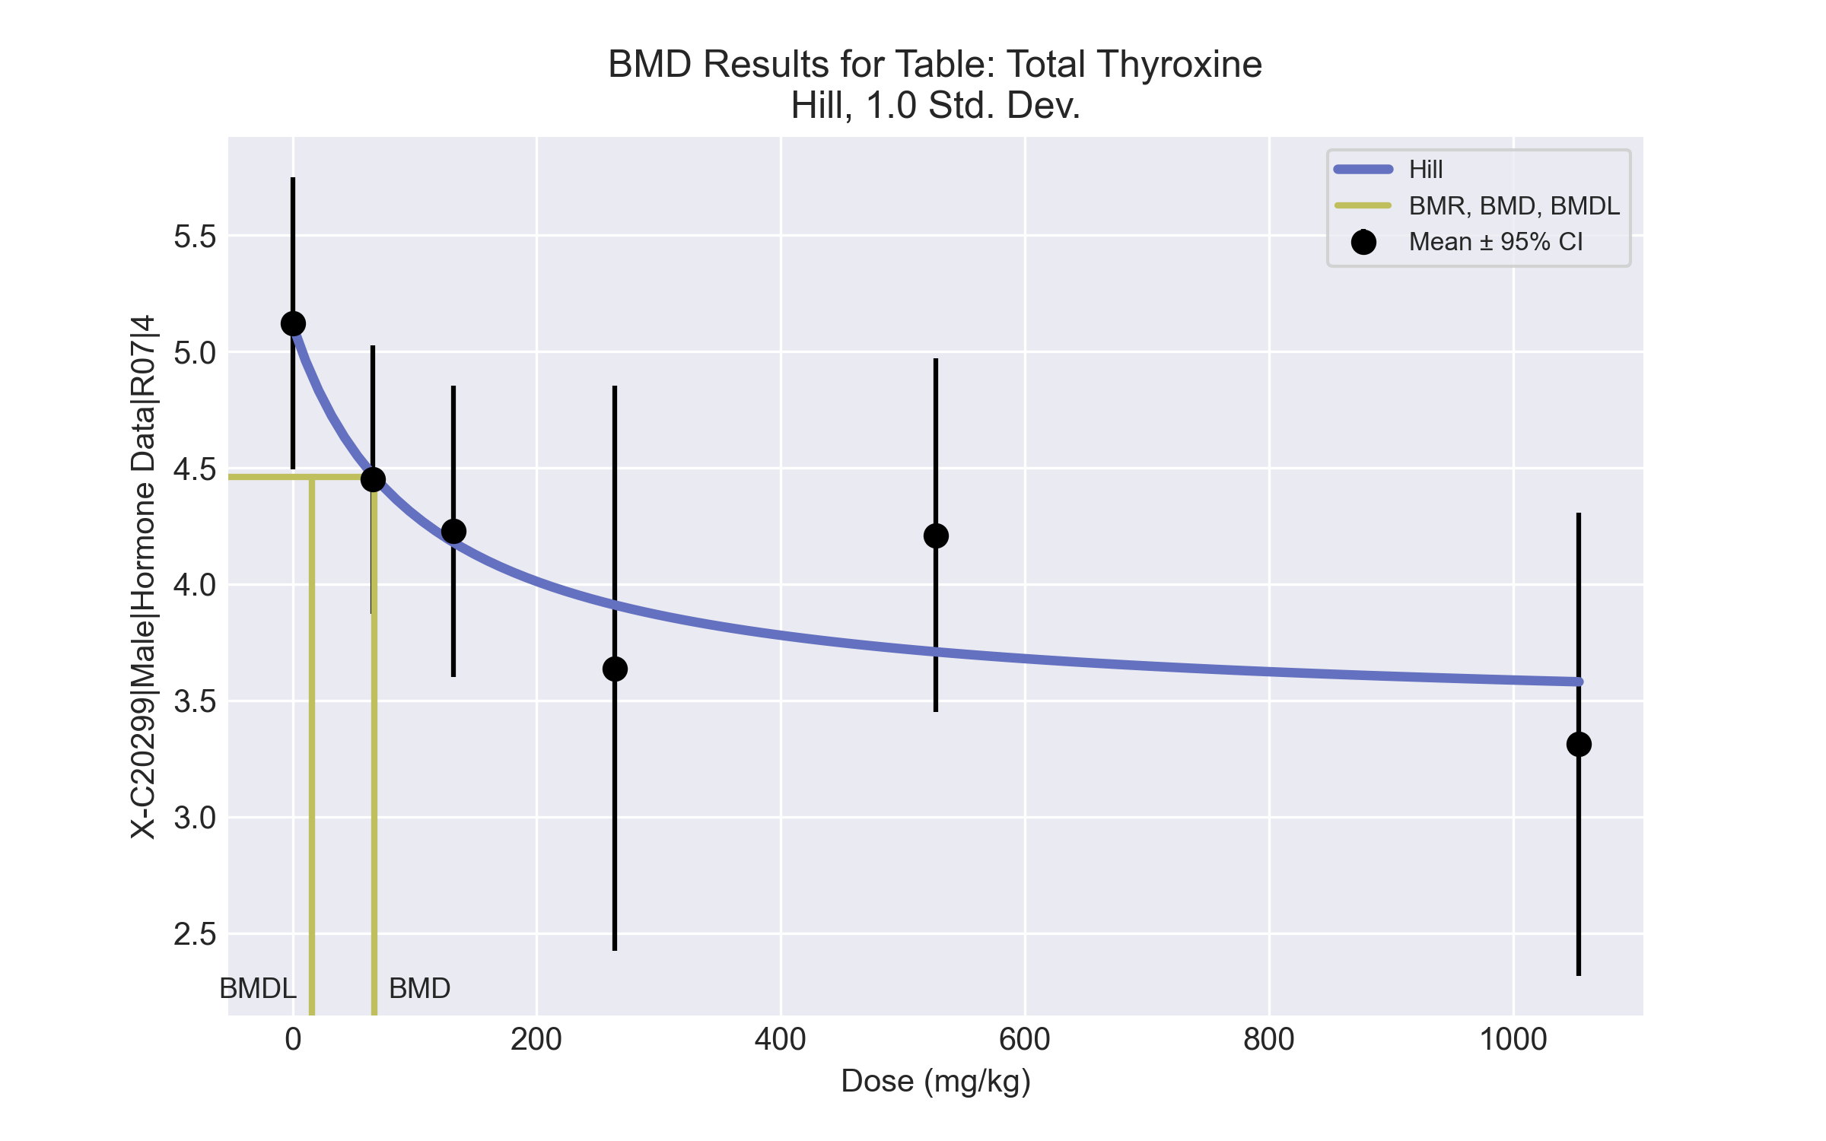
====================================================================
Hill Model. (Version: 2.18; Date: 03/14/2017)
Input Data File: C:\Windows\TEMP\bmds-jhpl8sxy.(d)
Gnuplot Plotting File: C:\Windows\TEMP\bmds-jhpl8sxy.plt
Tue May 18 15:28:38 2021
====================================================================
BMDS_Model_Run
~~~~~~~~~~~~~~~~~~~~~~~~~~~~~~~~~~~~~~~~~~~~~~~~~~~~~~~~~~~~~~~~~~~~~
The form of the response function is:
Y[dose] = intercept + v*dose^n/(k^n + dose^n)
Dependent variable = Response
Independent variable = Dose
rho is set to 0
Power parameter restricted to be greater than 1
A constant variance model is fit
Total number of dose groups = 6
Total number of records with missing values = 0
Maximum number of iterations = 500
Relative Function Convergence has been set to: 1e-008
Parameter Convergence has been set to: 1e-008
Default Initial Parameter Values
alpha = 0.450046
rho = 0 Specified
intercept = 5.122
v = -1.81
n = 1.07851
k = 134.461
Asymptotic Correlation Matrix of Parameter Estimates
( *** The model parameter(s) -rho -n
have been estimated at a boundary point, or have been specified by the user,
and do not appear in the correlation matrix )
alpha intercept v k
alpha 1 2.8e-006 -2.4e-006 -6.3e-007
intercept 2.8e-006 1 -0.54 -0.52
v -2.4e-006 -0.54 1 -0.32
k -6.3e-007 -0.52 -0.32 1
Parameter Estimates
95.0% Wald Confidence Interval
Variable Estimate Std. Err. Lower Conf. Limit Upper Conf. Limit
alpha 0.426686 0.11017 0.210758 0.642615
intercept 5.11457 0.292247 4.54178 5.68737
v -1.68926 0.411297 -2.49539 -0.883133
n 1 NA
k 106.293 93.8395 -77.6288 290.215
NA - Indicates that this parameter has hit a bound
implied by some inequality constraint and thus
has no standard error.
Table of Data and Estimated Values of Interest
Dose N Obs Mean Est Mean Obs Std Dev Est Std Dev Scaled Res.
------ --- -------- -------- ----------- ----------- ----------
0 5 5.12 5.11 0.507 0.653 0.0254
66 5 4.45 4.47 0.465 0.653 -0.0598
132 5 4.23 4.18 0.504 0.653 0.168
264 5 3.64 3.91 0.978 0.653 -0.932
527 5 4.21 3.71 0.612 0.653 1.72
1054 5 3.31 3.58 0.801 0.653 -0.918
Model Descriptions for likelihoods calculated
Model A1: Yij = Mu(i) + e(ij)
Var{e(ij)} = Sigma^2
Model A2: Yij = Mu(i) + e(ij)
Var{e(ij)} = Sigma(i)^2
Model A3: Yij = Mu(i) + e(ij)
Var{e(ij)} = Sigma^2
Model A3 uses any fixed variance parameters that
were specified by the user
Model R: Yi = Mu + e(i)
Var{e(i)} = Sigma^2
Likelihoods of Interest
Model Log(likelihood) # Param's AIC
A1 0.323220 7 13.353561
A2 2.675191 12 18.649618
A3 0.323220 7 13.353561
fitted -2.224432 4 12.448863
R -9.536877 2 23.073753
Explanation of Tests
Test 1: Do responses and/or variances differ among Dose levels?
(A2 vs. R)
Test 2: Are Variances Homogeneous? (A1 vs A2)
Test 3: Are variances adequately modeled? (A2 vs. A3)
Test 4: Does the Model for the Mean Fit? (A3 vs. fitted)
(Note: When rho=0 the results of Test 3 and Test 2 will be the same.)
Tests of Interest
Test -2*log(Likelihood Ratio) Test df p-value
Test 1 24.4241 10 0.006551
Test 2 4.70394 5 0.4531
Test 3 4.70394 5 0.4531
Test 4 5.0953 3 0.165
The p-value for Test 1 is less than .05. There appears to be a
difference between response and/or variances among the dose levels
It seems appropriate to model the data
The p-value for Test 2 is greater than .1. A homogeneous variance
model appears to be appropriate here
The p-value for Test 3 is greater than .1. The modeled variance appears
to be appropriate here
The p-value for Test 4 is greater than .1. The model chosen seems
to adequately describe the data
Benchmark Dose Computation
Specified effect = 1
Risk Type = Estimated standard deviations from the control mean
Confidence level = 0.95
BMD = 67.0162
BMDL = 15.6129
BMDU = 377.196

