Table 1. Structure of Compounds and Percent composition in IPP mixtureª.

Chemical Name | Structure | Percent Composition
TPHP | 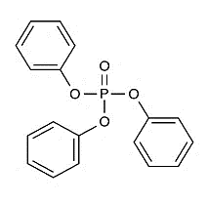 | 21.5%
Mono-IPP |  | 36.9%
Bis-IPP |  | 21.9%
Tris-IPP |  | 8.5%

ªThe IPP mixture is composed of TPHP and phenyl phosphate with mono-, bis- and tris- isopropyl side chains.

