Female BMD Results for Table: Liver Weight Absolute
BMDS version: BMDS v2.7.0

Input dataset
Dose | 0 | 0.15 | 0.5 | 1.4 | 4 | 12 | 37 | 111 | 333 | 1000
N | 10 | 5 | 5 | 5 | 5 | 5 | 5 | 5 | 5 | 5
Mean ± SD | 7.92 ± 1.3 | 8.474 ± 1.353 | 8.214 ± 0.482 | 7.8 ± 0.847 | 7.868 ± 1.026 | 8.15 ± 0.475 | 8.16 ± 0.534 | 7.868 ± 0.281 | 9.224 ± 0.397 | 12.018 ± 0.377

Summary table
Modelª | Goodness of fit |  | BMD | BMDL | Comments
 | p-value | AIC
Linear | 0.775 | 33.084 | 220.283 | 184.809 | No model was recommended as a best-fitting model. Doses were dropped until there were only 3 remaining dose-groups.
Polynomial 2° (equivalent models include Polynomial 3°, 4°, 5°, 6°, 7°, 8°) | 0.698 | 34.938 | 240.665 | 185.656
Power | 0.705 | 34.88 | 246.095 | 186.002
Hill | 0.658 | 36.387 | 282.368 | -999
Exponential M2 (equivalent models include Exponential M3) | 0.782 | 33.017 | 256.915 | 218.11
Exponential M4 | 0.68 | 35.091 | 219.881 | 162.44
Exponential M5 | 0.659 | 36.386 | 284.698 | 170.216
ª Modeled variance case presented (BMDS Test 2 p-value = 3.4E-04, BMDS Test 3 p-value = 0.005).

Model recommendation details
Model | Bin | Notes
Linear | Warning | Warnings  • Variance model poorly fits dataset (p-value 3 = 0.004616)
Polynomial 2° (equivalent models include Polynomial 3°, 4°, 5°, 6°, 7°, 8°) | Warning | Warnings  • Variance model poorly fits dataset (p-value 3 = 0.004616)
Power | Warning | Warnings  • Variance model poorly fits dataset (p-value 3 = 0.004616)
Hill | Failure | Failures  • BMDL does not exist  Warnings  • Variance model poorly fits dataset (p-value 3 = 0.004616)  Cautions  • Warning(s): BMDL computation failed.
Exponential M2 (equivalent models include Exponential M3) | Warning | Warnings  • Variance model poorly fits dataset (p-value 3 = 0.004616)
Exponential M4 | Warning | Warnings  • Variance model poorly fits dataset (p-value 3 = 0.004616)
Exponential M5 | Warning | Warnings  • Variance model poorly fits dataset (p-value 3 = 0.004616)

Recommended model
No model was recommended as a best-fitting model.

Female BMD Results for Table: Liver Weight Relative
BMDS version: BMDS v2.7.0

Input dataset
Dose | 0 | 0.15 | 0.5 | 1.4 | 4 | 12 | 37 | 111 | 333 | 1000
N | 10 | 5 | 5 | 5 | 5 | 5 | 5 | 5 | 5 | 5
Mean ± SD | 36.004 ± 2.271 | 37.504 ± 2.883 | 37.543 ± 0.863 | 35.52 ± 1.434 | 36.674 ± 2.523 | 37.148 ± 1.614 | 36.755 ± 1.025 | 36.404 ± 0.763 | 42.013 ± 1.109 | 53.976 ± 2.062

Summary table
Modelª | Goodness of fit |  | BMD | BMDL | Comments
 | p-value | AIC
Linear | 0.152 | 132.052 | 109.581 | 91.979 | No model was recommended as a best-fitting model. Doses were dropped until there were only 3 remaining dose-groups.
Polynomial 2° (equivalent models include Polynomial 5°, 6°, 7°, 8°) | 0.147 | 132.882 | 134.341 | 95.897
Polynomial 3° (equivalent models include Polynomial 4°) | 0.147 | 132.882 | 134.342 | 95.897
Power | 0.179 | 132.24 | 148.196 | 98.895
Hill | 0.369 | 130.574 | 302.32 | 143.094
Exponential M2 | 0.208 | 130.962 | 128.406 | 108.411
Exponential M3 | 0.152 | 132.765 | 143.12 | 109.068
Exponential M4 | 0.101 | 134.062 | 109.5 | 89.216
Exponential M5 | 0.369 | 130.574 | 304.527 | 143.251
ª Modeled variance case presented (BMDS Test 2 p-value = 0.024, BMDS Test 3 p-value = 0.014).

Model recommendation details
Model | Bin | Notes
Linear | Warning | Warnings  • Variance model poorly fits dataset (p-value 3 = 0.01397)
Polynomial 2° (equivalent models include Polynomial 5°, 6°, 7°, 8°) | Warning | Warnings  • Variance model poorly fits dataset (p-value 3 = 0.01397)
Polynomial 3° (equivalent models include Polynomial 4°) | Warning | Warnings  • Variance model poorly fits dataset (p-value 3 = 0.01397)
Power | Warning | Warnings  • Variance model poorly fits dataset (p-value 3 = 0.01397)
Hill | Warning | Warnings  • Variance model poorly fits dataset (p-value 3 = 0.01397)
Exponential M2 | Warning | Warnings  • Variance model poorly fits dataset (p-value 3 = 0.01397)
Exponential M3 | Warning | Warnings  • Variance model poorly fits dataset (p-value 3 = 0.01397)
Exponential M4 | Warning | Warnings  • Variance model poorly fits dataset (p-value 3 = 0.01397)
Exponential M5 | Warning | Warnings  • Variance model poorly fits dataset (p-value 3 = 0.01397)

Recommended model
No model was recommended as a best-fitting model.

Female BMD Results for Table: Aspartate Aminotransferase
BMDS version: BMDS v2.7.0

Input dataset
Dose | 0 | 0.15 | 0.5 | 1.4 | 4 | 12 | 37 | 111 | 333 | 1000
N | 10 | 5 | 5 | 5 | 5 | 5 | 5 | 5 | 5 | 5
Mean ± SD | 72.8 ± 5.613 | 73.6 ± 5.459 | 71.8 ± 4.55 | 76.4 ± 7.893 | 77 ± 5.788 | 75.6 ± 5.55 | 79.2 ± 6.648 | 74 ± 8.276 | 76 ± 6.124 | 103.6 ± 44.253

Summary table
Modelª | Goodness of fit |  | BMD | BMDL | Comments
 | p-value | AIC
Linear | 0.295 | 281.094 | 328.341 | 166.328 | Polynomial-2 recommended as best-fitting model on the basis of the lowest AIC.
Polynomial 2°^{b} | 0.413 | 280.572 | 497.046 | 340.458
Polynomial 3° | 0.382 | 281.829 | 581.505 | 276.527
Polynomial 4° | 0.398 | 281.671 | 633.117 | 280.386
Polynomial 5° | 0.402 | 281.625 | 678.281 | 281.014
Polynomial 6° | 0.404 | 281.61 | 715.667 | 281.061
Polynomial 7° | 0.404 | 281.605 | 746.075 | 281.034
Polynomial 8° | 0.404 | 281.604 | 770.868 | 281.014
Power | 0.386 | 281.789 | 653.695 | 319.255
Hill | 0.283 | 283.789 | 645.285 | -999
Exponential M2 | 0.239 | 282.752 | 349.77 | 181.833
Exponential M3 | 0.386 | 281.788 | 665.246 | 310.922
Exponential M4 | 0.151 | 285.098 | 328.082 | 158.902
Exponential M5 | 0.283 | 283.789 | 652.659 | 319.256
ª Modeled variance case presented (BMDS Test 2 p-value = <0.0001, BMDS Test 3 p-value = 0.967).
^{b} Recommended model

Model recommendation details
Model | Bin | Notes
Linear | Valid | Cautions  • Warning(s): THE MODEL HAS PROBABLY NOT CONVERGED!!!; THIS USUALLY MEANS THE MODEL HAS NOT CONVERGED!
Polynomial 2°ª | Valid | -
Polynomial 3° | Valid | -
Polynomial 4° | Valid | -
Polynomial 5° | Valid | -
Polynomial 6° | Valid | -
Polynomial 7° | Valid | -
Polynomial 8° | Valid | -
Power | Valid | -
Hill | Failure | Failures  • BMDL does not exist  Cautions  • Warning(s): BMDL computation failed.
Exponential M2 | Valid | -
Exponential M3 | Valid | -
Exponential M4 | Valid | -
Exponential M5 | Valid | -
ª Recommended model

Recommended model
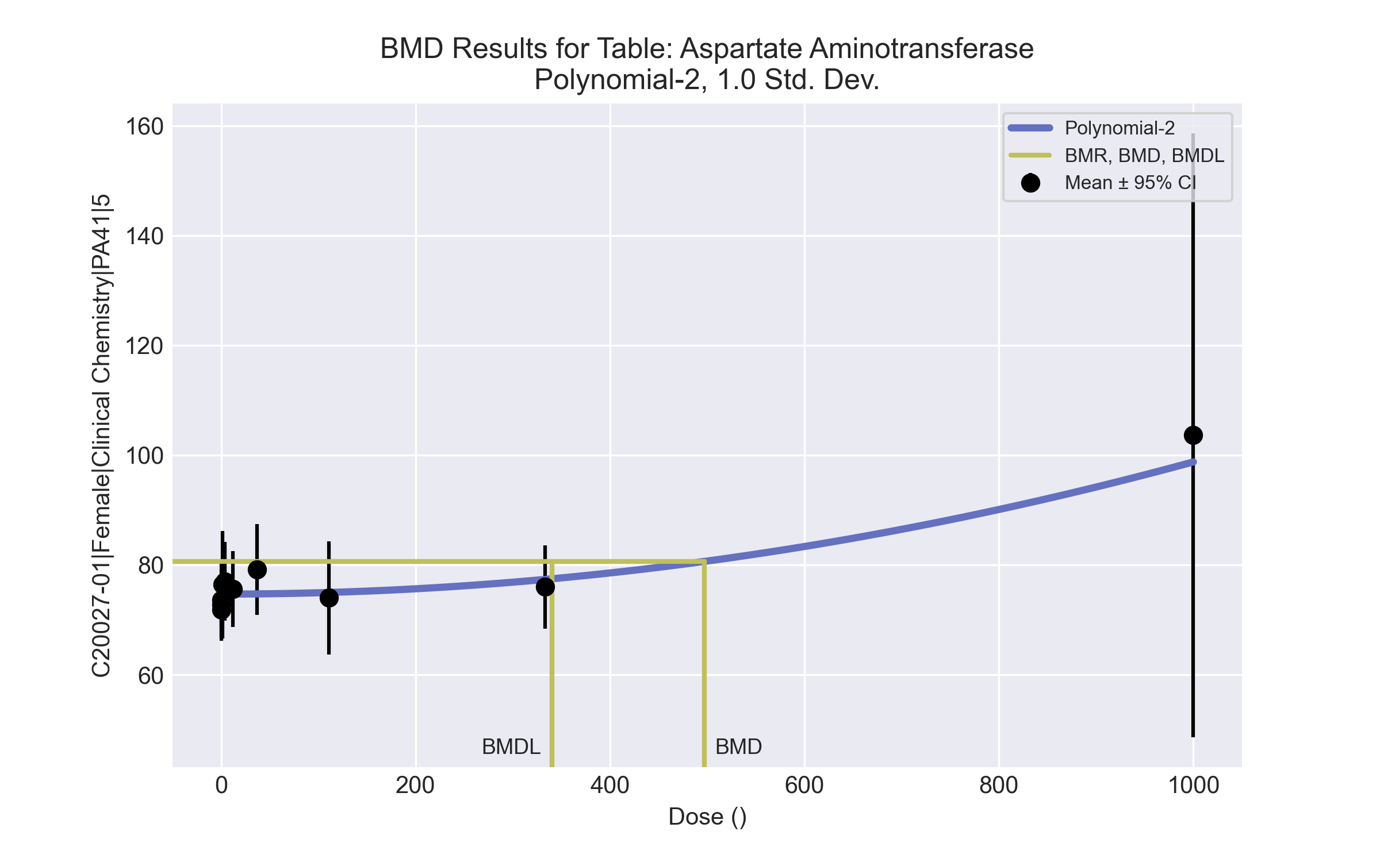
====================================================================
Polynomial Model. (Version: 2.21; Date: 03/14/2017)
Input Data File: C:\Windows\TEMP\bmds-06a6bhmm.(d)
Gnuplot Plotting File: C:\Windows\TEMP\bmds-06a6bhmm.plt
Thu Apr 15 13:45:31 2021
====================================================================
BMDS_Model_Run
~~~~~~~~~~~~~~~~~~~~~~~~~~~~~~~~~~~~~~~~~~~~~~~~~~~~~~~~~~~~~~~~~~~~~
The form of the response function is:
Y[dose] = beta_0 + beta_1*dose + beta_2*dose^2 + ...
Dependent variable = Response
Independent variable = Dose
The polynomial coefficients are restricted to be positive
The variance is to be modeled as Var(i) = exp(lalpha + log(mean(i)) * rho)
Total number of dose groups = 10
Total number of records with missing values = 0
Maximum number of iterations = 500
Relative Function Convergence has been set to: 1e-008
Parameter Convergence has been set to: 1e-008
Default Initial Parameter Values
lalpha = 5.34456
rho = 0
beta_0 = 75.1017
beta_1 = 0
beta_2 = 0
Asymptotic Correlation Matrix of Parameter Estimates
( *** The model parameter(s) -beta_1
have been estimated at a boundary point, or have been specified by the user,
and do not appear in the correlation matrix )
lalpha rho beta_0 beta_2
lalpha 1 -1 -0.00035 0.011
rho -1 1 0.00043 -0.011
beta_0 -0.00035 0.00043 1 -0.26
beta_2 0.011 -0.011 -0.26 1
Parameter Estimates
95.0% Wald Confidence Interval
Variable Estimate Std. Err. Lower Conf. Limit Upper Conf. Limit
lalpha -54.4827 10.1527 -74.3816 -34.5838
rho 13.4581 2.3377 8.87625 18.0399
beta_0 74.6848 0.889435 72.9416 76.4281
beta_1 2.58494e-029 NA
beta_2 2.40701e-005 1.97954e-005 -1.47281e-005 6.28683e-005
NA - Indicates that this parameter has hit a bound
implied by some inequality constraint and thus
has no standard error.
Table of Data and Estimated Values of Interest
Dose N Obs Mean Est Mean Obs Std Dev Est Std Dev Scaled Res.
------ --- -------- -------- ----------- ----------- ----------
0 10 72.8 74.7 5.61 5.95 -1
0.15 5 73.6 74.7 5.46 5.95 -0.408
0.5 5 71.8 74.7 4.55 5.95 -1.08
1.4 5 76.4 74.7 7.89 5.95 0.645
4 5 77 74.7 5.79 5.95 0.87
12 5 75.6 74.7 5.55 5.95 0.343
37 5 79.2 74.7 6.65 5.96 1.68
111 5 74 75 8.28 6.11 -0.359
333 5 76 77.4 6.12 7.53 -0.402
1000 5 104 98.8 44.3 39 0.278
Model Descriptions for likelihoods calculated
Model A1: Yij = Mu(i) + e(ij)
Var{e(ij)} = Sigma^2
Model A2: Yij = Mu(i) + e(ij)
Var{e(ij)} = Sigma(i)^2
Model A3: Yij = Mu(i) + e(ij)
Var{e(ij)} = exp(lalpha + rho*ln(Mu(i)))
Model A3 uses any fixed variance parameters that
were specified by the user
Model R: Yi = Mu + e(i)
Var{e(i)} = Sigma^2
Likelihoods of Interest
Model Log(likelihood) # Param's AIC
A1 -168.957083 11 359.914167
A2 -130.992657 20 301.985313
A3 -132.181824 12 288.363648
fitted -136.285898 4 280.571797
R -178.638723 2 361.277447
Explanation of Tests
Test 1: Do responses and/or variances differ among Dose levels?
(A2 vs. R)
Test 2: Are Variances Homogeneous? (A1 vs A2)
Test 3: Are variances adequately modeled? (A2 vs. A3)
Test 4: Does the Model for the Mean Fit? (A3 vs. fitted)
(Note: When rho=0 the results of Test 3 and Test 2 will be the same.)
Tests of Interest
Test -2*log(Likelihood Ratio) Test df p-value
Test 1 95.2921 18 <.0001
Test 2 75.9289 9 <.0001
Test 3 2.37834 8 0.9672
Test 4 8.20815 8 0.4134
The p-value for Test 1 is less than .05. There appears to be a
difference between response and/or variances among the dose levels
It seems appropriate to model the data
The p-value for Test 2 is less than .1. A non-homogeneous variance
model appears to be appropriate
The p-value for Test 3 is greater than .1. The modeled variance appears
to be appropriate here
The p-value for Test 4 is greater than .1. The model chosen seems
to adequately describe the data
Benchmark Dose Computation
Specified effect = 1
Risk Type = Estimated standard deviations from the control mean
Confidence level = 0.95
BMD = 497.046
BMDL = 340.458
BMDU = 694.186

Female BMD Results for Table: Bile salts/acids
BMDS version: BMDS v2.7.0

Input dataset
Dose | 0 | 0.15 | 0.5 | 1.4 | 4 | 12 | 37 | 111 | 333 | 1000ª
N | 10 | 5 | 5 | 5 | 5 | 5 | 5 | 5 | 5 | 5
Mean ± SD | 15.7 ± 5.143 | 26.2 ± 7.791 | 16.4 ± 5.273 | 21.2 ± 10.964 | 19.8 ± 8.044 | 17.6 ± 8.562 | 27 ± 14.23 | 21.8 ± 10.895 | 30 ± 12.39 | 24.8 ± 16.3
ª Dose group removed in BMD modeling session

Summary table
Modelª | Goodness of fit |  | BMD | BMDL | Comments
 | p-value | AIC
Linear (equivalent models include Power, Polynomial 2°, 3°, 4°, 5°, 6°, 7°, 8°) | 0.28 | 277.398 | 286.331 | 169.743 | Exponential-M4 recommended as best-fitting model on the basis of the lowest BMDL.
Hill | 0.208 | 279.203 | 253.883 | 26.123
Exponential M2 (equivalent models include Exponential M3) | 0.274 | 277.476 | 295.921 | 196.52
Exponential M4^{b} (equivalent models include Exponential M5) | 0.203 | 279.27 | 257.017 | 21.486
ª Constant variance case presented (BMDS Test 2 p-value = 0.204, BMDS Test 3 p-value = 0.204).
^{b} Recommended model

Model recommendation details
Model | Bin | Notes
Linear (equivalent models include Power, Polynomial 2°, 3°, 4°, 5°, 6°, 7°, 8°) | Warning | Warnings  • Ratio of modeled to actual stdev. at control is greater than threshold (1.78 > 1.5)
Hill | Warning | Warnings  • Ratio of modeled to actual stdev. at control is greater than threshold (1.78 > 1.5)  Cautions  • BMD/BMDL ratio is greater than threshold (9.72 > 5.0)
Exponential M2 (equivalent models include Exponential M3) | Valid | -
Exponential M4ª (equivalent models include Exponential M5) | Valid | Cautions  • BMD/BMDL ratio is greater than threshold (12.0 > 5.0)
ª Recommended model

Recommended model
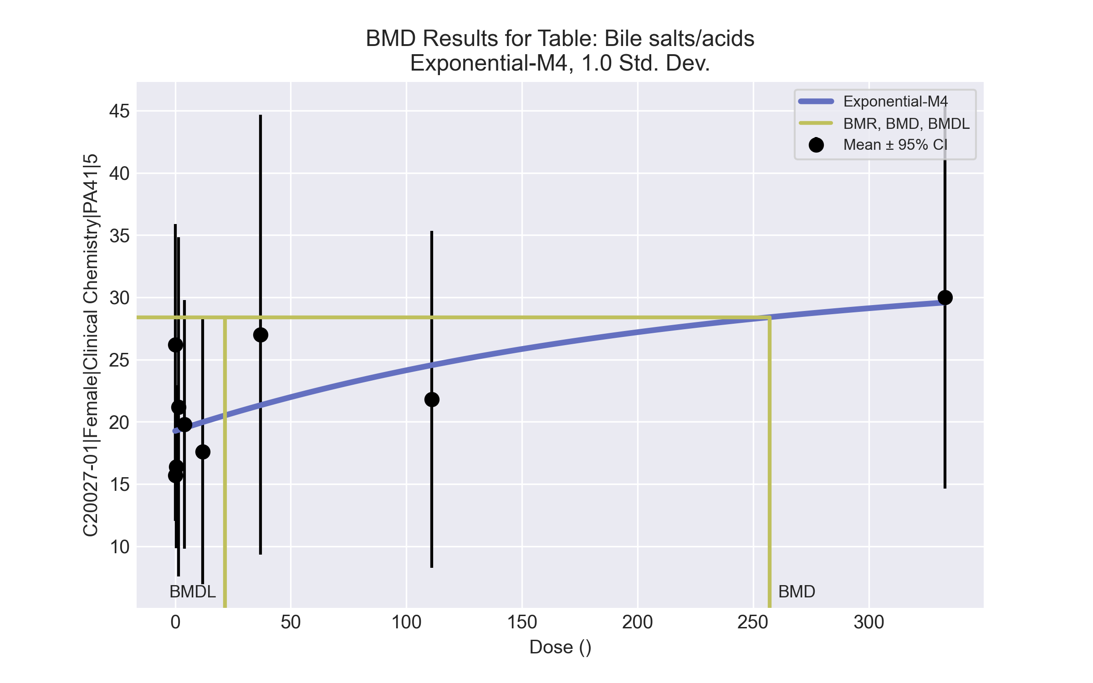
====================================================================
Exponential Model. (Version: 1.11; Date: 03/14/2017)
Input Data File: C:\Windows\TEMP\bmds-nyiku0fr.(d)
Gnuplot Plotting File:
Thu Apr 15 13:45:55 2021
====================================================================
BMDS_Model_Run
~~~~~~~~~~~~~~~~~~~~~~~~~~~~~~~~~~~~~~~~~~~~~~~~~~~~~~~~~~~~~~~~~~~~~
The form of the response function by Model:
Model 2: Y[dose] = a * exp{sign * b * dose}
Model 3: Y[dose] = a * exp{sign * (b * dose)^d}
Model 4: Y[dose] = a * [c-(c-1) * exp{-b * dose}]
Model 5: Y[dose] = a * [c-(c-1) * exp{-(b * dose)^d}]
Note: Y[dose] is the median response for exposure = dose;
sign = +1 for increasing trend in data;
sign = -1 for decreasing trend.
Model 2 is nested within Models 3 and 4.
Model 3 is nested within Model 5.
Model 4 is nested within Model 5.
Dependent variable = Response
Independent variable = Dose
Data are assumed to be distributed: normally
Variance Model: exp(lnalpha +rho *ln(Y[dose]))
rho is set to 0.
A constant variance model is fit.
Total number of dose groups = 9
Total number of records with missing values = 0
Maximum number of iterations = 500
Relative Function Convergence has been set to: 1e-008
Parameter Convergence has been set to: 1e-008
MLE solution provided: Exact
Initial Parameter Values
Variable Model 4
-------- --------
lnalpha 4.25524
rho 0 Specified
a 14.915
b 0.00731443
c 2.11197
d 1 Specified
Parameter Estimates
Variable Model 4 Std. Err.
-------- ------- ---------
lnalpha 4.42541 16.7094
a 19.2643 1.664
b 0.0046553 0.0138447
c 1.68001 0.976015
NC = No Convergence
Table of Stats From Input Data
Dose N Obs Mean Obs Std Dev
----- --- ---------- -------------
0 10 15.7 5.143
0.15 5 26.2 7.791
0.5 5 16.4 5.273
1.4 5 21.2 10.96
4 5 19.8 8.044
12 5 17.6 8.562
37 5 27 14.23
111 5 21.8 10.89
333 5 30 12.39
Estimated Values of Interest
Dose Est Mean Est Std Scaled Residual
------ ---------- --------- ----------------
0 19.26 9.14 -1.233
0.15 19.27 9.14 1.694
0.5 19.29 9.14 -0.7082
1.4 19.35 9.14 0.4527
4 19.51 9.14 0.07193
12 19.98 9.14 -0.5813
37 21.34 9.14 1.385
111 24.55 9.14 -0.6729
333 29.58 9.14 0.1017
Other models for which likelihoods are calculated:
Model A1: Yij = Mu(i) + e(ij)
Var{e(ij)} = Sigma^2
Model A2: Yij = Mu(i) + e(ij)
Var{e(ij)} = Sigma(i)^2
Model A3: Yij = Mu(i) + e(ij)
Var{e(ij)} = exp(lalpha + log(mean(i)) * rho)
Model R: Yij = Mu + e(i)
Var{e(ij)} = Sigma^2
Likelihoods of Interest
Model Log(likelihood) DF AIC
------- ----------------- ---- ------------
A1 -131.3811 10 282.7622
A2 -125.9014 18 287.8028
A3 -131.3811 10 282.7622
R -138.5718 2 281.1437
4 -135.6352 4 279.2704
Additive constant for all log-likelihoods = -45.95. This constant added to the
above values gives the log-likelihood including the term that does not
depend on the model parameters.
Explanation of Tests
Test 1: Does response and/or variances differ among Dose levels? (A2 vs. R)
Test 2: Are Variances Homogeneous? (A2 vs. A1)
Test 3: Are variances adequately modeled? (A2 vs. A3)
Test 6a: Does Model 4 fit the data? (A3 vs 4)
Tests of Interest
Test -2*log(Likelihood Ratio) D. F. p-value
-------- ------------------------ ------ --------------
Test 1 25.34 16 0.06404
Test 2 10.96 8 0.204
Test 3 10.96 8 0.204
Test 6a 8.508 6 0.2032
The p-value for Test 1 is greater than .05. There may not be a
diffence between responses and/or variances among the dose levels
Modelling the data with a dose/response curve may not be appropriate.
The p-value for Test 2 is greater than .1. A homogeneous
variance model appears to be appropriate here.
The p-value for Test 3 is greater than .1. The modeled
variance appears to be appropriate here.
The p-value for Test 6a is greater than .1. Model 4 seems
to adequately describe the data.
Benchmark Dose Computations:
Specified Effect = 1.000000
Risk Type = Estimated standard deviations from control
Confidence Level = 0.950000
BMD = 257.017
BMDL = 21.4864
BMDU = 3.33e+006

Female BMD Results for Table: Cholesterol
BMDS version: BMDS v2.7.0

Input dataset
Dose | 0 | 0.15 | 0.5 | 1.4 | 4 | 12ª | 37ª | 111ª | 333ª | 1000ª
N | 10 | 5 | 5 | 5 | 5 | 5 | 5 | 5 | 5 | 5
Mean ± SD | 95.6 ± 15.543 | 100.6 ± 17.242 | 104.8 ± 17.992 | 93.6 ± 26.623 | 82.2 ± 8.585 | 84.8 ± 4.97 | 90.4 ± 6.107 | 92.8 ± 7.014 | 38 ± 10.124 | 54 ± 15.166
ª Dose group removed in BMD modeling session

Summary table
Modelª | Goodness of fit |  | BMD | BMDL | Comments
 | p-value | AIC
Linear | 0.647 | 204.428 | 4.032 | 2.147 | Exponential-M5 recommended as best-fitting model on the basis of the lowest BMDL.
Polynomial 2° (equivalent models include Polynomial 4°, 5°, 8°) | 0.713 | 204.143 | 3.985 | 2.203
Polynomial 3° (equivalent models include Polynomial 6°) | 0.713 | 204.143 | 3.985 | 2.934
Polynomial 7° | 0.713 | 204.143 | 3.985 | 2.934
Power | 0.509 | 206.127 | 3.963 | 2.206
Hill | 0.29 | 207.895 | 1.763 | 0.639
Exponential M2 (equivalent models include Exponential M4) | 0.637 | 204.475 | 4.098 | 2.008
Exponential M3 | 0.511 | 206.119 | 3.955 | 2.085
Exponential M5^{b} | 0.29 | 207.895 | 1.591 | 0.58
ª Constant variance case presented (BMDS Test 2 p-value = 0.22, BMDS Test 3 p-value = 0.22).
^{b} Recommended model

Model recommendation details
Model | Bin | Notes
Linear | Warning | Warnings  • BMD/high dose ratio is greater than threshold (1.01 > 1.0)
Polynomial 2° (equivalent models include Polynomial 4°, 5°, 8°) | Valid | -
Polynomial 3° (equivalent models include Polynomial 6°) | Valid | -
Polynomial 7° | Valid | -
Power | Valid | -
Hill | Valid | -
Exponential M2 (equivalent models include Exponential M4) | Warning | Warnings  • BMD/high dose ratio is greater than threshold (1.02 > 1.0)
Exponential M3 | Valid | -
Exponential M5ª | Valid | -
ª Recommended model

Recommended model
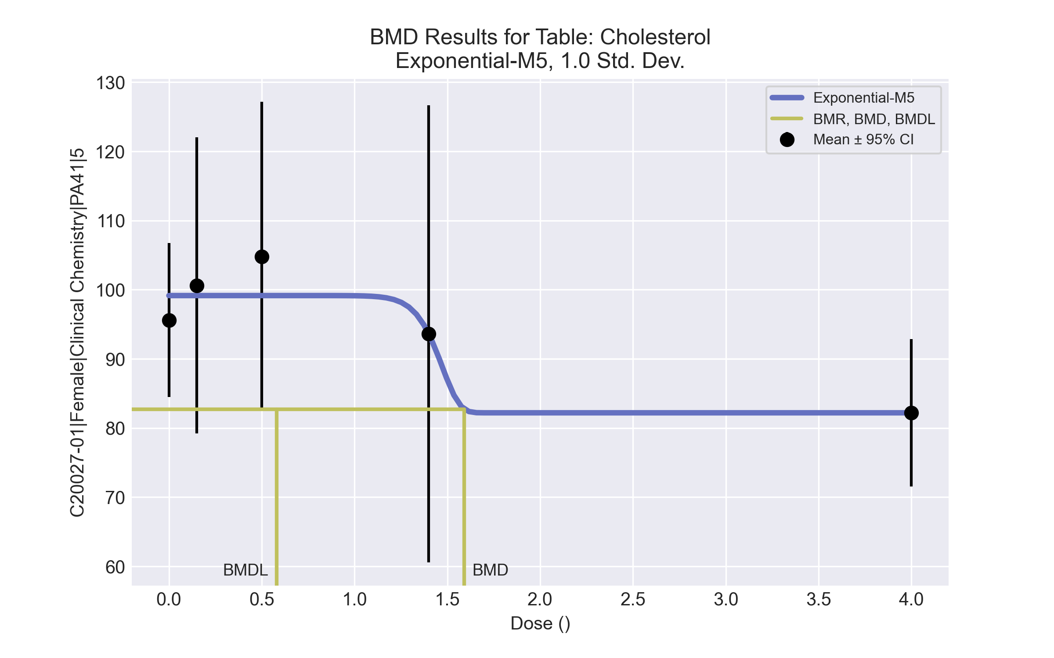
====================================================================
Exponential Model. (Version: 1.11; Date: 03/14/2017)
Input Data File: C:\Windows\TEMP\bmds-_g_hf_x9.(d)
Gnuplot Plotting File:
Thu Apr 15 13:46:49 2021
====================================================================
BMDS_Model_Run
~~~~~~~~~~~~~~~~~~~~~~~~~~~~~~~~~~~~~~~~~~~~~~~~~~~~~~~~~~~~~~~~~~~~~
The form of the response function by Model:
Model 2: Y[dose] = a * exp{sign * b * dose}
Model 3: Y[dose] = a * exp{sign * (b * dose)^d}
Model 4: Y[dose] = a * [c-(c-1) * exp{-b * dose}]
Model 5: Y[dose] = a * [c-(c-1) * exp{-(b * dose)^d}]
Note: Y[dose] is the median response for exposure = dose;
sign = +1 for increasing trend in data;
sign = -1 for decreasing trend.
Model 2 is nested within Models 3 and 4.
Model 3 is nested within Model 5.
Model 4 is nested within Model 5.
Dependent variable = Response
Independent variable = Dose
Data are assumed to be distributed: normally
Variance Model: exp(lnalpha +rho *ln(Y[dose]))
rho is set to 0.
A constant variance model is fit.
Total number of dose groups = 5
Total number of records with missing values = 0
Maximum number of iterations = 500
Relative Function Convergence has been set to: 1e-008
Parameter Convergence has been set to: 1e-008
MLE solution provided: Exact
Initial Parameter Values
Variable Model 5
-------- --------
lnalpha 5.55919
rho 0 Specified
a 110.04
b 0.52311
c 0.71143
d 1
Parameter Estimates
Variable Model 5 Std. Err.
-------- ------- ---------
lnalpha 5.59651 69.5807
a 99.15 3.67073
b 0.676323 15.4063
c 0.829047 0.0801534
d 16.932 7062.48
NC = No Convergence
Table of Stats From Input Data
Dose N Obs Mean Obs Std Dev
----- --- ---------- -------------
0 10 95.6 15.54
0.15 5 100.6 17.24
0.5 5 104.8 17.99
1.4 5 93.6 26.62
4 5 82.2 8.585
Estimated Values of Interest
Dose Est Mean Est Std Scaled Residual
------ ---------- --------- ----------------
0 99.15 16.42 -0.6839
0.15 99.15 16.42 0.1975
0.5 99.15 16.42 0.7696
1.4 93.6 16.42 -3.158e-008
4 82.2 16.42 1.523e-009
Other models for which likelihoods are calculated:
Model A1: Yij = Mu(i) + e(ij)
Var{e(ij)} = Sigma^2
Model A2: Yij = Mu(i) + e(ij)
Var{e(ij)} = Sigma(i)^2
Model A3: Yij = Mu(i) + e(ij)
Var{e(ij)} = exp(lalpha + log(mean(i)) * rho)
Model R: Yij = Mu + e(i)
Var{e(ij)} = Sigma^2
Likelihoods of Interest
Model Log(likelihood) DF AIC
------- ----------------- ---- ------------
A1 -98.3879 6 208.7758
A2 -95.52352 10 211.047
A3 -98.3879 6 208.7758
R -100.9729 2 205.9458
5 -98.94769 5 207.8954
Additive constant for all log-likelihoods = -27.57. This constant added to the
above values gives the log-likelihood including the term that does not
depend on the model parameters.
Explanation of Tests
Test 1: Does response and/or variances differ among Dose levels? (A2 vs. R)
Test 2: Are Variances Homogeneous? (A2 vs. A1)
Test 3: Are variances adequately modeled? (A2 vs. A3)
Test 7a: Does Model 5 fit the data? (A3 vs 5)
Tests of Interest
Test -2*log(Likelihood Ratio) D. F. p-value
-------- ------------------------ ------ --------------
Test 1 10.9 8 0.2075
Test 2 5.729 4 0.2203
Test 3 5.729 4 0.2203
Test 7a 1.12 1 0.29
The p-value for Test 1 is greater than .05. There may not be a
diffence between responses and/or variances among the dose levels
Modelling the data with a dose/response curve may not be appropriate.
The p-value for Test 2 is greater than .1. A homogeneous
variance model appears to be appropriate here.
The p-value for Test 3 is greater than .1. The modeled
variance appears to be appropriate here.
The p-value for Test 7a is greater than .1. Model 5 seems
to adequately describe the data.
Benchmark Dose Computations:
Specified Effect = 1.000000
Risk Type = Estimated standard deviations from control
Confidence Level = 0.950000
BMD = 1.59098
BMDL = 0.579739
BMDU = 40000

Female BMD Results for Table: Creatinine
BMDS version: BMDS v2.7.0

Input dataset
Dose | 0 | 0.15 | 0.5 | 1.4 | 4 | 12 | 37 | 111 | 333 | 1000
N | 10 | 5 | 5 | 5 | 5 | 5 | 5 | 5 | 5 | 5
Mean ± SD | 0.41 ± 0.057 | 0.4 ± 0 | 0.44 ± 0.055 | 0.42 ± 0.045 | 0.44 ± 0.055 | 0.42 ± 0.045 | 0.48 ± 0.045 | 0.4 ± 0 | 0.46 ± 0.055 | 0.46 ± 0.055

Summary table
Modelª | Goodness of fit |  | BMD | BMDL | Comments
 | p-value | AIC
Linear (equivalent models include Power, Polynomial 2°, 3°, 4°, 5°, 6°, 7°) | <0.0001 | -269.626 | 1195.15 | 555.747 | No model was recommended as a best-fitting model. Doses were dropped until there were only 3 remaining dose-groups.
Polynomial 8° | <0.0001 | -268.549 | -9999 | -999
Hill | <0.0001 | -269.644 | -999 | -999
Exponential M2 | -999 | 1495.624 | 611883 | 341.628
Exponential M3 | -999 | -224.8 | 896911 | -999
Exponential M4 | -999 | -26.965 | -999 | 0
Exponential M5 | -999 | -24.95 | -999 | 0
ª Modeled variance case presented (BMDS Test 2 p-value = <0.0001, BMDS Test 3 p-value = <0.0001).

Model recommendation details
Model | Bin | Notes
Linear (equivalent models include Power, Polynomial 2°, 3°, 4°, 5°, 6°, 7°) | Warning | Warnings  • Variance model poorly fits dataset (p-value 3 = 0.0001)  • BMD/high dose ratio is greater than threshold (1.2 > 1.0)  Cautions  • Warning(s): Warning: Likelihood for fitted model larger than the Likelihood for model A3.
Polynomial 8° | Failure | Failures  • BMDL does not exist  Warnings  • Residual of Interest does not exist  • Variance model poorly fits dataset (p-value 3 = 0.0001)  Cautions  • Warning(s): THIS USUALLY MEANS THE MODEL HAS NOT CONVERGED!; BMD = 100*(maximum dose); BMDL computation failed.; Warning: Likelihood for fitted model larger than the Likelihood for model A3.
Hill | Failure | Failures  • BMD does not exist  • BMDL does not exist  Warnings  • Residual of Interest does not exist  • Variance model poorly fits dataset (p-value 3 = 0.0001)  Cautions  • Warning(s): BMR value is not in the range of the mean function
Exponential M2 | Warning | Warnings  • BMD/BMDL ratio is greater than threshold (1.79e+03 > 20.0)  • BMD/high dose ratio is greater than threshold (6.12e+02 > 1.0)  Cautions  • BMD/BMDL ratio is greater than threshold (1.79e+03 > 5.0)
Exponential M3 | Failure | Failures  • BMDL does not exist  Warnings  • BMD/high dose ratio is greater than threshold (8.97e+02 > 1.0)  • Residual at lowest dose is greater than threshold (2.83 > 2.0)
Exponential M4 | Failure | Failures  • BMD does not exist  Warnings  • Residual of Interest does not exist  • Residual at lowest dose is greater than threshold (3.04 > 2.0)
Exponential M5 | Failure | Failures  • BMD does not exist  Warnings  • Residual of Interest does not exist  • Residual at lowest dose is greater than threshold (3.02 > 2.0)

Recommended model
No model was recommended as a best-fitting model.

Female BMD Results for Table: Triglycerides
BMDS version: BMDS v2.7.0

Input dataset
Dose | 0 | 0.15 | 0.5 | 1.4 | 4 | 12 | 37ª | 111ª | 333ª | 1000ª
N | 10 | 5 | 5 | 5 | 5 | 5 | 5 | 5 | 5 | 5
Mean ± SD | 70.9 ± 32.882 | 68.6 ± 42.01 | 45.4 ± 14.153 | 40.6 ± 17.184 | 34.6 ± 20.756 | 39.4 ± 11.739 | 47 ± 23.558 | 53 ± 17.321 | 111 ± 15.859 | 143.2 ± 56.331
ª Dose group removed in BMD modeling session

Summary table
Modelª | Goodness of fit |  | BMD | BMDL | Comments
 | p-value | AIC
Linear (equivalent models include Power, Polynomial 3°, 4°, 5°, 6°) | 0.015 | 268.534 | 21.641 | 11.162 | Exponential-M4 recommended as best-fitting model on the basis of the lowest AIC.
Polynomial 2° (equivalent models include Polynomial 7°) | 0.015 | 268.534 | 21.641 | 11.162
Polynomial 8° | 5.0E-04 | 276.361 | -9999 | -999
Hill | 0.836 | 260.603 | -999 | -999
Exponential M2 (equivalent models include Exponential M3) | 0.018 | 268.148 | 24.51 | 9.52
Exponential M4^{b} | 0.493 | 260.648 | 1.518 | 0.255
Exponential M5 | 0.836 | 260.603 | -999 | 0
ª Modeled variance case presented (BMDS Test 2 p-value = 0.019, BMDS Test 3 p-value = 0.602).
^{b} Recommended model

Model recommendation details
Model | Bin | Notes
Linear (equivalent models include Power, Polynomial 3°, 4°, 5°, 6°) | Warning | Warnings  • Goodness of fit p-value is less than threshold (0.0153 < 0.1)  • BMD/high dose ratio is greater than threshold (1.8 > 1.0)
Polynomial 2° (equivalent models include Polynomial 7°) | Warning | Warnings  • Goodness of fit p-value is less than threshold (0.0153 < 0.1)  • BMD/high dose ratio is greater than threshold (1.8 > 1.0)
Polynomial 8° | Failure | Failures  • BMDL does not exist  Warnings  • Residual of Interest does not exist  • Goodness of fit p-value is less than threshold (0.000498 < 0.1)  Cautions  • Warning(s): THIS USUALLY MEANS THE MODEL HAS NOT CONVERGED!; BMD = 100*(maximum dose); BMDL computation failed.
Hill | Failure | Failures  • BMD does not exist  • BMDL does not exist  Warnings  • Residual of Interest does not exist  Cautions  • Warning(s): BMR value is not in the range of the mean function
Exponential M2 (equivalent models include Exponential M3) | Warning | Warnings  • Goodness of fit p-value is less than threshold (0.0181 < 0.1)  • BMD/high dose ratio is greater than threshold (2.04 > 1.0)
Exponential M4ª | Valid | Cautions  • BMD/BMDL ratio is greater than threshold (5.95 > 5.0)
Exponential M5 | Failure | Failures  • BMD does not exist  Warnings  • Residual of Interest does not exist
ª Recommended model

Recommended model
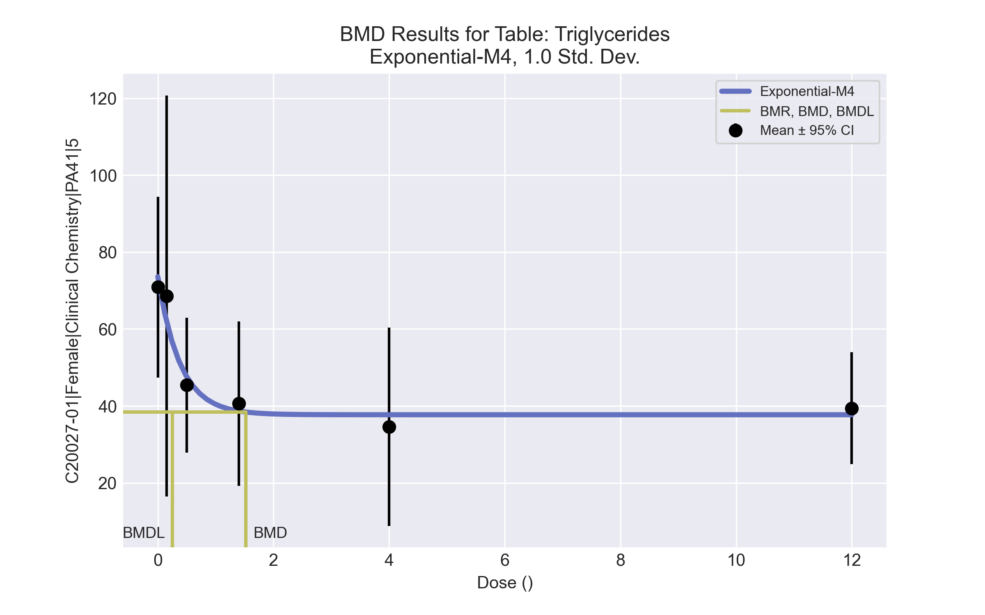
====================================================================
Exponential Model. (Version: 1.11; Date: 03/14/2017)
Input Data File: C:\Windows\TEMP\bmds-tw0_3cmf.(d)
Gnuplot Plotting File:
Thu Apr 15 13:48:19 2021
====================================================================
BMDS_Model_Run
~~~~~~~~~~~~~~~~~~~~~~~~~~~~~~~~~~~~~~~~~~~~~~~~~~~~~~~~~~~~~~~~~~~~~
The form of the response function by Model:
Model 2: Y[dose] = a * exp{sign * b * dose}
Model 3: Y[dose] = a * exp{sign * (b * dose)^d}
Model 4: Y[dose] = a * [c-(c-1) * exp{-b * dose}]
Model 5: Y[dose] = a * [c-(c-1) * exp{-(b * dose)^d}]
Note: Y[dose] is the median response for exposure = dose;
sign = +1 for increasing trend in data;
sign = -1 for decreasing trend.
Model 2 is nested within Models 3 and 4.
Model 3 is nested within Model 5.
Model 4 is nested within Model 5.
Dependent variable = Response
Independent variable = Dose
Data are assumed to be distributed: normally
Variance Model: exp(lnalpha +rho *ln(Y[dose]))
The variance is to be modeled as Var(i) = exp(lalpha + log(mean(i)) * rho)
Total number of dose groups = 6
Total number of records with missing values = 0
Maximum number of iterations = 500
Relative Function Convergence has been set to: 1e-008
Parameter Convergence has been set to: 1e-008
MLE solution provided: Exact
Initial Parameter Values
Variable Model 4
-------- --------
lnalpha -4.03687
rho 2.61177
a 74.445
b 0.235703
c 0.442641
d 1 Specified
Parameter Estimates
Variable Model 4 Std. Err.
-------- ------- ---------
lnalpha -4.03693 4.19401
rho 2.59561 1.06922
a 73.5994 10.1082
b 2.58242 1.52944
c 0.51242 0.0877637
NC = No Convergence
Table of Stats From Input Data
Dose N Obs Mean Obs Std Dev
----- --- ---------- -------------
0 10 70.9 32.88
0.15 5 68.6 42.01
0.5 5 45.4 14.15
1.4 5 40.6 17.18
4 5 34.6 20.76
12 5 39.4 11.74
Estimated Values of Interest
Dose Est Mean Est Std Scaled Residual
------ ---------- --------- ----------------
0 73.6 35.17 -0.2427
0.15 62.07 28.2 0.5174
0.5 47.58 19.97 -0.2441
1.4 38.68 15.26 0.2814
4 37.72 14.77 -0.4716
12 37.71 14.77 0.2553
Other models for which likelihoods are calculated:
Model A1: Yij = Mu(i) + e(ij)
Var{e(ij)} = Sigma^2
Model A2: Yij = Mu(i) + e(ij)
Var{e(ij)} = Sigma(i)^2
Model A3: Yij = Mu(i) + e(ij)
Var{e(ij)} = exp(lalpha + log(mean(i)) * rho)
Model R: Yij = Mu + e(i)
Var{e(ij)} = Sigma^2
Likelihoods of Interest
Model Log(likelihood) DF AIC
------- ----------------- ---- ------------
A1 -129.4853 7 272.9706
A2 -122.7507 12 269.5014
A3 -124.1228 8 264.2456
R -135.1807 2 274.3615
4 -125.3239 5 260.6478
Additive constant for all log-likelihoods = -32.16. This constant added to the
above values gives the log-likelihood including the term that does not
depend on the model parameters.
Explanation of Tests
Test 1: Does response and/or variances differ among Dose levels? (A2 vs. R)
Test 2: Are Variances Homogeneous? (A2 vs. A1)
Test 3: Are variances adequately modeled? (A2 vs. A3)
Test 6a: Does Model 4 fit the data? (A3 vs 4)
Tests of Interest
Test -2*log(Likelihood Ratio) D. F. p-value
-------- ------------------------ ------ --------------
Test 1 24.86 10 0.005617
Test 2 13.47 5 0.01936
Test 3 2.744 4 0.6015
Test 6a 2.402 3 0.4932
The p-value for Test 1 is less than .05. There appears to be a
difference between response and/or variances among the dose
levels, it seems appropriate to model the data.
The p-value for Test 2 is less than .1. A non-homogeneous
variance model appears to be appropriate.
The p-value for Test 3 is greater than .1. The modeled
variance appears to be appropriate here.
The p-value for Test 6a is greater than .1. Model 4 seems
to adequately describe the data.
Benchmark Dose Computations:
Specified Effect = 1.000000
Risk Type = Estimated standard deviations from control
Confidence Level = 0.950000
BMD = 1.51846
BMDL = 0.255109
BMDU = 120000

Female BMD Results for Table: Large Unstained Cell count
BMDS version: BMDS v2.7.0

Input dataset
Dose | 0 | 0.15 | 0.5 | 1.4 | 4 | 12 | 37 | 111 | 333 | 1000ª
N | 9 | 5 | 5 | 4 | 5 | 5 | 5 | 5 | 5 | 5
Mean ± SD | 0.038 ± 0.019 | 0.06 ± 0.022 | 0.054 ± 0.011 | 0.05 ± 0.016 | 0.054 ± 0.017 | 0.044 ± 0.017 | 0.064 ± 0.005 | 0.072 ± 0.019 | 0.068 ± 0.018 | 0.07 ± 0.038
ª Dose group removed in BMD modeling session

Summary table
Modelª | Goodness of fit |  | BMD | BMDL | Comments
 | p-value | AIC
Linear (equivalent models include Power, Polynomial 2°, 3°, 4°, 5°, 6°, 7°, 8°) | 0.041 | -332.839 | 265.641 | 161.565 | Exponential-M4 recommended as best-fitting model on the basis of the lowest AIC.
Hill | 0.134 | -335.018 | 38.173 | -999
Exponential M2 (equivalent models include Exponential M3) | 0.035 | -332.386 | 289.862 | 190.393
Exponential M4^{b} | 0.143 | -335.86 | 54.339 | 15.759
Exponential M5 | 0.134 | -335.018 | 37.347 | 12.803
ª Constant variance case presented (BMDS Test 2 p-value = 0.292, BMDS Test 3 p-value = 0.292).
^{b} Recommended model

Model recommendation details
Model | Bin | Notes
Linear (equivalent models include Power, Polynomial 2°, 3°, 4°, 5°, 6°, 7°, 8°) | Warning | Warnings  • Goodness of fit p-value is less than threshold (0.0414 < 0.1)  • Residual at lowest dose is greater than threshold (2.25 > 2.0)
Hill | Failure | Failures  • BMDL does not exist  Cautions  • Warning(s): BMDL computation failed.
Exponential M2 (equivalent models include Exponential M3) | Warning | Warnings  • Goodness of fit p-value is less than threshold (0.0352 < 0.1)  • Residual at lowest dose is greater than threshold (2.3 > 2.0)
Exponential M4ª | Valid | -
Exponential M5 | Valid | -
ª Recommended model

Recommended model
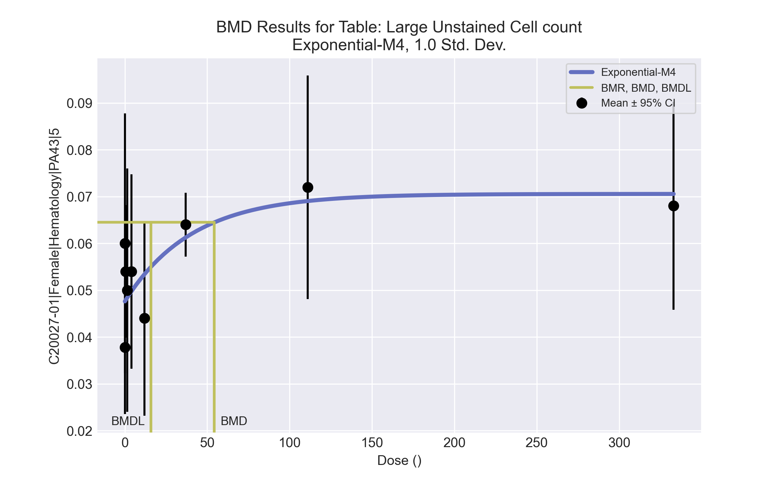
====================================================================
Exponential Model. (Version: 1.11; Date: 03/14/2017)
Input Data File: C:\Windows\TEMP\bmds-y8k9w5r5.(d)
Gnuplot Plotting File:
Thu Apr 15 13:45:44 2021
====================================================================
BMDS_Model_Run
~~~~~~~~~~~~~~~~~~~~~~~~~~~~~~~~~~~~~~~~~~~~~~~~~~~~~~~~~~~~~~~~~~~~~
The form of the response function by Model:
Model 2: Y[dose] = a * exp{sign * b * dose}
Model 3: Y[dose] = a * exp{sign * (b * dose)^d}
Model 4: Y[dose] = a * [c-(c-1) * exp{-b * dose}]
Model 5: Y[dose] = a * [c-(c-1) * exp{-(b * dose)^d}]
Note: Y[dose] is the median response for exposure = dose;
sign = +1 for increasing trend in data;
sign = -1 for decreasing trend.
Model 2 is nested within Models 3 and 4.
Model 3 is nested within Model 5.
Model 4 is nested within Model 5.
Dependent variable = Response
Independent variable = Dose
Data are assumed to be distributed: normally
Variance Model: exp(lnalpha +rho *ln(Y[dose]))
rho is set to 0.
A constant variance model is fit.
Total number of dose groups = 9
Total number of records with missing values = 0
Maximum number of iterations = 500
Relative Function Convergence has been set to: 1e-008
Parameter Convergence has been set to: 1e-008
MLE solution provided: Exact
Initial Parameter Values
Variable Model 4
-------- --------
lnalpha -8.36344
rho 0 Specified
a 0.0358891
b 0.00696525
c 2.10649
d 1 Specified
Parameter Estimates
Variable Model 4 Std. Err.
-------- ------- ---------
lnalpha -8.16375 5.8133e-005
a 0.0476037 0.00324839
b 0.0244522 0.0183599
c 1.4822 0.159195
NC = No Convergence
Table of Stats From Input Data
Dose N Obs Mean Obs Std Dev
----- --- ---------- -------------
0 9 0.03778 0.01856
0.15 5 0.06 0.02236
0.5 5 0.054 0.0114
1.4 4 0.05 0.01633
4 5 0.054 0.01673
12 5 0.044 0.01673
37 5 0.064 0.005477
111 5 0.072 0.01923
333 5 0.068 0.01789
Estimated Values of Interest
Dose Est Mean Est Std Scaled Residual
------ ---------- --------- ----------------
0 0.0476 0.01688 -1.747
0.15 0.04769 0.01688 1.631
0.5 0.04788 0.01688 0.8106
1.4 0.04838 0.01688 0.1924
4 0.04974 0.01688 0.5641
12 0.05344 0.01688 -1.251
37 0.06127 0.01688 0.3618
111 0.06904 0.01688 0.3926
333 0.07055 0.01688 -0.3381
Other models for which likelihoods are calculated:
Model A1: Yij = Mu(i) + e(ij)
Var{e(ij)} = Sigma^2
Model A2: Yij = Mu(i) + e(ij)
Var{e(ij)} = Sigma(i)^2
Model A3: Yij = Mu(i) + e(ij)
Var{e(ij)} = exp(lalpha + log(mean(i)) * rho)
Model R: Yij = Mu + e(i)
Var{e(ij)} = Sigma^2
Likelihoods of Interest
Model Log(likelihood) DF AIC
------- ----------------- ---- ------------
A1 176.7226 10 -333.4452
A2 181.5353 18 -327.0706
A3 176.7226 10 -333.4452
R 166.1513 2 -328.3026
4 171.93 4 -335.86
Additive constant for all log-likelihoods = -44.11. This constant added to the
above values gives the log-likelihood including the term that does not
depend on the model parameters.
Explanation of Tests
Test 1: Does response and/or variances differ among Dose levels? (A2 vs. R)
Test 2: Are Variances Homogeneous? (A2 vs. A1)
Test 3: Are variances adequately modeled? (A2 vs. A3)
Test 6a: Does Model 4 fit the data? (A3 vs 4)
Tests of Interest
Test -2*log(Likelihood Ratio) D. F. p-value
-------- ------------------------ ------ --------------
Test 1 30.77 16 0.0144
Test 2 9.625 8 0.2923
Test 3 9.625 8 0.2923
Test 6a 9.585 6 0.1432
The p-value for Test 1 is less than .05. There appears to be a
difference between response and/or variances among the dose
levels, it seems appropriate to model the data.
The p-value for Test 2 is greater than .1. A homogeneous
variance model appears to be appropriate here.
The p-value for Test 3 is greater than .1. The modeled
variance appears to be appropriate here.
The p-value for Test 6a is greater than .1. Model 4 seems
to adequately describe the data.
Benchmark Dose Computations:
Specified Effect = 1.000000
Risk Type = Estimated standard deviations from control
Confidence Level = 0.950000
BMD = 54.3394
BMDL = 15.7594
BMDU = 3.33e+006

Female BMD Results for Table: Monocyte count
BMDS version: BMDS v2.7.0

Input dataset
Dose | 0 | 0.15 | 0.5 | 1.4 | 4 | 12 | 37 | 111 | 333 | 1000
N | 9 | 5 | 5 | 4 | 5 | 5 | 5 | 5 | 5 | 5
Mean ± SD | 0.191 ± 0.125 | 0.31 ± 0.18 | 0.284 ± 0.068 | 0.29 ± 0.079 | 0.284 ± 0.109 | 0.22 ± 0.097 | 0.282 ± 0.071 | 0.368 ± 0.117 | 0.402 ± 0.141 | 0.656 ± 0.411

Summary table
Modelª | Goodness of fit |  | BMD | BMDL | Comments
 | p-value | AIC
Linear^{b} | 0.573 | -155.832 | 257.111 | 160.613 | Linear recommended as best-fitting model on the basis of the lowest AIC.
Polynomial 2° | 0.468 | -153.872 | 280.155 | 161.13
Polynomial 3° | 0.47 | -153.892 | 285.634 | 161.389
Polynomial 4° | 0.472 | -153.901 | 287.736 | 161.517
Polynomial 5° | 0.472 | -153.905 | 288.39 | 161.565
Polynomial 6° | 0.472 | -153.906 | 288.581 | 161.582
Polynomial 7° | 0.472 | -153.907 | 288.635 | 161.587
Polynomial 8° | 0.472 | -153.907 | 288.651 | 161.589
Power | 0.467 | -153.864 | 275.45 | 161.02
Hill | 0.355 | -151.863 | 275.404 | -999
Exponential M2 (equivalent models include Exponential M3) | 0.553 | -155.653 | 353.037 | 251.765
Exponential M4 | 0.464 | -153.831 | 256.625 | 115.12
Exponential M5 | 0.355 | -151.863 | 275.19 | 115.704
ª Modeled variance case presented (BMDS Test 2 p-value = <0.0001, BMDS Test 3 p-value = 0.191).
^{b} Recommended model

Model recommendation details
Model | Bin | Notes
Linearª | Valid | -
Polynomial 2° | Valid | -
Polynomial 3° | Valid | -
Polynomial 4° | Valid | -
Polynomial 5° | Valid | -
Polynomial 6° | Valid | -
Polynomial 7° | Valid | -
Polynomial 8° | Valid | -
Power | Valid | -
Hill | Failure | Failures  • BMDL does not exist  Cautions  • Warning(s): BMDL computation failed.
Exponential M2 (equivalent models include Exponential M3) | Warning | Warnings  • Residual at lowest dose is greater than threshold (2.01 > 2.0)
Exponential M4 | Valid | -
Exponential M5 | Valid | -
ª Recommended model

Recommended model
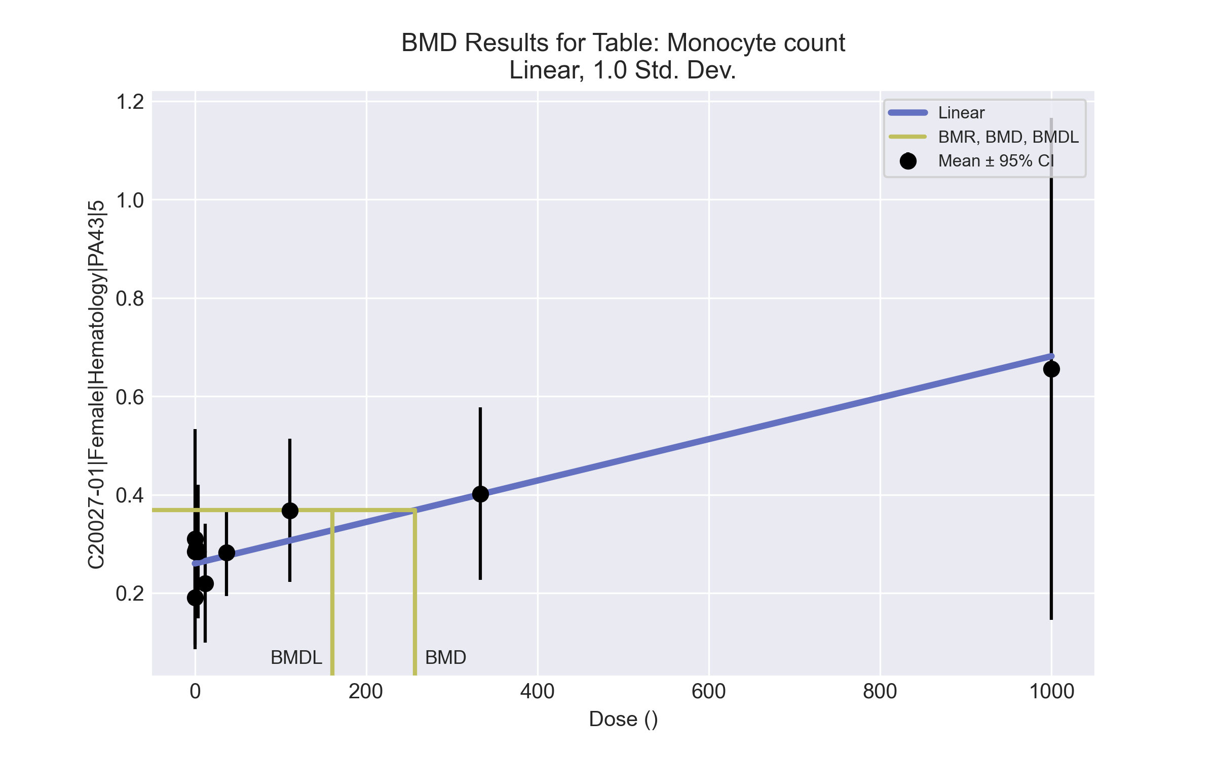
====================================================================
Polynomial Model. (Version: 2.21; Date: 03/14/2017)
Input Data File: C:\Windows\TEMP\bmds-nhr3za80.(d)
Gnuplot Plotting File: C:\Windows\TEMP\bmds-nhr3za80.plt
Thu Apr 15 13:45:55 2021
====================================================================
BMDS_Model_Run
~~~~~~~~~~~~~~~~~~~~~~~~~~~~~~~~~~~~~~~~~~~~~~~~~~~~~~~~~~~~~~~~~~~~~
The form of the response function is:
Y[dose] = beta_0 + beta_1*dose + beta_2*dose^2 + ...
Dependent variable = Response
Independent variable = Dose
The polynomial coefficients are restricted to be positive
The variance is to be modeled as Var(i) = exp(lalpha + log(mean(i)) * rho)
Total number of dose groups = 10
Total number of records with missing values = 0
Maximum number of iterations = 500
Relative Function Convergence has been set to: 1e-008
Parameter Convergence has been set to: 1e-008
Default Initial Parameter Values
lalpha = -3.57282
rho = 0
beta_0 = 0.269956
beta_1 = 0
Asymptotic Correlation Matrix of Parameter Estimates
lalpha rho beta_0 beta_1
lalpha 1 0.97 -0.083 0.15
rho 0.97 1 -0.091 0.17
beta_0 -0.083 -0.091 1 -0.33
beta_1 0.15 0.17 -0.33 1
Parameter Estimates
95.0% Wald Confidence Interval
Variable Estimate Std. Err. Lower Conf. Limit Upper Conf. Limit
lalpha -1.38176 0.765495 -2.88211 0.118578
rho 2.27391 0.622603 1.05363 3.49419
beta_0 0.260037 0.0176078 0.225526 0.294548
beta_1 0.000421459 0.000130575 0.000165538 0.000677381
Table of Data and Estimated Values of Interest
Dose N Obs Mean Est Mean Obs Std Dev Est Std Dev Scaled Res.
------ --- -------- -------- ----------- ----------- ----------
0 9 0.191 0.26 0.125 0.108 -1.91
0.15 5 0.31 0.26 0.18 0.108 1.03
0.5 5 0.284 0.26 0.0684 0.108 0.49
1.4 4 0.29 0.261 0.0787 0.109 0.541
4 5 0.284 0.262 0.109 0.109 0.456
12 5 0.22 0.265 0.097 0.111 -0.91
37 5 0.282 0.276 0.0712 0.116 0.123
111 5 0.368 0.307 0.117 0.131 1.05
333 5 0.402 0.4 0.141 0.177 0.0204
1000 5 0.656 0.681 0.411 0.324 -0.176
Model Descriptions for likelihoods calculated
Model A1: Yij = Mu(i) + e(ij)
Var{e(ij)} = Sigma^2
Model A2: Yij = Mu(i) + e(ij)
Var{e(ij)} = Sigma(i)^2
Model A3: Yij = Mu(i) + e(ij)
Var{e(ij)} = exp(lalpha + rho*ln(Mu(i)))
Model A3 uses any fixed variance parameters that
were specified by the user
Model R: Yi = Mu + e(i)
Var{e(i)} = Sigma^2
Likelihoods of Interest
Model Log(likelihood) # Param's AIC
A1 73.720722 11 -125.441445
A2 90.852404 20 -141.704808
A3 85.251176 12 -146.502352
fitted 81.916175 4 -155.832350
R 59.811074 2 -115.622148
Explanation of Tests
Test 1: Do responses and/or variances differ among Dose levels?
(A2 vs. R)
Test 2: Are Variances Homogeneous? (A1 vs A2)
Test 3: Are variances adequately modeled? (A2 vs. A3)
Test 4: Does the Model for the Mean Fit? (A3 vs. fitted)
(Note: When rho=0 the results of Test 3 and Test 2 will be the same.)
Tests of Interest
Test -2*log(Likelihood Ratio) Test df p-value
Test 1 62.0827 18 <.0001
Test 2 34.2634 9 <.0001
Test 3 11.2025 8 0.1905
Test 4 6.67 8 0.5726
The p-value for Test 1 is less than .05. There appears to be a
difference between response and/or variances among the dose levels
It seems appropriate to model the data
The p-value for Test 2 is less than .1. A non-homogeneous variance
model appears to be appropriate
The p-value for Test 3 is greater than .1. The modeled variance appears
to be appropriate here
The p-value for Test 4 is greater than .1. The model chosen seems
to adequately describe the data
Benchmark Dose Computation
Specified effect = 1
Risk Type = Estimated standard deviations from the control mean
Confidence level = 0.95
BMD = 257.111
BMDL = 160.613
BMDU = 544.663

Female BMD Results for Table: Platelet count
BMDS version: BMDS v2.7.0

Input dataset
Dose | 0 | 0.15 | 0.5 | 1.4 | 4 | 12 | 37 | 111 | 333 | 1000
N | 9 | 5 | 5 | 4 | 5 | 5 | 5 | 5 | 5 | 5
Mean ± SD | 993.556 ± 259.673 | 781.8 ± 350.486 | 841.2 ± 311.888 | 864.5 ± 152.292 | 980.2 ± 19.627 | 1005.4 ± 159.702 | 1005.6 ± 202.638 | 1083.8 ± 144.835 | 1214.2 ± 218.572 | 1003.8 ± 228.639

Summary table
Modelª | Goodness of fit |  | BMD | BMDL | Comments
 | p-value | AIC
Linear | 0.036 | 637.71 | -9999 | 2465.23 | No model was recommended as a best-fitting model. Doses were dropped until there were only 3 remaining dose-groups.
Polynomial 2° | 0.036 | 637.71 | -9999 | 1301.18
Polynomial 3° | 0.036 | 637.71 | -9999 | 1908.41
Polynomial 4° | 0.036 | 637.71 | -9999 | -999
Polynomial 5° | <0.0001 | 934.036 | -9999 | -999
Polynomial 6° | 0.037 | 637.618 | -9999 | 1088.05
Polynomial 7° | <0.0001 | 1030.282 | -9999 | -999
Polynomial 8° | <0.0001 | 1036.091 | -9999 | -999
Power | 0.034 | 638.423 | 1864.08 | 582.129
Hill | 0.34 | 632.571 | -999 | -999
Exponential M2 | 0.022 | 639.71 | 1 | -999
Exponential M3 | 0.012 | 641.71 | 340037 | 1218.86
Exponential M4 | 0.012 | 641.71 | -999 | 0
Exponential M5 | 0.006 | 643.71 | -999 | 0
ª Modeled variance case presented (BMDS Test 2 p-value = 0.001, BMDS Test 3 p-value = 0.002).

Model recommendation details
Model | Bin | Notes
Linear | Warning | Warnings  • Residual of Interest does not exist  • Variance model poorly fits dataset (p-value 3 = 0.002246)  • Goodness of fit p-value is less than threshold (0.036 < 0.1)  Cautions  • Warning(s): BMD = 100*(maximum dose)  • BMDL/high dose ratio is greater than threshold (2.47 > 1.0)
Polynomial 2° | Warning | Warnings  • Residual of Interest does not exist  • Variance model poorly fits dataset (p-value 3 = 0.002246)  • Goodness of fit p-value is less than threshold (0.036 < 0.1)  Cautions  • Warning(s): THIS USUALLY MEANS THE MODEL HAS NOT CONVERGED!; BMD = 100*(maximum dose)  • BMDL/high dose ratio is greater than threshold (1.3 > 1.0)
Polynomial 3° | Warning | Warnings  • Residual of Interest does not exist  • Variance model poorly fits dataset (p-value 3 = 0.002246)  • Goodness of fit p-value is less than threshold (0.036 < 0.1)  Cautions  • Warning(s): THIS USUALLY MEANS THE MODEL HAS NOT CONVERGED!; BMD = 100*(maximum dose)  • BMDL/high dose ratio is greater than threshold (1.91 > 1.0)
Polynomial 4° | Failure | Failures  • BMDL does not exist  Warnings  • Residual of Interest does not exist  • Variance model poorly fits dataset (p-value 3 = 0.002246)  • Goodness of fit p-value is less than threshold (0.036 < 0.1)  Cautions  • Warning(s): THIS USUALLY MEANS THE MODEL HAS NOT CONVERGED!; BMD = 100*(maximum dose); BMDL computation failed.
Polynomial 5° | Failure | Failures  • BMDL does not exist  Warnings  • Residual of Interest does not exist  • Variance model poorly fits dataset (p-value 3 = 0.002246)  • Ratio of modeled to actual stdev. at control is greater than threshold (2.94 > 1.5)  Cautions  • Warning(s): BMD = 100*(maximum dose); BMDL computation failed.
Polynomial 6° | Warning | Warnings  • Residual of Interest does not exist  • Variance model poorly fits dataset (p-value 3 = 0.002246)  • Goodness of fit p-value is less than threshold (0.0371 < 0.1)  Cautions  • Warning(s): BMD = 100*(maximum dose)  • BMDL/high dose ratio is greater than threshold (1.09 > 1.0)
Polynomial 7° | Failure | Failures  • BMDL does not exist  Warnings  • Residual of Interest does not exist  • Variance model poorly fits dataset (p-value 3 = 0.002246)  • Ratio of modeled to actual stdev. at control is greater than threshold (2.74 > 1.5)  Cautions  • Warning(s): THIS USUALLY MEANS THE MODEL HAS NOT CONVERGED!; BMD = 100*(maximum dose); BMDL computation failed.
Polynomial 8° | Failure | Failures  • BMDL does not exist  Warnings  • Residual of Interest does not exist  • Variance model poorly fits dataset (p-value 3 = 0.002246)  • Ratio of modeled to actual stdev. at control is greater than threshold (2.12 > 1.5)  Cautions  • Warning(s): THIS USUALLY MEANS THE MODEL HAS NOT CONVERGED!; BMD = 100*(maximum dose); BMDL computation failed.
Power | Warning | Warnings  • Variance model poorly fits dataset (p-value 3 = 0.002246)  • Goodness of fit p-value is less than threshold (0.034 < 0.1)  • BMD/high dose ratio is greater than threshold (1.86 > 1.0)
Hill | Failure | Failures  • BMD does not exist  • BMDL does not exist  Warnings  • Residual of Interest does not exist  • Variance model poorly fits dataset (p-value 3 = 0.002246)  Cautions  • Warning(s): BMR value is not in the range of the mean function
Exponential M2 | Failure | Failures  • BMDL does not exist  Warnings  • Variance model poorly fits dataset (p-value 3 = 0.002246)  • Goodness of fit p-value is less than threshold (0.0217 < 0.1)
Exponential M3 | Warning | Warnings  • Variance model poorly fits dataset (p-value 3 = 0.002246)  • Goodness of fit p-value is less than threshold (0.0123 < 0.1)  • BMD/BMDL ratio is greater than threshold (2.79e+02 > 20.0)  • BMD/high dose ratio is greater than threshold (3.4e+02 > 1.0)  Cautions  • BMD/BMDL ratio is greater than threshold (2.79e+02 > 5.0)  • BMDL/high dose ratio is greater than threshold (1.22 > 1.0)
Exponential M4 | Failure | Failures  • BMD does not exist  Warnings  • Residual of Interest does not exist  • Variance model poorly fits dataset (p-value 3 = 0.002246)  • Goodness of fit p-value is less than threshold (0.0123 < 0.1)
Exponential M5 | Failure | Failures  • BMD does not exist  Warnings  • Residual of Interest does not exist  • Variance model poorly fits dataset (p-value 3 = 0.002246)  • Goodness of fit p-value is less than threshold (0.0064 < 0.1)

Recommended model
No model was recommended as a best-fitting model.

Female BMD Results for Table: Reticulocyte count
BMDS version: BMDS v2.7.0

Input dataset
Dose | 0 | 0.15 | 0.5 | 1.4 | 4 | 12 | 37 | 111ª | 333ª | 1000ª
N | 9 | 5 | 5 | 4 | 5 | 5 | 5 | 5 | 5 | 5
Mean ± SD | 224.633 ± 34.579 | 235.06 ± 39.379 | 205.26 ± 38.534 | 206.55 ± 15.202 | 210.7 ± 26.564 | 200.64 ± 31.256 | 161.88 ± 14.639 | 199.44 ± 45.236 | 126.44 ± 21.113 | 112.26 ± 28.319
ª Dose group removed in BMD modeling session

Summary table
Modelª | Goodness of fit |  | BMD | BMDL | Comments
 | p-value | AIC
Linear (equivalent models include Power, Polynomial 2°, 3°, 4°, 5°, 6°, 7°, 8°) | 0.625 | 300.986 | 18.568 | 12.823 | Hill recommended as best-fitting model on the basis of the lowest BMDL.
Hill^{b} | 0.493 | 302.902 | 15.578 | 3.622
Exponential M2 (equivalent models include Exponential M3) | 0.634 | 300.929 | 17.123 | 11.118
Exponential M4 (equivalent models include Exponential M5) | 0.492 | 302.907 | 15.736 | 5.229
ª Constant variance case presented (BMDS Test 2 p-value = 0.208, BMDS Test 3 p-value = 0.208).
^{b} Recommended model

Model recommendation details
Model | Bin | Notes
Linear (equivalent models include Power, Polynomial 2°, 3°, 4°, 5°, 6°, 7°, 8°) | Valid | -
Hillª | Valid | -
Exponential M2 (equivalent models include Exponential M3) | Valid | -
Exponential M4 (equivalent models include Exponential M5) | Valid | -
ª Recommended model

Recommended model
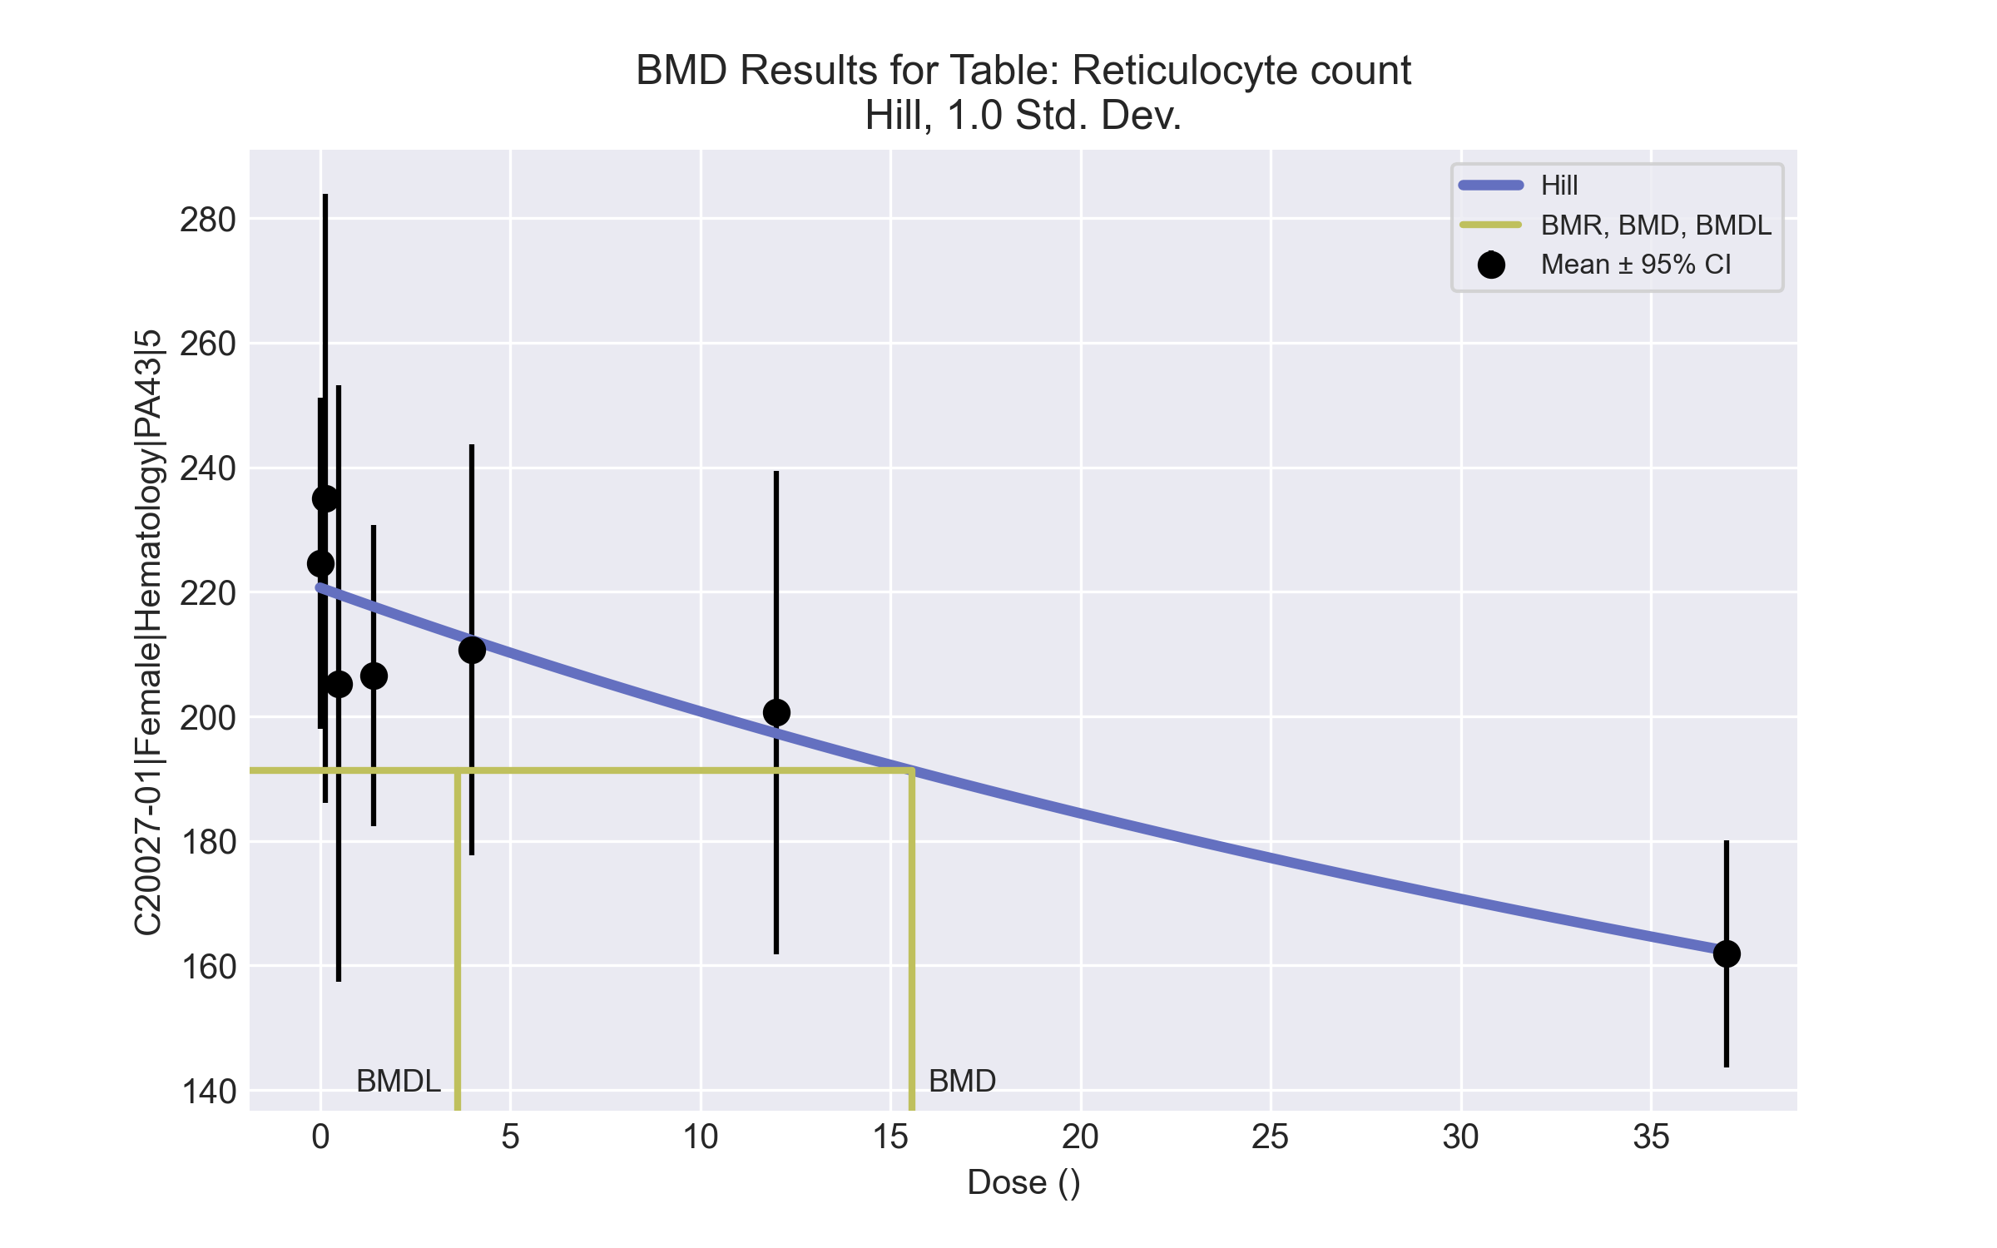
====================================================================
Hill Model. (Version: 2.18; Date: 03/14/2017)
Input Data File: C:\Windows\TEMP\bmds-onpbqya_.(d)
Gnuplot Plotting File: C:\Windows\TEMP\bmds-onpbqya_.plt
Thu Apr 15 13:47:43 2021
====================================================================
BMDS_Model_Run
~~~~~~~~~~~~~~~~~~~~~~~~~~~~~~~~~~~~~~~~~~~~~~~~~~~~~~~~~~~~~~~~~~~~~
The form of the response function is:
Y[dose] = intercept + v*dose^n/(k^n + dose^n)
Dependent variable = Response
Independent variable = Dose
rho is set to 0
Power parameter restricted to be greater than 1
A constant variance model is fit
Total number of dose groups = 7
Total number of records with missing values = 0
Maximum number of iterations = 500
Relative Function Convergence has been set to: 1e-008
Parameter Convergence has been set to: 1e-008
Default Initial Parameter Values
alpha = 967.385
rho = 0 Specified
intercept = 224.633
v = -62.7533
n = 0.725967
k = 16.7622
Asymptotic Correlation Matrix of Parameter Estimates
( *** The model parameter(s) -rho -n
have been estimated at a boundary point, or have been specified by the user,
and do not appear in the correlation matrix )
alpha intercept v k
alpha 1 -1.7e-007 -2.8e-007 3e-007
intercept -1.7e-007 1 0.45 -0.49
v -2.8e-007 0.45 1 -1
k 3e-007 -0.49 -1 1
Parameter Estimates
95.0% Wald Confidence Interval
Variable Estimate Std. Err. Lower Conf. Limit Upper Conf. Limit
alpha 863.142 198.018 475.033 1251.25
intercept 220.675 6.50133 207.932 233.417
v -205.439 584.214 -1350.48 939.598
n 1 NA
k 93.3517 364.828 -621.698 808.401
NA - Indicates that this parameter has hit a bound
implied by some inequality constraint and thus
has no standard error.
Table of Data and Estimated Values of Interest
Dose N Obs Mean Est Mean Obs Std Dev Est Std Dev Scaled Res.
------ --- -------- -------- ----------- ----------- ----------
0 9 225 221 34.6 29.4 0.404
0.15 5 235 220 39.4 29.4 1.12
0.5 5 205 220 38.5 29.4 -1.09
1.4 4 207 218 15.2 29.4 -0.755
4 5 211 212 26.6 29.4 -0.117
12 5 201 197 31.3 29.4 0.256
37 5 162 162 14.6 29.4 -0.0366
Model Descriptions for likelihoods calculated
Model A1: Yij = Mu(i) + e(ij)
Var{e(ij)} = Sigma^2
Model A2: Yij = Mu(i) + e(ij)
Var{e(ij)} = Sigma(i)^2
Model A3: Yij = Mu(i) + e(ij)
Var{e(ij)} = Sigma^2
Model A3 uses any fixed variance parameters that
were specified by the user
Model R: Yi = Mu + e(i)
Var{e(i)} = Sigma^2
Likelihoods of Interest
Model Log(likelihood) # Param's AIC
A1 -145.748953 8 307.497907
A2 -141.531344 14 311.062688
A3 -145.748953 8 307.497907
fitted -147.451003 4 302.902006
R -154.336538 2 312.673077
Explanation of Tests
Test 1: Do responses and/or variances differ among Dose levels?
(A2 vs. R)
Test 2: Are Variances Homogeneous? (A1 vs A2)
Test 3: Are variances adequately modeled? (A2 vs. A3)
Test 4: Does the Model for the Mean Fit? (A3 vs. fitted)
(Note: When rho=0 the results of Test 3 and Test 2 will be the same.)
Tests of Interest
Test -2*log(Likelihood Ratio) Test df p-value
Test 1 25.6104 12 0.01218
Test 2 8.43522 6 0.2079
Test 3 8.43522 6 0.2079
Test 4 3.4041 4 0.4926
The p-value for Test 1 is less than .05. There appears to be a
difference between response and/or variances among the dose levels
It seems appropriate to model the data
The p-value for Test 2 is greater than .1. A homogeneous variance
model appears to be appropriate here
The p-value for Test 3 is greater than .1. The modeled variance appears
to be appropriate here
The p-value for Test 4 is greater than .1. The model chosen seems
to adequately describe the data
Benchmark Dose Computation
Specified effect = 1
Risk Type = Estimated standard deviations from the control mean
Confidence level = 0.95
BMD = 15.5777
BMDL = 3.62221
BMDU = 32.9829

Female BMD Results for Table: Thyroid Stimulating Hormone
BMDS version: BMDS v2.7.0

Input dataset
Dose | 0 | 0.15 | 0.5 | 1.4 | 4 | 12 | 37 | 111 | 333 | 1000
N | 9 | 4 | 3 | 4 | 5 | 4 | 5 | 5 | 4 | 5
Mean ± SD | 3.122 ± 1.113 | 3.4 ± 2.026 | 2.8 ± 0.954 | 2.425 ± 0.75 | 3.02 ± 1.062 | 3.4 ± 1.651 | 2.54 ± 0.82 | 4.48 ± 0.867 | 3.775 ± 2.3 | 6.9 ± 2.087

Summary table
Modelª | Goodness of fit |  | BMD | BMDL | Comments
 | p-value | AIC
Linear^{b} (equivalent models include Power) | 0.601 | 83.361 | 356.61 | 268.917 | Linear recommended as best-fitting model on the basis of the lowest AIC.
Polynomial 2° | 0.494 | 85.345 | 380.134 | 269.122
Polynomial 3° | 0.498 | 85.306 | 403.724 | 269.605
Polynomial 4° | 0.501 | 85.286 | 414.764 | 269.854
Polynomial 5° | 0.501 | 85.278 | 419.532 | 269.948
Polynomial 6° | 0.502 | 85.276 | 421.518 | 269.981
Polynomial 7° | 0.502 | 85.275 | 422.329 | 269.992
Polynomial 8° | 0.502 | 85.275 | 422.661 | 269.996
Hill | 0.492 | 85.362 | 356.205 | 268.497
Exponential M2 (equivalent models include Exponential M3) | 0.593 | 83.428 | 452.862 | 370.185
Exponential M4 | 0.492 | 85.363 | 355.503 | 157.934
Exponential M5 | 0.492 | 85.363 | 355.546 | 157.936
ª Constant variance case presented (BMDS Test 2 p-value = 0.12, BMDS Test 3 p-value = 0.12).
^{b} Recommended model

Model recommendation details
Model | Bin | Notes
Linearª (equivalent models include Power) | Valid | -
Polynomial 2° | Valid | -
Polynomial 3° | Valid | -
Polynomial 4° | Valid | -
Polynomial 5° | Valid | -
Polynomial 6° | Valid | -
Polynomial 7° | Valid | -
Polynomial 8° | Valid | -
Hill | Valid | -
Exponential M2 (equivalent models include Exponential M3) | Valid | -
Exponential M4 | Valid | -
Exponential M5 | Valid | -
ª Recommended model

Recommended model
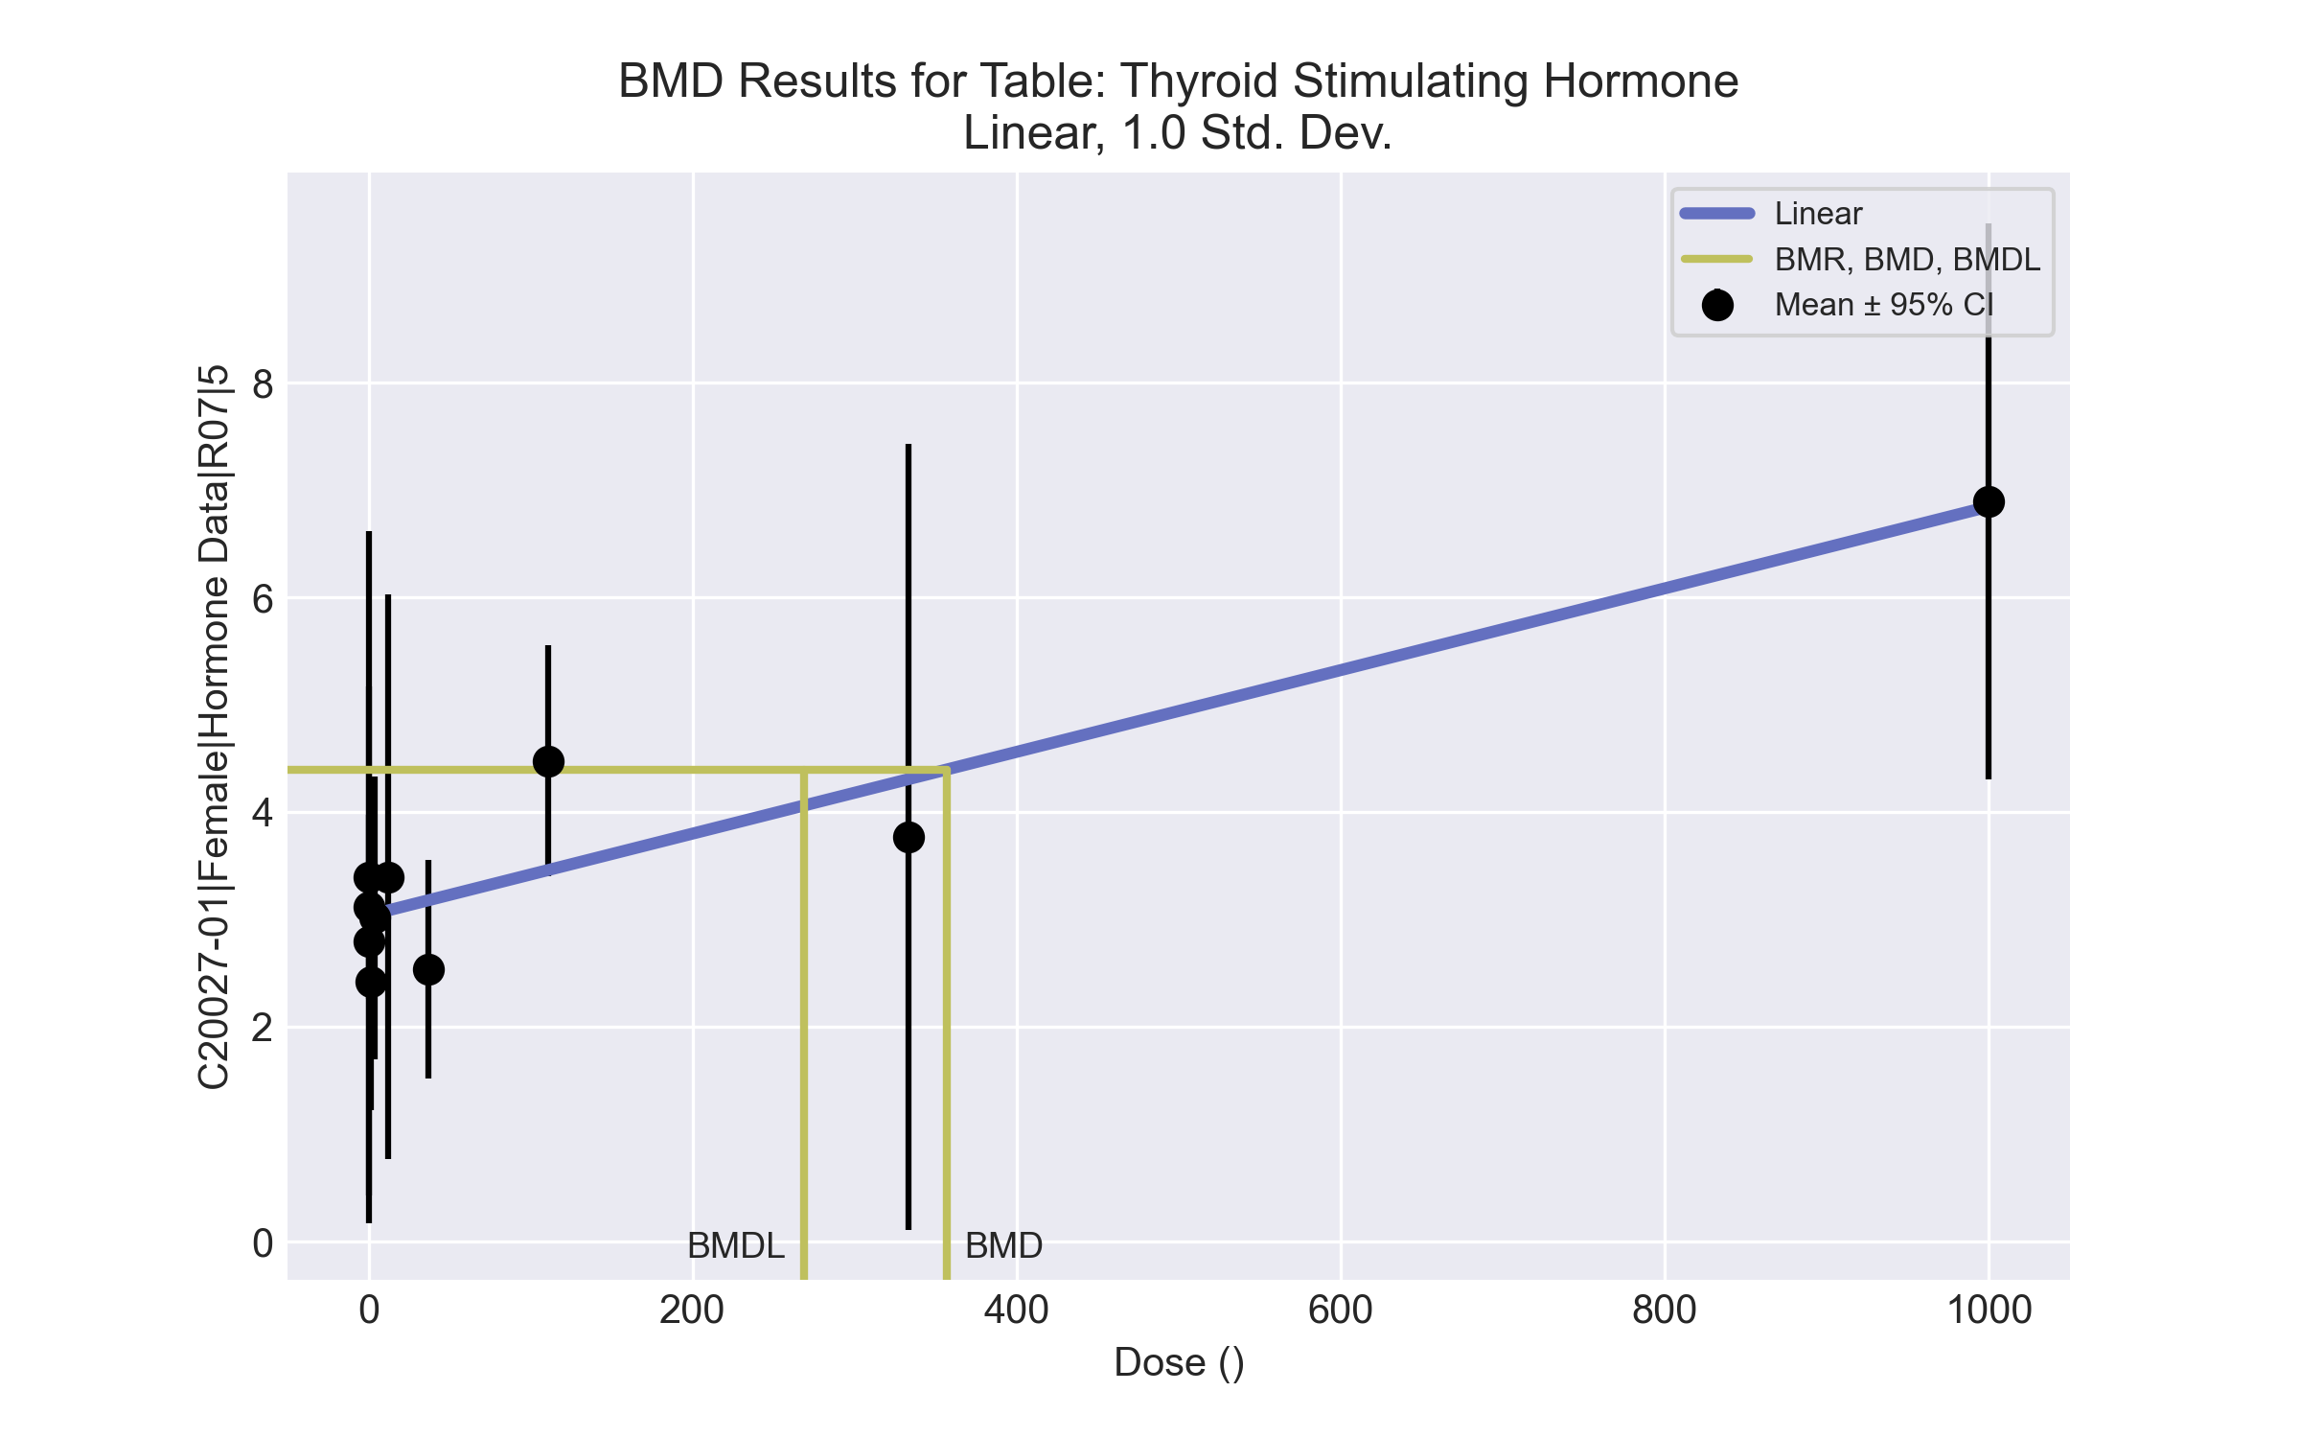
====================================================================
Polynomial Model. (Version: 2.21; Date: 03/14/2017)
Input Data File: C:\Windows\TEMP\bmds-n7bi_jou.(d)
Gnuplot Plotting File: C:\Windows\TEMP\bmds-n7bi_jou.plt
Thu Apr 15 13:45:29 2021
====================================================================
BMDS_Model_Run
~~~~~~~~~~~~~~~~~~~~~~~~~~~~~~~~~~~~~~~~~~~~~~~~~~~~~~~~~~~~~~~~~~~~~
The form of the response function is:
Y[dose] = beta_0 + beta_1*dose + beta_2*dose^2 + ...
Dependent variable = Response
Independent variable = Dose
rho is set to 0
The polynomial coefficients are restricted to be positive
A constant variance model is fit
Total number of dose groups = 10
Total number of records with missing values = 0
Maximum number of iterations = 500
Relative Function Convergence has been set to: 1e-008
Parameter Convergence has been set to: 1e-008
Default Initial Parameter Values
alpha = 2.03733
rho = 0 Specified
beta_0 = 3.01484
beta_1 = 0
Asymptotic Correlation Matrix of Parameter Estimates
( *** The model parameter(s) -rho
have been estimated at a boundary point, or have been specified by the user,
and do not appear in the correlation matrix )
alpha beta_0 beta_1
alpha 1 5.1e-008 -2.8e-008
beta_0 5.1e-008 1 -0.44
beta_1 -2.8e-008 -0.44 1
Parameter Estimates
95.0% Wald Confidence Interval
Variable Estimate Std. Err. Lower Conf. Limit Upper Conf. Limit
alpha 1.84356 0.376314 1.10599 2.58112
beta_0 3.04136 0.218168 2.61376 3.46896
beta_1 0.00380746 0.00064377 0.00254569 0.00506923
Table of Data and Estimated Values of Interest
Dose N Obs Mean Est Mean Obs Std Dev Est Std Dev Scaled Res.
------ --- -------- -------- ----------- ----------- ----------
0 9 3.12 3.04 1.11 1.36 0.179
0.15 4 3.4 3.04 2.03 1.36 0.527
0.5 3 2.8 3.04 0.954 1.36 -0.31
1.4 4 2.42 3.05 0.75 1.36 -0.916
4 5 3.02 3.06 1.06 1.36 -0.0603
12 4 3.4 3.09 1.65 1.36 0.461
37 5 2.54 3.18 0.82 1.36 -1.06
111 5 4.48 3.46 0.867 1.36 1.67
333 4 3.77 4.31 2.3 1.36 -0.787
1000 5 6.9 6.85 2.09 1.36 0.0843
Model Descriptions for likelihoods calculated
Model A1: Yij = Mu(i) + e(ij)
Var{e(ij)} = Sigma^2
Model A2: Yij = Mu(i) + e(ij)
Var{e(ij)} = Sigma(i)^2
Model A3: Yij = Mu(i) + e(ij)
Var{e(ij)} = Sigma^2
Model A3 uses any fixed variance parameters that
were specified by the user
Model R: Yi = Mu + e(i)
Var{e(i)} = Sigma^2
Likelihoods of Interest
Model Log(likelihood) # Param's AIC
A1 -35.472611 11 92.945222
A2 -28.440017 20 96.880033
A3 -35.472611 11 92.945222
fitted -38.680723 3 83.361446
R -51.818026 2 107.636051
Explanation of Tests
Test 1: Do responses and/or variances differ among Dose levels?
(A2 vs. R)
Test 2: Are Variances Homogeneous? (A1 vs A2)
Test 3: Are variances adequately modeled? (A2 vs. A3)
Test 4: Does the Model for the Mean Fit? (A3 vs. fitted)
(Note: When rho=0 the results of Test 3 and Test 2 will be the same.)
Tests of Interest
Test -2*log(Likelihood Ratio) Test df p-value
Test 1 46.756 18 0.0002299
Test 2 14.0652 9 0.12
Test 3 14.0652 9 0.12
Test 4 6.41622 8 0.6007
The p-value for Test 1 is less than .05. There appears to be a
difference between response and/or variances among the dose levels
It seems appropriate to model the data
The p-value for Test 2 is greater than .1. A homogeneous variance
model appears to be appropriate here
The p-value for Test 3 is greater than .1. The modeled variance appears
to be appropriate here
The p-value for Test 4 is greater than .1. The model chosen seems
to adequately describe the data
Benchmark Dose Computation
Specified effect = 1
Risk Type = Estimated standard deviations from the control mean
Confidence level = 0.95
BMD = 356.61
BMDL = 268.917
BMDU = 527.21

Female BMD Results for Table: Total Thyroxine
BMDS version: BMDS v2.7.0

Input dataset
Dose | 0 | 0.15 | 0.5 | 1.4 | 4 | 12 | 37 | 111 | 333 | 1000
N | 9 | 4 | 3 | 4 | 5 | 4 | 5 | 5 | 4 | 5
Mean ± SD | 3.123 ± 0.871 | 2.833 ± 0.854 | 2.307 ± 0.136 | 2.64 ± 0.865 | 2.756 ± 0.24 | 2.785 ± 0.311 | 2.314 ± 0.484 | 2.642 ± 0.581 | 1.198 ± 0.36 | 0.86 ± 0.311

Summary table
Modelª | Goodness of fit |  | BMD | BMDL | Comments
 | p-value | AIC
Linear (equivalent models include Power, Polynomial 2°, 3°, 4°, 5°, 7°, 8°) | 0.005 | 11.025 | 362.43 | 274.092 | No model was recommended as a best-fitting model. Doses were dropped until there were only 3 remaining dose-groups.
Polynomial 6° | <0.0001 | 645.525 | 109.611 | -999
Hill | 0.112 | 3.593 | 178.478 | 110.266
Exponential M2 (equivalent models include Exponential M3) | 0.028 | 6.489 | 206.446 | 128.265
Exponential M4 | 0.071 | 4.339 | 109.539 | 70.138
Exponential M5 | 0.115 | 3.52 | 186.048 | 98.774
ª Modeled variance case presented (BMDS Test 2 p-value = 0.002, BMDS Test 3 p-value = 0.024).

Model recommendation details
Model | Bin | Notes
Linear (equivalent models include Power, Polynomial 2°, 3°, 4°, 5°, 7°, 8°) | Warning | Warnings  • Variance model poorly fits dataset (p-value 3 = 0.02384)  • Goodness of fit p-value is less than threshold (0.00542 < 0.1)
Polynomial 6° | Failure | Failures  • BMDL does not exist  Warnings  • Variance model poorly fits dataset (p-value 3 = 0.02384)  • Residual at lowest dose is greater than threshold (3.17 > 2.0)  • Ratio of modeled to actual stdev. at control is greater than threshold (1.69e+02 > 1.5)  Cautions  • Warning(s): THE MODEL HAS PROBABLY NOT CONVERGED!!!; THIS USUALLY MEANS THE MODEL HAS NOT CONVERGED!; BMDL computation failed.
Hill | Warning | Warnings  • Variance model poorly fits dataset (p-value 3 = 0.02384)
Exponential M2 (equivalent models include Exponential M3) | Warning | Warnings  • Variance model poorly fits dataset (p-value 3 = 0.02384)  • Goodness of fit p-value is less than threshold (0.0281 < 0.1)
Exponential M4 | Warning | Warnings  • Variance model poorly fits dataset (p-value 3 = 0.02384)  • Goodness of fit p-value is less than threshold (0.0708 < 0.1)
Exponential M5 | Warning | Warnings  • Variance model poorly fits dataset (p-value 3 = 0.02384)

Recommended model
No model was recommended as a best-fitting model.

Female BMD Results for Table: Triiodothyronine
BMDS version: BMDS v2.7.0

Input dataset
Dose | 0 | 0.15 | 0.5 | 1.4 | 4 | 12 | 37 | 111 | 333 | 1000
N | 9 | 4 | 3 | 4 | 5 | 4 | 5 | 5 | 4 | 5
Mean ± SD | 66 ± 10.365 | 58.825 ± 3.454 | 66.9 ± 8.472 | 59.825 ± 9.9 | 61.54 ± 9.648 | 62.7 ± 8.914 | 63.74 ± 6.175 | 59.04 ± 4.673 | 42.425 ± 4.124 | 31.06 ± 4.152

Summary table
Modelª | Goodness of fit |  | BMD | BMDL | Comments
 | p-value | AIC
Linear (equivalent models include Power, Polynomial 2°, 3°, 4°, 5°, 6°, 7°, 8°) | 0.174 | 251.312 | 230.195 | 184.46 | Exponential-M2 recommended as best-fitting model on the basis of the lowest AIC.
Hill | 0.544 | 248.8 | 153.425 | 84.443
Exponential M2^{b} (equivalent models include Exponential M3) | 0.369 | 248.492 | 161.48 | 122.215
Exponential M4 | 0.435 | 248.745 | 108.24 | 67.644
Exponential M5 | 0.541 | 248.825 | 159.836 | 83.086
ª Constant variance case presented (BMDS Test 2 p-value = 0.102, BMDS Test 3 p-value = 0.102).
^{b} Recommended model

Model recommendation details
Model | Bin | Notes
Linear (equivalent models include Power, Polynomial 2°, 3°, 4°, 5°, 6°, 7°, 8°) | Valid | -
Hill | Valid | -
Exponential M2ª (equivalent models include Exponential M3) | Valid | -
Exponential M4 | Valid | -
Exponential M5 | Valid | -
ª Recommended model

Recommended model
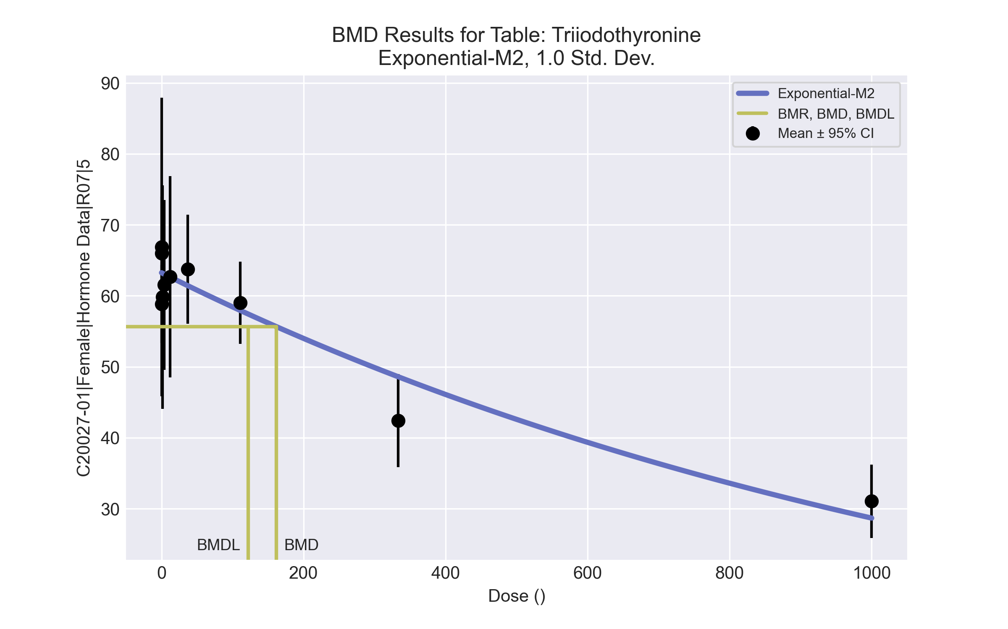
====================================================================
Exponential Model. (Version: 1.11; Date: 03/14/2017)
Input Data File: C:\Windows\TEMP\bmds-l0lnqngm.(d)
Gnuplot Plotting File:
Thu Apr 15 13:46:59 2021
====================================================================
BMDS_Model_Run
~~~~~~~~~~~~~~~~~~~~~~~~~~~~~~~~~~~~~~~~~~~~~~~~~~~~~~~~~~~~~~~~~~~~~
The form of the response function by Model:
Model 2: Y[dose] = a * exp{sign * b * dose}
Model 3: Y[dose] = a * exp{sign * (b * dose)^d}
Model 4: Y[dose] = a * [c-(c-1) * exp{-b * dose}]
Model 5: Y[dose] = a * [c-(c-1) * exp{-(b * dose)^d}]
Note: Y[dose] is the median response for exposure = dose;
sign = +1 for increasing trend in data;
sign = -1 for decreasing trend.
Model 2 is nested within Models 3 and 4.
Model 3 is nested within Model 5.
Model 4 is nested within Model 5.
Dependent variable = Response
Independent variable = Dose
Data are assumed to be distributed: normally
Variance Model: exp(lnalpha +rho *ln(Y[dose]))
rho is set to 0.
A constant variance model is fit.
Total number of dose groups = 10
Total number of records with missing values = 0
Maximum number of iterations = 500
Relative Function Convergence has been set to: 1e-008
Parameter Convergence has been set to: 1e-008
MLE solution provided: Exact
Initial Parameter Values
Variable Model 2
-------- --------
lnalpha 3.87091
rho 0 Specified
a 50.4179
b 0.000740297
c 0 Specified
d 1 Specified
Parameter Estimates
Variable Model 2 Std. Err.
-------- ------- ---------
lnalpha 4.05193 11.7388
a 63.2514 1.25318
b 0.000790886 0.000107381
NC = No Convergence
Table of Stats From Input Data
Dose N Obs Mean Obs Std Dev
----- --- ---------- -------------
0 9 66 10.36
0.15 4 58.83 3.454
0.5 3 66.9 8.472
1.4 4 59.83 9.9
4 5 61.54 9.648
12 4 62.7 8.914
37 5 63.74 6.175
111 5 59.04 4.673
333 4 42.42 4.124
1000 5 31.06 4.152
Estimated Values of Interest
Dose Est Mean Est Std Scaled Residual
------ ---------- --------- ----------------
0 63.25 7.583 1.087
0.15 63.24 7.583 -1.165
0.5 63.23 7.583 0.8391
1.4 63.18 7.583 -0.8852
4 63.05 7.583 -0.4457
12 62.65 7.583 0.01214
37 61.43 7.583 0.6819
111 57.94 7.583 0.3257
333 48.61 7.583 -1.63
1000 28.68 7.583 0.7015
Other models for which likelihoods are calculated:
Model A1: Yij = Mu(i) + e(ij)
Var{e(ij)} = Sigma^2
Model A2: Yij = Mu(i) + e(ij)
Var{e(ij)} = Sigma(i)^2
Model A3: Yij = Mu(i) + e(ij)
Var{e(ij)} = exp(lalpha + log(mean(i)) * rho)
Model R: Yij = Mu + e(i)
Var{e(ij)} = Sigma^2
Likelihoods of Interest
Model Log(likelihood) DF AIC
------- ----------------- ---- ------------
A1 -116.9018 11 255.8037
A2 -109.594 20 259.1881
A3 -116.9018 11 255.8037
R -146.9247 2 297.8494
2 -121.2462 3 248.4924
Additive constant for all log-likelihoods = -44.11. This constant added to the
above values gives the log-likelihood including the term that does not
depend on the model parameters.
Explanation of Tests
Test 1: Does response and/or variances differ among Dose levels? (A2 vs. R)
Test 2: Are Variances Homogeneous? (A2 vs. A1)
Test 3: Are variances adequately modeled? (A2 vs. A3)
Test 4: Does Model 2 fit the data? (A3 vs. 2)
Tests of Interest
Test -2*log(Likelihood Ratio) D. F. p-value
-------- ------------------------ ------ --------------
Test 1 74.66 18 < 0.0001
Test 2 14.62 9 0.1021
Test 3 14.62 9 0.1021
Test 4 8.689 8 0.3692
The p-value for Test 1 is less than .05. There appears to be a
difference between response and/or variances among the dose
levels, it seems appropriate to model the data.
The p-value for Test 2 is greater than .1. A homogeneous
variance model appears to be appropriate here.
The p-value for Test 3 is greater than .1. The modeled
variance appears to be appropriate here.
The p-value for Test 4 is greater than .1. Model 2 seems
to adequately describe the data.
Benchmark Dose Computations:
Specified Effect = 1.000000
Risk Type = Estimated standard deviations from control
Confidence Level = 0.950000
BMD = 161.48
BMDL = 122.215
BMDU = 227.372

