Male BMD Results for Table: Body Weight Gain
BMDS version: BMDS v2.7.0

Input dataset
Dose | 0 | 0.15 | 0.5 | 1.4 | 4 | 12 | 37 | 111 | 333
N | 10 | 5 | 5 | 5 | 5 | 5 | 5 | 5 | 5
Mean ± SD | 15.11 ± 3.698 | 13.6 ± 1.44 | 10 ± 3.628 | 16.7 ± 6.102 | 15.76 ± 1.773 | 12.7 ± 3.92 | 15.46 ± 3.789 | 15.6 ± 5.071 | -2 ± 9.428

Summary table
Modelª | Goodness of fit |  | BMD | BMDL | Comments
 | p-value | AIC
Linear | 0.015 | 211.467 | 157.274 | 92.192 | No model was recommended as a best-fitting model. Doses were dropped until there were only 3 remaining dose-groups.
Polynomial 2° | 0.072 | 207.115 | 177.858 | 137.985
Polynomial 3° | 0.113 | 205.755 | 217.885 | 155.991
Polynomial 4° | 0.026 | 211.166 | 234.716 | -999
Polynomial 5° | <0.0001 | 247.613 | -9999 | -999
Polynomial 6° | 0.084 | 207.261 | 266.912 | -999
Polynomial 7° | <0.0001 | 247.613 | -9999 | -999
Polynomial 8° | -999 | 628.545 | 11.303 | -999
Power | 0.128 | 205.029 | 308.022 | 149.442
Hill | <0.0001 | 209.029 | 288.43 | 114.953
Exponential M2 | <0.0001 | 1064.588 | -999 | 0
Exponential M3 | <0.0001 | 1066.588 | -999 | 0
Exponential M4 | <0.0001 | 243.89 | -999 | 0
Exponential M5 | 0.042 | 209.304 | 264.867 | 115.275
ª Modeled variance case presented (BMDS Test 2 p-value = 0.003, BMDS Test 3 p-value = 0.052).

Model recommendation details
Model | Bin | Notes
Linear | Warning | Warnings  • Variance model poorly fits dataset (p-value 3 = 0.05236)  • Goodness of fit p-value is less than threshold (0.0153 < 0.1)
Polynomial 2° | Warning | Warnings  • Variance model poorly fits dataset (p-value 3 = 0.05236)  • Goodness of fit p-value is less than threshold (0.0721 < 0.1)
Polynomial 3° | Warning | Warnings  • Variance model poorly fits dataset (p-value 3 = 0.05236)
Polynomial 4° | Failure | Failures  • BMDL does not exist  Warnings  • Variance model poorly fits dataset (p-value 3 = 0.05236)  • Goodness of fit p-value is less than threshold (0.026 < 0.1)  Cautions  • Warning(s): BMDL computation failed.
Polynomial 5° | Failure | Failures  • BMDL does not exist  Warnings  • Residual of Interest does not exist  • Variance model poorly fits dataset (p-value 3 = 0.05236)  • Ratio of modeled to actual stdev. at control is greater than threshold (1.84 > 1.5)  Cautions  • Warning(s): THIS USUALLY MEANS THE MODEL HAS NOT CONVERGED!; BMD = 100*(maximum dose); BMDL computation failed.
Polynomial 6° | Failure | Failures  • BMDL does not exist  Warnings  • Variance model poorly fits dataset (p-value 3 = 0.05236)  • Goodness of fit p-value is less than threshold (0.084 < 0.1)  Cautions  • Warning(s): BMDL computation failed.
Polynomial 7° | Failure | Failures  • BMDL does not exist  Warnings  • Residual of Interest does not exist  • Variance model poorly fits dataset (p-value 3 = 0.05236)  • Ratio of modeled to actual stdev. at control is greater than threshold (1.84 > 1.5)  Cautions  • Warning(s): THIS USUALLY MEANS THE MODEL HAS NOT CONVERGED!; BMD = 100*(maximum dose); BMDL computation failed.
Polynomial 8° | Failure | Failures  • BMDL does not exist  Warnings  • Variance model poorly fits dataset (p-value 3 = 0.05236)  • Residual of interest is greater than threshold (2.1 > 2.0)  • Zero degrees of freedom; saturated model  • Residual at lowest dose is greater than threshold (2.76 > 2.0)  • Ratio of modeled to actual stdev. at control is greater than threshold (7.27 > 1.5)  Cautions  • Warning(s): THIS USUALLY MEANS THE MODEL HAS NOT CONVERGED!; BMDL computation failed.
Power | Warning | Warnings  • Variance model poorly fits dataset (p-value 3 = 0.05902)
Hill | Warning | Warnings  • Variance model poorly fits dataset (p-value 3 = 0.0001)  Cautions  • Warning(s): THE MODEL HAS PROBABLY NOT CONVERGED!!!; THIS USUALLY MEANS THE MODEL HAS NOT CONVERGED!
Exponential M2 | Failure | Failures  • BMD does not exist  Warnings  • Residual of Interest does not exist  • Variance model poorly fits dataset (p-value 3 = 0.05902)
Exponential M3 | Failure | Failures  • BMD does not exist  Warnings  • Residual of Interest does not exist  • Variance model poorly fits dataset (p-value 3 = 0.05902)
Exponential M4 | Failure | Failures  • BMD does not exist  Warnings  • Residual of Interest does not exist  • Variance model poorly fits dataset (p-value 3 = 0.05902)
Exponential M5 | Warning | Warnings  • Variance model poorly fits dataset (p-value 3 = 0.05902)  • Goodness of fit p-value is less than threshold (0.0417 < 0.1)

Recommended model
No model was recommended as a best-fitting model.

Male BMD Results for Table: Kidney-Left Relative
BMDS version: BMDS v2.7.0

Input dataset
Dose | 0 | 0.15 | 0.5 | 1.4 | 4 | 12 | 37 | 111ª | 333ª
N | 10 | 5 | 5 | 5 | 5 | 5 | 5 | 5 | 5
Mean ± SD | 3.105 ± 0.182 | 3.207 ± 0.066 | 3.15 ± 0.181 | 3.109 ± 0.156 | 3.242 ± 0.155 | 3.198 ± 0.103 | 3.374 ± 0.114 | 3.194 ± 0.193 | 3.437 ± 0.303
ª Dose group removed in BMD modeling session

Summary table
Modelª | Goodness of fit |  | BMD | BMDL | Comments
 | p-value | AIC
Linear (equivalent models include Power, Polynomial 2°, 3°, 4°, 5°, 6°, 7°, 8°) | 0.577 | -110.192 | 22.732 | 14.892 | Hill recommended as best-fitting model on the basis of the lowest BMDL.
Hill^{b} | 0.435 | -108.212 | 20.907 | 4.272
Exponential M2 (equivalent models include Exponential M3) | 0.576 | -110.185 | 23.044 | 15.339
Exponential M4 | 0.434 | -108.21 | 21.076 | 5.404
Exponential M5 | 0.434 | -108.21 | 21.076 | 5.404
ª Constant variance case presented (BMDS Test 2 p-value = 0.246, BMDS Test 3 p-value = 0.246).
^{b} Recommended model

Model recommendation details
Model | Bin | Notes
Linear (equivalent models include Power, Polynomial 2°, 3°, 4°, 5°, 6°, 7°, 8°) | Valid | -
Hillª | Valid | -
Exponential M2 (equivalent models include Exponential M3) | Valid | -
Exponential M4 | Valid | -
Exponential M5 | Valid | -
ª Recommended model

Recommended model
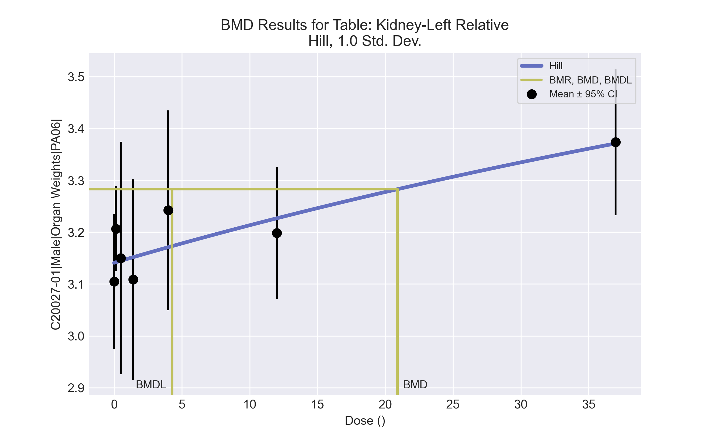
====================================================================
Hill Model. (Version: 2.18; Date: 03/14/2017)
Input Data File: C:\Windows\TEMP\bmds-1bu6fvvp.(d)
Gnuplot Plotting File: C:\Windows\TEMP\bmds-1bu6fvvp.plt
Fri Apr 16 08:36:12 2021
====================================================================
BMDS_Model_Run
~~~~~~~~~~~~~~~~~~~~~~~~~~~~~~~~~~~~~~~~~~~~~~~~~~~~~~~~~~~~~~~~~~~~~
The form of the response function is:
Y[dose] = intercept + v*dose^n/(k^n + dose^n)
Dependent variable = Response
Independent variable = Dose
rho is set to 0
Power parameter restricted to be greater than 1
A constant variance model is fit
Total number of dose groups = 7
Total number of records with missing values = 0
Maximum number of iterations = 500
Relative Function Convergence has been set to: 1e-008
Parameter Convergence has been set to: 1e-008
Default Initial Parameter Values
alpha = 0.0221976
rho = 0 Specified
intercept = 3.10457
v = 0.269343
n = 0.960543
k = 4.06052
Asymptotic Correlation Matrix of Parameter Estimates
( *** The model parameter(s) -rho -n
have been estimated at a boundary point, or have been specified by the user,
and do not appear in the correlation matrix )
alpha intercept v k
alpha 1 5.4e-008 7.6e-008 7.4e-008
intercept 5.4e-008 1 0.49 0.51
v 7.6e-008 0.49 1 1
k 7.4e-008 0.51 1 1
Parameter Estimates
95.0% Wald Confidence Interval
Variable Estimate Std. Err. Lower Conf. Limit Upper Conf. Limit
alpha 0.0201349 0.00450231 0.0113106 0.0289593
intercept 3.14098 0.0305465 3.08111 3.20085
v 1.19814 7.49667 -13.4951 15.8913
n 1 NA
k 155.626 1196.11 -2188.7 2499.95
NA - Indicates that this parameter has hit a bound
implied by some inequality constraint and thus
has no standard error.
Table of Data and Estimated Values of Interest
Dose N Obs Mean Est Mean Obs Std Dev Est Std Dev Scaled Res.
------ --- -------- -------- ----------- ----------- ----------
0 10 3.1 3.14 0.182 0.142 -0.811
0.15 5 3.21 3.14 0.0659 0.142 1.02
0.5 5 3.15 3.14 0.181 0.142 0.0833
1.4 5 3.11 3.15 0.156 0.142 -0.676
4 5 3.24 3.17 0.155 0.142 1.12
12 5 3.2 3.23 0.103 0.142 -0.445
37 5 3.37 3.37 0.114 0.142 0.0441
Model Descriptions for likelihoods calculated
Model A1: Yij = Mu(i) + e(ij)
Var{e(ij)} = Sigma^2
Model A2: Yij = Mu(i) + e(ij)
Var{e(ij)} = Sigma(i)^2
Model A3: Yij = Mu(i) + e(ij)
Var{e(ij)} = Sigma^2
Model A3 uses any fixed variance parameters that
were specified by the user
Model R: Yi = Mu + e(i)
Var{e(i)} = Sigma^2
Likelihoods of Interest
Model Log(likelihood) # Param's AIC
A1 60.002826 8 -104.005652
A2 63.946126 14 -99.892252
A3 60.002826 8 -104.005652
fitted 58.105977 4 -108.211953
R 53.177911 2 -102.355821
Explanation of Tests
Test 1: Do responses and/or variances differ among Dose levels?
(A2 vs. R)
Test 2: Are Variances Homogeneous? (A1 vs A2)
Test 3: Are variances adequately modeled? (A2 vs. A3)
Test 4: Does the Model for the Mean Fit? (A3 vs. fitted)
(Note: When rho=0 the results of Test 3 and Test 2 will be the same.)
Tests of Interest
Test -2*log(Likelihood Ratio) Test df p-value
Test 1 21.5364 12 0.04306
Test 2 7.8866 6 0.2465
Test 3 7.8866 6 0.2465
Test 4 3.7937 4 0.4346
The p-value for Test 1 is less than .05. There appears to be a
difference between response and/or variances among the dose levels
It seems appropriate to model the data
The p-value for Test 2 is greater than .1. A homogeneous variance
model appears to be appropriate here
The p-value for Test 3 is greater than .1. The modeled variance appears
to be appropriate here
The p-value for Test 4 is greater than .1. The model chosen seems
to adequately describe the data
Benchmark Dose Computation
Specified effect = 1
Risk Type = Estimated standard deviations from the control mean
Confidence level = 0.95
BMD = 20.9071
BMDL = 4.27187
BMDU = 1.369e+007

Male BMD Results for Table: Kidney-Right Absolute
BMDS version: BMDS v2.7.0

Input dataset
Dose | 0 | 0.15 | 0.5 | 1.4 | 4 | 12 | 37 | 111 | 333ª
N | 10 | 5 | 5 | 5 | 5 | 5 | 5 | 5 | 5
Mean ± SD | 0.975 ± 0.075 | 1.014 ± 0.052 | 0.984 ± 0.113 | 1.034 ± 0.142 | 1.066 ± 0.113 | 1.016 ± 0.059 | 1.104 ± 0.087 | 1.092 ± 0.153 | 1.062 ± 0.077
ª Dose group removed in BMD modeling session

Summary table
Modelª | Goodness of fit |  | BMD | BMDL | Comments
 | p-value | AIC
Linear^{b} (equivalent models include Power, Polynomial 2°, 3°, 4°, 5°, 6°, 7°, 8°) | 0.454 | -157.728 | 108.71 | 60.752 | Linear recommended as best-fitting model on the basis of the lowest AIC.
Hill | 0.725 | -158.618 | 27.948 | 0.515
Exponential M2 (equivalent models include Exponential M3) | 0.446 | -157.66 | 110.328 | 63.518
Exponential M4 (equivalent models include Exponential M5) | 0.648 | -158.117 | 44.315 | 0.491
ª Constant variance case presented (BMDS Test 2 p-value = 0.17, BMDS Test 3 p-value = 0.17).
^{b} Recommended model

Model recommendation details
Model | Bin | Notes
Linearª (equivalent models include Power, Polynomial 2°, 3°, 4°, 5°, 6°, 7°, 8°) | Valid | -
Hill | Warning | Warnings  • BMD/BMDL ratio is greater than threshold (54.3 > 20.0)  Cautions  • BMD/BMDL ratio is greater than threshold (54.3 > 5.0)
Exponential M2 (equivalent models include Exponential M3) | Valid | -
Exponential M4 (equivalent models include Exponential M5) | Warning | Warnings  • BMD/BMDL ratio is greater than threshold (90.3 > 20.0)  Cautions  • BMD/BMDL ratio is greater than threshold (90.3 > 5.0)
ª Recommended model

Recommended model
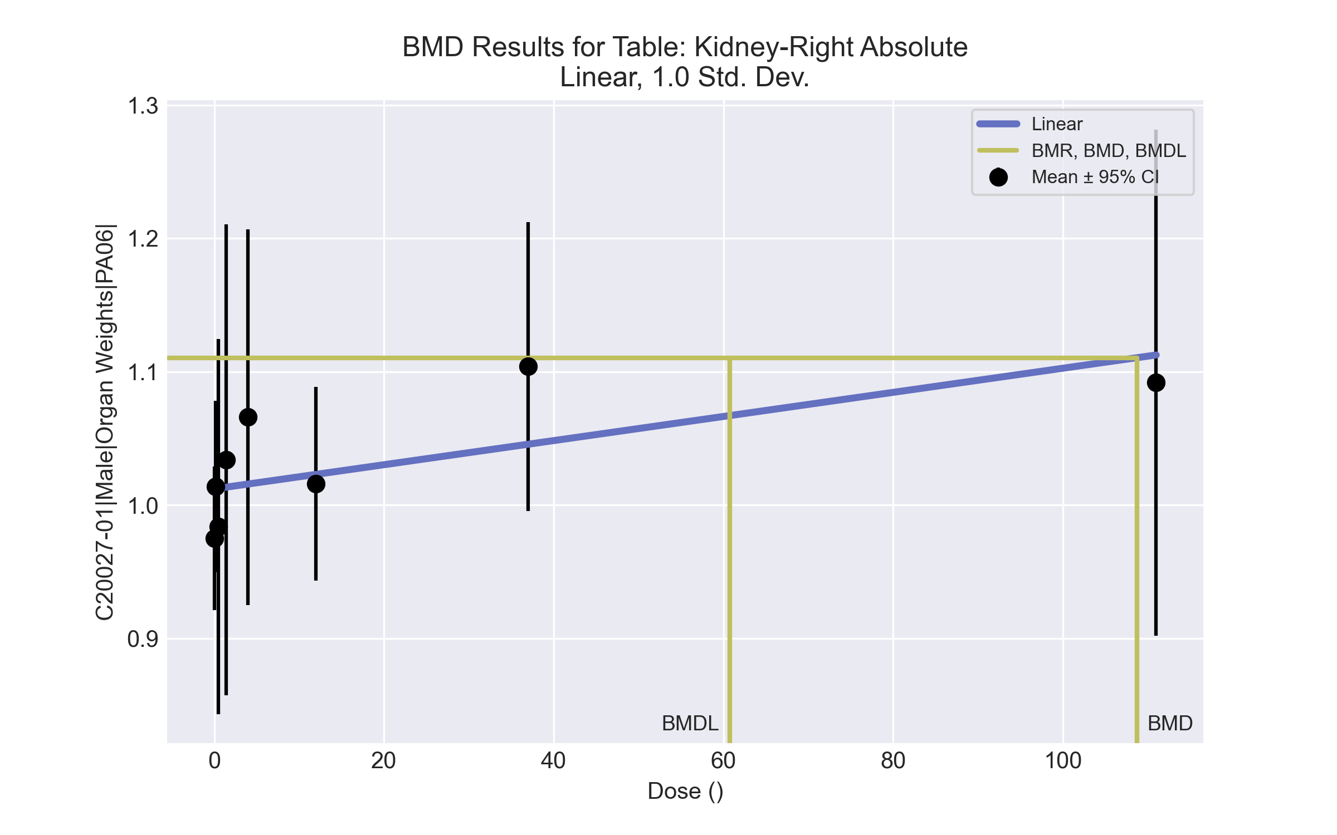
====================================================================
Polynomial Model. (Version: 2.21; Date: 03/14/2017)
Input Data File: C:\Windows\TEMP\bmds-b67nnb44.(d)
Gnuplot Plotting File: C:\Windows\TEMP\bmds-b67nnb44.plt
Fri Apr 16 08:36:26 2021
====================================================================
BMDS_Model_Run
~~~~~~~~~~~~~~~~~~~~~~~~~~~~~~~~~~~~~~~~~~~~~~~~~~~~~~~~~~~~~~~~~~~~~
The form of the response function is:
Y[dose] = beta_0 + beta_1*dose + beta_2*dose^2 + ...
Dependent variable = Response
Independent variable = Dose
rho is set to 0
The polynomial coefficients are restricted to be positive
A constant variance model is fit
Total number of dose groups = 8
Total number of records with missing values = 0
Maximum number of iterations = 500
Relative Function Convergence has been set to: 1e-008
Parameter Convergence has been set to: 1e-008
Default Initial Parameter Values
alpha = 0.0103581
rho = 0 Specified
beta_0 = 1.01839
beta_1 = 0
Asymptotic Correlation Matrix of Parameter Estimates
( *** The model parameter(s) -rho
have been estimated at a boundary point, or have been specified by the user,
and do not appear in the correlation matrix )
alpha beta_0 beta_1
alpha 1 2.9e-008 -3.6e-008
beta_0 2.9e-008 1 -0.47
beta_1 -3.6e-008 -0.47 1
Parameter Estimates
95.0% Wald Confidence Interval
Variable Estimate Std. Err. Lower Conf. Limit Upper Conf. Limit
alpha 0.00967311 0.00203927 0.00567622 0.01367
beta_0 1.0122 0.0166132 0.979635 1.04476
beta_1 0.000904723 0.000423463 7.47505e-005 0.00173469
Table of Data and Estimated Values of Interest
Dose N Obs Mean Est Mean Obs Std Dev Est Std Dev Scaled Res.
------ --- -------- -------- ----------- ----------- ----------
0 10 0.975 1.01 0.0752 0.0984 -1.2
0.15 5 1.01 1.01 0.0518 0.0984 0.0379
0.5 5 0.984 1.01 0.113 0.0984 -0.651
1.4 5 1.03 1.01 0.142 0.0984 0.467
4 5 1.07 1.02 0.113 0.0984 1.14
12 5 1.02 1.02 0.0586 0.0984 -0.16
37 5 1.1 1.05 0.0873 0.0984 1.33
111 5 1.09 1.11 0.153 0.0984 -0.469
Model Descriptions for likelihoods calculated
Model A1: Yij = Mu(i) + e(ij)
Var{e(ij)} = Sigma^2
Model A2: Yij = Mu(i) + e(ij)
Var{e(ij)} = Sigma(i)^2
Model A3: Yij = Mu(i) + e(ij)
Var{e(ij)} = Sigma^2
Model A3 uses any fixed variance parameters that
were specified by the user
Model R: Yi = Mu + e(i)
Var{e(i)} = Sigma^2
Likelihoods of Interest
Model Log(likelihood) # Param's AIC
A1 84.728972 9 -151.457943
A2 89.900537 16 -147.801074
A3 84.728972 9 -151.457943
fitted 81.864113 3 -157.728227
R 79.690302 2 -155.380604
Explanation of Tests
Test 1: Do responses and/or variances differ among Dose levels?
(A2 vs. R)
Test 2: Are Variances Homogeneous? (A1 vs A2)
Test 3: Are variances adequately modeled? (A2 vs. A3)
Test 4: Does the Model for the Mean Fit? (A3 vs. fitted)
(Note: When rho=0 the results of Test 3 and Test 2 will be the same.)
Tests of Interest
Test -2*log(Likelihood Ratio) Test df p-value
Test 1 20.4205 14 0.1174
Test 2 10.3431 7 0.1699
Test 3 10.3431 7 0.1699
Test 4 5.72972 6 0.4541
The p-value for Test 1 is greater than .05. There may not be a
diffence between responses and/or variances among the dose levels
Modelling the data with a dose/response curve may not be appropriate
The p-value for Test 2 is greater than .1. A homogeneous variance
model appears to be appropriate here
The p-value for Test 3 is greater than .1. The modeled variance appears
to be appropriate here
The p-value for Test 4 is greater than .1. The model chosen seems
to adequately describe the data
Benchmark Dose Computation
Specified effect = 1
Risk Type = Estimated standard deviations from the control mean
Confidence level = 0.95
BMD = 108.71
BMDL = 60.7516
BMDU = 515.034

Male BMD Results for Table: Kidney-Right Relative
BMDS version: BMDS v2.7.0

Input dataset
Dose | 0 | 0.15 | 0.5 | 1.4 | 4 | 12 | 37ª | 111ª | 333ª
N | 10 | 5 | 5 | 5 | 5 | 5 | 5 | 5 | 5
Mean ± SD | 3.096 ± 0.126 | 3.161 ± 0.097 | 3.163 ± 0.281 | 3.185 ± 0.27 | 3.425 ± 0.187 | 3.204 ± 0.134 | 3.495 ± 0.088 | 3.407 ± 0.23 | 3.496 ± 0.335
ª Dose group removed in BMD modeling session

Summary table
Modelª | Goodness of fit |  | BMD | BMDL | Comments
 | p-value | AIC
Linear (equivalent models include Power, Polynomial 2°, 3°, 7°, 8°) | 0.018 | -71.604 | 22.718 | 4.982 | Exponential-M4 recommended as best-fitting model on the basis of the lowest AIC.
Polynomial 4° | 0.018 | -71.604 | 22.718 | 4.982
Polynomial 5° (equivalent models include Polynomial 6°) | 0.018 | -71.604 | 22.718 | 4.982
Hill | 0.358 | -78.326 | 0.348 | -999
Exponential M2 (equivalent models include Exponential M3) | 0.018 | -71.586 | 23.172 | 5.459
Exponential M4^{b} | 0.33 | -78.119 | 0.464 | 0.082
Exponential M5 | 0.198 | -76.318 | 0.375 | 0.09
ª Modeled variance case presented (BMDS Test 2 p-value = 0.088, BMDS Test 3 p-value = 0.115).
^{b} Recommended model

Model recommendation details
Model | Bin | Notes
Linear (equivalent models include Power, Polynomial 2°, 3°, 7°, 8°) | Warning | Warnings  • Goodness of fit p-value is less than threshold (0.0177 < 0.1)  • BMD/high dose ratio is greater than threshold (1.89 > 1.0)  • Ratio of modeled to actual stdev. at control is greater than threshold (1.56 > 1.5)
Polynomial 4° | Warning | Warnings  • Goodness of fit p-value is less than threshold (0.0177 < 0.1)  • BMD/high dose ratio is greater than threshold (1.89 > 1.0)  • Ratio of modeled to actual stdev. at control is greater than threshold (1.56 > 1.5)
Polynomial 5° (equivalent models include Polynomial 6°) | Warning | Warnings  • Goodness of fit p-value is less than threshold (0.0177 < 0.1)  • BMD/high dose ratio is greater than threshold (1.89 > 1.0)  • Ratio of modeled to actual stdev. at control is greater than threshold (1.56 > 1.5)
Hill | Failure | Failures  • BMDL does not exist  Cautions  • Warning(s): BMDL computation failed.
Exponential M2 (equivalent models include Exponential M3) | Warning | Warnings  • Goodness of fit p-value is less than threshold (0.0176 < 0.1)  • BMD/high dose ratio is greater than threshold (1.93 > 1.0)
Exponential M4ª | Valid | Cautions  • BMD/BMDL ratio is greater than threshold (5.69 > 5.0)
Exponential M5 | Valid | -
ª Recommended model

Recommended model
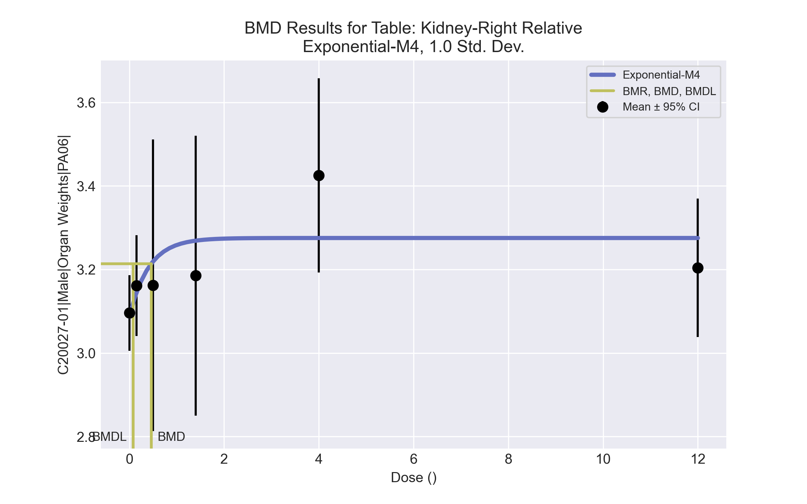
====================================================================
Exponential Model. (Version: 1.11; Date: 03/14/2017)
Input Data File: C:\Windows\TEMP\bmds-nx_htt7f.(d)
Gnuplot Plotting File:
Fri Apr 16 08:36:43 2021
====================================================================
BMDS_Model_Run
~~~~~~~~~~~~~~~~~~~~~~~~~~~~~~~~~~~~~~~~~~~~~~~~~~~~~~~~~~~~~~~~~~~~~
The form of the response function by Model:
Model 2: Y[dose] = a * exp{sign * b * dose}
Model 3: Y[dose] = a * exp{sign * (b * dose)^d}
Model 4: Y[dose] = a * [c-(c-1) * exp{-b * dose}]
Model 5: Y[dose] = a * [c-(c-1) * exp{-(b * dose)^d}]
Note: Y[dose] is the median response for exposure = dose;
sign = +1 for increasing trend in data;
sign = -1 for decreasing trend.
Model 2 is nested within Models 3 and 4.
Model 3 is nested within Model 5.
Model 4 is nested within Model 5.
Dependent variable = Response
Independent variable = Dose
Data are assumed to be distributed: normally
Variance Model: exp(lnalpha +rho *ln(Y[dose]))
The variance is to be modeled as Var(i) = exp(lalpha + log(mean(i)) * rho)
Total number of dose groups = 6
Total number of records with missing values = 0
Maximum number of iterations = 500
Relative Function Convergence has been set to: 1e-008
Parameter Convergence has been set to: 1e-008
MLE solution provided: Exact
Initial Parameter Values
Variable Model 4
-------- --------
lnalpha -9.32092
rho 4.95136
a 2.94107
b 0.0766445
c 1.22294
d 1 Specified
Parameter Estimates
Variable Model 4 Std. Err.
-------- ------- ---------
lnalpha -24.4138 0.292844
rho 18 NA
a 3.08686 2.19538
b 2.4173 0.0186201
c 1.06106 0
NC = No Convergence
Table of Stats From Input Data
Dose N Obs Mean Obs Std Dev
----- --- ---------- -------------
0 10 3.096 0.1264
0.15 5 3.161 0.09717
0.5 5 3.163 0.2813
1.4 5 3.185 0.2697
4 5 3.425 0.1875
12 5 3.204 0.1335
Estimated Values of Interest
Dose Est Mean Est Std Scaled Residual
------ ---------- --------- ----------------
0 3.087 0.1271 0.2241
0.15 3.144 0.15 0.2568
0.5 3.219 0.1854 -0.6815
1.4 3.269 0.213 -0.8803
4 3.275 0.2167 1.549
12 3.275 0.2167 -0.7375
Other models for which likelihoods are calculated:
Model A1: Yij = Mu(i) + e(ij)
Var{e(ij)} = Sigma^2
Model A2: Yij = Mu(i) + e(ij)
Var{e(ij)} = Sigma(i)^2
Model A3: Yij = Mu(i) + e(ij)
Var{e(ij)} = exp(lalpha + log(mean(i)) * rho)
Model R: Yij = Mu + e(i)
Var{e(ij)} = Sigma^2
Likelihoods of Interest
Model Log(likelihood) DF AIC
------- ----------------- ---- ------------
A1 44.70418 7 -75.40836
A2 49.49057 12 -74.98114
A3 45.77603 8 -75.55207
R 39.138 2 -74.276
4 44.05957 5 -78.11914
Additive constant for all log-likelihoods = -32.16. This constant added to the
above values gives the log-likelihood including the term that does not
depend on the model parameters.
Explanation of Tests
Test 1: Does response and/or variances differ among Dose levels? (A2 vs. R)
Test 2: Are Variances Homogeneous? (A2 vs. A1)
Test 3: Are variances adequately modeled? (A2 vs. A3)
Test 6a: Does Model 4 fit the data? (A3 vs 4)
Tests of Interest
Test -2*log(Likelihood Ratio) D. F. p-value
-------- ------------------------ ------ --------------
Test 1 20.71 10 0.02325
Test 2 9.573 5 0.08829
Test 3 7.429 4 0.1149
Test 6a 3.433 3 0.3296
The p-value for Test 1 is less than .05. There appears to be a
difference between response and/or variances among the dose
levels, it seems appropriate to model the data.
The p-value for Test 2 is less than .1. A non-homogeneous
variance model appears to be appropriate.
The p-value for Test 3 is greater than .1. The modeled
variance appears to be appropriate here.
The p-value for Test 6a is greater than .1. Model 4 seems
to adequately describe the data.
Benchmark Dose Computations:
Specified Effect = 1.000000
Risk Type = Estimated standard deviations from control
Confidence Level = 0.950000
BMD = 0.464376
BMDL = 0.081636
BMDU = Bad_Completion

Male BMD Results for Table: Liver Weight Absolute
BMDS version: BMDS v2.7.0

Input dataset
Dose | 0 | 0.15 | 0.5 | 1.4 | 4 | 12 | 37 | 111 | 333
N | 10 | 5 | 5 | 5 | 5 | 5 | 5 | 5 | 5
Mean ± SD | 11.783 ± 1.245 | 12.048 ± 0.519 | 11.83 ± 1.154 | 12.366 ± 1.459 | 12.288 ± 1.311 | 12.124 ± 0.751 | 13.466 ± 1.232 | 16.632 ± 1.224 | 18.04 ± 0.451

Summary table
Modelª | Goodness of fit |  | BMD | BMDL | Comments
 | p-value | AIC
Linear (equivalent models include Polynomial 3°) | 9.1E-04 | 81.433 | 65.488 | 53.388 | Exponential-M5 recommended as best-fitting model on the basis of the lowest AIC.
Polynomial 2° (equivalent models include Power, Polynomial 4°, 6°, 7°, 8°) | 9.1E-04 | 81.433 | 65.489 | 53.388
Polynomial 5° | 9.1E-04 | 81.433 | 65.488 | 53.388
Hill | 0.9 | 62.488 | 29.784 | 16.839
Exponential M2 (equivalent models include Exponential M3) | 1.6E-04 | 85.663 | 82.923 | 68.809
Exponential M4 | 0.698 | 62.722 | 17.663 | 12.655
Exponential M5^{b} | 0.901 | 62.484 | 28.507 | 15.286
ª Constant variance case presented (BMDS Test 2 p-value = 0.159, BMDS Test 3 p-value = 0.159).
^{b} Recommended model

Model recommendation details
Model | Bin | Notes
Linear (equivalent models include Polynomial 3°) | Warning | Warnings  • Goodness of fit p-value is less than threshold (0.00091 < 0.1)
Polynomial 2° (equivalent models include Power, Polynomial 4°, 6°, 7°, 8°) | Warning | Warnings  • Goodness of fit p-value is less than threshold (0.00091 < 0.1)
Polynomial 5° | Warning | Warnings  • Goodness of fit p-value is less than threshold (0.00091 < 0.1)
Hill | Valid | -
Exponential M2 (equivalent models include Exponential M3) | Warning | Warnings  • Goodness of fit p-value is less than threshold (0.000158 < 0.1)  • Residual of interest is greater than threshold (4.09 > 2.0)
Exponential M4 | Valid | -
Exponential M5ª | Valid | -
ª Recommended model

Recommended model
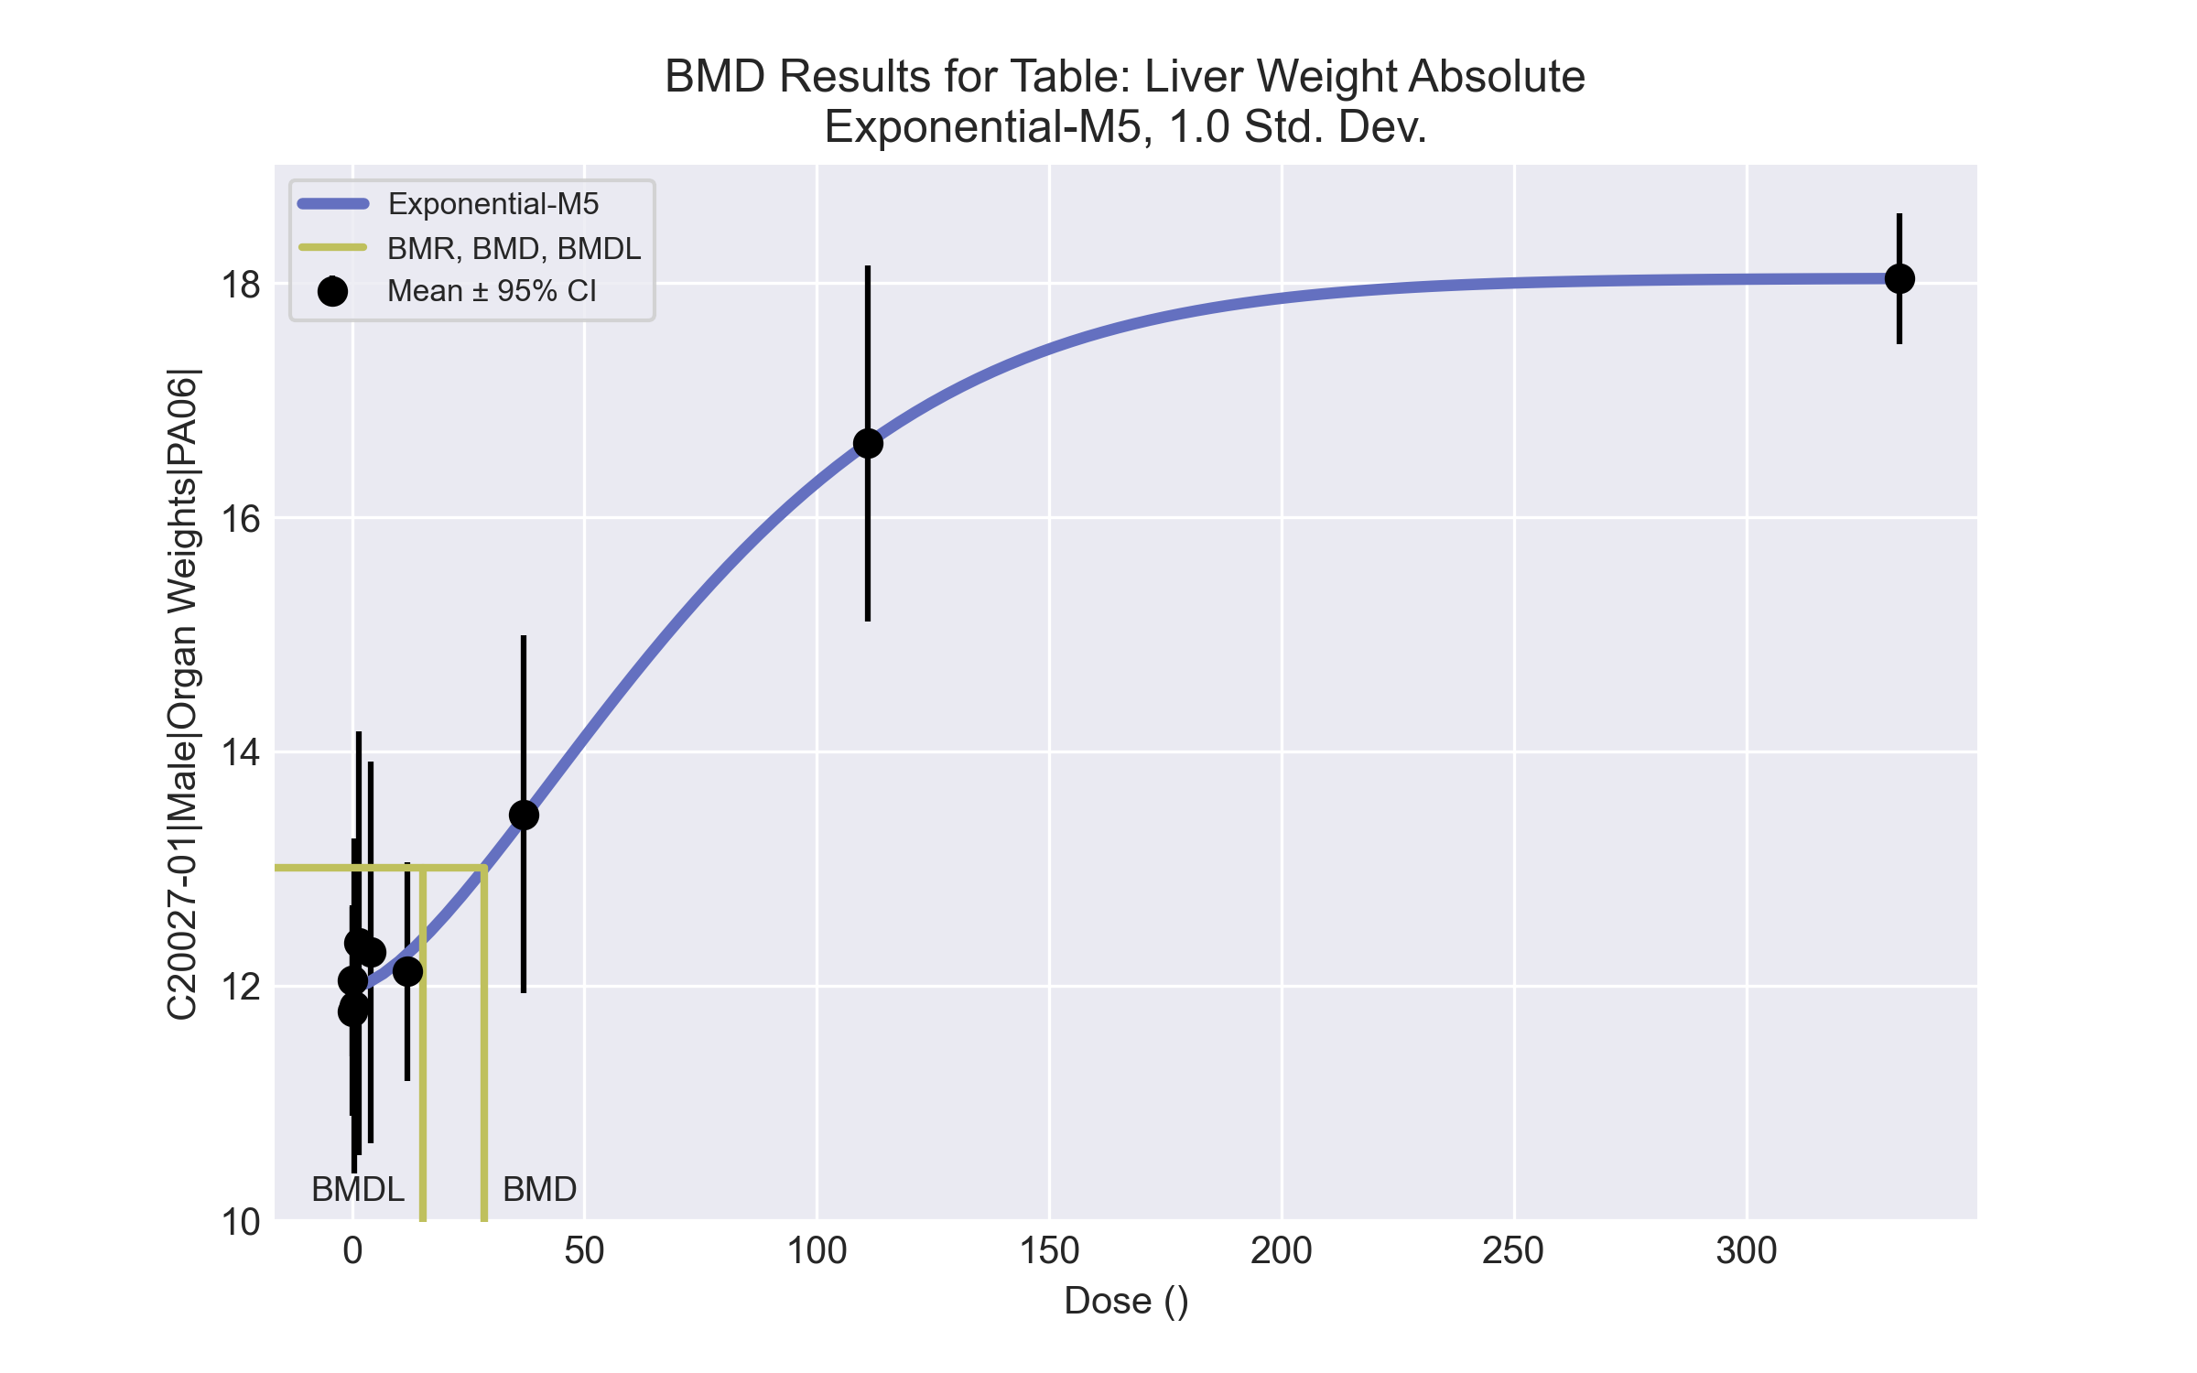
====================================================================
Exponential Model. (Version: 1.11; Date: 03/14/2017)
Input Data File: C:\Windows\TEMP\bmds-rqvj6is7.(d)
Gnuplot Plotting File:
Fri Apr 16 08:36:51 2021
====================================================================
BMDS_Model_Run
~~~~~~~~~~~~~~~~~~~~~~~~~~~~~~~~~~~~~~~~~~~~~~~~~~~~~~~~~~~~~~~~~~~~~
The form of the response function by Model:
Model 2: Y[dose] = a * exp{sign * b * dose}
Model 3: Y[dose] = a * exp{sign * (b * dose)^d}
Model 4: Y[dose] = a * [c-(c-1) * exp{-b * dose}]
Model 5: Y[dose] = a * [c-(c-1) * exp{-(b * dose)^d}]
Note: Y[dose] is the median response for exposure = dose;
sign = +1 for increasing trend in data;
sign = -1 for decreasing trend.
Model 2 is nested within Models 3 and 4.
Model 3 is nested within Model 5.
Model 4 is nested within Model 5.
Dependent variable = Response
Independent variable = Dose
Data are assumed to be distributed: normally
Variance Model: exp(lnalpha +rho *ln(Y[dose]))
rho is set to 0.
A constant variance model is fit.
Total number of dose groups = 9
Total number of records with missing values = 0
Maximum number of iterations = 500
Relative Function Convergence has been set to: 1e-008
Parameter Convergence has been set to: 1e-008
MLE solution provided: Exact
Initial Parameter Values
Variable Model 5
-------- --------
lnalpha 0.0175573
rho 0 Specified
a 11.1938
b 0.00694042
c 1.69218
d 1
Parameter Estimates
Variable Model 5 Std. Err.
-------- ------- ---------
lnalpha 0.0496716 0.210185
a 11.9827 0.18828
b 0.011558 0.00190584
c 1.50568 0.0459624
d 1.5182 0.391896
NC = No Convergence
Table of Stats From Input Data
Dose N Obs Mean Obs Std Dev
----- --- ---------- -------------
0 10 11.78 1.245
0.15 5 12.05 0.5185
0.5 5 11.83 1.154
1.4 5 12.37 1.459
4 5 12.29 1.311
12 5 12.12 0.7506
37 5 13.47 1.232
111 5 16.63 1.224
333 5 18.04 0.4514
Estimated Values of Interest
Dose Est Mean Est Std Scaled Residual
------ ---------- --------- ----------------
0 11.98 1.025 -0.6161
0.15 11.98 1.025 0.1415
0.5 11.99 1.025 -0.3384
1.4 11.99 1.025 0.8108
4 12.04 1.025 0.5422
12 12.28 1.025 -0.3343
37 13.44 1.025 0.05395
111 16.63 1.025 -0.005618
333 18.04 1.025 0.001081
Other models for which likelihoods are calculated:
Model A1: Yij = Mu(i) + e(ij)
Var{e(ij)} = Sigma^2
Model A2: Yij = Mu(i) + e(ij)
Var{e(ij)} = Sigma(i)^2
Model A3: Yij = Mu(i) + e(ij)
Var{e(ij)} = exp(lalpha + log(mean(i)) * rho)
Model R: Yij = Mu + e(i)
Var{e(ij)} = Sigma^2
Likelihoods of Interest
Model Log(likelihood) DF AIC
------- ----------------- ---- ------------
A1 -25.43893 10 70.87787
A2 -19.52258 18 75.04516
A3 -25.43893 10 70.87787
R -67.77458 2 139.5492
5 -26.24179 5 62.48358
Additive constant for all log-likelihoods = -45.95. This constant added to the
above values gives the log-likelihood including the term that does not
depend on the model parameters.
Explanation of Tests
Test 1: Does response and/or variances differ among Dose levels? (A2 vs. R)
Test 2: Are Variances Homogeneous? (A2 vs. A1)
Test 3: Are variances adequately modeled? (A2 vs. A3)
Test 7a: Does Model 5 fit the data? (A3 vs 5)
Tests of Interest
Test -2*log(Likelihood Ratio) D. F. p-value
-------- ------------------------ ------ --------------
Test 1 96.5 16 < 0.0001
Test 2 11.83 8 0.1588
Test 3 11.83 8 0.1588
Test 7a 1.606 5 0.9006
The p-value for Test 1 is less than .05. There appears to be a
difference between response and/or variances among the dose
levels, it seems appropriate to model the data.
The p-value for Test 2 is greater than .1. A homogeneous
variance model appears to be appropriate here.
The p-value for Test 3 is greater than .1. The modeled
variance appears to be appropriate here.
The p-value for Test 7a is greater than .1. Model 5 seems
to adequately describe the data.
Benchmark Dose Computations:
Specified Effect = 1.000000
Risk Type = Estimated standard deviations from control
Confidence Level = 0.950000
BMD = 28.5072
BMDL = 15.2863
BMDU = 47.3436

Male BMD Results for Table: Liver Weight Relative
BMDS version: BMDS v2.7.0

Input dataset
Dose | 0 | 0.15 | 0.5 | 1.4 | 4 | 12 | 37 | 111 | 333
N | 10 | 5 | 5 | 5 | 5 | 5 | 5 | 5 | 5
Mean ± SD | 37.368 ± 2.525 | 37.581 ± 1.417 | 38.03 ± 2.706 | 38.107 ± 2.347 | 39.498 ± 2.36 | 38.255 ± 2.364 | 42.605 ± 1.42 | 52.116 ± 2.372 | 59.299 ± 1.628

Summary table
Modelª | Goodness of fit |  | BMD | BMDL | Comments
 | p-value | AIC
Linear (equivalent models include Power, Polynomial 2°, 3°, 4°, 5°, 6°, 7°, 8°) | <0.0001 | 165.102 | 43.512 | 36.371 | Exponential-M4 recommended as best-fitting model on the basis of the lowest BMDL.
Hill | 0.597 | 133.619 | 21.002 | 12.44
Exponential M2 (equivalent models include Exponential M3) | <0.0001 | 173.109 | 58.732 | 49.605
Exponential M4^{b} | 0.406 | 134.103 | 12.122 | 9.527
Exponential M5 | 0.604 | 133.571 | 19.38 | 11.286
ª Constant variance case presented (BMDS Test 2 p-value = 0.734, BMDS Test 3 p-value = 0.734).
^{b} Recommended model

Model recommendation details
Model | Bin | Notes
Linear (equivalent models include Power, Polynomial 2°, 3°, 4°, 5°, 6°, 7°, 8°) | Valid | -
Hill | Valid | -
Exponential M2 (equivalent models include Exponential M3) | Valid | -
Exponential M4ª | Valid | -
Exponential M5 | Valid | -
ª Recommended model

Recommended model
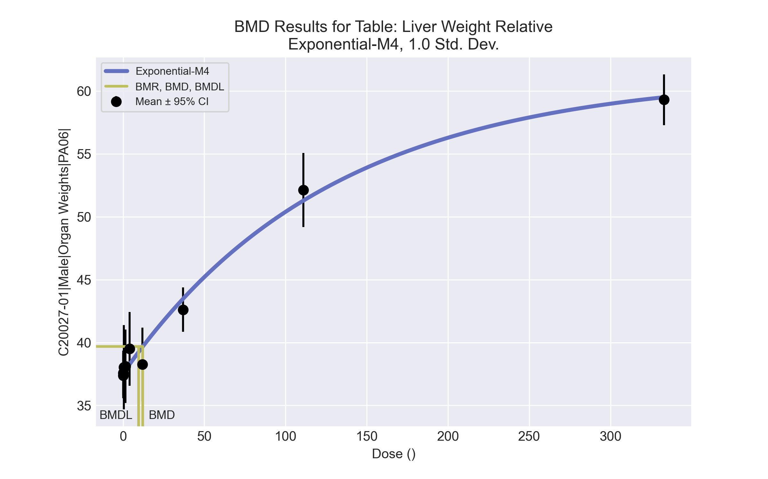
====================================================================
Exponential Model. (Version: 1.11; Date: 03/14/2017)
Input Data File: C:\Windows\TEMP\bmds-3dp9_ceg.(d)
Gnuplot Plotting File:
Fri Apr 16 08:36:55 2021
====================================================================
BMDS_Model_Run
~~~~~~~~~~~~~~~~~~~~~~~~~~~~~~~~~~~~~~~~~~~~~~~~~~~~~~~~~~~~~~~~~~~~~
The form of the response function by Model:
Model 2: Y[dose] = a * exp{sign * b * dose}
Model 3: Y[dose] = a * exp{sign * (b * dose)^d}
Model 4: Y[dose] = a * [c-(c-1) * exp{-b * dose}]
Model 5: Y[dose] = a * [c-(c-1) * exp{-(b * dose)^d}]
Note: Y[dose] is the median response for exposure = dose;
sign = +1 for increasing trend in data;
sign = -1 for decreasing trend.
Model 2 is nested within Models 3 and 4.
Model 3 is nested within Model 5.
Model 4 is nested within Model 5.
Dependent variable = Response
Independent variable = Dose
Data are assumed to be distributed: normally
Variance Model: exp(lnalpha +rho *ln(Y[dose]))
rho is set to 0.
A constant variance model is fit.
Total number of dose groups = 9
Total number of records with missing values = 0
Maximum number of iterations = 500
Relative Function Convergence has been set to: 1e-008
Parameter Convergence has been set to: 1e-008
MLE solution provided: Exact
Initial Parameter Values
Variable Model 4
-------- --------
lnalpha 1.39887
rho 0 Specified
a 35.4998
b 0.00684529
c 1.75391
d 1 Specified
Parameter Estimates
Variable Model 4 Std. Err.
-------- ------- ---------
lnalpha 1.52206 0.916327
a 37.535 0.378438
b 0.00779838 0.00128573
c 1.63219 0.0429455
NC = No Convergence
Table of Stats From Input Data
Dose N Obs Mean Obs Std Dev
----- --- ---------- -------------
0 10 37.37 2.525
0.15 5 37.58 1.417
0.5 5 38.03 2.706
1.4 5 38.11 2.347
4 5 39.5 2.36
12 5 38.26 2.364
37 5 42.6 1.42
111 5 52.12 2.372
333 5 59.3 1.628
Estimated Values of Interest
Dose Est Mean Est Std Scaled Residual
------ ---------- --------- ----------------
0 37.53 2.14 -0.2463
0.15 37.56 2.14 0.01961
0.5 37.63 2.14 0.4209
1.4 37.79 2.14 0.3287
4 38.26 2.14 1.29
12 39.65 2.14 -1.462
37 43.48 2.14 -0.9169
111 51.28 2.14 0.8746
333 59.5 2.14 -0.2064
Other models for which likelihoods are calculated:
Model A1: Yij = Mu(i) + e(ij)
Var{e(ij)} = Sigma^2
Model A2: Yij = Mu(i) + e(ij)
Var{e(ij)} = Sigma(i)^2
Model A3: Yij = Mu(i) + e(ij)
Var{e(ij)} = exp(lalpha + log(mean(i)) * rho)
Model R: Yij = Mu + e(i)
Var{e(ij)} = Sigma^2
Likelihoods of Interest
Model Log(likelihood) DF AIC
------- ----------------- ---- ------------
A1 -59.97171 10 139.9434
A2 -57.36106 18 150.7221
A3 -59.97171 10 139.9434
R -125.4582 2 254.9163
4 -63.0514 4 134.1028
Additive constant for all log-likelihoods = -45.95. This constant added to the
above values gives the log-likelihood including the term that does not
depend on the model parameters.
Explanation of Tests
Test 1: Does response and/or variances differ among Dose levels? (A2 vs. R)
Test 2: Are Variances Homogeneous? (A2 vs. A1)
Test 3: Are variances adequately modeled? (A2 vs. A3)
Test 6a: Does Model 4 fit the data? (A3 vs 4)
Tests of Interest
Test -2*log(Likelihood Ratio) D. F. p-value
-------- ------------------------ ------ --------------
Test 1 136.2 16 < 0.0001
Test 2 5.221 8 0.7337
Test 3 5.221 8 0.7337
Test 6a 6.159 6 0.4056
The p-value for Test 1 is less than .05. There appears to be a
difference between response and/or variances among the dose
levels, it seems appropriate to model the data.
The p-value for Test 2 is greater than .1. A homogeneous
variance model appears to be appropriate here.
The p-value for Test 3 is greater than .1. The modeled
variance appears to be appropriate here.
The p-value for Test 6a is greater than .1. Model 4 seems
to adequately describe the data.
Benchmark Dose Computations:
Specified Effect = 1.000000
Risk Type = Estimated standard deviations from control
Confidence Level = 0.950000
BMD = 12.1223
BMDL = 9.52697
BMDU = 16.1705

Male BMD Results for Table: A/G Ratio
BMDS version: BMDS v2.7.0

Input dataset
Dose | 0 | 0.15 | 0.5 | 1.4ª | 4ª | 12ª | 37ª | 111ª | 333ª
N | 10 | 5 | 5 | 5 | 4 | 5 | 5 | 5 | 5
Mean ± SD | 2.293 ± 0.176 | 2.281 ± 0.13 | 2.128 ± 0.093 | 2.027 ± 0.288 | 2.269 ± 0.161 | 2.688 ± 0.164 | 2.711 ± 0.132 | 3.504 ± 0.683 | 3.751 ± 0.69
ª Dose group removed in BMD modeling session

Summary table
Modelª | Goodness of fit |  | BMD | BMDL | Comments
 | p-value | AIC
Linear | 0.606 | -52.979 | 0.416 | 0.232 | Polynomial-2 recommended as best-fitting model on the basis of the lowest AIC.
Polynomial 2°^{b} | 0.977 | -53.245 | 0.456 | 0.237
Polynomial 3° (equivalent models include Polynomial 6°) | -999 | -51.246 | 0.466 | 0.237
Polynomial 4° | -999 | -51.246 | 0.473 | 0.237
Polynomial 5° | -999 | -47.246 | 0.473 | 0.237
Polynomial 7° | -999 | -51.246 | 0.462 | 0.342
Polynomial 8° | -999 | -45.246 | 0.482 | 0.237
Power | -999 | -51.246 | 0.459 | 0.237
Hill | -999 | -53.922 | 0.51 | 0.21
Exponential M2 (equivalent models include Exponential M4) | 0.593 | -52.96 | 0.415 | 0.225
Exponential M3 | -999 | -51.246 | 0.458 | 0.231
Exponential M5 | -999 | -53.922 | 0.509 | 0.159
ª Constant variance case presented (BMDS Test 2 p-value = 0.232, BMDS Test 3 p-value = 0.232).
^{b} Recommended model

Model recommendation details
Model | Bin | Notes
Linear | Valid | -
Polynomial 2°ª | Valid | -
Polynomial 3° (equivalent models include Polynomial 6°) | Warning | Warnings  • Zero degrees of freedom; saturated model
Polynomial 4° | Warning | Warnings  • Zero degrees of freedom; saturated model  Cautions  • Warning(s): Warning: Likelihood for fitted model larger than the Likelihood for model A3.
Polynomial 5° | Valid | Cautions  • Warning(s): THE MODEL HAS PROBABLY NOT CONVERGED!!!; THIS USUALLY MEANS THE MODEL HAS NOT CONVERGED!
Polynomial 7° | Warning | Warnings  • Zero degrees of freedom; saturated model
Polynomial 8° | Valid | Cautions  • Warning(s): Warning: Likelihood for fitted model larger than the Likelihood for model A3.
Power | Warning | Warnings  • Zero degrees of freedom; saturated model
Hill | Warning | Warnings  • Variance model poorly fits dataset (p-value 3 = 0.09014)  • Zero degrees of freedom; saturated model  • BMD/high dose ratio is greater than threshold (1.02 > 1.0)
Exponential M2 (equivalent models include Exponential M4) | Valid | -
Exponential M3 | Warning | Warnings  • Zero degrees of freedom; saturated model
Exponential M5 | Warning | Warnings  • Variance model poorly fits dataset (p-value 3 = 0.09014)  • Zero degrees of freedom; saturated model  • BMD/high dose ratio is greater than threshold (1.02 > 1.0)
ª Recommended model

Recommended model
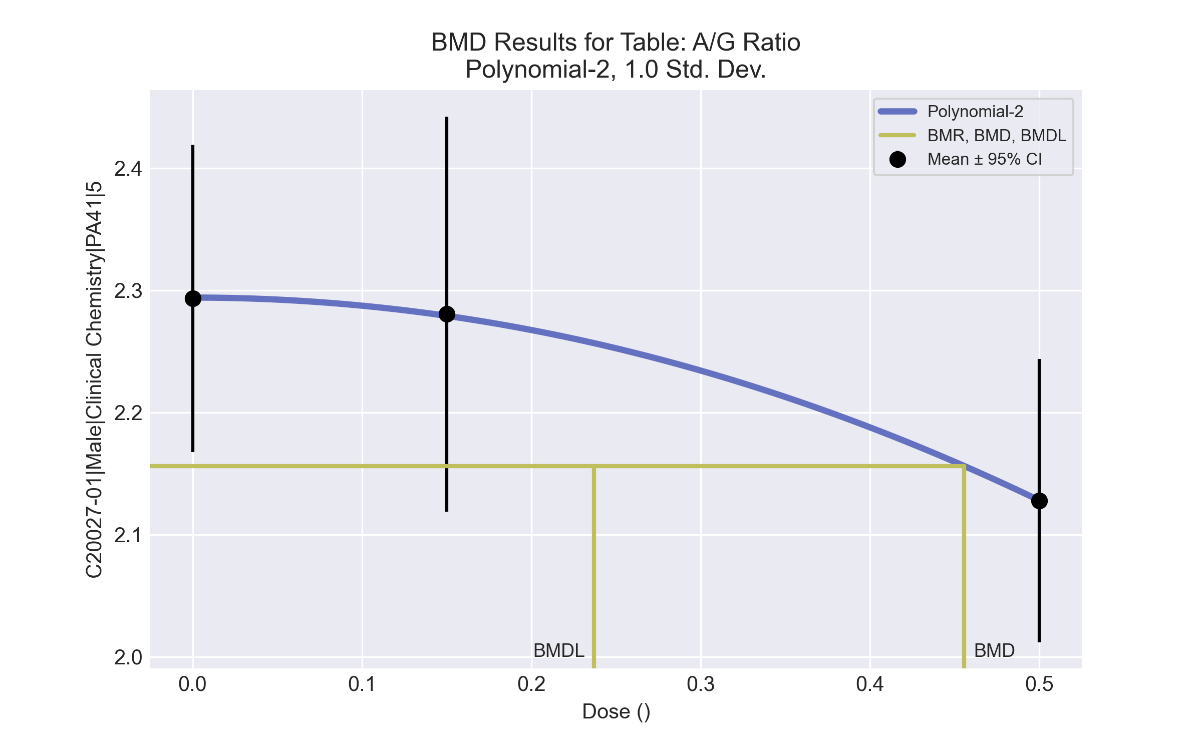
====================================================================
Polynomial Model. (Version: 2.21; Date: 03/14/2017)
Input Data File: C:\Windows\TEMP\bmds-qcmjrgji.(d)
Gnuplot Plotting File: C:\Windows\TEMP\bmds-qcmjrgji.plt
Fri Apr 16 00:37:30 2021
====================================================================
BMDS_Model_Run
~~~~~~~~~~~~~~~~~~~~~~~~~~~~~~~~~~~~~~~~~~~~~~~~~~~~~~~~~~~~~~~~~~~~~
The form of the response function is:
Y[dose] = beta_0 + beta_1*dose + beta_2*dose^2 + ...
Dependent variable = Response
Independent variable = Dose
rho is set to 0
The polynomial coefficients are restricted to be negative
A constant variance model is fit
Total number of dose groups = 3
Total number of records with missing values = 0
Maximum number of iterations = 500
Relative Function Convergence has been set to: 1e-008
Parameter Convergence has been set to: 1e-008
Default Initial Parameter Values
alpha = 0.0223756
rho = 0 Specified
beta_0 = 2.2933
beta_1 = 0
beta_2 = -0.703175
Asymptotic Correlation Matrix of Parameter Estimates
( *** The model parameter(s) -rho -beta_1
have been estimated at a boundary point, or have been specified by the user,
and do not appear in the correlation matrix )
alpha beta_0 beta_2
alpha 1 1.3e-008 3.3e-008
beta_0 1.3e-008 1 -0.54
beta_2 3.3e-008 -0.54 1
Parameter Estimates
95.0% Wald Confidence Interval
Variable Estimate Std. Err. Lower Conf. Limit Upper Conf. Limit
alpha 0.0190201 0.00601469 0.00723154 0.0308087
beta_0 2.29399 0.0367186 2.22202 2.36595
beta_1 -0 NA
beta_2 -0.664253 0.292566 -1.23767 -0.0908346
NA - Indicates that this parameter has hit a bound
implied by some inequality constraint and thus
has no standard error.
Table of Data and Estimated Values of Interest
Dose N Obs Mean Est Mean Obs Std Dev Est Std Dev Scaled Res.
------ --- -------- -------- ----------- ----------- ----------
0 10 2.29 2.29 0.176 0.138 -0.0158
0.15 5 2.28 2.28 0.13 0.138 0.0246
0.5 5 2.13 2.13 0.0933 0.138 -0.00222
Model Descriptions for likelihoods calculated
Model A1: Yij = Mu(i) + e(ij)
Var{e(ij)} = Sigma^2
Model A2: Yij = Mu(i) + e(ij)
Var{e(ij)} = Sigma(i)^2
Model A3: Yij = Mu(i) + e(ij)
Var{e(ij)} = Sigma^2
Model A3 uses any fixed variance parameters that
were specified by the user
Model R: Yi = Mu + e(i)
Var{e(i)} = Sigma^2
Likelihoods of Interest
Model Log(likelihood) # Param's AIC
A1 29.623017 4 -51.246035
A2 31.086362 6 -50.172724
A3 29.623017 4 -51.246035
fitted 29.622586 3 -53.245173
R 27.329384 2 -50.658767
Explanation of Tests
Test 1: Do responses and/or variances differ among Dose levels?
(A2 vs. R)
Test 2: Are Variances Homogeneous? (A1 vs A2)
Test 3: Are variances adequately modeled? (A2 vs. A3)
Test 4: Does the Model for the Mean Fit? (A3 vs. fitted)
(Note: When rho=0 the results of Test 3 and Test 2 will be the same.)
Tests of Interest
Test -2*log(Likelihood Ratio) Test df p-value
Test 1 7.51396 4 0.1111
Test 2 2.92669 2 0.2315
Test 3 2.92669 2 0.2315
Test 4 0.000862288 1 0.9766
The p-value for Test 1 is greater than .05. There may not be a
diffence between responses and/or variances among the dose levels
Modelling the data with a dose/response curve may not be appropriate
The p-value for Test 2 is greater than .1. A homogeneous variance
model appears to be appropriate here
The p-value for Test 3 is greater than .1. The modeled variance appears
to be appropriate here
The p-value for Test 4 is greater than .1. The model chosen seems
to adequately describe the data
Benchmark Dose Computation
Specified effect = 1
Risk Type = Estimated standard deviations from the control mean
Confidence level = 0.95
BMD = 0.455655
BMDL = 0.237136
BMDU = 1.67593

Male BMD Results for Table: Alanine aminotransferase
BMDS version: BMDS v2.7.0

Input dataset
Dose | 0 | 0.15 | 0.5 | 1.4 | 4 | 12 | 37 | 111ª | 333ª
N | 10 | 5 | 5 | 5 | 4 | 5 | 5 | 5 | 5
Mean ± SD | 61.2 ± 11.253 | 64 ± 11.64 | 55 ± 5.788 | 58.8 ± 7.225 | 70.5 ± 8.583 | 57.4 ± 8.295 | 72.2 ± 7.014 | 110.2 ± 43.9 | 209.2 ± 150.292
ª Dose group removed in BMD modeling session

Summary table
Modelª | Goodness of fit |  | BMD | BMDL | Comments
 | p-value | AIC
Linear | 0.08 | 220.332 | 33.662 | 19.195 | Polynomial-8 recommended as best-fitting model on the basis of the lowest AIC.
Polynomial 2° | 0.106 | 219.591 | 34.069 | 20.497
Polynomial 3° | 0.117 | 219.312 | 34.794 | 21.107
Polynomial 4° | 0.122 | 219.212 | 35.278 | 26.519
Polynomial 5° | 0.123 | 219.179 | 35.602 | 21.428
Polynomial 6° | 0.123 | 219.168 | 35.828 | 21.456
Polynomial 7° | 0.124 | 219.164 | 35.992 | 29.353
Polynomial 8°^{b} | 0.124 | 219.163 | 36.116 | 21.468
Power | 0.07 | 221.163 | 36.462 | 21.469
Hill | 0.034 | 223.163 | 36.394 | 19.953
Exponential M2 | 0.083 | 220.256 | 33.376 | 20.134
Exponential M3 | 0.07 | 221.163 | 36.586 | -999
Exponential M4 | 0.044 | 222.333 | 33.669 | 14.914
Exponential M5 | 0.034 | 223.163 | 36.448 | 19.88
ª Constant variance case presented (BMDS Test 2 p-value = 0.522, BMDS Test 3 p-value = 0.522).
^{b} Recommended model

Model recommendation details
Model | Bin | Notes
Linear | Warning | Warnings  • Goodness of fit p-value is less than threshold (0.0805 < 0.1)
Polynomial 2° | Valid | -
Polynomial 3° | Valid | -
Polynomial 4° | Valid | -
Polynomial 5° | Valid | -
Polynomial 6° | Valid | -
Polynomial 7° | Valid | -
Polynomial 8°ª | Valid | -
Power | Warning | Warnings  • Goodness of fit p-value is less than threshold (0.0704 < 0.1)
Hill | Warning | Warnings  • Goodness of fit p-value is less than threshold (0.0343 < 0.1)
Exponential M2 | Warning | Warnings  • Goodness of fit p-value is less than threshold (0.0828 < 0.1)
Exponential M3 | Failure | Failures  • BMDL does not exist  Warnings  • Goodness of fit p-value is less than threshold (0.0704 < 0.1)
Exponential M4 | Warning | Warnings  • Goodness of fit p-value is less than threshold (0.0435 < 0.1)
Exponential M5 | Warning | Warnings  • Goodness of fit p-value is less than threshold (0.0343 < 0.1)
ª Recommended model

Recommended model
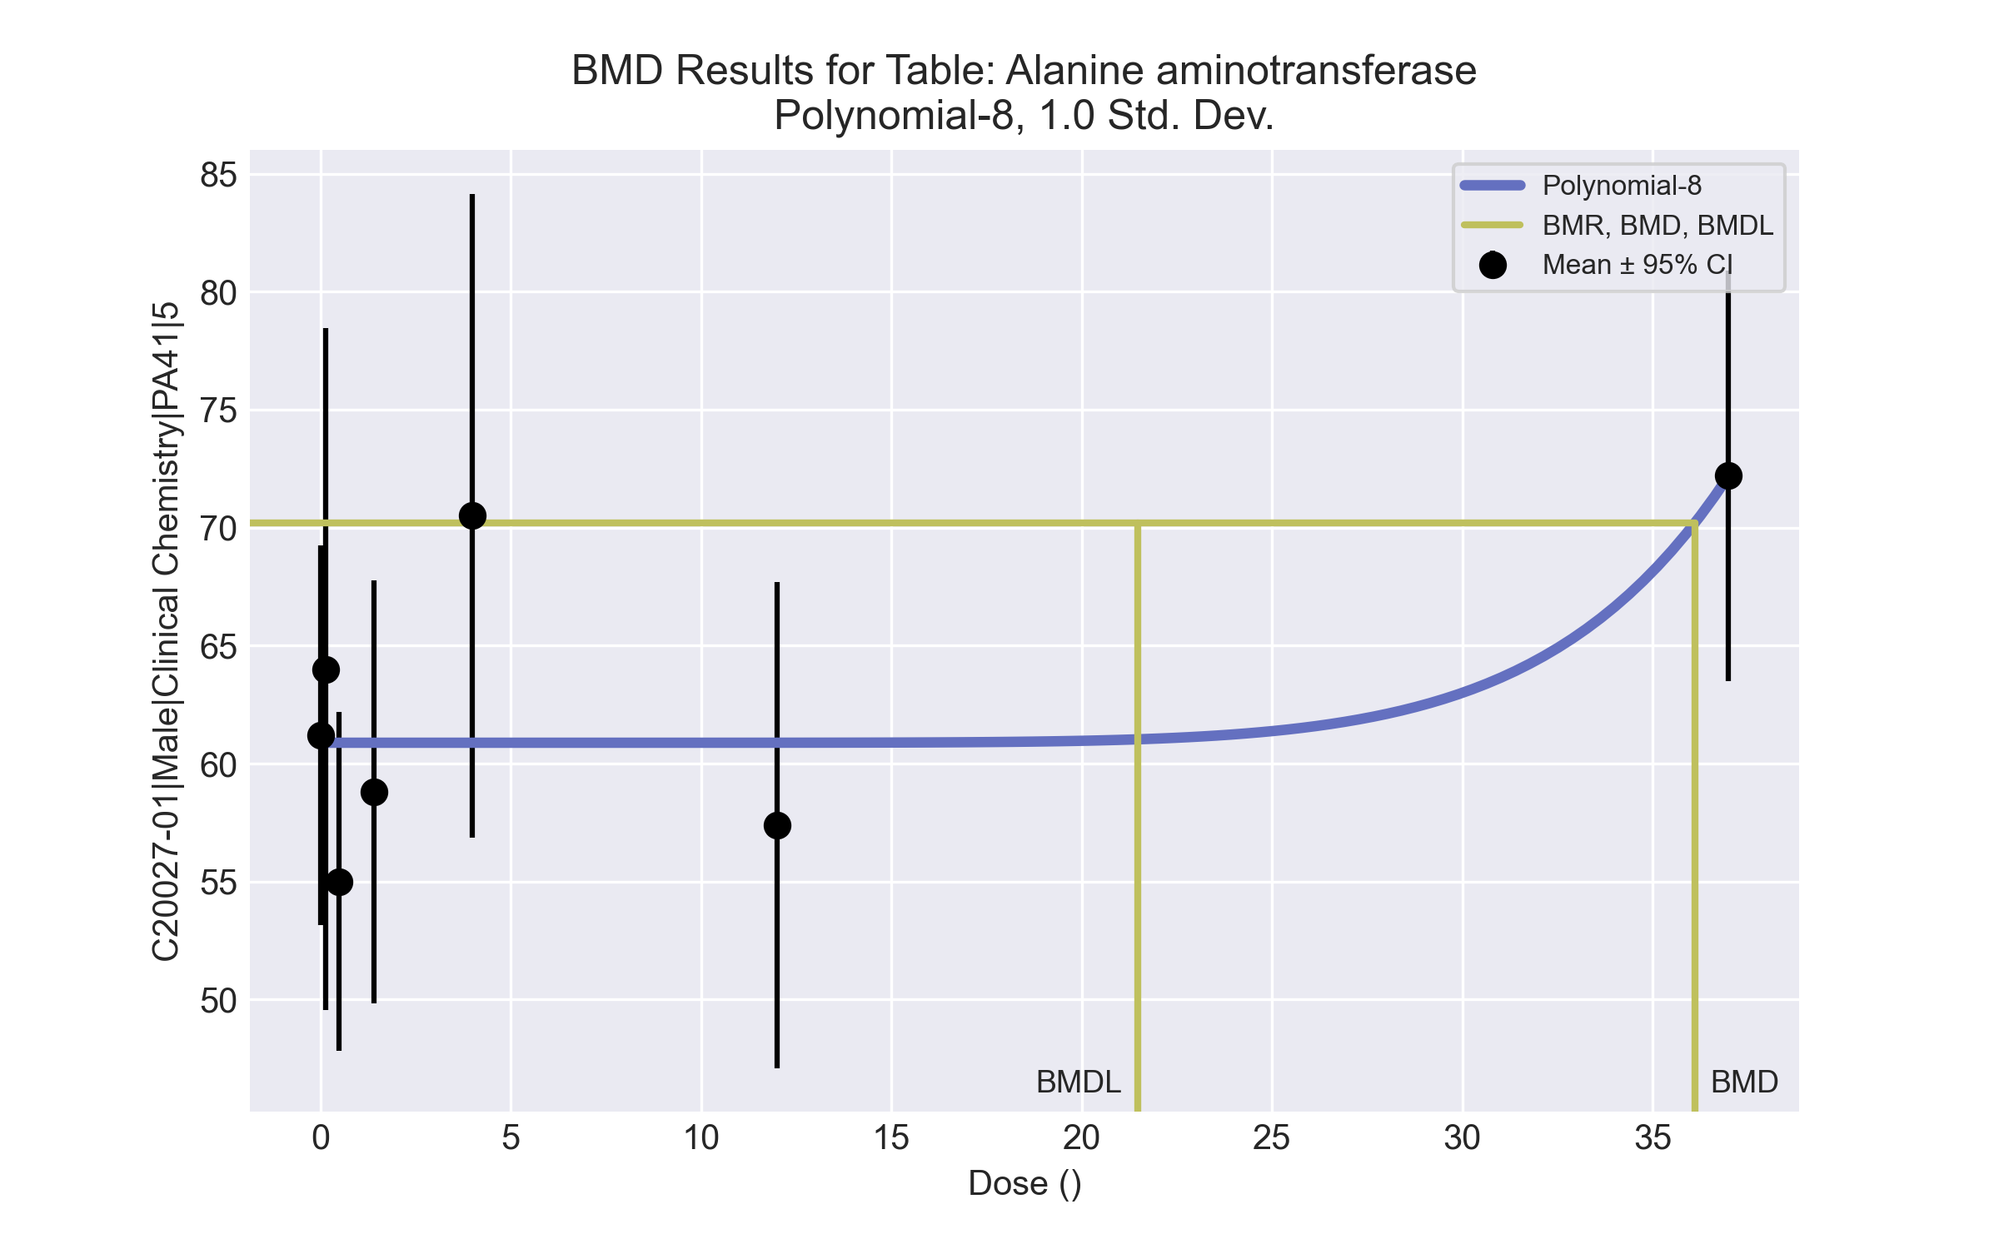
====================================================================
Polynomial Model. (Version: 2.21; Date: 03/14/2017)
Input Data File: C:\Windows\TEMP\bmds-t_7njl92.(d)
Gnuplot Plotting File: C:\Windows\TEMP\bmds-t_7njl92.plt
Fri Apr 16 00:37:46 2021
====================================================================
BMDS_Model_Run
~~~~~~~~~~~~~~~~~~~~~~~~~~~~~~~~~~~~~~~~~~~~~~~~~~~~~~~~~~~~~~~~~~~~~
The form of the response function is:
Y[dose] = beta_0 + beta_1*dose + beta_2*dose^2 + ...
Dependent variable = Response
Independent variable = Dose
rho is set to 0
The polynomial coefficients are restricted to be positive
A constant variance model is fit
Total number of dose groups = 7
Total number of records with missing values = 0
Maximum number of iterations = 500
Relative Function Convergence has been set to: 1e-008
Parameter Convergence has been set to: 1e-008
Default Initial Parameter Values
alpha = 84.9188
rho = 0 Specified
beta_0 = 94.0728
beta_1 = 0
beta_2 = 0
beta_3 = 0
beta_4 = 0
beta_5 = 0
beta_6 = 0
beta_7 = 0
beta_8 = 0
Asymptotic Correlation Matrix of Parameter Estimates
( *** The model parameter(s) -rho -beta_1 -beta_2 -beta_3 -beta_4 -beta_5 -beta_6 -beta_7
have been estimated at a boundary point, or have been specified by the user,
and do not appear in the correlation matrix )
alpha beta_0 beta_8
alpha 1 4.1e-007 -2.5e-007
beta_0 4.1e-007 1 -0.36
beta_8 -2.5e-007 -0.36 1
Parameter Estimates
95.0% Wald Confidence Interval
Variable Estimate Std. Err. Lower Conf. Limit Upper Conf. Limit
alpha 86.984 19.698 48.3767 125.591
beta_0 60.8822 1.59951 57.7472 64.0172
beta_1 -0 NA
beta_2 1.07239e-024 NA
beta_3 -0 NA
beta_4 6.15659e-027 NA
beta_5 8.16911e-027 NA
beta_6 2.13613e-029 NA
beta_7 -0 NA
beta_8 3.22204e-012 1.27181e-012 7.29344e-013 5.71474e-012
NA - Indicates that this parameter has hit a bound
implied by some inequality constraint and thus
has no standard error.
Table of Data and Estimated Values of Interest
Dose N Obs Mean Est Mean Obs Std Dev Est Std Dev Scaled Res.
------ --- -------- -------- ----------- ----------- ----------
0 10 61.2 60.9 11.3 9.33 0.108
0.15 5 64 60.9 11.6 9.33 0.748
0.5 5 55 60.9 5.79 9.33 -1.41
1.4 5 58.8 60.9 7.22 9.33 -0.499
4 4 70.5 60.9 8.58 9.33 2.06
12 5 57.4 60.9 8.29 9.33 -0.835
37 5 72.2 72.2 7.01 9.33 0.000103
Model Descriptions for likelihoods calculated
Model A1: Yij = Mu(i) + e(ij)
Var{e(ij)} = Sigma^2
Model A2: Yij = Mu(i) + e(ij)
Var{e(ij)} = Sigma(i)^2
Model A3: Yij = Mu(i) + e(ij)
Var{e(ij)} = Sigma^2
Model A3 uses any fixed variance parameters that
were specified by the user
Model R: Yi = Mu + e(i)
Var{e(i)} = Sigma^2
Likelihoods of Interest
Model Log(likelihood) # Param's AIC
A1 -102.255449 8 220.510898
A2 -99.670422 14 227.340845
A3 -102.255449 8 220.510898
fitted -106.581632 3 219.163263
R -109.552521 2 223.105041
Explanation of Tests
Test 1: Do responses and/or variances differ among Dose levels?
(A2 vs. R)
Test 2: Are Variances Homogeneous? (A1 vs A2)
Test 3: Are variances adequately modeled? (A2 vs. A3)
Test 4: Does the Model for the Mean Fit? (A3 vs. fitted)
(Note: When rho=0 the results of Test 3 and Test 2 will be the same.)
Tests of Interest
Test -2*log(Likelihood Ratio) Test df p-value
Test 1 19.7642 12 0.07168
Test 2 5.17005 6 0.5222
Test 3 5.17005 6 0.5222
Test 4 8.65236 5 0.1238
The p-value for Test 1 is greater than .05. There may not be a
diffence between responses and/or variances among the dose levels
Modelling the data with a dose/response curve may not be appropriate
The p-value for Test 2 is greater than .1. A homogeneous variance
model appears to be appropriate here
The p-value for Test 3 is greater than .1. The modeled variance appears
to be appropriate here
The p-value for Test 4 is greater than .1. The model chosen seems
to adequately describe the data
Benchmark Dose Computation
Specified effect = 1
Risk Type = Estimated standard deviations from the control mean
Confidence level = 0.95
BMD = 36.1159
BMDL = 21.4677
BMDU = 77.851

Male BMD Results for Table: Albumin
BMDS version: BMDS v2.7.0

Input dataset
Dose | 0 | 0.15 | 0.5 | 1.4 | 4 | 12 | 37 | 111 | 333
N | 10 | 5 | 5 | 5 | 4 | 5 | 5 | 5 | 5
Mean ± SD | 4.46 ± 0.184 | 4.46 ± 0.152 | 4.46 ± 0.182 | 4.54 ± 0.134 | 4.575 ± 0.096 | 4.56 ± 0.114 | 4.76 ± 0.152 | 4.78 ± 0.164 | 4.86 ± 0.241

Summary table
Modelª | Goodness of fit |  | BMD | BMDL | Comments
 | p-value | AIC
Linear (equivalent models include Power, Polynomial 2°, 3°, 4°, 5°, 6°, 7°, 8°) | 0.049 | -116.42 | 149.279 | 107.648 | Hill recommended as best-fitting model on the basis of the lowest AIC.
Hill^{b} | 0.92 | -126.52 | 13.365 | 4.084
Exponential M2 (equivalent models include Exponential M3) | 0.046 | -116.184 | 154.388 | 112.539
Exponential M4 (equivalent models include Exponential M5) | 0.893 | -126.252 | 15.201 | 6.167
ª Constant variance case presented (BMDS Test 2 p-value = 0.645, BMDS Test 3 p-value = 0.645).
^{b} Recommended model

Model recommendation details
Model | Bin | Notes
Linear (equivalent models include Power, Polynomial 2°, 3°, 4°, 5°, 6°, 7°, 8°) | Warning | Warnings  • Goodness of fit p-value is less than threshold (0.0494 < 0.1)
Hillª | Valid | -
Exponential M2 (equivalent models include Exponential M3) | Warning | Warnings  • Goodness of fit p-value is less than threshold (0.0455 < 0.1)
Exponential M4 (equivalent models include Exponential M5) | Valid | -
ª Recommended model

Recommended model
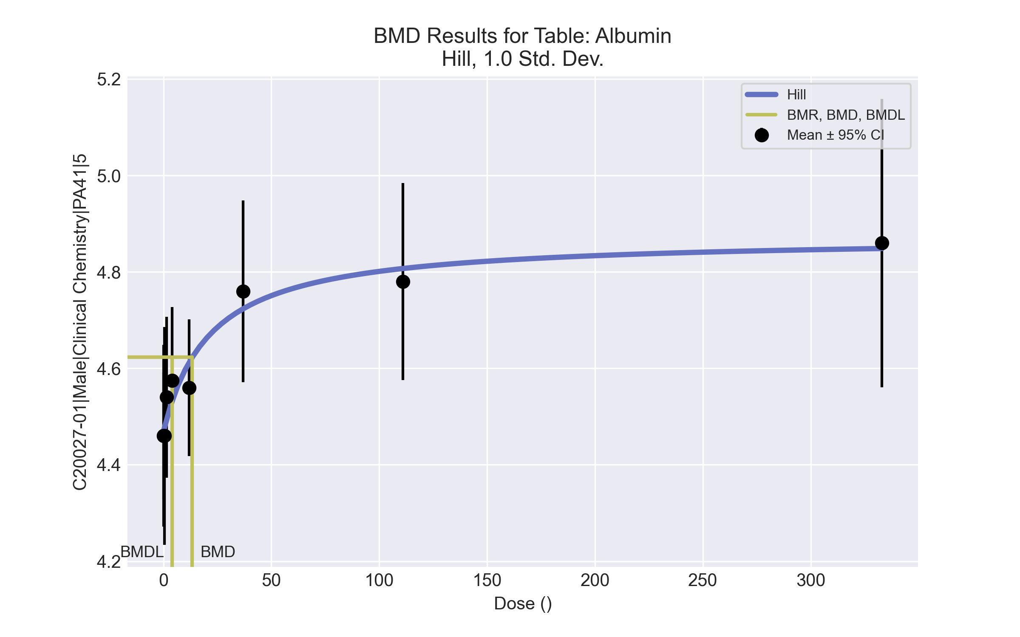
====================================================================
Hill Model. (Version: 2.18; Date: 03/14/2017)
Input Data File: C:\Windows\TEMP\bmds-1yt7doc_.(d)
Gnuplot Plotting File: C:\Windows\TEMP\bmds-1yt7doc_.plt
Fri Apr 16 00:37:50 2021
====================================================================
BMDS_Model_Run
~~~~~~~~~~~~~~~~~~~~~~~~~~~~~~~~~~~~~~~~~~~~~~~~~~~~~~~~~~~~~~~~~~~~~
The form of the response function is:
Y[dose] = intercept + v*dose^n/(k^n + dose^n)
Dependent variable = Response
Independent variable = Dose
rho is set to 0
Power parameter restricted to be greater than 1
A constant variance model is fit
Total number of dose groups = 9
Total number of records with missing values = 0
Maximum number of iterations = 500
Relative Function Convergence has been set to: 1e-008
Parameter Convergence has been set to: 1e-008
Default Initial Parameter Values
alpha = 0.0277875
rho = 0 Specified
intercept = 4.46
v = 0.4
n = 18
k = 49.5
Asymptotic Correlation Matrix of Parameter Estimates
( *** The model parameter(s) -rho -n
have been estimated at a boundary point, or have been specified by the user,
and do not appear in the correlation matrix )
alpha intercept v k
alpha 1 4.5e-007 -2.1e-006 -7.6e-007
intercept 4.5e-007 1 -0.24 0.45
v -2.1e-006 -0.24 1 0.55
k -7.6e-007 0.45 0.55 1
Parameter Estimates
95.0% Wald Confidence Interval
Variable Estimate Std. Err. Lower Conf. Limit Upper Conf. Limit
alpha 0.0236283 0.00477364 0.0142721 0.0329844
intercept 4.46924 0.0323613 4.40581 4.53267
v 0.404014 0.0741361 0.25871 0.549318
n 1 NA
k 21.7631 16.6624 -10.8946 54.4208
NA - Indicates that this parameter has hit a bound
implied by some inequality constraint and thus
has no standard error.
Table of Data and Estimated Values of Interest
Dose N Obs Mean Est Mean Obs Std Dev Est Std Dev Scaled Res.
------ --- -------- -------- ----------- ----------- ----------
0 10 4.46 4.47 0.184 0.154 -0.19
0.15 5 4.46 4.47 0.152 0.154 -0.175
0.5 5 4.46 4.48 0.182 0.154 -0.266
1.4 5 4.54 4.49 0.134 0.154 0.674
4 4 4.58 4.53 0.0957 0.154 0.56
12 5 4.56 4.61 0.114 0.154 -0.769
37 5 4.76 4.72 0.152 0.154 0.529
111 5 4.78 4.81 0.164 0.154 -0.393
333 5 4.86 4.85 0.241 0.154 0.168
Model Descriptions for likelihoods calculated
Model A1: Yij = Mu(i) + e(ij)
Var{e(ij)} = Sigma^2
Model A2: Yij = Mu(i) + e(ij)
Var{e(ij)} = Sigma(i)^2
Model A3: Yij = Mu(i) + e(ij)
Var{e(ij)} = Sigma^2
Model A3 uses any fixed variance parameters that
were specified by the user
Model R: Yi = Mu + e(i)
Var{e(i)} = Sigma^2
Likelihoods of Interest
Model Log(likelihood) # Param's AIC
A1 68.259666 10 -116.519333
A2 71.269225 18 -106.538449
A3 68.259666 10 -116.519333
fitted 67.260107 4 -126.520215
R 52.018998 2 -100.037996
Explanation of Tests
Test 1: Do responses and/or variances differ among Dose levels?
(A2 vs. R)
Test 2: Are Variances Homogeneous? (A1 vs A2)
Test 3: Are variances adequately modeled? (A2 vs. A3)
Test 4: Does the Model for the Mean Fit? (A3 vs. fitted)
(Note: When rho=0 the results of Test 3 and Test 2 will be the same.)
Tests of Interest
Test -2*log(Likelihood Ratio) Test df p-value
Test 1 38.5005 16 0.001283
Test 2 6.01912 8 0.6451
Test 3 6.01912 8 0.6451
Test 4 1.99912 6 0.9198
The p-value for Test 1 is less than .05. There appears to be a
difference between response and/or variances among the dose levels
It seems appropriate to model the data
The p-value for Test 2 is greater than .1. A homogeneous variance
model appears to be appropriate here
The p-value for Test 3 is greater than .1. The modeled variance appears
to be appropriate here
The p-value for Test 4 is greater than .1. The model chosen seems
to adequately describe the data
Benchmark Dose Computation
Specified effect = 1
Risk Type = Estimated standard deviations from the control mean
Confidence level = 0.95
BMD = 13.3653
BMDL = 4.08403
BMDU = 41.9096

Male BMD Results for Table: Alkaline phosphatase
BMDS version: BMDS v2.7.0

Input dataset
Dose | 0 | 0.15 | 0.5 | 1.4 | 4 | 12 | 37 | 111 | 333
N | 9 | 4 | 5 | 5 | 4 | 5 | 5 | 5 | 5
Mean ± SD | 302.222 ± 59.598 | 315.75 ± 36.764 | 277.2 ± 24.924 | 322.8 ± 41.889 | 346 ± 31.038 | 325 ± 37.716 | 335.8 ± 52.485 | 357.2 ± 40.996 | 527.8 ± 76.33

Summary table
Modelª | Goodness of fit |  | BMD | BMDL | Comments
 | p-value | AIC
Linear | 0.44 | 415.925 | 74.338 | 59.681 | Exponential-M2 recommended as best-fitting model on the basis of the lowest AIC.
Polynomial 2° | 0.41 | 417.143 | 101.7 | 61.599
Polynomial 3° | 0.423 | 417.027 | 103.813 | 61.926
Polynomial 4° | 0.427 | 416.993 | 104.327 | 62.026
Polynomial 5° | 0.428 | 416.982 | 104.443 | 62.058
Polynomial 6° | 0.429 | 416.979 | 104.464 | 62.068
Polynomial 7° | 0.311 | 418.978 | 104.474 | 62.07
Polynomial 8° | 0.203 | 420.977 | 104.445 | 62.073
Power | 0.381 | 417.416 | 100.349 | 60.878
Hill | 0.27 | 419.418 | 100.387 | 53.731
Exponential M2^{b} | 0.515 | 415.243 | 89.383 | 74.114
Exponential M3 | 0.402 | 417.215 | 96.353 | 74.181
Exponential M4 | 0.33 | 417.93 | 74.276 | 51.587
Exponential M5 | 0.27 | 419.417 | 100.37 | 54.058
ª Constant variance case presented (BMDS Test 2 p-value = 0.245, BMDS Test 3 p-value = 0.245).
^{b} Recommended model

Model recommendation details
Model | Bin | Notes
Linear | Valid | -
Polynomial 2° | Valid | -
Polynomial 3° | Valid | -
Polynomial 4° | Valid | -
Polynomial 5° | Valid | -
Polynomial 6° | Valid | -
Polynomial 7° | Valid | -
Polynomial 8° | Valid | -
Power | Valid | -
Hill | Valid | -
Exponential M2ª | Valid | -
Exponential M3 | Valid | -
Exponential M4 | Valid | -
Exponential M5 | Valid | -
ª Recommended model

Recommended model
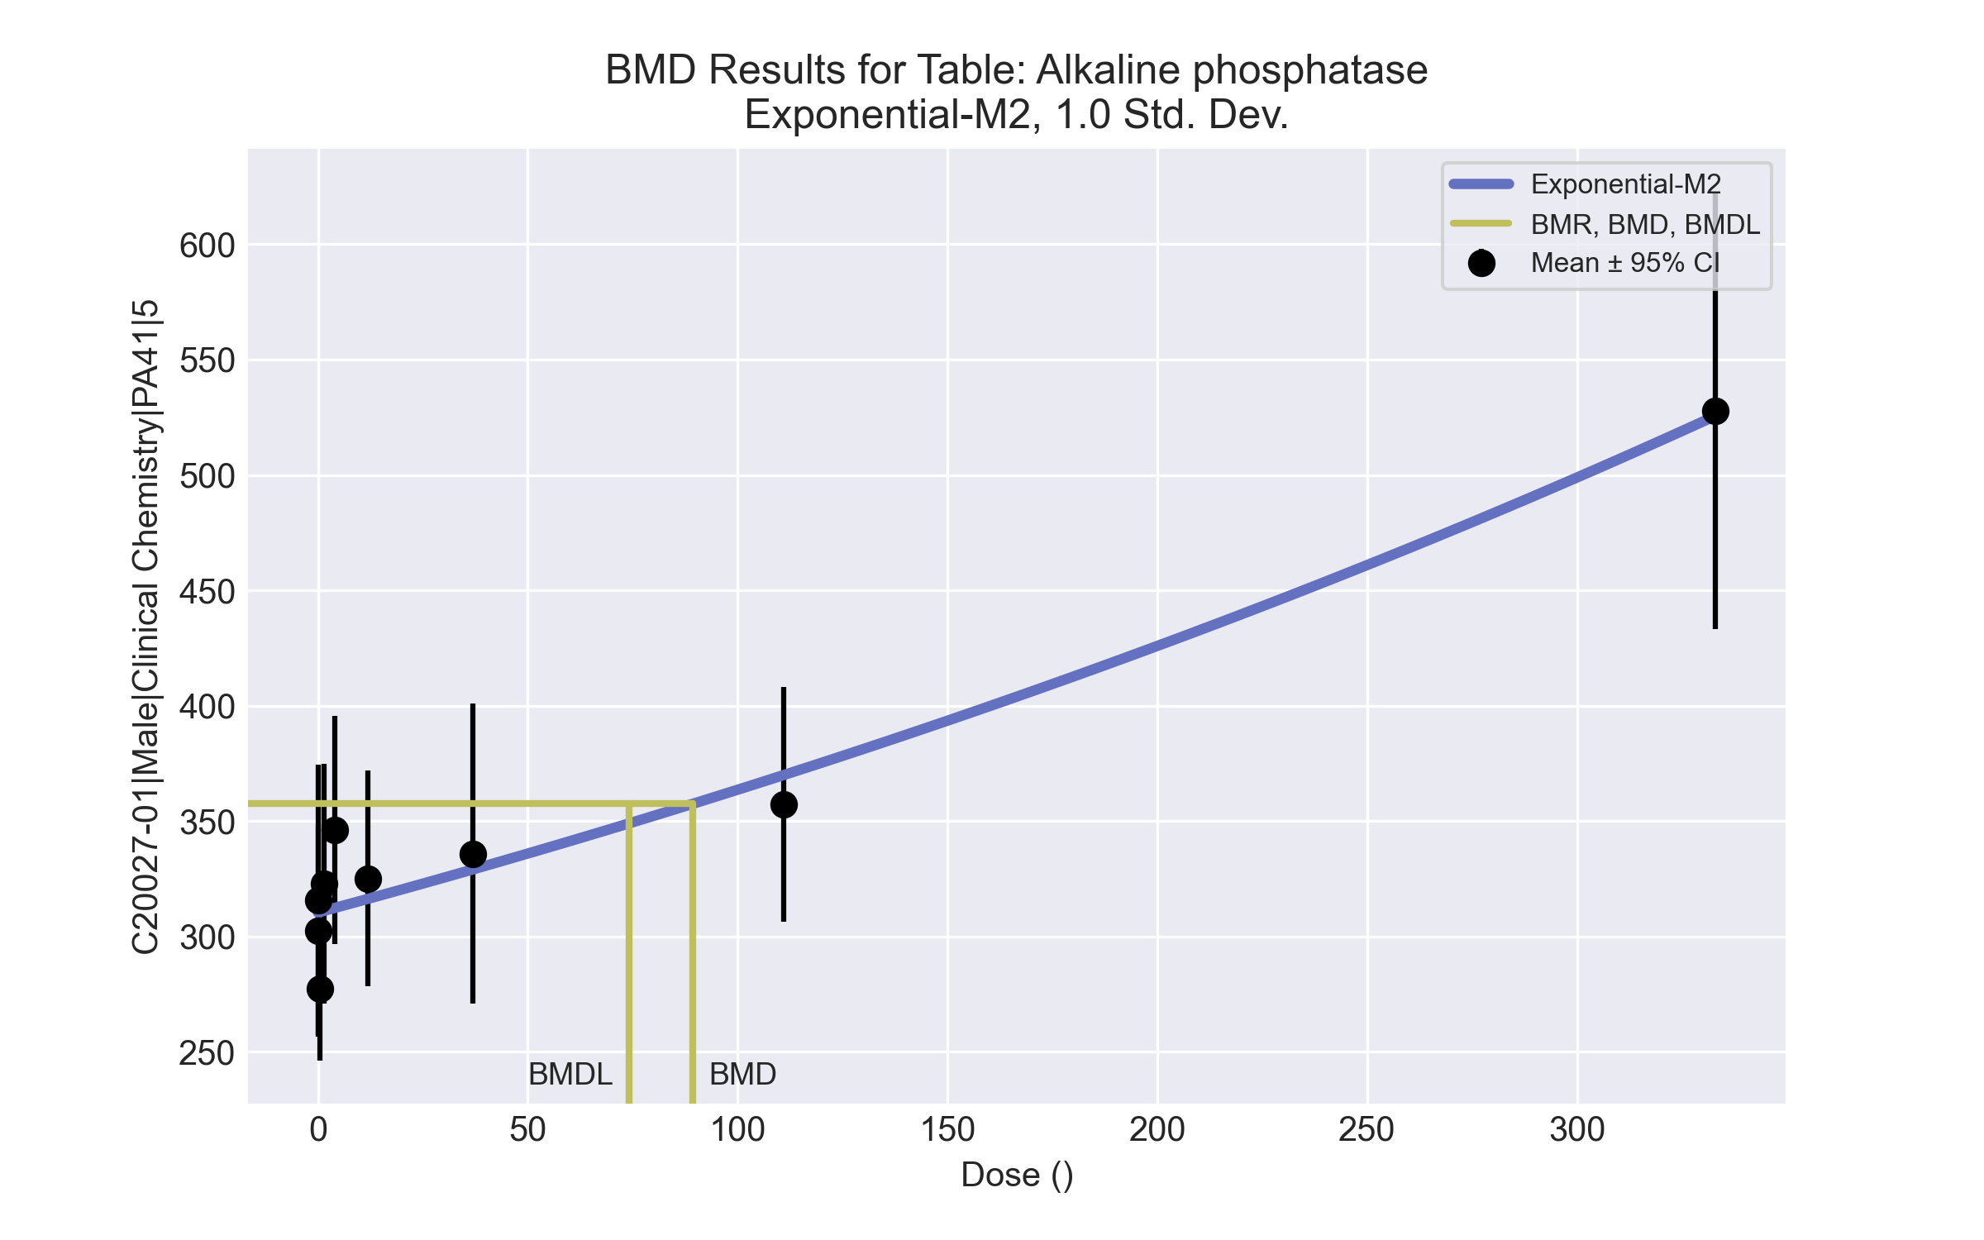
====================================================================
Exponential Model. (Version: 1.11; Date: 03/14/2017)
Input Data File: C:\Windows\TEMP\bmds-2decoy_8.(d)
Gnuplot Plotting File:
Fri Apr 16 00:37:54 2021
====================================================================
BMDS_Model_Run
~~~~~~~~~~~~~~~~~~~~~~~~~~~~~~~~~~~~~~~~~~~~~~~~~~~~~~~~~~~~~~~~~~~~~
The form of the response function by Model:
Model 2: Y[dose] = a * exp{sign * b * dose}
Model 3: Y[dose] = a * exp{sign * (b * dose)^d}
Model 4: Y[dose] = a * [c-(c-1) * exp{-b * dose}]
Model 5: Y[dose] = a * [c-(c-1) * exp{-(b * dose)^d}]
Note: Y[dose] is the median response for exposure = dose;
sign = +1 for increasing trend in data;
sign = -1 for decreasing trend.
Model 2 is nested within Models 3 and 4.
Model 3 is nested within Model 5.
Model 4 is nested within Model 5.
Dependent variable = Response
Independent variable = Dose
Data are assumed to be distributed: normally
Variance Model: exp(lnalpha +rho *ln(Y[dose]))
rho is set to 0.
A constant variance model is fit.
Total number of dose groups = 9
Total number of records with missing values = 0
Maximum number of iterations = 500
Relative Function Convergence has been set to: 1e-008
Parameter Convergence has been set to: 1e-008
MLE solution provided: Exact
Initial Parameter Values
Variable Model 2
-------- --------
lnalpha 7.57504
rho 0 Specified
a 310.019
b 0.00157759
c 0 Specified
d 1 Specified
Parameter Estimates
Variable Model 2 Std. Err.
-------- ------- ---------
lnalpha 7.70731 458.889
a 310.293 7.55913
b 0.00158309 0.000144639
NC = No Convergence
Table of Stats From Input Data
Dose N Obs Mean Obs Std Dev
----- --- ---------- -------------
0 9 302.2 59.6
0.15 4 315.8 36.76
0.5 5 277.2 24.92
1.4 5 322.8 41.89
4 4 346 31.04
12 5 325 37.72
37 5 335.8 52.49
111 5 357.2 41
333 5 527.8 76.33
Estimated Values of Interest
Dose Est Mean Est Std Scaled Residual
------ ---------- --------- ----------------
0 310.3 47.17 -0.5133
0.15 310.4 47.17 0.2283
0.5 310.5 47.17 -1.581
1.4 311 47.17 0.5603
4 312.3 47.17 1.431
12 316.2 47.17 0.4151
37 329 47.17 0.3219
111 369.9 47.17 -0.6022
333 525.7 47.17 0.1007
Other models for which likelihoods are calculated:
Model A1: Yij = Mu(i) + e(ij)
Var{e(ij)} = Sigma^2
Model A2: Yij = Mu(i) + e(ij)
Var{e(ij)} = Sigma(i)^2
Model A3: Yij = Mu(i) + e(ij)
Var{e(ij)} = exp(lalpha + log(mean(i)) * rho)
Model R: Yij = Mu + e(i)
Var{e(ij)} = Sigma^2
Likelihoods of Interest
Model Log(likelihood) DF AIC
------- ----------------- ---- ------------
A1 -201.5135 10 423.027
A2 -196.3697 18 428.7393
A3 -201.5135 10 423.027
R -229.9263 2 463.8525
2 -204.6218 3 415.2435
Additive constant for all log-likelihoods = -43.19. This constant added to the
above values gives the log-likelihood including the term that does not
depend on the model parameters.
Explanation of Tests
Test 1: Does response and/or variances differ among Dose levels? (A2 vs. R)
Test 2: Are Variances Homogeneous? (A2 vs. A1)
Test 3: Are variances adequately modeled? (A2 vs. A3)
Test 4: Does Model 2 fit the data? (A3 vs. 2)
Tests of Interest
Test -2*log(Likelihood Ratio) D. F. p-value
-------- ------------------------ ------ --------------
Test 1 67.11 16 < 0.0001
Test 2 10.29 8 0.2454
Test 3 10.29 8 0.2454
Test 4 6.217 7 0.5147
The p-value for Test 1 is less than .05. There appears to be a
difference between response and/or variances among the dose
levels, it seems appropriate to model the data.
The p-value for Test 2 is greater than .1. A homogeneous
variance model appears to be appropriate here.
The p-value for Test 3 is greater than .1. The modeled
variance appears to be appropriate here.
The p-value for Test 4 is greater than .1. Model 2 seems
to adequately describe the data.
Benchmark Dose Computations:
Specified Effect = 1.000000
Risk Type = Estimated standard deviations from control
Confidence Level = 0.950000
BMD = 89.383
BMDL = 74.1144
BMDU = 112.727

Male BMD Results for Table: Aspartate Aminotransferase
BMDS version: BMDS v2.7.0

Input dataset
Dose | 0 | 0.15 | 0.5 | 1.4 | 4 | 12 | 37 | 111 | 333
N | 10 | 5 | 5 | 5 | 4 | 5 | 5 | 5 | 5
Mean ± SD | 80.1 ± 14.94 | 83.4 ± 10.877 | 72.2 ± 6.907 | 78.4 ± 7.503 | 82.5 ± 9.11 | 74.2 ± 8.349 | 91 ± 10.536 | 128.4 ± 38.721 | 195 ± 120.814

Summary table
Modelª | Goodness of fit |  | BMD | BMDL | Comments
 | p-value | AIC
Linear^{b} | 0.105 | 328.316 | 28.117 | 19.352 | Linear recommended as best-fitting model on the basis of the lowest AIC.
Polynomial 2° (equivalent models include Polynomial 3°, 4°, 5°, 6°, 8°) | 0.065 | 330.303 | 28.637 | 19.367
Polynomial 7° | <0.0001 | 442.557 | -9999 | -999
Power | 0.08 | 329.726 | 33.661 | 20.138
Hill | 0.121 | 329.171 | 42.962 | -999
Exponential M2 (equivalent models include Exponential M3) | 0.055 | 330.223 | 37.697 | 27.332
Exponential M4 | 0.065 | 330.318 | 28.071 | 17.875
Exponential M5 | 0.118 | 329.233 | 43.515 | 25.115
ª Modeled variance case presented (BMDS Test 2 p-value = <0.0001, BMDS Test 3 p-value = 0.649).
^{b} Recommended model

Model recommendation details
Model | Bin | Notes
Linearª | Valid | -
Polynomial 2° (equivalent models include Polynomial 3°, 4°, 5°, 6°, 8°) | Warning | Warnings  • Goodness of fit p-value is less than threshold (0.0654 < 0.1)
Polynomial 7° | Failure | Failures  • BMDL does not exist  Warnings  • Residual of Interest does not exist  • Ratio of modeled to actual stdev. at control is greater than threshold (3.5 > 1.5)  Cautions  • Warning(s): THIS USUALLY MEANS THE MODEL HAS NOT CONVERGED!; BMD = 100*(maximum dose); BMDL computation failed.
Power | Warning | Warnings  • Goodness of fit p-value is less than threshold (0.0803 < 0.1)
Hill | Failure | Failures  • BMDL does not exist  Cautions  • Warning(s): BMDL computation failed.
Exponential M2 (equivalent models include Exponential M3) | Warning | Warnings  • Goodness of fit p-value is less than threshold (0.0554 < 0.1)
Exponential M4 | Warning | Warnings  • Goodness of fit p-value is less than threshold (0.0651 < 0.1)
Exponential M5 | Valid | -
ª Recommended model

Recommended model
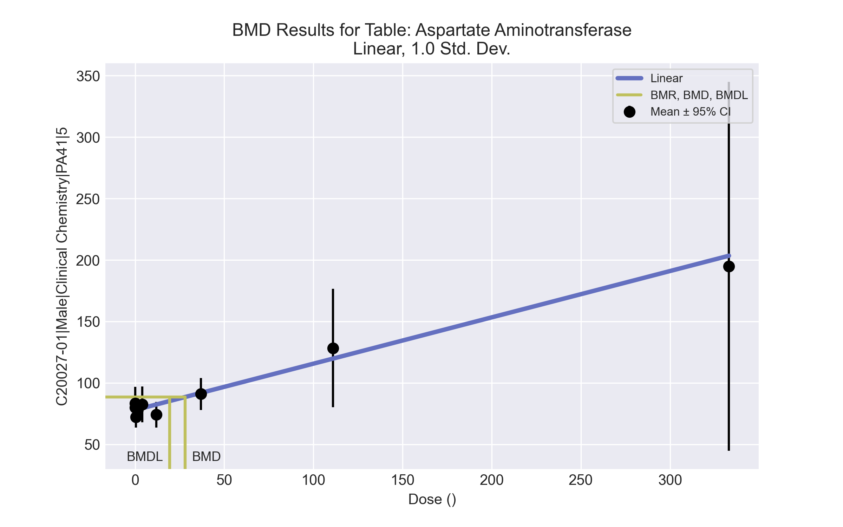
====================================================================
Polynomial Model. (Version: 2.21; Date: 03/14/2017)
Input Data File: C:\Windows\TEMP\bmds-p_9m3u8z.(d)
Gnuplot Plotting File: C:\Windows\TEMP\bmds-p_9m3u8z.plt
Fri Apr 16 00:37:57 2021
====================================================================
BMDS_Model_Run
~~~~~~~~~~~~~~~~~~~~~~~~~~~~~~~~~~~~~~~~~~~~~~~~~~~~~~~~~~~~~~~~~~~~~
The form of the response function is:
Y[dose] = beta_0 + beta_1*dose + beta_2*dose^2 + ...
Dependent variable = Response
Independent variable = Dose
The polynomial coefficients are restricted to be positive
The variance is to be modeled as Var(i) = exp(lalpha + log(mean(i)) * rho)
Total number of dose groups = 9
Total number of records with missing values = 0
Maximum number of iterations = 500
Relative Function Convergence has been set to: 1e-008
Parameter Convergence has been set to: 1e-008
Default Initial Parameter Values
lalpha = 7.44207
rho = 0
beta_0 = 78.4484
beta_1 = 0
Asymptotic Correlation Matrix of Parameter Estimates
lalpha rho beta_0 beta_1
lalpha 1 -1 -0.0022 0.014
rho -1 1 0.0025 -0.015
beta_0 -0.0022 0.0025 1 -0.32
beta_1 0.014 -0.015 -0.32 1
Parameter Estimates
95.0% Wald Confidence Interval
Variable Estimate Std. Err. Lower Conf. Limit Upper Conf. Limit
lalpha -16.601 3.06219 -22.6028 -10.5992
rho 4.89417 0.675505 3.57021 6.21814
beta_0 77.9893 1.89135 74.2823 81.6963
beta_1 0.376834 0.0894246 0.201565 0.552103
Table of Data and Estimated Values of Interest
Dose N Obs Mean Est Mean Obs Std Dev Est Std Dev Scaled Res.
------ --- -------- -------- ----------- ----------- ----------
0 10 80.1 78 14.9 10.6 0.63
0.15 5 83.4 78 10.9 10.6 1.13
0.5 5 72.2 78.2 6.91 10.7 -1.25
1.4 5 78.4 78.5 7.5 10.8 -0.0243
4 4 82.5 79.5 9.11 11.1 0.541
12 5 74.2 82.5 8.35 12.2 -1.53
37 5 91 91.9 10.5 15.8 -0.132
111 5 128 120 38.7 30.3 0.633
333 5 195 203 121 111 -0.171
Model Descriptions for likelihoods calculated
Model A1: Yij = Mu(i) + e(ij)
Var{e(ij)} = Sigma^2
Model A2: Yij = Mu(i) + e(ij)
Var{e(ij)} = Sigma(i)^2
Model A3: Yij = Mu(i) + e(ij)
Var{e(ij)} = exp(lalpha + rho*ln(Mu(i)))
Model A3 uses any fixed variance parameters that
were specified by the user
Model R: Yi = Mu + e(i)
Var{e(i)} = Sigma^2
Likelihoods of Interest
Model Log(likelihood) # Param's AIC
A1 -201.858649 10 423.717298
A2 -151.680685 18 339.361369
A3 -154.226934 11 330.453868
fitted -160.157778 4 328.315556
R -218.278516 2 440.557032
Explanation of Tests
Test 1: Do responses and/or variances differ among Dose levels?
(A2 vs. R)
Test 2: Are Variances Homogeneous? (A1 vs A2)
Test 3: Are variances adequately modeled? (A2 vs. A3)
Test 4: Does the Model for the Mean Fit? (A3 vs. fitted)
(Note: When rho=0 the results of Test 3 and Test 2 will be the same.)
Tests of Interest
Test -2*log(Likelihood Ratio) Test df p-value
Test 1 133.196 16 <.0001
Test 2 100.356 8 <.0001
Test 3 5.0925 7 0.6487
Test 4 11.8617 7 0.1052
The p-value for Test 1 is less than .05. There appears to be a
difference between response and/or variances among the dose levels
It seems appropriate to model the data
The p-value for Test 2 is less than .1. A non-homogeneous variance
model appears to be appropriate
The p-value for Test 3 is greater than .1. The modeled variance appears
to be appropriate here
The p-value for Test 4 is greater than .1. The model chosen seems
to adequately describe the data
Benchmark Dose Computation
Specified effect = 1
Risk Type = Estimated standard deviations from the control mean
Confidence level = 0.95
BMD = 28.1166
BMDL = 19.352
BMDU = 46.949

Male BMD Results for Table: Cholesterol
BMDS version: BMDS v2.7.0

Input dataset
Dose | 0 | 0.15 | 0.5 | 1.4 | 4 | 12 | 37 | 111 | 333
N | 10 | 5 | 5 | 5 | 4 | 5 | 5 | 5 | 5
Mean ± SD | 106.6 ± 12.039 | 107.6 ± 4.037 | 103.2 ± 4.97 | 114 ± 35.256 | 92.75 ± 10.813 | 89.6 ± 15.356 | 84.8 ± 9.471 | 75.6 ± 6.189 | 69.2 ± 10.986

Summary table
Modelª | Goodness of fit |  | BMD | BMDL | Comments
 | p-value | AIC
Linear (equivalent models include Power, Polynomial 2°, 4°, 5°, 6°, 7°) | 1.7E-04 | 327.285 | 168.984 | 116.069 | No model was recommended as a best-fitting model. Doses were dropped until there were only 3 remaining dose-groups.
Polynomial 3° | <0.0001 | 350.317 | 90.769 | -999
Polynomial 8° | <0.0001 | 922.314 | 11.568 | -999
Hill | 0.046 | 313.939 | 16.268 | -999
Exponential M2 (equivalent models include Exponential M3) | 3.1E-04 | 325.854 | 142.593 | 87.958
Exponential M4 (equivalent models include Exponential M5) | 0.057 | 312.882 | 21.618 | 9.046
ª Modeled variance case presented (BMDS Test 2 p-value = <0.0001, BMDS Test 3 p-value = 6.8E-04).

Model recommendation details
Model | Bin | Notes
Linear (equivalent models include Power, Polynomial 2°, 4°, 5°, 6°, 7°) | Warning | Warnings  • Variance model poorly fits dataset (p-value 3 = 0.0006811)  • Goodness of fit p-value is less than threshold (0.00017 < 0.1)
Polynomial 3° | Failure | Failures  • BMDL does not exist  Warnings  • Variance model poorly fits dataset (p-value 3 = 0.0006811)  Cautions  • Warning(s): THE MODEL HAS PROBABLY NOT CONVERGED!!!; THIS USUALLY MEANS THE MODEL HAS NOT CONVERGED!; BMDL computation failed.
Polynomial 8° | Failure | Failures  • BMDL does not exist  Warnings  • Variance model poorly fits dataset (p-value 3 = 0.0006811)  • Residual at lowest dose is greater than threshold (3.13 > 2.0)  • Ratio of modeled to actual stdev. at control is greater than threshold (29.5 > 1.5)  Cautions  • Warning(s): THIS USUALLY MEANS THE MODEL HAS NOT CONVERGED!; BMDL computation failed.
Hill | Failure | Failures  • BMDL does not exist  Warnings  • Variance model poorly fits dataset (p-value 3 = 0.0006811)  • Goodness of fit p-value is less than threshold (0.0462 < 0.1)  Cautions  • Warning(s): BMDL computation failed.
Exponential M2 (equivalent models include Exponential M3) | Warning | Warnings  • Variance model poorly fits dataset (p-value 3 = 0.0006811)  • Goodness of fit p-value is less than threshold (0.000308 < 0.1)
Exponential M4 (equivalent models include Exponential M5) | Warning | Warnings  • Variance model poorly fits dataset (p-value 3 = 0.0006811)  • Goodness of fit p-value is less than threshold (0.0573 < 0.1)

Recommended model
No model was recommended as a best-fitting model.

Male BMD Results for Table: Creatinine
BMDS version: BMDS v2.7.0

Input dataset
Dose | 0 | 0.15 | 0.5 | 1.4 | 4 | 12 | 37 | 111 | 333
N | 10 | 5 | 5 | 5 | 4 | 5 | 5 | 5 | 5
Mean ± SD | 0.41 ± 0.032 | 0.42 ± 0.045 | 0.42 ± 0.045 | 0.42 ± 0.045 | 0.425 ± 0.05 | 0.38 ± 0.045 | 0.44 ± 0.055 | 0.46 ± 0.055 | 0.5 ± 0.071

Summary table
Modelª | Goodness of fit |  | BMD | BMDL | Comments
 | p-value | AIC
Linear (equivalent models include Power, Polynomial 2°, 3°, 4°, 5°, 6°, 7°, 8°) | 0.621 | -247.03 | 168.349 | 117.96 | Hill recommended as best-fitting model on the basis of the lowest BMDL.
Hill^{b} | 0.504 | -244.021 | 97.38 | 32.365
Exponential M2 (equivalent models include Exponential M3) | 0.602 | -246.869 | 177.821 | 128.644
Exponential M4 | 0.589 | -245.696 | 109.356 | 42.934
Exponential M5 | 0.494 | -243.95 | 101.504 | 33.563
ª Constant variance case presented (BMDS Test 2 p-value = 0.801, BMDS Test 3 p-value = 0.801).
^{b} Recommended model

Model recommendation details
Model | Bin | Notes
Linear (equivalent models include Power, Polynomial 2°, 3°, 4°, 5°, 6°, 7°, 8°) | Valid | -
Hillª | Valid | -
Exponential M2 (equivalent models include Exponential M3) | Valid | -
Exponential M4 | Valid | -
Exponential M5 | Valid | -
ª Recommended model

Recommended model
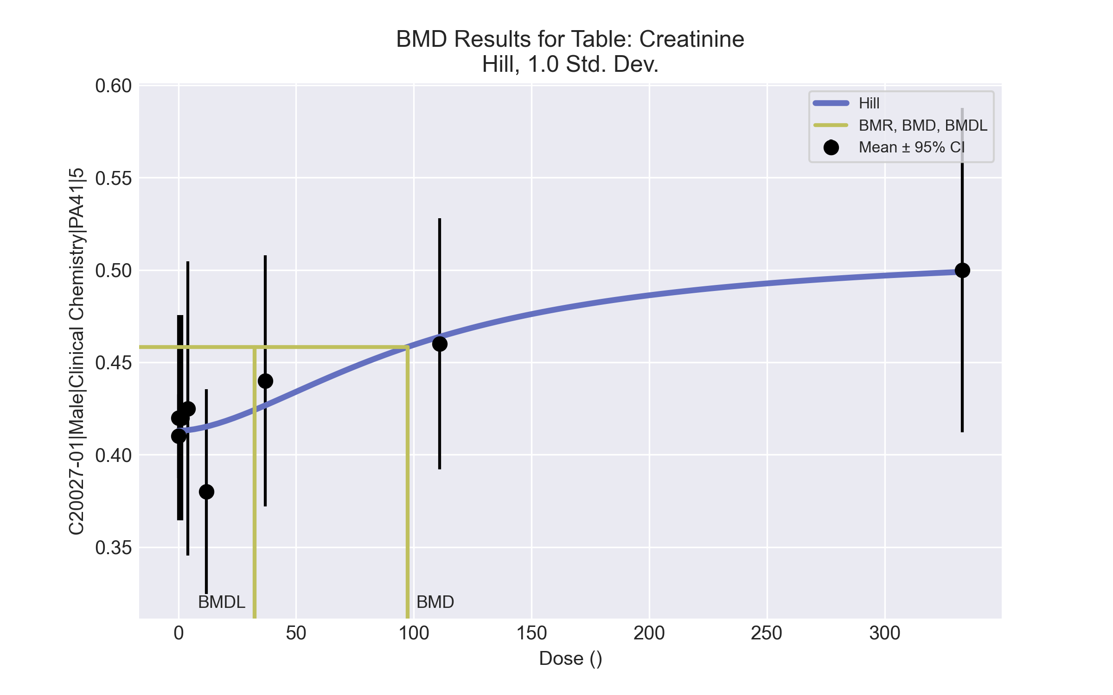
====================================================================
Hill Model. (Version: 2.18; Date: 03/14/2017)
Input Data File: C:\Windows\TEMP\bmds-eabc5ite.(d)
Gnuplot Plotting File: C:\Windows\TEMP\bmds-eabc5ite.plt
Fri Apr 16 00:38:52 2021
====================================================================
BMDS_Model_Run
~~~~~~~~~~~~~~~~~~~~~~~~~~~~~~~~~~~~~~~~~~~~~~~~~~~~~~~~~~~~~~~~~~~~~
The form of the response function is:
Y[dose] = intercept + v*dose^n/(k^n + dose^n)
Dependent variable = Response
Independent variable = Dose
rho is set to 0
Power parameter restricted to be greater than 1
A constant variance model is fit
Total number of dose groups = 9
Total number of records with missing values = 0
Maximum number of iterations = 500
Relative Function Convergence has been set to: 1e-008
Parameter Convergence has been set to: 1e-008
Default Initial Parameter Values
alpha = 0.00231249
rho = 0 Specified
intercept = 0.41
v = 0.09
n = 0.359539
k = 129.5
Asymptotic Correlation Matrix of Parameter Estimates
( *** The model parameter(s) -rho
have been estimated at a boundary point, or have been specified by the user,
and do not appear in the correlation matrix )
alpha intercept v n k
alpha 1 4.4e-008 -5.6e-007 1e-006 -1e-006
intercept 4.4e-008 1 -0.19 0.18 0.13
v -5.6e-007 -0.19 1 -0.73 0.85
n 1e-006 0.18 -0.73 1 -0.62
k -1e-006 0.13 0.85 -0.62 1
Parameter Estimates
95.0% Wald Confidence Interval
Variable Estimate Std. Err. Lower Conf. Limit Upper Conf. Limit
alpha 0.00206194 0.000416575 0.00124547 0.00287841
intercept 0.412916 0.00793646 0.397361 0.428471
v 0.0982305 0.0491049 0.00198674 0.194474
n 1.71404 1.30265 -0.839109 4.26719
k 106.362 99.4144 -88.4863 301.211
Table of Data and Estimated Values of Interest
Dose N Obs Mean Est Mean Obs Std Dev Est Std Dev Scaled Res.
------ --- -------- -------- ----------- ----------- ----------
0 10 0.41 0.413 0.0316 0.0454 -0.203
0.15 5 0.42 0.413 0.0447 0.0454 0.349
0.5 5 0.42 0.413 0.0447 0.0454 0.348
1.4 5 0.42 0.413 0.0447 0.0454 0.346
4 4 0.425 0.413 0.05 0.0454 0.517
12 5 0.38 0.415 0.0447 0.0454 -1.73
37 5 0.44 0.427 0.0548 0.0454 0.653
111 5 0.46 0.464 0.0548 0.0454 -0.188
333 5 0.5 0.499 0.0707 0.0454 0.0503
Model Descriptions for likelihoods calculated
Model A1: Yij = Mu(i) + e(ij)
Var{e(ij)} = Sigma^2
Model A2: Yij = Mu(i) + e(ij)
Var{e(ij)} = Sigma(i)^2
Model A3: Yij = Mu(i) + e(ij)
Var{e(ij)} = Sigma^2
Model A3 uses any fixed variance parameters that
were specified by the user
Model R: Yi = Mu + e(i)
Var{e(i)} = Sigma^2
Likelihoods of Interest
Model Log(likelihood) # Param's AIC
A1 129.173104 10 -238.346207
A2 131.466588 18 -226.933176
A3 129.173104 10 -238.346207
fitted 127.010655 5 -244.021309
R 119.019437 2 -234.038875
Explanation of Tests
Test 1: Do responses and/or variances differ among Dose levels?
(A2 vs. R)
Test 2: Are Variances Homogeneous? (A1 vs A2)
Test 3: Are variances adequately modeled? (A2 vs. A3)
Test 4: Does the Model for the Mean Fit? (A3 vs. fitted)
(Note: When rho=0 the results of Test 3 and Test 2 will be the same.)
Tests of Interest
Test -2*log(Likelihood Ratio) Test df p-value
Test 1 24.8943 16 0.07171
Test 2 4.58697 8 0.8007
Test 3 4.58697 8 0.8007
Test 4 4.3249 5 0.5036
The p-value for Test 1 is greater than .05. There may not be a
diffence between responses and/or variances among the dose levels
Modelling the data with a dose/response curve may not be appropriate
The p-value for Test 2 is greater than .1. A homogeneous variance
model appears to be appropriate here
The p-value for Test 3 is greater than .1. The modeled variance appears
to be appropriate here
The p-value for Test 4 is greater than .1. The model chosen seems
to adequately describe the data
Benchmark Dose Computation
Specified effect = 1
Risk Type = Estimated standard deviations from the control mean
Confidence level = 0.95
BMD = 97.3804
BMDL = 32.3651
BMDU = 254.521

Male BMD Results for Table: Globulin (measured)
BMDS version: BMDS v2.7.0

Input dataset
Dose | 0 | 0.15 | 0.5 | 1.4 | 4ª | 12ª | 37ª | 111ª | 333ª
N | 10 | 5 | 5 | 5 | 4 | 5 | 5 | 5 | 5
Mean ± SD | 1.95 ± 0.085 | 1.96 ± 0.114 | 2.1 ± 0.141 | 2.28 ± 0.363 | 2.025 ± 0.171 | 1.7 ± 0.071 | 1.76 ± 0.114 | 1.4 ± 0.235 | 1.34 ± 0.305
ª Dose group removed in BMD modeling session

Summary table
Modelª | Goodness of fit |  | BMD | BMDL | Comments
 | p-value | AIC
Linear^{b} (equivalent models include Polynomial 2°, 3°, 4°, 5°, 6°, 7°, 8°) | 0.902 | -71.445 | 0.322 | 0.188 | Linear recommended as best-fitting model on the basis of the lowest AIC.
Power | 0.653 | -69.449 | 0.33 | 0.188
Hill | -999 | -67.652 | 0.353 | -999
Exponential M2 (equivalent models include Exponential M3) | 0.889 | -71.416 | 0.34 | 0.203
Exponential M4 | 0.652 | -69.448 | 0.316 | 0.134
Exponential M5 | -999 | -67.652 | 0.356 | 0.138
ª Modeled variance case presented (BMDS Test 2 p-value = 8.6E-04, BMDS Test 3 p-value = 0.797).
^{b} Recommended model

Model recommendation details
Model | Bin | Notes
Linearª (equivalent models include Polynomial 2°, 3°, 4°, 5°, 6°, 7°, 8°) | Valid | -
Power | Valid | -
Hill | Failure | Failures  • BMDL does not exist  Warnings  • Zero degrees of freedom; saturated model  Cautions  • Warning(s): BMDL computation failed.
Exponential M2 (equivalent models include Exponential M3) | Valid | -
Exponential M4 | Valid | -
Exponential M5 | Warning | Warnings  • Zero degrees of freedom; saturated model
ª Recommended model

Recommended model
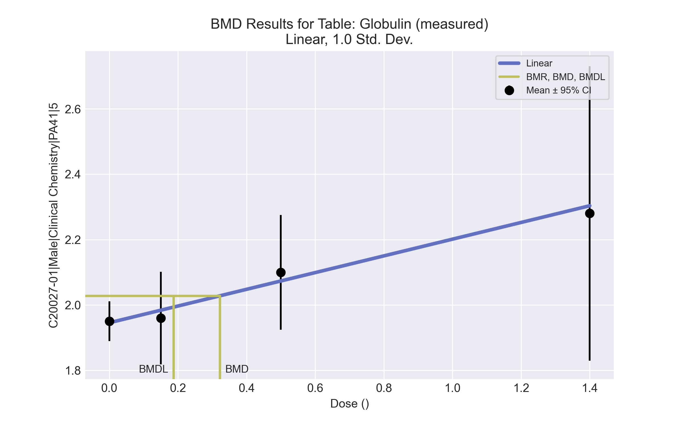
====================================================================
Polynomial Model. (Version: 2.21; Date: 03/14/2017)
Input Data File: C:\Windows\TEMP\bmds-r7xv5ada.(d)
Gnuplot Plotting File: C:\Windows\TEMP\bmds-r7xv5ada.plt
Fri Apr 16 00:39:17 2021
====================================================================
BMDS_Model_Run
~~~~~~~~~~~~~~~~~~~~~~~~~~~~~~~~~~~~~~~~~~~~~~~~~~~~~~~~~~~~~~~~~~~~~
The form of the response function is:
Y[dose] = beta_0 + beta_1*dose + beta_2*dose^2 + ...
Dependent variable = Response
Independent variable = Dose
The polynomial coefficients are restricted to be positive
The variance is to be modeled as Var(i) = exp(lalpha + log(mean(i)) * rho)
Total number of dose groups = 4
Total number of records with missing values = 0
Maximum number of iterations = 500
Relative Function Convergence has been set to: 1e-008
Parameter Convergence has been set to: 1e-008
Default Initial Parameter Values
lalpha = -3.36611
rho = 0
beta_0 = 1.94788
beta_1 = 0.243152
Asymptotic Correlation Matrix of Parameter Estimates
lalpha rho beta_0 beta_1
lalpha 1 -1 0.022 -0.046
rho -1 1 -0.022 0.046
beta_0 0.022 -0.022 1 -0.45
beta_1 -0.046 0.046 -0.45 1
Parameter Estimates
95.0% Wald Confidence Interval
Variable Estimate Std. Err. Lower Conf. Limit Upper Conf. Limit
lalpha -15.7156 3.17373 -21.936 -9.4952
rho 16.1167 4.41561 7.46228 24.7712
beta_0 1.94536 0.0232006 1.89988 1.99083
beta_1 0.255838 0.0856033 0.0880583 0.423617
Table of Data and Estimated Values of Interest
Dose N Obs Mean Est Mean Obs Std Dev Est Std Dev Scaled Res.
------ --- -------- -------- ----------- ----------- ----------
0 10 1.95 1.95 0.085 0.0825 0.178
0.15 5 1.96 1.98 0.114 0.0965 -0.55
0.5 5 2.1 2.07 0.141 0.138 0.434
1.4 5 2.28 2.3 0.363 0.322 -0.163
Model Descriptions for likelihoods calculated
Model A1: Yij = Mu(i) + e(ij)
Var{e(ij)} = Sigma^2
Model A2: Yij = Mu(i) + e(ij)
Var{e(ij)} = Sigma(i)^2
Model A3: Yij = Mu(i) + e(ij)
Var{e(ij)} = exp(lalpha + rho*ln(Mu(i)))
Model A3 uses any fixed variance parameters that
were specified by the user
Model R: Yi = Mu + e(i)
Var{e(i)} = Sigma^2
Likelihoods of Interest
Model Log(likelihood) # Param's AIC
A1 31.755736 5 -53.511472
A2 40.052751 8 -64.105502
A3 39.825858 6 -67.651715
fitted 39.722693 4 -71.445386
R 26.071802 2 -48.143604
Explanation of Tests
Test 1: Do responses and/or variances differ among Dose levels?
(A2 vs. R)
Test 2: Are Variances Homogeneous? (A1 vs A2)
Test 3: Are variances adequately modeled? (A2 vs. A3)
Test 4: Does the Model for the Mean Fit? (A3 vs. fitted)
(Note: When rho=0 the results of Test 3 and Test 2 will be the same.)
Tests of Interest
Test -2*log(Likelihood Ratio) Test df p-value
Test 1 27.9619 6 <.0001
Test 2 16.594 3 0.0008565
Test 3 0.453786 2 0.797
Test 4 0.206329 2 0.902
The p-value for Test 1 is less than .05. There appears to be a
difference between response and/or variances among the dose levels
It seems appropriate to model the data
The p-value for Test 2 is less than .1. A non-homogeneous variance
model appears to be appropriate
The p-value for Test 3 is greater than .1. The modeled variance appears
to be appropriate here
The p-value for Test 4 is greater than .1. The model chosen seems
to adequately describe the data
Benchmark Dose Computation
Specified effect = 1
Risk Type = Estimated standard deviations from the control mean
Confidence level = 0.95
BMD = 0.322328
BMDL = 0.187542
BMDU = 0.637721

Male BMD Results for Table: Sorbitol dehydrogenase
BMDS version: BMDS v2.7.0

Input dataset
Dose | 0 | 0.15 | 0.5 | 1.4 | 4 | 12 | 37 | 111 | 333
N | 10 | 5 | 5 | 5 | 4 | 5 | 5 | 5 | 5
Mean ± SD | 14.76 ± 5.452 | 20.5 ± 11.03 | 11.58 ± 3.468 | 14.64 ± 6.971 | 10.075 ± 3.172 | 10.54 ± 1.26 | 19.62 ± 7.806 | 46.1 ± 38.33 | 56.34 ± 49.012

Summary table
Modelª | Goodness of fit |  | BMD | BMDL | Comments
 | p-value | AIC
Linear (equivalent models include Polynomial 3°, 5°, 6°, 7°) | <0.0001 | 287.063 | 35.286 | 22.359 | Exponential-M5 recommended as best-fitting model on the basis of the lowest AIC.
Polynomial 2° | <0.0001 | 287.063 | 35.286 | 22.359
Polynomial 4° | <0.0001 | 287.063 | 35.286 | 22.359
Polynomial 8° | <0.0001 | 366.346 | -9999 | -999
Power | <0.0001 | 288.894 | 38.102 | 22.657
Hill | <0.0001 | 281.231 | 38.997 | -999
Exponential M2 (equivalent models include Exponential M3) | <0.0001 | 296.892 | 60.801 | 41.347
Exponential M4 | <0.0001 | 287.991 | 31.378 | 17.169
Exponential M5^{b} | <0.0001 | 281.034 | 48.424 | 31.861
ª Modeled variance case presented (BMDS Test 2 p-value = <0.0001, BMDS Test 3 p-value = 0.709).
^{b} Recommended model

Model recommendation details
Model | Bin | Notes
Linear (equivalent models include Polynomial 3°, 5°, 6°, 7°) | Valid | -
Polynomial 2° | Valid | -
Polynomial 4° | Valid | -
Polynomial 8° | Failure | Failures  • BMDL does not exist  Warnings  • Residual of Interest does not exist  • Ratio of modeled to actual stdev. at control is greater than threshold (4.4 > 1.5)  Cautions  • Warning(s): THIS USUALLY MEANS THE MODEL HAS NOT CONVERGED!; BMD = 100*(maximum dose); BMDL computation failed.
Power | Valid | -
Hill | Failure | Failures  • BMDL does not exist  Cautions  • Warning(s): THE MODEL HAS PROBABLY NOT CONVERGED!!!; THIS USUALLY MEANS THE MODEL HAS NOT CONVERGED!; BMDL computation failed.
Exponential M2 (equivalent models include Exponential M3) | Valid | -
Exponential M4 | Valid | -
Exponential M5ª | Valid | -
ª Recommended model

Recommended model
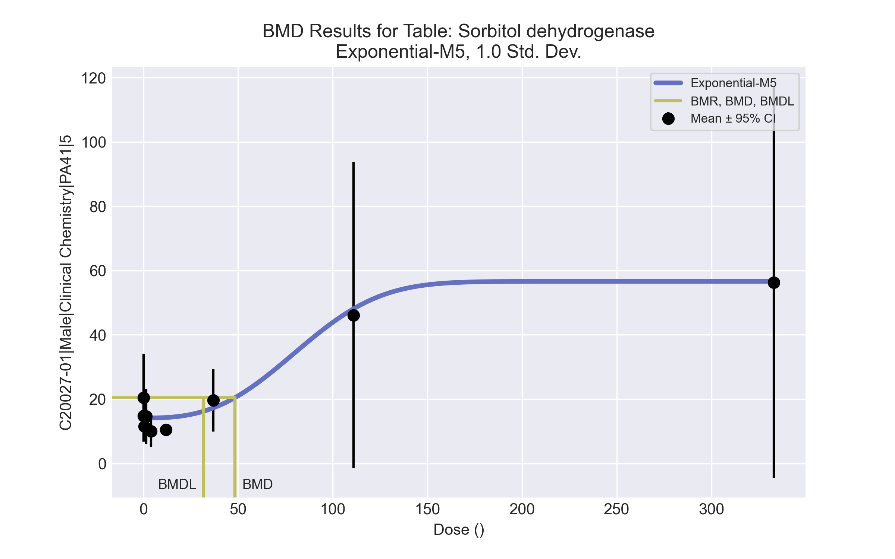
====================================================================
Exponential Model. (Version: 1.11; Date: 03/14/2017)
Input Data File: C:\Windows\TEMP\bmds-5a6yvnyu.(d)
Gnuplot Plotting File:
Fri Apr 16 00:39:20 2021
====================================================================
BMDS_Model_Run
~~~~~~~~~~~~~~~~~~~~~~~~~~~~~~~~~~~~~~~~~~~~~~~~~~~~~~~~~~~~~~~~~~~~~
The form of the response function by Model:
Model 2: Y[dose] = a * exp{sign * b * dose}
Model 3: Y[dose] = a * exp{sign * (b * dose)^d}
Model 4: Y[dose] = a * [c-(c-1) * exp{-b * dose}]
Model 5: Y[dose] = a * [c-(c-1) * exp{-(b * dose)^d}]
Note: Y[dose] is the median response for exposure = dose;
sign = +1 for increasing trend in data;
sign = -1 for decreasing trend.
Model 2 is nested within Models 3 and 4.
Model 3 is nested within Model 5.
Model 4 is nested within Model 5.
Dependent variable = Response
Independent variable = Dose
Data are assumed to be distributed: normally
Variance Model: exp(lnalpha +rho *ln(Y[dose]))
The variance is to be modeled as Var(i) = exp(lalpha + log(mean(i)) * rho)
Total number of dose groups = 9
Total number of records with missing values = 0
Maximum number of iterations = 500
Relative Function Convergence has been set to: 1e-008
Parameter Convergence has been set to: 1e-008
MLE solution provided: Exact
Initial Parameter Values
Variable Model 5
-------- --------
lnalpha -6.52175
rho 3.61364
a 9.57125
b 0.00891474
c 6.1807
d 1
Parameter Estimates
Variable Model 5 Std. Err.
-------- ------- ---------
lnalpha -3.61189 1.81082
rho 2.75871 0.629784
a 14.139 1.07969
b 0.0106966 0.00331113
c 4.0043 1.16424
d 2.76864 0.929589
NC = No Convergence
Table of Stats From Input Data
Dose N Obs Mean Obs Std Dev
----- --- ---------- -------------
0 10 14.76 5.452
0.15 5 20.5 11.03
0.5 5 11.58 3.468
1.4 5 14.64 6.971
4 4 10.07 3.172
12 5 10.54 1.26
37 5 19.62 7.806
111 5 46.1 38.33
333 5 56.34 49.01
Estimated Values of Interest
Dose Est Mean Est Std Scaled Residual
------ ---------- --------- ----------------
0 14.14 6.346 0.3094
0.15 14.14 6.346 2.241
0.5 14.14 6.346 -0.9017
1.4 14.14 6.347 0.1764
4 14.15 6.351 -1.282
12 14.28 6.436 -1.301
37 17.28 8.369 0.6252
111 48.11 34.37 -0.1311
333 56.62 43.01 -0.01439
Other models for which likelihoods are calculated:
Model A1: Yij = Mu(i) + e(ij)
Var{e(ij)} = Sigma^2
Model A2: Yij = Mu(i) + e(ij)
Var{e(ij)} = Sigma(i)^2
Model A3: Yij = Mu(i) + e(ij)
Var{e(ij)} = exp(lalpha + log(mean(i)) * rho)
Model R: Yij = Mu + e(i)
Var{e(ij)} = Sigma^2
Likelihoods of Interest
Model Log(likelihood) DF AIC
------- ----------------- ---- ------------
A1 -167.4591 10 354.9181
A2 -118.1214 18 272.2428
A3 -120.4204 11 262.8409
R -180.173 2 364.346
5 -134.5168 6 281.0336
Additive constant for all log-likelihoods = -45.03. This constant added to the
above values gives the log-likelihood including the term that does not
depend on the model parameters.
Explanation of Tests
Test 1: Does response and/or variances differ among Dose levels? (A2 vs. R)
Test 2: Are Variances Homogeneous? (A2 vs. A1)
Test 3: Are variances adequately modeled? (A2 vs. A3)
Test 7a: Does Model 5 fit the data? (A3 vs 5)
Tests of Interest
Test -2*log(Likelihood Ratio) D. F. p-value
-------- ------------------------ ------ --------------
Test 1 124.1 16 < 0.0001
Test 2 98.68 8 < 0.0001
Test 3 4.598 7 0.7089
Test 7a 28.19 5 < 0.0001
The p-value for Test 1 is less than .05. There appears to be a
difference between response and/or variances among the dose
levels, it seems appropriate to model the data.
The p-value for Test 2 is less than .1. A non-homogeneous
variance model appears to be appropriate.
The p-value for Test 3 is greater than .1. The modeled
variance appears to be appropriate here.
The p-value for Test 7a is less than .1. Model 5 may not adequately
describe the data; you may want to consider another model.
Benchmark Dose Computations:
Specified Effect = 1.000000
Risk Type = Estimated standard deviations from control
Confidence Level = 0.950000
BMD = 48.4242
BMDL = 31.8613
BMDU = 101.093

Male BMD Results for Table: Triglycerides
BMDS version: BMDS v2.7.0

Input dataset
Dose | 0 | 0.15 | 0.5 | 1.4 | 4 | 12 | 37 | 111 | 333
N | 10 | 5 | 5 | 5 | 4 | 5 | 5 | 5 | 5
Mean ± SD | 99.9 ± 31.267 | 85.6 ± 22.233 | 107.4 ± 42.559 | 118.4 ± 78.634 | 82 ± 6.055 | 48.8 ± 18.472 | 66.8 ± 31.204 | 53 ± 6.595 | 58.6 ± 33.02

Summary table
Modelª | Goodness of fit |  | BMD | BMDL | Comments
 | p-value | AIC
Linear (equivalent models include Power, Polynomial 3°, 5°, 7°) | <0.0001 | 413.407 | 389.727 | 200.876 | No model was recommended as a best-fitting model. Doses were dropped until there were only 3 remaining dose-groups.
Polynomial 2° (equivalent models include Polynomial 4°, 6°) | <0.0001 | 413.407 | 389.728 | 200.876
Polynomial 8° | <0.0001 | 688.01 | 3.507 | -999
Hill | 0.01 | 397.893 | 4.396 | -999
Exponential M2 (equivalent models include Exponential M3) | <0.0001 | 412.699 | 351.823 | 119.184
Exponential M4 | 0.002 | 401.269 | 12.268 | 3.76
Exponential M5 | 0.01 | 397.894 | 4.174 | 1.729
ª Modeled variance case presented (BMDS Test 2 p-value = <0.0001, BMDS Test 3 p-value = 0.008).

Model recommendation details
Model | Bin | Notes
Linear (equivalent models include Power, Polynomial 3°, 5°, 7°) | Warning | Warnings  • Variance model poorly fits dataset (p-value 3 = 0.008037)  • BMD/high dose ratio is greater than threshold (1.17 > 1.0)
Polynomial 2° (equivalent models include Polynomial 4°, 6°) | Warning | Warnings  • Variance model poorly fits dataset (p-value 3 = 0.008037)  • BMD/high dose ratio is greater than threshold (1.17 > 1.0)
Polynomial 8° | Failure | Failures  • BMDL does not exist  Warnings  • Variance model poorly fits dataset (p-value 3 = 0.008037)  • Residual at lowest dose is greater than threshold (3.03 > 2.0)  • Ratio of modeled to actual stdev. at control is greater than threshold (7.96 > 1.5)  Cautions  • Warning(s): THE MODEL HAS PROBABLY NOT CONVERGED!!!; THIS USUALLY MEANS THE MODEL HAS NOT CONVERGED!; BMDL computation failed.
Hill | Failure | Failures  • BMDL does not exist  Warnings  • Variance model poorly fits dataset (p-value 3 = 0.008037)  • Goodness of fit p-value is less than threshold (0.0103 < 0.1)  Cautions  • Warning(s): BMDL computation failed.
Exponential M2 (equivalent models include Exponential M3) | Warning | Warnings  • Variance model poorly fits dataset (p-value 3 = 0.008037)  • BMD/high dose ratio is greater than threshold (1.06 > 1.0)
Exponential M4 | Warning | Warnings  • Variance model poorly fits dataset (p-value 3 = 0.008037)  • Goodness of fit p-value is less than threshold (0.00235 < 0.1)
Exponential M5 | Warning | Warnings  • Variance model poorly fits dataset (p-value 3 = 0.008037)  • Goodness of fit p-value is less than threshold (0.0103 < 0.1)

Recommended model
No model was recommended as a best-fitting model.

Male BMD Results for Table: Basophil count
BMDS version: BMDS v2.7.0

Input dataset
Dose | 0 | 0.15 | 0.5 | 1.4 | 4 | 12 | 37 | 111 | 333
N | 9 | 4 | 5 | 4 | 4 | 5 | 5 | 4 | 4
Mean ± SD | 0.037 ± 0.012 | 0.018 ± 0.005 | 0.03 ± 0.014 | 0.03 ± 0 | 0.022 ± 0.013 | 0.026 ± 0.015 | 0.028 ± 0.008 | 0.018 ± 0.005 | 0.028 ± 0.013

Summary table
Modelª | Goodness of fit |  | BMD | BMDL | Comments
 | p-value | AIC
Linear (equivalent models include Power, Polynomial 2°) | <0.0001 | -339.875 | 1236.34 | 240.389 | No model was recommended as a best-fitting model. Doses were dropped until there were only 3 remaining dose-groups.
Polynomial 3° (equivalent models include Polynomial 4°) | <0.0001 | -339.875 | 1236.33 | 240.389
Polynomial 5° | <0.0001 | -313.497 | 120.543 | -999
Polynomial 6° | <0.0001 | 15.627 | -9999 | -999
Polynomial 7° | <0.0001 | -3.131 | 12.03 | -999
Polynomial 8° | <0.0001 | 3.276 | 11.987 | -999
Hill | <0.0001 | -345.11 | -999 | -999
Exponential M2 | -999 | -339.425 | 1 | -999
Exponential M3 | -999 | -337.425 | 2525.23 | 334.063
Exponential M4 | -999 | -337.425 | -999 | 0
Exponential M5 | -999 | -335.425 | -999 | 0
ª Modeled variance case presented (BMDS Test 2 p-value = <0.0001, BMDS Test 3 p-value = <0.0001).

Model recommendation details
Model | Bin | Notes
Linear (equivalent models include Power, Polynomial 2°) | Warning | Warnings  • Variance model poorly fits dataset (p-value 3 = 0.0001)  • BMD/high dose ratio is greater than threshold (3.71 > 1.0)  • Residual at lowest dose is greater than threshold (2.21 > 2.0)  Cautions  • BMD/BMDL ratio is greater than threshold (5.14 > 5.0)  • Warning(s): Warning: Likelihood for fitted model larger than the Likelihood for model A3.
Polynomial 3° (equivalent models include Polynomial 4°) | Warning | Warnings  • Variance model poorly fits dataset (p-value 3 = 0.0001)  • BMD/high dose ratio is greater than threshold (3.71 > 1.0)  • Residual at lowest dose is greater than threshold (2.21 > 2.0)  Cautions  • BMD/BMDL ratio is greater than threshold (5.14 > 5.0)  • Warning(s): Warning: Likelihood for fitted model larger than the Likelihood for model A3.
Polynomial 5° | Failure | Failures  • BMDL does not exist  Warnings  • Variance model poorly fits dataset (p-value 3 = 0.0001)  Cautions  • Warning(s): BMDL computation failed.; Warning: Likelihood for fitted model larger than the Likelihood for model A3.
Polynomial 6° | Failure | Failures  • BMDL does not exist  Warnings  • Residual of Interest does not exist  • Variance model poorly fits dataset (p-value 3 = 0.0001)  • Ratio of modeled to actual stdev. at control is greater than threshold (37.1 > 1.5)  Cautions  • Warning(s): THIS USUALLY MEANS THE MODEL HAS NOT CONVERGED!; BMD = 100*(maximum dose); BMDL computation failed.; Warning: Likelihood for fitted model larger than the Likelihood for model A3.
Polynomial 7° | Failure | Failures  • BMDL does not exist  Warnings  • Variance model poorly fits dataset (p-value 3 = 0.0001)  • Ratio of modeled to actual stdev. at control is greater than threshold (1.84 > 1.5)  Cautions  • Warning(s): THIS USUALLY MEANS THE MODEL HAS NOT CONVERGED!; BMDL computation failed.; Warning: Likelihood for fitted model larger than the Likelihood for model A3.
Polynomial 8° | Failure | Failures  • BMDL does not exist  Warnings  • Variance model poorly fits dataset (p-value 3 = 0.0001)  • Ratio of modeled to actual stdev. at control is greater than threshold (1.94 > 1.5)  Cautions  • Warning(s): THIS USUALLY MEANS THE MODEL HAS NOT CONVERGED!; BMDL computation failed.; Warning: Likelihood for fitted model larger than the Likelihood for model A3.
Hill | Failure | Failures  • BMD does not exist  • BMDL does not exist  Warnings  • Residual of Interest does not exist  • Variance model poorly fits dataset (p-value 3 = 0.0001)  Cautions  • Warning(s): BMR value is not in the range of the mean function
Exponential M2 | Failure | Failures  • BMDL does not exist  Warnings  • Variance model poorly fits dataset (p-value 3 = 0.0001)  • Residual at lowest dose is greater than threshold (2.35 > 2.0)
Exponential M3 | Warning | Warnings  • Variance model poorly fits dataset (p-value 3 = 0.0001)  • BMD/high dose ratio is greater than threshold (7.58 > 1.0)  • Residual at lowest dose is greater than threshold (2.35 > 2.0)  Cautions  • BMD/BMDL ratio is greater than threshold (7.56 > 5.0)  • BMDL/high dose ratio is greater than threshold (1.0 > 1.0)
Exponential M4 | Failure | Failures  • BMD does not exist  Warnings  • Residual of Interest does not exist  • Variance model poorly fits dataset (p-value 3 = 0.0001)  • Residual at lowest dose is greater than threshold (2.35 > 2.0)
Exponential M5 | Failure | Failures  • BMD does not exist  Warnings  • Residual of Interest does not exist  • Variance model poorly fits dataset (p-value 3 = 0.0001)  • Residual at lowest dose is greater than threshold (2.35 > 2.0)

Recommended model
No model was recommended as a best-fitting model.

Male BMD Results for Table: Eosinophil count
BMDS version: BMDS v2.7.0

Input dataset
Dose | 0 | 0.15 | 0.5 | 1.4 | 4 | 12 | 37 | 111 | 333
N | 9 | 4 | 5 | 4 | 4 | 5 | 5 | 4 | 4
Mean ± SD | 0.089 ± 0.06 | 0.058 ± 0.021 | 0.064 ± 0.015 | 0.09 ± 0.018 | 0.065 ± 0.013 | 0.06 ± 0.035 | 0.05 ± 0.028 | 0.045 ± 0.019 | 0.062 ± 0.046

Summary table
Modelª | Goodness of fit |  | BMD | BMDL | Comments
 | p-value | AIC
Linear (equivalent models include Power, Polynomial 4°, 7°) | 0.002 | -240.255 | 731.548 | 180.334 | No model was recommended as a best-fitting model. Doses were dropped until there were only 3 remaining dose-groups.
Polynomial 2° | 0.002 | -240.255 | 731.549 | 180.334
Polynomial 3° | 0.001 | -239.652 | 921.046 | 302.419
Polynomial 5° | <0.0001 | -200.012 | 120.788 | -999
Polynomial 6° | <0.0001 | 94.148 | 6.859 | -999
Polynomial 8° | <0.0001 | -60.314 | 42.482 | -999
Hill | 0.181 | -252.156 | -999 | -999
Exponential M2 | 0.002 | -240.354 | 770.092 | 95.481
Exponential M3 | 0.002 | -240.354 | 770.093 | 95.481
Exponential M4 | 0.181 | -252.156 | -999 | 0
Exponential M5 | 0.114 | -250.156 | -999 | 0
ª Modeled variance case presented (BMDS Test 2 p-value = 0.001, BMDS Test 3 p-value = 0.137).

Model recommendation details
Model | Bin | Notes
Linear (equivalent models include Power, Polynomial 4°, 7°) | Warning | Warnings  • Goodness of fit p-value is less than threshold (0.00186 < 0.1)  • BMD/high dose ratio is greater than threshold (2.2 > 1.0)
Polynomial 2° | Warning | Warnings  • Goodness of fit p-value is less than threshold (0.00186 < 0.1)  • BMD/high dose ratio is greater than threshold (2.2 > 1.0)
Polynomial 3° | Warning | Warnings  • Goodness of fit p-value is less than threshold (0.00146 < 0.1)  • BMD/high dose ratio is greater than threshold (2.77 > 1.0)
Polynomial 5° | Failure | Failures  • BMDL does not exist  Cautions  • Warning(s): BMDL computation failed.
Polynomial 6° | Failure | Failures  • BMDL does not exist  Cautions  • Warning(s): THIS USUALLY MEANS THE MODEL HAS NOT CONVERGED!; BMDL computation failed.
Polynomial 8° | Failure | Failures  • BMDL does not exist  Cautions  • Warning(s): THE MODEL HAS PROBABLY NOT CONVERGED!!!; THIS USUALLY MEANS THE MODEL HAS NOT CONVERGED!; BMDL computation failed.
Hill | Failure | Failures  • BMD does not exist  • BMDL does not exist  Warnings  • Residual of Interest does not exist  Cautions  • Warning(s): BMR value is not in the range of the mean function
Exponential M2 | Warning | Warnings  • Goodness of fit p-value is less than threshold (0.00194 < 0.1)  • BMD/high dose ratio is greater than threshold (2.31 > 1.0)  Cautions  • BMD/BMDL ratio is greater than threshold (8.07 > 5.0)
Exponential M3 | Warning | Warnings  • Goodness of fit p-value is less than threshold (0.00194 < 0.1)  • BMD/high dose ratio is greater than threshold (2.31 > 1.0)  Cautions  • BMD/BMDL ratio is greater than threshold (8.07 > 5.0)
Exponential M4 | Failure | Failures  • BMD does not exist  Warnings  • Residual of Interest does not exist
Exponential M5 | Failure | Failures  • BMD does not exist  Warnings  • Residual of Interest does not exist

Recommended model
No model was recommended as a best-fitting model.

Male BMD Results for Table: Mean Cell HGB Concentration
BMDS version: BMDS v2.7.0

Input dataset
Dose | 0 | 0.15 | 0.5 | 1.4 | 4 | 12 | 37 | 111ª | 333ª
N | 9 | 4 | 5 | 4 | 4 | 5 | 5 | 4 | 4
Mean ± SD | 28.489 ± 0.322 | 28.575 ± 0.189 | 28.6 ± 0.406 | 28.775 ± 0.624 | 28.975 ± 0.411 | 28.8 ± 0.332 | 29.12 ± 0.342 | 29.575 ± 0.922 | 28.425 ± 0.846
ª Dose group removed in BMD modeling session

Summary table
Modelª | Goodness of fit |  | BMD | BMDL | Comments
 | p-value | AIC
Linear (equivalent models include Power, Polynomial 2°, 3°, 4°, 5°, 6°, 7°, 8°) | 0.438 | -30.699 | 25.598 | 16.05 | Hill recommended as best-fitting model on the basis of the lowest BMDL.
Hill^{b} | 0.719 | -31.43 | 2.715 | 0.33
Exponential M2 (equivalent models include Exponential M3) | 0.437 | -30.689 | 25.699 | 16.187
Exponential M4 | 0.686 | -31.249 | 2.028 | 0.406
Exponential M5 | 0.522 | -29.271 | 1.981 | 0.409
ª Constant variance case presented (BMDS Test 2 p-value = 0.456, BMDS Test 3 p-value = 0.456).
^{b} Recommended model

Model recommendation details
Model | Bin | Notes
Linear (equivalent models include Power, Polynomial 2°, 3°, 4°, 5°, 6°, 7°, 8°) | Valid | -
Hillª | Valid | Cautions  • BMD/BMDL ratio is greater than threshold (8.23 > 5.0)
Exponential M2 (equivalent models include Exponential M3) | Valid | -
Exponential M4 | Valid | -
Exponential M5 | Valid | -
ª Recommended model

Recommended model
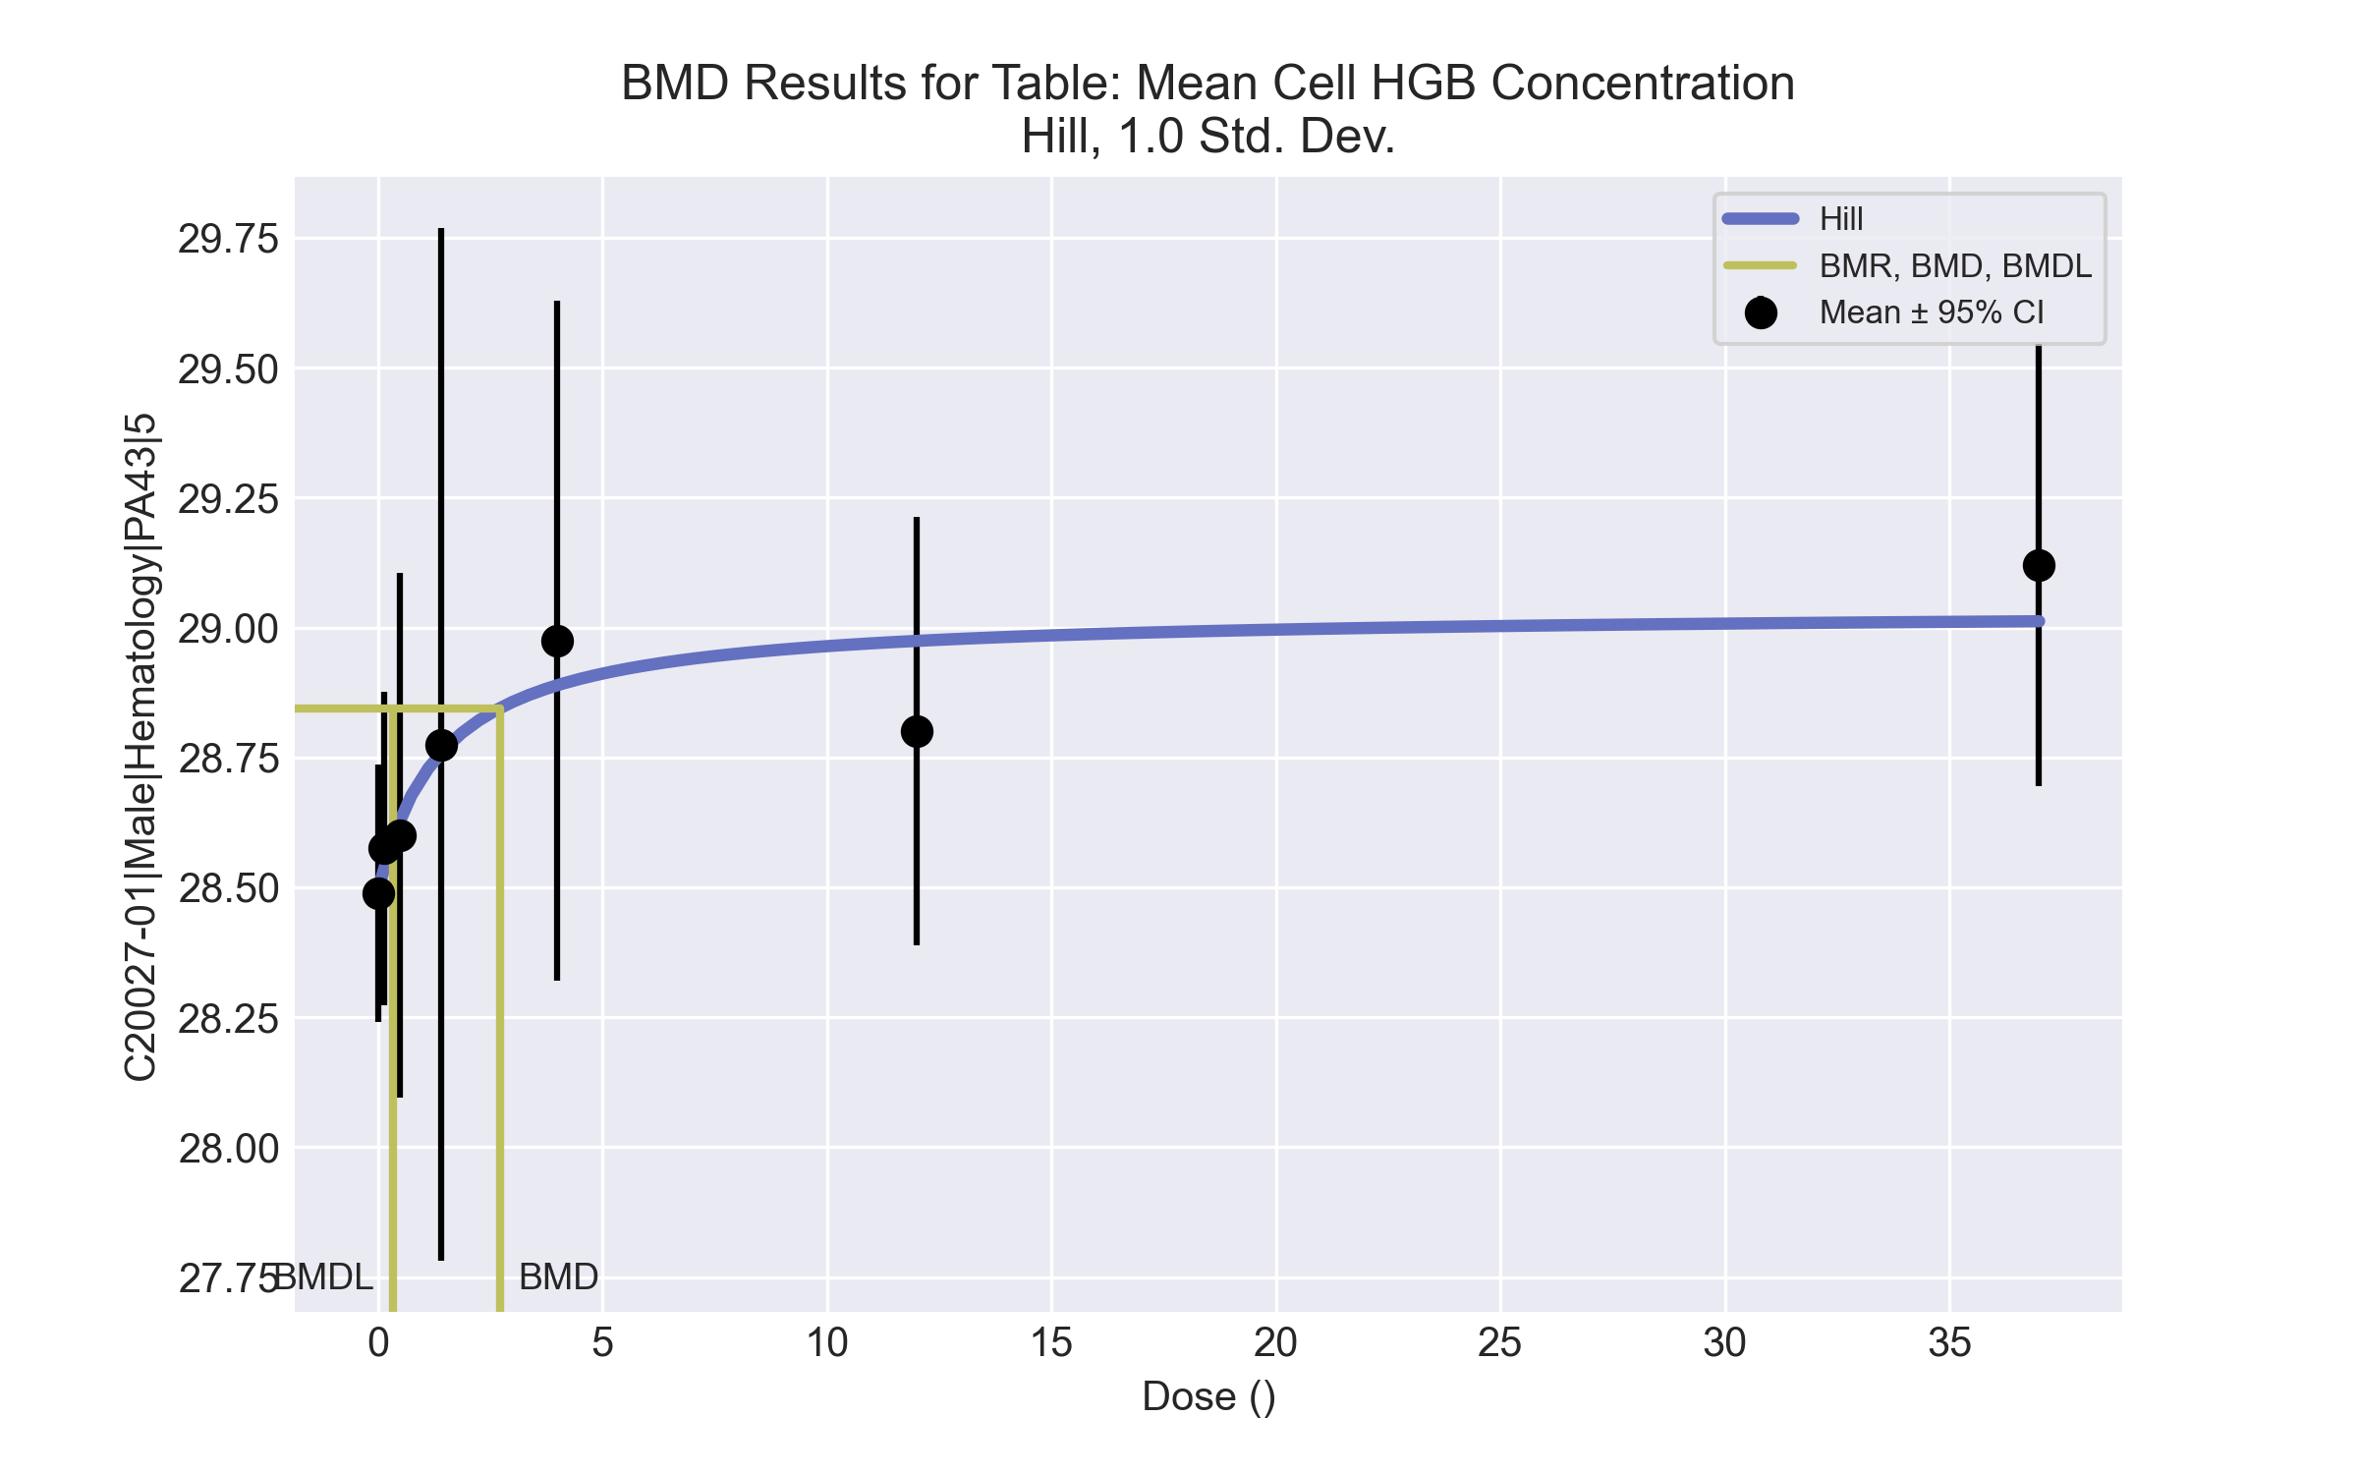
====================================================================
Hill Model. (Version: 2.18; Date: 03/14/2017)
Input Data File: C:\Windows\TEMP\bmds-nx1de38s.(d)
Gnuplot Plotting File: C:\Windows\TEMP\bmds-nx1de38s.plt
Fri Apr 16 00:43:41 2021
====================================================================
BMDS_Model_Run
~~~~~~~~~~~~~~~~~~~~~~~~~~~~~~~~~~~~~~~~~~~~~~~~~~~~~~~~~~~~~~~~~~~~~
The form of the response function is:
Y[dose] = intercept + v*dose^n/(k^n + dose^n)
Dependent variable = Response
Independent variable = Dose
rho is set to 0
Power parameter restricted to be greater than 1
A constant variance model is fit
Total number of dose groups = 7
Total number of records with missing values = 0
Maximum number of iterations = 500
Relative Function Convergence has been set to: 1e-008
Parameter Convergence has been set to: 1e-008
Default Initial Parameter Values
alpha = 0.144117
rho = 0 Specified
intercept = 28.4889
v = 0.631111
n = 0.246653
k = 6.21722
Asymptotic Correlation Matrix of Parameter Estimates
( *** The model parameter(s) -rho -n
have been estimated at a boundary point, or have been specified by the user,
and do not appear in the correlation matrix )
alpha intercept v k
alpha 1 7.4e-008 5.6e-008 1.2e-007
intercept 7.4e-008 1 -0.48 0.53
v 5.6e-008 -0.48 1 0.26
k 1.2e-007 0.53 0.26 1
Parameter Estimates
95.0% Wald Confidence Interval
Variable Estimate Std. Err. Lower Conf. Limit Upper Conf. Limit
alpha 0.123035 0.0289997 0.066197 0.179874
intercept 28.4939 0.105573 28.287 28.7008
v 0.538288 0.16041 0.223889 0.852686
n 1 NA
k 1.45136 1.92415 -2.3199 5.22261
NA - Indicates that this parameter has hit a bound
implied by some inequality constraint and thus
has no standard error.
Table of Data and Estimated Values of Interest
Dose N Obs Mean Est Mean Obs Std Dev Est Std Dev Scaled Res.
------ --- -------- -------- ----------- ----------- ----------
0 9 28.5 28.5 0.322 0.351 -0.0429
0.15 4 28.6 28.5 0.189 0.351 0.175
0.5 5 28.6 28.6 0.406 0.351 -0.203
1.4 4 28.8 28.8 0.624 0.351 0.0958
4 4 29 28.9 0.411 0.351 0.491
12 5 28.8 29 0.332 0.351 -1.11
37 5 29.1 29 0.342 0.351 0.689
Model Descriptions for likelihoods calculated
Model A1: Yij = Mu(i) + e(ij)
Var{e(ij)} = Sigma^2
Model A2: Yij = Mu(i) + e(ij)
Var{e(ij)} = Sigma(i)^2
Model A3: Yij = Mu(i) + e(ij)
Var{e(ij)} = Sigma^2
Model A3 uses any fixed variance parameters that
were specified by the user
Model R: Yi = Mu + e(i)
Var{e(i)} = Sigma^2
Likelihoods of Interest
Model Log(likelihood) # Param's AIC
A1 20.760367 8 -25.520734
A2 23.617340 14 -19.234679
A3 20.760367 8 -25.520734
fitted 19.715101 4 -31.430203
R 14.504267 2 -25.008534
Explanation of Tests
Test 1: Do responses and/or variances differ among Dose levels?
(A2 vs. R)
Test 2: Are Variances Homogeneous? (A1 vs A2)
Test 3: Are variances adequately modeled? (A2 vs. A3)
Test 4: Does the Model for the Mean Fit? (A3 vs. fitted)
(Note: When rho=0 the results of Test 3 and Test 2 will be the same.)
Tests of Interest
Test -2*log(Likelihood Ratio) Test df p-value
Test 1 18.2261 12 0.109
Test 2 5.71395 6 0.456
Test 3 5.71395 6 0.456
Test 4 2.09053 4 0.7191
The p-value for Test 1 is greater than .05. There may not be a
diffence between responses and/or variances among the dose levels
Modelling the data with a dose/response curve may not be appropriate
The p-value for Test 2 is greater than .1. A homogeneous variance
model appears to be appropriate here
The p-value for Test 3 is greater than .1. The modeled variance appears
to be appropriate here
The p-value for Test 4 is greater than .1. The model chosen seems
to adequately describe the data
Benchmark Dose Computation
Specified effect = 1
Risk Type = Estimated standard deviations from the control mean
Confidence level = 0.95
BMD = 2.71477
BMDL = 0.329856
BMDU = 1.369e+007

Male BMD Results for Table: Reticulocyte count
BMDS version: BMDS v2.7.0

Input dataset
Dose | 0 | 0.15 | 0.5 | 1.4 | 4 | 12 | 37ª | 111ª | 333ª
N | 9 | 4 | 5 | 4 | 4 | 5 | 5 | 4 | 4
Mean ± SD | 240.156 ± 25.607 | 237.15 ± 8.574 | 207.38 ± 30.467 | 228.375 ± 29.786 | 222.175 ± 13.252 | 211.94 ± 19.298 | 235.4 ± 22.174 | 194.925 ± 24.261 | 89.85 ± 19.573
ª Dose group removed in BMD modeling session

Summary table
Modelª | Goodness of fit |  | BMD | BMDL | Comments
 | p-value | AIC
Linear | 0.134 | 233.222 | 14.17 | 7.065 | Exponential-M5 recommended as best-fitting model on the basis of the lowest AIC.
Polynomial 2° (equivalent models include Power, Polynomial 3°, 4°, 5°, 6°, 7°, 8°) | 0.134 | 233.222 | 14.17 | 7.065
Hill | 0.273 | 232.78 | 0.202 | -999
Exponential M2 | 0.135 | 233.203 | 14.187 | 6.764
Exponential M3 | 0.135 | 233.203 | 14.187 | 6.764
Exponential M4 | 0.301 | 231.839 | 0.536 | 0.002
Exponential M5^{b} | 0.273 | 232.78 | 0.308 | 0.112
ª Constant variance case presented (BMDS Test 2 p-value = 0.119, BMDS Test 3 p-value = 0.119).
^{b} Recommended model

Model recommendation details
Model | Bin | Notes
Linear | Warning | Warnings  • BMD/high dose ratio is greater than threshold (1.18 > 1.0)
Polynomial 2° (equivalent models include Power, Polynomial 3°, 4°, 5°, 6°, 7°, 8°) | Warning | Warnings  • BMD/high dose ratio is greater than threshold (1.18 > 1.0)
Hill | Failure | Failures  • BMDL does not exist  Cautions  • Warning(s): BMDL computation failed.
Exponential M2 | Warning | Warnings  • BMD/high dose ratio is greater than threshold (1.18 > 1.0)
Exponential M3 | Warning | Warnings  • BMD/high dose ratio is greater than threshold (1.18 > 1.0)
Exponential M4 | Warning | Warnings  • BMD/BMDL ratio is greater than threshold (2.86e+02 > 20.0)  Cautions  • BMD/BMDL ratio is greater than threshold (2.86e+02 > 5.0)
Exponential M5ª | Valid | -
ª Recommended model

Recommended model
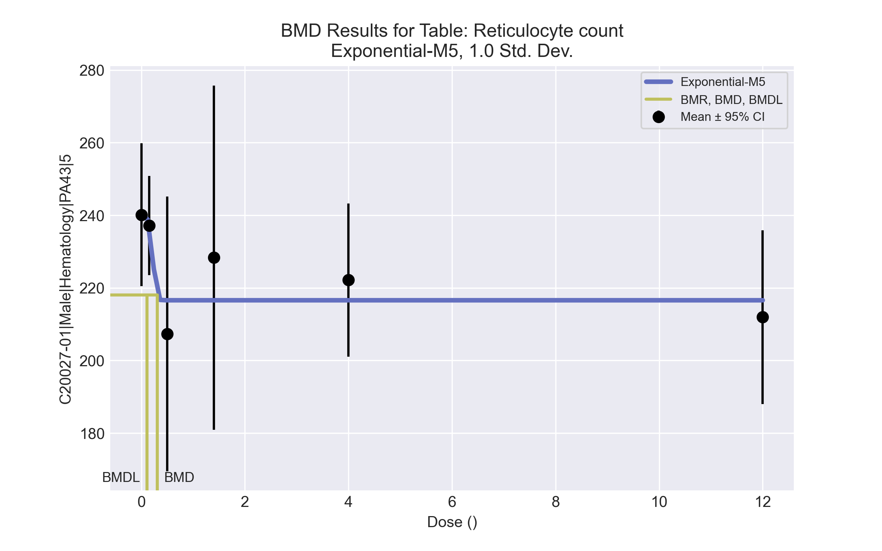
====================================================================
Exponential Model. (Version: 1.11; Date: 03/14/2017)
Input Data File: C:\Windows\TEMP\bmds-x6_b7r_u.(d)
Gnuplot Plotting File:
Fri Apr 16 00:43:59 2021
====================================================================
BMDS_Model_Run
~~~~~~~~~~~~~~~~~~~~~~~~~~~~~~~~~~~~~~~~~~~~~~~~~~~~~~~~~~~~~~~~~~~~~
The form of the response function by Model:
Model 2: Y[dose] = a * exp{sign * b * dose}
Model 3: Y[dose] = a * exp{sign * (b * dose)^d}
Model 4: Y[dose] = a * [c-(c-1) * exp{-b * dose}]
Model 5: Y[dose] = a * [c-(c-1) * exp{-(b * dose)^d}]
Note: Y[dose] is the median response for exposure = dose;
sign = +1 for increasing trend in data;
sign = -1 for decreasing trend.
Model 2 is nested within Models 3 and 4.
Model 3 is nested within Model 5.
Model 4 is nested within Model 5.
Dependent variable = Response
Independent variable = Dose
Data are assumed to be distributed: normally
Variance Model: exp(lnalpha +rho *ln(Y[dose]))
rho is set to 0.
A constant variance model is fit.
Total number of dose groups = 6
Total number of records with missing values = 0
Maximum number of iterations = 500
Relative Function Convergence has been set to: 1e-008
Parameter Convergence has been set to: 1e-008
MLE solution provided: Exact
Initial Parameter Values
Variable Model 5
-------- --------
lnalpha 6.10257
rho 0 Specified
a 252.163
b 0.128598
c 0.783241
d 1
Parameter Estimates
Variable Model 5 Std. Err.
-------- ------- ---------
lnalpha 6.18646 123.475
a 240.156 7.34938
b 4.14022 441.313
c 0.901915 0.0350724
d 4.1804 935.386
NC = No Convergence
Table of Stats From Input Data
Dose N Obs Mean Obs Std Dev
----- --- ---------- -------------
0 9 240.2 25.61
0.15 4 237.2 8.574
0.5 5 207.4 30.47
1.4 4 228.4 29.79
4 4 222.2 13.25
12 5 211.9 19.3
Estimated Values of Interest
Dose Est Mean Est Std Scaled Residual
------ ---------- --------- ----------------
0 240.2 22.05 -8.011e-007
0.15 237.1 22.05 1.382e-006
0.5 216.6 22.05 -0.9351
1.4 216.6 22.05 1.068
4 216.6 22.05 0.5057
12 216.6 22.05 -0.4726
Other models for which likelihoods are calculated:
Model A1: Yij = Mu(i) + e(ij)
Var{e(ij)} = Sigma^2
Model A2: Yij = Mu(i) + e(ij)
Var{e(ij)} = Sigma(i)^2
Model A3: Yij = Mu(i) + e(ij)
Var{e(ij)} = exp(lalpha + log(mean(i)) * rho)
Model R: Yij = Mu + e(i)
Var{e(ij)} = Sigma^2
Likelihoods of Interest
Model Log(likelihood) DF AIC
------- ----------------- ---- ------------
A1 -110.0899 7 234.1798
A2 -105.7046 12 235.4091
A3 -110.0899 7 234.1798
R -114.9501 2 233.9002
5 -111.3901 5 232.7802
Additive constant for all log-likelihoods = -28.49. This constant added to the
above values gives the log-likelihood including the term that does not
depend on the model parameters.
Explanation of Tests
Test 1: Does response and/or variances differ among Dose levels? (A2 vs. R)
Test 2: Are Variances Homogeneous? (A2 vs. A1)
Test 3: Are variances adequately modeled? (A2 vs. A3)
Test 7a: Does Model 5 fit the data? (A3 vs 5)
Tests of Interest
Test -2*log(Likelihood Ratio) D. F. p-value
-------- ------------------------ ------ --------------
Test 1 18.49 10 0.04722
Test 2 8.771 5 0.1186
Test 3 8.771 5 0.1186
Test 7a 2.6 2 0.2725
The p-value for Test 1 is less than .05. There appears to be a
difference between response and/or variances among the dose
levels, it seems appropriate to model the data.
The p-value for Test 2 is greater than .1. A homogeneous
variance model appears to be appropriate here.
The p-value for Test 3 is greater than .1. The modeled
variance appears to be appropriate here.
The p-value for Test 7a is greater than .1. Model 5 seems
to adequately describe the data.
Benchmark Dose Computations:
Specified Effect = 1.000000
Risk Type = Estimated standard deviations from control
Confidence Level = 0.950000
BMD = 0.307632
BMDL = 0.111792
BMDU = 120000

Male BMD Results for Table: Free Thyroxine
BMDS version: BMDS v2.7.0

Input dataset
Dose | 0 | 0.15 | 0.5 | 1.4 | 4 | 12 | 37 | 111 | 333
N | 9 | 5 | 5 | 4 | 4 | 5 | 5 | 4 | 4
Mean ± SD | 6.761 ± 2.451 | 5.864 ± 1.534 | 6.68 ± 0.706 | 5.755 ± 0.992 | 6.41 ± 0.785 | 4.982 ± 0.974 | 5.726 ± 1.479 | 5.115 ± 0.602 | 4.362 ± 0.847

Summary table
Modelª | Goodness of fit |  | BMD | BMDL | Comments
 | p-value | AIC
Linear (equivalent models include Power, Polynomial 3°, 4°, 5°) | 0.032 | 81.61 | 288.404 | 191.222 | No model was recommended as a best-fitting model. Doses were dropped until there were only 3 remaining dose-groups.
Polynomial 2° | 0.032 | 81.61 | 288.405 | 191.222
Polynomial 6° | <0.0001 | 391.119 | 11.587 | -999
Polynomial 7° | <0.0001 | 434.394 | -9999 | -999
Polynomial 8° | <0.0001 | 116.471 | 139.233 | -999
Hill | 0.097 | 79.024 | -999 | -999
Exponential M2 (equivalent models include Exponential M3) | 0.038 | 81.177 | 275.109 | 167.635
Exponential M4 (equivalent models include Exponential M5) | 0.063 | 80.257 | 168.019 | 0.584
ª Modeled variance case presented (BMDS Test 2 p-value = 0.004, BMDS Test 3 p-value = 0.177).

Model recommendation details
Model | Bin | Notes
Linear (equivalent models include Power, Polynomial 3°, 4°, 5°) | Warning | Warnings  • Goodness of fit p-value is less than threshold (0.0322 < 0.1)
Polynomial 2° | Warning | Warnings  • Goodness of fit p-value is less than threshold (0.0322 < 0.1)
Polynomial 6° | Failure | Failures  • BMDL does not exist  Cautions  • Warning(s): THE MODEL HAS PROBABLY NOT CONVERGED!!!; THIS USUALLY MEANS THE MODEL HAS NOT CONVERGED!; BMDL computation failed.
Polynomial 7° | Failure | Failures  • BMDL does not exist  Warnings  • Residual of Interest does not exist  • Residual at lowest dose is greater than threshold (2.2 > 2.0)  • Ratio of modeled to actual stdev. at control is greater than threshold (13.8 > 1.5)  Cautions  • Warning(s): BMD = 100*(maximum dose); BMDL computation failed.
Polynomial 8° | Failure | Failures  • BMDL does not exist  Cautions  • Warning(s): BMDL computation failed.
Hill | Failure | Failures  • BMD does not exist  • BMDL does not exist  Warnings  • Residual of Interest does not exist  • Goodness of fit p-value is less than threshold (0.0973 < 0.1)  Cautions  • Warning(s): BMR value is not in the range of the mean function
Exponential M2 (equivalent models include Exponential M3) | Warning | Warnings  • Goodness of fit p-value is less than threshold (0.0376 < 0.1)
Exponential M4 (equivalent models include Exponential M5) | Warning | Warnings  • Goodness of fit p-value is less than threshold (0.063 < 0.1)  • BMD/BMDL ratio is greater than threshold (2.88e+02 > 20.0)  Cautions  • BMD/BMDL ratio is greater than threshold (2.88e+02 > 5.0)

Recommended model
No model was recommended as a best-fitting model.

Male BMD Results for Table: Total Thyroxine
BMDS version: BMDS v2.7.0

Input dataset
Dose | 0 | 0.15 | 0.5 | 1.4 | 4 | 12 | 37 | 111 | 333ª
N | 9 | 5 | 5 | 4 | 4 | 5 | 5 | 4 | 4
Mean ± SD | 2.713 ± 0.492 | 2.468 ± 0.574 | 2.57 ± 0.663 | 2.522 ± 0.272 | 1.575 ± 0.312 | 1.014 ± 0.165 | 0.926 ± 0.226 | 0.663 ± 0.086 | 0.495 ± 0.044
ª Dose group removed in BMD modeling session

Summary table
Modelª | Goodness of fit |  | BMD | BMDL | Comments
 | p-value | AIC
Linear (equivalent models include Polynomial 2°, 3°, 4°, 5°, 8°) | <0.0001 | 7.606 | 64.582 | 48.198 | Exponential-M2 recommended as best-fitting model on the basis of the lowest AIC.
Polynomial 6° | <0.0001 | 38.788 | 32.329 | -999
Polynomial 7° | <0.0001 | 36.339 | 26.834 | -999
Power | <0.0001 | 7.606 | 64.582 | 48.198
Hill | 0.083 | -37.511 | 1.806 | 0.883
Exponential M2^{b} (equivalent models include Exponential M3) | <0.0001 | -5.704 | 3.19 | 1.774
Exponential M4 | 0.061 | -37.239 | 1.555 | 1.029
Exponential M5 | 0.035 | -35.4 | 1.768 | 1.041
ª Modeled variance case presented (BMDS Test 2 p-value = 0.001, BMDS Test 3 p-value = 0.554).
^{b} Recommended model

Model recommendation details
Model | Bin | Notes
Linear (equivalent models include Polynomial 2°, 3°, 4°, 5°, 8°) | Warning | Warnings  • Residual at lowest dose is greater than threshold (2.44 > 2.0)  • Ratio of modeled to actual stdev. at control is greater than threshold (1.66 > 1.5)
Polynomial 6° | Failure | Failures  • BMDL does not exist  Warnings  • Residual at lowest dose is greater than threshold (2.53 > 2.0)  • Ratio of modeled to actual stdev. at control is greater than threshold (1.74 > 1.5)  Cautions  • Warning(s): THIS USUALLY MEANS THE MODEL HAS NOT CONVERGED!; BMDL computation failed.
Polynomial 7° | Failure | Failures  • BMDL does not exist  Warnings  • Residual at lowest dose is greater than threshold (2.31 > 2.0)  • Ratio of modeled to actual stdev. at control is greater than threshold (1.6 > 1.5)  Cautions  • Warning(s): THE MODEL HAS PROBABLY NOT CONVERGED!!!; THIS USUALLY MEANS THE MODEL HAS NOT CONVERGED!; BMDL computation failed.
Power | Warning | Warnings  • Residual at lowest dose is greater than threshold (2.44 > 2.0)  • Ratio of modeled to actual stdev. at control is greater than threshold (1.66 > 1.5)
Hill | Warning | Warnings  • Goodness of fit p-value is less than threshold (0.0825 < 0.1)
Exponential M2ª (equivalent models include Exponential M3) | Valid | -
Exponential M4 | Warning | Warnings  • Goodness of fit p-value is less than threshold (0.0615 < 0.1)
Exponential M5 | Warning | Warnings  • Goodness of fit p-value is less than threshold (0.0346 < 0.1)
ª Recommended model

Recommended model
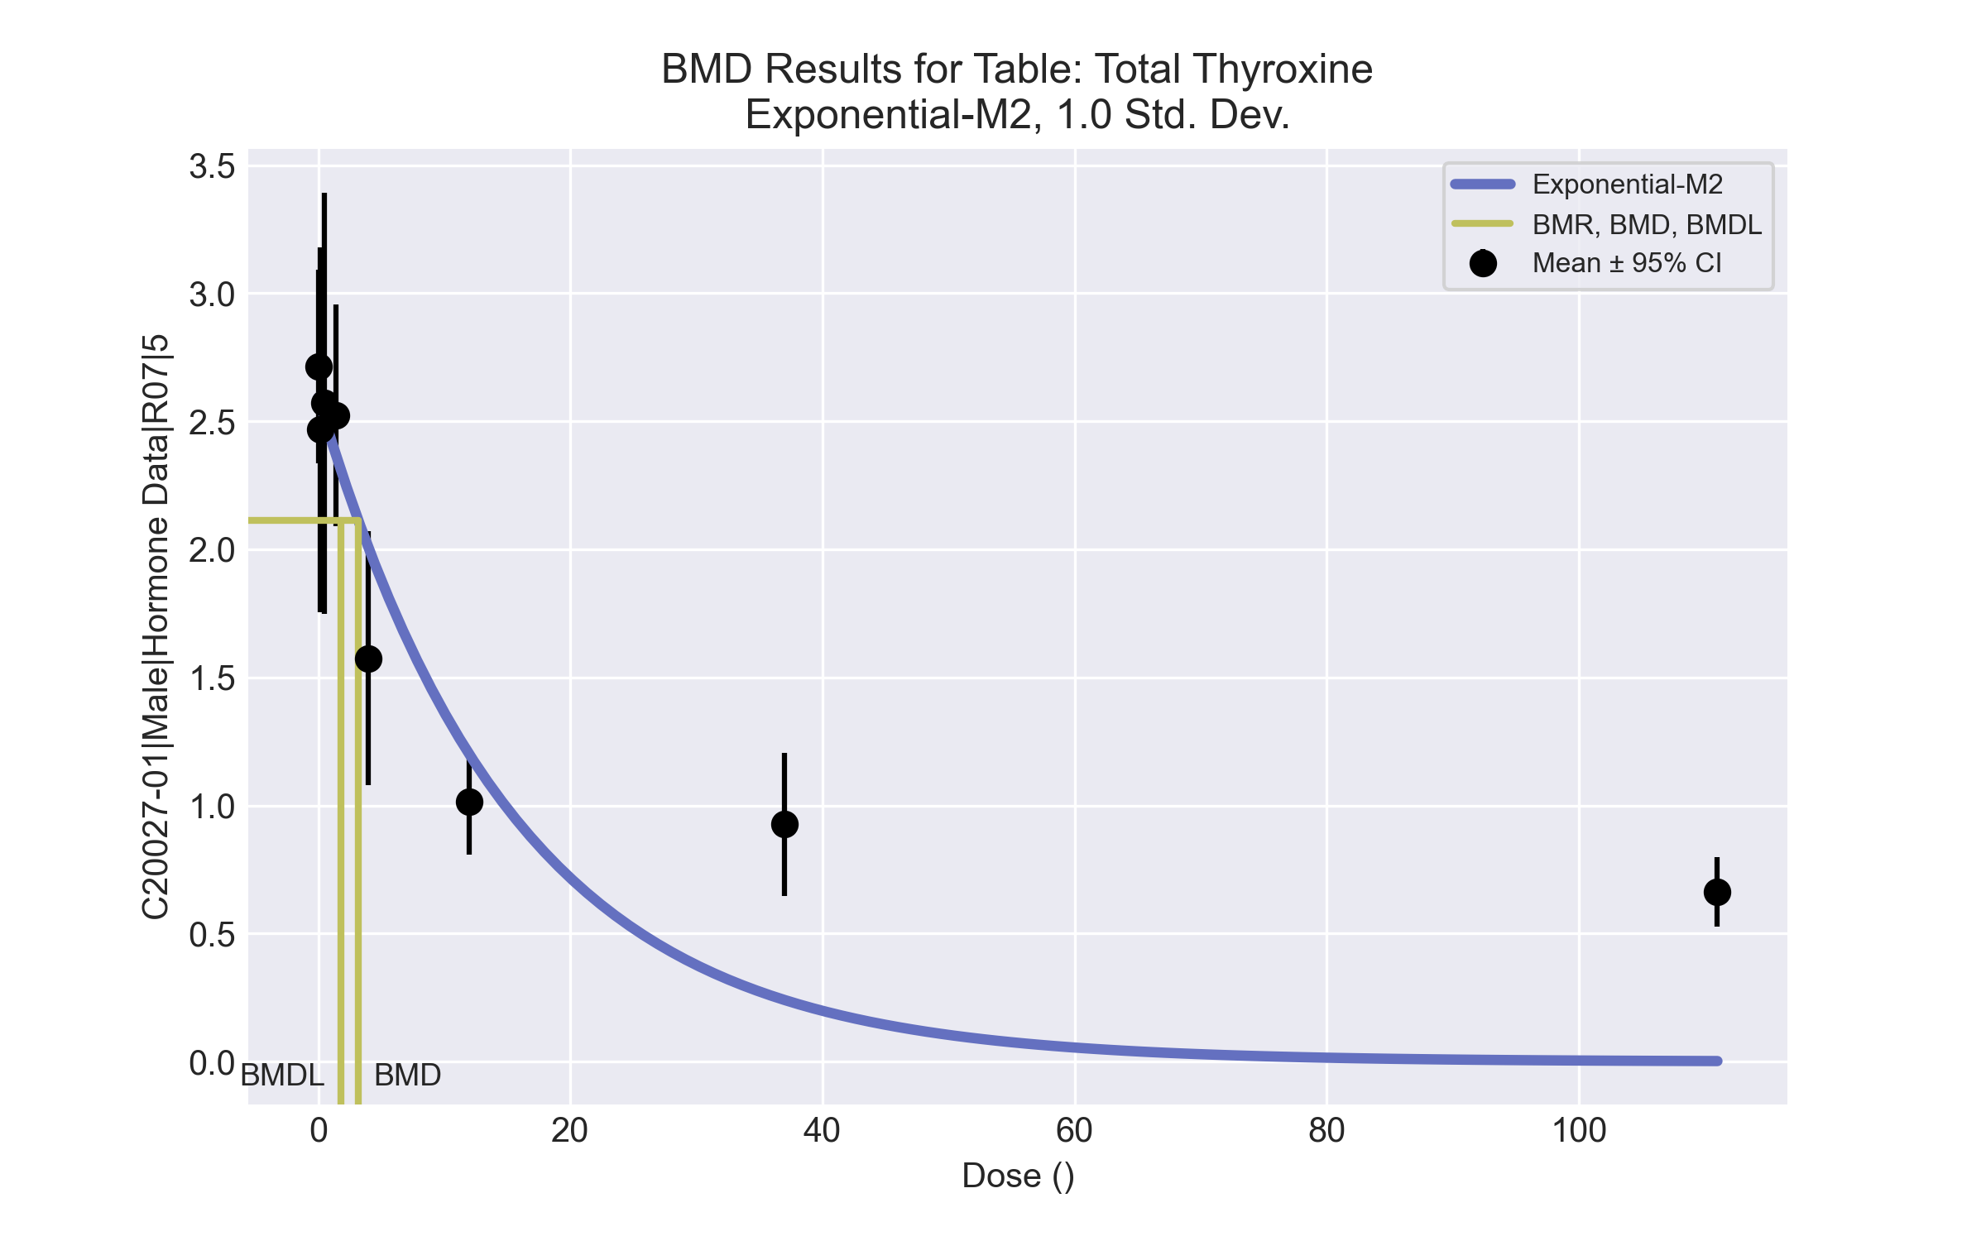
====================================================================
Exponential Model. (Version: 1.11; Date: 03/14/2017)
Input Data File: C:\Windows\TEMP\bmds-gxhpkmlf.(d)
Gnuplot Plotting File:
Fri Apr 16 00:51:06 2021
====================================================================
BMDS_Model_Run
~~~~~~~~~~~~~~~~~~~~~~~~~~~~~~~~~~~~~~~~~~~~~~~~~~~~~~~~~~~~~~~~~~~~~
The form of the response function by Model:
Model 2: Y[dose] = a * exp{sign * b * dose}
Model 3: Y[dose] = a * exp{sign * (b * dose)^d}
Model 4: Y[dose] = a * [c-(c-1) * exp{-b * dose}]
Model 5: Y[dose] = a * [c-(c-1) * exp{-(b * dose)^d}]
Note: Y[dose] is the median response for exposure = dose;
sign = +1 for increasing trend in data;
sign = -1 for decreasing trend.
Model 2 is nested within Models 3 and 4.
Model 3 is nested within Model 5.
Model 4 is nested within Model 5.
Dependent variable = Response
Independent variable = Dose
Data are assumed to be distributed: normally
Variance Model: exp(lnalpha +rho *ln(Y[dose]))
The variance is to be modeled as Var(i) = exp(lalpha + log(mean(i)) * rho)
Total number of dose groups = 8
Total number of records with missing values = 0
Maximum number of iterations = 500
Relative Function Convergence has been set to: 1e-008
Parameter Convergence has been set to: 1e-008
MLE solution provided: Exact
Initial Parameter Values
Variable Model 2
-------- --------
lnalpha -3.50527
rho 2.20374
a 1.36622
b 0.012583
c 0 Specified
d 1 Specified
Parameter Estimates
Variable Model 2 Std. Err.
-------- ------- ---------
lnalpha -1.35382 0.222683
rho -0.117548 0.110122
a 2.59236 0.101219
b 0.0642728 0.0107095
NC = No Convergence
Table of Stats From Input Data
Dose N Obs Mean Obs Std Dev
----- --- ---------- -------------
0 9 2.713 0.4922
0.15 5 2.468 0.5735
0.5 5 2.57 0.6632
1.4 4 2.523 0.2721
4 4 1.575 0.3125
12 5 1.014 0.1647
37 5 0.926 0.2257
111 4 0.6625 0.08578
Estimated Values of Interest
Dose Est Mean Est Std Scaled Residual
------ ---------- --------- ----------------
0 2.592 0.4805 0.7552
0.15 2.567 0.4808 -0.4627
0.5 2.51 0.4814 0.2769
1.4 2.369 0.4831 0.6343
4 2.005 0.4878 -1.762
12 1.199 0.5028 -0.8217
37 0.2404 0.5526 2.774
111 0.002067 0.7308 1.807
Other models for which likelihoods are calculated:
Model A1: Yij = Mu(i) + e(ij)
Var{e(ij)} = Sigma^2
Model A2: Yij = Mu(i) + e(ij)
Var{e(ij)} = Sigma(i)^2
Model A3: Yij = Mu(i) + e(ij)
Var{e(ij)} = exp(lalpha + log(mean(i)) * rho)
Model R: Yij = Mu + e(i)
Var{e(ij)} = Sigma^2
Likelihoods of Interest
Model Log(likelihood) DF AIC
------- ----------------- ---- ------------
A1 19.37427 9 -20.74854
A2 31.34614 16 -30.69228
A3 28.88579 10 -37.77158
R -15.696 2 35.392
2 6.852046 4 -5.704093
Additive constant for all log-likelihoods = -37.68. This constant added to the
above values gives the log-likelihood including the term that does not
depend on the model parameters.
Explanation of Tests
Test 1: Does response and/or variances differ among Dose levels? (A2 vs. R)
Test 2: Are Variances Homogeneous? (A2 vs. A1)
Test 3: Are variances adequately modeled? (A2 vs. A3)
Test 4: Does Model 2 fit the data? (A3 vs. 2)
Tests of Interest
Test -2*log(Likelihood Ratio) D. F. p-value
-------- ------------------------ ------ --------------
Test 1 94.08 14 < 0.0001
Test 2 23.94 7 0.001166
Test 3 4.921 6 0.554
Test 4 44.07 6 < 0.0001
The p-value for Test 1 is less than .05. There appears to be a
difference between response and/or variances among the dose
levels, it seems appropriate to model the data.
The p-value for Test 2 is less than .1. A non-homogeneous
variance model appears to be appropriate.
The p-value for Test 3 is greater than .1. The modeled
variance appears to be appropriate here.
The p-value for Test 4 is less than .1. Model 2 may not adequately
describe the data; you may want to consider another model.
Benchmark Dose Computations:
Specified Effect = 1.000000
Risk Type = Estimated standard deviations from control
Confidence Level = 0.950000
BMD = 3.18964
BMDL = 1.77414
BMDU = 6.91694

Male BMD Results for Table: Triiodothyronine
BMDS version: BMDS v2.7.0

Input dataset
Dose | 0 | 0.15 | 0.5 | 1.4ª | 4ª | 12ª | 37ª | 111ª | 333ª
N | 9 | 5 | 5 | 4 | 4 | 5 | 5 | 4 | 4
Mean ± SD | 49.244 ± 6.389 | 51.72 ± 4.097 | 56.58 ± 10.893 | 47.65 ± 1.997 | 44.975 ± 3.053 | 34.92 ± 6.262 | 31.96 ± 5.916 | 33.025 ± 1.999 | 33.15 ± 9.095
ª Dose group removed in BMD modeling session

Summary table
Modelª | Goodness of fit |  | BMD | BMDL | Comments
 | p-value | AIC
Linear^{b} (equivalent models include Power, Polynomial 2°, 3°, 5°, 6°, 7°, 8°) | 0.938 | 97.627 | 0.462 | 0.245 | Linear recommended as best-fitting model on the basis of the lowest AIC.
Polynomial 4° | 0.938 | 97.627 | 0.462 | 0.245
Hill | 0.051 | 112.994 | 1.419 | -999
Exponential M2 (equivalent models include Exponential M3) | 0.914 | 97.633 | 0.466 | 0.26
Exponential M4 | -999 | 99.621 | 0.454 | 0.004
Exponential M5 | -999 | 121.105 | -999 | 0
ª Constant variance case presented (BMDS Test 2 p-value = 0.103, BMDS Test 3 p-value = 0.103).
^{b} Recommended model

Model recommendation details
Model | Bin | Notes
Linearª (equivalent models include Power, Polynomial 2°, 3°, 5°, 6°, 7°, 8°) | Valid | -
Polynomial 4° | Valid | -
Hill | Failure | Failures  • BMDL does not exist  Warnings  • Goodness of fit p-value is less than threshold (0.0509 < 0.1)  • BMD/high dose ratio is greater than threshold (2.84 > 1.0)  Cautions  • Warning(s): THE MODEL HAS PROBABLY NOT CONVERGED!!!; THIS USUALLY MEANS THE MODEL HAS NOT CONVERGED!; BMDL computation failed.
Exponential M2 (equivalent models include Exponential M3) | Valid | -
Exponential M4 | Warning | Warnings  • BMD/BMDL ratio is greater than threshold (1.25e+02 > 20.0)  • Zero degrees of freedom; saturated model  Cautions  • BMD/BMDL ratio is greater than threshold (1.25e+02 > 5.0)
Exponential M5 | Failure | Failures  • BMD does not exist  Warnings  • Residual of Interest does not exist  • Zero degrees of freedom; saturated model
ª Recommended model

Recommended model
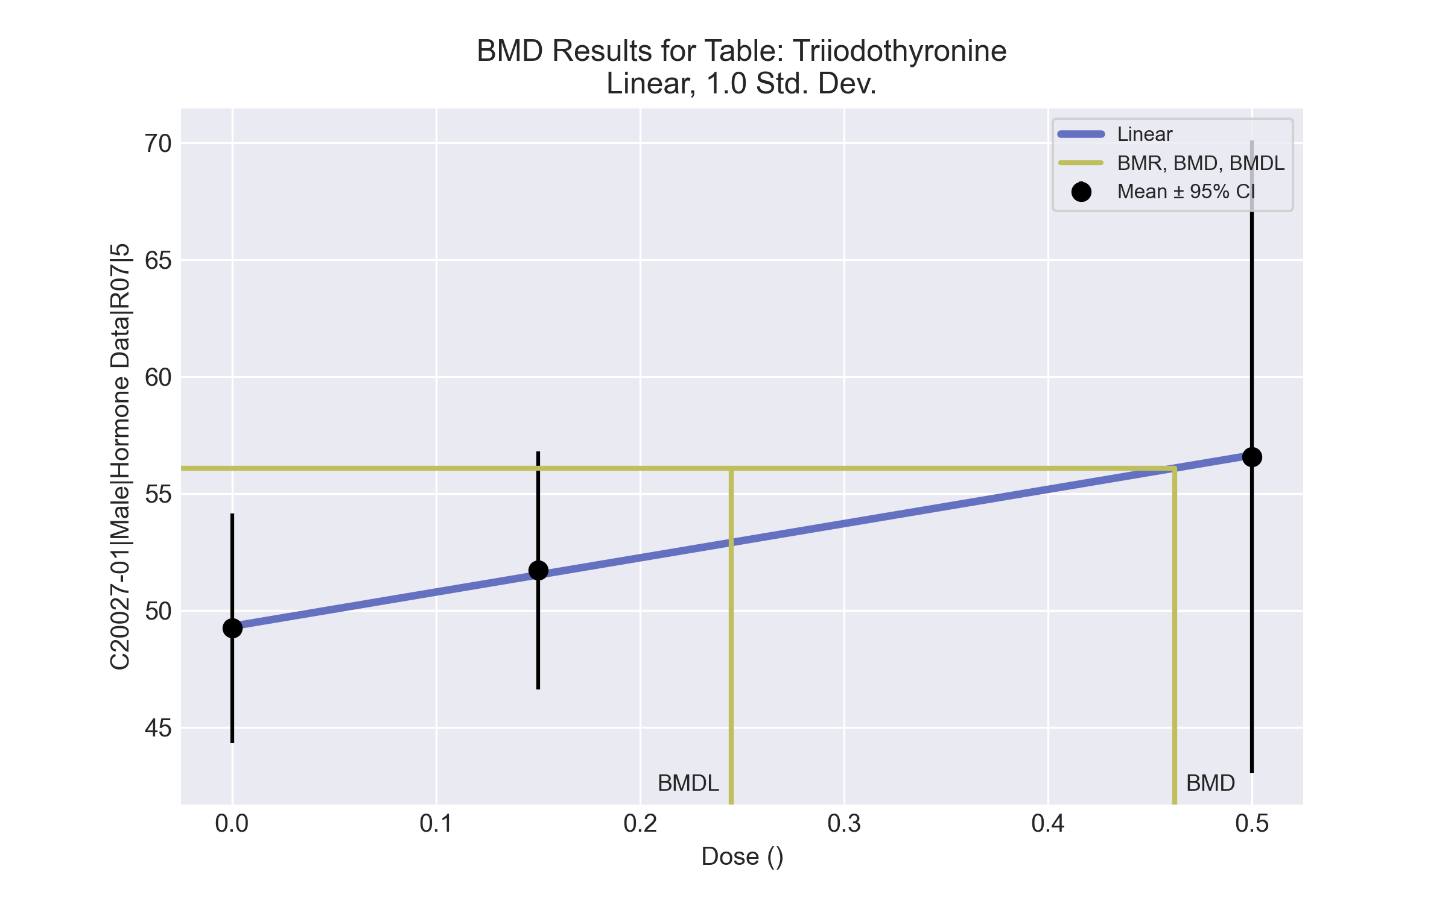
====================================================================
Polynomial Model. (Version: 2.21; Date: 03/14/2017)
Input Data File: C:\Windows\TEMP\bmds-vywbe9tw.(d)
Gnuplot Plotting File: C:\Windows\TEMP\bmds-vywbe9tw.plt
Fri Apr 16 00:51:36 2021
====================================================================
BMDS_Model_Run
~~~~~~~~~~~~~~~~~~~~~~~~~~~~~~~~~~~~~~~~~~~~~~~~~~~~~~~~~~~~~~~~~~~~~
The form of the response function is:
Y[dose] = beta_0 + beta_1*dose + beta_2*dose^2 + ...
Dependent variable = Response
Independent variable = Dose
rho is set to 0
The polynomial coefficients are restricted to be positive
A constant variance model is fit
Total number of dose groups = 3
Total number of records with missing values = 0
Maximum number of iterations = 500
Relative Function Convergence has been set to: 1e-008
Parameter Convergence has been set to: 1e-008
Default Initial Parameter Values
alpha = 54.2724
rho = 0 Specified
beta_0 = 49.3662
beta_1 = 14.5319
Asymptotic Correlation Matrix of Parameter Estimates
( *** The model parameter(s) -rho
have been estimated at a boundary point, or have been specified by the user,
and do not appear in the correlation matrix )
alpha beta_0 beta_1
alpha 1 7e-011 3.6e-011
beta_0 7e-011 1 -0.64
beta_1 3.6e-011 -0.64 1
Parameter Estimates
95.0% Wald Confidence Interval
Variable Estimate Std. Err. Lower Conf. Limit Upper Conf. Limit
alpha 45.7177 14.8328 16.646 74.7894
beta_0 49.3229 2.01609 45.3715 53.2744
beta_1 14.6352 7.52868 -0.120695 29.3912
Table of Data and Estimated Values of Interest
Dose N Obs Mean Est Mean Obs Std Dev Est Std Dev Scaled Res.
------ --- -------- -------- ----------- ----------- ----------
0 9 49.2 49.3 6.39 6.76 -0.0348
0.15 5 51.7 51.5 4.1 6.76 0.0667
0.5 5 56.6 56.6 10.9 6.76 -0.02
Model Descriptions for likelihoods calculated
Model A1: Yij = Mu(i) + e(ij)
Var{e(ij)} = Sigma^2
Model A2: Yij = Mu(i) + e(ij)
Var{e(ij)} = Sigma(i)^2
Model A3: Yij = Mu(i) + e(ij)
Var{e(ij)} = Sigma^2
Model A3 uses any fixed variance parameters that
were specified by the user
Model R: Yi = Mu + e(i)
Var{e(i)} = Sigma^2
Likelihoods of Interest
Model Log(likelihood) # Param's AIC
A1 -45.810571 4 99.621141
A2 -43.538114 6 99.076228
A3 -45.810571 4 99.621141
fitted -45.813605 3 97.627209
R -47.536853 2 99.073706
Explanation of Tests
Test 1: Do responses and/or variances differ among Dose levels?
(A2 vs. R)
Test 2: Are Variances Homogeneous? (A1 vs A2)
Test 3: Are variances adequately modeled? (A2 vs. A3)
Test 4: Does the Model for the Mean Fit? (A3 vs. fitted)
(Note: When rho=0 the results of Test 3 and Test 2 will be the same.)
Tests of Interest
Test -2*log(Likelihood Ratio) Test df p-value
Test 1 7.99748 4 0.09167
Test 2 4.54491 2 0.1031
Test 3 4.54491 2 0.1031
Test 4 0.00606768 1 0.9379
The p-value for Test 1 is greater than .05. There may not be a
diffence between responses and/or variances among the dose levels
Modelling the data with a dose/response curve may not be appropriate
The p-value for Test 2 is greater than .1. A homogeneous variance
model appears to be appropriate here
The p-value for Test 3 is greater than .1. The modeled variance appears
to be appropriate here
The p-value for Test 4 is greater than .1. The model chosen seems
to adequately describe the data
Benchmark Dose Computation
Specified effect = 1
Risk Type = Estimated standard deviations from the control mean
Confidence level = 0.95
BMD = 0.462
BMDL = 0.244666
BMDU = 4.05789

