Female BMD Results for Table: Kidney-Left Absolute
BMDS version: BMDS v2.7.0

Input dataset
Dose | 0 | 0.07 | 0.2 | 0.7 | 2 | 6 | 18 | 55 | 160 | 475
N | 10 | 5 | 5 | 5 | 5 | 5 | 5 | 5 | 5 | 5
Mean ± SD | 0.644 ± 0.05 | 0.692 ± 0.049 | 0.66 ± 0.06 | 0.672 ± 0.031 | 0.676 ± 0.029 | 0.666 ± 0.029 | 0.688 ± 0.041 | 0.7 ± 0.031 | 0.724 ± 0.059 | 0.716 ± 0.038

Summary table
Modelª | Goodness of fit |  | BMD | BMDL | Comments
 | p-value | AIC
Linear (equivalent models include Power, Polynomial 2°, 3°, 4°, 5°, 6°, 7°, 8°) | 0.177 | -281.771 | 366.374 | 227.305 | Exponential-M4 recommended as best-fitting model on the basis of the lowest AIC.
Hill | 0.589 | -285.638 | 58.534 | 7.695
Exponential M2 (equivalent models include Exponential M3) | 0.171 | -281.655 | 374.914 | 237.046
Exponential M4^{b} (equivalent models include Exponential M5) | 0.598 | -285.714 | 56.634 | 10.508
ª Constant variance case presented (BMDS Test 2 p-value = 0.507, BMDS Test 3 p-value = 0.507).
^{b} Recommended model

Model recommendation details
Model | Bin | Notes
Linear (equivalent models include Power, Polynomial 2°, 3°, 4°, 5°, 6°, 7°, 8°) | Warning | Warnings  • Residual at lowest dose is greater than threshold (2.02 > 2.0)
Hill | Valid | Cautions  • BMD/BMDL ratio is greater than threshold (7.61 > 5.0)
Exponential M2 (equivalent models include Exponential M3) | Warning | Warnings  • Residual at lowest dose is greater than threshold (2.03 > 2.0)
Exponential M4ª (equivalent models include Exponential M5) | Valid | Cautions  • BMD/BMDL ratio is greater than threshold (5.39 > 5.0)
ª Recommended model

Recommended model
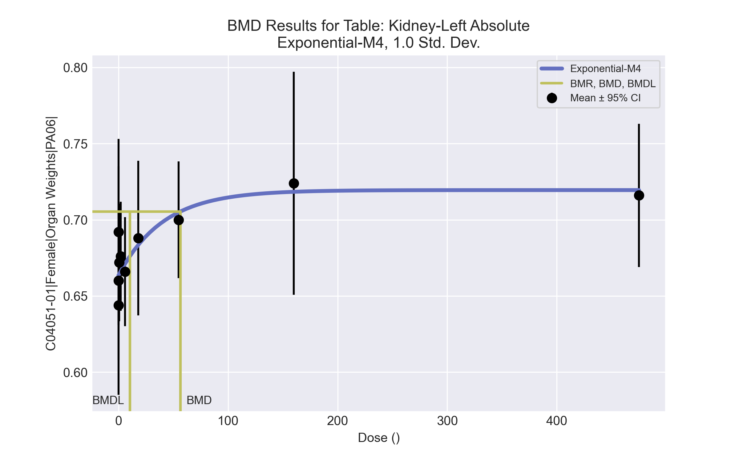
====================================================================
Exponential Model. (Version: 1.11; Date: 03/14/2017)
Input Data File: C:\Windows\TEMP\bmds-p4_u7hiu.(d)
Gnuplot Plotting File:
Tue Apr 13 09:56:27 2021
====================================================================
BMDS_Model_Run
~~~~~~~~~~~~~~~~~~~~~~~~~~~~~~~~~~~~~~~~~~~~~~~~~~~~~~~~~~~~~~~~~~~~~
The form of the response function by Model:
Model 2: Y[dose] = a * exp{sign * b * dose}
Model 3: Y[dose] = a * exp{sign * (b * dose)^d}
Model 4: Y[dose] = a * [c-(c-1) * exp{-b * dose}]
Model 5: Y[dose] = a * [c-(c-1) * exp{-(b * dose)^d}]
Note: Y[dose] is the median response for exposure = dose;
sign = +1 for increasing trend in data;
sign = -1 for decreasing trend.
Model 2 is nested within Models 3 and 4.
Model 3 is nested within Model 5.
Model 4 is nested within Model 5.
Dependent variable = Response
Independent variable = Dose
Data are assumed to be distributed: normally
Variance Model: exp(lnalpha +rho *ln(Y[dose]))
rho is set to 0.
A constant variance model is fit.
Total number of dose groups = 10
Total number of records with missing values = 0
Maximum number of iterations = 500
Relative Function Convergence has been set to: 1e-008
Parameter Convergence has been set to: 1e-008
MLE solution provided: Exact
Initial Parameter Values
Variable Model 4
-------- --------
lnalpha -6.44049
rho 0 Specified
a 0.6118
b 0.00340907
c 1.24256
d 1 Specified
Parameter Estimates
Variable Model 4 Std. Err.
-------- ------- ---------
lnalpha -6.34026 0.00033635
a 0.66346 0.00758079
b 0.0244564 0.0226753
c 1.08444 0.0239327
NC = No Convergence
Table of Stats From Input Data
Dose N Obs Mean Obs Std Dev
----- --- ---------- -------------
0 10 0.644 0.05038
0.07 5 0.692 0.04919
0.2 5 0.66 0.06042
0.7 5 0.672 0.03114
2 5 0.676 0.02881
6 5 0.666 0.02881
18 5 0.688 0.04087
55 5 0.7 0.03082
160 5 0.724 0.05899
475 5 0.716 0.03782
Estimated Values of Interest
Dose Est Mean Est Std Scaled Residual
------ ---------- --------- ----------------
0 0.6635 0.042 -1.465
0.07 0.6636 0.042 1.514
0.2 0.6637 0.042 -0.1988
0.7 0.6644 0.042 0.404
2 0.6661 0.042 0.5253
6 0.6711 0.042 -0.2719
18 0.6834 0.042 0.2444
55 0.7049 0.042 -0.2602
160 0.7184 0.042 0.3002
475 0.7195 0.042 -0.1853
Other models for which likelihoods are calculated:
Model A1: Yij = Mu(i) + e(ij)
Var{e(ij)} = Sigma^2
Model A2: Yij = Mu(i) + e(ij)
Var{e(ij)} = Sigma(i)^2
Model A3: Yij = Mu(i) + e(ij)
Var{e(ij)} = exp(lalpha + log(mean(i)) * rho)
Model R: Yij = Mu + e(i)
Var{e(ij)} = Sigma^2
Likelihoods of Interest
Model Log(likelihood) DF AIC
------- ----------------- ---- ------------
A1 149.6133 11 -277.2267
A2 153.7503 20 -267.5006
A3 149.6133 11 -277.2267
R 140.2633 2 -276.5267
4 146.8573 4 -285.7145
Additive constant for all log-likelihoods = -50.54. This constant added to the
above values gives the log-likelihood including the term that does not
depend on the model parameters.
Explanation of Tests
Test 1: Does response and/or variances differ among Dose levels? (A2 vs. R)
Test 2: Are Variances Homogeneous? (A2 vs. A1)
Test 3: Are variances adequately modeled? (A2 vs. A3)
Test 6a: Does Model 4 fit the data? (A3 vs 4)
Tests of Interest
Test -2*log(Likelihood Ratio) D. F. p-value
-------- ------------------------ ------ --------------
Test 1 26.97 18 0.07949
Test 2 8.274 9 0.5068
Test 3 8.274 9 0.5068
Test 6a 5.512 7 0.5977
The p-value for Test 1 is greater than .05. There may not be a
diffence between responses and/or variances among the dose levels
Modelling the data with a dose/response curve may not be appropriate.
The p-value for Test 2 is greater than .1. A homogeneous
variance model appears to be appropriate here.
The p-value for Test 3 is greater than .1. The modeled
variance appears to be appropriate here.
The p-value for Test 6a is greater than .1. Model 4 seems
to adequately describe the data.
Benchmark Dose Computations:
Specified Effect = 1.000000
Risk Type = Estimated standard deviations from control
Confidence Level = 0.950000
BMD = 56.6339
BMDL = 10.5076
BMDU = 4.75e+006

Female BMD Results for Table: Kidney-Left Relative
BMDS version: BMDS v2.7.0

Input dataset
Dose | 0 | 0.07 | 0.2 | 0.7 | 2 | 6 | 18 | 55 | 160 | 475
N | 10 | 5 | 5 | 5 | 5 | 5 | 5 | 5 | 5 | 5
Mean ± SD | 2.894 ± 0.202 | 3.096 ± 0.225 | 2.967 ± 0.231 | 3.008 ± 0.082 | 3.063 ± 0.15 | 2.924 ± 0.118 | 3.068 ± 0.147 | 3.085 ± 0.092 | 3.207 ± 0.203 | 3.166 ± 0.115

Summary table
Modelª | Goodness of fit |  | BMD | BMDL | Comments
 | p-value | AIC
Linear (equivalent models include Power, Polynomial 2°, 3°, 4°, 5°, 6°, 7°, 8°) | 0.105 | -131.973 | 385.142 | 234.684 | Exponential-M4 recommended as best-fitting model on the basis of the lowest AIC.
Hill | 0.192 | -132.497 | 87.571 | 15.481
Exponential M2 (equivalent models include Exponential M3) | 0.102 | -131.885 | 392.086 | 242.982
Exponential M4^{b} | 0.286 | -134.626 | 85.629 | 17.286
Exponential M5 | 0.2 | -132.627 | 85.314 | 17.294
ª Constant variance case presented (BMDS Test 2 p-value = 0.194, BMDS Test 3 p-value = 0.194).
^{b} Recommended model

Model recommendation details
Model | Bin | Notes
Linear (equivalent models include Power, Polynomial 2°, 3°, 4°, 5°, 6°, 7°, 8°) | Warning | Warnings  • Residual at lowest dose is greater than threshold (2.03 > 2.0)
Hill | Valid | Cautions  • BMD/BMDL ratio is greater than threshold (5.66 > 5.0)
Exponential M2 (equivalent models include Exponential M3) | Warning | Warnings  • Residual at lowest dose is greater than threshold (2.04 > 2.0)
Exponential M4ª | Valid | -
Exponential M5 | Valid | -
ª Recommended model

Recommended model
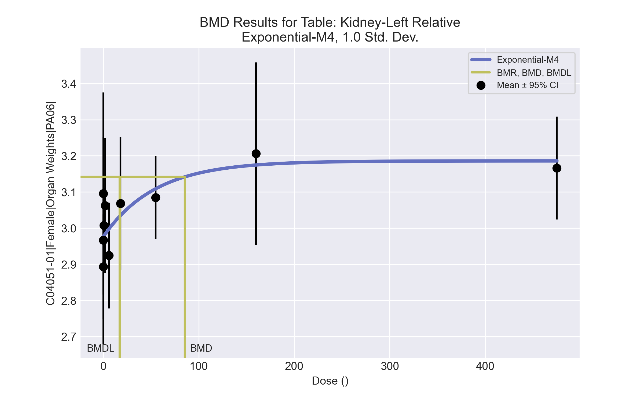
====================================================================
Exponential Model. (Version: 1.11; Date: 03/14/2017)
Input Data File: C:\Windows\TEMP\bmds-49o9b_o0.(d)
Gnuplot Plotting File:
Tue Apr 13 09:56:35 2021
====================================================================
BMDS_Model_Run
~~~~~~~~~~~~~~~~~~~~~~~~~~~~~~~~~~~~~~~~~~~~~~~~~~~~~~~~~~~~~~~~~~~~~
The form of the response function by Model:
Model 2: Y[dose] = a * exp{sign * b * dose}
Model 3: Y[dose] = a * exp{sign * (b * dose)^d}
Model 4: Y[dose] = a * [c-(c-1) * exp{-b * dose}]
Model 5: Y[dose] = a * [c-(c-1) * exp{-(b * dose)^d}]
Note: Y[dose] is the median response for exposure = dose;
sign = +1 for increasing trend in data;
sign = -1 for decreasing trend.
Model 2 is nested within Models 3 and 4.
Model 3 is nested within Model 5.
Model 4 is nested within Model 5.
Dependent variable = Response
Independent variable = Dose
Data are assumed to be distributed: normally
Variance Model: exp(lnalpha +rho *ln(Y[dose]))
rho is set to 0.
A constant variance model is fit.
Total number of dose groups = 10
Total number of records with missing values = 0
Maximum number of iterations = 500
Relative Function Convergence has been set to: 1e-008
Parameter Convergence has been set to: 1e-008
MLE solution provided: Exact
Initial Parameter Values
Variable Model 4
-------- --------
lnalpha -3.74888
rho 0 Specified
a 2.74884
b 0.00318188
c 1.22485
d 1 Specified
Parameter Estimates
Variable Model 4 Std. Err.
-------- ------- ---------
lnalpha -3.5932 0.00524598
a 2.97611 0.0289755
b 0.0182433 0.0162438
c 1.07052 0.0219726
NC = No Convergence
Table of Stats From Input Data
Dose N Obs Mean Obs Std Dev
----- --- ---------- -------------
0 10 2.894 0.2022
0.07 5 3.096 0.2252
0.2 5 2.967 0.2306
0.7 5 3.008 0.08211
2 5 3.063 0.1504
6 5 2.924 0.118
18 5 3.068 0.1472
55 5 3.085 0.09226
160 5 3.207 0.203
475 5 3.166 0.1148
Estimated Values of Interest
Dose Est Mean Est Std Scaled Residual
------ ---------- --------- ----------------
0 2.976 0.1659 -1.575
0.07 2.976 0.1659 1.61
0.2 2.977 0.1659 -0.1363
0.7 2.979 0.1659 0.3928
2 2.984 0.1659 1.065
6 2.998 0.1659 -0.9904
18 3.035 0.1659 0.453
55 3.109 0.1659 -0.3299
160 3.175 0.1659 0.4304
475 3.186 0.1659 -0.2671
Other models for which likelihoods are calculated:
Model A1: Yij = Mu(i) + e(ij)
Var{e(ij)} = Sigma^2
Model A2: Yij = Mu(i) + e(ij)
Var{e(ij)} = Sigma(i)^2
Model A3: Yij = Mu(i) + e(ij)
Var{e(ij)} = exp(lalpha + log(mean(i)) * rho)
Model R: Yij = Mu + e(i)
Var{e(ij)} = Sigma^2
Likelihoods of Interest
Model Log(likelihood) DF AIC
------- ----------------- ---- ------------
A1 75.59426 11 -129.1885
A2 81.77062 20 -123.5412
A3 75.59426 11 -129.1885
R 65.68851 2 -127.377
4 71.31299 4 -134.626
Additive constant for all log-likelihoods = -50.54. This constant added to the
above values gives the log-likelihood including the term that does not
depend on the model parameters.
Explanation of Tests
Test 1: Does response and/or variances differ among Dose levels? (A2 vs. R)
Test 2: Are Variances Homogeneous? (A2 vs. A1)
Test 3: Are variances adequately modeled? (A2 vs. A3)
Test 6a: Does Model 4 fit the data? (A3 vs 4)
Tests of Interest
Test -2*log(Likelihood Ratio) D. F. p-value
-------- ------------------------ ------ --------------
Test 1 32.16 18 0.02102
Test 2 12.35 9 0.1941
Test 3 12.35 9 0.1941
Test 6a 8.563 7 0.2856
The p-value for Test 1 is less than .05. There appears to be a
difference between response and/or variances among the dose
levels, it seems appropriate to model the data.
The p-value for Test 2 is greater than .1. A homogeneous
variance model appears to be appropriate here.
The p-value for Test 3 is greater than .1. The modeled
variance appears to be appropriate here.
The p-value for Test 6a is greater than .1. Model 4 seems
to adequately describe the data.
Benchmark Dose Computations:
Specified Effect = 1.000000
Risk Type = Estimated standard deviations from control
Confidence Level = 0.950000
BMD = 85.6285
BMDL = 17.2858
BMDU = 4.75e+006

Female BMD Results for Table: Kidney-Right Absolute
BMDS version: BMDS v2.7.0

Input dataset
Dose | 0 | 0.07 | 0.2 | 0.7 | 2 | 6 | 18 | 55 | 160 | 475
N | 10 | 5 | 5 | 5 | 5 | 5 | 5 | 5 | 5 | 5
Mean ± SD | 0.661 ± 0.045 | 0.704 ± 0.021 | 0.676 ± 0.056 | 0.67 ± 0.035 | 0.68 ± 0.035 | 0.67 ± 0.023 | 0.698 ± 0.062 | 0.714 ± 0.032 | 0.724 ± 0.059 | 0.756 ± 0.046

Summary table
Modelª | Goodness of fit |  | BMD | BMDL | Comments
 | p-value | AIC
Linear (equivalent models include Power, Polynomial 2°, 3°, 4°, 5°, 6°, 7°, 8°) | 0.451 | -286.026 | 242.671 | 170.616 | Hill recommended as best-fitting model on the basis of the lowest BMDL.
Hill^{b} | 0.689 | -287.089 | 72.145 | 18.001
Exponential M2 (equivalent models include Exponential M3) | 0.435 | -285.863 | 251.543 | 180.135
Exponential M4 (equivalent models include Exponential M5) | 0.649 | -286.757 | 84.051 | 19.608
ª Constant variance case presented (BMDS Test 2 p-value = 0.245, BMDS Test 3 p-value = 0.245).
^{b} Recommended model

Model recommendation details
Model | Bin | Notes
Linear (equivalent models include Power, Polynomial 2°, 3°, 4°, 5°, 6°, 7°, 8°) | Valid | -
Hillª | Valid | -
Exponential M2 (equivalent models include Exponential M3) | Valid | -
Exponential M4 (equivalent models include Exponential M5) | Valid | -
ª Recommended model

Recommended model
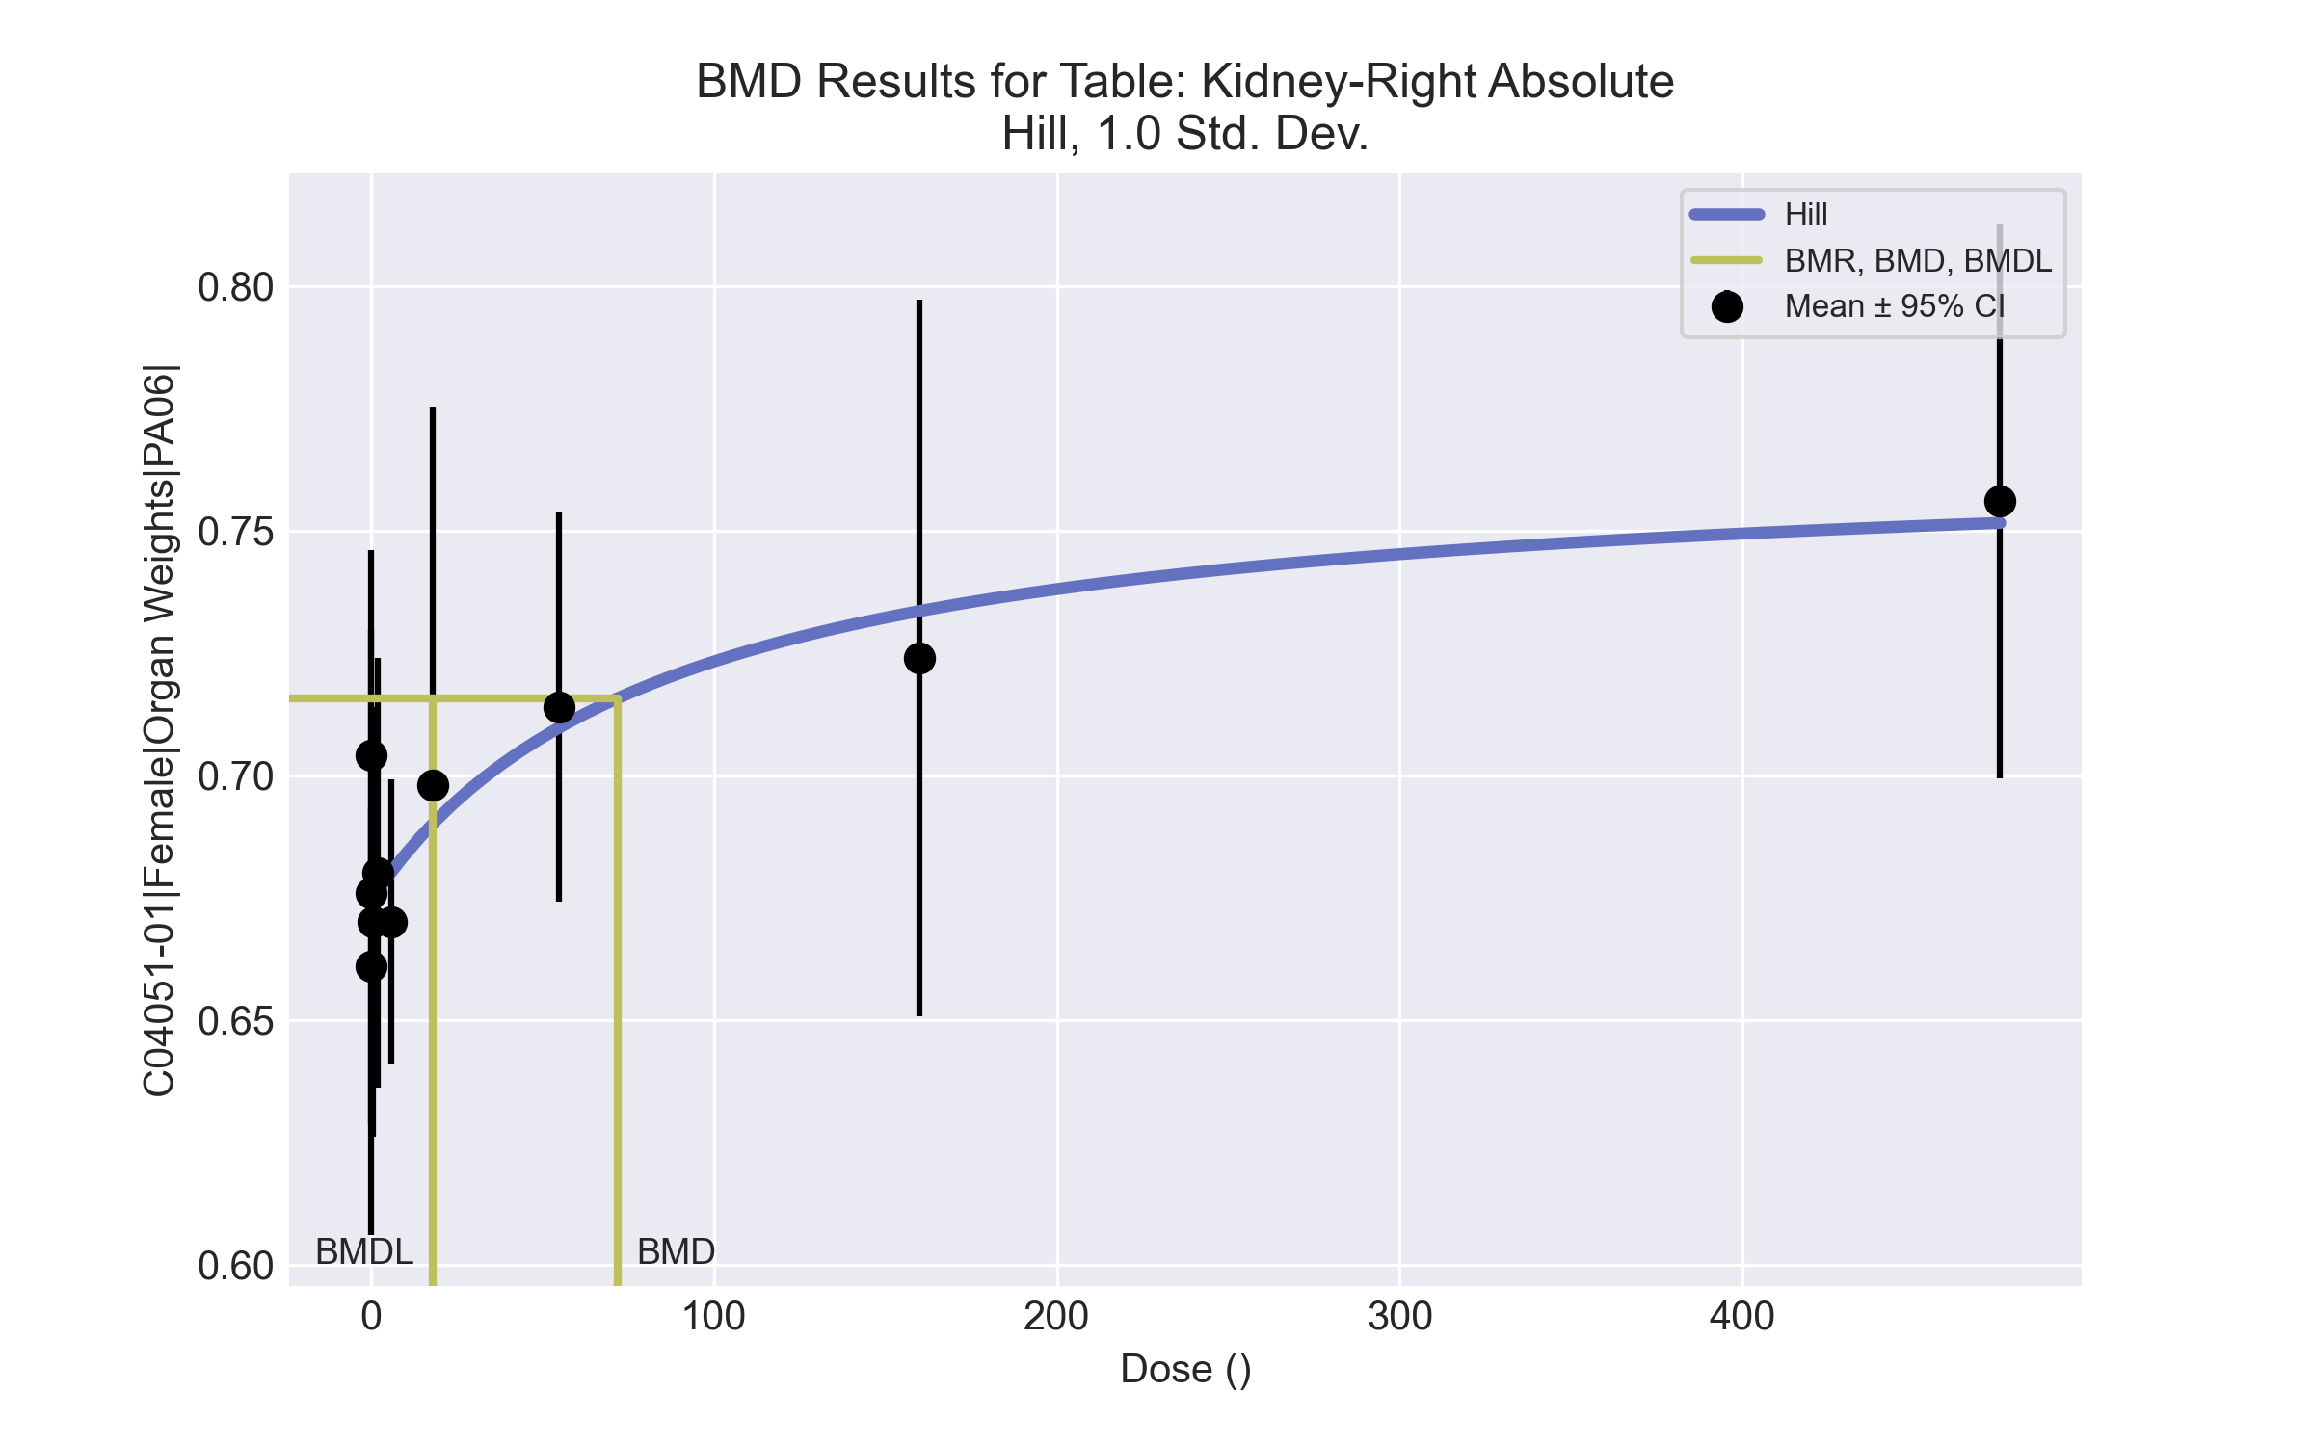
====================================================================
Hill Model. (Version: 2.18; Date: 03/14/2017)
Input Data File: C:\Windows\TEMP\bmds-klmp8hjn.(d)
Gnuplot Plotting File: C:\Windows\TEMP\bmds-klmp8hjn.plt
Tue Apr 13 09:56:38 2021
====================================================================
BMDS_Model_Run
~~~~~~~~~~~~~~~~~~~~~~~~~~~~~~~~~~~~~~~~~~~~~~~~~~~~~~~~~~~~~~~~~~~~~
The form of the response function is:
Y[dose] = intercept + v*dose^n/(k^n + dose^n)
Dependent variable = Response
Independent variable = Dose
rho is set to 0
Power parameter restricted to be greater than 1
A constant variance model is fit
Total number of dose groups = 10
Total number of records with missing values = 0
Maximum number of iterations = 500
Relative Function Convergence has been set to: 1e-008
Parameter Convergence has been set to: 1e-008
Default Initial Parameter Values
alpha = 0.00192821
rho = 0 Specified
intercept = 0.661
v = 0.095
n = 0.40759
k = 67.7187
Asymptotic Correlation Matrix of Parameter Estimates
( *** The model parameter(s) -rho -n
have been estimated at a boundary point, or have been specified by the user,
and do not appear in the correlation matrix )
alpha intercept v k
alpha 1 3e-009 5.7e-009 5.3e-009
intercept 3e-009 1 0.054 0.43
v 5.7e-009 0.054 1 0.81
k 5.3e-009 0.43 0.81 1
Parameter Estimates
95.0% Wald Confidence Interval
Variable Estimate Std. Err. Lower Conf. Limit Upper Conf. Limit
alpha 0.0017203 0.000328049 0.00107734 0.00236327
intercept 0.674309 0.00751048 0.659588 0.689029
v 0.0913551 0.0336258 0.0254496 0.15726
n 1 NA
k 86.7596 107.855 -124.633 298.152
NA - Indicates that this parameter has hit a bound
implied by some inequality constraint and thus
has no standard error.
Table of Data and Estimated Values of Interest
Dose N Obs Mean Est Mean Obs Std Dev Est Std Dev Scaled Res.
------ --- -------- -------- ----------- ----------- ----------
0 10 0.661 0.674 0.0451 0.0415 -1.01
0.07 5 0.704 0.674 0.0207 0.0415 1.6
0.2 5 0.676 0.675 0.0564 0.0415 0.0799
0.7 5 0.67 0.675 0.0354 0.0415 -0.272
2 5 0.68 0.676 0.0354 0.0415 0.196
6 5 0.67 0.68 0.0235 0.0415 -0.551
18 5 0.698 0.69 0.0622 0.0415 0.431
55 5 0.714 0.71 0.0321 0.0415 0.229
160 5 0.724 0.734 0.059 0.0415 -0.515
475 5 0.756 0.752 0.0456 0.0415 0.24
Model Descriptions for likelihoods calculated
Model A1: Yij = Mu(i) + e(ij)
Var{e(ij)} = Sigma^2
Model A2: Yij = Mu(i) + e(ij)
Var{e(ij)} = Sigma(i)^2
Model A3: Yij = Mu(i) + e(ij)
Var{e(ij)} = Sigma^2
Model A3 uses any fixed variance parameters that
were specified by the user
Model R: Yi = Mu + e(i)
Var{e(i)} = Sigma^2
Likelihoods of Interest
Model Log(likelihood) # Param's AIC
A1 149.925411 11 -277.850822
A2 155.656445 20 -271.312890
A3 149.925411 11 -277.850822
fitted 147.544495 4 -287.088989
R 138.359208 2 -272.718417
Explanation of Tests
Test 1: Do responses and/or variances differ among Dose levels?
(A2 vs. R)
Test 2: Are Variances Homogeneous? (A1 vs A2)
Test 3: Are variances adequately modeled? (A2 vs. A3)
Test 4: Does the Model for the Mean Fit? (A3 vs. fitted)
(Note: When rho=0 the results of Test 3 and Test 2 will be the same.)
Tests of Interest
Test -2*log(Likelihood Ratio) Test df p-value
Test 1 34.5945 18 0.01063
Test 2 11.4621 9 0.2454
Test 3 11.4621 9 0.2454
Test 4 4.76183 7 0.689
The p-value for Test 1 is less than .05. There appears to be a
difference between response and/or variances among the dose levels
It seems appropriate to model the data
The p-value for Test 2 is greater than .1. A homogeneous variance
model appears to be appropriate here
The p-value for Test 3 is greater than .1. The modeled variance appears
to be appropriate here
The p-value for Test 4 is greater than .1. The model chosen seems
to adequately describe the data
Benchmark Dose Computation
Specified effect = 1
Risk Type = Estimated standard deviations from the control mean
Confidence level = 0.95
BMD = 72.1451
BMDL = 18.0006
BMDU = 257.973

Female BMD Results for Table: Kidney-Right Relative
BMDS version: BMDS v2.7.0

Input dataset
Dose | 0 | 0.07 | 0.2 | 0.7 | 2 | 6 | 18 | 55 | 160 | 475
N | 10 | 5 | 5 | 5 | 5 | 5 | 5 | 5 | 5 | 5
Mean ± SD | 2.971 ± 0.194 | 3.149 ± 0.069 | 3.039 ± 0.213 | 2.998 ± 0.086 | 3.082 ± 0.196 | 2.942 ± 0.098 | 3.108 ± 0.154 | 3.147 ± 0.126 | 3.208 ± 0.231 | 3.341 ± 0.086

Summary table
Modelª | Goodness of fit |  | BMD | BMDL | Comments
 | p-value | AIC
Linear (equivalent models include Power, Polynomial 2°, 3°, 4°, 5°, 6°, 7°, 8°) | 0.29 | -140.404 | 260.26 | 180.915 | No model was recommended as a best-fitting model. Doses were dropped until there were only 3 remaining dose-groups.
Hill | 0.293 | -139.585 | 122.132 | 32.706
Exponential M2 (equivalent models include Exponential M3) | 0.285 | -140.325 | 267.377 | 189.41
Exponential M4 (equivalent models include Exponential M5) | 0.282 | -139.445 | 133.199 | 38.42
ª Modeled variance case presented (BMDS Test 2 p-value = 0.055, BMDS Test 3 p-value = 0.048).

Model recommendation details
Model | Bin | Notes
Linear (equivalent models include Power, Polynomial 2°, 3°, 4°, 5°, 6°, 7°, 8°) | Warning | Warnings  • Variance model poorly fits dataset (p-value 3 = 0.0477)
Hill | Warning | Warnings  • Variance model poorly fits dataset (p-value 3 = 0.0477)
Exponential M2 (equivalent models include Exponential M3) | Warning | Warnings  • Variance model poorly fits dataset (p-value 3 = 0.0477)
Exponential M4 (equivalent models include Exponential M5) | Warning | Warnings  • Variance model poorly fits dataset (p-value 3 = 0.0477)

Recommended model
No model was recommended as a best-fitting model.

Female BMD Results for Table: Liver Weight Absolute
BMDS version: BMDS v2.7.0

Input dataset
Dose | 0 | 0.07 | 0.2 | 0.7 | 2 | 6 | 18 | 55 | 160 | 475
N | 10 | 5 | 5 | 5 | 5 | 5 | 5 | 5 | 5 | 5
Mean ± SD | 8.164 ± 0.768 | 8.314 ± 0.676 | 7.69 ± 0.702 | 8.16 ± 0.462 | 8.116 ± 0.442 | 9.1 ± 1.09 | 9.074 ± 0.869 | 9.86 ± 0.926 | 9.916 ± 1.074 | 10.022 ± 0.77

Summary table
Modelª | Goodness of fit |  | BMD | BMDL | Comments
 | p-value | AIC
Linear (equivalent models include Power, Polynomial 2°, 3°, 4°, 5°, 6°, 7°, 8°) | 5.0E-04 | 53.494 | 232.176 | 165.05 | Exponential-M4 recommended as best-fitting model on the basis of the lowest AIC.
Hill | 0.62 | 34.059 | 6.826 | 2.542
Exponential M2 (equivalent models include Exponential M3) | 3.9E-04 | 54.147 | 252.301 | 184.166
Exponential M4^{b} (equivalent models include Exponential M5) | 0.675 | 32.52 | 8.801 | 3.465
ª Constant variance case presented (BMDS Test 2 p-value = 0.576, BMDS Test 3 p-value = 0.576).
^{b} Recommended model

Model recommendation details
Model | Bin | Notes
Linear (equivalent models include Power, Polynomial 2°, 3°, 4°, 5°, 6°, 7°, 8°) | Warning | Warnings  • Goodness of fit p-value is less than threshold (0.000503 < 0.1)
Hill | Valid | -
Exponential M2 (equivalent models include Exponential M3) | Warning | Warnings  • Goodness of fit p-value is less than threshold (0.000387 < 0.1)
Exponential M4ª (equivalent models include Exponential M5) | Valid | -
ª Recommended model

Recommended model
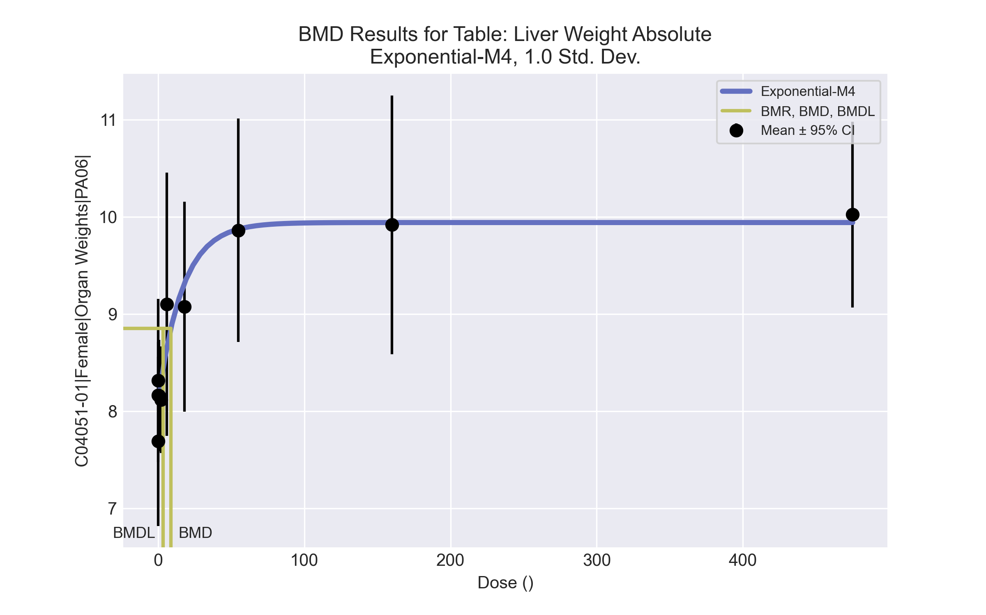
====================================================================
Exponential Model. (Version: 1.11; Date: 03/14/2017)
Input Data File: C:\Windows\TEMP\bmds-dtgl4q4o.(d)
Gnuplot Plotting File:
Tue Apr 13 09:57:20 2021
====================================================================
BMDS_Model_Run
~~~~~~~~~~~~~~~~~~~~~~~~~~~~~~~~~~~~~~~~~~~~~~~~~~~~~~~~~~~~~~~~~~~~~
The form of the response function by Model:
Model 2: Y[dose] = a * exp{sign * b * dose}
Model 3: Y[dose] = a * exp{sign * (b * dose)^d}
Model 4: Y[dose] = a * [c-(c-1) * exp{-b * dose}]
Model 5: Y[dose] = a * [c-(c-1) * exp{-(b * dose)^d}]
Note: Y[dose] is the median response for exposure = dose;
sign = +1 for increasing trend in data;
sign = -1 for decreasing trend.
Model 2 is nested within Models 3 and 4.
Model 3 is nested within Model 5.
Model 4 is nested within Model 5.
Dependent variable = Response
Independent variable = Dose
Data are assumed to be distributed: normally
Variance Model: exp(lnalpha +rho *ln(Y[dose]))
rho is set to 0.
A constant variance model is fit.
Total number of dose groups = 10
Total number of records with missing values = 0
Maximum number of iterations = 500
Relative Function Convergence has been set to: 1e-008
Parameter Convergence has been set to: 1e-008
MLE solution provided: Exact
Initial Parameter Values
Variable Model 4
-------- --------
lnalpha -0.642903
rho 0 Specified
a 7.3055
b 0.00493729
c 1.44044
d 1 Specified
Parameter Estimates
Variable Model 4 Std. Err.
-------- ------- ---------
lnalpha -0.554188 0.10956
a 8.09184 0.149609
b 0.0599768 0.0329075
c 1.2284 0.0332011
NC = No Convergence
Table of Stats From Input Data
Dose N Obs Mean Obs Std Dev
----- --- ---------- -------------
0 10 8.164 0.7676
0.07 5 8.314 0.6764
0.2 5 7.69 0.7017
0.7 5 8.16 0.4622
2 5 8.116 0.4417
6 5 9.1 1.09
18 5 9.074 0.8686
55 5 9.86 0.9258
160 5 9.916 1.074
475 5 10.02 0.77
Estimated Values of Interest
Dose Est Mean Est Std Scaled Residual
------ ---------- --------- ----------------
0 8.092 0.758 0.301
0.07 8.1 0.758 0.6325
0.2 8.114 0.758 -1.25
0.7 8.168 0.758 -0.0231
2 8.301 0.758 -0.545
6 8.65 0.758 1.326
18 9.312 0.758 -0.7025
55 9.872 0.758 -0.03475
160 9.94 0.758 -0.07053
475 9.94 0.758 0.2418
Other models for which likelihoods are calculated:
Model A1: Yij = Mu(i) + e(ij)
Var{e(ij)} = Sigma^2
Model A2: Yij = Mu(i) + e(ij)
Var{e(ij)} = Sigma(i)^2
Model A3: Yij = Mu(i) + e(ij)
Var{e(ij)} = exp(lalpha + log(mean(i)) * rho)
Model R: Yij = Mu + e(i)
Var{e(ij)} = Sigma^2
Likelihoods of Interest
Model Log(likelihood) DF AIC
------- ----------------- ---- ------------
A1 -9.820155 11 41.64031
A2 -6.026058 20 52.05212
A3 -9.820155 11 41.64031
R -32.0117 2 68.02341
4 -12.25982 4 32.51964
Additive constant for all log-likelihoods = -50.54. This constant added to the
above values gives the log-likelihood including the term that does not
depend on the model parameters.
Explanation of Tests
Test 1: Does response and/or variances differ among Dose levels? (A2 vs. R)
Test 2: Are Variances Homogeneous? (A2 vs. A1)
Test 3: Are variances adequately modeled? (A2 vs. A3)
Test 6a: Does Model 4 fit the data? (A3 vs 4)
Tests of Interest
Test -2*log(Likelihood Ratio) D. F. p-value
-------- ------------------------ ------ --------------
Test 1 51.97 18 < 0.0001
Test 2 7.588 9 0.5761
Test 3 7.588 9 0.5761
Test 6a 4.879 7 0.6747
The p-value for Test 1 is less than .05. There appears to be a
difference between response and/or variances among the dose
levels, it seems appropriate to model the data.
The p-value for Test 2 is greater than .1. A homogeneous
variance model appears to be appropriate here.
The p-value for Test 3 is greater than .1. The modeled
variance appears to be appropriate here.
The p-value for Test 6a is greater than .1. Model 4 seems
to adequately describe the data.
Benchmark Dose Computations:
Specified Effect = 1.000000
Risk Type = Estimated standard deviations from control
Confidence Level = 0.950000
BMD = 8.80071
BMDL = 3.46462
BMDU = 22.548

Female BMD Results for Table: Liver Weight Relative
BMDS version: BMDS v2.7.0

Input dataset
Dose | 0 | 0.07 | 0.2 | 0.7 | 2 | 6 | 18 | 55 | 160 | 475ª
N | 10 | 5 | 5 | 5 | 5 | 5 | 5 | 5 | 5 | 5
Mean ± SD | 36.648 ± 2.675 | 37.159 ± 2.483 | 34.56 ± 2.511 | 36.519 ± 1.369 | 36.726 ± 0.844 | 39.902 ± 3.986 | 40.462 ± 3.606 | 43.484 ± 4.379 | 43.895 ± 3.908 | 44.265 ± 1.825
ª Dose group removed in BMD modeling session

Summary table
Modelª | Goodness of fit |  | BMD | BMDL | Comments
 | p-value | AIC
Linear (equivalent models include Power, Polynomial 6°, 7°, 8°) | 0.002 | 174.497 | 42.344 | 21.145 | Exponential-M4 recommended as best-fitting model on the basis of the lowest AIC.
Polynomial 2° (equivalent models include Polynomial 3°, 4°, 5°) | 0.002 | 174.497 | 42.344 | 21.145
Hill | 0.276 | 162.754 | 4.62 | -999
Exponential M2 (equivalent models include Exponential M3) | 0.002 | 175.67 | 50.468 | 26.401
Exponential M4^{b} | 0.325 | 161.38 | 5.372 | 2.294
Exponential M5 | 0.224 | 163.379 | 5.383 | 2.294
ª Modeled variance case presented (BMDS Test 2 p-value = 0.034, BMDS Test 3 p-value = 0.193).
^{b} Recommended model

Model recommendation details
Model | Bin | Notes
Linear (equivalent models include Power, Polynomial 6°, 7°, 8°) | Warning | Warnings  • Goodness of fit p-value is less than threshold (0.00247 < 0.1)
Polynomial 2° (equivalent models include Polynomial 3°, 4°, 5°) | Warning | Warnings  • Goodness of fit p-value is less than threshold (0.00247 < 0.1)
Hill | Failure | Failures  • BMDL does not exist  Cautions  • Warning(s): BMDL computation failed.
Exponential M2 (equivalent models include Exponential M3) | Warning | Warnings  • Goodness of fit p-value is less than threshold (0.00155 < 0.1)
Exponential M4ª | Valid | -
Exponential M5 | Valid | -
ª Recommended model

Recommended model
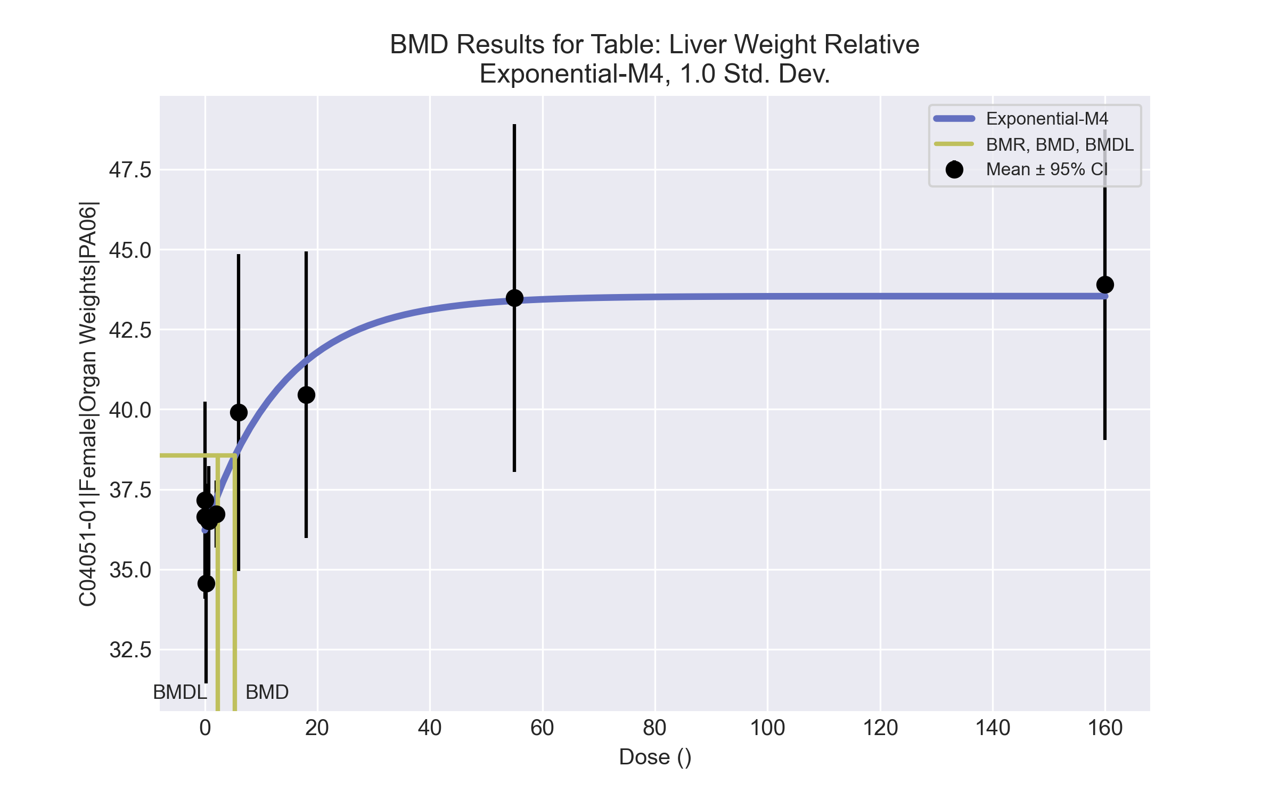
====================================================================
Exponential Model. (Version: 1.11; Date: 03/14/2017)
Input Data File: C:\Windows\TEMP\bmds-x8cnrp8l.(d)
Gnuplot Plotting File:
Tue Apr 13 09:57:28 2021
====================================================================
BMDS_Model_Run
~~~~~~~~~~~~~~~~~~~~~~~~~~~~~~~~~~~~~~~~~~~~~~~~~~~~~~~~~~~~~~~~~~~~~
The form of the response function by Model:
Model 2: Y[dose] = a * exp{sign * b * dose}
Model 3: Y[dose] = a * exp{sign * (b * dose)^d}
Model 4: Y[dose] = a * [c-(c-1) * exp{-b * dose}]
Model 5: Y[dose] = a * [c-(c-1) * exp{-(b * dose)^d}]
Note: Y[dose] is the median response for exposure = dose;
sign = +1 for increasing trend in data;
sign = -1 for decreasing trend.
Model 2 is nested within Models 3 and 4.
Model 3 is nested within Model 5.
Model 4 is nested within Model 5.
Dependent variable = Response
Independent variable = Dose
Data are assumed to be distributed: normally
Variance Model: exp(lnalpha +rho *ln(Y[dose]))
The variance is to be modeled as Var(i) = exp(lalpha + log(mean(i)) * rho)
Total number of dose groups = 9
Total number of records with missing values = 0
Maximum number of iterations = 500
Relative Function Convergence has been set to: 1e-008
Parameter Convergence has been set to: 1e-008
MLE solution provided: Exact
Initial Parameter Values
Variable Model 4
-------- --------
lnalpha -29.5174
rho 8.58884
a 32.832
b 0.0137364
c 1.40382
d 1 Specified
Parameter Estimates
Variable Model 4 Std. Err.
-------- ------- ---------
lnalpha -18.0419 10.6827
rho 5.49765 2.92689
a 36.2205 0.471155
b 0.0714055 0.0393531
c 1.202 0.0378206
NC = No Convergence
Table of Stats From Input Data
Dose N Obs Mean Obs Std Dev
----- --- ---------- -------------
0 10 36.65 2.675
0.07 5 37.16 2.483
0.2 5 34.56 2.511
0.7 5 36.52 1.369
2 5 36.73 0.8443
6 5 39.9 3.986
18 5 40.46 3.606
55 5 43.48 4.379
160 5 43.9 3.908
Estimated Values of Interest
Dose Est Mean Est Std Scaled Residual
------ ---------- --------- ----------------
0 36.22 2.331 0.5796
0.07 36.26 2.338 0.8625
0.2 36.32 2.349 -1.679
0.7 36.58 2.395 -0.05475
2 37.19 2.507 -0.4175
6 38.77 2.81 0.9006
18 41.51 3.391 -0.6935
55 43.39 3.83 0.05328
160 43.54 3.865 0.2074
Other models for which likelihoods are calculated:
Model A1: Yij = Mu(i) + e(ij)
Var{e(ij)} = Sigma^2
Model A2: Yij = Mu(i) + e(ij)
Var{e(ij)} = Sigma(i)^2
Model A3: Yij = Mu(i) + e(ij)
Var{e(ij)} = exp(lalpha + log(mean(i)) * rho)
Model R: Yij = Mu + e(i)
Var{e(ij)} = Sigma^2
Likelihoods of Interest
Model Log(likelihood) DF AIC
------- ----------------- ---- ------------
A1 -75.57336 10 171.1467
A2 -67.25425 18 170.5085
A3 -72.21398 11 166.428
R -95.31411 2 194.6282
4 -75.68975 5 161.3795
Additive constant for all log-likelihoods = -45.95. This constant added to the
above values gives the log-likelihood including the term that does not
depend on the model parameters.
Explanation of Tests
Test 1: Does response and/or variances differ among Dose levels? (A2 vs. R)
Test 2: Are Variances Homogeneous? (A2 vs. A1)
Test 3: Are variances adequately modeled? (A2 vs. A3)
Test 6a: Does Model 4 fit the data? (A3 vs 4)
Tests of Interest
Test -2*log(Likelihood Ratio) D. F. p-value
-------- ------------------------ ------ --------------
Test 1 56.12 16 < 0.0001
Test 2 16.64 8 0.0341
Test 3 9.919 7 0.1932
Test 6a 6.952 6 0.3254
The p-value for Test 1 is less than .05. There appears to be a
difference between response and/or variances among the dose
levels, it seems appropriate to model the data.
The p-value for Test 2 is less than .1. A non-homogeneous
variance model appears to be appropriate.
The p-value for Test 3 is greater than .1. The modeled
variance appears to be appropriate here.
The p-value for Test 6a is greater than .1. Model 4 seems
to adequately describe the data.
Benchmark Dose Computations:
Specified Effect = 1.000000
Risk Type = Estimated standard deviations from control
Confidence Level = 0.950000
BMD = 5.37236
BMDL = 2.29362
BMDU = 13.7161

Female BMD Results for Table: Alkaline phosphatase
BMDS version: BMDS v2.7.0

Input dataset
Dose | 0 | 0.07 | 0.2 | 0.7 | 2 | 6 | 18 | 55 | 160ª | 475ª
N | 10 | 5 | 5 | 5 | 5 | 5 | 5 | 5 | 5 | 5
Mean ± SD | 200.1 ± 30.545 | 195.6 ± 23.512 | 176.8 ± 18.66 | 191.4 ± 30.303 | 207 ± 39.881 | 210.2 ± 21.487 | 235.4 ± 8.562 | 234.2 ± 14.307 | 235.6 ± 31.817 | 247.8 ± 17.964
ª Dose group removed in BMD modeling session

Summary table
Modelª | Goodness of fit |  | BMD | BMDL | Comments
 | p-value | AIC
Linear (equivalent models include Polynomial 2°, 3°, 4°, 5°, 6°) | 0.031 | 343.942 | 43.02 | 27.782 | Exponential-M5 recommended as best-fitting model on the basis of the lowest AIC.
Power (equivalent models include Polynomial 7°) | 0.031 | 343.942 | 43.02 | 27.782
Polynomial 8° | 2.2E-04 | 356.095 | -9999 | -999
Hill | 0.898 | 335.152 | 6.611 | -999
Exponential M2 (equivalent models include Exponential M3) | 0.028 | 344.261 | 44.559 | 30.013
Exponential M4 | 0.543 | 336.123 | 9.973 | 4.741
Exponential M5^{b} | 0.898 | 335.152 | 6.461 | 6.003
ª Modeled variance case presented (BMDS Test 2 p-value = 0.046, BMDS Test 3 p-value = 0.322).
^{b} Recommended model

Model recommendation details
Model | Bin | Notes
Linear (equivalent models include Polynomial 2°, 3°, 4°, 5°, 6°) | Warning | Warnings  • Goodness of fit p-value is less than threshold (0.0312 < 0.1)
Power (equivalent models include Polynomial 7°) | Warning | Warnings  • Goodness of fit p-value is less than threshold (0.0312 < 0.1)
Polynomial 8° | Failure | Failures  • BMDL does not exist  Warnings  • Residual of Interest does not exist  • Goodness of fit p-value is less than threshold (0.000218 < 0.1)  Cautions  • Warning(s): THIS USUALLY MEANS THE MODEL HAS NOT CONVERGED!; BMD = 100*(maximum dose); BMDL computation failed.
Hill | Failure | Failures  • BMDL does not exist  Cautions  • Warning(s): BMDL computation failed.
Exponential M2 (equivalent models include Exponential M3) | Warning | Warnings  • Goodness of fit p-value is less than threshold (0.0276 < 0.1)
Exponential M4 | Valid | -
Exponential M5ª | Valid | -
ª Recommended model

Recommended model
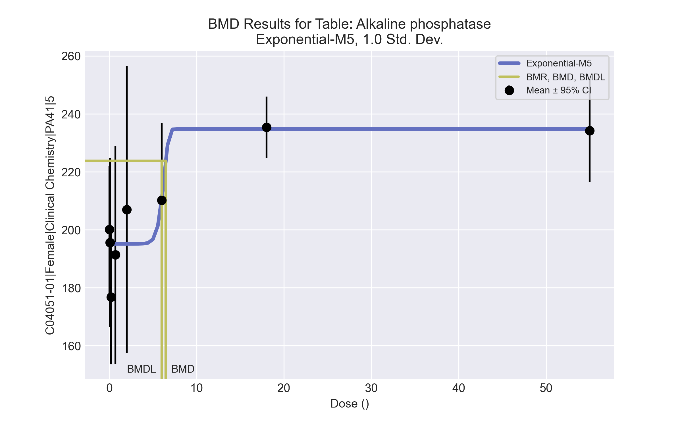
====================================================================
Exponential Model. (Version: 1.11; Date: 03/14/2017)
Input Data File: C:\Windows\TEMP\bmds-0ltil4st.(d)
Gnuplot Plotting File:
Tue Apr 13 10:13:49 2021
====================================================================
BMDS_Model_Run
~~~~~~~~~~~~~~~~~~~~~~~~~~~~~~~~~~~~~~~~~~~~~~~~~~~~~~~~~~~~~~~~~~~~~
The form of the response function by Model:
Model 2: Y[dose] = a * exp{sign * b * dose}
Model 3: Y[dose] = a * exp{sign * (b * dose)^d}
Model 4: Y[dose] = a * [c-(c-1) * exp{-b * dose}]
Model 5: Y[dose] = a * [c-(c-1) * exp{-(b * dose)^d}]
Note: Y[dose] is the median response for exposure = dose;
sign = +1 for increasing trend in data;
sign = -1 for decreasing trend.
Model 2 is nested within Models 3 and 4.
Model 3 is nested within Model 5.
Model 4 is nested within Model 5.
Dependent variable = Response
Independent variable = Dose
Data are assumed to be distributed: normally
Variance Model: exp(lnalpha +rho *ln(Y[dose]))
The variance is to be modeled as Var(i) = exp(lalpha + log(mean(i)) * rho)
Total number of dose groups = 8
Total number of records with missing values = 0
Maximum number of iterations = 500
Relative Function Convergence has been set to: 1e-008
Parameter Convergence has been set to: 1e-008
MLE solution provided: Exact
Initial Parameter Values
Variable Model 5
-------- --------
lnalpha 36.4636
rho -5.69819
a 167.96
b 0.0413236
c 1.4716
d 1
Parameter Estimates
Variable Model 5 Std. Err.
-------- ------- ---------
lnalpha 63.7762 17.7129
rho -10.8197 3.31142
a 195.166 5.12577
b 0.157739 1.31378
c 1.20308 0.0361518
d 13.4456 2034.01
NC = No Convergence
Table of Stats From Input Data
Dose N Obs Mean Obs Std Dev
----- --- ---------- -------------
0 10 200.1 30.54
0.07 5 195.6 23.51
0.2 5 176.8 18.66
0.7 5 191.4 30.3
2 5 207 39.88
6 5 210.2 21.49
18 5 235.4 8.562
55 5 234.2 14.31
Estimated Values of Interest
Dose Est Mean Est Std Scaled Residual
------ ---------- --------- ----------------
0 195.2 28.72 0.5433
0.07 195.2 28.72 0.03377
0.2 195.2 28.72 -1.43
0.7 195.2 28.72 -0.2933
2 195.2 28.72 0.9215
6 210.2 19.22 -0.0001639
18 234.8 10.56 0.127
55 234.8 10.56 -0.127
Other models for which likelihoods are calculated:
Model A1: Yij = Mu(i) + e(ij)
Var{e(ij)} = Sigma^2
Model A2: Yij = Mu(i) + e(ij)
Var{e(ij)} = Sigma(i)^2
Model A3: Yij = Mu(i) + e(ij)
Var{e(ij)} = exp(lalpha + log(mean(i)) * rho)
Model R: Yij = Mu + e(i)
Var{e(ij)} = Sigma^2
Likelihoods of Interest
Model Log(likelihood) DF AIC
------- ----------------- ---- ------------
A1 -164.6947 9 347.3894
A2 -157.543 16 347.0859
A3 -161.0383 10 342.0766
R -175.0473 2 354.0946
5 -161.5758 6 335.1516
Additive constant for all log-likelihoods = -41.35. This constant added to the
above values gives the log-likelihood including the term that does not
depend on the model parameters.
Explanation of Tests
Test 1: Does response and/or variances differ among Dose levels? (A2 vs. R)
Test 2: Are Variances Homogeneous? (A2 vs. A1)
Test 3: Are variances adequately modeled? (A2 vs. A3)
Test 7a: Does Model 5 fit the data? (A3 vs 5)
Tests of Interest
Test -2*log(Likelihood Ratio) D. F. p-value
-------- ------------------------ ------ --------------
Test 1 35.01 14 0.001466
Test 2 14.3 7 0.04604
Test 3 6.991 6 0.3217
Test 7a 1.075 4 0.8982
The p-value for Test 1 is less than .05. There appears to be a
difference between response and/or variances among the dose
levels, it seems appropriate to model the data.
The p-value for Test 2 is less than .1. A non-homogeneous
variance model appears to be appropriate.
The p-value for Test 3 is greater than .1. The modeled
variance appears to be appropriate here.
The p-value for Test 7a is greater than .1. Model 5 seems
to adequately describe the data.
Benchmark Dose Computations:
Specified Effect = 1.000000
Risk Type = Estimated standard deviations from control
Confidence Level = 0.950000
BMD = 6.46054
BMDL = 6.00322
BMDU = 17.1972

Female BMD Results for Table: Aspartate Aminotransferase
BMDS version: BMDS v2.7.0

Input dataset
Dose | 0 | 0.07 | 0.2 | 0.7 | 2 | 6 | 18 | 55 | 160 | 475
N | 10 | 5 | 5 | 5 | 5 | 5 | 5 | 5 | 5 | 5
Mean ± SD | 78.5 ± 6.721 | 81.4 ± 9.423 | 79.4 ± 5.03 | 84 ± 12.41 | 80.8 ± 3.701 | 75.8 ± 3.421 | 77.4 ± 3.715 | 92.8 ± 7.362 | 89.2 ± 7.05 | 82.6 ± 1.342

Summary table
Modelª | Goodness of fit |  | BMD | BMDL | Comments
 | p-value | AIC
Linear | 3.6E-04 | 283.894 | 6660.19 | -999 | No model was recommended as a best-fitting model. Doses were dropped until there were only 3 remaining dose-groups.
Polynomial 2° | 0.005 | 277.056 | 1840.29 | -999
Polynomial 3° | 0.008 | 275.786 | 1062.94 | 675.398
Polynomial 4° | 0.009 | 275.524 | 852.057 | -999
Polynomial 5° | 0.009 | 275.455 | 754.827 | -999
Polynomial 6° | 0.009 | 275.434 | 697.795 | 563.69
Polynomial 7° | 0.009 | 275.427 | 660.307 | 550.015
Polynomial 8° | 0.009 | 275.425 | 633.605 | 540.01
Power | 0.009 | 275.423 | 539.857 | 502.863
Hill | 0.008 | 276.102 | 33.025 | -999
Exponential M2 | 3.6E-04 | 283.869 | 5806.98 | 778.106
Exponential M3 | 0.005 | 277.423 | 545.73 | -999
Exponential M4 | 9.7E-04 | 281.575 | 77.756 | 21.971
Exponential M5 | 0.004 | 278.102 | 47.443 | 19.051
ª Modeled variance case presented (BMDS Test 2 p-value = 0.001, BMDS Test 3 p-value = 0.009).

Model recommendation details
Model | Bin | Notes
Linear | Failure | Failures  • BMDL does not exist  Warnings  • Variance model poorly fits dataset (p-value 3 = 0.008704)  • Goodness of fit p-value is less than threshold (0.000357 < 0.1)  • BMD/high dose ratio is greater than threshold (14.0 > 1.0)  Cautions  • Warning(s): THE MODEL HAS PROBABLY NOT CONVERGED!!!; THIS USUALLY MEANS THE MODEL HAS NOT CONVERGED!; BMDL computation failed.
Polynomial 2° | Failure | Failures  • BMDL does not exist  Warnings  • Variance model poorly fits dataset (p-value 3 = 0.008704)  • Goodness of fit p-value is less than threshold (0.00517 < 0.1)  • BMD/high dose ratio is greater than threshold (3.87 > 1.0)  Cautions  • Warning(s): BMDL computation failed.
Polynomial 3° | Warning | Warnings  • Variance model poorly fits dataset (p-value 3 = 0.008704)  • Goodness of fit p-value is less than threshold (0.00829 < 0.1)  • BMD/high dose ratio is greater than threshold (2.24 > 1.0)  Cautions  • BMDL/high dose ratio is greater than threshold (1.42 > 1.0)
Polynomial 4° | Failure | Failures  • BMDL does not exist  Warnings  • Variance model poorly fits dataset (p-value 3 = 0.008704)  • Goodness of fit p-value is less than threshold (0.00914 < 0.1)  • BMD/high dose ratio is greater than threshold (1.79 > 1.0)  Cautions  • Warning(s): BMDL computation failed.
Polynomial 5° | Failure | Failures  • BMDL does not exist  Warnings  • Variance model poorly fits dataset (p-value 3 = 0.008704)  • Goodness of fit p-value is less than threshold (0.00937 < 0.1)  • BMD/high dose ratio is greater than threshold (1.59 > 1.0)  Cautions  • Warning(s): BMDL computation failed.
Polynomial 6° | Warning | Warnings  • Variance model poorly fits dataset (p-value 3 = 0.008704)  • Goodness of fit p-value is less than threshold (0.00944 < 0.1)  • BMD/high dose ratio is greater than threshold (1.47 > 1.0)  Cautions  • BMDL/high dose ratio is greater than threshold (1.19 > 1.0)
Polynomial 7° | Warning | Warnings  • Variance model poorly fits dataset (p-value 3 = 0.008704)  • Goodness of fit p-value is less than threshold (0.00947 < 0.1)  • BMD/high dose ratio is greater than threshold (1.39 > 1.0)  Cautions  • BMDL/high dose ratio is greater than threshold (1.16 > 1.0)
Polynomial 8° | Warning | Warnings  • Variance model poorly fits dataset (p-value 3 = 0.008704)  • Goodness of fit p-value is less than threshold (0.00948 < 0.1)  • BMD/high dose ratio is greater than threshold (1.33 > 1.0)  Cautions  • BMDL/high dose ratio is greater than threshold (1.14 > 1.0)
Power | Warning | Warnings  • Variance model poorly fits dataset (p-value 3 = 0.008704)  • Goodness of fit p-value is less than threshold (0.00948 < 0.1)  • BMD/high dose ratio is greater than threshold (1.14 > 1.0)  Cautions  • BMDL/high dose ratio is greater than threshold (1.06 > 1.0)
Hill | Failure | Failures  • BMDL does not exist  Warnings  • Variance model poorly fits dataset (p-value 3 = 0.008704)  • Goodness of fit p-value is less than threshold (0.00846 < 0.1)  Cautions  • Warning(s): BMDL computation failed.
Exponential M2 | Warning | Warnings  • Variance model poorly fits dataset (p-value 3 = 0.008704)  • Goodness of fit p-value is less than threshold (0.000361 < 0.1)  • BMD/high dose ratio is greater than threshold (12.2 > 1.0)  Cautions  • BMD/BMDL ratio is greater than threshold (7.46 > 5.0)  • BMDL/high dose ratio is greater than threshold (1.64 > 1.0)
Exponential M3 | Failure | Failures  • BMDL does not exist  Warnings  • Variance model poorly fits dataset (p-value 3 = 0.008704)  • Goodness of fit p-value is less than threshold (0.00508 < 0.1)  • BMD/high dose ratio is greater than threshold (1.15 > 1.0)
Exponential M4 | Warning | Warnings  • Variance model poorly fits dataset (p-value 3 = 0.008704)  • Goodness of fit p-value is less than threshold (0.000974 < 0.1)  • Residual of interest is greater than threshold (2.23 > 2.0)
Exponential M5 | Warning | Warnings  • Variance model poorly fits dataset (p-value 3 = 0.008704)  • Goodness of fit p-value is less than threshold (0.00431 < 0.1)

Recommended model
No model was recommended as a best-fitting model.

Female BMD Results for Table: Glucose
BMDS version: BMDS v2.7.0

Input dataset
Dose | 0 | 0.07 | 0.2 | 0.7 | 2 | 6 | 18 | 55 | 160 | 475
N | 10 | 5 | 5 | 5 | 5 | 5 | 5 | 5 | 5 | 5
Mean ± SD | 235.2 ± 46.576 | 218.6 ± 57.134 | 239.4 ± 33.65 | 236.8 ± 17.225 | 215.6 ± 19.139 | 211 ± 4.743 | 197 ± 38.743 | 199.6 ± 23.628 | 227.4 ± 49.339 | 203 ± 30.34

Summary table
Modelª | Goodness of fit |  | BMD | BMDL | Comments
 | p-value | AIC
Linear | 0.031 | 457.709 | 927.045 | 375.599 | No model was recommended as a best-fitting model. Doses were dropped until there were only 3 remaining dose-groups.
Polynomial 2° | 0.032 | 457.579 | 673.88 | 435.437
Polynomial 3° | 0.034 | 457.445 | 598.808 | 439.463
Polynomial 4° | 0.034 | 457.394 | 564.81 | 392.883
Polynomial 5° | 0.034 | 457.377 | 545.497 | 456.504
Polynomial 6° | <0.0001 | 985.106 | -9999 | -999
Polynomial 7° | 0.035 | 457.368 | 524.322 | 456.627
Polynomial 8° | <0.0001 | 974.903 | 17.024 | -999
Power | 0.035 | 457.367 | 493.603 | 394.444
Hill | 0.218 | 452.278 | -999 | -999
Exponential M2 (equivalent models include Exponential M4) | 0.031 | 457.718 | 973.459 | 366.05
Exponential M3 | 0.02 | 459.367 | 500.726 | 387.169
Exponential M5 | 0.018 | 459.718 | 973.46 | 366.05
ª Modeled variance case presented (BMDS Test 2 p-value = 4.6E-04, BMDS Test 3 p-value = 0.006).

Model recommendation details
Model | Bin | Notes
Linear | Warning | Warnings  • Variance model poorly fits dataset (p-value 3 = 0.00578)  • Goodness of fit p-value is less than threshold (0.0307 < 0.1)  • BMD/high dose ratio is greater than threshold (1.95 > 1.0)
Polynomial 2° | Warning | Warnings  • Variance model poorly fits dataset (p-value 3 = 0.00578)  • Goodness of fit p-value is less than threshold (0.0321 < 0.1)  • BMD/high dose ratio is greater than threshold (1.42 > 1.0)
Polynomial 3° | Warning | Warnings  • Variance model poorly fits dataset (p-value 3 = 0.00578)  • Goodness of fit p-value is less than threshold (0.0336 < 0.1)  • BMD/high dose ratio is greater than threshold (1.26 > 1.0)
Polynomial 4° | Warning | Warnings  • Variance model poorly fits dataset (p-value 3 = 0.00578)  • Goodness of fit p-value is less than threshold (0.0342 < 0.1)  • BMD/high dose ratio is greater than threshold (1.19 > 1.0)
Polynomial 5° | Warning | Warnings  • Variance model poorly fits dataset (p-value 3 = 0.00578)  • Goodness of fit p-value is less than threshold (0.0344 < 0.1)  • BMD/high dose ratio is greater than threshold (1.15 > 1.0)
Polynomial 6° | Failure | Failures  • BMDL does not exist  Warnings  • Residual of Interest does not exist  • Variance model poorly fits dataset (p-value 3 = 0.00578)  • Residual at lowest dose is greater than threshold (3.56 > 2.0)  • Ratio of modeled to actual stdev. at control is greater than threshold (7.27 > 1.5)  Cautions  • Warning(s): THIS USUALLY MEANS THE MODEL HAS NOT CONVERGED!; BMD = 100*(maximum dose); BMDL computation failed.
Polynomial 7° | Warning | Warnings  • Variance model poorly fits dataset (p-value 3 = 0.00578)  • Goodness of fit p-value is less than threshold (0.0345 < 0.1)  • BMD/high dose ratio is greater than threshold (1.1 > 1.0)
Polynomial 8° | Failure | Failures  • BMDL does not exist  Warnings  • Variance model poorly fits dataset (p-value 3 = 0.00578)  • Residual of interest is greater than threshold (2.36 > 2.0)  • Residual at lowest dose is greater than threshold (2.87 > 2.0)  • Ratio of modeled to actual stdev. at control is greater than threshold (9.03 > 1.5)  Cautions  • Warning(s): THIS USUALLY MEANS THE MODEL HAS NOT CONVERGED!; BMDL computation failed.
Power | Warning | Warnings  • Variance model poorly fits dataset (p-value 3 = 0.00578)  • Goodness of fit p-value is less than threshold (0.0345 < 0.1)  • BMD/high dose ratio is greater than threshold (1.04 > 1.0)
Hill | Failure | Failures  • BMD does not exist  • BMDL does not exist  Warnings  • Residual of Interest does not exist  • Variance model poorly fits dataset (p-value 3 = 0.00578)  Cautions  • Warning(s): BMR value is not in the range of the mean function
Exponential M2 (equivalent models include Exponential M4) | Warning | Warnings  • Variance model poorly fits dataset (p-value 3 = 0.00578)  • Goodness of fit p-value is less than threshold (0.0306 < 0.1)  • BMD/high dose ratio is greater than threshold (2.05 > 1.0)
Exponential M3 | Warning | Warnings  • Variance model poorly fits dataset (p-value 3 = 0.00578)  • Goodness of fit p-value is less than threshold (0.0201 < 0.1)  • BMD/high dose ratio is greater than threshold (1.05 > 1.0)
Exponential M5 | Warning | Warnings  • Variance model poorly fits dataset (p-value 3 = 0.00578)  • Goodness of fit p-value is less than threshold (0.0177 < 0.1)  • BMD/high dose ratio is greater than threshold (2.05 > 1.0)

Recommended model
No model was recommended as a best-fitting model.

Female BMD Results for Table: Sorbitol dehydrogenase
BMDS version: BMDS v2.7.0

Input dataset
Dose | 0 | 0.07 | 0.2 | 0.7 | 2 | 6 | 18 | 55 | 160 | 475
N | 10 | 5 | 5 | 5 | 5 | 5 | 5 | 5 | 5 | 5
Mean ± SD | 12.89 ± 2.868 | 17.28 ± 1.365 | 16.46 ± 0.658 | 15.2 ± 3.588 | 16.04 ± 0.832 | 14.54 ± 0.873 | 15.42 ± 1.862 | 19.04 ± 5.224 | 15.72 ± 1.91 | 19.12 ± 5.803

Summary table
Modelª | Goodness of fit |  | BMD | BMDL | Comments
 | p-value | AIC
Linear (equivalent models include Power, Polynomial 2°, 4°, 6°, 8°) | 0.008 | 186.209 | 317.692 | 150.172 | No model was recommended as a best-fitting model. Doses were dropped until there were only 3 remaining dose-groups.
Polynomial 3° (equivalent models include Polynomial 5°, 7°) | 0.008 | 186.209 | 317.693 | 150.172
Hill | 0.044 | 181.871 | 34.488 | -999
Exponential M2 (equivalent models include Exponential M3) | 0.007 | 186.351 | 338.03 | 176.472
Exponential M4 | <0.0001 | 199 | -999 | 0
Exponential M5 | <0.0001 | 199 | -999 | 0
ª Modeled variance case presented (BMDS Test 2 p-value = <0.0001, BMDS Test 3 p-value = <0.0001).

Model recommendation details
Model | Bin | Notes
Linear (equivalent models include Power, Polynomial 2°, 4°, 6°, 8°) | Warning | Warnings  • Variance model poorly fits dataset (p-value 3 = 0.0001)  • Goodness of fit p-value is less than threshold (0.00771 < 0.1)  • Residual at lowest dose is greater than threshold (2.73 > 2.0)
Polynomial 3° (equivalent models include Polynomial 5°, 7°) | Warning | Warnings  • Variance model poorly fits dataset (p-value 3 = 0.0001)  • Goodness of fit p-value is less than threshold (0.00771 < 0.1)  • Residual at lowest dose is greater than threshold (2.73 > 2.0)
Hill | Failure | Failures  • BMDL does not exist  Warnings  • Variance model poorly fits dataset (p-value 3 = 0.0001)  • Goodness of fit p-value is less than threshold (0.0436 < 0.1)  • Residual at lowest dose is greater than threshold (2.82 > 2.0)  Cautions  • Warning(s): BMDL computation failed.
Exponential M2 (equivalent models include Exponential M3) | Warning | Warnings  • Variance model poorly fits dataset (p-value 3 = 0.0001)  • Goodness of fit p-value is less than threshold (0.00732 < 0.1)  • Residual at lowest dose is greater than threshold (2.75 > 2.0)
Exponential M4 | Failure | Failures  • BMD does not exist  Warnings  • Residual of Interest does not exist  • Variance model poorly fits dataset (p-value 3 = 0.0001)  • Residual at lowest dose is greater than threshold (2.79 > 2.0)
Exponential M5 | Failure | Failures  • BMD does not exist  Warnings  • Residual of Interest does not exist  • Variance model poorly fits dataset (p-value 3 = 0.0001)  • Residual at lowest dose is greater than threshold (2.79 > 2.0)

Recommended model
No model was recommended as a best-fitting model.

Female BMD Results for Table: Urea Nitrogen
BMDS version: BMDS v2.7.0

Input dataset
Dose | 0 | 0.07 | 0.2 | 0.7 | 2 | 6 | 18 | 55 | 160 | 475
N | 10 | 5 | 5 | 5 | 5 | 5 | 5 | 5 | 5 | 5
Mean ± SD | 16.6 ± 2.171 | 16.4 ± 1.14 | 15.2 ± 1.789 | 17.6 ± 2.074 | 16.6 ± 2.302 | 16.6 ± 0.548 | 15.6 ± 2.302 | 15.4 ± 1.517 | 14.6 ± 2.191 | 14.2 ± 1.789

Summary table
Modelª | Goodness of fit |  | BMD | BMDL | Comments
 | p-value | AIC
Linear (equivalent models include Power, Polynomial 2°, 3°, 4°, 5°, 7°, 8°) | 0.455 | 128.33 | 356.879 | 223.463 | Exponential-M5 recommended as best-fitting model on the basis of the lowest BMDL.
Polynomial 6° | 0.455 | 128.33 | 356.878 | 223.463
Hill | 0.521 | 129.728 | 124.016 | -999
Exponential M2 (equivalent models include Exponential M3) | 0.471 | 128.172 | 342.811 | 205.439
Exponential M4 (equivalent models include Exponential M5) | 0.63 | 127.797 | 118.445 | 20.385
ª Constant variance case presented (BMDS Test 2 p-value = 0.2, BMDS Test 3 p-value = 0.2).

Model recommendation details
Model | Bin | Notes
Linear (equivalent models include Power, Polynomial 2°, 3°, 4°, 5°, 7°, 8°) | Valid | -
Polynomial 6° | Valid | -
Hill | Failure | Failures  • BMDL does not exist  Cautions  • Warning(s): BMDL computation failed.
Exponential M2 (equivalent models include Exponential M3) | Valid | -
Exponential M4 (equivalent models include Exponential M5) | Valid | Cautions  • BMD/BMDL ratio is greater than threshold (5.81 > 5.0)

Recommended model
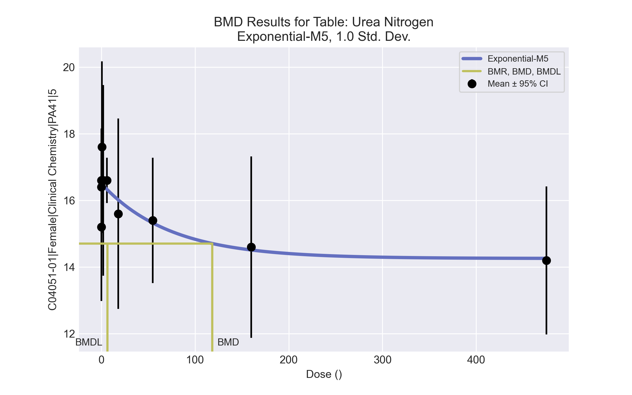
====================================================================
Exponential Model. (Version: 1.11; Date: 03/14/2017)
Input Data File: C:\Windows\TEMP\bmds-kwfe2f6q.(d)
Gnuplot Plotting File:
Tue Apr 13 10:15:53 2021
====================================================================
BMDS_Model_Run
~~~~~~~~~~~~~~~~~~~~~~~~~~~~~~~~~~~~~~~~~~~~~~~~~~~~~~~~~~~~~~~~~~~~~
The form of the response function by Model:
Model 2: Y[dose] = a * exp{sign * b * dose}
Model 3: Y[dose] = a * exp{sign * (b * dose)^d}
Model 4: Y[dose] = a * [c-(c-1) * exp{-b * dose}]
Model 5: Y[dose] = a * [c-(c-1) * exp{-(b * dose)^d}]
Note: Y[dose] is the median response for exposure = dose;
sign = +1 for increasing trend in data;
sign = -1 for decreasing trend.
Model 2 is nested within Models 3 and 4.
Model 3 is nested within Model 5.
Model 4 is nested within Model 5.
Dependent variable = Response
Independent variable = Dose
Data are assumed to be distributed: normally
Variance Model: exp(lnalpha +rho *ln(Y[dose]))
rho is set to 0.
A constant variance model is fit.
Total number of dose groups = 10
Total number of records with missing values = 0
Maximum number of iterations = 500
Relative Function Convergence has been set to: 1e-008
Parameter Convergence has been set to: 1e-008
MLE solution provided: Exact
Initial Parameter Values
Variable Model 5
-------- --------
lnalpha 1.08273
rho 0 Specified
a 18.48
b 0.00496362
c 0.731808
d 1
Parameter Estimates
Variable Model 5 Std. Err.
-------- ------- ---------
lnalpha 1.17812 0.619419
a 16.5078 0.316054
b 0.0136288 0.015932
c 0.863691 0.0478851
d 1 NA
NC = No Convergence
Table of Stats From Input Data
Dose N Obs Mean Obs Std Dev
----- --- ---------- -------------
0 10 16.6 2.171
0.07 5 16.4 1.14
0.2 5 15.2 1.789
0.7 5 17.6 2.074
2 5 16.6 2.302
6 5 16.6 0.5477
18 5 15.6 2.302
55 5 15.4 1.517
160 5 14.6 2.191
475 5 14.2 1.789
Estimated Values of Interest
Dose Est Mean Est Std Scaled Residual
------ ---------- --------- ----------------
0 16.51 1.802 0.1618
0.07 16.51 1.802 -0.1311
0.2 16.5 1.802 -1.615
0.7 16.49 1.802 1.382
2 16.45 1.802 0.1895
6 16.33 1.802 0.3336
18 16.02 1.802 -0.519
55 15.32 1.802 0.09804
160 14.51 1.802 0.1094
475 14.26 1.802 -0.07583
Other models for which likelihoods are calculated:
Model A1: Yij = Mu(i) + e(ij)
Var{e(ij)} = Sigma^2
Model A2: Yij = Mu(i) + e(ij)
Var{e(ij)} = Sigma(i)^2
Model A3: Yij = Mu(i) + e(ij)
Var{e(ij)} = exp(lalpha + log(mean(i)) * rho)
Model R: Yij = Mu + e(i)
Var{e(ij)} = Sigma^2
Likelihoods of Interest
Model Log(likelihood) DF AIC
------- ----------------- ---- ------------
A1 -57.27505 11 136.5501
A2 -51.1527 20 142.3054
A3 -57.27505 11 136.5501
R -64.96994 2 133.9399
5 -59.8983 4 127.7966
Additive constant for all log-likelihoods = -50.54. This constant added to the
above values gives the log-likelihood including the term that does not
depend on the model parameters.
Explanation of Tests
Test 1: Does response and/or variances differ among Dose levels? (A2 vs. R)
Test 2: Are Variances Homogeneous? (A2 vs. A1)
Test 3: Are variances adequately modeled? (A2 vs. A3)
Test 7a: Does Model 5 fit the data? (A3 vs 5)
Tests of Interest
Test -2*log(Likelihood Ratio) D. F. p-value
-------- ------------------------ ------ --------------
Test 1 27.63 18 0.06784
Test 2 12.24 9 0.1999
Test 3 12.24 9 0.1999
Test 7a 5.246 7 0.6299
The p-value for Test 1 is greater than .05. There may not be a
diffence between responses and/or variances among the dose levels
Modelling the data with a dose/response curve may not be appropriate.
The p-value for Test 2 is greater than .1. A homogeneous
variance model appears to be appropriate here.
The p-value for Test 3 is greater than .1. The modeled
variance appears to be appropriate here.
The p-value for Test 7a is greater than .1. Model 5 seems
to adequately describe the data.
Benchmark Dose Computations:
Specified Effect = 1.000000
Risk Type = Estimated standard deviations from control
Confidence Level = 0.950000
BMD = 118.445
BMDL = 6.61309
BMDU = 4.75e+006

Female BMD Results for Table: Hematocrit
BMDS version: BMDS v2.7.0

Input dataset
Dose | 0 | 0.07 | 0.2 | 0.7 | 2 | 6 | 18 | 55 | 160 | 475
N | 10 | 5 | 5 | 4 | 4 | 5 | 5 | 5 | 5 | 5
Mean ± SD | 45.01 ± 2.443 | 46.94 ± 1.942 | 45.64 ± 1.534 | 45.8 ± 2.754 | 45.05 ± 2.024 | 44.12 ± 1.472 | 44.12 ± 2.383 | 44.52 ± 1.764 | 45.18 ± 1.415 | 43.96 ± 0.783

Summary table
Modelª | Goodness of fit |  | BMD | BMDL | Comments
 | p-value | AIC
Linear | 0.289 | 128.806 | -9999 | 1277.4 | No model was recommended as a best-fitting model. Doses were dropped until there were only 3 remaining dose-groups.
Polynomial 2° | 0.289 | 128.806 | -9999 | 764.731
Polynomial 3° | 0.289 | 128.806 | -9999 | 653.425
Polynomial 4° | 0.289 | 128.806 | -9999 | 607.874
Polynomial 5° | 0.289 | 128.806 | -9999 | -999
Polynomial 6° | 0.289 | 128.806 | -9999 | 557.511
Polynomial 7° | 0.289 | 128.806 | -9999 | -999
Polynomial 8° | 0.289 | 128.806 | -9999 | -999
Power | 0.337 | 129.059 | 761.911 | 339.436
Hill | 0.516 | 129.223 | -999 | -999
Exponential M2 | 0.274 | 129.88 | -682.586 | -999
Exponential M3 | 0.274 | 129.88 | -682.586 | -999
Exponential M4 | 0.147 | 132.806 | -999 | 0
Exponential M5 | 0.095 | 134.806 | -999 | 0
ª Constant variance case presented (BMDS Test 2 p-value = 0.32, BMDS Test 3 p-value = 0.32).

Model recommendation details
Model | Bin | Notes
Linear | Warning | Warnings  • Residual of Interest does not exist  Cautions  • Warning(s): BMD = 100*(maximum dose)  • BMDL/high dose ratio is greater than threshold (2.69 > 1.0)
Polynomial 2° | Warning | Warnings  • Residual of Interest does not exist  Cautions  • Warning(s): BMD = 100*(maximum dose)  • BMDL/high dose ratio is greater than threshold (1.61 > 1.0)
Polynomial 3° | Warning | Warnings  • Residual of Interest does not exist  Cautions  • Warning(s): BMD = 100*(maximum dose)  • BMDL/high dose ratio is greater than threshold (1.38 > 1.0)
Polynomial 4° | Warning | Warnings  • Residual of Interest does not exist  Cautions  • Warning(s): BMD = 100*(maximum dose)  • BMDL/high dose ratio is greater than threshold (1.28 > 1.0)
Polynomial 5° | Failure | Failures  • BMDL does not exist  Warnings  • Residual of Interest does not exist  Cautions  • Warning(s): BMD = 100*(maximum dose); BMDL computation failed.
Polynomial 6° | Warning | Warnings  • Residual of Interest does not exist  Cautions  • Warning(s): BMD = 100*(maximum dose)  • BMDL/high dose ratio is greater than threshold (1.17 > 1.0)
Polynomial 7° | Failure | Failures  • BMDL does not exist  Warnings  • Residual of Interest does not exist  Cautions  • Warning(s): BMD = 100*(maximum dose); BMDL computation failed.
Polynomial 8° | Failure | Failures  • BMDL does not exist  Warnings  • Residual of Interest does not exist  Cautions  • Warning(s): BMD = 100*(maximum dose); BMDL computation failed.
Power | Warning | Warnings  • BMD/high dose ratio is greater than threshold (1.6 > 1.0)
Hill | Failure | Failures  • BMD does not exist  • BMDL does not exist  Warnings  • Residual of Interest does not exist  Cautions  • Warning(s): BMR value is not in the range of the mean function
Exponential M2 | Failure | Failures  • BMDL does not exist  Warnings  • Residual of Interest does not exist
Exponential M3 | Failure | Failures  • BMDL does not exist  Warnings  • Residual of Interest does not exist
Exponential M4 | Failure | Failures  • BMD does not exist  Warnings  • Residual of Interest does not exist
Exponential M5 | Failure | Failures  • BMD does not exist  Warnings  • Residual of Interest does not exist  • Goodness of fit p-value is less than threshold (0.0946 < 0.1)

Recommended model
No model was recommended as a best-fitting model.

Female BMD Results for Table: Hemoglobin
BMDS version: BMDS v2.7.0

Input dataset
Dose | 0 | 0.07 | 0.2 | 0.7 | 2 | 6 | 18 | 55 | 160 | 475
N | 10 | 5 | 5 | 4 | 4 | 5 | 5 | 5 | 5 | 5
Mean ± SD | 13.58 ± 0.811 | 14.28 ± 0.589 | 13.74 ± 0.65 | 13.875 ± 0.709 | 13.825 ± 0.709 | 13.34 ± 0.594 | 13.38 ± 0.726 | 13.46 ± 0.513 | 13.52 ± 0.415 | 13.36 ± 0.336

Summary table
Modelª | Goodness of fit |  | BMD | BMDL | Comments
 | p-value | AIC
Linear | 0.31 | 9.459 | -9999 | 1211.24 | No model was recommended as a best-fitting model. Doses were dropped until there were only 3 remaining dose-groups.
Polynomial 2° | 0.31 | 9.459 | -9999 | 721.906
Polynomial 3° | 0.31 | 9.459 | -9999 | 624.265
Polynomial 4° | 0.31 | 9.459 | -9999 | 582.404
Polynomial 5° | 0.31 | 9.459 | -9999 | -999
Polynomial 6° | 0.31 | 9.459 | -9999 | -999
Polynomial 7° | 0.31 | 9.459 | -9999 | 534.059
Polynomial 8° | 0.31 | 9.459 | -9999 | -999
Power | 0.338 | 9.998 | 834.356 | 353.376
Hill | 0.648 | 8.042 | -999 | -999
Exponential M2 | 0.274 | 10.814 | -750.061 | -999
Exponential M3 | 0.274 | 10.814 | -750.061 | -999
Exponential M4 | 0.161 | 13.459 | -999 | 0
Exponential M5 | 0.104 | 15.459 | -999 | 0
ª Constant variance case presented (BMDS Test 2 p-value = 0.617, BMDS Test 3 p-value = 0.617).

Model recommendation details
Model | Bin | Notes
Linear | Warning | Warnings  • Residual of Interest does not exist  Cautions  • Warning(s): BMD = 100*(maximum dose)  • BMDL/high dose ratio is greater than threshold (2.55 > 1.0)
Polynomial 2° | Warning | Warnings  • Residual of Interest does not exist  Cautions  • Warning(s): BMD = 100*(maximum dose)  • BMDL/high dose ratio is greater than threshold (1.52 > 1.0)
Polynomial 3° | Warning | Warnings  • Residual of Interest does not exist  Cautions  • Warning(s): BMD = 100*(maximum dose)  • BMDL/high dose ratio is greater than threshold (1.31 > 1.0)
Polynomial 4° | Warning | Warnings  • Residual of Interest does not exist  Cautions  • Warning(s): BMD = 100*(maximum dose)  • BMDL/high dose ratio is greater than threshold (1.23 > 1.0)
Polynomial 5° | Failure | Failures  • BMDL does not exist  Warnings  • Residual of Interest does not exist  Cautions  • Warning(s): BMD = 100*(maximum dose); BMDL computation failed.
Polynomial 6° | Failure | Failures  • BMDL does not exist  Warnings  • Residual of Interest does not exist  Cautions  • Warning(s): BMD = 100*(maximum dose); BMDL computation failed.
Polynomial 7° | Warning | Warnings  • Residual of Interest does not exist  Cautions  • Warning(s): BMD = 100*(maximum dose)  • BMDL/high dose ratio is greater than threshold (1.12 > 1.0)
Polynomial 8° | Failure | Failures  • BMDL does not exist  Warnings  • Residual of Interest does not exist  Cautions  • Warning(s): BMD = 100*(maximum dose); BMDL computation failed.
Power | Warning | Warnings  • BMD/high dose ratio is greater than threshold (1.76 > 1.0)
Hill | Failure | Failures  • BMD does not exist  • BMDL does not exist  Warnings  • Residual of Interest does not exist  Cautions  • Warning(s): BMR value is not in the range of the mean function
Exponential M2 | Failure | Failures  • BMDL does not exist  Warnings  • Residual of Interest does not exist
Exponential M3 | Failure | Failures  • BMDL does not exist  Warnings  • Residual of Interest does not exist
Exponential M4 | Failure | Failures  • BMD does not exist  Warnings  • Residual of Interest does not exist
Exponential M5 | Failure | Failures  • BMD does not exist  Warnings  • Residual of Interest does not exist

Recommended model
No model was recommended as a best-fitting model.

Female BMD Results for Table: Large Unstained Cell count
BMDS version: BMDS v2.7.0

Input dataset
Dose | 0 | 0.07 | 0.2 | 0.7 | 2 | 6 | 18 | 55 | 160 | 475
N | 10 | 5 | 5 | 4 | 4 | 5 | 5 | 5 | 5 | 5
Mean ± SD | 0.04 ± 0.014 | 0.05 ± 0.014 | 0.036 ± 0.013 | 0.035 ± 0.01 | 0.042 ± 0.013 | 0.05 ± 0.019 | 0.04 ± 0.012 | 0.052 ± 0.015 | 0.064 ± 0.021 | 0.07 ± 0.045

Summary table
Modelª | Goodness of fit |  | BMD | BMDL | Comments
 | p-value | AIC
Linear (equivalent models include Polynomial 2°, 3°, 4°, 5°, 6°, 8°) | 0.427 | -377.651 | 157.679 | 87.184 | Hill recommended as best-fitting model on the basis of the lowest BMDL.
Polynomial 7° | <0.0001 | -350.94 | -9999 | -999
Power | <0.0001 | 1.9E+07 | 1 | -999
Hill^{b} | 0.152 | -372.312 | 58.894 | 25.959
Exponential M2 (equivalent models include Exponential M3) | 0.356 | -376.872 | 198.281 | 122.205
Exponential M4 (equivalent models include Exponential M5) | 0.368 | -376.106 | 120.138 | 43.813
ª Modeled variance case presented (BMDS Test 2 p-value = 0.007, BMDS Test 3 p-value = 0.947).
^{b} Recommended model

Model recommendation details
Model | Bin | Notes
Linear (equivalent models include Polynomial 2°, 3°, 4°, 5°, 6°, 8°) | Valid | -
Polynomial 7° | Failure | Failures  • BMDL does not exist  Warnings  • Residual of Interest does not exist  Cautions  • Warning(s): BMD = 100*(maximum dose); BMDL computation failed.
Power | Failure | Failures  • BMDL does not exist  Warnings  • Residual of Interest does not exist  • Residual at lowest dose is greater than threshold (nan > 2.0)  • Ratio of modeled to actual stdev. at control is greater than threshold (nan > 1.5)  Cautions  • Warning(s): THE MODEL HAS PROBABLY NOT CONVERGED!!!; THIS USUALLY MEANS THE MODEL HAS NOT CONVERGED!; BMDL computation failed.
Hillª | Valid | Cautions  • Warning(s): THE MODEL HAS PROBABLY NOT CONVERGED!!!; THIS USUALLY MEANS THE MODEL HAS NOT CONVERGED!
Exponential M2 (equivalent models include Exponential M3) | Valid | -
Exponential M4 (equivalent models include Exponential M5) | Valid | -
ª Recommended model

Recommended model
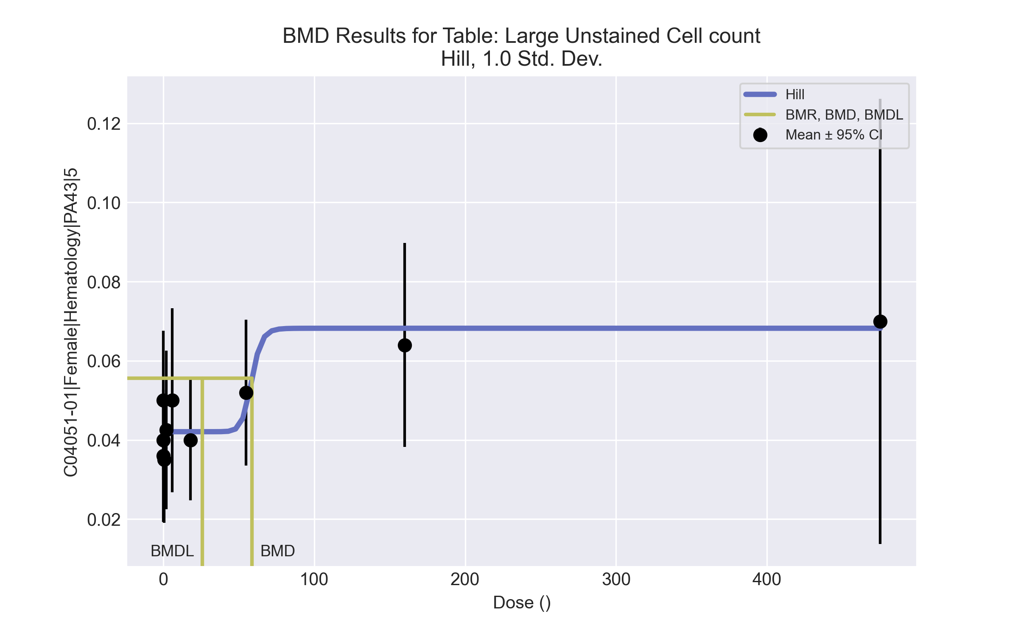
====================================================================
Hill Model. (Version: 2.18; Date: 03/14/2017)
Input Data File: C:\Windows\TEMP\bmds-xmqiqihu.(d)
Gnuplot Plotting File: C:\Windows\TEMP\bmds-xmqiqihu.plt
Tue Apr 13 11:21:18 2021
====================================================================
BMDS_Model_Run
~~~~~~~~~~~~~~~~~~~~~~~~~~~~~~~~~~~~~~~~~~~~~~~~~~~~~~~~~~~~~~~~~~~~~
The form of the response function is:
Y[dose] = intercept + v*dose^n/(k^n + dose^n)
Dependent variable = Response
Independent variable = Dose
Power parameter restricted to be greater than 1
The variance is to be modeled as Var(i) = exp(lalpha + rho * ln(mean(i)))
Total number of dose groups = 10
Total number of records with missing values = 0
Maximum number of iterations = 500
Relative Function Convergence has been set to: 1e-008
Parameter Convergence has been set to: 1e-008
Default Initial Parameter Values
lalpha = -7.84195
rho = 0
intercept = 0.04
v = 0.03
n = 18
k = 238.75
Asymptotic Correlation Matrix of Parameter Estimates
lalpha rho intercept v n k
lalpha 1 1 0.25 -0.7 NA NA
rho 1 1 0.29 -0.69 NA NA
intercept 0.25 0.29 1 -0.25 NA NA
v -0.7 -0.69 -0.25 1 NA NA
n NA NA NA NA NA NA
k NA NA NA NA NA NA
NA - This parameter's variance has been estimated as zero or less.
THE MODEL HAS PROBABLY NOT CONVERGED!!!
Parameter Estimates
95.0% Wald Confidence Interval
Variable Estimate Std. Err. Lower Conf. Limit Upper Conf. Limit
lalpha 2.23799 NA NA NA
rho 3.42354 NA NA NA
intercept 0.042089 NA NA NA
v 0.026123 NA NA NA
n 17.9707 NA NA NA
k 58.6658 NA NA NA
At least some variance estimates are negative.
THIS USUALLY MEANS THE MODEL HAS NOT CONVERGED!
Try again from another starting point.
Table of Data and Estimated Values of Interest
Dose N Obs Mean Est Mean Obs Std Dev Est Std Dev Scaled Res.
------ --- -------- -------- ----------- ----------- ----------
0 10 0.04 0.0421 0.0141 0.0135 -0.489
0.07 5 0.05 0.0421 0.0141 0.0135 1.31
0.2 5 0.036 0.0421 0.0134 0.0135 -1.01
0.7 4 0.035 0.0421 0.01 0.0135 -1.05
2 4 0.0425 0.0421 0.0126 0.0135 0.0608
6 5 0.05 0.0421 0.0187 0.0135 1.31
18 5 0.04 0.0421 0.0122 0.0135 -0.346
55 5 0.052 0.0483 0.0148 0.0171 0.48
160 5 0.064 0.0682 0.0207 0.0309 -0.305
475 5 0.07 0.0682 0.0453 0.0309 0.129
Model Descriptions for likelihoods calculated
Model A1: Yij = Mu(i) + e(ij)
Var{e(ij)} = Sigma^2
Model A2: Yij = Mu(i) + e(ij)
Var{e(ij)} = Sigma(i)^2
Model A3: Yij = Mu(i) + e(ij)
Var{e(ij)} = exp(lalpha + rho*ln(Mu(i)))
Model A3 uses any fixed variance parameters that
were specified by the user
Model R: Yi = Mu + e(i)
Var{e(i)} = Sigma^2
Likelihoods of Interest
Model Log(likelihood) # Param's AIC
A1 186.852718 11 -351.705435
A2 198.255920 20 -356.511841
A3 196.857705 12 -369.715409
fitted 192.155750 6 -372.311500
R 178.470094 2 -352.940188
Explanation of Tests
Test 1: Do responses and/or variances differ among Dose levels?
(A2 vs. R)
Test 2: Are Variances Homogeneous? (A1 vs A2)
Test 3: Are variances adequately modeled? (A2 vs. A3)
Test 4: Does the Model for the Mean Fit? (A3 vs. fitted)
(Note: When rho=0 the results of Test 3 and Test 2 will be the same.)
Tests of Interest
Test -2*log(Likelihood Ratio) Test df p-value
Test 1 39.5717 18 0.002386
Test 2 22.8064 9 0.006646
Test 3 2.79643 8 0.9465
Test 4 9.40391 6 0.1521
The p-value for Test 1 is less than .05. There appears to be a
difference between response and/or variances among the dose levels
It seems appropriate to model the data
The p-value for Test 2 is less than .1. A non-homogeneous variance
model appears to be appropriate
The p-value for Test 3 is greater than .1. The modeled variance appears
to be appropriate here
The p-value for Test 4 is greater than .1. The model chosen seems
to adequately describe the data
Benchmark Dose Computation
Specified effect = 1
Risk Type = Estimated standard deviations from the control mean
Confidence level = 0.95
BMD = 58.8938
BMDL = 25.9591
BMDU = 2.25625e+009

Female BMD Results for Table: Leukocyte Count
BMDS version: BMDS v2.7.0

Input dataset
Dose | 0 | 0.07 | 0.2 | 0.7 | 2 | 6 | 18 | 55 | 160 | 475
N | 10 | 5 | 5 | 4 | 4 | 5 | 5 | 5 | 5 | 5
Mean ± SD | 5.941 ± 1.323 | 7.708 ± 1.541 | 6.858 ± 2.263 | 6.33 ± 0.219 | 5.737 ± 0.615 | 7.538 ± 1.765 | 6.86 ± 1.822 | 7.234 ± 1.557 | 7.876 ± 2.117 | 7.558 ± 1.76

Summary table
Modelª | Goodness of fit |  | BMD | BMDL | Comments
 | p-value | AIC
Linear (equivalent models include Power, Polynomial 2°, 3°, 4°) | 0.043 | 110.721 | 630.723 | 250.584 | No model was recommended as a best-fitting model. Doses were dropped until there were only 3 remaining dose-groups.
Polynomial 5° (equivalent models include Polynomial 6°, 8°) | 0.043 | 110.721 | 630.724 | 250.584
Polynomial 7° | 0.043 | 110.721 | 630.726 | 250.584
Hill | 0.076 | 109.59 | -999 | -999
Exponential M2 (equivalent models include Exponential M3) | 0.042 | 110.805 | 637.403 | 277.005
Exponential M4 | 0.052 | 110.691 | -999 | 0
Exponential M5 | 0.052 | 110.691 | -999 | 0
ª Modeled variance case presented (BMDS Test 2 p-value = 0.019, BMDS Test 3 p-value = 0.093).

Model recommendation details
Model | Bin | Notes
Linear (equivalent models include Power, Polynomial 2°, 3°, 4°) | Warning | Warnings  • Variance model poorly fits dataset (p-value 3 = 0.09304)  • Goodness of fit p-value is less than threshold (0.0429 < 0.1)  • BMD/high dose ratio is greater than threshold (1.33 > 1.0)
Polynomial 5° (equivalent models include Polynomial 6°, 8°) | Warning | Warnings  • Variance model poorly fits dataset (p-value 3 = 0.09304)  • Goodness of fit p-value is less than threshold (0.0429 < 0.1)  • BMD/high dose ratio is greater than threshold (1.33 > 1.0)
Polynomial 7° | Warning | Warnings  • Variance model poorly fits dataset (p-value 3 = 0.09304)  • Goodness of fit p-value is less than threshold (0.0429 < 0.1)  • BMD/high dose ratio is greater than threshold (1.33 > 1.0)
Hill | Failure | Failures  • BMD does not exist  • BMDL does not exist  Warnings  • Residual of Interest does not exist  • Variance model poorly fits dataset (p-value 3 = 0.09304)  • Goodness of fit p-value is less than threshold (0.0762 < 0.1)  Cautions  • Warning(s): BMR value is not in the range of the mean function
Exponential M2 (equivalent models include Exponential M3) | Warning | Warnings  • Variance model poorly fits dataset (p-value 3 = 0.09304)  • Goodness of fit p-value is less than threshold (0.0417 < 0.1)  • BMD/high dose ratio is greater than threshold (1.34 > 1.0)
Exponential M4 | Failure | Failures  • BMD does not exist  Warnings  • Residual of Interest does not exist  • Variance model poorly fits dataset (p-value 3 = 0.09304)  • Goodness of fit p-value is less than threshold (0.0523 < 0.1)
Exponential M5 | Failure | Failures  • BMD does not exist  Warnings  • Residual of Interest does not exist  • Variance model poorly fits dataset (p-value 3 = 0.09304)  • Goodness of fit p-value is less than threshold (0.0523 < 0.1)

Recommended model
No model was recommended as a best-fitting model.

Female BMD Results for Table: Monocyte count
BMDS version: BMDS v2.7.0

Input dataset
Dose | 0 | 0.07 | 0.2 | 0.7 | 2 | 6 | 18 | 55 | 160 | 475
N | 10 | 5 | 5 | 4 | 4 | 5 | 5 | 5 | 5 | 5
Mean ± SD | 0.18 ± 0.068 | 0.196 ± 0.067 | 0.216 ± 0.105 | 0.17 ± 0.048 | 0.19 ± 0.076 | 0.288 ± 0.085 | 0.244 ± 0.067 | 0.278 ± 0.095 | 0.384 ± 0.159 | 0.302 ± 0.198

Summary table
Modelª | Goodness of fit |  | BMD | BMDL | Comments
 | p-value | AIC
Linear (equivalent models include Power, Polynomial 3°, 4°, 5°, 6°, 7°, 8°) | 0.058 | -189.138 | 133.546 | 68.109 | Hill recommended as best-fitting model on the basis of the lowest AIC.
Polynomial 2° | 0.058 | -189.138 | 133.545 | 68.109
Hill^{b} | 0.273 | -193.479 | 20.731 | 4.642
Exponential M2 (equivalent models include Exponential M3) | 0.023 | -186.474 | 204.747 | 112.137
Exponential M4 (equivalent models include Exponential M5) | 0.25 | -193.165 | 36.274 | 4.837
ª Modeled variance case presented (BMDS Test 2 p-value = 0.028, BMDS Test 3 p-value = 0.847).
^{b} Recommended model

Model recommendation details
Model | Bin | Notes
Linear (equivalent models include Power, Polynomial 3°, 4°, 5°, 6°, 7°, 8°) | Warning | Warnings  • Goodness of fit p-value is less than threshold (0.0578 < 0.1)
Polynomial 2° | Warning | Warnings  • Goodness of fit p-value is less than threshold (0.0578 < 0.1)
Hillª | Valid | -
Exponential M2 (equivalent models include Exponential M3) | Warning | Warnings  • Goodness of fit p-value is less than threshold (0.0233 < 0.1)
Exponential M4 (equivalent models include Exponential M5) | Valid | Cautions  • BMD/BMDL ratio is greater than threshold (7.5 > 5.0)
ª Recommended model

Recommended model
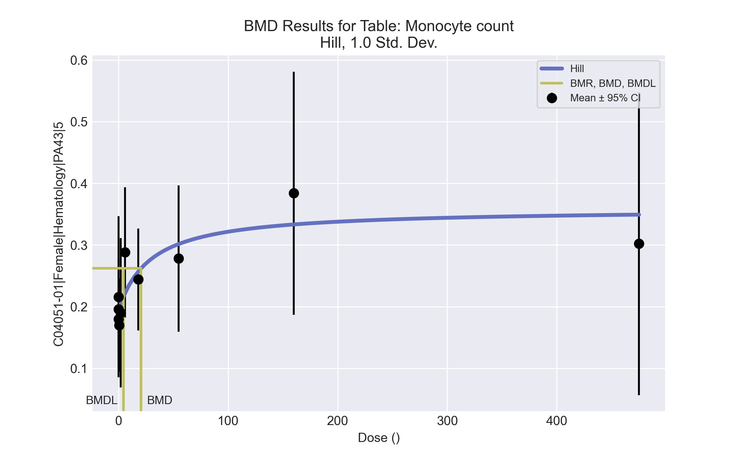
====================================================================
Hill Model. (Version: 2.18; Date: 03/14/2017)
Input Data File: C:\Windows\TEMP\bmds-og9sohbc.(d)
Gnuplot Plotting File: C:\Windows\TEMP\bmds-og9sohbc.plt
Tue Apr 13 11:22:26 2021
====================================================================
BMDS_Model_Run
~~~~~~~~~~~~~~~~~~~~~~~~~~~~~~~~~~~~~~~~~~~~~~~~~~~~~~~~~~~~~~~~~~~~~
The form of the response function is:
Y[dose] = intercept + v*dose^n/(k^n + dose^n)
Dependent variable = Response
Independent variable = Dose
Power parameter restricted to be greater than 1
The variance is to be modeled as Var(i) = exp(lalpha + rho * ln(mean(i)))
Total number of dose groups = 10
Total number of records with missing values = 0
Maximum number of iterations = 500
Relative Function Convergence has been set to: 1e-008
Parameter Convergence has been set to: 1e-008
Default Initial Parameter Values
lalpha = -4.52066
rho = 0
intercept = 0.18
v = 0.204
n = 0.527466
k = 6.2449
Asymptotic Correlation Matrix of Parameter Estimates
( *** The model parameter(s) -n
have been estimated at a boundary point, or have been specified by the user,
and do not appear in the correlation matrix )
lalpha rho intercept v k
lalpha 1 0.99 0.28 -0.41 0.061
rho 0.99 1 0.34 -0.39 0.068
intercept 0.28 0.34 1 0.074 0.57
v -0.41 -0.39 0.074 1 0.65
k 0.061 0.068 0.57 0.65 1
Parameter Estimates
95.0% Wald Confidence Interval
Variable Estimate Std. Err. Lower Conf. Limit Upper Conf. Limit
lalpha -0.939548 1.49958 -3.87867 1.99957
rho 2.69453 1.01469 0.705771 4.68329
intercept 0.193736 0.0155845 0.163191 0.224281
v 0.164954 0.0609344 0.0455244 0.284383
n 1 NA
k 29.1947 42.4017 -53.9111 112.3
NA - Indicates that this parameter has hit a bound
implied by some inequality constraint and thus
has no standard error.
Table of Data and Estimated Values of Interest
Dose N Obs Mean Est Mean Obs Std Dev Est Std Dev Scaled Res.
------ --- -------- -------- ----------- ----------- ----------
0 10 0.18 0.194 0.0682 0.0685 -0.634
0.07 5 0.196 0.194 0.0666 0.0687 0.0609
0.2 5 0.216 0.195 0.105 0.069 0.685
0.7 4 0.17 0.198 0.0476 0.0703 -0.785
2 4 0.19 0.204 0.0762 0.0736 -0.389
6 5 0.288 0.222 0.085 0.0822 1.8
18 5 0.244 0.257 0.0666 0.1 -0.283
55 5 0.278 0.301 0.0955 0.124 -0.423
160 5 0.384 0.333 0.159 0.142 0.798
475 5 0.302 0.349 0.198 0.151 -0.696
Model Descriptions for likelihoods calculated
Model A1: Yij = Mu(i) + e(ij)
Var{e(ij)} = Sigma^2
Model A2: Yij = Mu(i) + e(ij)
Var{e(ij)} = Sigma(i)^2
Model A3: Yij = Mu(i) + e(ij)
Var{e(ij)} = exp(lalpha + rho*ln(Mu(i)))
Model A3 uses any fixed variance parameters that
were specified by the user
Model R: Yi = Mu + e(i)
Var{e(i)} = Sigma^2
Likelihoods of Interest
Model Log(likelihood) # Param's AIC
A1 98.838321 11 -175.676642
A2 108.158831 20 -176.317661
A3 106.102926 12 -188.205853
fitted 101.739445 5 -193.478890
R 88.633134 2 -173.266268
Explanation of Tests
Test 1: Do responses and/or variances differ among Dose levels?
(A2 vs. R)
Test 2: Are Variances Homogeneous? (A1 vs A2)
Test 3: Are variances adequately modeled? (A2 vs. A3)
Test 4: Does the Model for the Mean Fit? (A3 vs. fitted)
(Note: When rho=0 the results of Test 3 and Test 2 will be the same.)
Tests of Interest
Test -2*log(Likelihood Ratio) Test df p-value
Test 1 39.0514 18 0.002805
Test 2 18.641 9 0.02842
Test 3 4.11181 8 0.8469
Test 4 8.72696 7 0.2729
The p-value for Test 1 is less than .05. There appears to be a
difference between response and/or variances among the dose levels
It seems appropriate to model the data
The p-value for Test 2 is less than .1. A non-homogeneous variance
model appears to be appropriate
The p-value for Test 3 is greater than .1. The modeled variance appears
to be appropriate here
The p-value for Test 4 is greater than .1. The model chosen seems
to adequately describe the data
Benchmark Dose Computation
Specified effect = 1
Risk Type = Estimated standard deviations from the control mean
Confidence level = 0.95
BMD = 20.7313
BMDL = 4.64196
BMDU = 128.137

Female BMD Results for Table: Neutrophil Count
BMDS version: BMDS v2.7.0

Input dataset
Dose | 0 | 0.07 | 0.2 | 0.7 | 2 | 6 | 18 | 55 | 160 | 475
N | 10 | 5 | 5 | 4 | 4 | 5 | 5 | 5 | 5 | 5
Mean ± SD | 0.419 ± 0.083 | 0.526 ± 0.066 | 0.616 ± 0.14 | 0.492 ± 0.067 | 0.525 ± 0.152 | 0.57 ± 0.202 | 0.534 ± 0.181 | 0.614 ± 0.108 | 0.604 ± 0.278 | 0.718 ± 0.251

Summary table
Modelª | Goodness of fit |  | BMD | BMDL | Comments
 | p-value | AIC
Linear (equivalent models include Power, Polynomial 2°, 5°, 7°, 8°) | 0.02 | -139.094 | 265.284 | 129.413 | Hill recommended as best-fitting model on the basis of the lowest AIC.
Polynomial 3° (equivalent models include Polynomial 4°, 6°) | 0.02 | -139.094 | 265.283 | 129.413
Hill^{b} | 0.134 | -144.212 | 0.071 | 0.013
Exponential M2 (equivalent models include Exponential M3) | 0.017 | -138.623 | 302.453 | 165.474
Exponential M4 | 0.026 | -139.385 | 98.068 | 0.239
Exponential M5 | 0.026 | -139.385 | 98.069 | 2.0E-04
ª Modeled variance case presented (BMDS Test 2 p-value = 0.006, BMDS Test 3 p-value = 0.414).
^{b} Recommended model

Model recommendation details
Model | Bin | Notes
Linear (equivalent models include Power, Polynomial 2°, 5°, 7°, 8°) | Warning | Warnings  • Goodness of fit p-value is less than threshold (0.0196 < 0.1)  • Residual at lowest dose is greater than threshold (2.28 > 2.0)  • Ratio of modeled to actual stdev. at control is greater than threshold (1.64 > 1.5)
Polynomial 3° (equivalent models include Polynomial 4°, 6°) | Warning | Warnings  • Goodness of fit p-value is less than threshold (0.0196 < 0.1)  • Residual at lowest dose is greater than threshold (2.28 > 2.0)  • Ratio of modeled to actual stdev. at control is greater than threshold (1.64 > 1.5)
Hillª | Valid | Cautions  • BMD/BMDL ratio is greater than threshold (5.43 > 5.0)
Exponential M2 (equivalent models include Exponential M3) | Warning | Warnings  • Goodness of fit p-value is less than threshold (0.0166 < 0.1)  • Residual at lowest dose is greater than threshold (2.31 > 2.0)
Exponential M4 | Warning | Warnings  • Goodness of fit p-value is less than threshold (0.0257 < 0.1)  • BMD/BMDL ratio is greater than threshold (4.11e+02 > 20.0)  • Residual at lowest dose is greater than threshold (2.17 > 2.0)  Cautions  • BMD/BMDL ratio is greater than threshold (4.11e+02 > 5.0)
Exponential M5 | Warning | Warnings  • Goodness of fit p-value is less than threshold (0.0257 < 0.1)  • BMD/BMDL ratio is greater than threshold (4.8e+05 > 20.0)  • Residual at lowest dose is greater than threshold (2.17 > 2.0)  Cautions  • BMD/BMDL ratio is greater than threshold (4.8e+05 > 5.0)
ª Recommended model

Recommended model
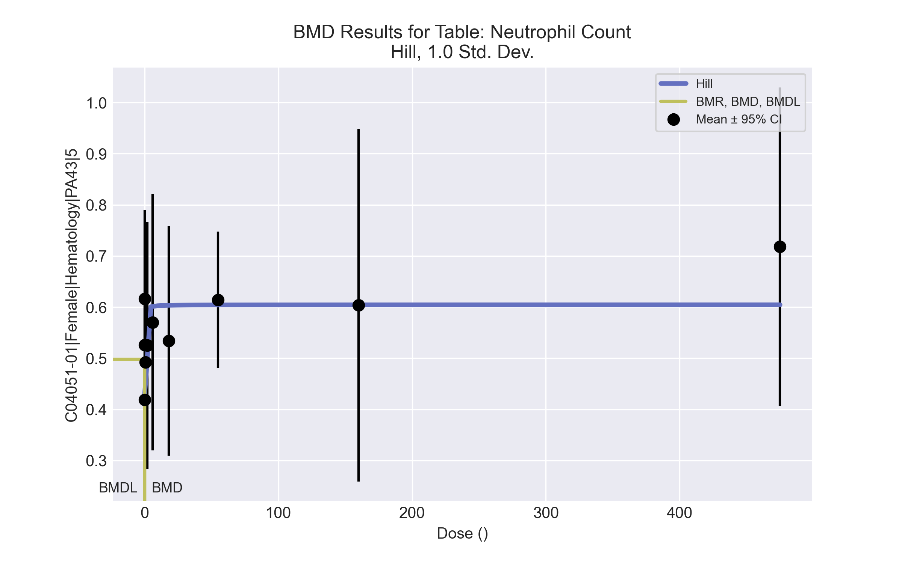
====================================================================
Hill Model. (Version: 2.18; Date: 03/14/2017)
Input Data File: C:\Windows\TEMP\bmds-7z9n551h.(d)
Gnuplot Plotting File: C:\Windows\TEMP\bmds-7z9n551h.plt
Tue Apr 13 11:22:31 2021
====================================================================
BMDS_Model_Run
~~~~~~~~~~~~~~~~~~~~~~~~~~~~~~~~~~~~~~~~~~~~~~~~~~~~~~~~~~~~~~~~~~~~~
The form of the response function is:
Y[dose] = intercept + v*dose^n/(k^n + dose^n)
Dependent variable = Response
Independent variable = Dose
Power parameter restricted to be greater than 1
The variance is to be modeled as Var(i) = exp(lalpha + rho * ln(mean(i)))
Total number of dose groups = 10
Total number of records with missing values = 0
Maximum number of iterations = 500
Relative Function Convergence has been set to: 1e-008
Parameter Convergence has been set to: 1e-008
Default Initial Parameter Values
lalpha = -3.62899
rho = 0
intercept = 0.419
v = 0.299
n = 0.0793903
k = 0.268611
Asymptotic Correlation Matrix of Parameter Estimates
( *** The model parameter(s) -n
have been estimated at a boundary point, or have been specified by the user,
and do not appear in the correlation matrix )
lalpha rho intercept v k
lalpha 1 0.97 0.37 -0.65 0.042
rho 0.97 1 0.46 -0.59 0.062
intercept 0.37 0.46 1 -0.59 0.33
v -0.65 -0.59 -0.59 1 0.073
k 0.042 0.062 0.33 0.073 1
Parameter Estimates
95.0% Wald Confidence Interval
Variable Estimate Std. Err. Lower Conf. Limit Upper Conf. Limit
lalpha -0.686358 1.11452 -2.87077 1.49805
rho 5.34583 1.71058 1.99315 8.69851
intercept 0.425528 0.0233968 0.379671 0.471385
v 0.178941 0.0394247 0.10167 0.256212
n 1 NA
k 0.104564 0.0771162 -0.0465806 0.255709
NA - Indicates that this parameter has hit a bound
implied by some inequality constraint and thus
has no standard error.
Table of Data and Estimated Values of Interest
Dose N Obs Mean Est Mean Obs Std Dev Est Std Dev Scaled Res.
------ --- -------- -------- ----------- ----------- ----------
0 10 0.419 0.426 0.0831 0.0723 -0.286
0.07 5 0.526 0.497 0.0662 0.11 0.586
0.2 5 0.616 0.543 0.14 0.139 1.18
0.7 4 0.492 0.581 0.0665 0.166 -1.07
2 4 0.525 0.596 0.152 0.178 -0.795
6 5 0.57 0.601 0.202 0.182 -0.385
18 5 0.534 0.603 0.181 0.184 -0.844
55 5 0.614 0.604 0.108 0.184 0.12
160 5 0.604 0.604 0.278 0.185 -0.00427
475 5 0.718 0.604 0.251 0.185 1.37
Model Descriptions for likelihoods calculated
Model A1: Yij = Mu(i) + e(ij)
Var{e(ij)} = Sigma^2
Model A2: Yij = Mu(i) + e(ij)
Var{e(ij)} = Sigma(i)^2
Model A3: Yij = Mu(i) + e(ij)
Var{e(ij)} = exp(lalpha + rho*ln(Mu(i)))
Model A3 uses any fixed variance parameters that
were specified by the user
Model R: Yi = Mu + e(i)
Var{e(i)} = Sigma^2
Likelihoods of Interest
Model Log(likelihood) # Param's AIC
A1 75.209227 11 -128.418453
A2 86.758026 20 -133.516051
A3 82.659540 12 -141.319080
fitted 77.106192 5 -144.212384
R 67.394809 2 -130.789618
Explanation of Tests
Test 1: Do responses and/or variances differ among Dose levels?
(A2 vs. R)
Test 2: Are Variances Homogeneous? (A1 vs A2)
Test 3: Are variances adequately modeled? (A2 vs. A3)
Test 4: Does the Model for the Mean Fit? (A3 vs. fitted)
(Note: When rho=0 the results of Test 3 and Test 2 will be the same.)
Tests of Interest
Test -2*log(Likelihood Ratio) Test df p-value
Test 1 38.7264 18 0.003101
Test 2 23.0976 9 0.005981
Test 3 8.19697 8 0.4145
Test 4 11.1067 7 0.134
The p-value for Test 1 is less than .05. There appears to be a
difference between response and/or variances among the dose levels
It seems appropriate to model the data
The p-value for Test 2 is less than .1. A non-homogeneous variance
model appears to be appropriate
The p-value for Test 3 is greater than .1. The modeled variance appears
to be appropriate here
The p-value for Test 4 is greater than .1. The model chosen seems
to adequately describe the data
Benchmark Dose Computation
Specified effect = 1
Risk Type = Estimated standard deviations from the control mean
Confidence level = 0.95
BMD = 0.0708856
BMDL = 0.0130537
BMDU computation failed.

Female BMD Results for Table: Platelet count
BMDS version: BMDS v2.7.0

Input dataset
Dose | 0 | 0.07 | 0.2 | 0.7 | 2 | 6 | 18 | 55ª | 160ª | 475ª
N | 10 | 5 | 5 | 4 | 4 | 5 | 5 | 5 | 5 | 5
Mean ± SD | 1041.2 ± 116.812 | 1067.2 ± 115.912 | 996.6 ± 76.356 | 970.5 ± 52.221 | 996.5 ± 37.811 | 965.6 ± 63.528 | 925.6 ± 69.694 | 1011.2 ± 47.061 | 916.4 ± 76.291 | 823.4 ± 122.382
ª Dose group removed in BMD modeling session

Summary table
Modelª | Goodness of fit |  | BMD | BMDL | Comments
 | p-value | AIC
Linear (equivalent models include Power, Polynomial 2°, 3°, 4°, 5°, 6°, 7°) | 0.121 | 382.182 | 16.536 | 9.974 | Exponential-M2 recommended as best-fitting model on the basis of the lowest AIC.
Polynomial 8° | <0.0001 | 872.478 | 0.308 | -999
Hill | 0.674 | 379.013 | -999 | -999
Exponential M2^{b} (equivalent models include Exponential M3) | 0.126 | 382.085 | 16.335 | 9.571
Exponential M4 | 0.66 | 377.89 | -999 | 0
Exponential M5 | 0.674 | 379.013 | -999 | 0
ª Modeled variance case presented (BMDS Test 2 p-value = 0.094, BMDS Test 3 p-value = 0.474).
^{b} Recommended model

Model recommendation details
Model | Bin | Notes
Linear (equivalent models include Power, Polynomial 2°, 3°, 4°, 5°, 6°, 7°) | Valid | -
Polynomial 8° | Failure | Failures  • BMDL does not exist  Warnings  • Ratio of modeled to actual stdev. at control is greater than threshold (3.13 > 1.5)  Cautions  • Warning(s): THIS USUALLY MEANS THE MODEL HAS NOT CONVERGED!; BMDL computation failed.
Hill | Failure | Failures  • BMD does not exist  • BMDL does not exist  Warnings  • Residual of Interest does not exist  Cautions  • Warning(s): BMR value is not in the range of the mean function
Exponential M2ª (equivalent models include Exponential M3) | Valid | -
Exponential M4 | Failure | Failures  • BMD does not exist  Warnings  • Residual of Interest does not exist
Exponential M5 | Failure | Failures  • BMD does not exist  Warnings  • Residual of Interest does not exist
ª Recommended model

Recommended model
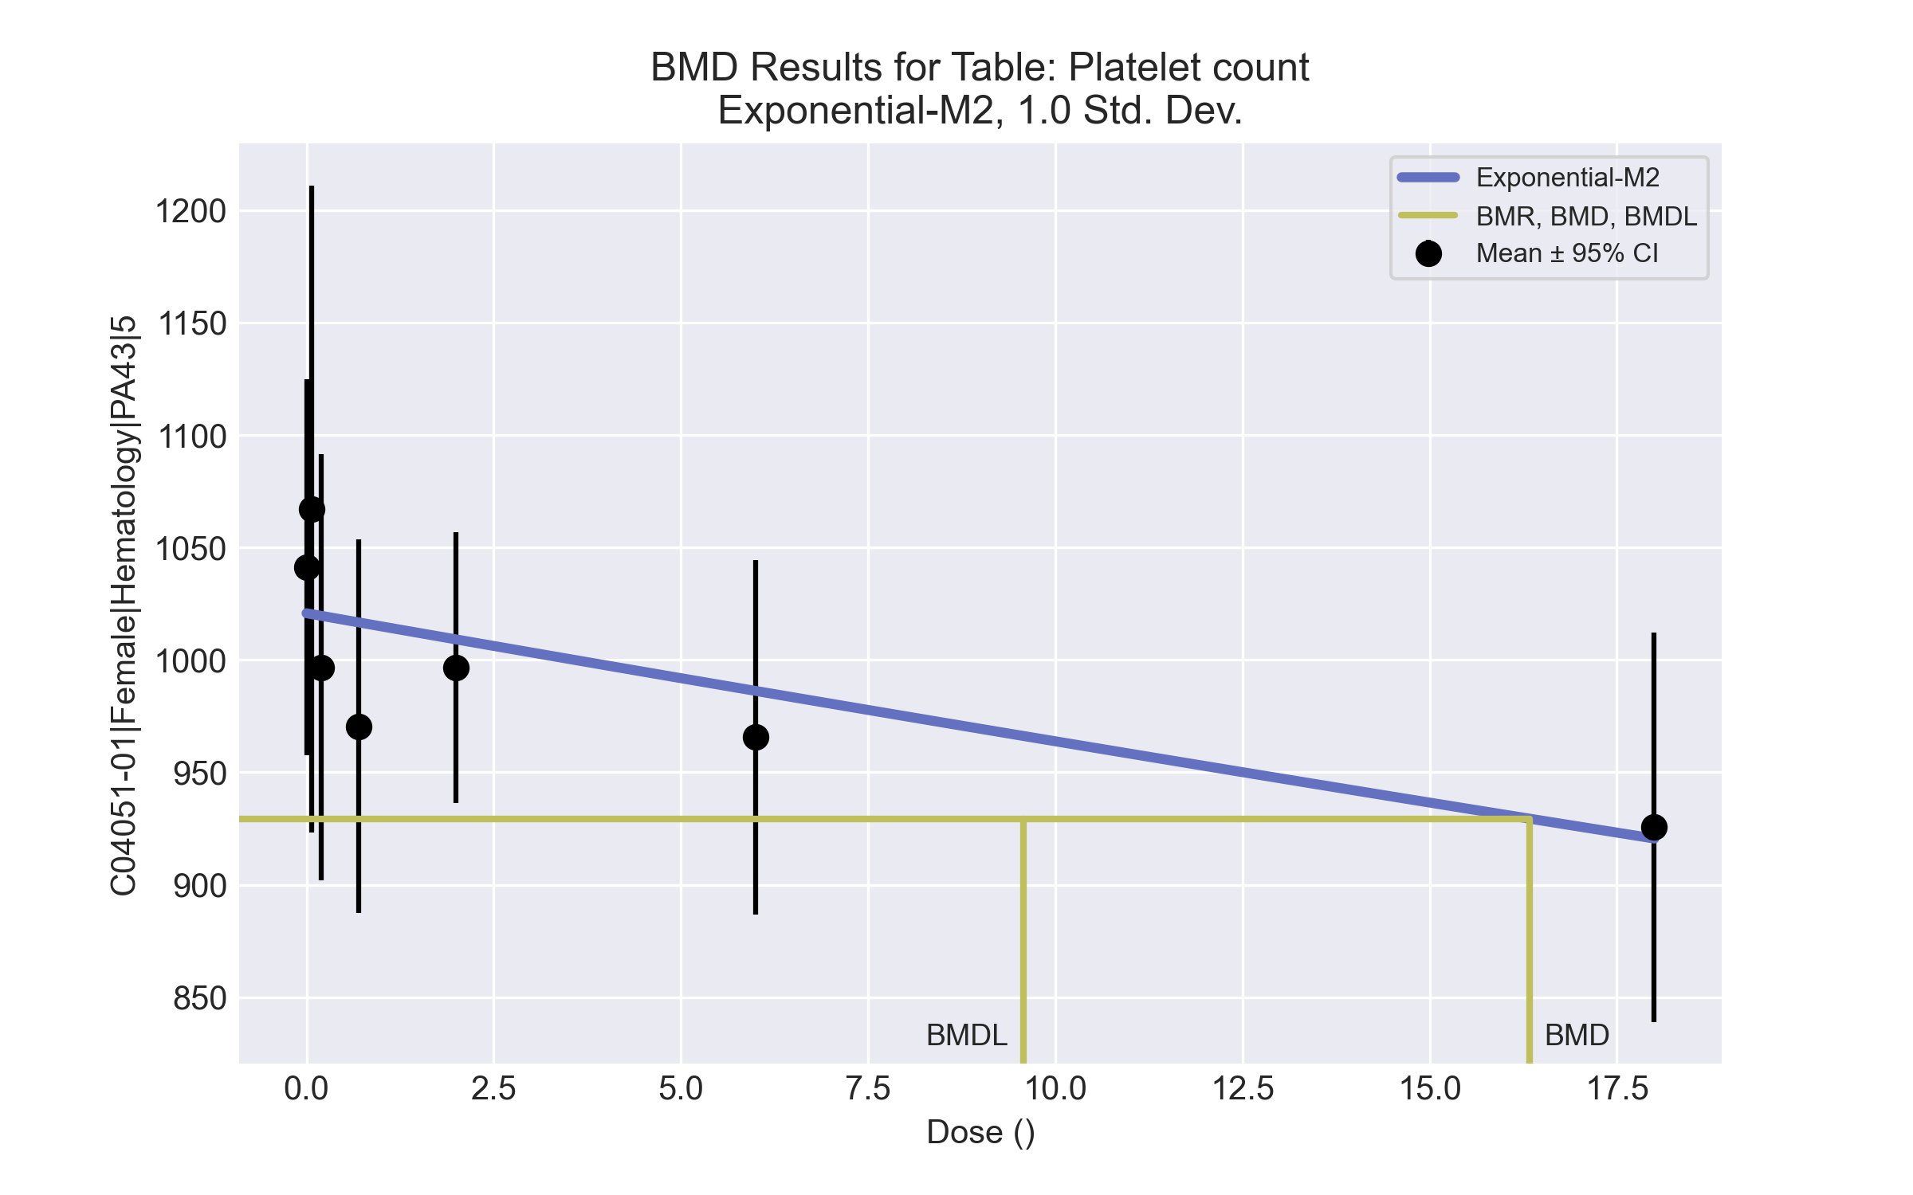
====================================================================
Exponential Model. (Version: 1.11; Date: 03/14/2017)
Input Data File: C:\Windows\TEMP\bmds-p_ty5kab.(d)
Gnuplot Plotting File:
Tue Apr 13 11:22:57 2021
====================================================================
BMDS_Model_Run
~~~~~~~~~~~~~~~~~~~~~~~~~~~~~~~~~~~~~~~~~~~~~~~~~~~~~~~~~~~~~~~~~~~~~
The form of the response function by Model:
Model 2: Y[dose] = a * exp{sign * b * dose}
Model 3: Y[dose] = a * exp{sign * (b * dose)^d}
Model 4: Y[dose] = a * [c-(c-1) * exp{-b * dose}]
Model 5: Y[dose] = a * [c-(c-1) * exp{-(b * dose)^d}]
Note: Y[dose] is the median response for exposure = dose;
sign = +1 for increasing trend in data;
sign = -1 for decreasing trend.
Model 2 is nested within Models 3 and 4.
Model 3 is nested within Model 5.
Model 4 is nested within Model 5.
Dependent variable = Response
Independent variable = Dose
Data are assumed to be distributed: normally
Variance Model: exp(lnalpha +rho *ln(Y[dose]))
The variance is to be modeled as Var(i) = exp(lalpha + log(mean(i)) * rho)
Total number of dose groups = 7
Total number of records with missing values = 0
Maximum number of iterations = 500
Relative Function Convergence has been set to: 1e-008
Parameter Convergence has been set to: 1e-008
MLE solution provided: Exact
Initial Parameter Values
Variable Model 2
-------- --------
lnalpha -60.3714
rho 9.98261
a 979.759
b 0.00600486
c 0 Specified
d 1 Specified
Parameter Estimates
Variable Model 2 Std. Err.
-------- ------- ---------
lnalpha -55.3411 48.9507
rho 9.29103 7.08797
a 1020.75 16.7812
b 0.00574065 0.00182515
NC = No Convergence
Table of Stats From Input Data
Dose N Obs Mean Obs Std Dev
----- --- ---------- -------------
0 10 1041 116.8
0.07 5 1067 115.9
0.2 5 996.6 76.36
0.7 4 970.5 52.22
2 4 996.5 37.81
6 5 965.6 63.53
18 5 925.6 69.69
Estimated Values of Interest
Dose Est Mean Est Std Scaled Residual
------ ---------- --------- ----------------
0 1021 91.37 0.7079
0.07 1020 91.2 1.149
0.2 1020 90.88 -0.5653
0.7 1017 89.68 -1.029
2 1009 86.62 -0.2908
6 986.2 77.86 -0.5913
18 920.5 56.54 0.2002
Other models for which likelihoods are calculated:
Model A1: Yij = Mu(i) + e(ij)
Var{e(ij)} = Sigma^2
Model A2: Yij = Mu(i) + e(ij)
Var{e(ij)} = Sigma(i)^2
Model A3: Yij = Mu(i) + e(ij)
Var{e(ij)} = exp(lalpha + log(mean(i)) * rho)
Model R: Yij = Mu + e(i)
Var{e(ij)} = Sigma^2
Likelihoods of Interest
Model Log(likelihood) DF AIC
------- ----------------- ---- ------------
A1 -185.8816 8 387.7632
A2 -180.4682 14 388.9365
A3 -182.7387 9 383.4775
R -191.0006 2 386.0012
2 -187.0425 4 382.0849
Additive constant for all log-likelihoods = -34.92. This constant added to the
above values gives the log-likelihood including the term that does not
depend on the model parameters.
Explanation of Tests
Test 1: Does response and/or variances differ among Dose levels? (A2 vs. R)
Test 2: Are Variances Homogeneous? (A2 vs. A1)
Test 3: Are variances adequately modeled? (A2 vs. A3)
Test 4: Does Model 2 fit the data? (A3 vs. 2)
Tests of Interest
Test -2*log(Likelihood Ratio) D. F. p-value
-------- ------------------------ ------ --------------
Test 1 21.06 12 0.04944
Test 2 10.83 6 0.09388
Test 3 4.541 5 0.4744
Test 4 8.607 5 0.1258
The p-value for Test 1 is less than .05. There appears to be a
difference between response and/or variances among the dose
levels, it seems appropriate to model the data.
The p-value for Test 2 is less than .1. A non-homogeneous
variance model appears to be appropriate.
The p-value for Test 3 is greater than .1. The modeled
variance appears to be appropriate here.
The p-value for Test 4 is greater than .1. Model 2 seems
to adequately describe the data.
Benchmark Dose Computations:
Specified Effect = 1.000000
Risk Type = Estimated standard deviations from control
Confidence Level = 0.950000
BMD = 16.3353
BMDL = 9.5714
BMDU = 37.2712

Female BMD Results for Table: Reticulocyte count
BMDS version: BMDS v2.7.0

Input dataset
Dose | 0 | 0.07 | 0.2 | 0.7 | 2 | 6 | 18 | 55 | 160ª | 475ª
N | 10 | 5 | 5 | 4 | 4 | 5 | 5 | 5 | 5 | 5
Mean ± SD | 223.21 ± 39.358 | 243.74 ± 50.624 | 225.06 ± 28.057 | 211.225 ± 34.914 | 218.4 ± 32.006 | 207.94 ± 18.031 | 223.48 ± 40.939 | 182.22 ± 11.666 | 192.8 ± 24.218 | 201.64 ± 17.641
ª Dose group removed in BMD modeling session

Summary table
Modelª | Goodness of fit |  | BMD | BMDL | Comments
 | p-value | AIC
Linear | 0.144 | 345.871 | 47.868 | 33.921 | Power recommended as best-fitting model on the basis of the lowest AIC.
Polynomial 2° | 0.226 | 344.467 | 51.226 | 37.518
Polynomial 3° | 0.161 | 346.223 | 52.096 | 38.382
Polynomial 4° | 0.165 | 346.142 | 52.678 | 38.698
Polynomial 5° | 0.167 | 346.115 | 53.084 | 38.806
Polynomial 6° | 0.167 | 346.106 | 53.375 | 38.841
Polynomial 7° | 0.167 | 346.103 | 53.591 | 38.853
Polynomial 8° | 0.168 | 346.102 | 53.758 | 38.857
Power^{b} | 0.244 | 344.214 | 54.561 | 38.414
Hill | 0.095 | 348.214 | 52.406 | -999
Exponential M2 (equivalent models include Exponential M4) | 0.129 | 346.195 | 47.612 | 32.226
Exponential M3 | 0.161 | 346.214 | 54.354 | 38.408
Exponential M5 | 0.095 | 348.214 | 52.114 | 19.53
ª Modeled variance case presented (BMDS Test 2 p-value = 0.077, BMDS Test 3 p-value = 0.964).
^{b} Recommended model

Model recommendation details
Model | Bin | Notes
Linear | Valid | -
Polynomial 2° | Valid | -
Polynomial 3° | Valid | -
Polynomial 4° | Valid | -
Polynomial 5° | Valid | -
Polynomial 6° | Valid | -
Polynomial 7° | Valid | -
Polynomial 8° | Valid | -
Powerª | Valid | -
Hill | Failure | Failures  • BMDL does not exist  Warnings  • Goodness of fit p-value is less than threshold (0.0948 < 0.1)  Cautions  • Warning(s): BMDL computation failed.
Exponential M2 (equivalent models include Exponential M4) | Valid | -
Exponential M3 | Valid | -
Exponential M5 | Warning | Warnings  • Goodness of fit p-value is less than threshold (0.0948 < 0.1)
ª Recommended model

Recommended model
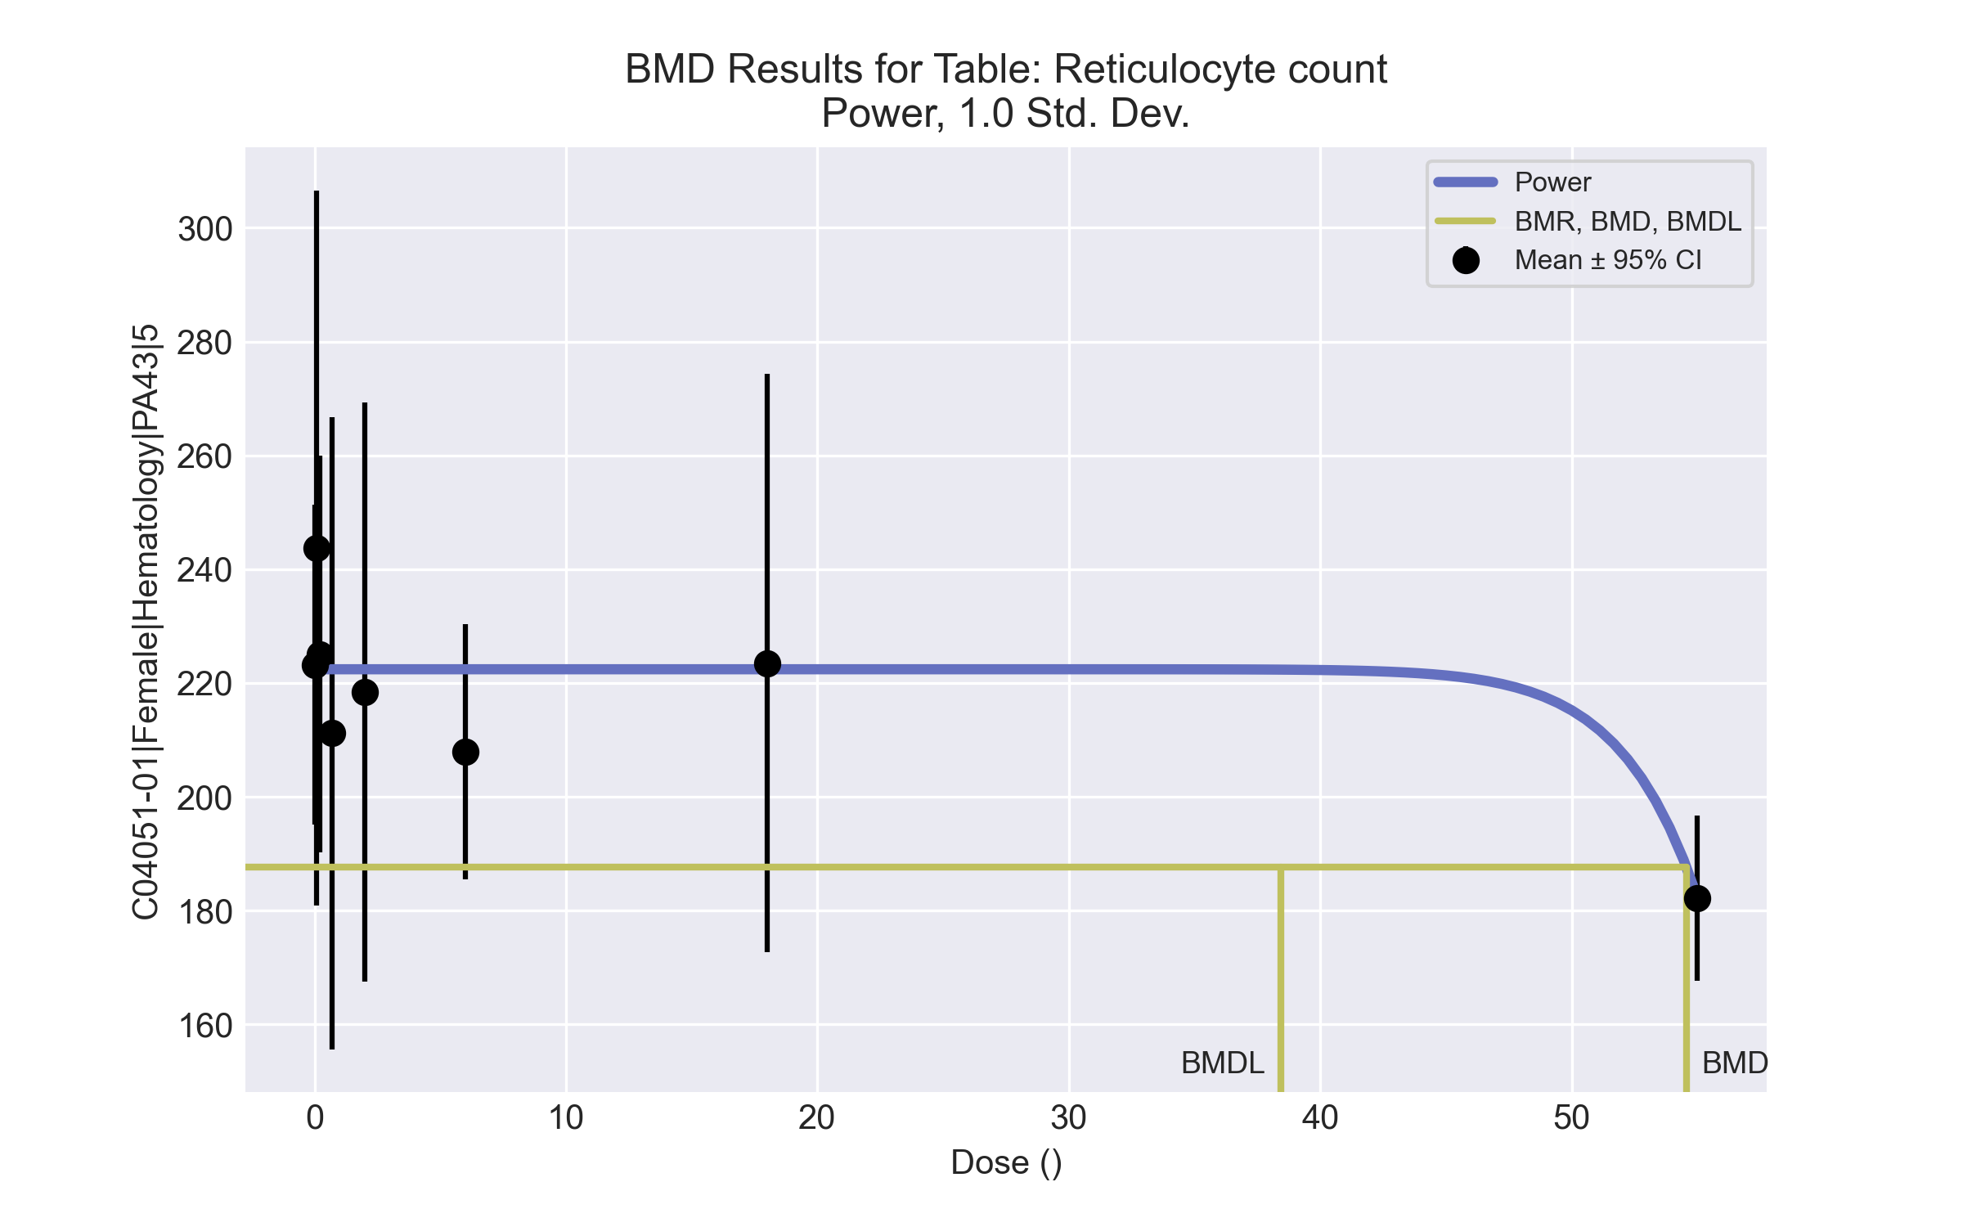
====================================================================
Power Model. (Version: 2.19; Date: 03/14/2017)
Input Data File: C:\Windows\TEMP\bmds-2g3ug6wq.(d)
Gnuplot Plotting File: C:\Windows\TEMP\bmds-2g3ug6wq.plt
Tue Apr 13 11:23:11 2021
====================================================================
BMDS_Model_Run
~~~~~~~~~~~~~~~~~~~~~~~~~~~~~~~~~~~~~~~~~~~~~~~~~~~~~~~~~~~~~~~~~~~~~
The form of the response function is:
Y[dose] = control + slope * dose^power
Dependent variable = Response
Independent variable = Dose
The power is restricted to be greater than or equal to 1
The variance is to be modeled as Var(i) = exp(lalpha + log(mean(i)) * rho)
Total number of dose groups = 8
Total number of records with missing values = 0
Maximum number of iterations = 500
Relative Function Convergence has been set to: 1e-008
Parameter Convergence has been set to: 1e-008
Default Initial Parameter Values
lalpha = 7.10474
rho = 0
control = 182.22
slope = 38.2475
power = -9999
Asymptotic Correlation Matrix of Parameter Estimates
( *** The model parameter(s) -power
have been estimated at a boundary point, or have been specified by the user,
and do not appear in the correlation matrix )
lalpha rho control slope
lalpha 1 -1 0.37 -0.53
rho -1 1 -0.38 0.54
control 0.37 -0.38 1 -0.77
slope -0.53 0.54 -0.77 1
Parameter Estimates
95.0% Wald Confidence Interval
Variable Estimate Std. Err. Lower Conf. Limit Upper Conf. Limit
lalpha -58.2126 21.5532 -100.456 -15.9691
rho 12.0846 4.02136 4.20287 19.9663
control 222.413 5.64471 211.35 233.477
slope -1.89506e-030 3.45315e-031 -2.57187e-030 -1.21826e-030
power 18 NA
NA - Indicates that this parameter has hit a bound
implied by some inequality constraint and thus
has no standard error.
Table of Data and Estimated Values of Interest
Dose N Obs Mean Est Mean Obs Std Dev Est Std Dev Scaled Res.
------ --- -------- -------- ----------- ----------- ----------
0 10 223 222 39.4 34.8 0.0724
0.07 5 244 222 50.6 34.8 1.37
0.2 5 225 222 28.1 34.8 0.17
0.7 4 211 222 34.9 34.8 -0.643
2 4 218 222 32 34.8 -0.231
6 5 208 222 18 34.8 -0.93
18 5 223 222 40.9 34.8 0.0686
55 5 182 182 11.7 10.4 -1e-008
Model Descriptions for likelihoods calculated
Model A1: Yij = Mu(i) + e(ij)
Var{e(ij)} = Sigma^2
Model A2: Yij = Mu(i) + e(ij)
Var{e(ij)} = Sigma(i)^2
Model A3: Yij = Mu(i) + e(ij)
Var{e(ij)} = exp(lalpha + rho*ln(Mu(i)))
Model A3 uses any fixed variance parameters that
were specified by the user
Model R: Yi = Mu + e(i)
Var{e(i)} = Sigma^2
Likelihoods of Interest
Model Log(likelihood) # Param's AIC
A1 -169.826130 9 357.652261
A2 -163.433180 16 358.866360
A3 -164.149823 10 348.299646
fitted -168.107176 4 344.214353
R -174.791274 2 353.582547
Explanation of Tests
Test 1: Do responses and/or variances differ among Dose levels?
(A2 vs. R)
Test 2: Are Variances Homogeneous? (A1 vs A2)
Test 3: Are variances adequately modeled? (A2 vs. A3)
Test 4: Does the Model for the Mean Fit? (A3 vs. fitted)
(Note: When rho=0 the results of Test 3 and Test 2 will be the same.)
Tests of Interest
Test -2*log(Likelihood Ratio) Test df p-value
Test 1 22.7162 14 0.06505
Test 2 12.7859 7 0.0775
Test 3 1.43329 6 0.9638
Test 4 7.91471 6 0.2444
The p-value for Test 1 is greater than .05. There may not be a
diffence between responses and/or variances among the dose levels
Modelling the data with a dose/response curve may not be appropriate
The p-value for Test 2 is less than .1. A non-homogeneous variance
model appears to be appropriate
The p-value for Test 3 is greater than .1. The modeled variance appears
to be appropriate here
The p-value for Test 4 is greater than .1. The model chosen seems
to adequately describe the data
Benchmark Dose Computation
Specified effect = 1
Risk Type = Estimated standard deviations from the control mean
Confidence level = 0.95
BMD = 54.5612
BMDL = 38.4142
BMDU = 64.4371

Female BMD Results for Table: Free Thyroxine
BMDS version: BMDS v2.7.0

Input dataset
Dose | 0 | 0.07 | 0.2 | 0.7 | 2 | 6 | 18 | 55 | 160 | 475
N | 10 | 5 | 5 | 3 | 4 | 5 | 5 | 5 | 4 | 3
Mean ± SD | 7.023 ± 2.407 | 6.89 ± 1.574 | 8.894 ± 7.083 | 7.277 ± 1.349 | 7.995 ± 1.441 | 8.554 ± 1.178 | 10.044 ± 2.696 | 9.84 ± 1.58 | 8.908 ± 0.986 | 8.807 ± 2.675

Summary table
Modelª | Goodness of fit |  | BMD | BMDL | Comments
 | p-value | AIC
Linear (equivalent models include Polynomial 2°, 3°, 4°, 5°, 6°, 7°, 8°) | 6.9E-04 | 157.337 | 1601.19 | 435.925 | No model was recommended as a best-fitting model. Doses were dropped until there were only 3 remaining dose-groups.
Power | 6.9E-04 | 157.337 | 1601.2 | 435.925
Hill | 0.051 | 146.822 | -999 | -999
Exponential M2 (equivalent models include Exponential M3) | 6.7E-04 | 157.404 | 1539.59 | 449.133
Exponential M4 | 0.049 | 146.373 | -999 | 0
Exponential M5 | 0.04 | 147.454 | -999 | 0
ª Modeled variance case presented (BMDS Test 2 p-value = <0.0001, BMDS Test 3 p-value = 0.038).

Model recommendation details
Model | Bin | Notes
Linear (equivalent models include Polynomial 2°, 3°, 4°, 5°, 6°, 7°, 8°) | Warning | Warnings  • Variance model poorly fits dataset (p-value 3 = 0.03806)  • Goodness of fit p-value is less than threshold (0.000689 < 0.1)  • BMD/high dose ratio is greater than threshold (3.37 > 1.0)
Power | Warning | Warnings  • Variance model poorly fits dataset (p-value 3 = 0.03806)  • Goodness of fit p-value is less than threshold (0.000689 < 0.1)  • BMD/high dose ratio is greater than threshold (3.37 > 1.0)
Hill | Failure | Failures  • BMD does not exist  • BMDL does not exist  Warnings  • Residual of Interest does not exist  • Variance model poorly fits dataset (p-value 3 = 0.03806)  • Goodness of fit p-value is less than threshold (0.0508 < 0.1)  • Ratio of modeled to actual stdev. at control is greater than threshold (1.52 > 1.5)  Cautions  • Warning(s): BMR value is not in the range of the mean function
Exponential M2 (equivalent models include Exponential M3) | Warning | Warnings  • Variance model poorly fits dataset (p-value 3 = 0.03806)  • Goodness of fit p-value is less than threshold (0.000671 < 0.1)  • BMD/high dose ratio is greater than threshold (3.24 > 1.0)
Exponential M4 | Failure | Failures  • BMD does not exist  Warnings  • Residual of Interest does not exist  • Variance model poorly fits dataset (p-value 3 = 0.03806)  • Goodness of fit p-value is less than threshold (0.0494 < 0.1)
Exponential M5 | Failure | Failures  • BMD does not exist  Warnings  • Residual of Interest does not exist  • Variance model poorly fits dataset (p-value 3 = 0.03806)  • Goodness of fit p-value is less than threshold (0.0403 < 0.1)

Recommended model
No model was recommended as a best-fitting model.

Female BMD Results for Table: Triiodothyronine
BMDS version: BMDS v2.7.0

Input dataset
Dose | 0 | 0.07 | 0.2 | 0.7 | 2 | 6 | 18 | 55 | 160 | 475
N | 10 | 5 | 5 | 3 | 4 | 5 | 5 | 5 | 4 | 3
Mean ± SD | 60.03 ± 11.713 | 67.18 ± 10.445 | 69.92 ± 14.716 | 70.5 ± 17.84 | 57.2 ± 14.166 | 62.22 ± 3.759 | 59.36 ± 10.114 | 58.32 ± 6.276 | 57.85 ± 4.034 | 45.333 ± 6.789

Summary table
Modelª | Goodness of fit |  | BMD | BMDL | Comments
 | p-value | AIC
Linear | 0.013 | 292.964 | -9999 | 1781.48 | Power recommended as best-fitting model on the basis of the lowest AIC.
Polynomial 2° | 0.013 | 292.964 | -9999 | 883.499
Polynomial 3° | 0.013 | 292.964 | -9999 | 422.902
Polynomial 4° | 0.013 | 292.964 | -9999 | 423.244
Polynomial 5° | 0.013 | 292.964 | -9999 | -999
Polynomial 6° | 0.013 | 292.964 | -9999 | -999
Polynomial 7° | 0.015 | 292.624 | -9999 | 440.836
Polynomial 8° | 0.013 | 292.964 | -9999 | -999
Power^{b} | 0.349 | 282.979 | 296.488 | 213.03
Hill | 0.364 | 283.714 | 198.09 | -999
Exponential M2 | 0.226 | 284.65 | -205.54 | -999
Exponential M3 | 0.226 | 284.65 | -205.54 | -999
Exponential M4 | 0.017 | 293.181 | -999 | 0
Exponential M5 | 0.016 | 293.749 | -999 | 0
ª Modeled variance case presented (BMDS Test 2 p-value = 0.037, BMDS Test 3 p-value = 0.113).
^{b} Recommended model

Model recommendation details
Model | Bin | Notes
Linear | Warning | Warnings  • Residual of Interest does not exist  • Goodness of fit p-value is less than threshold (0.0131 < 0.1)  Cautions  • Warning(s): THIS USUALLY MEANS THE MODEL HAS NOT CONVERGED!; BMD = 100*(maximum dose)  • BMDL/high dose ratio is greater than threshold (3.75 > 1.0)
Polynomial 2° | Warning | Warnings  • Residual of Interest does not exist  • Goodness of fit p-value is less than threshold (0.0131 < 0.1)  Cautions  • Warning(s): BMD = 100*(maximum dose)  • BMDL/high dose ratio is greater than threshold (1.86 > 1.0)
Polynomial 3° | Warning | Warnings  • Residual of Interest does not exist  • Goodness of fit p-value is less than threshold (0.0131 < 0.1)  Cautions  • Warning(s): THIS USUALLY MEANS THE MODEL HAS NOT CONVERGED!; BMD = 100*(maximum dose)
Polynomial 4° | Warning | Warnings  • Residual of Interest does not exist  • Goodness of fit p-value is less than threshold (0.0131 < 0.1)  Cautions  • Warning(s): BMD = 100*(maximum dose)
Polynomial 5° | Failure | Failures  • BMDL does not exist  Warnings  • Residual of Interest does not exist  • Goodness of fit p-value is less than threshold (0.0131 < 0.1)  Cautions  • Warning(s): BMD = 100*(maximum dose); BMDL computation failed.
Polynomial 6° | Failure | Failures  • BMDL does not exist  Warnings  • Residual of Interest does not exist  • Goodness of fit p-value is less than threshold (0.0131 < 0.1)  Cautions  • Warning(s): THIS USUALLY MEANS THE MODEL HAS NOT CONVERGED!; BMD = 100*(maximum dose); BMDL computation failed.
Polynomial 7° | Warning | Warnings  • Residual of Interest does not exist  • Goodness of fit p-value is less than threshold (0.0147 < 0.1)  Cautions  • Warning(s): THE MODEL HAS PROBABLY NOT CONVERGED!!!; THIS USUALLY MEANS THE MODEL HAS NOT CONVERGED!; BMD = 100*(maximum dose)
Polynomial 8° | Failure | Failures  • BMDL does not exist  Warnings  • Residual of Interest does not exist  • Goodness of fit p-value is less than threshold (0.0131 < 0.1)  Cautions  • Warning(s): THIS USUALLY MEANS THE MODEL HAS NOT CONVERGED!; BMD = 100*(maximum dose); BMDL computation failed.
Powerª | Valid | -
Hill | Failure | Failures  • BMDL does not exist  Cautions  • Warning(s): BMDL computation failed.
Exponential M2 | Failure | Failures  • BMDL does not exist  Warnings  • Residual of Interest does not exist
Exponential M3 | Failure | Failures  • BMDL does not exist  Warnings  • Residual of Interest does not exist
Exponential M4 | Failure | Failures  • BMD does not exist  Warnings  • Residual of Interest does not exist  • Goodness of fit p-value is less than threshold (0.0166 < 0.1)
Exponential M5 | Failure | Failures  • BMD does not exist  Warnings  • Residual of Interest does not exist  • Goodness of fit p-value is less than threshold (0.0155 < 0.1)
ª Recommended model

Recommended model
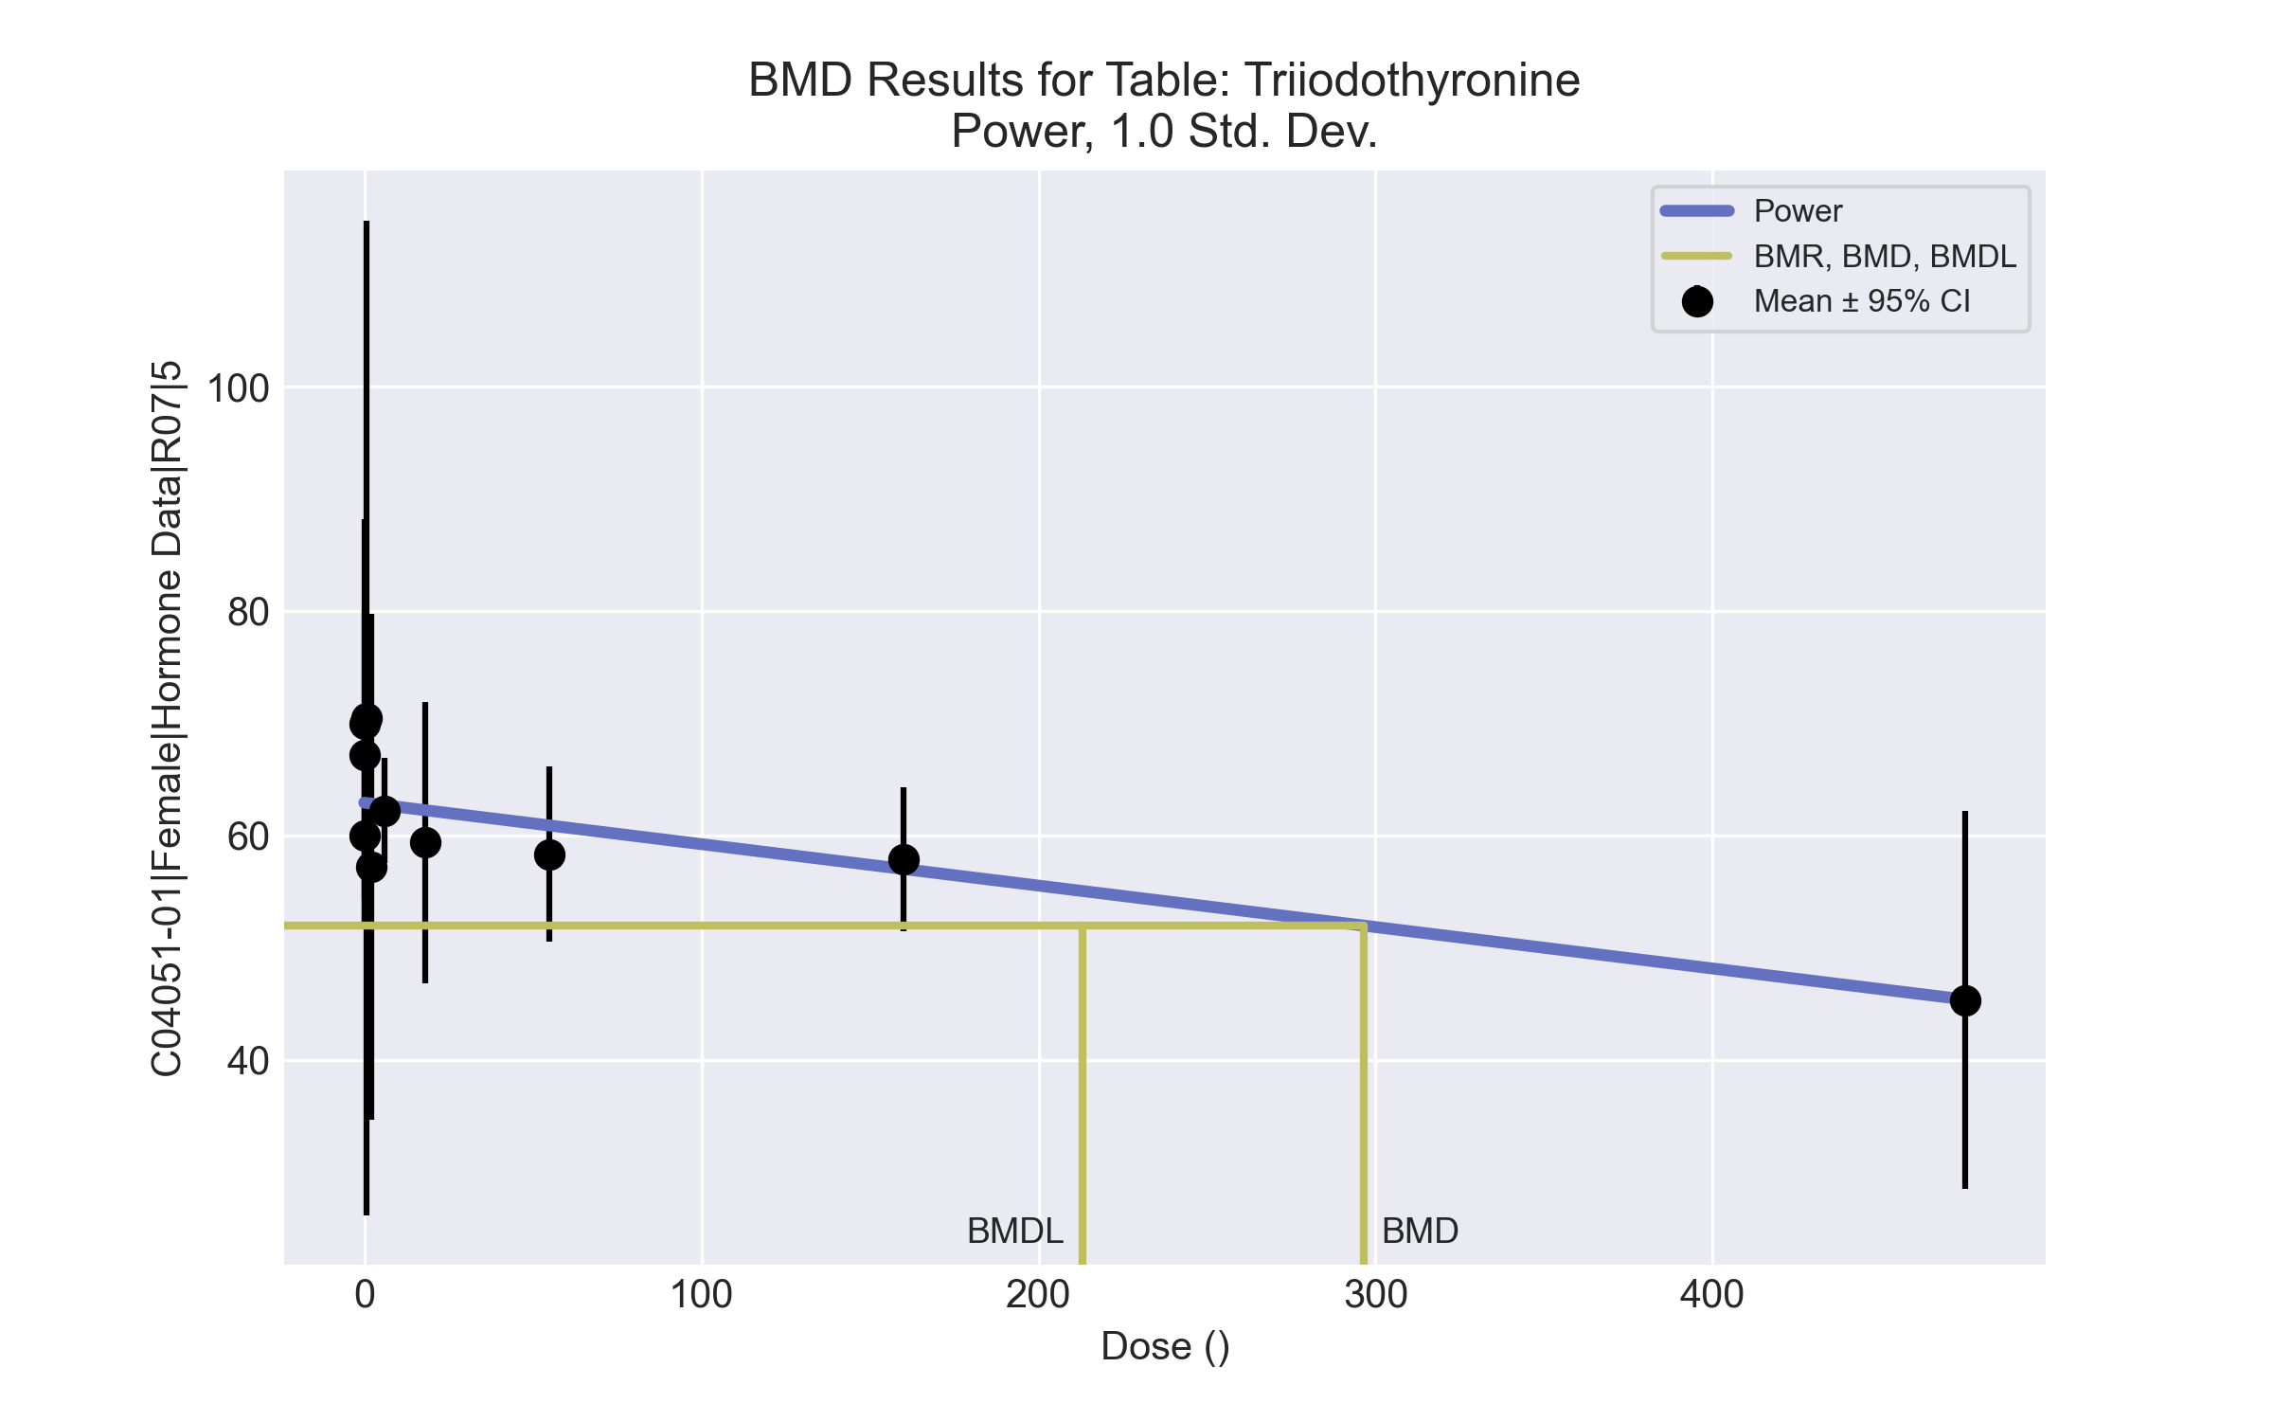
====================================================================
Power Model. (Version: 2.19; Date: 03/14/2017)
Input Data File: C:\Windows\TEMP\bmds-mriivf32.(d)
Gnuplot Plotting File: C:\Windows\TEMP\bmds-mriivf32.plt
Tue Apr 13 11:27:18 2021
====================================================================
BMDS_Model_Run
~~~~~~~~~~~~~~~~~~~~~~~~~~~~~~~~~~~~~~~~~~~~~~~~~~~~~~~~~~~~~~~~~~~~~
The form of the response function is:
Y[dose] = control + slope * dose^power
Dependent variable = Response
Independent variable = Dose
The power is restricted to be greater than or equal to 1
The variance is to be modeled as Var(i) = exp(lalpha + log(mean(i)) * rho)
Total number of dose groups = 10
Total number of records with missing values = 0
Maximum number of iterations = 500
Relative Function Convergence has been set to: 1e-008
Parameter Convergence has been set to: 1e-008
Default Initial Parameter Values
lalpha = 4.7572
rho = 0
control = 45.3333
slope = 18.7284
power = -9999
Asymptotic Correlation Matrix of Parameter Estimates
( *** The model parameter(s) -power
have been estimated at a boundary point, or have been specified by the user,
and do not appear in the correlation matrix )
lalpha rho control slope
lalpha 1 -1 0.21 -0.44
rho -1 1 -0.22 0.44
control 0.21 -0.22 1 -0.59
slope -0.44 0.44 -0.59 1
Parameter Estimates
95.0% Wald Confidence Interval
Variable Estimate Std. Err. Lower Conf. Limit Upper Conf. Limit
lalpha -17.2236 9.97026 -36.765 2.31774
rho 5.31426 2.42972 0.552102 10.0764
control 62.9187 1.64937 59.6859 66.1514
slope -0.0369419 0.00672555 -0.0501238 -0.0237601
power 1 NA
NA - Indicates that this parameter has hit a bound
implied by some inequality constraint and thus
has no standard error.
Table of Data and Estimated Values of Interest
Dose N Obs Mean Est Mean Obs Std Dev Est Std Dev Scaled Res.
------ --- -------- -------- ----------- ----------- ----------
0 10 60 62.9 11.7 11 -0.834
0.07 5 67.2 62.9 10.4 11 0.871
0.2 5 69.9 62.9 14.7 10.9 1.43
0.7 3 70.5 62.9 17.8 10.9 1.2
2 4 57.2 62.8 14.2 10.9 -1.03
6 5 62.2 62.7 3.76 10.9 -0.0983
18 5 59.4 62.3 10.1 10.6 -0.608
55 5 58.3 60.9 6.28 10 -0.572
160 4 57.9 57 4.03 8.43 0.2
475 3 45.3 45.4 6.79 4.59 -0.0143
Model Descriptions for likelihoods calculated
Model A1: Yij = Mu(i) + e(ij)
Var{e(ij)} = Sigma^2
Model A2: Yij = Mu(i) + e(ij)
Var{e(ij)} = Sigma(i)^2
Model A3: Yij = Mu(i) + e(ij)
Var{e(ij)} = exp(lalpha + rho*ln(Mu(i)))
Model A3 uses any fixed variance parameters that
were specified by the user
Model R: Yi = Mu + e(i)
Var{e(i)} = Sigma^2
Likelihoods of Interest
Model Log(likelihood) # Param's AIC
A1 -135.458963 11 292.917925
A2 -126.546532 20 293.093063
A3 -133.029849 12 290.059699
fitted -137.489468 4 282.978937
R -143.482137 2 290.964273
Explanation of Tests
Test 1: Do responses and/or variances differ among Dose levels?
(A2 vs. R)
Test 2: Are Variances Homogeneous? (A1 vs A2)
Test 3: Are variances adequately modeled? (A2 vs. A3)
Test 4: Does the Model for the Mean Fit? (A3 vs. fitted)
(Note: When rho=0 the results of Test 3 and Test 2 will be the same.)
Tests of Interest
Test -2*log(Likelihood Ratio) Test df p-value
Test 1 33.8712 18 0.01306
Test 2 17.8249 9 0.03726
Test 3 12.9666 8 0.113
Test 4 8.91924 8 0.3492
The p-value for Test 1 is less than .05. There appears to be a
difference between response and/or variances among the dose levels
It seems appropriate to model the data
The p-value for Test 2 is less than .1. A non-homogeneous variance
model appears to be appropriate
The p-value for Test 3 is greater than .1. The modeled variance appears
to be appropriate here
The p-value for Test 4 is greater than .1. The model chosen seems
to adequately describe the data
Benchmark Dose Computation
Specified effect = 1
Risk Type = Estimated standard deviations from the control mean
Confidence level = 0.95
BMD = 296.488
BMDL = 213.03
BMDU = 454.833

