Male BMD Results for Table: Liver Weight Absolute
BMDS version: BMDS v2.7.0

Input dataset
Dose | 0 | 0.07 | 0.2 | 0.7 | 2 | 6 | 18 | 55 | 160 | 475
N | 10 | 5 | 5 | 5 | 5 | 5 | 5 | 5 | 5 | 5
Mean ± SD | 12.517 ± 1.388 | 11.808 ± 1.671 | 12.574 ± 1.217 | 12.612 ± 1.23 | 12.054 ± 0.654 | 13.144 ± 1.171 | 13.484 ± 1.405 | 14.296 ± 0.883 | 15.69 ± 1.218 | 15.34 ± 1.186

Summary table
Modelª | Goodness of fit |  | BMD | BMDL | Comments
 | p-value | AIC
Linear (equivalent models include Power, Polynomial 2°, 3°, 4°, 5°, 6°, 7°, 8°) | 0.004 | 97.2 | 203.084 | 148.888 | Exponential-M4 recommended as best-fitting model on the basis of the lowest AIC.
Hill | 0.675 | 82.493 | 18.249 | 6.926
Exponential M2 (equivalent models include Exponential M3) | 0.003 | 98.158 | 224.813 | 168.943
Exponential M4^{b} (equivalent models include Exponential M5) | 0.814 | 80.177 | 21.893 | 10.337
ª Constant variance case presented (BMDS Test 2 p-value = 0.773, BMDS Test 3 p-value = 0.773).
^{b} Recommended model

Model recommendation details
Model | Bin | Notes
Linear (equivalent models include Power, Polynomial 2°, 3°, 4°, 5°, 6°, 7°, 8°) | Warning | Warnings  • Goodness of fit p-value is less than threshold (0.00375 < 0.1)  • Residual of interest is greater than threshold (2.84 > 2.0)
Hill | Valid | -
Exponential M2 (equivalent models include Exponential M3) | Warning | Warnings  • Goodness of fit p-value is less than threshold (0.0026 < 0.1)  • Residual of interest is greater than threshold (2.95 > 2.0)
Exponential M4ª (equivalent models include Exponential M5) | Valid | -
ª Recommended model

Recommended model
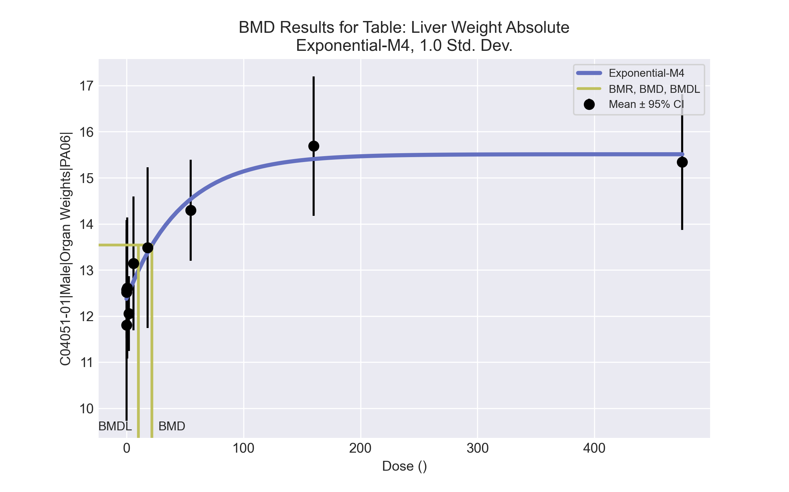
====================================================================
Exponential Model. (Version: 1.11; Date: 03/14/2017)
Input Data File: C:\Windows\TEMP\bmds-yl9p0x3f.(d)
Gnuplot Plotting File:
Tue Apr 13 09:11:44 2021
====================================================================
BMDS_Model_Run
~~~~~~~~~~~~~~~~~~~~~~~~~~~~~~~~~~~~~~~~~~~~~~~~~~~~~~~~~~~~~~~~~~~~~
The form of the response function by Model:
Model 2: Y[dose] = a * exp{sign * b * dose}
Model 3: Y[dose] = a * exp{sign * (b * dose)^d}
Model 4: Y[dose] = a * [c-(c-1) * exp{-b * dose}]
Model 5: Y[dose] = a * [c-(c-1) * exp{-(b * dose)^d}]
Note: Y[dose] is the median response for exposure = dose;
sign = +1 for increasing trend in data;
sign = -1 for decreasing trend.
Model 2 is nested within Models 3 and 4.
Model 3 is nested within Model 5.
Model 4 is nested within Model 5.
Dependent variable = Response
Independent variable = Dose
Data are assumed to be distributed: normally
Variance Model: exp(lnalpha +rho *ln(Y[dose]))
rho is set to 0.
A constant variance model is fit.
Total number of dose groups = 10
Total number of records with missing values = 0
Maximum number of iterations = 500
Relative Function Convergence has been set to: 1e-008
Parameter Convergence has been set to: 1e-008
MLE solution provided: Exact
Initial Parameter Values
Variable Model 4
-------- --------
lnalpha 0.245131
rho 0 Specified
a 11.2176
b 0.00429934
c 1.46863
d 1 Specified
Parameter Estimates
Variable Model 4 Std. Err.
-------- ------- ---------
lnalpha 0.312317 0.260598
a 12.3759 0.20837
b 0.0213164 0.00970104
c 1.2533 0.037875
NC = No Convergence
Table of Stats From Input Data
Dose N Obs Mean Obs Std Dev
----- --- ---------- -------------
0 10 12.52 1.388
0.07 5 11.81 1.671
0.2 5 12.57 1.217
0.7 5 12.61 1.23
2 5 12.05 0.6544
6 5 13.14 1.171
18 5 13.48 1.405
55 5 14.3 0.8832
160 5 15.69 1.218
475 5 15.34 1.186
Estimated Values of Interest
Dose Est Mean Est Std Scaled Residual
------ ---------- --------- ----------------
0 12.38 1.169 0.3816
0.07 12.38 1.169 -1.095
0.2 12.39 1.169 0.3533
0.7 12.42 1.169 0.3627
2 12.51 1.169 -0.8661
6 12.75 1.169 0.7492
18 13.37 1.169 0.2087
55 14.54 1.169 -0.4669
160 15.41 1.169 0.5409
475 15.51 1.169 -0.3263
Other models for which likelihoods are calculated:
Model A1: Yij = Mu(i) + e(ij)
Var{e(ij)} = Sigma^2
Model A2: Yij = Mu(i) + e(ij)
Var{e(ij)} = Sigma(i)^2
Model A3: Yij = Mu(i) + e(ij)
Var{e(ij)} = exp(lalpha + log(mean(i)) * rho)
Model R: Yij = Mu + e(i)
Var{e(ij)} = Sigma^2
Likelihoods of Interest
Model Log(likelihood) DF AIC
------- ----------------- ---- ------------
A1 -34.24111 11 90.48222
A2 -31.40933 20 102.8187
A3 -34.24111 11 90.48222
R -55.97339 2 115.9468
4 -36.08871 4 80.17742
Additive constant for all log-likelihoods = -50.54. This constant added to the
above values gives the log-likelihood including the term that does not
depend on the model parameters.
Explanation of Tests
Test 1: Does response and/or variances differ among Dose levels? (A2 vs. R)
Test 2: Are Variances Homogeneous? (A2 vs. A1)
Test 3: Are variances adequately modeled? (A2 vs. A3)
Test 6a: Does Model 4 fit the data? (A3 vs 4)
Tests of Interest
Test -2*log(Likelihood Ratio) D. F. p-value
-------- ------------------------ ------ --------------
Test 1 49.13 18 0.0001021
Test 2 5.664 9 0.7731
Test 3 5.664 9 0.7731
Test 6a 3.695 7 0.8141
The p-value for Test 1 is less than .05. There appears to be a
difference between response and/or variances among the dose
levels, it seems appropriate to model the data.
The p-value for Test 2 is greater than .1. A homogeneous
variance model appears to be appropriate here.
The p-value for Test 3 is greater than .1. The modeled
variance appears to be appropriate here.
The p-value for Test 6a is greater than .1. Model 4 seems
to adequately describe the data.
Benchmark Dose Computations:
Specified Effect = 1.000000
Risk Type = Estimated standard deviations from control
Confidence Level = 0.950000
BMD = 21.8929
BMDL = 10.3368
BMDU = 46.3444

Male BMD Results for Table: Liver Weight Relative
BMDS version: BMDS v2.7.0

Input dataset
Dose | 0 | 0.07 | 0.2 | 0.7 | 2 | 6 | 18 | 55 | 160 | 475
N | 10 | 5 | 5 | 5 | 5 | 5 | 5 | 5 | 5 | 5
Mean ± SD | 37.411 ± 2.087 | 36.069 ± 2.902 | 37.695 ± 2.143 | 37.424 ± 2.103 | 36.768 ± 0.94 | 39.294 ± 1.968 | 41.443 ± 3.293 | 42.312 ± 1.855 | 46.853 ± 2.601 | 45.932 ± 2.044

Summary table
Modelª | Goodness of fit |  | BMD | BMDL | Comments
 | p-value | AIC
Linear (equivalent models include Power, Polynomial 2°, 3°, 4°, 5°, 6°, 7°, 8°) | <0.0001 | 184.721 | 154.464 | 119.222 | Hill recommended as best-fitting model on the basis of the lowest AIC.
Hill^{b} | 0.366 | 149.057 | 8.087 | 4.336
Exponential M2 (equivalent models include Exponential M3) | <0.0001 | 186.292 | 173.4 | 136.091
Exponential M4 (equivalent models include Exponential M5) | 0.325 | 149.511 | 12.437 | 7.255
ª Constant variance case presented (BMDS Test 2 p-value = 0.52, BMDS Test 3 p-value = 0.52).
^{b} Recommended model

Model recommendation details
Model | Bin | Notes
Linear (equivalent models include Power, Polynomial 2°, 3°, 4°, 5°, 6°, 7°, 8°) | Warning | Warnings  • Residual of interest is greater than threshold (3.7 > 2.0)
Hillª | Valid | -
Exponential M2 (equivalent models include Exponential M3) | Warning | Warnings  • Residual of interest is greater than threshold (3.81 > 2.0)
Exponential M4 (equivalent models include Exponential M5) | Valid | -
ª Recommended model

Recommended model
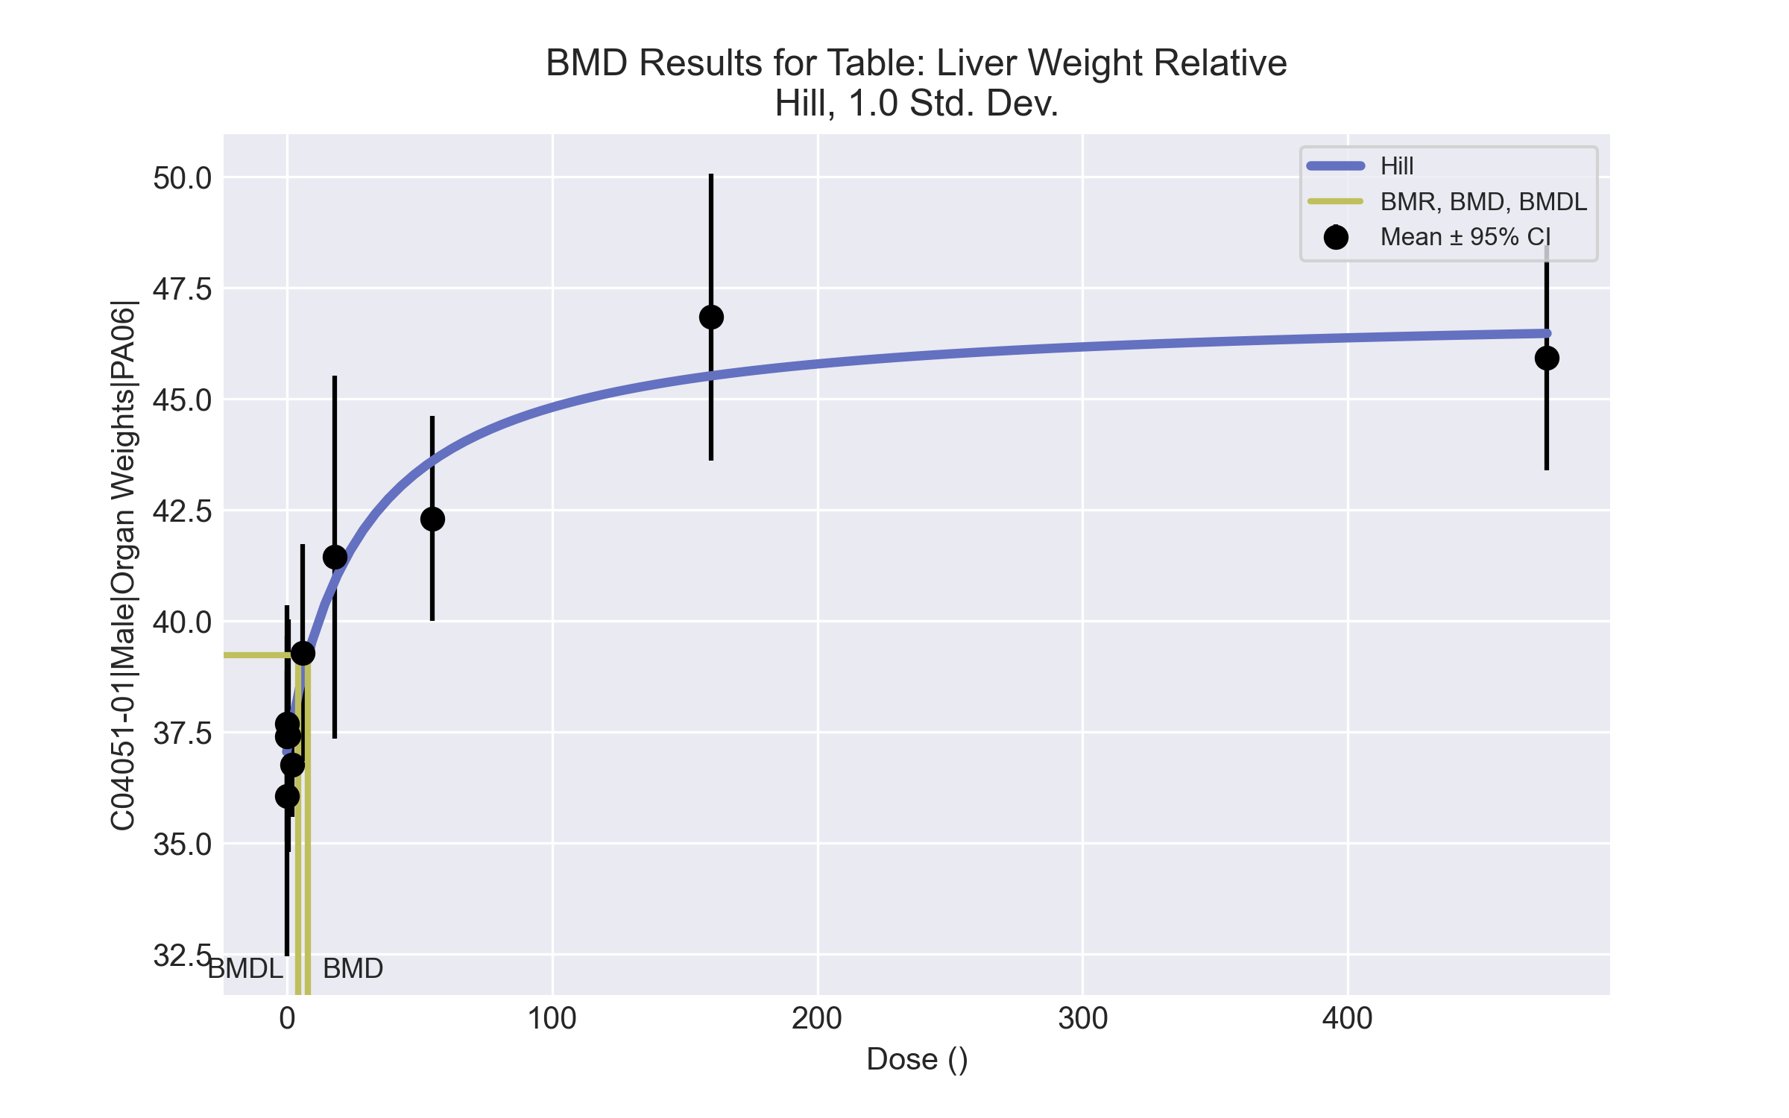
====================================================================
Hill Model. (Version: 2.18; Date: 03/14/2017)
Input Data File: C:\Windows\TEMP\bmds-usaqyob6.(d)
Gnuplot Plotting File: C:\Windows\TEMP\bmds-usaqyob6.plt
Tue Apr 13 09:11:47 2021
====================================================================
BMDS_Model_Run
~~~~~~~~~~~~~~~~~~~~~~~~~~~~~~~~~~~~~~~~~~~~~~~~~~~~~~~~~~~~~~~~~~~~~
The form of the response function is:
Y[dose] = intercept + v*dose^n/(k^n + dose^n)
Dependent variable = Response
Independent variable = Dose
rho is set to 0
Power parameter restricted to be greater than 1
A constant variance model is fit
Total number of dose groups = 10
Total number of records with missing values = 0
Maximum number of iterations = 500
Relative Function Convergence has been set to: 1e-008
Parameter Convergence has been set to: 1e-008
Default Initial Parameter Values
alpha = 5.08645
rho = 0 Specified
intercept = 37.4106
v = 9.4426
n = 0.665024
k = 62.6735
Asymptotic Correlation Matrix of Parameter Estimates
( *** The model parameter(s) -rho -n
have been estimated at a boundary point, or have been specified by the user,
and do not appear in the correlation matrix )
alpha intercept v k
alpha 1 1.2e-007 3.4e-007 6.5e-007
intercept 1.2e-007 1 -0.23 0.43
v 3.4e-007 -0.23 1 0.56
k 6.5e-007 0.43 0.56 1
Parameter Estimates
95.0% Wald Confidence Interval
Variable Estimate Std. Err. Lower Conf. Limit Upper Conf. Limit
alpha 4.78111 0.911722 2.99417 6.56805
intercept 37.0578 0.418998 36.2366 37.879
v 9.99469 1.01661 8.00217 11.9872
n 1 NA
k 28.8785 12.2415 4.88559 52.8715
NA - Indicates that this parameter has hit a bound
implied by some inequality constraint and thus
has no standard error.
Table of Data and Estimated Values of Interest
Dose N Obs Mean Est Mean Obs Std Dev Est Std Dev Scaled Res.
------ --- -------- -------- ----------- ----------- ----------
0 10 37.4 37.1 2.09 2.19 0.51
0.07 5 36.1 37.1 2.9 2.19 -1.04
0.2 5 37.7 37.1 2.14 2.19 0.582
0.7 5 37.4 37.3 2.1 2.19 0.132
2 5 36.8 37.7 0.94 2.19 -0.958
6 5 39.3 38.8 1.97 2.19 0.528
18 5 41.4 40.9 3.29 2.19 0.56
55 5 42.3 43.6 1.86 2.19 -1.33
160 5 46.9 45.5 2.6 2.19 1.36
475 5 45.9 46.5 2.04 2.19 -0.561
Model Descriptions for likelihoods calculated
Model A1: Yij = Mu(i) + e(ij)
Var{e(ij)} = Sigma^2
Model A2: Yij = Mu(i) + e(ij)
Var{e(ij)} = Sigma(i)^2
Model A3: Yij = Mu(i) + e(ij)
Var{e(ij)} = Sigma^2
Model A3 uses any fixed variance parameters that
were specified by the user
Model R: Yi = Mu + e(i)
Var{e(i)} = Sigma^2
Likelihoods of Interest
Model Log(likelihood) # Param's AIC
A1 -66.712529 11 155.425059
A2 -62.643595 20 165.287191
A3 -66.712529 11 155.425059
fitted -70.528494 4 149.056988
R -105.403485 2 214.806970
Explanation of Tests
Test 1: Do responses and/or variances differ among Dose levels?
(A2 vs. R)
Test 2: Are Variances Homogeneous? (A1 vs A2)
Test 3: Are variances adequately modeled? (A2 vs. A3)
Test 4: Does the Model for the Mean Fit? (A3 vs. fitted)
(Note: When rho=0 the results of Test 3 and Test 2 will be the same.)
Tests of Interest
Test -2*log(Likelihood Ratio) Test df p-value
Test 1 85.5198 18 <.0001
Test 2 8.13787 9 0.5203
Test 3 8.13787 9 0.5203
Test 4 7.63193 7 0.3662
The p-value for Test 1 is less than .05. There appears to be a
difference between response and/or variances among the dose levels
It seems appropriate to model the data
The p-value for Test 2 is greater than .1. A homogeneous variance
model appears to be appropriate here
The p-value for Test 3 is greater than .1. The modeled variance appears
to be appropriate here
The p-value for Test 4 is greater than .1. The model chosen seems
to adequately describe the data
Benchmark Dose Computation
Specified effect = 1
Risk Type = Estimated standard deviations from the control mean
Confidence level = 0.95
BMD = 8.08711
BMDL = 4.33554
BMDU = 17.7394

Male BMD Results for Table: A/G Ratio
BMDS version: BMDS v2.7.0

Input dataset
Dose | 0 | 0.07 | 0.2 | 0.7 | 2 | 6 | 18 | 55 | 160 | 475
N | 9 | 5 | 5 | 5 | 5 | 5 | 5 | 5 | 5 | 4
Mean ± SD | 2.654 ± 0.222 | 2.671 ± 0.462 | 2.751 ± 0.309 | 2.562 ± 0.102 | 2.536 ± 0.282 | 2.55 ± 0.367 | 2.681 ± 0.519 | 2.562 ± 0.119 | 2.354 ± 0.268 | 2.332 ± 0.19

Summary table
Modelª | Goodness of fit |  | BMD | BMDL | Comments
 | p-value | AIC
Linear (equivalent models include Power, Polynomial 2°, 3°, 5°, 6°) | 0.257 | -72.66 | 463 | 269.118 | No model was recommended as a best-fitting model. Doses were dropped until there were only 3 remaining dose-groups.
Polynomial 4° (equivalent models include Polynomial 7°) | 0.257 | -72.66 | 463.005 | 269.118
Polynomial 8° | <0.0001 | 308.588 | 18.057 | -999
Hill | 0.285 | -71.371 | -999 | -999
Exponential M2 (equivalent models include Exponential M3) | 0.263 | -72.757 | 456.651 | 253.828
Exponential M4 | 0.295 | -72.336 | 312.295 | 79.049
Exponential M5 | 0.285 | -71.371 | -999 | 0
ª Modeled variance case presented (BMDS Test 2 p-value = 0.011, BMDS Test 3 p-value = 0.09).

Model recommendation details
Model | Bin | Notes
Linear (equivalent models include Power, Polynomial 2°, 3°, 5°, 6°) | Warning | Warnings  • Variance model poorly fits dataset (p-value 3 = 0.09035)
Polynomial 4° (equivalent models include Polynomial 7°) | Warning | Warnings  • Variance model poorly fits dataset (p-value 3 = 0.09035)
Polynomial 8° | Failure | Failures  • BMDL does not exist  Warnings  • Variance model poorly fits dataset (p-value 3 = 0.09035)  • Residual of interest is greater than threshold (2.73 > 2.0)  • Ratio of modeled to actual stdev. at control is greater than threshold (2.43 > 1.5)  Cautions  • Warning(s): THE MODEL HAS PROBABLY NOT CONVERGED!!!; THIS USUALLY MEANS THE MODEL HAS NOT CONVERGED!; BMDL computation failed.
Hill | Failure | Failures  • BMD does not exist  • BMDL does not exist  Warnings  • Residual of Interest does not exist  • Variance model poorly fits dataset (p-value 3 = 0.09035)  Cautions  • Warning(s): BMR value is not in the range of the mean function
Exponential M2 (equivalent models include Exponential M3) | Warning | Warnings  • Variance model poorly fits dataset (p-value 3 = 0.09035)
Exponential M4 | Warning | Warnings  • Variance model poorly fits dataset (p-value 3 = 0.09035)
Exponential M5 | Failure | Failures  • BMD does not exist  Warnings  • Residual of Interest does not exist  • Variance model poorly fits dataset (p-value 3 = 0.09035)

Recommended model
No model was recommended as a best-fitting model.

Male BMD Results for Table: Alanine aminotransferase
BMDS version: BMDS v2.7.0

Input dataset
Dose | 0 | 0.07 | 0.2 | 0.7 | 2 | 6 | 18 | 55 | 160 | 475
N | 9 | 5 | 5 | 5 | 5 | 5 | 5 | 5 | 5 | 4
Mean ± SD | 61.778 ± 9.189 | 54.4 ± 7.232 | 60.4 ± 7.893 | 64.2 ± 13.773 | 58.6 ± 6.066 | 55.8 ± 1.095 | 63.8 ± 6.261 | 64 ± 21.378 | 66.6 ± 7.403 | 96 ± 20.992

Summary table
Modelª | Goodness of fit |  | BMD | BMDL | Comments
 | p-value | AIC
Linear (equivalent models include Power) | 0.008 | 307.617 | 134.227 | 88.022 | No model was recommended as a best-fitting model. Doses were dropped until there were only 3 remaining dose-groups.
Polynomial 2° | 0.004 | 309.49 | 160 | 88.892
Polynomial 3° | 0.004 | 309.34 | 174.489 | 89.962
Polynomial 4° | 0.005 | 309.274 | 180.951 | 90.444
Polynomial 5° | 0.005 | 309.25 | 183.764 | 90.621
Polynomial 6° | <0.0001 | 340.555 | -9999 | -999
Polynomial 7° | 0.005 | 309.239 | 185.424 | 90.704
Polynomial 8° | 0.005 | 309.238 | 185.615 | 90.711
Hill | 0.004 | 309.619 | 134.004 | -999
Exponential M2 (equivalent models include Exponential M3) | 0.008 | 307.482 | 152.446 | 108.005
Exponential M4 | <0.0001 | 342.555 | 1 | -999
Exponential M5 | 0.004 | 309.619 | 134.037 | 46.088
ª Modeled variance case presented (BMDS Test 2 p-value = <0.0001, BMDS Test 3 p-value = 0.021).

Model recommendation details
Model | Bin | Notes
Linear (equivalent models include Power) | Warning | Warnings  • Variance model poorly fits dataset (p-value 3 = 0.02115)  • Goodness of fit p-value is less than threshold (0.0075 < 0.1)
Polynomial 2° | Warning | Warnings  • Variance model poorly fits dataset (p-value 3 = 0.02115)  • Goodness of fit p-value is less than threshold (0.00417 < 0.1)
Polynomial 3° | Warning | Warnings  • Variance model poorly fits dataset (p-value 3 = 0.02115)  • Goodness of fit p-value is less than threshold (0.00442 < 0.1)
Polynomial 4° | Warning | Warnings  • Variance model poorly fits dataset (p-value 3 = 0.02115)  • Goodness of fit p-value is less than threshold (0.00454 < 0.1)
Polynomial 5° | Warning | Warnings  • Variance model poorly fits dataset (p-value 3 = 0.02115)  • Goodness of fit p-value is less than threshold (0.00458 < 0.1)
Polynomial 6° | Failure | Failures  • BMDL does not exist  Warnings  • Residual of Interest does not exist  • Variance model poorly fits dataset (p-value 3 = 0.02115)  • Ratio of modeled to actual stdev. at control is greater than threshold (1.55 > 1.5)  Cautions  • Warning(s): BMD = 100*(maximum dose); BMDL computation failed.
Polynomial 7° | Warning | Warnings  • Variance model poorly fits dataset (p-value 3 = 0.02115)  • Goodness of fit p-value is less than threshold (0.0046 < 0.1)
Polynomial 8° | Warning | Warnings  • Variance model poorly fits dataset (p-value 3 = 0.02115)  • Goodness of fit p-value is less than threshold (0.0046 < 0.1)
Hill | Failure | Failures  • BMDL does not exist  Warnings  • Variance model poorly fits dataset (p-value 3 = 0.02115)  • Goodness of fit p-value is less than threshold (0.00396 < 0.1)  Cautions  • Warning(s): BMDL computation failed.
Exponential M2 (equivalent models include Exponential M3) | Warning | Warnings  • Variance model poorly fits dataset (p-value 3 = 0.02115)  • Goodness of fit p-value is less than threshold (0.00789 < 0.1)
Exponential M4 | Failure | Failures  • BMDL does not exist  Warnings  • Variance model poorly fits dataset (p-value 3 = 0.02115)
Exponential M5 | Warning | Warnings  • Variance model poorly fits dataset (p-value 3 = 0.02115)  • Goodness of fit p-value is less than threshold (0.00396 < 0.1)

Recommended model
No model was recommended as a best-fitting model.

Male BMD Results for Table: Alkaline phosphatase
BMDS version: BMDS v2.7.0

Input dataset
Dose | 0 | 0.07 | 0.2 | 0.7 | 2 | 6 | 18 | 55 | 160 | 475
N | 9 | 5 | 5 | 5 | 4 | 5 | 5 | 5 | 5 | 4
Mean ± SD | 267.778 ± 23.926 | 253.4 ± 55.025 | 252.8 ± 19.344 | 277 ± 40.682 | 269.5 ± 16.34 | 263.8 ± 23.973 | 285 ± 9.975 | 284.8 ± 45.746 | 326 ± 53.094 | 351 ± 25.547

Summary table
Modelª | Goodness of fit |  | BMD | BMDL | Comments
 | p-value | AIC
Linear (equivalent models include Power, Polynomial 2°, 3°, 4°, 5°, 6°, 7°, 8°) | 0.459 | 424.127 | 149.957 | 87.451 | No model was recommended as a best-fitting model. Doses were dropped until there were only 3 remaining dose-groups.
Hill | 0.792 | 423.518 | 55.827 | -999
Exponential M2 (equivalent models include Exponential M3) | 0.368 | 425.089 | 174.338 | 106.358
Exponential M4 | 0.88 | 421.435 | 56.015 | 23.484
Exponential M5 | 0.803 | 423.427 | 57.836 | 23.515
ª Modeled variance case presented (BMDS Test 2 p-value = 0.005, BMDS Test 3 p-value = 0.004).

Model recommendation details
Model | Bin | Notes
Linear (equivalent models include Power, Polynomial 2°, 3°, 4°, 5°, 6°, 7°, 8°) | Warning | Warnings  • Variance model poorly fits dataset (p-value 3 = 0.003843)
Hill | Failure | Failures  • BMDL does not exist  Warnings  • Variance model poorly fits dataset (p-value 3 = 0.003843)  Cautions  • Warning(s): BMDL computation failed.
Exponential M2 (equivalent models include Exponential M3) | Warning | Warnings  • Variance model poorly fits dataset (p-value 3 = 0.003843)
Exponential M4 | Warning | Warnings  • Variance model poorly fits dataset (p-value 3 = 0.003843)
Exponential M5 | Warning | Warnings  • Variance model poorly fits dataset (p-value 3 = 0.003843)

Recommended model
No model was recommended as a best-fitting model.

Male BMD Results for Table: Aspartate Aminotransferase
BMDS version: BMDS v2.7.0

Input dataset
Dose | 0 | 0.07 | 0.2 | 0.7 | 2 | 6 | 18 | 55 | 160 | 475
N | 9 | 5 | 5 | 5 | 5 | 5 | 5 | 5 | 5 | 4
Mean ± SD | 80.222 ± 10.592 | 77.8 ± 6.76 | 86 ± 16.386 | 83.2 ± 14.789 | 78.6 ± 6.656 | 76.6 ± 5.505 | 76.8 ± 5.215 | 87 ± 19.774 | 88.4 ± 8.961 | 122.25 ± 22.911

Summary table
Modelª | Goodness of fit |  | BMD | BMDL | Comments
 | p-value | AIC
Linear | 0.024 | 319.775 | 129.607 | 89.156 | No model was recommended as a best-fitting model. Doses were dropped until there were only 3 remaining dose-groups.
Polynomial 2° | 0.017 | 321.237 | 175.747 | 92.609
Polynomial 3° | 0.017 | 321.134 | 184.671 | 93.329
Polynomial 4° | 0.018 | 321.088 | 189.873 | 93.656
Polynomial 5° | 0.018 | 321.071 | 192.598 | 93.777
Polynomial 6° | 0.018 | 321.066 | 193.927 | 93.819
Polynomial 7° | 0.018 | 321.064 | 194.541 | 93.834
Polynomial 8° | 0.018 | 321.063 | 194.814 | 93.838
Power | 0.016 | 321.313 | 168.965 | 92.084
Hill | 0.009 | 323.338 | 168.18 | -999
Exponential M2 | 0.027 | 319.437 | 144.888 | 105.443
Exponential M3 | 0.017 | 321.243 | 172.549 | 106.647
Exponential M4 | 0.014 | 321.78 | 129.461 | 71.556
Exponential M5 | 0.009 | 323.315 | 168.931 | 76.86
ª Modeled variance case presented (BMDS Test 2 p-value = 0.006, BMDS Test 3 p-value = 0.6).

Model recommendation details
Model | Bin | Notes
Linear | Warning | Warnings  • Goodness of fit p-value is less than threshold (0.0241 < 0.1)
Polynomial 2° | Warning | Warnings  • Goodness of fit p-value is less than threshold (0.0168 < 0.1)
Polynomial 3° | Warning | Warnings  • Goodness of fit p-value is less than threshold (0.0174 < 0.1)
Polynomial 4° | Warning | Warnings  • Goodness of fit p-value is less than threshold (0.0177 < 0.1)
Polynomial 5° | Warning | Warnings  • Goodness of fit p-value is less than threshold (0.0178 < 0.1)
Polynomial 6° | Warning | Warnings  • Goodness of fit p-value is less than threshold (0.0179 < 0.1)
Polynomial 7° | Warning | Warnings  • Goodness of fit p-value is less than threshold (0.0179 < 0.1)
Polynomial 8° | Warning | Warnings  • Goodness of fit p-value is less than threshold (0.0179 < 0.1)
Power | Warning | Warnings  • Goodness of fit p-value is less than threshold (0.0163 < 0.1)
Hill | Failure | Failures  • BMDL does not exist  Warnings  • Goodness of fit p-value is less than threshold (0.00856 < 0.1)  Cautions  • Warning(s): BMDL computation failed.
Exponential M2 | Warning | Warnings  • Goodness of fit p-value is less than threshold (0.0271 < 0.1)
Exponential M3 | Warning | Warnings  • Goodness of fit p-value is less than threshold (0.0167 < 0.1)
Exponential M4 | Warning | Warnings  • Goodness of fit p-value is less than threshold (0.0137 < 0.1)
Exponential M5 | Warning | Warnings  • Goodness of fit p-value is less than threshold (0.00864 < 0.1)

Recommended model
No model was recommended as a best-fitting model.

Male BMD Results for Table: Cholesterol
BMDS version: BMDS v2.7.0

Input dataset
Dose | 0 | 0.07 | 0.2 | 0.7 | 2 | 6 | 18 | 55ª | 160ª | 475ª
N | 9 | 5 | 5 | 5 | 5 | 5 | 5 | 5 | 5 | 4
Mean ± SD | 118.111 ± 11.062 | 117 ± 11.446 | 110 ± 6.205 | 114.8 ± 5.586 | 113.8 ± 6.261 | 118.6 ± 8.204 | 104.6 ± 14.571 | 115.6 ± 12.402 | 107.6 ± 12.798 | 100.75 ± 2.872
ª Dose group removed in BMD modeling session

Summary table
Modelª | Goodness of fit |  | BMD | BMDL | Comments
 | p-value | AIC
Linear | 0.424 | 220.037 | 17.099 | 9.572 | Polynomial-7 recommended as best-fitting model on the basis of the lowest AIC.
Polynomial 2° | 0.556 | 219.059 | 16.693 | 10.501
Polynomial 3° | 0.601 | 218.749 | 16.989 | 12.919
Polynomial 4° | 0.616 | 218.653 | 17.212 | 11.034
Polynomial 5° | 0.62 | 218.622 | 17.36 | 12.99
Polynomial 6° | 0.622 | 218.611 | 17.464 | 12.996
Polynomial 7°^{b} | 0.623 | 218.608 | 17.539 | 14.31
Polynomial 8° | 0.173 | 224.609 | 17.543 | 14.31
Power | 0.477 | 220.606 | 17.773 | 11.105
Hill | 0.32 | 222.606 | 17.792 | 10.964
Exponential M2 (equivalent models include Exponential M4) | 0.417 | 220.089 | 17.292 | 9.333
Exponential M3 | 0.477 | 220.606 | 17.778 | 11.032
Exponential M5 | 0.32 | 222.606 | 17.74 | 6.356
ª Constant variance case presented (BMDS Test 2 p-value = 0.198, BMDS Test 3 p-value = 0.198).
^{b} Recommended model

Model recommendation details
Model | Bin | Notes
Linear | Valid | -
Polynomial 2° | Valid | -
Polynomial 3° | Valid | -
Polynomial 4° | Valid | -
Polynomial 5° | Valid | -
Polynomial 6° | Valid | -
Polynomial 7°ª | Valid | -
Polynomial 8° | Valid | Cautions  • Warning(s): THE MODEL HAS PROBABLY NOT CONVERGED!!!; THIS USUALLY MEANS THE MODEL HAS NOT CONVERGED!
Power | Valid | -
Hill | Valid | Cautions  • Warning(s): THIS USUALLY MEANS THE MODEL HAS NOT CONVERGED!
Exponential M2 (equivalent models include Exponential M4) | Valid | -
Exponential M3 | Valid | -
Exponential M5 | Valid | -
ª Recommended model

Recommended model
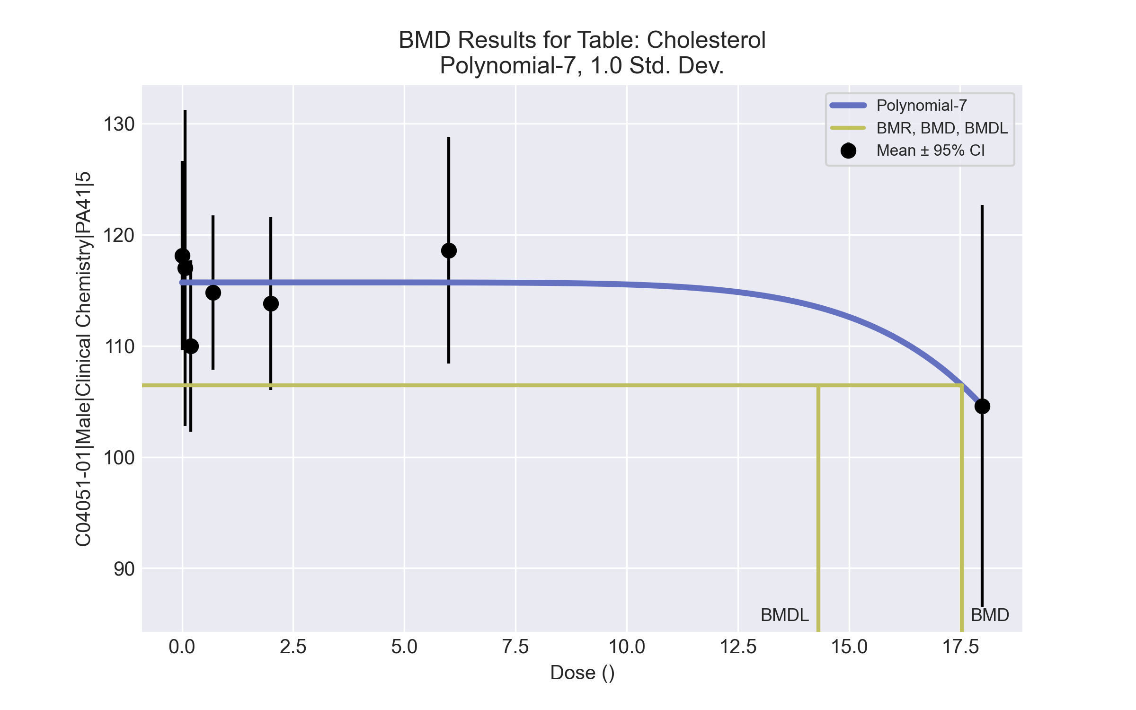
====================================================================
Polynomial Model. (Version: 2.21; Date: 03/14/2017)
Input Data File: C:\Windows\TEMP\bmds-yddlnpcd.(d)
Gnuplot Plotting File: C:\Windows\TEMP\bmds-yddlnpcd.plt
Tue Apr 13 09:17:53 2021
====================================================================
BMDS_Model_Run
~~~~~~~~~~~~~~~~~~~~~~~~~~~~~~~~~~~~~~~~~~~~~~~~~~~~~~~~~~~~~~~~~~~~~
The form of the response function is:
Y[dose] = beta_0 + beta_1*dose + beta_2*dose^2 + ...
Dependent variable = Response
Independent variable = Dose
rho is set to 0
The polynomial coefficients are restricted to be negative
A constant variance model is fit
Total number of dose groups = 7
Total number of records with missing values = 0
Maximum number of iterations = 500
Relative Function Convergence has been set to: 1e-008
Parameter Convergence has been set to: 1e-008
Default Initial Parameter Values
alpha = 95.5278
rho = 0 Specified
beta_0 = 32.8116
beta_1 = -15.3838
beta_2 = -258.964
beta_3 = 0
beta_4 = -266.2
beta_5 = 0
beta_6 = 0
beta_7 = -0.124249
Asymptotic Correlation Matrix of Parameter Estimates
( *** The model parameter(s) -rho -beta_1 -beta_2 -beta_3 -beta_4 -beta_5 -beta_6
have been estimated at a boundary point, or have been specified by the user,
and do not appear in the correlation matrix )
alpha beta_0 beta_7
alpha 1 8.4e-008 -8.8e-008
beta_0 8.4e-008 1 -0.36
beta_7 -8.9e-008 -0.36 1
Parameter Estimates
95.0% Wald Confidence Interval
Variable Estimate Std. Err. Lower Conf. Limit Upper Conf. Limit
alpha 85.754 19.4194 47.6926 123.815
beta_0 115.706 1.58824 112.594 118.819
beta_1 -4.71417e-022 NA
beta_2 -1.70097e-023 NA
beta_3 -0 NA
beta_4 0 NA
beta_5 -7.67619e-027 NA
beta_6 -2.23902e-028 NA
beta_7 -1.81391e-008 7.2453e-009 -3.23396e-008 -3.93855e-009
NA - Indicates that this parameter has hit a bound
implied by some inequality constraint and thus
has no standard error.
Table of Data and Estimated Values of Interest
Dose N Obs Mean Est Mean Obs Std Dev Est Std Dev Scaled Res.
------ --- -------- -------- ----------- ----------- ----------
0 9 118 116 11.1 9.26 0.779
0.07 5 117 116 11.4 9.26 0.312
0.2 5 110 116 6.2 9.26 -1.38
0.7 5 115 116 5.59 9.26 -0.219
2 5 114 116 6.26 9.26 -0.46
6 5 119 116 8.2 9.26 0.7
18 5 105 105 14.6 9.26 -0.00032
Model Descriptions for likelihoods calculated
Model A1: Yij = Mu(i) + e(ij)
Var{e(ij)} = Sigma^2
Model A2: Yij = Mu(i) + e(ij)
Var{e(ij)} = Sigma(i)^2
Model A3: Yij = Mu(i) + e(ij)
Var{e(ij)} = Sigma^2
Model A3 uses any fixed variance parameters that
were specified by the user
Model R: Yi = Mu + e(i)
Var{e(i)} = Sigma^2
Likelihoods of Interest
Model Log(likelihood) # Param's AIC
A1 -104.551031 8 225.102062
A2 -100.259495 14 228.518991
A3 -104.551031 8 225.102062
fitted -106.303913 3 218.607825
R -109.210095 2 222.420190
Explanation of Tests
Test 1: Do responses and/or variances differ among Dose levels?
(A2 vs. R)
Test 2: Are Variances Homogeneous? (A1 vs A2)
Test 3: Are variances adequately modeled? (A2 vs. A3)
Test 4: Does the Model for the Mean Fit? (A3 vs. fitted)
(Note: When rho=0 the results of Test 3 and Test 2 will be the same.)
Tests of Interest
Test -2*log(Likelihood Ratio) Test df p-value
Test 1 17.9012 12 0.1187
Test 2 8.58307 6 0.1984
Test 3 8.58307 6 0.1984
Test 4 3.50576 5 0.6225
The p-value for Test 1 is greater than .05. There may not be a
diffence between responses and/or variances among the dose levels
Modelling the data with a dose/response curve may not be appropriate
The p-value for Test 2 is greater than .1. A homogeneous variance
model appears to be appropriate here
The p-value for Test 3 is greater than .1. The modeled variance appears
to be appropriate here
The p-value for Test 4 is greater than .1. The model chosen seems
to adequately describe the data
Benchmark Dose Computation
Specified effect = 1
Risk Type = Estimated standard deviations from the control mean
Confidence level = 0.95
BMD = 17.5389
BMDL = 14.3102
BMDU = 24.6502

Male BMD Results for Table: Creatinine
BMDS version: BMDS v2.7.0

Input dataset
Dose | 0 | 0.07 | 0.2 | 0.7 | 2 | 6 | 18 | 55 | 160 | 475
N | 9 | 5 | 5 | 5 | 5 | 5 | 5 | 5 | 5 | 4
Mean ± SD | 0.478 ± 0.044 | 0.46 ± 0.055 | 0.46 ± 0.055 | 0.5 ± 0 | 0.42 ± 0.045 | 0.42 ± 0.045 | 0.42 ± 0.045 | 0.38 ± 0.11 | 0.44 ± 0.055 | 0.475 ± 0.05

Summary table
Modelª | Goodness of fit |  | BMD | BMDL | Comments
 | p-value | AIC
Linear | <0.0001 | -238.868 | -9999 | 454.687 | No model was recommended as a best-fitting model. Doses were dropped until there were only 3 remaining dose-groups.
Polynomial 2° | <0.0001 | -238.868 | -9999 | 655.211
Polynomial 3° | <0.0001 | -238.868 | -9999 | 643.396
Polynomial 4° | <0.0001 | -238.868 | -9999 | 597.384
Polynomial 5° | <0.0001 | -200.154 | -9999 | -999
Polynomial 6° | <0.0001 | -238.868 | -9999 | -999
Polynomial 7° | <0.0001 | 672.235 | -9999 | -999
Polynomial 8° | <0.0001 | -238.868 | -9999 | -999
Power | <0.0001 | -236.518 | 582.081 | 436
Hill | <0.0001 | -246.746 | 2.016 | -999
Exponential M2 | -999 | -236.868 | 1 | -999
Exponential M3 | -999 | -234.868 | 26102 | -999
Exponential M4 | -999 | -239.607 | -999 | 0
Exponential M5 | -999 | -238.605 | -999 | 0
ª Modeled variance case presented (BMDS Test 2 p-value = <0.0001, BMDS Test 3 p-value = <0.0001).

Model recommendation details
Model | Bin | Notes
Linear | Warning | Warnings  • Residual of Interest does not exist  • Variance model poorly fits dataset (p-value 3 = 0.0001)  Cautions  • Warning(s): THIS USUALLY MEANS THE MODEL HAS NOT CONVERGED!; BMD = 100*(maximum dose); Warning: Likelihood for fitted model larger than the Likelihood for model A3.
Polynomial 2° | Warning | Warnings  • Residual of Interest does not exist  • Variance model poorly fits dataset (p-value 3 = 0.0001)  Cautions  • Warning(s): BMD = 100*(maximum dose); Warning: Likelihood for fitted model larger than the Likelihood for model A3.  • BMDL/high dose ratio is greater than threshold (1.38 > 1.0)
Polynomial 3° | Warning | Warnings  • Residual of Interest does not exist  • Variance model poorly fits dataset (p-value 3 = 0.0001)  Cautions  • Warning(s): THIS USUALLY MEANS THE MODEL HAS NOT CONVERGED!; BMD = 100*(maximum dose); Warning: Likelihood for fitted model larger than the Likelihood for model A3.  • BMDL/high dose ratio is greater than threshold (1.35 > 1.0)
Polynomial 4° | Warning | Warnings  • Residual of Interest does not exist  • Variance model poorly fits dataset (p-value 3 = 0.0001)  Cautions  • Warning(s): THIS USUALLY MEANS THE MODEL HAS NOT CONVERGED!; BMD = 100*(maximum dose); Warning: Likelihood for fitted model larger than the Likelihood for model A3.  • BMDL/high dose ratio is greater than threshold (1.26 > 1.0)
Polynomial 5° | Failure | Failures  • BMDL does not exist  Warnings  • Residual of Interest does not exist  • Variance model poorly fits dataset (p-value 3 = 0.0001)  • Ratio of modeled to actual stdev. at control is greater than threshold (1.56 > 1.5)  Cautions  • Warning(s): BMD = 100*(maximum dose); BMDL computation failed.; Warning: Likelihood for fitted model larger than the Likelihood for model A3.
Polynomial 6° | Failure | Failures  • BMDL does not exist  Warnings  • Residual of Interest does not exist  • Variance model poorly fits dataset (p-value 3 = 0.0001)  Cautions  • Warning(s): THIS USUALLY MEANS THE MODEL HAS NOT CONVERGED!; BMD = 100*(maximum dose); BMDL computation failed.; Warning: Likelihood for fitted model larger than the Likelihood for model A3.
Polynomial 7° | Failure | Failures  • BMDL does not exist  Warnings  • Residual of Interest does not exist  • Variance model poorly fits dataset (p-value 3 = 0.0001)  • Residual at lowest dose is greater than threshold (3.18 > 2.0)  • Ratio of modeled to actual stdev. at control is greater than threshold (3.2e+03 > 1.5)  Cautions  • Warning(s): THIS USUALLY MEANS THE MODEL HAS NOT CONVERGED!; BMD = 100*(maximum dose); BMDL computation failed.; Warning: Likelihood for fitted model larger than the Likelihood for model A3.
Polynomial 8° | Failure | Failures  • BMDL does not exist  Warnings  • Residual of Interest does not exist  • Variance model poorly fits dataset (p-value 3 = 0.0001)  Cautions  • Warning(s): THE MODEL HAS PROBABLY NOT CONVERGED!!!; THIS USUALLY MEANS THE MODEL HAS NOT CONVERGED!; BMD = 100*(maximum dose); BMDL computation failed.; Warning: Likelihood for fitted model larger than the Likelihood for model A3.
Power | Warning | Warnings  • Variance model poorly fits dataset (p-value 3 = 0.0001)  • BMD/high dose ratio is greater than threshold (1.23 > 1.0)  Cautions  • Warning(s): Warning: Likelihood for fitted model larger than the Likelihood for model A3.
Hill | Failure | Failures  • BMDL does not exist  Warnings  • Variance model poorly fits dataset (p-value 3 = 0.0001)  Cautions  • Warning(s): BMDL computation failed.
Exponential M2 | Failure | Failures  • BMDL does not exist  Warnings  • Variance model poorly fits dataset (p-value 3 = 0.0001)
Exponential M3 | Failure | Failures  • BMDL does not exist  Warnings  • Variance model poorly fits dataset (p-value 3 = 0.0001)  • BMD/high dose ratio is greater than threshold (55.0 > 1.0)
Exponential M4 | Failure | Failures  • BMD does not exist  Warnings  • Residual of Interest does not exist  • Variance model poorly fits dataset (p-value 3 = 0.0001)
Exponential M5 | Failure | Failures  • BMD does not exist  Warnings  • Residual of Interest does not exist  • Variance model poorly fits dataset (p-value 3 = 0.0001)

Recommended model
No model was recommended as a best-fitting model.

Male BMD Results for Table: Globulin (measured)
BMDS version: BMDS v2.7.0

Input dataset
Dose | 0 | 0.07 | 0.2 | 0.7 | 2 | 6 | 18 | 55 | 160 | 475ª
N | 9 | 5 | 5 | 5 | 5 | 5 | 5 | 5 | 5 | 4
Mean ± SD | 1.678 ± 0.12 | 1.68 ± 0.192 | 1.6 ± 0.1 | 1.72 ± 0.084 | 1.78 ± 0.148 | 1.74 ± 0.27 | 1.66 ± 0.279 | 1.76 ± 0.114 | 1.9 ± 0.255 | 1.875 ± 0.171
ª Dose group removed in BMD modeling session

Summary table
Modelª | Goodness of fit |  | BMD | BMDL | Comments
 | p-value | AIC
Linear (equivalent models include Power) | 0.148 | -116.789 | 124.821 | 65.1 | Exponential-M2 recommended as best-fitting model on the basis of the lowest AIC.
Polynomial 2° | 0.095 | -114.795 | 127.215 | 65.14
Polynomial 3° | 0.096 | -114.815 | 131.477 | 65.279
Polynomial 4° | 0.096 | -114.823 | 134.312 | 65.335
Polynomial 5° | 0.096 | -114.826 | 136.452 | 65.355
Polynomial 6° | 0.096 | -114.827 | 138.155 | 65.361
Polynomial 7° | 0.096 | -114.827 | 139.555 | 65.364
Polynomial 8° | 0.096 | -114.827 | 140.736 | 65.364
Hill | 0.095 | -114.789 | 124.752 | -999
Exponential M2^{b} (equivalent models include Exponential M3) | 0.148 | -116.794 | 125.835 | 68.45
Exponential M4 | 0.095 | -114.789 | 124.771 | 0.44
Exponential M5 | 0.095 | -114.789 | 124.765 | 8.165
ª Modeled variance case presented (BMDS Test 2 p-value = 0.039, BMDS Test 3 p-value = 0.318).
^{b} Recommended model

Model recommendation details
Model | Bin | Notes
Linear (equivalent models include Power) | Valid | -
Polynomial 2° | Warning | Warnings  • Goodness of fit p-value is less than threshold (0.0954 < 0.1)
Polynomial 3° | Warning | Warnings  • Goodness of fit p-value is less than threshold (0.096 < 0.1)
Polynomial 4° | Warning | Warnings  • Goodness of fit p-value is less than threshold (0.0963 < 0.1)
Polynomial 5° | Warning | Warnings  • Goodness of fit p-value is less than threshold (0.0964 < 0.1)
Polynomial 6° | Warning | Warnings  • Goodness of fit p-value is less than threshold (0.0964 < 0.1)
Polynomial 7° | Warning | Warnings  • Goodness of fit p-value is less than threshold (0.0964 < 0.1)
Polynomial 8° | Warning | Warnings  • Goodness of fit p-value is less than threshold (0.0964 < 0.1)
Hill | Failure | Failures  • BMDL does not exist  Warnings  • Goodness of fit p-value is less than threshold (0.0951 < 0.1)  Cautions  • Warning(s): BMDL computation failed.
Exponential M2ª (equivalent models include Exponential M3) | Valid | -
Exponential M4 | Warning | Warnings  • Goodness of fit p-value is less than threshold (0.0951 < 0.1)  • BMD/BMDL ratio is greater than threshold (2.84e+02 > 20.0)  Cautions  • BMD/BMDL ratio is greater than threshold (2.84e+02 > 5.0)
Exponential M5 | Warning | Warnings  • Goodness of fit p-value is less than threshold (0.0951 < 0.1)  Cautions  • BMD/BMDL ratio is greater than threshold (15.3 > 5.0)
ª Recommended model

Recommended model
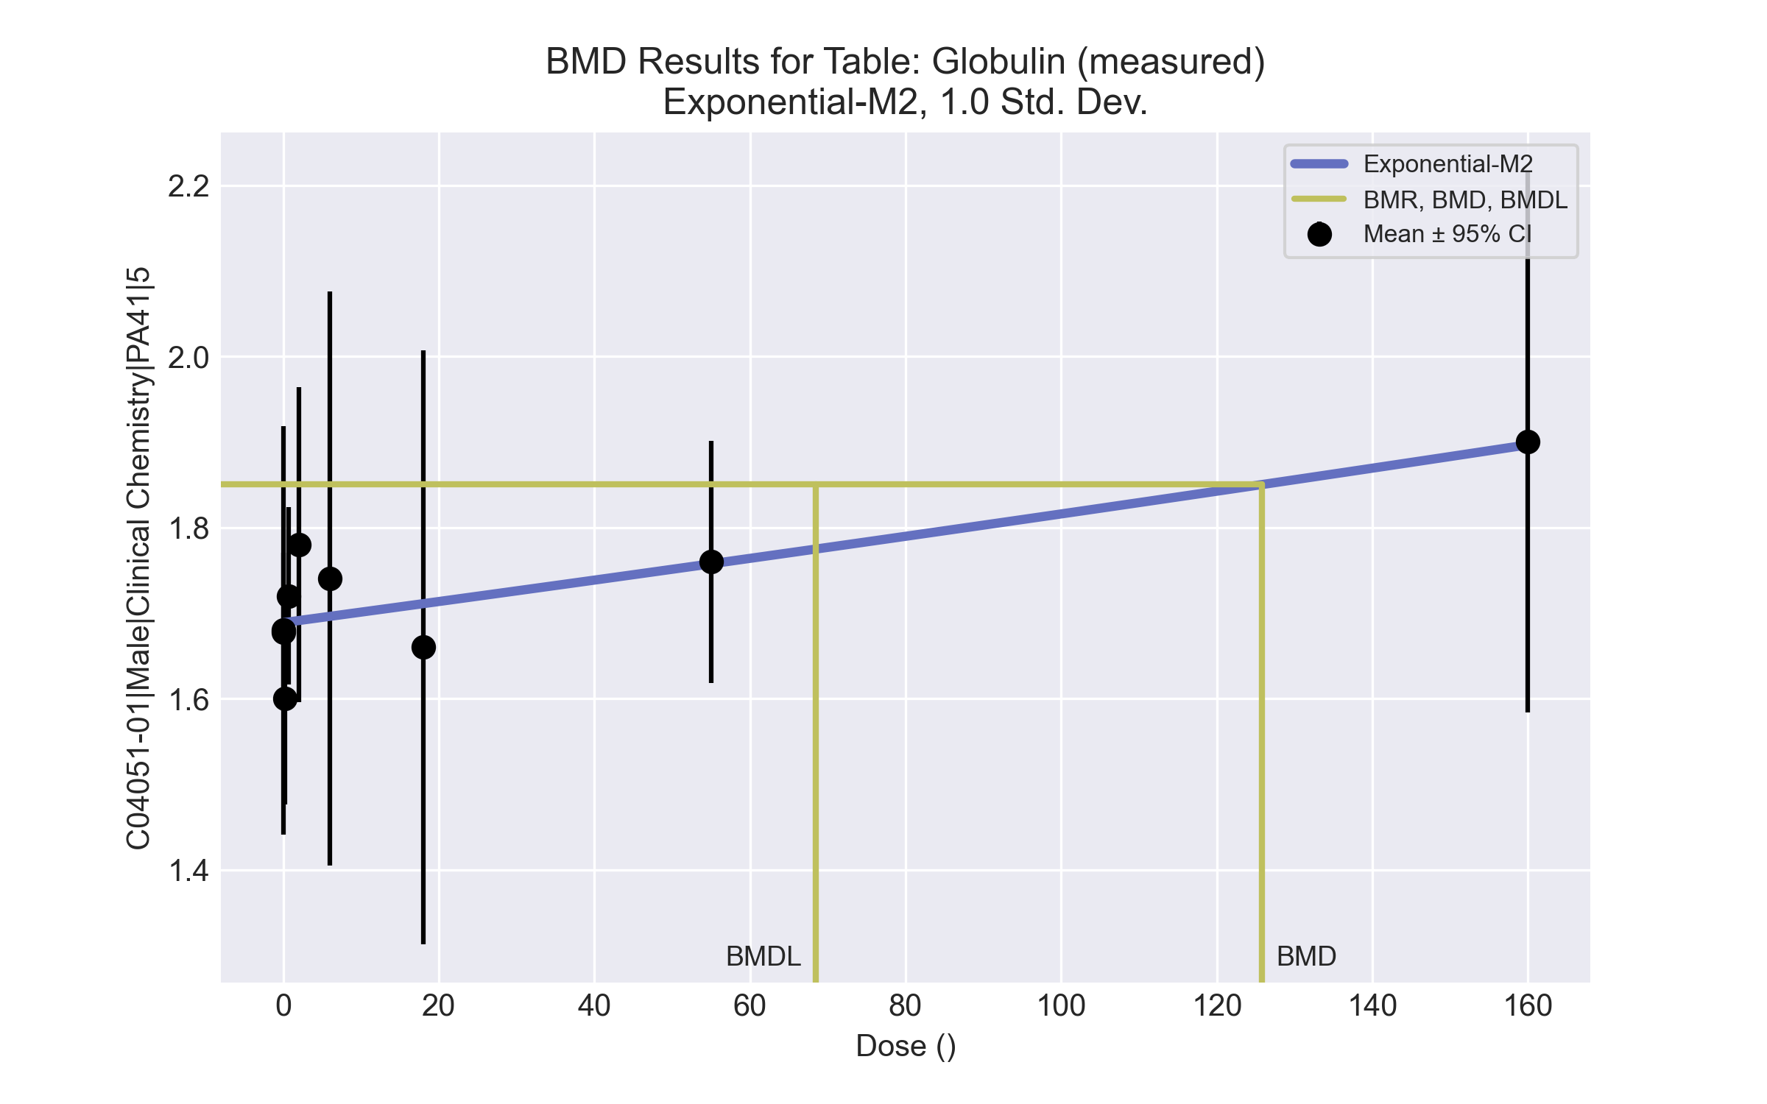
====================================================================
Exponential Model. (Version: 1.11; Date: 03/14/2017)
Input Data File: C:\Windows\TEMP\bmds-6fn5mbu1.(d)
Gnuplot Plotting File:
Tue Apr 13 09:18:53 2021
====================================================================
BMDS_Model_Run
~~~~~~~~~~~~~~~~~~~~~~~~~~~~~~~~~~~~~~~~~~~~~~~~~~~~~~~~~~~~~~~~~~~~~
The form of the response function by Model:
Model 2: Y[dose] = a * exp{sign * b * dose}
Model 3: Y[dose] = a * exp{sign * (b * dose)^d}
Model 4: Y[dose] = a * [c-(c-1) * exp{-b * dose}]
Model 5: Y[dose] = a * [c-(c-1) * exp{-(b * dose)^d}]
Note: Y[dose] is the median response for exposure = dose;
sign = +1 for increasing trend in data;
sign = -1 for decreasing trend.
Model 2 is nested within Models 3 and 4.
Model 3 is nested within Model 5.
Model 4 is nested within Model 5.
Dependent variable = Response
Independent variable = Dose
Data are assumed to be distributed: normally
Variance Model: exp(lnalpha +rho *ln(Y[dose]))
The variance is to be modeled as Var(i) = exp(lalpha + log(mean(i)) * rho)
Total number of dose groups = 9
Total number of records with missing values = 0
Maximum number of iterations = 500
Relative Function Convergence has been set to: 1e-008
Parameter Convergence has been set to: 1e-008
MLE solution provided: Exact
Initial Parameter Values
Variable Model 2
-------- --------
lnalpha -7.00167
rho 6.10097
a 1.68783
b 0.000732677
c 0 Specified
d 1 Specified
Parameter Estimates
Variable Model 2 Std. Err.
-------- ------- ---------
lnalpha -6.57539 3.47089
rho 5.58872 6.40013
a 1.68876 0.0261302
b 0.000725655 0.000334428
NC = No Convergence
Table of Stats From Input Data
Dose N Obs Mean Obs Std Dev
----- --- ---------- -------------
0 9 1.678 0.1202
0.07 5 1.68 0.1924
0.2 5 1.6 0.1
0.7 5 1.72 0.08367
2 5 1.78 0.1483
6 5 1.74 0.2702
18 5 1.66 0.2793
55 5 1.76 0.114
160 5 1.9 0.255
Estimated Values of Interest
Dose Est Mean Est Std Scaled Residual
------ ---------- --------- ----------------
0 1.689 0.1615 -0.204
0.07 1.689 0.1615 -0.1224
0.2 1.689 0.1615 -1.232
0.7 1.69 0.1617 0.4202
2 1.691 0.1621 1.225
6 1.696 0.1634 0.6002
18 1.711 0.1675 -0.6804
55 1.758 0.1805 0.03072
160 1.897 0.2233 0.03338
Other models for which likelihoods are calculated:
Model A1: Yij = Mu(i) + e(ij)
Var{e(ij)} = Sigma^2
Model A2: Yij = Mu(i) + e(ij)
Var{e(ij)} = Sigma(i)^2
Model A3: Yij = Mu(i) + e(ij)
Var{e(ij)} = exp(lalpha + log(mean(i)) * rho)
Model R: Yij = Mu + e(i)
Var{e(ij)} = Sigma^2
Likelihoods of Interest
Model Log(likelihood) DF AIC
------- ----------------- ---- ------------
A1 63.76057 10 -107.5211
A2 71.87408 18 -107.7482
A3 67.78869 11 -113.5774
R 58.73563 2 -113.4713
2 62.39679 4 -116.7936
Additive constant for all log-likelihoods = -45.03. This constant added to the
above values gives the log-likelihood including the term that does not
depend on the model parameters.
Explanation of Tests
Test 1: Does response and/or variances differ among Dose levels? (A2 vs. R)
Test 2: Are Variances Homogeneous? (A2 vs. A1)
Test 3: Are variances adequately modeled? (A2 vs. A3)
Test 4: Does Model 2 fit the data? (A3 vs. 2)
Tests of Interest
Test -2*log(Likelihood Ratio) D. F. p-value
-------- ------------------------ ------ --------------
Test 1 26.28 16 0.05025
Test 2 16.23 8 0.03924
Test 3 8.171 7 0.3178
Test 4 10.78 7 0.1483
The p-value for Test 1 is greater than .05. There may not be a
diffence between responses and/or variances among the dose levels
Modelling the data with a dose/response curve may not be appropriate.
The p-value for Test 2 is less than .1. A non-homogeneous
variance model appears to be appropriate.
The p-value for Test 3 is greater than .1. The modeled
variance appears to be appropriate here.
The p-value for Test 4 is greater than .1. Model 2 seems
to adequately describe the data.
Benchmark Dose Computations:
Specified Effect = 1.000000
Risk Type = Estimated standard deviations from control
Confidence Level = 0.950000
BMD = 125.835
BMDL = 68.4501
BMDU = 523.332

Male BMD Results for Table: Reticulocyte count
BMDS version: BMDS v2.7.0

Input dataset
Dose | 0 | 0.07 | 0.2 | 0.7 | 2 | 6 | 18 | 55 | 160ª | 475ª
N | 10 | 5 | 5 | 5 | 5 | 5 | 5 | 5 | 5 | 4
Mean ± SD | 227.38 ± 30.772 | 226.36 ± 20.748 | 264.32 ± 36.085 | 258.4 ± 42.383 | 234.7 ± 33.706 | 241.22 ± 26.565 | 216.68 ± 39.678 | 210.62 ± 8.811 | 226.56 ± 54.38 | 174.5 ± 14.537
ª Dose group removed in BMD modeling session

Summary table
Modelª | Goodness of fit |  | BMD | BMDL | Comments
 | p-value | AIC
Linear | 0.061 | 364.058 | -9999 | 195.613 | Power recommended as best-fitting model on the basis of the lowest AIC.
Polynomial 2° | 0.061 | 364.058 | -9999 | 99.776
Polynomial 3° | 0.061 | 364.058 | -9999 | 80.906
Polynomial 4° | 0.061 | 364.058 | -9999 | 73.256
Polynomial 5° | 0.061 | 364.058 | -9999 | 70.604
Polynomial 6° | 0.061 | 364.058 | -9999 | 75.058
Polynomial 7° | 0.061 | 364.058 | -9999 | -999
Polynomial 8° | 0.061 | 364.058 | -9999 | -999
Power^{b} | 0.162 | 361.774 | 54.227 | 30.205
Hill | 0.145 | 362.77 | -999 | -999
Exponential M2 | 0.117 | 362.742 | -44.298 | -999
Exponential M3 | 0.117 | 362.742 | -44.298 | -999
Exponential M4 | 0.019 | 368.058 | -999 | 0
Exponential M5 | 0.009 | 370.058 | -999 | 0
ª Constant variance case presented (BMDS Test 2 p-value = 0.111, BMDS Test 3 p-value = 0.111).
^{b} Recommended model

Model recommendation details
Model | Bin | Notes
Linear | Warning | Warnings  • Residual of Interest does not exist  • Goodness of fit p-value is less than threshold (0.061 < 0.1)  Cautions  • Warning(s): BMD = 100*(maximum dose)  • BMDL/high dose ratio is greater than threshold (3.56 > 1.0)
Polynomial 2° | Warning | Warnings  • Residual of Interest does not exist  • Goodness of fit p-value is less than threshold (0.061 < 0.1)  Cautions  • Warning(s): BMD = 100*(maximum dose)  • BMDL/high dose ratio is greater than threshold (1.81 > 1.0)
Polynomial 3° | Warning | Warnings  • Residual of Interest does not exist  • Goodness of fit p-value is less than threshold (0.061 < 0.1)  Cautions  • Warning(s): BMD = 100*(maximum dose)  • BMDL/high dose ratio is greater than threshold (1.47 > 1.0)
Polynomial 4° | Warning | Warnings  • Residual of Interest does not exist  • Goodness of fit p-value is less than threshold (0.061 < 0.1)  Cautions  • Warning(s): BMD = 100*(maximum dose)  • BMDL/high dose ratio is greater than threshold (1.33 > 1.0)
Polynomial 5° | Warning | Warnings  • Residual of Interest does not exist  • Goodness of fit p-value is less than threshold (0.061 < 0.1)  Cautions  • Warning(s): BMD = 100*(maximum dose)  • BMDL/high dose ratio is greater than threshold (1.28 > 1.0)
Polynomial 6° | Warning | Warnings  • Residual of Interest does not exist  • Goodness of fit p-value is less than threshold (0.061 < 0.1)  Cautions  • Warning(s): BMD = 100*(maximum dose)  • BMDL/high dose ratio is greater than threshold (1.36 > 1.0)
Polynomial 7° | Failure | Failures  • BMDL does not exist  Warnings  • Residual of Interest does not exist  • Goodness of fit p-value is less than threshold (0.061 < 0.1)  Cautions  • Warning(s): BMD = 100*(maximum dose); BMDL computation failed.
Polynomial 8° | Failure | Failures  • BMDL does not exist  Warnings  • Residual of Interest does not exist  • Goodness of fit p-value is less than threshold (0.061 < 0.1)  Cautions  • Warning(s): BMD = 100*(maximum dose); BMDL computation failed.
Powerª | Valid | -
Hill | Failure | Failures  • BMD does not exist  • BMDL does not exist  Warnings  • Residual of Interest does not exist  Cautions  • Warning(s): BMR value is not in the range of the mean function
Exponential M2 | Failure | Failures  • BMDL does not exist  Warnings  • Residual of Interest does not exist
Exponential M3 | Failure | Failures  • BMDL does not exist  Warnings  • Residual of Interest does not exist  • Residual at lowest dose is greater than threshold (25.2 > 2.0)
Exponential M4 | Failure | Failures  • BMD does not exist  Warnings  • Residual of Interest does not exist  • Goodness of fit p-value is less than threshold (0.0192 < 0.1)
Exponential M5 | Failure | Failures  • BMD does not exist  Warnings  • Residual of Interest does not exist  • Goodness of fit p-value is less than threshold (0.00911 < 0.1)
ª Recommended model

Recommended model
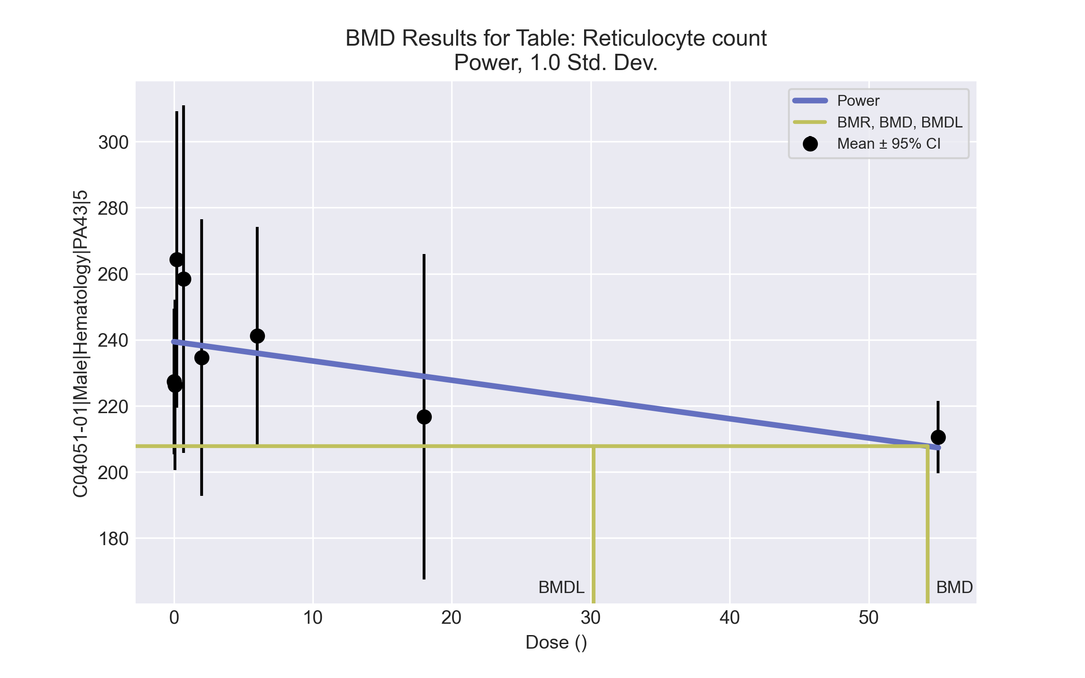
====================================================================
Power Model. (Version: 2.19; Date: 03/14/2017)
Input Data File: C:\Windows\TEMP\bmds-3cwza94_.(d)
Gnuplot Plotting File: C:\Windows\TEMP\bmds-3cwza94_.plt
Tue Apr 13 09:19:34 2021
====================================================================
BMDS_Model_Run
~~~~~~~~~~~~~~~~~~~~~~~~~~~~~~~~~~~~~~~~~~~~~~~~~~~~~~~~~~~~~~~~~~~~~
The form of the response function is:
Y[dose] = control + slope * dose^power
Dependent variable = Response
Independent variable = Dose
rho is set to 0
The power is restricted to be greater than or equal to 1
A constant variance model is fit
Total number of dose groups = 8
Total number of records with missing values = 0
Maximum number of iterations = 500
Relative Function Convergence has been set to: 1e-008
Parameter Convergence has been set to: 1e-008
Default Initial Parameter Values
alpha = 989.533
rho = 0 Specified
control = 210.62
slope = 24.3155
power = -9999
Asymptotic Correlation Matrix of Parameter Estimates
( *** The model parameter(s) -rho -power
have been estimated at a boundary point, or have been specified by the user,
and do not appear in the correlation matrix )
alpha control slope
alpha 1 -5.6e-010 -1.1e-010
control -5.6e-010 1 -0.47
slope -1.1e-010 -0.47 1
Parameter Estimates
95.0% Wald Confidence Interval
Variable Estimate Std. Err. Lower Conf. Limit Upper Conf. Limit
alpha 998.335 210.468 585.827 1410.84
control 239.425 5.33404 228.97 249.879
slope -0.582672 0.274857 -1.12138 -0.0439619
power 1 NA
NA - Indicates that this parameter has hit a bound
implied by some inequality constraint and thus
has no standard error.
Table of Data and Estimated Values of Interest
Dose N Obs Mean Est Mean Obs Std Dev Est Std Dev Scaled Res.
------ --- -------- -------- ----------- ----------- ----------
0 10 227 239 30.8 31.6 -1.21
0.07 5 226 239 20.7 31.6 -0.922
0.2 5 264 239 36.1 31.6 1.77
0.7 5 258 239 42.4 31.6 1.37
2 5 235 238 33.7 31.6 -0.252
6 5 241 236 26.6 31.6 0.374
18 5 217 229 39.7 31.6 -0.867
55 5 211 207 8.81 31.6 0.229
Model Descriptions for likelihoods calculated
Model A1: Yij = Mu(i) + e(ij)
Var{e(ij)} = Sigma^2
Model A2: Yij = Mu(i) + e(ij)
Var{e(ij)} = Sigma(i)^2
Model A3: Yij = Mu(i) + e(ij)
Var{e(ij)} = Sigma^2
Model A3 uses any fixed variance parameters that
were specified by the user
Model R: Yi = Mu + e(i)
Var{e(i)} = Sigma^2
Likelihoods of Interest
Model Log(likelihood) # Param's AIC
A1 -173.283492 9 364.566983
A2 -167.429620 16 366.859239
A3 -173.283492 9 364.566983
fitted -177.887010 3 361.774020
R -180.028767 2 364.057534
Explanation of Tests
Test 1: Do responses and/or variances differ among Dose levels?
(A2 vs. R)
Test 2: Are Variances Homogeneous? (A1 vs A2)
Test 3: Are variances adequately modeled? (A2 vs. A3)
Test 4: Does the Model for the Mean Fit? (A3 vs. fitted)
(Note: When rho=0 the results of Test 3 and Test 2 will be the same.)
Tests of Interest
Test -2*log(Likelihood Ratio) Test df p-value
Test 1 25.1983 14 0.03266
Test 2 11.7077 7 0.1106
Test 3 11.7077 7 0.1106
Test 4 9.20704 6 0.1623
The p-value for Test 1 is less than .05. There appears to be a
difference between response and/or variances among the dose levels
It seems appropriate to model the data
The p-value for Test 2 is greater than .1. A homogeneous variance
model appears to be appropriate here
The p-value for Test 3 is greater than .1. The modeled variance appears
to be appropriate here
The p-value for Test 4 is greater than .1. The model chosen seems
to adequately describe the data
Benchmark Dose Computation
Specified effect = 1
Risk Type = Estimated standard deviations from the control mean
Confidence level = 0.95
BMD = 54.2268
BMDL = 30.2052
BMDU = 264.27

Male BMD Results for Table: Free Thyroxine
BMDS version: BMDS v2.7.0

Input dataset
Dose | 0 | 0.07 | 0.2 | 0.7 | 2 | 6 | 18 | 55 | 160 | 475
N | 9 | 4 | 4 | 4 | 4 | 4 | 4 | 5 | 5 | 5
Mean ± SD | 7.26 ± 0.875 | 7.205 ± 0.474 | 6.785 ± 0.398 | 5.98 ± 0.734 | 6.84 ± 1.37 | 6.485 ± 1.167 | 6.98 ± 0.945 | 7.042 ± 0.557 | 5.604 ± 0.792 | 6.232 ± 1.187

Summary table
Modelª | Goodness of fit |  | BMD | BMDL | Comments
 | p-value | AIC
Linear (equivalent models include Power, Polynomial 2°) | 0.067 | 47.108 | 515.172 | 276.926 | Exponential-M5 recommended as best-fitting model on the basis of the lowest AIC.
Polynomial 3° (equivalent models include Polynomial 4°, 6°, 7°, 8°) | 0.067 | 47.108 | 515.171 | 276.926
Polynomial 5° | 0.067 | 47.108 | 515.173 | 276.926
Hill | 0.213 | 44.102 | 104.854 | -999
Exponential M2 (equivalent models include Exponential M3) | 0.07 | 46.99 | 502.014 | 256.124
Exponential M4 | 0.092 | 46.796 | 401.957 | 59.72
Exponential M5^{b} | 0.143 | 46.102 | 142.469 | 57.746
ª Constant variance case presented (BMDS Test 2 p-value = 0.263, BMDS Test 3 p-value = 0.263).
^{b} Recommended model

Model recommendation details
Model | Bin | Notes
Linear (equivalent models include Power, Polynomial 2°) | Warning | Warnings  • Goodness of fit p-value is less than threshold (0.0675 < 0.1)  • BMD/high dose ratio is greater than threshold (1.08 > 1.0)
Polynomial 3° (equivalent models include Polynomial 4°, 6°, 7°, 8°) | Warning | Warnings  • Goodness of fit p-value is less than threshold (0.0675 < 0.1)  • BMD/high dose ratio is greater than threshold (1.08 > 1.0)
Polynomial 5° | Warning | Warnings  • Goodness of fit p-value is less than threshold (0.0675 < 0.1)  • BMD/high dose ratio is greater than threshold (1.08 > 1.0)
Hill | Failure | Failures  • BMDL does not exist  Cautions  • Warning(s): BMDL computation failed.
Exponential M2 (equivalent models include Exponential M3) | Warning | Warnings  • Goodness of fit p-value is less than threshold (0.0701 < 0.1)  • BMD/high dose ratio is greater than threshold (1.06 > 1.0)
Exponential M4 | Warning | Warnings  • Goodness of fit p-value is less than threshold (0.0916 < 0.1)  Cautions  • BMD/BMDL ratio is greater than threshold (6.73 > 5.0)
Exponential M5ª | Valid | -
ª Recommended model

Recommended model
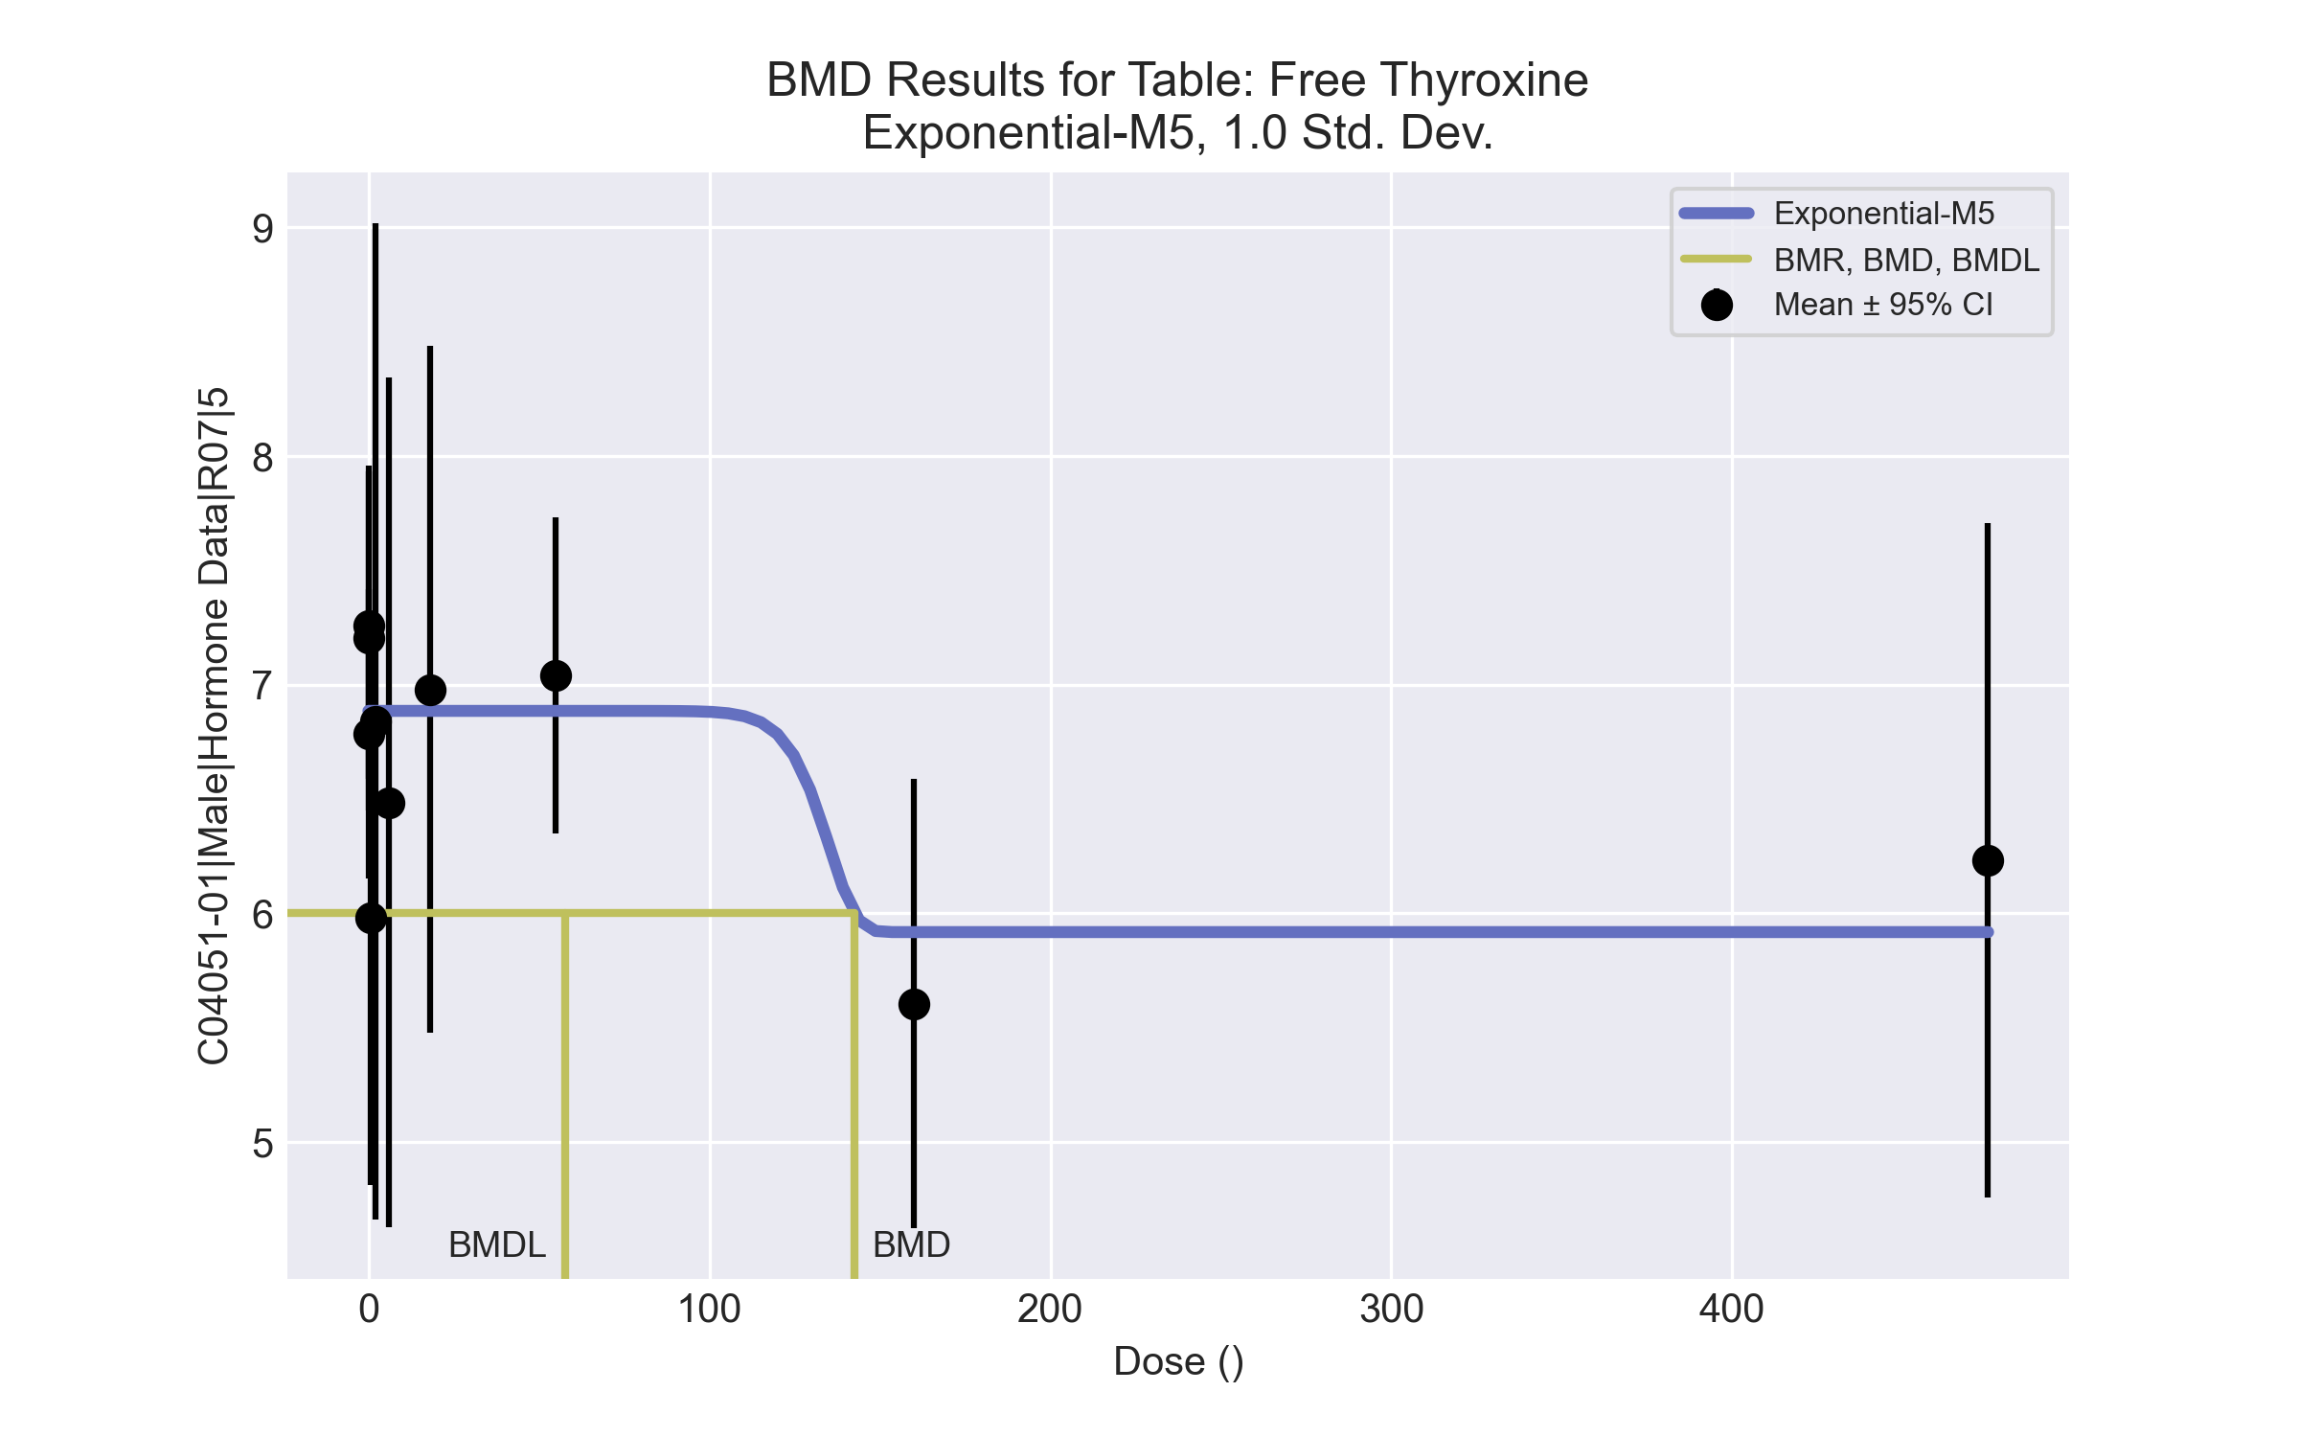
====================================================================
Exponential Model. (Version: 1.11; Date: 03/14/2017)
Input Data File: C:\Windows\TEMP\bmds-4o5xn1pi.(d)
Gnuplot Plotting File:
Tue Apr 13 09:27:33 2021
====================================================================
BMDS_Model_Run
~~~~~~~~~~~~~~~~~~~~~~~~~~~~~~~~~~~~~~~~~~~~~~~~~~~~~~~~~~~~~~~~~~~~~
The form of the response function by Model:
Model 2: Y[dose] = a * exp{sign * b * dose}
Model 3: Y[dose] = a * exp{sign * (b * dose)^d}
Model 4: Y[dose] = a * [c-(c-1) * exp{-b * dose}]
Model 5: Y[dose] = a * [c-(c-1) * exp{-(b * dose)^d}]
Note: Y[dose] is the median response for exposure = dose;
sign = +1 for increasing trend in data;
sign = -1 for decreasing trend.
Model 2 is nested within Models 3 and 4.
Model 3 is nested within Model 5.
Model 4 is nested within Model 5.
Dependent variable = Response
Independent variable = Dose
Data are assumed to be distributed: normally
Variance Model: exp(lnalpha +rho *ln(Y[dose]))
rho is set to 0.
A constant variance model is fit.
Total number of dose groups = 10
Total number of records with missing values = 0
Maximum number of iterations = 500
Relative Function Convergence has been set to: 1e-008
Parameter Convergence has been set to: 1e-008
MLE solution provided: Exact
Initial Parameter Values
Variable Model 5
-------- --------
lnalpha -0.447682
rho 0 Specified
a 7.623
b 0.00320938
c 0.700137
d 1
Parameter Estimates
Variable Model 5 Std. Err.
-------- ------- ---------
lnalpha -0.247876 0.15931
a 6.88553 0.143312
b 0.00737614 0.287471
c 0.859484 0.0443416
d 18 NA
NC = No Convergence
Table of Stats From Input Data
Dose N Obs Mean Obs Std Dev
----- --- ---------- -------------
0 9 7.26 0.8753
0.07 4 7.205 0.4737
0.2 4 6.785 0.3985
0.7 4 5.98 0.7344
2 4 6.84 1.37
6 4 6.485 1.167
18 4 6.98 0.9446
55 5 7.042 0.5573
160 5 5.604 0.7917
475 5 6.232 1.187
Estimated Values of Interest
Dose Est Mean Est Std Scaled Residual
------ ---------- --------- ----------------
0 6.886 0.8834 1.272
0.07 6.886 0.8834 0.7233
0.2 6.886 0.8834 -0.2276
0.7 6.886 0.8834 -2.05
2 6.886 0.8834 -0.1031
6 6.886 0.8834 -0.9067
18 6.886 0.8834 0.2139
55 6.886 0.8834 0.3961
160 5.918 0.8834 -0.7948
475 5.918 0.8834 0.7948
Other models for which likelihoods are calculated:
Model A1: Yij = Mu(i) + e(ij)
Var{e(ij)} = Sigma^2
Model A2: Yij = Mu(i) + e(ij)
Var{e(ij)} = Sigma(i)^2
Model A3: Yij = Mu(i) + e(ij)
Var{e(ij)} = exp(lalpha + log(mean(i)) * rho)
Model R: Yij = Mu + e(i)
Var{e(ij)} = Sigma^2
Likelihoods of Interest
Model Log(likelihood) DF AIC
------- ----------------- ---- ------------
A1 -13.25564 11 48.51129
A2 -7.657695 20 55.31539
A3 -13.25564 11 48.51129
R -22.38312 2 48.76624
5 -18.05097 5 46.10194
Additive constant for all log-likelihoods = -44.11. This constant added to the
above values gives the log-likelihood including the term that does not
depend on the model parameters.
Explanation of Tests
Test 1: Does response and/or variances differ among Dose levels? (A2 vs. R)
Test 2: Are Variances Homogeneous? (A2 vs. A1)
Test 3: Are variances adequately modeled? (A2 vs. A3)
Test 7a: Does Model 5 fit the data? (A3 vs 5)
Tests of Interest
Test -2*log(Likelihood Ratio) D. F. p-value
-------- ------------------------ ------ --------------
Test 1 29.45 18 0.04314
Test 2 11.2 9 0.2625
Test 3 11.2 9 0.2625
Test 7a 9.591 6 0.143
The p-value for Test 1 is less than .05. There appears to be a
difference between response and/or variances among the dose
levels, it seems appropriate to model the data.
The p-value for Test 2 is greater than .1. A homogeneous
variance model appears to be appropriate here.
The p-value for Test 3 is greater than .1. The modeled
variance appears to be appropriate here.
The p-value for Test 7a is greater than .1. Model 5 seems
to adequately describe the data.
Benchmark Dose Computations:
Specified Effect = 1.000000
Risk Type = Estimated standard deviations from control
Confidence Level = 0.950000
BMD = 142.469
BMDL = 57.7463
BMDU = 4.75e+006

Male BMD Results for Table: Thyroid Stimulating Hormone
BMDS version: BMDS v2.7.0

Input dataset
Dose | 0 | 0.07 | 0.2 | 0.7 | 2 | 6 | 18 | 55 | 160 | 475
N | 9 | 4 | 4 | 4 | 4 | 4 | 4 | 5 | 5 | 5
Mean ± SD | 4.5 ± 2.001 | 3.275 ± 1.735 | 2.725 ± 1.204 | 4.05 ± 2.011 | 3.425 ± 1.613 | 5.4 ± 2.317 | 6.8 ± 3.058 | 12.48 ± 4.847 | 5.76 ± 1.935 | 11.56 ± 5.11

Summary table
Modelª | Goodness of fit |  | BMD | BMDL | Comments
 | p-value | AIC
Linear^{b} (equivalent models include Power, Polynomial 2°, 3°, 4°, 5°, 6°, 7°, 8°) | <0.0001 | 175.161 | 138.723 | 20.376 | Linear recommended as best-fitting model on the basis of the lowest BMDL.
Hill | 0.005 | 150.239 | 9.382 | 4.195
Exponential M2 (equivalent models include Exponential M3) | <0.0001 | 177.709 | 274.775 | 183.257
Exponential M4 | 0.007 | 149.081 | 7.502 | 3.519
Exponential M5 | 0.006 | 149.7 | 10.678 | 4.426
ª Modeled variance case presented (BMDS Test 2 p-value = 0.014, BMDS Test 3 p-value = 0.999).
^{b} Recommended model

Model recommendation details
Model | Bin | Notes
Linearª (equivalent models include Power, Polynomial 2°, 3°, 4°, 5°, 6°, 7°, 8°) | Valid | Cautions  • BMD/BMDL ratio is greater than threshold (6.81 > 5.0)
Hill | Warning | Warnings  • Goodness of fit p-value is less than threshold (0.00483 < 0.1)
Exponential M2 (equivalent models include Exponential M3) | Valid | -
Exponential M4 | Warning | Warnings  • Goodness of fit p-value is less than threshold (0.00682 < 0.1)
Exponential M5 | Warning | Warnings  • Goodness of fit p-value is less than threshold (0.006 < 0.1)
ª Recommended model

Recommended model
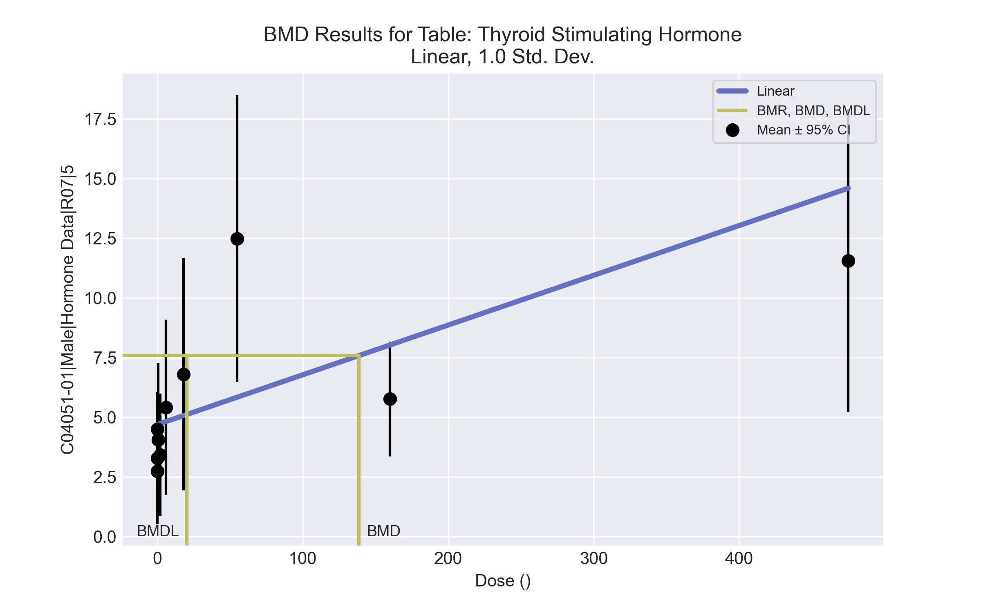
====================================================================
Polynomial Model. (Version: 2.21; Date: 03/14/2017)
Input Data File: C:\Windows\TEMP\bmds-wyu1dkx8.(d)
Gnuplot Plotting File: C:\Windows\TEMP\bmds-wyu1dkx8.plt
Tue Apr 13 09:27:37 2021
====================================================================
BMDS_Model_Run
~~~~~~~~~~~~~~~~~~~~~~~~~~~~~~~~~~~~~~~~~~~~~~~~~~~~~~~~~~~~~~~~~~~~~
The form of the response function is:
Y[dose] = beta_0 + beta_1*dose + beta_2*dose^2 + ...
Dependent variable = Response
Independent variable = Dose
The polynomial coefficients are restricted to be positive
The variance is to be modeled as Var(i) = exp(lalpha + log(mean(i)) * rho)
Total number of dose groups = 10
Total number of records with missing values = 0
Maximum number of iterations = 500
Relative Function Convergence has been set to: 1e-008
Parameter Convergence has been set to: 1e-008
Default Initial Parameter Values
lalpha = 2.13971
rho = 0
beta_0 = 4.95165
beta_1 = 0
Asymptotic Correlation Matrix of Parameter Estimates
lalpha rho beta_0 beta_1
lalpha 1 -0.99 0.037 -0.4
rho -0.99 1 -0.046 0.42
beta_0 0.037 -0.046 1 -0.28
beta_1 -0.4 0.42 -0.28 1
Parameter Estimates
95.0% Wald Confidence Interval
Variable Estimate Std. Err. Lower Conf. Limit Upper Conf. Limit
lalpha -0.546647 1.57813 -3.63973 2.54643
rho 1.72954 0.89955 -0.0335498 3.49262
beta_0 4.68593 0.483509 3.73827 5.63359
beta_1 0.020856 0.00694542 0.00724324 0.0344688
Table of Data and Estimated Values of Interest
Dose N Obs Mean Est Mean Obs Std Dev Est Std Dev Scaled Res.
------ --- -------- -------- ----------- ----------- ----------
0 9 4.5 4.69 2 2.89 -0.193
0.07 4 3.27 4.69 1.73 2.89 -0.976
0.2 4 2.73 4.69 1.2 2.9 -1.36
0.7 4 4.05 4.7 2.01 2.9 -0.448
2 4 3.42 4.73 1.61 2.92 -0.894
6 4 5.4 4.81 2.32 2.96 0.398
18 4 6.8 5.06 3.06 3.09 1.12
55 5 12.5 5.83 4.85 3.5 4.25
160 5 5.76 8.02 1.93 4.61 -1.1
475 5 11.6 14.6 5.11 7.73 -0.878
Model Descriptions for likelihoods calculated
Model A1: Yij = Mu(i) + e(ij)
Var{e(ij)} = Sigma^2
Model A2: Yij = Mu(i) + e(ij)
Var{e(ij)} = Sigma(i)^2
Model A3: Yij = Mu(i) + e(ij)
Var{e(ij)} = exp(lalpha + rho*ln(Mu(i)))
Model A3 uses any fixed variance parameters that
were specified by the user
Model R: Yi = Mu + e(i)
Var{e(i)} = Sigma^2
Likelihoods of Interest
Model Log(likelihood) # Param's AIC
A1 -69.746250 11 161.492500
A2 -59.419402 20 158.838804
A3 -59.801919 12 143.603837
fitted -83.580438 4 175.160876
R -92.286909 2 188.573817
Explanation of Tests
Test 1: Do responses and/or variances differ among Dose levels?
(A2 vs. R)
Test 2: Are Variances Homogeneous? (A1 vs A2)
Test 3: Are variances adequately modeled? (A2 vs. A3)
Test 4: Does the Model for the Mean Fit? (A3 vs. fitted)
(Note: When rho=0 the results of Test 3 and Test 2 will be the same.)
Tests of Interest
Test -2*log(Likelihood Ratio) Test df p-value
Test 1 65.735 18 <.0001
Test 2 20.6537 9 0.01428
Test 3 0.765033 8 0.9993
Test 4 47.557 8 <.0001
The p-value for Test 1 is less than .05. There appears to be a
difference between response and/or variances among the dose levels
It seems appropriate to model the data
The p-value for Test 2 is less than .1. A non-homogeneous variance
model appears to be appropriate
The p-value for Test 3 is greater than .1. The modeled variance appears
to be appropriate here
The p-value for Test 4 is less than .1. You may want to try a different
model
Benchmark Dose Computation
Specified effect = 1
Risk Type = Estimated standard deviations from the control mean
Confidence level = 0.95
BMD = 138.723
BMDL = 20.3764
BMDU = 359.799

Male BMD Results for Table: Triiodothyronine
BMDS version: BMDS v2.7.0

Input dataset
Dose | 0 | 0.07 | 0.2 | 0.7 | 2 | 6 | 18 | 55 | 160 | 475
N | 9 | 4 | 4 | 4 | 4 | 4 | 4 | 4 | 5 | 5
Mean ± SD | 47.989 ± 6.689 | 47.45 ± 7.953 | 51.25 ± 2.031 | 48.025 ± 5.934 | 42.975 ± 3.478 | 51.75 ± 4.605 | 50.825 ± 4.984 | 45.9 ± 6.139 | 40.6 ± 4.03 | 39.74 ± 2.967

Summary table
Modelª | Goodness of fit |  | BMD | BMDL | Comments
 | p-value | AIC
Linear (equivalent models include Power, Polynomial 2°, 3°, 4°, 5°, 6°, 8°) | 0.103 | 212.404 | 267.551 | 181.943 | Hill recommended as best-fitting model on the basis of the lowest BMDL.
Polynomial 7° | 0.103 | 212.404 | 267.55 | 181.943
Hill^{b} | 0.167 | 212.269 | 76.524 | 42.495
Exponential M2 (equivalent models include Exponential M3) | 0.114 | 212.074 | 247.938 | 161.19
Exponential M4 | 0.156 | 211.768 | 109.275 | 43.172
Exponential M5 | 0.167 | 212.275 | 58.757 | 45.513
ª Constant variance case presented (BMDS Test 2 p-value = 0.191, BMDS Test 3 p-value = 0.191).
^{b} Recommended model

Model recommendation details
Model | Bin | Notes
Linear (equivalent models include Power, Polynomial 2°, 3°, 4°, 5°, 6°, 8°) | Valid | -
Polynomial 7° | Valid | -
Hillª | Valid | -
Exponential M2 (equivalent models include Exponential M3) | Valid | -
Exponential M4 | Valid | -
Exponential M5 | Valid | -
ª Recommended model

Recommended model
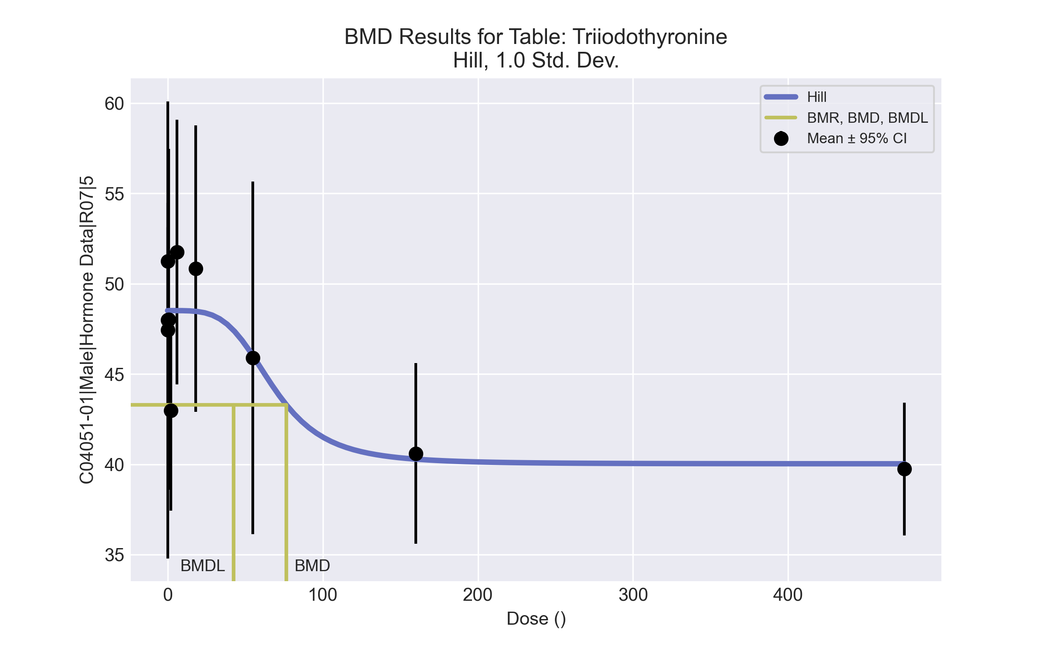
====================================================================
Hill Model. (Version: 2.18; Date: 03/14/2017)
Input Data File: C:\Windows\TEMP\bmds-szfx65yj.(d)
Gnuplot Plotting File: C:\Windows\TEMP\bmds-szfx65yj.plt
Tue Apr 13 09:27:40 2021
====================================================================
BMDS_Model_Run
~~~~~~~~~~~~~~~~~~~~~~~~~~~~~~~~~~~~~~~~~~~~~~~~~~~~~~~~~~~~~~~~~~~~~
The form of the response function is:
Y[dose] = intercept + v*dose^n/(k^n + dose^n)
Dependent variable = Response
Independent variable = Dose
rho is set to 0
Power parameter restricted to be greater than 1
A constant variance model is fit
Total number of dose groups = 10
Total number of records with missing values = 0
Maximum number of iterations = 500
Relative Function Convergence has been set to: 1e-008
Parameter Convergence has been set to: 1e-008
Default Initial Parameter Values
alpha = 28.4679
rho = 0 Specified
intercept = 47.9889
v = -8.24889
n = 1.22627
k = 1.77103
Asymptotic Correlation Matrix of Parameter Estimates
( *** The model parameter(s) -rho
have been estimated at a boundary point, or have been specified by the user,
and do not appear in the correlation matrix )
alpha intercept v n k
alpha 1 -2.3e-008 2.9e-008 6.4e-008 -4.7e-008
intercept -2.3e-008 1 -0.29 0.049 -0.14
v 2.9e-008 -0.29 1 0.7 -0.68
n 6.4e-008 0.049 0.7 1 -0.91
k -4.7e-008 -0.14 -0.68 -0.91 1
Parameter Estimates
95.0% Wald Confidence Interval
Variable Estimate Std. Err. Lower Conf. Limit Upper Conf. Limit
alpha 27.2102 5.61304 16.2089 38.2115
intercept 48.5108 0.911925 46.7235 50.2982
v -8.48535 2.70003 -13.7773 -3.1934
n 4.05187 12.092 -19.648 27.7517
k 68.1879 65.9871 -61.1444 197.52
Table of Data and Estimated Values of Interest
Dose N Obs Mean Est Mean Obs Std Dev Est Std Dev Scaled Res.
------ --- -------- -------- ----------- ----------- ----------
0 9 48 48.5 6.69 5.22 -0.3
0.07 4 47.5 48.5 7.95 5.22 -0.407
0.2 4 51.3 48.5 2.03 5.22 1.05
0.7 4 48 48.5 5.93 5.22 -0.186
2 4 43 48.5 3.48 5.22 -2.12
6 4 51.8 48.5 4.6 5.22 1.24
18 4 50.8 48.5 4.98 5.22 0.902
55 4 45.9 46 6.14 5.22 -0.041
160 5 40.6 40.3 4.03 5.22 0.135
475 5 39.7 40 2.97 5.22 -0.124
Model Descriptions for likelihoods calculated
Model A1: Yij = Mu(i) + e(ij)
Var{e(ij)} = Sigma^2
Model A2: Yij = Mu(i) + e(ij)
Var{e(ij)} = Sigma(i)^2
Model A3: Yij = Mu(i) + e(ij)
Var{e(ij)} = Sigma^2
Model A3 uses any fixed variance parameters that
were specified by the user
Model R: Yi = Mu + e(i)
Var{e(i)} = Sigma^2
Likelihoods of Interest
Model Log(likelihood) # Param's AIC
A1 -96.574389 11 215.148778
A2 -90.364749 20 220.729498
A3 -96.574389 11 215.148778
fitted -101.134412 5 212.268823
R -109.363943 2 222.727886
Explanation of Tests
Test 1: Do responses and/or variances differ among Dose levels?
(A2 vs. R)
Test 2: Are Variances Homogeneous? (A1 vs A2)
Test 3: Are variances adequately modeled? (A2 vs. A3)
Test 4: Does the Model for the Mean Fit? (A3 vs. fitted)
(Note: When rho=0 the results of Test 3 and Test 2 will be the same.)
Tests of Interest
Test -2*log(Likelihood Ratio) Test df p-value
Test 1 37.9984 18 0.003875
Test 2 12.4193 9 0.1907
Test 3 12.4193 9 0.1907
Test 4 9.12005 6 0.1669
The p-value for Test 1 is less than .05. There appears to be a
difference between response and/or variances among the dose levels
It seems appropriate to model the data
The p-value for Test 2 is greater than .1. A homogeneous variance
model appears to be appropriate here
The p-value for Test 3 is greater than .1. The modeled variance appears
to be appropriate here
The p-value for Test 4 is greater than .1. The model chosen seems
to adequately describe the data
Benchmark Dose Computation
Specified effect = 1
Risk Type = Estimated standard deviations from the control mean
Confidence level = 0.95
BMD = 76.5236
BMDL = 42.4946
BMDU = 241.026

