Female BMD Results for Table: Liver Weight Absolute
BMDS version: BMDS v2.7.0

Input dataset
Dose | 0 | 0.15 | 0.5 | 1.4 | 4 | 12 | 37 | 111 | 333 | 1000
N | 10 | 5 | 5 | 5 | 5 | 5 | 5 | 5 | 5 | 5
Mean ± SD | 7.661 ± 0.788 | 7.626 ± 1.399 | 7.904 ± 0.801 | 8.436 ± 0.859 | 7.99 ± 0.988 | 8.054 ± 0.7 | 8.92 ± 1.069 | 9.278 ± 0.619 | 8.73 ± 0.833 | 9.378 ± 0.262

Summary table
Modelª | Goodness of fit |  | BMD | BMDL | Comments
 | p-value | AIC
Linear (equivalent models include Power, Polynomial 2°, 3°, 4°, 5°, 6°, 7°, 8°) | 0.031 | 51.333 | 647.314 | 425.62 | Exponential-M4 recommended as best-fitting model on the basis of the lowest AIC.
Hill | 0.555 | 42.327 | 23.753 | 3.734
Exponential M2 (equivalent models include Exponential M3) | 0.029 | 51.53 | 675.627 | 458.479
Exponential M4^{b} (equivalent models include Exponential M5) | 0.598 | 41.973 | 24.928 | 7.768
ª Constant variance case presented (BMDS Test 2 p-value = 0.174, BMDS Test 3 p-value = 0.174).
^{b} Recommended model

Model recommendation details
Model | Bin | Notes
Linear (equivalent models include Power, Polynomial 2°, 3°, 4°, 5°, 6°, 7°, 8°) | Warning | Warnings  • Goodness of fit p-value is less than threshold (0.0314 < 0.1)
Hill | Valid | Cautions  • BMD/BMDL ratio is greater than threshold (6.36 > 5.0)
Exponential M2 (equivalent models include Exponential M3) | Warning | Warnings  • Goodness of fit p-value is less than threshold (0.0294 < 0.1)
Exponential M4ª (equivalent models include Exponential M5) | Valid | -
ª Recommended model

Recommended model
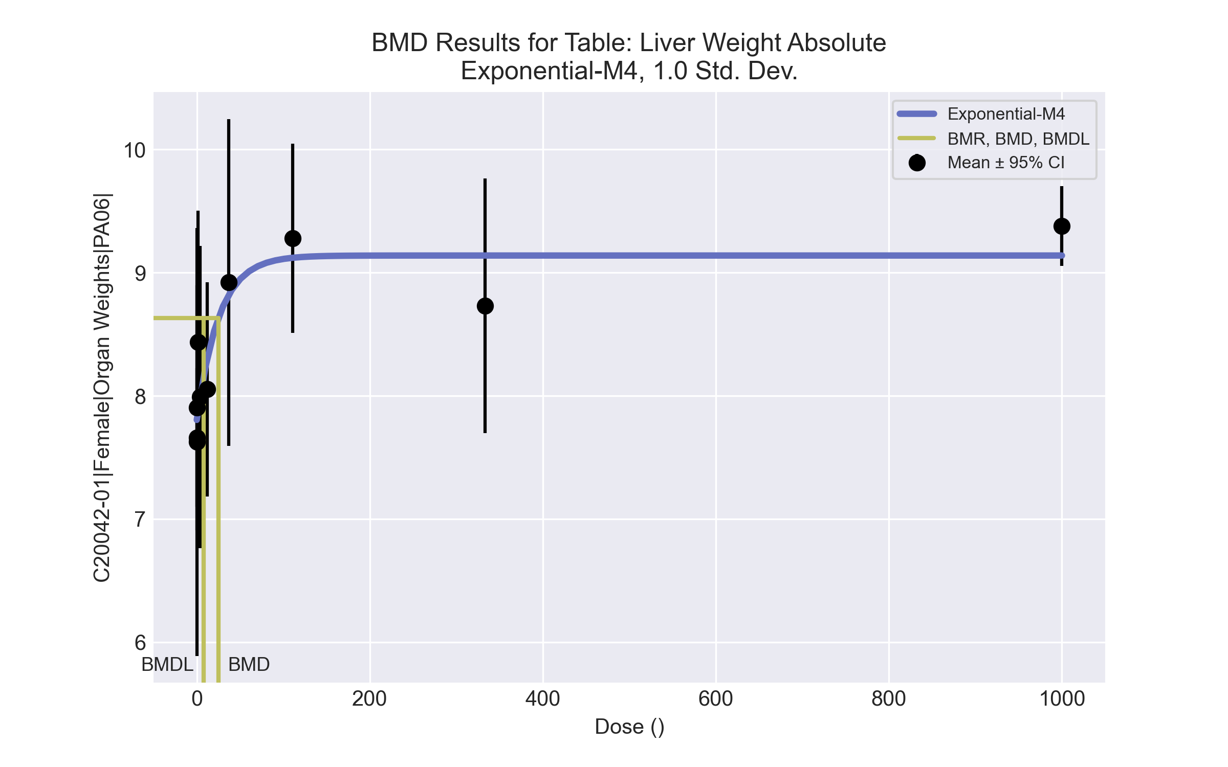
====================================================================
Exponential Model. (Version: 1.11; Date: 03/14/2017)
Input Data File: C:\Windows\TEMP\bmds-sa1w_6wk.(d)
Gnuplot Plotting File:
Tue Apr 13 12:25:00 2021
====================================================================
BMDS_Model_Run
~~~~~~~~~~~~~~~~~~~~~~~~~~~~~~~~~~~~~~~~~~~~~~~~~~~~~~~~~~~~~~~~~~~~~
The form of the response function by Model:
Model 2: Y[dose] = a * exp{sign * b * dose}
Model 3: Y[dose] = a * exp{sign * (b * dose)^d}
Model 4: Y[dose] = a * [c-(c-1) * exp{-b * dose}]
Model 5: Y[dose] = a * [c-(c-1) * exp{-(b * dose)^d}]
Note: Y[dose] is the median response for exposure = dose;
sign = +1 for increasing trend in data;
sign = -1 for decreasing trend.
Model 2 is nested within Models 3 and 4.
Model 3 is nested within Model 5.
Model 4 is nested within Model 5.
Dependent variable = Response
Independent variable = Dose
Data are assumed to be distributed: normally
Variance Model: exp(lnalpha +rho *ln(Y[dose]))
rho is set to 0.
A constant variance model is fit.
Total number of dose groups = 10
Total number of records with missing values = 0
Maximum number of iterations = 500
Relative Function Convergence has been set to: 1e-008
Parameter Convergence has been set to: 1e-008
MLE solution provided: Exact
Initial Parameter Values
Variable Model 4
-------- --------
lnalpha -0.482559
rho 0 Specified
a 7.2447
b 0.00196417
c 1.35919
d 1 Specified
Parameter Estimates
Variable Model 4 Std. Err.
-------- ------- ---------
lnalpha -0.382307 0.130107
a 7.80419 0.160982
b 0.0387084 0.0245564
c 1.17099 0.0360047
NC = No Convergence
Table of Stats From Input Data
Dose N Obs Mean Obs Std Dev
----- --- ---------- -------------
0 10 7.661 0.788
0.15 5 7.626 1.399
0.5 5 7.904 0.801
1.4 5 8.436 0.8588
4 5 7.99 0.9876
12 5 8.054 0.7004
37 5 8.92 1.069
111 5 9.278 0.6188
333 5 8.73 0.8326
1000 5 9.378 0.2619
Estimated Values of Interest
Dose Est Mean Est Std Scaled Residual
------ ---------- --------- ----------------
0 7.804 0.826 -0.5482
0.15 7.812 0.826 -0.5033
0.5 7.83 0.826 0.2009
1.4 7.875 0.826 1.52
4 7.996 0.826 -0.01518
12 8.3 0.826 -0.666
37 8.82 0.826 0.2707
111 9.12 0.826 0.4265
333 9.139 0.826 -1.106
1000 9.139 0.826 0.648
Other models for which likelihoods are calculated:
Model A1: Yij = Mu(i) + e(ij)
Var{e(ij)} = Sigma^2
Model A2: Yij = Mu(i) + e(ij)
Var{e(ij)} = Sigma(i)^2
Model A3: Yij = Mu(i) + e(ij)
Var{e(ij)} = exp(lalpha + log(mean(i)) * rho)
Model R: Yij = Mu + e(i)
Var{e(ij)} = Sigma^2
Likelihoods of Interest
Model Log(likelihood) DF AIC
------- ----------------- ---- ------------
A1 -14.22964 11 50.45928
A2 -7.853379 20 55.70676
A3 -14.22964 11 50.45928
R -27.67333 2 59.34667
4 -16.98655 4 41.9731
Additive constant for all log-likelihoods = -50.54. This constant added to the
above values gives the log-likelihood including the term that does not
depend on the model parameters.
Explanation of Tests
Test 1: Does response and/or variances differ among Dose levels? (A2 vs. R)
Test 2: Are Variances Homogeneous? (A2 vs. A1)
Test 3: Are variances adequately modeled? (A2 vs. A3)
Test 6a: Does Model 4 fit the data? (A3 vs 4)
Tests of Interest
Test -2*log(Likelihood Ratio) D. F. p-value
-------- ------------------------ ------ --------------
Test 1 39.64 18 0.002336
Test 2 12.75 9 0.1741
Test 3 12.75 9 0.1741
Test 6a 5.514 7 0.5975
The p-value for Test 1 is less than .05. There appears to be a
difference between response and/or variances among the dose
levels, it seems appropriate to model the data.
The p-value for Test 2 is greater than .1. A homogeneous
variance model appears to be appropriate here.
The p-value for Test 3 is greater than .1. The modeled
variance appears to be appropriate here.
The p-value for Test 6a is greater than .1. Model 4 seems
to adequately describe the data.
Benchmark Dose Computations:
Specified Effect = 1.000000
Risk Type = Estimated standard deviations from control
Confidence Level = 0.950000
BMD = 24.9281
BMDL = 7.76811
BMDU = 97.2949

Female BMD Results for Table: Liver Weight Relative
BMDS version: BMDS v2.7.0

Input dataset
Dose | 0 | 0.15 | 0.5 | 1.4 | 4 | 12 | 37 | 111 | 333 | 1000
N | 10 | 5 | 5 | 5 | 5 | 5 | 5 | 5 | 5 | 5
Mean ± SD | 35.552 ± 1.626 | 35.557 ± 3.856 | 36.53 ± 1.442 | 36.913 ± 2.517 | 36.883 ± 1.533 | 36.799 ± 1.117 | 41.391 ± 4.457 | 42.008 ± 1.525 | 41.528 ± 2.61 | 44.404 ± 0.796

Summary table
Modelª | Goodness of fit |  | BMD | BMDL | Comments
 | p-value | AIC
Linear (equivalent models include Power, Polynomial 2°, 3°, 4°, 5°, 6°, 7°, 8°) | 3.3E-04 | 174.991 | 481.448 | 363.17 | No model was recommended as a best-fitting model. Doses were dropped until there were only 3 remaining dose-groups.
Hill | 0.41 | 156.187 | 18.65 | 6.452
Exponential M2 (equivalent models include Exponential M3) | 2.8E-04 | 175.404 | 507.849 | 393.487
Exponential M4 | 0.359 | 155.775 | 11.719 | 6.04
Exponential M5 | 0.411 | 156.175 | 20.206 | 7.653
ª Modeled variance case presented (BMDS Test 2 p-value = 0.002, BMDS Test 3 p-value = 9.7E-04).

Model recommendation details
Model | Bin | Notes
Linear (equivalent models include Power, Polynomial 2°, 3°, 4°, 5°, 6°, 7°, 8°) | Warning | Warnings  • Variance model poorly fits dataset (p-value 3 = 0.0009702)  • Goodness of fit p-value is less than threshold (0.000327 < 0.1)  • Residual at lowest dose is greater than threshold (2.08 > 2.0)  • Ratio of modeled to actual stdev. at control is greater than threshold (2.02 > 1.5)
Hill | Warning | Warnings  • Variance model poorly fits dataset (p-value 3 = 0.0009702)
Exponential M2 (equivalent models include Exponential M3) | Warning | Warnings  • Variance model poorly fits dataset (p-value 3 = 0.0009702)  • Goodness of fit p-value is less than threshold (0.000277 < 0.1)  • Residual at lowest dose is greater than threshold (2.1 > 2.0)
Exponential M4 | Warning | Warnings  • Variance model poorly fits dataset (p-value 3 = 0.0009702)
Exponential M5 | Warning | Warnings  • Variance model poorly fits dataset (p-value 3 = 0.0009702)

Recommended model
No model was recommended as a best-fitting model.

Female BMD Results for Table: A/G Ratio
BMDS version: BMDS v2.7.0

Input dataset
Dose | 0 | 0.15 | 0.5 | 1.4 | 4 | 12 | 37 | 111 | 333 | 1000
N | 10 | 5 | 5 | 5 | 5 | 5 | 5 | 5 | 5 | 5
Mean ± SD | 2.385 ± 0.239 | 2.759 ± 0.098 | 2.364 ± 0.123 | 2.437 ± 0.087 | 2.499 ± 0.202 | 2.546 ± 0.103 | 2.26 ± 0.08 | 2.367 ± 0.139 | 2.455 ± 0.177 | 2.349 ± 0.159

Summary table
Modelª | Goodness of fit |  | BMD | BMDL | Comments
 | p-value | AIC
Linear | 1.6E-04 | -119.851 | -9999 | 2505.45 | No model was recommended as a best-fitting model. Doses were dropped until there were only 3 remaining dose-groups.
Polynomial 2° | 1.6E-04 | -119.851 | -9999 | 1565.98
Polynomial 3° | 1.6E-04 | -119.851 | -9999 | 1315.41
Polynomial 4° | 1.6E-04 | -119.851 | -9999 | 1515.29
Polynomial 5° | 1.6E-04 | -119.851 | -9999 | -999
Polynomial 6° | 1.6E-04 | -119.851 | -9999 | -999
Polynomial 7° | 1.6E-04 | -119.851 | -9999 | -999
Polynomial 8° | 1.6E-04 | -119.851 | -9999 | -999
Power | 4.4E-04 | -122.393 | 1964 | 873.884
Hill | 4.3E-04 | -121.921 | -999 | -999
Exponential M2 | <0.0001 | -117.851 | 1 | -999
Exponential M3 | <0.0001 | -99.743 | -1281.28 | -999
Exponential M4 | <0.0001 | -115.851 | -999 | 0
Exponential M5 | <0.0001 | -115.851 | -999 | 0
ª Modeled variance case presented (BMDS Test 2 p-value = 0.059, BMDS Test 3 p-value = 0.073).

Model recommendation details
Model | Bin | Notes
Linear | Warning | Warnings  • Residual of Interest does not exist  • Variance model poorly fits dataset (p-value 3 = 0.07325)  • Goodness of fit p-value is less than threshold (0.000162 < 0.1)  Cautions  • Warning(s): THE MODEL HAS PROBABLY NOT CONVERGED!!!; THIS USUALLY MEANS THE MODEL HAS NOT CONVERGED!; BMD = 100*(maximum dose)  • BMDL/high dose ratio is greater than threshold (2.51 > 1.0)
Polynomial 2° | Warning | Warnings  • Residual of Interest does not exist  • Variance model poorly fits dataset (p-value 3 = 0.07325)  • Goodness of fit p-value is less than threshold (0.000162 < 0.1)  Cautions  • Warning(s): THIS USUALLY MEANS THE MODEL HAS NOT CONVERGED!; BMD = 100*(maximum dose)  • BMDL/high dose ratio is greater than threshold (1.57 > 1.0)
Polynomial 3° | Warning | Warnings  • Residual of Interest does not exist  • Variance model poorly fits dataset (p-value 3 = 0.07325)  • Goodness of fit p-value is less than threshold (0.000162 < 0.1)  Cautions  • Warning(s): BMD = 100*(maximum dose)  • BMDL/high dose ratio is greater than threshold (1.32 > 1.0)
Polynomial 4° | Warning | Warnings  • Residual of Interest does not exist  • Variance model poorly fits dataset (p-value 3 = 0.07325)  • Goodness of fit p-value is less than threshold (0.000162 < 0.1)  Cautions  • Warning(s): BMD = 100*(maximum dose)  • BMDL/high dose ratio is greater than threshold (1.52 > 1.0)
Polynomial 5° | Failure | Failures  • BMDL does not exist  Warnings  • Residual of Interest does not exist  • Variance model poorly fits dataset (p-value 3 = 0.07325)  • Goodness of fit p-value is less than threshold (0.000162 < 0.1)  Cautions  • Warning(s): BMD = 100*(maximum dose); BMDL computation failed.
Polynomial 6° | Failure | Failures  • BMDL does not exist  Warnings  • Residual of Interest does not exist  • Variance model poorly fits dataset (p-value 3 = 0.07325)  • Goodness of fit p-value is less than threshold (0.000162 < 0.1)  Cautions  • Warning(s): THIS USUALLY MEANS THE MODEL HAS NOT CONVERGED!; BMD = 100*(maximum dose); BMDL computation failed.
Polynomial 7° | Failure | Failures  • BMDL does not exist  Warnings  • Residual of Interest does not exist  • Variance model poorly fits dataset (p-value 3 = 0.07325)  • Goodness of fit p-value is less than threshold (0.000162 < 0.1)  Cautions  • Warning(s): THIS USUALLY MEANS THE MODEL HAS NOT CONVERGED!; BMD = 100*(maximum dose); BMDL computation failed.
Polynomial 8° | Failure | Failures  • BMDL does not exist  Warnings  • Residual of Interest does not exist  • Variance model poorly fits dataset (p-value 3 = 0.07325)  • Goodness of fit p-value is less than threshold (0.000162 < 0.1)  Cautions  • Warning(s): THIS USUALLY MEANS THE MODEL HAS NOT CONVERGED!; BMD = 100*(maximum dose); BMDL computation failed.
Power | Warning | Warnings  • Variance model poorly fits dataset (p-value 3 = 0.07325)  • Goodness of fit p-value is less than threshold (0.000443 < 0.1)  • BMD/high dose ratio is greater than threshold (1.96 > 1.0)
Hill | Failure | Failures  • BMD does not exist  • BMDL does not exist  Warnings  • Residual of Interest does not exist  • Variance model poorly fits dataset (p-value 3 = 0.07325)  • Goodness of fit p-value is less than threshold (0.000432 < 0.1)  Cautions  • Warning(s): BMR value is not in the range of the mean function
Exponential M2 | Failure | Failures  • BMDL does not exist  Warnings  • Variance model poorly fits dataset (p-value 3 = 0.07325)
Exponential M3 | Failure | Failures  • BMDL does not exist  Warnings  • Residual of Interest does not exist  • Variance model poorly fits dataset (p-value 3 = 0.07325)
Exponential M4 | Failure | Failures  • BMD does not exist  Warnings  • Residual of Interest does not exist  • Variance model poorly fits dataset (p-value 3 = 0.07325)
Exponential M5 | Failure | Failures  • BMD does not exist  Warnings  • Residual of Interest does not exist  • Variance model poorly fits dataset (p-value 3 = 0.07325)

Recommended model
No model was recommended as a best-fitting model.

Female BMD Results for Table: Alkaline phosphatase
BMDS version: BMDS v2.7.0

Input dataset
Dose | 0 | 0.15 | 0.5 | 1.4 | 4 | 12 | 37 | 111 | 333 | 1000
N | 10 | 5 | 5 | 5 | 5 | 5 | 5 | 5 | 5 | 5
Mean ± SD | 201.3 ± 41.358 | 198.8 ± 26.593 | 216.2 ± 86.803 | 210 ± 44.565 | 218.4 ± 22.568 | 208.4 ± 16.441 | 222.8 ± 55.979 | 240 ± 20.748 | 241.4 ± 12.759 | 272.2 ± 40.678

Summary table
Modelª | Goodness of fit |  | BMD | BMDL | Comments
 | p-value | AIC
Linear (equivalent models include Power, Polynomial 2°, 3°, 4°, 5°, 6°, 8°) | 0.283 | 466.971 | 644.753 | 427.604 | No model was recommended as a best-fitting model. Doses were dropped until there were only 3 remaining dose-groups.
Polynomial 7° | 0.283 | 466.971 | 644.752 | 427.604
Hill | 0.526 | 465.333 | 222.224 | -999
Exponential M2 (equivalent models include Exponential M3) | 0.261 | 467.278 | 681.136 | 472.905
Exponential M4 (equivalent models include Exponential M5) | 0.465 | 465.885 | 225.225 | 47.683
ª Modeled variance case presented (BMDS Test 2 p-value = 4.1E-04, BMDS Test 3 p-value = 0.003).

Model recommendation details
Model | Bin | Notes
Linear (equivalent models include Power, Polynomial 2°, 3°, 4°, 5°, 6°, 8°) | Warning | Warnings  • Variance model poorly fits dataset (p-value 3 = 0.003117)
Polynomial 7° | Warning | Warnings  • Variance model poorly fits dataset (p-value 3 = 0.003117)
Hill | Failure | Failures  • BMDL does not exist  Warnings  • Variance model poorly fits dataset (p-value 3 = 0.003117)  Cautions  • Warning(s): BMDL computation failed.
Exponential M2 (equivalent models include Exponential M3) | Warning | Warnings  • Variance model poorly fits dataset (p-value 3 = 0.003117)
Exponential M4 (equivalent models include Exponential M5) | Warning | Warnings  • Variance model poorly fits dataset (p-value 3 = 0.003117)

Recommended model
No model was recommended as a best-fitting model.

Female BMD Results for Table: Cholesterol
BMDS version: BMDS v2.7.0

Input dataset
Dose | 0 | 0.15 | 0.5 | 1.4 | 4 | 12 | 37 | 111 | 333 | 1000
N | 10 | 5 | 5 | 5 | 5 | 5 | 5 | 5 | 5 | 5
Mean ± SD | 105 ± 16.607 | 97.8 ± 12.95 | 100.8 ± 15.802 | 88.6 ± 10.502 | 101 ± 8.515 | 109 ± 27.359 | 123.8 ± 23.264 | 105.6 ± 12.341 | 120.8 ± 13.498 | 162.4 ± 19.087

Summary table
Modelª | Goodness of fit |  | BMD | BMDL | Comments
 | p-value | AIC
Linear^{b} (equivalent models include Power) | 0.135 | 373.284 | 288.242 | 226.543 | Linear recommended as best-fitting model on the basis of the lowest AIC.
Polynomial 2° | 0.089 | 375.282 | 292.517 | 226.555
Polynomial 3° | 0.089 | 375.274 | 299.479 | 226.625
Polynomial 4° | 0.089 | 375.272 | 300.989 | 226.65
Polynomial 5° | 0.089 | 375.271 | 301.38 | 226.658
Polynomial 6° | 0.089 | 375.271 | 301.491 | 226.66
Polynomial 7° | 0.089 | 375.271 | 301.524 | 226.661
Polynomial 8° | 0.054 | 377.27 | 301.532 | 226.661
Hill | 0.089 | 375.284 | 287.68 | 225.981
Exponential M2 (equivalent models include Exponential M3) | 0.131 | 373.386 | 336.592 | 274.666
Exponential M4 | 0.089 | 375.284 | 287.087 | 149.15
Exponential M5 | 0.089 | 375.285 | 286.834 | 149.146
ª Constant variance case presented (BMDS Test 2 p-value = 0.246, BMDS Test 3 p-value = 0.246).
^{b} Recommended model

Model recommendation details
Model | Bin | Notes
Linearª (equivalent models include Power) | Valid | -
Polynomial 2° | Warning | Warnings  • Goodness of fit p-value is less than threshold (0.0887 < 0.1)
Polynomial 3° | Warning | Warnings  • Goodness of fit p-value is less than threshold (0.0889 < 0.1)
Polynomial 4° | Warning | Warnings  • Goodness of fit p-value is less than threshold (0.089 < 0.1)
Polynomial 5° | Warning | Warnings  • Goodness of fit p-value is less than threshold (0.089 < 0.1)
Polynomial 6° | Warning | Warnings  • Goodness of fit p-value is less than threshold (0.089 < 0.1)
Polynomial 7° | Warning | Warnings  • Goodness of fit p-value is less than threshold (0.089 < 0.1)
Polynomial 8° | Warning | Warnings  • Goodness of fit p-value is less than threshold (0.0542 < 0.1)
Hill | Warning | Warnings  • Goodness of fit p-value is less than threshold (0.0886 < 0.1)
Exponential M2 (equivalent models include Exponential M3) | Valid | -
Exponential M4 | Warning | Warnings  • Goodness of fit p-value is less than threshold (0.0886 < 0.1)
Exponential M5 | Warning | Warnings  • Goodness of fit p-value is less than threshold (0.0886 < 0.1)
ª Recommended model

Recommended model
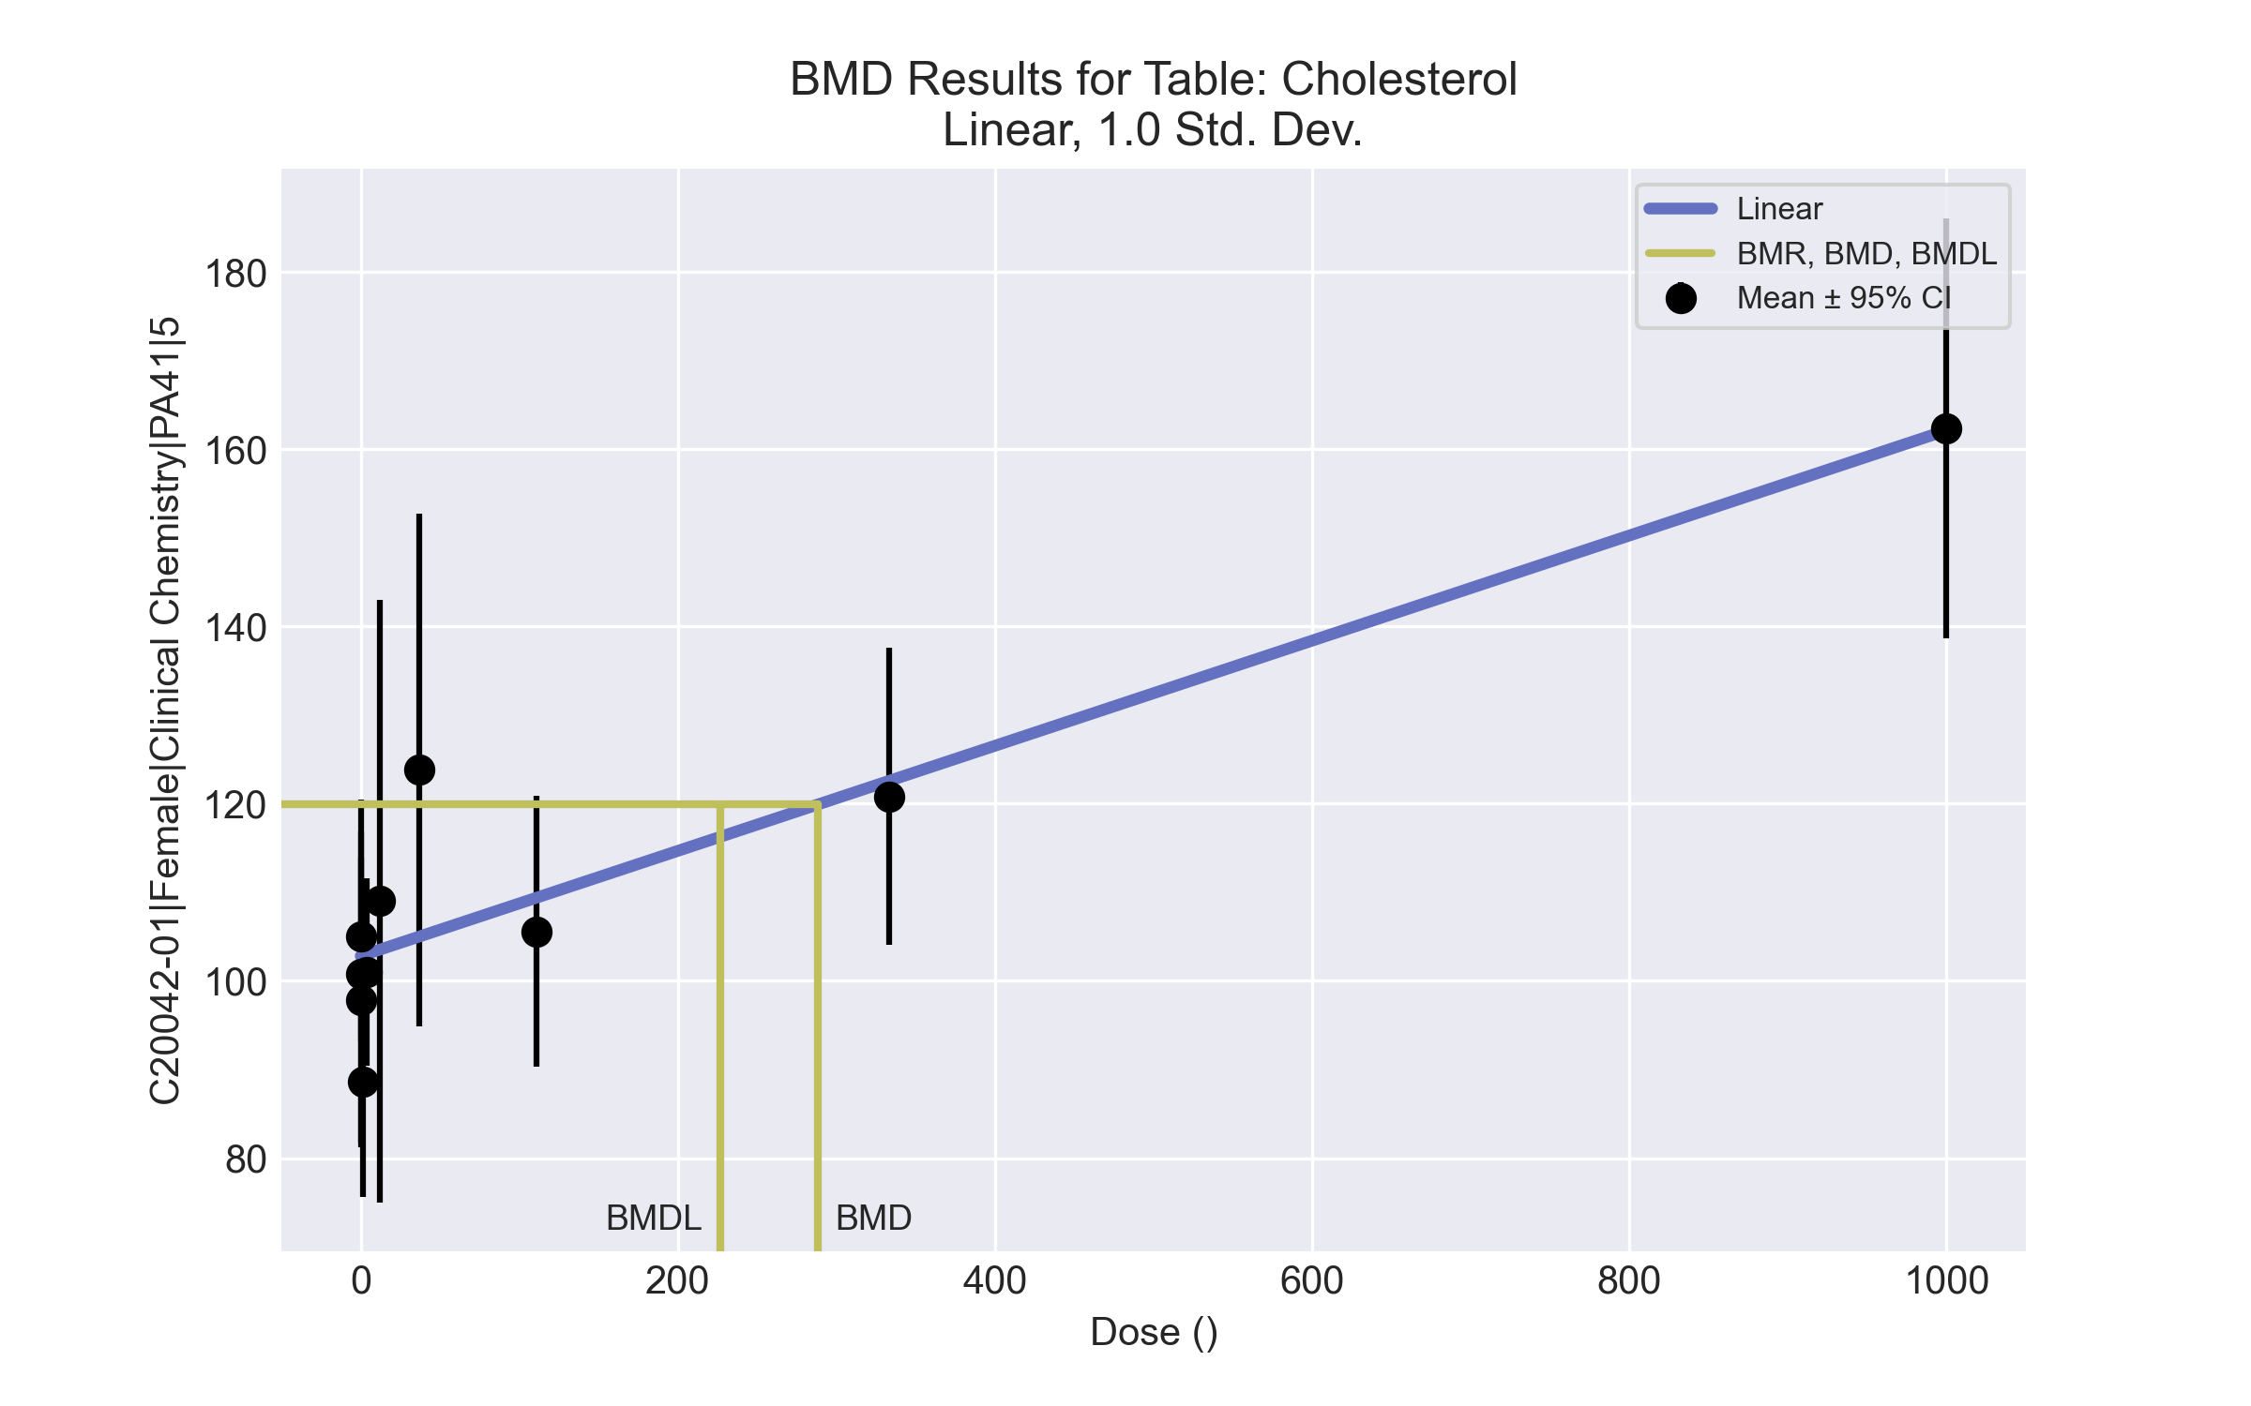
====================================================================
Polynomial Model. (Version: 2.21; Date: 03/14/2017)
Input Data File: C:\Windows\TEMP\bmds-m3_o4mnn.(d)
Gnuplot Plotting File: C:\Windows\TEMP\bmds-m3_o4mnn.plt
Tue Apr 13 13:46:42 2021
====================================================================
BMDS_Model_Run
~~~~~~~~~~~~~~~~~~~~~~~~~~~~~~~~~~~~~~~~~~~~~~~~~~~~~~~~~~~~~~~~~~~~~
The form of the response function is:
Y[dose] = beta_0 + beta_1*dose + beta_2*dose^2 + ...
Dependent variable = Response
Independent variable = Dose
rho is set to 0
The polynomial coefficients are restricted to be positive
A constant variance model is fit
Total number of dose groups = 10
Total number of records with missing values = 0
Maximum number of iterations = 500
Relative Function Convergence has been set to: 1e-008
Parameter Convergence has been set to: 1e-008
Default Initial Parameter Values
alpha = 285.262
rho = 0 Specified
beta_0 = 102.533
beta_1 = 0
Asymptotic Correlation Matrix of Parameter Estimates
( *** The model parameter(s) -rho
have been estimated at a boundary point, or have been specified by the user,
and do not appear in the correlation matrix )
alpha beta_0 beta_1
alpha 1 1.6e-006 4.7e-007
beta_0 1.6e-006 1 -0.43
beta_1 4.7e-007 -0.43 1
Parameter Estimates
95.0% Wald Confidence Interval
Variable Estimate Std. Err. Lower Conf. Limit Upper Conf. Limit
alpha 292.33 55.7452 183.072 401.589
beta_0 102.807 2.54848 97.8124 107.802
beta_1 0.0593171 0.00796986 0.0436965 0.0749377
Table of Data and Estimated Values of Interest
Dose N Obs Mean Est Mean Obs Std Dev Est Std Dev Scaled Res.
------ --- -------- -------- ----------- ----------- ----------
0 10 105 103 16.6 17.1 0.406
0.15 5 97.8 103 12.9 17.1 -0.656
0.5 5 101 103 15.8 17.1 -0.266
1.4 5 88.6 103 10.5 17.1 -1.87
4 5 101 103 8.51 17.1 -0.267
12 5 109 104 27.4 17.1 0.717
37 5 124 105 23.3 17.1 2.46
111 5 106 109 12.3 17.1 -0.496
333 5 121 123 13.5 17.1 -0.23
1000 5 162 162 19.1 17.1 0.036
Model Descriptions for likelihoods calculated
Model A1: Yij = Mu(i) + e(ij)
Var{e(ij)} = Sigma^2
Model A2: Yij = Mu(i) + e(ij)
Var{e(ij)} = Sigma(i)^2
Model A3: Yij = Mu(i) + e(ij)
Var{e(ij)} = Sigma^2
Model A3 uses any fixed variance parameters that
were specified by the user
Model R: Yi = Mu + e(i)
Var{e(i)} = Sigma^2
Likelihoods of Interest
Model Log(likelihood) # Param's AIC
A1 -177.450299 11 376.900598
A2 -171.725501 20 383.451001
A3 -177.450299 11 376.900598
fitted -183.641824 3 373.283649
R -202.801549 2 409.603099
Explanation of Tests
Test 1: Do responses and/or variances differ among Dose levels?
(A2 vs. R)
Test 2: Are Variances Homogeneous? (A1 vs A2)
Test 3: Are variances adequately modeled? (A2 vs. A3)
Test 4: Does the Model for the Mean Fit? (A3 vs. fitted)
(Note: When rho=0 the results of Test 3 and Test 2 will be the same.)
Tests of Interest
Test -2*log(Likelihood Ratio) Test df p-value
Test 1 62.1521 18 <.0001
Test 2 11.4496 9 0.2461
Test 3 11.4496 9 0.2461
Test 4 12.3831 8 0.1349
The p-value for Test 1 is less than .05. There appears to be a
difference between response and/or variances among the dose levels
It seems appropriate to model the data
The p-value for Test 2 is greater than .1. A homogeneous variance
model appears to be appropriate here
The p-value for Test 3 is greater than .1. The modeled variance appears
to be appropriate here
The p-value for Test 4 is greater than .1. The model chosen seems
to adequately describe the data
Benchmark Dose Computation
Specified effect = 1
Risk Type = Estimated standard deviations from the control mean
Confidence level = 0.95
BMD = 288.242
BMDL = 226.543
BMDU = 394.641

Female BMD Results for Table: Globulin (measured)
BMDS version: BMDS v2.7.0

Input dataset
Dose | 0 | 0.15 | 0.5 | 1.4 | 4 | 12 | 37 | 111ª | 333ª | 1000ª
N | 10 | 5 | 5 | 5 | 5 | 5 | 5 | 5 | 5 | 5
Mean ± SD | 1.93 ± 0.226 | 1.66 ± 0.055 | 1.88 ± 0.11 | 1.88 ± 0.084 | 1.86 ± 0.182 | 1.84 ± 0.114 | 2.04 ± 0.207 | 1.94 ± 0.114 | 1.9 ± 0.2 | 1.98 ± 0.11
ª Dose group removed in BMD modeling session

Summary table
Modelª | Goodness of fit |  | BMD | BMDL | Comments
 | p-value | AIC
Linear | 1.3E-04 | -90.762 | -9999 | 96.355 | Hill recommended as best-fitting model on the basis of the lowest AIC.
Polynomial 2° | 1.3E-04 | -90.762 | -9999 | 38.406
Polynomial 3° | 1.3E-04 | -90.762 | -9999 | 37.074
Polynomial 4° | 1.3E-04 | -90.762 | -9999 | 36.685
Polynomial 5° | 1.3E-04 | -90.762 | -9999 | -999
Polynomial 6° | 1.3E-04 | -90.762 | -9999 | -999
Polynomial 7° | 1.3E-04 | -90.762 | -9999 | -999
Polynomial 8° | <0.0001 | 396.005 | -9999 | -999
Power | 1.8E-04 | -91.749 | 36.758 | 21.342
Hill^{b} | <0.0001 | -89.749 | 36.678 | 13.695
Exponential M2 | <0.0001 | -88.762 | 1 | -999
Exponential M3 | <0.0001 | -88.403 | 50.384 | 38.023
Exponential M4 | <0.0001 | -86.762 | -999 | 0
Exponential M5 | <0.0001 | -86.762 | -999 | 0
ª Modeled variance case presented (BMDS Test 2 p-value = 0.012, BMDS Test 3 p-value = 0.565).
^{b} Recommended model

Model recommendation details
Model | Bin | Notes
Linear | Warning | Warnings  • Residual of Interest does not exist  • Goodness of fit p-value is less than threshold (0.000128 < 0.1)  Cautions  • Warning(s): THIS USUALLY MEANS THE MODEL HAS NOT CONVERGED!; BMD = 100*(maximum dose)  • BMDL/high dose ratio is greater than threshold (2.6 > 1.0)
Polynomial 2° | Warning | Warnings  • Residual of Interest does not exist  • Goodness of fit p-value is less than threshold (0.000128 < 0.1)  Cautions  • Warning(s): BMD = 100*(maximum dose)  • BMDL/high dose ratio is greater than threshold (1.04 > 1.0)
Polynomial 3° | Warning | Warnings  • Residual of Interest does not exist  • Goodness of fit p-value is less than threshold (0.000128 < 0.1)  Cautions  • Warning(s): THIS USUALLY MEANS THE MODEL HAS NOT CONVERGED!; BMD = 100*(maximum dose)  • BMDL/high dose ratio is greater than threshold (1.0 > 1.0)
Polynomial 4° | Warning | Warnings  • Residual of Interest does not exist  • Goodness of fit p-value is less than threshold (0.000128 < 0.1)  Cautions  • Warning(s): THIS USUALLY MEANS THE MODEL HAS NOT CONVERGED!; BMD = 100*(maximum dose)
Polynomial 5° | Failure | Failures  • BMDL does not exist  Warnings  • Residual of Interest does not exist  • Goodness of fit p-value is less than threshold (0.000128 < 0.1)  Cautions  • Warning(s): BMD = 100*(maximum dose); BMDL computation failed.
Polynomial 6° | Failure | Failures  • BMDL does not exist  Warnings  • Residual of Interest does not exist  • Goodness of fit p-value is less than threshold (0.000128 < 0.1)  Cautions  • Warning(s): THIS USUALLY MEANS THE MODEL HAS NOT CONVERGED!; BMD = 100*(maximum dose); BMDL computation failed.
Polynomial 7° | Failure | Failures  • BMDL does not exist  Warnings  • Residual of Interest does not exist  • Goodness of fit p-value is less than threshold (0.000128 < 0.1)  Cautions  • Warning(s): THIS USUALLY MEANS THE MODEL HAS NOT CONVERGED!; BMD = 100*(maximum dose); BMDL computation failed.
Polynomial 8° | Failure | Failures  • BMDL does not exist  Warnings  • Residual of Interest does not exist  • Ratio of modeled to actual stdev. at control is greater than threshold (4.51 > 1.5)  Cautions  • Warning(s): THIS USUALLY MEANS THE MODEL HAS NOT CONVERGED!; BMD = 100*(maximum dose); BMDL computation failed.
Power | Warning | Warnings  • Goodness of fit p-value is less than threshold (0.000175 < 0.1)  Cautions  • Warning(s): THE MODEL HAS PROBABLY NOT CONVERGED!!!; THIS USUALLY MEANS THE MODEL HAS NOT CONVERGED!
Hillª | Valid | -
Exponential M2 | Failure | Failures  • BMDL does not exist
Exponential M3 | Warning | Warnings  • BMD/high dose ratio is greater than threshold (1.36 > 1.0)  Cautions  • BMDL/high dose ratio is greater than threshold (1.03 > 1.0)
Exponential M4 | Failure | Failures  • BMD does not exist  Warnings  • Residual of Interest does not exist
Exponential M5 | Failure | Failures  • BMD does not exist  Warnings  • Residual of Interest does not exist
ª Recommended model

Recommended model
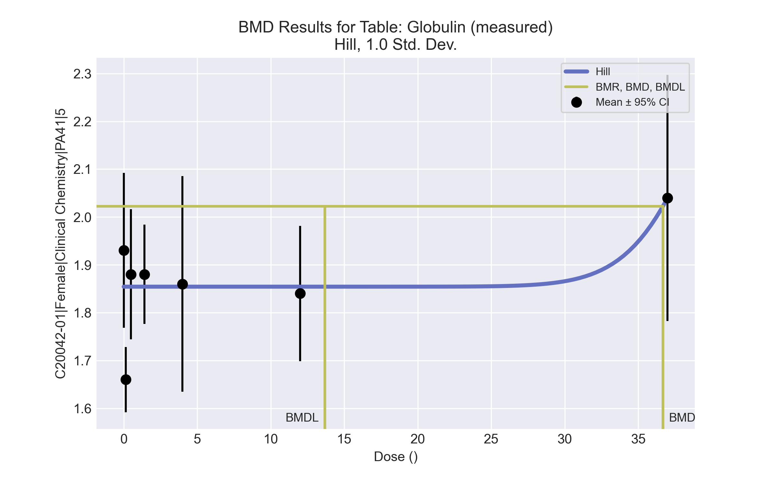
====================================================================
Hill Model. (Version: 2.18; Date: 03/14/2017)
Input Data File: C:\Windows\TEMP\bmds-9grtlgid.(d)
Gnuplot Plotting File: C:\Windows\TEMP\bmds-9grtlgid.plt
Tue Apr 13 13:47:02 2021
====================================================================
BMDS_Model_Run
~~~~~~~~~~~~~~~~~~~~~~~~~~~~~~~~~~~~~~~~~~~~~~~~~~~~~~~~~~~~~~~~~~~~~
The form of the response function is:
Y[dose] = intercept + v*dose^n/(k^n + dose^n)
Dependent variable = Response
Independent variable = Dose
Power parameter restricted to be greater than 1
The variance is to be modeled as Var(i) = exp(lalpha + rho * ln(mean(i)))
Total number of dose groups = 7
Total number of records with missing values = 0
Maximum number of iterations = 500
Relative Function Convergence has been set to: 1e-008
Parameter Convergence has been set to: 1e-008
Default Initial Parameter Values
lalpha = -3.59633
rho = 0
intercept = 1.93
v = 0.11
n = 1
k = 43.875
Asymptotic Correlation Matrix of Parameter Estimates
lalpha rho intercept v n k
lalpha 1 -1 -0.053 0.00025 -0.00051 0.0003
rho -1 1 0.047 -0.00024 0.00051 -0.0003
intercept -0.053 0.047 1 -0.00017 0.00029 -3.6e-005
v 0.00025 -0.00024 -0.00017 1 -0.48 0.94
n -0.00051 0.00051 0.00029 -0.48 1 -0.74
k 0.0003 -0.0003 -3.6e-005 0.94 -0.74 1
Parameter Estimates
95.0% Wald Confidence Interval
Variable Estimate Std. Err. Lower Conf. Limit Upper Conf. Limit
lalpha -4.85517 4.50401 -13.6829 3.97253
rho 2.08355 7.14672 -11.9238 16.0909
intercept 1.85429 0.028383 1.79866 1.90992
v 0.878941 517.356 -1013.12 1014.88
n 14.4172 3986.46 -7798.9 7827.73
k 40.5395 2738.75 -5327.31 5408.39
Table of Data and Estimated Values of Interest
Dose N Obs Mean Est Mean Obs Std Dev Est Std Dev Scaled Res.
------ --- -------- -------- ----------- ----------- ----------
0 10 1.93 1.85 0.226 0.168 1.43
0.15 5 1.66 1.85 0.0548 0.168 -2.59
0.5 5 1.88 1.85 0.11 0.168 0.342
1.4 5 1.88 1.85 0.0837 0.168 0.342
4 5 1.86 1.85 0.182 0.168 0.0761
12 5 1.84 1.85 0.114 0.168 -0.19
37 5 2.04 2.04 0.207 0.185 1.39e-006
Model Descriptions for likelihoods calculated
Model A1: Yij = Mu(i) + e(ij)
Var{e(ij)} = Sigma^2
Model A2: Yij = Mu(i) + e(ij)
Var{e(ij)} = Sigma(i)^2
Model A3: Yij = Mu(i) + e(ij)
Var{e(ij)} = exp(lalpha + rho*ln(Mu(i)))
Model A3 uses any fixed variance parameters that
were specified by the user
Model R: Yi = Mu + e(i)
Var{e(i)} = Sigma^2
Likelihoods of Interest
Model Log(likelihood) # Param's AIC
A1 55.774020 8 -95.548039
A2 63.967982 14 -99.935965
A3 62.021623 9 -106.043247
fitted 50.874380 6 -89.748759
R 48.380880 2 -92.761760
Explanation of Tests
Test 1: Do responses and/or variances differ among Dose levels?
(A2 vs. R)
Test 2: Are Variances Homogeneous? (A1 vs A2)
Test 3: Are variances adequately modeled? (A2 vs. A3)
Test 4: Does the Model for the Mean Fit? (A3 vs. fitted)
(Note: When rho=0 the results of Test 3 and Test 2 will be the same.)
Tests of Interest
Test -2*log(Likelihood Ratio) Test df p-value
Test 1 31.1742 12 0.001853
Test 2 16.3879 6 0.01182
Test 3 3.89272 5 0.565
Test 4 22.2945 3 <.0001
The p-value for Test 1 is less than .05. There appears to be a
difference between response and/or variances among the dose levels
It seems appropriate to model the data
The p-value for Test 2 is less than .1. A non-homogeneous variance
model appears to be appropriate
The p-value for Test 3 is greater than .1. The modeled variance appears
to be appropriate here
The p-value for Test 4 is less than .1. You may want to try a different
model
Benchmark Dose Computation
Specified effect = 1
Risk Type = Estimated standard deviations from the control mean
Confidence level = 0.95
BMD = 36.6778
BMDL = 13.6954
BMDU = 1.369e+007

Female BMD Results for Table: Eosinophil count
BMDS version: BMDS v2.7.0

Input dataset
Dose | 0 | 0.15 | 0.5 | 1.4 | 4 | 12 | 37 | 111 | 333 | 1000
N | 8 | 5 | 5 | 5 | 5 | 5 | 5 | 5 | 4 | 5
Mean ± SD | 0.083 ± 0.029 | 0.078 ± 0.046 | 0.08 ± 0.031 | 0.092 ± 0.039 | 0.068 ± 0.042 | 0.05 ± 0.016 | 0.042 ± 0.027 | 0.076 ± 0.047 | 0.03 ± 0.022 | 0.044 ± 0.028

Summary table
Modelª | Goodness of fit |  | BMD | BMDL | Comments
 | p-value | AIC
Linear (equivalent models include Power, Polynomial 2°, 3°, 4°, 5°, 6°, 7°, 8°) | 0.105 | -291.4 | 1000.14 | 558.717 | Exponential-M5 recommended as best-fitting model on the basis of the lowest BMDL.
Hill | 0.414 | -294.524 | 5.053 | -999
Exponential M2 (equivalent models include Exponential M3) | 0.126 | -292 | 820.54 | 281.561
Exponential M4 | 0.45 | -295.805 | 17.001 | 3.067
Exponential M5^{b} | 0.414 | -294.524 | 4.428 | 1.564
ª Constant variance case presented (BMDS Test 2 p-value = 0.397, BMDS Test 3 p-value = 0.397).
^{b} Recommended model

Model recommendation details
Model | Bin | Notes
Linear (equivalent models include Power, Polynomial 2°, 3°, 4°, 5°, 6°, 7°, 8°) | Warning | Warnings  • BMD/high dose ratio is greater than threshold (1.0 > 1.0)
Hill | Failure | Failures  • BMDL does not exist  Cautions  • Warning(s): BMDL computation failed.
Exponential M2 (equivalent models include Exponential M3) | Valid | -
Exponential M4 | Valid | Cautions  • BMD/BMDL ratio is greater than threshold (5.54 > 5.0)
Exponential M5ª | Valid | -
ª Recommended model

Recommended model
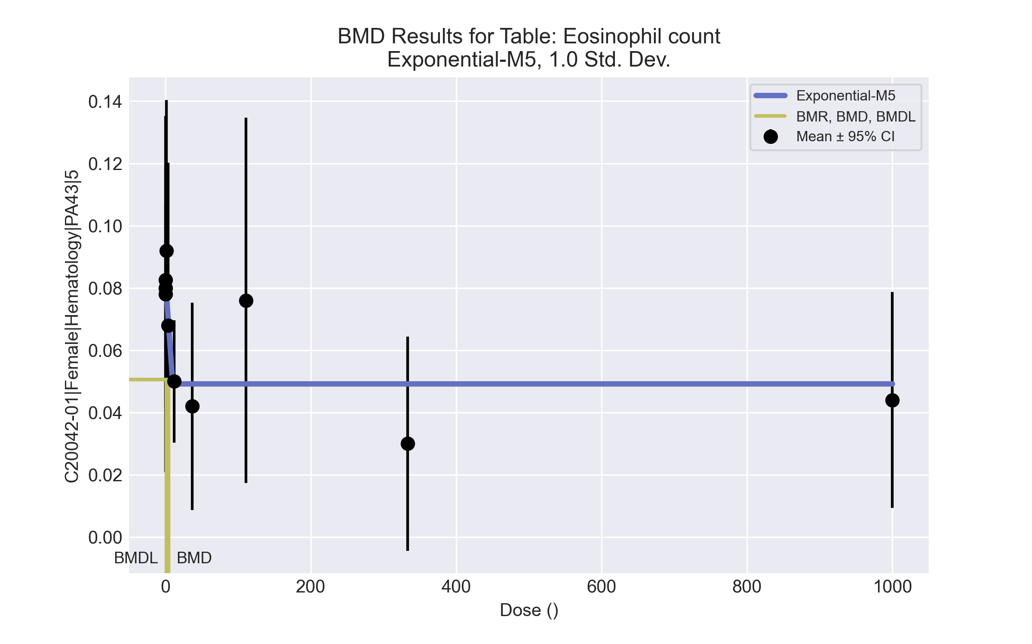
====================================================================
Exponential Model. (Version: 1.11; Date: 03/14/2017)
Input Data File: C:\Windows\TEMP\bmds-n3ygn080.(d)
Gnuplot Plotting File:
Tue Apr 13 13:58:21 2021
====================================================================
BMDS_Model_Run
~~~~~~~~~~~~~~~~~~~~~~~~~~~~~~~~~~~~~~~~~~~~~~~~~~~~~~~~~~~~~~~~~~~~~
The form of the response function by Model:
Model 2: Y[dose] = a * exp{sign * b * dose}
Model 3: Y[dose] = a * exp{sign * (b * dose)^d}
Model 4: Y[dose] = a * [c-(c-1) * exp{-b * dose}]
Model 5: Y[dose] = a * [c-(c-1) * exp{-(b * dose)^d}]
Note: Y[dose] is the median response for exposure = dose;
sign = +1 for increasing trend in data;
sign = -1 for decreasing trend.
Model 2 is nested within Models 3 and 4.
Model 3 is nested within Model 5.
Model 4 is nested within Model 5.
Dependent variable = Response
Independent variable = Dose
Data are assumed to be distributed: normally
Variance Model: exp(lnalpha +rho *ln(Y[dose]))
rho is set to 0.
A constant variance model is fit.
Total number of dose groups = 10
Total number of records with missing values = 0
Maximum number of iterations = 500
Relative Function Convergence has been set to: 1e-008
Parameter Convergence has been set to: 1e-008
MLE solution provided: Exact
Initial Parameter Values
Variable Model 5
-------- --------
lnalpha -6.97312
rho 0 Specified
a 0.0966
b 0.00256643
c 0.29577
d 1
Parameter Estimates
Variable Model 5 Std. Err.
-------- ------- ---------
lnalpha -6.85622 0.000206487
a 0.0830434 0.0067659
b 0.242104 2.3972
c 0.592059 0.0932113
d 16.5946 5119.88
NC = No Convergence
Table of Stats From Input Data
Dose N Obs Mean Obs Std Dev
----- --- ---------- -------------
0 8 0.0825 0.02916
0.15 5 0.078 0.04604
0.5 5 0.08 0.03082
1.4 5 0.092 0.03899
4 5 0.068 0.04207
12 5 0.05 0.01581
37 5 0.042 0.02683
111 5 0.076 0.04722
333 4 0.03 0.0216
1000 5 0.044 0.02793
Estimated Values of Interest
Dose Est Mean Est Std Scaled Residual
------ ---------- --------- ----------------
0 0.08304 0.03245 -0.04737
0.15 0.08304 0.03245 -0.3476
0.5 0.08304 0.03245 -0.2097
1.4 0.08304 0.03245 0.6172
4 0.068 0.03245 4.391e-006
12 0.04917 0.03245 0.05743
37 0.04917 0.03245 -0.4939
111 0.04917 0.03245 1.849
333 0.04917 0.03245 -1.181
1000 0.04917 0.03245 -0.356
Other models for which likelihoods are calculated:
Model A1: Yij = Mu(i) + e(ij)
Var{e(ij)} = Sigma^2
Model A2: Yij = Mu(i) + e(ij)
Var{e(ij)} = Sigma(i)^2
Model A3: Yij = Mu(i) + e(ij)
Var{e(ij)} = exp(lalpha + log(mean(i)) * rho)
Model R: Yij = Mu + e(i)
Var{e(ij)} = Sigma^2
Likelihoods of Interest
Model Log(likelihood) DF AIC
------- ----------------- ---- ------------
A1 155.3012 11 -288.6024
A2 160.0273 20 -280.0546
A3 155.3012 11 -288.6024
R 146.5308 2 -289.0616
5 152.2618 5 -294.5236
Additive constant for all log-likelihoods = -47.78. This constant added to the
above values gives the log-likelihood including the term that does not
depend on the model parameters.
Explanation of Tests
Test 1: Does response and/or variances differ among Dose levels? (A2 vs. R)
Test 2: Are Variances Homogeneous? (A2 vs. A1)
Test 3: Are variances adequately modeled? (A2 vs. A3)
Test 7a: Does Model 5 fit the data? (A3 vs 5)
Tests of Interest
Test -2*log(Likelihood Ratio) D. F. p-value
-------- ------------------------ ------ --------------
Test 1 26.99 18 0.07913
Test 2 9.452 9 0.3966
Test 3 9.452 9 0.3966
Test 7a 6.079 6 0.4144
The p-value for Test 1 is greater than .05. There may not be a
diffence between responses and/or variances among the dose levels
Modelling the data with a dose/response curve may not be appropriate.
The p-value for Test 2 is greater than .1. A homogeneous
variance model appears to be appropriate here.
The p-value for Test 3 is greater than .1. The modeled
variance appears to be appropriate here.
The p-value for Test 7a is greater than .1. Model 5 seems
to adequately describe the data.
Benchmark Dose Computations:
Specified Effect = 1.000000
Risk Type = Estimated standard deviations from control
Confidence Level = 0.950000
BMD = 4.4275
BMDL = 1.5636
BMDU = 1e+007

Female BMD Results for Table: Mean Cell Hemoglobin
BMDS version: BMDS v2.7.0

Input dataset
Dose | 0 | 0.15 | 0.5 | 1.4 | 4 | 12 | 37 | 111 | 333 | 1000ª
N | 8 | 5 | 5 | 5 | 5 | 5 | 5 | 5 | 4 | 5
Mean ± SD | 17.863 ± 0.358 | 18.18 ± 0.455 | 18.08 ± 0.37 | 17.76 ± 0.23 | 17.66 ± 0.27 | 17.88 ± 0.277 | 17.82 ± 0.356 | 17.78 ± 0.396 | 17.45 ± 0.311 | 17.74 ± 0.483
ª Dose group removed in BMD modeling session

Summary table
Modelª | Goodness of fit |  | BMD | BMDL | Comments
 | p-value | AIC
Linear (equivalent models include Power, Polynomial 2°) | 0.256 | -48.185 | 252.318 | 151.291 | Exponential-M2 recommended as best-fitting model on the basis of the lowest AIC.
Polynomial 3° | 0.177 | -46.186 | 255.577 | 151.301
Polynomial 4° | 0.177 | -46.186 | 258.03 | 151.311
Polynomial 5° | 0.177 | -46.187 | 259.675 | 151.314
Polynomial 6° | 0.177 | -46.187 | 260.855 | 151.316
Polynomial 7° | 0.177 | -46.187 | 261.743 | 151.316
Polynomial 8° | 0.177 | -46.187 | 262.433 | 151.316
Hill | 0.177 | -46.185 | 251.156 | -999
Exponential M2^{b} (equivalent models include Exponential M3) | 0.257 | -48.185 | 251.686 | 149.752
Exponential M4 (equivalent models include Exponential M5) | 0.177 | -46.185 | 251.268 | 1.333
ª Constant variance case presented (BMDS Test 2 p-value = 0.887, BMDS Test 3 p-value = 0.887).
^{b} Recommended model

Model recommendation details
Model | Bin | Notes
Linear (equivalent models include Power, Polynomial 2°) | Valid | -
Polynomial 3° | Valid | -
Polynomial 4° | Valid | -
Polynomial 5° | Valid | -
Polynomial 6° | Valid | -
Polynomial 7° | Valid | -
Polynomial 8° | Valid | -
Hill | Failure | Failures  • BMDL does not exist  Cautions  • Warning(s): BMDL computation failed.
Exponential M2ª (equivalent models include Exponential M3) | Valid | -
Exponential M4 (equivalent models include Exponential M5) | Warning | Warnings  • BMD/BMDL ratio is greater than threshold (1.89e+02 > 20.0)  Cautions  • BMD/BMDL ratio is greater than threshold (1.89e+02 > 5.0)
ª Recommended model

Recommended model
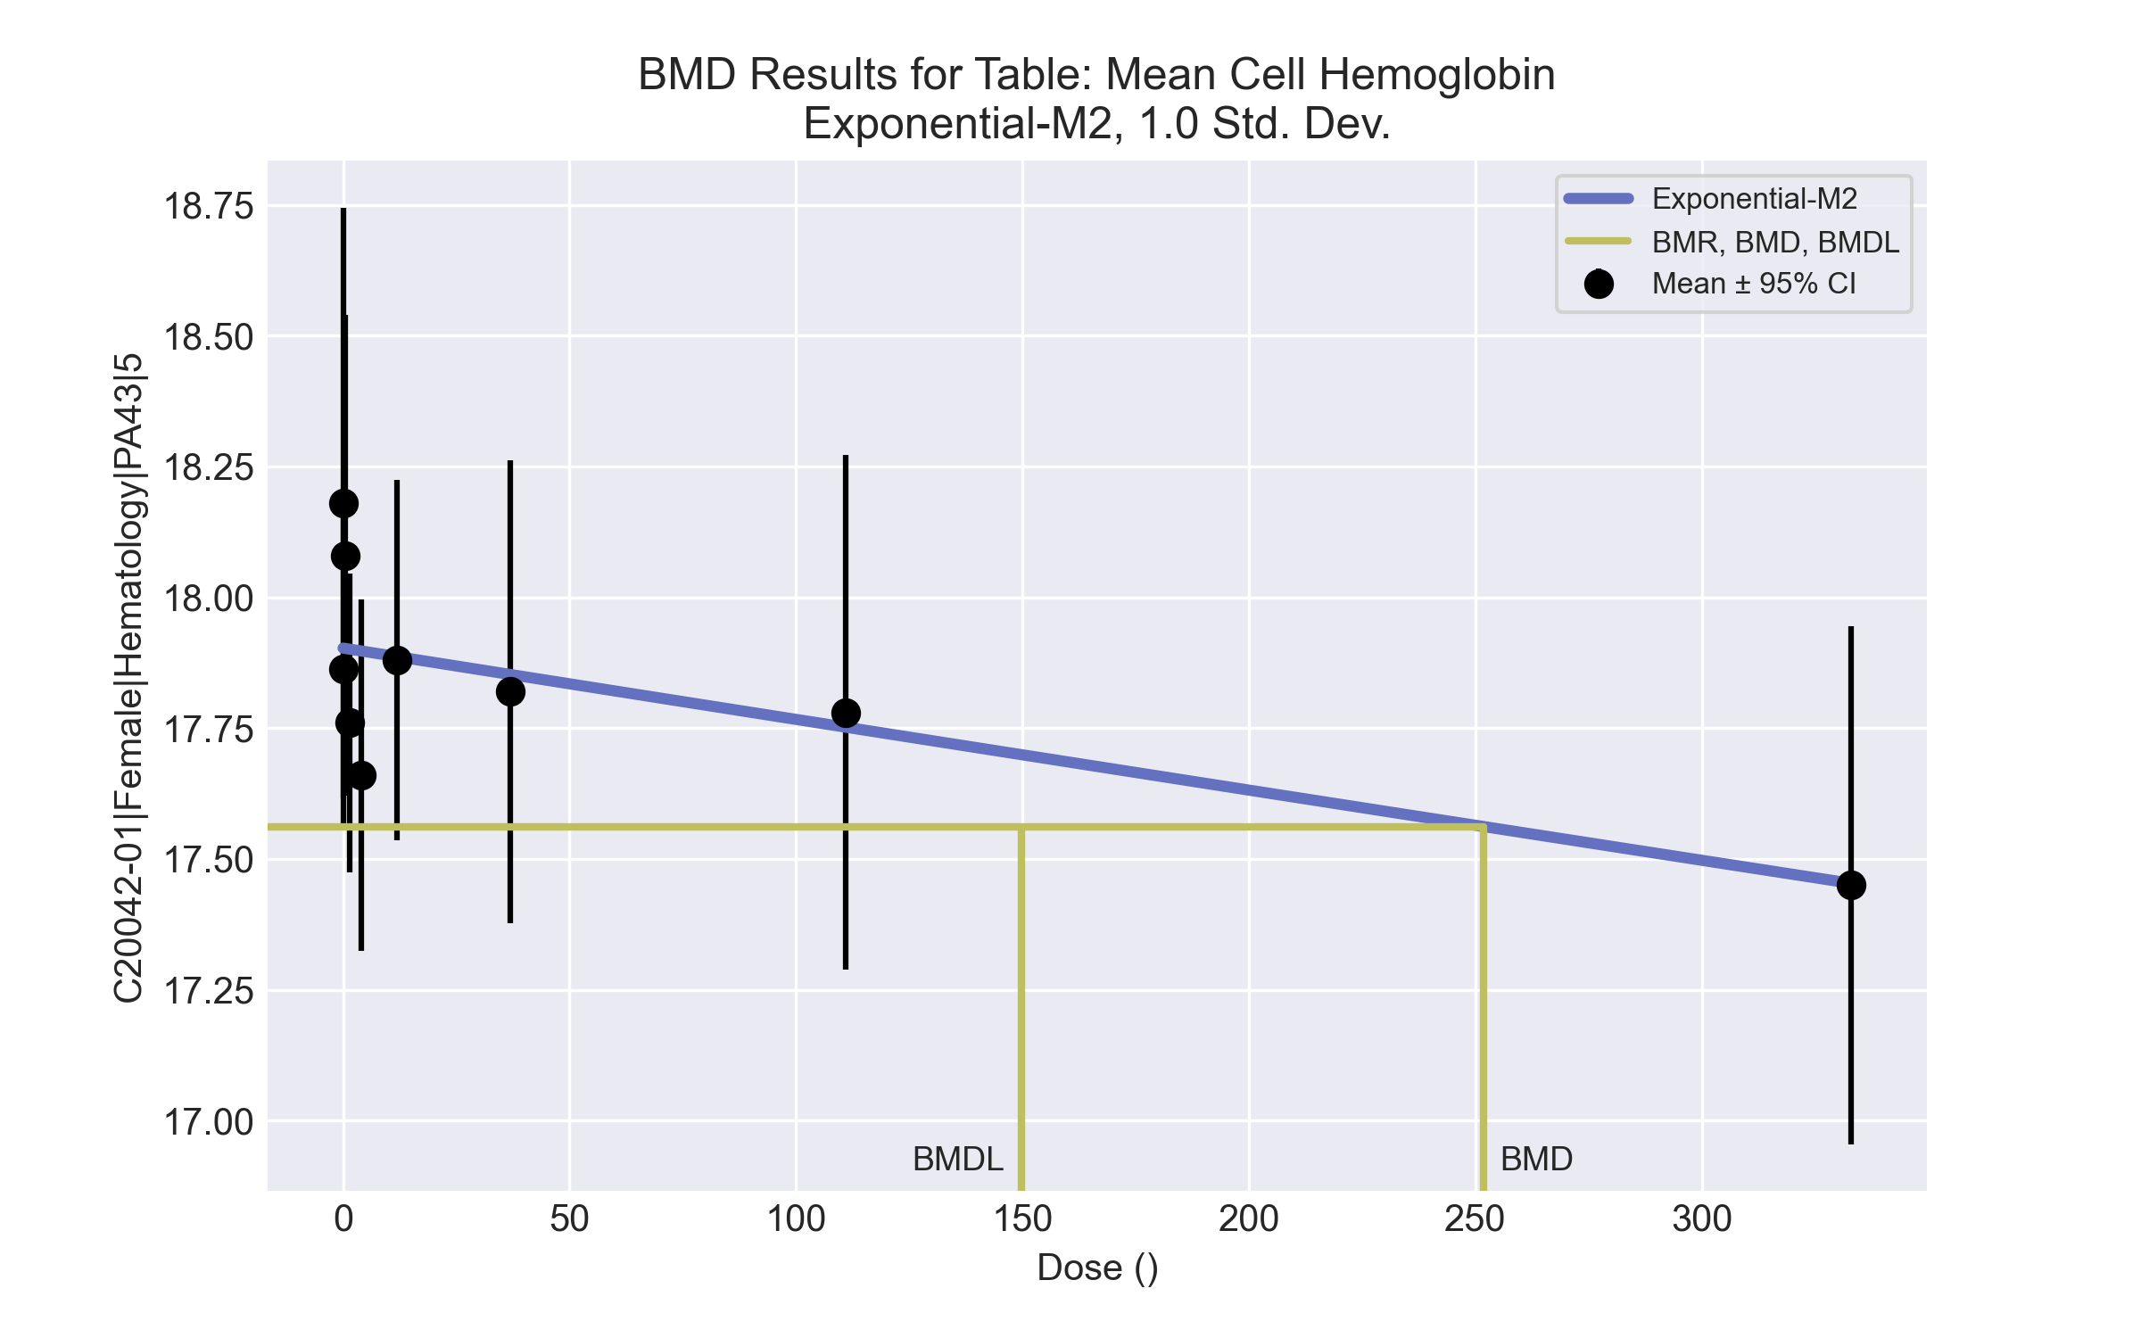
====================================================================
Exponential Model. (Version: 1.11; Date: 03/14/2017)
Input Data File: C:\Windows\TEMP\bmds-6yxynn_g.(d)
Gnuplot Plotting File:
Tue Apr 13 13:58:42 2021
====================================================================
BMDS_Model_Run
~~~~~~~~~~~~~~~~~~~~~~~~~~~~~~~~~~~~~~~~~~~~~~~~~~~~~~~~~~~~~~~~~~~~~
The form of the response function by Model:
Model 2: Y[dose] = a * exp{sign * b * dose}
Model 3: Y[dose] = a * exp{sign * (b * dose)^d}
Model 4: Y[dose] = a * [c-(c-1) * exp{-b * dose}]
Model 5: Y[dose] = a * [c-(c-1) * exp{-(b * dose)^d}]
Note: Y[dose] is the median response for exposure = dose;
sign = +1 for increasing trend in data;
sign = -1 for decreasing trend.
Model 2 is nested within Models 3 and 4.
Model 3 is nested within Model 5.
Model 4 is nested within Model 5.
Dependent variable = Response
Independent variable = Dose
Data are assumed to be distributed: normally
Variance Model: exp(lnalpha +rho *ln(Y[dose]))
rho is set to 0.
A constant variance model is fit.
Total number of dose groups = 9
Total number of records with missing values = 0
Maximum number of iterations = 500
Relative Function Convergence has been set to: 1e-008
Parameter Convergence has been set to: 1e-008
MLE solution provided: Exact
Initial Parameter Values
Variable Model 2
-------- --------
lnalpha -2.34324
rho 0 Specified
a 17.777
b 7.62082e-005
c 0 Specified
d 1 Specified
Parameter Estimates
Variable Model 2 Std. Err.
-------- ------- ---------
lnalpha -2.15287 0.02396
a 17.9028 0.0554374
b 7.63658e-005 3.02302e-005
NC = No Convergence
Table of Stats From Input Data
Dose N Obs Mean Obs Std Dev
----- --- ---------- -------------
0 8 17.86 0.3583
0.15 5 18.18 0.455
0.5 5 18.08 0.3701
1.4 5 17.76 0.2302
4 5 17.66 0.2702
12 5 17.88 0.2775
37 5 17.82 0.3564
111 5 17.78 0.3962
333 4 17.45 0.3109
Estimated Values of Interest
Dose Est Mean Est Std Scaled Residual
------ ---------- --------- ----------------
0 17.9 0.3408 -0.3341
0.15 17.9 0.3408 1.82
0.5 17.9 0.3408 1.167
1.4 17.9 0.3408 -0.9241
4 17.9 0.3408 -1.557
12 17.89 0.3408 -0.04172
37 17.85 0.3408 -0.2116
111 17.75 0.3408 0.186
333 17.45 0.3408 -0.01897
Other models for which likelihoods are calculated:
Model A1: Yij = Mu(i) + e(ij)
Var{e(ij)} = Sigma^2
Model A2: Yij = Mu(i) + e(ij)
Var{e(ij)} = Sigma(i)^2
Model A3: Yij = Mu(i) + e(ij)
Var{e(ij)} = exp(lalpha + log(mean(i)) * rho)
Model R: Yij = Mu + e(i)
Var{e(ij)} = Sigma^2
Likelihoods of Interest
Model Log(likelihood) DF AIC
------- ----------------- ---- ------------
A1 31.56616 10 -43.13232
A2 33.38962 18 -30.77923
A3 31.56616 10 -43.13232
R 24.05161 2 -44.10323
2 27.09243 3 -48.18486
Additive constant for all log-likelihoods = -43.19. This constant added to the
above values gives the log-likelihood including the term that does not
depend on the model parameters.
Explanation of Tests
Test 1: Does response and/or variances differ among Dose levels? (A2 vs. R)
Test 2: Are Variances Homogeneous? (A2 vs. A1)
Test 3: Are variances adequately modeled? (A2 vs. A3)
Test 4: Does Model 2 fit the data? (A3 vs. 2)
Tests of Interest
Test -2*log(Likelihood Ratio) D. F. p-value
-------- ------------------------ ------ --------------
Test 1 18.68 16 0.2858
Test 2 3.647 8 0.8875
Test 3 3.647 8 0.8875
Test 4 8.947 7 0.2565
The p-value for Test 1 is greater than .05. There may not be a
diffence between responses and/or variances among the dose levels
Modelling the data with a dose/response curve may not be appropriate.
The p-value for Test 2 is greater than .1. A homogeneous
variance model appears to be appropriate here.
The p-value for Test 3 is greater than .1. The modeled
variance appears to be appropriate here.
The p-value for Test 4 is greater than .1. Model 2 seems
to adequately describe the data.
Benchmark Dose Computations:
Specified Effect = 1.000000
Risk Type = Estimated standard deviations from control
Confidence Level = 0.950000
BMD = 251.686
BMDL = 149.752
BMDU = 762.475

Female BMD Results for Table: Platelet count
BMDS version: BMDS v2.7.0

Input dataset
Dose | 0 | 0.15 | 0.5 | 1.4 | 4 | 12 | 37 | 111 | 333 | 1000
N | 8 | 5 | 5 | 5 | 5 | 5 | 5 | 5 | 4 | 5
Mean ± SD | 967.5 ± 255.215 | 974.4 ± 161.769 | 984.6 ± 33.366 | 1054.8 ± 107.297 | 1048 ± 172.208 | 1150.4 ± 134.97 | 1197.2 ± 64.616 | 1012.8 ± 298.713 | 1123.5 ± 223.834 | 1183.6 ± 186.945

Summary table
Modelª | Goodness of fit |  | BMD | BMDL | Comments
 | p-value | AIC
Linear (equivalent models include Power, Polynomial 2°, 3°, 4°, 5°, 6°, 7°) | 0.034 | 601.584 | 1201 | 555.135 | No model was recommended as a best-fitting model. Doses were dropped until there were only 3 remaining dose-groups.
Polynomial 8° | 0.034 | 601.584 | 1200.87 | 555.135
Hill | 0.063 | 600.865 | -999 | -999
Exponential M2 (equivalent models include Exponential M3) | 0.034 | 601.608 | 1193.92 | 591.601
Exponential M4 | 0.105 | 598.79 | -999 | 0
Exponential M5 | 0.065 | 600.78 | -999 | 0
ª Modeled variance case presented (BMDS Test 2 p-value = 0.001, BMDS Test 3 p-value = 0.011).

Model recommendation details
Model | Bin | Notes
Linear (equivalent models include Power, Polynomial 2°, 3°, 4°, 5°, 6°, 7°) | Warning | Warnings  • Variance model poorly fits dataset (p-value 3 = 0.01076)  • Goodness of fit p-value is less than threshold (0.0338 < 0.1)  • BMD/high dose ratio is greater than threshold (1.2 > 1.0)
Polynomial 8° | Warning | Warnings  • Variance model poorly fits dataset (p-value 3 = 0.01076)  • Goodness of fit p-value is less than threshold (0.0338 < 0.1)  • BMD/high dose ratio is greater than threshold (1.2 > 1.0)
Hill | Failure | Failures  • BMD does not exist  • BMDL does not exist  Warnings  • Residual of Interest does not exist  • Variance model poorly fits dataset (p-value 3 = 0.01076)  • Goodness of fit p-value is less than threshold (0.0633 < 0.1)  Cautions  • Warning(s): BMR value is not in the range of the mean function
Exponential M2 (equivalent models include Exponential M3) | Warning | Warnings  • Variance model poorly fits dataset (p-value 3 = 0.01076)  • Goodness of fit p-value is less than threshold (0.0336 < 0.1)  • BMD/high dose ratio is greater than threshold (1.19 > 1.0)
Exponential M4 | Failure | Failures  • BMD does not exist  Warnings  • Residual of Interest does not exist  • Variance model poorly fits dataset (p-value 3 = 0.01076)
Exponential M5 | Failure | Failures  • BMD does not exist  Warnings  • Residual of Interest does not exist  • Variance model poorly fits dataset (p-value 3 = 0.01076)  • Goodness of fit p-value is less than threshold (0.0653 < 0.1)

Recommended model
No model was recommended as a best-fitting model.

Female BMD Results for Table: Reticulocyte count
BMDS version: BMDS v2.7.0

Input dataset
Dose | 0 | 0.15 | 0.5 | 1.4 | 4 | 12 | 37 | 111 | 333 | 1000
N | 8 | 5 | 5 | 5 | 5 | 5 | 5 | 5 | 4 | 5
Mean ± SD | 227.162 ± 44.806 | 254.48 ± 27.037 | 210.6 ± 34.657 | 210.76 ± 55.873 | 225.44 ± 37.913 | 209.22 ± 8.416 | 188 ± 25.592 | 177.26 ± 24.292 | 134.525 ± 31.921 | 138.84 ± 35.493

Summary table
Modelª | Goodness of fit |  | BMD | BMDL | Comments
 | p-value | AIC
Linear (equivalent models include Power, Polynomial 3°, 5°) | 0.005 | 442.136 | 434.65 | 316.444 | No model was recommended as a best-fitting model. Doses were dropped until there were only 3 remaining dose-groups.
Polynomial 2° | 0.005 | 442.136 | 434.649 | 273.238
Polynomial 4° | 0.005 | 442.136 | 434.648 | 245.823
Polynomial 6° | <0.0001 | 970.837 | -9999 | 189.37
Polynomial 7° | <0.0001 | 457.842 | -9999 | 745.272
Polynomial 8° | <0.0001 | 459.842 | -9999 | 190.738
Hill | 0.548 | 427.916 | 36.248 | -999
Exponential M2 (equivalent models include Exponential M3) | 0.01 | 439.972 | 299.305 | 110.651
Exponential M4 (equivalent models include Exponential M5) | 0.515 | 428.201 | 52.664 | 23.346
ª Modeled variance case presented (BMDS Test 2 p-value = 0.051, BMDS Test 3 p-value = 0.039).

Model recommendation details
Model | Bin | Notes
Linear (equivalent models include Power, Polynomial 3°, 5°) | Warning | Warnings  • Variance model poorly fits dataset (p-value 3 = 0.03889)  • Goodness of fit p-value is less than threshold (0.00464 < 0.1)
Polynomial 2° | Warning | Warnings  • Variance model poorly fits dataset (p-value 3 = 0.03889)  • Goodness of fit p-value is less than threshold (0.00464 < 0.1)
Polynomial 4° | Warning | Warnings  • Variance model poorly fits dataset (p-value 3 = 0.03889)  • Goodness of fit p-value is less than threshold (0.00464 < 0.1)
Polynomial 6° | Warning | Warnings  • Residual of Interest does not exist  • Variance model poorly fits dataset (p-value 3 = 0.03889)  • Residual at lowest dose is greater than threshold (3.05 > 2.0)  • Ratio of modeled to actual stdev. at control is greater than threshold (11.0 > 1.5)  Cautions  • Warning(s): THIS USUALLY MEANS THE MODEL HAS NOT CONVERGED!; BMD = 100*(maximum dose)
Polynomial 7° | Warning | Warnings  • Residual of Interest does not exist  • Variance model poorly fits dataset (p-value 3 = 0.03889)  Cautions  • Warning(s): BMD = 100*(maximum dose)
Polynomial 8° | Warning | Warnings  • Residual of Interest does not exist  • Variance model poorly fits dataset (p-value 3 = 0.03889)  Cautions  • Warning(s): BMD = 100*(maximum dose)
Hill | Failure | Failures  • BMDL does not exist  Warnings  • Variance model poorly fits dataset (p-value 3 = 0.03889)  Cautions  • Warning(s): BMDL computation failed.
Exponential M2 (equivalent models include Exponential M3) | Warning | Warnings  • Variance model poorly fits dataset (p-value 3 = 0.03889)  • Goodness of fit p-value is less than threshold (0.0104 < 0.1)
Exponential M4 (equivalent models include Exponential M5) | Warning | Warnings  • Variance model poorly fits dataset (p-value 3 = 0.03889)

Recommended model
No model was recommended as a best-fitting model.

Female BMD Results for Table: Thyroid Stimulating Hormone
BMDS version: BMDS v2.7.0

Input dataset
Dose | 0 | 0.15 | 0.5 | 1.4 | 4 | 12 | 37ª | 111ª | 333ª | 1000ª
N | 6 | 5 | 5 | 5 | 4 | 5 | 4 | 5 | 4 | 5
Mean ± SD | 2.783 ± 0.799 | 3.36 ± 1.907 | 2.94 ± 1.537 | 4.2 ± 1.065 | 4.025 ± 0.665 | 4.26 ± 1.101 | 4.475 ± 0.479 | 5.48 ± 2.463 | 4.9 ± 2.719 | 8.6 ± 3.941
ª Dose group removed in BMD modeling session

Summary table
Modelª | Goodness of fit |  | BMD | BMDL | Comments
 | p-value | AIC
Linear (equivalent models include Power, Polynomial 2°, 3°, 4°, 5°, 6°, 7°, 8°) | 0.353 | 47.436 | 12.541 | 6.575 | Hill recommended as best-fitting model on the basis of the lowest AIC.
Hill^{b} | 0.84 | 45.86 | 1.078 | 0.267
Exponential M2 (equivalent models include Exponential M3) | 0.335 | 47.584 | 12.973 | 7.529
Exponential M4 | 0.643 | 46.693 | 1.801 | 0.251
Exponential M5 | 0.658 | 47.86 | 1.281 | 0.512
ª Constant variance case presented (BMDS Test 2 p-value = 0.197, BMDS Test 3 p-value = 0.197).
^{b} Recommended model

Model recommendation details
Model | Bin | Notes
Linear (equivalent models include Power, Polynomial 2°, 3°, 4°, 5°, 6°, 7°, 8°) | Warning | Warnings  • BMD/high dose ratio is greater than threshold (1.05 > 1.0)  • Ratio of modeled to actual stdev. at control is greater than threshold (1.51 > 1.5)
Hillª | Valid | -
Exponential M2 (equivalent models include Exponential M3) | Warning | Warnings  • BMD/high dose ratio is greater than threshold (1.08 > 1.0)
Exponential M4 | Valid | Cautions  • BMD/BMDL ratio is greater than threshold (7.19 > 5.0)
Exponential M5 | Valid | -
ª Recommended model

Recommended model
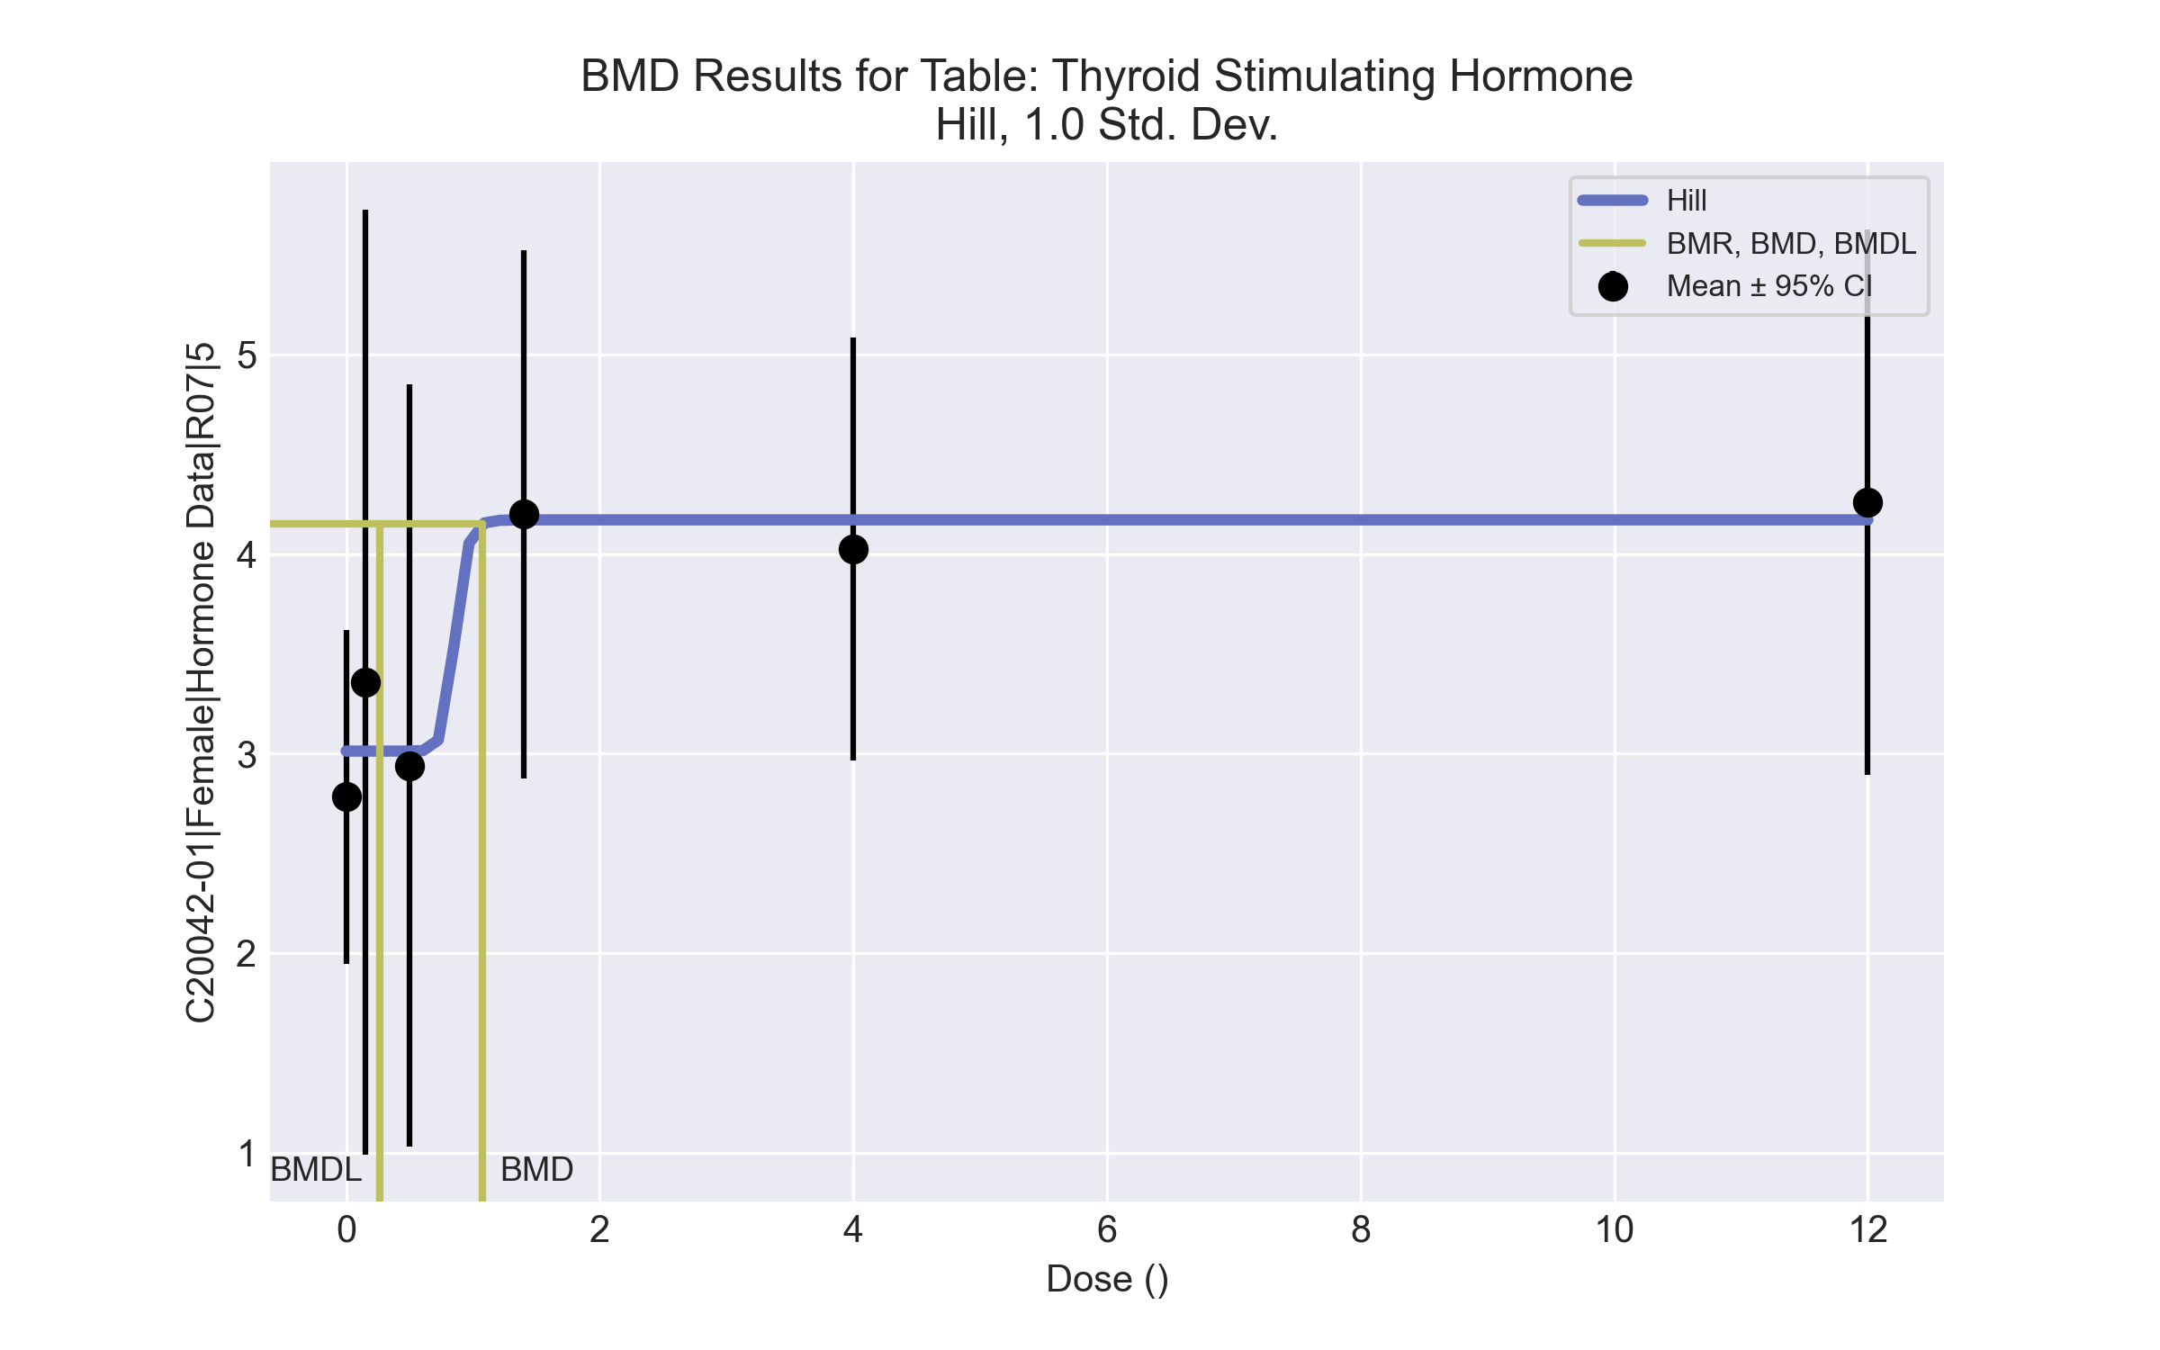
====================================================================
Hill Model. (Version: 2.18; Date: 03/14/2017)
Input Data File: C:\Windows\TEMP\bmds-ae61de6y.(d)
Gnuplot Plotting File: C:\Windows\TEMP\bmds-ae61de6y.plt
Tue Apr 13 14:02:33 2021
====================================================================
BMDS_Model_Run
~~~~~~~~~~~~~~~~~~~~~~~~~~~~~~~~~~~~~~~~~~~~~~~~~~~~~~~~~~~~~~~~~~~~~
The form of the response function is:
Y[dose] = intercept + v*dose^n/(k^n + dose^n)
Dependent variable = Response
Independent variable = Dose
rho is set to 0
Power parameter restricted to be greater than 1
A constant variance model is fit
Total number of dose groups = 6
Total number of records with missing values = 0
Maximum number of iterations = 500
Relative Function Convergence has been set to: 1e-008
Parameter Convergence has been set to: 1e-008
Default Initial Parameter Values
alpha = 1.57966
rho = 0 Specified
intercept = 2.78333
v = 1.47667
n = 0.998488
k = 1.88452
Asymptotic Correlation Matrix of Parameter Estimates
( *** The model parameter(s) -rho -n
have been estimated at a boundary point, or have been specified by the user,
and do not appear in the correlation matrix )
alpha intercept v k
alpha 1 -8.3e-008 1.9e-007 -2.3e-007
intercept -8.3e-008 1 -0.68 0.012
v 1.9e-007 -0.68 1 0.016
k -2.3e-007 0.012 0.016 1
Parameter Estimates
95.0% Wald Confidence Interval
Variable Estimate Std. Err. Lower Conf. Limit Upper Conf. Limit
alpha 1.29954 0.33554 0.641894 1.95718
intercept 3.01248 0.28502 2.45385 3.57111
v 1.15901 0.417269 0.341175 1.97684
n 18 NA
k 0.858502 7.68332 -14.2005 15.9175
NA - Indicates that this parameter has hit a bound
implied by some inequality constraint and thus
has no standard error.
Table of Data and Estimated Values of Interest
Dose N Obs Mean Est Mean Obs Std Dev Est Std Dev Scaled Res.
------ --- -------- -------- ----------- ----------- ----------
0 6 2.78 3.01 0.799 1.14 -0.492
0.15 5 3.36 3.01 1.91 1.14 0.682
0.5 5 2.94 3.01 1.54 1.14 -0.142
1.4 5 4.2 4.17 1.07 1.14 0.0563
4 4 4.03 4.17 0.665 1.14 -0.257
12 5 4.26 4.17 1.1 1.14 0.174
Model Descriptions for likelihoods calculated
Model A1: Yij = Mu(i) + e(ij)
Var{e(ij)} = Sigma^2
Model A2: Yij = Mu(i) + e(ij)
Var{e(ij)} = Sigma(i)^2
Model A3: Yij = Mu(i) + e(ij)
Var{e(ij)} = Sigma^2
Model A3 uses any fixed variance parameters that
were specified by the user
Model R: Yi = Mu + e(i)
Var{e(i)} = Sigma^2
Likelihoods of Interest
Model Log(likelihood) # Param's AIC
A1 -18.510987 7 51.021974
A2 -14.843525 12 53.687051
A3 -18.510987 7 51.021974
fitted -18.930143 4 45.860286
R -22.363833 2 48.727665
Explanation of Tests
Test 1: Do responses and/or variances differ among Dose levels?
(A2 vs. R)
Test 2: Are Variances Homogeneous? (A1 vs A2)
Test 3: Are variances adequately modeled? (A2 vs. A3)
Test 4: Does the Model for the Mean Fit? (A3 vs. fitted)
(Note: When rho=0 the results of Test 3 and Test 2 will be the same.)
Tests of Interest
Test -2*log(Likelihood Ratio) Test df p-value
Test 1 15.0406 10 0.1306
Test 2 7.33492 5 0.1969
Test 3 7.33492 5 0.1969
Test 4 0.838312 3 0.8403
The p-value for Test 1 is greater than .05. There may not be a
diffence between responses and/or variances among the dose levels
Modelling the data with a dose/response curve may not be appropriate
The p-value for Test 2 is greater than .1. A homogeneous variance
model appears to be appropriate here
The p-value for Test 3 is greater than .1. The modeled variance appears
to be appropriate here
The p-value for Test 4 is greater than .1. The model chosen seems
to adequately describe the data
Benchmark Dose Computation
Specified effect = 1
Risk Type = Estimated standard deviations from the control mean
Confidence level = 0.95
BMD = 1.07767
BMDL = 0.266926
BMDU = 1.44e+006

