Male BMD Results for Table: Liver Weight Absolute
BMDS version: BMDS v2.7.0

Input dataset
Dose | 0 | 0.15 | 0.5 | 1.4 | 4ª | 12ª | 37ª | 111ª | 333ª | 1000ª
N | 10 | 5 | 5 | 5 | 5 | 5 | 5 | 5 | 5 | 5
Mean ± SD | 12.679 ± 1.208 | 12.46 ± 0.962 | 12.142 ± 0.733 | 14.416 ± 0.871 | 13.164 ± 1.022 | 12.84 ± 1.629 | 12.816 ± 1.3 | 13.194 ± 0.51 | 15.484 ± 1.13 | 14.89 ± 1.482
ª Dose group removed in BMD modeling session

Summary table
Modelª | Goodness of fit |  | BMD | BMDL | Comments
 | p-value | AIC
Linear | 0.075 | 33.015 | 0.839 | 0.533 | Polynomial-8 recommended as best-fitting model on the basis of the lowest AIC.
Polynomial 2° | 0.327 | 30.064 | 1.005 | 0.822
Polynomial 3° | 0.487 | 29.266 | 1.113 | 0.976
Polynomial 4° | 0.55 | 29.026 | 1.177 | 0.853
Polynomial 5° | 0.572 | 28.946 | 1.218 | 0.851
Polynomial 6° | 0.58 | 28.918 | 1.246 | 0.854
Polynomial 7° | 0.583 | 28.908 | 1.267 | 0.855
Polynomial 8°^{b} | 0.584 | 28.905 | 1.283 | 0.821
Power | 0.3 | 30.903 | 1.341 | 0.805
Hill | -999 | 32.903 | 1.336 | 0.53
Exponential M2 | 0.083 | 32.8 | 0.841 | 0.554
Exponential M3 | 0.3 | 30.903 | 1.347 | 0.811
Exponential M4 | 0.023 | 35.015 | 0.839 | 0.533
Exponential M5 | -999 | 32.903 | 1.342 | 0.805
ª Constant variance case presented (BMDS Test 2 p-value = 0.508, BMDS Test 3 p-value = 0.508).
^{b} Recommended model

Model recommendation details
Model | Bin | Notes
Linear | Warning | Warnings  • Goodness of fit p-value is less than threshold (0.0748 < 0.1)
Polynomial 2° | Valid | -
Polynomial 3° | Valid | -
Polynomial 4° | Valid | -
Polynomial 5° | Valid | -
Polynomial 6° | Valid | -
Polynomial 7° | Valid | -
Polynomial 8°ª | Valid | -
Power | Valid | -
Hill | Warning | Warnings  • Zero degrees of freedom; saturated model  Cautions  • Warning(s): THE MODEL HAS PROBABLY NOT CONVERGED!!!; THIS USUALLY MEANS THE MODEL HAS NOT CONVERGED!
Exponential M2 | Warning | Warnings  • Goodness of fit p-value is less than threshold (0.0833 < 0.1)
Exponential M3 | Valid | -
Exponential M4 | Warning | Warnings  • Goodness of fit p-value is less than threshold (0.0228 < 0.1)
Exponential M5 | Warning | Warnings  • Zero degrees of freedom; saturated model
ª Recommended model

Recommended model
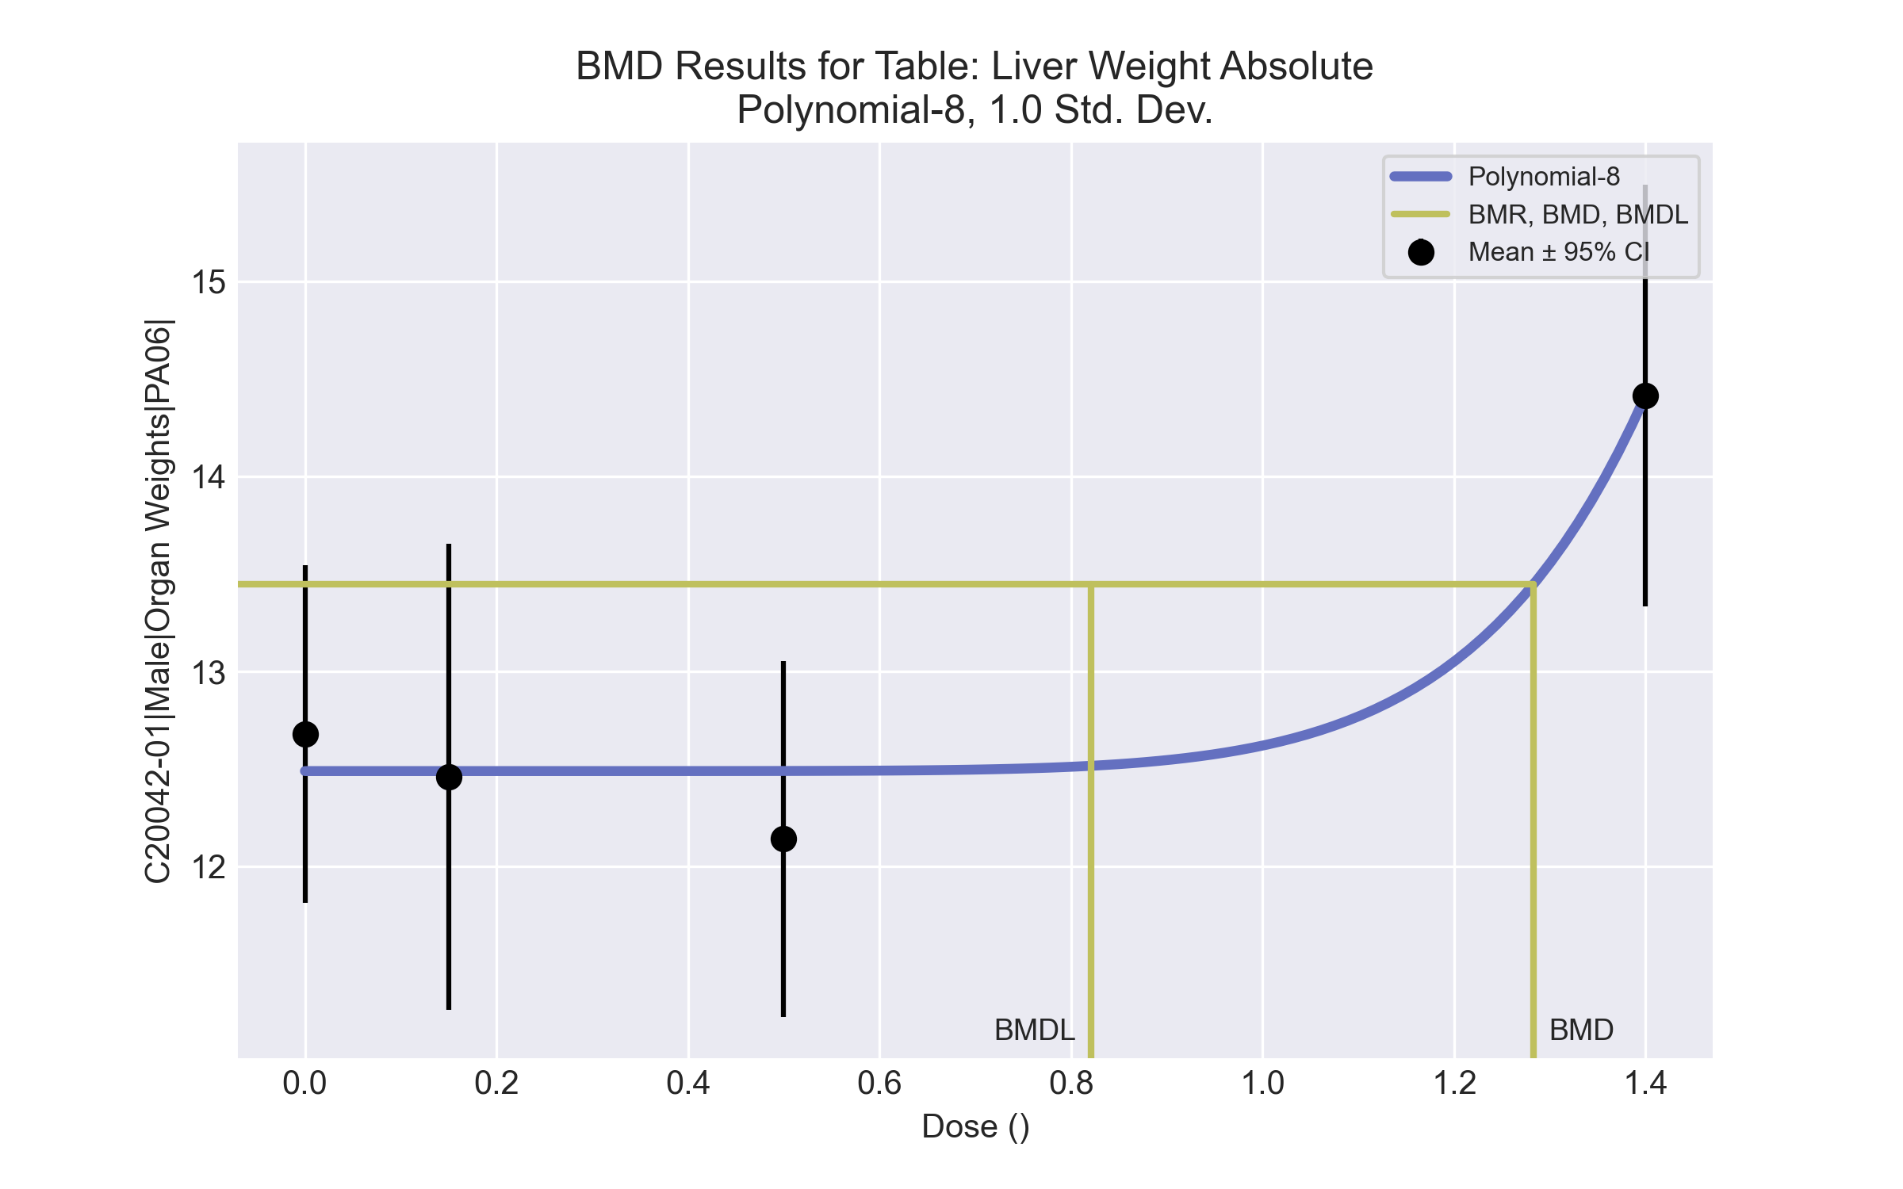
====================================================================
Polynomial Model. (Version: 2.21; Date: 03/14/2017)
Input Data File: C:\Windows\TEMP\bmds-p6ullff7.(d)
Gnuplot Plotting File: C:\Windows\TEMP\bmds-p6ullff7.plt
Tue Apr 13 11:49:35 2021
====================================================================
BMDS_Model_Run
~~~~~~~~~~~~~~~~~~~~~~~~~~~~~~~~~~~~~~~~~~~~~~~~~~~~~~~~~~~~~~~~~~~~~
The form of the response function is:
Y[dose] = beta_0 + beta_1*dose + beta_2*dose^2 + ...
Dependent variable = Response
Independent variable = Dose
rho is set to 0
The polynomial coefficients are restricted to be positive
A constant variance model is fit
Total number of dose groups = 4
Total number of records with missing values = 0
Maximum number of iterations = 500
Relative Function Convergence has been set to: 1e-008
Parameter Convergence has been set to: 1e-008
Default Initial Parameter Values
alpha = 1.04863
rho = 0 Specified
beta_0 = -47.4623
beta_1 = 0
beta_2 = 0
beta_3 = 0
beta_4 = 0
beta_5 = 0
beta_6 = 0
beta_7 = 0
beta_8 = 0
Asymptotic Correlation Matrix of Parameter Estimates
( *** The model parameter(s) -rho -beta_1 -beta_2 -beta_3 -beta_4 -beta_5 -beta_6 -beta_7
have been estimated at a boundary point, or have been specified by the user,
and do not appear in the correlation matrix )
alpha beta_0 beta_8
alpha 1 -2.2e-007 1.1e-006
beta_0 -2.2e-007 1 -0.45
beta_8 1.1e-006 -0.45 1
Parameter Estimates
95.0% Wald Confidence Interval
Variable Estimate Std. Err. Lower Conf. Limit Upper Conf. Limit
alpha 0.919612 0.260106 0.409814 1.42941
beta_0 12.4899 0.214445 12.0696 12.9102
beta_1 0 NA
beta_2 -0 NA
beta_3 0 NA
beta_4 0 NA
beta_5 0 NA
beta_6 3.13352e-022 NA
beta_7 2.95604e-021 NA
beta_8 0.130507 0.032492 0.0668242 0.194191
NA - Indicates that this parameter has hit a bound
implied by some inequality constraint and thus
has no standard error.
Table of Data and Estimated Values of Interest
Dose N Obs Mean Est Mean Obs Std Dev Est Std Dev Scaled Res.
------ --- -------- -------- ----------- ----------- ----------
0 10 12.7 12.5 1.21 0.959 0.624
0.15 5 12.5 12.5 0.962 0.959 -0.0697
0.5 5 12.1 12.5 0.733 0.959 -0.812
1.4 5 14.4 14.4 0.871 0.959 0.000211
Model Descriptions for likelihoods calculated
Model A1: Yij = Mu(i) + e(ij)
Var{e(ij)} = Sigma^2
Model A2: Yij = Mu(i) + e(ij)
Var{e(ij)} = Sigma(i)^2
Model A3: Yij = Mu(i) + e(ij)
Var{e(ij)} = Sigma^2
Model A3 uses any fixed variance parameters that
were specified by the user
Model R: Yi = Mu + e(i)
Var{e(i)} = Sigma^2
Likelihoods of Interest
Model Log(likelihood) # Param's AIC
A1 -10.914174 5 31.828348
A2 -9.752573 8 35.505147
A3 -10.914174 5 31.828348
fitted -11.452455 3 28.904910
R -17.676651 2 39.353303
Explanation of Tests
Test 1: Do responses and/or variances differ among Dose levels?
(A2 vs. R)
Test 2: Are Variances Homogeneous? (A1 vs A2)
Test 3: Are variances adequately modeled? (A2 vs. A3)
Test 4: Does the Model for the Mean Fit? (A3 vs. fitted)
(Note: When rho=0 the results of Test 3 and Test 2 will be the same.)
Tests of Interest
Test -2*log(Likelihood Ratio) Test df p-value
Test 1 15.8482 6 0.01459
Test 2 2.3232 3 0.5081
Test 3 2.3232 3 0.5081
Test 4 1.07656 2 0.5838
The p-value for Test 1 is less than .05. There appears to be a
difference between response and/or variances among the dose levels
It seems appropriate to model the data
The p-value for Test 2 is greater than .1. A homogeneous variance
model appears to be appropriate here
The p-value for Test 3 is greater than .1. The modeled variance appears
to be appropriate here
The p-value for Test 4 is greater than .1. The model chosen seems
to adequately describe the data
Benchmark Dose Computation
Specified effect = 1
Risk Type = Estimated standard deviations from the control mean
Confidence level = 0.95
BMD = 1.28313
BMDL = 0.82108
BMDU = 1.3887

Male BMD Results for Table: Liver Weight Relative
BMDS version: BMDS v2.7.0

Input dataset
Dose | 0 | 0.15 | 0.5 | 1.4 | 4ª | 12ª | 37ª | 111ª | 333ª | 1000ª
N | 10 | 5 | 5 | 5 | 5 | 5 | 5 | 5 | 5 | 5
Mean ± SD | 39.109 ± 2.37 | 38.879 ± 2.196 | 37.254 ± 1.955 | 43.959 ± 2.598 | 40.327 ± 1.915 | 40.142 ± 3.122 | 40.51 ± 1.873 | 42.47 ± 1.01 | 48.533 ± 1.747 | 47.017 ± 2.921
ª Dose group removed in BMD modeling session

Summary table
Modelª | Goodness of fit |  | BMD | BMDL | Comments
 | p-value | AIC
Linear | 0.011 | 77.474 | 0.751 | 0.493 | Polynomial-8 recommended as best-fitting model on the basis of the lowest AIC.
Polynomial 2° | 0.099 | 73.142 | 0.93 | 0.717
Polynomial 3° | 0.198 | 71.763 | 1.051 | 0.802
Polynomial 4° | 0.248 | 71.311 | 1.125 | 0.832
Polynomial 5° | 0.268 | 71.157 | 1.175 | 0.839
Polynomial 6° | 0.275 | 71.102 | 1.209 | 0.934
Polynomial 7° | 0.278 | 71.083 | 1.235 | 0.89
Polynomial 8°^{b} | 0.279 | 71.076 | 1.254 | 0.844
Power | 0.11 | 73.072 | 1.33 | 0.842
Hill | 0.11 | 73.072 | 1.301 | 0.539
Exponential M2 | 0.013 | 77.209 | 0.753 | 0.508
Exponential M3 | 0.11 | 73.072 | 1.335 | -999
Exponential M4 | 0.003 | 79.474 | 0.751 | 0.493
Exponential M5 | -999 | 75.072 | 1.328 | 0.842
ª Constant variance case presented (BMDS Test 2 p-value = 0.909, BMDS Test 3 p-value = 0.909).
^{b} Recommended model

Model recommendation details
Model | Bin | Notes
Linear | Warning | Warnings  • Goodness of fit p-value is less than threshold (0.0114 < 0.1)
Polynomial 2° | Warning | Warnings  • Goodness of fit p-value is less than threshold (0.0993 < 0.1)
Polynomial 3° | Valid | -
Polynomial 4° | Valid | -
Polynomial 5° | Valid | -
Polynomial 6° | Valid | -
Polynomial 7° | Valid | -
Polynomial 8°ª | Valid | -
Power | Valid | -
Hill | Valid | Cautions  • Warning(s): THE MODEL HAS PROBABLY NOT CONVERGED!!!; THIS USUALLY MEANS THE MODEL HAS NOT CONVERGED!
Exponential M2 | Warning | Warnings  • Goodness of fit p-value is less than threshold (0.013 < 0.1)
Exponential M3 | Failure | Failures  • BMDL does not exist
Exponential M4 | Warning | Warnings  • Goodness of fit p-value is less than threshold (0.00277 < 0.1)
Exponential M5 | Warning | Warnings  • Zero degrees of freedom; saturated model
ª Recommended model

Recommended model
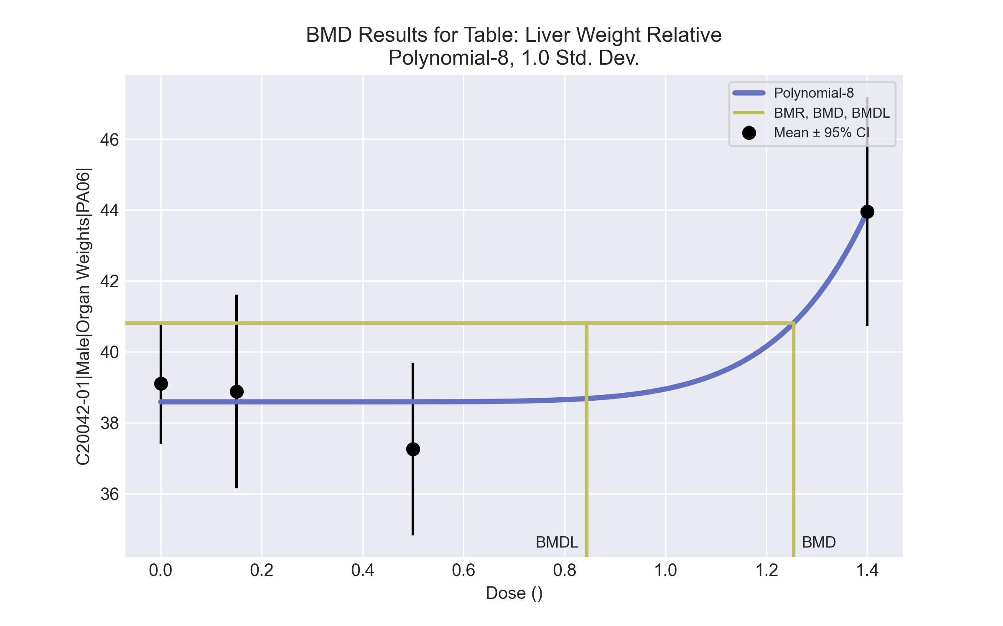
====================================================================
Polynomial Model. (Version: 2.21; Date: 03/14/2017)
Input Data File: C:\Windows\TEMP\bmds-d9i15g4n.(d)
Gnuplot Plotting File: C:\Windows\TEMP\bmds-d9i15g4n.plt
Tue Apr 13 11:50:12 2021
====================================================================
BMDS_Model_Run
~~~~~~~~~~~~~~~~~~~~~~~~~~~~~~~~~~~~~~~~~~~~~~~~~~~~~~~~~~~~~~~~~~~~~
The form of the response function is:
Y[dose] = beta_0 + beta_1*dose + beta_2*dose^2 + ...
Dependent variable = Response
Independent variable = Dose
rho is set to 0
The polynomial coefficients are restricted to be positive
A constant variance model is fit
Total number of dose groups = 4
Total number of records with missing values = 0
Maximum number of iterations = 500
Relative Function Convergence has been set to: 1e-008
Parameter Convergence has been set to: 1e-008
Default Initial Parameter Values
alpha = 5.34026
rho = 0 Specified
beta_0 = -144.308
beta_1 = 0
beta_2 = 0
beta_3 = 0
beta_4 = 0
beta_5 = 0
beta_6 = 0
beta_7 = 0
beta_8 = 0
Asymptotic Correlation Matrix of Parameter Estimates
( *** The model parameter(s) -rho -beta_1 -beta_2 -beta_3 -beta_4 -beta_5 -beta_6 -beta_7
have been estimated at a boundary point, or have been specified by the user,
and do not appear in the correlation matrix )
alpha beta_0 beta_8
alpha 1 7.4e-007 -7.5e-008
beta_0 7.4e-007 1 -0.45
beta_8 -7.5e-008 -0.45 1
Parameter Estimates
95.0% Wald Confidence Interval
Variable Estimate Std. Err. Lower Conf. Limit Upper Conf. Limit
alpha 4.96814 1.4052 2.21399 7.72229
beta_0 38.5875 0.498438 37.6106 39.5644
beta_1 2.30843e-020 NA
beta_2 0 NA
beta_3 6.26087e-021 NA
beta_4 -0 NA
beta_5 0 NA
beta_6 1.82648e-021 NA
beta_7 0 NA
beta_8 0.363929 0.0755216 0.215909 0.511949
NA - Indicates that this parameter has hit a bound
implied by some inequality constraint and thus
has no standard error.
Table of Data and Estimated Values of Interest
Dose N Obs Mean Est Mean Obs Std Dev Est Std Dev Scaled Res.
------ --- -------- -------- ----------- ----------- ----------
0 10 39.1 38.6 2.37 2.23 0.74
0.15 5 38.9 38.6 2.2 2.23 0.293
0.5 5 37.3 38.6 1.96 2.23 -1.34
1.4 5 44 44 2.6 2.23 0.000354
Model Descriptions for likelihoods calculated
Model A1: Yij = Mu(i) + e(ij)
Var{e(ij)} = Sigma^2
Model A2: Yij = Mu(i) + e(ij)
Var{e(ij)} = Sigma(i)^2
Model A3: Yij = Mu(i) + e(ij)
Var{e(ij)} = Sigma^2
Model A3 uses any fixed variance parameters that
were specified by the user
Model R: Yi = Mu + e(i)
Var{e(i)} = Sigma^2
Likelihoods of Interest
Model Log(likelihood) # Param's AIC
A1 -31.261519 5 72.523038
A2 -30.989350 8 77.978701
A3 -31.261519 5 72.523038
fitted -32.538062 3 71.076124
R -40.749681 2 85.499363
Explanation of Tests
Test 1: Do responses and/or variances differ among Dose levels?
(A2 vs. R)
Test 2: Are Variances Homogeneous? (A1 vs A2)
Test 3: Are variances adequately modeled? (A2 vs. A3)
Test 4: Does the Model for the Mean Fit? (A3 vs. fitted)
(Note: When rho=0 the results of Test 3 and Test 2 will be the same.)
Tests of Interest
Test -2*log(Likelihood Ratio) Test df p-value
Test 1 19.5207 6 0.003369
Test 2 0.544338 3 0.909
Test 3 0.544338 3 0.909
Test 4 2.55309 2 0.279
The p-value for Test 1 is less than .05. There appears to be a
difference between response and/or variances among the dose levels
It seems appropriate to model the data
The p-value for Test 2 is greater than .1. A homogeneous variance
model appears to be appropriate here
The p-value for Test 3 is greater than .1. The modeled variance appears
to be appropriate here
The p-value for Test 4 is greater than .1. The model chosen seems
to adequately describe the data
Benchmark Dose Computation
Specified effect = 1
Risk Type = Estimated standard deviations from the control mean
Confidence level = 0.95
BMD = 1.25425
BMDL = 0.844308
BMDU = 1.33981

Male BMD Results for Table: A/G Ratio
BMDS version: BMDS v2.7.0

Input dataset
Dose | 0 | 0.15 | 0.5 | 1.4 | 4 | 12 | 37 | 111 | 333ª | 1000ª
N | 10 | 5 | 5 | 5 | 5 | 5 | 5 | 5 | 5 | 5
Mean ± SD | 2.039 ± 0.212 | 1.989 ± 0.179 | 1.924 ± 0.28 | 2.032 ± 0.168 | 2.038 ± 0.089 | 1.959 ± 0.139 | 1.948 ± 0.056 | 1.89 ± 0.12 | 1.805 ± 0.127 | 1.88 ± 0.066
ª Dose group removed in BMD modeling session

Summary table
Modelª | Goodness of fit |  | BMD | BMDL | Comments
 | p-value | AIC
Linear (equivalent models include Power, Polynomial 2°, 3°, 4°, 7°) | 0.657 | -115.416 | 155.225 | 90.396 | Polynomial-5 recommended as best-fitting model on the basis of the lowest AIC.
Polynomial 5°^{b} | <0.0001 | -64.708 | 47.003 | 11.049
Polynomial 6° | <0.0001 | 396.127 | 3.805 | -999
Polynomial 8° | <0.0001 | 659.363 | 11.722 | -999
Hill | 0.976 | -117.215 | -999 | -999
Exponential M2 (equivalent models include Exponential M3) | 0.548 | -113.472 | 156.383 | 89.278
Exponential M4 | 0.93 | -115.096 | -999 | 0
Exponential M5 | 0.93 | -115.096 | -999 | 0
ª Modeled variance case presented (BMDS Test 2 p-value = 0.024, BMDS Test 3 p-value = 0.115).
^{b} Recommended model

Model recommendation details
Model | Bin | Notes
Linear (equivalent models include Power, Polynomial 2°, 3°, 4°, 7°) | Warning | Warnings  • BMD/high dose ratio is greater than threshold (1.4 > 1.0)
Polynomial 5°ª | Valid | -
Polynomial 6° | Failure | Failures  • BMDL does not exist  Warnings  • Residual of interest is greater than threshold (2.56 > 2.0)  • Residual at lowest dose is greater than threshold (2.74 > 2.0)  • Ratio of modeled to actual stdev. at control is greater than threshold (12.7 > 1.5)  Cautions  • Warning(s): THE MODEL HAS PROBABLY NOT CONVERGED!!!; THIS USUALLY MEANS THE MODEL HAS NOT CONVERGED!; BMDL computation failed.
Polynomial 8° | Failure | Failures  • BMDL does not exist  Warnings  • Residual at lowest dose is greater than threshold (3.43 > 2.0)  • Ratio of modeled to actual stdev. at control is greater than threshold (1.28e+03 > 1.5)  Cautions  • Warning(s): BMDL computation failed.
Hill | Failure | Failures  • BMD does not exist  • BMDL does not exist  Warnings  • Residual of Interest does not exist  Cautions  • Warning(s): BMR value is not in the range of the mean function
Exponential M2 (equivalent models include Exponential M3) | Warning | Warnings  • BMD/high dose ratio is greater than threshold (1.41 > 1.0)
Exponential M4 | Failure | Failures  • BMD does not exist  Warnings  • Residual of Interest does not exist
Exponential M5 | Failure | Failures  • BMD does not exist  Warnings  • Residual of Interest does not exist
ª Recommended model

Recommended model
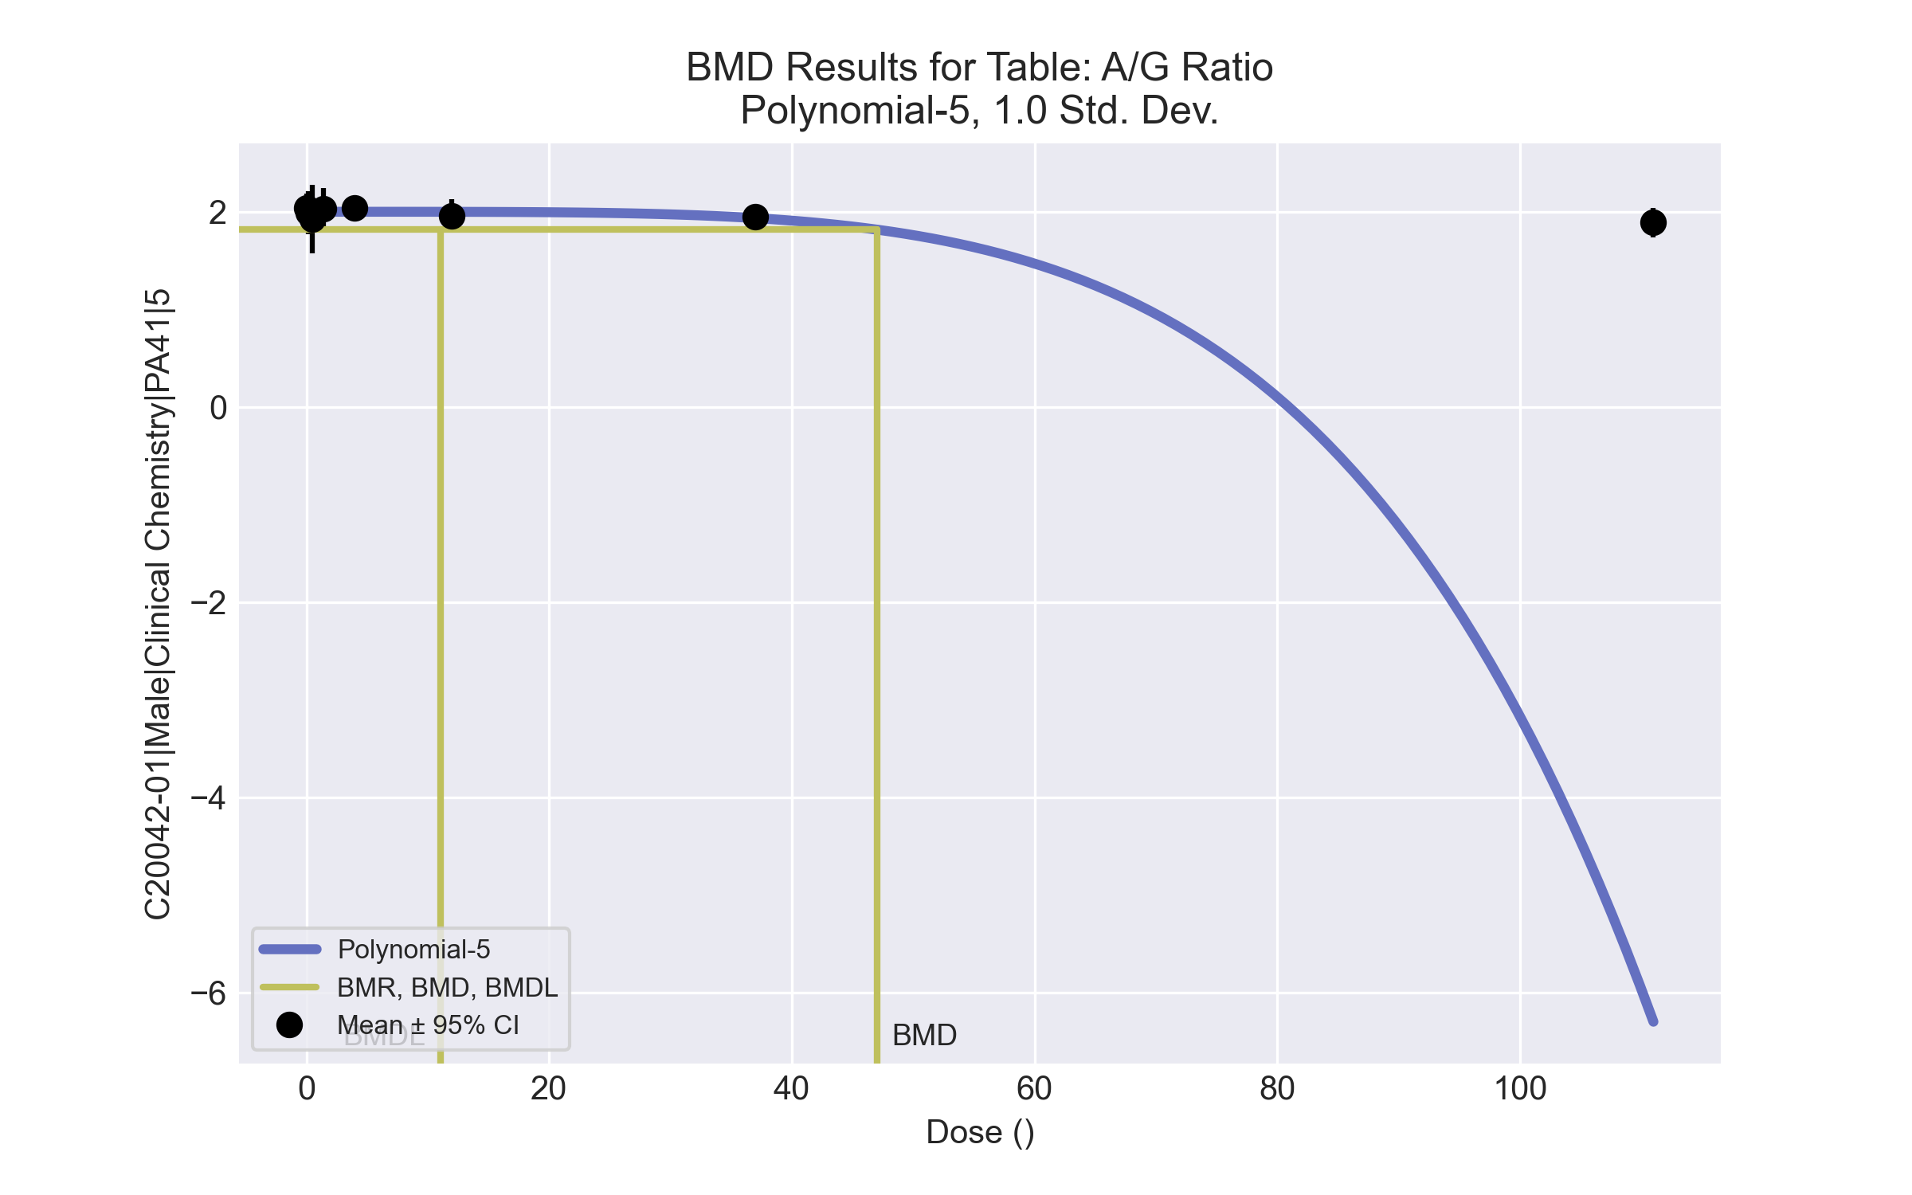
====================================================================
Polynomial Model. (Version: 2.21; Date: 03/14/2017)
Input Data File: C:\Windows\TEMP\bmds-vkr05wpd.(d)
Gnuplot Plotting File: C:\Windows\TEMP\bmds-vkr05wpd.plt
Tue Apr 13 12:05:40 2021
====================================================================
BMDS_Model_Run
~~~~~~~~~~~~~~~~~~~~~~~~~~~~~~~~~~~~~~~~~~~~~~~~~~~~~~~~~~~~~~~~~~~~~
The form of the response function is:
Y[dose] = beta_0 + beta_1*dose + beta_2*dose^2 + ...
Dependent variable = Response
Independent variable = Dose
The polynomial coefficients are restricted to be negative
The variance is to be modeled as Var(i) = exp(lalpha + log(mean(i)) * rho)
Total number of dose groups = 8
Total number of records with missing values = 0
Maximum number of iterations = 500
Relative Function Convergence has been set to: 1e-008
Parameter Convergence has been set to: 1e-008
Default Initial Parameter Values
lalpha = -3.48303
rho = 0
beta_0 = 1.9975
beta_1 = -0.0153676
beta_2 = 0
beta_3 = -0.00115933
beta_4 = 0
beta_5 = -1.90913e-007
!!! Warning: optimum may not have been found. !!!
!!! You may want to try choosing different initial values. !!!
Asymptotic Correlation Matrix of Parameter Estimates
( *** The model parameter(s) -beta_1 -beta_2 -beta_4
have been estimated at a boundary point, or have been specified by the user,
and do not appear in the correlation matrix )
lalpha rho beta_0 beta_3 beta_5
lalpha 1 -0.9 -0.029 -0.095 -0.0023
rho -0.9 1 0.021 0.048 0.14
beta_0 -0.029 0.021 1 -0.4 0.4
beta_3 -0.095 0.048 -0.4 1 -1
beta_5 -0.0023 0.14 0.4 -1 1
Parameter Estimates
95.0% Wald Confidence Interval
Variable Estimate Std. Err. Lower Conf. Limit Upper Conf. Limit
lalpha -7.53623 0.412431 -8.34458 -6.72788
rho 5.96775 0.299987 5.37979 6.55572
beta_0 2.0001 0.0310232 1.9393 2.06091
beta_1 -7.71662e-022 NA
beta_2 -3.74757e-023 NA
beta_3 0 1.73288e-006 -3.39638e-006 3.39638e-006
beta_4 -2.47885e-008 NA
beta_5 -2.6917e-010 1.37365e-010 -5.38401e-010 6.05092e-014
NA - Indicates that this parameter has hit a bound
implied by some inequality constraint and thus
has no standard error.
Table of Data and Estimated Values of Interest
Dose N Obs Mean Est Mean Obs Std Dev Est Std Dev Scaled Res.
------ --- -------- -------- ----------- ----------- ----------
0 10 2.04 2 0.212 0.183 0.674
0.15 5 1.99 2 0.179 0.183 -0.138
0.5 5 1.92 2 0.28 0.183 -0.926
1.4 5 2.03 2 0.168 0.183 0.39
4 5 2.04 2 0.0893 0.183 0.46
12 5 1.96 2 0.139 0.183 -0.496
37 5 1.95 1.93 0.0555 0.166 0.178
111 5 1.89 -6.3 0.12 5.6 3.27
Model Descriptions for likelihoods calculated
Model A1: Yij = Mu(i) + e(ij)
Var{e(ij)} = Sigma^2
Model A2: Yij = Mu(i) + e(ij)
Var{e(ij)} = Sigma(i)^2
Model A3: Yij = Mu(i) + e(ij)
Var{e(ij)} = exp(lalpha + rho*ln(Mu(i)))
Model A3 uses any fixed variance parameters that
were specified by the user
Model R: Yi = Mu + e(i)
Var{e(i)} = Sigma^2
Likelihoods of Interest
Model Log(likelihood) # Param's AIC
A1 60.272458 9 -102.544915
A2 68.341814 16 -104.683627
A3 63.219064 10 -106.438129
fitted 37.353801 5 -64.707603
R 57.877773 2 -111.755546
Explanation of Tests
Test 1: Do responses and/or variances differ among Dose levels?
(A2 vs. R)
Test 2: Are Variances Homogeneous? (A1 vs A2)
Test 3: Are variances adequately modeled? (A2 vs. A3)
Test 4: Does the Model for the Mean Fit? (A3 vs. fitted)
(Note: When rho=0 the results of Test 3 and Test 2 will be the same.)
Tests of Interest
Test -2*log(Likelihood Ratio) Test df p-value
Test 1 20.9281 14 0.1035
Test 2 16.1387 7 0.02388
Test 3 10.2455 6 0.1147
Test 4 51.7305 5 <.0001
The p-value for Test 1 is greater than .05. There may not be a
diffence between responses and/or variances among the dose levels
Modelling the data with a dose/response curve may not be appropriate
The p-value for Test 2 is less than .1. A non-homogeneous variance
model appears to be appropriate
The p-value for Test 3 is greater than .1. The modeled variance appears
to be appropriate here
The p-value for Test 4 is less than .1. You may want to try a different
model
Benchmark Dose Computation
Specified effect = 1
Risk Type = Estimated standard deviations from the control mean
Confidence level = 0.95
BMD = 47.0028
BMDL = 11.0485
BMDU computation failed.

Male BMD Results for Table: Alanine aminotransferase
BMDS version: BMDS v2.7.0

Input dataset
Dose | 0 | 0.15 | 0.5 | 1.4 | 4 | 12 | 37 | 111 | 333 | 1000
N | 10 | 5 | 5 | 5 | 5 | 5 | 5 | 5 | 5 | 5
Mean ± SD | 60.8 ± 14.861 | 57.2 ± 6.907 | 55 ± 11.247 | 64.2 ± 7.759 | 63.2 ± 11.904 | 57.6 ± 5.771 | 50.4 ± 5.32 | 52.6 ± 7.197 | 53.6 ± 6.269 | 52.4 ± 11.675

Summary table
Modelª | Goodness of fit |  | BMD | BMDL | Comments
 | p-value | AIC
Linear (equivalent models include Power, Polynomial 3°, 4°, 6°, 7°, 8°) | 0.027 | 316.347 | 1463.17 | 634.353 | No model was recommended as a best-fitting model. Doses were dropped until there were only 3 remaining dose-groups.
Polynomial 2° | 0.027 | 316.347 | 1463.16 | 634.353
Polynomial 5° | 0.027 | 316.347 | 1463.18 | 634.353
Hill | 0.433 | 308.041 | -999 | -999
Exponential M2 | 0.028 | 316.285 | 1477.85 | 594.429
Exponential M3 | 0.028 | 316.285 | 1477.84 | 594.429
Exponential M4 | 0.328 | 309.132 | -999 | 0
Exponential M5 | 0.324 | 310.041 | -999 | 0
ª Modeled variance case presented (BMDS Test 2 p-value = 0.079, BMDS Test 3 p-value = 0.483).

Model recommendation details
Model | Bin | Notes
Linear (equivalent models include Power, Polynomial 3°, 4°, 6°, 7°, 8°) | Warning | Warnings  • Goodness of fit p-value is less than threshold (0.0274 < 0.1)  • BMD/high dose ratio is greater than threshold (1.46 > 1.0)
Polynomial 2° | Warning | Warnings  • Goodness of fit p-value is less than threshold (0.0274 < 0.1)  • BMD/high dose ratio is greater than threshold (1.46 > 1.0)
Polynomial 5° | Warning | Warnings  • Goodness of fit p-value is less than threshold (0.0274 < 0.1)  • BMD/high dose ratio is greater than threshold (1.46 > 1.0)
Hill | Failure | Failures  • BMD does not exist  • BMDL does not exist  Warnings  • Residual of Interest does not exist  Cautions  • Warning(s): BMR value is not in the range of the mean function
Exponential M2 | Warning | Warnings  • Goodness of fit p-value is less than threshold (0.028 < 0.1)  • BMD/high dose ratio is greater than threshold (1.48 > 1.0)
Exponential M3 | Warning | Warnings  • Goodness of fit p-value is less than threshold (0.028 < 0.1)  • BMD/high dose ratio is greater than threshold (1.48 > 1.0)
Exponential M4 | Failure | Failures  • BMD does not exist  Warnings  • Residual of Interest does not exist
Exponential M5 | Failure | Failures  • BMD does not exist  Warnings  • Residual of Interest does not exist

Recommended model
No model was recommended as a best-fitting model.

Male BMD Results for Table: Cholesterol
BMDS version: BMDS v2.7.0

Input dataset
Dose | 0 | 0.15 | 0.5 | 1.4 | 4 | 12 | 37 | 111 | 333 | 1000
N | 10 | 5 | 5 | 5 | 5 | 5 | 5 | 5 | 5 | 5
Mean ± SD | 114.9 ± 18.538 | 115.2 ± 4.97 | 119.6 ± 30.312 | 112.2 ± 17.796 | 123 ± 10.724 | 114.2 ± 7.662 | 117.8 ± 20.729 | 123.4 ± 13.164 | 131 ± 7.681 | 163.6 ± 15.915

Summary table
Modelª | Goodness of fit |  | BMD | BMDL | Comments
 | p-value | AIC
Linear (equivalent models include Power, Polynomial 2°, 3°, 4°, 5°, 6°, 7°, 8°) | 0.986 | 362.66 | 334.218 | 257.922 | No model was recommended as a best-fitting model. Doses were dropped until there were only 3 remaining dose-groups.
Hill | 0.97 | 364.645 | 318.281 | -999
Exponential M2 (equivalent models include Exponential M3) | 0.983 | 362.788 | 372.303 | 295.365
Exponential M4 (equivalent models include Exponential M5) | 0.97 | 364.645 | 318.469 | 167.165
ª Modeled variance case presented (BMDS Test 2 p-value = 0.004, BMDS Test 3 p-value = 0.003).

Model recommendation details
Model | Bin | Notes
Linear (equivalent models include Power, Polynomial 2°, 3°, 4°, 5°, 6°, 7°, 8°) | Warning | Warnings  • Variance model poorly fits dataset (p-value 3 = 0.002918)
Hill | Failure | Failures  • BMDL does not exist  Warnings  • Variance model poorly fits dataset (p-value 3 = 0.002918)  Cautions  • Warning(s): BMDL computation failed.
Exponential M2 (equivalent models include Exponential M3) | Warning | Warnings  • Variance model poorly fits dataset (p-value 3 = 0.002918)
Exponential M4 (equivalent models include Exponential M5) | Warning | Warnings  • Variance model poorly fits dataset (p-value 3 = 0.002918)

Recommended model
No model was recommended as a best-fitting model.

Male BMD Results for Table: Globulin (measured)
BMDS version: BMDS v2.7.0

Input dataset
Dose | 0 | 0.15 | 0.5 | 1.4 | 4 | 12 | 37 | 111 | 333 | 1000
N | 10 | 5 | 5 | 5 | 5 | 5 | 5 | 5 | 5 | 5
Mean ± SD | 2.15 ± 0.227 | 2.16 ± 0.114 | 2.24 ± 0.344 | 2.12 ± 0.217 | 2.18 ± 0.045 | 2.2 ± 0.1 | 2.26 ± 0.089 | 2.26 ± 0.152 | 2.3 ± 0.141 | 2.3 ± 0.1

Summary table
Modelª | Goodness of fit |  | BMD | BMDL | Comments
 | p-value | AIC
Linear (equivalent models include Power, Polynomial 2°, 3°, 4°, 5°, 6°, 7°, 8°) | 0.043 | -135.711 | 1606.7 | 863.883 | No model was recommended as a best-fitting model. Doses were dropped until there were only 3 remaining dose-groups.
Hill | 0.443 | -141.815 | -999 | -999
Exponential M2 (equivalent models include Exponential M3) | 0.043 | -135.673 | 1592.17 | 873.591
Exponential M4 | 0.44 | -142.74 | -999 | 0
Exponential M5 | 0.442 | -141.806 | -999 | 0
ª Modeled variance case presented (BMDS Test 2 p-value = 6.9E-04, BMDS Test 3 p-value = 0.097).

Model recommendation details
Model | Bin | Notes
Linear (equivalent models include Power, Polynomial 2°, 3°, 4°, 5°, 6°, 7°, 8°) | Warning | Warnings  • Variance model poorly fits dataset (p-value 3 = 0.09691)  • Goodness of fit p-value is less than threshold (0.0434 < 0.1)  • BMD/high dose ratio is greater than threshold (1.61 > 1.0)
Hill | Failure | Failures  • BMD does not exist  • BMDL does not exist  Warnings  • Residual of Interest does not exist  • Variance model poorly fits dataset (p-value 3 = 0.09691)  Cautions  • Warning(s): BMR value is not in the range of the mean function
Exponential M2 (equivalent models include Exponential M3) | Warning | Warnings  • Variance model poorly fits dataset (p-value 3 = 0.09691)  • Goodness of fit p-value is less than threshold (0.0429 < 0.1)  • BMD/high dose ratio is greater than threshold (1.59 > 1.0)
Exponential M4 | Failure | Failures  • BMD does not exist  Warnings  • Residual of Interest does not exist  • Variance model poorly fits dataset (p-value 3 = 0.09691)
Exponential M5 | Failure | Failures  • BMD does not exist  Warnings  • Residual of Interest does not exist  • Variance model poorly fits dataset (p-value 3 = 0.09691)

Recommended model
No model was recommended as a best-fitting model.

Male BMD Results for Table: Eosinophil count
BMDS version: BMDS v2.7.0

Input dataset
Dose | 0 | 0.15 | 0.5 | 1.4 | 4 | 12ª | 37ª | 111ª | 333ª | 1000ª
N | 9 | 5 | 5 | 4 | 5 | 5 | 5 | 5 | 5 | 4
Mean ± SD | 0.1 ± 0.057 | 0.068 ± 0.029 | 0.09 ± 0.045 | 0.22 ± 0.28 | 0.098 ± 0.027 | 0.056 ± 0.027 | 0.084 ± 0.059 | 0.058 ± 0.036 | 0.05 ± 0.029 | 0.037 ± 0.01
ª Dose group removed in BMD modeling session

Summary table
Modelª | Goodness of fit |  | BMD | BMDL | Comments
 | p-value | AIC
Linear (equivalent models include Polynomial 2°, 3°, 4°, 5°, 6°, 7°, 8°) | <0.0001 | -96.377 | 1.077 | 0.498 | Exponential-M5 recommended as best-fitting model on the basis of the lowest AIC.
Power | <0.0001 | -98.437 | 5.405 | 5.259
Hill | <0.0001 | -110.423 | 0.859 | -999
Exponential M2 | <0.0001 | -87.791 | 1 | -999
Exponential M3 | <0.0001 | -91.356 | 2.47 | 0.939
Exponential M4 | <0.0001 | -101.419 | -999 | 0
Exponential M5^{b} | <0.0001 | -108.424 | 1.194 | 0.522
ª Modeled variance case presented (BMDS Test 2 p-value = <0.0001, BMDS Test 3 p-value = 0.585).
^{b} Recommended model

Model recommendation details
Model | Bin | Notes
Linear (equivalent models include Polynomial 2°, 3°, 4°, 5°, 6°, 7°, 8°) | Valid | -
Power | Warning | Warnings  • BMD/high dose ratio is greater than threshold (1.35 > 1.0)  • Ratio of modeled to actual stdev. at control is greater than threshold (2.14 > 1.5)  Cautions  • BMDL/high dose ratio is greater than threshold (1.31 > 1.0)
Hill | Failure | Failures  • BMDL does not exist  Cautions  • Warning(s): BMDL computation failed.
Exponential M2 | Failure | Failures  • BMDL does not exist  Warnings  • Residual of interest is greater than threshold (2.02 > 2.0)
Exponential M3 | Valid | -
Exponential M4 | Failure | Failures  • BMD does not exist  Warnings  • Residual of Interest does not exist
Exponential M5ª | Valid | -
ª Recommended model

Recommended model
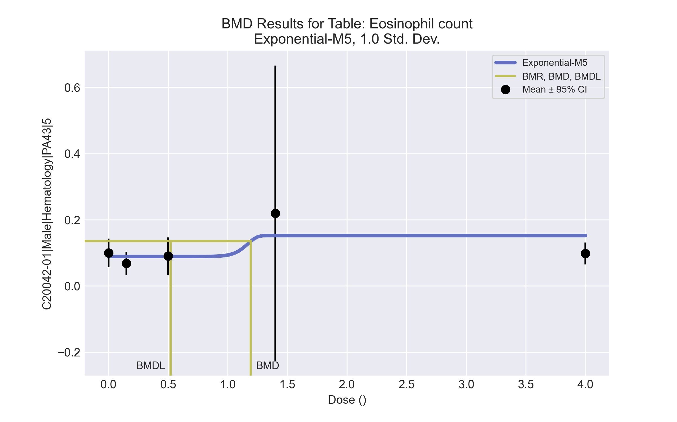
====================================================================
Exponential Model. (Version: 1.11; Date: 03/14/2017)
Input Data File: C:\Windows\TEMP\bmds-qlzieysu.(d)
Gnuplot Plotting File:
Tue Apr 13 12:08:59 2021
====================================================================
BMDS_Model_Run
~~~~~~~~~~~~~~~~~~~~~~~~~~~~~~~~~~~~~~~~~~~~~~~~~~~~~~~~~~~~~~~~~~~~~
The form of the response function by Model:
Model 2: Y[dose] = a * exp{sign * b * dose}
Model 3: Y[dose] = a * exp{sign * (b * dose)^d}
Model 4: Y[dose] = a * [c-(c-1) * exp{-b * dose}]
Model 5: Y[dose] = a * [c-(c-1) * exp{-(b * dose)^d}]
Note: Y[dose] is the median response for exposure = dose;
sign = +1 for increasing trend in data;
sign = -1 for decreasing trend.
Model 2 is nested within Models 3 and 4.
Model 3 is nested within Model 5.
Model 4 is nested within Model 5.
Dependent variable = Response
Independent variable = Dose
Data are assumed to be distributed: normally
Variance Model: exp(lnalpha +rho *ln(Y[dose]))
The variance is to be modeled as Var(i) = exp(lalpha + log(mean(i)) * rho)
Total number of dose groups = 5
Total number of records with missing values = 0
Maximum number of iterations = 500
Relative Function Convergence has been set to: 1e-008
Parameter Convergence has been set to: 1e-008
MLE solution provided: Exact
Initial Parameter Values
Variable Model 5
-------- --------
lnalpha 3.41631
rho 4.08536
a 0.0646
b 0.262454
c 3.57585
d 1
Parameter Estimates
Variable Model 5 Std. Err.
-------- ------- ---------
lnalpha 5.79772 9.03777
rho 4.93927 3.81659
a 0.0889474 0.0105761
b 0.851382 12.2345
c 1.71136 0.682262
d 16.5291 860.665
NC = No Convergence
Table of Stats From Input Data
Dose N Obs Mean Obs Std Dev
----- --- ---------- -------------
0 9 0.1 0.05657
0.15 5 0.068 0.02864
0.5 5 0.09 0.04528
1.4 4 0.22 0.2804
4 5 0.098 0.02683
Estimated Values of Interest
Dose Est Mean Est Std Scaled Residual
------ ---------- --------- ----------------
0 0.08895 0.0461 0.7193
0.15 0.08895 0.0461 -1.016
0.5 0.08895 0.0461 0.05105
1.4 0.1522 0.1738 0.7801
4 0.1522 0.1738 -0.6977
Other models for which likelihoods are calculated:
Model A1: Yij = Mu(i) + e(ij)
Var{e(ij)} = Sigma^2
Model A2: Yij = Mu(i) + e(ij)
Var{e(ij)} = Sigma(i)^2
Model A3: Yij = Mu(i) + e(ij)
Var{e(ij)} = exp(lalpha + log(mean(i)) * rho)
Model R: Yij = Mu + e(i)
Var{e(ij)} = Sigma^2
Likelihoods of Interest
Model Log(likelihood) DF AIC
------- ----------------- ---- ------------
A1 50.68597 6 -89.37194
A2 71.04723 10 -122.0945
A3 70.07675 7 -126.1535
R 47.89547 2 -91.79094
5 60.21213 6 -108.4243
Additive constant for all log-likelihoods = -25.73. This constant added to the
above values gives the log-likelihood including the term that does not
depend on the model parameters.
Explanation of Tests
Test 1: Does response and/or variances differ among Dose levels? (A2 vs. R)
Test 2: Are Variances Homogeneous? (A2 vs. A1)
Test 3: Are variances adequately modeled? (A2 vs. A3)
Test 7a: Does Model 5 fit the data? (A3 vs 5)
Tests of Interest
Test -2*log(Likelihood Ratio) D. F. p-value
-------- ------------------------ ------ --------------
Test 1 46.3 8 < 0.0001
Test 2 40.72 4 < 0.0001
Test 3 1.941 3 0.5848
Test 7a 19.73 1 < 0.0001
The p-value for Test 1 is less than .05. There appears to be a
difference between response and/or variances among the dose
levels, it seems appropriate to model the data.
The p-value for Test 2 is less than .1. A non-homogeneous
variance model appears to be appropriate.
The p-value for Test 3 is greater than .1. The modeled
variance appears to be appropriate here.
The p-value for Test 7a is less than .1. Model 5 may not adequately
describe the data; you may want to consider another model.
Benchmark Dose Computations:
Specified Effect = 1.000000
Risk Type = Estimated standard deviations from control
Confidence Level = 0.950000
BMD = 1.19358
BMDL = 0.521706
BMDU = 40000

Male BMD Results for Table: Platelet count
BMDS version: BMDS v2.7.0

Input dataset
Dose | 0 | 0.15 | 0.5 | 1.4 | 4 | 12 | 37 | 111 | 333 | 1000
N | 9 | 5 | 5 | 5 | 5 | 5 | 5 | 5 | 4 | 4
Mean ± SD | 868.889 ± 150.507 | 1029.2 ± 131.201 | 926.2 ± 53.765 | 954 ± 179.094 | 904 ± 356.4 | 974.6 ± 59.919 | 877 ± 190.162 | 883.4 ± 146.189 | 1061 ± 84.546 | 1177.75 ± 59.236

Summary table
Modelª | Goodness of fit |  | BMD | BMDL | Comments
 | p-value | AIC
Linear (equivalent models include Power, Polynomial 3°, 4°, 5°, 6°, 7°, 8°) | 0.013 | 579.966 | 673.733 | 511.633 | No model was recommended as a best-fitting model. Doses were dropped until there were only 3 remaining dose-groups.
Polynomial 2° | 0.013 | 579.966 | 673.734 | 511.633
Hill | 0.005 | 583.126 | 547.392 | -999
Exponential M2 (equivalent models include Exponential M3) | 0.012 | 580.189 | 702.207 | 549.076
Exponential M4 | 0.009 | 581.331 | 526.639 | 279.699
Exponential M5 | 0.009 | 581.612 | 359.119 | 270.336
ª Modeled variance case presented (BMDS Test 2 p-value = 2.4E-04, BMDS Test 3 p-value = 0.213).

Model recommendation details
Model | Bin | Notes
Linear (equivalent models include Power, Polynomial 3°, 4°, 5°, 6°, 7°, 8°) | Warning | Warnings  • Goodness of fit p-value is less than threshold (0.0128 < 0.1)
Polynomial 2° | Warning | Warnings  • Goodness of fit p-value is less than threshold (0.0128 < 0.1)
Hill | Failure | Failures  • BMDL does not exist  Warnings  • Goodness of fit p-value is less than threshold (0.00495 < 0.1)  Cautions  • Warning(s): THE MODEL HAS PROBABLY NOT CONVERGED!!!; THIS USUALLY MEANS THE MODEL HAS NOT CONVERGED!; BMDL computation failed.
Exponential M2 (equivalent models include Exponential M3) | Warning | Warnings  • Goodness of fit p-value is less than threshold (0.0118 < 0.1)
Exponential M4 | Warning | Warnings  • Goodness of fit p-value is less than threshold (0.00891 < 0.1)
Exponential M5 | Warning | Warnings  • Goodness of fit p-value is less than threshold (0.00907 < 0.1)

Recommended model
No model was recommended as a best-fitting model.

Male BMD Results for Table: Reticulocyte count
BMDS version: BMDS v2.7.0

Input dataset
Dose | 0 | 0.15 | 0.5 | 1.4 | 4 | 12 | 37 | 111 | 333 | 1000
N | 9 | 5 | 5 | 5 | 5 | 5 | 5 | 5 | 5 | 4
Mean ± SD | 244.7 ± 21.461 | 247.22 ± 47.71 | 232.6 ± 28.537 | 212.3 ± 27.996 | 258.34 ± 31.852 | 210.78 ± 31.508 | 168.74 ± 19.588 | 147 ± 24.588 | 138.5 ± 14.982 | 122.425 ± 29.794

Summary table
Modelª | Goodness of fit |  | BMD | BMDL | Comments
 | p-value | AIC
Linear (equivalent models include Power, Polynomial 5°) | <0.0001 | 454.346 | 341.771 | 257.016 | Exponential-M4 recommended as best-fitting model on the basis of the lowest BMDL.
Polynomial 2° (equivalent models include Polynomial 3°, 4°, 6°) | <0.0001 | 454.346 | 341.77 | 257.016
Polynomial 7° | <0.0001 | 454.346 | 341.773 | 257.016
Polynomial 8° | <0.0001 | 454.359 | 345.622 | 256.86
Hill | 0.095 | 417.488 | 13.542 | 6.061
Exponential M2 (equivalent models include Exponential M3) | <0.0001 | 449.005 | 197.918 | 130.422
Exponential M4^{b} | 0.108 | 416.483 | 11.837 | 6.978
Exponential M5 | 0.07 | 418.372 | 14.169 | 7.05
ª Constant variance case presented (BMDS Test 2 p-value = 0.432, BMDS Test 3 p-value = 0.432).
^{b} Recommended model

Model recommendation details
Model | Bin | Notes
Linear (equivalent models include Power, Polynomial 5°) | Warning | Warnings  • Ratio of modeled to actual stdev. at control is greater than threshold (1.94 > 1.5)
Polynomial 2° (equivalent models include Polynomial 3°, 4°, 6°) | Warning | Warnings  • Ratio of modeled to actual stdev. at control is greater than threshold (1.94 > 1.5)
Polynomial 7° | Warning | Warnings  • Ratio of modeled to actual stdev. at control is greater than threshold (1.94 > 1.5)
Polynomial 8° | Warning | Warnings  • Ratio of modeled to actual stdev. at control is greater than threshold (1.96 > 1.5)
Hill | Warning | Warnings  • Goodness of fit p-value is less than threshold (0.0952 < 0.1)
Exponential M2 (equivalent models include Exponential M3) | Valid | -
Exponential M4ª | Valid | -
Exponential M5 | Warning | Warnings  • Goodness of fit p-value is less than threshold (0.0697 < 0.1)
ª Recommended model

Recommended model
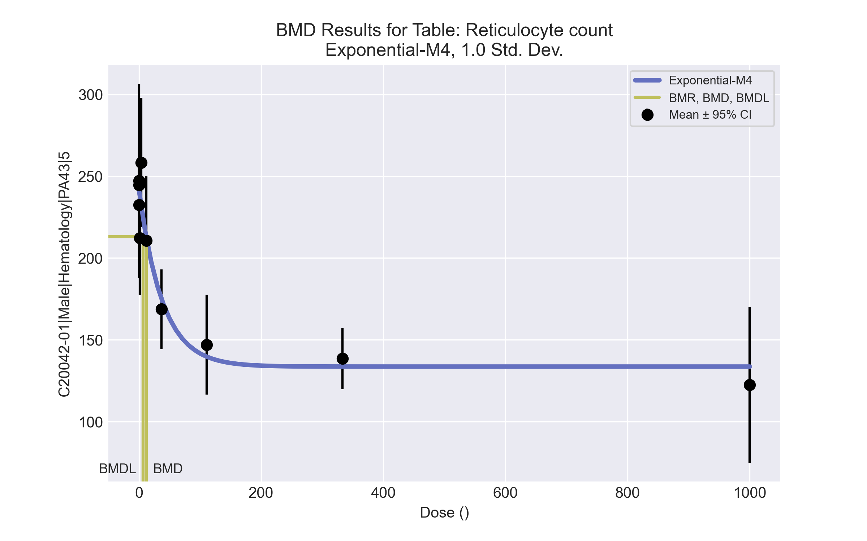
====================================================================
Exponential Model. (Version: 1.11; Date: 03/14/2017)
Input Data File: C:\Windows\TEMP\bmds-g5z4_5sw.(d)
Gnuplot Plotting File:
Tue Apr 13 12:09:50 2021
====================================================================
BMDS_Model_Run
~~~~~~~~~~~~~~~~~~~~~~~~~~~~~~~~~~~~~~~~~~~~~~~~~~~~~~~~~~~~~~~~~~~~~
The form of the response function by Model:
Model 2: Y[dose] = a * exp{sign * b * dose}
Model 3: Y[dose] = a * exp{sign * (b * dose)^d}
Model 4: Y[dose] = a * [c-(c-1) * exp{-b * dose}]
Model 5: Y[dose] = a * [c-(c-1) * exp{-(b * dose)^d}]
Note: Y[dose] is the median response for exposure = dose;
sign = +1 for increasing trend in data;
sign = -1 for decreasing trend.
Model 2 is nested within Models 3 and 4.
Model 3 is nested within Model 5.
Model 4 is nested within Model 5.
Dependent variable = Response
Independent variable = Dose
Data are assumed to be distributed: normally
Variance Model: exp(lnalpha +rho *ln(Y[dose]))
rho is set to 0.
A constant variance model is fit.
Total number of dose groups = 10
Total number of records with missing values = 0
Maximum number of iterations = 500
Relative Function Convergence has been set to: 1e-008
Parameter Convergence has been set to: 1e-008
MLE solution provided: Exact
Initial Parameter Values
Variable Model 4
-------- --------
lnalpha 6.48492
rho 0 Specified
a 271.257
b 0.00369601
c 0.429833
d 1 Specified
Parameter Estimates
Variable Model 4 Std. Err.
-------- ------- ---------
lnalpha 6.70723 158.961
a 241.74 5.62349
b 0.0259732 0.00870846
c 0.552918 0.0369698
NC = No Convergence
Table of Stats From Input Data
Dose N Obs Mean Obs Std Dev
----- --- ---------- -------------
0 9 244.7 21.46
0.15 5 247.2 47.71
0.5 5 232.6 28.54
1.4 5 212.3 28
4 5 258.3 31.85
12 5 210.8 31.51
37 5 168.7 19.59
111 5 147 24.59
333 5 138.5 14.98
1000 4 122.4 29.79
Estimated Values of Interest
Dose Est Mean Est Std Scaled Residual
------ ---------- --------- ----------------
0 241.7 28.61 0.3104
0.15 241.3 28.61 0.4612
0.5 240.3 28.61 -0.6055
1.4 237.9 28.61 -2
4 231.1 28.61 2.131
12 212.8 28.61 -0.1578
37 175 28.61 -0.4896
111 139.7 28.61 0.5697
333 133.7 28.61 0.3766
1000 133.7 28.61 -0.7857
Other models for which likelihoods are calculated:
Model A1: Yij = Mu(i) + e(ij)
Var{e(ij)} = Sigma^2
Model A2: Yij = Mu(i) + e(ij)
Var{e(ij)} = Sigma(i)^2
Model A3: Yij = Mu(i) + e(ij)
Var{e(ij)} = exp(lalpha + log(mean(i)) * rho)
Model R: Yij = Mu + e(i)
Var{e(ij)} = Sigma^2
Likelihoods of Interest
Model Log(likelihood) DF AIC
------- ----------------- ---- ------------
A1 -198.3505 11 418.701
A2 -193.8237 20 427.6475
A3 -198.3505 11 418.701
R -236.9292 2 477.8584
4 -204.2416 4 416.4833
Additive constant for all log-likelihoods = -48.7. This constant added to the
above values gives the log-likelihood including the term that does not
depend on the model parameters.
Explanation of Tests
Test 1: Does response and/or variances differ among Dose levels? (A2 vs. R)
Test 2: Are Variances Homogeneous? (A2 vs. A1)
Test 3: Are variances adequately modeled? (A2 vs. A3)
Test 6a: Does Model 4 fit the data? (A3 vs 4)
Tests of Interest
Test -2*log(Likelihood Ratio) D. F. p-value
-------- ------------------------ ------ --------------
Test 1 86.21 18 < 0.0001
Test 2 9.054 9 0.4323
Test 3 9.054 9 0.4323
Test 6a 11.78 7 0.108
The p-value for Test 1 is less than .05. There appears to be a
difference between response and/or variances among the dose
levels, it seems appropriate to model the data.
The p-value for Test 2 is greater than .1. A homogeneous
variance model appears to be appropriate here.
The p-value for Test 3 is greater than .1. The modeled
variance appears to be appropriate here.
The p-value for Test 6a is greater than .1. Model 4 seems
to adequately describe the data.
Benchmark Dose Computations:
Specified Effect = 1.000000
Risk Type = Estimated standard deviations from control
Confidence Level = 0.950000
BMD = 11.8372
BMDL = 6.97754
BMDU = 21.822

Male BMD Results for Table: Free Thyroxine
BMDS version: BMDS v2.7.0

Input dataset
Dose | 0 | 0.15 | 0.5 | 1.4 | 4 | 12ª | 37ª | 111ª | 333ª | 1000ª
N | 8 | 5 | 5 | 4 | 5 | 5 | 4 | 3 | 4 | 3
Mean ± SD | 7.067 ± 0.884 | 6.102 ± 2.048 | 8.47 ± 3.144 | 14.438 ± 11.318 | 9.842 ± 4.748 | 14.388 ± 3.313 | 10.803 ± 2.829 | 8.383 ± 2.254 | 13.957 ± 1.314 | 10.353 ± 5.036
ª Dose group removed in BMD modeling session

Summary table
Modelª | Goodness of fit |  | BMD | BMDL | Comments
 | p-value | AIC
Linear (equivalent models include Polynomial 5°, 8°) | 3.9E-04 | 104.818 | 0.367 | 0.199 | Exponential-M2 recommended as best-fitting model on the basis of the lowest AIC.
Polynomial 2° (equivalent models include Power, Polynomial 3°, 4°, 6°, 7°) | 3.9E-04 | 104.818 | 0.367 | 0.199
Hill | 0.05 | 94.429 | 0.489 | -999
Exponential M2^{b} (equivalent models include Exponential M3) | <0.0001 | 113.451 | 0.79 | 0.395
Exponential M4 | 0.084 | 93.535 | 0.3 | 0.072
Exponential M5 | 0.052 | 94.361 | 0.437 | 0.101
ª Modeled variance case presented (BMDS Test 2 p-value = <0.0001, BMDS Test 3 p-value = 0.138).
^{b} Recommended model

Model recommendation details
Model | Bin | Notes
Linear (equivalent models include Polynomial 5°, 8°) | Warning | Warnings  • Goodness of fit p-value is less than threshold (0.000392 < 0.1)  • Ratio of modeled to actual stdev. at control is greater than threshold (1.72 > 1.5)
Polynomial 2° (equivalent models include Power, Polynomial 3°, 4°, 6°, 7°) | Warning | Warnings  • Goodness of fit p-value is less than threshold (0.000392 < 0.1)  • Ratio of modeled to actual stdev. at control is greater than threshold (1.72 > 1.5)
Hill | Failure | Failures  • BMDL does not exist  Warnings  • Goodness of fit p-value is less than threshold (0.0497 < 0.1)  • Ratio of modeled to actual stdev. at control is greater than threshold (1.57 > 1.5)  Cautions  • Warning(s): BMDL computation failed.
Exponential M2ª (equivalent models include Exponential M3) | Valid | -
Exponential M4 | Warning | Warnings  • Goodness of fit p-value is less than threshold (0.0838 < 0.1)
Exponential M5 | Warning | Warnings  • Goodness of fit p-value is less than threshold (0.0518 < 0.1)
ª Recommended model

Recommended model
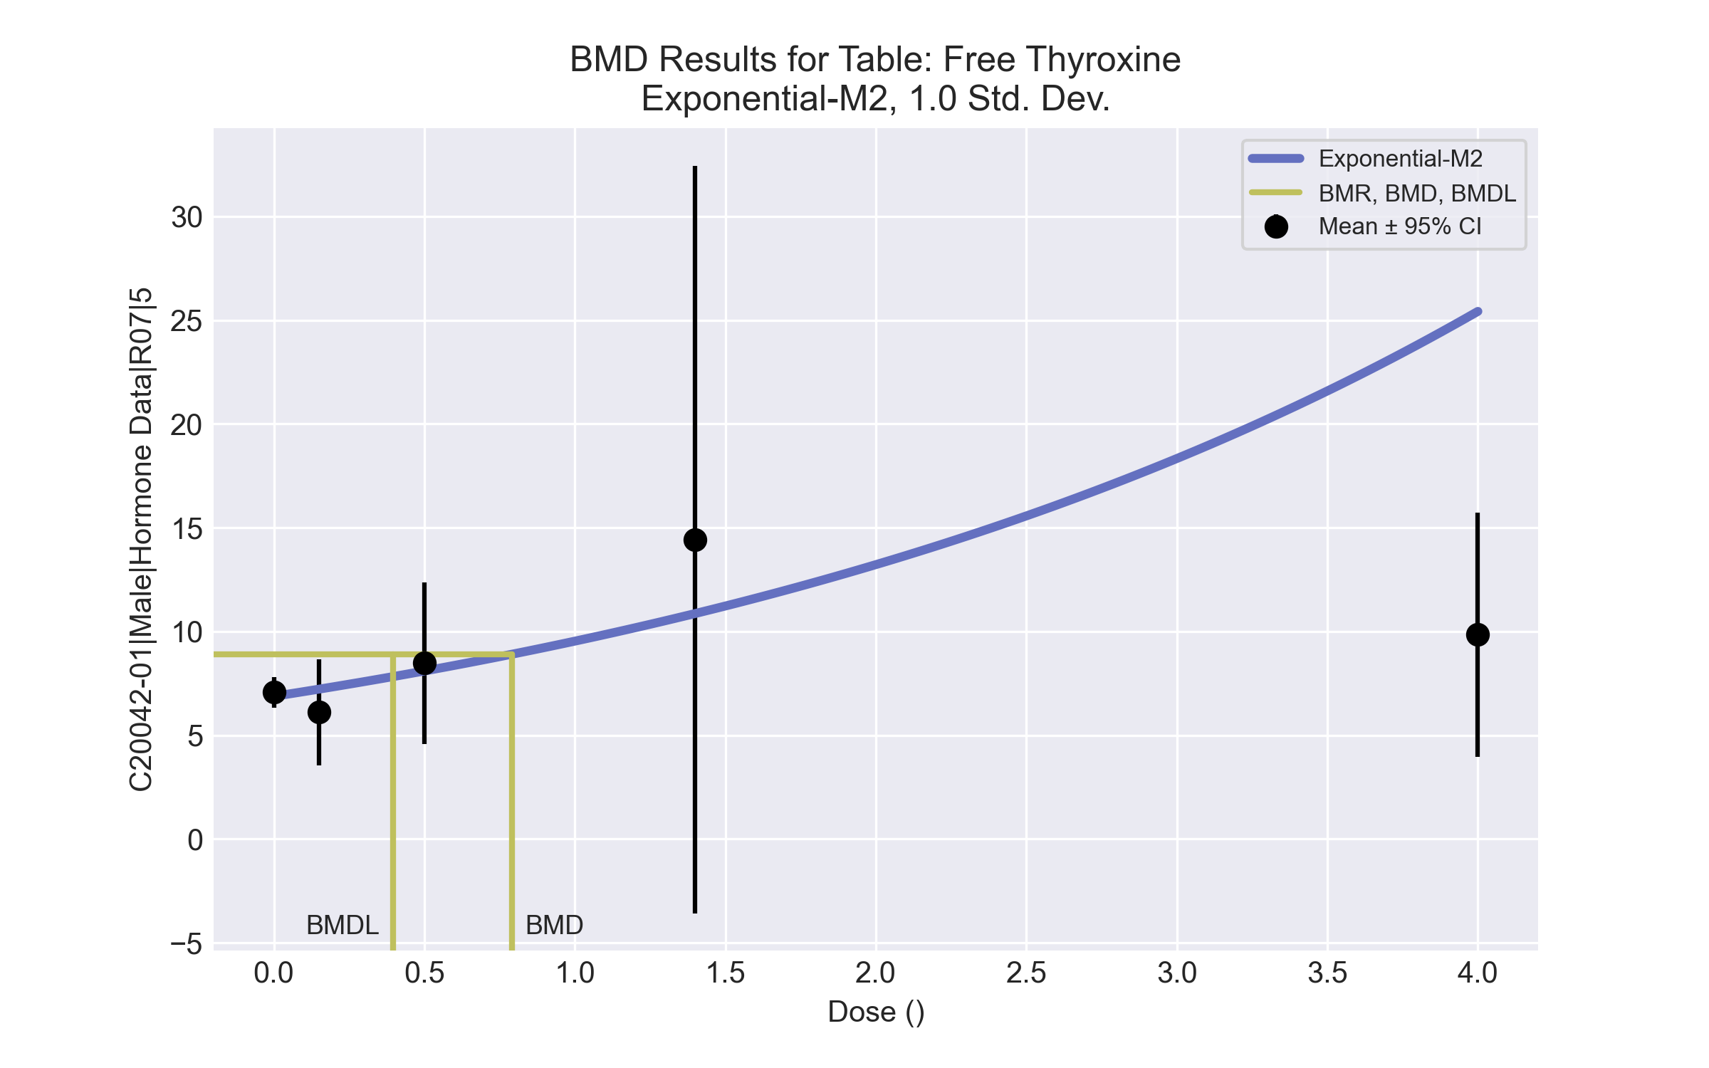
====================================================================
Exponential Model. (Version: 1.11; Date: 03/14/2017)
Input Data File: C:\Windows\TEMP\bmds-m196arm0.(d)
Gnuplot Plotting File:
Tue Apr 13 12:15:12 2021
====================================================================
BMDS_Model_Run
~~~~~~~~~~~~~~~~~~~~~~~~~~~~~~~~~~~~~~~~~~~~~~~~~~~~~~~~~~~~~~~~~~~~~
The form of the response function by Model:
Model 2: Y[dose] = a * exp{sign * b * dose}
Model 3: Y[dose] = a * exp{sign * (b * dose)^d}
Model 4: Y[dose] = a * [c-(c-1) * exp{-b * dose}]
Model 5: Y[dose] = a * [c-(c-1) * exp{-(b * dose)^d}]
Note: Y[dose] is the median response for exposure = dose;
sign = +1 for increasing trend in data;
sign = -1 for decreasing trend.
Model 2 is nested within Models 3 and 4.
Model 3 is nested within Model 5.
Model 4 is nested within Model 5.
Dependent variable = Response
Independent variable = Dose
Data are assumed to be distributed: normally
Variance Model: exp(lnalpha +rho *ln(Y[dose]))
The variance is to be modeled as Var(i) = exp(lalpha + log(mean(i)) * rho)
Total number of dose groups = 5
Total number of records with missing values = 0
Maximum number of iterations = 500
Relative Function Convergence has been set to: 1e-008
Parameter Convergence has been set to: 1e-008
MLE solution provided: Exact
Initial Parameter Values
Variable Model 2
-------- --------
lnalpha -8.69261
rho 5.05734
a 7.53732
b 0.102114
c 0 Specified
d 1 Specified
Parameter Estimates
Variable Model 2 Std. Err.
-------- ------- ---------
lnalpha -6.82714 2.91461
rho 4.2741 1.39576
a 6.8743 0.561425
b 0.326944 0.135612
NC = No Convergence
Table of Stats From Input Data
Dose N Obs Mean Obs Std Dev
----- --- ---------- -------------
0 8 7.067 0.8837
0.15 5 6.102 2.048
0.5 5 8.47 3.144
1.4 4 14.44 11.32
4 5 9.842 4.748
Estimated Values of Interest
Dose Est Mean Est Std Scaled Residual
------ ---------- --------- ----------------
0 6.874 2.026 0.2697
0.15 7.22 2.25 -1.111
0.5 8.095 2.874 0.2917
1.4 10.86 5.389 1.326
4 25.42 33.15 -1.051
Other models for which likelihoods are calculated:
Model A1: Yij = Mu(i) + e(ij)
Var{e(ij)} = Sigma^2
Model A2: Yij = Mu(i) + e(ij)
Var{e(ij)} = Sigma(i)^2
Model A3: Yij = Mu(i) + e(ij)
Var{e(ij)} = exp(lalpha + log(mean(i)) * rho)
Model R: Yij = Mu + e(i)
Var{e(ij)} = Sigma^2
Likelihoods of Interest
Model Log(likelihood) DF AIC
------- ----------------- ---- ------------
A1 -53.84791 6 119.6958
A2 -36.53264 10 93.06528
A3 -39.28873 7 92.57745
R -58.00647 2 120.0129
2 -52.72524 4 113.4505
Additive constant for all log-likelihoods = -24.81. This constant added to the
above values gives the log-likelihood including the term that does not
depend on the model parameters.
Explanation of Tests
Test 1: Does response and/or variances differ among Dose levels? (A2 vs. R)
Test 2: Are Variances Homogeneous? (A2 vs. A1)
Test 3: Are variances adequately modeled? (A2 vs. A3)
Test 4: Does Model 2 fit the data? (A3 vs. 2)
Tests of Interest
Test -2*log(Likelihood Ratio) D. F. p-value
-------- ------------------------ ------ --------------
Test 1 42.95 8 < 0.0001
Test 2 34.63 4 < 0.0001
Test 3 5.512 3 0.1379
Test 4 26.87 3 < 0.0001
The p-value for Test 1 is less than .05. There appears to be a
difference between response and/or variances among the dose
levels, it seems appropriate to model the data.
The p-value for Test 2 is less than .1. A non-homogeneous
variance model appears to be appropriate.
The p-value for Test 3 is greater than .1. The modeled
variance appears to be appropriate here.
The p-value for Test 4 is less than .1. Model 2 may not adequately
describe the data; you may want to consider another model.
Benchmark Dose Computations:
Specified Effect = 1.000000
Risk Type = Estimated standard deviations from control
Confidence Level = 0.950000
BMD = 0.790135
BMDL = 0.395036
BMDU = 3.42982

Male BMD Results for Table: Thyroid Stimulating Hormone
BMDS version: BMDS v2.7.0

Input dataset
Dose | 0 | 0.15 | 0.5 | 1.4 | 4 | 12 | 37 | 111 | 333 | 1000
N | 8 | 5 | 5 | 4 | 5 | 5 | 4 | 3 | 4 | 3
Mean ± SD | 2.95 ± 1.746 | 3.76 ± 3.238 | 4.26 ± 1.568 | 3.275 ± 2.241 | 2.76 ± 0.792 | 3.9 ± 2.281 | 4.525 ± 1.889 | 7.033 ± 1.106 | 7.5 ± 2.146 | 7.233 ± 1.75

Summary table
Modelª | Goodness of fit |  | BMD | BMDL | Comments
 | p-value | AIC
Linear (equivalent models include Power, Polynomial 2°, 3°, 4°, 5°, 6°, 7°, 8°) | 0.044 | 120.572 | 459.181 | 312.019 | Exponential-M4 recommended as best-fitting model on the basis of the lowest AIC.
Hill | 0.831 | 111.506 | 48.208 | 20.314
Exponential M2 (equivalent models include Exponential M3) | 0.023 | 122.472 | 611.164 | 455.531
Exponential M4^{b} | 0.853 | 110.013 | 44.526 | 19.298
Exponential M5 | 0.841 | 111.425 | 50.667 | 21.201
ª Constant variance case presented (BMDS Test 2 p-value = 0.249, BMDS Test 3 p-value = 0.249).
^{b} Recommended model

Model recommendation details
Model | Bin | Notes
Linear (equivalent models include Power, Polynomial 2°, 3°, 4°, 5°, 6°, 7°, 8°) | Warning | Warnings  • Goodness of fit p-value is less than threshold (0.044 < 0.1)
Hill | Valid | -
Exponential M2 (equivalent models include Exponential M3) | Warning | Warnings  • Goodness of fit p-value is less than threshold (0.0229 < 0.1)  • Residual of interest is greater than threshold (2.28 > 2.0)
Exponential M4ª | Valid | -
Exponential M5 | Valid | -
ª Recommended model

Recommended model
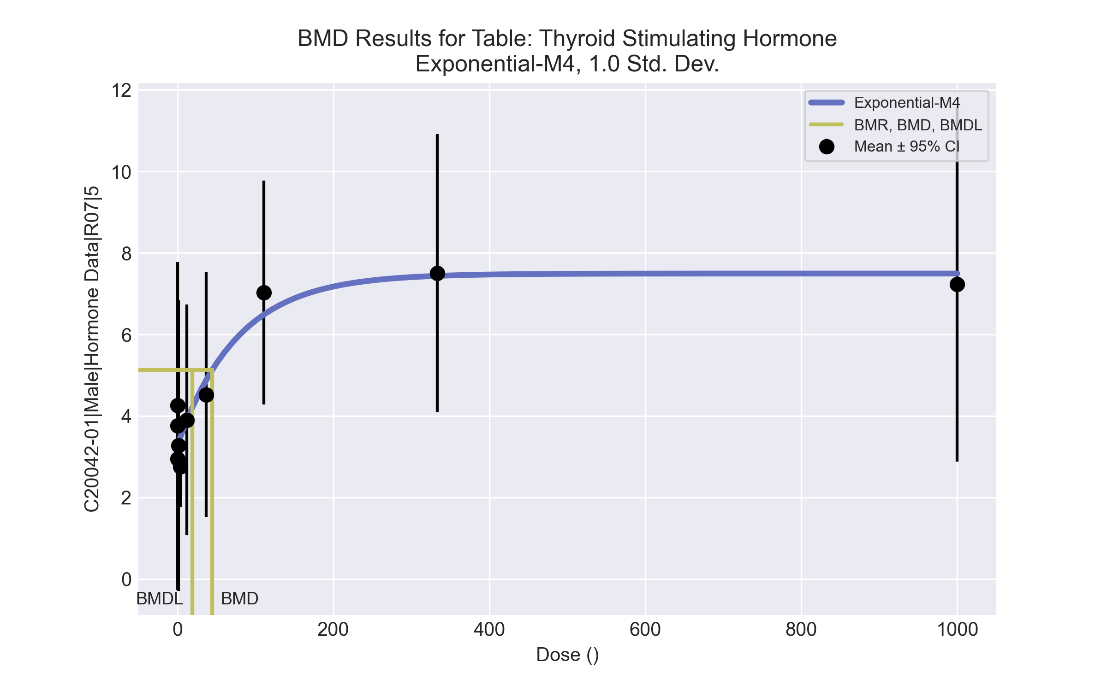
====================================================================
Exponential Model. (Version: 1.11; Date: 03/14/2017)
Input Data File: C:\Windows\TEMP\bmds-p2_hclwc.(d)
Gnuplot Plotting File:
Tue Apr 13 12:15:18 2021
====================================================================
BMDS_Model_Run
~~~~~~~~~~~~~~~~~~~~~~~~~~~~~~~~~~~~~~~~~~~~~~~~~~~~~~~~~~~~~~~~~~~~~
The form of the response function by Model:
Model 2: Y[dose] = a * exp{sign * b * dose}
Model 3: Y[dose] = a * exp{sign * (b * dose)^d}
Model 4: Y[dose] = a * [c-(c-1) * exp{-b * dose}]
Model 5: Y[dose] = a * [c-(c-1) * exp{-(b * dose)^d}]
Note: Y[dose] is the median response for exposure = dose;
sign = +1 for increasing trend in data;
sign = -1 for decreasing trend.
Model 2 is nested within Models 3 and 4.
Model 3 is nested within Model 5.
Model 4 is nested within Model 5.
Dependent variable = Response
Independent variable = Dose
Data are assumed to be distributed: normally
Variance Model: exp(lnalpha +rho *ln(Y[dose]))
rho is set to 0.
A constant variance model is fit.
Total number of dose groups = 10
Total number of records with missing values = 0
Maximum number of iterations = 500
Relative Function Convergence has been set to: 1e-008
Parameter Convergence has been set to: 1e-008
MLE solution provided: Exact
Initial Parameter Values
Variable Model 4
-------- --------
lnalpha 1.14536
rho 0 Specified
a 2.622
b 0.00284976
c 3.00343
d 1 Specified
Parameter Estimates
Variable Model 4 Std. Err.
-------- ------- ---------
lnalpha 1.21768 0.704638
a 3.28751 0.347892
b 0.0128951 0.00706172
c 2.2801 0.316531
NC = No Convergence
Table of Stats From Input Data
Dose N Obs Mean Obs Std Dev
----- --- ---------- -------------
0 8 2.95 1.746
0.15 5 3.76 3.238
0.5 5 4.26 1.568
1.4 4 3.275 2.241
4 5 2.76 0.7925
12 5 3.9 2.281
37 4 4.525 1.889
111 3 7.033 1.106
333 4 7.5 2.146
1000 3 7.233 1.75
Estimated Values of Interest
Dose Est Mean Est Std Scaled Residual
------ ---------- --------- ----------------
0 3.288 1.838 -0.5193
0.15 3.296 1.838 0.5648
0.5 3.315 1.838 1.15
1.4 3.363 1.838 -0.09552
4 3.499 1.838 -0.899
12 3.891 1.838 0.01116
37 4.884 1.838 -0.3909
111 6.49 1.838 0.5118
333 7.438 1.838 0.06704
1000 7.496 1.838 -0.2473
Other models for which likelihoods are calculated:
Model A1: Yij = Mu(i) + e(ij)
Var{e(ij)} = Sigma^2
Model A2: Yij = Mu(i) + e(ij)
Var{e(ij)} = Sigma(i)^2
Model A3: Yij = Mu(i) + e(ij)
Var{e(ij)} = exp(lalpha + log(mean(i)) * rho)
Model R: Yij = Mu + e(i)
Var{e(ij)} = Sigma^2
Likelihoods of Interest
Model Log(likelihood) DF AIC
------- ----------------- ---- ------------
A1 -49.34328 11 120.6866
A2 -43.64357 20 127.2871
A3 -49.34328 11 120.6866
R -63.42016 2 130.8403
4 -51.00655 4 110.0131
Additive constant for all log-likelihoods = -42.27. This constant added to the
above values gives the log-likelihood including the term that does not
depend on the model parameters.
Explanation of Tests
Test 1: Does response and/or variances differ among Dose levels? (A2 vs. R)
Test 2: Are Variances Homogeneous? (A2 vs. A1)
Test 3: Are variances adequately modeled? (A2 vs. A3)
Test 6a: Does Model 4 fit the data? (A3 vs 4)
Tests of Interest
Test -2*log(Likelihood Ratio) D. F. p-value
-------- ------------------------ ------ --------------
Test 1 39.55 18 0.0024
Test 2 11.4 9 0.2493
Test 3 11.4 9 0.2493
Test 6a 3.327 7 0.8532
The p-value for Test 1 is less than .05. There appears to be a
difference between response and/or variances among the dose
levels, it seems appropriate to model the data.
The p-value for Test 2 is greater than .1. A homogeneous
variance model appears to be appropriate here.
The p-value for Test 3 is greater than .1. The modeled
variance appears to be appropriate here.
The p-value for Test 6a is greater than .1. Model 4 seems
to adequately describe the data.
Benchmark Dose Computations:
Specified Effect = 1.000000
Risk Type = Estimated standard deviations from control
Confidence Level = 0.950000
BMD = 44.5258
BMDL = 19.2976
BMDU = 122.566

Male BMD Results for Table: Total Thyroxine
BMDS version: BMDS v2.7.0

Input dataset
Dose | 0 | 0.15 | 0.5 | 1.4 | 4 | 12 | 37 | 111 | 333 | 1000
N | 8 | 5 | 5 | 4 | 5 | 5 | 4 | 3 | 4 | 3
Mean ± SD | 2.795 ± 0.568 | 2.592 ± 0.539 | 2.714 ± 0.492 | 3.155 ± 0.494 | 2.82 ± 0.865 | 2.718 ± 0.616 | 2.53 ± 0.704 | 1.973 ± 0.405 | 1.647 ± 0.248 | 1.717 ± 0.284

Summary table
Modelª | Goodness of fit |  | BMD | BMDL | Comments
 | p-value | AIC
Linear (equivalent models include Power, Polynomial 2°, 3°, 4°, 5°, 7°, 8°) | 0.102 | 2.659 | 451.101 | 308.027 | Hill recommended as best-fitting model on the basis of the lowest BMDL.
Polynomial 6° | 0.102 | 2.659 | 451.1 | 308.027
Hill^{b} | 0.81 | -3.636 | 61.426 | 24.276
Exponential M2 (equivalent models include Exponential M3) | 0.184 | 0.698 | 309.877 | 179.923
Exponential M4 | 0.858 | -5.343 | 60.953 | 24.743
Exponential M5 | 0.815 | -3.678 | 66.028 | 26.194
ª Constant variance case presented (BMDS Test 2 p-value = 0.35, BMDS Test 3 p-value = 0.35).
^{b} Recommended model

Model recommendation details
Model | Bin | Notes
Linear (equivalent models include Power, Polynomial 2°, 3°, 4°, 5°, 7°, 8°) | Valid | -
Polynomial 6° | Valid | -
Hillª | Valid | -
Exponential M2 (equivalent models include Exponential M3) | Valid | -
Exponential M4 | Valid | -
Exponential M5 | Valid | -
ª Recommended model

Recommended model
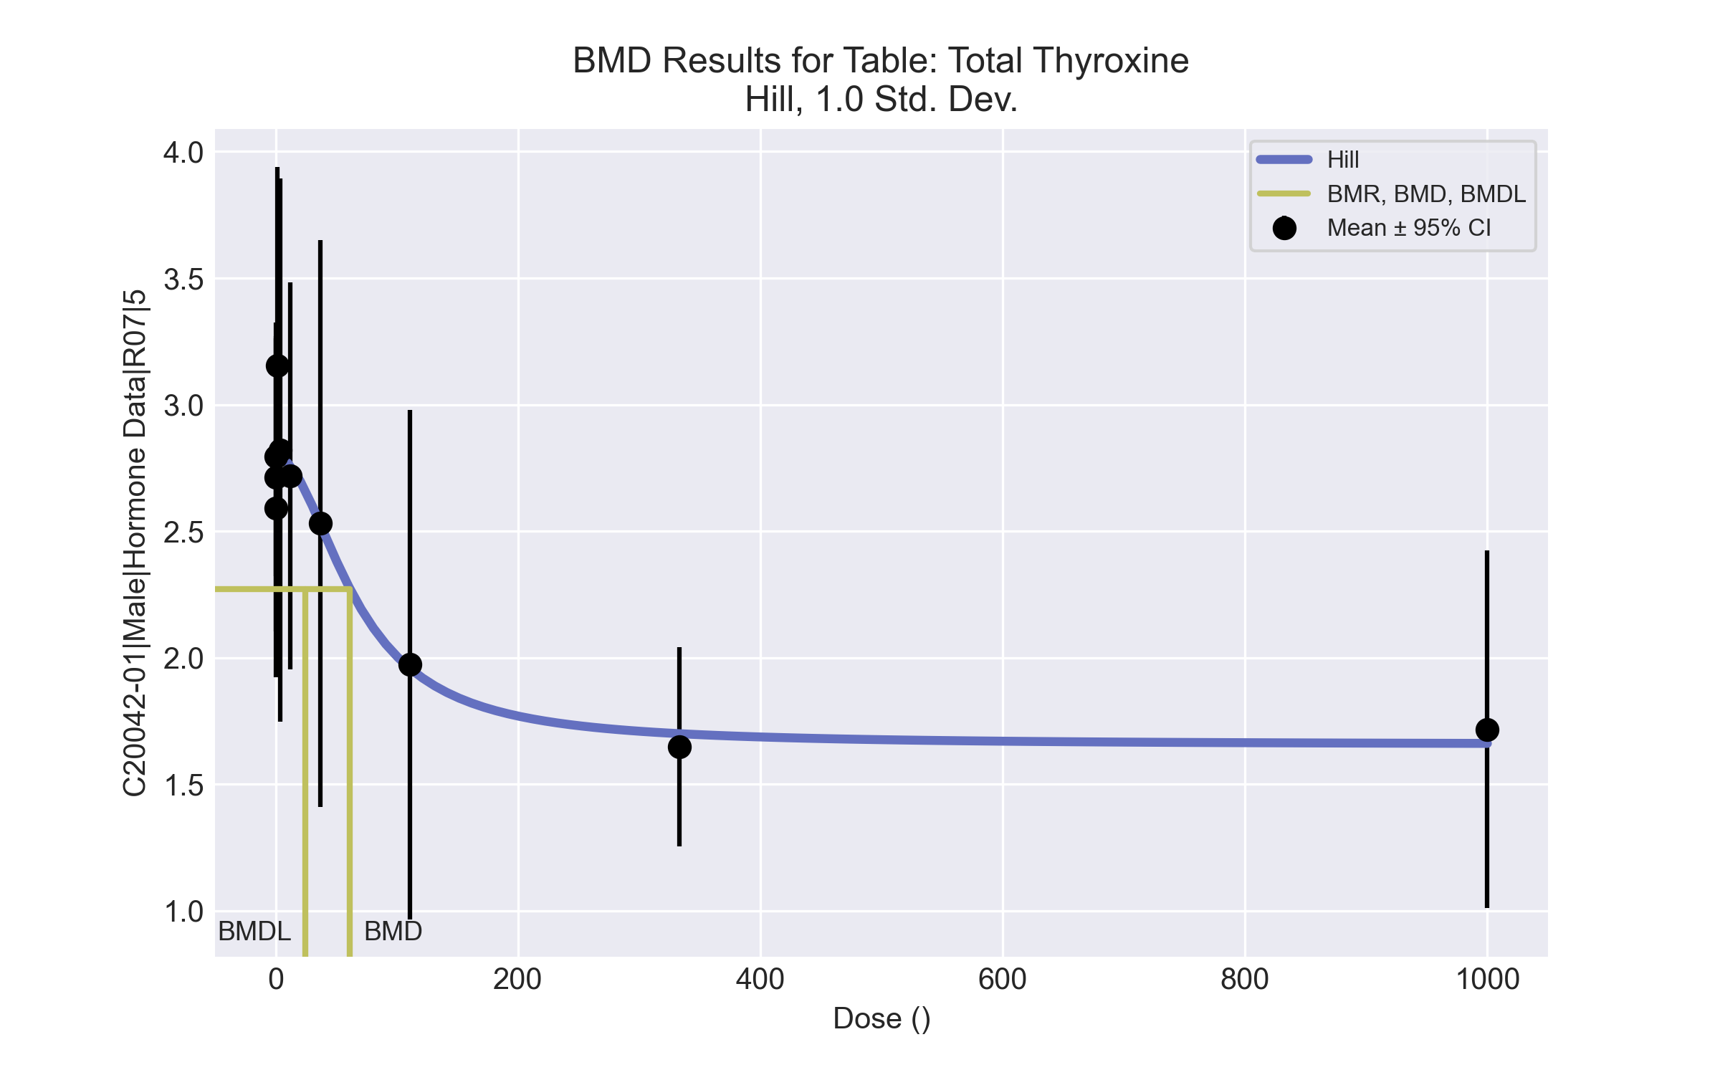
====================================================================
Hill Model. (Version: 2.18; Date: 03/14/2017)
Input Data File: C:\Windows\TEMP\bmds-r78c_ihp.(d)
Gnuplot Plotting File: C:\Windows\TEMP\bmds-r78c_ihp.plt
Tue Apr 13 12:15:22 2021
====================================================================
BMDS_Model_Run
~~~~~~~~~~~~~~~~~~~~~~~~~~~~~~~~~~~~~~~~~~~~~~~~~~~~~~~~~~~~~~~~~~~~~
The form of the response function is:
Y[dose] = intercept + v*dose^n/(k^n + dose^n)
Dependent variable = Response
Independent variable = Dose
rho is set to 0
Power parameter restricted to be greater than 1
A constant variance model is fit
Total number of dose groups = 10
Total number of records with missing values = 0
Maximum number of iterations = 500
Relative Function Convergence has been set to: 1e-008
Parameter Convergence has been set to: 1e-008
Default Initial Parameter Values
alpha = 0.327472
rho = 0 Specified
intercept = 2.795
v = -1.1475
n = 1.24608
k = 78.0434
Asymptotic Correlation Matrix of Parameter Estimates
( *** The model parameter(s) -rho
have been estimated at a boundary point, or have been specified by the user,
and do not appear in the correlation matrix )
alpha intercept v n k
alpha 1 -1.1e-008 8.7e-008 4.2e-008 -2e-009
intercept -1.1e-008 1 -0.44 -0.28 -0.21
v 8.7e-008 -0.44 1 0.53 -0.42
n 4.2e-008 -0.28 0.53 1 -0.22
k -2e-009 -0.21 -0.42 -0.22 1
Parameter Estimates
95.0% Wald Confidence Interval
Variable Estimate Std. Err. Lower Conf. Limit Upper Conf. Limit
alpha 0.273508 0.0570304 0.161731 0.385285
intercept 2.79441 0.0979412 2.60244 2.98637
v -1.1383 0.264438 -1.65659 -0.620009
n 2.0054 1.64611 -1.2209 5.23171
k 66.6137 38.146 -8.15102 141.378
Table of Data and Estimated Values of Interest
Dose N Obs Mean Est Mean Obs Std Dev Est Std Dev Scaled Res.
------ --- -------- -------- ----------- ----------- ----------
0 8 2.79 2.79 0.568 0.523 0.00321
0.15 5 2.59 2.79 0.539 0.523 -0.865
0.5 5 2.71 2.79 0.492 0.523 -0.344
1.4 4 3.15 2.79 0.494 0.523 1.38
4 5 2.82 2.79 0.865 0.523 0.127
12 5 2.72 2.76 0.616 0.523 -0.175
37 4 2.53 2.53 0.704 0.523 0.0127
111 3 1.97 1.96 0.405 0.523 0.0544
333 4 1.65 1.7 0.248 0.523 -0.199
1000 3 1.72 1.66 0.284 0.523 0.184
Model Descriptions for likelihoods calculated
Model A1: Yij = Mu(i) + e(ij)
Var{e(ij)} = Sigma^2
Model A2: Yij = Mu(i) + e(ij)
Var{e(ij)} = Sigma(i)^2
Model A3: Yij = Mu(i) + e(ij)
Var{e(ij)} = Sigma^2
Model A3 uses any fixed variance parameters that
were specified by the user
Model R: Yi = Mu + e(i)
Var{e(i)} = Sigma^2
Likelihoods of Interest
Model Log(likelihood) # Param's AIC
A1 8.313929 11 5.372142
A2 13.314424 20 13.371152
A3 8.313929 11 5.372142
fitted 6.817765 5 -3.635530
R -4.657175 2 13.314350
Explanation of Tests
Test 1: Do responses and/or variances differ among Dose levels?
(A2 vs. R)
Test 2: Are Variances Homogeneous? (A1 vs A2)
Test 3: Are variances adequately modeled? (A2 vs. A3)
Test 4: Does the Model for the Mean Fit? (A3 vs. fitted)
(Note: When rho=0 the results of Test 3 and Test 2 will be the same.)
Tests of Interest
Test -2*log(Likelihood Ratio) Test df p-value
Test 1 35.9432 18 0.007175
Test 2 10.001 9 0.3504
Test 3 10.001 9 0.3504
Test 4 2.99233 6 0.8098
The p-value for Test 1 is less than .05. There appears to be a
difference between response and/or variances among the dose levels
It seems appropriate to model the data
The p-value for Test 2 is greater than .1. A homogeneous variance
model appears to be appropriate here
The p-value for Test 3 is greater than .1. The modeled variance appears
to be appropriate here
The p-value for Test 4 is greater than .1. The model chosen seems
to adequately describe the data
Benchmark Dose Computation
Specified effect = 1
Risk Type = Estimated standard deviations from the control mean
Confidence level = 0.95
BMD = 61.4259
BMDL = 24.2755
BMDU = 158.988

