Analysis of Aristolochia fangchii root Extract Using LC-QToF-MS method

Names of investigators: Bharathi Avula, Kumar Katragunta
Affiliation: National Center for Natural Products Research, School of Pharmacy, University of Mississippi, University, MS 38677, USA

Analysis date: December 13, 2021

Common Botanical Name | CAS No. | Lot No. | Container ID | Net Weight
Aristolochia fangchii |  | RK-3-27-1-AF-C  RK-3-27-1-AF-D

Sample storage condition until analysis
2-8°C

Quantitative/Targeted method:
UHPLC-PDA Method

UHPLC conditions
System:Waters H-Class  Column: Acquity BEH Sheild RP18 (2.1 X 100mm, 1.7µm) (Waters corporation, MA, USA)  Mobile phase A: Water+0.1% formic acid  Mobile phase B: Acetonitrile +0.1% formic acid  Flow rate: 0.20 mL/min  Column temperature: 40°C  Gradient  Time (min) Mobile phase B (%)  0.0 30  6.5 30  34.0 43  50.0 65  55.0 100 | Compound Retention time (min)  Aristolochic acid C 19.8  Aristolochic acid II 29.3  Aristolochic acid I 37.7

Quantitative results

Compound | Concentration in extract (mg/g)  RK-3-27-1-AF-C | Concentration in extract (mg/g)  RK-3-27-1-AF-D
Aristolochic acid C | 0.6mg/g | 0.7mg/g
Aristolochic acid II | 3.0 mg/g | 3.0 mg/g
Aristolochic acid I | 76.0 mg/g | 76.0 mg/g

Standards
Name | Supplier | CAS Number | Catalog number | Purity %
Aristolochic acid C | Millipore Sigma | 4849-90-5 | PHL80355 | 80%
Aristolochic acid II | Millipore Sigma | 475-80-9 | PHL89566 | 97%
Aristolochic acid I | Millipore Sigma | 313-67-7 | PHL89565 | 99%

Chemical structures of standards used for quantitative analysis

Chromatograms
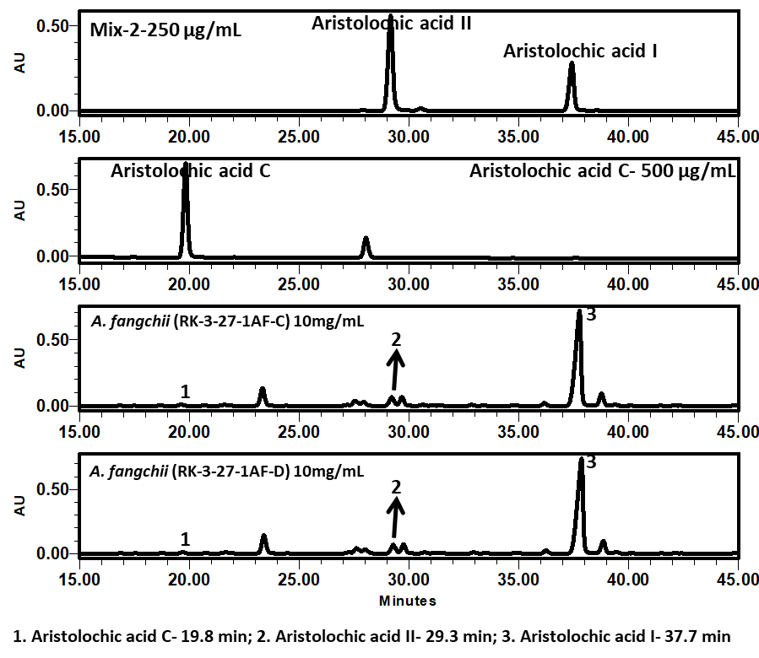

Ref.: Schaneberg, B.T. and Khan, I.A., 2004. Analysis of products suspected of containing Aristolochia or Asarum species. Journal of Ethnopharmacology, 94(2-3), pp.245-249.
Calibration
Compound | Limit of detection (LOD) ng/mL | Limit of quantitation (LOQ) ng/mL | Calibration range (mg/g) | Number of Calibration Points | r² | Concentration  mg/g (n = 3)  RK-3-27-1-AF-C | Concentration  mg/g (n = 3)  RK-3-27-1-AF-D
Aristolochic acid C | 50 ng/mL | 100 ng/mL | 0.8 – 40μg/mL | 5 | 0.9998 | 0.6 ± 0.34 | 0.7 ± 0.40
Aristolochic acid II | 50 ng/mL | 100 ng/mL | 5.0 – 500μg/mL | 5 | 0.9999 | 2.7 ± 0.21 | 2.8 ± 1.87
Aristolochic acid I | 50 ng/mL | 100 ng/mL | 5.0 – 500μg/mL | 5 | 0.9999 | 75.5 ± 0.13 | 77.0 ± 3.50

Linearity profiles
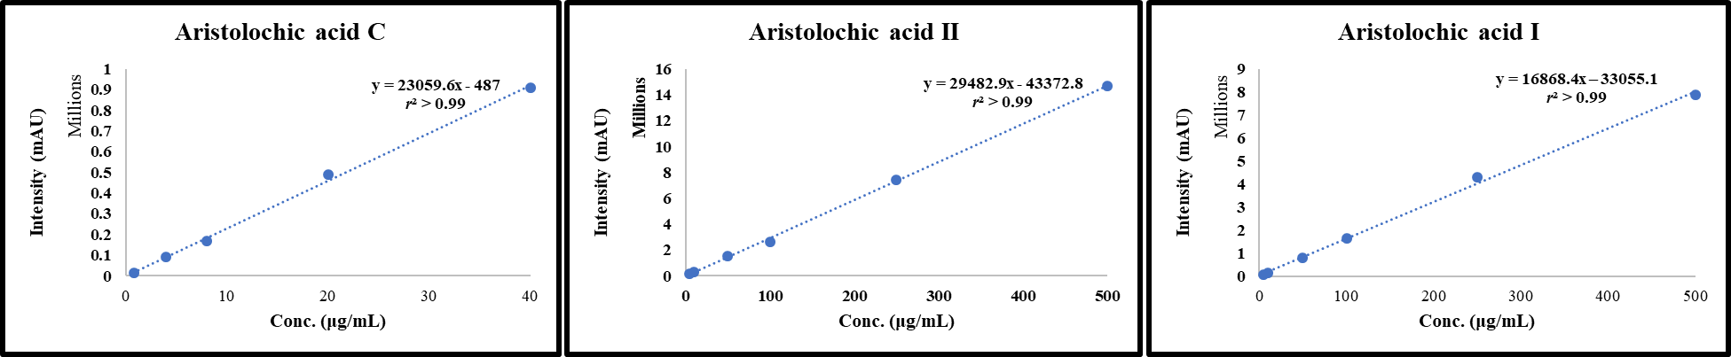

Untargeted Analysis
UHPLC conditions | Mass spectrometer conditions
System: Agilent 1290 series  Column: Poroshell 120 EC-C18 (2.1 X 150mm, 2.7µm) (Agilent technologies, Palo Alto, CA, USA)  Mobile phase A: Water+0.1% formic acid  Mobile phase B: Acetonitrile +0.1% formic acid  Flow rate: 0.20 mL/min  Column temperature: 35°C  Gradient:  Time (min) Mobile phase B (%)  0.0 01  3.0 01  30.0 45  50.0 100 | System: QToF-MS 6530A series (Agilent technologies, Palo Alto, CA, USA)  Ionization: ESI  Polarity: Positive mode/Negative mode  Main Interface:  · Nebulizing gas flow: 11 L/min  . Gas temperature: 325°C/300°C  . Nebulizer: 30 psig  . Sheath gas temperature: 300°C  . Sheath gas flow: 11L/min  · Capillary voltage: 3.5 kV  · Fragmentor: 100V/175V

Table 1: Proposed identification of constituents of Aristolochiafangchii root extract showing RT, m/z, ppm, tentative compound name and molecular formula
Peak No. | RT (min) | Exp. m/z | Mass accuracy  (ppm) | Proposed ID’s  (Confirmed with Std in green)  (Most probable ID is yellow) | Molecular Formula
1 | 15.8 | 342.1703 [M]+ | 0.6 | Magnoflorine& Isomer | C₂₀H₂₄NO₄⁺
2 | 16.8
3 | 16.4 | 330.1703  [M]+ | 0.6 | Sinomenine/Isosinomenine | C₁₉H₂₄NO₄⁺
4 | 18.8 | 442.1131  [M+H]⁺ | 0.5 | Aristolactam-Ia-N-β-D-glucopyranoside/  Aristolactam-IIIa-N-β-D-glucopyranoside | C₂₂H₁₉NO₉
5 | 22.1
6 | 19.5 | 625.1762 | -0.2 | Narcissin (Isorhamnetin 3-O-rutinoside) | C₂₈H₃₂O₁₆
7 | 21.2 | 537.1349  [M+NH4]⁺ | 0.4 | Aristolochin | C₂₃H₂₁NO₁₃
8 | 22.1 | 442.1131  [M+H]⁺ | 0.5 | Aristolactam-IIIa-N-β-D-glucopyranoside | C₂₂H₁₉NO₉
9 | 24.2 | 426.1183  [M+H]⁺ | 0.0 | Aristolactam-II-N-β-D-glucopyranoside | C₂₂H₁₉NO₈
10 | 25.0 | 456.1285  [M+H]⁺ | 0.9 | Aristolactam I-N-β-D-glucopyranoside | C₂₃H₂₁NO₉
11 | 26.2 | 340.1177  [M+H]⁺ | 0.6 | Aristolactam IIIc | C₁₉H₁₇NO₅
12 | 27.1 | 345.0719  [M+NH4]⁺ | -0.6 | Aristolochic acid IIIa/  Aristolochic acid Ia | C₁₆H₉NO₇
13 | 29.2 | 345.0719  [M+NH4]⁺ | -0.6 | Aristolochic acid C | C₁₆H₉NO₇
14 | 28.7 | 266.0815  [M+H]⁺ | -1.1 | AristolactamIIa | C₁₆H₁₁NO₃
15 | 28.74 | 375.0821  [M+NH4]⁺ | 0.5 | Aristolochic acid D/Aristolochic acid Via | C₁₇H₁₁NO₈
16 | 28.9
17 | 32.7 | 264.0654  [M+H]⁺ | 0.4 | Aristolactam II | C₁₆H₉NO₃
18 | 34.0 | 329.0765  [M+NH4]⁺ | 0.9 | Aristolochic acid II | C₁₆H₉NO₆
19 | 34.3 | 359.0876  [M+NH4]⁺ | -0.6 | Aristolochic acid III | C₁₇H₁₁NO₇
20 | 35.2 | 359.0876  [M+NH4]⁺ | -0.6 | Aristolochic acid I | C₁₇H₁₁NO₇
21 | 34.6 | 389.0981  [M+NH4]⁺ | -0.5 | Aristolochic acid V/  Aristolochic acid IV | C₁₈H₁₃NO₈
22 | 35.6

Figure 1: Chromatograms
Structures of compounds in Tables 1
Table 2: HRMS product ions for the peaks of the botanical extract (Aristolochia fangchii Root) showing RT, m/z, tentative compound name and fragment ions
Peak No. | RT (min) | [M]⁺/[M+H]⁺/[M+NH₄]⁺  m/z | Proposed Compounds  (Confirmed with Std in green)  (Probable ID is yellow)  CAS Number | Product Ions  m/z
1 | 15.8 | 342.1703 [M]⁺ | Magnoflorine& Isomer | 297.1117  282.0889  265.0857  237.0900  222.0670
2 | 16.8
3 | 16.4 | 330.1703  [M]⁺ | Sinomenine/Isosinomenine | 239.1010  207.0777  137.0581
4 | 18.8 | 442.1131  [M+H]⁺ | Aristolactam-Ia-N-β-D-glucopyranoside/  Aristolactam-IIIa-N-β-D-glucopyranoside | 424.1074  322.0695  280.0594
5 | 22.1
6 | 19.5 | 625.1762  [M+H]⁺ | Narcissin (Isorhamnetin 3-O-rutinoside) | 479.1173  317.0654
7 | 21.2 | 537.1349  [M+NH₄]⁺ | Aristolochin | 314.0661
8 | 22.1 | 442.1131  [M+H]⁺ | Aristolactam-IIIa-N-β-D-glucopyranoside | 322.0695  280.0594
9 | 24.2 | 426.1183  [M+H]⁺ | Aristolactam-II-N-β-D-glucopyranoside | 408.1069  306.0752
10 | 25.0 | 456.1285  [M+H]⁺ | Aristolactam I-N-β-D-glucopyranoside | 336.0857  306.0744  294.0735  279.0557
11 | 26.2 | 340.1177  [M+H]⁺ | Aristolactam IIIc | -
12 | 27.1 | 345.0719  [M+NH₄]⁺ | Aristolochic acid IIIa/  Aristolochic acid Ia | 310.0349  284.0536
13 | 29.2 | 345.0719  [M+NH₄]⁺ | Aristolochic acid C | 310.0348  284.0557  266.0523
14 | 28.7 | 266.0815  [M+H]⁺ | AristolactamIIa | 251.0550  223.0386  195.0591
15 | 28.74 | 375.0821  [M+NH4]⁺ | Aristolochic acid D/Aristolochic acid Via | 340.0423  297.0408  281.0302  253.0365  237.0425
16 | 28.9
17 | 32.7 | 264.0654  [M+H]⁺ | Aristolactam II | 206.0619
18 | 34.0 | 329.0765  [M+NH₄]⁺ | Aristolochic acid II | 294.0451  268.0569  250.0466  238.0452
19 | 34.3 | 359.0876  [M+NH₄]⁺ | Aristolochic acid III | 342.0592  298.0692  296.0673  281.0461
20 | 35.2 | 359.0876  [M+NH₄]⁺ | Aristolochic acid I | 342.0603  324.0500  298.0710  296.0673  281.0461  268.0652
21 | 34.6 | 389.0981  [M+NH₄]⁺ | Aristolochic acid V/  Aristolochic acid IV | 354.0603  328.0825  266.0467
22 | 35.6 |  |  | 372.0709  326.0787  311.0559  283.0604

References
- Analysis of isoquinoline alkaloids from Mahonia leschenaultia and Mahonia napaulensis roots using UHPLC-Orbitrap-MSn and UHPLC-QqQLIT-MS/MS. Journal of Pharmaceutical Analysis Volume 7, Issue 2, April 2017, Pages 77-86.
- Johanna et al., LC-MS- and 1H NMR-Based Metabolomic Analysis and in Vitro Toxicological Assessment of 43 Aristolochia Species. J. Nat. Prod. 2016, 79, 30−37
- Wu et al., Aristolochic acids, aristolactam alkaloids and amides from Aristolochia kankauensis. Phytochemistry Volume 36, Issue 4, July 1994, Pages 1063-1068.
- Wen-Wen et al., Characterization and quantitation of aristolochic acid analogs in different parts of Aristolochiae fructus, using UHPLCQ/TOF-MS and UHPLC-QqQ-MS. Chinese Journal of Natural Medicines 2017, 15(5): 0392-0400
- Hee-Jung et al., Simultaneous Determination of Structurally Diverse Compounds in Different Fangchi Species by UHPLC-DAD and UHPLC-ESI-MS/MS. Molecules 2013, 18, 5235-5250.
- Schaneberg BT, Khan IA. Analysis of products suspected of containing Aristolochia or Asarum species. J Ethnopharmacol. 2004 Oct;94(2-3):245-9. doi: 10.1016/j.jep.2004.06.010. PMID: 15325726.

