**Analysis of Blue Cohosh Extract Using UPLC-MS/MS**

Josh Kellogg, Teal Jordan

Pennsylvania State University

325 Huck Life Sciences Building

Pennsylvania State University

University Park, PA 16802

June 2022

|  |  |  |  |  |
| --- | --- | --- | --- | --- |
| Common Botanical Name | CAS No. | Lot No. | Container ID | Net Weight |
| Blue Cohosh |  |  |  |  |

|  |
| --- |
| Sample storage condition until analysis |
| -80 ℃ |

**Quantitative/Targeted method:**

|  |  |
| --- | --- |
| **UPLC-MS Method** | |
| UHPLC conditions | Mass spectrometry |
| System: **Waters Acquity**  Column: **Waters Acquity Ultra C18 (2.1 x 100 mm, 1.7 um)**  Mobile phase A: **H2O + 0.1% FA**  Mobile phase B: **CH3CN + 0.1% FA**  Flow rate: **0.3 mL/min**  Column temperature: **50 ℃**  Gradient   |  |  | | --- | --- | | Time (min) | Mobile phase B (%) | | **0** | **3** | | **1.0** | **3** | | **5.0** | **75** | | **5.5** | **75** | | **6.0** | **3** | |  |  | |  |  | |  |  | |  |  | | System: **Waters TQS**  Ionization: **Electrospray (ESI)**  Polarity: **Positive**  Main Interface:  · Nebulizing gas flow: **150 L/hr**  · Heating gas flow: **500 L/hr**  · Interface temperature: **150 ℃**  · Capillary voltage: **2.5 kV**  · Cone voltage: **50 V**  Ion guide:  · Drying gas flow: **0.15 mL/min**  · Desolvation line temperature: **500 ℃**  · Heat block temperature:  SRM dwell time:   |  |  |  |  |  | | --- | --- | --- | --- | --- | | Selected Reaction Monitoring (SRM) events | | | | | | Compound | Precursor ion (*m/z*) | Product ion (*m/z*) | Collision energy (V) | Retention time (min) | | **Baptifoline** | 261.16 | - | 45 | 0.51 | | **Lupanine** | 249.20 | - | 45 | 0.50 | | **Taspine** | 370.13 | - | 45 | 4.00 | | **Anagyrine** | 245.16 | - | 45 | 0.50 | | **Boldine** | 328.16 | - | 45 | 0.50 | | **Magnoflorine** | 342.17 | - | 45 | 0.50 | | **N-methylcytisine** | 205.13 | - | 45 | 0.50 | | *Quantifier, †Qualifier | | | | | |

**Quantitative results**

|  |  |
| --- | --- |
| **Compound** | **Concentration in extract (mg/g)** |
| Baptifoline | **2.45 ± 0.31** |
| Lupanine | **6.43 ± 0.35** |
| Taspine | **0.774 ± 0.091** |
| Anagyrine | **1.257 ± 0.044** |
| Boldine | **0.275 ± 0.024** |
| Magnoflorine | **10.76 ± 0.52** |
| N-methylcytisine | **0.753 ± 0.024** |

**Standards**

|  |  |  |  |  |  |
| --- | --- | --- | --- | --- | --- |
| **Name** | **Supplier** | **CAS Number** | **Catalog number** | **Purity %** | **Batch/Lot number** |
| **Baptifoline** | ALB | 732-50-3 | ALB-RS-9182 | >98% | ALB-202105 |
| **Lupanine** | ALB | 550-90-3 | ALB-RS-1465 | >98% | ALB-202105 |
| **Taspine** | ALB | 602-07-3 | ALB-RS-8444 | >98% | ALB-202105 |
| **Anagyrine** | Cayman | 486-89-5 | 31169 | >98% | 0611867-5 |
| **Boldine** | Phytolab | 476-70-0 | 80145-100mg | >98% | 88561562 |
| **Magnoflorine** | Sigma | 2141-09-5 | SMB00377-100mg | >98% | SLCH1683 |
| **N-methylcytisine** | Phytolab | 486-86-2 | 83219-10mg | >98% | 115786903 |

**Chemical structures of standards used for quantitative analysis**



**Chromatograms**

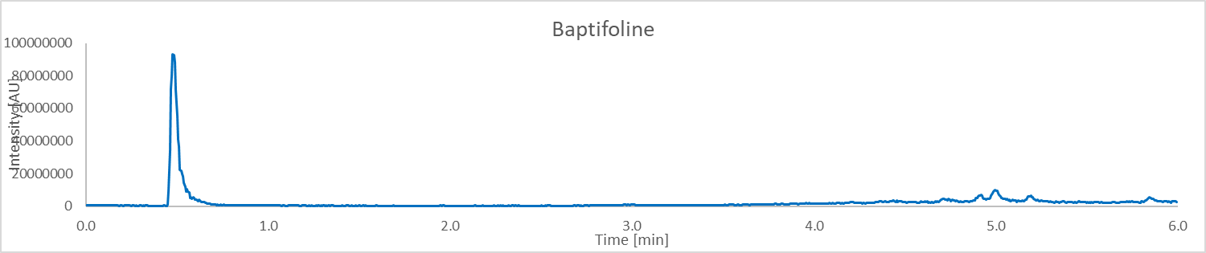

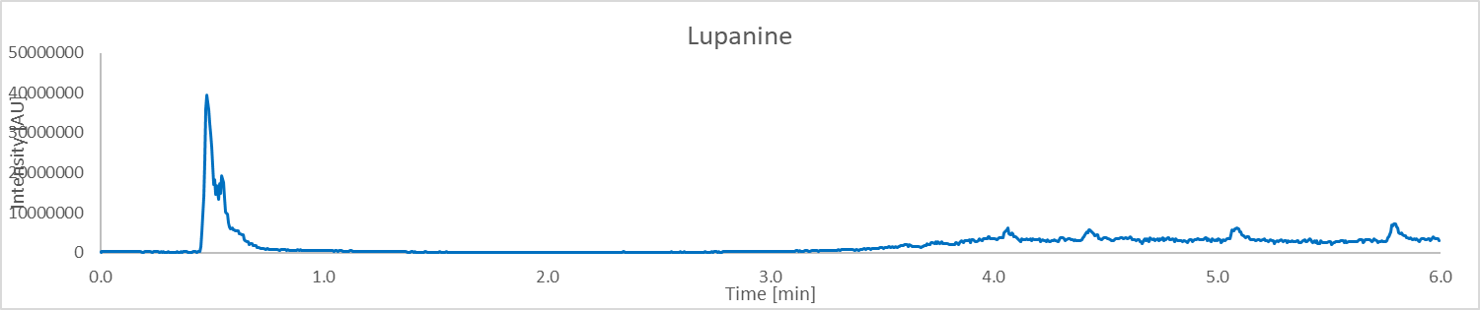

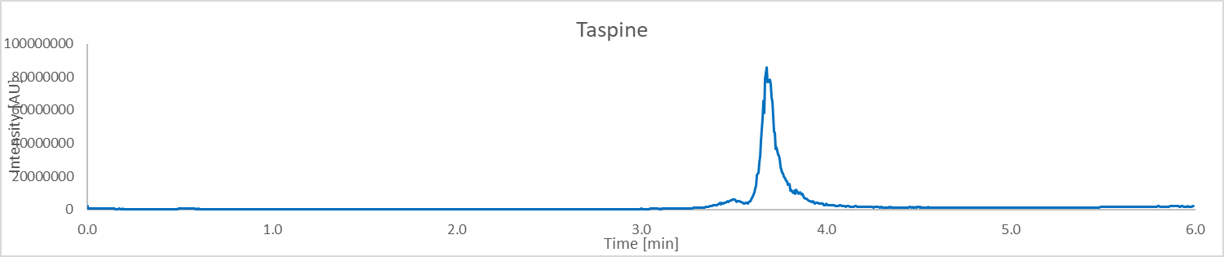

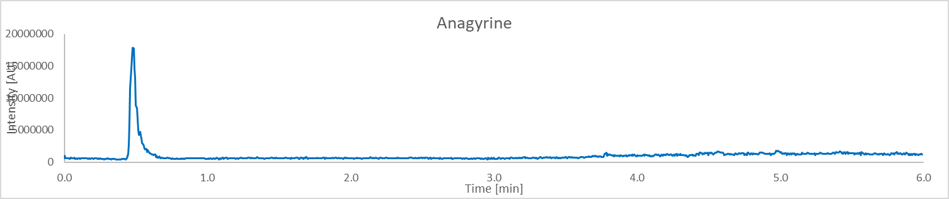

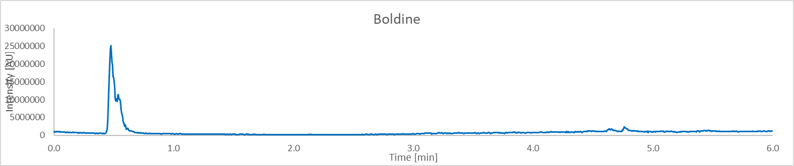

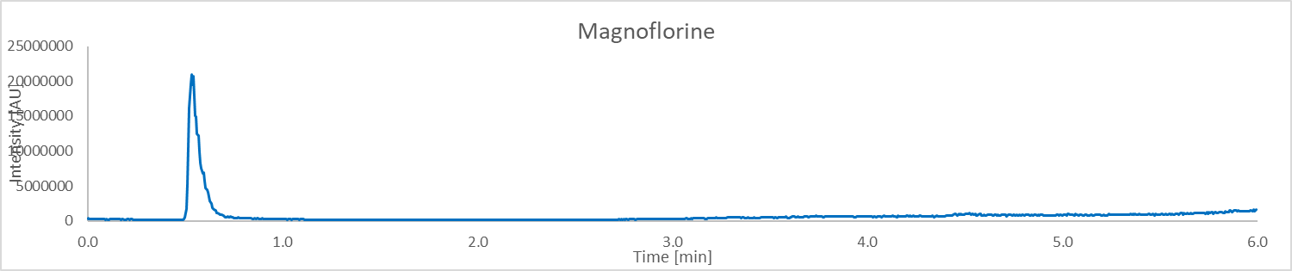

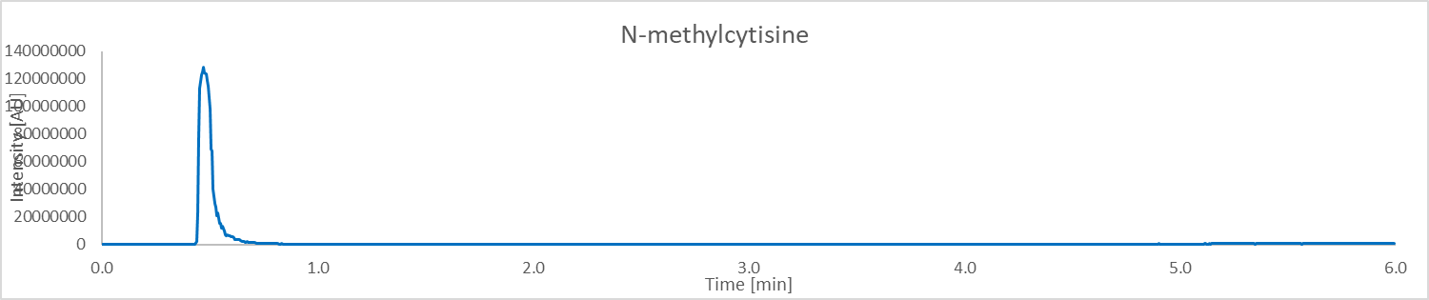

**Calibration**

|  |  |  |  |  |  |
| --- | --- | --- | --- | --- | --- |
| Compound | Lower limit of quantitation (LLOQ) **ug/mL** | Calibration range (**ug/mL**) | Number of Calibration Points | R2 | Concentration  mg/g **in extract** (n = 3) |
| **Baptifoline** | 0.001 | 0.001 – 0.729 | 7 | 0.9994 | **2.45 ± 0.31** |
| **Lupanine** | 0.001 | 0.001 – 0.729 | 7 | 0.9990 | **6.43 ± 0.35** |
| **Taspine** | 0.001 | 0.001 – 0.729 | 7 | 0.9986 | **0.774 ± 0.091** |
| **Anagyrine** | 0.001 | 0.001 – 0.729 | 7 | 0.9994 | **1.257 ± 0.044** |
| **Boldine** | 0.001 | 0.001 – 2.187 | 8 | 0.9962 | **0.275 ± 0.024** |
| **Magnoflorine** | 0.001 | 0.001 – 0.729 | 7 | 0.9970 | **10.76 ± 0.52** |
| **N-methylcytisine** | 0.001 | 0.001 – 0.729 | 7 | 0.9990 | **0.753 ± 0.024** |

Untargeted Analysis

|  |  |
| --- | --- |
|  | |
| UHPLC conditions | Mass spectrometer conditions |
| System: Thermo Vanquish  Column: Waters Acquity Ultra C18 (1.7 um, 1.0 x 150 mm)  Mobile phase A: H2O w/ 0.1% FA  Mobile phase B: ACN w/ 0.1% FA  Flow rate: 0.100 mL/min  Column temperature: 55℃  Gradient:   |  |  | | --- | --- | | Time (min) | Mobile phase B (%) | | 0 | 5 | | 1 | 5 | | 12.5 | 98 | | 13.5 | 98 | | 12.6 | 5 | | 15 | 5 | | System: Thermo Orbitrap Fusion Lumos  Mode: ESI  Polarity: positive  Main-Interface:  · Interface voltage: 3500  · Nebulizing gas flow: 25  · Heating gas flow: 5  · Interface temperature: 325 ℃  · Desolvation temperature: 350 ℃  Ion guide:  · Drying gas flow: 1  · DL temperature: 350 ℃  · Heat block temperature |

|  |  |  |  |  |  |
| --- | --- | --- | --- | --- | --- |
| **Table 1: Proposed identification of constituents of Blue Cohosh** | | | | | |
| Peak No. | RT (min) | Exp. *m/z* | Mass accuracy  (ppm) | Proposed ID’s  (Confirmed with Std in **green**)  (Structure with correlated MS2 spectra in **orange**)  (Most probable ID is **yellow**) | Molecular Formula |
| 1 | 10.47 | 221.1898 | -3.16 | Caryophyllene epoxide | C15H24O |
| 2 | 10.44 | 203.1796 | -1.48 | Alismol | C15H24O |
| 3 | 1.18 | 138.055 | -3.62 | 3-carboxy-1-methylpyridinium | C7H8NO2+ |
| 4 | 7.23 | 453.3371 | -74.34 | DL-alpha-Tocopherol | C29H50O2 |
| 5 | 1.12 | 245.1647 | -2.86 | Anagyrine | C15H20N2O |
| 6 | 1.1 | 261.1598 | -1.91 | Baptifoline | C15H20N2O2 |
| 7 | 1.11 | 338.1385 | -2.07 | Columbamine | C20H20NO4+ |
| 8 | 1.12 | 297.1122 | -123.86 | Cryptotanshinone | C19H20O3 |
| 9 | 2.77 | 342.1703 | -0.58 | Magnoflorine | C20H24NO4+ |
| 10 | 9.55 | 274.2742 | -1.46 | N-Lauryldiethanolamine | C16H35NO2 |
| 11 | 1.12 | 249.1959 | -3.21 | Lupanine | C15H24N2O |
| 12 | 7.3 | 751.4615 | -2.26 | a-Hederin | C41H66O12 |
| 13 | 7.28 | 781.4727 | -1.41 | Saikosaponin A | C42H68O13 |
| 14 | 6.96 | 959.5229 | 1.35 | Asiaticoside | C48H78O19 |
| 15 | 1.11 | 265.1547 | -1.89 | 2-propenamide | C14H20N2O3 |
| 16 | 1.1 | 205.1337 | -1.95 | N-methylcytisine | C12H16N2O |
| 17 | 10.54 | 455.3519 | -1.32 | NCGC00380944-01 | C30H46O3 |
| 18 | 9.73 | 286.1439 | -1.40 | Piperine | C17H19NO3 |
| 19 | 5.97 | 370.1284 | -7.56 | Taspine | C20H19NO6 |
| 20 | 3.68 | 328.1544 | -7.92 | Boldine | C19H21NO4 |
| 21 |  |  |  |  |  |
| 22 |  |  |  |  |  |
| 23 |  |  |  |  |  |
| 24 |  |  |  |  |  |
| 25 |  |  |  |  |  |
| 26 |  |  |  |  |  |
| 27 |  |  |  |  |  |
| 28 |  |  |  |  |  |
| 29 |  |  |  |  |  |
| 30 |  |  |  |  |  |
| 31 |  |  |  |  |  |
| 32 |  |  |  |  |  |
| 33 |  |  |  |  |  |

Figure 1: Chromatograms

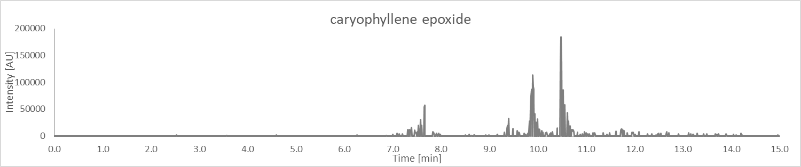

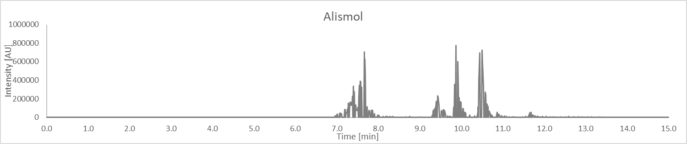

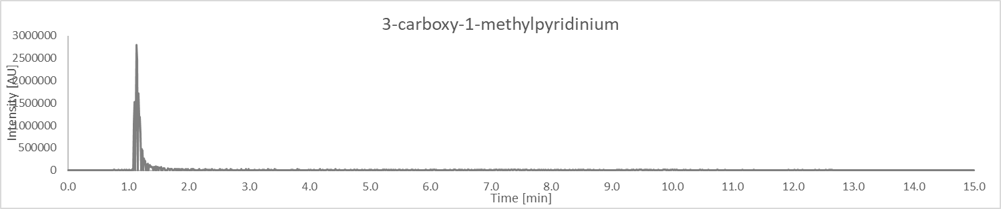

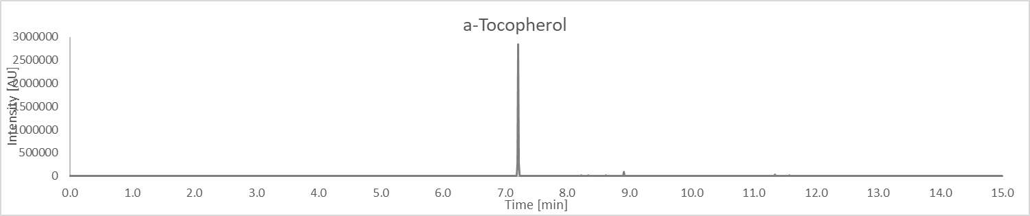

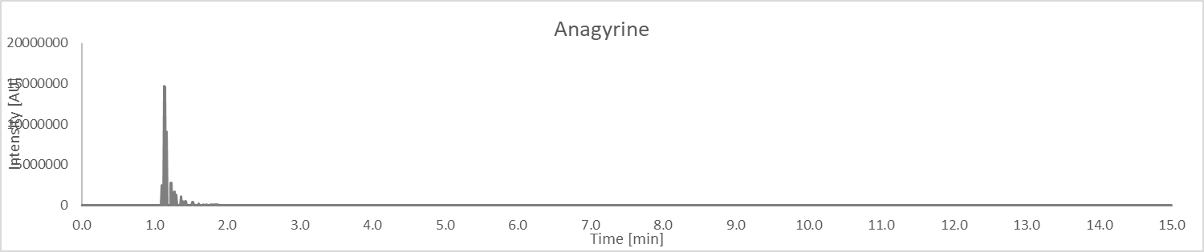

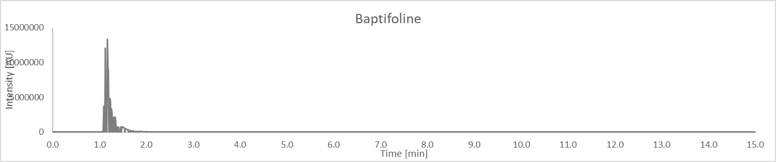

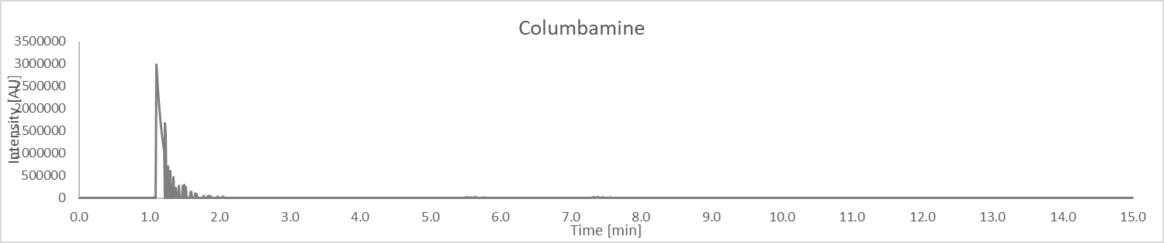

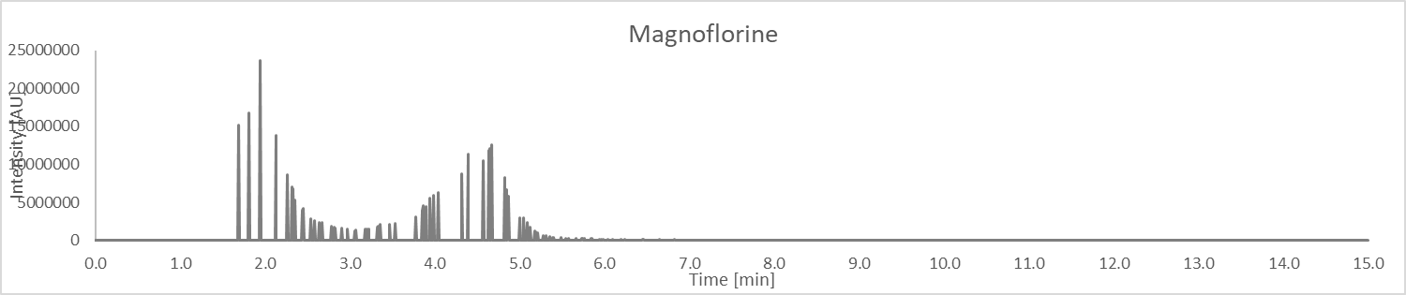

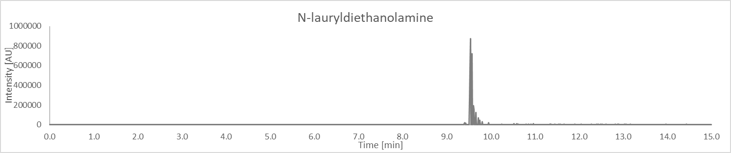

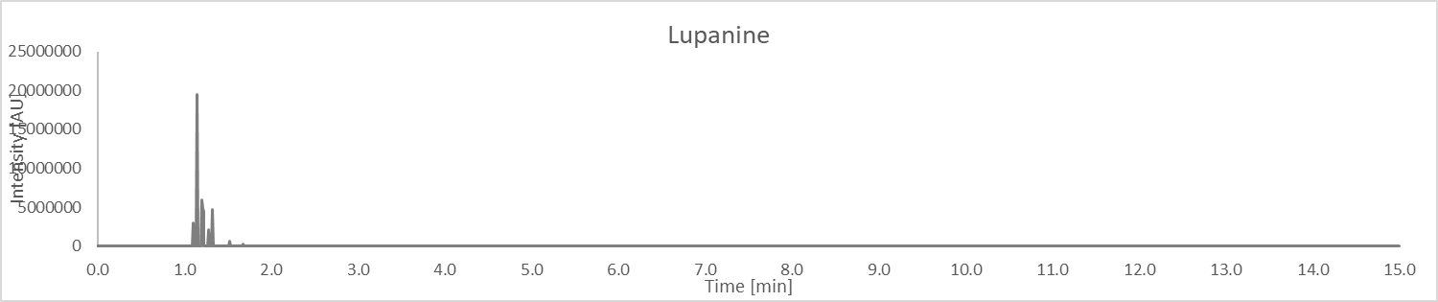

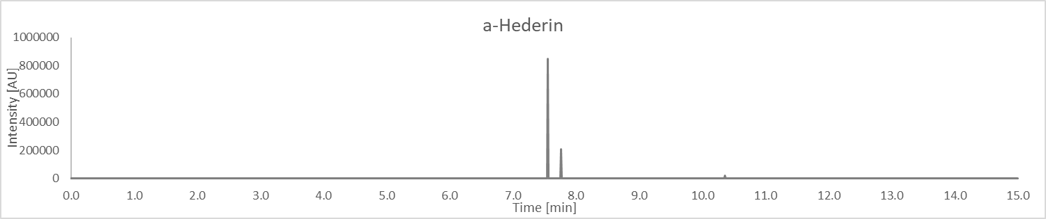

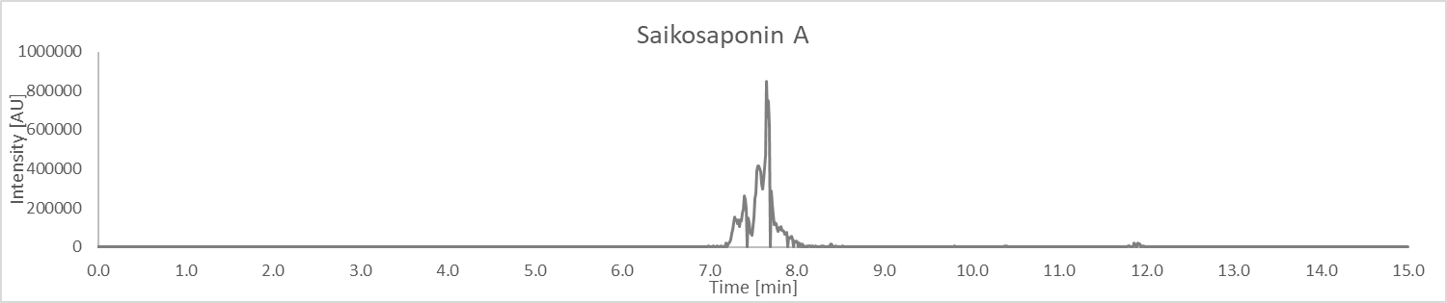

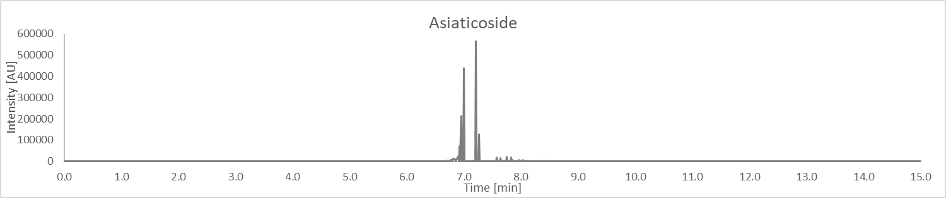

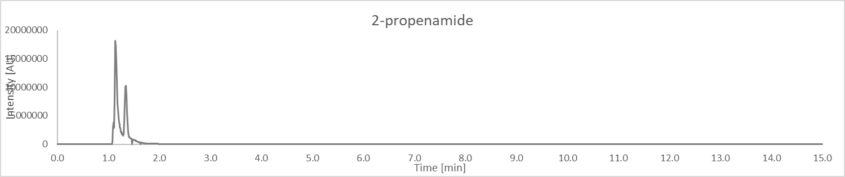

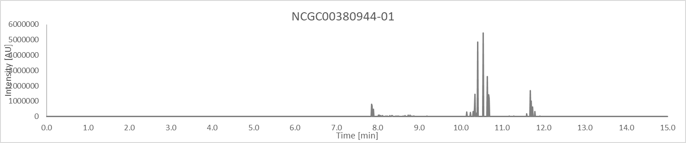

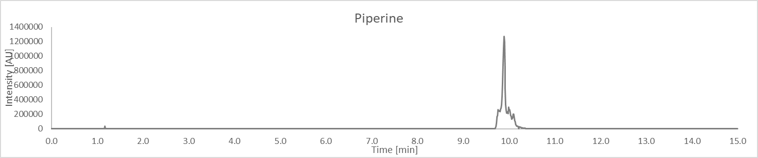

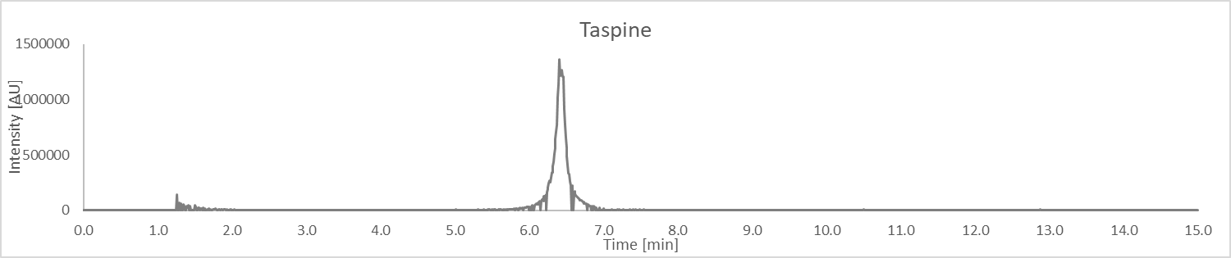

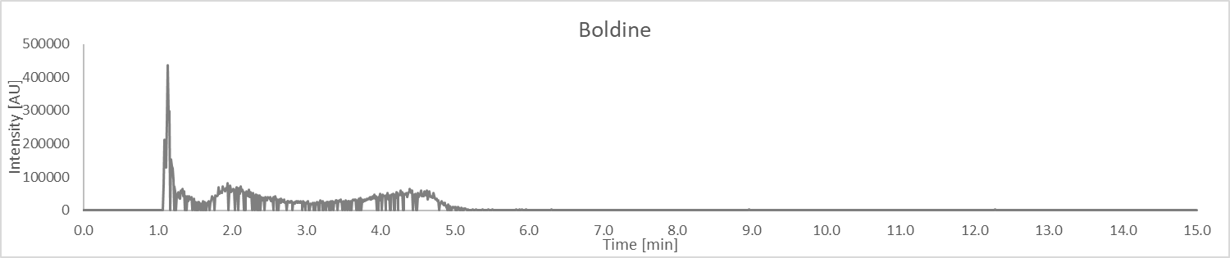

Structures of compounds in Table 1





|  |  |  |  |  |
| --- | --- | --- | --- | --- |
| **Table 3: HRMS product ions for the peaks of the botanical extract** | | | | |
| Peak No. | RT (min) | *m/z* | Proposed Compounds  (Confirmed with Std in **green**)  (Probable ID is **yellow**)  CAS Number | Product Ions  *m/z* Rel. Int.. |
| N1 | 10.47 | 221.1898 | Caryophyllene oxide  13877-94-6 | 55.0544 52  64.7965 26  67.0544 36  69.0700 44  79.0541 30  81.0697 66  91.0540 31  93.0696 46  93.9621 23  95.0854 50  105.0697 67  107.0854 100  119.0854 60  121.1016 32  131.9666 22  133.1017 39  189.4265 25 |
| 2 | 10.44 | 203.1796 | Alismol  87827-55-2 | 55.0541 50  57.0696 10  67.0540 47  69.0696 31  79.0539 24  81.0699 44  91.0545 34  93.0701 31  95.0855 53  105.0700 100  107.0861 31  109.1011 18  119.0857 69  131.0857 11  133.1015 58  145.1011 12  147.1169 33 |
| 3 | 1.17 | 138.055 | 3-carboxy-1-methylpyridinium  7164-65-0 | 53.0384 6  55.9342 100  59.5012 1  65.0383 7  67.0539 4  78.0338 2  79.0414 2  91.0532 1  92.0370 1  92.0493 12  93.0573 4  94.0649 35  95.0492 2  96.0442 10  96.9611 1  110.0600 23  110.1170 1  114.9714 4  138.0553 19 |
| 4 | 7.23 | 453.3371 | DL-alpha-tocopherol  10191-41-0 | 69.0700 14  81.0698 48  93.0701 24  95.0855 100  97.1017 14  105.0698 29  106.7621 16  107.0854 52  109.1011 38  111.0812 38  119.0860 56  121.1015 46  123.1162 14  133.1013 45  135.1167 22  145.1008 23  147.1172 40  149.1339 42  159.1181 33  161.1323 42  163.1488 39  173.1335 29  175.1498 29  177.1638 27  178.3174 41  187.1486 33  189.1650 72  191.1799 19  201.1645 58  203.1809 52  213.1654 17  391.3340 14 |
| 5 | 1.12 | 245.1647 | **Anagyrine**  **486-89-5** | 57.9729 0  70.0645 2  82.7397 0  83.5940 0  84.0801 2  96.0800 2  98.0958 100  98.8100 0  110.0591 1  113.0349 0  122.0598 0  124.1109 0  136.1115 1  142.4957 0  150.1277 1  161.4449 0  162.0915 0  178.3302 0  245.1649 10 |
| 6 | 1.10 | 261.1598 | **Baptifoline**  **732-50-3** | 70.0645 7  82.0651 0  94.0645 1  95.0492 0  96.0801 24  98.0960 1  100.0755 1  110.0595 2  114.0908 100  122.0590 1  122.0965 0  134.0959 1  146.0597 1  146.0964 2  150.0913 0  152.1064 0  160.0748 1  162.0901 1  164.1067 4  166.1225 1  172.0764 0  214.1259 0  243.1488 3  261.1598 19 |
| 7 | 1.1 | 338.1385 | Columbamine  3621-36-1 | 77.1201 2  84.2681 2  184.7630 2  204.1856 1  205.4491 2  277.1118 8  279.0912 15  280.0986 15  293.1063 5  294.1143 86  306.1149 24  307.0854 4  308.0937 52  322.1094 100  323.1177 52  338.1414 14 |
| 8 | 1.12 | 297.1122 | Cryptotanshinone  35825-57-1 | 60.5945 4  70.0644 5  84.0802 10  87.3620 3  132.0811 15  141.0693 13  144.0571 4  152.0639 6  153.0696 25  165.0699 82  166.0774 100  167.0853 18  168.0569 11  175.0098 4  176.0621 8  177.0694 38  178.0776 50  179.0853 184  180.0929 15  181.0643 33  181.1008 71  182.0855 6  183.0821 5  186.0312 5  189.0698 61  190.0776 90  191.0853 388  192.0568 6  192.0940 17  193.0647 43  194.0724 156  195.0798 29  196.0876 5  201.0686 13  202.0773 14  203.0857 15  204.0564 14  205.0647 173  205.1075 10  206.0722 34  207.0803 301  208.0881 141  209.0529 9  209.0959 145  211.0754 24  217.0655 30  218.0726 82  219.0802 211  220.0885 28  221.0594 91  221.1017 4  222.0675 335  223.0750 20  224.0826 9  225.0921 6  229.0717 6  233.0593 56  234.0670 18  235.0754 84  236.0829 124  237.0908 132  238.0603 5  239.0701 77  246.0658 7  247.0754 43  248.0819 8  249.0544 36  250.0619 36  251.0705 29  252.0774 20  253.0858 30  254.0931 11  255.1007 7  263.0699 60  264.0780 35  265.0858 101  266.0943 11  267.0650 62  281.0819 8  282.0886 147  297.1116 12 |
| 9 | 2.77 | 342.1703 | **Magnoflorine**  **2141-09-5** | 223.0714 20  238.0970 71  265.0889 24  266.0908 100  283.0962 42  298.1167 35  328.4781 18 |
| 10 | 9.55 | 274.2742 | N-Lauryldiethanolamine  1541-67-9 | 57.0697 69  70.0650 81  71.0853 21  75.6440 5  88.0756 100  102.0916 24  106.0863 35  113.8427 6  119.5663 5  129.8173 6  147.8442 6  242.5163 6  256.2640 14  274.2766 23 |
| 11 | 1.12 | 249.1959 | Lupanine  486-87-3 | 58.0646 15  69.0330 14  70.0645 48  77.3171 9  80.0488 12  84.0802 100  84.6111 10  85.0647 20  87.0440 17  96.0802 52  97.0270 12  98.0592 20  98.0958 128  99.6445 11  101.0072 14  112.0753 11  114.0908 255  115.1669 10  129.0027 15  129.0698 17  134.0961 28  136.1115 380  150.1274 65  166.1222 35  206.1514 18  231.1863 22  247.1797 13  249.1962 1657 |
| 12 | 7.30 | 751.4615 | a-Hederin  27013-91-8 | 85.0282 0  115.0396 1  129.0533 1  144.7982 1  166.8288 1  174.1212 1  205.9828 1  207.1751 1  279.1080 3  399.2415 1  409.3452 2  437.3444 8  455.3527 12  583.4149 1  601.4205 1  619.4366 1  751.4638 1  115.1669 1  129.0027 1  129.0698 1  134.0961 2  136.1115 23  150.1274 4  166.1222 2  206.1514 1  231.1863 1  247.1797 1  249.1962 100 |
| 13 | 7.28 | 781.4727 | Saikosaponin A  20736-09-8 | 85.0277 7  100.5207 3  129.0534 13  160.9071 4  197.6016 4  207.1744 7  309.1187 35  397.3084 6  409.3487 16  437.3436 100  455.3534 95  601.4177 9  619.4238 10  781.4708 7 |
| 14 | 6.96 | 959.5229 | Asiaticoside  16830-15-2 | 129.0542 12  131.0180 7  147.0656 8  156.9923 7  165.6242 8  170.9757 7  179.9275 9  184.0413 8  207.1756 12  273.0966 13  309.1175 62  310.1227 19  408.3279 11  426.3463 14  436.3269 14  453.3390 54  454.3430 78  471.3497 50  472.3524 100  600.3837 15  618.4042 23  636.4207 28  652.4166 17  798.4795 17 |
| 15 | 1.11 | 265.1547 | 2-propenamide  501-13-3 | 64.0008 0  72.0802 8  75.1916 1  80.1905 1  86.0596 1  89.0381 4  89.1072 1  98.0958 5  98.9753 1  104.0613 1  105.3945 1  110.9755 1  112.0749 1  117.0331 28  134.0349 2  135.0442 1  145.0281 100  149.0594 13  163.0395 1  165.0700 1  166.0773 1  177.0546 47  177.5520 1  178.2809 1  179.0860 1  189.0688 1  190.0769 2  191.0854 6  194.0728 3  195.0783 1  205.0659 1  207.0813 1  208.0896 1  209.0981 1  219.0821 2  222.0683 5  247.1819 1  265.1914 7 |
| 16 | 1.10 | 205.1337 | N-methylcytisine  63699-79-6 | 55.9338 0  56.0490 0  58.0646 100  79.2350 0  82.0649 0  84.0807 0  94.0651 0  97.3501 0  108.0655 0  108.0802 2  110.0608 0  110.0959 1  118.0645 0  118.0823 0  122.0602 0  125.7762 0  130.0652 0  132.0818 0  133.0523 0  136.4594 0  139.8265 0  144.0804 0  146.0596 1  147.0666 0  160.0753 0  162.0906 0  164.0939 0  205.1335 6 |
| 17 | 10.54 | 455.3519 | NCGC00380944-01 | 67.0544 9  69.0698 13  79.0544 6  81.0697 39  83.0851 8  86.3485 3  91.0537 7  93.0698 22  95.0854 72  97.0989 4  105.0700 31  107.0855 48  109.0656 6  109.1012 44  111.0804 66  119.0857 46  121.1012 46  123.1166 17  131.0858 10  133.1015 48  135.1170 31  137.1326 4  139.1124 5  145.1012 24  147.1171 53  149.1329 45  151.1126 5  153.0912 6  159.1176 27  161.1328 44  163.1487 39  173.1330 22  175.1489 35  177.1641 27  178.2791 11  183.8857 4  185.1308 5  187.1494 24  189.1645 100  191.1796 10  199.1482 6  201.1644 47  203.1802 62  207.1755 7  213.1646 7  215.1807 20  219.1752 7  221.1917 3  227.1813 6  229.1945 5  243.2109 10  255.2098 8  269.2270 6  351.3017 4  409.3434 9 |
| 18 | 9.73 | 286.1439 | Piperine  94-62-2 | 64.7003 12  69.0696 21  76.0397 13  115.0543 52  125.0967 11  133.4080 12  135.0441 55  143.0500 53  171.0447 35  173.0614 19  201.0554 100 |
| 19 | 5.97 | 370.1284 | **Taspine** | 80.9558 20  131.0990 22  325.0716 100 |
| 20 | 3.68 | 328.1544 | **Boldine** | 65.7076 0  85.0292 0  139.0606 0  150.0509 0  165.0725 1  166.0788 0  167.0868 0  176.0657 0  177.0708 10  178.0792 0  179.0867 0  181.0669 0  181.1024 0  183.0821 0  187.0759 0  189.0729 0  190.0761 0  191.0864 1  193.0662 0  194.0738 2  195.0817 0  201.0585 0  204.0578 0  205.0659 43  206.0737 1  207.0814 1  208.0893 0  209.0597 0  209.0972 2  210.0685 0  211.0764 1  218.0725 0  219.0813 1  220.0907 0  221.0609 0  222.0688 12  223.0759 0  224.0856 0  225.0922 3  226.1000 1  227.0720 0  233.0608 14  234.0686 2  235.0764 0  236.0847 1  237.0921 100  237.9525 0  239.0715 2  240.0790 0  247.0760 0  248.0851 0  250.0636 5  251.0717 3  253.0872 1  254.0950 5  255.1039 0  264.0797 0  265.0873 44  266.0951 6  267.0665 7  268.0734 0  269.1176 0  270.0886 0  279.1013 0  281.0746 0  282.0901 12  297.1136 5 |