Analysis of Symphytum officinale (Comfrey) root Extract Using LC-QToF-MS method

Names of investigators: Bharathi Avula, Kumar Katragunta
Affiliation: National Center for Natural Products Research, School of Pharmacy, University of Mississippi, University, MS 38677, USA

Analysis date: December 13, 2021

Common Botanical Name | CAS No. | Lot No. | Container ID | Net Weight
Symphytum offcinale (Comfrey) |  | RK-3-23-1-SO-C  RK-3-23-1-SO-D

Sample storage condition until analysis
2-8°C

Quantitative/Targeted method:
UHPLC-QToF-MS Method

UHPLC conditions | Mass spectrometry
System: Agilent 1290 series  Column: Poroshell 120 EC-C18 (2.1 X 150mm, 2.7µm) (Agilent technologies, Palo Alto, CA, USA)  Mobile phase A: Water+0.1% formic acid  Mobile phase B: Acetonitrile +0.1% formic acid  Flow rate: 0.23 mL/min  Column temperature: 35°C  Gradient  Time (min) Mobile phase B (%)  0.0 01  3.0 01  40.0 40  45.0 100 | System: QToF-MS 6530A series (Agilent technologies, Palo Alto, CA, USA)  Ionization: ESI  Polarity: Positive mode/Negative mode  Main Interface:  · Nebulizing gas flow: 11 L/min  . Gas temperature: 325°C  . Nebulizer: 30 psig  . Sheath gas temperature: 300°C  . Sheath gas flow: 11L/min  Capillary voltage: 3.5 kV  Fragmentor: 100V/150V  Compound Precursor ion (m/z) [M+H]⁺ Retention time (min)  Intermedine 300.1805 12.3  Lycopsamine 300.1805 12.6  Intermedine N-oxide 316.1755 13.8  Lycopsamine N-oxide 316.1755 14.2  7-acetylintermedine 342.1911 17.65  7-acetyllycosamine 342.1911 17.78  7-acetylintermedine N-oxide 358.1858 17.9  7-acetyllycosamine N-oxide 358.1858 18.1  Rosmarinic acid DAD@330 nm 26.6

Quantitative results
Compound | Concentration in extract (mg/g)  RK-3-21-1-SO-C | Concentration in extract (mg/g)  RK-3-21-1-SO-D
Intermedine | 3 mg/g | 3 mg/g
Lycopsamine | 3 mg/g | 3 mg/g
Intermedine N-oxide | 3.7 mg/g | 3.7 mg/g
Lycopsamine N-oxide | 3.7 mg/g | 3.7 mg/g
7-acetylintermedine | 0.2 mg/g | 0.2 mg/g
7-acetyllycopsamine | 0.2 mg/g | 0.2 mg/g
7-acetylintermedine N-oxide | 3 mg/g | 3 mg/g
7-acetyllycopsamine N-oxide | 5 mg/g | 5 mg/g
Rosmarinic acid | 17 mg/g | 17 mg/g
Standards
Name | Supplier | CAS Number | Catalog number | Purity %
Intermedine | Millipore Sigma | 10285-06-0 | PHL82424 | 99%
Lycopsamine | Millipore Sigma | 10285-07-1 | PHL89726 | 99%
Intermedine N-oxide | Millipore Sigma | 95462-14-9 | PHL83446 | 99%
Lycopsamine N-oxide | Millipore Sigma | 95462-15-0 | PHL83447 | 99%
7-acetylintermedine | Millipore Sigma | 74243-01-9 | PHL83759 | 99%
7-acetylintermedine N-oxide | Millipore Sigma | 685132-59-6 | PHL83795 | 99%
7-acetyllycopsamine N-oxide | Millipore Sigma | 685132-58-5 | PHL84275 | 99%
Rosamarinic acid | Millipore Sigma | 20283-92-5 | R4033 | 98%

Chemical structures of standards used for quantitative analysis

Chromatograms
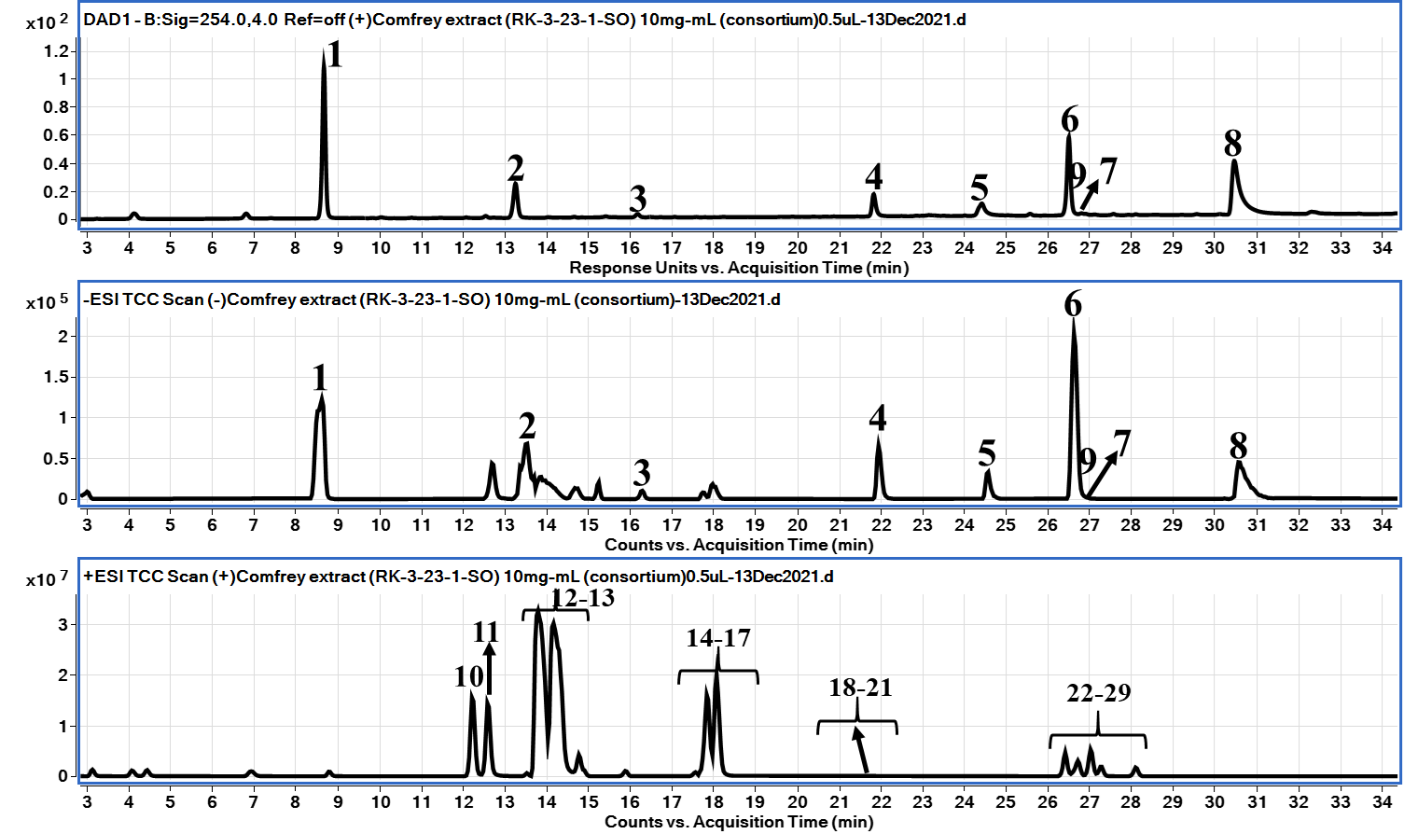

Calibration
Compound | Limit of detection (LOD) ng/mL | Limit of quantitation (LOQ) ng/mL | Calibration range (mg/g) | Number of Calibration Points | r² | Concentration  mg/g (n = 3)  RK-3-21-1-SO-C | Concentration  mg/g (n = 3)  RK-3-21-1-SO-D
Intermedine | 0.5 ng/mL | 1.0 ng/mL | 0.1 – 2.5 μg/mL | 5 | 0.9993 | 3.4 ± 0.28 | 3.4 ± 0.71
Lycopsamine | 0.5 ng/mL | 1.0 ng/mL | 0.1 – 2.5 μg/mL | 5 | 0.9995 | 3.1 ± 0.32 | 3.2 ± 1.66
Intermedine N-oxide | 1.0 ng/mL | 2.5 ng/mL | 0.1 – 2.5 μg/mL | 5 | 0.9995 | 3.7 ± 2.30 | 3.7 ± 0.51
Lycopsamine N-oxide | 0.5 ng/mL | 1.0 ng/mL | 0.1 – 2.5 μg/mL | 5 | 0.9995 | 3.7 ± 0.33 | 3.7 ± 0.53
7-acetylintermedine | 0.5 ng/mL | 1.0 ng/mL | 0.1 – 2.5 μg/mL | 5 | 0.9994 | 0.2 ± 1.38 | 0.2 ± 2.22
7-acetyllycopsamine | 1.0 ng/mL | 2.5 ng/mL | 0.1 – 2.5 μg/mL | 5 | 0.9994 | 0.2 ± 1.61 | 0.2 ± 2.12
7-acetylintermedine N-oxide | 0.5 ng/mL | 1.0 ng/mL | 0.1 – 2.5 μg/mL | 5 | 0.9995 | 3.5 ± 0.62 | 3.5 ± 0.61
7-acetyllycopsamine N-oxide | 1.0 ng/mL | 2.5 ng/mL | 0.1 – 2.5 μg/mL | 5 | 0.9995 | 4.8 ± 0.35 | 4.7 ± 1.25
Rosamarinic acid | 10 ng/mL | 50 ng/mL | 0.5 – 25 μg/mL | 5 | 0.9996 | 16.8 ± 0.10 | 16.9 ± 0.24

Linearity profiles
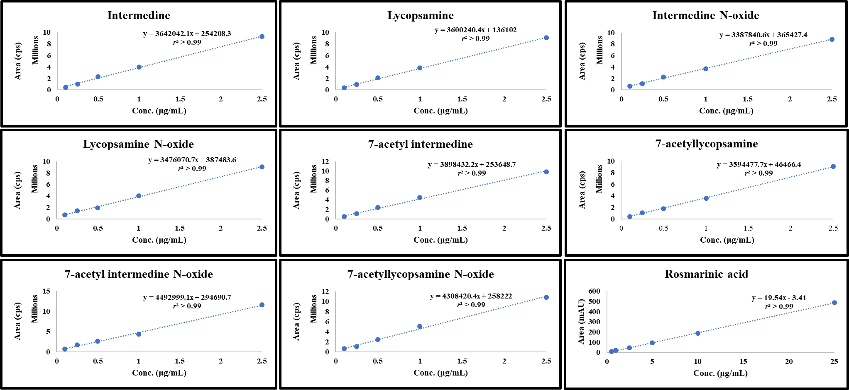

Untargeted Analysis
UHPLC conditions | Mass spectrometer conditions
System: Agilent 1290 series  Column: Poroshell 120 EC-C18 (2.1 X 150mm, 2.7µm) (Agilent technologies, Palo Alto, CA, USA)  Mobile phase A: Water+0.1% formic acid  Mobile phase B: Acetonitrile +0.1% formic acid  Flow rate: 0.23 mL/min  Column temperature: 35°C  Gradient:  Time (min) Mobile phase B (%)  0.0 01  3.0 01  40.0 40  45.0 100 | System: QToF-MS 6530A series (Agilent technologies, Palo Alto, CA, USA)  Ionization: ESI  Polarity: Positive mode  Main Interface:  · Nebulizing gas flow: 11 L/min  . Gas temperature: 325°C  . Nebulizer: 30 psig  . Sheath gas temperature: 300°C  . Sheath gas flow: 11L/min  Capillary voltage: 3.5 kV  Fragmentor: 100V/150V

Table 1: Proposed identification of constituents of Symphytum officinale root extract showing RT, m/z, ppm, tentative compound name and molecular formula
Peak No. | RT (min) | Exp. m/z | Mass accuracy  (ppm) | Proposed ID’s  (Confirmed with Std in green)  (Most probable ID is yellow) | Molecular Formula
Phenolic compounds [M-H]⁻
1 | 8.5 | 599.1615 | -0.5 | Hydroxybenzoic acid derivative | C₂₆H₃₂O₁₆
2 | 13.5 | 161.0818 | -0.6 | Viridifloric acid | C₇H₁₄O₄
3 | 16.3 | 179.0347 | -1.7 | Caffeic acid | C₉H₈O₄
4 | 21.9 | 537.1036 | -0.4 | Globoidnan B | C₂₇H₂₂O₁₂
5 | 24.58 | 717.1459 | -0.3 | Rabdosin | C₃₆H₃₀O₁₆
6 | 26.6 | 359.0770 | -0.6 | Rosmarinic acid | C₁₈H₁₆O₈
7 | 26.7 | 719.1619 | 0.1 | Dihydrorabdosin | C₃₆H₃₂O₁₆
8 | 26.9 | 493.1143 | 0.6 | Dihydrogloboidnan A | C₂₆H₂₂O₁₀
9 | 30.6 | 491.0989 | 1.0 | Globoidnan A/Eritrichin | C₂₆H₂₀O₁₀
Pyrrolizidine alkaloids (PAs) [M+H]⁺
10 | 12.3 | 300.1807 | 0.7 | Intermedine | C₁₅H₂₅NO₅
11 | 12.6 | 300.1807 | 0.7 | Lycopasamine | C₁₅H₂₅NO₅
12 | 13.8 | 316.1757 | 0.6 | Intermedine-N-oxide | C₁₅H₂₅NO₆
13 | 14.2 | 316.1757 | 0.6 | Lycopasamine N-oxide | C₁₅H₂₅NO₆
14 | 17.65 | 342.1912 | 0.3 | 7-Acetylintermedine | C₁₇H₂₇NO₆
15 | 17.78 | 342.1912 | 0.3 | 7-Acetyllycopsamine | C₁₇H₂₇NO₆
16 | 17.9 | 358.1858 | -0.6 | 7-Acetylintermedine N-oxide | C₁₇H₂₇NO₇
17 | 18.1 | 358.1858 | -0.6 | 7-Acetyllycopsamine N-oxide | C₁₇H₂₇NO₇
18 | 19.2 | 414.2123 | 0.2 | 7-Sarracinyl-9- trachelantyl-retronecine-N-oxide/ 7-Sarracinyl-9- viridiflorylretronecine-N-oxide/Echimidine-N-Oxide/  Heliosupine-N-oxide | C₂₀H₃₁NO₈
19 | 19.9
20 | 20.5
21 | 22.0
22 | 26.4 | 382.2223 | -0.3 | Symphytine/ Symviridine/  Anadoline/Symlandine | C₂₀H₃₁NO₆
23 | 26.7
24 | 26.9
25 | 27.2
26 | 26.5 | 398.2175 | 0.5 | Echimidine/ Heliosupine/Symphytine N-oxide/ Symviridine N-oxide/ Anadoline-N-Oxide/ Symlandine N-oxide | C₂₀H₃₁NO₇
27 | 26.9
28 | 27.2
29 | 27.5

Figure 1: Chromatograms
Structures of compounds in Tables 1

Table 2: HRMS product ions for the peaks of the botanical extract (Symphytum officinale root) showing RT, m/z, tentative compound name and fragment ions
Peak No. | RT (min) | [M-H]⁻/[M+H]⁺  m/z | Proposed Compounds  (Confirmed with Std in green)  (Probable ID is yellow)  CAS Number | Product Ions  m/z
Phenolic compounds [M-H]⁻
1 | 8.5 | 599.1615 | Hydroxybenzoic acid derivative | 137.0250  93.0354
2 | 13.5 | 161.0818 | Viridifloric acid | 135.0571  117.0556
3 | 16.3 | 179.0347 | Caffeic acid | 135.0448
4 | 21.9 | 537.1036 | Globoidnan B | 493.1141  339.0505  197.0451  135.0452
5 | 24.58 | 717.1459 | Rabdosin | 537.1006  519.0916  475.1019  339.0502  197.0456
6 | 26.6 | 359.0770 | Rosmarinic acid | 197.0461  161.0231
7 | 26.9 | 493.1143 | Dihydrogloboidnan A | 359.0746  295.0597  185.0234  161.0239
8 | 30.6 | 491.0989 | Globoidnan A/Eritrichin | 311.0563  179.0348  135.0450
9 | 26.7 | 719.1619 | Dihydrorabdosin | 359.0765  197.0456  161.0246
Pyrrolizidine alkaloids (PAs) [M+H]⁺
10 | 12.3 | 300.1807 | Intermedine | 156.1006
11 | 12.6 | 300.1807 | Lycopsamine | 156.1006
12 | 13.8 | 316.1757 | Intermedine-N-oxide | 172.0841
13 | 14.2 | 316.1757 | Lycopasamine N-oxide | 172.0841
14 | 17.65 | 342.1912 | 7-Acetylintermedine | 120.0629
15 | 17.78 | 342.1912 | 7-Acetyllycopsamine | 120.0629
16 | 17.9 | 358.1858 | 7-Acetylintermedine N-oxide | 214.1067  180.1007  120.0802
17 | 18.1 | 358.1858 | 7-Acetyllycopsamine N-oxide | 214.1067  180.1007  120.0802
18 | 19.2 | 414.2123 | 7-Sarracinyl-9- trachelantyl-retronecine-N-oxide/ 7-Sarracinyl-9- viridiflorylretronecine-N-oxide/Echimidine-N-Oxide/  Heliosupine-N-oxide | 298.1575  270.1307  236.1311  214.1048  154.0832  137.0810  120.0800
19 | 19.9
20 | 20.5
21 | 22.0
22 | 26.4 | 382.2223 | Symphytine/ Symviridine/  Anadoline/Symlandine | 138.0893  120.0809
23 | 26.7
24 | 26.9
25 | 27.2
26 | 26.5 | 398.2175 | Echimidine/ Heliosupine/Symphytine N-oxide/  Symviridine N-oxide/ Anadoline-N-Oxide/ Symlandine N-oxide | 254.1282  138.0893  120.0809
27 | 26.9
28 | 27.2
29 | 27.5

References:
- Wuilloud JC, Gratze SR, Gamble BM, Wolnik KA. Simultaneous analysis of hepatotoxic pyrrolizidine alkaloids and N-oxides in comfrey root by LC-ion trap mass spectrometry. Analyst. 2004 Feb;129(2):150-6. doi: 10.1039/b311030c. Epub 2004 Jan 8. PMID: 14752559.
- Trifan A, Opitz SEW, Josuran R, Grubelnik A, Esslinger N, Peter S, Bräm S, Meier N, Wolfram E. Is comfrey root more than toxic pyrrolizidine alkaloids? Salvianolic acids among antioxidant polyphenols in comfrey (Symphytum officinale L.) roots. Food Chem Toxicol. 2018 Feb;112:178-187.
- Trifan A, Wolfram E, Esslinger N, Grubelnik A, Skalicka-Woźniak K, Minceva M, Luca SV. Globoidnan A, rabdosiin and globoidnan B as new phenolic markers in European-sourced comfrey (Symphytum officinale L.) root samples. Phytochem Anal. 2021 Jul;32(4):482-494. doi: 10.1002/pca.2996. Epub 2020 Oct 5. PMID: 33015885.
- Avula B, Sagi S, Wang YH, Zweigenbaum J, Wang M, Khan IA. Characterization and screening of pyrrolizidine alkaloids and N-oxides from botanicals and dietary supplements using UHPLC-high resolution mass spectrometry. Food Chem. 2015 Jul 1;178:136-48. doi:

