**Analysis of Ginseng Extract Using UPLC-MS/MS**

Tim Cristy

Battelle

505 King Ave

Columbus, OH 43201

May 2023

|  |  |  |  |  |
| --- | --- | --- | --- | --- |
| Common Botanical Name | CAS No. | Lot No. | Container ID | Net Weight |
| Asian Ginseng (*Panax ginseng*) | 50647-08-0 | 0100410401 | NA | ~20 g |

|  |
| --- |
| Sample storage condition until analysis |
| -20 ℃ |

**Quantitative, Targeted, and Untargeted Method:**

**UPLC/MS/MS Method**

|  |  |
| --- | --- |
| UPLC Conditions | MS Conditions |
| System: **Waters Acquity I-Class**  Column: **Waters HSS T3 (2.1 x 100 mm, 1.8 um)**  Mobile phase A: **95:5 H2O:CH3CN + 0.1% FA**  Mobile phase B: **CH3CN + 0.1% FA**  Flow rate: **0.6 mL/min**  Column temperature: **40 ℃**  Detector: Thermo Corona VEO Charged Aerosol Detector (CAD)  Gradient”   |  |  | | --- | --- | | Time (min) | Mobile phase B (%) | | **0** | **0** | | **15** | **15** | | **60** | **35** | | **80** | **95** | | **82** | **95** | | **84** | **0** | | **90** | **0** | | System: **Sciex Triple TOF 6600**  Ionization: **Electrospray (ESI)**  Polarity: **Positive**  Source Settings:  · Nebulizer Gas: **50 psi**  · Heater Gas: **50 psi**  · Curtain Gas: **35 psi**  · Ion Source Voltage: **5500 V**  · Source Temperature: **450 ℃**  · Declustering Potential: **40 V**  MS Settings:  · TOF-MS Scan Range: **m/z 50 – 1500**  · TOF-MS Collision Energy: **5 V**  · IDA MS/MS Scan Range: **m/z 50 – 1500**  · IDA MS/MS Collision Energy: **25 V** |

**Quantitative Results – Compounds with Standardsa**

|  |  |  |
| --- | --- | --- |
| **Compound** | **Concentration** | |
| **mg/g**  **Average ± s** | **% wt/wt** |
| Ginsenoside Rg1 | **2.59 ± 0.44** | **0.259** |
| Ginsenoside Re | **4.70 ± 0.72** | **0.470** |
| Ginsenoside Rb1 | **7.10 ± 1.42** | **0.710** |
| Ginsenoside Rc | **5.90 ± 0.81** | **0.590** |
| Ginsenoside Rb2 | **5.57 ± 0.88** | **0.557** |
| Ginsenoside Rd | **3.91 ± 0.93** | **0.391** |
| Protopanaxadiol | **0.103 ± 0.000** | **0.0103** |
| Protopanaxatriol | **<0.1** | **<0.01** |
| Prosapogenin A | **<0.1** | **<0.01** |
| Ginsenoside Rg2 | **0.672 ± 0.082** | **0.0672** |
| Ginsenoside Ro | **1.10 ± 0.23** | **0.110** |
| Ginsenoside Rf | **0.995 ± 0.126** | **0.0995** |
| Ginsenoside Rg3 | **0.144 ± 0.004** | **0.0144** |
| Ginsenoside Rh1 | **<0.1** | **<0.01** |
| Kaempferol | **<0.1** | **<0.01** |
| Protocatechuic Acid | **<0.1** | **<0.01** |
| Chlorogenic Acid | **0.125 ± 0.001** | **0.0125** |
| p-Coumaric Acid | **<0.1** | **<0.01** |
| m-Coumaric Acid | **Not Detected** | **Not Detected** |
| Naringenin | **<0.1** | **<0.01** |

1. **Quantitated using MS XIC for molecular ion**

**Quantitative Results – Compounds**

**without Standardsb**

|  |  |  |  |
| --- | --- | --- | --- |
| **Compound** | **Calibration**  **Curve Used** | **Concentration** | |
| **mg/g**  **Average ± s** | **% wt/wt** |
| Ginsenoside Ra2 | Ginsenoside Rb1 | **3.40 ± 0.15** | **0.340** |
| Malonyl Ginsenoside Rb1 | Ginsenoside Rb1 | **3.19 ± 0.04** | **0.319** |
| Malonyl Ginsenoside Rb2 | Ginsenoside Rb2 | **2.66 ± 0.03** | **0.266** |
| Malonyl Ginsenoside Rc | Ginsenoside Rc | **2.47 ± 0.07** | **0.247** |
| Malonyl Rd/Acetyl Rc Mix | Ginsenoside Rd | **2.22 ± 0.06** | **0.222** |
| Ginsenoside Rb3 | Ginsenoside Rb2 | **1.08 ± 0.01** | **0.108** |
| Acetyl Ginsenoside Rb1 | Ginsenoside Rb1 | **1.01 ± 0.07** | **0.101** |
| Malonyl Ginsenoside Rb3 | Ginsenoside Rb2 | **0.634 ± 0.045** | **0.0634** |
| Acetyl Ginsenoside Rb2 | Ginsenoside Rb2 | **0.575 ± 0.043** | **0.0575** |
| Notoginsenoside R2 | Ginsenoside Rf | **0.426 ± 0.026** | **0.0426** |
| Ginsenoside Re1 Isomer | Ginsenoside Rf | **0.376 ± 0.033** | **0.0376** |
| Malonyl Ginsenoside Re | Ginsenoside Re | **0.247 ± 0.013** | **0.0247** |
| Ginsenoside Ra3 | Ginsenoside Rb1 | **0.237 ± 0.019** | **0.0237** |
| Acetyl Ginsenoside Rd | Ginsenoside Rf | **0.194 ± 0.035** | **0.0194** |
| Notoginsenoside R1 | Ginsenoside Rf | **0.193 ± 0.003** | **0.0193** |

1. **Quantitated using CAD and the calibration curve for a similar compound.**

**Standards**

|  |  |  |  |  |  |
| --- | --- | --- | --- | --- | --- |
| **Name** | **Supplier** | **CAS Number** | **Catalog Number** | **Purity %** | **Batch/Lot number** |
| **Ginsenoside Rg1** | Sigma-Aldrich | 22427-39-0 | PHL89214 | 95% | 97763879 |
| **Ginsenoside Re** | Sigma-Aldrich | 52286-59-6 | PHL89212 | 88% | 118375130 |
| **Ginsenoside Rb1** | Sigma-Aldrich | 41753-43-9 | PHL89208 | 95% | 97763860 |
| **Ginsenoside Rc** | Sigma-Aldrich | 11021-14-0 | PHL89210 | 85% | 114905356 |
| **Ginsenoside Rb2** | Sigma-Aldrich | 11021-13-9 | PHL89209 | 94% | 81786801 |
| **Ginsenoside Rd** | Sigma-Aldrich | 52705-93-8 | PHL89211 | 93% | 81786836 |
| **Protopanaxadiol** | Sigma-Aldrich | 7755-01-3 | PHL89767 | 98% | 117272060 |
| **Protopanaxatriol** | Sigma-Aldrich | 1453-93-6 | PHL89768 | 92% | 117272079 |
| **Prosapogenin A** | Sigma-Aldrich | 19057-67-1 | PHL80558 | 97% | 76413363 |
| **Ginsenoside Rg2** | Sigma-Aldrich | 52286-74-5 | PHL89680 | 94% | 93587995 |
| **Ginsenoside Ro** | Sigma-Aldrich | 34367-04-9 | PHL80462 | 88% | 111810893 |
| **Ginsenoside Rf** | Sigma-Aldrich | 52286-58-5 | PHL89213 | 94% | 118119843 |
| **Ginsenoside Rg3** | Sigma-Aldrich | 14197-60-5 | PHL89681 | 93% | 117533476 |
| **Ginsenoside Rh1** | Sigma-Aldrich | 63223-86-9 | PHL89682 | 93% | 117533484 |
| **Kaempferol** | Sigma-Aldrich | 520-18-3 | PHR2705 | 95.3% | LRAC5726 |
| **Protocatechuic Acid** | Sigma-Aldrich | 99-50-3 | 0393-05-90 | 99.3% | HWI02119-2 |
| **Chlorogenic Acid** | Sigma-Aldrich | 327-97-9 | PHL89175 | ≥95% | 118030397 |
| **p-Coumaric Acid** | Sigma-Aldrich | 501-98-4 | 55823 | 99.8% | BCCD7809 |
| **m-Coumaric Acid** | Sigma-Aldrich | 14755-02-3 | 92649 | 99.7% | BCCC1584 |
| **Naringenin** | Sigma-Aldrich | 67604-48-2 | 52186 | 98% | BCCG3820 |

**Chemical structures of standards used for quantitative analysis**

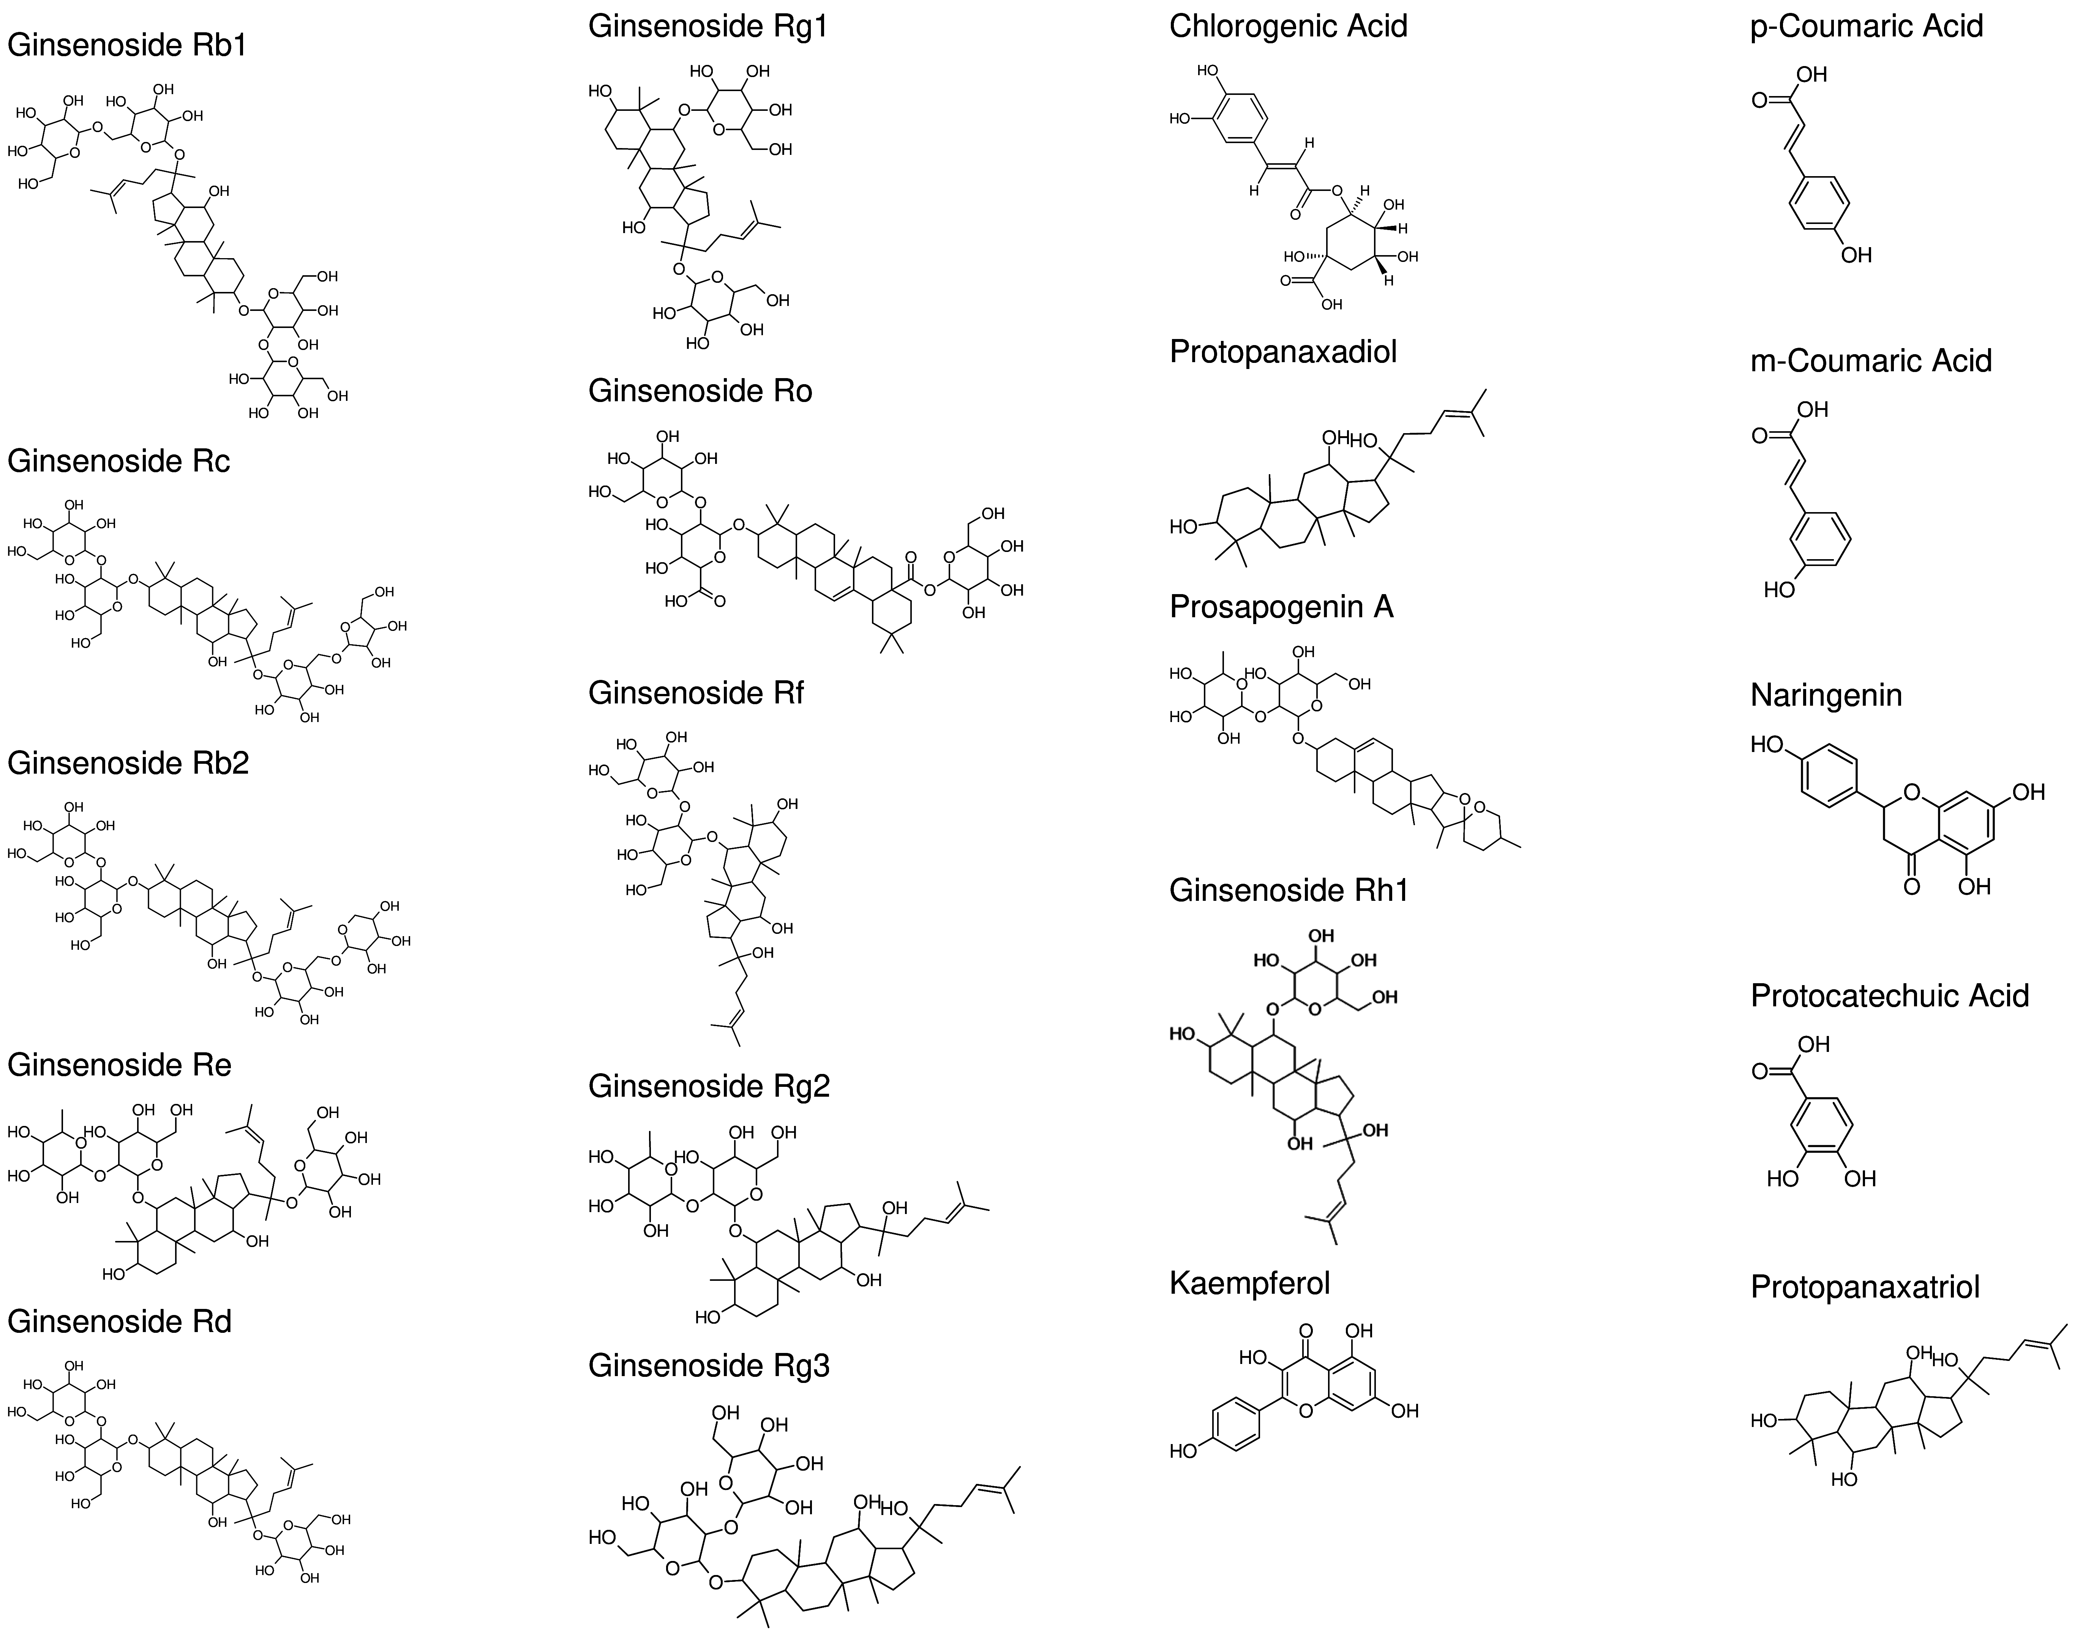

**Quantitative Analysis Extracted Ion Chromatograms – Standards (See Targeted/Untargeted Section for Sample XICs)**

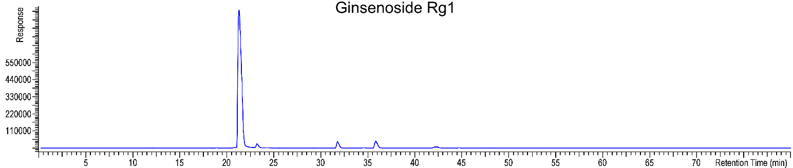

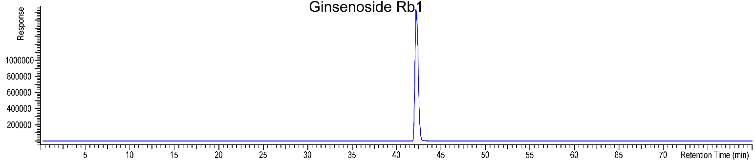

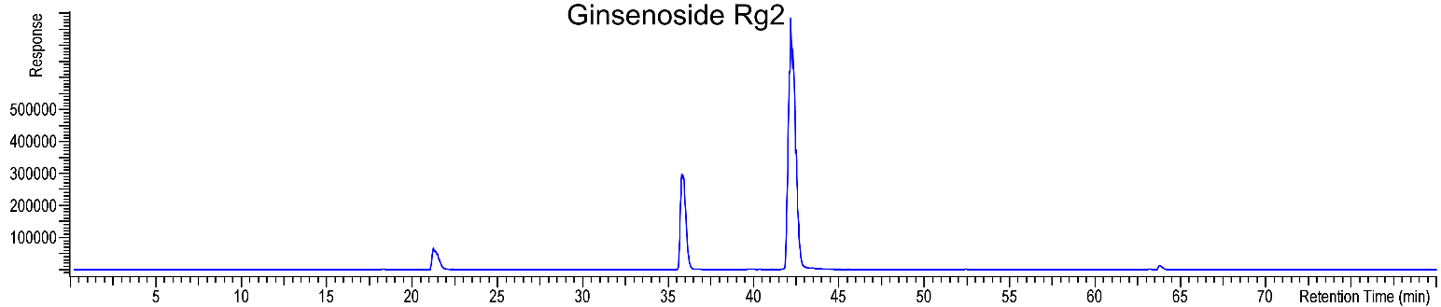

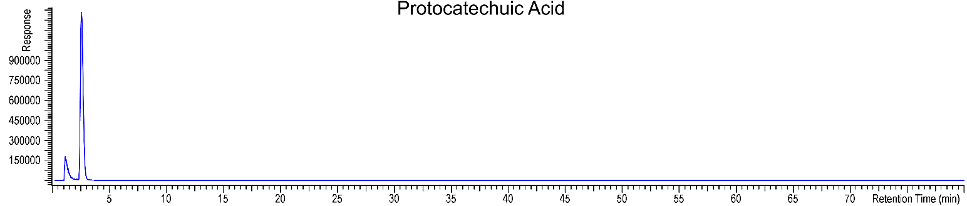

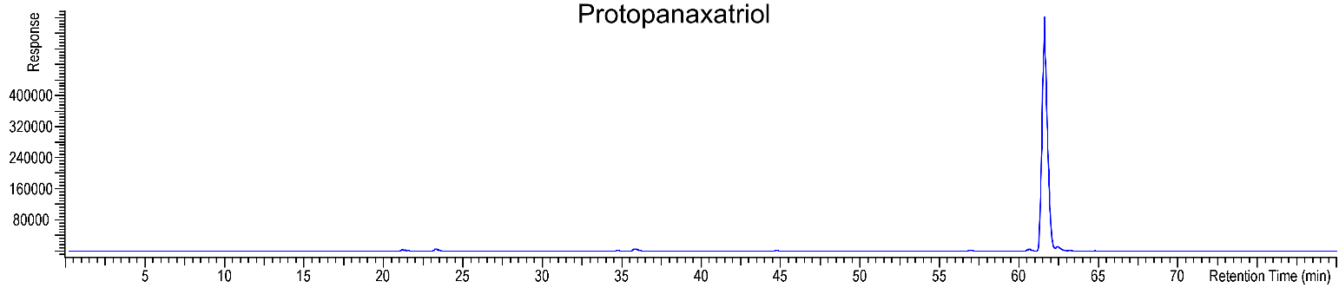

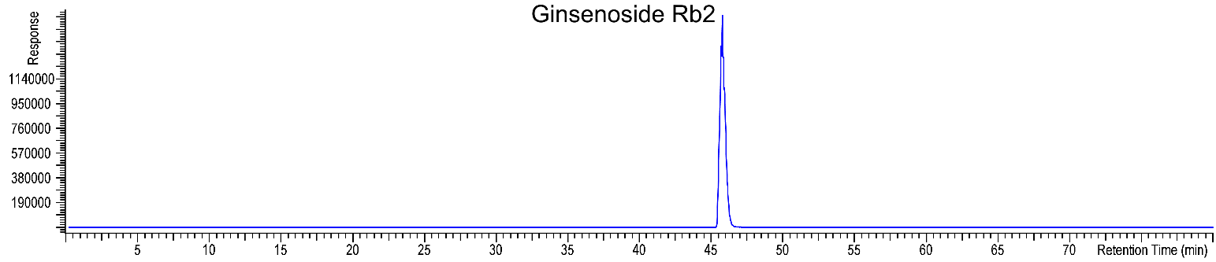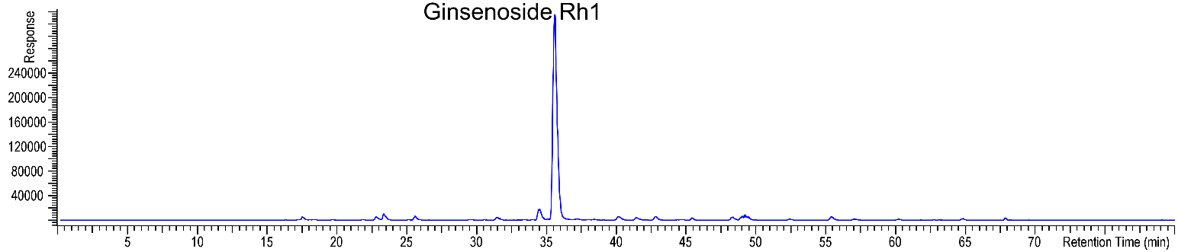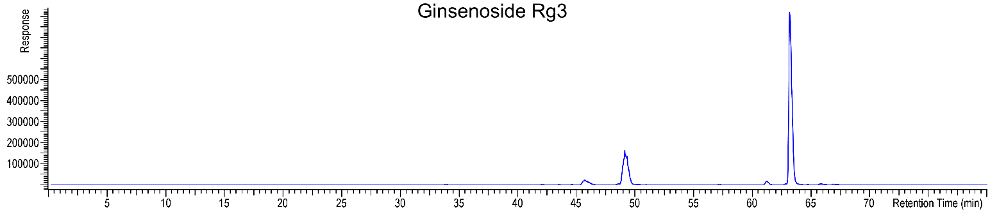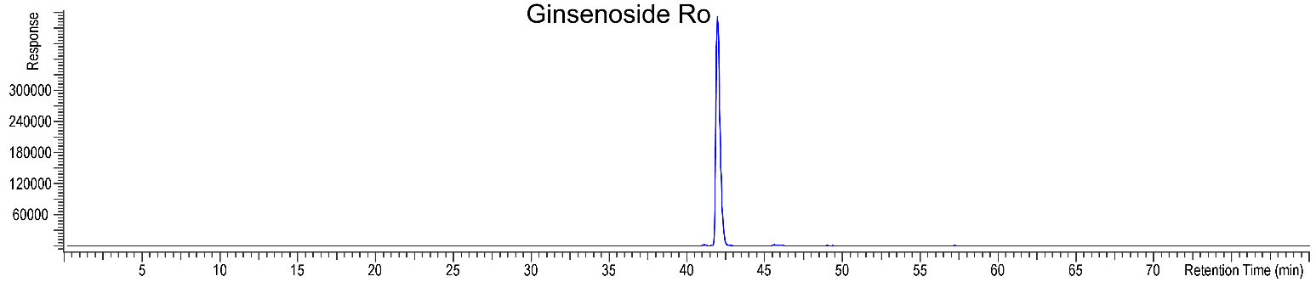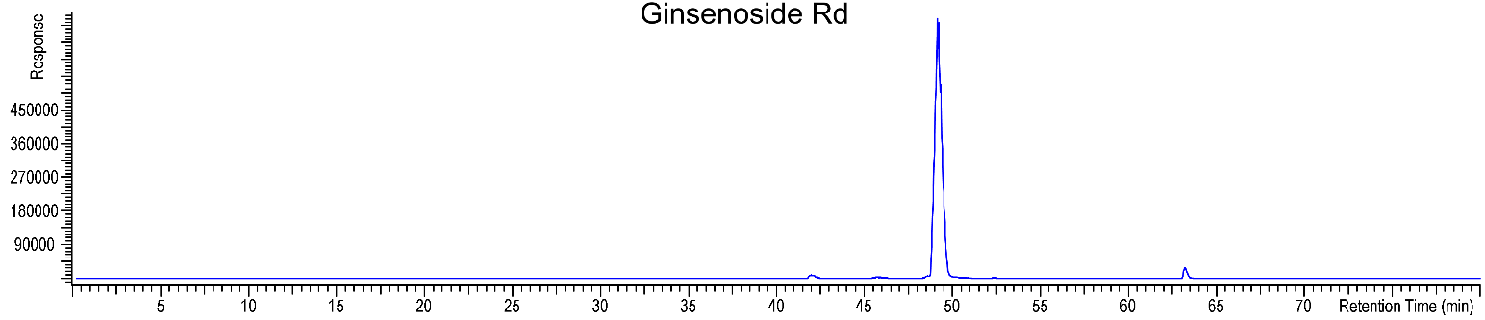

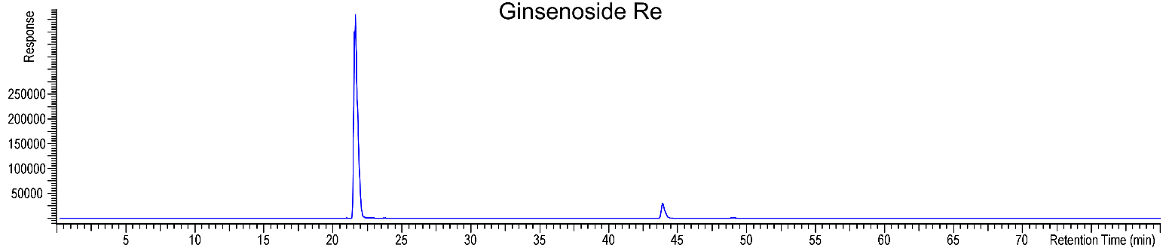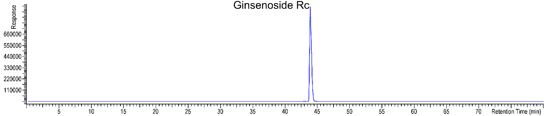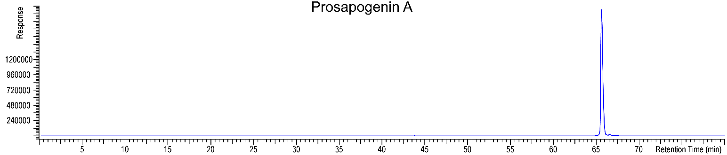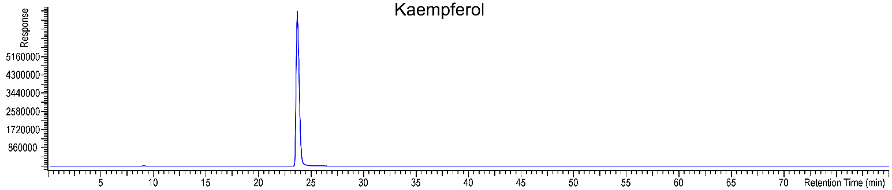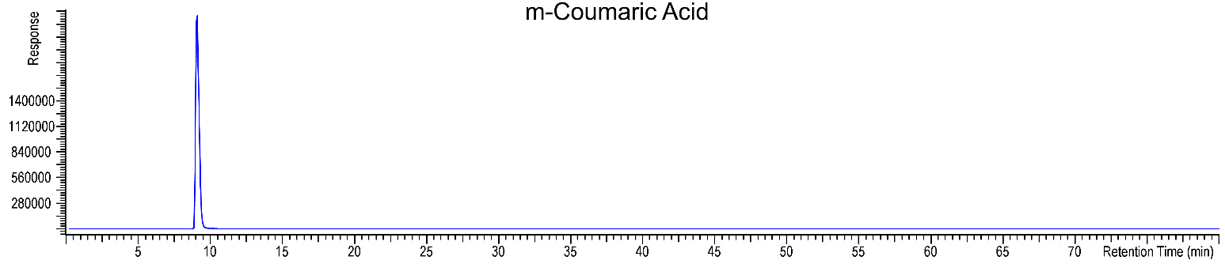

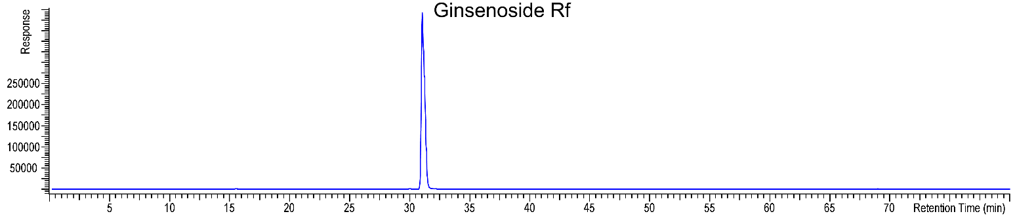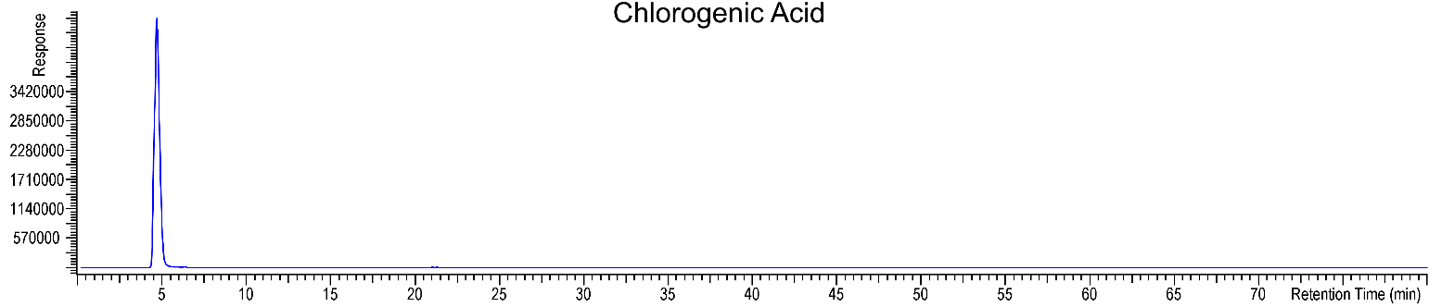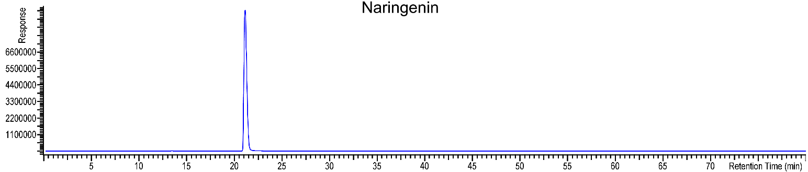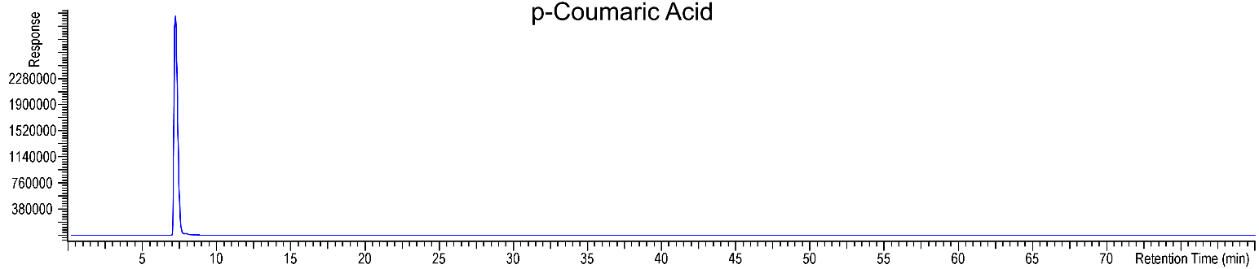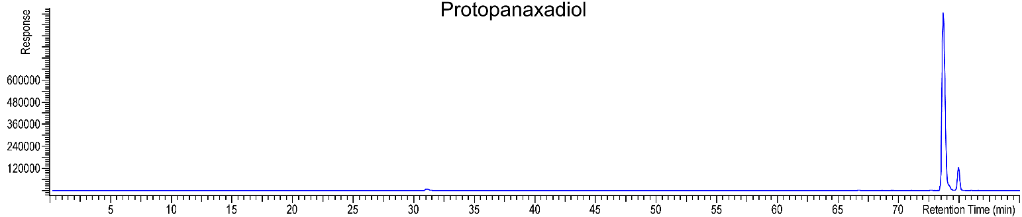

**Calibration**

|  |  |  |  |  |
| --- | --- | --- | --- | --- |
| Compound | Lower Limit of Quantitation (LLOQ) **ug/mL** | Calibration Range (**ug/mL**) | Number of Calibration Points | R2 |
| Ginsenoside Rg1 | 50 | 50 – 400 | 3 | 0.9606 |
| Ginsenoside Re | 50 | 50 – 400 | 3 | 0.9590 |
| Ginsenoside Rb1 | 50 | 50 – 400 | 3 | 0.9508 |
| Ginsenoside Rc | 50 | 50 – 400 | 3 | 0.9477 |
| Ginsenoside Rb2 | 50 | 50 – 400 | 3 | 0.9490 |
| Ginsenoside Rd | 50 | 50 – 400 | 3 | 0.9679 |
| Protopanaxadiol | 5 | 5 – 80 | 3 | 0.9994 |
| Protopanaxatriol | 5 | 5 – 80 | 3 | 0.9860 |
| Prosapogenin A | 5 | 5 – 80 | 3 | 0.5052 |
| Ginsenoside Rg2 | 5 | 5 – 80 | 3 | 0.9928 |
| Ginsenoside Ro | 5 | 5 – 80 | 3 | 0.9926 |
| Ginsenoside Rf | 5 | 5 – 80 | 3 | 0.9945 |
| Ginsenoside Rg3 | 5 | 5 – 80 | 3 | 0.9699 |
| Ginsenoside Rh1 | 5 | 5 – 80 | 3 | 0.9964 |
| Kaempferol | 5 | 5 – 80 | 3 | 0.9968 |
| Protocatechuic Acid | 5 | 5 – 80 | 3 | 0.9993 |
| Chlorogenic Acid | 5 | 5 – 80 | 3 | 0.9938 |
| p-Coumaric Acid | 5 | 5 – 80 | 3 | 0.9913 |
| m-Coumaric Acid | 5 | 5 – 80 | 3 | 0.9892 |
| Naringenin | 5 | 5 – 80 | 3 | 0.9983 |

|  |  |  |  |  |  |  |  |  |  |  |
| --- | --- | --- | --- | --- | --- | --- | --- | --- | --- | --- |
| Table 1. Targeted and Untargeted Identification | | | | | | | | | | |
| **#** | **ID** | **Retention**  **Timea**  **(minutes)** | | **Expected**  **M+H**  **Exact Mass (Da)** | **Found**  **M+H**  **Exact Mass (Da)** | **Mass**  **Error**  **(Da)** | **CAS**  **RN** | **Molecular**  **Formula** | **Structure** | **ID**  **Confidence**  **Levelb** |
| 1 | Ginsenoside Rb1 | 42.22 | | 1109.611 | 1109.604 | 0.007 | 41753-43-9 | C54H92O23 |  | 1 |
| 2 | Ginsenoside Rc | 43.94 | | 1079.600 | 079.599 | 0.001 | 11021-14-0 | C53H90O22 |  | 1 |
| 3 | Ginsenoside Rb2 | 45.70 | | 1079.600 | 1079.599 | 0.001 | 11021-13-9 | C53H90O22 |  | 1 |
| 4 | Ginsenoside Re | 21.65 | | 947.558 | 947.559 | 0.001 | 52286-59-6 | C48H82O18 |  | 1 |
| 5 | Ginsenoside Rd | 49.06 | | 947.558 | 947.560 | 0.002 | 52705-93-8 | C48H82O18 |  | 1 |
| 6 | Ginsenoside Rg1 | 21.31 | | 801.500 | 801.500 | 0.000 | 22427-39-0 | C42H72O14 |  | 1 |
| 7 | Ginsenoside Ro | 41.96 | | 957.506 | 957.501 | 0.005 | 34367-04-9 | C48H76O19 |  | 1 |
| 8 | Ginsenoside Rf | 31.10 | | 801.500 | 801.499 | 0.001 | 52286-58-5 | C42H72O14 |  | 1 |
| 9 | Ginsenoside Rg2 | 35.85 | | 785.505 | 785.501 | 0.004 | 52286-74-5 | C42H72O13 |  | 1 |
| 10 | Ginsenoside Rg3 | 63.19 | | 785.505 | 785.500 | 0.005 | 14197-60-5 | C42H72O13 |  | 1 |
| 11 | Chlorogenic Acid | 4.71 | | 355.103 | 355.104 | 0.001 | 327-97-9 | C16H18O9 |  | 1 |
| 12 | Protopanaxadiol | 73.74 | | 461.399 | 461.347 | 0.052e | 7755-01-3 | C30H52O3 |  | 1c |
| 13 | Prosapogenin A | 65.59 | | 723.432 | 723.366 | 0.066e | 19057-67-1 | C39H62O12 |  | 1 |
| 14 | Ginsenoside Rh1 | 35.56 | | 639.447 | 639.443 | 0.004 | 63223-86-9 | C36H62O9 |  | 1 |
| 15 | Kaempferol | 23.80 | | 287.056 | 287.057 | 0.001 | 520-18-3 | C15H10O6 |  | 1c |
| 16 | p-Coumaric Acid | 7.22 | | 165.055 | 165.053 | 0.002 | 501-98-4 | C9H8O3 |  | 1 |
| 17 | Naringenin | 21.16 | | 273.076 | 273.074 | 0.002 | 67604-48-2 | C15H12O5 |  | 1c |
| 18 | Protocatechuic Acid | 2.49 | | 155.034 | 155.033 | 0.001 | 99-50-3 | C7H6O4 |  | 1c |
| 19 | Protopanaxatriol | 61.62 | | 477.394 | 477.399 | 0.005 | 1453-93-6 | C30H52O4 |  | 1c |
| 20 | Ginsenoside Rb3 | 46.30 | | 1079.600 | 1079.599 | 0.001 | 68406-26-8 | C53H90O22 |  | 5d |
| 21 | Malonyl Ginsenoside Rb1 | 43.39 | | 1195.611 | 1195.606 | 0.005 | 88140-34-5 | C57H94O26 |  | 3 |
| 22 | Acetyl Ginsenoside Rb1 (Quinquenoside R1 Shown) | 48.19 | | 1151.621 | 1151.620 | 0.001 | 85013-02-1 | C56H94O24 |  | 3 |
| 23 | Malonyl  Ginsenoside Rc | 45.18 | | 1165.601 | 1165.599 | 0.002 | 88140-36-7 | C56H92O25 |  | 3 |
| 24 | Malonyl  Ginsenoside Rb2 | 46.81 | | 1165.601 | 1165.598 | 0.003 | 88156-44-9 | C56H92O25 |  | 3 |
| 25 | Malonyl Ginsenoside Rb3 | 47.70 | | 1165.601 | 1165.601 | 0.000 | 1227255-74-4 | C56H92O25 |  | 5d |
| 26a | Malonyl Ginsenoside Rd | 50.25 | | 1033.558 | 1033.560 | 0.002 | 88140-37-8 | C51H84O21 |  | 3 |
| 26b | Acetyl Ginsenoside Rc (Ginsenoside Rs2 Shown) | | 50.15 | 1121.611 | 1121.611 | 0.000 | 87733-66-2 | C55H92O23 |  | 3 |
| 27 | Acetyl Ginsenoside Rb2/Rb3 Isomer (Ginsenoside Rs1 Shown) | | 51.84 | 1121.611 | 1121.611 | 0.000 | 87733-67-3 | C55H92O23 |  | 3 |
| 28 | Acetyl Ginsenoside Rd Isomer (Quinquenoside III Shown) | | 55.79 | 989.569 | 989.570 | 0.001 | 208764-53-8 | C50H84O19 |  | 3 |
| 29 | Ginsenoside Ra2 | | 44.32 | 1211.642 | 1211.635 | 0.007 | 83459-42-1 | C58H98O26 |  | 3 |
| 30 | Ginsenoside Ra3 | 38.26 | | 1241.653 | 1241.647 | 0.006 | 90985-77-6 | C59H100O27 |  | 3 |
| 31 | Malonyl Ginsenoside Re | 25.94 | | 1033.558 | 1033.558 | 0.000 | 1250255-07-2 | C51H84O21 |  | 3 |
| 32 | Ginsenoside Re1 Isomer | 18.52 | | 963.553 | 963.545 | 0.008 | 1260229-19-3 | C48H82O19 |  | 3 |
| 33 | Notoginsenoside R1 | 19.56 | | 933.542 | 933.536 | 0.006 | 80418-24-2 | C47H80O18 |  | 3 |
| 34 | Notoginsenoside R2 | 33.25 | | 771.489 | 771.482 | 0.007 | 80418-25-3 | C41H70O13 |  | 3 |

1. Retention time of the molecular ion peak in the MS for the first sample replicate used
2. **Level 1:** Retention time, exact mass, and MS/MS match with a reference standard

**Level 2:** MS/MS match with a library/literature spectrum obtained under similar conditions or only one possible structure consistent with MS/MS

**Level 3:** MS/MS consistent with the structure of a literature constituent or class of constituents or a library spectrum obtained under different conditions; relative retention consistent with literature if available

**Level 4:** Only one molecular formula fits the exact mass and isotope ratio

**Level 5:** Exact mass matches a literature constituent

1. ID based on retention time and MS match with standard rather than MS/MS because response in the sample was too low to trigger MS/MS
2. In addition to exact mass, the retention time of this peak is also consistent with the relative retention seen in the literature
3. Mass error greater than the typical mass accuracy of this instrument, but response is very low and retention time matches the reference standard

Figure 1: Extracted Ion Chromatograms for each constituent in Ginseng from Table 1

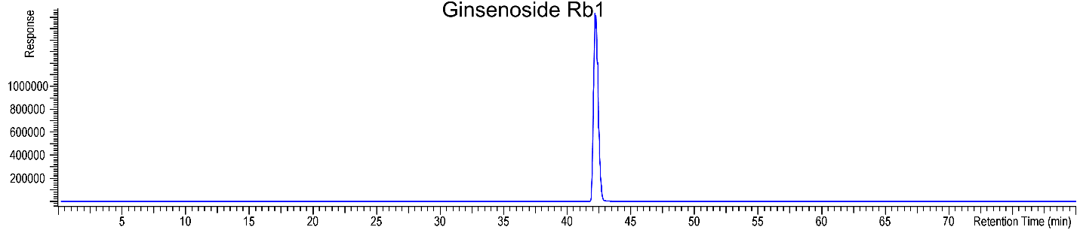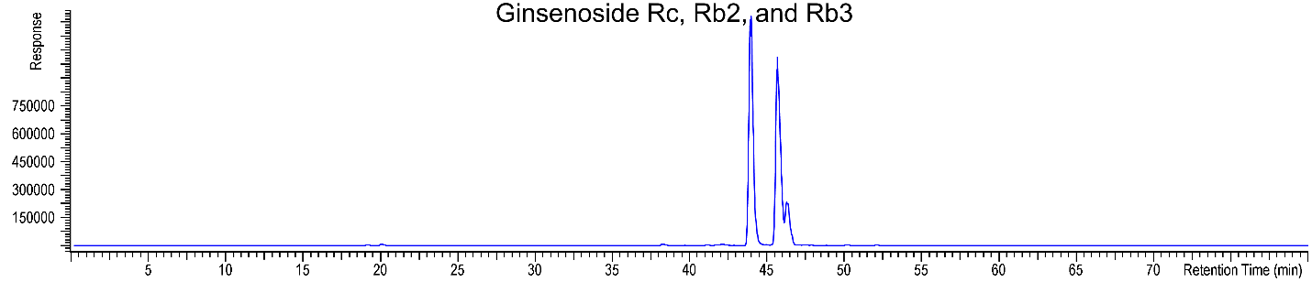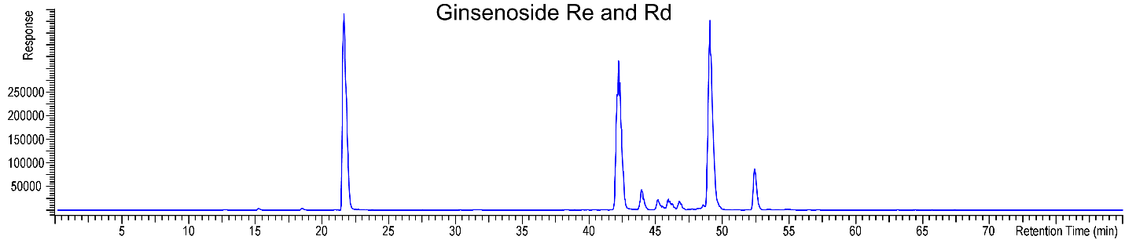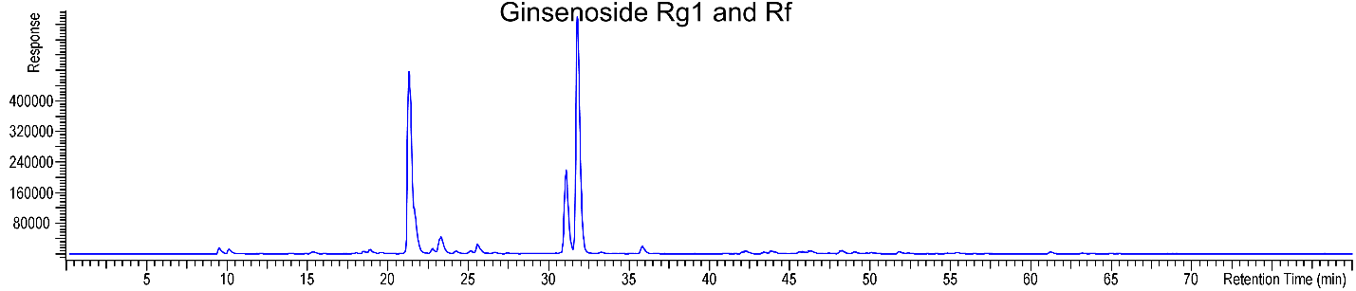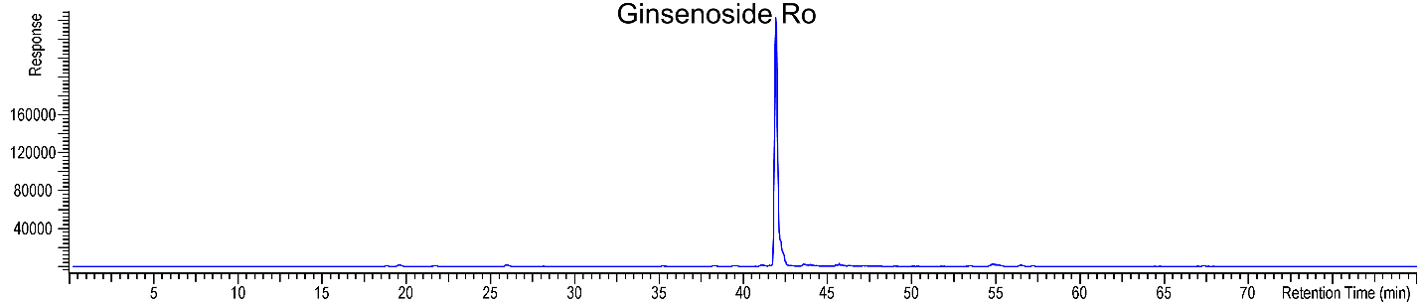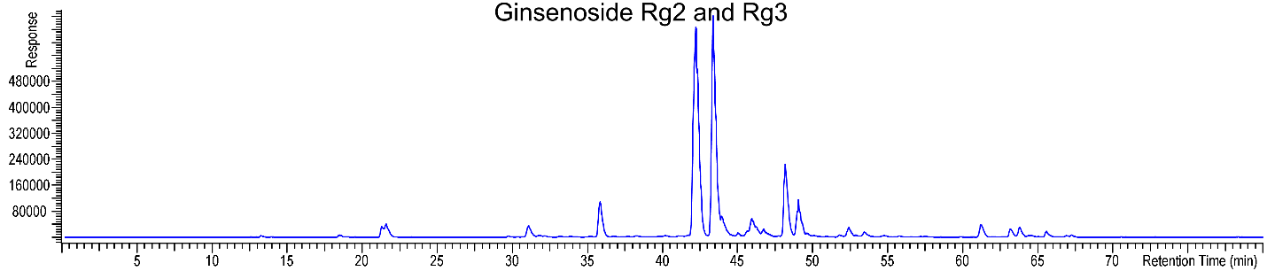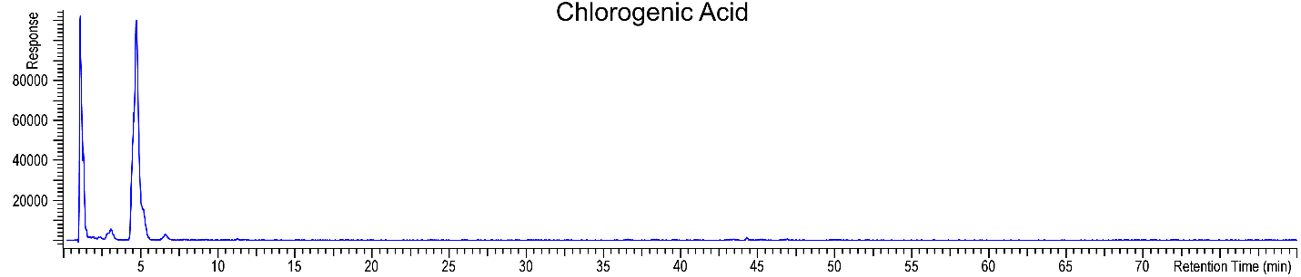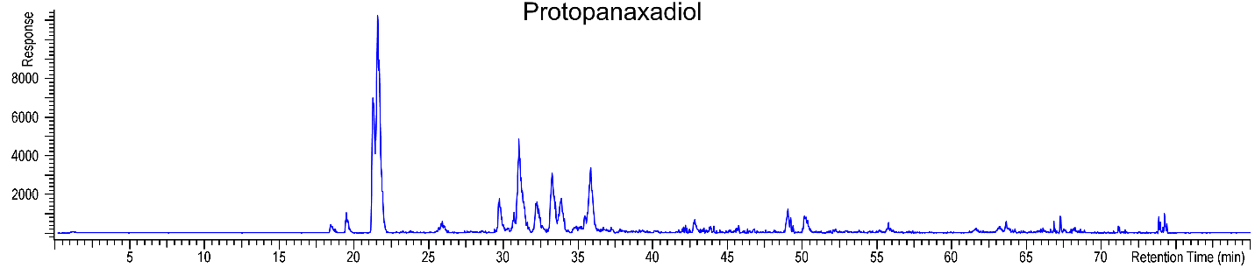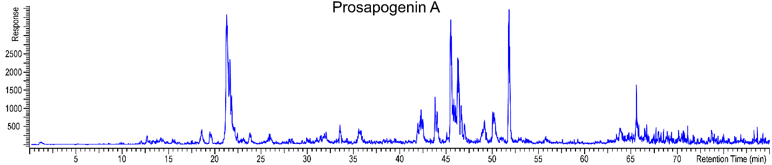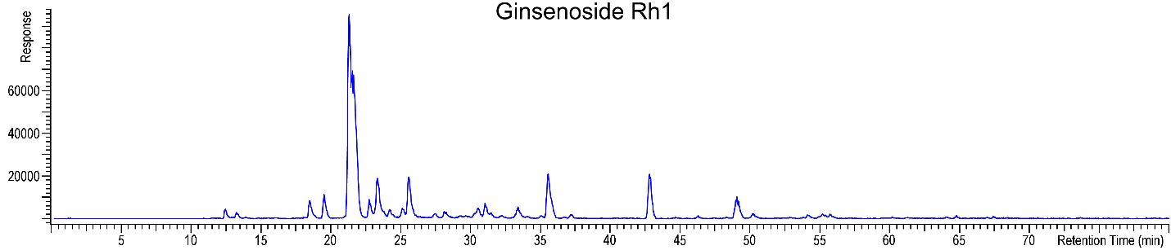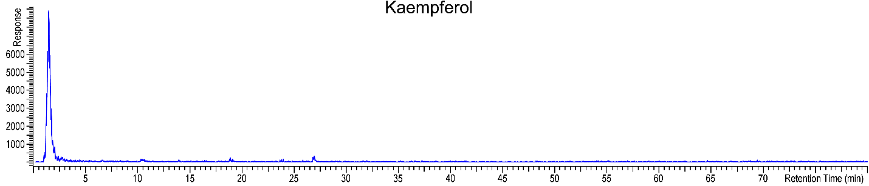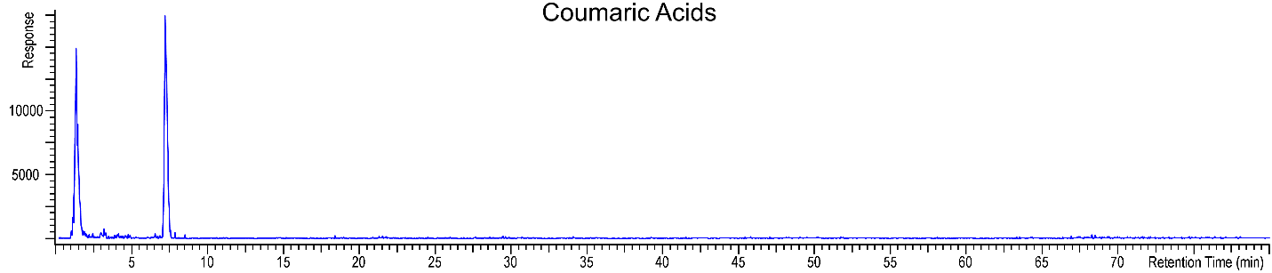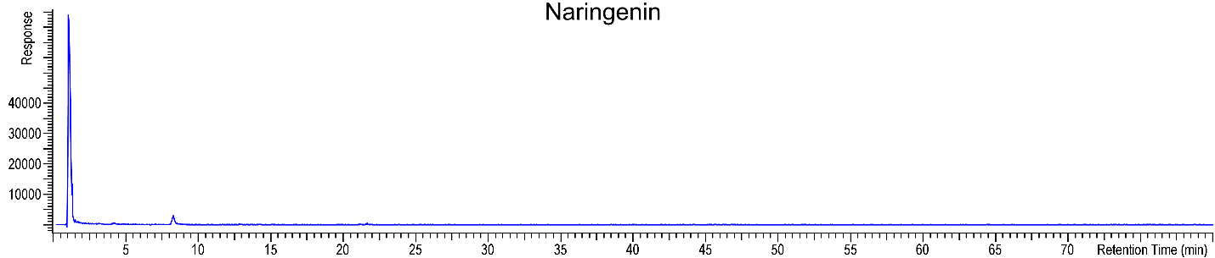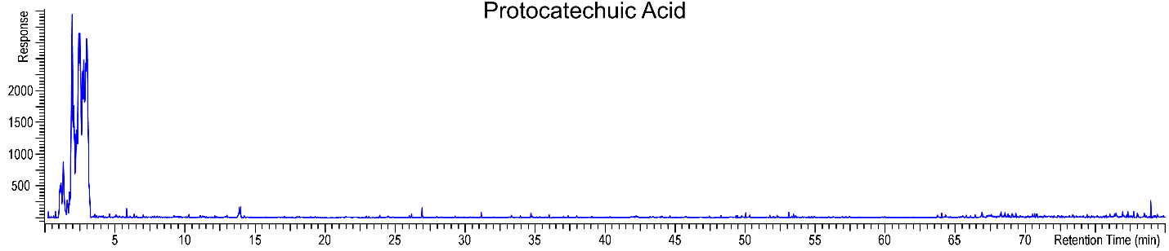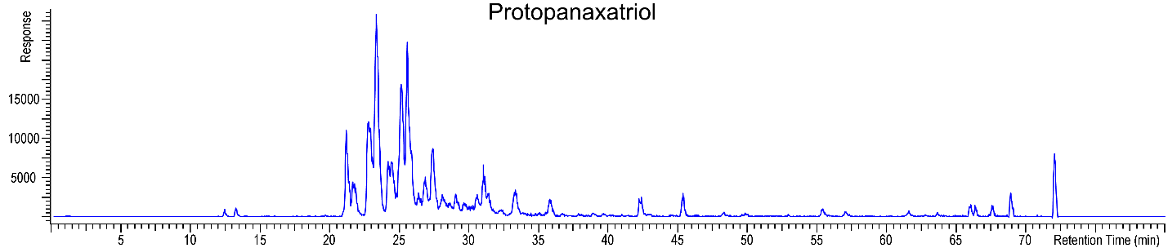

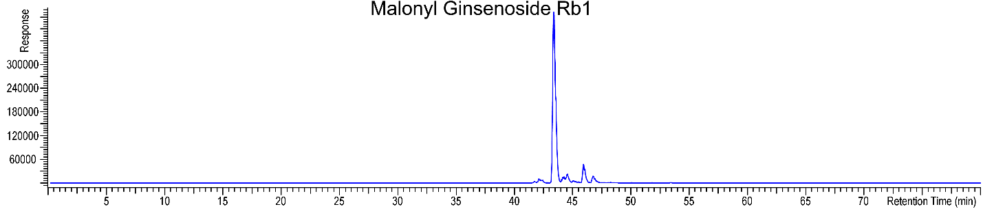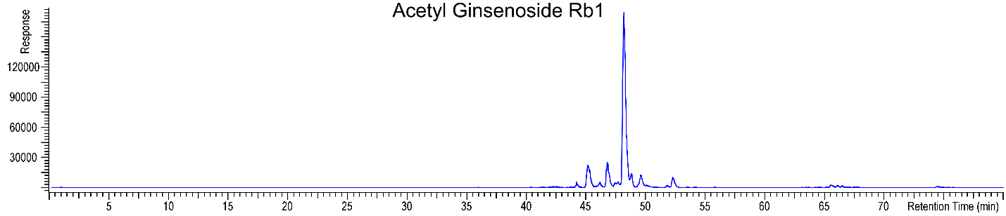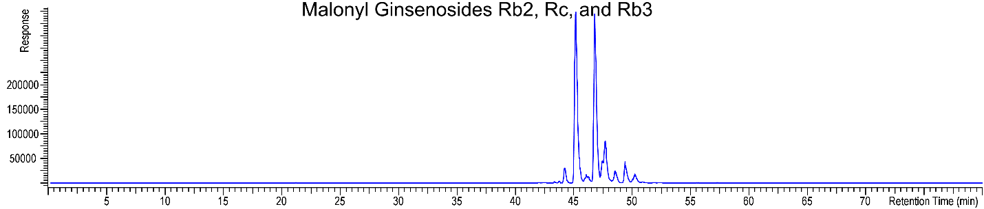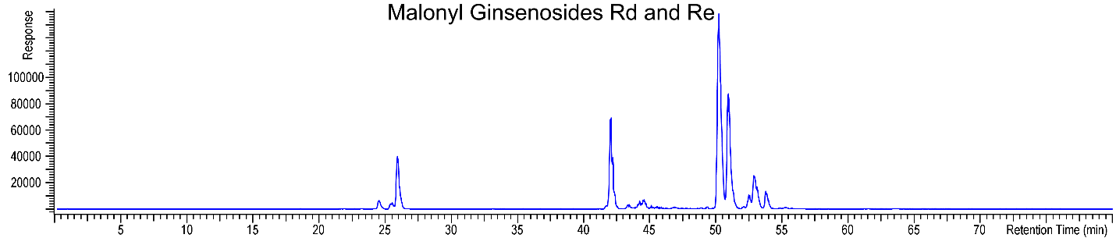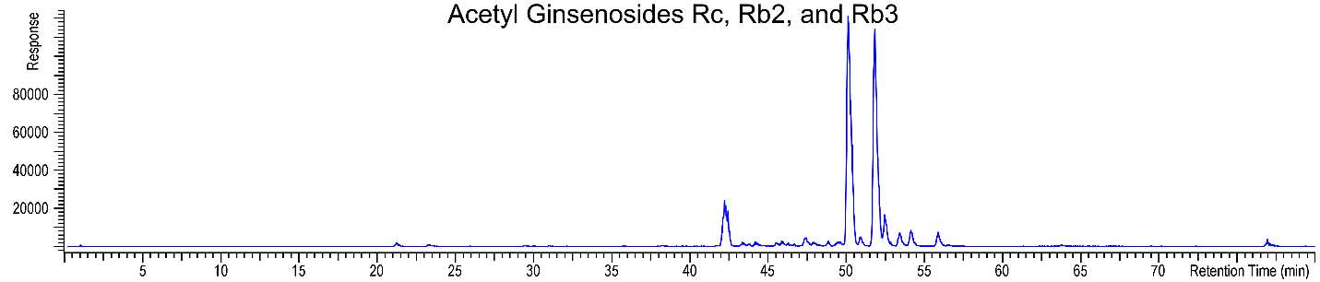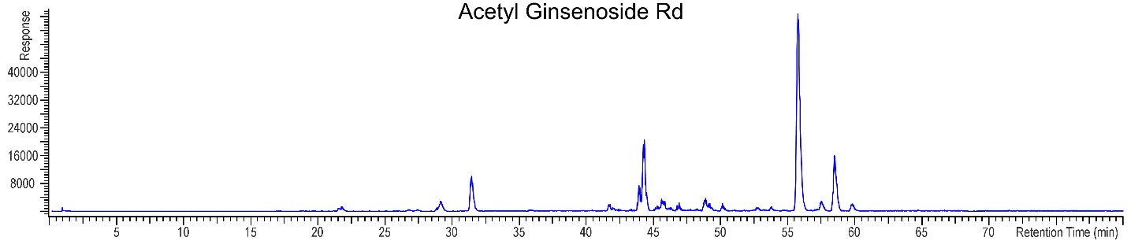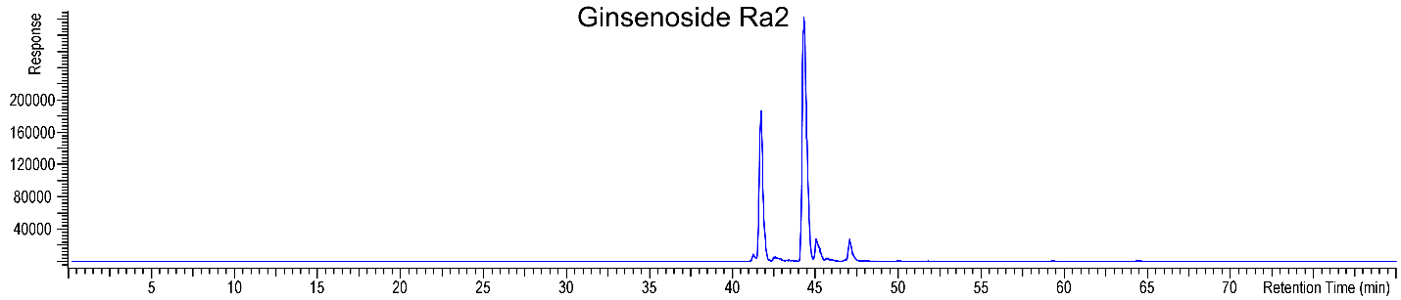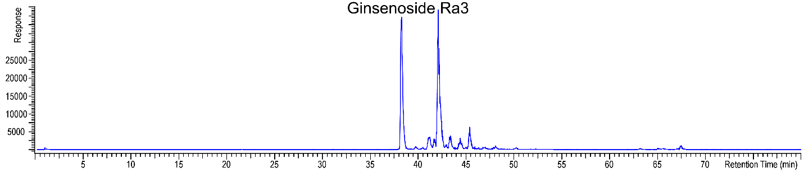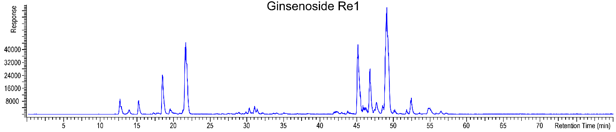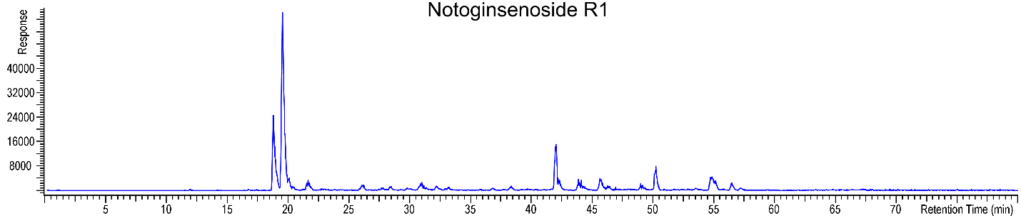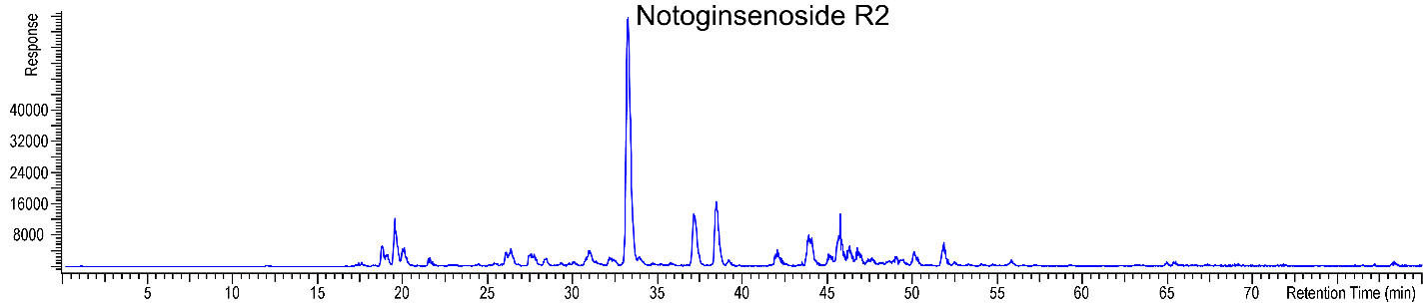

|  |  |  |  |  |
| --- | --- | --- | --- | --- |
| **Table 2: MS/MS product ions for the peaks of the botanical extract** | | | | |
| Peak No. | RT (min) | *Precursor*  *m/z1* | Proposed Compounds  (Confirmed with Std in **green** by RT and MS or MS2)  (Structure with correlated MS2 spectra in **orange**)  (Most probable ID is **yellow**)  CAS Number | Product Ions  *m/z* Rel. Int |
| 1 | 42.10 | 1109.6 | Ginsenoside Rb1  41753-43-9 | 145.050 4.04  163.060 10.10  217.197 1.57  289.094 3.94  325.115 100.00  326.115 2.64  343.124 7.10  407.370 13.08  425.378 18.30  426.386 1.13  443.389 4.75  451.144 1.08  487.165 32.29  488.172 1.52  505.176 6.97  569.420 1.02  587.430 4.65  605.440 7.19  649.220 14.95  667.230 12.59  685.243 2.96  749.479 4.17  767.490 13.96  768.497 1.39  785.502 5.57  929.545 7.14  947.559 3.02  1091.596 5.83  1092.593 1.16  1109.600 20.88  1110.104 2.12  1110.600 1.43 |
| 2 | 43.88 | 1079.6 | Ginsenoside Rc  11021-14-0 | 127.038 1.81  133.048 1.29  145.048 6.36  147.117 1.55  149.129 1.06  163.058 13.36  191.179 1.33  203.178 3.16  207.177 2.55  217.195 3.75  259.082 5.38  277.094 2.03  289.094 2.37  295.104 40.82  313.115 7.67  325.115 100.00  326.115 1.51  343.124 3.50  351.306 1.27  369.318 1.39  407.367 33.70  408.376 1.78  409.383 1.13  425.378 37.99  426.386 2.05  443.389 14.05  457.155 37.05  458.167 1.01  475.165 7.23  487.167 24.25  488.172 1.15  505.182 3.32  539.409 1.40  557.418 2.92  569.423 1.57  575.430 4.75  587.430 10.05  605.440 14.83  619.209 14.53  637.218 10.64  719.472 1.62  737.479 4.63  749.483 12.15  755.488 5.82  767.494 51.47  768.497 3.16  785.498 1.57  881.527 3.04  899.535 32.86  900.529 1.78  917.534 1.66  929.540 6.69  947.554 8.51  1061.587 6.41  1079.591 29.71  1080.592 2.82 |
| 3 | 45.70 | 1079.6 | Ginsenoside Rb2  11021-13-9 | 127.036 1.89  133.048 3.01  145.048 7.10  163.058 11.88  217.197 3.09  241.073 2.40  259.081 25.89  277.092 4.31  289.088 1.48  295.106 100.00  313.112 20.21  325.117 63.54  326.117 1.52  343.123 1.17  407.369 33.53  408.375 3.67  421.136 2.29  425.380 48.60  426.385 2.09  427.145 3.74  439.149 1.43  443.388 14.02  445.154 1.73  457.158 83.55  458.163 2.55  475.167 19.19  487.167 16.32  488.168 2.14  569.419 3.03  575.429 4.56  583.188 1.03  587.429 9.58  589.199 4.40  605.443 12.46  605.456 4.62  607.212 4.64  619.212 49.77  620.214 2.92  625.212 3.98  637.221 43.07  638.224 1.85  649.212 1.19  719.475 3.62  737.478 10.04  749.486 7.05  755.495 30.89  756.494 3.33  767.496 21.36  768.492 1.54  881.526 3.60  899.526 20.89  900.536 2.63  914.534 2.80  917.541 9.85  923.545 3.36  929.551 2.06  1043.569 1.14  1061.585 19.47  1062.596 1.82  1079.594 49.57  1080.591 3.94  1091.594 1.31 |
| 4 | 21.63 | 947.6 | Ginsenoside Re  52286-59-6 | 127.109 1.01  129.053 5.87  147.065 15.00  149.130 1.01  163.058 1.57  203.181 8.82  207.175 6.42  217.195 7.87  243.211 2.17  255.086 4.16  273.098 14.94  293.126 9.22  309.122 59.05  310.122 2.44  325.116 1.72  327.130 18.48  367.299 2.73  405.353 26.41  406.360 2.14  407.370 1.92  423.364 100.00  424.366 13.04  425.376 5.43  441.373 50.74  442.379 5.70  455.178 2.91  459.388 4.49  471.173 6.60  489.187 4.84  533.397 2.00  551.402 6.52  569.421 7.48  587.431 22.24  588.428 1.71  603.423 7.91  604.433 1.58  605.441 4.02  621.437 12.88  622.438 2.55  731.471 1.03  749.488 11.06  750.480 3.72  767.495 25.14  768.498 3.41  801.502 2.23  913.548 4.58  914.545 1.14  929.541 4.45  947.555 9.17 |
| 5 | 48.86 | 947.6 | Ginsenoside Rd  52705-93-8 | 109.099 1.93  127.039 3.66  145.050 20.06  147.114 4.54  163.061 30.36  189.164 3.21  191.182 3.46  203.182 6.59  207.178 4.29  217.201 7.01  271.086 1.14  289.095 3.27  325.117 100.00  326.117 3.58  343.129 3.75  407.372 58.44  408.375 4.95  409.391 1.62  425.386 64.48  426.385 8.06  443.397 22.62  444.396 2.34  487.173 11.55  505.181 5.91  569.429 3.41  587.436 16.47  588.443 1.51  605.443 20.78  606.451 2.58  623.455 1.49  686.469 9.23  749.490 17.27  767.504 52.08  768.504 2.32  785.509 2.31  857.525 1.43  858.030 2.78  929.555 6.90  947.557 8.64 |
| 6 | 21.22 | 801.5 | Ginsenoside Rg1  22427-39-0 | 135.115 1.14  143.104 5.73  145.045 2.04  147.116 6.62  163.060 8.11  189.164 1.52  203.177 14.10  207.173 10.92  215.177 1.14  217.196 9.78  221.187 3.18  289.094 1.14  325.116 27.32  343.122 3.42  367.304 1.14  405.353 31.96  407.368 1.14  423.364 100.00  441.374 63.49  459.388 10.60  585.419 1.14  603.430 20.41  621.437 40.49  639.446 2.05  765.479 1.62  783.491 4.32  801.490 12.02 |
| 7 | 41.92 | 957.5 | Ginsenoside Ro  34367-04-9 | 145.046 2.71  163.058 7.51  191.185 1.39  247.173 2.29  321.084 11.49  325.115 3.93  339.094 6.76  393.353 2.68  411.365 1.50  439.356 100.00  440.359 14.46  501.144 2.50  587.393 1.92  615.388 2.09  633.399 11.99  714.419 4.78  777.433 1.67  795.454 5.57  957.517 10.51  958.012 6.15 |
| 8 | 30.95 | 801.5 | Ginsenoside Rf  52286-58-5 | 109.101 1.14  123.116 1.52  147.118 1.14  163.059 2.37  187.147 1.14  189.164 1.14  203.175 4.45  205.158 1.14  207.171 1.14  215.180 1.52  219.175 1.14  219.210 1.14  275.991 1.14  289.094 1.14  325.116 17.30  367.302 1.52  405.356 32.13  423.364 100.00  424.363 10.39  441.374 58.49  442.374 4.26  459.385 8.36  585.429 1.14  603.430 2.37  621.437 12.82  622.438 1.52  765.467 4.36  766.481 3.54  783.479 5.15  801.486 7.20 |
| 9 | 35.70 | 785.5 | Ginsenoside Rg2  52286-74-5 | 129.051 2.67  147.068 2.67  187.149 3.34  207.175 2.67  217.199 9.62  257.102 2.67  293.126 3.34  309.119 7.51  405.352 22.41  423.366 100.00  424.368 8.79  441.373 38.38  442.379 3.78  459.379 3.34  569.430 2.67  603.429 5.34  621.418 2.67  621.450 4.62  622.433 3.34  749.479 5.39  767.494 18.52  785.502 3.34 |
| 10 | 63.07 | 785.5 | Ginsenoside Rg3  14197-60-5 | 127.112 7.06  145.048 14.12  163.062 20.29  189.158 7.06  191.178 7.06  203.176 7.06  203.182 7.06  217.199 10.59  271.245 7.06  289.093 7.06  325.120 72.35  407.369 100.00  408.369 7.06  424.368 7.06  425.375 42.35  443.382 37.65  587.432 7.06  605.432 10.59  693.436 7.06  749.478 93.82  767.489 33.82  785.367 17.65  785.501 10.59 |
| 11 | 4.59 | 355.1 | Chlorogenic Acid  327-97-9 | 117.032 1.71  135.042 3.51  145.028 6.41  163.039 100.00  355.102 1.58 |
| 12 | 74.21 | 461.4 | Protopanaxadiol  7755-01-3 | 141.086 16.61  149.021 12.46  184.131 20.76  379.169 16.61  444.366 100.00  461.362 16.61 |
| 13 | 65.57 | 723.4 | Prosapogenin A  19057-67-1 | 147.065 5.85  253.191 11.71  397.317 5.85  579.325 17.56  723.434 100.00  723.446 23.41  723.453 23.41 |
| 14 | 35.64 | 639.4 | Ginsenoside Rh1  63223-86-9 | 123.119 11.44  147.116 10.99  179.144 11.56  187.155 11.90  191.177 15.79  203.179 17.51  207.173 19.68  215.182 12.02  217.196 19.00  229.172 8.13  257.220 8.13  313.254 11.67  405.353 26.78  423.364 100.00  441.380 22.89  603.426 23.80  621.441 48.20  639.457 14.76 |
| 15 | 23.80 | 287.1 | Kaempferol  520-18-3 | No MS/MS recorded. Matches RT and MS with standard. |
| 16 | 7.09 | 165.1 | p-Coumaric Acid  501-98-4 | 65.036 2.72  91.051 26.10  95.045 1.82  119.045 59.00  123.038 1.82  146.957 1.82  147.041 100.00  165.048 2.72 |
| 17 | 21.16 | 273.1 | Naringenin  67604-48-2 | No MS/MS recorded. Matches RT and MS with standard. |
| 18 | 2.49 | 155.0 | Protocatechuic Acid  Acid 99-50-3 | No MS/MS recorded. Matches RT and MS with standard. |
| 19 | 61.62 | 477.4 | Protopanaxatriol  1453-93-6 | No MS/MS recorded. Matches RT and MS with standard. |
| 20 | 46.30 | 1079.6 | Ginsenoside Rb3  68406-26-8 | No MS/MS recorded. MS1 spectrum consistent with identity. |
| 21 | 43.34 | 1195.6 | Malonyl Ginsenoside Rb1  88140-34-5 | 127.110 2.00  145.049 1.62  163.060 1.10  213.039 2.27  231.051 9.23  249.060 13.37  325.112 10.38  343.126 2.73  357.087 1.11  375.093 6.77  393.104 16.98  407.369 25.33  411.113 100.00  412.118 3.20  425.380 28.75  443.385 6.78  487.163 1.73  573.166 20.65  587.435 1.34  591.176 2.35  605.439 3.10  649.215 1.54  659.169 1.18  667.228 2.04  685.234 3.47  735.215 15.70  753.224 11.20  767.488 1.06  785.500 6.03  821.210 1.42  835.480 23.01  836.478 1.49  853.489 50.63  854.494 4.31  1015.538 6.50  1177.588 9.95  1195.595 40.23  1196.095 2.33  1196.600 3.38 |
| 22 | 48.12 | 1151.6 | Acetyl Ginsenoside Rb1  Quinquenoside R1 is 85013-02-1 | 145.050 1.14  163.060 1.07  169.051 2.93  187.060 1.80  203.180 1.16  205.071 35.81  217.195 1.47  325.115 18.92  331.107 2.96  343.129 1.72  349.113 4.26  367.129 100.00  368.132 1.92  407.372 23.53  425.381 34.82  426.389 1.07  443.394 11.47  487.167 1.27  529.181 29.27  547.187 1.84  569.417 1.43  605.450 4.21  685.246 1.31  691.232 16.88  709.247 8.61  733.239 1.20  767.493 1.47  773.492 1.01  785.510 4.28  791.500 17.37  792.503 1.27  809.510 31.30  810.509 2.43  953.538 1.03  971.559 3.43  1133.606 6.26  1151.623 22.24  1251.879 1.16 |
| 23 | 45.13 | 1165.6 | Malonyl Ginsenoside Rc  88140-36-7 | 105.016 1.48  127.038 2.21  145.050 1.69  213.039 1.45  217.197 1.24  231.049 9.08  249.061 14.27  295.102 1.83  357.085 1.26  393.105 16.25  407.367 27.35  411.114 100.00  412.119 1.48  425.378 34.04  443.389 7.22  543.154 9.58  573.167 6.85  575.431 1.77  587.430 1.03  591.177 1.57  605.437 1.43  705.206 3.58  723.215 2.20  755.496 1.71  817.468 1.63  835.482 26.73  836.484 1.77  853.491 51.88  854.492 2.18  985.533 6.80  1015.549 1.70  1147.579 2.24  1165.586 20.02  1166.588 1.04 |
| 24 | 46.69 | 1165.6 | Malonyl Ginsenoside Rb2  88156-44-9 | 127.038 2.58  145.048 2.17  213.039 1.04  217.195 1.65  231.052 6.83  249.061 14.17  259.084 1.60  295.104 8.44  313.115 2.81  363.093 1.03  375.096 6.20  381.108 1.80  393.105 16.65  407.370 24.64  408.370 1.16  411.114 100.00  412.120 2.59  425.381 34.59  426.386 1.48  427.149 2.91  443.392 7.64  445.158 1.01  543.157 22.36  573.167 8.82  575.431 1.27  589.197 2.91  605.440 2.38  607.206 3.78  705.210 23.96  723.216 12.53  737.480 1.66  755.493 8.94  756.496 1.48  821.220 3.19  835.482 29.68  836.480 1.61  853.492 54.97  985.529 5.27  1015.550 1.30  1147.579 8.16  1165.587 15.93 |
| 25 | 47.53 | 1165.6 | Malonyl Ginsenoside Rb3  1227255-74-4 | 127.112 2.69  145.051 2.03  149.133 1.33  163.060 1.40  203.180 1.20  217.197 1.34  231.051 3.22  249.063 55.20  259.086 1.09  295.104 7.35  313.119 1.50  325.117 1.31  381.102 1.29  381.110 1.35  393.109 2.94  407.372 41.42  411.116 100.00  412.124 1.00  425.383 26.46  426.382 1.04  443.394 3.84  457.158 1.45  543.163 6.91  557.430 1.20  561.171 1.60  573.169 11.85  587.436 1.29  591.180 2.40  605.443 3.60  673.434 1.13  705.208 10.26  723.221 6.47  737.478 1.04  835.484 28.43  836.487 1.33  853.494 49.65  854.494 1.45  985.535 11.18  1015.534 3.35  1033.560 1.47  1147.586 4.85  1165.594 31.09  1166.595 1.82 |
| 26a | 50.16 | 1033.6 | Malonyl Ginsenoside Rd  88140-37-8 | 99.078 1.87  105.016 2.02  127.040 2.42  145.050 2.08  203.180 1.50  213.037 2.11  217.195 2.05  249.063 21.39  357.079 1.93  375.095 2.83  393.104 12.38  407.369 45.25  411.116 100.00  412.127 1.62  425.383 49.49  443.391 13.71  569.413 1.29  587.432 1.68  659.165 1.65  836.487 2.37  853.490 58.26  854.490 3.65  871.492 1.74  1033.556 4.55 |
| 26b | 50.03 | 1121.6 | Acetyl Ginsenoside Rc  Ginsenoside Rs2 is 87733-66-2 | 127.110 1.11  163.059 1.08  169.048 2.23  187.061 4.36  189.165 1.52  203.181 1.98  205.072 40.78  207.176 1.25  217.196 2.69  295.105 2.56  331.105 2.48  349.116 1.63  367.127 100.00  407.370 44.50  408.370 1.09  425.381 42.25  499.169 14.55  529.181 14.53  547.191 4.13  575.430 2.69  605.447 2.47  661.218 8.17  679.231 6.26  755.492 3.50  773.488 1.06  791.495 28.85  809.505 64.82  810.500 1.07  923.532 1.03  941.549 15.10  971.558 2.13  989.562 1.82  1103.598 4.33  1121.611 23.29  1122.598 1.20 |
| 27 | 51.77 | 1121.6 | Acetyl Ginsenoside Rb2/Rb3 Isomer  Ginsenoside Rs1 is 87733-67-3 | 145.050 1.19  163.058 1.02  187.058 3.77  203.180 1.30  205.071 50.50  207.177 1.22  217.195 1.02  259.084 3.73  271.118 1.02  295.104 11.38  301.091 1.04  313.114 1.37  331.109 1.10  337.119 1.81  349.118 1.55  367.126 100.00  368.130 1.09  407.369 26.32  408.376 1.22  425.381 35.98  426.386 2.07  443.397 9.20  463.152 1.01  481.161 1.37  499.169 24.74  517.191 1.27  529.181 5.67  575.434 1.47  587.430 1.05  587.436 1.05  605.440 3.45  607.213 1.11  625.227 1.02  661.218 20.46  679.231 11.90  737.479 2.21  755.496 9.45  756.492 1.14  791.496 19.20  792.499 1.08  809.506 33.80  810.509 1.02  941.546 2.90  971.546 1.04  1103.586 4.41  1104.593 1.06  1121.612 7.53  1122.604 1.44 |
| 28 | 55.61 | 989.6 | Acetyl Ginsenoside Rd Isomer  Quinquenoside III is 208764-53-8 | 105.064 1.81  127.110 2.38  149.126 1.78  161.132 2.38  169.049 2.38  173.130 1.78  175.156 2.29  187.060 2.88  189.168 2.38  191.183 2.38  203.185 2.38  205.071 66.77  205.200 2.38  207.173 3.39  217.197 7.72  257.240 1.78  269.222 2.38  289.096 2.38  349.119 2.38  365.112 1.78  367.126 75.74  369.318 2.38  407.370 100.00  408.373 3.90  425.349 1.78  425.381 60.93  426.383 2.38  443.392 13.26  443.410 2.63  587.427 2.38  605.461 1.78  623.467 3.39  773.481 1.78  791.496 34.62  792.499 3.73  809.503 35.15  810.513 2.88  989.453 1.78  989.550 2.63  989.568 5.38  1175.622 2.88  1251.895 1.81 |
| 29 | 44.28 | 1211.6 | Ginsenoside Ra2  83459-42-1 | 145.049 2.91  163.060 5.42  229.071 3.56  241.068 1.30  247.082 1.18  259.081 30.82  265.093 14.93  277.091 6.81  295.104 85.68  296.107 1.08  313.114 20.45  325.114 54.23  391.125 5.81  397.135 1.16  407.369 18.29  408.378 1.59  421.136 5.81  425.380 29.44  426.382 1.63  427.148 64.55  428.152 1.05  439.146 2.38  443.391 6.47  445.157 40.54  446.170 1.06  457.158 100.00  458.160 1.44  475.167 11.65  487.167 15.77  553.181 2.15  557.421 1.38  559.185 4.50  575.429 2.65  577.195 7.59  587.432 6.03  589.199 41.33  605.439 10.32  607.208 16.04  619.208 39.14  637.214 10.01  649.215 3.94  691.228 2.35  709.235 2.17  719.471 2.35  721.237 4.31  737.478 4.98  739.247 7.85  749.482 6.86  751.246 31.78  752.243 1.11  755.491 2.91  757.255 4.53  767.492 18.38  769.259 38.21  770.255 1.47  853.276 1.98  869.521 4.15  871.289 7.71  881.522 4.22  887.528 9.73  889.297 11.90  890.302 1.44  899.530 32.40  900.528 1.71  917.545 3.17  929.547 4.48  1031.567 15.38  1032.568 1.32  1047.817 1.23  1049.580 5.22  1061.576 7.69  1062.587 1.17  1079.590 8.55  1091.593 5.36  1092.600 1.07  1193.621 19.42  1194.616 1.10  1203.139 1.18  1209.861 3.77  1210.871 1.29  1211.628 61.39  1211.863 1.21  1212.127 11.45  1212.630 2.86  1371.908 1.02  1372.917 1.02 |
| 30 | 38.09 | 1241.6 | Ginsenoside Ra3  90985-77-6 | 127.110 1.59  145.048 1.93  163.060 4.81  223.064 1.02  259.081 3.11  289.095 2.45  295.104 57.67  296.107 1.28  313.112 2.49  313.131 1.22  325.114 100.00  325.590 1.11  341.703 1.54  343.126 5.64  343.305 1.33  407.363 3.40  421.139 2.68  425.380 3.95  443.388 2.22  457.155 81.92  475.167 96.11  476.168 1.64  487.167 29.15  505.175 2.06  505.188 1.83  569.412 1.02  587.422 1.67  605.436 4.03  619.180 1.07  619.205 18.81  637.221 2.77  649.215 12.03  667.232 3.20  719.486 1.02  731.472 1.02  749.478 2.68  767.489 7.98  781.258 9.90  785.505 1.58  799.264 4.69  800.268 1.35  881.518 1.67  899.526 6.32  917.541 1.28  929.534 3.40  931.302 1.32  947.570 1.02  1061.572 3.40  1079.604 2.29  1091.575 4.93  1109.602 1.77  1205.627 1.02  1209.856 1.02  1223.626 10.66  1224.648 1.64  1238.358 1.01  1241.630 22.54  1241.902 1.00  1242.644 1.62  1371.903 1.32 |
| 31 | 25.82 | 1033.6 | Malonyl Ginsenoside Re  1250255-07-2 | 73.022 2.77  123.114 3.02  127.109 3.68  139.114 2.15  147.063 2.98  163.066 2.74  175.149 2.20  189.153 2.10  191.183 2.10  203.179 4.39  207.175 3.55  213.040 5.22  215.179 2.11  217.195 2.93  225.170 2.04  231.052 10.61  237.083 3.66  243.207 2.26  249.059 7.04  255.082 2.97  273.096 6.01  285.073 2.27  295.233 2.27  308.146 2.20  309.122 43.77  315.107 5.86  327.130 19.45  341.087 3.73  359.099 12.63  367.310 2.27  377.108 7.14  393.108 2.17  395.122 29.00  405.353 23.40  407.370 2.27  411.112 3.84  413.132 19.07  423.367 100.00  424.358 2.56  425.387 3.94  441.376 49.77  442.359 2.17  459.382 5.58  489.386 2.31  515.391 2.86  521.151 3.20  539.165 4.80  551.409 4.30  557.171 13.23  569.421 10.35  575.179 5.22  585.409 3.06  587.428 37.49  587.441 11.41  603.426 7.44  605.441 3.66  621.437 3.02  653.412 2.20  671.413 3.71  689.435 2.27  707.433 5.77  731.471 2.27  749.484 14.39  767.491 32.45  835.475 2.19  851.468 5.76  853.489 4.90  869.462 2.86  871.499 2.27  872.718 2.15  979.530 2.10  997.528 4.48  1015.537 8.21  1033.555 23.62  1034.548 2.74 |
| 32 | 18.30 | 963.5 | Ginsenoside Re1 Isomer  1260229-19-3 | 123.122 2.50  145.048 3.49  151.147 2.30  163.060 4.35  189.174 3.36  203.181 3.39  215.179 3.20  219.175 3.43  257.222 2.52  289.094 2.54  315.237 2.38  325.116 25.00  343.114 2.50  367.296 2.54  405.059 2.30  405.356 16.59  423.364 100.00  424.948 3.96  441.373 57.38  442.376 2.44  459.385 5.29  487.171 4.10  505.177 7.88  523.191 2.42  585.415 4.23  603.423 14.30  621.430 7.18  639.446 2.63  732.344 2.15  765.471 10.59  783.483 26.00  792.986 2.36  801.494 4.35  847.321 2.42  917.782 2.15  945.513 2.61  963.542 7.14  964.221 2.42  1309.875 2.15 |
| 33 | 19.44 | 933.5 | Notoginsenoside R1  80418-24-2 | 115.036 2.73  127.106 2.96  133.052 5.13  145.052 4.85  163.058 11.78  203.179 5.82  207.177 4.57  223.059 2.91  241.071 5.55  259.082 12.62  260.089 3.33  295.105 100.00  313.115 21.70  325.116 7.35  343.106 4.16  405.353 12.89  407.359 3.33  423.364 96.86  424.363 4.71  441.376 45.93  457.156 10.40  459.385 4.85  475.157 4.44  475.169 11.80  501.383 3.74  555.403 4.81  573.413 4.62  603.430 10.67  621.433 10.54  717.483 3.77  735.473 5.45  736.486 3.95  753.481 18.68  765.463 2.70  771.485 5.68  783.495 2.96  801.494 2.87  837.354 2.59  888.242 2.43  897.513 2.89  915.509 7.35  933.439 2.89  933.551 6.52  934.456 2.75 |
| 34 | 33.25 | 771.5 | Notoginsenoside R2  80418-25-3 | No MS/MS recorded. MS1 spectrum consistent with identity. |

1 The mass resolution of the quadrupole in the QTOF is 0.1 Da