Analysis of Goldenseal Extract Using UPLC-MS/MS

Josh Kellogg, Teal Jordan

Pennsylvania State University

325 Huck Life Sciences Building
Pennsylvania State University
University Park, PA 16802

June 2022

Common Botanical Name | CAS No. | Lot No. | Container ID | Net Weight
Goldenseal

Sample storage condition until analysis
-80 ℃

Quantitative/Targeted method:

UPLC-MS Method

UHPLC conditions | Mass spectrometry
System: Waters Acquity  Column: Waters Acquity Ultra C18 (2.1 x 100 mm, 1.7 um)  Mobile phase A: H₂O + 0.1% FA  Mobile phase B: CH₃CN + 0.1% FA  Flow rate: 0.3 mL/min  Column temperature: 50 ℃  Gradient  Time (min) Mobile phase B (%)  0 3  1.0 3  5.0 75  5.5 75  6.0 3 | System: Waters TQS  Ionization: Electrospray (ESI)  Polarity: Positive  Main Interface:  · Nebulizing gas flow: 150 L/hr  · Heating gas flow: 500 L/hr  · Interface temperature: 150 ℃  · Capillary voltage: 2.5 kV  · Cone voltage: 50 V  Ion guide:  · Drying gas flow: 0.15 mL/min  · Desolvation line temperature: 500 ℃  · Heat block temperature:  SRM dwell time:  Selected Reaction Monitoring (SRM) events  Compound Precursor ion (m/z) Product ion (m/z) Collision energy (V) Retention time (min)  Hydrastine 384.14 - 45 3.60  Canadine 340.15 - 45 4.02  Coptisine 320.09 - 45 3.90  Hydrastinine 190.08 - 45 0.48  Jatrorrhizine 338.14 - 45 3.95  Palmatine 352.15 - 45 4.14  Berberine 336.12 - 45 4.15  Chlorogenic acid 163.04 - 45 5.25

Quantitative results

Compound | Concentration in extract (mg/g)
Berberine | 8.12 ± 0.20
Canadine | 0.197 ± 0.025
Chlorogenic acid | 0.6987 ± 0.0061
Coptisine | 0.1800 ± 0.0093
Hydrastine | 7.26 ± 0.38
Hydrastinine | 0.0875 ± 0.0046
Jatrorrhizine | 0.0773 ± 0.0121
Palmatine | 0.0813 ± 0.0066

Standards
Name | Supplier | CAS Number | Catalog number | Purity % | Batch/Lot number
Berberine | USP | 2086-83-1 | 1065210 | >98% | R04130
Canadine | Phytolab | 522-97-4 | 80378-10mg | >98% | 97763836
Chlorogenic acid | USP | 202650-88-2 | 11155545 | >98% | R001C0
Coptisine | Sigma | 6020-18-4 | SMB00314-25mg | >98% | SLCC9042
Hydrastine | Phytolab | 118-08-1 | 89511-50mg | >98% | 85963619
Hydrastinine | Sigma |  | 5438308-10mg | >98% | B02666596
Jatrorrhizine | Phytolab | 6681-15-8 | 89530-10mg | >98% | 117270386
Palmatine | Phytolab | 10605-02-4 | 89490-25mg | >98% | 78339594

Chemical structures of standards used for quantitative analysis
Chromatograms
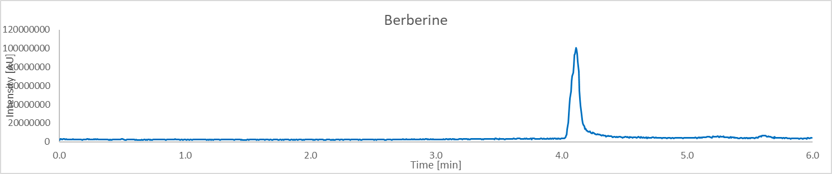
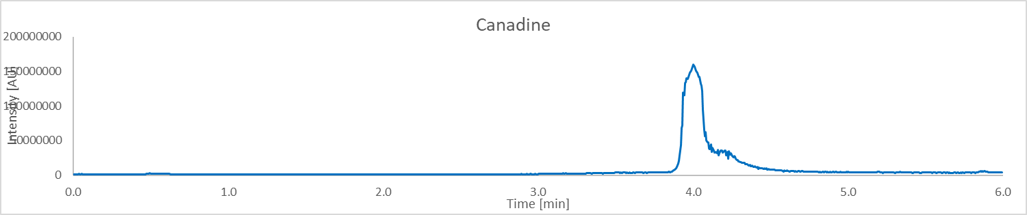
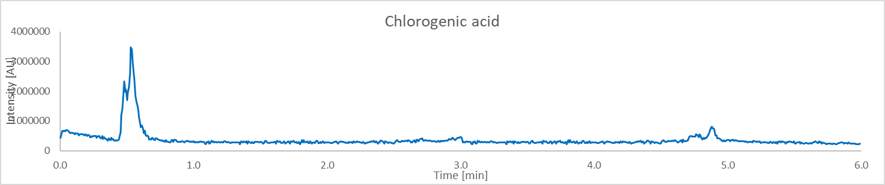
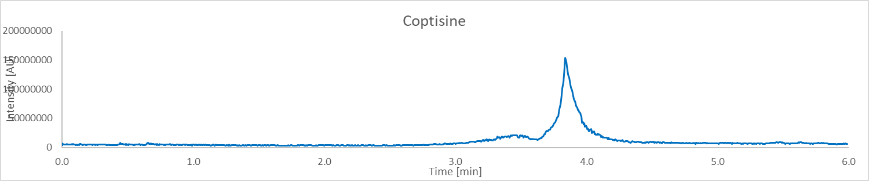
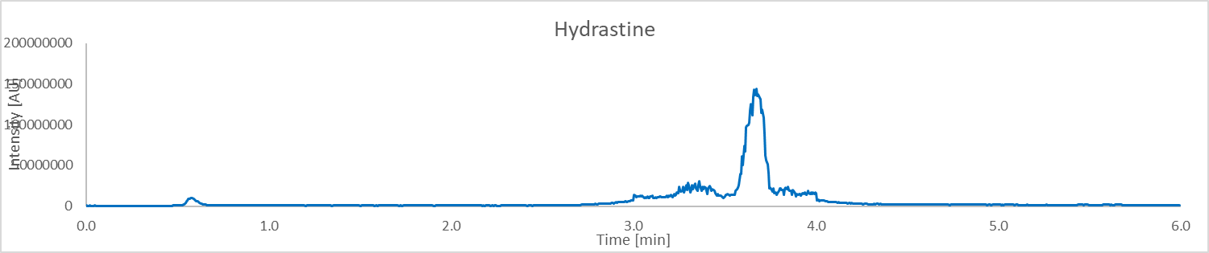
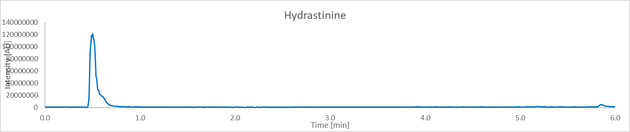
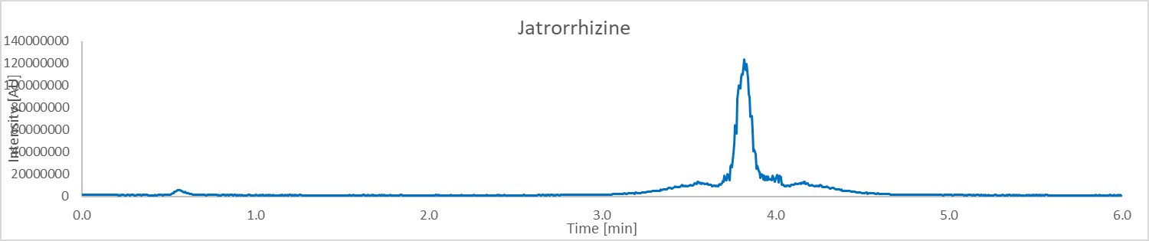
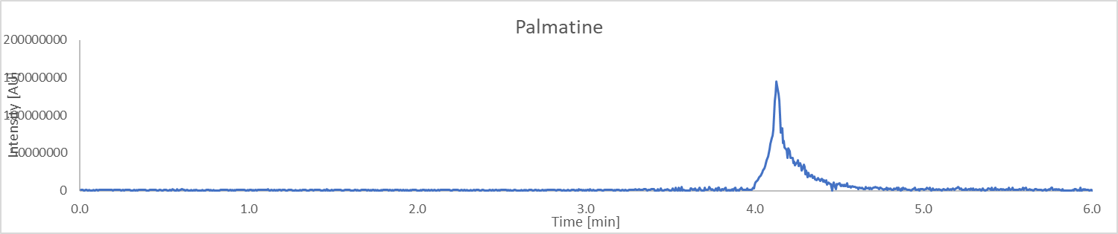
Calibration
Compound | Lower limit of quantitation (LLOQ) ug/mL | Calibration range (ug/mL) | Number of Calibration Points | R² | Concentration  mg/g in extract (n = 3)
Berberine | 0.001 | 0.001 – 0.243 | 6 | 0.9984 | 8.12 ± 0.20
Canadine | 0.001 | 0.001 – 0.243 | 6 | 0.9986 | 0.197 ± 0.025
Chlorogenic acid | 0.001 | 0.001 – 0.243 | 6 | 0.9967 | 0.6987 ± 0.0061
Coptisine | 0.001 | 0.001 – 0.243 | 6 | 0.9990 | 0.1800 ± 0.0093
Hydrastine | 0.001 | 0.001 – 0.243 | 6 | 0.9996 | 7.26 ± 0.38
Hydrastinine | 0.001 | 0.001 – 0.243 | 6 | 0.9982 | 0.0875 ± 0.0046
Jatrorrhizine | 0.001 | 0.001 – 0.729 | 7 | 0.9979 | 0.0773 ± 0.0121
Palmatine | 0.001 | 0.001 – 0.243 | 6 | 0.9990 | 0.0813 ± 0.0066

Untargeted Analysis
UHPLC conditions | Mass spectrometer conditions
System: Thermo Vanquish  Column: Waters Acquity Ultra C18 (1.7 um, 1.0 x 150 mm)  Mobile phase A: H2O w/ 0.1% FA  Mobile phase B: ACN w/ 0.1% FA  Flow rate: 0.100 mL/min  Column temperature: 55℃  Gradient:  Time (min) Mobile phase B (%)  0 5  1 5  12.5 98  13.5 98  12.6 5  15 5 | System: Thermo Orbitrap Fusion Lumos  Mode: ESI  Polarity: positive/negative  Main-Interface:  · Interface voltage: 3500/2500  · Nebulizing gas flow: 25  · Heating gas flow: 5  · Interface temperature: 325 ℃  · Desolvation temperature: 350 ℃  Ion guide:  · Drying gas flow: 1  · DL temperature: 350 ℃  · Heat block temperature

Table 1: Proposed identification of constituents of Goldenseal
Peak No. | RT (min) | Exp. m/z | Mass accuracy  (ppm) | Proposed ID’s  (Confirmed with Std in green)  (Structure with correlated MS² spectra in orange)  (Most probable ID is blue) | Molecular Formula
1 | 7.28 | 384.1442 | -1.30 | Hydrastine | C21H21NO6
2 | 1.12 | 367.1035 | 1.63 | 3-Feruloylquinic acid | C17H20O9
3 | 1.14 | 163.0390 | 6.13 | 4-Hydroxyphenylpyruvic acid | C9H8O4
4 | 9.16 | 354.1338 | 2.26 | 8-oxocanadine | C20H19NO5
5 | 8.53 | 340.1176 | -2.65 | 8-oxotetrahydrothalifendine | C19H17NO5
6 | 5.93 | 337.1270 | -13.05 | Berberine | C20H18NO4+
7 | 1.14 | 163.0390 | 0.00 | Caffeic acid | C9H8O4
8 | 1.09 | 340.1543 | -1.47 | Canadine | C20H21NO4
9 | 1.10 | 353.0877 | 1.42 | Chlorogenic acid | C16H18O9
10 | 6.32 | 339.1324 | -20.05 | Columbamine | C20H20NO4
11 | 1.13 | 352.1178 | 22.15 | Evodine | C18H19NO5
12 | 1.12 | 177.0546 | 3.39 | Ferulic aid | C10H10O4
13 | 9.51 | 274.2740 | 0.00 | Lauryldiethanolamine | C16H35NO2
14 | 5.19 | 367.1035 | 1.36 | Methyl chlorogenate | C17H20O9
15 | 1.17 | 360.1500 | 0.00 | Palatinose | C12H22O11
16 | 1.1 | 191.0560 | 2.62 | Quinic acid | C7H12O6
17 | 1.16 | 328.1544 | 1.22 | Scoulerine | C19H21NO4
18 | 6.65 | 336.1814 | 4.16 | Senecionine | C18H25NO5
19 | 7.56 | 338.1410 | 5.32 | Jatrorrhizine | C20H20NO4
20 | 1.17 | 314.1750 | -0.32 | Magnocurarine | C19H24NO3+
21 | 1.11 | 400.1389 | -0.50 | 1-Hydroxyhydrastine | C21H21NO7
22 | 5.24 | 324.1232 | 0.62 | Demethyleneberberine | C19H18NO4+
23 | 6.9 | 356.1494 | -1.12 | 13-Hydroxycanadine | C20H21NO5
24 | 1.13 | 330.1702 | -0.91 | 3'-Hydroxy-N,N-dimethylcoclaurine | C19H24NO4+
25 | 5.75 | 481.3159 | -0.21 | 20-Hydroxyecdysone | C27H44O7
26 | 1.14 | 385.1595 | -2.34 | Hydrastine methiodine | C22H24NO6+
27 | 1.14 | 370.1648 | -0.27 | Canadaline | C21H23NO5
28 | 1.26 | 355.1024 | 0.00 | Neochlorogenic acid | C16H18O9
29 | 1.1 | 354.1695 | -1.41 | 13-Methylcanadine | C21H23NO4
30 | 6.45 | 352.1180 | 0.28 | 8-Oxoberberine | C20H17NO5
31 | 1.13 | 350.1388 | -1.14 | 13-Methylberberine | C21H20NO4+
32 | 6.98 | 344.1856 | -1.74 | Tembetarine | C20H26NO4+
33 | 5.10 | 342.1696 | -2.63 | Magnoflorine | C20H24NO4+
34 | 1.11 | 342.1699 | -0.29 | Isocorypalmine | C20H23NO4
35 | 5.80 | 336.1236 | 0.30 | Epiberberine | C20H18NO4+
36 | 1.16 | 328.1544 | -1.22 | 1,2-dehydroreticuline | C19H22NO4+
37 | 9.86 | 329.1021 | 0.30 | 6,8-C-Dimethylluteolin-7-methyl ether | C18H16O6
38 | 5.24 | 327.0872 | -0.61 | Dehydrodiscretamine | C19H18NO4+
39 | 1.29 | 324.1231 | -1.12 | Thalinfendin | C19H16NO4+
40 | 6.51 | 315.0865 | -1.55 | 6-C-Methylluteolin-7-methyl ether | C17H14O6
41 | 6.94 | 313.0718 | 0.63 | 1,2-Dihydronorreticuline | C18H19NO4
42 | 10.66 | 314.1385 | 0.32 | Sideroxylin | C18H16O5
43 | 1.13 | 313.1069 | -0.64 | N-methylcocluarine / canelilline | C18H22NO3+
44 | 9.98 | 311.0924 | -0.32 | Desmethyl-sideroxylin | C17H14O5
45 | 7.04 | 320.0918 | -1.25 | Coptisine | C19H14NO4+
46 | 1.11 | 190.0864 | -2.10 | Hydrastinine | C11H13NO3
47 | 14.08 | 279.2329 | 0.00 | Linoleic acid | C18H32O2
48 | 6.74 | 352.1539 | -1.14 | Palmatine | C21H22NO4+
49 | 14.60 | 255.2329 | 0.00 | Palmitic acid | C16H32O2
50 | 14.80 | 283.2643 | 0.35 | Stearic acid | C18H36O2

Figure 1: Chromatograms
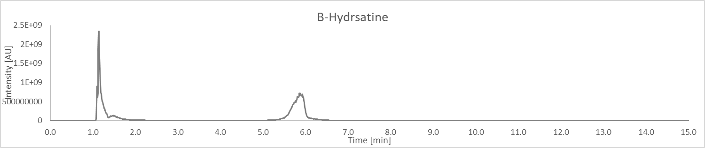
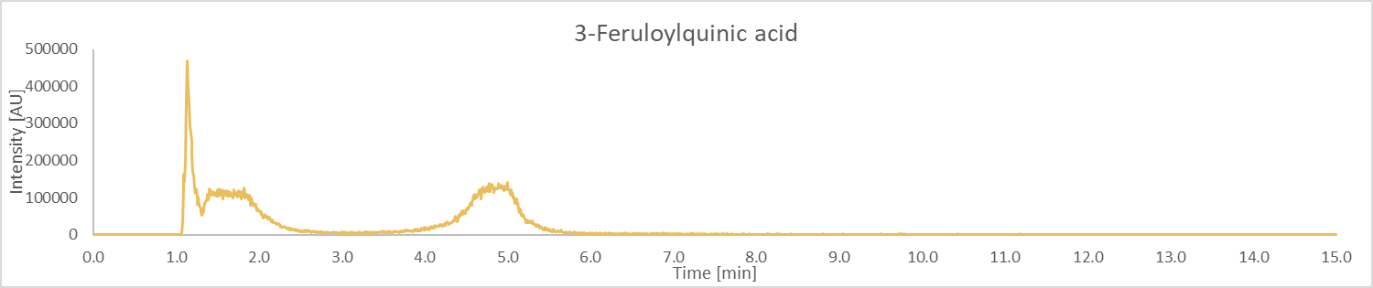
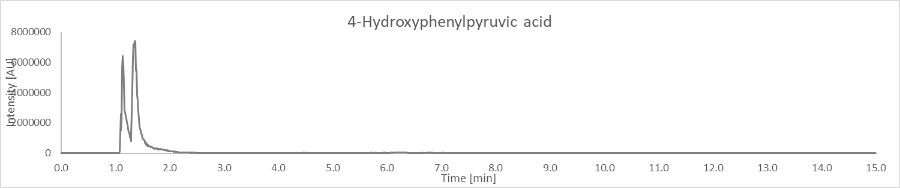
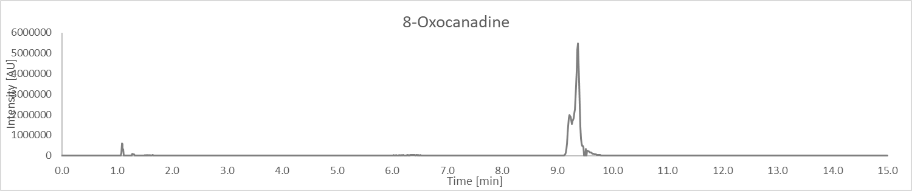
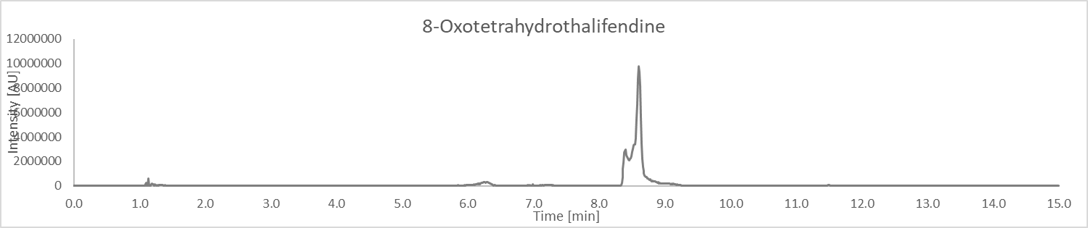
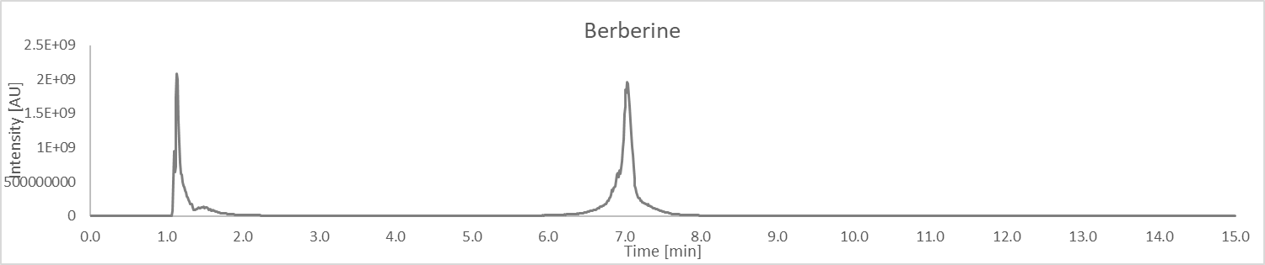
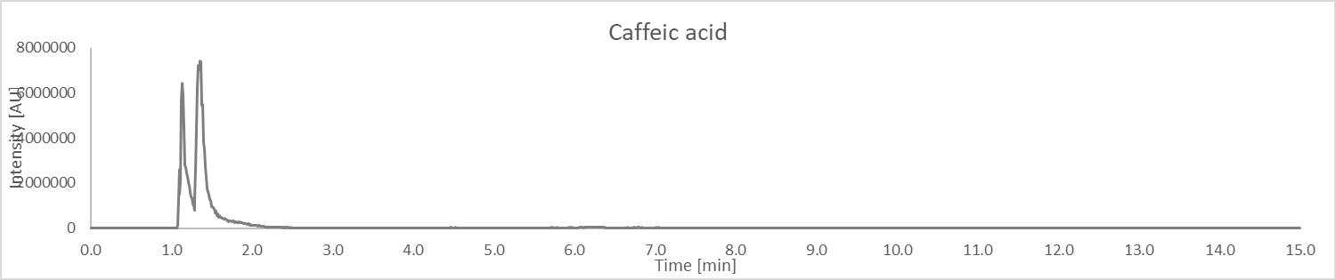
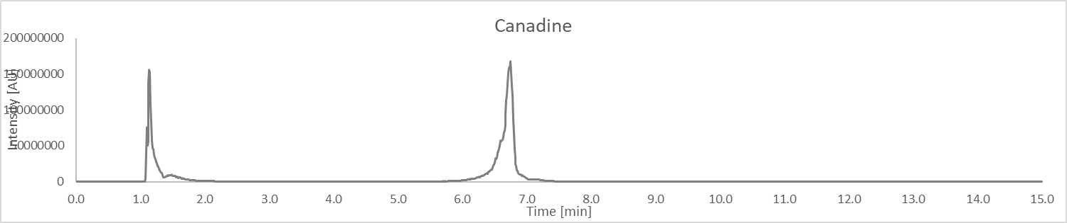
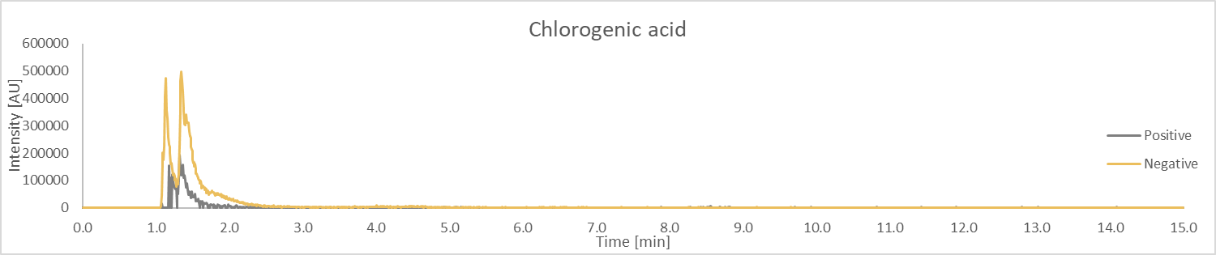
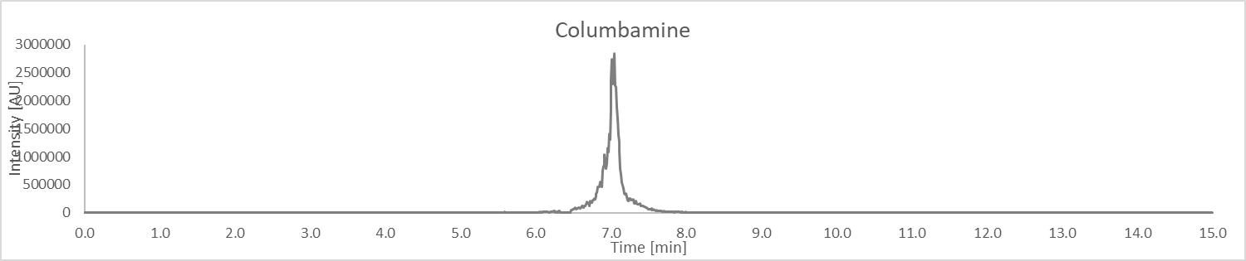
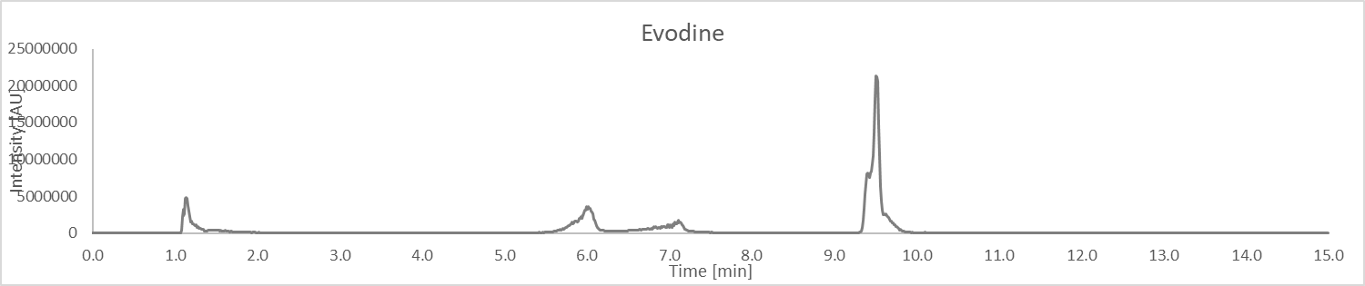
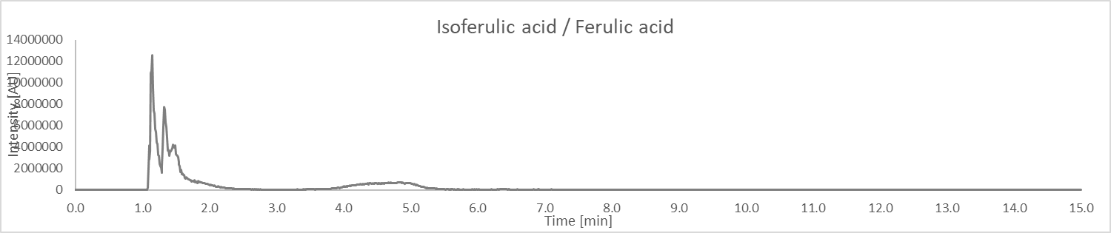
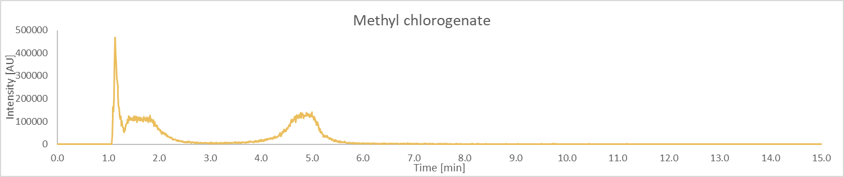
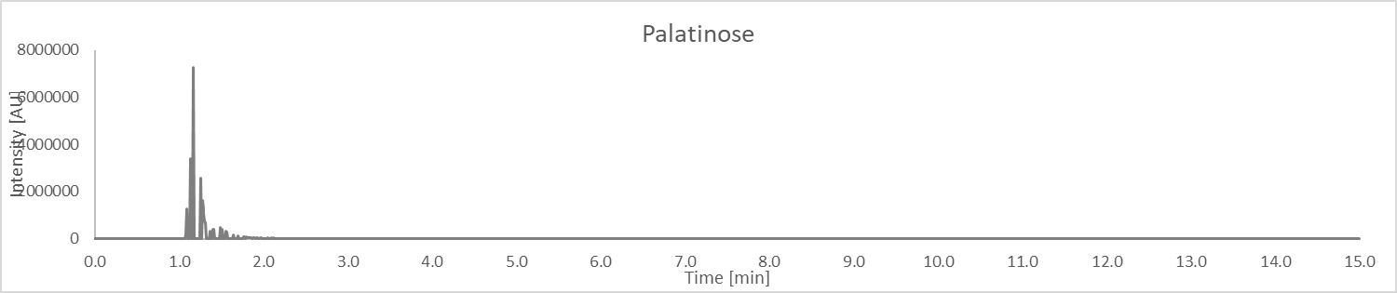
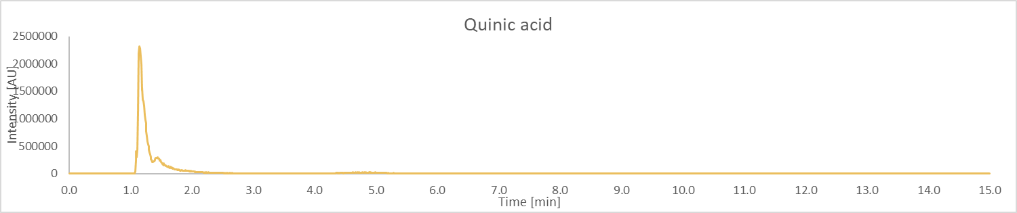
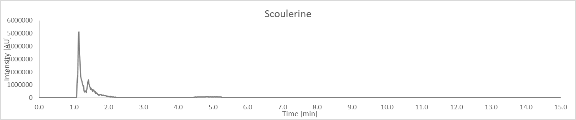
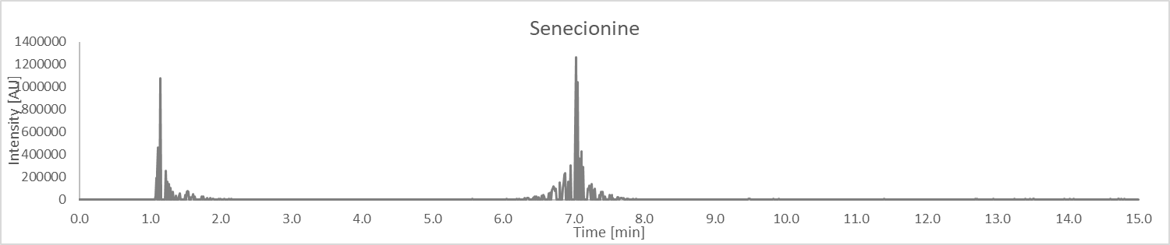
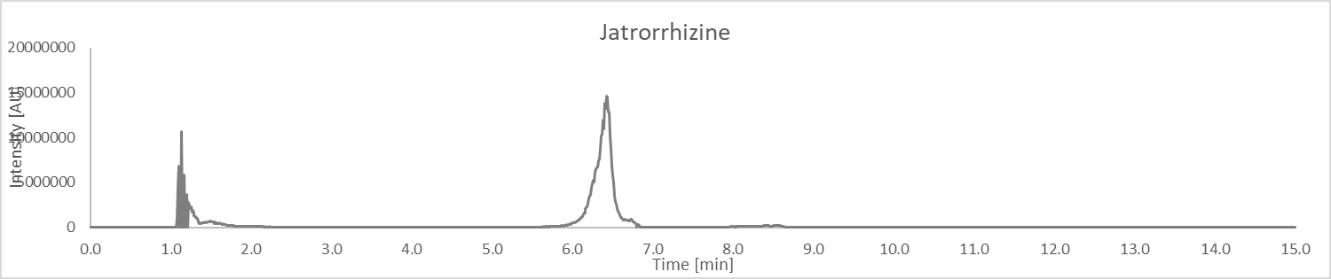
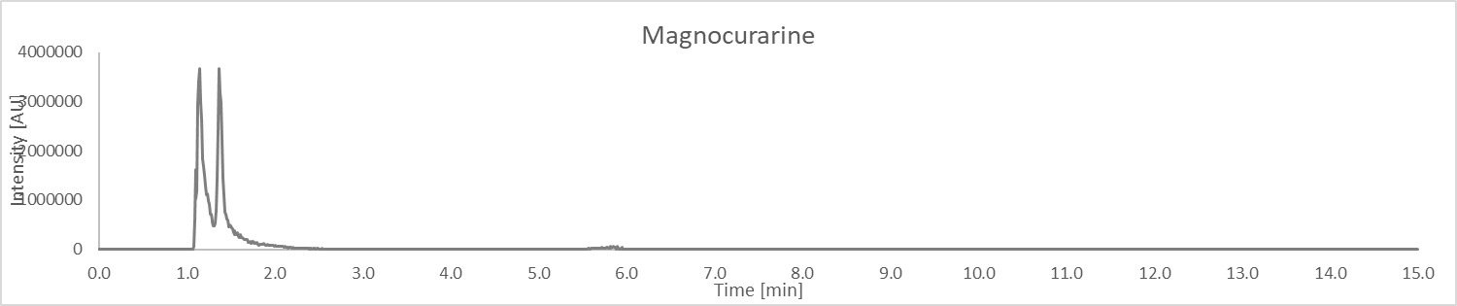
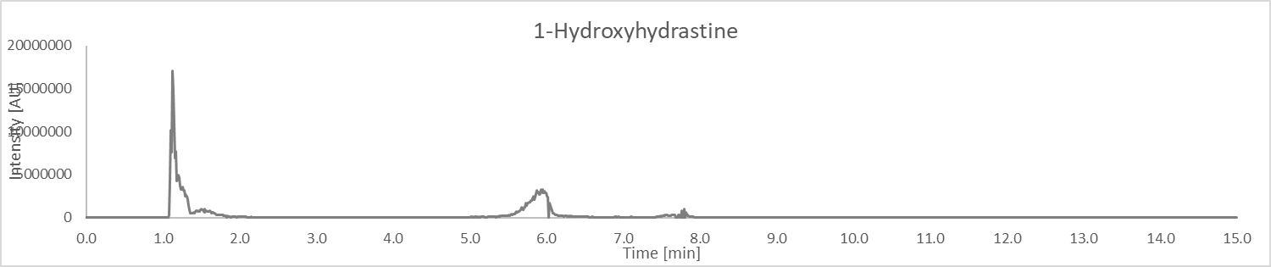
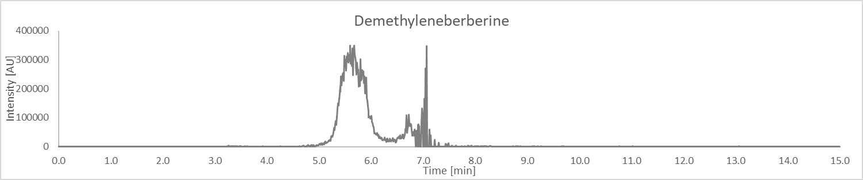
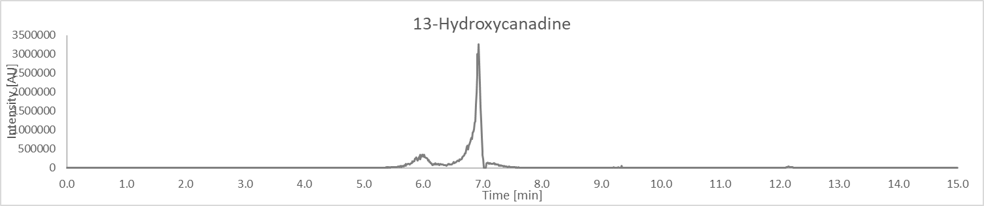
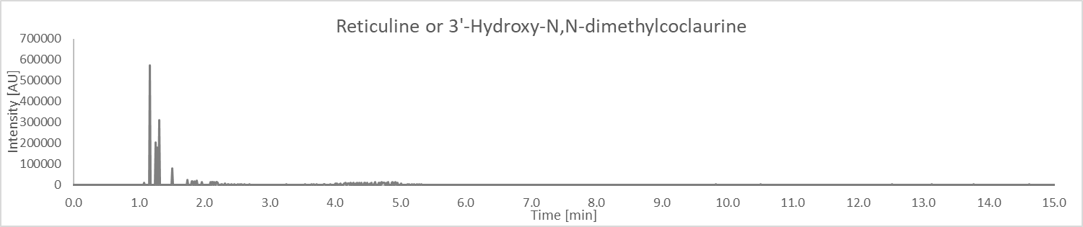
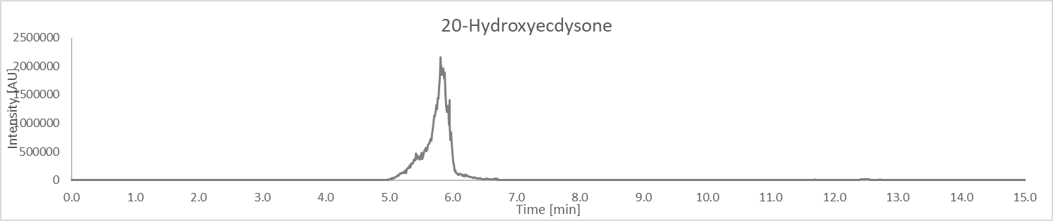
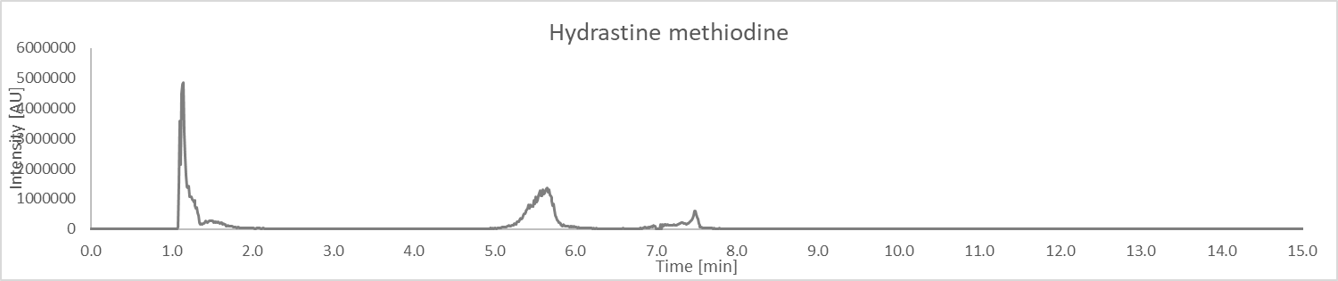
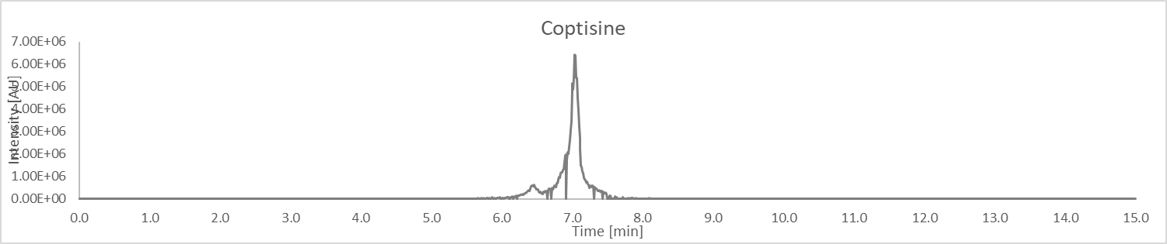
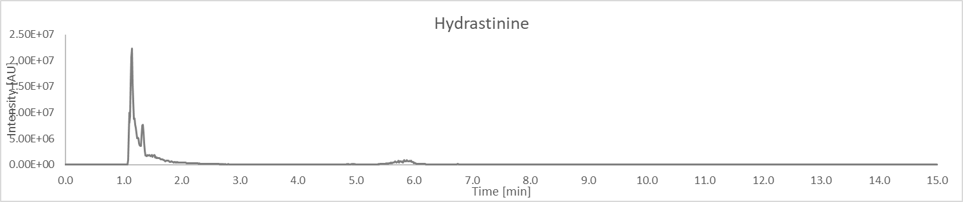
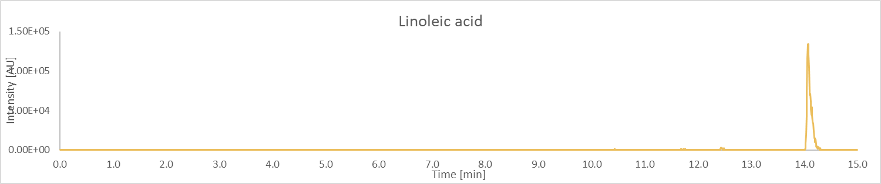
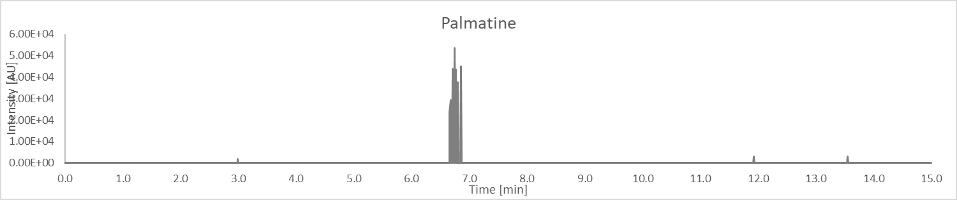
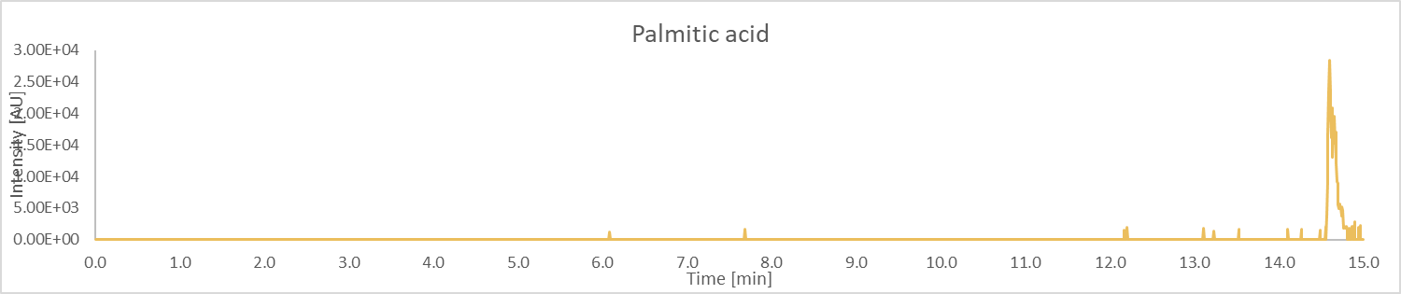
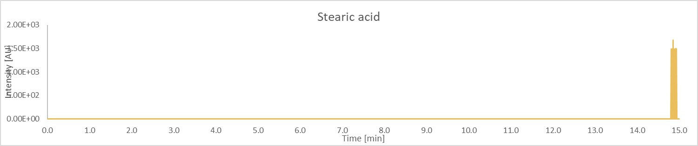
Structures of compounds in Table 1

Table 3: HRMS product ions for the peaks of the botanical extract
Peak No. | RT (min) | m/z | Proposed ID’s  (Confirmed with Std in green)  (Structure with correlated MS² spectra in orange)  (Most probable ID is blue)  CAS ID | Product Ions  m/z Rel. Int..
1 | 7.28 | 384.1442 | Hydrastine | 91.0537 4  97.4632 3  119.0484 5  142.2554 3  149.059 19  165.0579 3  174.0556 4  176.0711 11  188.0706 4  189.078 11  190.0862 100  193.0504 11  206.0816 4  237.0897 4  247.0777 4  250.063 6  260.0459 3  263.0705 5  265.0858 31  267.1037 4  277.0929 5  278.0555 7  279.0627 6  280.0744 10  282.0897 8  291.065 10  292.0741 21  293.0814 88  294.0874 10  295.0966 24  302.0598 9  304.0771 11  305.0765 4  307.0613 3  308.0697 11  320.0706 14  322.0891 11  323.0919 62  335.0929 5  336.1235 4  338.1125 5
2 | 1.12 | 367.1035 | 3-Feruloylquinic acid | 61.7852 1  67.0191 3  83.0506 2  85.029 4  85.3573 1  87.0086 7  93.0344 20  111.0449 5  117.0346 11  134.0369 100  149.0606 7  155.0343 3  173.0444 6  191.0551 30  191.0895 2  193.0498 24
3 | 1.14 | 163.039 | 4-Hydroxyphenylpyrucid acid | 51.0227 0  53.0385 0  55.0176 1  57.0335 1  63.0227 5  69.0333 2  77.0384 7  79.054 7  85.0284 1  89.0384 100  91.0539 1  93.2065 0  95.0489 5  103.0544 1  105.0447 2  107.0491 4  115.0545 2  117.0336 19  117.0702 2  120.1275 0  135.0442 9  159.0427 0  162.0473 1  163.0544 4
4 | 9.16 | 354.1338 | 8-Oxocanadine | 61.0151 4  67.6876 4  93.0339 4  110.0371 4  117.656 4  125.0593 4  136.0523 8  164.0474 46  172.0397 5  174.0549 13  176.0712 100  176.104 6  190.0507 23  244.5497 4  339.1139 6  354.1369 14
5 | 8.53 | 340.1176 | 8-Oxotetrahydrothalifendine | 66.5769 25  105.6166 23  176.0714 100  268.9152 25  310.0732 91  325.0962 36
6 | 5.93 | 337.1270 | Berberine | 74.9383 2  75.5677 2  87.5868 2  143.688 3  259.908 3  261.2167 3  276.0958 10  279.0843 11  292.0967 15  293.1021 97  305.1016 23  306.0811 7  307.0818 36  320.0914 5  321.0974 100  322.1053 45  337.1293 17
7 | 1.14 | 163.039 | Caffeic acid | 51.0227 0  53.0385 0  55.0176 1  57.0335 1  63.0227 5  69.0333 2  77.0384 7  79.054 7  85.0284 1  89.0384 100  91.0539 1  93.2065 0  95.0489 5  103.0544 1  105.0447 2  107.0491 4  115.0545 2  117.0336 19  117.0702 2  120.1275 0  135.0442 9  159.0427 0  162.0473 1  163.0544 4
8 | 1.09 | 340.1543 | Canadine | 91.0545 2  119.0494 3  149.0601 9  150.0679 2  151.0756 1  165.0914 3  174.0555 2  176.071 100  189.0789 1  292.1026 1  324.1219 1  340.1543 2
9 | 1.10 | 353.0877 | Chlorogenic acid | 85.029 12  93.0338 4  135.0441 60  135.0655 5  173.0441 4  178.3094 3  179.0329 13  191.054 100  235.9413 3
10 | 6.32 | 339.1324 | Columbamine | 178.3113 3  257.0621 2  278.111 10  280.091 20  281.1003 10  293.1034 3  294.1103 15  295.1151 78  306.1075 3  307.1152 20  308.0891 8  309.0947 46  322.1037 5  323.1102 100  324.1181 47  339.1405 15
11 | 1.13 | 352.1178 | Evodine | 108.3074 1  117.5906 1  263.3792 1  269.3829 1  278.0826 3  279.0851 2  280.0999 3  290.0872 2  291.0904 12  292.1001 4  294.0792 10  306.0782 5  307.0854 6  308.0944 98  309.0994 2  318.0843 1  319.0847 1  320.0944 24  321.1035 4  322.0742 38  336.0895 100  337.097 47  352.1213 25
12 | 1.12 | 177.0546 | Isoferulic acid / Ferulic acid | 55.9343 2  63.0229 3  65.0383 1  72.937 2  77.0385 2  78.0462 13  79.0537 1  89.0385 100  91.0542 5  95.0491 3  103.0542 2  105.0332 2  105.0459 1  106.0412 7  117.0336 42  124.0521 1  134.0365 9  135.0444 1  145.0288 2  149.0602 4
13 | 9.51 | 274.2740 | Lauryldiethanolamine | 57.0697 67  58.0656 7  70.065 78  71.085 18  73.5135 7  88.0756 100  102.0912 22  106.0864 48  178.2883 7  190.1865 9  256.2643 13  274.2755 22  279.0829 8
14 | 5.19 | 367.1035 | Methyl chlorogenate | 61.3372 14  67.0187 16  87.0094 17  93.0344 72  104.6632 15  134.0363 37  191.0552 100  193.0466 26  294.2483 18
15 | 1.17 | 360.1500 | Palatinose | 69.0333 4  72.6721 1  73.0281 1  85.0282 91  85.3258 1  97.0282 32  99.044 3  109.0281 2  115.0389 1  127.039 81  145.0498 100  162.0749 1  163.0606 9  163.8879 1  180.0869 14  180.1206 1  198.0979 7  211.0609 1  247.4641 1  259.0822 3  271.0834 1  289.0932 6  307.1062 1  325.115 5  360.1493 1
16 | 1.10 | 191.0560 | Quinic acid | 54.6171 5  57.0342 5  58.9589 11  59.0137 24  67.0187 5  71.0139 9  81.0345 7  83.0498 6  85.0294 100  87.0084 16  93.0347 28  109.0291 9  127.0404 7  178.3156 13  191.0554 9
17 | 1.16 | 328.1544 | Scoulerine | 91.0538 2  95.0494 1  119.0488 2  137.0594 1  151.0752 7  163.0629 6  164.0706 8  176.0714 2  178.0864 100  191.0935 1  233.0611 1  265.0882 1  296.1285 1  312.1217 1  313.1316 1  328.1554 1
18 | 6.65 | 336.1814 | Senecionine | 67.0355 1  79.1607 1  92.9701 1  118.306 1  275.0958 10  278.0832 12  291.0904 5  292.0987 100  304.099 22  306.0784 37  320.0941 95  321.102 39  336.1254 16
19 | 7.56 | 338.1410 | Jatrorrhizine | 96.894 3  129.5885 3  277.0977 7  278.0759 4  280.0886 8  292.0977 11  293.0991 16  294.103 81  304.1021 4  306.1034 20  307.0792 5  308.0825 32  321.0977 10  322.0984 100  323.1055 40  338.1314 16  345.779 3
20 | 1.17 | 314.175 | Magnocurarine | 58.0649 100  89.9815 1  91.0543 1  97.0283 1  103.1647 1  107.0491 35  115.0549 2  117.0699 1  119.0499 1  121.0649 7  131.049 1  136.0624 3  137.06 4  143.0498 4  145.033 1  145.0649 4  147.0806 1  149.06 1  151.0755 3  152.0714 1  160.0524 2  163.0766 2  164.0684 1  175.0759 6  176.0798 1  176.6842 1  181.1017 1  191.0847 1  192.1022 3  193.109 1  209.0962 3  211.1147 2  237.0925 4  239.1068 1  254.0945 1  269.12 1  298.1095 4  299.1162 2
21 | 1.11 | 400.1389 | 1-Hydroxyhydrastine | 118.2722 1  149.0588 1  176.0713 2  178.0876 1  188.0699 5  190.0861 13  193.0486 4  206.0808 5  265.0859 1  279.0672 1  281.0856 1  292.0959 5  293.0813 3  296.0699 1  302.0529 1  305.0782 1  306.0774 2  308.0727 1  311.0937 3  320.0879 6  321.0997 21  322.0934 1  323.0928 3  334.0975 1  336.1234 100  337.1274 2  338.1348 2  339.0848 1
22 | 5.24 | 324.1232 | Demethyleneberberine | 81.106 32  97.8473 31  100.9352 38  294.0756 52  309.1021 100
23 | 6.90 | 356.1494 | 13-Hydroxycanadine | 91.0542 4  118.0772 4  121.0654 5  132.0436 5  133.0639 4  134.072 8  135.0434 8  135.0804 12  136.0884 3  147.0799 5  149.0596 84  150.0674 32  161.0853 5  162.056 4  163.0751 21  164.0833 100  165.0552 12  165.091 65  165.1204 5  174.0553 31  175.063 11  176.0712 17  183.102 3  189.0794 5  190.0863 3  192.066 98  192.1029 13  289.5709 3  294.1132 3  304.1013 7  308.1306 12  322.1109 10  338.1426 51  356.1475 4
24 | 1.13 | 330.1702 | Reticuline / 3'-Hydroxy-N,N-dimethylcoclaurine | n/a
25 | 5.75 | 481.3159 | 20-Hydroxyecdysone | n/a
26 | 1.14 | 385.1595 | Hydrastine methiodine | n/a
27 | 1.14 | 370.1648 | Canadaline | 145.0278 7  190.0869 100  251.069 11  279.067 22  281.0853 10  298.9464 6  309.0789 20
28 | 1.26 | 355.1024 | Neochlorogenic acid | 89.0385 5  117.0333 7  135.0441 20  145.0282 22  163.0393 100  190.0856 3  191.0904 4
29 | 6.45 | 354.1695 | 13-Methylcanadine | 61.019 17  140.981 16  181.7687 17  190.0872 100  320.0554 23  339.0992 18
30 | 1.13 | 352.1180 | 8-Oxoberberine | 108.3074 1  117.5906 1  263.3792 1  269.3829 1  278.0826 3  279.0851 2  280.0999 3  290.0872 2  291.0904 12  292.1001 4  294.0792 10  306.0782 5  307.0854 6  308.0944 98  309.0994 2  318.0843 1  319.0847 1  320.0944 24  321.1035 4  322.0742 38  336.0895 100  337.097 47  352.1213 25
31 | 6.98 | 350.1388 | 13-Methylberberine | 247.5166 100
32 | 5.10 | 344.1856 | Tembetarine | n/a
33 | 1.11 | 342.1696 | Magnoflorine | 91.0542 2  95.049 1  119.0493 2  136.0523 1  149.06 2  150.066 4  151.0753 8  163.0636 6  165.0912 4  166.0932 1  176.0712 16  177.0746 18  178.0863 100  190.0855 1  191.0909 1  192.1029 6  207.0822 1  222.0665 1  237.0914 1  265.0883 2  282.0916 1  294.0945 1  297.1127 1  326.1398 1  342.1689 3
34 | 5.80 | 342.1699 | Isocorypalmine | 128.7082 2  150.0671 6  151.0749 9  158.5845 2  163.062 4  165.0908 14  169.0445 2  176.0702 6  177.0753 7  178.0863 100  178.3134 2  190.0877 2  192.1022 46
35 | 1.08 | 336.1236 | Epiberberine | 263.0953 1  275.0955 11  276.1032 1  278.0829 11  291.0909 5  292.0985 100  304.099 23  305.1061 1  306.0783 35  318.0811 1  320.0938 91  321.102 38  336.1256 15
36 | 1.16 | 328.1544 | 1,2-Dehydroreticuline | 91.0538 2  95.0494 1  119.0488 2  137.0594 1  151.0752 7  163.0629 6  164.0706 8  176.0714 2  178.0864 100  191.0935 1  233.0611 1  265.0882 1  296.1285 1  312.1217 1  313.1316 1  328.1554 1
37 | 9.86 | 329.1021 | 6,8-C-Dimethylluteolin-7-methyl ether | n/a
38 | 5.24 | 324.1231 | Dehydrodiscretamine | 81.106 32  97.8473 31  100.9352 38  294.0756 52  309.1021 100
39 | 1.19 | 322.1074 | Thalinfendin | 100.9064 6  113.0107 5  145.0039 6  151.9779 10  161.9604 6  177.0366 6  279.0901 13  293.1007 14  305.0992 9  307.0857 100  321.0983 23  322.1099 15
40 | 6.51 | 315.0865 | 6-C-Methylluteolin-7-methyl ether | 154.2853 45  178.2729 80  201.1571 44  224.7724 38  299.056 50  300.0638 100
41 | 6.94 | 314.1385 | 1,2-Dihydronorreticuline | 93.0697 26  102.4157 32  121.0649 100  132.6369 24  145.0285 90  177.0548 45
42 | 10.66 | 313.1069 | Sideroxylin | n/a
43 | 1.13 | 300.1595 | N-methylcocluarine / canelilline | 79.0543 1  91.0541 1  93.0699 1  95.0489 1  103.0541 1  107.0491 100  115.0544 5  117.0699 2  119.0494 2  121.0649 9  131.0494 3  133.0651 1  137.06 8  143.0495 13  144.0575 1  145.0651 7  147.0807 1  149.0604 1  151.0754 2  155.0611 1  160.0524 3  163.0757 2  164.0707 1  165.0719 1  175.076 10  175.1097 1  178.0864 2  179.0873 1  180.1028 1  181.0658 1  181.1024 2  182.0735 1  191.0869 3  192.1027 2  194.0734 2  195.0804 1  197.0971 6  207.0829 1  209.0971 9  209.1404 1  211.1124 1  219.0824 2  225.0926 2  237.0923 7  238.0999 1  254.0947 2  269.1196 2
44 | 9.98 | 299.0916 | Desmethyl-sideroxylin | 79.9387 47  80.5415 46  133.8388 44  178.3192 73  194.8692 45  284.0692 100
45 | 7.04 | 320.0918 | Coptisine | 66.0495 1  85.2445 1  127.6488 1  149.0857 1  169.0817 1  178.2759 2  218.0732 1  262.0836 7  264.106 2  274.0699 6  277.0553 8  288.0689 1  290.0807 13  291.0708 2  292.0965 9  303.0509 2  305.0699 4  318.0759 100  320.0917 93
46 | 1.11 | 190.0864 | Hydrastinine | 82.4169 3  91.0535 8  103.0536 11  117.0575 6  119.0489 9  131.0491 18  131.069 4  132.0808 29  134.0974 4  135.0446 3  137.2301 2  147.068 4  149.0594 12  159.0439 5  160.0761 22  161.0596 5  174.0541 5  175.0629 35  190.0865 100
47 | 14.08 | 279.2329 | Linoleic acid | 74.367 8  80.7718 9  85.0036 9  86.9123 8  128.0099 100  134.7439 10  181.6503 7  196.9125 12  235.5706 8  258.3408 9
48 | 6.74 | 352.1539 | Palmatine | n/a
49 | 14.56 | 255.2329 | Palmitic acid | 67.3201 100  75.7724 95  85.2747 84  229.6982 95
50 | 14.80 | 283.2643 | Stearic acid | n/a

