**Analysis of Green Tea Extract Using UPLC-MS/MS and LC/UV**

Tim Cristy

Battelle

505 King Ave

Columbus, OH 43201

May 2023

|  |  |  |  |  |
| --- | --- | --- | --- | --- |
| Common Botanical Name | CAS No. | Lot No. | Container ID | Net Weight |
| Green Tea | NA | 20S0293200 | NA | 5 kg |

|  |
| --- |
| Sample storage condition until analysis |
| -20 ℃ |

**Quantitative Method:**

|  |  |
| --- | --- |
| **LC/UV Method** | |
| LC Conditions | UV Conditions |
| System: **Agilent 1260**  Column: **Thermo Scientific Accucore aQ**  **(4.6 x 150 mm, 2.6 um)**  Mobile phase A: **97:3 H2O:CH3CN + 0.1% FA**  Mobile phase B: **CH3CN + 0.1% FA**  Flow rate: **1 mL/min**  Column temperature: **40 ℃**  Gradient   |  |  | | --- | --- | | Time (min) | Mobile phase B (%) | | **0** | **0** | | **40** | **10** | | **50** | **30** | | **60** | **30** | | **61** | **0** | | **70** | **0** | | System: **Agilent 1260**  Wavelength: **274 nm** |

**Quantitative Resultsa**

|  |  |  |
| --- | --- | --- |
| **Compoundb** | **Concentration in extract**  **mg/g**  **Average ± s** | **Concentration in extract**  **% wt/wt**  **Average** |
| Caffeine | **1.12 ± 0.02** | **0.112** |
| Catechin [C] | **6.72 ± 0.68** | **0.672** |
| Epicatechin [EC] | **85.1 ± 0.7** | **8.51** |
| Epigallocatechin [EGC] | **147 ± 2** | **14.7** |
| Epigallocatechin gallate [EGCG] | **440 ± 4** | **44.0** |
| Epicatechin gallate [ECG] | **84.5 ± 0.7** | **8.45** |
| Gallocatechin gallate [GCG] | **23.8 ± 0.4** | **2.38** |
| Gallocatechin [GC] | **14.8 ± 0.2** | **1.48** |
| Gallic acid [GA] | **6.21 ± 0.11** | **0.621** |
| Theobromine | **1.43 ± 0.05** | **0.143** |
| Theophylline | **0.148 ± 0.043** | **0.0148** |

1. **Quantitated using UV Chromatograms**
2. **The standards used were a specific enantiomer for the chiral compounds, but the analytical method is not enantioselective so the common name is used in the results**

**Standards**

|  |  |  |  |  |  |
| --- | --- | --- | --- | --- | --- |
| **Name** | **Supplier** | **CAS Number** | **Catalog Number** | **Purity %** | **Batch/Lot number** |
| **Caffeine** | Sigma-Aldrich | 58-08-2 | C1778 | 99.6% | SLCJ5558 |
| **(−)-Catechin [C]** | Sigma-Aldrich | **18829-70-4** | PHL80992 | 100.00% | 112218378 |
| **(−)-Epicatechin [EC]** | Sigma-Aldrich | **490-46-0** | PHL89192 | 99.73% | 99627492 |
| **(−)-Epigallocatechin [EGC]** | Sigma-Aldrich | **970-74-1** | PHL89655 | 98.47% | 87929981 |
| **(−)-Epigallocatechin-3-O-gallate [EGCG]** | Sigma-Aldrich | **989-51-5** | 1236700 | 92% | R088T0 |
| **(−)-Epicatechin gallate [ECG]** | Sigma-Aldrich | **1257-08-5** | E3893 | 99% | WXBD0103V |
| **(−)-Gallocatechin gallate [GCG]** | Sigma-Aldrich | **4233-96-9** | G6782 | 99% | SLCH7064 |
| **(-)-Gallocatechin [GC]** | Sigma-Aldrich | **3371-27-5** | 01388 | 99.6% | WXBD3189V |
| **Gallic acid [GA]** | Sigma-Aldrich | **149-91-7** | PHL89198 | 100.00% | 111238103 |
| **Theobromine** | Sigma-Aldrich | **83-67-0** | T4500 | 99.4% | BCCF0961 |
| **Theophylline** | Sigma-Aldrich | **58-55-9** | 1653004 | 99.9% | R084X0 |

**Chemical structures of standards used for quantitative analysis**

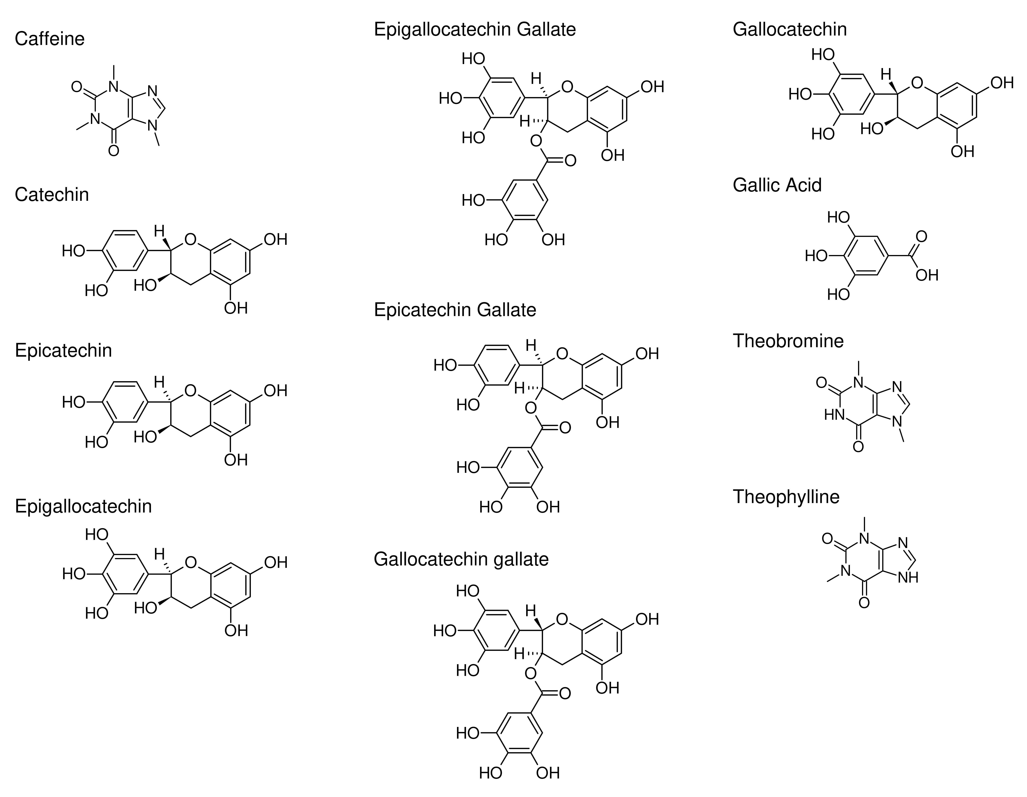

**Chromatograms**

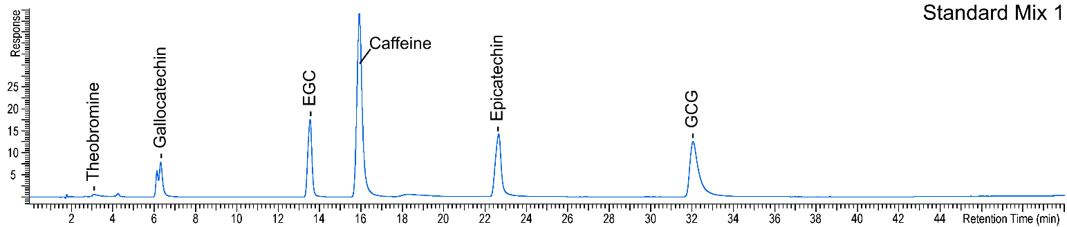

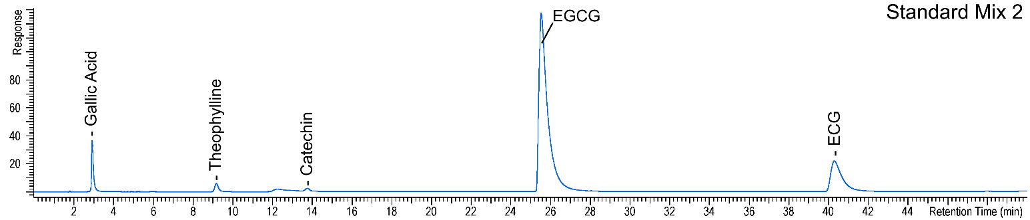

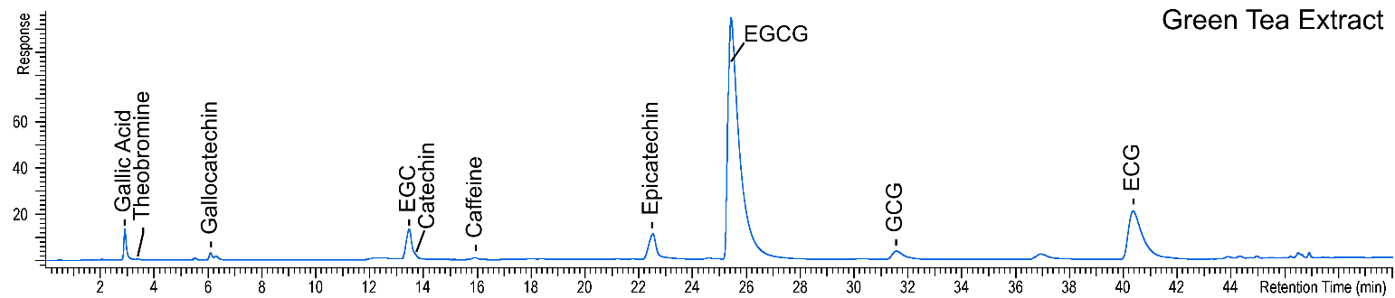

**Calibration**

|  |  |  |  |  |
| --- | --- | --- | --- | --- |
| **Compound** | **Lower Limit of Quantitation (LLOQ) ug/mL** | **Calibration Range (ug/mL)** | **Number of Calibration Points** | **R2** |
| **Caffeine** | 0.20 | 0.20 – 10 | 3 | 1.0000 |
| **Catechin [C]** | 0.20 | 0.20 – 2.0 | 3 | 0.9992 |
| **Epicatechin [EC]** | 1.4 | 1.4 – 20 | 3 | 0.9998 |
| **Epigallocatechin [EGC]** | 2.0 | 2.0 – 40 | 3 | 0.9999 |
| **Epigallocatechin gallate [EGCG]** | 8.0 | 8.0 – 120 | 3 | 0.9993 |
| **Epicatechin gallate [ECG]** | 1.0 | 1.0 – 20 | 3 | 0.9999 |
| **Gallocatechin gallate [GCG]** | 2.0 | 2.0 – 16 | 3 | 0.9928 |
| **Gallocatechin [GC]** | 1.0 | 1.0 – 10 | 3 | 0.9997 |
| **Gallic acid [GA]** | 0.80 | 0.80 – 3.0 | 3 | 0.9999 |
| **Theobromine** | 0.10 | 0.10 – 1.0 | 3 | 0.9709 |
| **Theophylline** | 0.10 | 0.10 –1.0 | 3 | 1.0000 |

**Targeted and Untargeted Identification Method:**

**UPLC/MS/MS Method**

|  |  |
| --- | --- |
| UPLC Conditions | MS Conditions |
| System: **Waters Acquity I-Class**  Column: **Thermo Scientific Accucore aQ (4.6 x 150 mm, 2.6 um)**  Mobile phase A: **97:3 H2O:CH3CN + 0.1% FA**  Mobile phase B: **CH3CN + 0.1% FA**  Flow rate: **1 mL/min**  Column temperature: **40 ℃**  Gradient   |  |  | | --- | --- | | Time (min) | Mobile phase B (%) | | **0** | **0** | | **40** | **10** | | **50** | **30** | | **60** | **30** | | **61** | **0** | | **70** | **0** | | System: **Sciex Triple TOF 5600**  Ionization: **Electrospray (ESI)**  Polarity: **Positive**  Source Settings:  · Nebulizer Gas: **30 psi**  · Heater Gas: **50 psi**  · Curtain Gas: **35 psi**  · Ion Source Voltage: **5500 V**  · Source Temperature: **450** **℃**  MS Settings:  · TOF-MS Scan Range: **m/z 50 – 1000**  · TOF-MS Collision Energy: **10 V**  · IDA MS/MS Scan Range: **m/z 20 – 1000**  · IDA MS/MS Collision Energy: **25 V** |

|  |  |  |  |  |  |  |  |  |
| --- | --- | --- | --- | --- | --- | --- | --- | --- |
| Table 1. Targeted and Untargeted Identification | | | | | | | | |
| **ID** | **Retention**  **Timea**  **(minutes)** | **Expected M+H**  **Exact Mass (Da)** | **Found M+H Exact Mass (Da)** | **Mass Error**  **(Da)** | **CAS**  **Number** | **Molecular**  **Formula** | **Structure** | **ID**  **Confidence**  **Levelb** |
| Caffeine | 14.18 | 195.088 | 195.087 | 0.001 | 58-08-2 | C8H10N4O2 |  | 1 |
| Catechin [C] | 10.95 | 291.087 | 291.087 | 0.000 | 18829-70-4 | C15H14O6 |  | 1 |
| Epicatechin [EC] | 18.62 | 291.087 | 291.087 | 0.000 | 490-46-0 | C15H14O6 |  | 1 |
| Epigallocatechin [EGC] | 10.60 | 307.082 | 307.083 | 0.001 | 970-74-1 | C15H14O7 |  | 1 |
| Epigallocatechin gallate [EGCG] | 20.94 | 459.093 | 459.092 | 0.001 | 989-51-5 | C22H18O11 |  | 1 |
| Epicatechin gallate [ECG] | 33.62 | 443.098 | 443.094 | 0.004 | 1257-08-5 | C22H18O10 |  | 1 |
| Gallocatechin gallate [GCG] | 25.99 | 459.093 | 459.089 | 0.004 | 4233-96-9 | C22H18O11 |  | 1 |
| Gallocatechin [GC] | 5.09 | 307.082 | 307.083 | 0.001 | 3371-27-5 | C15H14O7 |  | 1 |
| Gallic acid [GA] | 2.97 | 171.029 | 171.030 | 0.001 | 149-91-7 | C7H6O5 |  | 1 |
| Theobromine | 5.65 | 181.073 | 181.071 | 0.002 | 83-67-0 | C7H8N4O2 |  | 1 |
| Theophylline | 8.09 | 181.073 | 181.073 | 0.000 | 58-55-9 | C7H8N4O2 |  | 1 |
| Catechin gallate [CG] | 37.14 | 443.098 | 443.097 | 0.001 | 130405-40-2 | C22H18O10 |  | 3 |
| Epigallocatechin methylgallate  [EGCGMe] | 31.28 | 473.108 | 473.105 | 0.003 | 83104-87-4 | C23H20O11 |  | 5c |
| Theanine | 2.02 | 175.108 | 175.109 | 0.001 | 3081-61-6 | C7H14N2O3 |  | 5 |

1. Retention time of the molecular ion peak in the MS for the sample.
2. Level 1: Retention time, exact mass, and MS/MS match with a reference standard

Level 2: MS/MS Match with a library/literature spectrum obtained under similar conditions or only one possible structure consistent with MS/MS

Level 3: MS/MS consistent with the structure of a literature compound or class of compounds or a library spectrum obtained under different conditions; relative retention consistent with literature if available

Level 4: Only one molecular formula fits the exact mass and isotope ratio

Level 5: Exact mass matches a literature compound

1. In addition to the exact mass, the retention time is consistent with literature relative retention

Figure 1: Extracted Ion Chromatograms for each constituent in Green Tea from Table 1

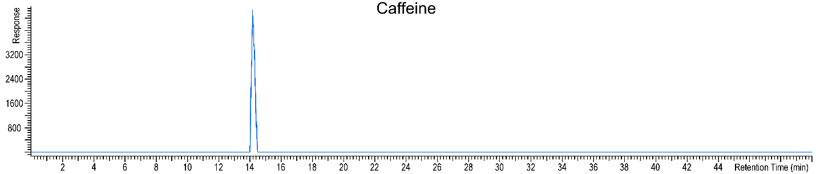

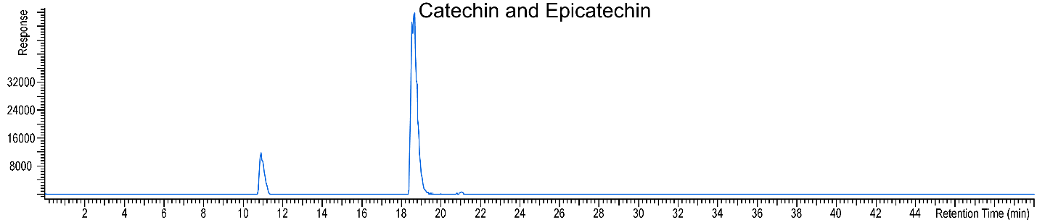

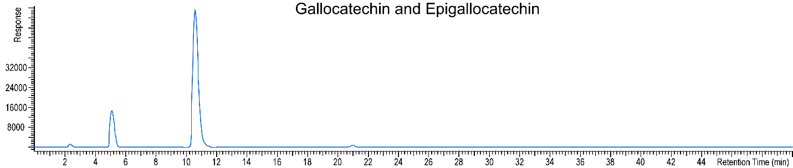

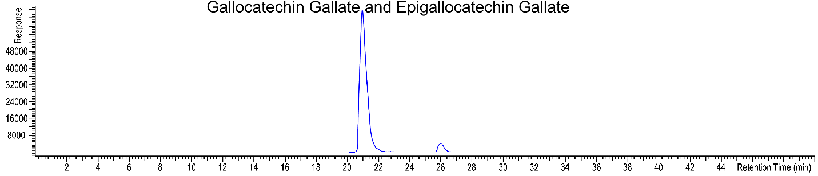

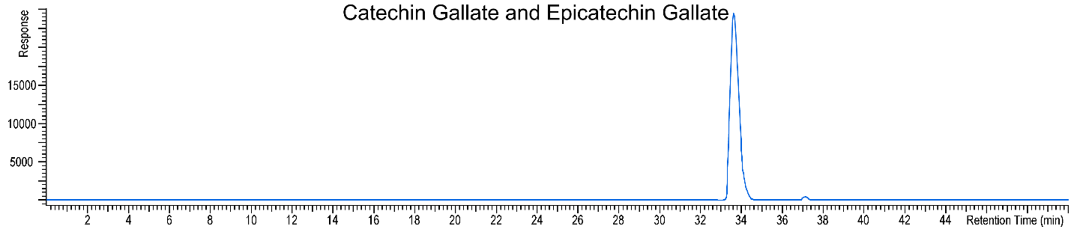

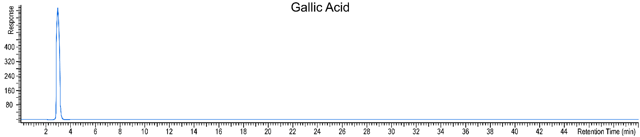

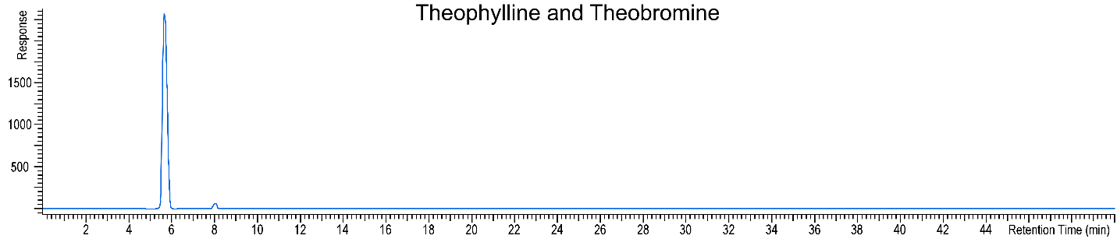

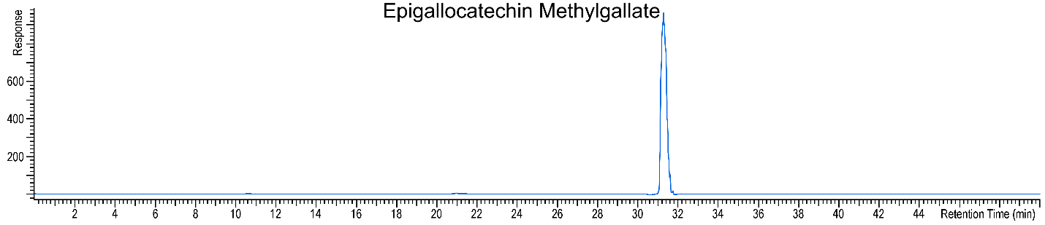

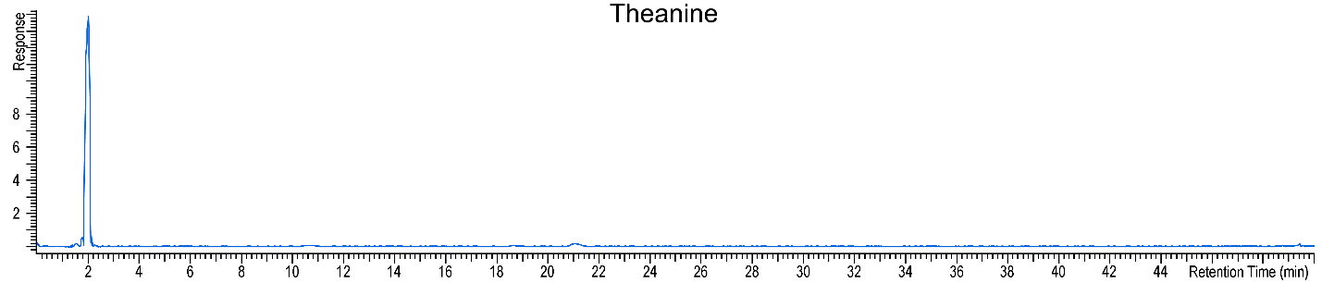

|  |  |  |  |  |
| --- | --- | --- | --- | --- |
| **Table 2: MS/MS product ions for the peaks of the botanical extract** | | | | |
| Peak No. | RT (min) | *Precursor*  *m/z1* | Proposed Compounds  (Confirmed with Std in **green**)  (Probable ID is **yellow**)  CAS Number | Product Ions  *m/z* Rel. Int |
| 1 | 14.22 | 195.1 | Caffeine  58-08-2 | 42.036 3.11  56.056 1.17  69.047 2.33  83.061 2.72  84.960 5.84  110.072 6.61  123.043 2.33  130.965 3.11  135.924 1.17  138.066 31.13  195.088 100.00 |
| 2 | 10.98 | 291.1 | Catechin [C]  18829-70-4 | 119.050 8.47  123.042 54.03  139.039 100.00  147.042 20.97  165.057 20.97  179.075 8.47  207.061 16.53  291.084 83.06 |
| 3 | 18.56 | 291.1 | Epicatechin [EC]  490-46-0 | 111.043 3.63  119.053 2.75  123.043 51.95  127.038 2.75  135.042 2.75  138.616 1.95  139.039 100.00  140.044 1.95  143.046 3.63  147.042 22.87  151.039 3.63  161.059 10.99  165.051 12.77  179.071 4.61  181.049 4.61  189.057 5.50  207.065 15.51  249.072 3.63  273.077 5.50  291.088 39.72 |
| 4 | 10.48 | 307.1 | Epigallocatechin [EGC]  970-74-1 | 135.044 2.70  139.039 100.00  151.039 7.57  163.037 12.92  169.050 4.64  177.055 4.64  181.051 9.78  195.064 7.08  205.046 1.70  223.058 3.67  247.064 1.23  289.070 6.34  307.081 30.49 |
| 5 | 20.87 | 459.1 | Epigallocatechin gallate [EGCG]  989-51-5 | 139.040 100.00  151.037 8.49  153.018 6.31  163.040 2.65  181.049 2.90  205.050 1.81  289.069 20.68  307.083 2.29  333.063 1.34  459.089 16.50 |
| 6 | 33.60 | 443.1 | Epicatechin gallate [ECG]  1257-08-5 | 123.044 72.44  139.039 100.00  151.037 8.90  153.017 9.40  165.055 4.09  273.074 43.11  291.085 7.67  317.064 2.26  443.097 42.28 |
| 7 | 26.02 | 459.1 | Gallocatechin gallate [GCG]  4233-96-9 | 139.037 100.00  151.036 6.43  153.020 11.07  163.039 4.29  181.047 7.86  205.050 2.14  289.070 26.79  307.086 3.21  333.061 2.14  376.985 1.07  399.799 1.43  459.090 21.43 |
| 8 | 5.07 | 307.1 | Gallocatechin [GC]  3371-27-5 | 133.027 2.01  139.039 100.00  151.037 5.76  163.039 11.65  169.050 7.14  177.055 3.88  181.049 15.54  195.066 6.52  205.050 1.88  229.885 1.88  239.879 1.88  247.057 3.26  247.894 2.63  265.861 1.88  289.068 7.77  307.081 22.68 |
| 9 | 2.95 | 171.0 | Gallic acid [GA]  149-91-7 | 51.023 2.94  53.042 17.65  79.029 8.82  81.033 55.88  88.954 20.59  109.028 82.35  116.932 17.65  125.024 35.29  127.041 52.94  134.943 17.65  135.012 8.82  153.015 94.12  171.028 100.00 |
| 10 | 5.69 | 181.1 | Theobromine  83-67-0 | 42.040 3.31  54.950 1.99  67.031 3.97  69.045 2.65  83.061 2.65  84.960 6.62  95.974 4.64  108.061 2.65  110.072 5.30  113.037 1.99  116.932 1.99  122.059 3.31  123.044 2.65  134.944 2.65  135.065 3.97  137.084 2.65  138.066 19.21  139.923 2.65  162.934 2.65  163.060 9.27  181.070 100.00 |
| 11 | 8.06 | 181.1 | Theophylline  58-55-9 | 42.042 16.00  95.975 20.00  116.930 12.00  124.051 56.00  134.944 16.00  139.923 12.00  162.935 16.00  181.071 100.00 |
| 12 | 37.06 | 443.1 | Catechin gallate [CG]  130405-40-2 | 123.045 46.88  139.037 100.00  151.043 6.25  153.019 9.38  165.050 6.25  273.077 34.38  291.086 9.38  317.072 6.25  396.787 6.25  401.728 6.25  443.095 34.38 |
| 13 | 31.22 | 473.1 | Epigallocatechin methylgallate [EGCGMe]  83104-87-4 | 139.039 100.00  151.039 8.11  163.033 2.70  167.035 17.57  205.048 2.70  289.070 29.73  347.079 2.70  413.771 2.70  454.787 2.70  473.109 20.27 |

1 The mass resolution of the quadrupole in the QTOF is 0.1 Da