Analysis of Kava (Piper methysticum) Extract Using High Resolution UHPLC-MS and UHPLC-MS/MS

Richard B.van Breemen and Ruth N. Muchiri
Department of Pharmaceutical Sciences
Linus Pauling Institute
Oregon State University
2900 Campus Way
Corvallis, OR 97331

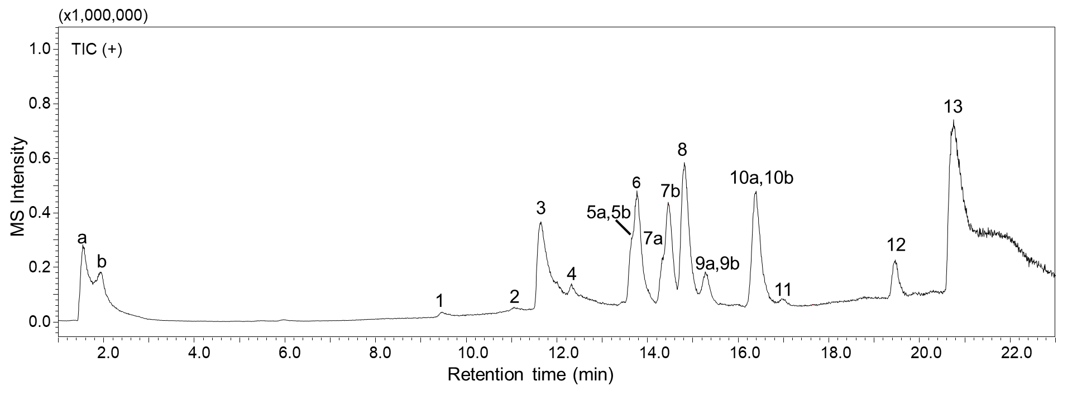
Figure 1. Total ion chromatogram of kava extract (10 µg/mL) analyzed on a Shimadzu 9030 UHPLC-Q-ToF mass spectrometer (resolving power 30,000) with positive ion electrospray. A 22-min gradient from 5% to 95% methanol containing formic acid (0.1%) in water (also containing 0.1% formic acid) was used for the UHPLC separation with a Waters Cortecs C₁₈ (2.1 × 150 mm, 1.7 µm) column.
Table 1. Proposed and confirmed components corresponding to the peaks in the UHPLC-HRMS chromatogram in Figure 1 of Kava (Piper methysticum) extract.

Peak number | Retention time  (min) | m/z  [M+H]⁺ | ΔM  (ppm error) | Proposed ID  Molecular Formula  (CAS)  Confidence³ | Chemical Structure | Comments
1 | 9.53 | 259.0882 | 7.7 | d4-Daidzein  C₁₅H₆D₄O₄  486-66-8  Reference standard |  | HRMS supports molecular formula.  MS/MS supports structure via reference standard.  Retention time matches that of reference standard. D4-daidzein was included as an injection standard
2 | 10.97 | 279.1200 | 9.4 | 11-Hydroxy-12-methoxydihydrokavain  C₁₅H₁₈O₅  -  Tentative |  | HRMS supports molecular formula. MS/MS supports structure where the major fragment ions are also observed in other kavalactones. This structure is reported ion the literature [1].
3 | 11.53 | 201.2392 | - | Unknown | - | The observed peak is a background noise that was also observed in the solvent. When the chromatogram was aligned with the XCMS online, the fold difference between the peak in the extract and the blank was insignificant
4 | 12.35 | 293.1364 | 6.6 | 11,12-Dimethoxydihydrokavain  C₁₆H₂₀O₅  -  Partial |  | The HRMS support molecular formulae. The structure is partially supported by the MS/MS via manual interpretation. It maybe another kavalactone that is not reported in the literature. There is no literature data for 11,12-Dimethoxydihydrokavain
5a | 13.59 | 289.1050 | 7.1 | 10-methoxyyangonin  C₁₆H₁₆O₅  77900-32-4  Partial |  | The HRMS support molecular formulae. The structure is partially supported by the MS/MS via manual interpretation. It maybe another kavalactone that is not reported in the literature. There is no literature data
5b | 13.67 | 275.0895 | 6.9 | Methysticin  C₁₅H₁₄O₅  495-85-2  Reference standard |  | HRMS supports molecular formula.  MS/MS supports structure via reference standard.  Retention time matches that of reference standard
6 | 13.79 | 277.1052 | 6.8 | Dihydromethylsticin  C₁₅H₁₆O₅  19902-91-1  Reference standard |  | HRMS supports molecular formula.  MS/MS supports structure via reference standard.  Retention time matches that of reference standard
7a | 14.32 | 263.1260 | 6.7 | 5,6,7,8-Tetrahydroyangonin  C₁₅H₁₈O₄  -  Matched |  | HRMS supports molecular formula. MS/MS supports structure via manual interpretation where the major fragment ions are also observed in other kavalactones. The MS/MS matches that reported in the literature. [2].
7b | 14.48 | 231.1001 | 6.5 | Kavain  C₁₄H₁₄O₃  500-64-1  Reference standard |  | HRMS supports molecular formula.  MS/MS supports structure via reference standard.  Retention time matches that of reference standard
8 | 14.86 | 233.1159 | 5.6 | 7,8-Dihydrokavain  C₁₄H₁₆O₃  587-63-3  Reference standard |  | HRMS supports molecular formula.  MS/MS supports structure via reference standard.  Retention time matches that of reference standard
9a | 15.33 | 259.0947 | 6.9 | Yangonin  C₁₅H₁₄O₄  500-62-9  Reference standard |  | HRMS supports molecular formula.  MS/MS supports structure via reference standard.  Retention time matches that of reference standard
9b | 15.33 | 262.1135 | 6.8 | Yangonin-d3  C₁₅H₁₁D₃O₄  500-62-9  Reference standard |  | HRMS supports molecular formula.  MS/MS supports structure via reference standard.  Retention time matches that of reference standard. This compound was used as an internal standard.
10a | 16.35 | 229.0844 | 6.5 | Desmethoxyyangonin  C₁₄H₁₂O₃  15345-89-8  Reference standard |  | HRMS supports molecular formula.  MS/MS supports structure via reference standard.  Retention time matches that of reference standard
10b | 16.61 | 315.1205 | 6.9 | Flavokavain A  C₁₈H₁₈O₅  3420-72-2  Reference standard |  | HRMS supports molecular formula.  MS/MS supports structure via reference standard.  Retention time matches that of reference standard
11 | 17.02 | 285.1101 | 7.0 | Flavokavain B  C₁₇H₁₆O₄  1775-97-9  Reference standard |  | HRMS supports molecular formula.  MS/MS supports structure via reference standard.  Retention time matches that of reference standard
12 | 19.49 | 393.2832 |  | unknown | - | The observed peak is a background noise that was also observed in the solvent. When the chromatogram was aligned with the XCMS online, the fold difference between the peak in the extract and the blank was insignificant
13 | 20.76 | 270.3142 |  | unknown | - | The observed peak is a background noise that was also observed in the solvent. When the chromatogram was aligned with the XCMS online, the fold difference between the peak in the extract and the blank was insignificant

[1] He X-G, Lin L-Z, Lian L-Z. Electrospray high performance liquid chromatography-mass spectrometry in phytochemical analysis of kava (Piper methysticum) extract. Planta Medica. 1997; 63: 70.
[2] Tang Y, Fields CA. UHPLC-UV method development and validation for determining kavalactones and flavokavains in Piper methysticum (Kava). Molecules. 2019; 24: 1245.

Appendix

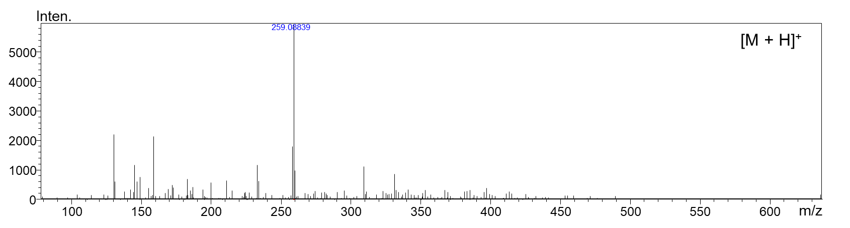
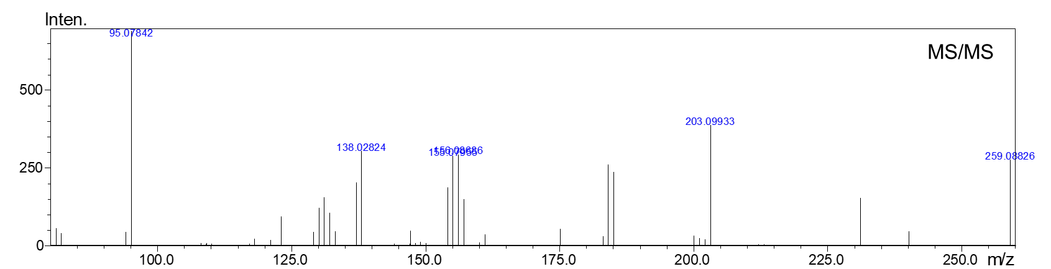

Figure 2. Positive ion electrospray HRMS (top panel) and MS/MS of peak 1 with m/z 259.0882 eluting at 9.53 min

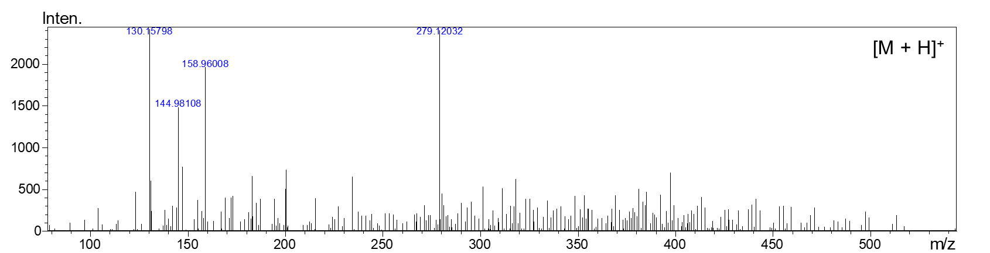
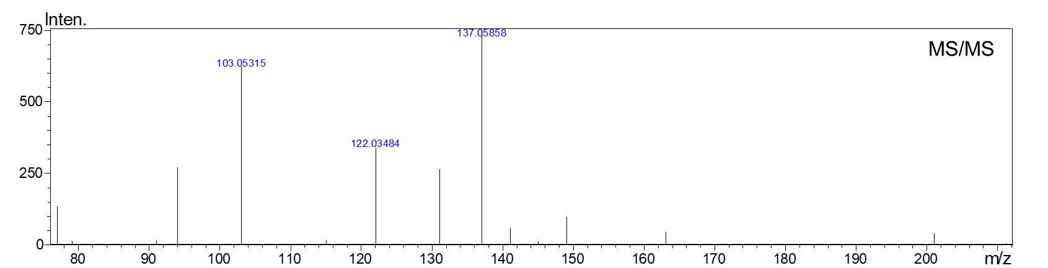

Figure 3. Positive ion electrospray HRMS (top panel) and MS/MS of peak 2 with m/z 279.1200 eluting at 10.97 min

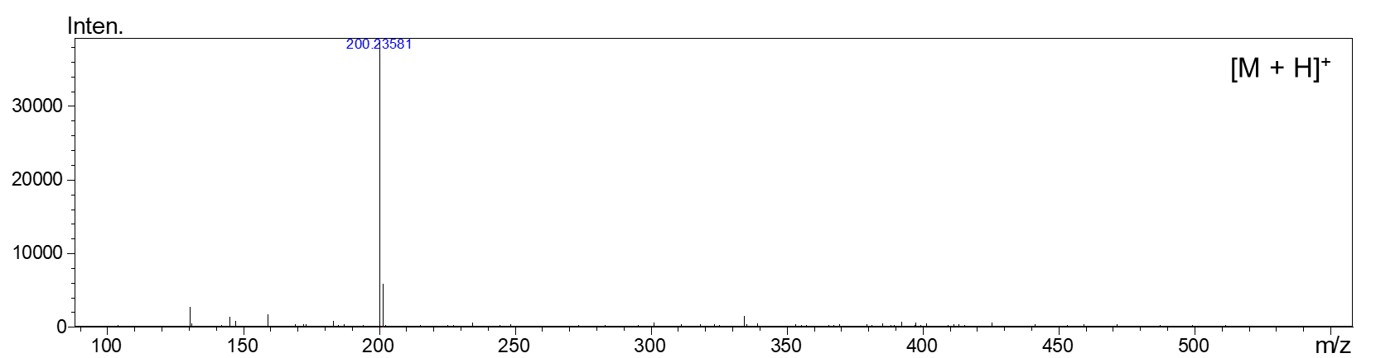
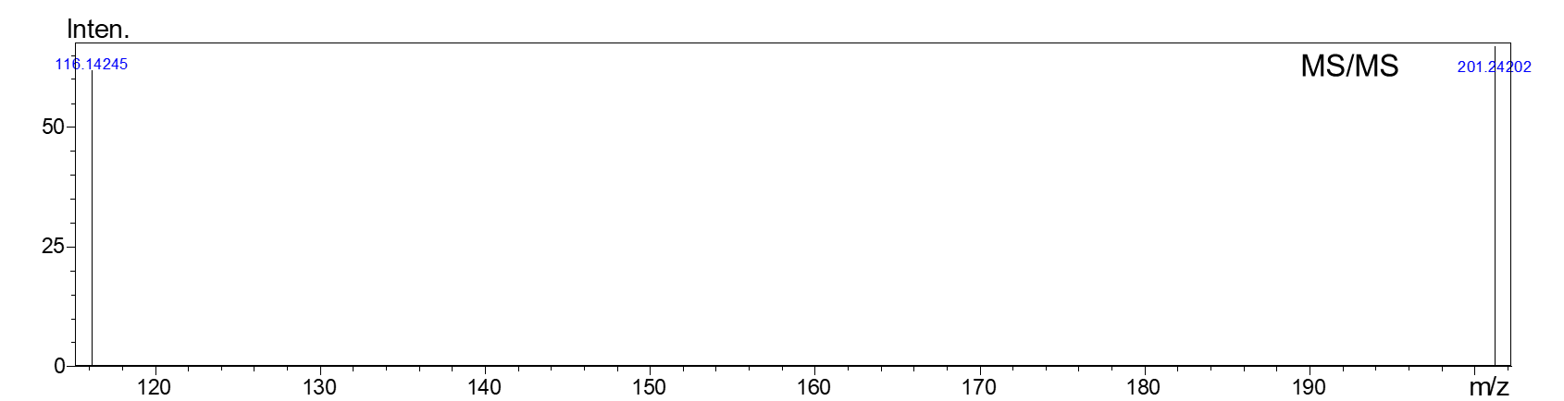

Figure 4. Positive ion electrospray HRMS (top panel) and MS/MS of peak 3 with m/z 201.2392 eluting at 11.53 min

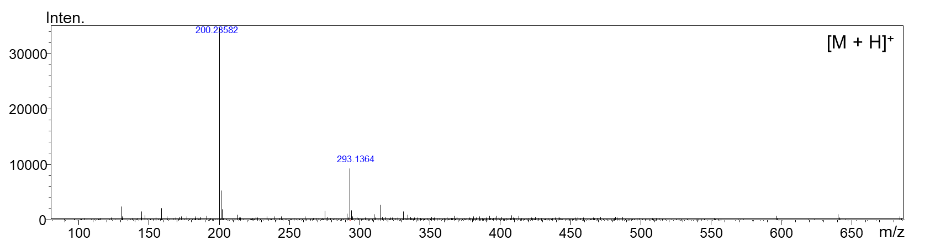
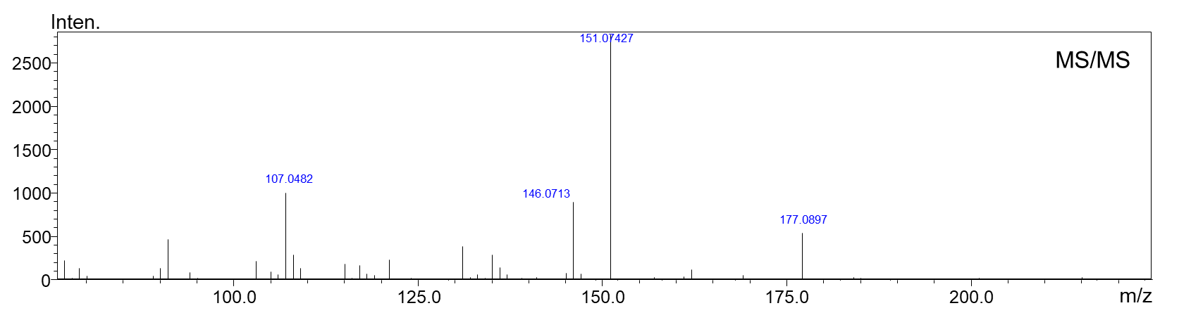

Figure 5. Positive ion electrospray HRMS (top panel) and MS/MS of peak 4 with m/z 293.1364 eluting at 12.35 min

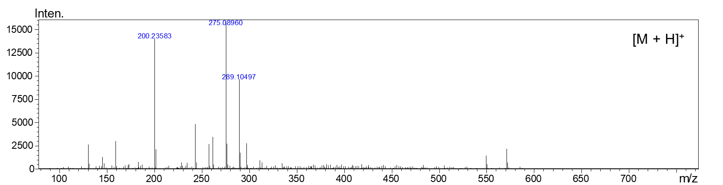
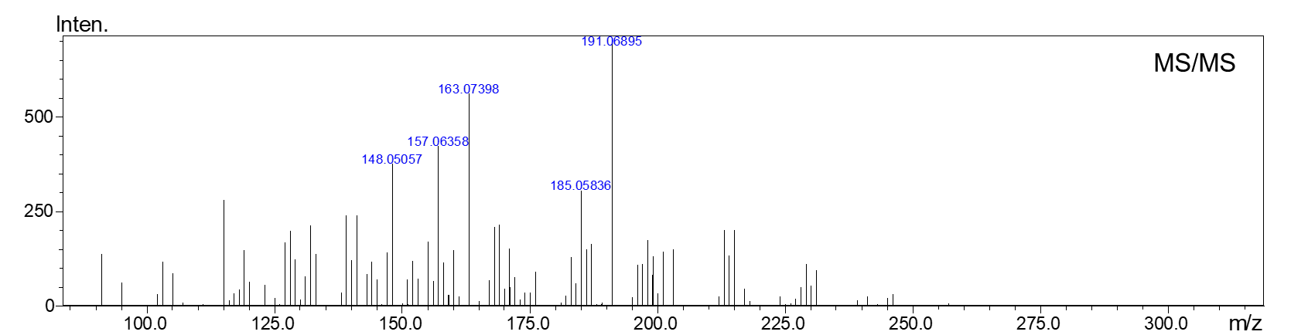

Figure 6. Positive ion electrospray HRMS (top panel) and MS/MS of peak 5a with m/z 289.1050 eluting at 13.59 min

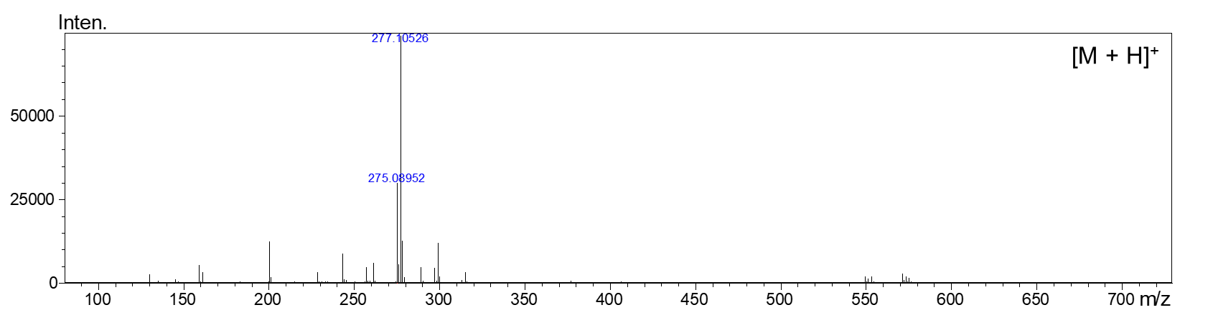
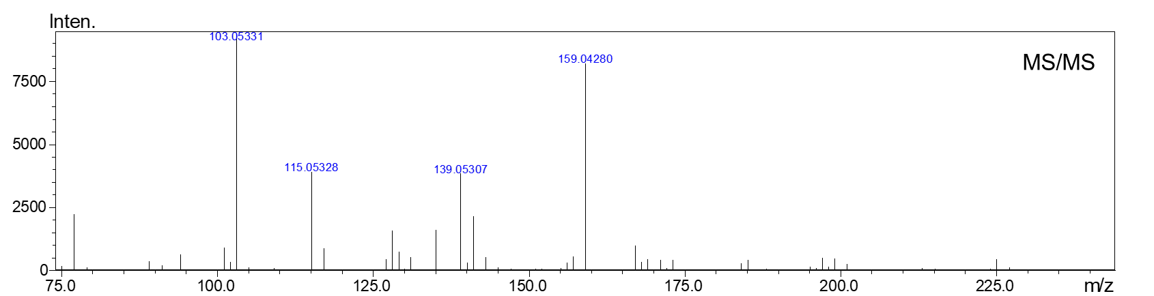

Figure 7. Positive ion electrospray HRMS (top panel) and MS/MS of peak 5b with m/z 275.0895 eluting at 13.67 min

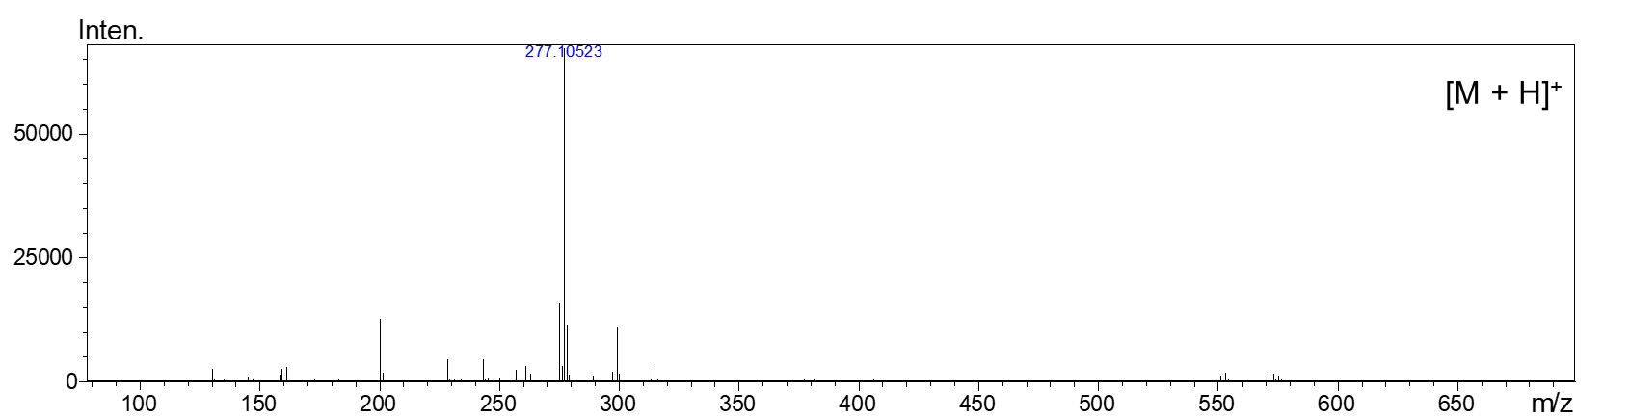
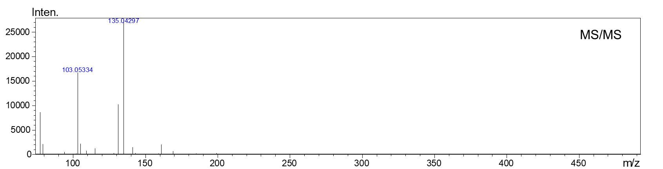

Figure 8. Positive ion electrospray HRMS (top panel) and MS/MS of peak 6 with m/z 277.10523 eluting at 13.79 min

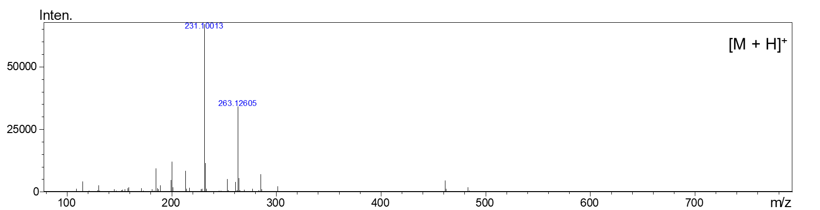
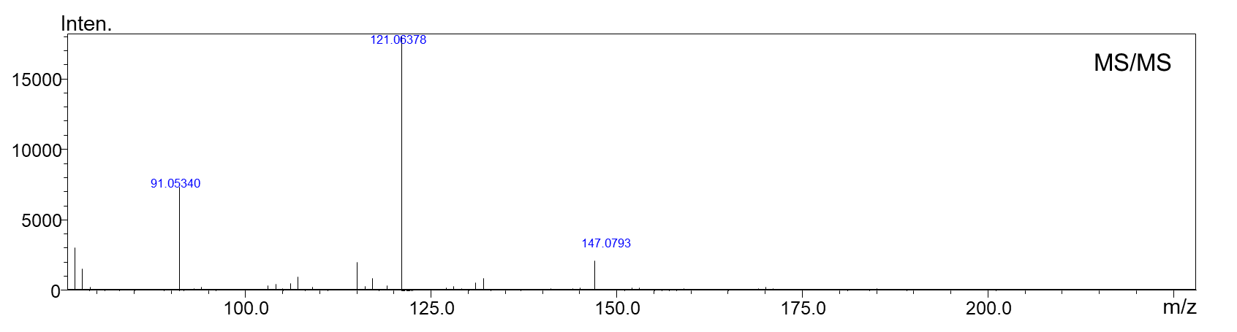

Figure 9. Positive ion electrospray HRMS (top panel) and MS/MS of peak 7a with m/z 263.1260 eluting at 14.32 min

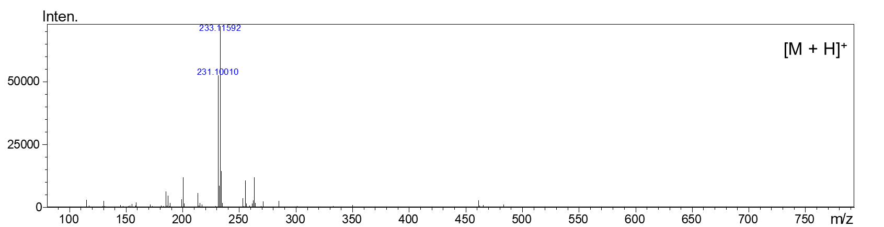
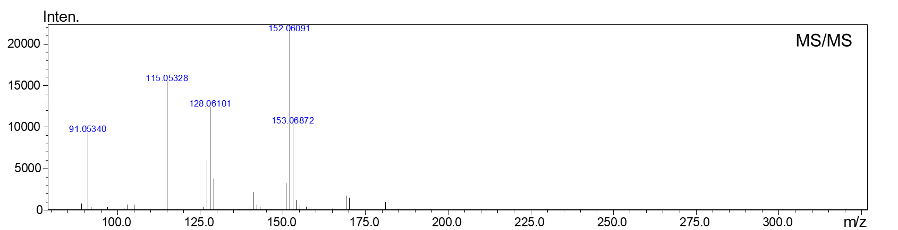

Figure 10. Positive ion electrospray HRMS (top panel) and MS/MS of peak 7b with m/z 231.1001 eluting at 14.48 min

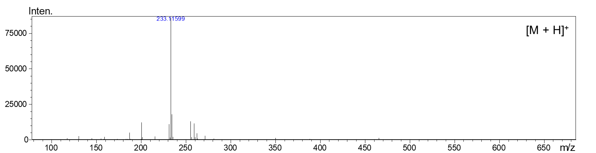
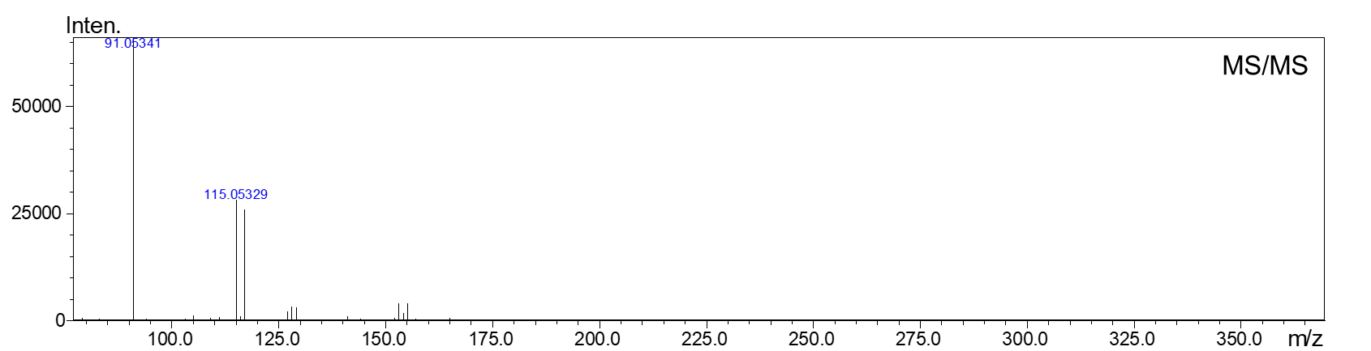

Figure 11. Positive ion electrospray HRMS (top panel) and MS/MS of peak 8 with m/z 233.1159 eluting at 14.86 min

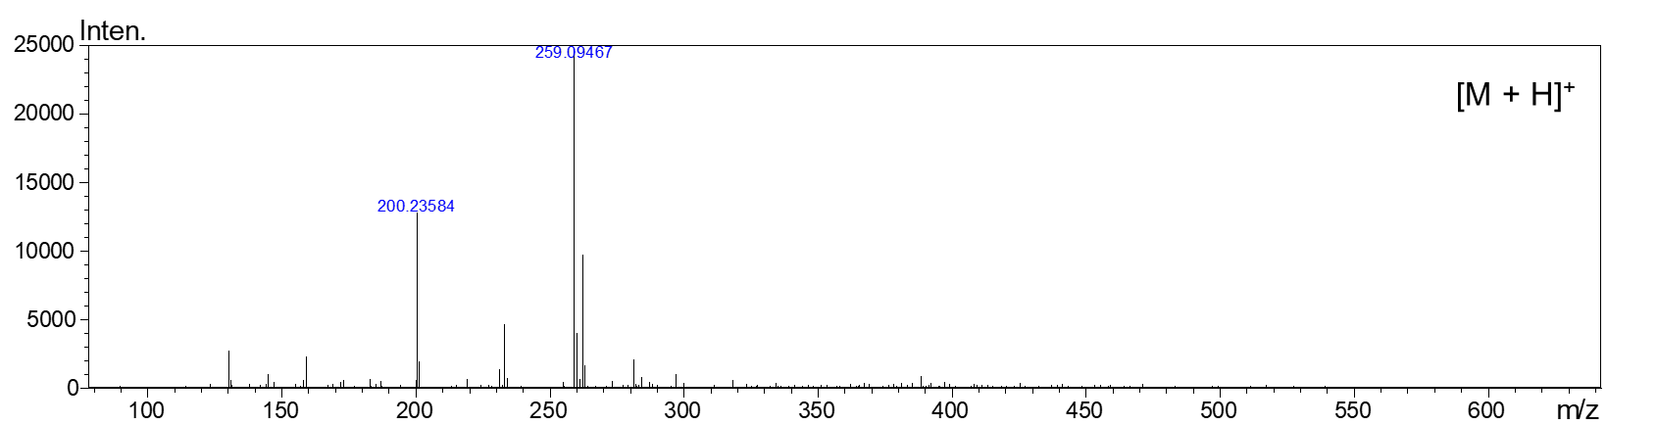
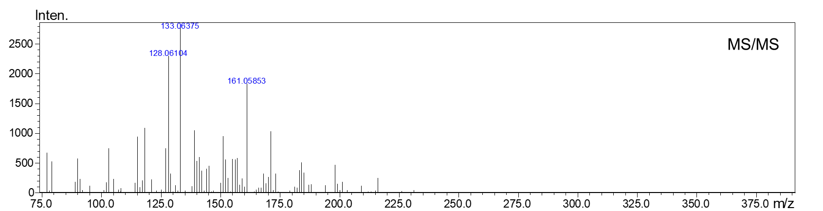
Figure 12. Positive ion electrospray HRMS (top panel) and MS/MS of peak 9a with m/z 259.0947 eluting at 15.33 min

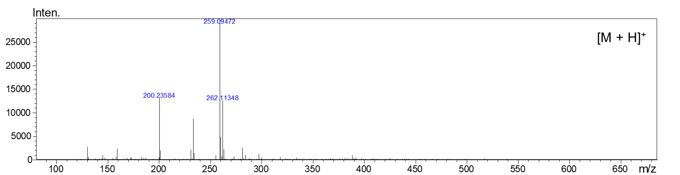
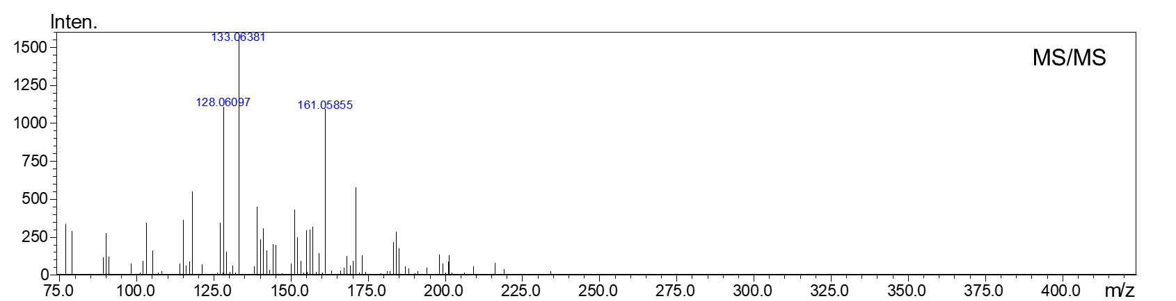
Figure 13. Positive ion electrospray HRMS (top panel) and MS/MS of peak 9b with m/z 262.1135 eluting at 15.33 min

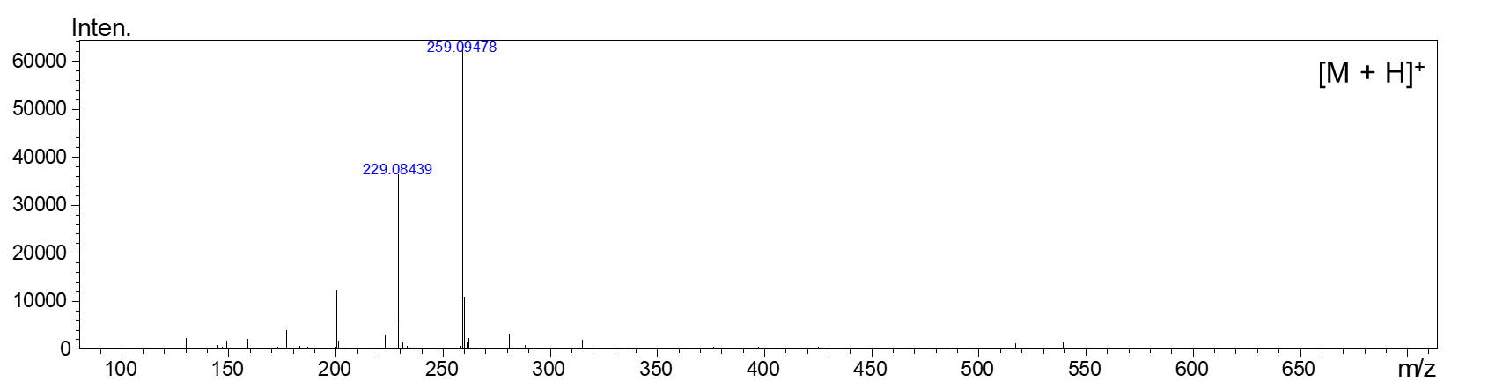
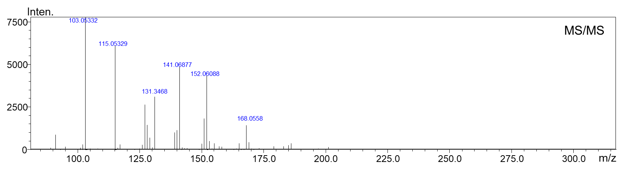
Figure 14. Positive ion electrospray HRMS (top panel) and MS/MS of peak 10a with m/z 229.0844 eluting at 16.35 min

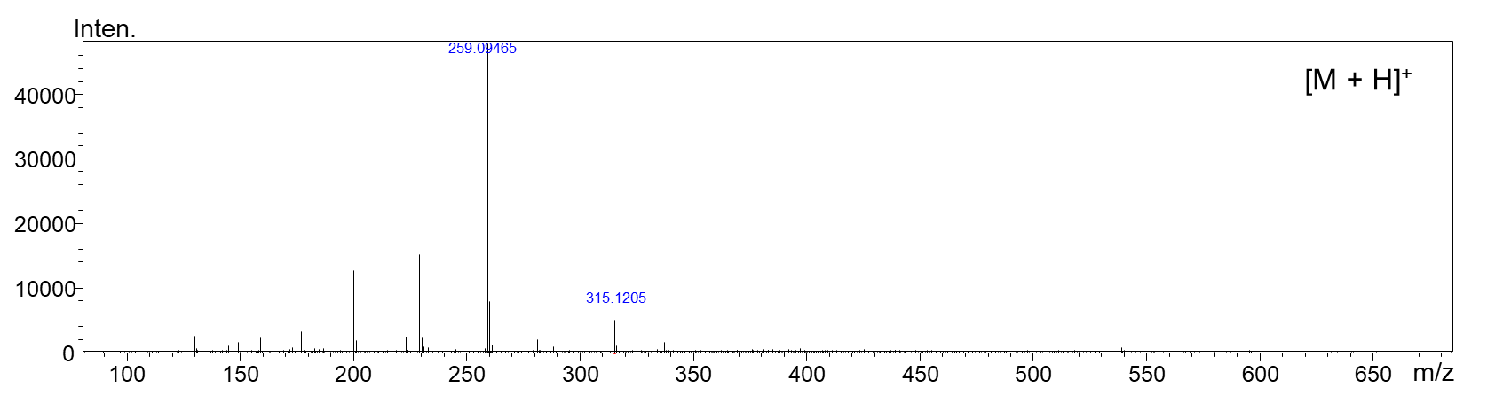
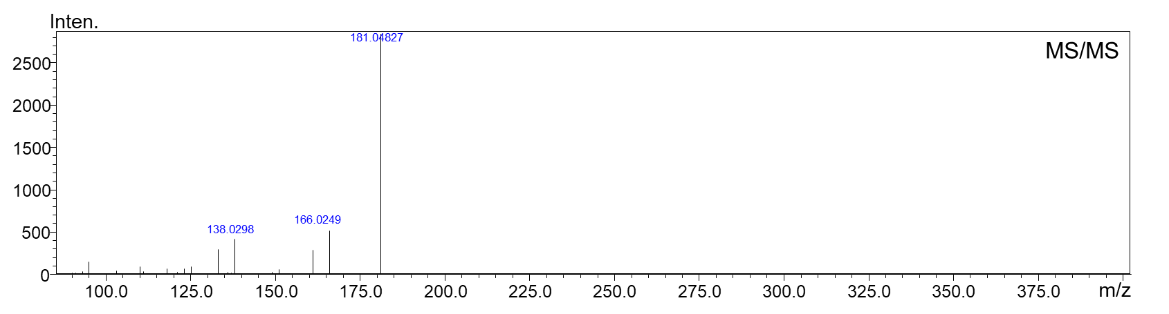

Figure 15. Positive ion electrospray HRMS (top panel) and MS/MS of peak 10b with m/z 315.1205 eluting at 16.61 min

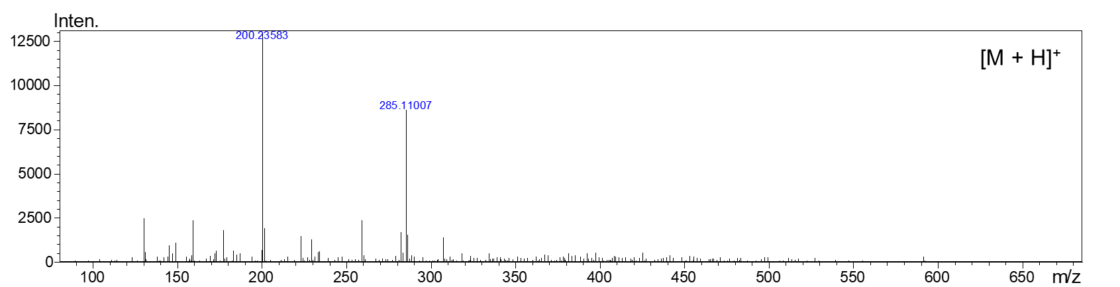
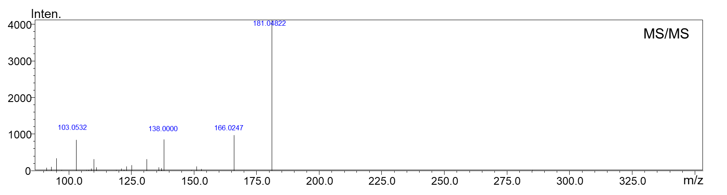

Figure 16. Positive ion electrospray HRMS (top panel) and MS/MS of peak 11 with m/z 285.1101 eluting at 17.02 min

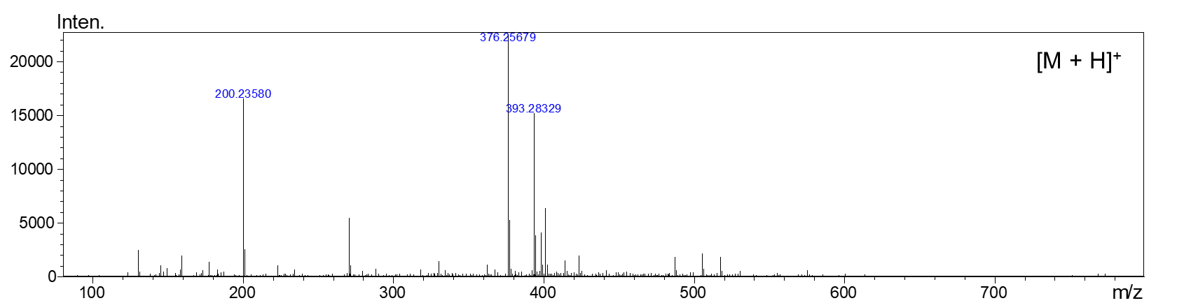
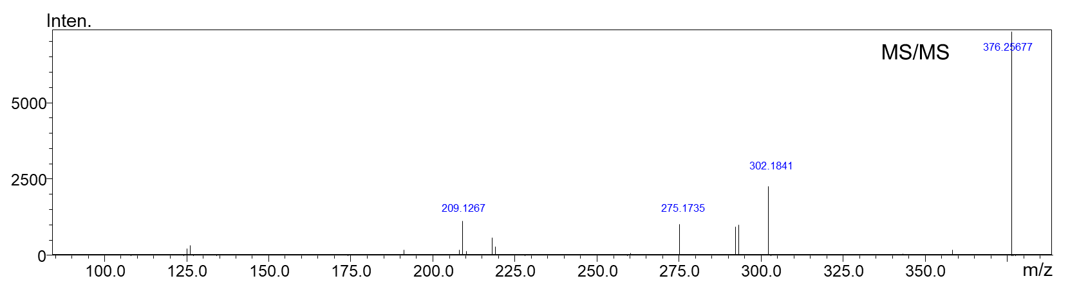

Figure 17. Positive ion electrospray HRMS (top panel) and MS/MS of peak 12 with m/z 393.2832 eluting at 19.49 min

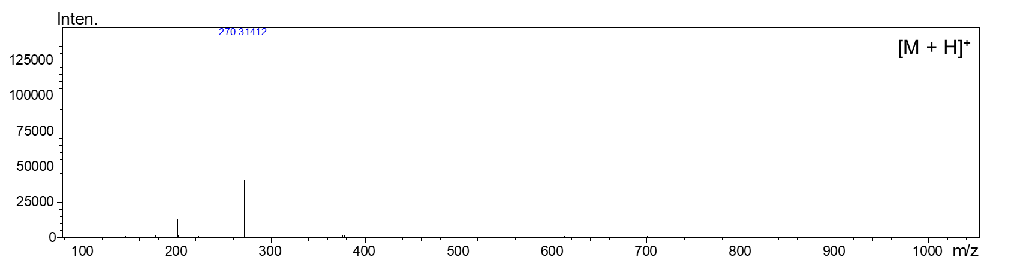
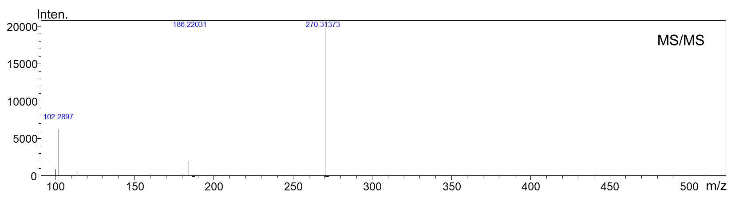
Figure 18. Positive ion electrospray HRMS (top panel) and MS/MS of peak 13 with m/z 270.3142 eluting at 20.76 min

