Analysis of Kratom (Mitragyna speciosa) Extract Using High Resolution UHPLC-MS and UHPLC-MS/MS

Richard B.van Breemen and Daniel G. Nosal
Department of Pharmaceutical Sciences
Linus Pauling Institute
Oregon State University
2900 Campus Way
Corvallis, OR 97331

Analysis date: May 22, 2022

Common Botanical Name | CAS No. | Lot No. | Container ID | Net Weight
Kratom extract  Kratom extract | NOCAS  NOCAS | RK-3-25-1-MS  RK-3-25-1-MS | C  D | ~250 mg  ~250 mg

UHPLC conditions | Mass spectrometer conditions
System: Shimadzu Nexara UHPLC (LC-30AD)  Column: Shimadzu Nexcol C₁₈ (2.1 x 50 mm, 1.8µm)  Mobile phase A: Water + 0.1% formic acid  Mobile phase B: Acetonitrile + 0.1% formic acid  Flow rate: 0.5 mL/min  Column temperature: 50 °C  Gradient:  Time (min) Mobile phase B (%)  0.00 5  0.50 5  23.0 100  26.0 100  27.0 5  30.0 5 | System: Shimadzu 9030 triple quadrupole time of flight (QToF)  Mode: Electrospray ionization  Polarity: Positive mode  Main-Interface:  · Interface voltage: 4.0 kV (+), -3.0 kV (-)  · Nebulizing gas flow: 3.0 L/min  · Heating gas flow: 10.0 L/min  · Interface temperature: 300 °C  · Desolvation temperature: 526 °C  Ion guide:  · Drying gas flow: 10.0 L/min  · DL temperature: 250 °C  · Heat block temperature: 400 °C

Table 1: Proposed identification of constituents of Kratom C extract using UHPLC-HRMS.
Peak No. | RT (min) | Exp. m/z | Mass accuracy  (ppm) | Proposed ID’s  (Confirmed with Std in green)  (Most probable ID is yellow) | Molecular Formula
1 | 2.864 | 291.0863 | -3.73 | Epicatechin | C₁₅H₁₄O₆
2 | 4.512 | 415.2227 | -2.98 | Ciliaphylline, Mitragynine-N-(4)-oxide, Speciociliatine-N-(4)-oxide | C₂₃H₃₀N₂O₅
3 | 4.867 | 415.2227 | -3.94 | Ciliaphylline, Mitragynine-N-(4)-oxide, Speciociliatine-N-(4)-oxide | C₂₃H₃₀N₂O₅
4 | 4.916 | 401.2071 | -2.21 | Isomitrafoline, Isospeciofoline, Mitrafoline, Stipulatine | C₂₂H₂₈N₂O₅
5 | 4.972 | 413.2071 | -2.41 | Epiallo-isopaynantheine-N-(4)-oxide, Isopaynantheine-N-(4)-oxide | C₂₃H₂₈N₂O₅
6 | 4.973 | 383.1965 | -0.22 | Corynoxeine | C₂₂H₂₆N₂O₄
7 | 5.014 | 385.2122 | -3.10 | 3-epicorynoxine B, 3-epirhynchophylline, 9-hydroxycorynantheidine, Isorhynchophylline | C₂₂H₂₈N₂O₄
8 | 5.195 | 385.2122 | -3.16 | 3-epicorynoxine B, 3-epirhynchophylline, 9-hydroxycorynantheidine, Isorhynchophylline | C₂₂H₂₈N₂O₄
9 | 5.201 | 401.2071 | -2.76 | Isomitrafoline, Isospeciofoline, Mitrafoline, Stipulatine | C₂₂H₂₈N₂O₅
10 | 5.216 | 383.1965 | 2.60 | Corynoxeine | C₂₂H₂₆N₂O₄
11 | 5.306 | 413.2071 | -2.07 | Epiallo-isopaynantheine-N-(4)-oxide, Isopaynantheine-N-(4)-oxide | C₂₃H₂₈N₂O₅
12 | 5.325 | 385.2122 | -3.34 | Corynoxine B | C₂₂H₂₈N₂O₄
13 | 5.369 | 415.2227 | -4.66 | Ciliaphylline, Mitragynine-N-(4)-oxide, Speciociliatine-N-(4)-oxide | C₂₃H₃₀N₂O₅
14 | 5.511 | 415.2227 | -2.98 | 7-hydroxymitragynine | C₂₃H₃₀N₂O₅
15 | 5.553 | 385.2122 | -3.31 | Rhynchophylline | C₂₂H₂₈N₂O₄
16 | 5.601 | 415.2227 | -3.22 | Ciliaphylline, Mitragynine-N-(4)-oxide, Speciociliatine-N-(4)-oxide | C₂₃H₃₀N₂O₅
17 | 5.793 | 385.2122 | -3.39 | Corynoxine A | C₂₂H₂₈N₂O₄
18 | 5.836 | 413.2071 | 3.21 | Epiallo-isopaynantheine-N-(4)-oxide, Isopaynantheine-N-(4)-oxide | C₂₃H₂₈N₂O₅
19 | 5.946 | 415.2227 | -4.16 | Ciliaphylline, Mitragynine-N-(4)-oxide, Speciociliatine-N-(4)-oxide | C₂₃H₃₀N₂O₅
20 | 6.036 | 415.2227 | -3.05 | Ciliaphylline, Mitragynine-N-(4)-oxide, Speciociliatine-N-(4)-oxide | C₂₃H₃₀N₂O₅
21 | 6.052 | 385.2122 | -0.74 | 3-epicorynoxine B, 3-epirhynchophylline, 9-hydroxycorynantheidine, Isorhynchophylline | C₂₂H₂₈N₂O₄
22 | 6.197 | 415.2227 | -3.58 | Ciliaphylline, Mitragynine-N-(4)-oxide, Speciociliatine-N-(4)-oxide | C₂₃H₃₀N₂O₅
23 | 6.488 | 397.2122 | -3.34 | Paynantheine | C₂₃H₂₈N₂O₄
24 | 6.539 | 399.2278 | -2.62 | Mitragynine | C₂₃H₃₀N₂O₄
25 | 6.792 | 399.2278 | -3.14 | Speciogynine | C₂₃H₃₀N₂O₄
26 | 7.108 | 399.2278 | -3.02 | Speciociliatine | C₂₃H₃₀N₂O₄
27 | 7.178 | 413.2071 | 2.58 | Epiallo-isopaynantheine-N-(4)-oxide, Isopaynantheine-N-(4)-oxide | C₂₃H₂₈N₂O₅
28 | 7.26 | 395.1965 | -2.02 | 3,4,5,6-tetradehydromitragynine | C₂₃H₂₇N₂O₄⁺
29 | 7.289 | 397.2122 | -3.06 | Mitraciliatine | C₂₃H₂₈N₂O₄
30 | 7.347 | 415.2227 | 0.85 | Ciliaphylline, Mitragynine-N-(4)-oxide, Speciociliatine-N-(4)-oxide | C₂₃H₃₀N₂O₅
31 | 7.468 | 397.2122 | -3.16 | Mitraciliatine | C₂₃H₂₈N₂O₄
32 | 7.524 | 395.1965 | -2.71 | 3,4,5,6-tetradehydromitragynine | C₂₃H₂₇N₂O₄⁺
33 | 7.608 | 399.2278 | -4.95 | Unknown | C₂₃H₃₀N₂O₄

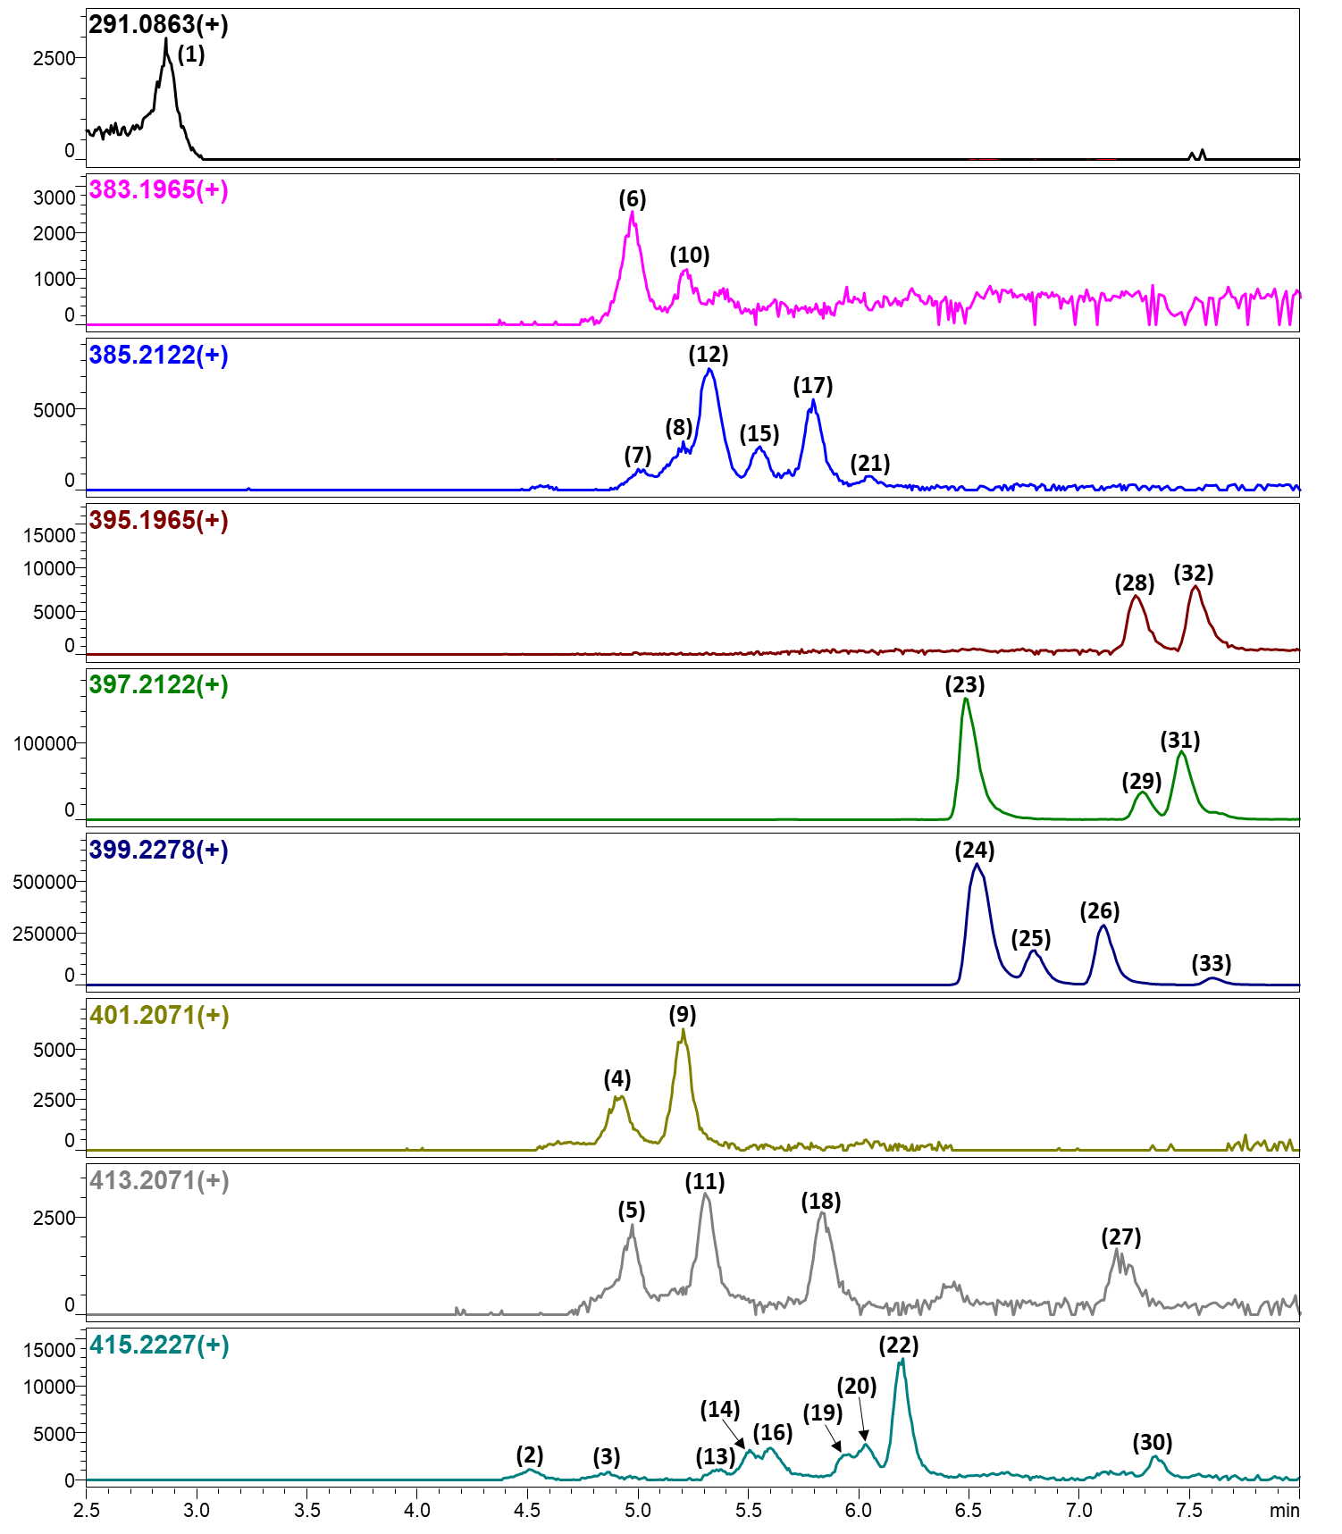
Figure 1: UHPLC-HRMS computer reconstructed mass chromatograms for m/z 291.0863, 383.1965, 385.2122, 395.1965, 397.2122, 399.2278, 401.2071, 413.2071, and 415.2227 from the Kratom C extract.

Table 2: Proposed identification of constituents of Kratom D extract using UHPLC-HRMS.
Peak No. | RT (min) | Exp. m/z | Mass accuracy  (ppm) | Proposed ID’s  (Confirmed with Std in green)  (Most probable ID is yellow) | Molecular Formula
1 | 2.86 | 291.0857 | -2.15 | Epicatechin | C₁₅H₁₄O₆
2 | 4.52 | 415.2217 | -2.52 | Ciliaphylline, Mitragynine-N-(4)-oxide, Speciociliatine-N-(4)-oxide | C₂₃H₃₀N₂O₅
3 | 4.86 | 415.2215 | -2.90 | Ciliaphylline, Mitragynine-N-(4)-oxide, Speciociliatine-N-(4)-oxide | C₂₃H₃₀N₂O₅
4 | 4.92 | 401.2066 | -1.23 | Isomitrafoline, Isospeciofoline, Mitrafoline, Stipulatine | C₂₂H₂₈N₂O₅
5 | 4.98 | 413.2064 | -1.73 | Epiallo-isopaynantheine-N-(4)-oxide, Isopaynantheine-N-(4)-oxide | C₂₃H₂₈N₂O₅
6 | 4.98 | 383.1968 | 0.72 | Corynoxeine | C₂₂H₂₆N₂O₄
7 | 5.02 | 385.2113 | -2.32 | 3-epicorynoxine B, 3-epirhynchophylline, 9-hydroxycorynantheidine, Isorhynchophylline | C₂₂H₂₈N₂O₄
8 | 5.21 | 385.2113 | -2.30 | 3-epicorynoxine B, 3-epirhynchophylline, 9-hydroxycorynantheidine, Isorhynchophylline | C₂₂H₂₈N₂O₄
9 | 5.21 | 401.2063 | -1.91 | Isomitrafoline, Isospeciofoline, Mitrafoline, Stipulatine | C₂₂H₂₈N₂O₅
10 | 5.23 | 383.1973 | 1.94 | Corynoxeine | C₂₂H₂₆N₂O₄
11 | 5.32 | 413.2068 | -0.64 | Epiallo-isopaynantheine-N-(4)-oxide, Isopaynantheine-N-(4)-oxide | C₂₃H₂₈N₂O₅
12 | 5.34 | 385.2114 | -2.17 | Corynoxine B | C₂₂H₂₈N₂O₄
13 | 5.37 | 415.2215 | -2.95 | Ciliaphylline, Mitragynine-N-(4)-oxide, Speciociliatine-N-(4)-oxide | C₂₃H₃₀N₂O₅
14 | 5.53 | 415.2217 | -2.54 | 7-hydroxymitragynine | C₂₃H₃₀N₂O₅
15 | 5.57 | 385.2116 | -1.65 | Rhynchophylline | C₂₂H₂₈N₂O₄
16 | 5.62 | 415.2218 | -2.18 | Ciliaphylline, Mitragynine-N-(4)-oxide, Speciociliatine-N-(4)-oxide | C₂₃H₃₀N₂O₅
17 | 5.81 | 385.2114 | -2.01 | Corynoxine A | C₂₂H₂₈N₂O₄
18 | 5.85 | 413.2064 | -1.71 | Epiallo-isopaynantheine-N-(4)-oxide, Isopaynantheine-N-(4)-oxide | C₂₃H₂₈N₂O₅
19 | 5.96 | 415.2216 | -2.83 | Ciliaphylline, Mitragynine-N-(4)-oxide, Speciociliatine-N-(4)-oxide | C₂₃H₃₀N₂O₅
20 | 6.06 | 415.2215 | -3.10 | Ciliaphylline, Mitragynine-N-(4)-oxide, Speciociliatine-N-(4)-oxide | C₂₃H₃₀N₂O₅
21 | 6.07 | 385.21347 | 3.33 | 3-epicorynoxine B, 3-epirhynchophylline, 9-hydroxycorynantheidine, Isorhynchophylline | C₂₂H₂₈N₂O₄
22 | 6.22 | 415.2218 | -2.37 | Ciliaphylline, Mitragynine-N-(4)-oxide, Speciociliatine-N-(4)-oxide | C₂₃H₃₀N₂O₅
23 | 6.51 | 397.2113 | -2.23 | Paynantheine | C₂₃H₂₈N₂O₄
24 | 6.56 | 399.2273 | -1.44 | Mitragynine | C₂₃H₃₀N₂O₄
25 | 6.82 | 399.2269 | -2.24 | Speciogynine | C₂₃H₃₀N₂O₄
26 | 7.13 | 399.2270 | -2.17 | Speciociliatine | C₂₃H₃₀N₂O₄
27 | 7.22 | 413.2086 | 3.67 | Epiallo-isopaynantheine-N-(4)-oxide, Isopaynantheine-N-(4)-oxide | C₂₃H₂₈N₂O₅
28 | 7.29 | 395.1962 | -0.81 | 3,4,5,6-tetradehydromitragynine | C₂₃H₂₇N₂O₄⁺
29 | 7.31 | 397.2114 | -2.08 | Mitraciliatine | C₂₃H₂₈N₂O₄
30 | 7.38 | 415.2223 | -1.00 | Ciliaphylline, Mitragynine-N-(4)-oxide, Speciociliatine-N-(4)-oxide | C₂₃H₃₀N₂O₅
31 | 7.49 | 397.2113 | -2.33 | Mitraciliatine | C₂₃H₂₈N₂O₄
32 | 7.55 | 395.1965 | -0.08 | 3,4,5,6-tetradehydromitragynine | C₂₃H₂₇N₂O₄⁺
33 | 7.63 | 399.2269 | -2.29 | Unknown | C₂₃H₃₀N₂O₄

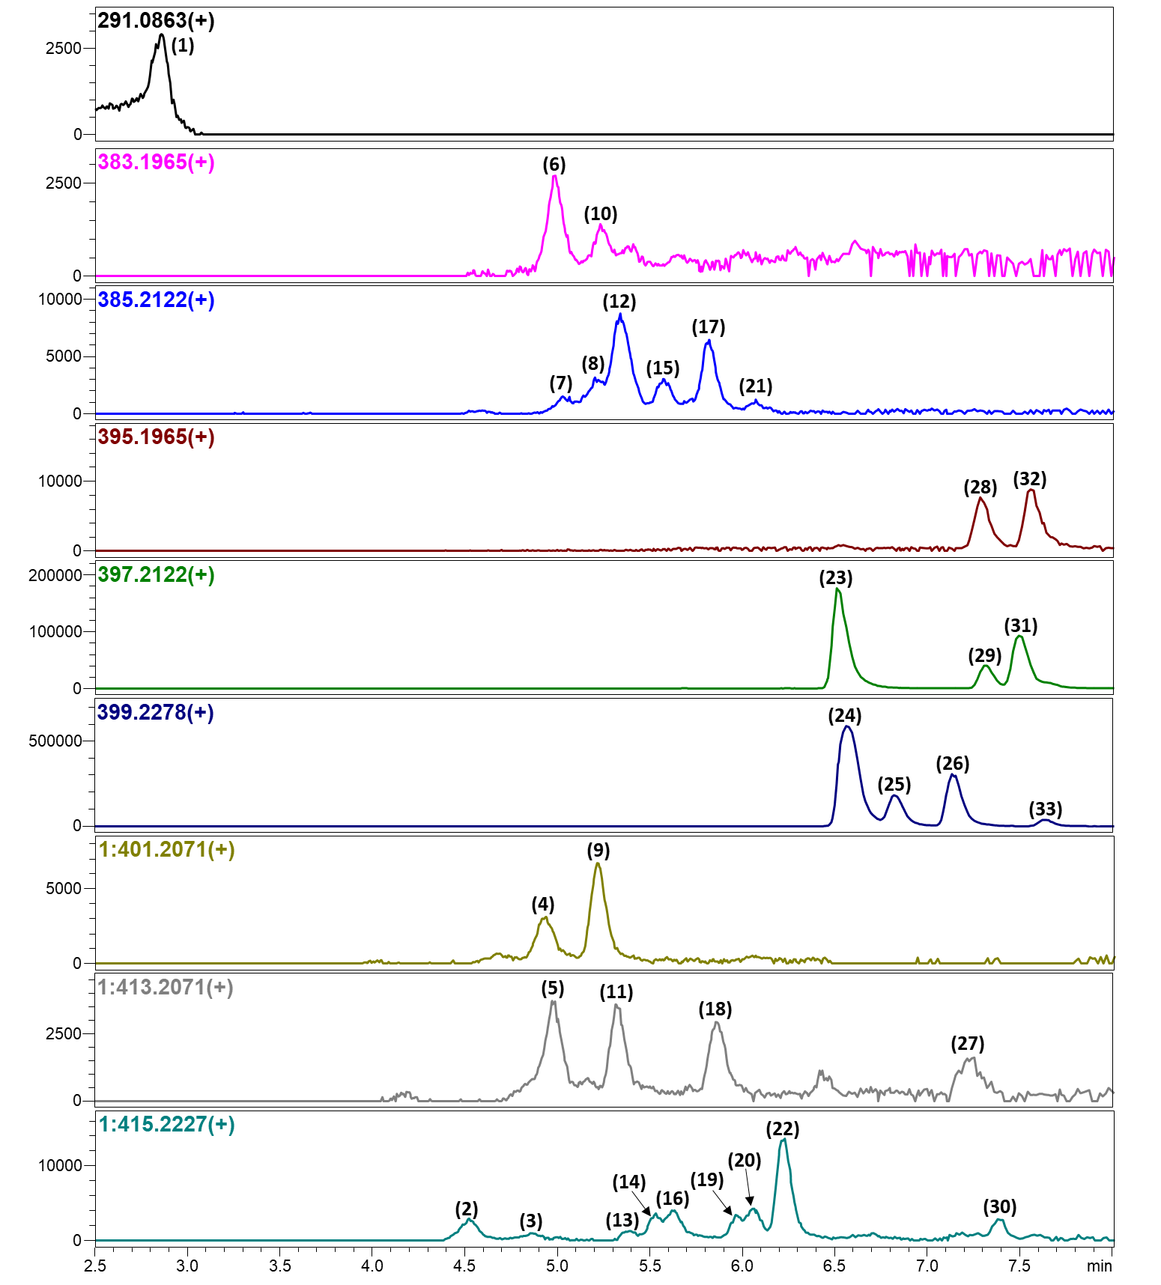
Figure 2: UHPLC-HRMS computer reconstructed mass chromatograms for m/z 291.0863, 383.1965, 385.2122, 395.1965, 397.2122, 399.2278, 401.2071, 413.2071, and 415.2227 from the Kratom D extract.

Figure 3: Structures of compounds in Kratom C and D extracts (Tables 1 and 2).
Table 3: HRMS product ions for the peaks of the Kratom C extract.
Peak No. | RT (min) | [M+H]⁺ m/z | Proposed Compounds  (Confirmed with Std in green)  (Probable ID is yellow)  CAS Number | Product Ions  m/z Rel. Int..
1 | 2.864 | 291.0863 | Epicatechin  490-46-0 | 77.04001 6  93.03254 4  105.0320 4  111.0427 7  115.0531 8  119.0483 19  123.0431 100  139.0383 93  143.0475 9  147.0428 30  161.0587 14
2 | 4.512 | 415.2227 | Ciliaphylline (18002-98-7)  Mitragynine-N-(4)-oxide, Speciociliatine-N-(4)-oxide | 190.0840 100  381.1822 35  397.2106 35
3 | 4.867 | 415.2227 | Ciliaphylline (18002-98-7)  Mitragynine-N-(4)-oxide, Speciociliatine-N-(4)-oxide | 190.0845 100
4 | 4.916 | 401.2071 | Isomitrafoline, Isospeciofoline, Mitrafoline, Stipulatine | 148.0400 25  148.0751 14  158.0580 34  176.0694 74  197.1127 9  229.1006 13  257.1275 33  283.1419 18  285.1586 23  369.1778 77  401.2058 100
5 | 4.972 | 413.2071 | Epiallo-isopaynantheine-N-(4)-oxide, Isopaynantheine-N-(4)-oxide | 150.0555 14  200.0585 4  215.0816 7  254.1055 17  269.1275 100  381.1753 6  411.1926 4  413.2076 27
6 | 4.973 | 383.1965 | Corynoxeine  6877-32-3 | 118.0650 10  132.0811 25  142.0642 17  160.0755 100  267.1461 15  351.1726 13  383.1979 27
7 | 5.014 | 385.2122 | 3-Epicorynoxine B, 3-Epirhynchophylline, 9-Hydroxycorynantheidine, Isorhynchophylline | 110.0955 29  132.0805 8  160.0756 100  186.0948 8  238.1453 15  385.2089 15
8 | 5.195 | 385.2122 | 3-Epicorynoxine B, 3-Epirhynchophylline, 9-Hydroxycorynantheidine, Isorhynchophylline | 108.0798 37  130.0658 33  132.0773 21  144.0810 29  160.0758 100  241.1338 94  269.1659 25  321.1586 30  385.2133 60
9 | 5.201 | 401.2071 | Isomitrafoline, Isospeciofoline, Mitrafoline, Stipulatine | 110.0964 11  122.0957 6  123.0792 7  130.0663 9  148.0375 9  148.0746 11  158.0616 11  168.1018 3  176.0697 73  229.0990 6  257.1275 19  285.1588 22  337.1518 5  369.1665 3  369.1802 30  401.2057 100
10 | 5.216 | 383.1965 | Corynoxeine  6877-32-3 | 108.0799 67  142.0642 60  160.0754 100
11 | 5.306 | 413.2071 | Epiallo-isopaynantheine-N-(4)-oxide, Isopaynantheine-N-(4)-oxide | 108.0816 12  172.0739 6  175.0630 8  188.0688 6  190.0857 41  217.0960 18  231.1119 11  297.1574 5  413.2052 100
12 | 5.325 | 385.2122 | Corynoxine B  17391-18-3 | 109.8998 3  110.0245 3  110.0961 22  115.0538 11  117.0569 11  118.0654 6  132.0435 13  132.0799 32  142.0642 19  144.0788 9  158.0591 12  160.0749 100  162.0911 3  170.0967 5  187.0847 37  213.1021 11  215.1171 11  241.1337 85  265.1354 6  267.1489 12  269.1648 25  321.1562 6  353.1859 32  385.2105 81
13 | 5.369 | 415.2227 | Ciliaphylline, Mitragynine-N-(4)-oxide, Speciociliatine-N-(4)-oxide | 238.1481 100  415.2179 98
14 | 5.511 | 415.2227 | 7-Hydroxymitragynine  174418-82-7 | 108.0826 6  123.0804 6  162.0531 11  190.0867 26  208.1338 7  217.1005 8  239.1468 9  271.1433 43  383.1976 9  415.2228 100
15 | 5.553 | 385.2122 | Rhynchophylline  76-66-4 | 110.0959 23  132.0798 32  160.0746 100  226.1435 16  269.1607 11  385.2084 25
16 | 5.601 | 415.2227 | Ciliaphylline, Mitragynine-N-(4)-oxide, Speciociliatine-N-(4)-oxide | 108.0826 3  123.0804 3  162.0531 5  190.0860 20  208.1326 7  217.0928 5  217.1005 4  239.1468 4  271.1434 34  383.1947 14  415.2222 100
17 | 5.793 | 385.2122 | Corynoxine A  6877-32-3 | 108.0800 9  109.9823 2  110.0957 35  132.0437 13  132.0801 34  142.0648 27  158.0589 5  160.0746 100  215.1200 4  226.1442 6  241.1330 25  265.1294 9  267.1505 10  269.1639 29  321.1531 5  353.1839 30  385.2113 63
18 | 5.836 | 413.2071 | Epiallo-isopaynantheine-N-(4)-oxide, Isopaynantheine-N-(4)-oxide | 86.2225 6  162.0914 9  190.0849 66  243.1114 12  297.1581 31  395.1968 100  413.2066 97
19 | 5.946 | 415.2227 | Ciliaphylline, Mitragynine-N-(4)-oxide, Speciociliatine-N-(4)-oxide | 110.0960 21  190.0859 100  271.1440 29  415.2224 65
20 | 6.036 | 415.2227 | Ciliaphylline, Mitragynine-N-(4)-oxide, Speciociliatine-N-(4)-oxide | 110.0962 10  123.0805 8  162.0905 7  172.0742 5  175.0586 5  190.0856 25  192.1011 6  208.1292 9  224.1267 6  299.1745 4  415.2225 100
21 | 6.052 | 385.2122 | 3-epicorynoxine B, 3-epirhynchophylline, 9-hydroxycorynantheidine, Isorhynchophylline | 160.0755 100
22 | 6.197 | 415.2227 | Ciliaphylline, Mitragynine-N-(4)-oxide, Speciociliatine-N-(4)-oxide | 108.0811 5  110.0238 2  110.0957 31  116.0477 4  129.0532 4  130.0633 3  138.0520 3  144.0796 2  147.0669 9  160.0387 2  162.0541 13  162.0911 10  168.1025 3  171.1006 4  172.0716 2  172.0752 15  174.0916 3  175.0626 10  188.0702 2  190.0855 100  217.0959 3  226.1450 15  245.1280 4  271.1434 26  295.1439 6  297.1599 4  299.1745 15  383.1958 26  415.2214 79
23 | 6.488 | 397.2122 | Paynantheine  4697-66-9 | 91.0540 2  95.0482 2  108.0799 8  109.0643 3  115.0536 3  117.0698 5  118.0645 3  120.0808 3  127.0538 2  129.0550 3  129.0682 2  130.0647 2  131.0727 3  143.0718 5  144.0799 10  146.0956 2  147.0743 2  149.0583 2  159.0671 29  160.0745 3  169.0863 2  174.0905 100  185.0822 2  186.0903 4  190.0852 2  192.1017 5  199.0984 2  200.1062 6  204.1008 4  210.0902 2  212.1054 3  224.1277 11  236.1058 2  236.1275 8  328.1528 3  397.2112 5
24 | 6.539 | 399.2278 | Mitragynine  4098-40-2 | 75.0435 2  108.0802 2  110.0958 20  115.0537 3  117.0692 5  118.0645 2  122.0958 2  127.0534 2  129.0542 10  130.0645 3  131.0723 3  139.0746 3  143.0722 5  144.0800 8  146.0956 4  152.0698 2  159.0671 29  160.0749 3  166.0856 2  168.1011 6  171.1009 2  174.0906 100  184.0749 2  185.0828 2  186.0906 2  188.106 2  194.1168 3  199.0981 2  200.1062 7  202.1218 2  206.117 2  210.0906 3  212.1061 2  226.143 22  238.1429 22  255.1483 2  367.2005 4  399.2266 17
25 | 6.792 | 399.2278 | Speciogynine  4697-67-0 | 75.0433 2  108.0803 3  110.0959 14  115.0537 2  117.0694 5  118.0647 2  127.0540 2  129.0542 10  130.0643 2  131.0722 3  139.0752 2  143.0723 5  144.0802 7  146.0956 3  159.0671 28  160.0751 3  171.1007 5  174.0906 100  177.0907 2  186.0904 2  188.1065 2  194.1171 3  200.1062 5  206.1167 2  212.1061 2  226.1431 18  238.1428 21  266.1526 2  328.154 2  367.2007 2  399.2266 12
26 | 7.108 | 399.2278 | Speciociliatine  14382-79-7 | 75.0436 2  95.0486 2  108.0802 2  110.0959 16  115.0537 2  117.0695 6  118.0647 2  122.0959 2  127.0537 2  129.0541 11  130.0641 2  131.0726 2  139.0745 2  143.0721 4  144.0801 8  146.0954 4  152.0699 2  159.0673 26  160.075 4  162.0905 2  168.1012 5  171.1006 2  174.0906 100  177.0902 2  180.1015 2  182.1168 2  184.0748 2  185.0831 2  186.0908 4  188.1061 5  194.1167 3  198.0907 2  199.0984 3  200.1063 7  206.1169 2  210.0904 4  212.1063 4  224.1067 2  226.1429 19  236.1063 3  238.0858 2  238.1428 20  255.1484 2  264.1013 2  266.1529 3  270.1117 2  296.1275 3  328.1533 5  335.1739 2  367.2007 7  399.2268 18
27 | 7.178 | 413.2071 | Epiallo-isopaynantheine-N-(4)-oxide, Isopaynantheine-N-(4)-oxide | 190.0837 26  199.0852 35  200.0979 36  214.1086 100  381.1806 95  395.1920 38
28 | 7.26 | 395.1965 | 3,4,5,6-Tetradehydromitragynine | 172.0765 7  186.0902 14  198.0904 13  199.0860 6  211.0858 26  212.0952 10  227.1164 100  235.0838 4  237.1031 5  239.1167 6  250.1130 4  250.1236 4  251.1170 10  263.1165 11  264.1225 5  279.1487 50  293.0899 11  309.12 7  379.1641 78  395.1951 93
29 | 7.289 | 397.2122 | Mitraciliatine  14509-92-3 | 91.0541 4  95.0484 2  108.0803 6  109.0638 6  115.0539 2  117.0563 2  117.0690 3  118.0644 3  120.0792 3  121.0640 5  123.0435 2  126.0905 3  129.0547 2  130.0644 2  131.0726 3  143.0718 3  144.0799 9  146.0592 2  146.096 3  148.0742 2  149.0588 4  155.0702 2  159.0674 26  160.075 7  169.0867 3  172.0755 2  173.0824 2  174.0905 100  178.0847 3  180.0993 2  181.0855 2  184.0757 2  185.0827 5  186.0894 5  188.1053 4  192.101 4  198.0906 3  199.0961 3  200.1064 19  202.122 2  210.0901 3  210.111 3  212.1062 7  224.1273 8  229.1334 2  236.1276 8  328.1525 4  365.186 2  397.2112 11
30 | 7.347 | 415.2227 | Ciliaphylline, Mitragynine-N-(4)-oxide, Speciociliatine-N-(4)-oxide | 158.0597 18  174.0889 34  186.0904 14  214.1084 100  255.1437 18  269.1643 30  383.1977 48  397.2101 72
31 | 7.468 | 397.2122 | Mitraciliatine  14509-92-3 | 172.0750 4  174.0906 2  184.0628 2  186.0906 6  187.0987 2  198.0780 2  198.0911 4  199.0860 5  211.0863 9  212.0936 7  214.1094 2  223.0841 2  227.1172 42  237.1020 2  238.1091 2  239.1167 4  251.1175 9  252.1332 4  253.133 5  265.1332 10  266.1412 2  279.1472 3  281.164 43  293.0913 2  309.1218 2  321.1216 2  365.1838 2  381.1799 71  382.1871 6  397.2109 100
32 | 7.524 | 395.1965 | 3,4,5,6-Tetradehydromitragynine | 169.0742 2  197.0711 3  210.0756 2  211.0849 7  212.0938 13  236.0926 3  237.1013 12  249.0974 3  250.1131 2  251.1165 12  263.1144 2  264.1243 11  279.1474 20  291.1094 3  291.1484 2  292.088 6  303.1482 2  320.1111 2  320.1513 3  380.1714 42  395.1957 100
33 | 7.608 | 399.2278 | Unknown | 110.0963 11  115.0541 2  117.0691 6  118.0641 3  122.0952 2  129.0539 10  130.0655 2  131.0713 2  139.0748 2  143.0736 3  144.0795 8  146.0962 4  159.0674 25  160.0744 5  166.0861 2  171.1010 3  172.0741 2  174.0906 100  177.0906 5  184.0746 2  185.0837 2  186.0904 3  188.1053 6  194.1158 3  198.0919 2  199.0986 2  200.1066 15  202.1209 2  206.1155 2  210.0892 2  212.106 2  224.1258 2  226.1434 15  238.1428 24  266.1524 3  281.1629 3  283.1781 2  328.1531 2  367.1998 4  399.2253 28

Table 4: HRMS product ion m/z’s for the identified peaks of the Kratom C extract.
Peak No. | RT (min) | [M+H]⁺  m/z | Proposed Compounds  (Confirmed with Std in green)  (Probable ID is yellow) | Product Ions  m/z Rel. Int..
1 | 2.864 | 291.0863 | Epicatechin  490-46-0 | 77.0384 11  91.0536 14  93.0326 5  95.0477 6  105.0312 4  111.0430 6  115.0545 7  119.0489 13  123.0432 100  139.0379 62  142.7416 2  147.0440 27
2 | 4.512 | 415.2227 | Ciliaphylline, Mitragynine-N-(4)-oxide, Speciociliatine-N-(4)-oxide | 110.0956 5  147.0677 12  162.0554 5  175.0616 38  190.0853 100  226.1437 8  238.1419 16  281.1629 12  381.1796 9  397.2123 29  415.2178 11
3 | 4.867 | 415.2227 | Ciliaphylline, Mitragynine-N-(4)-oxide, Speciociliatine-N-(4)-oxide | 190.0850 100
4 | 4.916 | 401.2071 | Isomitrafoline, Isospeciofoline, Mitrafoline, Stipulatine | 110.0962 17  130.0655 9  158.0618 8  176.0695 100  229.0953 18  257.1266 41  283.1055 7  283.1434 23  285.1608 10  369.1800 52  401.2070 93
5 | 4.972 | 413.2071 | Epiallo-isopaynantheine-N-(4)-oxide, Isopaynantheine-N-(4)-oxide | 150.0529 30  212.0649 7  215.0814 11  226.0734 5  241.0926 4  251.0810 4  254.1053 27  269.1276 100  295.1429 5  297.1582 11  381.1786 20  411.1917 7  413.2078 31
6 | 4.973 | 383.1965 | Corynoxeine  6877-32-3 | 108.0808 12  117.0564 7  132.0791 22  142.0644 10  158.0593 14  160.0751 100  201.1004 33  267.1514 18
7 | 5.014 | 385.2122 | 3-epicorynoxine B, 3-epirhynchophylline, 9-hydroxycorynantheidine, Isorhynchophylline | 160.0743 100  226.1421 30  385.2091 22
8 | 5.195 | 385.2122 | 3-epicorynoxine B, 3-epirhynchophylline, 9-hydroxycorynantheidine, Isorhynchophylline | 108.0793 7  130.0643 7  132.0806 19  158.0583 9  160.0748 100  187.0863 16  226.1466 9  241.1332 90  265.1285 10  269.1611 28  353.1859 40  385.2132 63
9 | 5.201 | 401.2071 | Isomitrafoline, Isospeciofoline, Mitrafoline, Stipulatine | 108.0790 4  110.0954 20  130.0672 3  134.0595 5  148.0391 8  148.0744 19  158.0590 8  168.1035 2  171.1007 4  176.0703 85  194.1174 4  203.0813 2  226.1435 3  229.0973 4  231.1139 5  257.1281 18  283.1454 8  285.1596 18  337.1572 3  369.181 23  401.2062 100
10 | 5.216 | 383.1965 | Corynoxeine | 115.0528 39  132.0801 30  160.0747 100
11 | 5.306 | 413.2071 | Epiallo-isopaynantheine-N-(4)-oxide, Isopaynantheine-N-(4)-oxide | 99.2115 2  108.0812 11  115.0507 3  160.0392 5  190.0862 33  217.0957 27  231.1126 16  297.1584 15  413.2058 100
12 | 5.325 | 385.2122 | Corynoxine B  17391-18-3 | 91.0545 3  108.0792 4  110.0954 24  115.0543 5  118.0636 7  123.0797 9  124.1115 3  130.0638 5  132.0440 14  132.0806 26  140.0495 3  142.0646 18  144.0799 12  158.0583 6  160.0751 100  168.1004 10  172.0753 3  187.0855 27  215.1164 6  226.1411 9  241.1326 72  265.135 4  267.1479 16  269.1635 26  353.1855 30  385.211 86
13 | 5.369 | 415.2227 | Ciliaphylline, Mitragynine-N-(4)-oxide, Speciociliatine-N-(4)-oxide | 190.0844 100  238.1417 55
14 | 5.511 | 415.2227 | 7-Hydroxymitragynine  174418-82-7 | 190.0845 31  208.1316 6  217.0985 19  271.1442 83  415.2219 100
15 | 5.553 | 385.2122 | Rhynchophylline  76-66-4 | 110.0950 15  110.0974 7  132.0427 12  132.0807 36  142.0652 13  160.0749 100  174.0893 27  186.0892 15  200.0834 4  226.1420 9  269.1638 18  385.2133 30
16 | 5.601 | 415.2227 | Ciliaphylline, Mitragynine-N-(4)-oxide, Speciociliatine-N-(4)-oxide | 209.0791 26  415.2214 100
17 | 5.793 | 385.2122 | Corynoxine A  6877-32-3 | 108.0794 4  110.0234 3  110.0969 30  110.1458 2  115.0547 5  118.0649 7  132.0433 10  132.0798 24  142.0651 22  144.0795 9  158.0560 3  160.0750 100  174.0922 8  187.0844 4  213.0982 4  226.1423 8  241.1344 20  265.1346 2  267.1479 6  269.1632 22  353.1836 23  385.2119 40
18 | 5.836 | 413.2071 | Epiallo-isopaynantheine-N-(4)-oxide, Isopaynantheine-N-(4)-oxide | 108.0806 10  162.0496 9  162.0912 10  172.0713 9  190.0852 72  198.0727 9  279.1520 14  297.1592 18  299.2011 4  365.1426 9  395.1957 66  413.2063 100
19 | 5.946 | 415.2227 | Ciliaphylline, Mitragynine-N-(4)-oxide, Speciociliatine-N-(4)-oxide | 110.0969 22  162.0893 21  168.1014 4  190.0855 100  271.1420 12  383.1962 17  415.2196 90
20 | 6.036 | 415.2227 | Ciliaphylline, Mitragynine-N-(4)-oxide, Speciociliatine-N-(4)-oxide | 110.0951 4  123.0797 8  127.0376 2  139.0384 3  189.0776 3  190.0852 16  192.1024 2  208.1341 3  210.1129 7  217.0948 3  239.1515 3  271.1413 9  383.1940 3  415.2215 100
21 | 6.052 | 385.2122 | 3-epicorynoxine B, 3-epirhynchophylline, 9-hydroxycorynantheidine, Isorhynchophylline | 144.0785 37  174.0901 100
22 | 6.197 | 415.2227 | Ciliaphylline, Mitragynine-N-(4)-oxide, Speciociliatine-N-(4)-oxide | 93.0697 2  98.0970 3  108.0809 5  110.0228 2  110.0961 30  116.0474 2  117.0697 2  124.1125 4  132.0816 2  139.0744 2  147.0665 3  147.0735 2  148.0752 2  160.0378 2  162.0551 10  162.0903 20  168.1008 5  171.1022 3  172.0742 14  174.0896 2  175.0617 18  188.0713 2  190.0853 100  194.1169 2  217.0989 4  226.143 16  243.1135 3  245.1281 3  271.1433 24  295.1423 3  297.1591 5  299.1753 20  383.1957 37  415.2225 90
23 | 6.488 | 397.2122 | Paynantheine  4697-66-9 | 91.0536 2  95.0490 2  106.0645 2  108.0802 8  109.0640 3  115.0538 2  117.0696 5  118.0646 3  120.0805 2  121.0645 2  127.0540 2  129.0544 3  130.0646 2  131.0725 3  132.0798 2  137.0590 2  143.0724 5  144.0802 9  146.096 3  149.0592 3  159.0672 29  160.0749 4  169.0859 3  174.0908 100  184.0751 2  185.0832 2  186.0906 4  192.1015 6  199.0982 2  200.1064 7  204.1011 5  212.106 3  224.1277 11  236.1273 9  281.1641 2  328.1537 2  397.2112 8
24 | 6.539 | 399.2278 | Mitragynine  4098-40-2 | 75.0436 2  108.0803 2  110.0959 20  115.0538 3  117.0694 5  118.0646 2  122.0959 2  127.0536 2  129.0543 10  130.0647 3  131.0724 3  139.0747 3  143.0723 5  144.0802 8  146.0957 4  152.0699 2  159.0673 28  160.0751 3  166.0857 2  168.1013 6  171.101 2  174.0908 100  185.0829 2  186.0909 2  188.1064 3  194.117 3  199.0983 2  200.1064 7  202.1219 2  206.1171 2  210.0908 3  212.1065 2  226.1431 22  236.1065 2  238.1431 22  255.1485 2  367.2009 4  399.2271 17
25 | 6.792 | 399.2278 | Speciogynine  4697-67-0 | 75.0436 2  108.0805 3  110.0959 13  115.0538 2  117.0693 5  118.0646 2  127.0541 2  129.0542 10  130.0648 2  131.0726 3  139.0743 2  143.0723 4  144.0801 7  146.0956 3  154.1224 2  159.0673 27  160.0753 3  168.1013 2  171.101 5  174.0907 100  177.0906 2  185.083 2  186.0904 3  188.1062 2  194.1169 3  200.1062 5  206.1177 2  212.1066 2  226.143 18  238.143 22  266.1529 2  328.1538 2  399.2265 12
26 | 7.108 | 399.2278 | Speciociliatine  14382-79-7 | 75.0435 2  95.0487 3  108.0804 2  110.0959 16  115.0537 3  117.0692 5  118.0647 2  122.0959 2  127.0538 2  129.0545 10  130.0648 2  131.0723 3  139.0748 2  143.0724 5  144.0802 8  146.0961 4  152.0701 2  159.0673 26  160.0752 4  162.0906 2  168.1013 5  171.1014 2  174.0907 100  182.1168 2  184.0748 2  185.0835 2  186.0909 4  188.1059 4  194.1172 3  198.0913 2  199.0981 3  200.1064 7  206.1169 2  210.0907 4  212.1066 3  224.1063 2  226.1432 18  236.1064 3  238.0858 2  238.143 19  264.1013 2  266.1531 3  270.1126 2  284.1269 2  296.1283 3  328.1541 5  367.2007 7  399.2272 16
27 | 7.178 | 413.2071 | Epiallo-isopaynantheine-N-(4)-oxide, Isopaynantheine-N-(4)-oxide | 97.0639 8  175.0600 33  190.0868 21  199.0833 14  200.0943 38  214.1092 100  253.1296 17  267.1483 19  381.1747 24  381.1828 40  395.1942 54
28 | 7.26 | 395.1965 | 3,4,5,6-Tetradehydromitragynine | 184.0632 4  186.0908 17  187.0976 7  198.0926 4  211.0863 22  212.0926 11  227.1170 74  237.1025 5  263.1190 9  277.1345 6  279.1487 52  293.0891 11  309.1218 8  379.1646 85  380.1727 6  395.1954 100
29 | 7.289 | 397.2122 | Mitraciliatine  14509-92-3 | 91.0538 3  95.0484 2  108.0804 6  109.0645 3  115.0546 2  117.0697 4  118.0650 3  120.0801 3  121.0639 4  126.0910 4  129.0543 2  130.0645 3  131.0728 3  132.0804 2  137.0586 2  143.0723 4  144.0801 9  146.0591 2  146.0961 3  149.0593 3  159.067 22  160.0752 7  162.0904 2  163.075 2  169.0852 3  171.0661 2  172.0758 2  173.0823 2  174.0909 100  178.0852 2  180.1021 2  181.0857 2  184.0754 3  185.0833 5  186.0907 7  188.1062 4  192.1018 5  197.0838 3  198.0912 3  199.0982 3  200.1063 20  204.1013 5  210.0907 2  210.1122 4  212.1069 7  222.112 2  224.1061 2  224.1279 10  226.1226 2  229.1331 2  236.107 2  236.1282 8  238.1225 2  264.1028 2  268.1321 2  281.1648 2  296.128 2  328.1532 4  365.1848 4  397.2113 16
30 | 7.347 | 415.2227 | Ciliaphylline, Mitragynine-N-(4)-oxide, Speciociliatine-N-(4)-oxide | 186.0943 19  199.0868 20  214.1097 100  269.1653 47  383.1983 80  397.2111 78
31 | 7.468 | 397.2122 | Mitraciliatine  14509-92-3 | 172.0750 4  174.0908 2  184.0627 2  186.0908 7  198.0901 6  199.0869 5  211.0860 8  212.0940 8  214.1088 2  223.0867 2  227.1174 36  237.1016 2  238.1098 2  239.1178 5  251.1174 10  252.1367 3  253.1334 5  265.1332 10  266.1415 3  279.149 2  281.1641 46  293.0903 2  309.1228 3  349.1532 2  365.185 2  381.1802 72  382.1888 5  397.2111 100
32 | 7.524 | 395.1965 | 3,4,5,6-Tetradehydromitragynine | 123.0799 5  169.0765 4  197.0689 4  198.0777 2  210.0726 2  211.0881 8  212.0939 14  222.0786 3  236.0950 4  237.1014 16  248.0923 3  249.1004 5  250.1084 3  251.1181 17  264.0904 2  264.1274 5  279.1484 23  288.1244 3  292.0823 5  293.164 2  319.1058 4  320.1507 2  348.1486 3  351.1692 3  363.1733 4  380.1735 50  395.195 100
33 | 7.608 | 399.2278 | Unknown | 75.0440 2  91.0531 2  108.0800 2  110.0966 10  117.0689 6  118.0648 2  129.0543 10  131.0719 2  143.0724 6  144.0802 7  146.0953 4  159.0672 26  160.0761 6  171.1019 3  172.0744 2  174.0907 100  177.0889 5  185.0835 2  186.0902 4  188.1065 5  194.1167 2  199.0971 3  200.1063 12  202.1212 2  210.0923 3  212.1065 3  226.1431 17  227.1172 2  229.1213 2  236.1057 2  238.1427 23  254.1526 2  266.1534 3  281.1632 3  283.1717 3  296.1275 2  328.1533 4  367.201 4  383.1852 4  399.225 33

