Analysis of Usnea Extract Using UPLC-MS/MS

Josh Kellogg, Teal Jordan

Pennsylvania State University

325 Huck Life Sciences Building
Pennsylvania State University
University Park, PA 16802

June 2022

Common Botanical Name | CAS No. | Lot No. | Container ID | Net Weight
Usnea lichen

Sample storage condition until analysis
-80 ℃

Quantitative/Targeted method:

UPLC-MS Method

UHPLC conditions | Mass spectrometry
System: Waters Acquity  Column: Waters Acquity Ultra C18 (2.1 x 100 mm, 1.7 um)  Mobile phase A: H₂O + 0.1% FA  Mobile phase B: CH₃CN + 0.1% FA  Flow rate: 0.3 mL/min  Column temperature: 50 ℃  Gradient  Time (min) Mobile phase B (%)  0 3  1.0 3  5.0 75  5.5 75  6.0 3 | System: Waters TQS  Ionization: Electrospray (ESI)  Polarity: Positive  Main Interface:  · Nebulizing gas flow: 150 L/hr  · Heating gas flow: 500 L/hr  · Interface temperature: 150 ℃  · Capillary voltage: 2.5 kV  · Cone voltage: 50 V  Ion guide:  · Drying gas flow: 0.15 mL/min  · Desolvation line temperature: 500 ℃  · Heat block temperature:  SRM dwell time:  Selected Reaction Monitoring (SRM) events  Compound Precursor ion (m/z) Product ion (m/z) Collision energy (V) Retention time (min)  Atranorin 373.09 - 45 3.35  p-coumaric acid 165.05 - 45 3.72  Ellagic acid 303.01 - 45 3.39  Gallic acid 171.03 - 45 0.50  Usnic acid 345.10 - 45 5.55  *Quantifier, †Qualifier

Quantitative results

Compound | Concentration in extract (mg/g)
Atranorin | 2.419 ± 0.070
p-coumaric acid | 0.560 ± 0.038
Ellagic acid | 227.2 ± 2.8
Gallic acid | 26.72 ± 0.32
Usnic acid | 141.6 ± 1.6

Standards
Name | Supplier | CAS Number | Catalog number | Purity % | Batch/Lot number
Atranorin | Phytolab | 479-20-9 | 84203-10mg | >98% | 118154304
p-coumaric acid | Sigma | 501-98-4 | C9008-1g | >98% | BCCF4731
Ellagic acid | Sigma | 476-66-4 | E2250-1g | >98% | BCCF5486
Gallic acid | Sigma | 149-91-7 | G7384-100g | >97.5% | SLCJ6385
Usnic acid | Sigma | 7562-61-0 | 329967-5g | >98% | MKCN5004

Chemical structures of standards used for quantitative analysis
Chromatograms
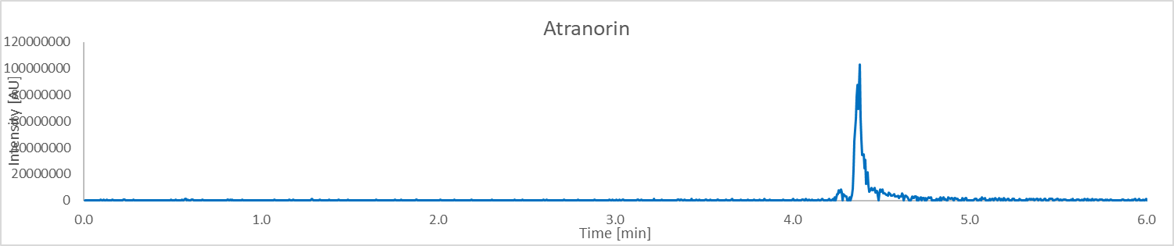
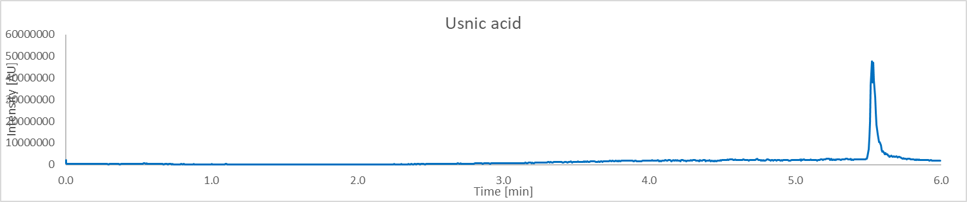
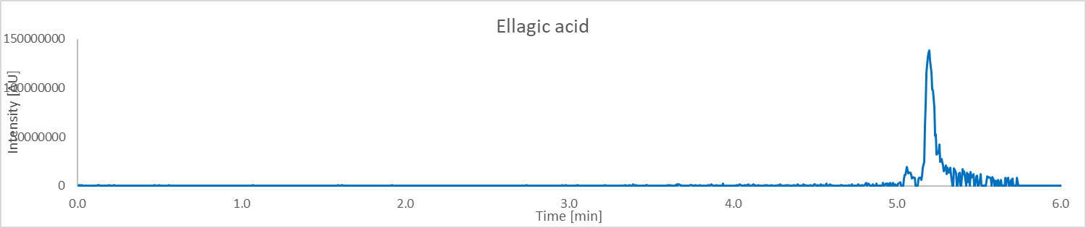
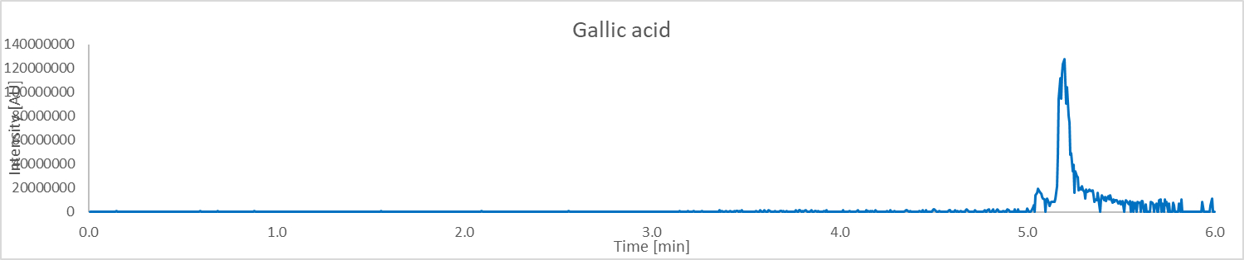
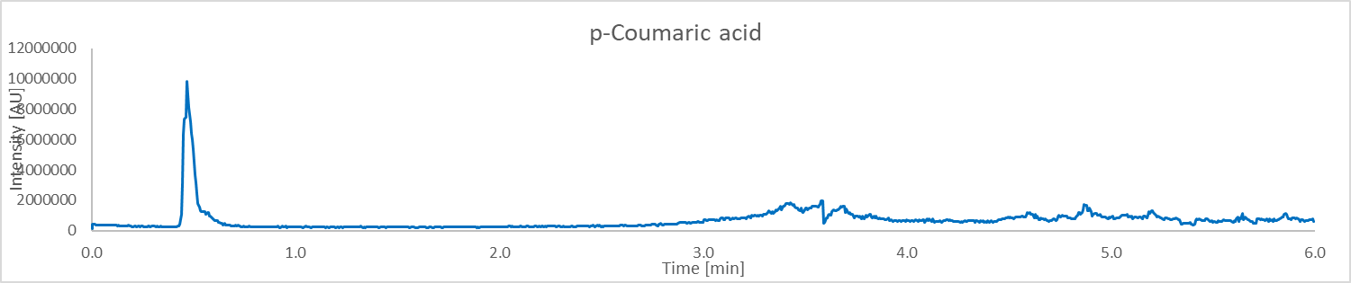
Calibration
Compound | Lower limit of quantitation (LLOQ) ug/mL | Calibration range (ug/mL) | Number of Calibration Points | R² | Concentration  mg/g in extract (n = 3)
Atranorin | 0.001 | 0.001 – 2.187 | 8 | 0.9991 | 2.419 ± 0.070
Usnic acid | 0.001 | 0.001 – 0.729 | 7 | 0.9997 | 141.6 ± 1.6
Ellagic acid | 0.003 | 0.003 – 19.683 | 9 | 0.9979 | 227.2 ± 2.8
Gallic acid | 0.081 | 0.081 – 19.683 | 7 | 0.9989 | 26.72 ± 0.32
p-coumaric acid | 0.001 | 0.001 – 0.729 | 7 | 0.9972 | 0.560 ± 0.038

Untargeted Analysis
UHPLC conditions | Mass spectrometer conditions
System: Thermo Vanquish  Column: Waters Acquity Ultra C18 (1.7 um, 1.0 x 150 mm)  Mobile phase A: H2O w/ 0.1% FA  Mobile phase B: ACN w/ 0.1% FA  Flow rate: 0.100 mL/min  Column temperature: 55℃  Gradient:  Time (min) Mobile phase B (%)  0 5  1 5  12.5 98  13.5 98  12.6 5  15 5 | System: Thermo Orbitrap Fusion Lumos  Mode: ESI  Polarity: positive/negative  Main-Interface:  · Interface voltage: 3500/2500  · Nebulizing gas flow: 25  · Heating gas flow: 5  · Interface temperature: 325 ℃  · Desolvation temperature: 350 ℃  Ion guide:  · Drying gas flow: 1  · DL temperature: 350 ℃  · Heat block temperature

Table 1: Proposed identification of constituents of Usnea
Peak No. | RT (min) | Exp. m/z | Mass accuracy  (ppm) | Proposed ID’s  (Confirmed with Std in green)  (Structure with correlated MS² spectra in orange)  (Most probable ID is blue) | Molecular Formula
1 | 10.79 | 149.0598 | -0.67 | Cinnamic acid | C9H8O2
2 | 10.52 | 373.0930 | -1.88 | Atranorin | C19H18O8
3 | 1.12 | 153.0759 | 2.61 | Arabitol | C5H12O5
4 | 12.40 | 345.0969 | 1.45 | Usnic Acid | C18H16O7
5 | 7.05 | 387.0357 | -1.29 | Salazinic Acid | C18H12O10
6 | 12.04 | 359.1136 | -1.67 | Barbatic Acid | C19H20O7
7 | 12.39 | 709.1541 | -1.13 | Isousnic Acid | C18H16O7
8 | 10.47 | 639.1708 | 0.78 | Secalonic Acid | C32H30O14
9 | 8.14 | 373.0566 | -1.88 | Menegazziaic Acid/Protocetaric Acid | C18H14O9
10 | 10.06 | 467.0988 | -2.14 | Gyrophoric Acid | C24H20O10
11 | 10.4 | 487.1958 | 2.05 | Oxyphysodic Acid | C26H30O9
12 | 10.94 | 375.3257 | -95.38 | 3-Ketocholanic Acid | C24H38O3
13 | 9.53 | 274.2741 | 1.82 | N-Lauryldiethanolamine | C16H35NO2
14 | 13.07 | 339.2530 | 1.47 | 5,6-dihydroxy-8Z,11Z,14Z-eicosatrienoic acid | C20H34O4
15 | 11.33 | 315.1954 | 1.90 | 7-Oxodehydroabietic acid | C20H26O3
16 | 13.58 | 439.3571 | 1.14 | Oleanolic Acid | C30H48O3
17 | 13.9 | 637.3046 | -3.14 | (132S, 17S, 18S)-132-hydroxy-20-chloro-ethylpheophorbide a | C37H40N4O6
18 | 10.41 | 165.0548 | -1.21 | p-coumaric acid | C9H8O3
19 | 1.76 | 171.0345 | -33.33 | Gallic acid | C7H6O5
20 | 9.2 | 181.0495 | 0.00 | Caffeic acid | C9H8O4
21 | 10.08 | 333.0969 | 0.00 | Evernic acid | C17H16O7
22 | 1.38 | 353.0878 | 0.00 | Chlorogenic acid | C16H18O9
23 | 9 | 371.041 | -0.54 | Norstictic acid | C18H12O9
24 | 9.32 | 373.0916 | 0.54 | cryptostictinolide | C19H16O8
25 | 11.46 | 373.1292 | 0.00 | Diffractic acid | C20H22O7
26 | 8.31 | 387.071 | 0.00 | Stictic acid | C19H14O9
27 | 8.08 | 387.0722 | -0.26 | Cryptostictic acid | C19H16O9
28 | 9.35 | 391.102 | 1.02 | Squamatic acid | C19H18O9
29 | 6.65 | 401.0512 | 0.25 | Constictic acid/Peristictic acid | C19H14O10
30 | 12.32 | 417.1556 | -0.48 | Sekikaic acid | C22H26O8
31 | 12.35 | 429.3361 | 0.47 | Ergosterol peroxide | C28H44O3
32 | 8.75 | 429.0466 | -0.70 | Galbinic acid | C20H14O11

Figure 1: Chromatograms
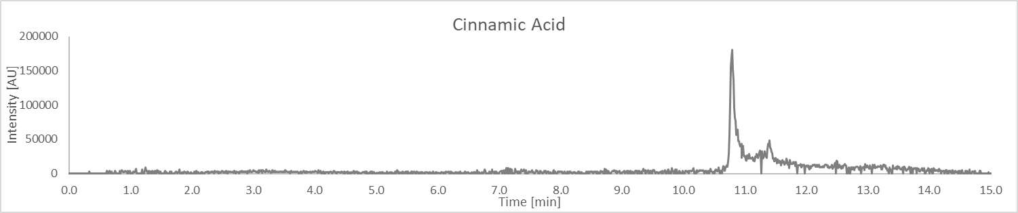
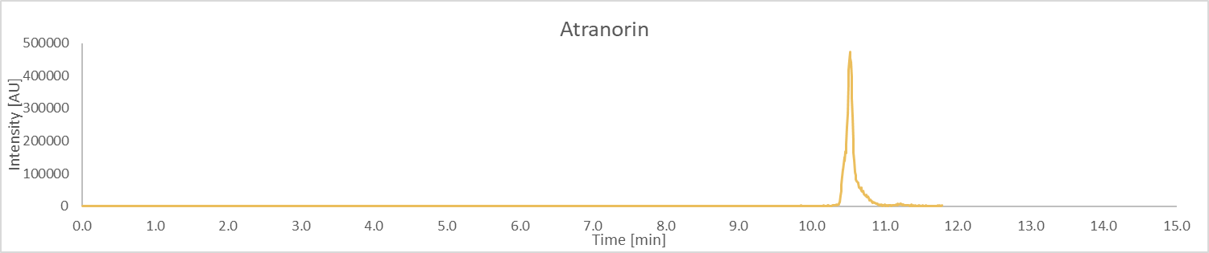
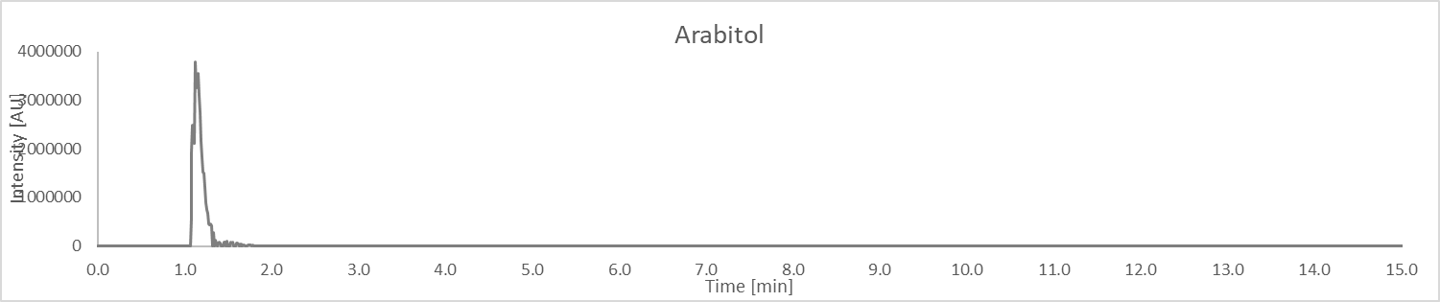
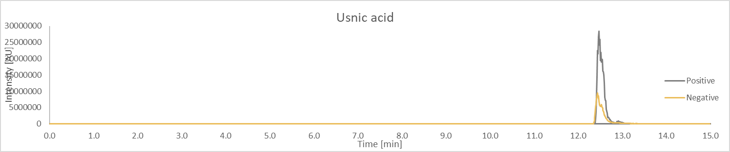
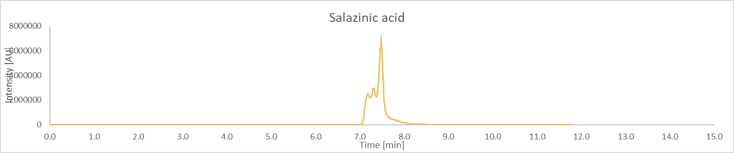
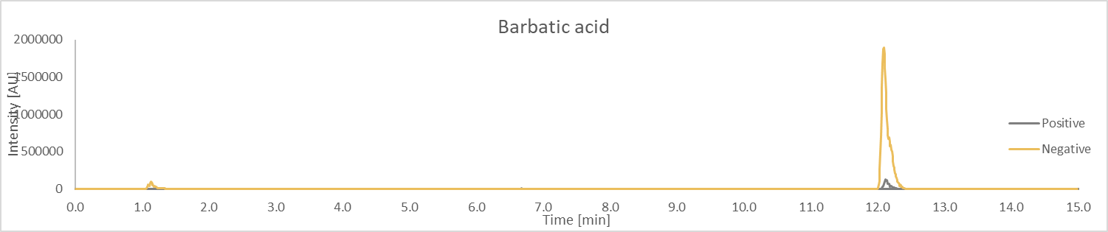
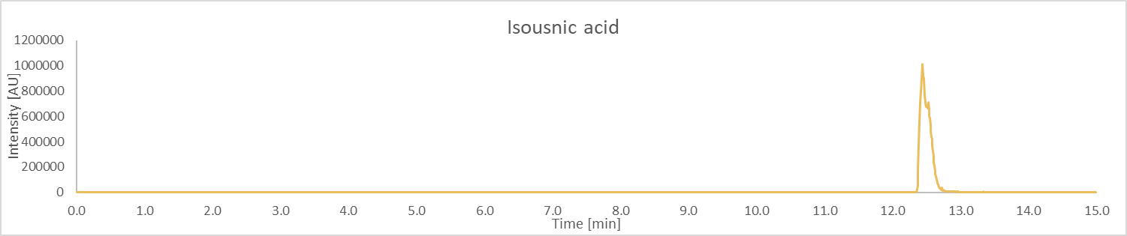
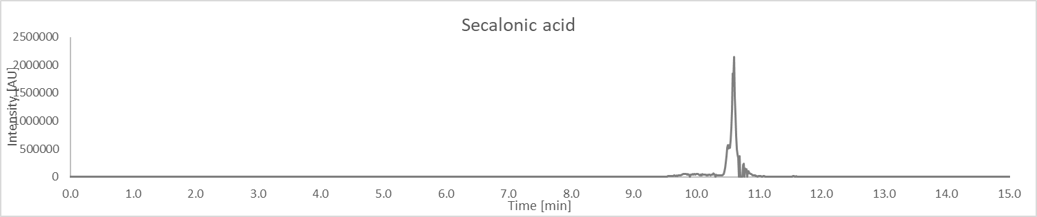
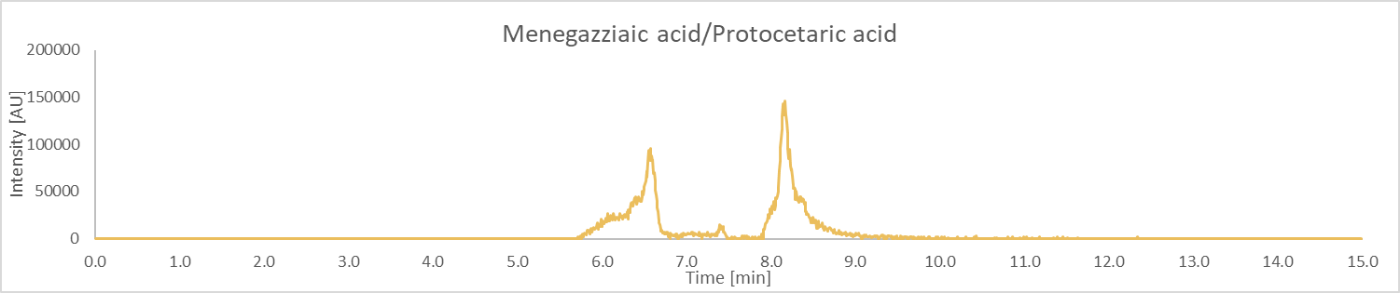
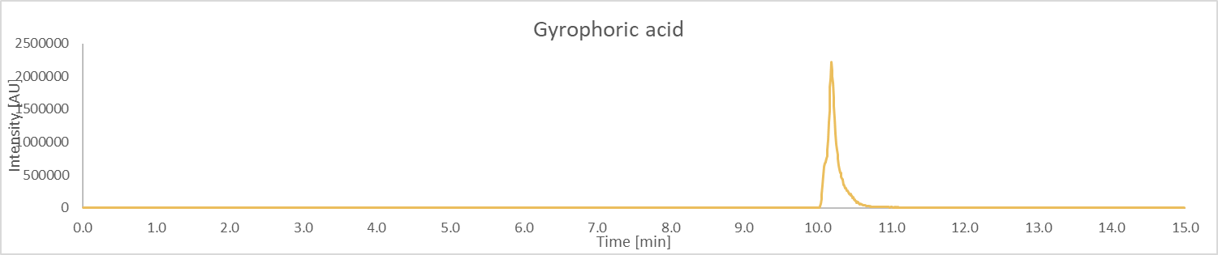
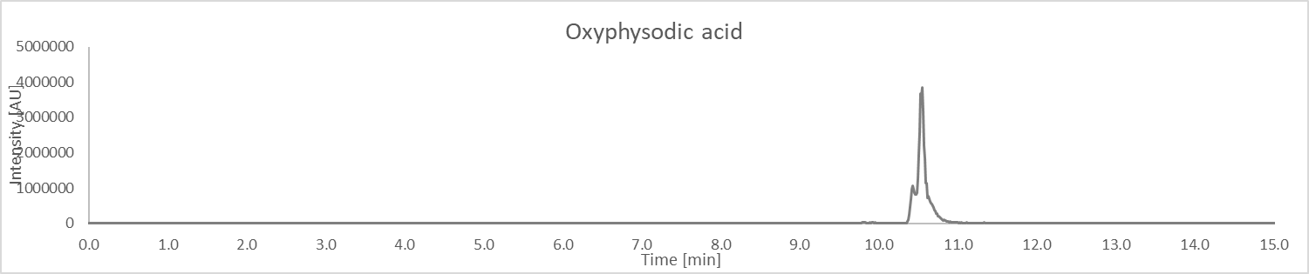
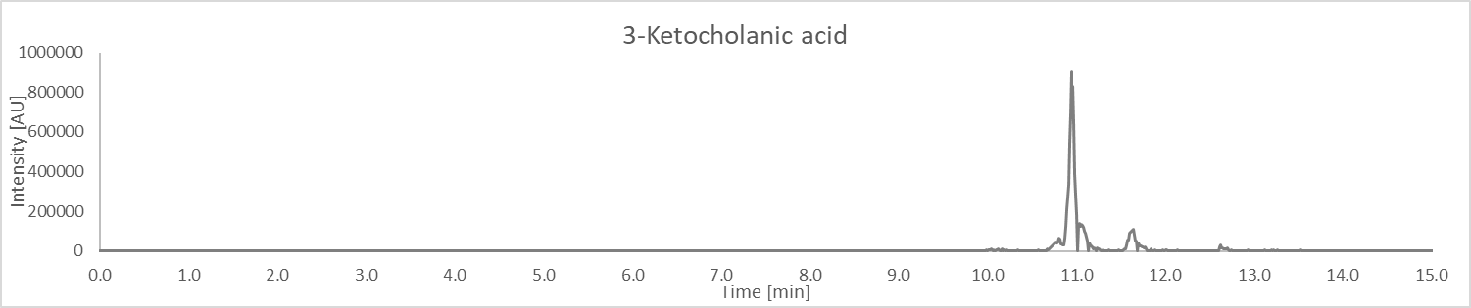
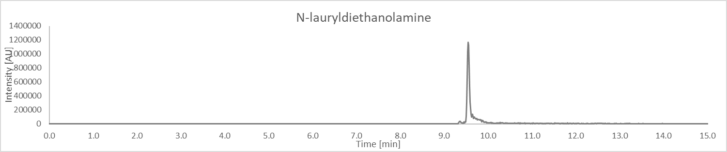
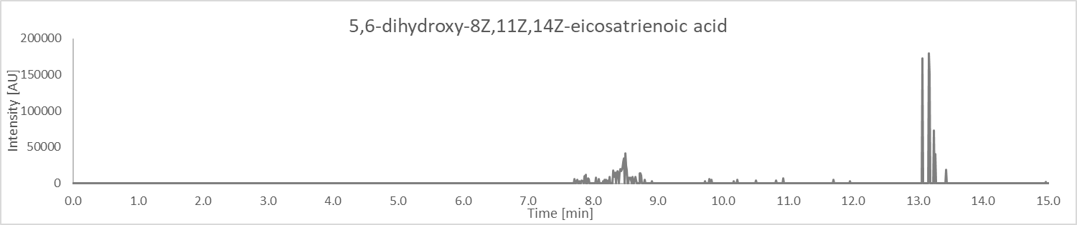
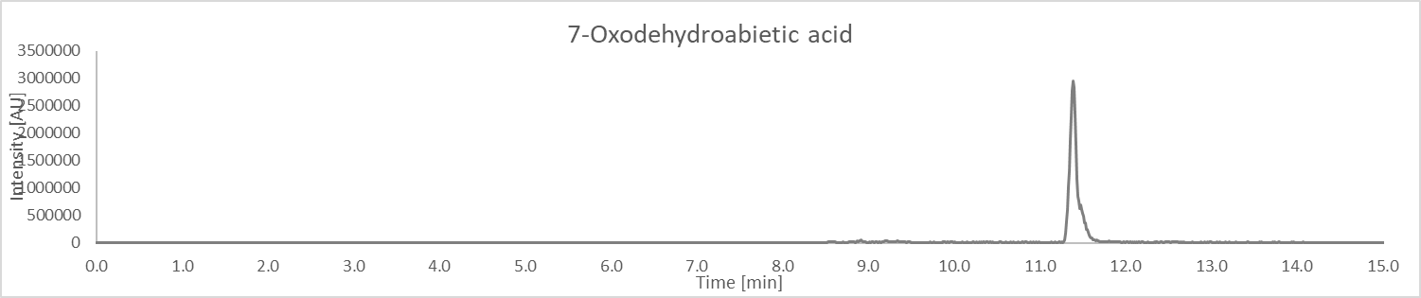
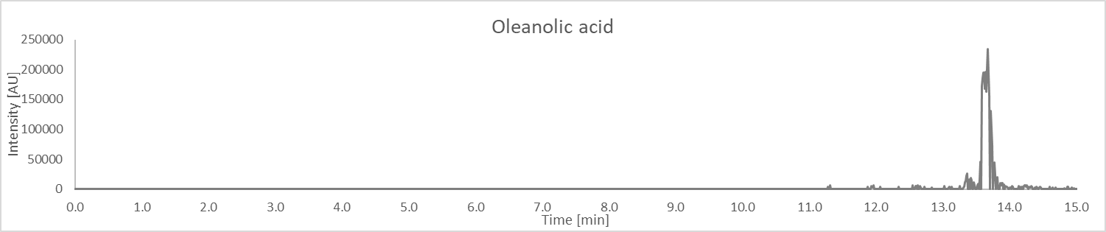
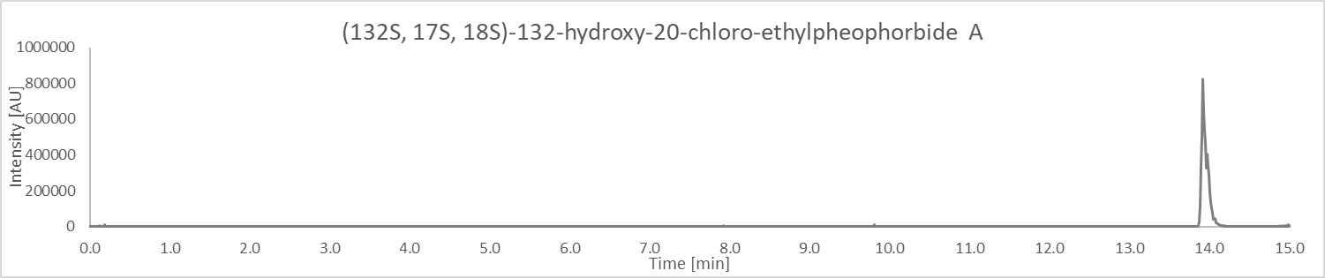
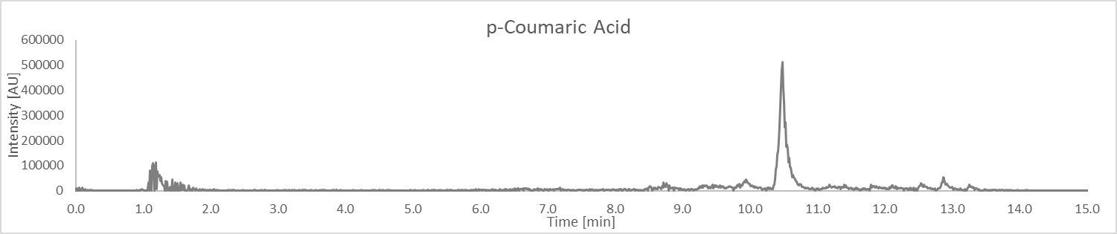
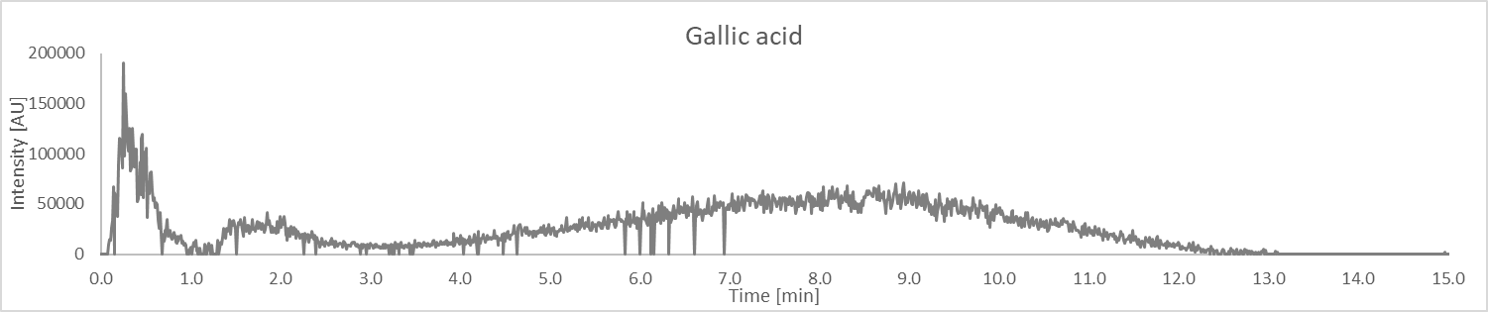
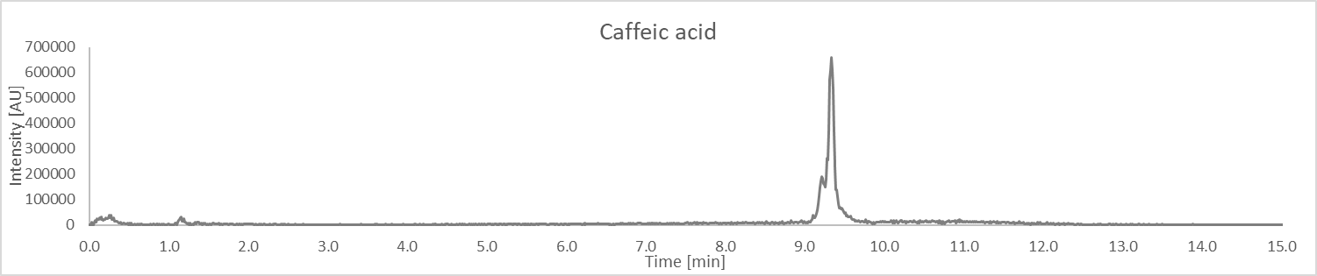
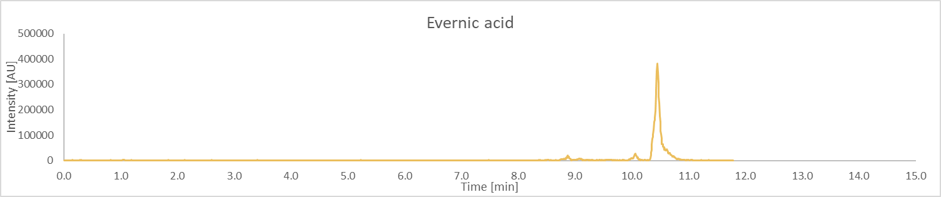
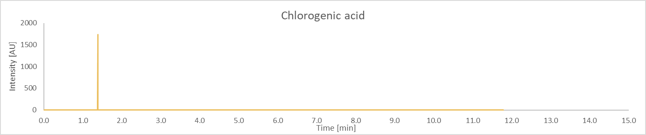
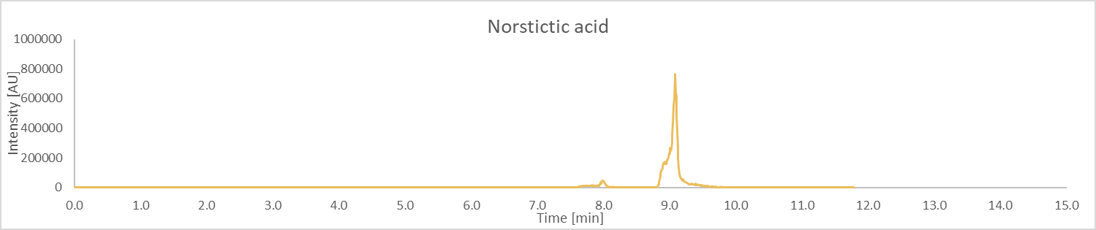
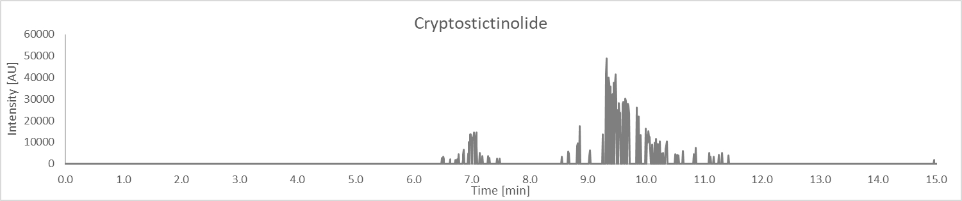
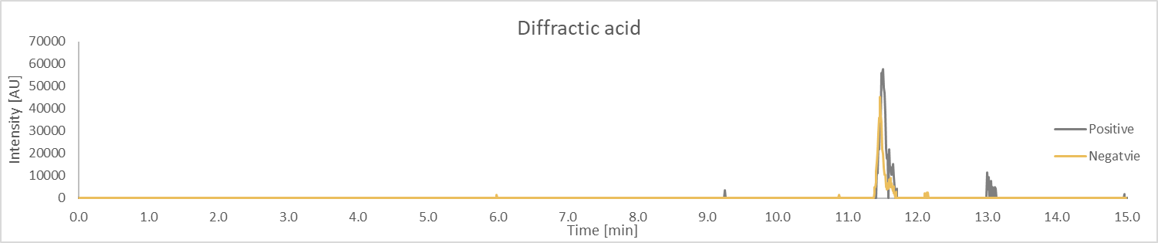
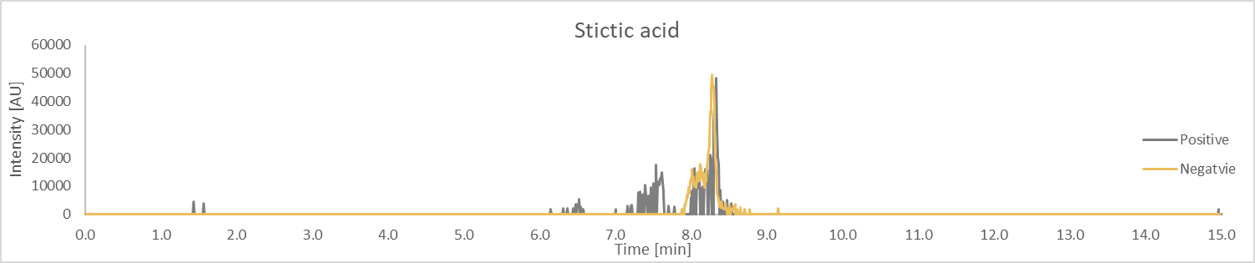
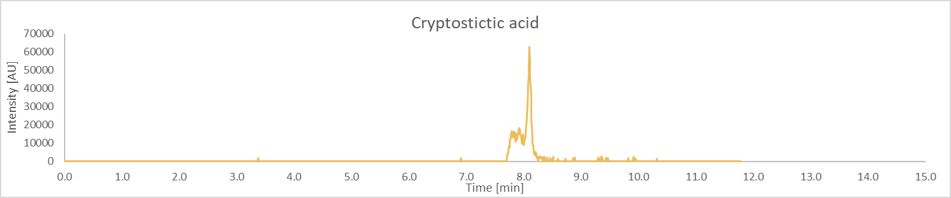
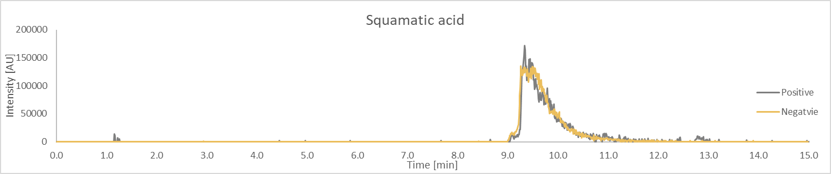
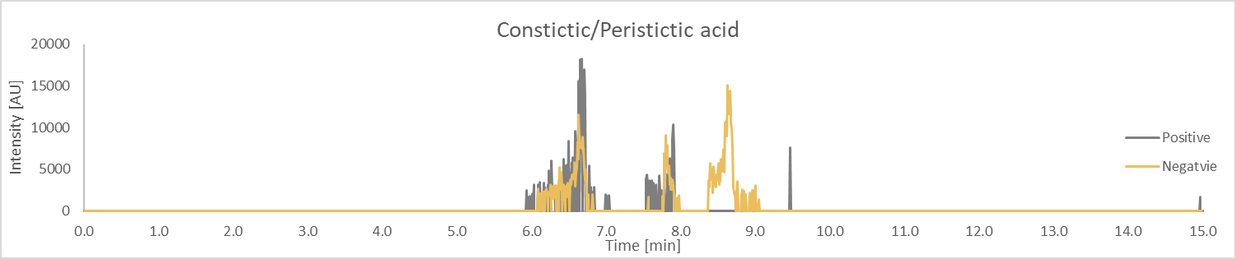
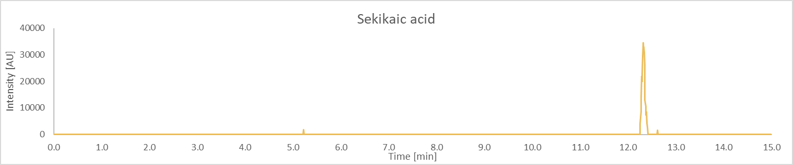
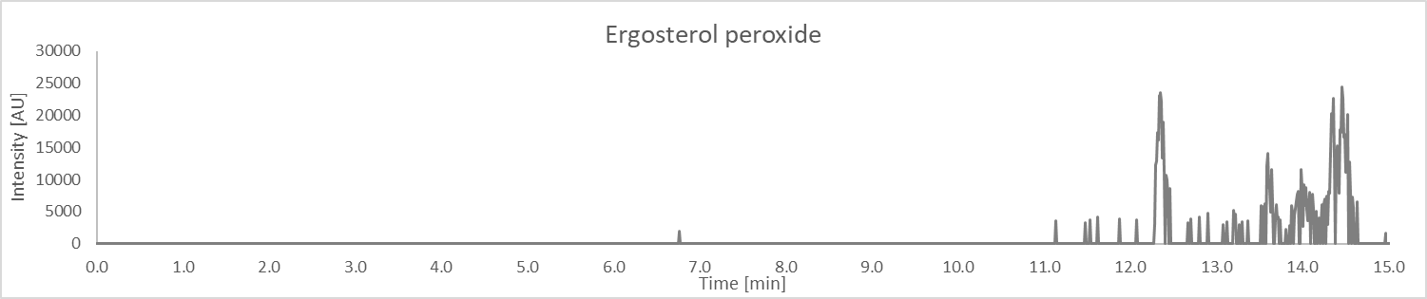
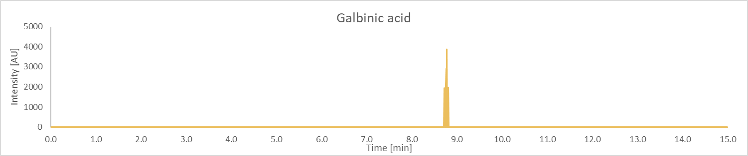

Structures of compounds in Table 1

Table 3: HRMS product ions for the peaks of the botanical extract
Peak No. | RT (min) | m/z | Proposed ID’s  (Confirmed with Std in green)  (Structure with correlated MS² spectra in orange)  (Most probable ID is blue)  CAS ID | Product Ions  m/z Rel. Int..
1 | 10.79 | 149.0598 | Cinnamic acid | 67.0285 16  79.0532 7  91.0543 7  95.049 64  105.0333 100
2 | 10.52 | 373.0930 | Atranorin | 80.1094 23  119.0493 50  133.0292 51  163.0396 100  177.0211 42  200.4178 28
3 | 1.12 | 153.0759 | Arabitol | 53.0385 5  55.0176 5  57.0333 79  59.0489 3  61.0283 5  69.0333 100  70.9416 1  70.9811 1  71.0126 17  71.0489 20  73.0283 13  75.0442 1  76.775 1  80.2019 1  81.0334 5  87.0441 3  99.0441 83  111.9685 6  111.9839 1  112.0058 1  116.2628 1  117.0548 33  135.0656 14  153.0763 1
4 | 12.40 | 345.0969 | Usnic Acid | 71.0126 3  85.0274 3  118.068 2  121.0287 2  131.329 2  133.6191 2  177.0542 5  187.0761 4  191.0703 8  201.0534 6  205.0477 3  205.087 4  215.07 37  219.0653 22  233.0808 100  235.0905 2  239.0711 3  243.0652 20  257.0802 14  261.0758 42  263.0725 4  267.0646 7  275.0928 4  281.0813 10  284.0702 2  285.0763 17  291.0688 3  294.0504 3  297.0386 5  299.0906 5  303.089 7  309.0764 17  312.0625 11  315.0515 13  327.0868 21  330.0748 10
5 | 7.05 | 387.0357 | Salazinic Acid | 74.3278 28  84.5254 30  118.6729 31  121.0291 58  151.0403 46  178.3161 59  181.9935 35  213.0567 36  215.8074 38  225.0554 50  227.0329 81  241.0505 88  243.0276 100  269.0423 80
6 | 12.04 | 359.1136 | Barbatic Acid | 63.4371 11  119.0497 22  120.0538 16  137.0601 100  138.064 58  150.4137 13  163.0398 78  164.0428 56  181.0497 72  182.0533 60  340.0687 13  241.0505 33  243.0276 37  269.0423 30
7 | 12.39 | 709.1541 | Isousnic Acid | 83.0159 26  91.8227 3  113.785 3  122.5103 3  231.0713 23  232.0725 9  259.0667 81  260.0698 43  299.0997 10  300.0998 12  301.0722 8  302.0768 7  313.037 5  328.0652 100  329.0683 98  343.0894 31  344.0912 24
8 | 10.47 | 639.1708 | Secalonic Acid | 95.0492 16  123.0442 46  141.0559 34  151.0392 29  169.0498 97  172.9659 15  183.0655 38  193.05 42  285.6843 16  346.91 16  377.0702 100  455.1151 44  469.099 32  483.1107 45  501.1237 58  502.1313 40  511.1093 18  529.0942 17  543.1223 17
9 | 8.14 | 373.0566 | Menegazziaic Acid/Protocetaric Acid | 62.5342 59  142.6553 61  256.0666 79  268.0692 100
10 | 10.06 | 467.0988 | Gyrophoric Acid | 73.4358 3  97.0183 4  167.0341 35  178.3149 10  317.0648 100
11 | 10.4 | 487.1958 | Oxyphysodic Acid | 71.0848 8  84.1846 3  95.0849 4  177.0896 3  219.0645 10  273.0418 4  275.0604 3  301.0328 4  317.1368 14  328.0949 12  329.1014 9  373.2081 6  399.1049 10  427.1762 100  427.3089 6
12 | 10.94 | 375.3257 | 3-Ketocholanic Acid | 67.0539 73  69.0696 40  79.0541 44  81.0698 61  91.0543 23  93.0697 100  94.0735 29  95.0856 61  96.0888 25  101.8679 17  107.0857 43  119.0856 20  121.1011 39  122.1051 22  311.9981 22  376.3295 29
13 | 9.53 | 274.2741 | N-Lauryldiethanolamine | 57.0697 61  58.0653 5  59.3362 4  70.065 85  71.0853 17  78.7121 4  82.8639 5  88.0756 100  102.0913 24  106.0864 34  256.2649 12  274.2759 17
14 | 13.07 | 339.2530 | 5,6-dihydroxy-8Z,11Z,14Z-eicosatrienoic acid | 67.054 54  69.0695 81  71.0854 35  81.0696 100  83.0848 43  93.0696 56  95.0852 51  109.1012 27  116.9715 36  121.1019 37  135.1167 30
15 | 11.33 | 315.1954 | 7-Oxodehydroabietic acid | 66.499 2  69.0698 2  87.1659 2  98.9858 2  99.7033 2  107.0855 3  117.0706 5  129.0686 4  131.0854 11  143.0854 3  145.0645 9  147.0807 9  157.0642 9  171.0803 14  171.1102 2  173.0953 4  187.1118 100  190.6516 2  199.1118 14  209.1322 6  213.1277 14  227.1426 4  318.0153 2
16 | 13.58 | 439.3571 | Oleanolic Acid | 81.0703 30  95.0856 51  107.0865 31  109.1018 45  119.0852 48  121.1002 54  133.1004 38  147.1173 41  163.1487 28  189.1635 56  189.3654 31  203.1808 100  239.3945 26
17 | 13.9 | 637.3046 | (132S, 17S, 18S)-132-hydroxy-20-chloro-ethylpheophorbide a | 83.0484 18  91.0528 3  91.4687 3  109.2185 2  116.5271 2  141.0693 4  147.116 26  163.0137 3  175.0142 4  227.0445 6  239.0454 13  260.9916 5  283.1035 3  337.024 100  337.1167 5  393.0859 36  413.0583 6  469.1185 20  525.1804 25  581.2383 6
18 | 10.41 | 165.0548 | p-coumaric acid | 59.4256 21  65.94 50  74.1178 20  83.9297 100  84.0117 24  101.9409 39  110.0691 22
19 | 1.76 | 171.0345 | Gallic acid | 53.9389 12  55.0541 4  55.9344 4  60.9863 44  60.9934 5  70.942 2  72.9368 11  78.9969 100  88.9522 4  89.9636 6  97.0075 49  100.1328 2  102.0132 6  106.9921 4  120.0243 6
20 | 9.2 | 181.0495 | Caffeic acid | 54.9471 5  56.7179 5  56.9647 42  57.9346 100  67.0176 12  79.0543 7  91.47 5  98.9607 15  107.049 5  116.9719 33  126.9686 8  135.0445 47
21 | 10.08 | 333.0969 | Evernic acid | 72.0929 72  113.6758 66  226.062 81  254.0544 100  322.8821 74
22 | 1.38 | 353.0878 | Chlorogenic acid | n/a
23 | 9 | 371.041 | Norstictic acid | 81.1114 84  110.0152 100
24 | 9.32 | 373.0916 | cryptostictinolide | n/a
25 | 11.46 | 373.1292 | Diffractic acid | 68.6623 23  82.3379 25  103.3434 29  135.0813 100  145.391 27  178.2756 47  281.6184 26
26 | 8.31 | 387.071 | Stictic acid | 149.5851 37  164.1086 42  178.3198 85  209.0617 47  254.0553 96  267.0312 100  284.3924 43
27 | 8.08 | 387.0722 | Cryptostictic acid | 119.9679 17  121.0294 70  201.0572 20  213.0543 44  220.3165 18  225.0555 69  227.0337 100  228.0608 21  239.0333 51  241.0482 52  243.0294 60  251.033 46  253.0489 30  256.0677 31  269.0432 56  289.928 21  314.1177 21
28 | 9.35 | 391.102 | Squamatic acid | 119.0497 15  127.1115 21  137.0606 50  143.1074 12  155.1095 14  157.1226 13  163.0399 74  171.1018 17  181.051 38  187.0977 13  195.1349 11  201.1129 72  211.1314 15  213.1493 21  240.6411 10  371.2781 46  387.2723 59  389.2882 100
29 | 6.65 | 401.0512 | Constictic acid/Peristictic acid | n/a
30 | 12.32 | 417.1556 | Sekikaic acid | 79.0967 7  108.1354 9  110.0875 7  149.0604 19  165.0544 17  193.0499 100  400.9641 9
31 | 12.35 | 429.3361 | Ergosterol peroxide | n/a
32 | 8.75 | 429.0466 | Galbinic acid | n/a

