Analysis of Pausinystalia johimbe (Yohimbe) root Extract Using LC-QToF method

Names of investigators: Yan-Hong Wang, Bharathi Avula, Kumar Katragunta
Affiliation: National Center for Natural Products Research, School of Pharmacy, University of Mississippi, University, MS 38677, USA

Analysis date: Feb. 15, 2022

Common Botanical Name | CAS No. | Lot No. | Container ID | Net Weight
Pausinystalia johimbe (Yohimbe) |  | RK-3-31-1-PJ-C  RK-3-31-1-PJ-D

Sample storage condition until analysis
2-8°C

Quantitative/Targeted method:

UHPLC-MS/MS Method

UHPLC conditions | Mass spectrometry
System: Waters Acquity UPLC  Column: Waters Acquity UPLC BEH C18 (2.1 x 100 mm i.d., 1.7 μm)  Mobile phase A: 50 mM ammonium formate in 5% methanol aqueous (pH = 8.2)  Mobile phase B: methanol with 0.01% ammonium hydroxide  Flow rate: 0.25 mL/min  Column temperature: 50 °C  Gradient  Time (min) Mobile phase B (%)  0.0 32.0  7.0 50.0  11.0 65.0  15.0 100.0  18.0 100.0 | System: Waters Xevo G-2 QToF  Ionization: Electrospray  Polarity: Positive Ion  Main Interface:  · Capillary: 3.0 kV  . Cone: 25 V  . Source temperature: 150 °C  . Desolvation temperature: 350 °C  . Desolvation gas flow: 900 L/hr  · Con gas flow: 50 L/hr  SRM dwell time:  Selected Reaction Monitoring (SRM) events  Compound Precursor ion (m/z) [M+H]⁺ Product ion* (m/z) Collision energy (V) Retention time (min)  Yohimbic acid 341.2 198.1 28 3.40  Corynanthine 355.2 212.1 28 7.31  Yohimbine 355.2 212.1 28 7.80  Rauwolscine 355.2 212.1 28 11.1  Ajmalicine 353.2 210.1 23 12.2  *Quantifier, †Qualifier

Quantitative results

Compound | Concentration in extract (mg/g)  RK-3-31-1-PJ-C | Concentration in extract (mg/g)  RK-3-31-1-PJ-D
Yohimbic acid | 3.3 mg/g | 3.4 mg/g
Corynanthine | 8.0 mg/g | 8.5 mg/g
Yohimbine | 49.2 mg/g | 50.5 mg/g
Rauwolscine | 3.1 mg/g | 3.2 mg/g
Ajmalicine | 0.02 mg/g | 0.02 mg/g

Standards
Name | Supplier | CAS Number | Catalog number | Purity %
Yohimbic acid | Chromadex | 522-87-2 | NA | 99%
Corynanthine | Chromadex | 483-10-3 | ASB-00003812-010 | 99%
Yohimbine | Millipore Sigma | 65-19-0 | Y3125 | 99%
Rauwolscine | Indofine | 4373-34-6 | 020622 | 99%
Ajmalicine | Chromadex | 4373-34-6 | ASB-00001492-050 | 99%

Chemical structures of standards used for quantitative analysis

Calibration
Compound | Limit of detection (LOD) ng/mL | Limit of quantitation (LOQ) ng/mL | Calibration range (mg/g) | Number of Calibration Points | R²
Yohimbic acid | 30 ng/mL | 100 ng/mL | 0.1 – 5.0 μg/mL | 7 | 0.993
Corynanthine | 30 ng/mL | 100 ng/mL | 0.1 – 5.0 μg/mL | 7 | 0.997
Yohimbine | 27 ng/mL | 90 ng/mL | 0.09 – 4.5 μg/mL | 7 | 0.998
Rauwolscine | 27 ng/mL | 90 ng/mL | 0.09 – 4.5 μg/mL | 7 | 0.996
Ajmalicine | 30 ng/mL | 100 ng/mL | 0.1 – 5.0 μg/mL | 7 | 0.998

Linearity profiles
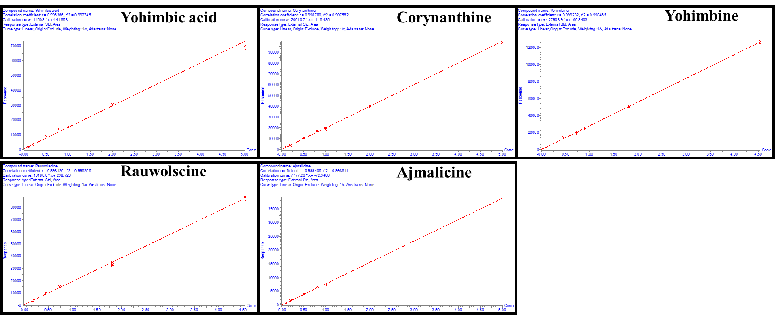
Untargeted Analysis
UHPLC conditions | Mass spectrometer conditions
System: Agilent 1290 series  Column: Poroshell 120 EC-C18 (2.1 X 150mm, 2.7µm) (Agilent technologies, Palo Alto, CA, USA)  Mobile phase A: Water+0.1% formic acid  Mobile phase B: Acetonitrile +0.1% formic acid  Flow rate: 0.20 mL/min  Column temperature: 35°C  Gradient:  Time (min) Mobile phase B (%)  0.0 10  25.0 33  30 100 | System: QToF-MS 6530A series (Agilent technologies, Palo Alto, CA, USA)  Ionization: ESI  Polarity: Positive mode  Main Interface:  · Nebulizing gas flow: 13 L/min  . Gas temperature: 270°C  . Nebulizer: 27 psig  . Sheath gas temperature: 300°C  . Sheath gas flow: 13L/min  · Capillary voltage: 3.5 kV  · Fragmentor: 150V

Table 1: Proposed identification of constituents of Pausinystalia johimbe root extract showing RT, m/z, ppm, tentative compound name and molecular formula
Peak No. | RT (min) | Exp. m/z  [M+H]⁺ | Mass accuracy  (ppm) | Proposed ID’s  (Confirmed with Std in green)  (Most probable ID is yellow) | Molecular Formula
1 | 10.14 | 341.1858 | 0.6 | Yohimbic acid | C₂₀H₂₄N₂O₃
2 | 11.60 | 355.2013 | 0.8 | Rauwolscine | C₂₁H₂₆N₂O₃
3 | 13.81 | 355.2013 | 0.8 | Yohimbine | C₂₁H₂₆N₂O₃
4 | 14.37 | 355.2019 | -0.8 | Corynanthine | C₂₁H₂₆N₂O₃
5 | 12.93 | 355.2015 | 0.3 | β-Yohimbine/ Pseudoyohimbine/ Alloyohimbine/ Methyl (3β,16β,17α,20α)-17-hydroxyyohimban-16-carboxylate/ Yohimban-16-carboxylic acid, 17-hydroxy-, methyl ester/ Epialloyohimbine | C₂₁H₂₆N₂O₃
6 | 13.16
7 | 13.46
8 | 14.35
9 | 15.85
10 | 16.14
11 | 17.75
12 | 18.17
13 | 18.47
14 | 19.0
15 | 12.96 | 353.1857 | 0.8 | Ajmalicine/Tetrahydroalstonine/Akuammigine/19-Epiajmalicine/Rauniticine/Isoajmalicine/3-Iso-19-epiajmalicine | C₂₁H₂₄N₂O₃
16 | 13.58
17 | 14.10
18 | 14.50
19 | 14.77
20 | 15.20
21 | 17.45
22 | 17.74
23 | 18.72
24 | 19.37
25 | 20.83
26 | 14.34 | 357.2170 | 0.8 | Dihydrositsirikine epimers | C₂₁H₂₈N₂O₃
27 | 15.03
28 | 16.78
29 | 18.86
30 | 20.50
31 | 17.74 | 369.2170 | 0.8 | O-Methylyohimbine epimers | C₂₂H₂₈N₂O₃
32 | 22.0
33 | 23.30
34 | 21.90 | 367.2014 | 0.5 | Ajamalinine/Corynantheine epimers | C₂₂H₂₆N₂O₃
35 | 25.14
36 | 25.80

Figure 1: Chromatograms
Structures of compounds in Tables 1
Table 2: HRMS product ions for the peaks of the botanical extract (Pausinystalia johimbe root) showing RT, m/z, tentative compound name and fragment ions
Peak No. | RT (min) | [M+H]⁺  m/z | Proposed Compounds  (Confirmed with Std in green)  (Probable ID is yellow)  CAS Number | Product Ions  m/z
1 | 10.14 | 341.1858 | Yohimbic acid | 144.0804
2 | 11.60 | 355.2013 | Rauwolscine | 144.0809
3 | 13.81 | 355.2013 | Yohimbine | 212.1279  144.0805
4 | 14.37 | 355.2019 | Corynanthine | 144.0803
5 | 12.93 | 355.2015 | β-Yohimbine/ Pseudoyohimbine/ Alloyohimbine/ Methyl (3β,16β,17α,20α)-17-hydroxyyohimban-16-carboxylate/ Yohimban-16-carboxylic acid, 17-hydroxy-, methyl ester/ Epialloyohimbine | 144.0808
6 | 13.16
7 | 13.46
8 | 14.35
9 | 15.85
10 | 16.14
11 | 17.75
12 | 18.17
13 | 18.47
14 | 19.0
15 | 12.96 | 353.1857 | Ajmalicine/Tetrahydroalstonine/Akuammigine/19-Epiajmalicine/Rauniticine/Isoajmalicine/3-Iso-19-epiajmalicine | 144.0806  117.0696
16 | 13.58
17 | 14.10
18 | 14.50
19 | 14.77
20 | 15.20
21 | 17.45
22 | 17.74
23 | 18.72
24 | 19.37
25 | 20.83
26 | 14.34 | 357.2170 | Dihydrositsirikine epimers | 144.0808
27 | 15.03
28 | 16.78
29 | 18.86
30 | 20.50
31 | 17.74 | 369.2170 | O-Methylyohimbine epimers | 144.0803
32 | 22.0
33 | 23.30
34 | 21.90 | 367.2014 | Ajamalinine/Corynantheine epimers | 144.0810
35 | 25.14
36 | 25.80

References
- Sun, Jianghao et al., Profiling the indole alkaloids in yohimbe bark with ultra-performance liquid chromatography coupled with ion mobility quadrupole time-of-flight mass spectrometry. Rapid Communications in Mass Spectrometry. 2011, Volume: 25 Issue: 18 Page: 2591-2602
- Sun, Jianghao et al., Chromatographic fingerprint analysis of yohimbe bark and related dietary supplements using UHPLC/UV/MS. Journal of Pharmaceutical and Biomedical Analysis. Volume 61, 5 March 2012, Pages 142-149.
- Cohen PA, Wang YH, Maller G, DeSouza R, Khan IA. Pharmaceutical quantities of yohimbine found in dietary supplements in the USA. Drug Test Anal. 2016 Mar-Apr;8(3-4):357-69. doi: 10.1002/dta.1849. Epub 2015 Sep 22. PMID: 26391406.

