Analysis of Milk Thistle (Silybum marianum) Extract Using High Resolution UHPLC-MS and UHPLC-MS/MS

Richard B.van Breemen and Ruth N. Muchiri
Department of Pharmaceutical Sciences
Linus Pauling Institute
Oregon State University
2900 Campus Way
Corvallis, OR 97331

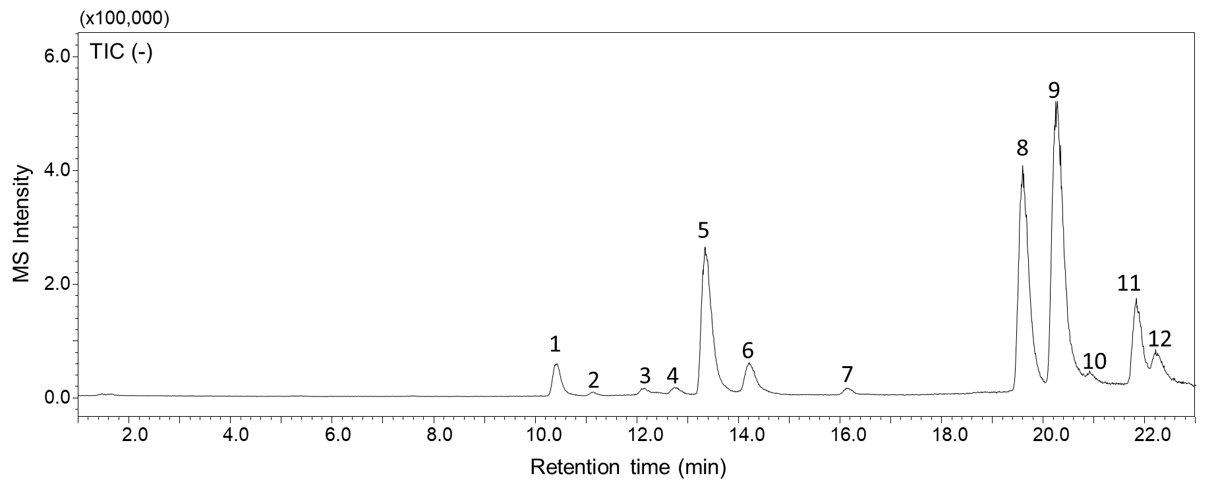
Figure 1. Total ion chromatogram of milk thistle extract (10 µg/mL) analyzed on a Shimadzu 9030 UHPLC-Q-ToF mass spectrometer (resolving power 30,000) with negative ion electrospray. A 22-min gradient from 5% to 95% methanol containing formic acid (0.1%) in water (also containing 0.1% formic acid) was used for the UHPLC separation with a Waters Cortecs C₁₈ (2.1 × 150 mm, 1.7 µm) column.
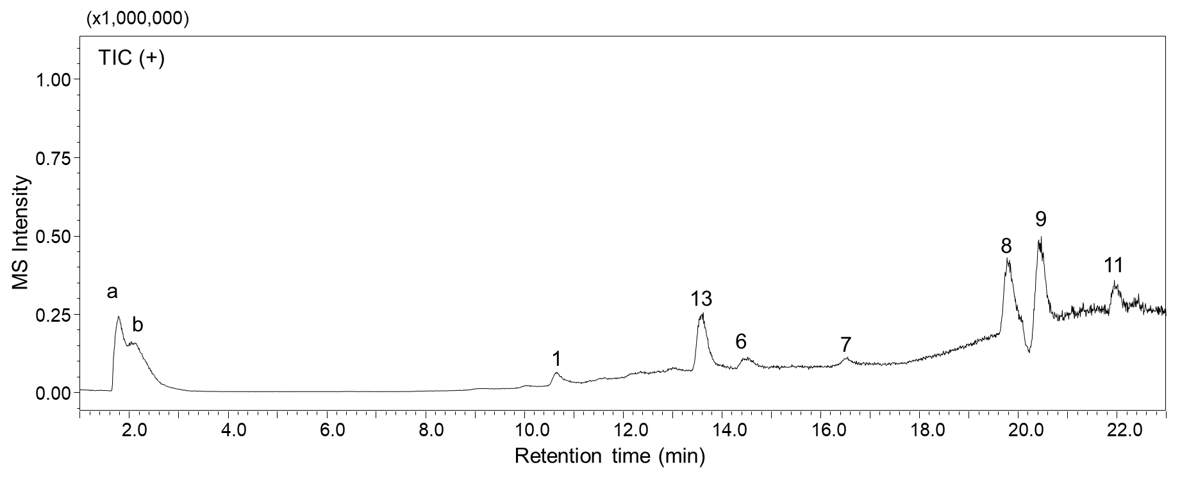
Figure 2. Total ion chromatogram of milk thistle extract (10 µg/mL) analyzed on a Shimadzu 9030 UHPLC-Q-ToF mass spectrometer (rssolving power 30,000) with positive ion electrospray. A 22-min gradient from 5% to 95% methanol containing formic acid (0.1%) in water (also containing 0.1% formic acid) was used for the UHPLC separation with a Waters Cortecs C18 (2.1 × 150 mm, 1.7 µm) column.

Table 1. Proposed and confirmed components corresponding to the peaks in the UHPLC-HRMS chromatograms in Figures 1 and 2 of milk thistle (Silybum marianum) extract.

Peak number | Retention time (min) | m/z  (-) top  (+) (bottom) | ΔM (ppm)  (-) top  (+) bottom | Proposed ID  Molecular Formula  (CAS)  Confidence³ | Chemical  Structure | Comments
1 | 10.42 | 303.0485  305.0554 | 8.2  1.3 | Taxifolin  C₁₅H₁₂O₇  24198-97-8  Reference standard |  | HRMS supports molecular formula.  MS/MS supports structure via reference standard.  Retention time matches that of reference standard
2 | 11.14 | 303.0485  - | 8.2  - | Taxifolin isomer  C₁₅H₁₂O₇  -  Tentative |  | HRMS supports molecular formula.  MS/MS supports structure through comparison of taxifolin major fragment ion of m/z 125
3 | 12.13 | 287.0538  - | 8.0  - | Taxifolin minus H2O  C₁₅H₁₂O₆  -  Tentative |  | HRMS supports molecular formula of taxifolin minus a water molecule.  MS/MS supports structure through comparison of taxifolin major fragment ion of m/z 125
4 | 12.76 | 481.1101  - | 8.1  - | Neusilychristin  C₂₅H₂₂O₁₀  -  Tentative |  | The peak elution of silybin isomers are usually close and among silychristin isomers reported in literature, neusilychristin is suggested as the peak eluting before silychristin A. The MS/MS data match that of silychristin. Neuchristin was reported in the literature [1].
5 | 13.35 | 481.1102  - | 7.9  - | Silychristin  C₂₅H₂₂O₁₀  33889-69-9  Reference standard |  | HRMS supports molecular formula.  MS/MS supports structure via reference standard.  Retention time matches that of reference standard
6 | 14.20 | 481.1101  - | 8.1  - | Silydianin  C₂₅H₂₂O₁₀  29782-68-1  Reference standard |  | HRMS supports molecular formula.  MS/MS supports structure via reference standard.  Retention time matches that of reference standard
7 | 16.15 | 257.0735  259.0899 | 8.5  1.2 | D4-Daidzein internal standard  C₁₅H₆D₄O₄  486-66-8  Reference standard |  | HRMS supports molecular formula.  MS/MS supports structure via reference standard.  Retention time matches that of reference standard
8 | 19.60 | 481.1102  483.1283 | 7.9  0.41 | Silybin A  C₂₅H₂₂O₁₀  22888-70-6  Reference standard |  | HRMS supports molecular formula.  MS/MS supports structure via reference standard.  Retention time matches that of reference standard
9 | 20.27 | 481.1103  483.1284 | 7.7  0.2 | Silybin B  C₂₅H₂₂O₁₀  142797-34-0  Reference standard |  | HRMS supports molecular formula.  MS/MS supports structure via reference standard.  Retention time matches that of reference standard.
10 | 20.93 | 481.1102  - | 7.9  - | A silymarin isomer, likely 2,3-cis-silybin A  C₂₅H₂₂O₁₀  ₋-  Tentative |  | The peak elution of silybin isomers are usually close. Based on structural similarity, the suggested isomer is 2,3-cis-silybin A, which is reported in the literature [1]. The HRMS data support a silybin isomer and the MS/MS matches that of other silybins.
11 | 21.85 | 481.1103  483.1254 | 7.7  6.4 | Isosilybin A  C₂₅H₂₂O₁₀  142796-21-2  Reference standard |  | HRMS supports molecular formula.  MS/MS supports structure via reference standard.  Retention time matches that of reference standard
12 | 22.26 | 481.1102  - | 7.9  - | Isosilybin B  C₂₅H₂₂O₁₀  142796-22-3  Reference standard |  | HRMS supports molecular formula.  MS/MS supports structure via reference standard.  Retention time matches that of reference standard
13 | 13.59 | -  453.1176 | -  0.88 | In source fragment of silychristin  C₂₄H₂₀O₉  -  Tentative |  | Common fragment ion for silybins and isosilybins. The retention time suggest an insource fragment ion of silychristin. Fragmentation data of silychristin match literature data [2].
14  Shoulder of peak 6 | 14.51 | -  505.1101 | -  0.79 | Na⁺ adduct of silydianin  C₂₅H₂₂NaO₁₀⁺  -  Tentative |  | Retention time and accurate mass strongly support a sodium adduct of silydianin.

[1] Csupor D, Csorba A, Hohmann J. Recent advances in the analysis of flavonolignans of Silybum marianum. J. Pharmaceut. Biomed. Anal. 2016; 130: 301.
[2] Lee JI, Hsu BH, Wu D, Barrett JS. Separation and characterization of silybin, isosilybin, silydianin and silychristin in milk thistle extract by liquid chromatography–electrospray tandem mass spectrometry. J. Chromatogr. A 2006; 1116: 57.

Appendix

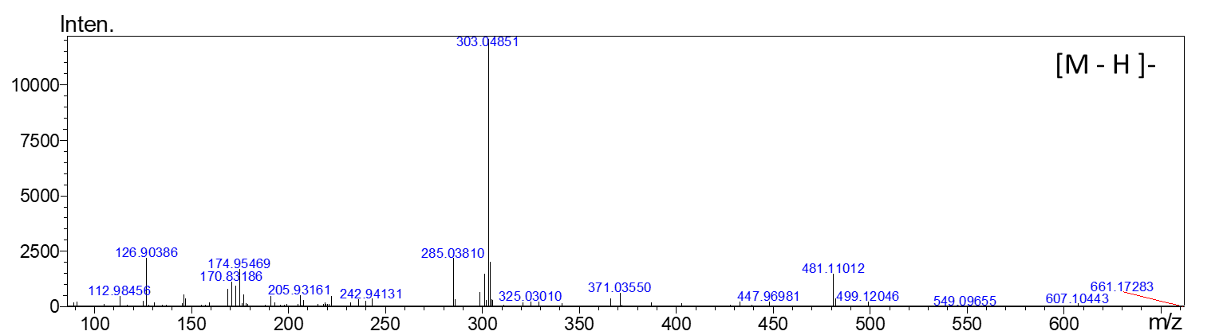

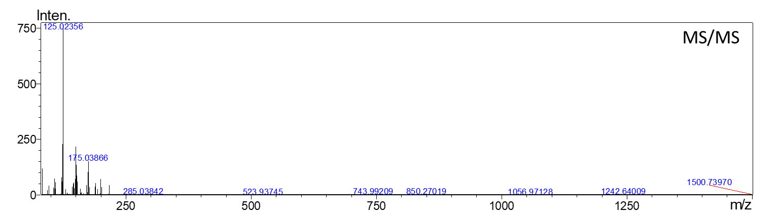

Figure 3. Negative ion electrospray HRMS (top panel) and MS/MS of peak 1 with m/z 303.04854 eluting at 10.42 min

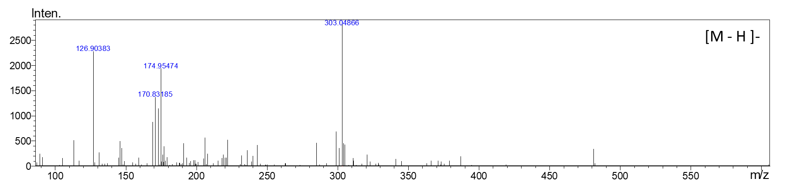
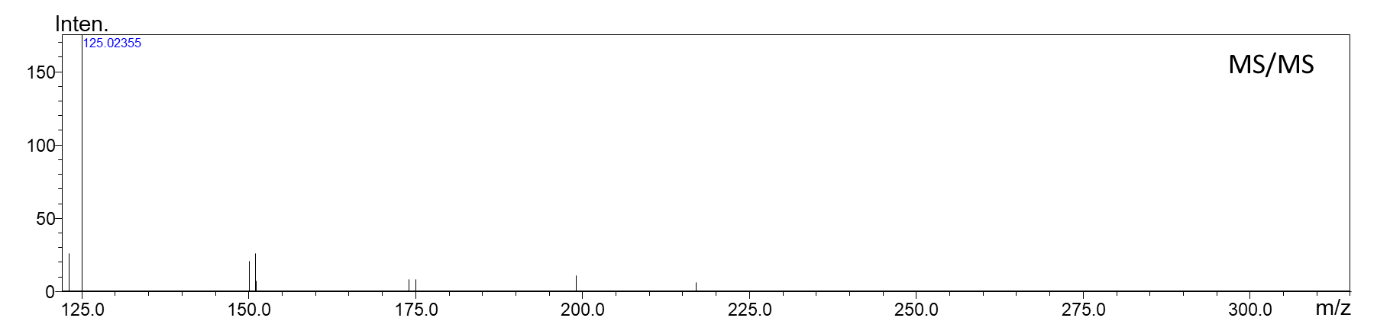

Figure 4. Negative ion electrospray HRMS (top panel) and MS/MS of peak 2 with m/z 303.04854 eluting at 11.14 min

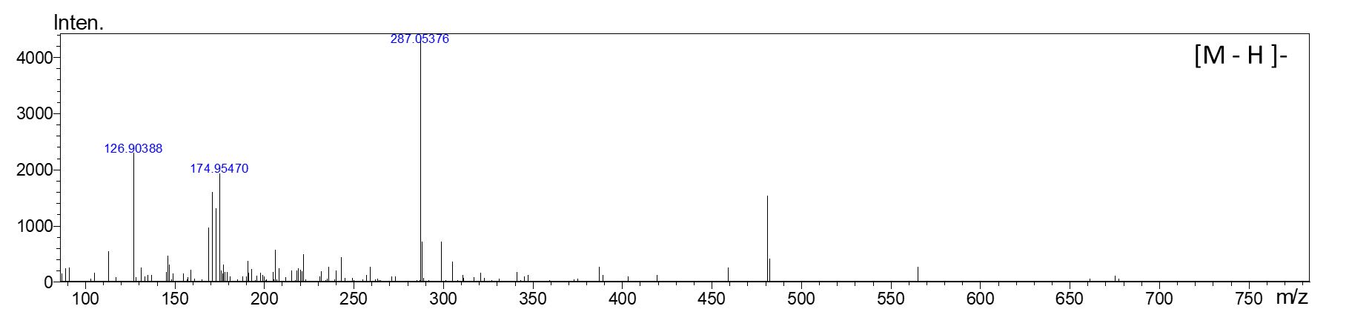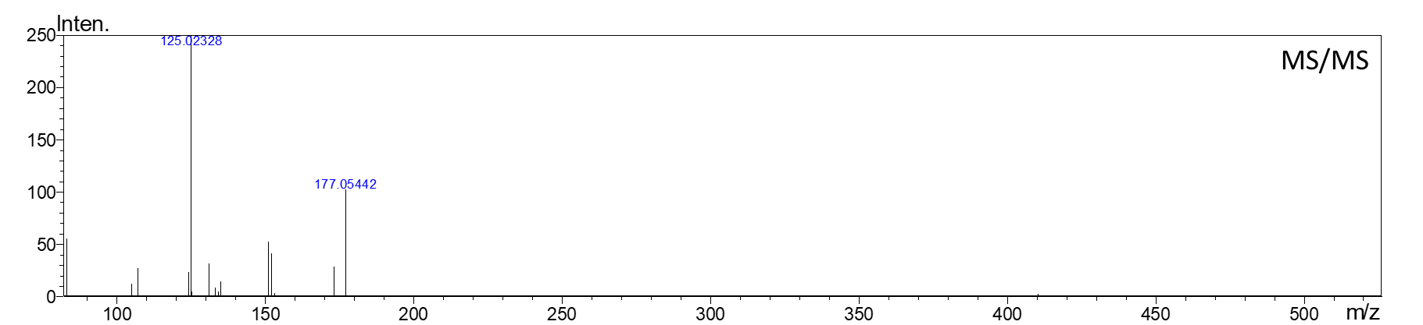

Figure 5. Negative ion electrospray HRMS (top panel) and MS/MS of peak 3 with m/z 287.0538 eluting at 12.13 min

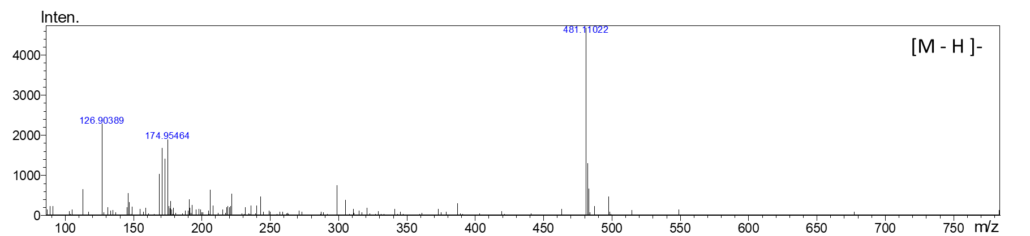
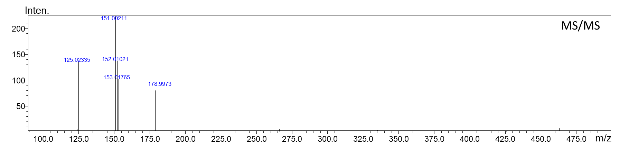

Figure 6. Negative ion electrospray HRMS (top panel) and MS/MS of peak 4 with m/z 481.1101 eluting at 12.76 min

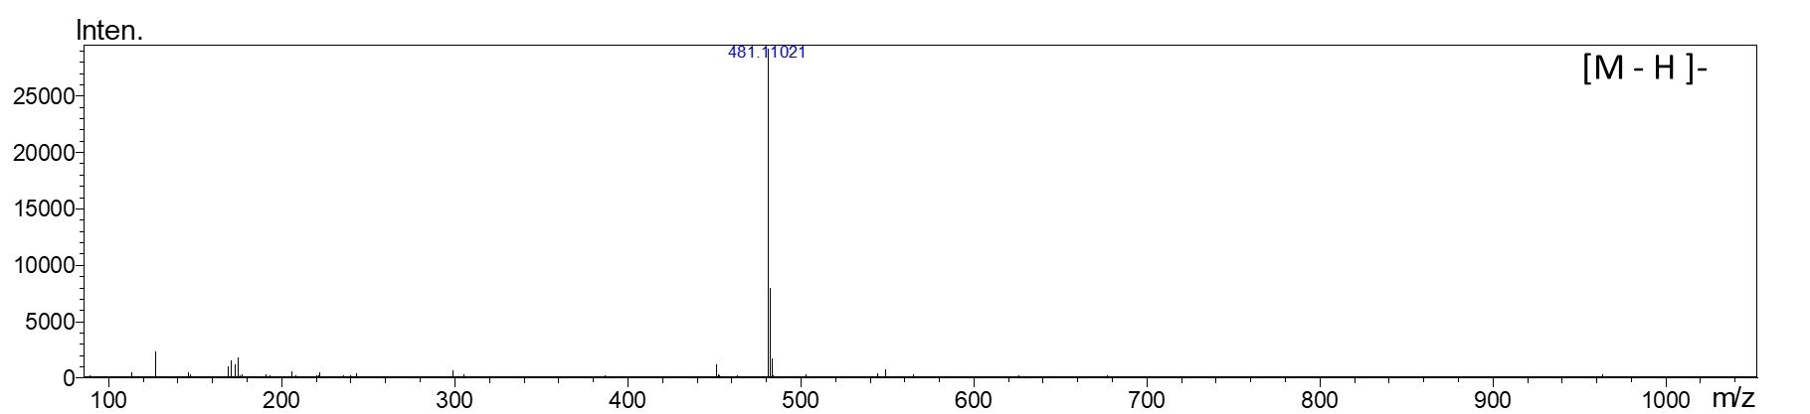
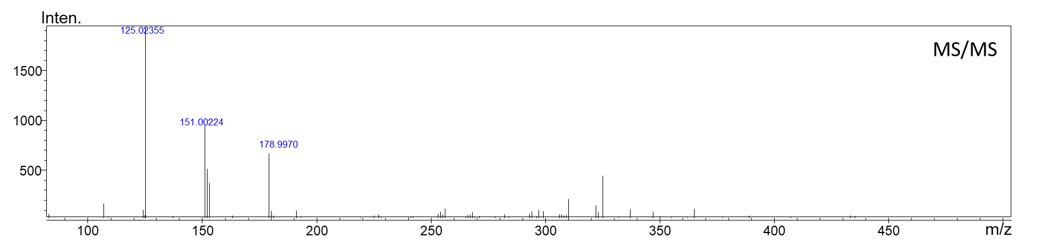

Figure 7. Negative ion electrospray HRMS (top panel) and MS/MS of peak 5 with m/z 481.1102 eluting at 13.35 min

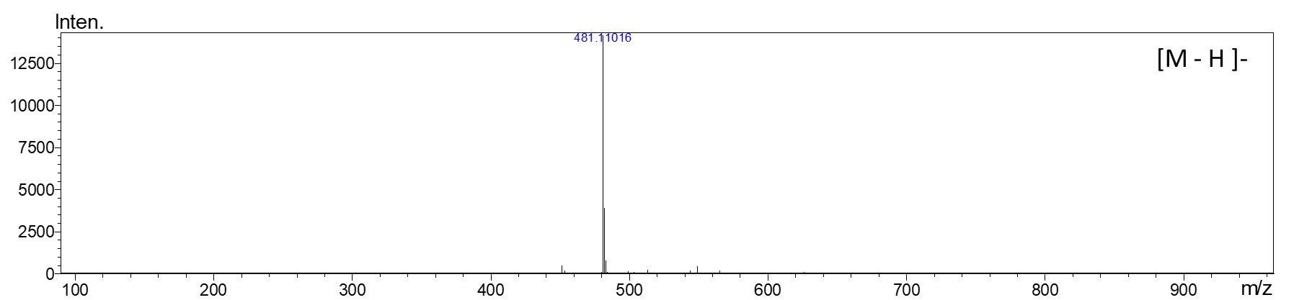
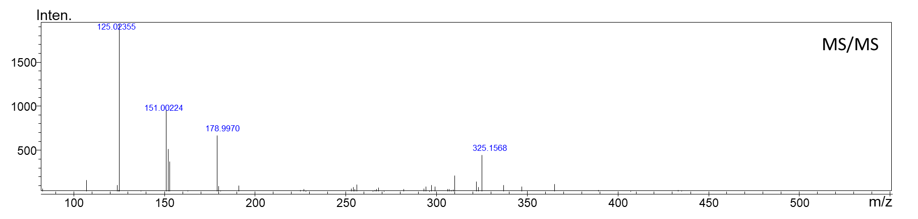

Figure 8. Negative ion electrospray HRMS (top panel) and MS/MS of peak 6 with m/z 481.1101 eluting at 14.20 min

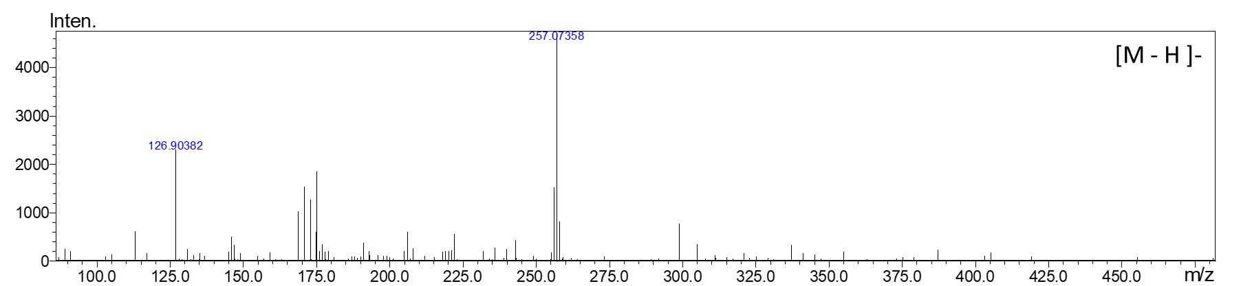

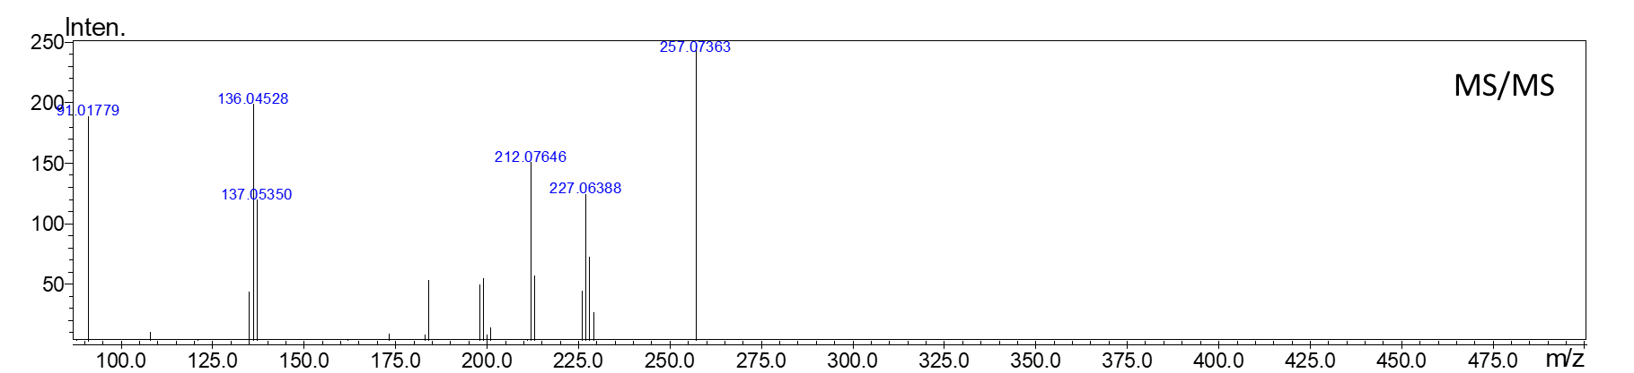

Figure 9. Negative ion electrospray HRMS (top panel) and MS/MS of peak 7 with m/z 257.0735 eluting at 16.15 min

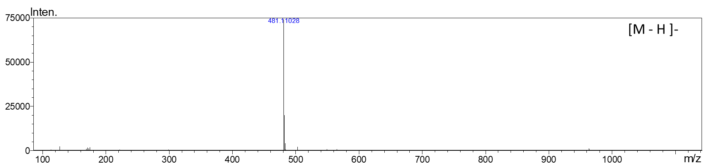
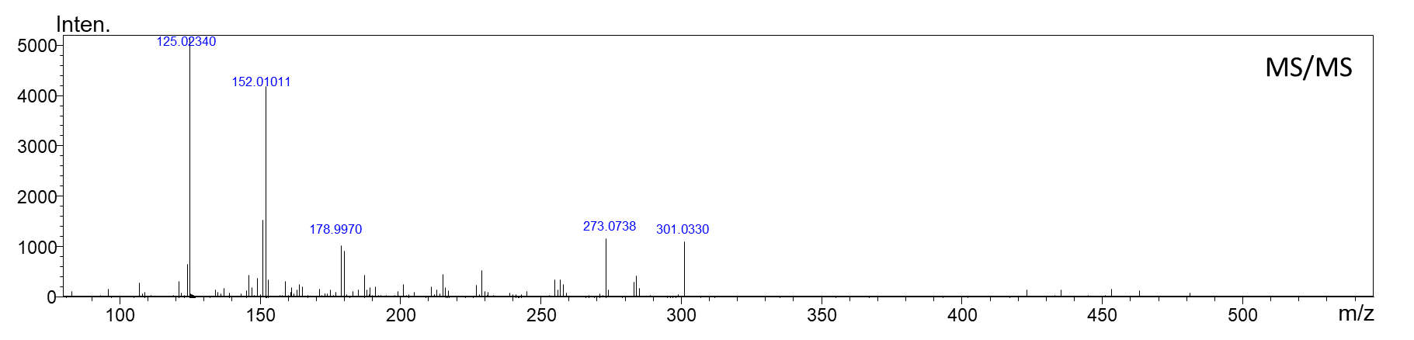
Figure 10. Negative ion electrospray HRMS (top panel) and MS/MS of peak 8 with m/z 481.1102 eluting at 19.60 min

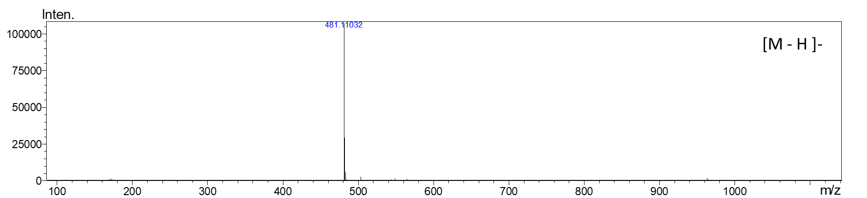
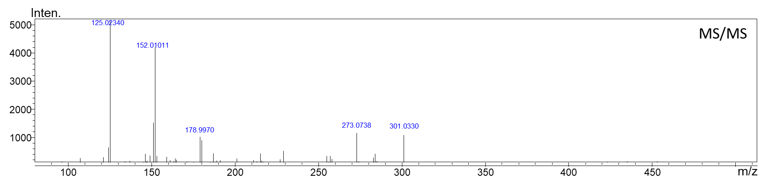

Figure 11. Negative ion electrospray HRMS (top panel) and MS/MS of peak 9 with m/z 481.1103 eluting at 20.27 min

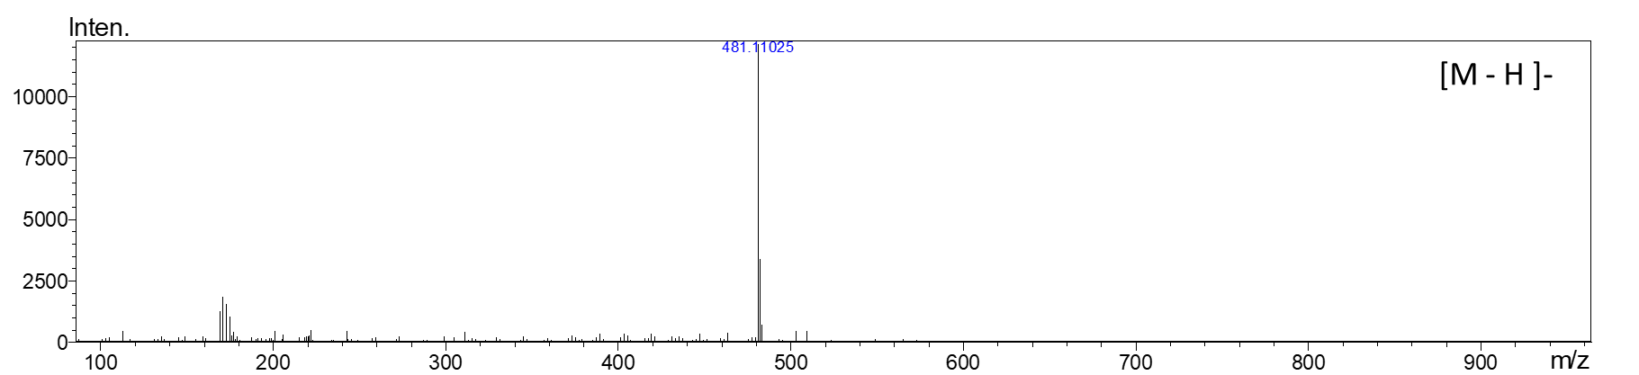
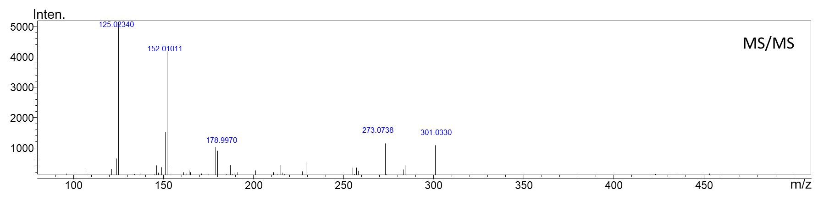

Figure 12. Negative ion electrospray HRMS (top panel) and MS/MS of peak 10 with m/z 481.1102 eluting at 20.93 min

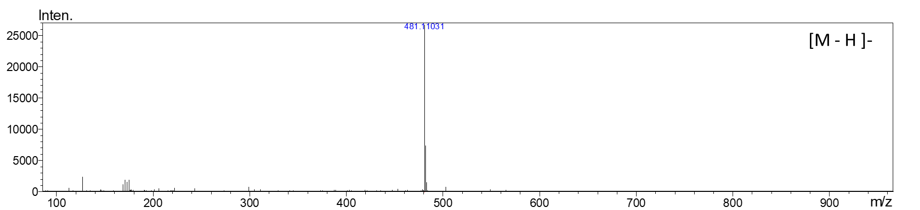
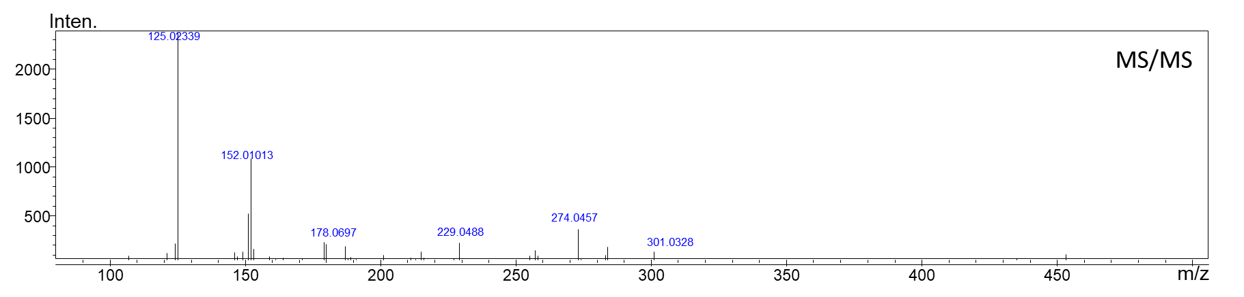

Figure 13. Negative ion electrospray HRMS (top panel) and MS/MS of peak 11 with m/z 481.1103 eluting at 21.85 min

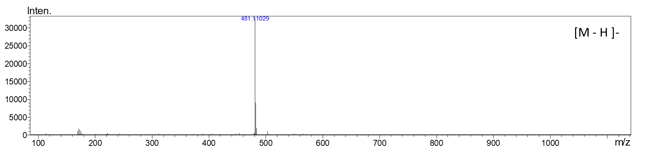
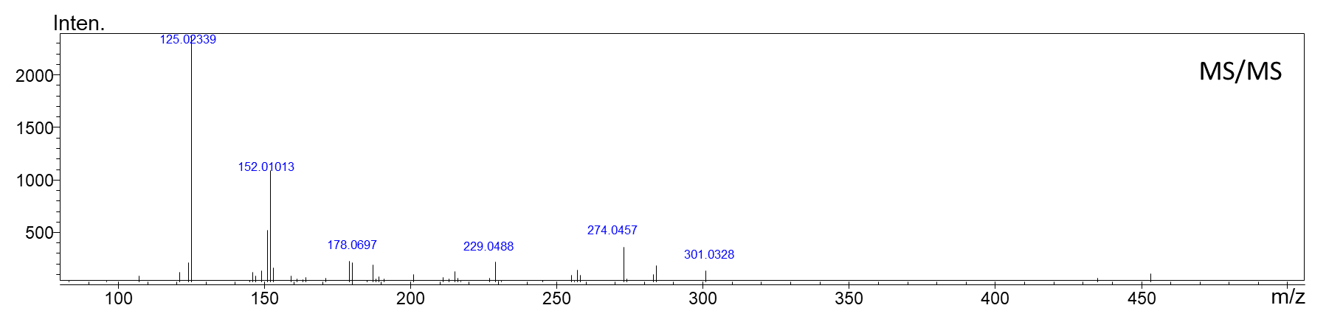

Figure 14. Negative ion electrospray HRMS (top panel) and MS/MS of peak 12 with m/z 481.1102 eluting at 22.26 min

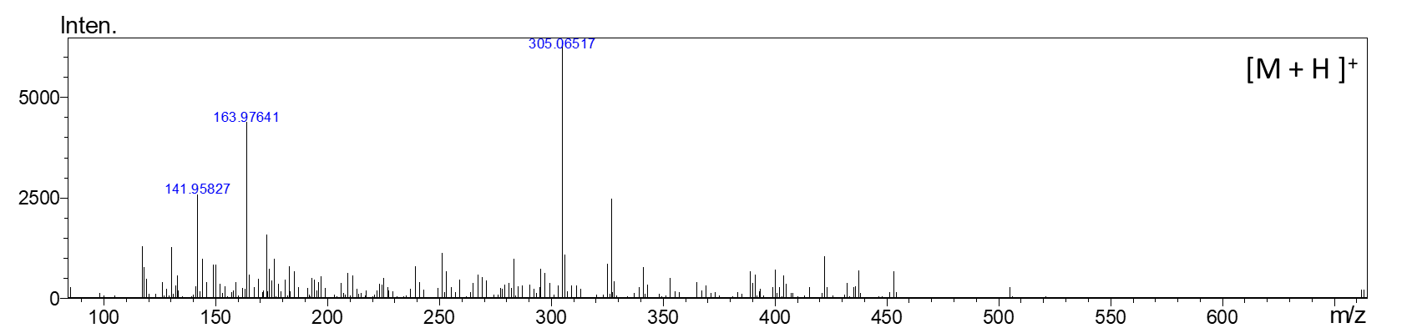
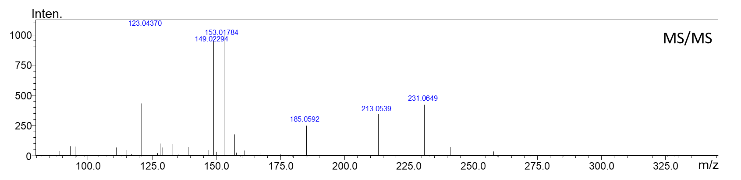

Figure 15. Positive ion electrospray HRMS (top panel) and MS/MS of peak 1 with m/z 305.0651 eluting at 10.64 min

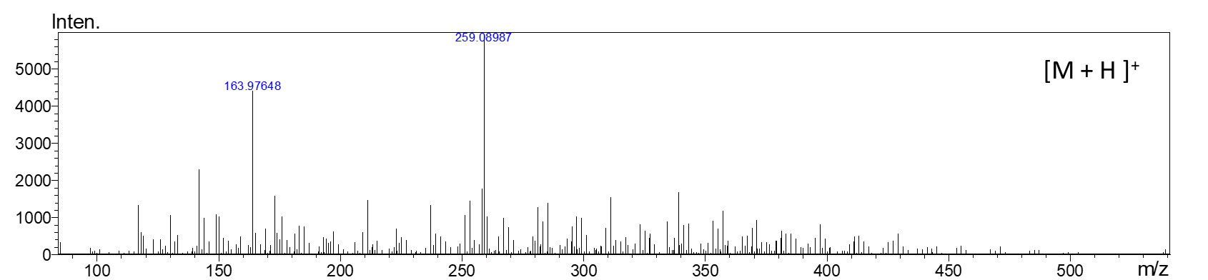
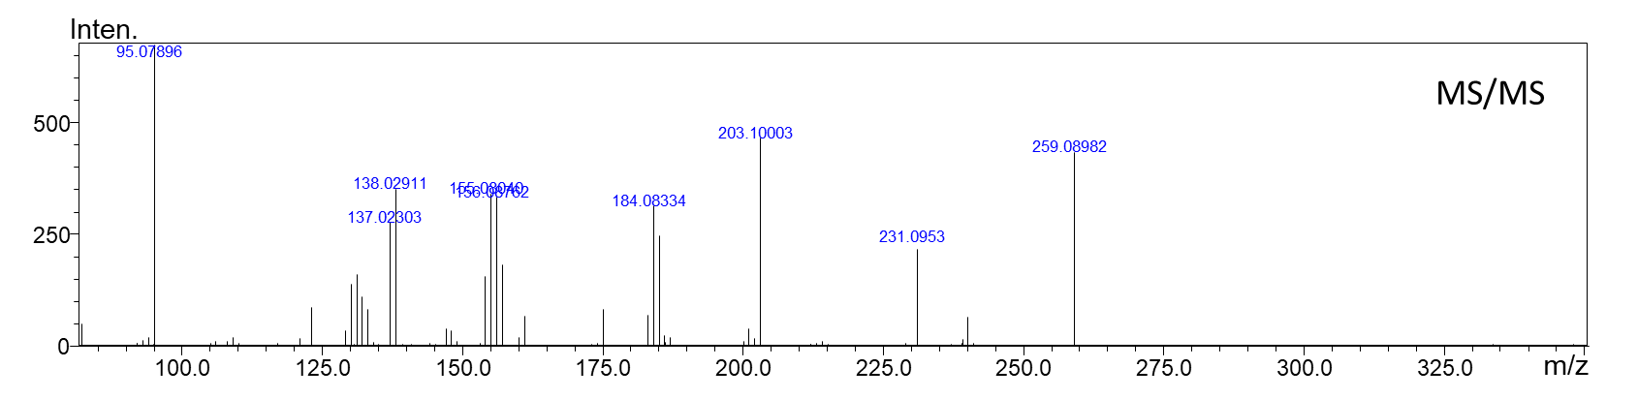

Figure 16. Positive ion electrospray HRMS (top panel) and MS/MS of peak 7 with m/z 259.0899 eluting at 16.51 min

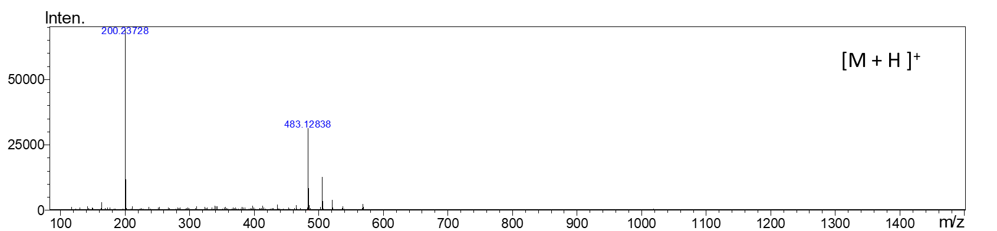
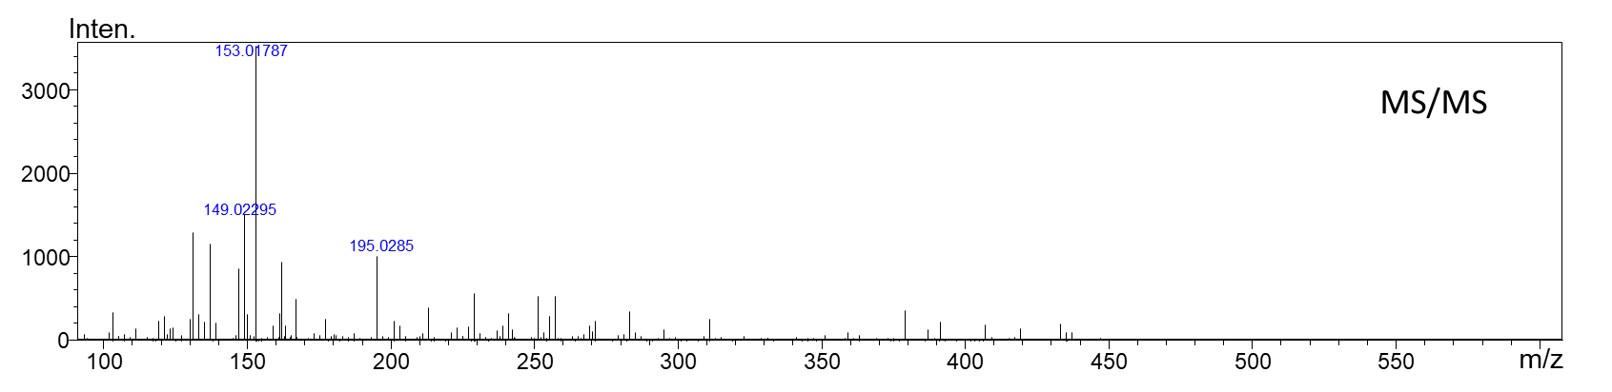

Figure 17. Positive ion electrospray HRMS (top panel) and MS/MS of peak 8 with m/z 483.1283 eluting at 19.80 min

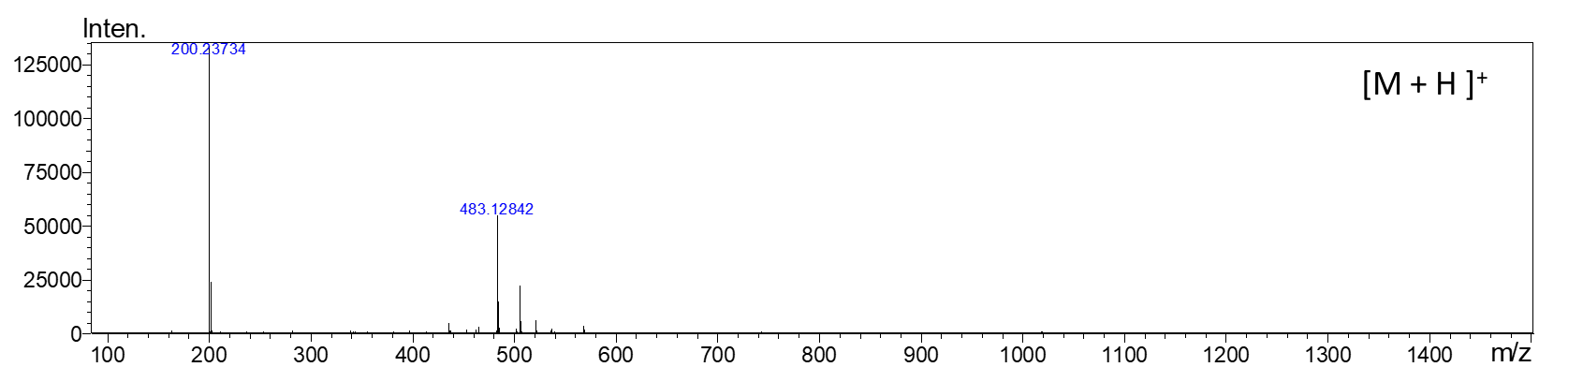
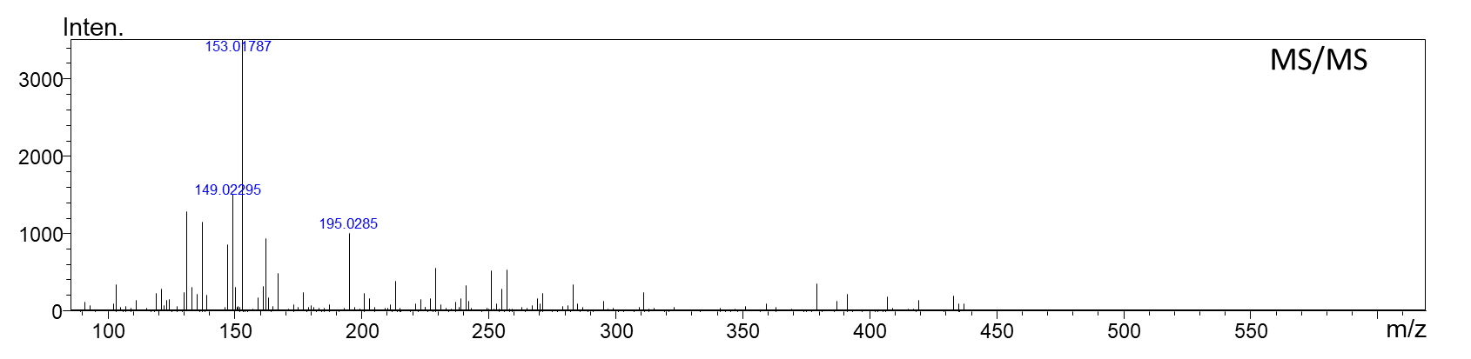

Figure 18. Positive ion electrospray HRMS (top panel) and MS/MS of peak 9 with m/z 483.1284 eluting at 20.43 min

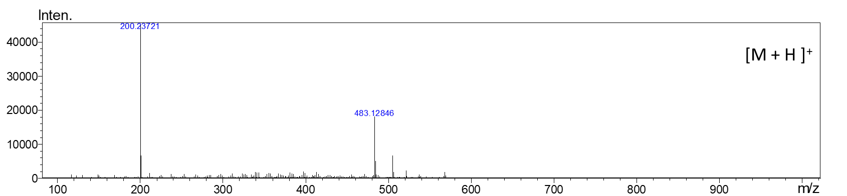
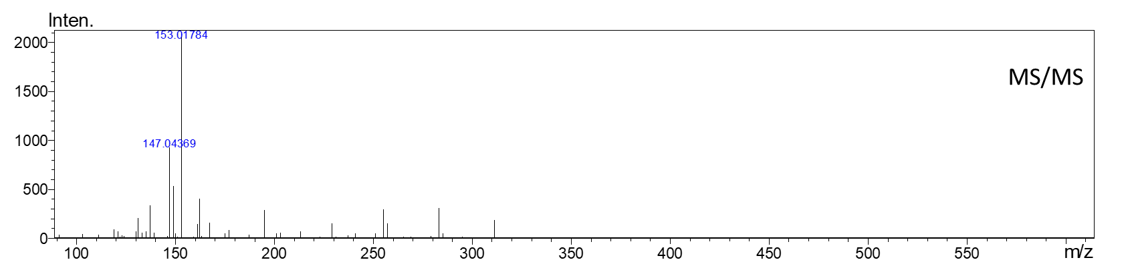

Figure 19. Positive ion electrospray HRMS (top panel) and MS/MS of peak 11 with m/z 483.1254 eluting at 21.99 min

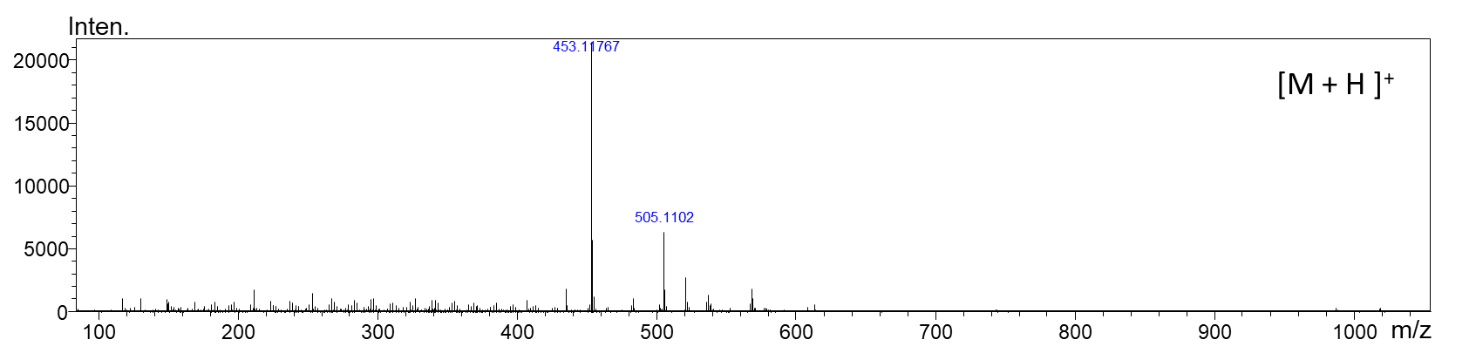
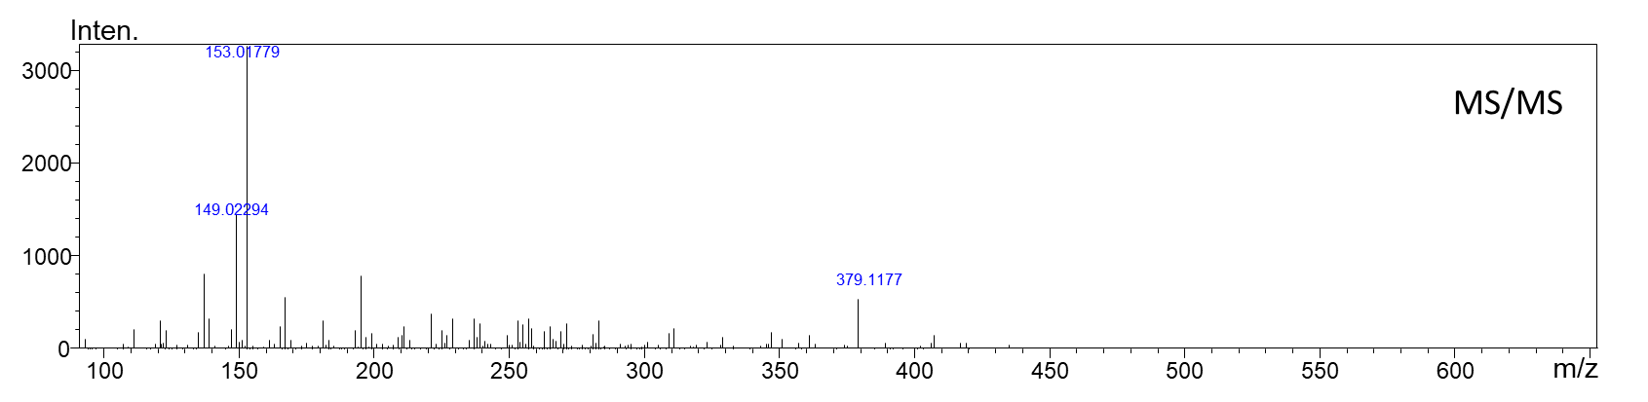

Figure 20. Positive ion electrospray HRMS (top panel) and MS/MS of peak 13 with m/z 453.1176 eluting at 13.59 min

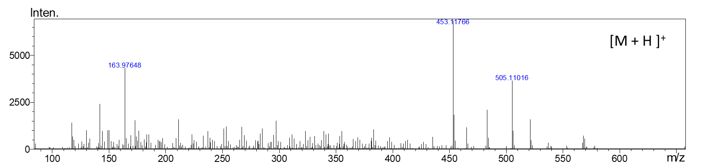
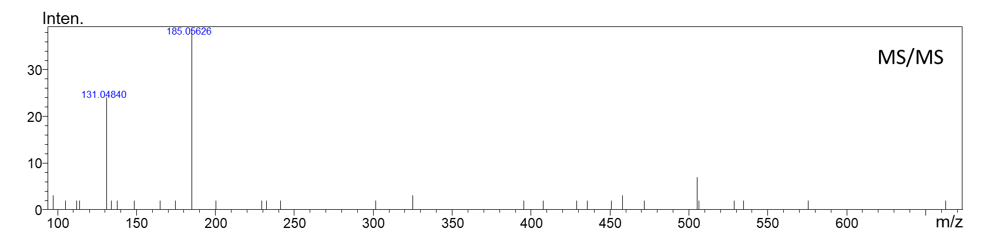

Figure 21. Positive ion electrospray HRMS (top panel) and MS/MS of peak 14 with m/z 505.1101 eluting at 14.51 min

