Figure S-2. Nucleotide composition of sequencing paired-end RNA-Seq reads from rat RNA.
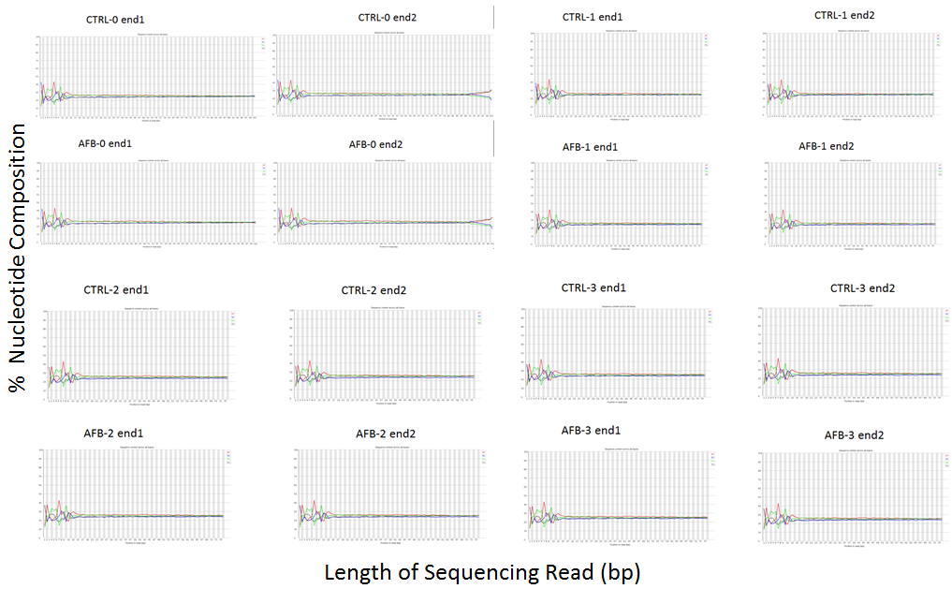

The nucleotide compositions of RNA-Seq reads were plotted (yellow bars) in each panel for each end of control (CTRL) or aflatoxin (AFB1) treated rats. The percentage of each nucleotide (y-axis) is indicated by color (T= red; C = blue; C= green; G = black) and is plotted against read length (x-axis). For the samples, CTRL-0 and AFB-0, the read length extends to 100bp while the remaining six samples, CTRL-1,2,3 and AFB-1,2,3, were at 75bp length. Note the changing composition in beginning reads (1-12) becomes evenly distributed in longer read lengths which is common in RNA-Seq data.

