Supplemental Figure 1
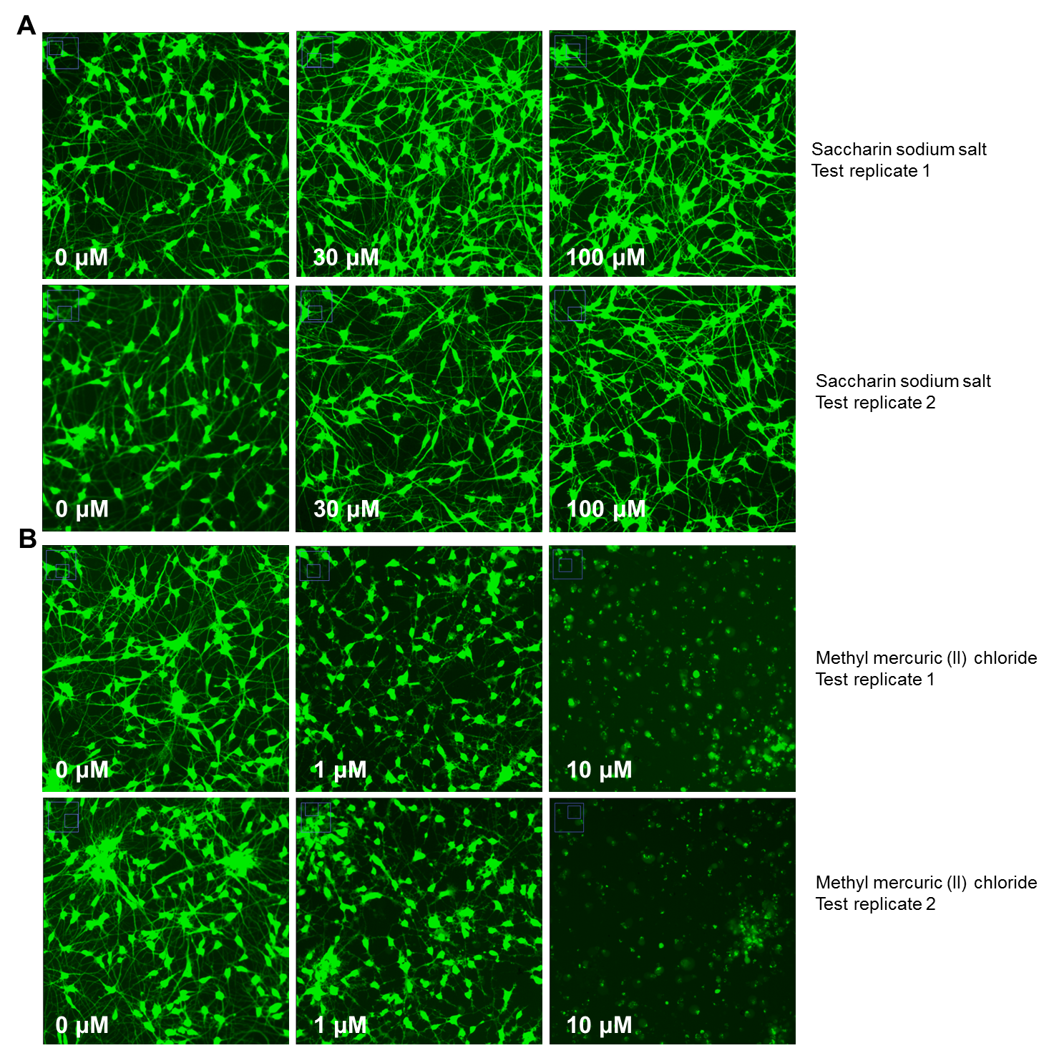

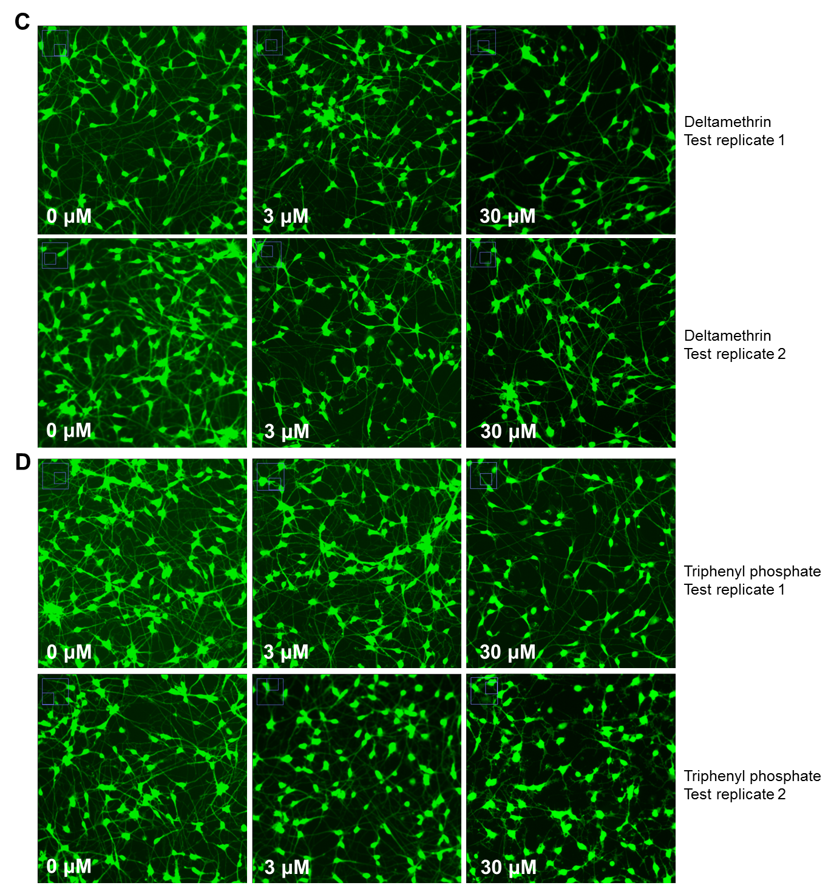
Supplemental Figure 1: Determination of assay reproducibility, Part 1. Assay reproducibility is achieved between test replicate compounds in the (A-D) neurite outgrowth assay. Representative concentration response images from iPSC-neurons treated with test replicates (A) saccharin sodium salt [negative control], (B) methyl mercuric (II) chloride [positive control], (C) deltamethrin, and (D) triphenyl phosphate. High-content images of neuronal bodies and neurites were visualized with Calcien AM dye (green) following a 72 hr compound exposure.

Supplemental Figure 2
E
Chemical | Total  Outgrowth |  | Total  Processes |  | Total  Branches | Viable Cells
Saccharin sodium salt – 1 | 100.00 | 100.00 |  | 100.00 |  |  | 100.00
Saccharin sodium salt – 2 | 100.00 | 100.00 |  | 100.00 |  |  | 100.00
Methyl mercuric (II) chloride - 1 | 0.82 | 1.56 |  | 0.55 |  |  | 2.00
Methyl mercuric (II) chloride - 2 | 0.98 | 1.48 |  | 0.96 |  |  | 1.42
Deltamethrin - 1 | 25.00 | 42.00 |  | 23.80 |  |  | 43.30
Deltamethrin - 2 | 27.20 | 30.50 |  | 26.80 |  |  | 29.50
Triphenyl phosphate - 1 | 23.47 | 42.22 |  | 20.52 |  |  | 47.78
Triphenyl phosphate - 2 | 22.10 | 46.15 |  | 13.30 |  |  | 51.80

Supplemental Figure 2: Determination of assay reproducibility, Part 2. Assay reproducibility is achieved between test replicate compounds in the (A-D) neurite outgrowth assay. Concentration response curves are plotted from normalized data (noted by an asterisk *) for each concentration and endpoint. Concentration-response curves for the test replicates are shown side-by-side. Benchmark concentration (BMC) values were estimated for all four compounds: (A) saccharin sodium salt, (B) methyl mercuric (II) chloride, (C) deltamethrin, and (D) triphenyl phosphate. The solid circle ● represents the estimated BMC values which are displayed in the associated (E) table. The open square □ represents outlier data points which were not included in BMC analysis. Key for A-D plots: Black = viable cell number for both assays, red = total outgrowth, blue = total branches, and green = total processes).

Supplemental Figure 3
Supplemental Figure 3: High concordance is observed between neurite outgrowth endpoints. Pearson’s correlation coefficient values (CCV) were calculated for comparison between neurite outgrowth endpoints. Scatter plots represent comparisons of all data points (normalized values) for (A) total process vs. total outgrowth, (B) total branches vs. total process and (C) total branches vs. total outgrowth.

