Supplemental Material
Identification of Estrogen-Related Receptor Alpha Agonists in the Tox21 Compound Library
Caitlin Lynch, Jinghua Zhao, Ruili Huang, Noriko Kanaya, Lauren Bernal, Jui-Hua Hsieh, Scott S. Auerbach, Kristine L. Witt, B. Alex Merrick, Shiuan Chen, Christina T. Teng, Menghang Xia
Table of Contents
Tables
Table S1. qHTS primary and follow-up screen data…………………………………………….2
Table S2. qHTS primary and follow-up screen data for single actives………………………....21

Supplementary Table S1. qHTS primary and follow-up screen data
Chemical Name |  | ERR |  | PGC/ERR
(CASRN, Supplier) |  | Primary | Follow-up | Primary | Follow-up
NCGC# | Structure | EC₅₀ (µM) | EC₅₀ (µM) | EC₅₀ (µM) | EC₅₀ (µM)
[Purity Rating] |  | [Efficacy§ (%)] | [Efficacy§ (%)] | [Efficacy§ (%)] | [Efficacy§ (%)]
 |  | Cluster 1.10
Adriamycin hydrochloride  (25316-40-9, Toronto Research)  NCGC00260032-01¹  [A]  (25316-40-9, Tocris)  NCGC00024415-34²  [A] | 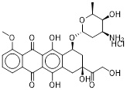 | Inactive*¹ | Inactive*² | 0.235 ± 0.0324  [57.5 ± 15.0]¹ | 0.419 ± 0.0482  [75.7 ± 7.71]²
Daunomycin Hydrochloride  (23541-50-6, LKT Labs)  NCGC00258711-01  [A] | 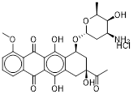 | Inactive* | Inactive* | 0.109 ± 0.0304  [39.3 ± 14.5] | 0.344 ± 0.0395  [107 ± 9.17]
Pirarubicin  (72496-41-4, Sigma)  NCGC00344543-01  [B] | 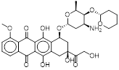 | Inactive* | Inactive* | 0.406 ± 0.0265  [50.9 ± 10.0] | 0.692 ± 0.0882  [87.7 ± 4.21]
 |  | Cluster 1.13
Biochanin A  (491-80-5, Sigma)  NCGC00256458-01  [A] | 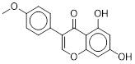 | 3.47 ± 1.96  [169 ± 7.73] | 11.3 ± 2.03  [172 ± 7.54] | 7.92 ± 2.21  [168 ± 25.7] | 13.1 ± 1.81  [123 ± 4.87]
Genistein  (446-72-0, Light Biologicals)  NCGC00254275-01  [A] | 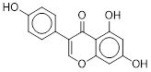 | 4.34 ± 1.43  [101 ± 9.53] | 12.1 ± 0.00  [125 ± 3.97] | 8.15 ± 1.84  [115 ± 18.2] | 11.2 ± 0.758  [88.1 ± 1.97]
 |  | Cluster 1.15
5,6-Benzoflavone  (6051-87-2, Acros)  NCGC00255199-01  [A] | 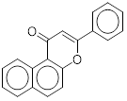 | 0.102 ± 0.0183  [216 ± 28.0] | 0.360 ± 0.0813  [239 ± 8.62] | 0.203 ± 0.0701  [109 ± 2.52] | 0.337 ± 0.0938  [127 ± 21.9]
Flavone  (525-82-6, Sigma)  NCGC00260532-01¹  [A]  (525-82-6, Sigma)  NCGC00090962-05²  [A] | 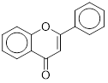 | 5.99 ± 3.28  [70.7 ± 9.22]¹ | 11.7 ± 1.99  [74.2 ± 7.19]² | 8.50 ± 2.06  [34.0 ± 5.90]¹ | 9.54 ± 0.00  [31.8 ± 5.45]²
 |  | Cluster 2.12
Apigenin  (520-36-5, Light Biologicals)  NCGC00256419-01  [A] | 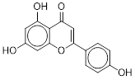 | 5.72 ± 1.03  [119 ± 19.6] | 7.73 ± 1.62  [102 ± 12.1] | 4.87 ± 2.48  [80.4 ± 32.9] | 12.8 ± 2.88  [80.6 ± 5.13]
Chrysin  (480-40-0, Sigma)  NCGC00255307-01  [A] | 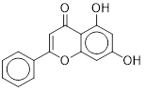 | 7.42 ± 0.483  [190 ± 46.1] | 7.48 ± 2.81  [145 ± 28.8] | 2.63 ± 0.171  [53.7 ± 5.79] | 11.4 ± 4.25  [95.3 ± 9.57]
 |  | Cluster 2.13
Daidzein  (486-66-8, Sigma)  NCGC00258995-01¹  [A]  (486-66-8, Light Biologicals)  NCGC00257367-01²  [A] | 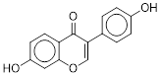 | 16.6 ± 2.82  [154 ± 38.8]¹ | 30.3 ± 0.00  [135 ± 6.41]² | 24.2 ± 2.78  [124 ± 18.7]¹ | 34.5 ± 6.44  [111 ± 16.5]²
Formononetin  (485-72-3, Light Biologicals)  NCGC00255167-01  [A] | 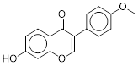 | 4.26 ± 1.03  [162 ± 15.3] | 7.73 ± 1.62  [161 ± 11.0] | 12.5 ± 8.16  [155 ± 66.9] | 13.1 ± 0.851  [118 ± 13.0]
Ipriflavone  (35212-22-7, Sequoia)  NCGC00018139-05  [A] | 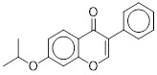 | 1.68 ± 0.599  [143 ± 25.9] | 2.03 ± 0.279  [95.3 ± 9.78] | 1.91 ± 0.736  [78.8 ± 11.8] | 2.87 ± 2.08  [74.8 ± 17.5]
 |  | Cluster 6.20
2-Amino-6-methoxybenzothiazole  (1747-60-0, Sigma)  NCGC00256938-01  [A] | 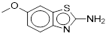 | 22.4 ± 9.37  [37.4 ± 7.25] | 14.2 ± 1.81  [47.2 ± 3.86] | Inactive* | Inactive*
Riluzole  (1744-22-5, Vitas)  NCGC00015882-15  [A] | 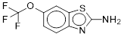 | 10.2 ± 0.665  [67.8 ± 13.3] | 10.7 ± 2.44  [44.8 ± 8.78] | 10.6 ± 0.00  [40.0 ± 4.54] | 18.0 ± 1.17  [42.3 ± 7.00]
 |  | Cluster 7.9
Albendazole  (54965-21-8, Sigma)  NCGC00255250-01  [A] | 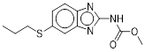 | 3.87 ± 1.27  [35.2 ± 9.15] | Inactive* | 12.0 ± 10.7  [75.0 ± 24.7] | 2.53 ± 0.747  [56.1 ± 12.2]
Carbendazim  (10605-21-7, Light Biologicals)  NCGC00254328-01  [A] | 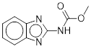 | Inactive* | Inactive* | Inactive* | Inactive*
Parbendazole  (14255-87-9, Prestwick)  NCGC00016706-07  [A] | 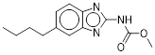 | 1.02 ± 0.0665  [35.8 ± 13.9] | Inactive* | 6.47 ± 4.69  [94.2 ± 14.9] | 3.65 ± 2.00  [69.6 ± 16.6]
Thiophanate  (23564-06-9, Light Biologicals)  NCGC00255347-01  [A] | 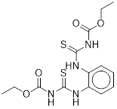 | Inactive* | Inactive* | Inactive* | Inactive*
 |  | Cluster 7.10
Cyclobendazole  (31431-43-3, GVK)  NCGC00262953-01  [A] | 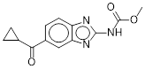 | Inactive* | Inactive* | 6.44 ± 0.420  [38.8 ± 2.95] | Inactive*
Fenbendazole  (43210-67-9, Vitas)  NCGC00016855-10  [A] | 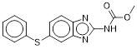 | 3.26 ± 0.555  [34.1 ± 14.9] | Inactive* | 16.5 ± 9.00  [138 ± 48.9] | 5.71 ± 0.786  [49.5 ± 1.06]
Mebendazole  (31431-39-7, Microsource)  NCGC00016806-13  [A] | 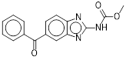 | Inactive* | Inactive* | 4.06 ± 0.265  [65.2 ± 5.05] | 3.45 ± 0.234  [48.7 ± 7.77]
Nocodazole  (31430-18-9, Prestwick Chemical, Inc.)  NCGC00015647-18  [A] | 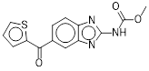 | Inactive* | Inactive* | 4.81 ± 3.14  [82.4 ± 18.3] | 6.50 ± 1.62  [53.4 ± 4.83]
Oxfendazole  (53716-50-0, Vitas)  NCGC00095157-05  [ND] | 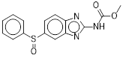 | Inactive* | Inactive* | 15.4 ± 7.23  [111 ± 25.8] | 6.28 ± 3.65  [51.8 ± 7.24]
 |  | Cluster 8.14
Benzyl salicylate  (118-58-1, Sigma)  NCGC00256928-01  [A] | 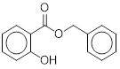 | 28.5 ± 3.64  [35.0 ± 7.44] | 22.7 ± 5.13  [52.7 ± 6.67] | Inactive* | 23.1 ± 15.5  [33.6 ± 14.4]
Phenyl 1-hydroxy-2-naphthoate  (132-54-7, Sigma)  NCGC00255458-01  [A] | 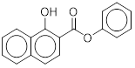 | 22.3 ± 8.72  [167 ± 43.8] | 12.1 ± 0.00  [137 ± 7.73] | 10.9 ± 1.25  [74.6 ± 7.93] | 10.8 ± 1.24  [86.8 ± 4.83]
Salicylic acid p-tolyl ester  (607-88-5, TCI)  NCGC00256803-01  [A] | 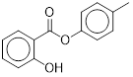 | Inactive* | 27.0 ± 0.00  [42.6 ± 1.96] | Inactive* | 21.8 ± 4.56  [34.9 ± 0.752]
 |  | Cluster 8.15
Benzylparaben  (94-18-8, Sigma)  NCGC00255352-01  [A] | 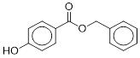 | 12.5 ± 2.24  [47.7 ± 8.50] | 28.1 ± 9.57  [66.6 ± 9.42] | 12.4 ± 0.837  [47.1 ± 4.80] | 24.9 ± 10.4  [45.5 ± 11.7]
Butylparaben  (94-26-8, Enamine)  NCGC00254294-01  [A] | 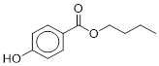 | 15.4 ± 5.07  [34.8 ± 4.52] | Inactive* | 20.4 ± 7.64  [30.0 ± 8.84] | 31.6 ± 2.14  [35.9 ± 4.61]
Heptylparaben  (1085-12-7, Alfa Aesar)  NCGC00257279-01  [A] | 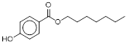 | Inactive* | Inactive* | 21.3 ± 13.3  [31.6 ± 5.06] | Inactive*
Hexylparaben  (1083-27-8, Light Biologicals)  NCGC00257292-01  [A] | 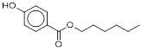 | 6.42 ± 1.15  [85.2 ± 7.20] | 11.6 ± 0.758  [75.3 ± 4.44] | 14.9 ± 10.8  [85.6 ± 21.0] | 14.2 ± 8.75  [57.7 ± 8.34]
Methylparaben  (99-76-3, Enamine)  NCGC00253939-01  [A] | 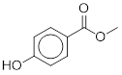 | Inactive* | Inactive* | Inactive* | Inactive*
Phenylparaben  (17696-62-7, TCI)  NCGC00257341-01  [A] | 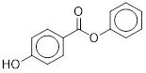 | 25.8 ± 5.81  [41.0 ± 5.80] | 29.2 ± 1.90  [68.3 ± 6.85] | 39.7 ± 18.6  [71.1 ± 21.1] | 35.4 ± 2.40  [87.0 ± 10.0]
sec-Butylparaben  (17696-61-6, Light Biologicals)  NCGC00257425-01  [A] | 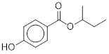 | Inactive* | 7.82 ± 2.50  [31.5 ± 3.48] | Inactive* | Inactive*
tert-Butyl 4-hydroxybenzoate  (25804-49-3, Sigma)  NCGC00256248-01  [A] | 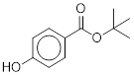 | Inactive* | 12.1 ± 0.00  [37.2 ± 7.08] | Inactive* | Inactive*
 |  | Cluster 8.18
4-Ethoxyphenol  (622-62-8, Sigma)  NCGC00256790-01  [A] | 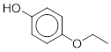 | Inactive* | Inactive* | 59.2 ± 8.14  [35.2 ± 3.39] | Inactive*
4-(Hexyloxy)phenol  (18979-55-0, Sigma)  NCGC00257244-01  [A] | 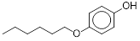 | Inactive* | Inactive* | 16.5 ± 9.66  [68.8 ± 13.1] | 29.8 ± 11.2  [47.6 ± 7.25]
 |  | Cluster 10.14
Naphthalen-2-yl 2-aminobenzoate  (63449-68-3, Oakwood)  NCGC00256876-01  [A] | 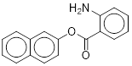 | 17.3 ± 1.99  [192 ± 15.9] | 20.3 ± 8.74  [156 ± 16.9] | 15.8 ± 4.41  [110 ± 14.7] | 17.6 ± 5.67  [106 ± 7.21]
Phenethyl anthranilate  (133-18-6, Light Biologicals)  NCGC00257318-01  [A] | 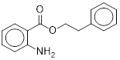 | 2.15 ± 0.598  [187 ± 33.0] | 4.63 ± 0.302  [156 ± 16.2] | 4.06 ± 3.98  [131 ± 64.6] | 3.54 ± 0.240  [106 ± 6.28]
 |  | Cluster 15.23
Atorvastatin  (134523-00-5, Waterstone)  NCGC00255181-01  [A] | 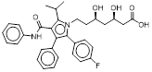 | 6.04 ± 1.36  [71.2 ± 12.6] | 9.69 ± 0.632  [70.6 ± 4.86] | Inactive* | Inactive*
Atorvastatin Calcium  (134523-03-8, Light Biologicals)  NCGC00255845-01  [A] | 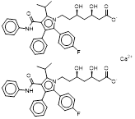 | 1.79 ± 0.752  [62.2 ± 2.13] | 5.22 ± 0.600  [50.5 ± 4.09] | Inactive* | Inactive*
Cerivastatin sodium  (143201-11-0, Sequoia)  NCGC00164625-04  [A] | 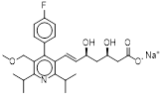 | 0.0986 ± 0.0126  [63.1 ± 15.8] | 0.173 ± 0.0117  [64.5 ± 7.04] | Inactive* | Inactive*
Fluvastatin  (93957-54-1, Enamine)  NCGC00256490-01  [A] | 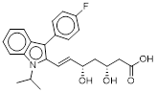 | 1.54 ± 0.177  [69.4 ± 14.4] | 2.63 ± 0.448  [54.4 ± 5.56] | Inactive* | Inactive*
 |  | Cluster 17.8
2,7-Acetylaminofluorene  (304-28-9, ChemService)  NCGC00259068-01¹  [A]  (304-28-9, Light Biologicals)  NCGC00256587-01²  [A] | 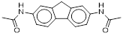 | Inactive*¹ | Inactive*² | Inactive*¹ | Inactive*²
N-(2-Fluorenyl)-2,2,2-trifluoroacetamide  (363-17-7, Light Biologicals)  NCGC00255119-01  [A] | 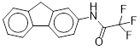 | 8.70 ± 5.54  [37.7 ± 7.42] | Inactive* | 17.7 ± 14.2  [34.7 ± 10.4] | Inactive*
 |  | Cluster 18.9
Isoproturon  (34123-59-6, Sigma)  NCGC00255738-01  [A] | 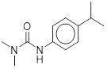 | 27.3 ± 0.00  [30.6 ± 5.61] | Inactive* | Inactive* | Inactive*
 |  | Cluster 18.15
Bromindione  (1146-98-1, Microsource)  NCGC00160590-03  [C] | 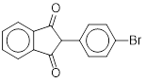 | 9.52 ± 6.61  [80.9 ± 31.5] | Inactive* | 16.8 ± 5.99  [44.0 ± 7.95] | Inactive*
 |  | Cluster 19.17
2-Ethylanthracene-9,10-dione  (84-51-5, Sigma)  NCGC00256285-01  [A] | 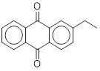 | 5.45 ± 0.00  [130 ± 20.3] | 8.24 ± 0.537  [105 ± 9.70] | 9.28 ± 2.75  [65.4 ± 2.63] | 10.1 ± 3.79  [73.1 ± 5.54]
2-Methylanthraquinone  (84-54-8, Acros)  NCGC00255621-01  [A] | 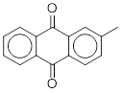 | 25.2 ± 1.71  [115 ± 20.2] | 9.49 ± 2.64  [55.9 ± 3.72] | 15.4 ± 5.59  [45.5 ± 5.31] | 18.8 ± 10.3  [53.7 ± 6.54]
2-(Propan-2-yl)-9H-thioxanthen-9-one  (5495-84-1, Light Biologicals)  NCGC00256279-01  [A] | 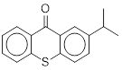 | 5.39 ± 1.50  [201 ± 44.0] | 6.82 ± 0.784  [134 ± 13.0] | 3.59 ± 0.458  [90.5 ± 5.56] | 8.19 ± 4.46  [97.8 ± 19.3]
 |  | Cluster 20.8
Nitazoxanide  (55981-09-4, Toronto Research)  NCGC00258778-01¹  [C]  (55981-09-4, NIEHS)  NCGC00090774-01²  [A] | 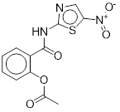 | 1.45 ± 0.895  [123 ± 11.1]¹ | 2.22 ± 1.69  [99.7 ± 18.7]² | 1.41 ± 1.00  [63.5 ± 16.3]¹ | 1.11 ± 0.512  [74.1 ± 13.9]²
Tenonitrozole  (3810-35-3, Vitas)  NCGC00160655-03  [A] | 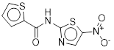 | 0.729 ± 0.124  [77.0 ± 17.8] | 1.03 ± 0.257  [71.2 ± 7.67] | 0.688 ± 0.192  [32.8 ± 5.46] | 1.60 ± 0.104  [57.3 ± 3.69]
 |  | Cluster 21.10
Resveratrol  (501-36-0, ChromaDex)  NCGC00258925-01¹  [A]  (501-36-0, Prestwick)  NCGC00015894-02²  [A] | 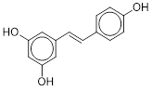 | 4.43 ± 0.927  [199 ± 11.6]¹ | 3.74 ± 0.672  [229 ± 12.7]² | 5.30 ± 0.345  [165 ± 7.28]¹ | 5.87 ± 0.397  [270 ± 15.0]²
 |  | Cluster 22.12
2-(2H-Benzotriazol-2-yl)-4-methylphenol  (2440-22-4, Sigma)  NCGC00257391-01  [A] | 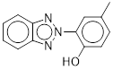 | 21.8 ± 2.50  [194 ± 25.2] | 12.6 ± 0.851  [157 ± 5.58] | 14.2 ± 6.75  [78.6 ± 22.5] | 16.1 ± 6.94  [110 ± 14.0]
 |  | Cluster 22.22
13-cis Retinoic acid  (4759-48-2, Sigma)  NCGC00257647-01  [I] | 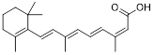 | 6.61 ± 3.86  [43.7 ± 5.32] | 20.9 ± 0.00  [38.1 ± 6.00] | Inactive* | Inactive*
Sorbic acid  (110-44-1, Enamine)  NCGC00253957-01  [A] | 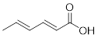 | Inactive* | 42.6 ± 0.00  [47.2 ± 4.29] | Inactive* | 40.3 ± 3.28  [34.9 ± 5.80]
trans-Retinoic acid  (302-79-4, Sigma)  NCGC00259879-01¹  [B]  (302-79-4, Labotest)  NCGC00017280-10²  [I] | 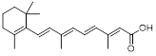 | 14.5 ± 6.25  [51.5 ± 14.8]¹ | Inactive*² | 22.0 ± 8.49  [31.1 ± 8.46]¹ | Inactive*²
 |  | Cluster 24.11
4,4'-Sulfonyldiphenol  (80-09-1, Sigma)  NCGC00256437-01  [A] | 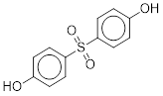 | Inactive* | Inactive* | Inactive* | Inactive*
4-Phenylphenol  (92-69-3, Sigma)  NCGC00256447-01  [A] | 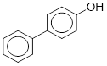 | Inactive* | Inactive* | Inactive* | Inactive*
Hydroquinone  (123-31-9, Enamine)  NCGC00254037-01  [A] | 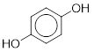 | 17.0 ± 4.75  [45.6 ± 13.7] | 22.2 ± 10.6  [44.3 ± 7.09] | Inactive* | 22.4 ± 1.51  [81.7 ± 9.08]
p-Phenylazophenol  (1689-82-3, Sigma)  NCGC00260514-01  [A] | Chemical Structure | 9.11 ± 0.616  [95.1 ± 9.31] | 10.3 ± 2.32  [91.4 ± 16.9] | 27.8 ± 3.19  [97.5 ± 5.98] | 33.2 ± 2.16  [125 ± 9.78]
 |  | Cluster 24.23
2-Carboxyethyl acrylate  (24615-84-7, Sigma)  NCGC00257334-01  [Z] | 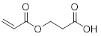 | Inactive* | 28.1 ± 1.90  [45.0 ± 8.28] | Inactive* | Inactive*
 |  | Cluster 25.22
4-Hydroxybutyl prop-2-enoate  (2478-10-6, Light Biologicals)  NCGC00256652-01  [Z] | 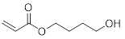 | 56.7 ± 3.84  [103 ± 27.1] | 42.9 ± 0.00  [109 ± 3.09] | Inactive* | 44.6 ± 3.02  [68.6 ± 6.84]
2-Hydroxyethyl acrylate  (818-61-1, Light Biologicals)  NCGC00256462-01  [ND] | 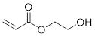 | 56.7 ± 3.84  [96.5 ± 19.7] | 38.4 ± 0.00  [142 ± 4.31] | 55.2 ± 10.3  [39.7 ± 5.03] | 40.2 ± 5.12  [79.2 ± 13.0]
 |  | Cluster 26.8
1-Amino-2-methylanthraquinone  (82-28-0, Enamine)  NCGC00256386-01  [A] | 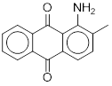 | 6.57 ± 1.94  [107 ± 17.3] | 8.24 ± 2.70  [92.1 ± 11.1] | 5.86 ± 3.64  [52.0 ± 6.73] | 6.08 ± 2.21  [59.6 ± 8.86]
2-Aminoanthraquinone  (117-79-3, Sigma)  NCGC00253972-01  [A] | 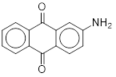 | 4.46 ± 1.24  [140 ± 13.5] | 4.95 ± 1.38  [133 ± 18.6] | 2.18 ± 0.354  [77.8 ± 3.23]^ | 6.35 ± 2.19  [85.9 ± 11.3]
 |  | Cluster 26.23
2-Phenylethyl 3-phenylprop-2-enoate  (103-53-7, Sigma)  NCGC00256862-01  [A] | 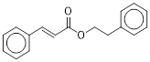 | 18.6 ± 7.81  [123 ± 13.3] | 22.1 ± 6.16  [111 ± 18.8] | 7.39 ± 3.11  [48.0 ± 8.54] | 10.6 ± 2.57  [59.3 ± 3.46]
Benzyl cinnamate  (103-41-3, Acros)  NCGC00254607-01  [A] | 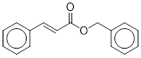 | 33.4 ± 13.2  [52.5 ± 13.9] | 32.6 ± 7.89  [30.6 ± 10.5] | 25.3 ± 1.71  [42.2 ± 11.9] | 35.7 ± 6.43  [32.6 ± 2.45]
 |  | Cluster 27.22
2-(2-Ethoxyethoxy)ethyl prop-2-enoate  (7328-17-8, Sigma)  NCGC00256257-01  [Z] | 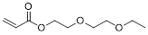 | Inactive* | 43.0 ± 4.95  [54.7 ± 5.71] | Inactive* | Inactive*
2-(Dihydrocyclopentadienyloxy)ethyl methacrylate  (68169-03-9, Sigma)  NCGC00254736-01  [A] | 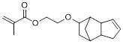 | Inactive* | Inactive* | Inactive* | Inactive*
2-Phenoxyethyl acrylate  (48145-04-6, Sigma)  NCGC00255604-01  [Z] | 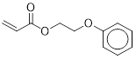 | 63.6 ± 4.30  [57.3 ± 8.84] | 28.1 ± 1.90  [31.5 ± 1.32] | 61.3 ± 7.05  [39.9 ± 13.1] | 41.3 ± 2.69  [39.9 ± 7.64]
Tripropylene glycol diacrylate  (42978-66-5, Sigma)  NCGC00255375-01  [Z] | 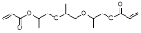 | 19.4 ± 2.23  [96.5 ± 25.4] | 10.5 ± 1.21  [101 ± 19.6] | 22.6 ± 1.53  [70.4 ± 10.5] | 7.16 ± 0.466  [60.8 ± 8.63]
 |  | Cluster 29.9
1,4-Benzenediamine  (106-50-3, Enamine)  NCGC00256482-01  [ND] | 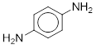 | Inactive* | Inactive* | 32.1 ± 15.7  [33.4 ± 10.8] | Inactive*
3,4,4'-Triaminodiphenyl ether  (6264-66-0, Light Biologicals)  NCGC00255251-01  [C] | 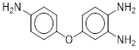 | 4.86 ± 0.00  [103 ± 30.0] | 7.65 ± 0.880  [83.6 ± 6.08] | 8.99 ± 0.608  [87.9 ± 9.09] | 17.1 ± 6.09  [86.0 ± 8.78]
4-Aminoazobenzene  (60-09-3, Sigma)  NCGC00164077-02  [A] | 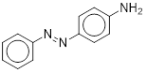 | 10.2 ± 2.99  [91.9 ± 15.6]³ | 14.4 ± 4.08  [81.3 ± 7.60] | 8.26 ± 5.17  [46.6 ± 6.59]³ | 20.5 ± 6.03  [69.8 ± 6.35]
4-Biphenylamine hydrochloride  (2113-61-3, Enamine)  NCGC00257524-01  [A] | 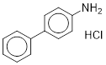 | 14.3 ± 9.75  [40.0 ± 5.82] | 18.5 ± 2.55  [32.5 ± 2.72] | Inactive* | 40.5 ± 3.30  [31.9 ± 3.26]
4'-Fluoro-4-aminodiphenyl  (324-93-6, Light Biologicals)  NCGC00255397-01  [A] | 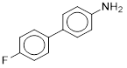 | Inactive* | 22.3 ± 7.60  [34.4 ± 1.39] | Inactive* | 30.5 ± 4.95  [30.6 ± 4.59]
Benzidine  (92-87-5, Enamine)  NCGC00254474-01  [A] | 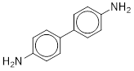 | Inactive* | 23.4 ± 11.0  [38.2 ± 5.22] | Inactive* | Inactive*
 |  | Cluster 29.10
2,3-Diaminotoluene  (2687-25-4, Sigma)  NCGC00254106-01  [C] | 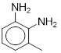 | 14.4 ± 12.6  [106 ± 28.8] | 21.2 ± 5.92  [52.4 ± 10.7] | 16.6 ± 13.4  [44.6 ± 10.9] | 26.5 ± 9.98  [56.2 ± 6.79]
3,4-Diaminotoluene  (496-72-0, Light Biologicals)  NCGC00254324-01  [A] | 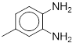 | 3.84 ± 2.84  [202 ± 40.4] | 8.40 ± 3.16  [55.2 ± 16.6] | 3.71 ± 2.11  [80.6 ± 5.22] | 15.2 ± 5.43  [99.0 ± 10.7]
3-Methylaniline  (108-44-1, Light Biologicals)  NCGC00254415-01  [A] | 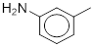 | Inactive* | Inactive* | Inactive* | Inactive*
 |  | Cluster 30.6
Phenazopyridine hydrochloride  (136-40-3, Sigma)  NCGC00256528-01  [A] | 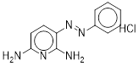 | 9.73 ± 1.12  [108 ± 14.2] | 9.72 ± 1.82  [84.9 ± 18.1] | 8.75 ± 1.63  [67.5 ± 20.2] | 20.1 ± 6.94  [82.8 ± 13.6]
 |  | Cluster 30.9
2-Aminoanthracene  (613-13-8, Sigma)  NCGC00257001-01  [B] | 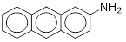 | 22.1 ± 5.05  [61.9 ± 6.39] | 10.8 ± 1.24  [51.6 ± 11.4] | 22.4 ± 13.0  [36.9 ± 8.97] | 14.3 ± 9.38  [52.7 ± 17.0]
3,3'-Diaminobenzidine  (91-95-2, Acros)  NCGC00255443-01  [Z] | 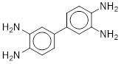 | Inactive* | Inactive* | 23.3 ± 12.7  [30.5 ± 8.21] | Inactive*
 |  | Cluster 31.9
2-Amino-4-phenylthiazole hydrobromide hydrate  (52253-69-7, Sigma)  NCGC00257725-01¹  [A]  (52253-69-7, NIEHS)  NCGC00091948-01²  [A] | 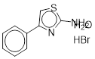 | 38.8 ± 22.0  [48.0 ± 5.99]¹ | 14.6 ± 3.54  [41.2 ± 4.85]² | Inactive*¹ | Inactive*²
2-Amino-5,6-dimethylbenzothiazole  (29927-08-0, Sigma)  NCGC00258632-01¹  [A]  (29927-08-0, NIEHS)  NCGC00091571-01²  [A] | 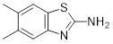 | 14.5 ± 5.01  [145 ± 29.7] ¹ | 11.0 ± 1.98  [132 ± 12.2] ² | 23.0 ± 7.94  [99.7 ± 11.0] ¹ | 12.7 ± 5.33  [85.7 ± 7.23] ²
2-Aminobenzothiazole  (136-95-8, Sigma)  NCGC00258372-01¹  [A]  (136-95-8, NIEHS)  NCGC00091895-01²  [A] | 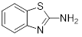 | 47.6 ± 15.6  [38.1 ± 9.67]¹ | Inactive*² | Inactive*¹ | Inactive*²
 |  | Cluster 32.12
Dihydralazine  (484-23-1, Labotest)  NCGC00159421-03  [ND] | 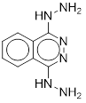 | 30.0 ± 3.45  [78.4 ± 8.18] | 0.391 ± 0.115  [35.7 ± 4.91] | 21.2 ± 10.8  [36.2 ± 2.27] | Inactive*
Hydralazine hydrochloride  (304-20-1, Light Biologicals)  NCGC00256719-01  [A] | 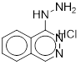 | 2.84 ± 0.967  [129 ± 4.64] | Inactive* | 4.75 ± 3.93  [110 ± 42.6] | 0.543 ± 0.0880  [31.1 ± 2.81]
 |  | Cluster 33.9
4-(2-Phenylpropan-2-yl)-N-[4-(2-phenylpropan-2-yl)phenyl]aniline  (10081-67-1, TCI)  NCGC00257239-01  [A] | 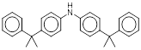 | Inactive* | Inactive* | Inactive* | Inactive*
10,11-Dihydro-5H-dibenz[b,f]azepine  (494-19-9, GVK)  NCGC00253630-01  [A] | 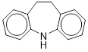 | Inactive* | Inactive* | Inactive* | Inactive*
N-Phenyl-1-naphthylamine  (90-30-2, Sigma)  NCGC00259622-01¹  [A]  (90-30-2, Sigma)  NCGC00256930-01²  [A] | 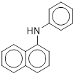 | 14.3 ± 5.67  [44.4 ± 6.71]¹ | 27.1 ± 9.89  [74.3 ± 8.58]² | 19.6 ± 4.21  [41.3 ± 11.3]¹ | 34.0 ± 0.00  [67.6 ± 11.7]²
N-Phenyl-2-naphthylamine  (135-88-6, Sigma)  NCGC00256440-01  [A] | 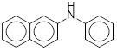 | 13.7 ± 4.52  [77.3 ± 16.6] | 35.4 ± 2.40  [81.1 ± 6.54] | 27.7 ± 5.17  [62.0 ± 12.9] | 38.4 ± 4.41  [60.0 ± 0.834]
 |  | Cluster 33.14
Anthracene  (120-12-7, Enamine)  NCGC00254204-01  [B] | 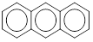 | Inactive* | 34.3 ± 5.56  [32.9 ± 8.05] | Inactive* | Inactive*
Benz(a)anthracene  (56-55-3, Light Biologicals)  NCGC00254419-01  [A] | 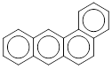 | 13.3 ± 5.26  [129 ± 39.7] | 26.2 ± 3.60  [133 ± 8.64] | 21.1 ± 3.59  [68.5 ± 18.0] | 26.5 ± 9.98  [83.4 ± 17.5]
Benzo(b)fluoranthene  (205-99-2, Sigma)  NCGC00254223-01  [A] | 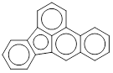 | 15.5 ± 13.2  [35.6 ± 6.09] | 11.0 ± 5.95  [44.1 ± 6.42] | 56.7 ± 3.84  [43.6 ± 3.52] | Inactive*
Dibenz(a,h)anthracene  (53-70-3, Sigma)  NCGC00257287-01  [A] | 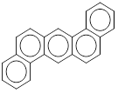 | 0.598 ± 0.167  [122 ± 14.7] | 3.01 ± 0.346  [125 ± 5.38] | 3.10 ± 3.92  [76.9 ± 49.3] | 2.87 ± 0.851  [68.9 ± 6.73]
Fluoranthene  (206-44-0, Light Biologicals)  NCGC00254498-01  [A] | 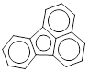 | Inactive* | Inactive* | Inactive* | Inactive*
 |  | Cluster 37.19
Fuberidazole  (3878-19-1, Light Biologicals)  NCGC00255946-01  [A] | 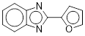 | 21.1 ± 3.59  [79.2 ± 6.34] | 8.17 ± 3.67  [50.2 ± 5.92] | 19.6 ± 7.56  [41.4 ± 6.37] | 33.0 ± 4.54  [66.0 ± 8.73]
Thiabendazole  (148-79-8, Sigma)  NCGC00259946-01¹  [A]  (148-79-8, NIEHS)  NCGC00016410-06²  [A] | 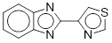 | 27.6 ± 3.17  [98.4 ± 24.3]¹ | 8.44 ± 5.52  [71.4 ± 12.5]² | 28.8 ± 5.19  [46.8 ± 5.08]¹ | 8.90 ± 5.17  [41.1 ± 4.56]²
 |  | Cluster 40.23
Lovastatin  (75330-75-5, Vitas)  NCGC00023509-13¹  [A]  (75330-75-5, NIEHS)  NCGC00023509-03²  [A] | 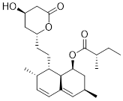 | 2.78 ± 0.354  [64.4 ± 10.9]¹ | 8.75 ± 1.57  [49.5 ± 8.39]² | Inactive*¹ | Inactive*²
Simvastatin  (79902-63-9, Toronto Research)  NCGC00254418-01  [B] | 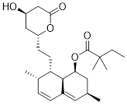 | 13.5 ± 3.27  [64.8 ± 25.6] | Inactive* | Inactive* | Inactive*
 |  | Cluster 42.9
3'-Methyl-4-dimethylaminoazobenzene  (55-80-1, Sigma DiscoveryCPR)  NCGC00256428-01  [A] | 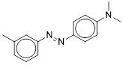 | 3.07 ± 0.751  [231 ± 22.9] | 5.40 ± 1.93  [205 ± 33.9] | 5.56 ± 4.61  [177 ± 89.6] | 4.89 ± 1.12  [131 ± 13.0]
Methyl Red  (493-52-7, Sigma)  NCGC00255799-01  [A] | 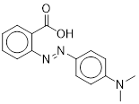 | 5.98 ± 3.19  [55.6 ± 16.0] | 3.68 ± 1.21  [54.0 ± 6.86] | 8.12 ± 3.04  [41.5 ± 4.35] | 9.04 ± 4.17  [67.7 ± 9.33]
Michler's ketone  (90-94-8, Sigma)  NCGC00254018-01  [A] | 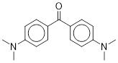 | Inactive* | Inactive* | 20.0 ± 6.43  [61.9 ± 3.43] | 11.1 ± 3.09  [62.4 ± 7.73]
N,N-Dimethyl-4-nitrosoaniline  (138-89-6, Sigma)  NCGC00257004-01  [A] | 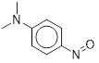 | 6.89 ± 0.792  [71.5 ± 12.8] | Inactive* | 8.99 ± 0.608  [127 ± 89.0] | 12.1 ± 1.39  [112 ± 33.9]
§: The % efficacy is based on the maximal efficacy produced by Genistein.
*: Compound was identified as inactive if the efficacy was below 30% of Genistein’s activity.
#: At our lowest concentration, the efficacy is already higher than 100% and therefore we generated an estimate based on the lowest test concentration.
Purity Ratings: A = MW Confirmed, Purity > 90%; B = MW Confirmed, Purity 75 – 90%; C = MW Confirmed, Purity 50 – 75%; I = MW Confirmed, Two or more isomers detected; Z = MW Confirmed, No Purity Info; A_{c} = Purity > 90%, Low concentration of sample; ND = Not determined yet
1: This compound was used in the primary screen and picked for the follow-up screen; however, we ran out of the sample and therefore, had to create a new stock.
2: This is the lot we created to replace 1 for the follow-up screens.
3: n=48, for this sample.
^: n=2, the third sample was an outlier.

Supplementary Table S2. qHTS primary and follow-up screen data for singletons
Chemical Name |  | ERR |  | PGC/ERR
(CASRN, Supplier) | Structure | Primary | Follow-up | Primary | Follow-up
NCGC# |  | EC₅₀ (µM) | EC₅₀ (µM) | EC₅₀ (µM) | EC₅₀ (µM)
[Purity Rating] |  | [Efficacy§ (%)] | [Efficacy§ (%)] | [Efficacy§ (%)] | [Efficacy§ (%)]
 |  | Single Actives
4-Chloro-1,2-diaminobenzene  (95-83-0, Sigma)  NCGC00091663-03  [C] | 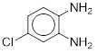 | 4.91 ± 4.42  [159 ± 50.7]³ | 9.72 ± 1.82  [78.1 ± 6.28] | 3.10 ± 3.92  [76.9 ± 49.3]³ | 19.5 ± 4.46  [83.3 ± 4.96]
Amlenanox  (68302-57-8, Bosche)  NCGC00167472-03  [A] | 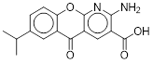 | 1.50 ± 0.173  [178 ± 43.0] | 2.97 ± 0.341  [172 ± 13.7] | 1.52 ± 0.318  [73.8 ± 5.62] | 1.94 ± 0.660  [117 ± 7.31]
Axitinib  (319460-85-0, Sequoia)  NCGC00241108-04  [I] | 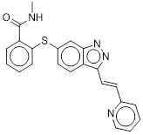 | 0.948 ± 0.312  [128 ± 17.5] | 0.756 ± 0.173  [86.3 ± 8.76] | 1.16 ± 0.197  [80.4 ± 5.85] | 1.39 ± 0.249  [71.8 ± 3.07]
C.I. Disperse Yellow 3  (2832-40-8, Sigma Chemical Company)  NCGC00357249-01¹  [ND]  (2832-40-8, Sigma)  NCGC00164349-01²  [A] | 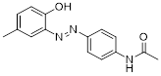 | 4.50 ± 0.305  [219 ± 27.8]¹ | 3.82 ± 0.00  [183 ± 3.94]² | 3.37 ± 1.27  [90.1 ± 5.90]¹ | 6.30 ± 0.426  [142 ± 10.5]²
Fanetizole  (79069-94-6, Enamine)  NCGC00160438-02  [B] | 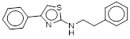 | 1.36 ± 0.729  [86.3 ± 20.1] | 5.47 ± 0.370  [139 ± 3.66] | 2.58 ± 0.354  [75.6 ± 4.59] | 14.3 ± 0.930  [155 ± 6.13]
Febuxostat  (144060-53-7, Tocris)  NCGC00182059-03¹  [A]  (144060-53-7, APAC)  NCGC00182059-02²  [A] | 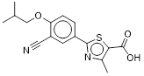 | 0.562 ± 0.127  [173 ± 41.7]¹ | 1.71 ± 0.477  [203 ± 22.8]² | 0.738 ± 0.564  [83.8 ± 16.1]¹ | 1.53 ± 0.493  [129 ± 4.08]²
Forskolin  (66575-29-9, Sigma)  NCGC00255526-01  [A] | 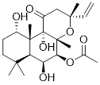 | Inactive* | Inactive* | 1.73 ± 0.199  [277 ± 27.3] | 0.964 ± 0.111  [172 ± 10.4]
Frentizole  (26130-02-9, Vitas)  NCGC00160657-03  [A] | 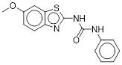 | 1.19 ± 0.00  [249 ± 39.0] | 2.02 ± 0.131  [181 ± 16.7] | 0.690 ± 0.222  [96.7 ± 8.43] | 2.27 ± 0.313  [122 ± 3.29]
HMR1426  (262376-75-0, Pharma)  NCGC00254151-01  [C] | 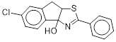 | 3.45 ± 1.26  [108 ± 10.6] | 4.30 ± 1.57  [45.4 ± 7.25] | 7.04 ± 2.76  [58.0 ± 12.7] | 5.94 ± 3.25  [41.8 ± 16.5]
Para-Azoxyanisole  (1562-94-3, Sigma)  NCGC00258714-01¹  [A]  (1562-94-3, Sigma)  NCGC00091863-04²  [B] | 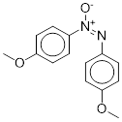 | 0.654 ± 0.0426  [166 ± 17.0]¹ | 1.61 ± 0.222  [177 ± 13.7]² | 0.660 ± 0.112  [82.2 ± 6.32]¹ | 1.91 ± 1.25  [113 ± 12.4]²
Suberoylanilide hydroxamic acid (SAHA)  (149647-78-9, Prestwick)  NCGC00168085-05  [ND] | 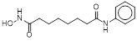 | Inactive* | Inactive* | 1.96 ± 0.133  [112 ± 4.69] | 3.33 ± 0.383  [191 ± 4.26]

§: The % efficacy is based on the maximal efficacy produced by Genistein.
*: Compound was identified as inactive if the efficacy was below 30% of Genistein’s activity.
#: At our lowest concentration, the efficacy is already higher than 100% and therefore we generated an estimate based on the lowest test concentration.
Purity Ratings: A = MW Confirmed, Purity > 90%; B = MW Confirmed, Purity 75 – 90%; C = MW Confirmed, Purity 50 – 75%; I = MW Confirmed, Two or more isomers detected; ND = Not determined yet
1: This compound was used in the primary screen and picked for the follow-up screen; however, we ran out of the sample and therefore, had to create a new stock.
2: This is the lot we created to replace 1 for the follow-up screens.

