Supplementary Tables and Figures
Table A. GSE66384: Top 20 Pathways for Follicular Lymphoma vs. Tonsillectomy Comparison
Microarray measured transcriptome |  | S1500 genes-based transcriptome |  | Random 1500 genes-based transcriptome
Pathway | ES | Pathway | ES | Pathway | ES
REACTOME PHOSPHORYLATION OF CD3 AND TCR ZETA CHAINS | 0.918 | KEGG ASTHMA | 0.904 | REACTOME STRIATED MUSCLE CONTRACTION | -0.756
KEGG ASTHMA | 0.901 | KEGG ALLOGRAFT REJECTION | 0.866 | BIOCARTA CLASSIC PATHWAY | -0.750
KEGG ALLOGRAFT REJECTION | 0.881 | KEGG GRAFT VERSUS HOST DISEASE | 0.865 | REACTOME MUSCLE CONTRACTION | -0.732
KEGG TYPE I DIABETES MELLITUS | 0.858 | KEGG TYPE I DIABETES MELLITUS | 0.861 | BIOCARTA IL12 PATHWAY | 0.717
KEGG GRAFT VERSUS HOST DISEASE | 0.834 | KEGG INTESTINAL IMMUNE NETWORK FOR IGA PRODUCTION | 0.804 | REACTOME SMOOTH MUSCLE CONTRACTION | -0.708
KEGG AUTOIMMUNE THYROID DISEASE | 0.816 | KEGG ANTIGEN PROCESSING AND PRESENTATION | 0.767 | REACTOME INTERFERON ALPHA BETA SIGNALING | -0.670
KEGG INTESTINAL IMMUNE NETWORK FOR IGA PRODUCTION | 0.813 | KEGG LEISHMANIA INFECTION | 0.763 | PID INTEGRIN1 PATHWAY | -0.643
REACTOME GENERATION OF SECOND MESSENGER MOLECULES | 0.807 | REACTOME ENDOSOMAL VACUOLAR PATHWAY | 0.727 | REACTOME TRANSPORT OF MATURE TRANSCRIPT TO CYTOPLASM | 0.628
KEGG ANTIGEN PROCESSING AND PRESENTATION | 0.716 | REACTOME INTERFERON ALPHA BETA SIGNALING | -0.711 | REACTOME GLYCOLYSIS | -0.607
REACTOME TCR SIGNALING | 0.712 | KEGG SYSTEMIC LUPUS ERYTHEMATOSUS | 0.692 | REACTOME GLUCONEOGENESIS | -0.590
KEGG VIRAL MYOCARDITIS | 0.704 | REACTOME ANTIGEN PRESENTATION FOLDING ASSEMBLY AND PEPTIDE LOADING OF CLASS I MHC | 0.594 | REACTOME ANTIGEN PRESENTATION FOLDING ASSEMBLY AND PEPTIDE LOADING OF CLASS I MHC | 0.563
REACTOME INTERFERON ALPHA BETA SIGNALING | -0.680 | REACTOME MRNA 3 END PROCESSING | 0.594 | PID SYNDECAN 1 PATHWAY | -0.562
REACTOME NEF MEDIATES DOWN MODULATION OF CELL SURFACE RECEPTORS BY RECRUITING THEM TO CLATHRIN ADAPTERS | -0.680 | KEGG STEROID BIOSYNTHESIS | -0.587 | REACTOME COLLAGEN FORMATION | -0.560
KEGG SYSTEMIC LUPUS ERYTHEMATOSUS | 0.663 | REACTOME CYTOSOLIC TRNA AMINOACYLATION | 0.568 | KEGG ECM RECEPTOR INTERACTION | -0.558
KEGG CELL ADHESION MOLECULES CAMS | 0.635 | REACTOME DEPOSITION OF NEW CENPA CONTAINING NUCLEOSOMES AT THE CENTROMERE | 0.568 | REACTOME ASSOCIATION OF TRIC CCT WITH TARGET PROTEINS DURING BIOSYNTHESIS | 0.555
REACTOME THE ROLE OF NEF IN HIV1 REPLICATION AND DISEASE PATHOGENESIS | -0.606 | REACTOME PACKAGING OF TELOMERE ENDS | 0.559 | PID AVB3 INTEGRIN PATHWAY | -0.532
REACTOME MRNA 3 END PROCESSING | 0.540 | REACTOME CHOLESTEROL BIOSYNTHESIS | -0.558 | REACTOME EXTRACELLULAR MATRIX ORGANIZATION | -0.530
REACTOME TRANSPORT OF MATURE TRANSCRIPT TO CYTOPLASM | 0.510 | REACTOME TRANSPORT OF MATURE TRANSCRIPT TO CYTOPLASM | 0.551 | REACTOME DESTABILIZATION OF MRNA BY AUF1 HNRNP D0 | 0.524
REACTOME CLEAVAGE OF GROWING TRANSCRIPT IN THE TERMINATION REGION | 0.435 | REACTOME TRIGLYCERIDE BIOSYNTHESIS | -0.551 | REACTOME GLUCOSE METABOLISM | -0.512
REACTOME INFLUENZA LIFE CYCLE | 0.391 | KEGG ARGININE AND PROLINE METABOLISM | -0.546 | KEGG PROTEASOME | 0.468
For each transcriptome analysis, Top 20 Canonical pathways from Molecular Signature Database (MSigDB) with Kolomogorov-Smirnov test p-value <=0.001 were ranked by absolute Enrichment Score (ES) value.
The shaded cells of the table denote the pathways that overlap with top-pathway based on the original microarray measured transcriptome.

Table B. GSE66384: Top 20 Pathways for Follicular Lymphoma vs. Tonsillectomy Comparison
Microarray measured transcriptome |  | S1500+ genes-based transcriptome |  | Random 2739 genes-based transcriptome
Pathway | ES | Pathway | ES | Pathway | ES
REACTOME PHOSPHORYLATION OF CD3 AND TCR ZETA CHAINS | 0.918 | REACTOME PHOSPHORYLATION OF CD3 AND TCR ZETA CHAINS | 0.926 | REACTOME PHOSPHORYLATION OF CD3 AND TCR ZETA CHAINS | 0.871
KEGG ASTHMA | 0.901 | KEGG ASTHMA | 0.895 | KEGG ASTHMA | 0.853
KEGG ALLOGRAFT REJECTION | 0.881 | KEGG ALLOGRAFT REJECTION | 0.871 | KEGG TYPE I DIABETES MELLITUS | 0.841
KEGG TYPE I DIABETES MELLITUS | 0.858 | KEGG TYPE I DIABETES MELLITUS | 0.869 | KEGG ALLOGRAFT REJECTION | 0.828
KEGG GRAFT VERSUS HOST DISEASE | 0.834 | KEGG GRAFT VERSUS HOST DISEASE | 0.851 | BIOCARTA BLYMPHOCYTE PATHWAY | 0.827
KEGG AUTOIMMUNE THYROID DISEASE | 0.816 | BIOCARTA BLYMPHOCYTE PATHWAY | 0.846 | BIOCARTA TH1TH2 PATHWAY | 0.819
KEGG INTESTINAL IMMUNE NETWORK FOR IGA PRODUCTION | 0.813 | BIOCARTA INFLAM PATHWAY | 0.791 | KEGG GRAFT VERSUS HOST DISEASE | 0.817
REACTOME GENERATION OF SECOND MESSENGER MOLECULES | 0.807 | KEGG INTESTINAL IMMUNE NETWORK FOR IGA PRODUCTION | 0.786 | REACTOME ENDOSOMAL VACUOLAR PATHWAY | 0.815
KEGG ANTIGEN PROCESSING AND PRESENTATION | 0.716 | KEGG AUTOIMMUNE THYROID DISEASE | 0.776 | KEGG AUTOIMMUNE THYROID DISEASE | 0.745
REACTOME TCR SIGNALING | 0.712 | KEGG LEISHMANIA INFECTION | 0.762 | KEGG INTESTINAL IMMUNE NETWORK FOR IGA PRODUCTION | 0.738
KEGG VIRAL MYOCARDITIS | 0.704 | KEGG ANTIGEN PROCESSING AND PRESENTATION | 0.727 | PID IL12 STAT4PATHWAY | 0.728
REACTOME INTERFERON ALPHA BETA SIGNALING | -0.680 | REACTOME TCR SIGNALING | 0.721 | KEGG ANTIGEN PROCESSING AND PRESENTATION | 0.728
REACTOME NEF MEDIATES DOWN MODULATION OF CELL SURFACE RECEPTORS BY RECRUITING THEM TO CLATHRIN ADAPTERS | -0.680 | KEGG VIRAL MYOCARDITIS | 0.692 | BIOCARTA IL12 PATHWAY | 0.719
KEGG SYSTEMIC LUPUS ERYTHEMATOSUS | 0.663 | KEGG SYSTEMIC LUPUS ERYTHEMATOSUS | 0.679 | REACTOME ANTIGEN PRESENTATION FOLDING ASSEMBLY AND PEPTIDE LOADING OF CLASS I MHC | 0.708
KEGG CELL ADHESION MOLECULES CAMS | 0.635 | REACTOME INTERFERON ALPHA BETA SIGNALING | -0.641 | REACTOME CHONDROITIN SULFATE BIOSYNTHESIS | -0.700
REACTOME THE ROLE OF NEF IN HIV1 REPLICATION AND DISEASE PATHOGENESIS | -0.606 | REACTOME REGULATION OF IFNA SIGNALING | -0.629 | KEGG LEISHMANIA INFECTION | 0.697
REACTOME MRNA 3 END PROCESSING | 0.540 | REACTOME CHOLESTEROL BIOSYNTHESIS | -0.615 | PID NFAT TFPATHWAY | 0.692
REACTOME TRANSPORT OF MATURE TRANSCRIPT TO CYTOPLASM | 0.510 | KEGG CELL ADHESION MOLECULES CAMS | 0.605 | KEGG VIRAL MYOCARDITIS | 0.686
REACTOME CLEAVAGE OF GROWING TRANSCRIPT IN THE TERMINATION REGION | 0.435 | REACTOME DEPOSITION OF NEW CENPA CONTAINING NUCLEOSOMES AT THE CENTROMERE | 0.496 | REACTOME NEP NS2 INTERACTS WITH THE CELLULAR EXPORT MACHINERY | 0.644
REACTOME INFLUENZA LIFE CYCLE | 0.391 | REACTOME MRNA 3 END PROCESSING | 0.474 | REACTOME DESTABILIZATION OF MRNA BY AUF1 HNRNP D0 | 0.642
For each transcriptome analysis, Top 20 Canonical pathways from Molecular Signature Database (MSigDB) with Kolomogorov-Smirnov test p-value <=0.001 were ranked by absolute Enrichment Score (ES) value.
The shaded cells of the table denote the pathways that overlap with top-pathway based on the original microarray measured transcriptome.

Figure A. Logit-transformed CIS/DIS Density and Correlation Plot
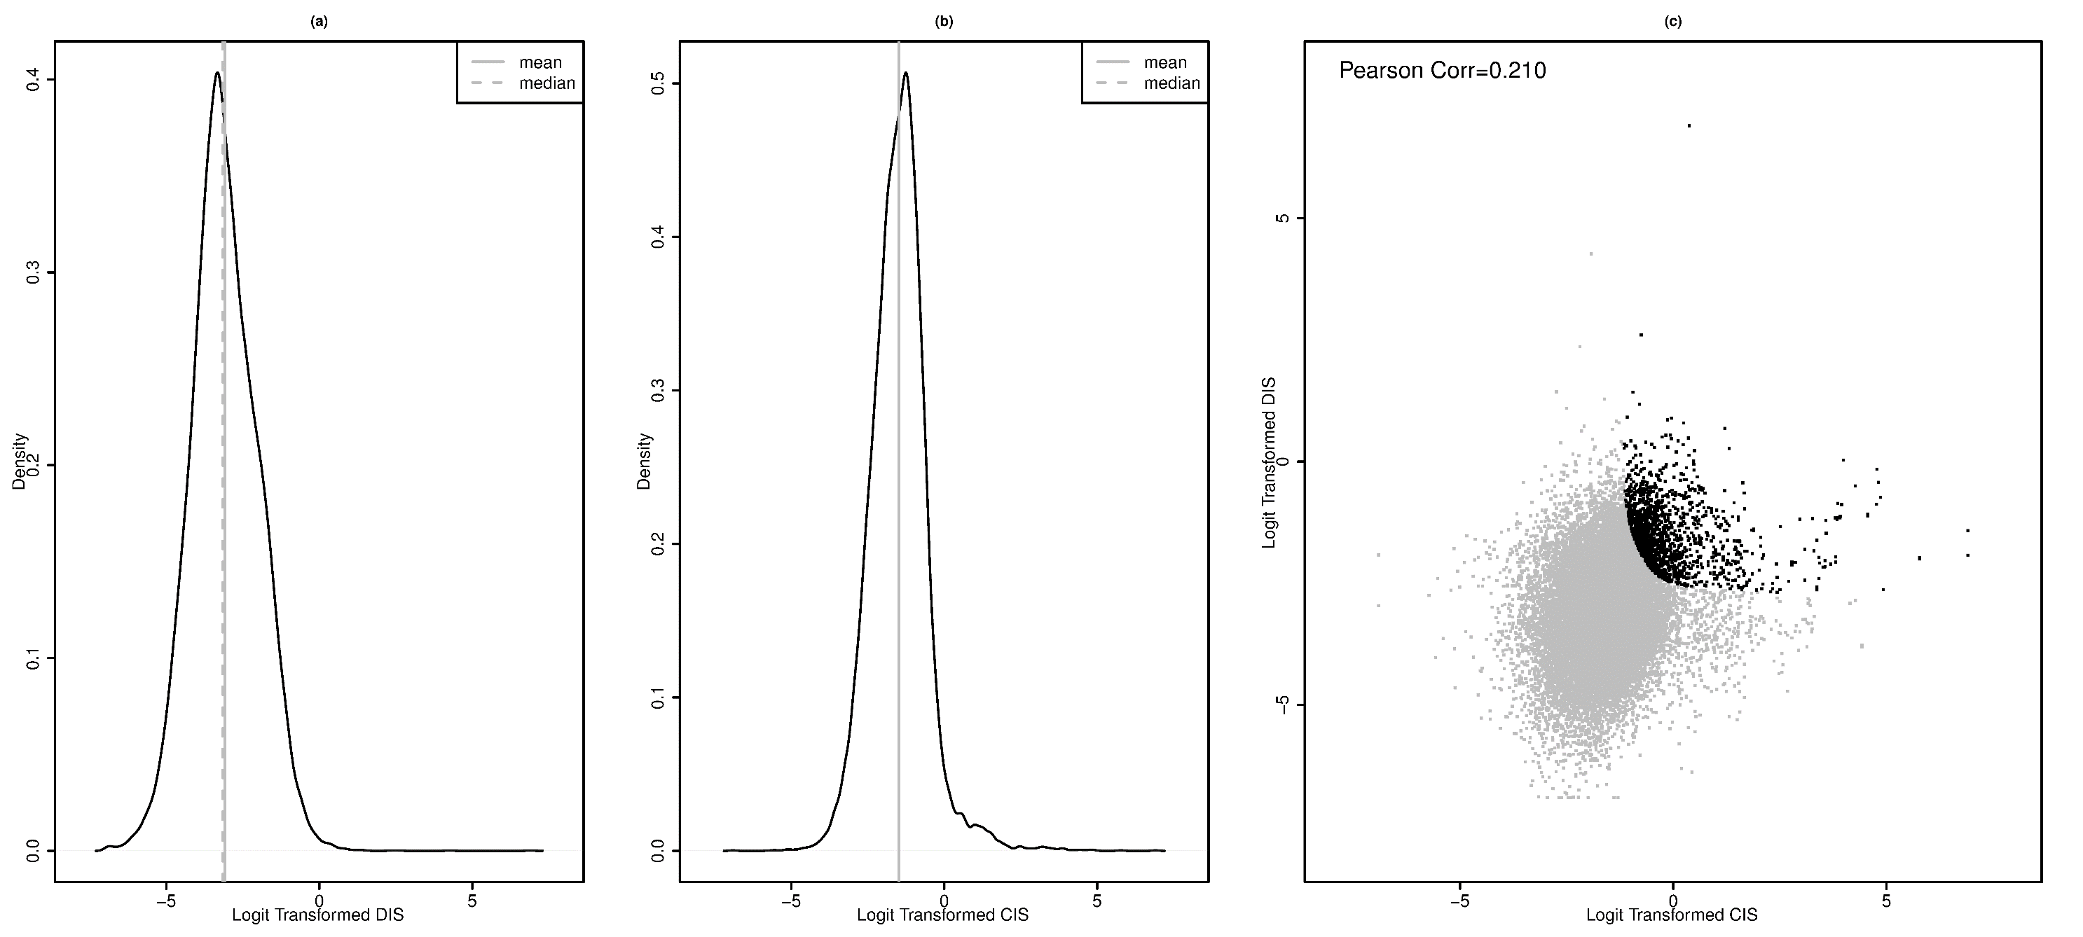
- Displays empirical density plot of logit transformed Diversity Importance Score (DIS); (b) Displays empirical density plot of logit transformed Co-expression Importance Score (CIS); (c) Displays scatter plots of logit transformed CIS/DIS values, (black points denote genes top 1500 genes according to overall importance score and gray points denote remaining genes). Note that following logit transformation was used plot convenience
logit(x*) = log(x*/(1- x*)) where x*=(x-min(x))/(max(x)-min(x))

