BMD Results for Table: Body Weight SD4
BMDS version: BMDS v2.7.0

Input dataset
Dose | 0 | 61 | 123 | 245 | 489 | 979
N | 4 | 3 | 4 | 5 | 4 | 3
Mean ± SD | 272.225 ± 0.806 | 275.5 ± 11.964 | 274.05 ± 15.57 | 270.22 ± 13.723 | 247.125 ± 13.411 | 258 ± 9.042

Summary table
Modelª | Goodness of fit |  | BMD | BMDL | Comments
 | p-value | AIC
Linear (equivalent models include Power, Polynomial 2°, 3°, 4°, 5°) | 0.099 | 146.364 | 336.228 | 160.857 | No model was recommended as a best-fitting model. Doses were dropped until there were only 3 remaining dose-groups.
Hill | 0.599 | 142.445 | 265.544 | -999
Exponential M2 | 0.106 | 146.193 | 320.936 | 152.931
Exponential M3 | 0.106 | 146.193 | 320.937 | 152.931
Exponential M4 | 0.115 | 146.504 | 167.838 | 0.255
Exponential M5 | 0.392 | 144.445 | 299.221 | 180.129
ª Modeled variance case presented (BMDS Test 2 p-value = 0.002, BMDS Test 3 p-value = 6.9E-04).

Model recommendation details
Model | Bin | Notes
Linear (equivalent models include Power, Polynomial 2°, 3°, 4°, 5°) | Warning | Warnings  • Variance model poorly fits dataset (p-value 3 = 0.000694)  • Goodness of fit p-value is less than threshold (0.0994 < 0.1)  • Ratio of modeled to actual stdev. at control is greater than threshold (12.3 > 1.5)
Hill | Failure | Failures  • BMDL does not exist  Warnings  • Variance model poorly fits dataset (p-value 3 = 0.000694)  • Ratio of modeled to actual stdev. at control is greater than threshold (12.9 > 1.5)  Cautions  • Warning(s): BMDL computation failed.
Exponential M2 | Warning | Warnings  • Variance model poorly fits dataset (p-value 3 = 0.000694)
Exponential M3 | Warning | Warnings  • Variance model poorly fits dataset (p-value 3 = 0.000694)
Exponential M4 | Warning | Warnings  • Variance model poorly fits dataset (p-value 3 = 0.000694)  • BMD/BMDL ratio is greater than threshold (6.58e+02 > 20.0)  Cautions  • BMD/BMDL ratio is greater than threshold (6.58e+02 > 5.0)
Exponential M5 | Warning | Warnings  • Variance model poorly fits dataset (p-value 3 = 0.000694)

Recommended model
No model was recommended as a best-fitting model.

BMD Results for Table: Brain Weight Relative
BMDS version: BMDS v2.7.0

Input dataset
Dose | 0 | 61 | 123 | 245 | 489 | 979
N | 4 | 3 | 4 | 5 | 4 | 3
Mean ± SD | 6.144 ± 0.525 | 6.529 ± 0.19 | 6.436 ± 0.4 | 6.637 ± 0.363 | 7.186 ± 0.458 | 6.763 ± 0.288

Summary table
Modelª | Goodness of fit |  | BMD | BMDL | Comments
 | p-value | AIC
Linear (equivalent models include Power, Polynomial 2°, 5°) | 0.046 | -10.578 | 627.657 | 361.024 | Exponential-M4 recommended as best-fitting model on the basis of the lowest AIC.
Polynomial 3° | 0.046 | -10.578 | 627.656 | 361.024
Polynomial 4° | 0.046 | -10.578 | 627.655 | 361.024
Hill | 0.08 | -11.212 | 143.406 | 20.625
Exponential M2 (equivalent models include Exponential M3) | 0.043 | -10.409 | 659.486 | 388.258
Exponential M4^{b} | 0.199 | -13.613 | 123.685 | 43.317
Exponential M5 | 0.111 | -11.864 | 231.716 | 45.976
ª Constant variance case presented (BMDS Test 2 p-value = 0.542, BMDS Test 3 p-value = 0.542).
^{b} Recommended model

Model recommendation details
Model | Bin | Notes
Linear (equivalent models include Power, Polynomial 2°, 5°) | Warning | Warnings  • Goodness of fit p-value is less than threshold (0.046 < 0.1)  • Residual of interest is greater than threshold (2.09 > 2.0)
Polynomial 3° | Warning | Warnings  • Goodness of fit p-value is less than threshold (0.046 < 0.1)  • Residual of interest is greater than threshold (2.09 > 2.0)
Polynomial 4° | Warning | Warnings  • Goodness of fit p-value is less than threshold (0.046 < 0.1)  • Residual of interest is greater than threshold (2.09 > 2.0)
Hill | Warning | Warnings  • Goodness of fit p-value is less than threshold (0.0798 < 0.1)  Cautions  • BMD/BMDL ratio is greater than threshold (6.95 > 5.0)
Exponential M2 (equivalent models include Exponential M3) | Warning | Warnings  • Goodness of fit p-value is less than threshold (0.0429 < 0.1)  • Residual of interest is greater than threshold (2.12 > 2.0)
Exponential M4ª | Valid | -
Exponential M5 | Valid | Cautions  • BMD/BMDL ratio is greater than threshold (5.04 > 5.0)
ª Recommended model

Recommended model
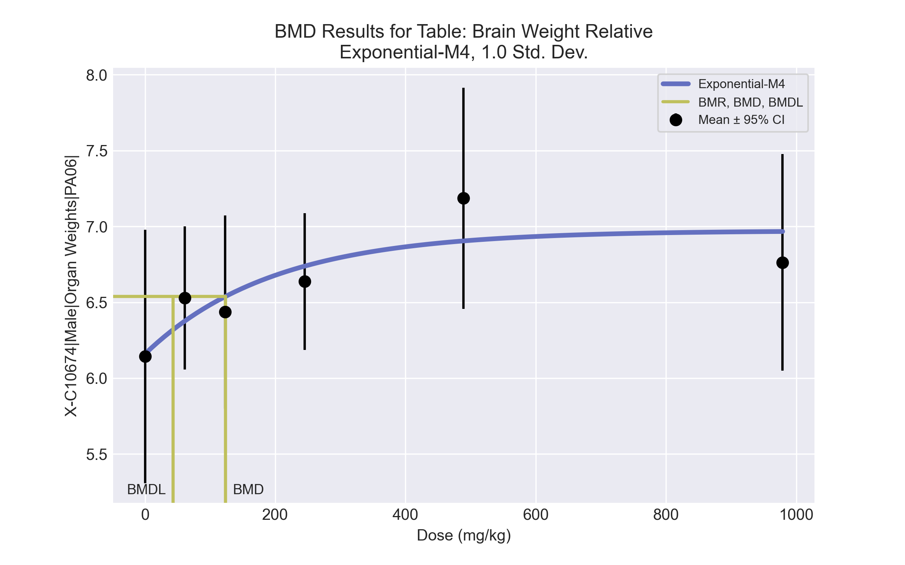
====================================================================
Exponential Model. (Version: 1.11; Date: 03/14/2017)
Input Data File: C:\Windows\TEMP\bmds-rk_y4odd.(d)
Gnuplot Plotting File:
Thu Jul 15 23:22:12 2021
====================================================================
BMDS_Model_Run
~~~~~~~~~~~~~~~~~~~~~~~~~~~~~~~~~~~~~~~~~~~~~~~~~~~~~~~~~~~~~~~~~~~~~
The form of the response function by Model:
Model 2: Y[dose] = a * exp{sign * b * dose}
Model 3: Y[dose] = a * exp{sign * (b * dose)^d}
Model 4: Y[dose] = a * [c-(c-1) * exp{-b * dose}]
Model 5: Y[dose] = a * [c-(c-1) * exp{-(b * dose)^d}]
Note: Y[dose] is the median response for exposure = dose;
sign = +1 for increasing trend in data;
sign = -1 for decreasing trend.
Model 2 is nested within Models 3 and 4.
Model 3 is nested within Model 5.
Model 4 is nested within Model 5.
Dependent variable = Response
Independent variable = Dose
Data are assumed to be distributed: normally
Variance Model: exp(lnalpha +rho *ln(Y[dose]))
rho is set to 0.
A constant variance model is fit.
Total number of dose groups = 6
Total number of records with missing values = 0
Maximum number of iterations = 500
Relative Function Convergence has been set to: 1e-008
Parameter Convergence has been set to: 1e-008
MLE solution provided: Exact
Initial Parameter Values
Variable Model 4
-------- --------
lnalpha -2.14206
rho 0 Specified
a 5.8365
b 0.00138397
c 1.29286
d 1 Specified
Parameter Estimates
Variable Model 4 Std. Err.
-------- ------- ---------
lnalpha -1.9397 0.0423889
a 6.15963 0.165691
b 0.00508023 0.00292978
c 1.13194 0.0405247
NC = No Convergence
Table of Stats From Input Data
Dose N Obs Mean Obs Std Dev
----- --- ---------- -------------
0 4 6.144 0.5249
61 3 6.529 0.1896
123 4 6.436 0.4
245 5 6.637 0.363
489 4 7.186 0.4581
979 3 6.763 0.2875
Estimated Values of Interest
Dose Est Mean Est Std Scaled Residual
------ ---------- --------- ----------------
0 6.16 0.3791 -0.08408
61 6.376 0.3791 0.6976
123 6.537 0.3791 -0.5324
245 6.738 0.3791 -0.5977
489 6.905 0.3791 1.487
979 6.967 0.3791 -0.9314
Other models for which likelihoods are calculated:
Model A1: Yij = Mu(i) + e(ij)
Var{e(ij)} = Sigma^2
Model A2: Yij = Mu(i) + e(ij)
Var{e(ij)} = Sigma(i)^2
Model A3: Yij = Mu(i) + e(ij)
Var{e(ij)} = exp(lalpha + log(mean(i)) * rho)
Model R: Yij = Mu + e(i)
Var{e(ij)} = Sigma^2
Likelihoods of Interest
Model Log(likelihood) DF AIC
------- ----------------- ---- ------------
A1 13.13369 7 -12.26737
A2 15.16039 12 -6.320783
A3 13.13369 7 -12.26737
R 5.79212 2 -7.584241
4 10.8065 4 -13.61301
Additive constant for all log-likelihoods = -21.14. This constant added to the
above values gives the log-likelihood including the term that does not
depend on the model parameters.
Explanation of Tests
Test 1: Does response and/or variances differ among Dose levels? (A2 vs. R)
Test 2: Are Variances Homogeneous? (A2 vs. A1)
Test 3: Are variances adequately modeled? (A2 vs. A3)
Test 6a: Does Model 4 fit the data? (A3 vs 4)
Tests of Interest
Test -2*log(Likelihood Ratio) D. F. p-value
-------- ------------------------ ------ --------------
Test 1 18.74 10 0.04374
Test 2 4.053 5 0.5418
Test 3 4.053 5 0.5418
Test 6a 4.654 3 0.1989
The p-value for Test 1 is less than .05. There appears to be a
difference between response and/or variances among the dose
levels, it seems appropriate to model the data.
The p-value for Test 2 is greater than .1. A homogeneous
variance model appears to be appropriate here.
The p-value for Test 3 is greater than .1. The modeled
variance appears to be appropriate here.
The p-value for Test 6a is greater than .1. Model 4 seems
to adequately describe the data.
Benchmark Dose Computations:
Specified Effect = 1.000000
Risk Type = Estimated standard deviations from control
Confidence Level = 0.950000
BMD = 123.685
BMDL = 43.3168
BMDU = 724.836

BMD Results for Table: Liver Weight Absolute
BMDS version: BMDS v2.7.0

Input dataset
Dose | 0 | 61 | 123 | 245ª | 489ª | 979ª
N | 4 | 3 | 4 | 5 | 4 | 3
Mean ± SD | 10.4 ± 0.613 | 11.693 ± 1.619 | 12.395 ± 0.972 | 12.312 ± 0.548 | 11.907 ± 0.64 | 12.293 ± 1.682
ª Dose group removed in BMD modeling session

Summary table
Modelª | Goodness of fit |  | BMD | BMDL | Comments
 | p-value | AIC
Linear (equivalent models include Power, Polynomial 2°, 3°, 4°, 5°) | 0.625 | 15.279 | 57.054 | 34.591 | Exponential-M2 recommended as best-fitting model on the basis of the lowest AIC.
Hill | 0.878 | 17.141 | 57.619 | 2.5E-13
Exponential M2^{b} (equivalent models include Exponential M3) | 0.578 | 15.35 | 60.364 | 37.973
Exponential M4 | -999 | 17.041 | 38.913 | 0.147
Exponential M5 | -999 | 19.141 | 51.506 | 0.22
ª Constant variance case presented (BMDS Test 2 p-value = 0.246, BMDS Test 3 p-value = 0.246).
^{b} Recommended model

Model recommendation details
Model | Bin | Notes
Linear (equivalent models include Power, Polynomial 2°, 3°, 4°, 5°) | Warning | Warnings  • Ratio of modeled to actual stdev. at control is greater than threshold (1.51 > 1.5)
Hill | Warning | Warnings  • BMD/BMDL ratio is greater than threshold (2.35e+14 > 20.0)  Cautions  • BMD/BMDL ratio is greater than threshold (2.35e+14 > 5.0)
Exponential M2ª (equivalent models include Exponential M3) | Valid | -
Exponential M4 | Warning | Warnings  • BMD/BMDL ratio is greater than threshold (2.64e+02 > 20.0)  • Zero degrees of freedom; saturated model  Cautions  • BMD/BMDL ratio is greater than threshold (2.64e+02 > 5.0)
Exponential M5 | Warning | Warnings  • BMD/BMDL ratio is greater than threshold (2.34e+02 > 20.0)  • Zero degrees of freedom; saturated model  Cautions  • BMD/BMDL ratio is greater than threshold (2.34e+02 > 5.0)
ª Recommended model

Recommended model
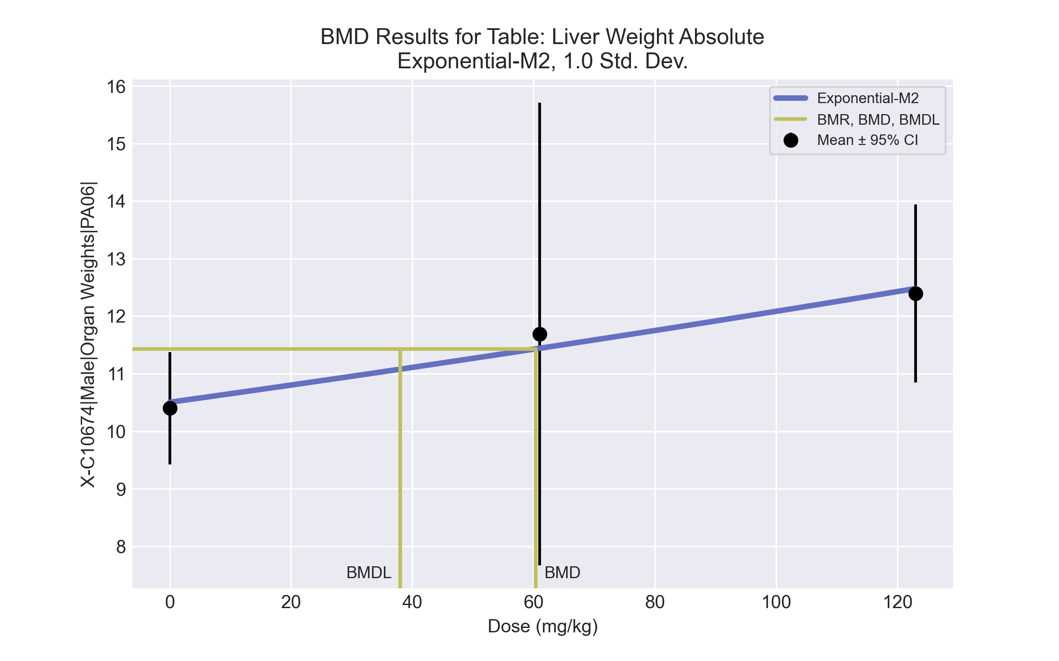
====================================================================
Exponential Model. (Version: 1.11; Date: 03/14/2017)
Input Data File: C:\Windows\TEMP\bmds-dh9n1n97.(d)
Gnuplot Plotting File:
Thu Jul 15 23:22:27 2021
====================================================================
BMDS_Model_Run
~~~~~~~~~~~~~~~~~~~~~~~~~~~~~~~~~~~~~~~~~~~~~~~~~~~~~~~~~~~~~~~~~~~~~
The form of the response function by Model:
Model 2: Y[dose] = a * exp{sign * b * dose}
Model 3: Y[dose] = a * exp{sign * (b * dose)^d}
Model 4: Y[dose] = a * [c-(c-1) * exp{-b * dose}]
Model 5: Y[dose] = a * [c-(c-1) * exp{-(b * dose)^d}]
Note: Y[dose] is the median response for exposure = dose;
sign = +1 for increasing trend in data;
sign = -1 for decreasing trend.
Model 2 is nested within Models 3 and 4.
Model 3 is nested within Model 5.
Model 4 is nested within Model 5.
Dependent variable = Response
Independent variable = Dose
Data are assumed to be distributed: normally
Variance Model: exp(lnalpha +rho *ln(Y[dose]))
rho is set to 0.
A constant variance model is fit.
Total number of dose groups = 3
Total number of records with missing values = 0
Maximum number of iterations = 500
Relative Function Convergence has been set to: 1e-008
Parameter Convergence has been set to: 1e-008
MLE solution provided: Exact
Initial Parameter Values
Variable Model 2
-------- --------
lnalpha -0.178087
rho 0 Specified
a 10.4867
b 0.00142564
c 0 Specified
d 1 Specified
Parameter Estimates
Variable Model 2 Std. Err.
-------- ------- ---------
lnalpha -0.149968 0.367019
a 10.5037 0.423097
b 0.0014022 0.00046529
NC = No Convergence
Table of Stats From Input Data
Dose N Obs Mean Obs Std Dev
----- --- ---------- -------------
0 4 10.4 0.6131
61 3 11.69 1.619
123 4 12.4 0.9724
Estimated Values of Interest
Dose Est Mean Est Std Scaled Residual
------ ---------- --------- ----------------
0 10.5 0.9278 -0.2235
61 11.44 0.9278 0.4699
123 12.48 0.9278 -0.185
Other models for which likelihoods are calculated:
Model A1: Yij = Mu(i) + e(ij)
Var{e(ij)} = Sigma^2
Model A2: Yij = Mu(i) + e(ij)
Var{e(ij)} = Sigma(i)^2
Model A3: Yij = Mu(i) + e(ij)
Var{e(ij)} = exp(lalpha + log(mean(i)) * rho)
Model R: Yij = Mu + e(i)
Var{e(ij)} = Sigma^2
Likelihoods of Interest
Model Log(likelihood) DF AIC
------- ----------------- ---- ------------
A1 -4.520522 4 17.04104
A2 -3.117596 6 18.23519
A3 -4.520522 4 17.04104
R -8.008415 2 20.01683
2 -4.675176 3 15.35035
Additive constant for all log-likelihoods = -10.11. This constant added to the
above values gives the log-likelihood including the term that does not
depend on the model parameters.
Explanation of Tests
Test 1: Does response and/or variances differ among Dose levels? (A2 vs. R)
Test 2: Are Variances Homogeneous? (A2 vs. A1)
Test 3: Are variances adequately modeled? (A2 vs. A3)
Test 4: Does Model 2 fit the data? (A3 vs. 2)
Tests of Interest
Test -2*log(Likelihood Ratio) D. F. p-value
-------- ------------------------ ------ --------------
Test 1 9.782 4 0.04427
Test 2 2.806 2 0.2459
Test 3 2.806 2 0.2459
Test 4 0.3093 1 0.5781
The p-value for Test 1 is less than .05. There appears to be a
difference between response and/or variances among the dose
levels, it seems appropriate to model the data.
The p-value for Test 2 is greater than .1. A homogeneous
variance model appears to be appropriate here.
The p-value for Test 3 is greater than .1. The modeled
variance appears to be appropriate here.
The p-value for Test 4 is greater than .1. Model 2 seems
to adequately describe the data.
Benchmark Dose Computations:
Specified Effect = 1.000000
Risk Type = Estimated standard deviations from control
Confidence Level = 0.950000
BMD = 60.3637
BMDL = 37.9732
BMDU = 158.744

BMD Results for Table: Liver Weight Relative
BMDS version: BMDS v2.7.0

Input dataset
Dose | 0 | 61 | 123 | 245 | 489 | 979
N | 4 | 3 | 4 | 5 | 4 | 3
Mean ± SD | 38.206 ± 2.298 | 42.338 ± 4.267 | 45.199 ± 1.524 | 45.699 ± 3.763 | 48.2 ± 1.499 | 47.539 ± 4.954

Summary table
Modelª | Goodness of fit |  | BMD | BMDL | Comments
 | p-value | AIC
Linear (equivalent models include Power, Polynomial 2°, 3°, 4°) | 0.012 | 88.068 | 459.426 | 293.312 | Exponential-M4 recommended as best-fitting model on the basis of the lowest AIC.
Polynomial 5° | 0.012 | 88.068 | 459.427 | 293.312
Hill | 0.654 | 80.081 | 35.235 | 9.595
Exponential M2 (equivalent models include Exponential M3) | 0.01 | 88.484 | 502.12 | 329.542
Exponential M4^{b} (equivalent models include Exponential M5) | 0.798 | 78.245 | 39.401 | 17.23
ª Constant variance case presented (BMDS Test 2 p-value = 0.135, BMDS Test 3 p-value = 0.135).
^{b} Recommended model

Model recommendation details
Model | Bin | Notes
Linear (equivalent models include Power, Polynomial 2°, 3°, 4°) | Warning | Warnings  • Goodness of fit p-value is less than threshold (0.0121 < 0.1)  • Residual at lowest dose is greater than threshold (2.23 > 2.0)  • Ratio of modeled to actual stdev. at control is greater than threshold (1.57 > 1.5)
Polynomial 5° | Warning | Warnings  • Goodness of fit p-value is less than threshold (0.0121 < 0.1)  • Residual at lowest dose is greater than threshold (2.23 > 2.0)  • Ratio of modeled to actual stdev. at control is greater than threshold (1.57 > 1.5)
Hill | Valid | -
Exponential M2 (equivalent models include Exponential M3) | Warning | Warnings  • Goodness of fit p-value is less than threshold (0.0101 < 0.1)  • Residual at lowest dose is greater than threshold (2.29 > 2.0)
Exponential M4ª (equivalent models include Exponential M5) | Valid | -
ª Recommended model

Recommended model
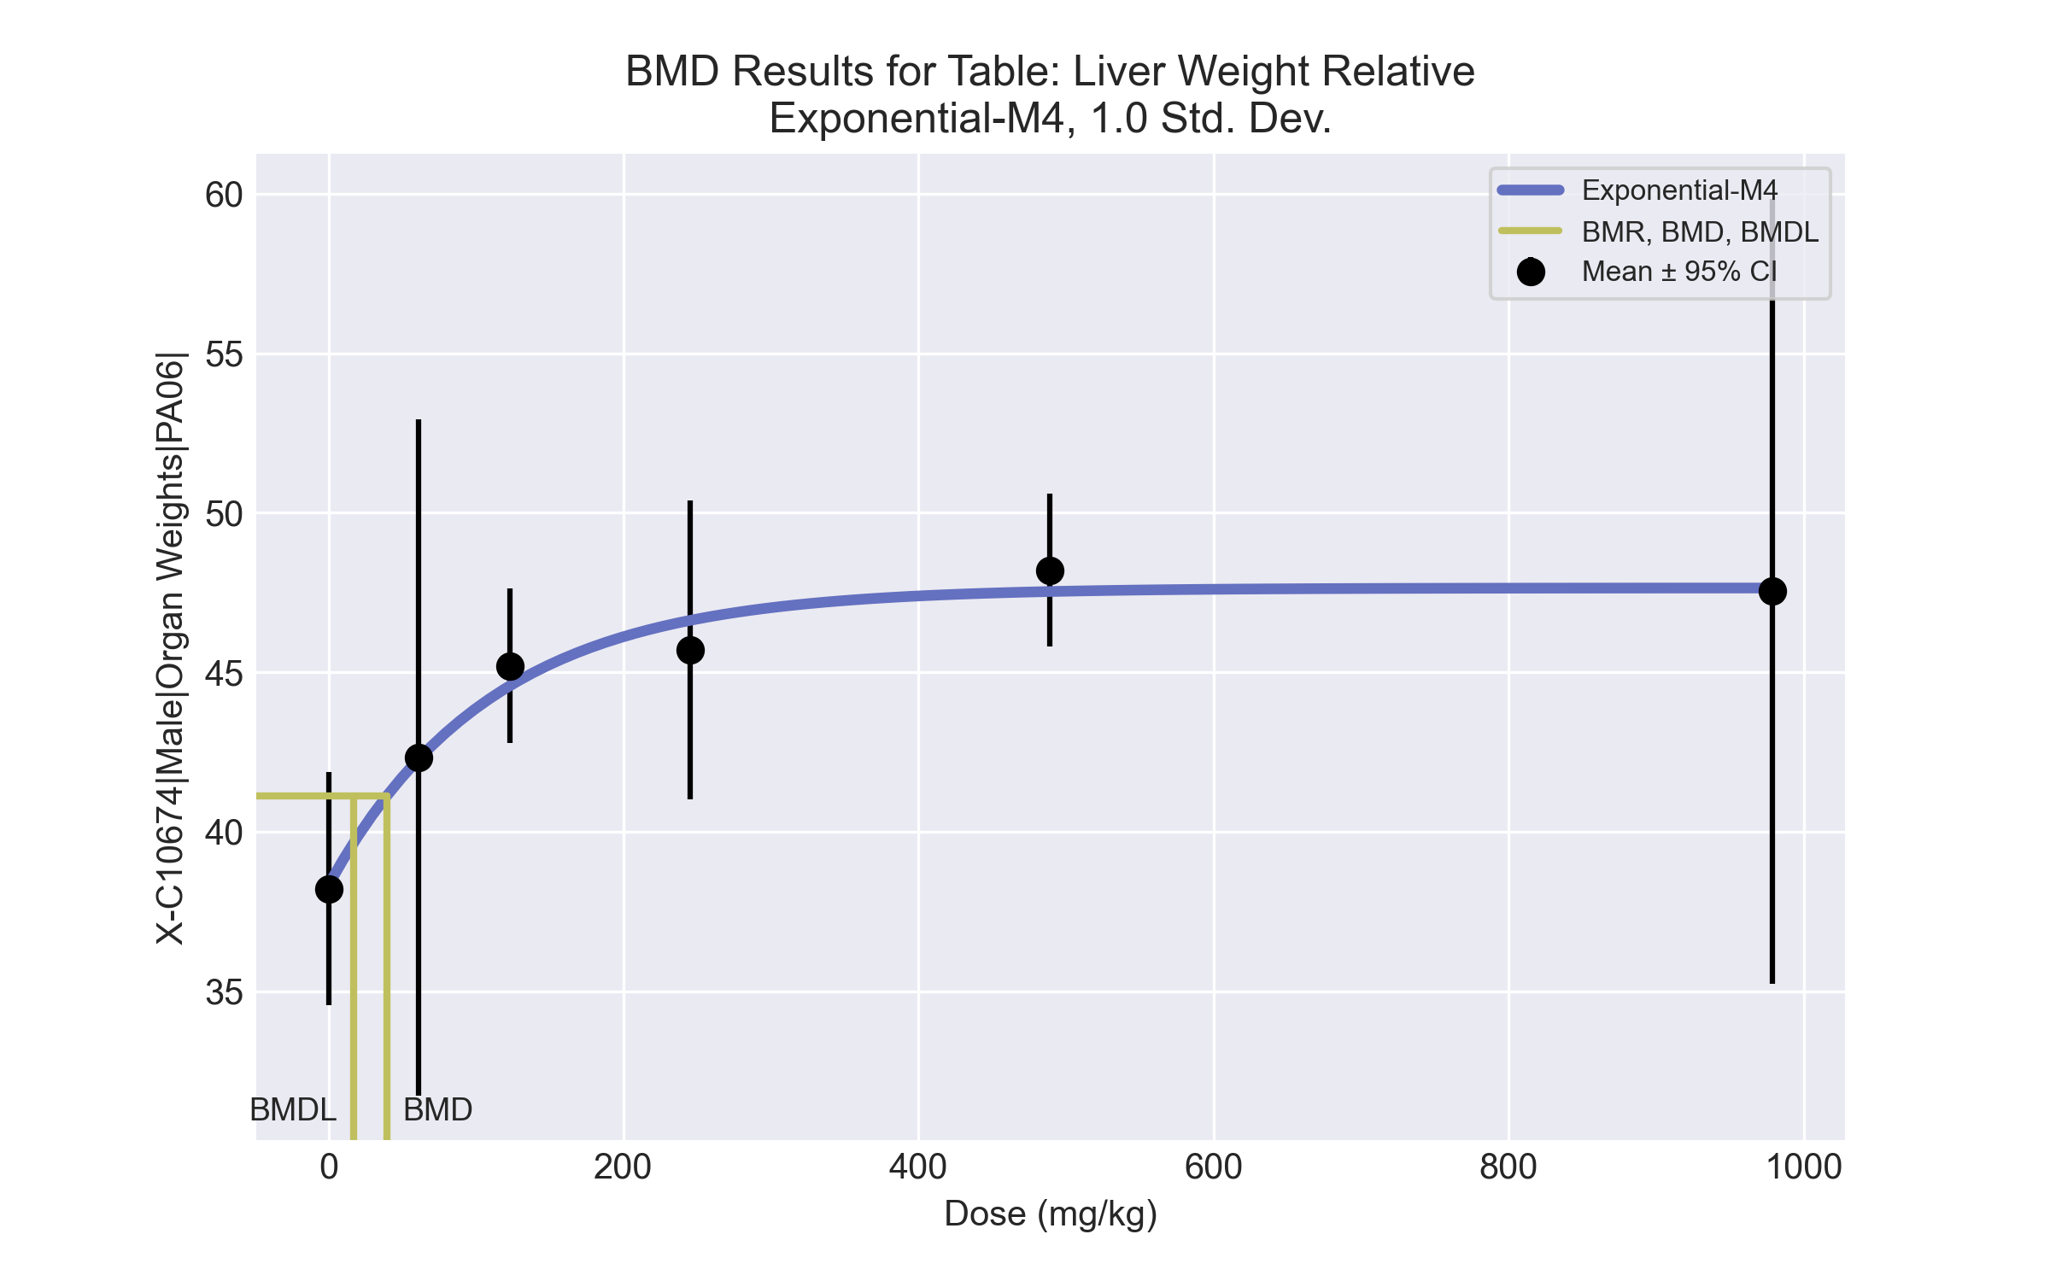
====================================================================
Exponential Model. (Version: 1.11; Date: 03/14/2017)
Input Data File: C:\Windows\TEMP\bmds-62h2s0sl.(d)
Gnuplot Plotting File:
Thu Jul 15 23:22:31 2021
====================================================================
BMDS_Model_Run
~~~~~~~~~~~~~~~~~~~~~~~~~~~~~~~~~~~~~~~~~~~~~~~~~~~~~~~~~~~~~~~~~~~~~
The form of the response function by Model:
Model 2: Y[dose] = a * exp{sign * b * dose}
Model 3: Y[dose] = a * exp{sign * (b * dose)^d}
Model 4: Y[dose] = a * [c-(c-1) * exp{-b * dose}]
Model 5: Y[dose] = a * [c-(c-1) * exp{-(b * dose)^d}]
Note: Y[dose] is the median response for exposure = dose;
sign = +1 for increasing trend in data;
sign = -1 for decreasing trend.
Model 2 is nested within Models 3 and 4.
Model 3 is nested within Model 5.
Model 4 is nested within Model 5.
Dependent variable = Response
Independent variable = Dose
Data are assumed to be distributed: normally
Variance Model: exp(lnalpha +rho *ln(Y[dose]))
rho is set to 0.
A constant variance model is fit.
Total number of dose groups = 6
Total number of records with missing values = 0
Maximum number of iterations = 500
Relative Function Convergence has been set to: 1e-008
Parameter Convergence has been set to: 1e-008
MLE solution provided: Exact
Initial Parameter Values
Variable Model 4
-------- --------
lnalpha 2.01008
rho 0 Specified
a 36.2958
b 0.00218837
c 1.39439
d 1 Specified
Parameter Estimates
Variable Model 4 Std. Err.
-------- ------- ---------
lnalpha 2.05415 2.30015
a 38.3214 1.37876
b 0.00904205 0.00423166
c 1.24317 0.0494477
NC = No Convergence
Table of Stats From Input Data
Dose N Obs Mean Obs Std Dev
----- --- ---------- -------------
0 4 38.21 2.298
61 3 42.34 4.267
123 4 45.2 1.524
245 5 45.7 3.763
489 4 48.2 1.499
979 3 47.54 4.954
Estimated Values of Interest
Dose Est Mean Est Std Scaled Residual
------ ---------- --------- ----------------
0 38.32 2.793 -0.08261
61 42.27 2.793 0.04063
123 44.58 2.793 0.4466
245 46.62 2.793 -0.7401
489 47.53 2.793 0.4816
979 47.64 2.793 -0.06153
Other models for which likelihoods are calculated:
Model A1: Yij = Mu(i) + e(ij)
Var{e(ij)} = Sigma^2
Model A2: Yij = Mu(i) + e(ij)
Var{e(ij)} = Sigma(i)^2
Model A3: Yij = Mu(i) + e(ij)
Var{e(ij)} = exp(lalpha + log(mean(i)) * rho)
Model R: Yij = Mu + e(i)
Var{e(ij)} = Sigma^2
Likelihoods of Interest
Model Log(likelihood) DF AIC
------- ----------------- ---- ------------
A1 -34.61596 7 83.23192
A2 -30.41069 12 84.82139
A3 -34.61596 7 83.23192
R -45.32767 2 94.65535
4 -35.12269 4 78.24538
Additive constant for all log-likelihoods = -21.14. This constant added to the
above values gives the log-likelihood including the term that does not
depend on the model parameters.
Explanation of Tests
Test 1: Does response and/or variances differ among Dose levels? (A2 vs. R)
Test 2: Are Variances Homogeneous? (A2 vs. A1)
Test 3: Are variances adequately modeled? (A2 vs. A3)
Test 6a: Does Model 4 fit the data? (A3 vs 4)
Tests of Interest
Test -2*log(Likelihood Ratio) D. F. p-value
-------- ------------------------ ------ --------------
Test 1 29.83 10 0.0009119
Test 2 8.411 5 0.135
Test 3 8.411 5 0.135
Test 6a 1.013 3 0.798
The p-value for Test 1 is less than .05. There appears to be a
difference between response and/or variances among the dose
levels, it seems appropriate to model the data.
The p-value for Test 2 is greater than .1. A homogeneous
variance model appears to be appropriate here.
The p-value for Test 3 is greater than .1. The modeled
variance appears to be appropriate here.
The p-value for Test 6a is greater than .1. Model 4 seems
to adequately describe the data.
Benchmark Dose Computations:
Specified Effect = 1.000000
Risk Type = Estimated standard deviations from control
Confidence Level = 0.950000
BMD = 39.401
BMDL = 17.2295
BMDU = 106.79

BMD Results for Table: Terminal Body Weight
BMDS version: BMDS v2.7.0

Input dataset
Dose | 0 | 61 | 123 | 245 | 489 | 979
N | 4 | 3 | 4 | 5 | 4 | 3
Mean ± SD | 272.225 ± 0.806 | 275.5 ± 11.964 | 274.05 ± 15.57 | 270.22 ± 13.723 | 247.125 ± 13.411 | 258 ± 9.042

Summary table
Modelª | Goodness of fit |  | BMD | BMDL | Comments
 | p-value | AIC
Linear (equivalent models include Power, Polynomial 2°, 3°, 4°, 5°) | 0.099 | 146.364 | 336.228 | 160.857 | No model was recommended as a best-fitting model. Doses were dropped until there were only 3 remaining dose-groups.
Hill | 0.599 | 142.445 | 265.544 | -999
Exponential M2 | 0.106 | 146.193 | 320.936 | 152.931
Exponential M3 | 0.106 | 146.193 | 320.937 | 152.931
Exponential M4 | 0.115 | 146.504 | 167.838 | 0.255
Exponential M5 | 0.392 | 144.445 | 299.221 | 180.129
ª Modeled variance case presented (BMDS Test 2 p-value = 0.002, BMDS Test 3 p-value = 6.9E-04).

Model recommendation details
Model | Bin | Notes
Linear (equivalent models include Power, Polynomial 2°, 3°, 4°, 5°) | Warning | Warnings  • Variance model poorly fits dataset (p-value 3 = 0.000694)  • Goodness of fit p-value is less than threshold (0.0994 < 0.1)  • Ratio of modeled to actual stdev. at control is greater than threshold (12.3 > 1.5)
Hill | Failure | Failures  • BMDL does not exist  Warnings  • Variance model poorly fits dataset (p-value 3 = 0.000694)  • Ratio of modeled to actual stdev. at control is greater than threshold (12.9 > 1.5)  Cautions  • Warning(s): BMDL computation failed.
Exponential M2 | Warning | Warnings  • Variance model poorly fits dataset (p-value 3 = 0.000694)
Exponential M3 | Warning | Warnings  • Variance model poorly fits dataset (p-value 3 = 0.000694)
Exponential M4 | Warning | Warnings  • Variance model poorly fits dataset (p-value 3 = 0.000694)  • BMD/BMDL ratio is greater than threshold (6.58e+02 > 20.0)  Cautions  • BMD/BMDL ratio is greater than threshold (6.58e+02 > 5.0)
Exponential M5 | Warning | Warnings  • Variance model poorly fits dataset (p-value 3 = 0.000694)

Recommended model
No model was recommended as a best-fitting model.

BMD Results for Table: A/G Ratio
BMDS version: BMDS v2.7.0

Input dataset
Dose | 0 | 61 | 123 | 245 | 489 | 979
N | 4 | 3 | 4 | 5 | 4 | 3
Mean ± SD | 1.226 ± 0.116 | 1.195 ± 0.045 | 1.213 ± 0.085 | 1.162 ± 0.052 | 1.111 ± 0.087 | 1.138 ± 0.072

Summary table
Modelª | Goodness of fit |  | BMD | BMDL | Comments
 | p-value | AIC
Linear (equivalent models include Power, Polynomial 2°, 3°, 4°, 5°) | 0.53 | -90.771 | 732.334 | 396.104 | Exponential-M4 recommended as best-fitting model on the basis of the lowest BMDL.
Hill | 0.9 | -91.354 | 258.436 | 66.405
Exponential M2 (equivalent models include Exponential M3) | 0.543 | -90.851 | 708.925 | 372.433
Exponential M4^{b} | 0.733 | -90.657 | 256.65 | 65.511
Exponential M5 | 0.746 | -89.354 | 253.926 | 125.254
ª Constant variance case presented (BMDS Test 2 p-value = 0.469, BMDS Test 3 p-value = 0.469).
^{b} Recommended model

Model recommendation details
Model | Bin | Notes
Linear (equivalent models include Power, Polynomial 2°, 3°, 4°, 5°) | Valid | -
Hill | Valid | -
Exponential M2 (equivalent models include Exponential M3) | Valid | -
Exponential M4ª | Valid | -
Exponential M5 | Valid | -
ª Recommended model

Recommended model
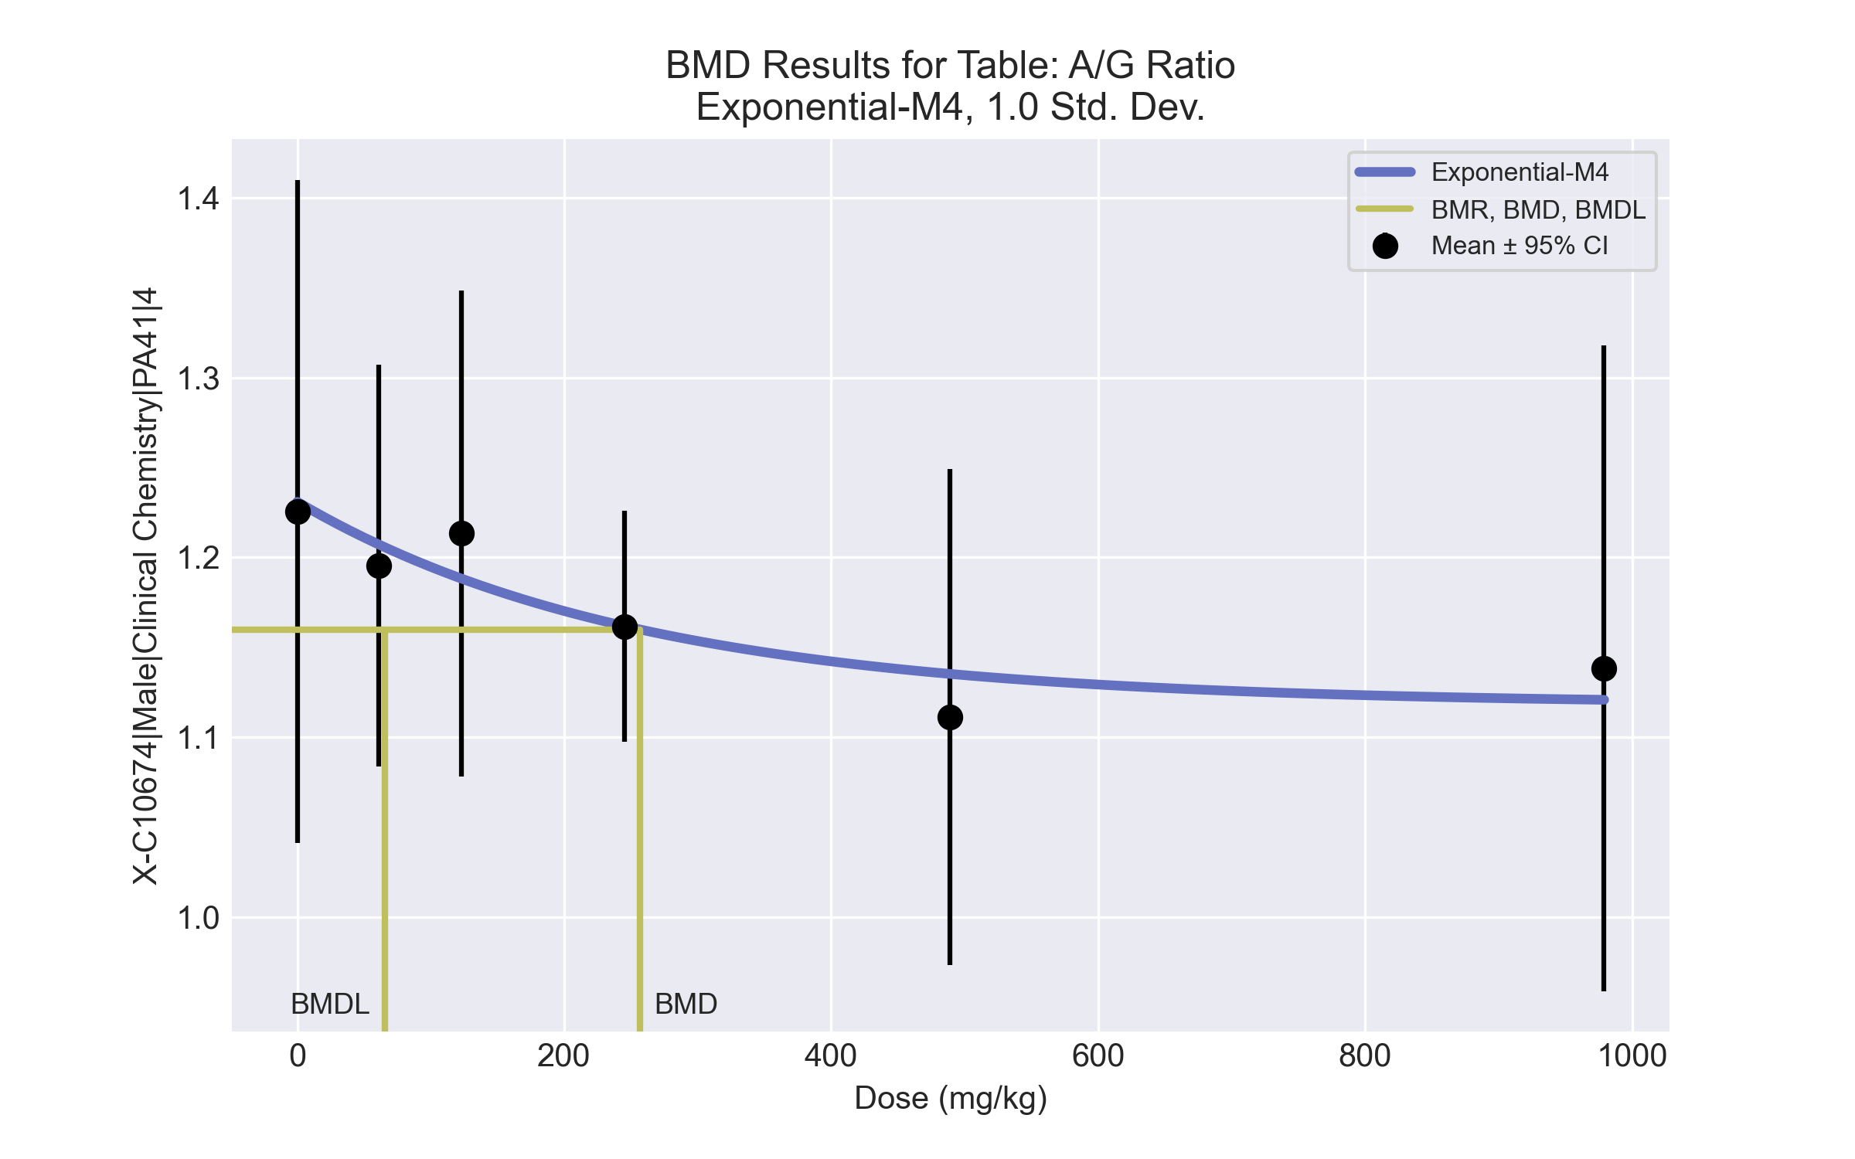
====================================================================
Exponential Model. (Version: 1.11; Date: 03/14/2017)
Input Data File: C:\Windows\TEMP\bmds-anlrfp78.(d)
Gnuplot Plotting File:
Thu Jul 15 23:23:30 2021
====================================================================
BMDS_Model_Run
~~~~~~~~~~~~~~~~~~~~~~~~~~~~~~~~~~~~~~~~~~~~~~~~~~~~~~~~~~~~~~~~~~~~~
The form of the response function by Model:
Model 2: Y[dose] = a * exp{sign * b * dose}
Model 3: Y[dose] = a * exp{sign * (b * dose)^d}
Model 4: Y[dose] = a * [c-(c-1) * exp{-b * dose}]
Model 5: Y[dose] = a * [c-(c-1) * exp{-(b * dose)^d}]
Note: Y[dose] is the median response for exposure = dose;
sign = +1 for increasing trend in data;
sign = -1 for decreasing trend.
Model 2 is nested within Models 3 and 4.
Model 3 is nested within Model 5.
Model 4 is nested within Model 5.
Dependent variable = Response
Independent variable = Dose
Data are assumed to be distributed: normally
Variance Model: exp(lnalpha +rho *ln(Y[dose]))
rho is set to 0.
A constant variance model is fit.
Total number of dose groups = 6
Total number of records with missing values = 0
Maximum number of iterations = 500
Relative Function Convergence has been set to: 1e-008
Parameter Convergence has been set to: 1e-008
MLE solution provided: Exact
Initial Parameter Values
Variable Model 4
-------- --------
lnalpha -5.34522
rho 0 Specified
a 1.287
b 0.00158017
c 0.822307
d 1 Specified
Parameter Estimates
Variable Model 4 Std. Err.
-------- ------- ---------
lnalpha -5.28942 0.00148759
a 1.23098 0.0298478
b 0.00387623 0.00334931
c 0.908447 0.0371745
NC = No Convergence
Table of Stats From Input Data
Dose N Obs Mean Obs Std Dev
----- --- ---------- -------------
0 4 1.226 0.1159
61 3 1.195 0.04496
123 4 1.213 0.08494
245 5 1.162 0.0517
489 4 1.111 0.08677
979 3 1.138 0.07227
Estimated Values of Interest
Dose Est Mean Est Std Scaled Residual
------ ---------- --------- ----------------
0 1.231 0.07103 -0.1483
61 1.207 0.07103 -0.2871
123 1.188 0.07103 0.7103
245 1.162 0.07103 -0.007456
489 1.135 0.07103 -0.6755
979 1.121 0.07103 0.4277
Other models for which likelihoods are calculated:
Model A1: Yij = Mu(i) + e(ij)
Var{e(ij)} = Sigma^2
Model A2: Yij = Mu(i) + e(ij)
Var{e(ij)} = Sigma(i)^2
Model A3: Yij = Mu(i) + e(ij)
Var{e(ij)} = exp(lalpha + log(mean(i)) * rho)
Model R: Yij = Mu + e(i)
Var{e(ij)} = Sigma^2
Likelihoods of Interest
Model Log(likelihood) DF AIC
------- ----------------- ---- ------------
A1 49.97007 7 -85.94015
A2 52.26005 12 -80.5201
A3 49.97007 7 -85.94015
R 46.50018 2 -89.00035
4 49.32839 4 -90.65677
Additive constant for all log-likelihoods = -21.14. This constant added to the
above values gives the log-likelihood including the term that does not
depend on the model parameters.
Explanation of Tests
Test 1: Does response and/or variances differ among Dose levels? (A2 vs. R)
Test 2: Are Variances Homogeneous? (A2 vs. A1)
Test 3: Are variances adequately modeled? (A2 vs. A3)
Test 6a: Does Model 4 fit the data? (A3 vs 4)
Tests of Interest
Test -2*log(Likelihood Ratio) D. F. p-value
-------- ------------------------ ------ --------------
Test 1 11.52 10 0.3185
Test 2 4.58 5 0.4693
Test 3 4.58 5 0.4693
Test 6a 1.283 3 0.7331
The p-value for Test 1 is greater than .05. There may not be a
diffence between responses and/or variances among the dose levels
Modelling the data with a dose/response curve may not be appropriate.
The p-value for Test 2 is greater than .1. A homogeneous
variance model appears to be appropriate here.
The p-value for Test 3 is greater than .1. The modeled
variance appears to be appropriate here.
The p-value for Test 6a is greater than .1. Model 4 seems
to adequately describe the data.
Benchmark Dose Computations:
Specified Effect = 1.000000
Risk Type = Estimated standard deviations from control
Confidence Level = 0.950000
BMD = 256.65
BMDL = 65.5111
BMDU = 9.79e+006

BMD Results for Table: Aspartate Aminotransferase
BMDS version: BMDS v2.7.0

Input dataset
Dose | 0 | 61 | 123 | 245 | 489 | 979
N | 4 | 3 | 4 | 5 | 4 | 3
Mean ± SD | 169.75 ± 92.349 | 123 ± 47.508 | 115.75 ± 44.969 | 92.2 ± 33.7 | 69.5 ± 12.793 | 92.333 ± 28.537

Summary table
Modelª | Goodness of fit |  | BMD | BMDL | Comments
 | p-value | AIC
Linear | 0.003 | 206.266 | 2248.26 | 736.099 | Exponential-M4 recommended as best-fitting model on the basis of the lowest AIC.
Polynomial 2° | 0.003 | 206.266 | 2248.24 | 736.099
Power (equivalent models include Polynomial 3°, 5°) | 0.003 | 206.266 | 2248.25 | 736.099
Polynomial 4° | 0.003 | 206.266 | 2248.28 | 736.099
Hill | 0.066 | 199.485 | 217.136 | -999
Exponential M2 | 0.004 | 205.666 | 2069.82 | 433.801
Exponential M3 | 0.004 | 205.666 | 2069.81 | 433.801
Exponential M4^{b} | 0.181 | 196.911 | 223.528 | 51.946
Exponential M5 | 0.181 | 196.911 | 223.53 | 51.946
ª Modeled variance case presented (BMDS Test 2 p-value = 0.012, BMDS Test 3 p-value = 0.969).
^{b} Recommended model

Model recommendation details
Model | Bin | Notes
Linear | Warning | Warnings  • Goodness of fit p-value is less than threshold (0.00273 < 0.1)  • BMD/high dose ratio is greater than threshold (2.3 > 1.0)  Cautions  • Warning(s): THE MODEL HAS PROBABLY NOT CONVERGED!!!; THIS USUALLY MEANS THE MODEL HAS NOT CONVERGED!
Polynomial 2° | Warning | Warnings  • Goodness of fit p-value is less than threshold (0.00273 < 0.1)  • BMD/high dose ratio is greater than threshold (2.3 > 1.0)  Cautions  • Warning(s): THE MODEL HAS PROBABLY NOT CONVERGED!!!; THIS USUALLY MEANS THE MODEL HAS NOT CONVERGED!
Power (equivalent models include Polynomial 3°, 5°) | Warning | Warnings  • Goodness of fit p-value is less than threshold (0.00273 < 0.1)  • BMD/high dose ratio is greater than threshold (2.3 > 1.0)
Polynomial 4° | Warning | Warnings  • Goodness of fit p-value is less than threshold (0.00273 < 0.1)  • BMD/high dose ratio is greater than threshold (2.3 > 1.0)  Cautions  • Warning(s): THE MODEL HAS PROBABLY NOT CONVERGED!!!; THIS USUALLY MEANS THE MODEL HAS NOT CONVERGED!
Hill | Failure | Failures  • BMDL does not exist  Warnings  • Goodness of fit p-value is less than threshold (0.0656 < 0.1)  Cautions  • Warning(s): BMDL computation failed.
Exponential M2 | Warning | Warnings  • Goodness of fit p-value is less than threshold (0.00356 < 0.1)  • BMD/high dose ratio is greater than threshold (2.11 > 1.0)
Exponential M3 | Warning | Warnings  • Goodness of fit p-value is less than threshold (0.00356 < 0.1)  • BMD/high dose ratio is greater than threshold (2.11 > 1.0)
Exponential M4ª | Valid | -
Exponential M5 | Valid | -
ª Recommended model

Recommended model
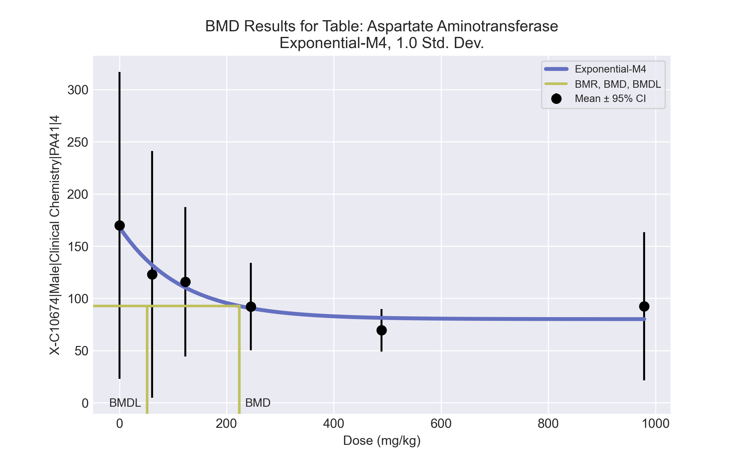
====================================================================
Exponential Model. (Version: 1.11; Date: 03/14/2017)
Input Data File: C:\Windows\TEMP\bmds-c4h5zof3.(d)
Gnuplot Plotting File:
Thu Jul 15 23:23:35 2021
====================================================================
BMDS_Model_Run
~~~~~~~~~~~~~~~~~~~~~~~~~~~~~~~~~~~~~~~~~~~~~~~~~~~~~~~~~~~~~~~~~~~~~
The form of the response function by Model:
Model 2: Y[dose] = a * exp{sign * b * dose}
Model 3: Y[dose] = a * exp{sign * (b * dose)^d}
Model 4: Y[dose] = a * [c-(c-1) * exp{-b * dose}]
Model 5: Y[dose] = a * [c-(c-1) * exp{-(b * dose)^d}]
Note: Y[dose] is the median response for exposure = dose;
sign = +1 for increasing trend in data;
sign = -1 for decreasing trend.
Model 2 is nested within Models 3 and 4.
Model 3 is nested within Model 5.
Model 4 is nested within Model 5.
Dependent variable = Response
Independent variable = Dose
Data are assumed to be distributed: normally
Variance Model: exp(lnalpha +rho *ln(Y[dose]))
The variance is to be modeled as Var(i) = exp(lalpha + log(mean(i)) * rho)
Total number of dose groups = 6
Total number of records with missing values = 0
Maximum number of iterations = 500
Relative Function Convergence has been set to: 1e-008
Parameter Convergence has been set to: 1e-008
MLE solution provided: Exact
Initial Parameter Values
Variable Model 4
-------- --------
lnalpha -12.3668
rho 4.1953
a 178.238
b 0.00285692
c 0.371361
d 1 Specified
Parameter Estimates
Variable Model 4 Std. Err.
-------- ------- ---------
lnalpha -8.21921 6.69937
rho 3.29125 1.44539
a 168.302 30.8638
b 0.00870592 0.00346191
c 0.475936 0.101602
NC = No Convergence
Table of Stats From Input Data
Dose N Obs Mean Obs Std Dev
----- --- ---------- -------------
0 4 169.8 92.35
61 3 123 47.51
123 4 115.8 44.97
245 5 92.2 33.7
489 4 69.5 12.79
979 3 92.33 28.54
Estimated Values of Interest
Dose Est Mean Est Std Scaled Residual
------ ---------- --------- ----------------
0 168.3 75.6 0.0383
61 132 50.66 -0.3064
123 110.3 37.73 0.2873
245 90.55 27.26 0.1352
489 81.35 22.85 -1.037
979 80.12 22.29 0.9493
Other models for which likelihoods are calculated:
Model A1: Yij = Mu(i) + e(ij)
Var{e(ij)} = Sigma^2
Model A2: Yij = Mu(i) + e(ij)
Var{e(ij)} = Sigma(i)^2
Model A3: Yij = Mu(i) + e(ij)
Var{e(ij)} = exp(lalpha + log(mean(i)) * rho)
Model R: Yij = Mu + e(i)
Var{e(ij)} = Sigma^2
Likelihoods of Interest
Model Log(likelihood) DF AIC
------- ----------------- ---- ------------
A1 -98.0887 7 210.1774
A2 -90.74528 12 205.4906
A3 -91.01879 8 198.0376
R -103.2055 2 210.411
4 -93.45561 5 196.9112
Additive constant for all log-likelihoods = -21.14. This constant added to the
above values gives the log-likelihood including the term that does not
depend on the model parameters.
Explanation of Tests
Test 1: Does response and/or variances differ among Dose levels? (A2 vs. R)
Test 2: Are Variances Homogeneous? (A2 vs. A1)
Test 3: Are variances adequately modeled? (A2 vs. A3)
Test 6a: Does Model 4 fit the data? (A3 vs 4)
Tests of Interest
Test -2*log(Likelihood Ratio) D. F. p-value
-------- ------------------------ ------ --------------
Test 1 24.92 10 0.005498
Test 2 14.69 5 0.01179
Test 3 0.547 4 0.9688
Test 6a 4.874 3 0.1813
The p-value for Test 1 is less than .05. There appears to be a
difference between response and/or variances among the dose
levels, it seems appropriate to model the data.
The p-value for Test 2 is less than .1. A non-homogeneous
variance model appears to be appropriate.
The p-value for Test 3 is greater than .1. The modeled
variance appears to be appropriate here.
The p-value for Test 6a is greater than .1. Model 4 seems
to adequately describe the data.
Benchmark Dose Computations:
Specified Effect = 1.000000
Risk Type = Estimated standard deviations from control
Confidence Level = 0.950000
BMD = 223.528
BMDL = 51.9458
BMDU = 9.79e+006

BMD Results for Table: Bile salts/acids
BMDS version: BMDS v2.7.0

Input dataset
Dose | 0 | 61 | 123 | 245 | 489 | 979
N | 4 | 3 | 4 | 5 | 4 | 3
Mean ± SD | 52.15 ± 10.314 | 34.867 ± 7.206 | 22.15 ± 9.499 | 27.62 ± 5.828 | 16.475 ± 9.049 | 20.033 ± 8.62

Summary table
Modelª | Goodness of fit |  | BMD | BMDL | Comments
 | p-value | AIC
Linear (equivalent models include Power, Polynomial 4°, 5°) | 2.0E-04 | 142.406 | 474.478 | 300.042 | Exponential-M4 recommended as best-fitting model on the basis of the lowest AIC.
Polynomial 2° (equivalent models include Polynomial 3°) | 2.0E-04 | 142.406 | 474.479 | 300.042
Hill | 0.092 | 129.17 | 20.137 | 4.376
Exponential M2 (equivalent models include Exponential M3) | 0.001 | 138.452 | 179.729 | 84.313
Exponential M4^{b} (equivalent models include Exponential M5) | 0.151 | 127.713 | 20.348 | 9.305
ª Constant variance case presented (BMDS Test 2 p-value = 0.888, BMDS Test 3 p-value = 0.888).
^{b} Recommended model

Model recommendation details
Model | Bin | Notes
Linear (equivalent models include Power, Polynomial 4°, 5°) | Warning | Warnings  • Goodness of fit p-value is less than threshold (0.0002 < 0.1)  • Residual at lowest dose is greater than threshold (2.7 > 2.0)
Polynomial 2° (equivalent models include Polynomial 3°) | Warning | Warnings  • Goodness of fit p-value is less than threshold (0.0002 < 0.1)  • Residual at lowest dose is greater than threshold (2.7 > 2.0)
Hill | Warning | Warnings  • Goodness of fit p-value is less than threshold (0.0924 < 0.1)  Cautions  • Minimum dose/BMD ratio is greater than threshold (3.03 > 3.0)
Exponential M2 (equivalent models include Exponential M3) | Warning | Warnings  • Goodness of fit p-value is less than threshold (0.00121 < 0.1)
Exponential M4ª (equivalent models include Exponential M5) | Valid | -
ª Recommended model

Recommended model
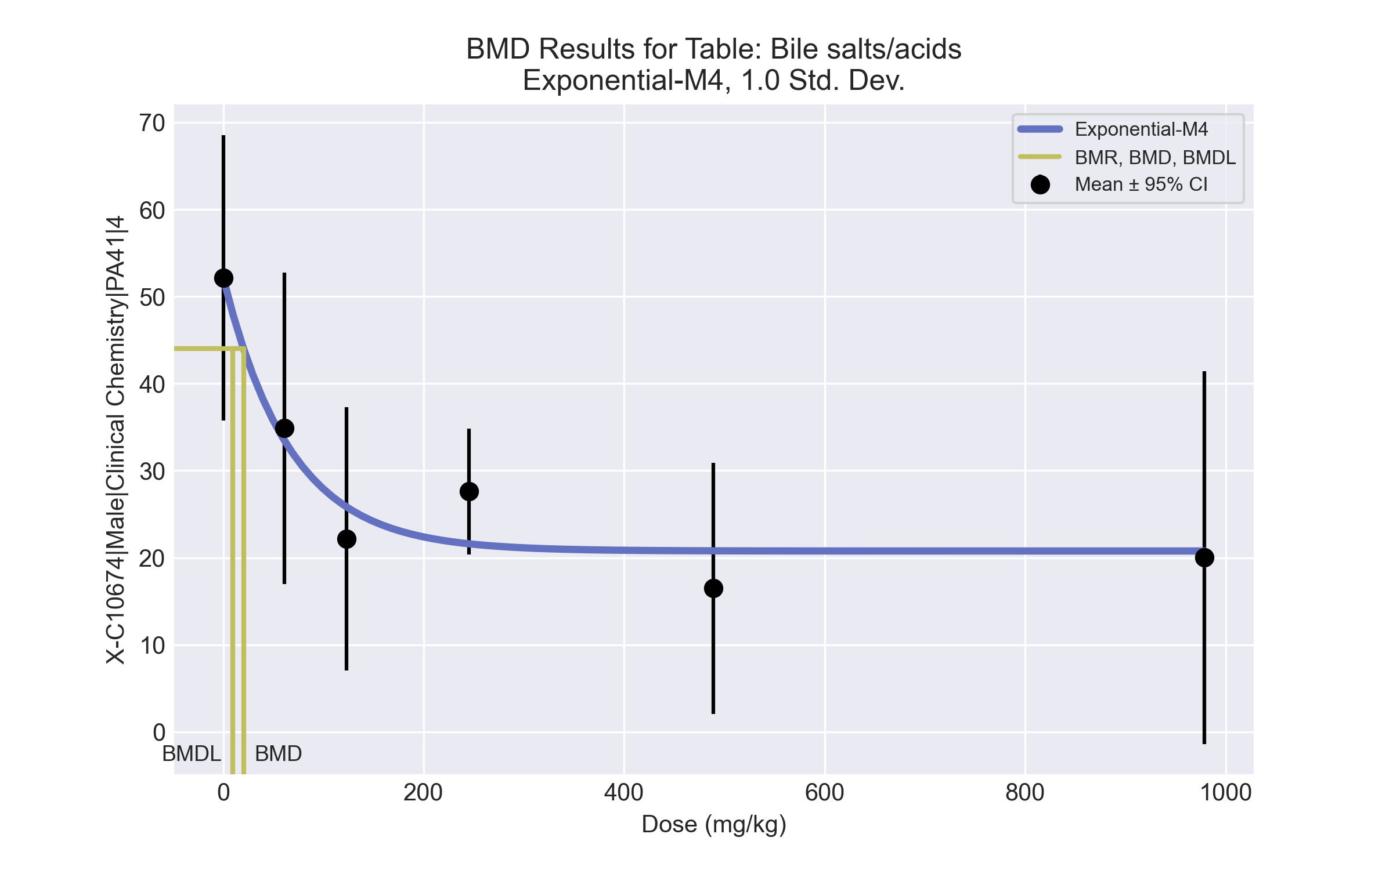
====================================================================
Exponential Model. (Version: 1.11; Date: 03/14/2017)
Input Data File: C:\Windows\TEMP\bmds-xj4294eq.(d)
Gnuplot Plotting File:
Thu Jul 15 23:23:39 2021
====================================================================
BMDS_Model_Run
~~~~~~~~~~~~~~~~~~~~~~~~~~~~~~~~~~~~~~~~~~~~~~~~~~~~~~~~~~~~~~~~~~~~~
The form of the response function by Model:
Model 2: Y[dose] = a * exp{sign * b * dose}
Model 3: Y[dose] = a * exp{sign * (b * dose)^d}
Model 4: Y[dose] = a * [c-(c-1) * exp{-b * dose}]
Model 5: Y[dose] = a * [c-(c-1) * exp{-(b * dose)^d}]
Note: Y[dose] is the median response for exposure = dose;
sign = +1 for increasing trend in data;
sign = -1 for decreasing trend.
Model 2 is nested within Models 3 and 4.
Model 3 is nested within Model 5.
Model 4 is nested within Model 5.
Dependent variable = Response
Independent variable = Dose
Data are assumed to be distributed: normally
Variance Model: exp(lnalpha +rho *ln(Y[dose]))
rho is set to 0.
A constant variance model is fit.
Total number of dose groups = 6
Total number of records with missing values = 0
Maximum number of iterations = 500
Relative Function Convergence has been set to: 1e-008
Parameter Convergence has been set to: 1e-008
MLE solution provided: Exact
Initial Parameter Values
Variable Model 4
-------- --------
lnalpha 3.9742
rho 0 Specified
a 54.7575
b 0.00361711
c 0.286545
d 1 Specified
Parameter Estimates
Variable Model 4 Std. Err.
-------- ------- ---------
lnalpha 4.20491 19.7614
a 52.1757 4.11884
b 0.0148412 0.00652523
c 0.398072 0.0583859
NC = No Convergence
Table of Stats From Input Data
Dose N Obs Mean Obs Std Dev
----- --- ---------- -------------
0 4 52.15 10.31
61 3 34.87 7.206
123 4 22.15 9.499
245 5 27.62 5.828
489 4 16.48 9.049
979 3 20.03 8.62
Estimated Values of Interest
Dose Est Mean Est Std Scaled Residual
------ ---------- --------- ----------------
0 52.18 8.186 -0.006276
61 33.47 8.186 0.2954
123 25.83 8.186 -0.8992
245 21.6 8.186 1.645
489 20.79 8.186 -1.055
979 20.77 8.186 -0.1558
Other models for which likelihoods are calculated:
Model A1: Yij = Mu(i) + e(ij)
Var{e(ij)} = Sigma^2
Model A2: Yij = Mu(i) + e(ij)
Var{e(ij)} = Sigma(i)^2
Model A3: Yij = Mu(i) + e(ij)
Var{e(ij)} = exp(lalpha + log(mean(i)) * rho)
Model R: Yij = Mu + e(i)
Var{e(ij)} = Sigma^2
Likelihoods of Interest
Model Log(likelihood) DF AIC
------- ----------------- ---- ------------
A1 -57.20326 7 128.4065
A2 -56.34909 12 136.6982
A3 -57.20326 7 128.4065
R -72.27099 2 148.542
4 -59.85641 4 127.7128
Additive constant for all log-likelihoods = -21.14. This constant added to the
above values gives the log-likelihood including the term that does not
depend on the model parameters.
Explanation of Tests
Test 1: Does response and/or variances differ among Dose levels? (A2 vs. R)
Test 2: Are Variances Homogeneous? (A2 vs. A1)
Test 3: Are variances adequately modeled? (A2 vs. A3)
Test 6a: Does Model 4 fit the data? (A3 vs 4)
Tests of Interest
Test -2*log(Likelihood Ratio) D. F. p-value
-------- ------------------------ ------ --------------
Test 1 31.84 10 0.0004252
Test 2 1.708 5 0.8878
Test 3 1.708 5 0.8878
Test 6a 5.306 3 0.1507
The p-value for Test 1 is less than .05. There appears to be a
difference between response and/or variances among the dose
levels, it seems appropriate to model the data.
The p-value for Test 2 is greater than .1. A homogeneous
variance model appears to be appropriate here.
The p-value for Test 3 is greater than .1. The modeled
variance appears to be appropriate here.
The p-value for Test 6a is greater than .1. Model 4 seems
to adequately describe the data.
Benchmark Dose Computations:
Specified Effect = 1.000000
Risk Type = Estimated standard deviations from control
Confidence Level = 0.950000
BMD = 20.3484
BMDL = 9.30458
BMDU = 52.6453

BMD Results for Table: Cholesterol
BMDS version: BMDS v2.7.0

Input dataset
Dose | 0 | 61 | 123 | 245 | 489 | 979
N | 4 | 3 | 4 | 5 | 4 | 3
Mean ± SD | 115 ± 18.111 | 113 ± 1.732 | 133.5 ± 4.123 | 128.6 ± 23.522 | 142.5 ± 22.279 | 150.333 ± 28.989

Summary table
Modelª | Goodness of fit |  | BMD | BMDL | Comments
 | p-value | AIC
Linear (equivalent models include Power, Polynomial 2°, 3°, 4°, 5°) | 0.12 | 161.422 | 328.551 | 159.337 | No model was recommended as a best-fitting model. Doses were dropped until there were only 3 remaining dose-groups.
Hill | 0.054 | 163.931 | 151.104 | -999
Exponential M2 (equivalent models include Exponential M3) | 0.105 | 161.76 | 376.114 | 193.041
Exponential M4 | 0.107 | 162.2 | 158.814 | 54.697
Exponential M5 | 0.05 | 164.105 | 166.99 | 55.665
ª Modeled variance case presented (BMDS Test 2 p-value = 4.9E-04, BMDS Test 3 p-value = 0.003).

Model recommendation details
Model | Bin | Notes
Linear (equivalent models include Power, Polynomial 2°, 3°, 4°, 5°) | Warning | Warnings  • Variance model poorly fits dataset (p-value 3 = 0.00345)
Hill | Failure | Failures  • BMDL does not exist  Warnings  • Variance model poorly fits dataset (p-value 3 = 0.00345)  • Goodness of fit p-value is less than threshold (0.0544 < 0.1)  Cautions  • Warning(s): BMDL computation failed.
Exponential M2 (equivalent models include Exponential M3) | Warning | Warnings  • Variance model poorly fits dataset (p-value 3 = 0.00345)
Exponential M4 | Warning | Warnings  • Variance model poorly fits dataset (p-value 3 = 0.00345)
Exponential M5 | Warning | Warnings  • Variance model poorly fits dataset (p-value 3 = 0.00345)  • Goodness of fit p-value is less than threshold (0.0499 < 0.1)

Recommended model
No model was recommended as a best-fitting model.

BMD Results for Table: Globulin
BMDS version: BMDS v2.7.0

Input dataset
Dose | 0 | 61 | 123 | 245 | 489 | 979
N | 4 | 3 | 4 | 5 | 4 | 3
Mean ± SD | 2.9 ± 0.082 | 3.1 ± 0.2 | 2.925 ± 0.126 | 3.02 ± 0.259 | 3.2 ± 0.141 | 3.2 ± 0.2

Summary table
Modelª | Goodness of fit |  | BMD | BMDL | Comments
 | p-value | AIC
Linear (equivalent models include Power, Polynomial 2°, 3°, 4°, 5°) | 0.327 | -52.008 | 572.522 | 340.534 | Exponential-M4 recommended as best-fitting model on the basis of the lowest BMDL.
Hill | 0.389 | -51.617 | 274.074 | 93.751
Exponential M2 (equivalent models include Exponential M3) | 0.32 | -51.939 | 590.042 | 359.696
Exponential M4^{b} | 0.27 | -50.718 | 336.018 | 95.21
Exponential M5 | 0.221 | -49.617 | 266.172 | 121.341
ª Constant variance case presented (BMDS Test 2 p-value = 0.264, BMDS Test 3 p-value = 0.264).
^{b} Recommended model

Model recommendation details
Model | Bin | Notes
Linear (equivalent models include Power, Polynomial 2°, 3°, 4°, 5°) | Warning | Warnings  • Ratio of modeled to actual stdev. at control is greater than threshold (2.11 > 1.5)
Hill | Warning | Warnings  • Ratio of modeled to actual stdev. at control is greater than threshold (2.03 > 1.5)
Exponential M2 (equivalent models include Exponential M3) | Valid | -
Exponential M4ª | Valid | -
Exponential M5 | Valid | -
ª Recommended model

Recommended model
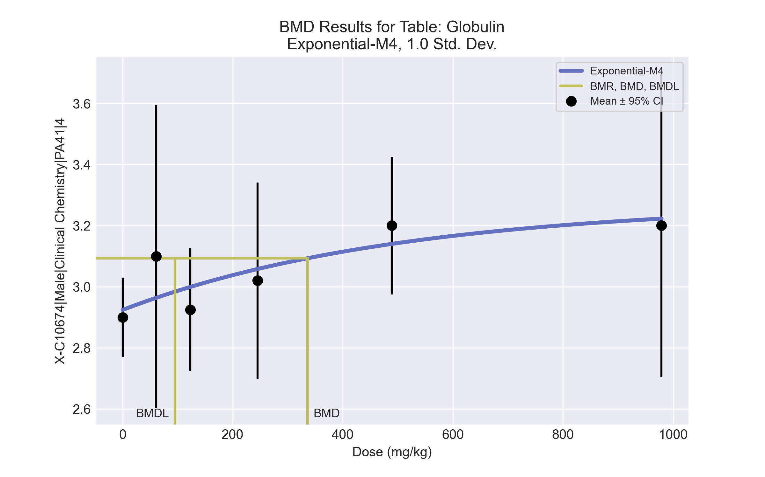
====================================================================
Exponential Model. (Version: 1.11; Date: 03/14/2017)
Input Data File: C:\Windows\TEMP\bmds-hq_mulq7.(d)
Gnuplot Plotting File:
Thu Jul 15 23:23:59 2021
====================================================================
BMDS_Model_Run
~~~~~~~~~~~~~~~~~~~~~~~~~~~~~~~~~~~~~~~~~~~~~~~~~~~~~~~~~~~~~~~~~~~~~
The form of the response function by Model:
Model 2: Y[dose] = a * exp{sign * b * dose}
Model 3: Y[dose] = a * exp{sign * (b * dose)^d}
Model 4: Y[dose] = a * [c-(c-1) * exp{-b * dose}]
Model 5: Y[dose] = a * [c-(c-1) * exp{-(b * dose)^d}]
Note: Y[dose] is the median response for exposure = dose;
sign = +1 for increasing trend in data;
sign = -1 for decreasing trend.
Model 2 is nested within Models 3 and 4.
Model 3 is nested within Model 5.
Model 4 is nested within Model 5.
Dependent variable = Response
Independent variable = Dose
Data are assumed to be distributed: normally
Variance Model: exp(lnalpha +rho *ln(Y[dose]))
rho is set to 0.
A constant variance model is fit.
Total number of dose groups = 6
Total number of records with missing values = 0
Maximum number of iterations = 500
Relative Function Convergence has been set to: 1e-008
Parameter Convergence has been set to: 1e-008
MLE solution provided: Exact
Initial Parameter Values
Variable Model 4
-------- --------
lnalpha -3.72338
rho 0 Specified
a 2.755
b 0.00171242
c 1.2196
d 1 Specified
Parameter Estimates
Variable Model 4 Std. Err.
-------- ------- ---------
lnalpha -3.55298 0.00844524
a 2.92391 0.066976
b 0.00196668 0.00247449
c 1.11969 0.0711117
NC = No Convergence
Table of Stats From Input Data
Dose N Obs Mean Obs Std Dev
----- --- ---------- -------------
0 4 2.9 0.08165
61 3 3.1 0.2
123 4 2.925 0.1258
245 5 3.02 0.2588
489 4 3.2 0.1414
979 3 3.2 0.2
Estimated Values of Interest
Dose Est Mean Est Std Scaled Residual
------ ---------- --------- ----------------
0 2.924 0.1692 -0.2826
61 2.963 0.1692 1.397
123 2.999 0.1692 -0.8758
245 3.058 0.1692 -0.4984
489 3.14 0.1692 0.7079
979 3.223 0.1692 -0.2337
Other models for which likelihoods are calculated:
Model A1: Yij = Mu(i) + e(ij)
Var{e(ij)} = Sigma^2
Model A2: Yij = Mu(i) + e(ij)
Var{e(ij)} = Sigma(i)^2
Model A3: Yij = Mu(i) + e(ij)
Var{e(ij)} = exp(lalpha + log(mean(i)) * rho)
Model R: Yij = Mu + e(i)
Var{e(ij)} = Sigma^2
Likelihoods of Interest
Model Log(likelihood) DF AIC
------- ----------------- ---- ------------
A1 31.31886 7 -48.63772
A2 34.55119 12 -45.10239
A3 31.31886 7 -48.63772
R 26.0624 2 -48.12479
4 29.35925 4 -50.7185
Additive constant for all log-likelihoods = -21.14. This constant added to the
above values gives the log-likelihood including the term that does not
depend on the model parameters.
Explanation of Tests
Test 1: Does response and/or variances differ among Dose levels? (A2 vs. R)
Test 2: Are Variances Homogeneous? (A2 vs. A1)
Test 3: Are variances adequately modeled? (A2 vs. A3)
Test 6a: Does Model 4 fit the data? (A3 vs 4)
Tests of Interest
Test -2*log(Likelihood Ratio) D. F. p-value
-------- ------------------------ ------ --------------
Test 1 16.98 10 0.07486
Test 2 6.465 5 0.2636
Test 3 6.465 5 0.2636
Test 6a 3.919 3 0.2703
The p-value for Test 1 is greater than .05. There may not be a
diffence between responses and/or variances among the dose levels
Modelling the data with a dose/response curve may not be appropriate.
The p-value for Test 2 is greater than .1. A homogeneous
variance model appears to be appropriate here.
The p-value for Test 3 is greater than .1. The modeled
variance appears to be appropriate here.
The p-value for Test 6a is greater than .1. Model 4 seems
to adequately describe the data.
Benchmark Dose Computations:
Specified Effect = 1.000000
Risk Type = Estimated standard deviations from control
Confidence Level = 0.950000
BMD = 336.018
BMDL = 95.2096
BMDU = 9.79e+006

BMD Results for Table: HDL Cholesterol
BMDS version: BMDS v2.7.0

Input dataset
Dose | 0 | 61 | 123 | 245 | 489 | 979
N | 4 | 3 | 4 | 5 | 4 | 3
Mean ± SD | 50 ± 5.477 | 54.667 ± 6.658 | 68 ± 4.546 | 68 ± 9.899 | 74.75 ± 19.772 | 87.667 ± 16.653

Summary table
Modelª | Goodness of fit |  | BMD | BMDL | Comments
 | p-value | AIC
Linear (equivalent models include Polynomial 2°, 3°, 4°, 5°) | 0.083 | 137.591 | 141.175 | 61.805 | Exponential-M4 recommended as best-fitting model on the basis of the lowest AIC.
Power | 0.083 | 137.591 | 141.176 | 61.805
Hill | 0.398 | 135.182 | 38.095 | -999
Exponential M2 (equivalent models include Exponential M3) | 0.037 | 139.565 | 224.961 | 109.57
Exponential M4^{b} (equivalent models include Exponential M5) | 0.57 | 133.351 | 36.78 | 18.336
ª Modeled variance case presented (BMDS Test 2 p-value = 0.026, BMDS Test 3 p-value = 0.334).
^{b} Recommended model

Model recommendation details
Model | Bin | Notes
Linear (equivalent models include Polynomial 2°, 3°, 4°, 5°) | Warning | Warnings  • Goodness of fit p-value is less than threshold (0.0828 < 0.1)
Power | Warning | Warnings  • Goodness of fit p-value is less than threshold (0.0828 < 0.1)
Hill | Failure | Failures  • BMDL does not exist  Cautions  • Warning(s): BMDL computation failed.
Exponential M2 (equivalent models include Exponential M3) | Warning | Warnings  • Goodness of fit p-value is less than threshold (0.0368 < 0.1)
Exponential M4ª (equivalent models include Exponential M5) | Valid | -
ª Recommended model

Recommended model
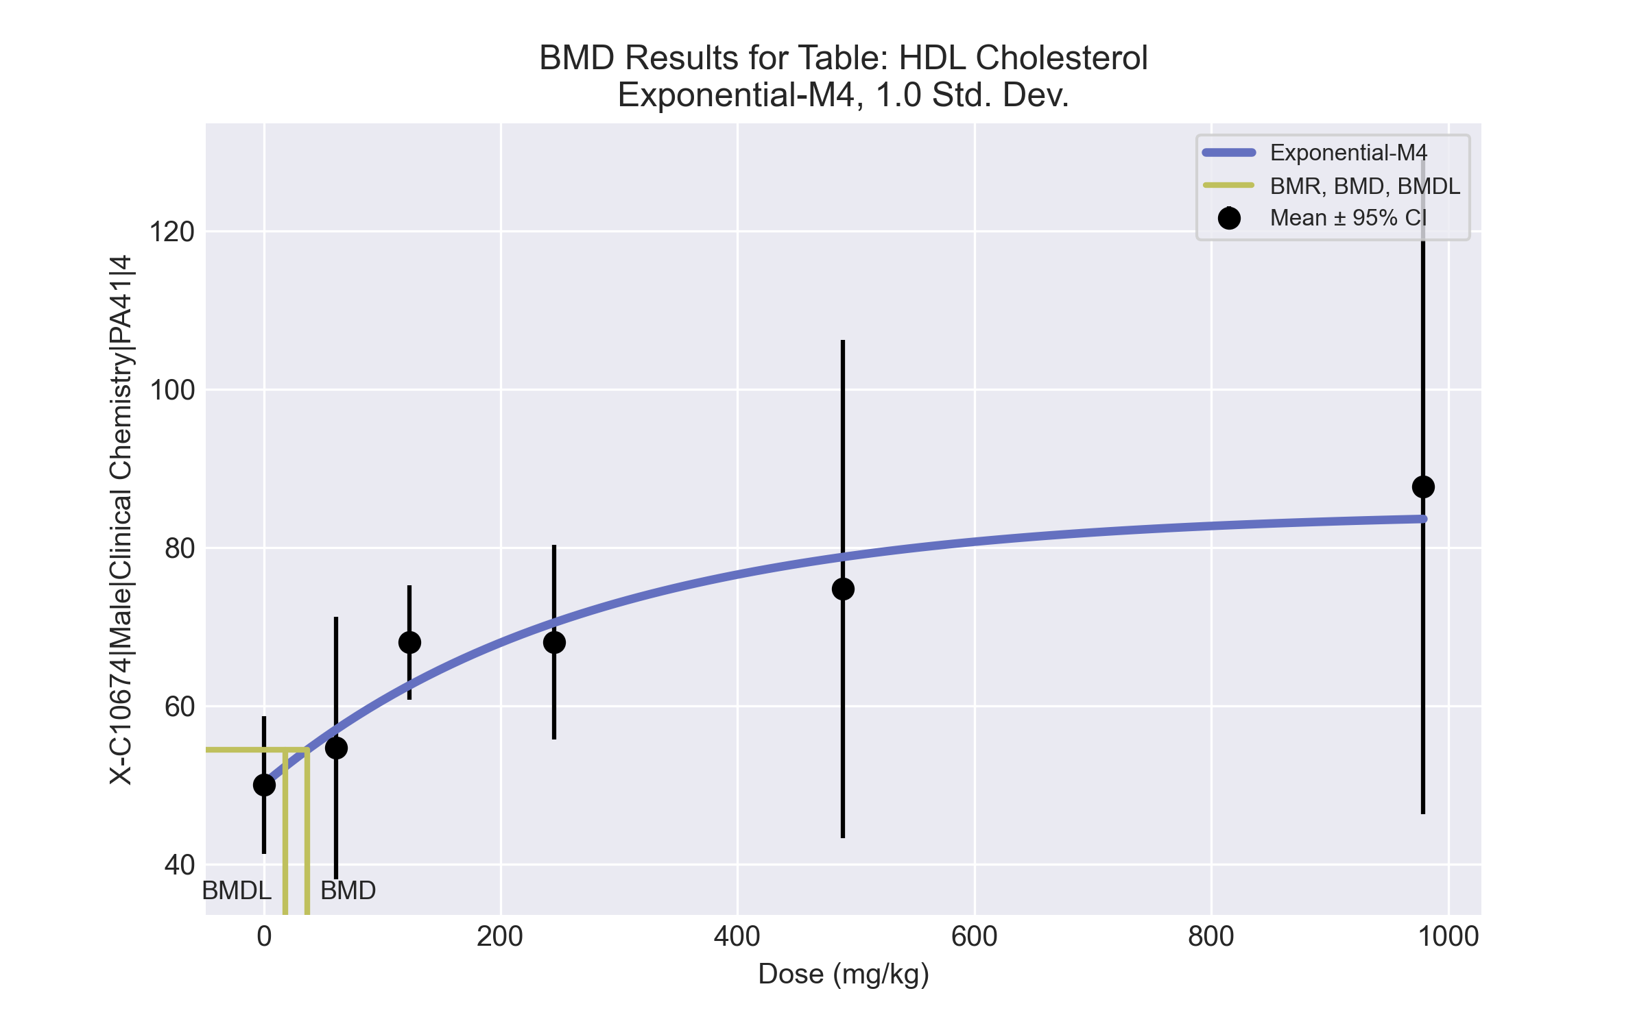
====================================================================
Exponential Model. (Version: 1.11; Date: 03/14/2017)
Input Data File: C:\Windows\TEMP\bmds-zz490uzw.(d)
Gnuplot Plotting File:
Thu Jul 15 23:24:03 2021
====================================================================
BMDS_Model_Run
~~~~~~~~~~~~~~~~~~~~~~~~~~~~~~~~~~~~~~~~~~~~~~~~~~~~~~~~~~~~~~~~~~~~~
The form of the response function by Model:
Model 2: Y[dose] = a * exp{sign * b * dose}
Model 3: Y[dose] = a * exp{sign * (b * dose)^d}
Model 4: Y[dose] = a * [c-(c-1) * exp{-b * dose}]
Model 5: Y[dose] = a * [c-(c-1) * exp{-(b * dose)^d}]
Note: Y[dose] is the median response for exposure = dose;
sign = +1 for increasing trend in data;
sign = -1 for decreasing trend.
Model 2 is nested within Models 3 and 4.
Model 3 is nested within Model 5.
Model 4 is nested within Model 5.
Dependent variable = Response
Independent variable = Dose
Data are assumed to be distributed: normally
Variance Model: exp(lnalpha +rho *ln(Y[dose]))
The variance is to be modeled as Var(i) = exp(lalpha + log(mean(i)) * rho)
Total number of dose groups = 6
Total number of records with missing values = 0
Maximum number of iterations = 500
Relative Function Convergence has been set to: 1e-008
Parameter Convergence has been set to: 1e-008
MLE solution provided: Exact
Initial Parameter Values
Variable Model 4
-------- --------
lnalpha -13.5104
rho 4.27457
a 47.5
b 0.00232696
c 1.93789
d 1 Specified
Parameter Estimates
Variable Model 4 Std. Err.
-------- ------- ---------
lnalpha -17.4224 7.40795
rho 5.20012 1.77407
a 50.1146 2.0693
b 0.00365406 0.00165887
c 1.68755 0.17488
NC = No Convergence
Table of Stats From Input Data
Dose N Obs Mean Obs Std Dev
----- --- ---------- -------------
0 4 50 5.477
61 3 54.67 6.658
123 4 68 4.546
245 5 68 9.899
489 4 74.75 19.77
979 3 87.67 16.65
Estimated Values of Interest
Dose Est Mean Est Std Scaled Residual
------ ---------- --------- ----------------
0 50.11 4.333 -0.05288
61 57 6.055 -0.6671
123 62.59 7.723 1.401
245 70.5 10.52 -0.5302
489 78.8 14.06 -0.5762
979 83.61 16.4 0.4288
Other models for which likelihoods are calculated:
Model A1: Yij = Mu(i) + e(ij)
Var{e(ij)} = Sigma^2
Model A2: Yij = Mu(i) + e(ij)
Var{e(ij)} = Sigma(i)^2
Model A3: Yij = Mu(i) + e(ij)
Var{e(ij)} = exp(lalpha + log(mean(i)) * rho)
Model R: Yij = Mu + e(i)
Var{e(ij)} = Sigma^2
Likelihoods of Interest
Model Log(likelihood) DF AIC
------- ----------------- ---- ------------
A1 -64.75602 7 143.512
A2 -58.38394 12 140.7679
A3 -60.66957 8 137.3391
R -74.49106 2 152.9821
4 -61.67533 5 133.3507
Additive constant for all log-likelihoods = -21.14. This constant added to the
above values gives the log-likelihood including the term that does not
depend on the model parameters.
Explanation of Tests
Test 1: Does response and/or variances differ among Dose levels? (A2 vs. R)
Test 2: Are Variances Homogeneous? (A2 vs. A1)
Test 3: Are variances adequately modeled? (A2 vs. A3)
Test 6a: Does Model 4 fit the data? (A3 vs 4)
Tests of Interest
Test -2*log(Likelihood Ratio) D. F. p-value
-------- ------------------------ ------ --------------
Test 1 32.21 10 0.0003688
Test 2 12.74 5 0.0259
Test 3 4.571 4 0.3342
Test 6a 2.012 3 0.57
The p-value for Test 1 is less than .05. There appears to be a
difference between response and/or variances among the dose
levels, it seems appropriate to model the data.
The p-value for Test 2 is less than .1. A non-homogeneous
variance model appears to be appropriate.
The p-value for Test 3 is greater than .1. The modeled
variance appears to be appropriate here.
The p-value for Test 6a is greater than .1. Model 4 seems
to adequately describe the data.
Benchmark Dose Computations:
Specified Effect = 1.000000
Risk Type = Estimated standard deviations from control
Confidence Level = 0.950000
BMD = 36.7796
BMDL = 18.3359
BMDU = 98.29

BMD Results for Table: Cholinesterase
BMDS version: BMDS v2.7.0

Input dataset
Dose | 0 | 61 | 123 | 245 | 489 | 979
N | 4 | 3 | 4 | 5 | 4 | 3
Mean ± SD | 291.25 ± 18.768 | 200.333 ± 27.062 | 196 ± 20.928 | 164.8 ± 44.201 | 149 ± 22.39 | 133.667 ± 14.012

Summary table
Modelª | Goodness of fit |  | BMD | BMDL | Comments
 | p-value | AIC
Linear (equivalent models include Power, Polynomial 2°, 3°, 4°, 5°) | <0.0001 | 201.047 | 340.174 | 234.363 | Hill recommended as best-fitting model on the basis of the lowest AIC.
Hill^{b} | 0.64 | 179.391 | 12.475 | 6.079
Exponential M2 (equivalent models include Exponential M3) | 2.1E-04 | 197.586 | 195.139 | 121.455
Exponential M4 (equivalent models include Exponential M5) | 0.265 | 181.675 | 20.665 | 11.486
ª Constant variance case presented (BMDS Test 2 p-value = 0.184, BMDS Test 3 p-value = 0.184).
^{b} Recommended model

Model recommendation details
Model | Bin | Notes
Linear (equivalent models include Power, Polynomial 2°, 3°, 4°, 5°) | Warning | Warnings  • Residual at lowest dose is greater than threshold (3.07 > 2.0)  • Ratio of modeled to actual stdev. at control is greater than threshold (2.24 > 1.5)
Hillª | Valid | Cautions  • Minimum dose/BMD ratio is greater than threshold (4.89 > 3.0)
Exponential M2 (equivalent models include Exponential M3) | Warning | Warnings  • Goodness of fit p-value is less than threshold (0.000212 < 0.1)  • Residual at lowest dose is greater than threshold (2.67 > 2.0)
Exponential M4 (equivalent models include Exponential M5) | Valid | -
ª Recommended model

Recommended model
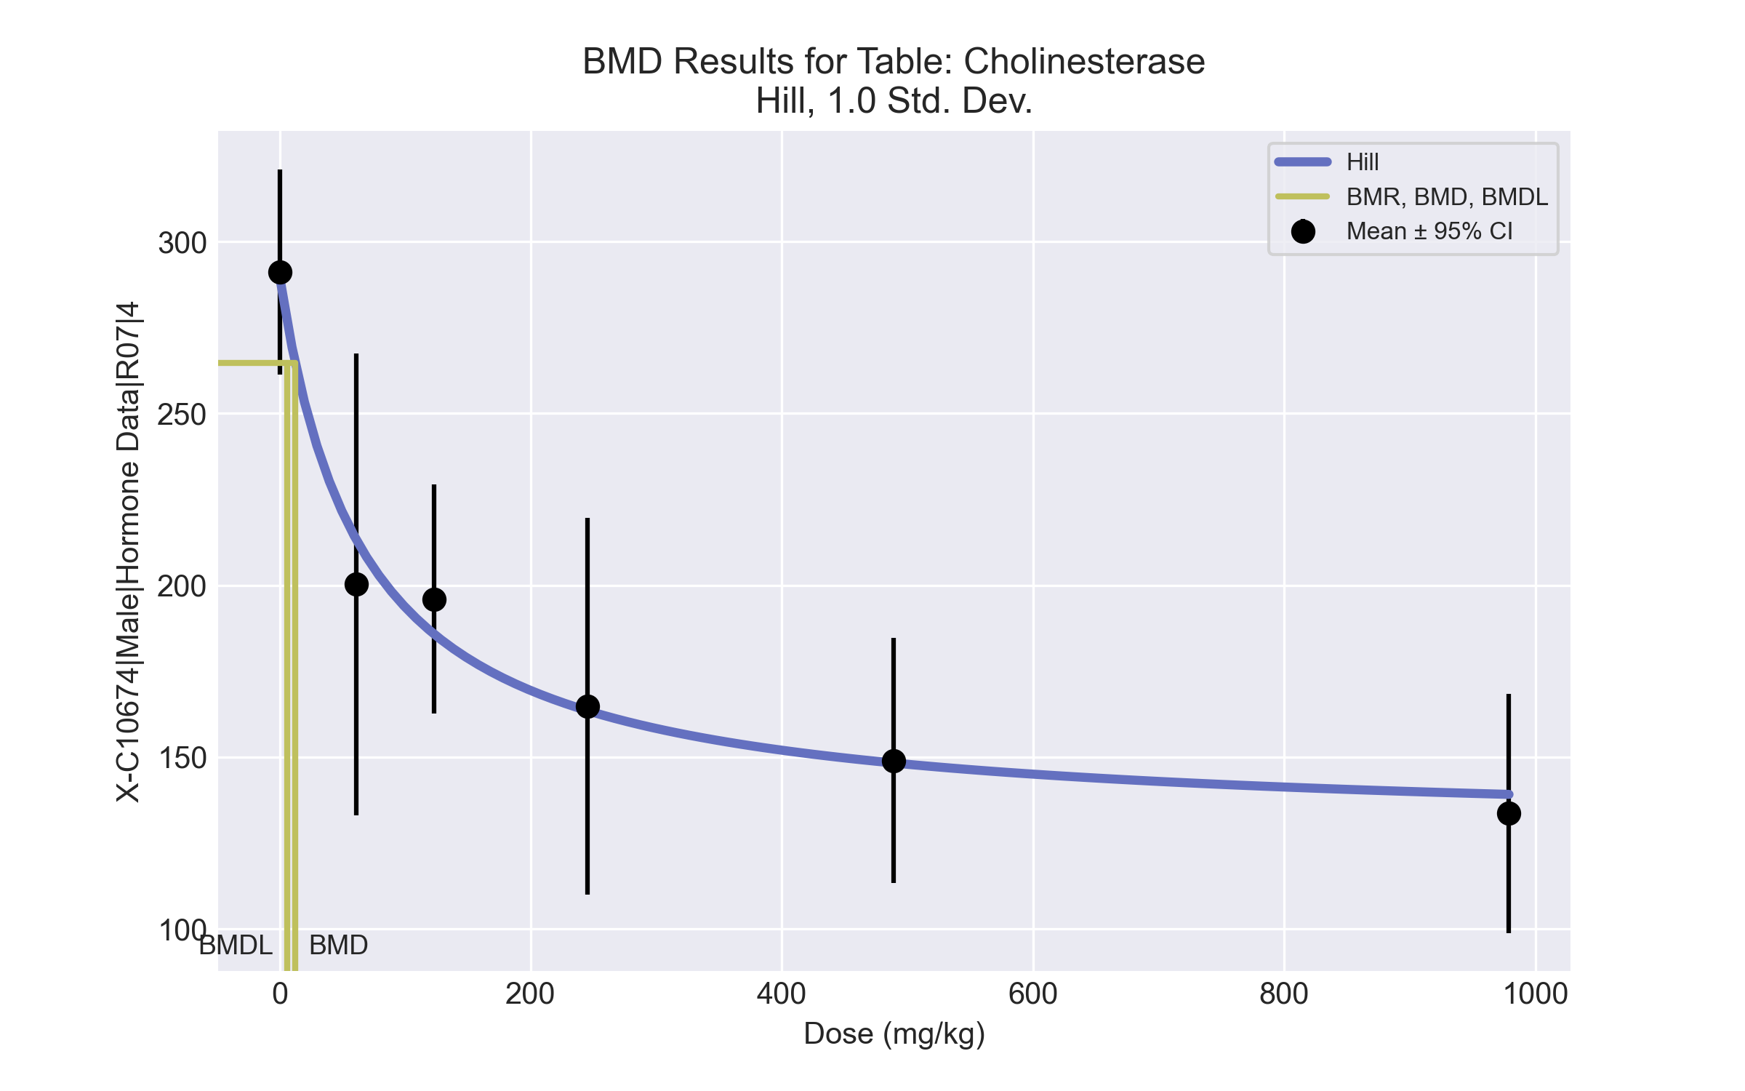
====================================================================
Hill Model. (Version: 2.18; Date: 03/14/2017)
Input Data File: C:\Windows\TEMP\bmds-3akihw1i.(d)
Gnuplot Plotting File: C:\Windows\TEMP\bmds-3akihw1i.plt
Thu Jul 15 23:47:02 2021
====================================================================
BMDS_Model_Run
~~~~~~~~~~~~~~~~~~~~~~~~~~~~~~~~~~~~~~~~~~~~~~~~~~~~~~~~~~~~~~~~~~~~~
The form of the response function is:
Y[dose] = intercept + v*dose^n/(k^n + dose^n)
Dependent variable = Response
Independent variable = Dose
rho is set to 0
Power parameter restricted to be greater than 1
A constant variance model is fit
Total number of dose groups = 6
Total number of records with missing values = 0
Maximum number of iterations = 500
Relative Function Convergence has been set to: 1e-008
Parameter Convergence has been set to: 1e-008
Default Initial Parameter Values
alpha = 796.875
rho = 0 Specified
intercept = 291.25
v = -157.583
n = 1.14621
k = 52.8648
Asymptotic Correlation Matrix of Parameter Estimates
( *** The model parameter(s) -rho -n
have been estimated at a boundary point, or have been specified by the user,
and do not appear in the correlation matrix )
alpha intercept v k
alpha 1 -3.1e-010 6.2e-008 4.8e-008
intercept -3.1e-010 1 -0.6 -0.41
v 6.2e-008 -0.6 1 -0.37
k 4.8e-008 -0.41 -0.37 1
Parameter Estimates
95.0% Wald Confidence Interval
Variable Estimate Std. Err. Lower Conf. Limit Upper Conf. Limit
alpha 633.834 186.907 267.502 1000.17
intercept 289.909 12.6747 265.067 314.751
v -161.142 17.8829 -196.192 -126.092
n 1 NA
k 67.374 28.996 10.5428 124.205
NA - Indicates that this parameter has hit a bound
implied by some inequality constraint and thus
has no standard error.
Table of Data and Estimated Values of Interest
Dose N Obs Mean Est Mean Obs Std Dev Est Std Dev Scaled Res.
------ --- -------- -------- ----------- ----------- ----------
0 4 291 290 18.8 25.2 0.107
61 3 200 213 27.1 25.2 -0.895
123 4 196 186 20.9 25.2 0.811
245 5 165 164 44.2 25.2 0.113
489 4 149 148 22.4 25.2 0.0572
979 3 134 139 14 25.2 -0.377
Model Descriptions for likelihoods calculated
Model A1: Yij = Mu(i) + e(ij)
Var{e(ij)} = Sigma^2
Model A2: Yij = Mu(i) + e(ij)
Var{e(ij)} = Sigma(i)^2
Model A3: Yij = Mu(i) + e(ij)
Var{e(ij)} = Sigma^2
Model A3 uses any fixed variance parameters that
were specified by the user
Model R: Yi = Mu + e(i)
Var{e(i)} = Sigma^2
Likelihoods of Interest
Model Log(likelihood) # Param's AIC
A1 -84.851802 7 183.703604
A2 -81.085091 12 186.170182
A3 -84.851802 7 183.703604
fitted -85.695547 4 179.391095
R -104.445456 2 212.890913
Explanation of Tests
Test 1: Do responses and/or variances differ among Dose levels?
(A2 vs. R)
Test 2: Are Variances Homogeneous? (A1 vs A2)
Test 3: Are variances adequately modeled? (A2 vs. A3)
Test 4: Does the Model for the Mean Fit? (A3 vs. fitted)
(Note: When rho=0 the results of Test 3 and Test 2 will be the same.)
Tests of Interest
Test -2*log(Likelihood Ratio) Test df p-value
Test 1 46.7207 10 <.0001
Test 2 7.53342 5 0.1839
Test 3 7.53342 5 0.1839
Test 4 1.68749 3 0.6397
The p-value for Test 1 is less than .05. There appears to be a
difference between response and/or variances among the dose levels
It seems appropriate to model the data
The p-value for Test 2 is greater than .1. A homogeneous variance
model appears to be appropriate here
The p-value for Test 3 is greater than .1. The modeled variance appears
to be appropriate here
The p-value for Test 4 is greater than .1. The model chosen seems
to adequately describe the data
Benchmark Dose Computation
Specified effect = 1
Risk Type = Estimated standard deviations from the control mean
Confidence level = 0.95
BMD = 12.4753
BMDL = 6.07923
BMDU = 32.3833

