1(A). BioSeek dose-response data for 5HPP-33.  Open bars show assay responses below where cytotoxicity was observed.  Solid bars show SRB cytotoxicity assay responses in endothelial cells, fibroblasts, T-cells, and SMCs. 

(B) Median of the log(AC50) for cytotoxicity assays across ToxCast following 5HPP-33 treatment.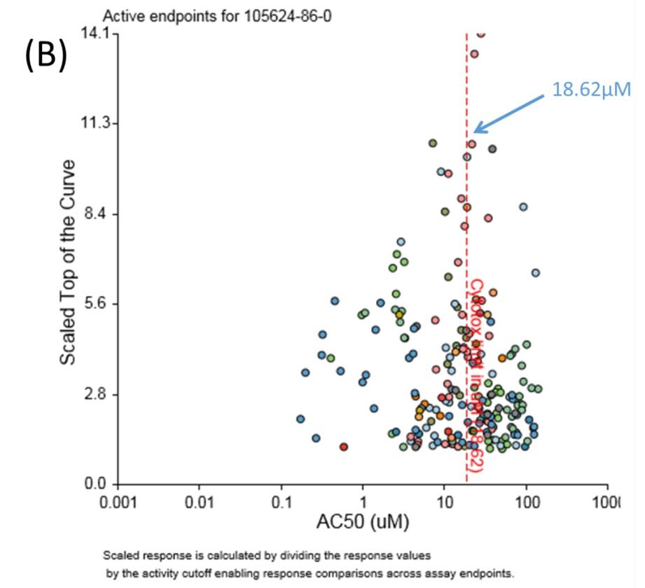

1(C). CytoTox-Fluor assay dose-response data for 5HPP-33 in rat aortic explants.

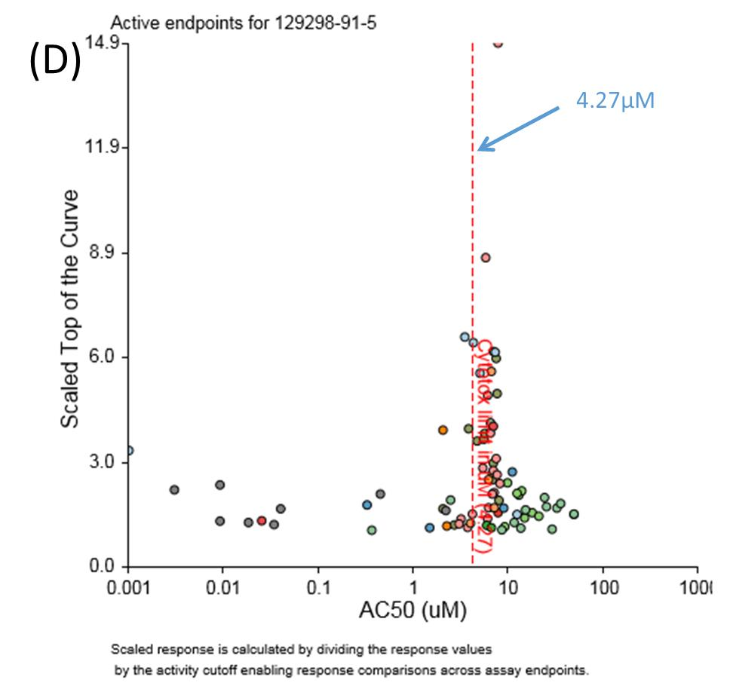

1(E). CytoTox-Fluor assay dose-response data for TNP-470 in rat aortic explants. 

**Supplemental Figure 1. Cytotoxicity evaluation in the BioSeek SRB assay, across ToxCast HTS assay endpoints, and Cyto-Tox-Fluor assay in rat aortic explants.** (A) BioSeek dose-response data for 5HPP-33. Open bars show assay responses below where cytotoxicity was observed. Solid bars show SRB cytotoxicity assay responses in endothelial cells, fibroblasts, T-cells, and SMCs. (B) Median of the log(AC50) for cytotoxicity assays across ToxCast following 5HPP-33 treatment. (C) CytoTox-Fluor assay dose-response data for 5HPP-33 in rat aortic explants. (D) Median of the log(AC50) for cytotoxicity assays across ToxCast following TNP-470 treatment. (E) CytoTox-Fluor assay dose-response data for TNP-470 in rat aortic explants.