SUPPORTING INFORMATION

Title
Black Cohosh Botanical Extracts and Powders induce Micronuclei, a Biomarker of Genetic Damage, in Human Cells

Authors
Stephanie L. Smith-Roe, Carol D. Swartz, Kim G. Shepard, Steven M. Bryce, Stephen D. Dertinger, Suramya Waidyanatha, Grace E. Kissling, Scott S. Auerbach, Kristine L. Witt

Table of Contents

Title Page | 1
Materials and Methods for Figure S1 | 2
Results for Figure S1 | 2
References for Figure S1 | 2
Figure S1 | 3
Figure S2 | 4
Figure S3 | 5
In Vitro Micronucleus Assay Tables 1, 2 | 6
In Vitro Micronucleus Assay Tables 3, 4 | 7
In Vitro Micronucleus Assay Tables 5, 6 | 8
In Vitro Micronucleus Assay Tables 7, 8 | 9
In Vitro Micronucleus Assay Tables 9, 10 | 10
In Vitro Micronucleus Assay Tables 11, 12 | 11
In Vitro Micronucleus Assay Tables 13, 14 | 12
In Vitro Micronucleus Assay Tables 15, 16 | 13

SUPPORTING INFORMATION

Materials and Methods for Figure S1
TK6 cells were grown in 0, 7.5, 15, 30, 60, 90, 120, or 3000 nM FA in 12-well plates for 24 or 120 h. Cells were sub-cultured at 72 h for the 120 h time point. Cells were assessed for induction of MN using the In Vitro MicroFlow® kit (Litron Laboratories, Rochester, NY), according to manufacturer’s instructions. This kit was also used to identify cells undergoing apoptosis and/or necrosis using a dual staining procedure in which the nuclear material only from cells with compromised membranes is stained with both dyes.

Results for Figure S1
RPMI 1640 cell culture medium typically contains supraphysiological amounts of FA. The RPMI 1640 used for routine culturing of TK6 cells by ILS, Inc. (Sigma-Aldrich, catalog # R8758) contains 3000 nM FA, whereas the reference range for plasma folate levels for adults is 4.5 to 45 nM (concentrations greater than 12 nM are considered to be normal). Previous work by others showed that MN are induced in human lymphocytes when cultured in defined medium containing very low levels of FA, but baseline levels of MN were similar in cultures of human lymphocytes grown in 120 nM FA compared to whole blood and short-term lymphocyte cultures (Crott et al., 2001). Also, cells become dependent on the amount of FA in culture after several rounds of cell division (Libbus et al., 1990; Crott et al., 2001). To test the effects of cohosh samples using a more physiologically relevant amount of folic acid, we cultured TK6 cells in defined medium containing 0, 7.5, 15, 30, 60, 90, 120, or 3000 nM FA for 24 or 120 h and determined %MN and the percent of apoptotic and necrotic (dying) cells (Figure S1). There were no significant differences between %MN and the percent of dying cells for TK6 cells grown in 120 versus 3000 nM FA for 120 h. However, dose-dependent, significant increases in these measures became apparent when the concentration of FA dropped below 60 nM. Growth in various concentrations of FA did not affect the %MN or the percent of dying cells after 24 h of culture (data not shown). Furthermore, 120 nM FA was sufficient to maintain TK6 cell doubling time (14 – 16 h), whereas growth in concentrations ≤ 60 nM FA reduced cell growth (data not shown). Taken together, although 120 nM FA is approximately 2.5 to 25.5-fold higher than the typical range of plasma FA for an adult, 120 nM FA maintains growth and prevents induction of MN in TK6 cells.

Supporting Information References
Crott JW, Mashiyama ST, Ames BN, Fenech MF. 2001. Methylenetetrahydrofolate reductase C677T polymorphism does not alter folic acid deficiency-induced uracil incorporation into primary human lymphocyte DNA in vitro. Carcinogenesis 22(7):1019-25.
Libbus BL, Borman LS, Ventrone CH, Branda RF. 1990. Nutritional folate-deficiency in Chinese hamster ovary cells. Chromosomal abnormalities associated with perturbations in nucleic acid precursors. Cancer Genet Cytogenet 46(2):231-42.

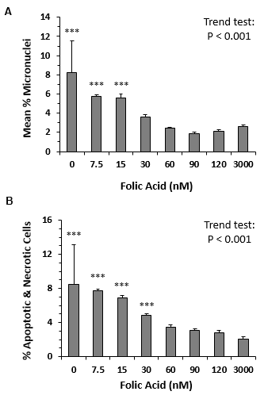

Figure S1: MN induction (A) and cell death (B) in TK6 cells grown for 120 h in medium containing different concentrations of FA. The zero concentration is < 1 nM FA due to residual amounts of FA in dialyzed FBS. Each concentration was evaluated using triplicate wells. Bars show the means and error bars show SEMs. ***P < 0.001.
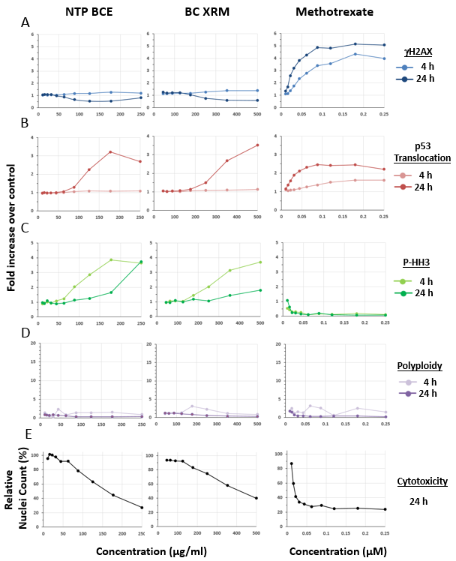
Figure S2: TK6 cell MultiFlow® DNA Damage assay results for γH2AX (A), p53 translocation (B), P-histone H3 (C), and polyploidy (D) after 4 or 24 h of exposure, and cytotoxicity (E) after 24 h of exposure, to NTP BCE (genotoxic in mice and rats in NTP studies) and a BC XRM. Methotrexate, which inhibits DHFR, is shown as a positive control for clastogenicity induced by impairment of the folate metabolism pathway. Cytotoxicity data for NTP BCE, BC XRM, and methotrexate are the same as those shown in Figure 5.
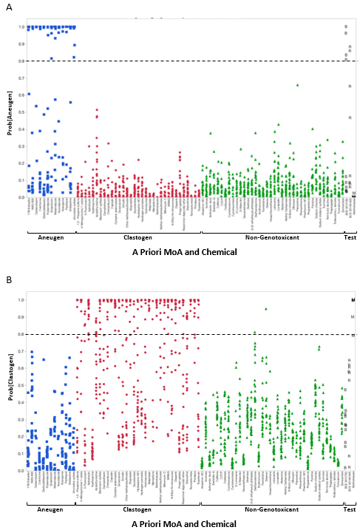
Figure S3: Comparison of NTP BCE (B), BC XRM (R), and methotrexate (M) to well-characterized clastogens, aneugens, and non-genotoxicants using the MultiFlow® DNA Damage assay 4-factor linear regression models for aneugenicity (A) and clastogenicity (B). The 4-factor linear regression models were developed using TK6 cells.
Supporting Information, Tables 1 - 16: In vitro micronucleus data that support the positive calls for each cohosh sample tested
Criteria for a positive call: The trend test is significant (P < 0.025) and at least one dose group is significantly increased (P < 0.025) compared to the control.
BCE 3012782 (the material tested in Mercado-Feliciano et al., 2012), 125 µg/ml, was used as a reference positive control for all other cohosh samples to allow for assessment of relative strength of response; mitomycin C, 100 ng/ml (0.3 µM), was used as a standard positive control in the in vitro MN assay.

Table 1: Actaea racemosa (black cohosh), extract reference material, product # ASB-00030148-005
120 nM folic acid, 24 h exposure
Cohosh sample (µg/ml) | Mean %MN | Std. Error | Pairwise P value | Relative Survival (%)
DMSO | 0.96 | 0.01 | - | 100
125 | 1.70 | .11 | ns | 64
250 | 4.15 | 0.05 | 0.025 | 52
300 | 4.67 | 0.15 | 0.01 | 59
400 | 8.32 | 1.05 | 0.01 | 50
 |  | Trend P value | 0.001
Controls | Mean %MN | Std. Error | Relative Survival (%)
BCE 3012782, 125 µg/ml | 7.41 | 0.003 | 54
Water control for MMC | 0.76 | 0.01 | 100
MMC, 100 ng/ml | 16.26 | 1.18 | 43

Table 2: BCE-3012782 (see also Figures 2A, B in Smith-Roe et al., 2018)
120 nM folic acid, 24 h exposure
Cohosh sample (µg/ml) | Mean %MN | Std. Error | Pairwise P value | Relative Survival (%)
DMSO | 1.12 | 0.31 | - | 100
10 | 1.09 | 0.05 | ns | 83
30 | 1.65 | 0.09 | ns | 76
45 | 1.99 | 0.25 | 0.05 | 72
65 | 1.91 | 0.04 | 0.05 | 73
95 | 3.17 | 0.46 | 0.01 | 66
110 | 4.83 | 0.89 | 0.01 | 65
125 | 5.43 | 0.71 | 0.01 | 71
 |  | Trend P value | 0.001
Controls | Mean %MN | Std. Error | Relative Survival (%)
Water control for MMC | 1.16 | 0.06 | 100
MMC, 100 ng/ml | 5.01 | 0.10 | 62

Table 3: BCE-3012782 was also tested using the dose range of 10 – 250 µg/ml:
120 nM folic acid, 24 h exposure
Cohosh sample (µg/ml) | Mean %MN | Std. Error | Pairwise P value | Relative Survival (%)
DMSO | 1.13 | 0.17 | - | 100
10 | 1.37 | 0.43 | ns | 78
25 | 1.37 | 0 | ns | 74
50 | 1.77 | 0.05 | 0.05 | 74
75 | 2.92 | 0.03 | 0.01 | 68
100 | 6.48 | 0.64 | 0.01 | 58
125 | 10.50 | 0.47 | 0.01 | 62
 |  | Trend P value | 0.001
Controls | Mean %MN | Std. Error | Relative Survival (%)
Water control for MMC | 1.16 | 0.06 | 100
MMC, 100 ng/ml | 5.01 | 0.10 | 41

Table 4: BCE-3012781
120 nM folic acid, 24 h exposure
Cohosh sample (µg/ml) | Mean %MN | Std. Error | Pairwise P value | Relative Survival (%)
DMSO | 0.63 | 0.01 | - | 100
10 | 0.94 | 0.23 | ns | 92
25 | 1.52 | 0.11 | 0.025 | 89
50 | 1.11 | 0.16 | ns | 83
75 | 1.65 | 0.03 | 0.01 | 77
100 | 2.32 | 0.36 | 0.01 | 75
125 | 3.32 | 0.15 | 0.01 | 73
175 | 5.90 | 0.45 | 0.01 | 66
250 | 8.73 | 0.28 | 0.01 | 50
 |  | Trend P value | 0.001
Controls | Mean %MN | Std. Error | Relative Survival (%)
BCE 3012782, 125 µg/ml | 5.98 | 0.66 | 65
Water control for MMC | 0.96 | 0.03 | 100
MMC, 100 ng/ml | 9.05 | 0.85 | 57

Table 5: BCE-331501
120 nM folic acid, 24 h exposure
Cohosh sample (µg/ml) | Mean %MN | Std. Error | Pairwise P value | Relative Survival (%)
DMSO | 1.57 | 0.06 | - | 100
10 | 1.63 | 0.13 | ns | 109
25 | 1.46 | 0.21 | ns | 117
50 | 1.89 | 0.01 | ns | 113
75 | 1.56 | 0.13 | ns | 100
100 | 2.06 | 0.32 | ns | 105
125 | 2.43 | 0.03 | ns | 100
175 | 1.95 | 0.34 | ns | 98
250 | 3.40 | 0.06 | 0.025 | 91
 |  | Trend P value | 0.002
Controls | Mean %MN | Std. Error | Relative Survival (%)
BCE 3012782, 125 µg/ml | 16.81 | 0.29 | 59
Water control for MMC | 2.00 | 0.26 | 100
MMC, 100 ng/ml | 16.39 | 6.26 | 43

Table 6: BCE-331502
120 nM folic acid, 24 h exposure
Cohosh sample (µg/ml) | Mean %MN | Std. Error | Pairwise P value | Relative Survival (%)
DMSO | 0.97 | 0.04 | - | 100
10 | 0.81 | 0.12 | ns | 86
25 | 1.12 | 0.27 | ns | 84
50 | 1.18 | 0.01 | ns | 74
75 | 1.05 | 0.23 | ns | 74
100 | 1.05 | 0.16 | ns | 75
125 | 1.38 | 0.15 | ns | 69
175 | 1.53 | 0.02 | 0.05 | 63
250 | 2.70 | 0.26 | 0.025 | 63
 |  | Trend P value | 0.001
Controls | Mean %MN | Std. Error | Relative Survival (%)
BCE 3012782, 125 µg/ml | 7.49 | 0.25 | 54
Water control for MMC | 0.99 | 0.12 | 100
MMC, 100 ng/ml | 6.14 | 0.78 | 42
Table 7: BCE-331503
120 nM folic acid, 24 h exposure
Cohosh sample (µg/ml) | Mean %MN | Std. Error | Pairwise P value | Relative Survival (%)
DMSO | 0.53 | 0.06 | - | 100
10 | 0.62 | 0 | ns | 106
25 | 0.85 | 0.37 | ns | 117
50 | 1.05 | 0.19 | 0.025 | 99
75 | 0.82 | 0.12 | ns | 72
100 | 0.73 | 0.06 | ns | 103
125 | 1.00 | 0.05 | 0.025 | 91
175 | 1.31 | 0.05 | 0.01 | 97
250 | 1.55 | 0.08 | 0.01 | 99
 |  | Trend P value | 0.001
Controls | Mean %MN | Std. Error | Relative Survival (%)
BCE 3012782, 125 µg/ml | 5.98 | 0.09 | 60
Water control for MMC | 0.58 | 0.03 | 100
MMC, 100 ng/ml | 15.18 | 0.41 | 57

Table 8: BCE-BC15240103
120 nM folic acid, 24 h exposure
Cohosh sample (µg/ml) | Mean %MN | Std. Error | Pairwise P value | Relative Survival (%)
DMSO | 1.07 | 0.03 | - | 100
10 | 1.52 | 0.20 | ns | 94
25 | 1.10 | 0.22 | ns | 83
50 | 1.35 | 0.003 | ns | 84
75 | 1.68 | 0.06 | 0.025 | 92
100 | 2.59 | 0.73 | 0.01 | 83
125 | 3.01 | 0.20 | 0.01 | 80
175 | 4.96 | 0.83 | 0.01 | 59
250 | 9.34 | 0.56 | 0.01 | 64
 |  | Trend P value | 0.001
Controls | Mean %MN | Std. Error | Relative Survival (%)
BCE 3012782, 125 µg/ml | 8.36 | 0.91 | 48
Water control for MMC | 1.38 | 0.14 | 100
MMC, 100 ng/ml | 18.08 | 2.40 | 64

Table 9: BCE-TP20141210-R
120 nM folic acid, 24 h exposure
Cohosh sample (µg/ml) | Mean %MN | Std. Error | Pairwise P value | Relative Survival (%)
DMSO | 1.01 | 0.03 | - | 100
10 | 1.11 | 0.06 | ns | 111
25 | 0.88 | 0.10 | ns | 107
50 | 1.08 | 0.06 | ns | 106
75 | 1.32 | 0.21 | ns | 100
100 | 1.39 | 0.15 | 0.025 | 106
125 | 2.13 | 0.57 | 0.01 | 102
175 | 5.89 | 0.48 | 0.01 | 89
250 | 12.00 | 2.69 | 0.01 | 77
 |  | Trend P value | 0.001
Controls | Mean %MN | Std. Error | Relative Survival (%)
BCE 3012782, 125 µg/ml | 6.64 | 0.30 | 76
Water control for MMC | 0.95 | 0.14 | 100
MMC, 100 ng/ml | 14.19 | 2.88 | 53

Table 10: BCE-RP0712
120 nM folic acid, 24 h exposure
Cohosh sample (µg/ml) | Mean %MN | Std. Error | Pairwise P value | Relative Survival (%)
DMSO | 1.09 | 0.06 | - | 100
125 | 1.00 | 0.26 | ns | 79
250 | 3.79 | 0.54 | ns | 33
300 | 5.56 | 0.43 | 0.025 | 46
 |  | Trend P value | 0.005
Controls | Mean %MN | Std. Error | Relative Survival (%)
BCE 3012782, 125 µg/ml | 8.56 | 1.73 | 60
Water control for MMC | 1.09 | 0.20 | 100
MMC, 100 ng/ml | 15.99 | 0.23 | 45

Table 11: BCE-B14J0808
120 nM folic acid, 24 h exposure
Cohosh sample (µg/ml) | Mean %MN | Std. Error | Pairwise P value | Relative Survival (%)
DMSO | 1.13 | 0.17 | - | 100
125 | 1.26 | 0.10 | ns | 86
250 | 1.01 | 0.16 | ns | 88
300 | 1.55 | 0.59 | ns | 80
400 | 1.46 | 0.05 | ns | 86
500 | 1.78 | 0.25 | ns | 83
750 | 2.15 | 0.65 | 0.05 | 84
1000 | 3.19 | 0.17 | 0.025 | 82
 |  | Trend P value | 0.001
Controls | Mean %MN | Std. Error | Relative Survival (%)
BCE 3012782, 125 µg/ml ª | 10.50 | 0.47 | 62
Water control for MMC | 1.16 | 0.14 | 100
MMC, 100 ng/ml | 29.23 | 8.91 | 41
ª Sample B14J0808 was run at the same time as sample 3012782 (Table 3); the 125 µg/ml BCE from Table 3 served as the BCE 3012782 control value for Table 11.

Table 12: BCE-BCO2.5A2401090310
120 nM folic acid, 24 h exposure
Cohosh sample (µg/ml) | Mean %MN | Std. Error | Pairwise P value | Relative Survival (%)
DMSO | 1.32 | 0.04 | - | 100
125 | 2.27 | 0.42 | ns | 92
250 | 4.92 | 0.22 | 0.025 | 78
300 | 6.69 | 0.88 | 0.01 | 74
400 | 12.15 | 2.12 | 0.01 | 63
500 | 14.12 | 0.39 | 0.01 | 65
 |  | Trend P value | 0.001
Controls | Mean %MN | Std. Error | Relative Survival (%)
BCE 3012782, 125 µg/ml | 14.85 | 0.39 | 54
Water control for MMC | 2.18 | 0.04 | 100
MMC, 100 ng/ml | 33.15 | 14.90 | 45

Table 13: BCE-01541C
120 nM folic acid, 24 h exposure
Cohosh sample (µg/ml) | Mean %MN | Std. Error | Pairwise P value | Relative Survival (%)
DMSO | 1.32 | 0.04 | - | 100
125 | 4.60 | 1.36 | ns | 97
250 | 21.72 | 4.20 | 0.025 | 104
300 | 25.95 | 0.48 | 0.025 | 101
400 | 58.97 | 7.65 | 0.01 | 96
500 | 73.57 | 4.12 | 0.01 | 98
750 | 123.28 | 2.86 | 0.01 | 72
 |  | Trend P value | 0.001
Controls | Mean %MN | Std. Error | Relative Survival (%)
BCE 3012782, 125 µg/ml | 14.85 | 0.39 | 57
Water control for MMC | 2.18 | 0.04 | 100
MMC, 100 ng/ml | 33.15 | 14.90 | 58

Table 14: Table Actaea dahurica (Chinese cohosh) root powder, vouchered botanical reference material, product # ASB-00030669-134
120 nM folic acid, 24 h exposure
Cohosh sample (µg/ml) | Mean %MN | Std. Error | Pairwise P value | Relative Survival (%)
DMSO | 0.77 | 0.11 | - | 100
10 | 1.20 | 0.04 | ns | 110
25 | 1.29 | 0.04 | ns | 90
50 | 1.04 | 0.14 | ns | 99
75 | 1.13 | 0.02 | ns | 88
100 | 1.59 | 0.13 | 0.01 | 89
125 | 1.17 | 0.04 | 0.025 | 82
175 | 1.77 | 0.16 | 0.01 | 82
250 | 4.01 | 0.57 | 0.01 | 45
 |  | Trend P value | 0.001
Controls | Mean %MN | Std. Error | Relative Survival (%)
BCE 3012782, 125 µg/ml | 8.32 | 0.09 | 83
Water control for MMC | 1.03 | 0.10 | 100
MMC, 100 ng/ml | 12.69 | 0.68 | 47

Table 15: Actaea rubra (red cohosh) root powder, vouchered botanical reference material, product # ASB-00030836-202
120 nM folic acid, 24 h exposure
Cohosh sample (µg/ml) | Mean %MN | Std. Error | Pairwise P value | Relative Survival (%)
DMSO | 0.96 | 0.01 | - | 100
125 | 1.21 | 0.12 | ns | 70
250 | 2.03 | 0.37 | 0.025 | 52
300 | 4.43 | .11 | 0.01 | 104
400 | 5.20 | .66 | 0.01 | 102
500 | 8.90 | .01 | 0.01 | 71
750 | 22.34 | 2.63 | 0.01 | 52
 |  | Trend P value | 0.001
Controls | Mean %MN | Std. Error | Relative Survival (%)
BCE 3012782, 125 µg/ml | 7.41 | 0.003 | 54
Water control for MMC | 0.76 | 0.01 | 100
MMC, 100 ng/ml | 16.26 | 1.18 | 43

Table 16: Actaea podocarpa (yellow cohosh) root powder, vouchered botanical reference material, product # ASB-00030837-05
120 nM folic acid, 24 h exposure
Cohosh sample (µg/ml) | Mean %MN | Std. Error | Pairwise P value | Relative Survival (%)
DMSO | 1.09 | 0.06 | - | 100
125 | 1.58 | 0.91 | ns | 89
250 | 2.60 | 0.08 | ns | 67
300 | 18.17 | 8.75 | 0.025 | 116
400 | 33.87 | 18.42 | 0.025 | 63
 |  | Trend P value | 0.001
Controls | Mean %MN | Std. Error | Relative Survival (%)
BCE 3012782, 125 µg/ml | 8.56 | 1.73 | 60
Water control for MMC | 1.09 | 0.2 | 100
MMC, 100 ng/ml | 16.0 | 0.23 | 46

