Supplemental Data
Image Preparation
- Download NIH ImageJ software and the Sholl Analysis plugin. ImageJ downloads are free.
  - ImageJ is available at http://rsbweb.nih.gov/ij/. Download the latest version available.
  - Installation of the plugin is available at http://fiji.sc/Sholl_Analysis#.
    - Download Advanced_Sholl_Analysis.jar to the ImageJ/plugins/ directory or immediate subfolder.
    - Restart ImageJ and the Sholl Analysis… command will be available in the Analyze drop down menu.

- Prepare whole mounts and capture images.
  - Prepare a mammary gland whole mount according to section E. of the NTP Specifications for the Conduct of Studies to Evaluate the Reproductive and Developmental Toxicity of Chemical, Biological, and Physical Agents in Laboratory Animals available at http://ntp.niehs.nih.gov/ntp/Test_Info/FinalNTP_ReproSpecsMay2011_508.pdf.
    - Though not imperative, care should be taken to cleanly excise the entire 4th inguinal gland, including the area where the epithelium attached to the nipple (attachment area).
    - The 4th gland is used for analysis because typically this entire gland is visible on a whole mount. However, as long as the attachment area and all borders of the gland are visible and the same respective glands are used for analysis, any gland can be used.
  - Capture and save images of the respective mammary gland and record magnification for scale.

- Prepare image for analysis.
  - Trace around the gland using the Freehand tool (Figure 1).
    - Edit Clear Outside.
  - Use the Freehand tool to cut out lymph nodes if necessary.
    - Edit Cut.
  - Separate color channels (Figure 2).
    - Image Color Split Channels.
      - Splits an RGB image (or stack) into three 8-bit grayscale images containing the red, green and blue components of the original.
    - Select the channel with the best contrast, typically the blue channel.
  - Subtract Background (Figure 3).
    - Removes smooth continuous backgrounds.
    - Parameters are selected according to the user.
    - Process Subtract Background.
      - Set parameters and click Preview to preview the changes.
    - Alternatively, Process Filters Unsharp Mask can be used to create contrast.
      - Sharpens and enhances edges by subtracting a blurred version of the image (the unsharp mask) from the original.
      - Equivalent to adding a high-pass filtered image and thus sharpens the image.
  - Remove Noise (Figure 3).
    - The component of this procedure that has the greatest potential influence on intersection data is noise. All images contain noise to some extent due to staining intensity, non-relevant physiological entities (blood vessels), and artifacts of thresholding. Each image must be addressed independently due to variations in the amount of noise between images. Care must be taken as removing too little or too much noise can skew the number of intersections and, consequently, the interpretation of branching density. However, the extent to which noise affects the interpretation has not been examined. The user should decide how meticulous to be with noise removal and should also exercise consistency in order to maintain the integrity of the images. Noise removal is described in detail the ImageJ User’s Guide available at http://rsbweb.nih.gov/ij/docs/guide/146-29.html#toc-Subsection-29.6. In this procedure, noise is removed primarily from the background subtracted image (section III.D.). Additionally, segments of the gland itself may be removed by the thresholding process. Portions of the gland where only a few pixels have been removed will be reconstructed automatically when the skeletonized image is dilated. However, expansive gaps may require manual reconstruction. The user should decide whether and to what extent to reconstruct these segments (section III.G.), again maintaining the integrity of the original images.

    - ImageJ offers three methods: a) despeckle, b) remove outliers, and c) remove NaNs.
      - Process Noise Despeckle
        - A median filter, which replaces each pixel with the median value in its 3 × 3 neighborhood.
      - Process Noise Remove Outliers
        - Replaces a pixel by the median of the pixels in the surrounding if it deviates from the median by more than a certain value (the threshold).
      - Process Noise Remove NaNs
        - This method is not applicable since it uses 32-bit images and the current method uses 8-bit images.
    - Noise can also be removed manually.
      - Open a copy of the original image and use this as a guide for what is and what is not noise.
      - Click the double red arrows button at the far right of the ImageJ toolbar.
      - Select Drawing Tools. The Drawing tool buttons will now appear in the toolbar.
      - Click the Eraser tool.
        - The eraser diameter can be adjusted by right clicking the Eraser tool button.
      - Hold the left mouse button to erase noise.
        - Only one session of erasing can be undone. Once the left mouse button is let up and clicked again, the previous erase cannot be undone.
- Adjust Threshold (Figure 4).
    - Sets lower and upper threshold values, segmenting grayscale images into features of interest and background.
    - Image Adjust Threshold.
      - Slide the tabs to adjust the threshold values until an adequate depiction of the gland is achieved.
- At this point additional noise can be removed and portions of the gland can be reconstructed.
    - Remove additional noise if necessary as described in section 3.E.
    - Image Reconstruction (Figure 5).
        - Image reconstruction should be conducted carefully and on a minimal basis as to maintain the integrity of the original image.
- Open a copy of the original image and use this as a guide for what is and what is not mammary gland.
      - Click the Spray Can tool (added to the ImageJ tool bar with the Drawing Tools).
        - The spray diameter and rate can be adjusted by right clicking the Spray Can tool button
      - Carefully fill in missing sections of gland by clicking or holding down the left mouse button.
- Skeletonize Image (Figure 6).
    - Repeatedly removes pixels from the edges of objects in a binary image until they are reduced to single-pixel-wide shapes. This is the image that will be used for the Sholl Analysis.
      - The thresholded image should be binary. However, if an error message appears that the image is not binary then Process Binary Make Binary.
      - A black image with white background can be created by Process Binary Options Uncheck Black Background.
- Process Binary Skeletonize.
- Dilate the image one time to fill in gaps created by thresholding and skeletonizing.
  - Process Binary Dilate.
- Adds pixels to the edges of objects in a binary image.
- File Save As Select image type filename.
- Create overlay (optional).
    - The skeletonized image can be overlaid onto the original image to check accuracy of the skeleton branching.
    - Open both the original image and the skeletonized image with the original image on top.
    - Image Overlay Add image…
    - The Add image dialog box will open (Figure 7).
      - Image to add: select skeleton image from drop down menu.
      - Opacity (0-100%): 30%.
- The skeleton image will be overlaid onto the original image (Figure 8).
- File Save As Select image type filename.
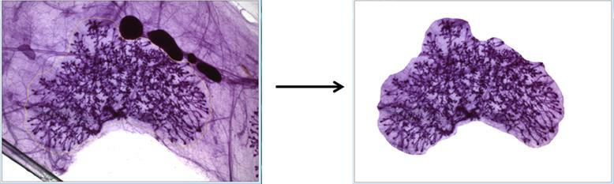
Figure 1. Use Freehand tool to trace around gland and clear outside.
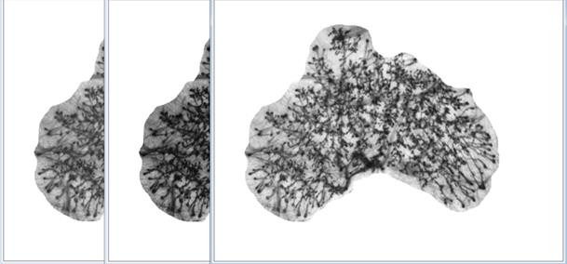
Figure 2. Split Channels separates the RGB image into individual color components. The figure depicts the green, red, and blue channels from left to right.
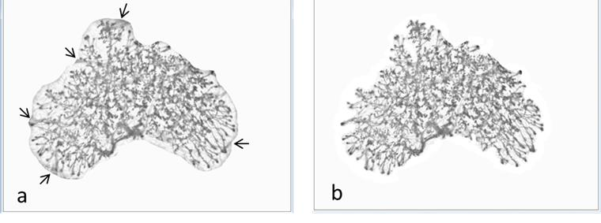
Figure 3. Image with background subtracted from blue color channel. A) Noise created by blood vessels (arrows) and B) after noise is removed.
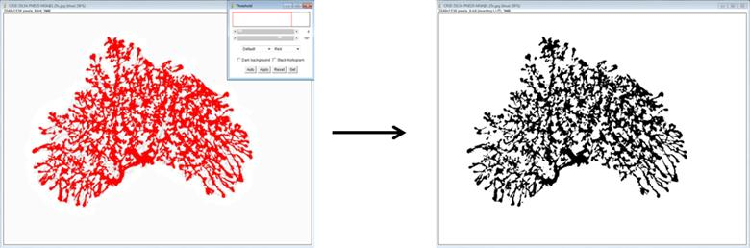
Figure 4. Thresholding the image creates a binary (black 0, white 255) image.
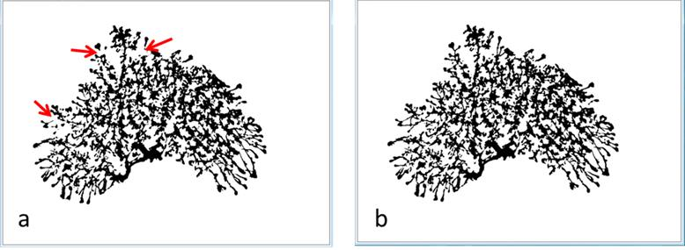
Figure 5. a) Red arrows indicate regions where gland reconstruction may be performed. b) After reconstruction.
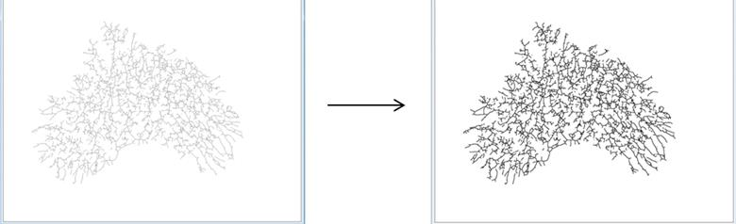
Figure 6. Skeletonized image with one dilation. This is the image that will be used for the analysis.

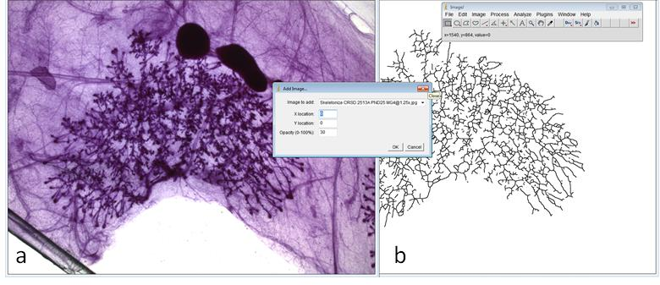
Figure 7. Add Image dialog window. In this example, the skeletonized image (b) will be overlaid onto the original image (a) with 30% opacity, resulting in figure 8.

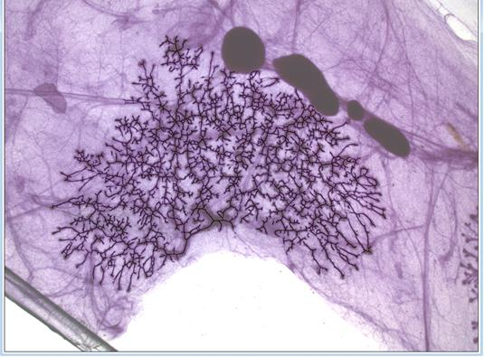
Figure 8. Overlay image showing skeletonized image overlaid onto the original image. As this image demonstrates, the skeletonized gland reflects the branching of the actual gland with a high degree of accuracy.

