**Supplemental Data**

**Sholl Analysis**

The ImageJ User’s Guide is available at http://imagej.nih.gov/ij/docs/guide/ (accessed 5/2014). ImageJ software is frequently updated and the methods described herein are based on version 1.48v. Updates can be obtained by selecting Help 🡪 Update ImageJ from the toolbar. The date of each version and the changes that were made can be viewed by selecting Help 🡪 ImageJ News. Additional help is available on the ImageJ website: http://imagej.nih.gov/ij/. The Sholl Analysis user’s guide is available on Fiji at http://fiji.sc/Sholl_Analysis (accessed 5/2014). Fiji is free image processing software which contains ImageJ, Java, Java3D, and additional plugins. The Sholl analysis method is also updated regularly and the protocol described here is based on v3.4.1. Changes made in later versions of both ImageJ and the Sholl Analysis plugin can affect these methods and should be addressed as needed. All parameters are defined in subheadings on the Fiji Sholl Analysis website. Parameter settings within this procedure are based on images captured from mammary gland whole mounts created in our laboratory and are not absolute. Whole mount preparation varies from lab to lab and these parameters may be adjusted accordingly to optimize images and output.

1. Sholl Analysis (SA).
   1. Open the Skeleton image.
   2. Make image binary by Process 🡪 Binary 🡪 Make Binary.
   3. Set magnification scale. The magnification scale must be set prior to SA or an error message will appear.
      * Analyze 🡪 Set Scale
        + Determine pixel/mm scale of captured image.
        + Set number of pixels.
        + Known Distance = 1.
        + Pixel Aspect Ratio = 1.
        + Unit of Length = millimeters.
        + Check Global if all images are the same magnification.
   4. Determine ending radius (longitudinal growth).
      * Click Line tool.
      * Draw a line from the base of attachment to the most distal point of the gland.
        + The base of attachment will be the center of the SA.
      * Press the M key to measure the distance of the line.
        + A Results window will open, the value in the Length column is the length of the line in mm.
        + Round the maximum length of all the images up to the nearest 0.5 mm.
        + This value will be used as the Ending Radius when setting SA parameters.
   5. Run the analysis.
      * Plugins 🡪 Advanced Sholl Analysis.
      * A parameter window will appear.

* Definition of Shells
  + - * Starting Radius = 0.00 mm

Ending Radius defaults as the length of the line tool measurement.

Using the Line tool, draw a line beginning at the base of attachment (red arrow) and extending to the most distal point of the gland (blue arrow). The length of this line is the ending radius (Fig.1).

This value is also the longitudinal growth of the mammary epithelial area (MEA).

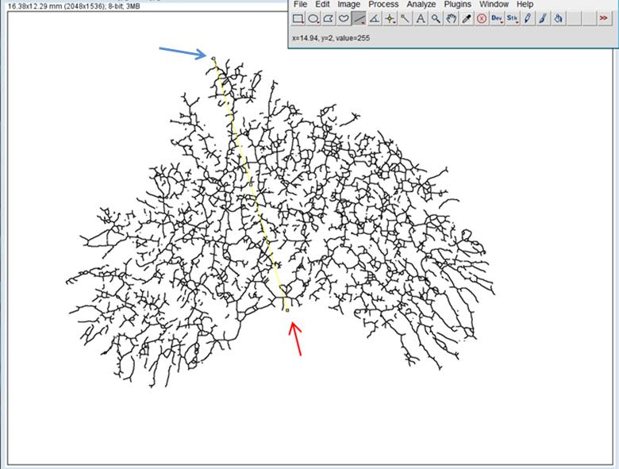

Figure 1. Defining the ending radius.

* + - * + Radius Step Size = 0.1 mm

Adjusted to increase or decrease the number of rings (iterations).

NOTE: The radius step size here was arbitrarily chosen to be 0.1 mm. However, N/mm2 was calculated using step sizes of 0.1, 0.05, and 0.0125 mm to examine whether differences in step size distorted the observed branching density differences. In each case, there was a significant difference between means and the *p*-values were similar, suggesting the impact of step size is negligible.

* Multiple Samples per Radius:
  + - * + # Samples = 1
        + Integration = Mean
* Descriptors and Curve Fitting:
  + - * + Enclosing radius cutoff = 1.
* # Primary branches

NA, check infer from starting radius.

* Fit profile and compute descriptors and Show fitting details can be checked as needed.
* Sholl Methods:
  + Profiles Without Normalization

Check Linear and select Best fitting degree

* + Normalized Profiles

Check Most informative and select normalizer

* Check Create Intersections Mask
  + Check Create intersections mask if a window showing skeletonized image with concentric rings is desired (Fig. 2).
* Background can be adjusted from 0 to 228.

Intersections mask. 

Figure 2. Intersections mask.

* + - Clicking Cf. Segmentation will generate a preview window image with rings to confirm area of analysis.
    - Clicking OK will run the analysis and generate output as selected.